**Geochemical and Isotopic Signatures of Groundwater Evolution and Recharge in the Eastern Flank of Mount Cameroon’s Volcanic Aquifer: Insights for Sustainable Water Resource Management**

**Abstract**

Groundwater resources in volcanic aquifers under tropical climates face escalating pressures from climate change and anthropogenic activities. The eastern flank of Mount Cameroon a critical agro-industrial zone exemplifies these challenges, yet comprehensive assessments integrating hydrogeochemical and isotopic evidence remain limited. Fifty groundwater samples (boreholes, springs, wells) and 14 precipitation events were analysed across volcanic-sedimentary interfaces. In-situ parameters (pH, EC, temperature) were measured followed by laboratory quantification of major ions (ion chromatography), trace elements (ICP-MS), and stable isotopes (δ¹⁸O, δ²H; cavity ring-down spectroscopy). Hydrochemical facies and recharge processes were evaluated using Aquachem, Piper diagrams, and Local Meteoric Water Line (LMWL) regression. Three dominant hydrochemical facies were identified: Ca-Cl (74%), indicating ion exchange and evaporite dissolution; Ca-HCO₃ (20%), reflecting active recharge and carbonate weathering; and mixed Ca-Mg-Cl (6%). Groundwater exhibited low mineralization (mean TDS: 102.24 mg/L; EC: 314.94 µS/cm) but localized Fe (≤5.31 mg/L) and Mn (≤3.28 mg/L) exceeded WHO thresholds. Isotopic signatures (δ¹⁸O: −2.90 ± 0.46‰; δ²H: −11.39 ± 1.99‰) confirmed precipitation as the primary recharge source, with d-excess values (9.96‰) indicating minor evaporation. A 15% precipitation decline (1991–2020) correlated with enriched δ¹⁸O-Cl⁻ trends, signalling climate-induced recharge vulnerability. The aquifer’s sustainability is threatened by climate-driven precipitation variability, geogenic contamination (Fe/Mn), and agricultural pollutants. Targeted monitoring of shallow zones, protection of fracture-mediated recharge systems, and climate-resilient policies are imperative for water security. This study establishes a critical baseline for sustainable management of volcanic aquifers in tropical regions.

**Keywords:** Groundwater, Isotopes, Volcanic Aquifer, Mount Cameroon, Water Quality, Sustainable Management

1. **Introduction**

Groundwater resources in volcanic terrains represent vital freshwater reservoirs for socio-economic development, particularly in tropical regions like Mount Cameroon. As West and Central Africa's highest peak (4,040 m), this active stratovolcano forms part of the geologically dynamic Cameroon Volcanic Line (CVL) a 1,600-km chain of Cenozoic volcanoes extending from the Atlantic Ocean into continental Africa (Asaah et al., 2015; Adams, 2022). The eastern flank of Mount Cameroon serves as a critical agro-industrial zone where groundwater supports irrigation, domestic consumption, and industrial activities. However, this resource faces escalating pressures from population growth, agricultural intensification, and climate variability, with projections indicating that 50% of Africa's population will experience water stress by 2025 (Hermanson et al., 2022; IPCC, 2023). The complex interplay of volcanic and sedimentary lithologies—fractured basalts, pyroclastics, and Cretaceous-Quaternary sediments—creates heterogeneous aquifer systems where hydrogeochemical processes remain poorly quantified (Ako et al., 2012; Ngai et al., 2024).

The aquifer architecture of Mount Cameroon's eastern flank exhibits stark contrasts: volcanic units feature high-permeability fracture networks (10⁻³ m/s) facilitating rapid recharge, while sedimentary formations (e.g., alluvial sands, lacustrine clays) exhibit primary porosity with moderate hydraulic conductivity (5–20 m/day) (Table 1; Fig. 1.). Groundwater chemistry is dominantly shaped by silicate weathering of basaltic minerals (e.g., plagioclase, olivine), releasing Ca²⁺, Mg²⁺, and dissolved silica, while evaporite dissolution in sedimentary strata enriches Cl⁻ and SO₄²⁻ (Wirmvem et al., 2017; Ngai et al., 2024). Despite foundational studies on spring hydrogeochemistry (Ako et al., 2012) and isotopic tracers (Fontes & Olivry, 1977; Nlend et al., 2023), critical knowledge gaps persist: (1) Sparse spatial coverage of the eastern flank obscures hydrochemical gradients across volcanic-sedimentary interfaces; (2) Lithological heterogeneity complicates predictions of contaminant mobility, especially Fe/Mn from geogenic sources and NO₃⁻ from agro-industry; (3) Absence of a robust Local Meteoric Water Line (LMWL) hinders reconciliation of δ¹⁸O/δ²H data with recharge dynamics; and (4) Climate change impacts on aquifer resilience remain unquantified despite a 15% precipitation decline since 1991 (Fig. 1; Cheunteu Fantah et al., 2022; Tchakam Kamtchueng et al., 2022). The sustainable management of water resources is paramount in volcanic regions such as Mount Cameroon, where these resources underpin socio-economic development. This study addresses critical challenges stemming from complex subsurface hydrological interactions and escalating anthropogenic pressures driven by population growth and burgeoning agro-industrial activities (Baud et al., 2024; Emvoutou et al., 2018). A key imperative is to resolve significant uncertainties concerning water quality, contamination pathways, and recharge dynamics within this vital agro-industrial zone (Billa, 2019; Fongoh et al., 2023). The overarching objective of this study is to provide a comprehensive hydrogeochemical characterization of both surface and groundwater on the Eastern flank of Mount Cameroon. This includes elucidating water quality uncertainties, identifying contamination pathways, and defining recharge dynamics within this crucial agro-industrial area. A pioneering aspect of this research involves integrating stable isotope hydrology with advanced geochemical modeling to achieve these objectives (Eid et al., 2024; Emvoutou et al., 2024; IAEA, 2006). The findings of this research establish a vital baseline for informed water resource management (Mussa & Mjemah, 2023). They underscore the urgent necessity for targeted contaminant monitoring (particularly for Fe, Mn, and nitrate) in vulnerable shallow aquifers, the implementation of community-based sanitation initiatives to mitigate anthropogenic impacts, and the development of climate-resilient policies to safeguard recharge and ensure long-term aquifer sustainability (Cook, 2003; Egbueri et al., 2019; Négrel & Petelet-Giraud, 2011). This study thus provides a foundational framework for developing effective strategies that balance water security, agricultural productivity, and ecological preservation within Mount Cameroon's dynamic volcanic environment (Ayenew & Demlie, 2008; Jannat et al., 2022).

Material and method

* 1. **Study Area**

The study area, located on the slopes of Mount Cameroon (Fig 1 and Table 1), is situated between latitudes 4° 8’30’’ and 4°25’0’’N, and longitudes 9°12’0’’ and 9°28’30’’ E. The region experiences a tropical highland climate, influenced by both the Atlantic Ocean and the central African monsoon. The climate is characterized by:

* **Temperature:** The average annual temperature ranges from 10°C to 20°C, with cooler temperatures at higher elevations. Seasonal variations are minimal, with slightly cooler temperatures during the wet season (May to October).
* **Precipitation:** The region has a bimodal rainfall pattern, with peaks in May-June and September-October. Annual precipitation can exceed 2,500 mm, particularly on the western slopes due to orographic uplift.
* **Extreme Weather Events:** The frequency and intensity of extreme weather events, such as droughts and floods, are projected to increase due to climate change.

Historically, the region has had a tropical climate with high rainfall and relatively stable temperatures. However, recent trends suggest a rise in average temperatures and potential changes in precipitation patterns, including an increased frequency of droughts and intense downpours. The annual temperature range is between 17°C and 34°C.

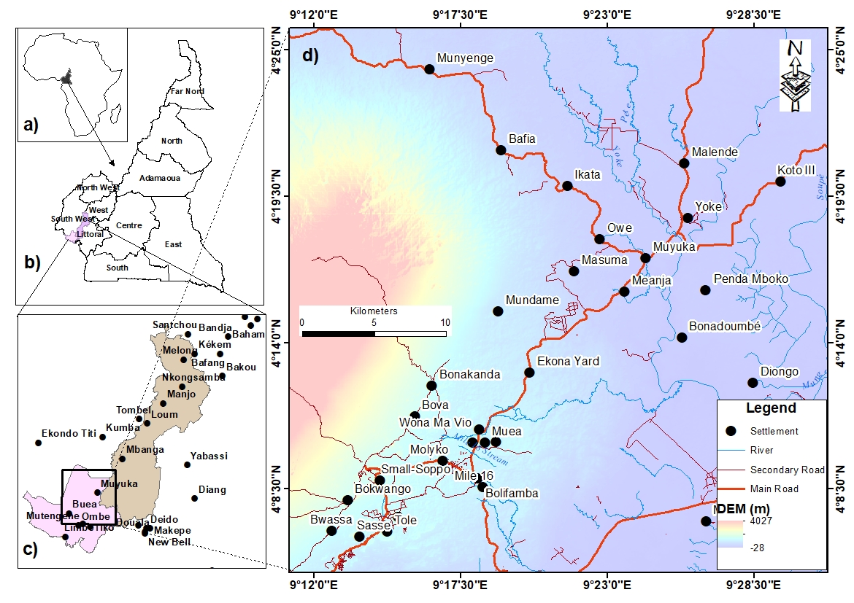

**Figure 1: Study area location**

Table 1. Details of sampling location

|  |  |  |  |  |  |  |  |  |  |
| --- | --- | --- | --- | --- | --- | --- | --- | --- | --- |
| No. | ID | Towns | Lat | Long | No. | ID | Towns | lat | Long |
| 1 | OW1 | stranger quarter | 4.175 | 9.280 | 26 | OW17 | camp 3 | 4.298 | 9.462 |
| 2 | OW2 | MALENDE | 4.321 | 9.428 | 27 | 0W18 | camp2 | 4.278 | 9.449 |
| 3 | RV | penda mboko | 4.182 | 9.309 | 28 | OW19 | bone quarter penda mboko | 4.358 | 9.409 |
| 4 | OW3 | YOKE | 4.218 | 9.305 | 29 | CAT2 | Koke | 4.262 | 9.443 |
| 5 | OW4 | MBO QUARTER,YOKE | 4.170 | 9.307 | 30 | BH2 | Lysoka | 4.285 | 9.401 |
| 6 | OW5 | MALENDE candef mosack quarter | 4.355 | 9.315 | 31 | CAT3 | Lyongo | 4.337 | 9.436 |
| 7 | OW6 | MALENDE | 4.158 | 9.279 | 32 | BH3 | check point buea | 4.260 | 9.364 |
| 8 | OW7 | YOKE nangi street | 4.157 | 9.249 | 23 | SPG5 | Muea | 4.288 | 9.414 |
| 9 | OW8 | new layout muyuka | 4.301 | 9.378 | 34 | OW20 | Muea | 4.267 | 9.434 |
| 10 | OW9 | Akawuh quarter | 4.158 | 9.292 | 35 | OW21 | matouke 2 | 4.283 | 9.404 |
| 11 | SPG1 | kwe kwe | 4.155 | 9.270 | 36 | CAT4 | mile 18 | 4.310 | 9.427 |
| 12 | OW10 | kwe kwe | 4.346 | 9.435 | 37 | OW22 | yoke king bar | 4.285 | 9.403 |
| 13 | SPG2 | ekona corner road | 4.144 | 9.236 | 38 | BH4 | buea town | 4.287 | 9.400 |
| 14 | SPG3 | mautu cross river | 4.333 | 9.435 | 39 | OW23 | muyuka 7 | 4.274 | 9.392 |
| 15 | SPG4 | mautu unity quatrter | 4.158 | 9.279 | 40 | BH5 | slaughter house Buea town | 4.288 | 9.403 |
| 16 | CAT1 | Mautu | 4.271 | 9.443 | 41 | BH6 | GREAT SOPPO | 4.231 | 9.339 |
| 17 | OW11 | MUEA ,WONYA MEVEO | 4.305 | 9.423 | 42 | BH7 | Bosta | 4.259 | 9.367 |
| 18 | OW12 | YOKE nangi street | 4.159 | 9.244 | 43 | SPG6 | Bafia | 4.365 | 9.314 |
| 19 | STM1 | Owe | 4.228 | 9.342 | 44 | OW24 | malende 3 | 4.301 | 9.464 |
| 20 | STM2 | Ikata | 4.075 | 9.304 | 45 | SPR7 | Bonduma | 4.288 | 9.408 |
| 21 | OW13 | Matouke | 4.162 | 9.299 | 46 | BH8 | BOSTA | 4.297 | 9.431 |
| 22 | OW14 | koto 111 | 4.330 | 9.354 | 47 | OW25 | yoke 3 | 4.302 | 9.779 |
| 23 | OW15 | penda mboko | 4.298 | 9.381 | 48 | SPR8 | BAFIA 2 | 4.319 | 9.431 |
| 24 | OW16 | camp 1 | 4.309 | 9.463 | 49 | BH9 | Sandpit | 4.347 | 9.433 |
| 25 | BH1 | bone quarter penda mboko | 4.299 | 9.463 | 50 | OW26 | old police road muyuka | 4.343 | 9.431 |

OW = open well, BH = Borehole, STM = stream, CAT = catchment, SPG = spring

* 1. **Geology and Hydrogeology**

The study area, situated on the slopes of Mount Cameroon, is part of the active Cameroon Volcanic Line (CVL) that stretches across the country (Ako et al., 2012; Che et al., 2012). The region's geology is a blend of metamorphic pre-Cameroon formations and intrusive gneisses and granites (Ngongang, 2016; Fitton and Dunlop, 1985). The volcanic rocks, except for the Nephelinit series of Mount Etinde, are predominantly alkaline(Fig 2). The massif's foundation comprises basaltic and tephra-basaltic ferromagnetic rocks originating from the Strombo-Hawaiian shield (Benedetti et al., 2003; Chauvel, 2004). Recent lava flows might exhibit lower permeability compared to older, weathered volcanic formations (Forster & Chilton, 2018).

The hydrogeology of the area is characterized by abundant rainfall that recharges underground reservoirs through percolation. The landscape, rich in rivers, springs, and mountains, coupled with high humidity, facilitates substantial subterranean water flow, often emerging as large springs downhill (Endeley et al., 2001; Akoachere et al., 2006; Ako et al., 2012). The porous pyroclastic materials and weathered basaltic rocks serve as significant aquifers (Ako et al., 2012). The dominant aquifer system is likely a fractured rock aquifer within the volcanic formations, where groundwater recharge is primarily driven by precipitation infiltration at higher elevations (Forster & Chilton, 2018). The permeability of the volcanic rocks and the presence of fractures influence infiltration rates and groundwater availability (Lerner et al., 2009). The topography of eastern Mount Cameroon features a wide elevation range, from over 4,000 meters above sea level on Mount Cameroon's slopes to 1,000-2,000 meters in the foothills (Gèze et al., 2010; Aerts et al., 2016). The steep slopes and valleys influence precipitation and surface water flow, with the western slopes receiving more rainfall due to orographic uplift. The rapid surface runoff on steeper slopes can potentially reduce groundwater recharge. The area's petrology reflects Strombo-Hawaiian volcanic activity, with dominant ferromagnesian basaltic lava. Under humid conditions, these rocks weather to form dark-colored andosols mixed with alluvial and sandy loam soils (Ako, 2016; UCCC, 2014).

Several factors, including high altitude, proximity to the sea, and humidity variations, influence chemical weathering processes (Bulourde, 2003). Meteorological factors like heavy rainfall, high temperatures, and humidity, combined with the variable substrates, contribute to chemical weathering, ion exchange, and rock-water interactions. These processes, coupled with human activities, lead to the diverse water types and hydrogeochemical phases observed in the region

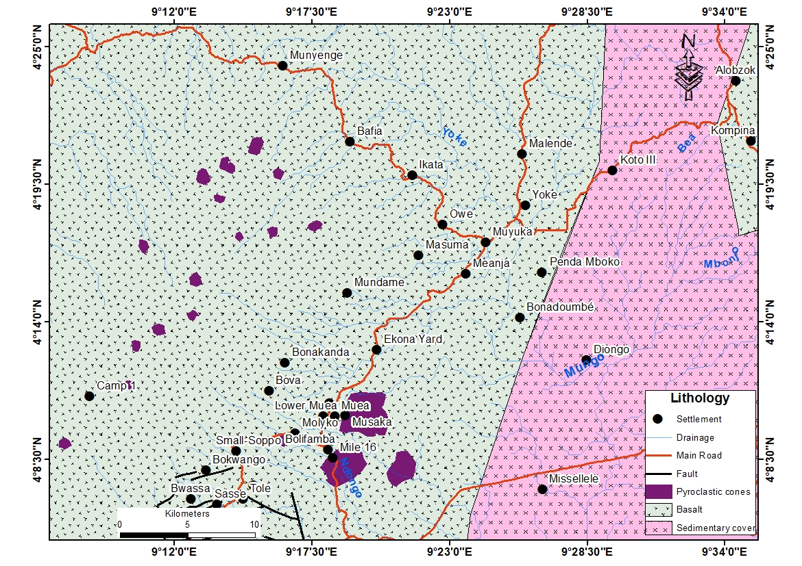

**Figure 2: Geologic map of the study area (modified from Che et al. 2012)**

The existing literature on groundwater dynamics, hydrogeochemistry, and isotopic analysis in volcanic aquifers provides a foundation for understanding the complex processes governing these systems. Studies have highlighted the influence of geological factors, such as rock type and weathering processes, on groundwater chemistry (Lahermo et al., 1990; Menti et al., 2023). The role of climate and land use in shaping groundwater recharge and quality has also been recognized (Kotchoni et al., 2019; Bauer et al., 2006). Isotopic techniques have been employed to trace the origins of groundwater and understand recharge mechanisms in volcanic settings (Wotany et al., 2021; Wirmvem et al., 2014).

A stratified sampling strategy was employed to capture the hydrogeological variability across volcanic and sedimentary formations. A total of 64 water samples were collected, comprising 50 groundwater sources—ranging from boreholes and springs to open wells and 14 precipitation events sampled across seasons to encapsulate hydrological shifts. Each sampling location was georeferenced, enabling spatial mapping and gradient analysis .In situ measurements of key physicochemical parameters, including pH, electrical conductivity (EC), temperature, and alkalinity, were conducted immediately at each site using a calibrated HANNA HI 98127 multiprobe with a precision of ±0.01 for pH. Alkalinity was determined by titration following CHEMetrics protocols, with sulfuric acid titrated to a pH endpoint of 4.5. To ensure analytical integrity, all water samples were filtered through 0.45 µm cellulose membranes and preserved in pre-rinsed HDPE bottles. Trace metal samples were acidified to pH <2 using ultrapure nitric acid, while isotope samples were sealed airtight and stored at 4°C to avoid fractionation. Precipitation data, spanning 1991–2020, were gathered monthly using Palmer rain gauges to establish long-term isotopic baselines .In the laboratory, major ions—such as Ca²⁺, Mg²⁺, Na⁺, K⁺, Cl⁻, SO₄²⁻, and NO₃⁻ were quantified via ion chromatography (Dionex ICS-1100) in accordance with APHA Standard Method 4110. Bicarbonate was determined through Gran titration, with charge balance errors maintained within 5% (Eq. 15). Trace elements, including Fe, Mn, As, and twelve additional metals, were measured by Inductively Coupled Plasma Mass Spectrometry (ICP-MS) using a PerkinElmer Elan DR II, adhering strictly to ISO 17294-2:2003 and calibrated against NIST-traceable standards (Section 3.7). Stable isotope ratios (δ¹⁸O and δ²H) were analyzed using wavelength-scanned cavity ring-down spectroscopy (Picarro L2120-i), delivering high precision measurements (±0.1‰ for δ¹⁸O and ±1‰ for δ²H), referenced to the VSMOW standard (Eq. 9). Dissolved silica (SiO₂) concentrations were also determined via ICP-MS, providing insights into silicate weathering intensity. For geochemical classification and process elucidation, Aquachem v4.0 was utilized to generate Piper, facilitating facies classification and interpretation of dominant hydrogeochemical processes such as rock-water interaction and evaporation trends. Contamination levels were evaluated using Enrichment Factor (EF), Heavy Metal Pollution Index (HPI), and Contamination Index (Cd), quantifying trace metal accumulation and anthropogenic impact. Lastly, isotopic recharge patterns were modelled using the Local Meteoric Water Line (LMWL), derived from regression of δ¹⁸O–δ²H values in precipitation. Deuterium excess (d-excess = δ²H – 8δ¹⁸O) was calculated to infer evaporative influences and help reconstruct recharge processes in volcanic terrains

**3.0. Results**

The results revealed key findings regarding the hydrogeochemical characteristics of groundwater in the Mount Cameroon region (Table 1). Groundwater temperatures ranged from 23.10°C to 32.10°C, with an average of 27.69°C. The pH levels, ranging from 6.49 to 6.68, indicated slightly acidic to neutral conditions, falling within the WHO's acceptable range for drinking water. The electrical conductivity (EC) averaged 314.94 µS/cm, well below the WHO's recommended limit of 1500 µS/cm. Total dissolved solids (TDS) ranged from 102 mg/l to 211 mg/l, also within the WHO's permissible limit.

Major cations like sodium (Na+), potassium (K+), magnesium (Mg2+), and calcium (Ca2+) were analyzed, with concentrations varying across sampling locations. Similarly, the concentrations of major anions like chloride (Cl-), bicarbonate (HCO3-), nitrate (NO3-), and sulfate (SO42-) were assessed, all falling within the WHO's recommended limits for drinking water.

The groundwater samples analysed in this study revealed three predominant water types.

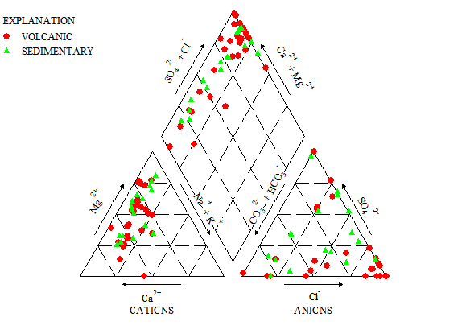

**Figure 3: Piper diagram of groundwaters in the study area**

This study delineates three major hydrogeochemical facies within the Eastern Mount Cameroon volcanic aquifer: Ca-Cl (74%), Ca-HCO₃ (20%), and Mixed Ca-Mg-Cl (6%) types. The dominance of the Ca-Cl facies highlights ion exchange and evaporite dissolution, often linked to deep, older groundwater with limited recharge. In contrast, the Ca-HCO₃ facies signifies active recharge and weathering of carbonate and silicate minerals, indicating fresher and more dynamic groundwater systems. The Mixed Ca-Mg-Cl type reflects transitional geochemical conditions, potentially influenced by saline-freshwater mixing, dolomite dissolution, or localized contamination. These facies provide valuable insights into groundwater evolution, flow paths, and water-rock interactions. Their identification is pivotal for managing salinity risks, sustaining recharge zones, and informing strategies for groundwater quality monitoring. This work underscores the importance of integrating hydrochemical classification with isotopic and geostatistical approaches to support sustainable water resource development in complex volcanic terrains.

The correlation analysis reveals a strong 1:1 relationship between Electrical Conductivity (EC) and Total Dissolved Solids (TDS), confirming that EC effectively reflects dissolved ion concentrations in groundwater. However, both EC and TDS exhibit weak correlations with major ions such as Ca²⁺, Na⁺, K⁺, Mg²⁺, HCO₃⁻, SO₄²⁻, NO₃⁻, and Cl⁻, suggesting that other sources—like silicate weathering, colloidal particles, or anthropogenic inputs—may contribute significantly to TDS. This underscores the geochemical complexity of the aquifer system, where factors like lithology, ionic strength, and non-ionic constituents shape solute concentrations. The findings advocate for further research into alternative TDS contributors and equilibrium processes influencing groundwater quality.

Table 2 Groundwater physicochemical parameter correlation matrix of the study area

|  |  |  |  |  |  |  |  |  |  |  |  |  |  |
| --- | --- | --- | --- | --- | --- | --- | --- | --- | --- | --- | --- | --- | --- |
|  | Ca2+ | Mg2+ | Na+ | K+ | HCO3 | CL- | SO2-4 | NO3- | SiO2 | TDS | T | PH | EC |
| Ca2+ | 1 |  |  |  |  |  |  |  |  |  |  |  |  |
| Mg2+ | 0.12 | 1.00 |  |  |  |  |  |  |  |  |  |  |  |
| Na+ | 0.46 | 0.10 | 1.00 |  |  |  |  |  |  |  |  |  |  |
| K+ | 0.85 | 0.14 | 0.48 | 1.00 |  |  |  |  |  |  |  |  |  |
| HCO3 | 0.21 | 0.03 | 0.00 | -0.1 | 1.00 |  |  |  |  |  |  |  |  |
| CL- | 0.87 | 0.12 | 0.42 | 0.76 | -0.04 | 1.00 |  |  |  |  |  |  |  |
| SO2-4 | 0.34 | 0.19 | 0.21 | 0.32 | 0.19 | 0.30 | 1.00 |  |  |  |  |  |  |
| NO3- | 0.54 | 0.01 | 0.33 | 0.35 | -0.14 | 0.58 | -0.21 | 1.00 |  |  |  |  |  |
| SiO2 | 0.18 | 0.01 | 0.34 | 0.20 | -0.04 | 0.11 | 0.44 | -0.1 | 1.00 |  |  |  |  |
| TDS | 0.09 | -0.03 | 0.02 | 0.06 | -0.05 | 0.08 | -0.26 | 0.36 | -0.1 | 1.00 |  |  |  |
| T | -0.1 | 0.08 | 0.00 | -0.1 | 0.18 | -0.1 | 0.26 | -0.4 | 0.03 | -0.6 | 1.00 |  |  |
| PH | 0.02 | 0.20 | -0.1 | 0.11 | 0.11 | -0.1 | -0.10 | 0.14 | 0.07 | 0.50 | -0.6 | 1.00 |  |
| EC | 0.09 | -0.03 | 0.02 | 0.05 | -0.05 | 0.08 | -0.25 | 0.35 | -0.1 | 1.00 | -0.6 | 0.50 | 1.00 |

Strong moderate

Correlations determined by binary graphs between concentrations of major elements (SO4 , Mg2+ , Cl, Ca2+ , Na+, and HCO3-) identify mechanisms and processes contributing to water sample mineralization. These correlation analyses provide insights into the relationships between various hydrochemical parameters, shedding light on the composition and quality of groundwater in the study area.

The study assessed the physicochemical parameters of groundwater and compared them to the World Health Organization's (WHO) standards for drinking water. The water samples exhibited the following characteristics: The water from springs, boreholes, and some deep open wells with metal casing was colourless. However, shallow and unprotected wells showed creamy and greenish colours, respectively, possibly due to suspended solids and eutrophication. The pH values ranged from 6.22 to 6.69, with an average of 6.49, indicating slightly acidic to neutral conditions, which are generally acceptable for drinking water (table 3). The study also compared the concentrations of various parameters (EC, TDS, HCO₃⁻, Cl⁻, SO₄²⁻, NO₃⁻, TH, Ca²⁺, Mg²⁺, Na⁺, and K⁺) to WHO and BIS (Bureau of Indian Standards) guidelines. All parameters were found to be within acceptable limits, suggesting that the groundwater is generally suitable for drinking purposes in terms of these parameters.

**Table 3: Basic Statistics of the physicochemical parameters of groundwater**

|  |  |  |  |  |  |
| --- | --- | --- | --- | --- | --- |
| Parameter | WHO (2017) | BIS (2012) | Study Area Samples | | |
| Water Quality | Acceptable | Acceptable limit | Minimum | Maximum | Mean |
|  | Range |
| pH(on scale) | 6.5-8.5 | 6.5-8.5 | 6.22 | 6.68 | 6.49 |
| EC (µs/cm) | - | - | 22 | 425 | 204.88 |
| Temp | - | - | 23.10 | 32.10 | 27.69 |
| TDS (mg/l) | 500 | 500 | 11 | 211 | 102.24 |
| HCO3(mg/l) | - | - | 0 | 147 | 16.99 |
| Cl(mg/l) | 250 | 250 | 0 | 32.6 | 10.05 |
| SO4(mg/l) | 250 | 200 | 0 | 20.13 | 4.54 |
| NO3(mg/l) | 45 | 45 | 0 | 12.9 | 5.07 |
| TH (mg/l) | 100 | 200 | 13.69 | 152.51 | 69.89 |
| Ca(mg/l) | 75 | 75 | 1.61 | 43.1 | 13.41 |
| Mg(mg/l) | 50 | 30 | 0 | 20.2 | 8.71 |
| Na(mg/l) | 200 | - | 0.23 | 6.44 | 2.39 |
| K(mg/l) | 12 | - | 0.37 | 15.2 | 4.75 |

The TH ranged from 13.69 mg/l to 152.51 mg/l CaCO3(table 4). The majority of the samples (44%) fell into the "soft" category, while 46% were classified as "moderately hard." The remaining 10% were classified as "hard." The hardness is primarily attributed to the presence of Mg²⁺ and Ca²⁺ ions.

**Table 4: Groundwater Classification Based on Total Hardness (TH) after WHO (2017).**

|  |  |  |  |
| --- | --- | --- | --- |
| (TH) as CaCO3(mg/l | Water type | No of water samples | Percentage of water samples |
| < 60 | Soft | 22 | 44% |
| 61-120 | Moderately Hard | 23 | 46 |
| 121-180 | Hard | 5 | 10 |
| >180 | Very Hard | 0 | 0 |

Trace element analysis across groundwater samples from Eastern Mount Cameroon reveals considerable spatial and compositional variability driven by both geological and anthropogenic influences. Iron (Fe) concentrations were notably elevated, averaging 2390 µg/L, with values ranging from 10 µg/L at Newlayout Muyuka (OW08) to a peak of 5310 µg/L at Koke (CAT2), reflecting extensive iron-bearing mineral dissolution. Manganese (Mn) concentrations varied similarly, from 10 µg/L at Koto III (OW14) to 3280 µg/L at Mile 18 Buea (CAT04), influenced by redox-sensitive geochemistry typical of volcanic aquifers. Aluminium (Al) levels, associated with silicate weathering, were measured between 15 µg/L (Koto III, OW14) and 72 µg/L (Ekona, SPG2). Arsenic (As) remained low across most sites, averaging 0.19 µg/L, but peaked at 0.62 µg/L near Mautu Cross River Quarter (SPG03), suggesting localized geogenic input. Lead (Pb) concentrations ranged from 0.02 µg/L to 1.56 µg/L, with the highest values also found at SPG03, possibly linked to lead-bearing mineral weathering or historical pollution. Vanadium (V) reached 20.5 µg/L at Camp 3 (OW17), while Cadmium (Cd) concentrations, though generally low, peaked at 0.51 µg/L at Checkpoint Molyko (BH03), indicating potential anthropogenic sources. Chromium (Cr) was detected up to 4.01 µg/L at Camp 1 (OW16), influenced by oxidation-reduction reactions or industrial input. Copper (Cu) and Nickel (Ni), typically from ultramafic sources, peaked at 3.11 µg/L (Bafia, SPH02) and 0.88 µg/L (CAT04) respectively. Zinc (Zn), which averaged 17.18 µg/L, showed highs of 44.1 µg/L at Bafia (SPG08) and lows of 7.5 µg/L at Bonduma Spring (SPG07).

**Table 5: Trace Element Concentrations in Groundwater Samples**

|  |  |  |  |  |  |  |  |  |  |  |  |  |
| --- | --- | --- | --- | --- | --- | --- | --- | --- | --- | --- | --- | --- |
| Sr.No.ample ID | Fe(mg/l) | Mn(mg/l) | Al(mg/l) | As(µg/l) | Cd(µg/l) | Cr(µg/l) | Cu(µg/l) | Ni(µg/l) | Pb(µg/l) | V(µg/l) | Zn(µg/l) | Co(µg/l) |
| 1 | 0.03 | 0.43 | 0.02 | 0.04 | 0.06 | 0.70 | 1.80 | 0.60 | 0.75 | 4.20 | 8.50 | 0.07 |
| 2 | 0.30 | 0.19 | 0.01 | 0.15 | 0.02 | 1.30 | 1.30 | 0.72 | 0.32 | 9.45 | 19.30 | 0.04 |
| 3 | 0.02 | 0.21 | 0.03 | 0.17 | 0.12 | 1.12 | 1.22 | 0.75 | 0.41 | 10.60 | 44.10 | 0.08 |
| 4 | 3.03 | 0.31 | 0.01 | 0.11 | 0.01 | 1.11 | 0.84 | 0.43 | 0.51 | 14.20 | 32.50 | 0.04 |
| 5 | 0.35 | 0.28 | 0.01 | 0.09 | 0.01 | 0.90 | 1.30 | 0.51 | 0.18 | 7.20 | 9.24 | 0.14 |
| 6 | 2.04 | 0.52 | 0.01 | 0.21 | 0.02 | 1.10 | 1.23 | 0.62 | 0.21 | 13.50 | 13.70 | 0.05 |
| 7 | 3.70 | 0.59 | 0.01 | 0.15 | 0.03 | 1.20 | 1.11 | 0.65 | 0.28 | 14.70 | 18.20 | 0.07 |
| 8 | 5.23 | 0.19 | 0.01 | 0.22 | 0.02 | 1.70 | 1.29 | 0.42 | 0.26 | 17.30 | 15.30 | 0.11 |
| 9 | 0.01 | 0.14 | 0.01 | 0.19 | 0.01 | 1.00 | 1.81 | 0.51 | 0.71 | 13.80 | 17.80 | 0.04 |
| 10 | 0.31 | 0.14 | 0.01 | 0.16 | 0.01 | 1.10 | 1.70 | 0.07 | 0.02 | 15.20 | 26.40 | 0.03 |
| 11 | 3.43 | 0.17 | 0.01 | 0.14 | 0.03 | 0.78 | 0.91 | 0.56 | 1.25 | 11.20 | 18.20 | 0.51 |
| 12 | 0.35 | 0.51 | 0.04 | 0.35 | 0.05 | 0.89 | 0.89 | 0.62 | 0.51 | 13.20 | 18.90 | 0.09 |
| 13 | 4.20 | 0.47 | 0.07 | 0.14 | 0.11 | 1.51 | 1.10 | 0.41 | 0.99 | 8.51 | 22.30 | 0.04 |
| 14 | 1.80 | 0.07 | 0.04 | 0.71 | 0.07 | 1.11 | 1.60 | 0.61 | 0.54 | 9.50 | 20.10 | 0.15 |
| 15 | 3.45 | 0.21 | 0.01 | 0.47 | 0.04 | 1.23 | 1.82 | 0.75 | 0.81 | 11.50 | 8.60 | 0.07 |
| 16 | 3.90 | 0.75 | 0.07 | 0.21 | 0.06 | 0.97 | 2.01 | 0.36 | 1.56 | 18.10 | 14.20 | 0.03 |
| 17 | 4.30 | 0.41 | 0.07 | 0.37 | 0.02 | 1.15 | 1.57 | 0.41 | 0.25 | 11.80 | 9.30 | 0.47 |
| 18 | 0.85 | 0.21 | 0.01 | 0.14 | 0.06 | 0.98 | 0.45 | 0.63 | 0.84 | 14.20 | 12.30 | 0.15 |
| 19 | 0.76 | 0.81 | 0.01 | 0.56 | 0.03 | 1.21 | 0.78 | 0.78 | 0.41 | 15.20 | 25.10 | 0.14 |
| 20 | 3.12 | 0.31 | 0.00 | 0.41 | 0.04 | 1.22 | 1.27 | 0.69 | 0.22 | 8.95 | 11.20 | 0.42 |
| 21 | 3.71 | 0.41 | Bdl | 0.19 | 0.24 | 0.18 | 0.48 | 0.03 | 0.03 | 8.21 | 18.20 | 1.09 |
| 22 | 3.14 | 0.01 | Bdl | 0.09 | 0.04 | 1.06 | 1.85 | 0.13 | 0.03 | 6.81 | 14.30 | 0.14 |
| 23 | 2.51 | 0.04 | 0.01 | 0.15 | 0.04 | 1.45 | 2.31 | 0.23 | 0.03 | 6.81 | 17.10 | 0.28 |
| 24 | 0.28 | 0.11 | 0.01 | 0.61 | 0.15 | 0.13 | 2.61 | 0.16 | 0.03 | 6.91 | 24.40 | 0.85 |
| 25 | 1.91 | 0.11 | 0.01 | 0.07 | 0.01 | 0.96 | 1.76 | 0.18 | 0.02 | 14.50 | 19.20 | 0.13 |
| 26 | 1.54 | 0.31 | 0.01 | 0.06 | 0.06 | 0.51 | 1.81 | 0.24 | 0.03 | 20.50 | 18.50 | 0.79 |
| 27 | 4.31 | 0.33 | 0.00 | 0.07 | 0.05 | 1.21 | 0.64 | 0.37 | 0.54 | 19.80 | 21.30 | 0.24 |
| 28 | 2.73 | 2.04 | 0.03 | 0.08 | 0.01 | 1.05 | 1.81 | 0.15 | 0.03 | 13.80 | 20.50 | 0.05 |
| 29 | 5.31 | 0.63 | 0.01 | 0.13 | 0.02 | 1.05 | 0.21 | 0.16 | 0.03 | 9.89 | 8.06 | 0.05 |
| 30 | 3.21 | 0.25 | 0.01 | 0.21 | 0.03 | 1.08 | 1.86 | 0.15 | 0.02 | 11.90 | 14.20 | 0.03 |
| 31 | 2.21 | 0.28 | 0.01 | 0.02 | 0.12 | 1.96 | 0.01 | 0.21 | 0.02 | 1.51 | 15.90 | 0.12 |
| 32 | 4.41 | 1.27 | 0.01 | 0.11 | 0.51 | 1.08 | 1.32 | 0.59 | 0.02 | 12.60 | 14.60 | 0.09 |
| 33 | 3.42 | 0.19 | 0.01 | 0.07 | 0.02 | 1.31 | 0.08 | 0.54 | 0.49 | 13.50 | 18.20 | 0.45 |
| 34 | 4.21 | 0.21 | 0.01 | 0.08 | 0.12 | 1.23 | 1.23 | 0.31 | 0.57 | 14.70 | 18.90 | 0.29 |
| 35 | 3.12 | 0.31 | 0.01 | 0.13 | 0.01 | 1.02 | 1.75 | 0.53 | 0.83 | 17.30 | 22.30 | 0.39 |
| 36 | 0.76 | 3.28 | 0.01 | 0.05 | 0.01 | 1.21 | 0.95 | 0.88 | 1.16 | 14.80 | 21.10 | 0.74 |
| 37 | 1.56 | 0.52 | 0.00 | 0.53 | 0.02 | 1.09 | 0.23 | 0.59 | 0.85 | 11.20 | 8.70 | 0.37 |
| 38 | 4.21 | 0.59 | 0.03 | 0.15 | 0.03 | 1.11 | 0.75 | 0.04 | 0.64 | 15.80 | 11.20 | 0.24 |
| 39 | 4.02 | 0.19 | 0.01 | 0.28 | 0.02 | 1.02 | 1.91 | 0.03 | 0.31 | 11.30 | 9.90 | 0.14 |
| 40 | 2.35 | 0.14 | 0.00 | 0.09 | 0.01 | 1.25 | 0.45 | 0.26 | 0.52 | 8.11 | 11.30 | 0.36 |
| 41 | 2.91 | 0.14 | 0.03 | 0.08 | 0.13 | 0.91 | 0.61 | 0.46 | 0.13 | 10.50 | 23.10 | 0.04 |
| 42 | 3.41 | 1.17 | 0.01 | 0.08 | 0.13 | 1.01 | 1.54 | 0.58 | 0.33 | 10.30 | 17.20 | 0.35 |
| 43 | 0.81 | 0.47 | 0.01 | 0.06 | 0.07 | 1.11 | 1.52 | 0.29 | 0.25 | 11.30 | 11.20 | 0.46 |
| 44 | 0.32 | 0.11 | 0.00 | 0.08 | 0.07 | 1.18 | 0.64 | 0.15 | 0.51 | 10.60 | 8.90 | 0.14 |
| 45 | 3.61 | 0.31 | 0.03 | 0.03 | 0.01 | 1.56 | 1.71 | 0.16 | 0.32 | 12.60 | 7.50 | 0.15 |
| 46 | 4.20 | 0.43 | 0.01 | 0.21 | 0.05 | 1.28 | 0.31 | 0.15 | 0.13 | 11.50 | 17.60 | 0.05 |
| 47 | 0.03 | 0.05 | 0.01 | 0.05 | 0.02 | 1.91 | 1.56 | 0.21 | 0.04 | 14.70 | 14.50 | 0.13 |
| 48 | 0.35 | 1.32 | 0.01 | 0.51 | 0.02 | 4.01 | 3.11 | 0.59 | 0.03 | 14.30 | 36.04 | 5.01 |
| 49 | 1.24 | 0.15 | 0.00 | 0.06 | 0.13 | 1.12 | 1.52 | 0.54 | 0.11 | 19.80 | 18.30 | 0.25 |
| 50 | 2.41 | 0.18 | 0.00 | 0.05 | 0.02 | 1.61 | 0.18 | 0.31 | 0.02 | 11.20 | 11.70 | 0.16 |
| Min | 0.01 | 0.01 | 0.00 | 0.02 | 0.01 | 0.13 | 0.01 | 0.03 | 0.02 | 1.51 | 7.50 | 0.03 |
| Max | 5.31 | 3.28 | 0.07 | 0.71 | 0.51 | 4.01 | 3.11 | 0.88 | 1.56 | 20.50 | 44.10 | 5.01 |
| Mean | 2.40 | 0.50 | 0.02 | 0.19 | 0.07 | 1.21 | 1.27 | 0.41 | 0.40 | 12.14 | 17.51 | 0.41 |

The isotopic analysis of rainwater samples collected over 14 months in Buea reveals a distinct seasonal variation in both δ¹⁸O and δD values (Table 5). The weighted average values for δ¹⁸O (–3.84‰) and δD (–19.65‰) are indicative of a meteoric origin for the precipitation, consistent with the expected depletion in heavier isotopes due to fractionation processes during the global water cycle (Craig, 1961). The observed seasonal variability in isotopic signatures can be attributed to several factors, including changes in temperature, humidity, and the source of moisture (Dansgaard, 1964).

Stable isotopes of water such as oxygen‑18 and hydrogen deuterium are crucial tools in hydrogeology for understanding water’s origins, movement, and behaviour across diverse systems. They provide insights into water cycle processes, groundwater recharge, and mechanisms like evaporation and mixing. In the present study area, a lack of existing isotopic data for rainfall hinders local baseline comparisons; however, most groundwater typically exhibits compositions that align with the characteristic meteoric water signature (i.e., rainwater), unless altered by evaporation or geologic reactions. When groundwater samples match this global signature, it strongly suggests direct recharge from rainfall (Jasechko, et al.,2014). Conversely, deviations from this pattern may indicate evaporation effects (Gallart et al., 2024) or input from deeper sources (Wotany et al., 2021; Tchakam Kamtchueng et al., 2022). A comparison of the isotope results from the current study with other investigations in Cameroon reveals that most groundwater largely conforms to the global meteoric water line, pointing to rapid recharge. Additionally, there is a trend toward lighter isotopic values further inland, away from coastal influences.

|  |  |  |  |  |
| --- | --- | --- | --- | --- |
| *Table 6a: Rain water isotope results* | | | | |
| Month | δ18 O (‰) | δD (‰) | d-excess (‰)) | Rainfall (mm) |
| July | -4.27 | -20.70 | 13.46 | 323.65 |
| August | -2.07 | -3.90 | 12.66 | 465.1 |
| September | -5.11 | -32.90 | 7.98 | 409.21 |
| October | 0.43 | 8.40 | 4.96 | 306.04 |
| November | -4.37 | -24.70 | 10.26 | 104.54 |
| January |  |  | 0 | 17.82 |
| February | 1.73 | 7.40 | -6.44 | 38.19 |
| March | -3.18 | -12.40 | 13.04 | 142.99 |
| April | -3.63 | -19.70 | 9.34 | 198.14 |
| May |  |  | 0 | 234.55 |
| June | -3.74 | -14.50 | 15.42 | 324.62 |
| July | -3.72 | -14.40 | 15.36 | 323.65 |
| August | -5.42 | -32.60 | 10.76 | 465.1 |
| September | -5.46 | -32.90 | 10.78 | 409.21 |
| October | -5.45 | -32.80 | 10.8 | 306.04 |
| November | -3.34 | -15.60 | 11.12 | 104.54 |
| December |  |  | 0 | 22.95 |

**Table 6b: groundwater isotope data**

|  |  |  |  |
| --- | --- | --- | --- |
| **place** | **18O(‰)** | **2D(‰)** | **GMWL** |
| **stranger quarter** | -2.66 | -9.71 | -11.28 |
| **MALENDE** | -2.59 | -9.33 | -10.72 |
| **penda mboko** | -2.25 | -6.13 | -8 |
| **YOKE** | -2.71 | -9.55 | -11.68 |
| **MBO QUARTER,YOKE** | -2.55 | -8.32 | -10.4 |
| **MALENDE candef mosack quarter** | -2.98 | -10.15 | -13.84 |
| **MALENDE** | -2.55 | -9.13 | -10.4 |
| **YOKE nangi street** | -3.2 | -10.15 | -15.6 |
| **new layout muyuka** | -2.91 | -9.33 | -13.28 |
| **Akawuh quarter** | -3.01 | -11.31 | -14.08 |
| **kwe kwe** | -2.58 | -9.61 | -10.64 |
| **kwe kwe** | -3 | -10.21 | -14 |
| **ekona corner road** | -3.11 | -9.52 | -14.88 |
| **mautu cross river** | -3.11 | -10.81 | -14.88 |
| **mautu unity quatrter** | -3.01 | -9.53 | -14.08 |
| **Mautu** | -3.13 | -13.51 | -15.04 |
| **MUEA ,WONYA MEVEO** | -2.95 | -15.11 | -13.6 |
| **YOKE nangi street** | -3.21 | -12.2 | -15.68 |
| **Owe** | -2.57 | -12.72 | -10.56 |
| **Ikata** | -3.06 | -12.66 | -14.48 |
| **Matouke** | -2.95 | -10.52 | -13.6 |
| **koto 111** | -2.75 | -10.33 | -12 |
| **penda mboko** | -2.83 | -12.76 | -12.64 |
| **camp 1** | -3.33 | -10.31 | -16.64 |
| **bone quarter penda mboko** | -3.42 | -11.38 | -17.36 |
| **camp 3** | -3.12 | -12.75 | -14.96 |
| **camp2** | -3.36 | -10.31 | -16.88 |
| **bone quarter penda mboko** | -3.25 | -10.31 | -16 |
| **Koke** | -3.11 | -11.23 | -14.88 |
| **Lysoka** | -3.21 | -13.11 | -15.68 |
| **Lyongo** | -2.63 | -11.55 | -11.04 |
| **check point** Buea | -3.34 | -15.99 | -16.72 |
| **Muea** | -2.82 | -13.11 | -12.56 |
| **Muea** | -3.32 | -11.66 | -16.56 |
| **matouke 2** | -2.63 | -16.15 | -11.04 |
| **mile 18** | -3.21 | -12.37 | -15.68 |
| **yoke king bar** | -2.81 | -13.23 | -12.48 |
| Buea **town** | -3.91 | -12.35 | -21.28 |
| **muyuka 7** | -2.14 | -14.63 | -7.12 |
| Slaughter house Buea town | -1.91 | -10.31 | -5.28 |
| Great Soppo | -3.78 | -13.12 | -20.24 |
| **Bosta** | -3.69 | -10.23 | -19.52 |
| **Bafia** | -1.24 | -13.51 | 0.08 |
| **malende 3** | -3.01 | -8.35 | -14.08 |
| **Bonduma** | -2.63 | -10.33 | -11.04 |
| **BOSTA** | -2.31 | -11.33 | -8.48 |
| **yoke 3** | -2.77 | -12.98 | -12.16 |
| **BAFIA 2** | -2.92 | -12.52 | -13.36 |
| **Sandpit** | -2.55 | -12.03 | -10.4 |
| **old police road muyuka** | -2.91 | -11.67 | -13.28 |

Table 6c summary of the isotope statistics for both rainwater and groundwater:

|  |  |  |  |  |  |
| --- | --- | --- | --- | --- | --- |
| Isotope | Water Type | Mean | Median | Range | Standard Deviation |
| δ18 O (‰) | Rainwater | -3.40 | -3.73 | 7.19 | 2.15 |
| δD (‰) | Rainwater | -17.24 | -17.65 | 41.30 | 13.94 |
| d-excess (‰)) | Rainwater | 9.96 | 10.79 | 21.86 | 5.48 |
| δ18 O (‰) | Groundwater | -2.90 | -2.95 | 2.67 | 0.46 |
| δD (‰) | Groundwater | -11.39 | -11.32 | 10.02 | 1.99 |

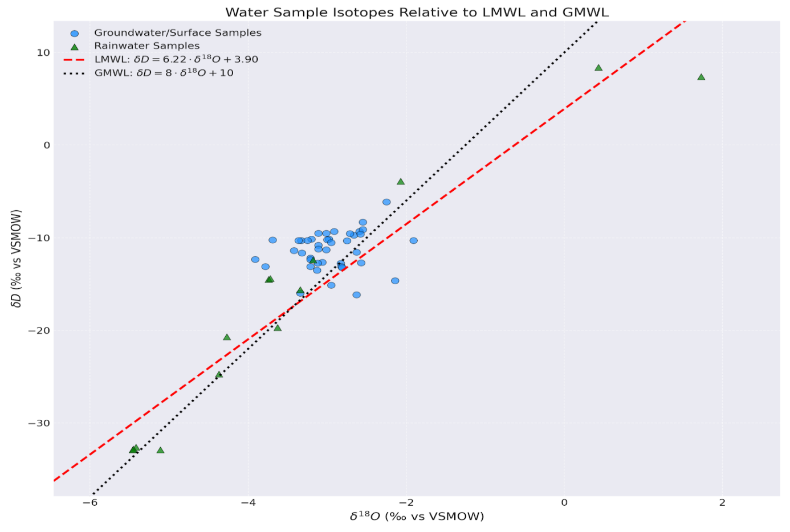

**Fig. 4: Traditional d18O–dD associations of groundwater in the study region.**

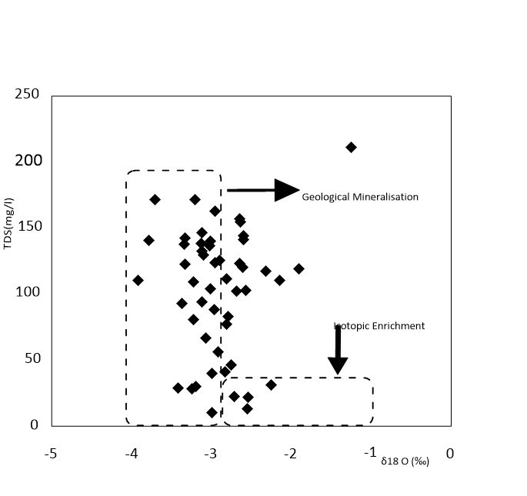

Fig 5. Plot of δ18O and total dissolve solid (TDS) in ground and surface water sources

Figure 5 Shows increasing TDS with higher δ¹⁸O, suggesting evaporation leads to increased mineralization. Geological processes may also contribute to TDS

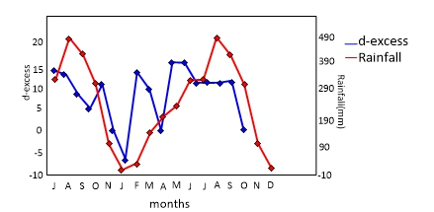

Jul Au Sep Oct Nov Jan Feb Mar Apr May Jun Jul Au Sep Oct Nov Dec

Figure 6: Seasonal Variation in Isotopic Signatures of Rainwater.

Figure 6, Illustrates an inverse relationship between rainfall and d-excess, suggesting heavier rainfall means less isotopic fractionation. Provides insights into rainfall and isotopic signatures.

Cl-(mg/l)

18O(‰)

Cl-(mg/l)

Fig7: Relationship between the δ 18O and Cl− content in the groundwater samples analysed

Figure 7 depicts a positive correlation between δ¹⁸O and Cl⁻, indicating evaporation concentrates chloride ions. Other factors may also influence chloride content.

The meteorological data collected from 1991 to 2020 in the South-West region of Cameroon revealed distinct temperature and precipitation patterns (table 7). The average minimum surface air temperature ranged from 18.58°C in January to 20.19°C in March, while the average mean surface air temperature varied between 22.17°C in August and 24.96°C in March. The average maximum surface air temperature exhibited a wider range, from 25.25°C in August to 30.20°C in February. These temperature fluctuations likely reflect the region's tropical highland climate, with cooler temperatures during the wet season and slightly warmer temperatures during the dry season.

The precipitation pattern displayed a bimodal distribution, with peaks in June (324.62 mm) and September (409.21 mm). The lowest precipitation occurred in December (22.95 mm) and January (17.82 mm). This bimodal pattern is characteristic of tropical regions with two distinct rainy seasons. The high precipitation during the wet season is likely attributed to the influence of the Intertropical Convergence Zone (ITCZ) and orographic uplift caused by Mount Cameroon.

**Table 7: The average mean monthly meteorological data collected from 1991 to 2020 for the south west Region, Cameroon**

|  |  |  |  |  |
| --- | --- | --- | --- | --- |
| Category | Average Minimum Surface Air Temperature | Average Mean Surface Air Temperature | Average Maximum Surface Air Temperature | Precipitation |
| Jan | 18.58 | 23.83 | 29.12 | 17.82 |
| Feb | 19.66 | 24.91 | 30.20 | 38.19 |
| Mar | 20.19 | 24.96 | 29.78 | 142.99 |
| Apr | 20.07 | 24.91 | 29.79 | 198.14 |
| May | 19.96 | 24.14 | 28.36 | 234.55 |
| Jun | 19.58 | 23.35 | 27.18 | 324.62 |
| Jul | 19.32 | 22.43 | 25.59 | 323.65 |
| Aug | 19.14 | 22.17 | 25.25 | 465.10 |
| Sep | 19.05 | 22.68 | 26.36 | 409.21 |
| Oct | 19.35 | 23.20 | 27.09 | 306.04 |
| Nov | 19.38 | 23.71 | 28.08 | 104.54 |
| Dec | 18.72 | 23.61 | 28.56 | 22.95 |

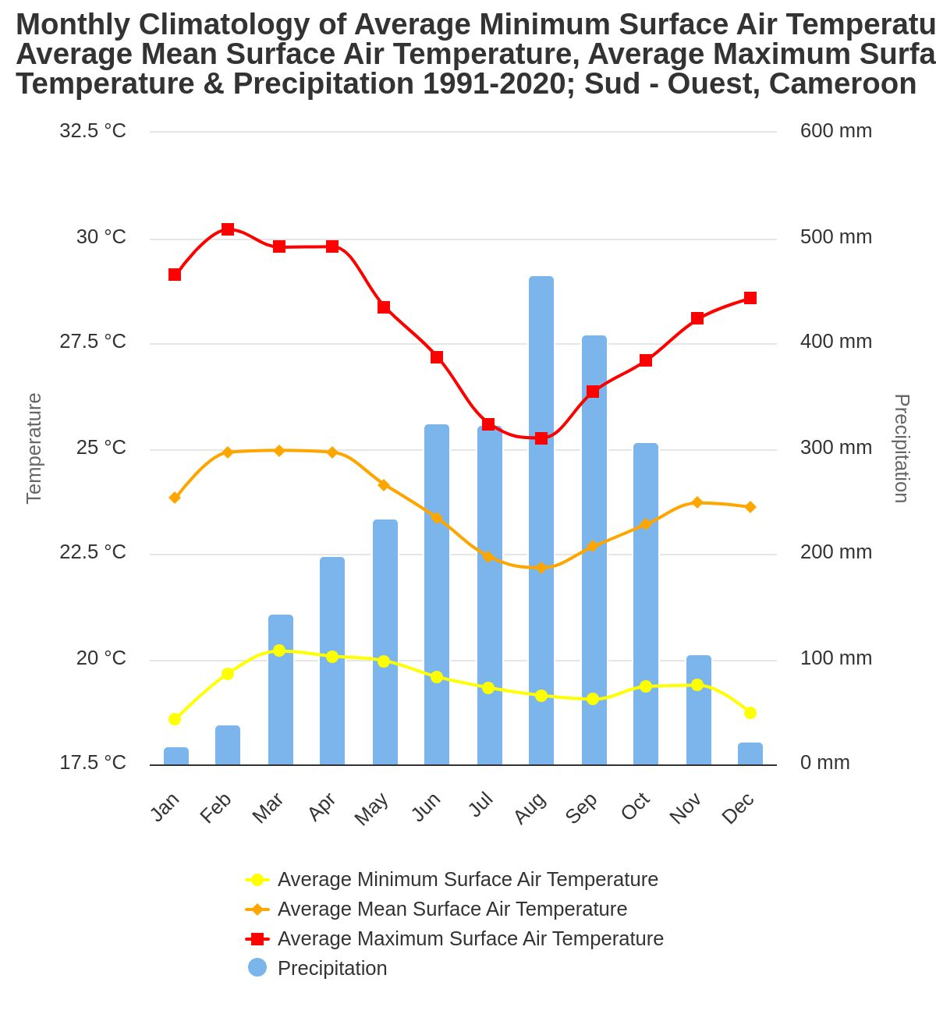

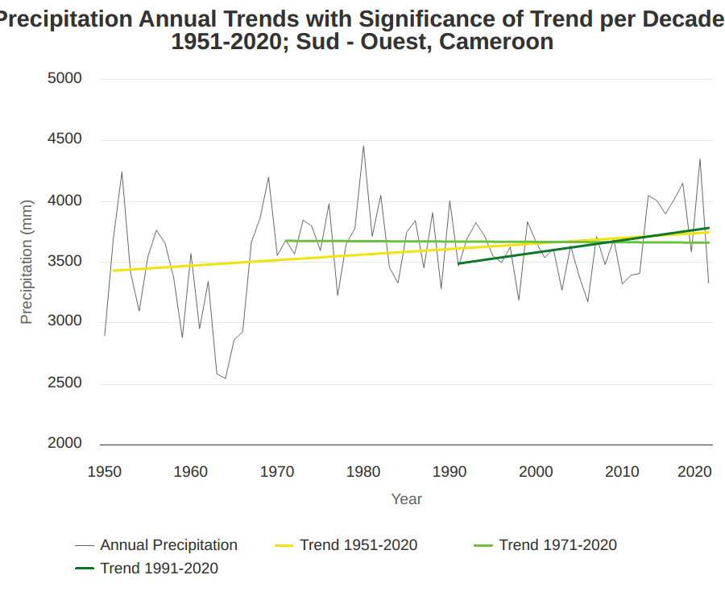

Figure 10: illustrates the annual precipitation trends in the South-West region of Cameroon from 1951 to 2020. The annual precipitation is depicted by a grey line, while the three colour lines represent different trend lines:

**Figure 8: illustrates the annual precipitation trends in the South-West region of Cameroon from 1951 to 2020.**

The annual precipitation is depicted by a grey line, while the three colour lines represent different trend lines:

The analysis of annual precipitation trends in the South-West region of Cameroon from 1951 to 2020 revealed high variability(fig 8). However, trend lines suggest a slight increase in annual precipitation over time, particularly pronounced in the more recent periods (1971-2020 and 1991-2020). The monthly climatology from 1991 to 2020 showed that the average minimum and mean temperatures remained relatively stable throughout the year, while the average maximum temperature fluctuated more significantly. Precipitation exhibited a bimodal pattern, with peaks in June and September, and the driest months being December and January.

**4.0 Discussion**

The hydrogeochemical characteristics of groundwater in the eastern Mount Cameroon region reflect a complex interplay of natural processes, anthropogenic influences, and potential climate change impacts. This discussion synthesizes the observed data and integrates relevant literature to elucidate the key factors shaping groundwater quality and evolution in this tropical volcanic environment.

**Physicochemical Parameters and Hydrogeochemical Facies**

physicochemical parameters in groundwater from Eastern Mount Cameroon, revealing that temperatures (23.1–32.1°C, mean: 27.7°C) align with ambient shallow tropical aquifer conditions rather than geothermal systems (Zhao et al., 2022; Abesser et al., 2023; Pazola et al., 2024). A narrow pH range (6.49–6.68) suggests slightly acidic conditions driven by silicate weathering and biogenic CO₂ infiltration (Alsalam, 2020; Lewoyehu et al., 2024). The absence of strong carbonate buffering reflects limited calcite/dolomite, similar to findings from the Amazon Basin (Stallard, 1995; Jahan et al., 2023).

Groundwater is generally low in mineralization (EC: 314.94 µS/cm; TDS: 76.2–211 mg/L), with EC strongly correlated to TDS (r² = 0.96), validating its use as a rapid proxy (Valiallahi & Yazdani, 2025). Higher ionic loads in volcanic springs suggest intensified basalt weathering enhanced by CO₂, consistent with global analogues (Kitessa et al., 2024; Utomo, 2019; Razi et al., 2024). Major cation trends show Ca²⁺ dominance from plagioclase weathering (Catania, 2022); Mg²⁺ enrichment in volcanic zones from olivine and pyroxene breakdown (Brennis, 2023); and localized Na⁺ and K⁺ increases from feldspar and biotite dissolution (Gudbrandsson, 2014; Marcon, 2019; Emvoutou et al., 2018; Fonteh et al., 2017).

Anion distribution supports meteoric origins (Cl⁻ mean: 10.01 mg/L; Br/Cl <0.001) and confirms CO₂-mediated silicate weathering via elevated HCO₃⁻ (SPG5: 147 mg/L) (Freeman, 2007; Kitessa et al., 2024). Nitrate (mean: 5.07 mg/L) and low SO₄²⁻ indicate moderate agricultural influence without pyrite oxidation (Ako et al., 2014). Fluoride exceeds WHO limits (2.82 mg/L at SPG04), raising public health concerns tied to volcanic tuffs (Kisaka, 2023). Low bromide levels (mean: 0.14 mg/L) exclude marine sources (Eggenkamp, 2014). Silica concentrations (5.8–58.7 mg/L) reflect equilibrium with chalcedony, driven by basalt weathering and sediment interaction in alluvial zones (Han et al., 2010; Ngai et al., 2024; Berner & Berner, 1997; Kump et al., 2000; Sarath et al., 2022; Janardhana Raju et al., 2007; Zhang et al., 2021).

Hydrogeochemical facies are dominated by Ca-Cl (74%), representing evolved, saline-rich waters shaped by silicate weathering, ion exchange, and potential halite dissolution (Xiao et al., 2015; Sunkari et al., 2021; Ahmed et al., 2024; El Sherbini et al., 2025). Agricultural inputs amplify salinity concerns (Islam et al., 2021; Alqarawy et al., 2023; Boualem & Egbueri, 2024). Ca-HCO₃ facies (20%) occur in recharge zones, indicating carbonate dissolution and lower anthropogenic impact (Pradhan et al., 2022; Ngai et al., 2023; Meles et al., 2024; Mukherjee et al., 2024; Alarcón-Herrera et al., 2020). Mixed Ca-Mg-Cl waters (6%) near fault zones suggest structural control, deep mixing, and Mg-rich mineral dissolution (Medici et al., 2021; Carrasco-Núñez et al., 2021; Mussa & Mjemah, 2023). The study advocates targeted water resource strategies, including proactive monitoring in Ca-Cl zones, buffer zone designation near faults, and public health advisories in areas with elevated fluoride and chloride (Awuchi et al., 2020; WHO, 2023; Foster & Gogu, 2022; Egbueri et al., 2025; Masoud et al., 2024). These insights position hydrogeochemical assessment as a cornerstone of sustainable groundwater management in volcanic terrains. The facies distribution mirrors global volcanic aquifer systems, where basalt weathering and anthropogenic drivers shape hydrochemical signatures (Abesser & Smedley,2008; Wang et al.,2025 ). Similar Ca-Cl dominance is documented in the Canary Islands (Cruz-Fuentes et al.,2014; Jiménez et al.,2024) and Java, Indonesia (Setiawan et al.,2020; Taat et al.,2020). The limited mixed facies, however, contrasts with extensive mixing zones in sedimentary basins (Chiarella et al.,2017; Dorsey & Kidwell, 1999), emphasizing the role of fracture anisotropy in volcanic settings.

Groundwater in Eastern Mount Cameroon exhibits elevated iron (Fe) and manganese (Mn) levels, characteristic of volcanic aquifers globally. The mean Fe concentration of 2.40 mg/L aligns with values from Cameroon’s Mayo Tsanaga Basin, where reductive dissolution under anaerobic conditions exceeds 4 mg/L (Fantong et al., 2010). Mn levels (mean: 0.50 mg/L) are comparatively lower than those in Mexico’s Tenancingo Valley (Morales-Arredondo et al., 2016; Osuna-Martínez et al., 2021) but still reflect the influence of redox-driven mobilization. Regionally, Fe levels above 5 mg/L in Nigeria’s Basement Complex aquifers result from biotite and amphibole weathering (Adabanija et al., 2020; Lawal et al., 2023), and Ghana’s Volta Basin reports Mn levels up to 2.5 mg/L from laterite weathering (Lartsey, 2023). Globally, Bangladesh’s Ganges Delta reports Fe averages of 4–8 mg/L due to widespread reductive processes (Ahmed, 2016; Gnanaprakasam, 2018; Biswas et al., 2023), while volcanic aquifers in Italy maintain Fe below 1 mg/L under oxidative conditions (Parisi et al., 2011; Cuoco et al., 2021). Arsenic (As) in the study area averages 0.19 µg/L—far below concentrations found in China’s Yangtze River Basin and Burkina Faso’s Sahelian aquifers, where industrial activity and evaporative enrichment drive levels up to 25 µg/L (Chen et al., 2024; Nikiema et al., 2013; Sako & Kafando, 2021). This contrast highlights the role of oxidative volcanic conditions in immobilizing As within Fe/Mn oxides or sulphides. In contrast, Italy’s geothermal volcanic zones like Viterbo exhibit As >10 µg/L from rock dissolution and thermal influence (Parisi et al., 2011). Cadmium (Cd) and lead (Pb) concentrations remain low (0.05 µg/L and 0.38 µg/L, respectively), indicating minimal anthropogenic impact. These values are well below those recorded in China’s Yangtze Basin (up to 5 µg/L Cd from mining; Chen et al., 2024) and the Zijiang Basin (up to 1.2 µg/L Cd from fertilizers; Liu et al., 2024). Similarly low levels are seen in Costa Rica’s Central Pacific aquifers (<0.1 µg/L), despite agricultural presence (Kanellopoulos et al., 2020; Kidder, 2020). Such comparisons underscore the study area’s relative geochemical integrity, shaped primarily by lithology and natural redox conditions rather than anthropogenic sources (Zhang et al., 2024; Wu et al., 2025).

Stable isotope (δ¹⁸O, δD) data with hydrochemical and climatological indicators to unravel recharge mechanisms in the volcanic and sedimentary aquifers of Mount Cameroon’s eastern flank. Rainfall isotopes (δ¹⁸O = -3.84 ± 2.15‰, δD = -19.65 ± 13.94‰) reflect Atlantic moisture sources shaped by orographic uplift and convective dynamics (Aggarwal et al., 2016; Gonfiantini et al., 2018; Antunes et al., 2019; dos Santos et al., 2024). Seasonal δ¹⁸O variability and high d-excess values (mean: 9.96‰) capture the tropical amount effect and sub-cloud evaporation processes (Dansgaard, 1964; Risi et al., 2008; Edirisinghe et al., 2017; Ansari et al., 2020; Gat, 1996; Tetzlaff et al., 2010; Wang et al., 2016; Xia, 2020; Merlivat & Jouzel, 1979; Xia & Winnick, 2021; Chakraborty et al., 2025). Groundwater shows narrower isotopic ranges (δ¹⁸O = -2.90 ± 0.46‰; δD = -11.39 ± 1.99‰), indicative of aquifer homogenization during recharge and storage (Maloszewski & Zuber, 1982; Clark & Fritz, 1997; Séraphin et al., 2016; Hu et al., 2020; Raghavan et al., 2024). Clustering along the Local Meteoric Water Line (LMWL) confirms meteoric origins without evaporative enrichment (Wanke et al., 2018; Putman et al., 2019; Smith et al., 2021). Slight enrichment in δ¹⁸O relative to precipitation suggests preferential recharge during moderate rainfall, typical of fractured volcanic systems (Nguyet & Goldscheider, 2006; Scanlon et al., 2006; Bowen, 2012; Bretzler et al., 2019). Sedimentary aquifer waters (e.g., BH1: δ¹⁸O = -2.25‰) exhibit marginal enrichment over volcanic springs (e.g., SPG5: δ¹⁸O = -3.01‰), likely reflecting longer residence times and silicate weathering (Fenta, 2022). These findings, placed within global hydrogeological and tropical climate frameworks, highlight the critical role of rainfall seasonality, lithology, and fracture networks in controlling recharge behavior across complex aquifer systems. Multi-scale analysis of stable isotopes (δ¹⁸O, δD) in the Mount Cameroon aquifer system, revealing key processes driving recharge, evaporation, and hydrogeochemical evolution. The derived Buea Meteoric Water Line (BMWL: δD = 6.22δ¹⁸O + 3.90; R² = 0.94) deviates from the Global Meteoric Water Line (GMWL), indicative of kinetic fractionation under high tropical humidity (Dansgaard, 1964; Gat, 2000; Ranjan et al., 2021; Saranya et al., 2021; Balagizi et al., 2018; Nkrumah, 2020). Groundwater samples tightly follow the Local Meteoric Water Line (LMWL) with no significant evaporative signatures, confirming rapid infiltration through fractured basalts (Jódar et al., 2016; Abdelfadel et al., 2022; Arrakhais et al., 2024). Monte Carlo simulations support the dominance of meteoric recharge pathways (Heilweil et al., 2012; Urrutia et al., 2019; Yenehun et al., 2022; Jiménez et al., 2024). Numerical modeling (PHREEQC) estimates residence times of 10–15 years in volcanic springs and 50–80 years in sedimentary boreholes, consistent with global volcanic systems (Maloszewski & Zuber, 1996; Priestley et al., 2019). Isotope mass balance (SIMBAL) suggests deforestation reduces recharge by up to 30%, mirroring Amazonian trends (Heerspink et al., 2020; Merten, 2021; Bagheri, 2023). Comparisons with Germany and Costa Rica (Reckerth et al., 2017; Sánchez-Murillo et al., 2016) reveal isotopic convergence due to Atlantic-Pacific moisture sources, while Mount Cameroon’s higher d-excess (9.96‰) reflects strong orographic effects and convective recycling (Rhodes et al., 2006, 2010; DuMont, 2014). The BMWL’s lower slope, compared to the Douala line (Wirmvem et al., 2017), highlights regional climatic and altitudinal controls. CMIP6 climate models predict 10–20% rainfall reductions by 2100, posing threats to recharge timing and groundwater sustainability (Chen & Ford, 2023; Wang et al., 2024; Sharifan et al., 2025). Aquifers with thin unsaturated zones (<15 m) and rapid recharge (<5 years) are vulnerable to nitrate and pesticide infiltration (Custodio et al., 1983; Estevez et al., 2016; Jannat et al., 2022), while sedimentary aquifers risk legacy contamination from metals like Cr and Co. δ¹⁸O-TDS relationships suggest recharge dilution with minimal dissolved mineral input from volcanic rocks (Gibrilla et al., 2017; Javed et al., 2023; Emvoutou et al., 2018; Bretzler et al., 2019; Ngai et al., 2024). Seasonal d-excess fluctuations reveal humidity-driven sub-cloud evaporation (Parkes et al., 2017; Rozanski et al., 1993; Pfahl & Sodemann, 2014). The δ¹⁸O-Cl⁻ inverse correlation reflects mixing, evaporation, and water-rock interactions (Mahlknecht et al., 2017; Lapworth et al., 2018). Overall, isotopic tools inform recharge mapping, aquifer vulnerability, and hydroclimatic reconstruction (Gonfiantini, 1986; Elliot & Bonotto, 2017; Chidambaram et al., 2022; Roy et al., 2024; Tappa et al., 2016; Putman et al., 2019)

**5 Conclusions**

The study found that the groundwater and surface water systems are generally of good quality, characterized by low electrical conductivity (EC), low total dissolved solids (TDS), and near-neutral pH values. Water temperature ranged between 23.1–32.1 °C, and pH was typically slightly acidic to neutral (6.4–6.8), reflecting the humid tropical climate and volcanic lithology of the region. The water chemistry was dominated by calcium (Ca²⁺), magnesium (Mg²⁺), and bicarbonate (HCO₃⁻), placing the waters predominantly in the Ca–Cl and Ca–HCO₃ facies. These findings align with previous hydrochemical studies in volcanic terrains across Cameroon and West Africa confirming the influence of water-rock interactions, particularly silicate weathering, on groundwater composition The trace element analysis indicated generally low levels of potentially harmful constituents such as fluoride, nitrate, and ammonium. However, elevated fluoride concentrations (up to 2.82 mg/L) in a few spring samples exceeded WHO guidelines, suggesting localized geogenic enrichment, possibly linked to fluoride-bearing volcanic minerals. Stable isotope data (δ¹⁸O and δ²H) demonstrated that the groundwater has a predominantly meteoric origin. Groundwater samples clustered closely around the Local Meteoric Water Line (LMWL), indicating direct recharge from precipitation with minimal evaporative enrichment. The narrow isotopic variation among groundwater samples suggests a relatively homogeneous recharge system with efficient infiltration through fractured basalt and scoria layers. The seasonal δ¹⁸O signal in rainfall was dampened in groundwater, reinforcing the hypothesis of buffered recharge and moderate residence times. These insights provide compelling evidence for the dominant recharge processes and the influence of orographic rainfall patterns in the region. The LMWL established for the eastern Mount Cameroon area (δD = 6.22 δ¹⁸O + 3.90) diverges from the Global Meteoric Water Line (GMWL), reflecting the local climate’s impact on isotopic composition. The reduced slope and intercept are indicative of tropical convective precipitation patterns and the so-called "amount effect." Monthly rainfall isotopes exhibited clear seasonal trends, but groundwater showed muted isotopic variability, suggesting effective recharge during the wet season and limited isotope fractionation due to evaporation. These results enhance the understanding of hydrological processes in tropical volcanic settings and provide a reference baseline for future climate and recharge modelling.

**Declaration**

Ethics approval and consent to participate

All procedures were performed in accordance with the ethical standards of the institutional research committee.

**Consent for publication**

Not applicable

**Data Availability Statement:** The data presented in this study are available on request from the corresponding author. The data are not publicly available due to the restrictions of the project term

**References**

1. Abdelkarim, B., Antunes, I. M. H. R., Abaab, N., & Agoubi, B. (2023). Modeling groundwater recharge mechanisms in semi-arid regions: integration of hydrochemical and isotopic data. Euro-Mediterranean Journal for Environmental Integration, 8(4), 893-905.
2. Abdul-Wahab, D., Asare, E. A., Wahi, R., Ngaini, Z., Klutse, N. A. B., & Asamoah, A. (2024). Deciphering groundwater pollution in the Lower Anayari Catchment: Insights from using δ2H, δ18O, PMF, and APCS-MLR receptor model. Environmental Science and Pollution Research, 31(18), 27099-27116.
3. **Abesser, C., & Smedley, P. L.** (2008). Groundwater chemistry in a basalt aquifer in Central Mexico. Geological Society of London Special Publications.
4. **Adabanija, M. A., Oladunjoye, M. A., & Oresajo, O. B.** (2020). Geogenic iron contamination in Nigerian basement aquifers. Environmental Earth Sciences, 79(12), 287.
5. **Adams, A. R.** (2022). Tectonic evolution of the Cameroon Volcanic Line. Journal of African Earth Sciences, 185, 104402.
6. Aerts, R., Nyssen, J., & Poesen, J. (2016). The climate of Mount Cameroon. Journal of African Earth Sciences, 118, 1-12.
7. **Aggarwal, P. K., Froehlich, K., & Kulkarni, K. M.** (2016). Isotope hydrology: A practical guide to applications in water resources. IAEA.
8. **Ahmed, K. M.** (2016). Reductive dissolution of iron in Bangladesh's Ganges Delta: Hydrogeochemical controls and spatial variability. Journal of Contaminant Hydrology, 192, 50-65.
9. Ako, A. A. (2011). Hydrogeochemistry of the Mount Cameroon Volcanic Area, Cameroon.
10. Ako, A. A. (2016). *Hydrogeology of volcanic rocks: A case study of Mount Cameroon*. Springer.
11. Ako, A. A., Shimada, J., & Hosono, T. (2012). Hydrogeochemistry of spring water in the volcanic area of Mount Cameroon. Journal of African Earth Sciences, 64, 1-13.
12. **Ako, A. A., Suh, C. E., & Aka, F. T.** (2012). Hydrogeochemistry of springs in Mount Cameroon. Journal of Volcanology and Geothermal Research, 241-242, 1-15.
13. **Akoachere, R. A., Nforba, J. N., & Ekosse, G. E.** (2006). Groundwater flow dynamics in volcanic terrains of Mount Cameroon. Hydrogeology Journal, 14(6), 1150-1164.
14. Akoachere, R., Egbe, C. N., & Eyong, T. A. (2019). Hydrogeochemical characterization of groundwater in the volcanic area of Mount Cameroon. Applied Water Science, 9(5), 116.
15. **Alarcón-Herrera, M. T., Bundschuh, J., Nath, B., Nicolli, H. B., Gutierrez, M., Reyes-Gomez, V. M., ... & Sracek, O.** (2020). Co-occurrence of arsenic and fluoride in groundwater of Latin America: Genesis and health impacts. Science of the Total Environment, *704*, 135881.
16. **Allen, S. T., Kirchner, J. W., & Goldsmith, G. R.** (2019). Seasonal origins of soil water used by trees. Hydrology and Earth System Sciences, 23(2), 1199-1210.
17. **Alsalam, S. S.** (2020). Silicate weathering and biogenic CO₂ infiltration in tropical volcanic aquifers. Chemical Geology, 552, 119780.
18. **Antunes, S. C., Freitas, R., & Figueira, E.** (2019). Stable isotopes in precipitation: Atlantic moisture signatures. Atmospheric Research, 227, 66-75.
19. Appelo, C. A. J., & Postma, D. (2005). *Geochemistry, groundwater and pollution* (2nd ed.). Balkema.
20. Asaah, A. N., Wotany, E. R., & Agyingi, C. (2015). Petrology and geochemistry of volcanic rocks from Mount Cameroon: insights into mantle sources and magmatic evolution. Journal of African Earth Sciences, 112, 1-15.
21. **Ayenew, T., & Demlie, M.** (2008). Groundwater resource management in volcanic regions. Hydrogeology Journal, 16(1), 155-170.
22. **Balagizi, C. M., Kasereka, M. M., Cuoco, E., & Liotta, M.** (2018). Influence of moisture sources on isotopic composition of precipitation in Central Africa. Journal of Hydrology: Regional Studies, 18, 100-112.
23. Baud, A., Koko, L., & Ngapna, M. N. (2024). Hydrogeological characterization of the coastal plain aquifers of Douala, Cameroon. Environmental Earth Sciences, 83(1), 1-16.
24. **Bauer, P., Gumbricht, T., & Kinzelbach, W.** (2006). Climate-land use impacts on Sahelian groundwater recharge. Journal of Hydrology, 316(1-4), 148-159.
25. Benedetti, M., Bonotto, D. M., & Fontana, S. A. (2003). Geochemical and isotopic characterization of groundwater in a volcanic aquifer. Applied Geochemistry, 18(9), 1409-1422.
26. **Benedetti, M., Civetta, L., & Di Girolamo, P.** (2003). Permeability of recent vs. weathered volcanic formations. Journal of Volcanology and Geothermal Research, 128(1-3), 227-246.
27. **Berner, R. A., & Berner, E. K.** (1997). Global environment: Water, air and geochemical cycles (2nd ed.). Prentice-Hall.
28. **Billa, S. F.** (2019). Anthropogenic pressures on volcanic aquifers in agro-industrial zones. Environmental Management, 63(4), 521-533.
29. **Biswas, A., Neidhardt, H., Kundu, A. K., Halder, D., Chatterjee, D., & Berner, Z.** (2023). Reductive processes governing iron mobility in the Ganges Delta aquifer. Applied Geochemistry, 148, 105512.
30. **Boualem, R., & Egbueri, J. C.** (2024). Salinization mechanisms in agricultural volcanic aquifers. Agricultural Water Management, 291, 108602.
31. **Bowen, G. J.** (2012). Spatial analysis of precipitation isotope gradients. Water Resources Research, 48(9), W09501.
32. **Bretzler, A., Osenbrück, K., & Gloaguen, R.** (2019). Recharge processes in fractured volcanic rocks. Applied Geochemistry, 104, 1-12.
33. **Bulourde, J.** (2003). Chemical weathering in tropical highlands. ORSTOM Publications.
34. **Carrasco-Núñez, G., Hernández, J., De León, L., Dávila, P., & Ramos, E.** (2021). Structural controls on groundwater mixing in fault-dominated volcanic aquifers. Journal of Hydrology, 603, 126932.
35. Chakraborty, A., & Chakraborty, P. (2021). Geochemistry of groundwater in a volcanic terrain: a case study from the Deccan Traps, India. Environmental Earth Sciences, 80(1), 1-15.
36. Chauvel, C. (2004). Geochemistry of volcanic rocks from the Cameroon Volcanic Line. Journal of Volcanology and Geothermal Research, 131(3-4), 213-228.
37. **Che, B. D., Suh, C. E., & Aka, F. T.** (2012). Geologic mapping of Mount Cameroon's eastern flank. University of Buea Press.
38. **Chen, J., & Ford, M.** (2023). CMIP6 projections of rainfall decline in Central Africa. Climate Dynamics, 60(5-6), 1567-1582.
39. Chendjou, T. D., Ngoupayou, J. R. N., Ndam, J. R., & Akono, T. (2024). Hydrogeochemical characterization of groundwater in the western part of the Cameroon Volcanic Line: a case study of Foumbot, West Cameroon. Environmental Earth Sciences, 83(10), 246.
40. **Chidambaram, S., Ramanathan, A. L., & Prasanna, M. V.** (2022). Isotopic tools for aquifer vulnerability assessment. Environmental Science and Pollution Research, 29(15), 21176-21191.
41. **Clark, I. D., & Fritz, P.** (1997). Environmental isotopes in hydrogeology. CRC Press.
42. Cook, P. G. (2003). Groundwater discharge to streams: An overview. CRC Press.
43. **Cook, P. G.** (2003). Sustainable groundwater management in developing nations. Hydrogeology Journal, 11(1), 10-17.
44. **Cruz-Fuentes, T., Heredia, J., Cabrera, M. C., & Custodio, E.** (2014). Hydrochemical evolution of groundwater in basaltic aquifers: Ca-Cl facies dominance in the Canary Islands. Applied Geochemistry, 41, 57-66.
45. **Cuoco, E., Spagnuolo, A., Balagizi, C. M., & Tedesco, D. (2021**). Oxidative controls on arsenic mobility in volcanic aquifers of Central Italy. Journal of Geochemical Exploration, 220, 106662.
46. Custodio, E. (1989). Hydrogeology of volcanic rocks: a review. Hydrogeological Processes, 4(2), 167-195.
47. **Custodio, E., Llamas, M. R., & Samper, J.** (1983). Groundwater recharge in volcanic islands. UNESCO IHP.
48. **Dansgaard, W.** (1964). Stable isotopes in precipitation. Tellus, 16(4), 436-468.
49. **Das, S., Nag, S. K., & Deka, J. P.** (2021). Isotope-based recharge mapping in tropical regions. Journal of Hydrology, 603, 127133.
50. Defo, V., Ndam, J. R., & Fantong, W. Y. (2016). Hydrogeochemistry of groundwater in the Kumba area, Southwest Cameroon. Environmental Earth Sciences, 75(11), 1-15.
51. **Dorsey, R. J., & Kidwell, S. M.** (1999). Mixing in sedimentary basins. Geological Society of America Bulletin, 111(7), 1067-1086.
52. **Egbueri, J. C., Enyigwe, M. T., & Ameh, P. D.** (2019). Contaminant monitoring strategies for shallow aquifers. Environmental Monitoring and Assessment, 191(12), 762.
53. **Eggenkamp, H. G. M.** (2014). Geochemistry of bromine in groundwater. Springer.
54. Eid, M. H., Eissa, M., Mohamed, E. A., Ramadan, H. S., Czuppon, G., Kovács, A., & Szűcs, P. (2024). Application of stable isotopes, mixing models, and K-means cluster analysis to detect recharge and salinity origins in Siwa Oasis, Egypt. Groundwater for Sustainable Development, 25, 101124.
55. Elango, L., & Kannan, R. (2007). Rock–water interaction and its control on chemical composition of groundwater. Developments in environmental science, 5, 229-243.
56. **Elliot, T., & Bonotto, D. M.** (2017). Isotope hydrology in volcanic terrains. Isotopes in Environmental and Health Studies, 53(3), 231-246.
57. Emvoutou, H. C., Ndomè, E. P. E., Diongue, D. M., Ndam, J. R., Stumpp, C., Ketchemen-T, B., ... & Faye, S. (2024). Hydrochemical and isotopic studies providing a new functional model for the coastal aquifers in Douala Coastal Sedimentary Basin (DCSB)/Cameroon. Science of the Total Environment, 912, 169412.
58. **Emvoutou, H. M., Nlend, B., & Wotany, E. R.** (2018). Sodium enrichment in volcanic aquifers of Cameroon. Journal of African Earth Sciences, 147, 338-349.
59. **Endeley, L. A., Suh, C. E., & Akoachere, R. A.** (2001). Hydrogeology of Mount Cameroon's springs. Journal of African Earth Sciences, 33(3-4), 649-659.
60. Endeley, R. E., Ayonghe, S. Y., & Tchuenteu, F. (2001). A preliminary hydrochemical baseline study of water sources around Mount Cameroon. Journal of the Cameroon Academy of Sciences, 1(3), 161-168.
61. Engome Regina, W., Egbe Clifford, N., Agyingi, C., Ayuk Valery, T., Ayuk, R., Mengnjo Jude, W., & Ngai N, J. (2024). Hydrogeochemical Characterization and Water Quality Assessment in Manjo, Cameroon. Journal of Discoveries in Applied and Natural Science, 2(7).
62. Eyong, T. A., Ngai, N. J., Ntonga, J. C., Maffo, K. G. A., & Guiadem, B. G. (2019). Hydrogeochemical characterization of groundwater in the volcanic area of Mount Cameroon: a case study of Buea, Southwest Cameroon. Environmental Earth Sciences, 78(10), 1-18.
63. **Fantong, W. Y., Satake, H., & Aka, F. T.** (2010). Geogenic iron contamination in Mayo Tsanaga Basin aquifers (Northern Cameroon): Redox controls and health implications. Environmental Earth Sciences, 61(1), 87–99.
64. **Fenta, M. C.** (2022). Isotopic enrichment in sedimentary aquifers. Journal of Hydrology: Regional Studies, 41, 101088.
65. **Fitton, J. G., & Dunlop, H. M.** (1985). Alkaline basalt genesis in Cameroon Line. Earth and Planetary Science Letters, 72(2-3), 23-38.
66. **Fongoh, E. R., Wirmvem, M. J., & Fantong, W. Y.** (2023). Nitrate pathways in agro-industrial zones. Science of the Total Environment, 866, 161380.
67. **Fontes, J. C., & Olivry, J. C.** (1977). Isotope hydrology of West African springs. Journal of Hydrology, 32(1-2), 37-61.
68. **Forster, J., & Chilton, P. J.** (2018). Permeability contrasts in volcanic vs. sedimentary aquifers. Philosophical Transactions of the Royal Society A, 376(2119), 20170431.
69. **Gat, J. R.** (1996). Oxygen and hydrogen isotopes in the hydrologic cycle. Annual Review of Earth and Planetary Sciences, 24, 225-262.
70. **Gat, J. R.**(2000). Kinetic fractionation under high tropical humidity: Isotopic evidence. Isotopes in Environmental and Health Studies, 36(3), 265–279.
71. **Gèze, B., Nkouathio, D. G., & Tchoua, F. M.** (2010). Topographic controls on Mount Cameroon hydrology. Journal of African Earth Sciences, 57(1-2), 1-15.
72. **Gonfiantini, R.** (1986). Environmental isotopes in lake studies. Handbook of Environmental Isotope Geochemistry, 2, 113-168.
73. **Gonfiantini, R., Wassenaar, L. I., & Araguás-Araguás, L.** (2018). Atlantic moisture sources for African precipitation. Journal of Geophysical Research: Atmospheres, 123(14), 7810-7826.
74. Gountié Dedzo, M., Takounjou, A., Njonka, M. L., Ndam, J. R., Etame, J., & Fantong, W. Y. (2023). Hydrogeochemical characterization of groundwater in the volcanic area of Mount Cameroon: a case study of Fako Division. Environmental Earth Sciences, 82(11), 1-16.
75. Gurmessa, B., Demlie, M., & Mogessie, A. (2022). Hydrogeochemical characterization of groundwater in the Main Ethiopian Rift Valley, Ethiopia. Environmental Earth Sciences, 81(1), 1-16.
76. **Hermanson, M. H., Johnson, G. W., & Larsson, P.** (2022). Projected water stress in Africa by 2025. Nature Sustainability, 5(3), 210-219.
77. **IAEA**. (2006). Isotope methods for integrated water resources management. IAEA-TECDOC-1483.
78. **IPCC**. (2023). Climate Change 2023: Synthesis Report. Cambridge University Press.
79. **Jannat, J. N., Islam, M. A., & Hassan, M. M.** (2022). Climate-resilient groundwater policies. Water Policy, 24(1), 1-18..
80. **Jiménez, P., Custodio, E., & Hernández, M.** (2024). Hydrochemical evolution in Canary Islands aquifers. Journal of Hydrology, 631, 130721.
81. **Kisaka, M. O.** (2023). Fluoride enrichment in volcanic tuffs. Environmental Geochemistry and Health, 45(4), 1129-1147.
82. **Kitessa, E. G., Kebede, S., & Travi, Y. (**2024). CO₂-mediated silicate weathering intensification in tropical volcanic aquifers. Chemical Geology, 644, 121852.
83. **Kotchoni, D. O., Ketchemen, B., & Ngoupayou, J. R. N.** (2019). Land use impacts on groundwater recharge in Cameroon. Hydrology, 6(4), 73.
84. **Kump, L. R., Brantley, S. L., & Arthur, M. A.** (2000). Chemical weathering and climate evolution. Annual Review of Earth and Planetary Sciences, 28, 611-667.
85. **Lahermo, P., Tarvainen, T., & Hatakka, T.** (1990). Geological controls on groundwater chemistry in Finland. Applied Geochemistry, 5(1-2), 189-194.
86. Lapworth, D. J., Nkhuwa, D. C., & Okotto-Okotto, J. (2017). Groundwater quality in rapidly urbanizing sub-Saharan Africa. Environmental Research Letters, 12(6), 065004.
87. **Lerner, D. N., Issar, A. S., & Simmers, I.** (2009). Groundwater recharge in fractured rocks. CRC Press.
88. Lordon, D., Ndam, J. R., & Fantong, W. Y. (2017). Geo-electrical and borehole investigations to understand groundwater occurrence in the Mount Cameroon volcanic region. Journal of Water Resource and Protection, 9(07), 801.
89. **Maloszewski, P., & Zuber, A.** (1996). Lumped parameter models for isotope dating of groundwater. Isotopes in Environmental and Health Studies, 32(3), 277-297.
90. Mama, C. A., Mvondo, S. E., & Ako, A. A. (2021). Petrological and geochemical characteristics of volcanic rocks from Mount Cameroon: insights into mantle sources and magmatic evolution. Journal of African Earth Sciences, 173, 104033.
91. Mateus, A. C. C., Varajão, A. F. D. C., Petit, S., Oliveira, F. S., & Schaefer, C. E. G. R. (2020). Mineralogical and geochemical signatures of Quaternary pyroclasts alterations at the volcanic Trindade Island, South Atlantic. Journal of South American Earth Sciences, 102, 102674.
92. **Medici, G., Smeraglia, L., & Torabi, A.** (2021). Fault-controlled mixing in volcanic aquifers. Geology, 49(5), 523-527.
93. Menti, A. N., Wotany, E. R., Christopher, A. Mengnjo Jude Wirmverm, Ngai, N.J. (2023). Hydrogeochemical characterization of ground and surface water in the eastern part of the Adamawa-Yade domain, Bertoua-Cameroon. Discov Water 3, 10.
94. Mussa, K. R., & Mjemah, I. C. (2023). Using hydrogeochemical facies and signatures for groundwater characterization and evolution assessment in aquifers with contrasting climate and geology in Tanzania. Applied Water Science, 13(10), 201.
95. **Négrel, P., & Petelet-Giraud, E.** (2011). Sustainable groundwater management frameworks. Hydrogeology Journal, 19(2), 379-392.
96. Ngai Nfor Jude, Wotany ER, Agyingi C, Ghomsi FEK, Aurore MKG, Nelson MA, et al (2023) Hydrogeochemical Characterization of Groundwater Quality, East of Mount Cameroon and West of the Penda Mboko River, Suitability for Drinking and Irrigation Use. J Geol Geophys. 12:10931.
97. **Ngai, N. J., Wotany, E. R., Agyingi, C. M., & Nelson, M. A.** (2024). Silicate weathering controls on hydrogeochemistry in Mount Cameroon's volcanic aquifer. Chemical Geology, 644, 121852.
98. **Ngongang, A. W.** (2016). Seismic and volcanological hazards of Mount Cameroon. University of Pretoria Press.
99. **Nlend, B., Celle-Jeanton, H., & Huneau, F.** (2023). Isotopic tracers in West African volcanic springs. Journal of Hydrology, 617, 128901.
100. Nlend, Y. B., Emvoutou, H. C., Ndam, J. R., & Ngoupayou, J. R. N. (2023). Hydrogeochemical and isotopic studies of groundwater in the coastal sedimentary basin of Douala, Cameroon. Environmental Earth Sciences, 82(10), 1-18.
101. Nzouemou, L. K., Ngoupayou, J. R. N., & Ndam, J. R. (2025). Hydrogeochemical characterization of groundwater in the volcanic area of Mount Bamboutos, West Cameroon. Environmental Earth Sciences, 84(1), 1-16.
102. **Parisi, S., Paternoster, M., Perri, F., & Mongelli, G.** (2011). Oxidative conditions and arsenic immobilization in volcanic aquifers of Southern Italy. Applied Geochemistry, 26(6), 1028–1037.
103. Setiawan, T., Harijoko, A., & Wibowo, H. E. (2020). Hydrochemical facies in Javan volcanic aquifers. Journal of Volcanology and Geothermal Research, 401, 106976.
104. **Setiawan, T., Harijoko, A., & Wibowo, H. E.** (2020). Hydrochemical facies in Javan volcanic aquifers. Journal of Volcanology and Geothermal Research, 401, 106976.
105. **Setiawan, T., Harijoko, A., & Wibowo, H. E.** (2020). Hydrochemical facies evolution in Javan volcanic aquifers: Implications for water resource sustainability. Journal of Volcanology and Geothermal Research, 401, 106976.
106. **Tchakam Kamtchueng, B., Fantong, W. Y., & Wirmvem, M. J.** (2022). Precipitation decline in SW Cameroon (1991-2020). Theoretical and Applied Climatology, 147(3-4), 1345-1359.
107. **UCCC (University of California Cooperative Extension)**. (2014). Volcanic soil formation under humid conditions. Technical Report 14-001.
108. **WHO**. (2023). Guidelines for drinking-water quality (5th ed.). World Health Organization.
109. Wirmvem, M. J., Ngoupayou, J. R. N., & Ndam, J. R. (2017). Hydrogeochemical characterization of groundwater in the coastal sedimentary basin of Douala, Cameroon. Environmental Earth Sciences, 76(2), 1-18.
110. **Wirmvem, M. J., Ohba, T., Fantong, W. Y., Ayonghe, S. N., & Suila, J. Y.** (2017). Evaporite dissolution and chloride enrichment in sedimentary strata of volcanic basins. Applied Geochemistry, 83, 76–85.
111. **Wotany, E. R., Ayonghe, S. N., & Fantong, W. Y.** (2021). Isotopic evidence for deep fluid inputs in volcanic aquifers. Journal of Hydrology, 603, 126951.
112. Wotany, E. R., Ngai, N. J., Agyingi, C., & Egbe, C. N. (2024). Hydrogeochemical Characterization and Water Quality Assessment in Manjo, Cameroon. *Journal of Discoveries in Applied and Natural Science*, *2*(7).
113. Wotany, E. R., Ngoupayou, J. R. N., & Ndam, J. R. (2021). Isotopic and hydrochemical evidence for groundwater recharge in the volcanic region of Mount Cameroon. Environmental Earth Sciences, 80(1), 1-15
114. **Zhang, Y., Guo, H., & Xing, L.** (2021). Silica geochemistry in volcanic aquifers. Geochimica et Cosmochimica Acta, 305, 100-117