**Original Research Article**

**Morphotectonic and Morphometric Analysis of the Nirguna (Bhikund) River Watershed of Akola and Washim Districs, Maharashtra, India with reference to Remote Sensing and GIS**

**Abstract:**

The morphotectonic parameters, also known as the Geomorphic Indices of Active Tectonics (GIAT), are utilised to evaluate the impact of the tectonic setting on the Nirguna (Bhikund) River. A tributary of the Man River is the Nirguna (Bhikund) River. Morphotectonic indices are frequently used to detect areas affected by recent tectonic deformation because they have been shown to be effective tools for assessing the level and kind of tectonic activity in a given location. The consequences of neotectonic activity across a wide area can be identified and quantified with the help of remote sensing and GIS tools. In order to comprehend the continuing tectonic changes of the landscape as a result of neotectonic activity, the analysis has been conducted utilising remote sensing and GIS techniques.  The drainage and structures of geology present in the area is mainly controlled by the underlying lithology. The basin's asymmetry stems from the overall inclination of the ground towards the west. Here the work carried to examine the morphometry of drainage, and influence of it on processes of landform, soil and land erosion and basaltic flows which are exposed in the Nirguna (Bhikund) River watershed.

**Keywords:** Geomorphic, Tectonic, Neotectonic, Lava, Drainage, Erosion.

1. **Introduction:**

A remote sensing GIS approach has been used to study the geomorphic evaluation of active tectonics in the Nirguna (Bhikund) river watershed in the Akola and Washim Districts of Maharashtra. Because they can offer quick insight into a particular area within a region that is adjusting to relatively rapid or even sluggish rates of active tectonics, geomorphic indices are helpful tools in the evaluation of active tectonics (Keller, 1986). Any drainage basin's morphological evolution is significantly influenced by tectonics, which is evident in its structure, fluvial characteristics, and morphotectonics parameters. The use of morphotectonic indicators, which are responsive to tectonic processes that result in the evolution of landscapes, rock resistance, and climatic changes, is essential for the analysis of active tectonics. After gathering the required data from topographic maps, aerial photos, and satellite data, the tectonic information of a region can be obtained by qualifying morphotectonic indices (Keller 1986).   
Surface techniques such as remote sensing and morphotectonic analysis offer quick and accurate information without requiring field geology expertise. The interaction between tectonic processes that result in the production of geomorphic characteristics is described by geomorphology (Burbank and Anderson, 2000). Data from remote sensing combined with features of drainage patterns and methodical observation. Measurements of the basin and slope contribution's linear, areal, and relief aspects are used to do the morphometric study (Nag and Chakraborty, 2003). The following morphometric parameters have been measured: drainage density, frequency of the stream, drainage texture, form factor, stream order, stream number, relief ratio, and so on. The results are displayed in the below table.

### Materials and methods

### Study Area:

The Nirguna (Bhikund) river is tributary of Man River. The Nirguna (Bhikund) river watershed has an aerial extent of 726 sq. Km that spreads between Latitudes 20°10':20°40'N and Longitudes 76°40':76°50'E in survey of India Topographical sheet No. 55D/14, 55D/15, 55H/3 which is measured on a scale of 1:50000.

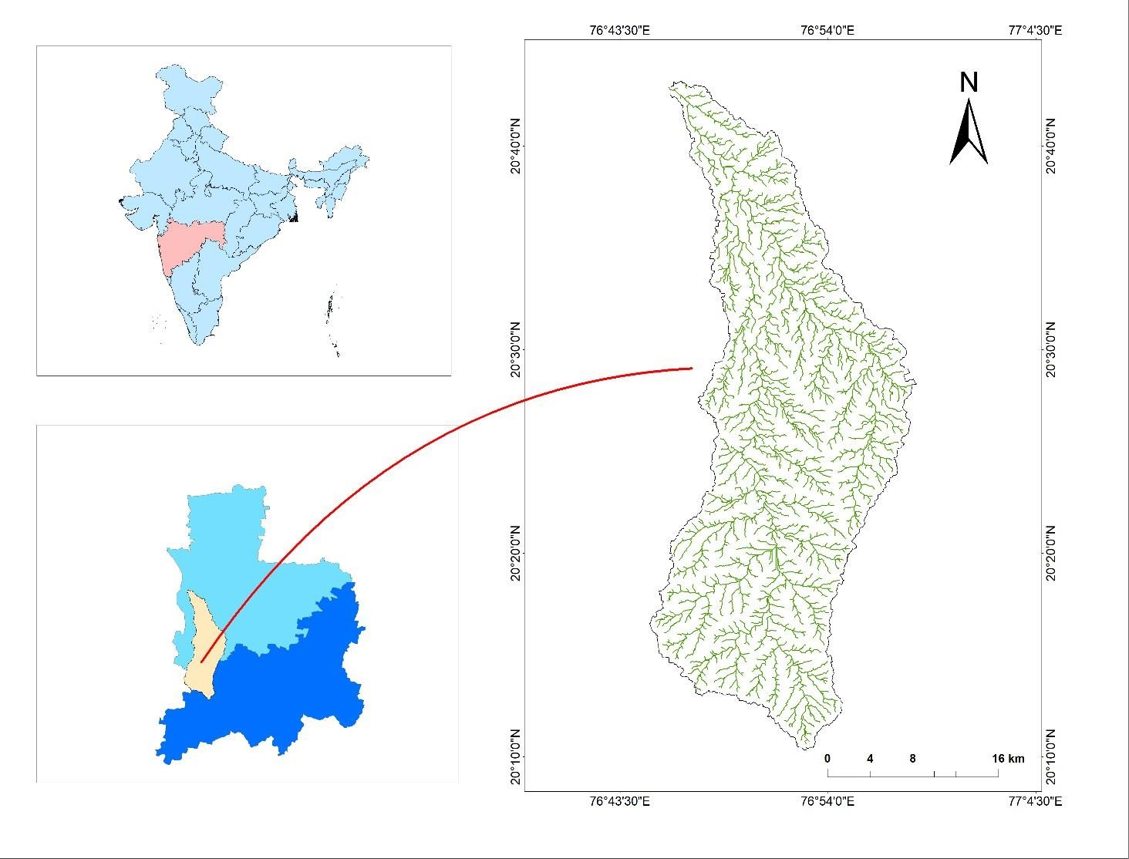

**Fig 1: Location Map of Nirguna (Bhikund) river watershed.**

* 1. **Methodology:**

The remotely sensed data, which was rectified using ArcGIS 10.8.1 software using the WGS 1984 datum, and which included different data on the aspects like drainage, orders of stream and different maps and information related to it was obtained in the form of SRTM (DEM) satellite imagery with a special resolution of 90 m. The river's drainage network was then digitalized. Scholarly mathematical equations are used to evaluate morphotectonic parameters. For topographical shapes that assess the local tectonics, the morphometric parameter is employed. Structure, drainage, and geomorphological features are recognised and distinguished using digital image processing techniques. Using ArcGIS's unique overlap approach, the data is merged into the GIS.

Toposheet Map

SRTM DEM

Data

Fill

Flow

Direction

Flow Accumulation

Stream Order

Drainage

Drainage Map

Contour Map

Lineament Map

Aspect Map

Slope map

Hillshade map

Geo- referencing

Morphotectonic Parameter

1. Elongation Ratio
2. Asymmetric Factor

Drainage Map

Morphometric Parameter

1. Linear Aspect
2. Areal Aspect
3. Relief Aspect

Digitization

**Fig. 2 Systematic Representation of Methodology Used.**

1. **Data Results and discussion:**

**3.1 Contour:**

In cartography, imaginary lines, sometimes known as "counters," are used to join locations that are uniformly elevated above a given elevation, such as mean sea level. A contour line, also known as an isocline, an isopleth, or an isarithm, of a function of two variables is a curve along which the function has a constant value. For example, a topographic map would show valleys and hills, as well as how steep and gentle the slopes are. A map with contour lines drawn on it is called a contour map. The contour interval on a contour map is the elevation difference between two successive contour lines. Most of the area is between 300 and 550 meters above sea level.

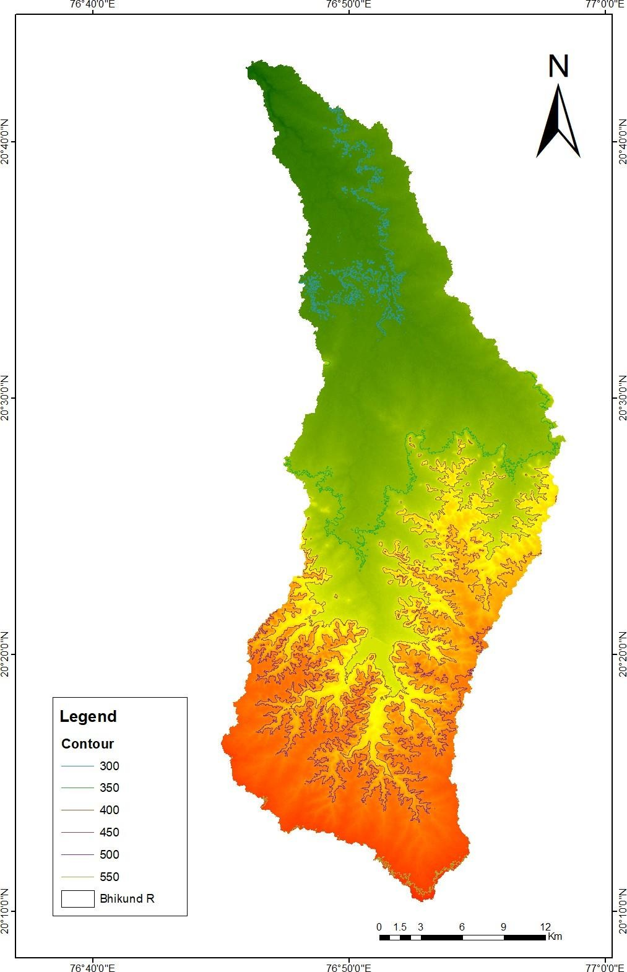

**Fig. 3 Contour map of the Nirguna (Bhikund) river watershed.**

**3.2 Slope:**

One useful tool for locating structural faults is a slope map. A slope map is made, showing the locations of fault scarps, strata tilts, and other features. The study area's northwest edges most likely exhibit tectonic disturbances, and the slope there is likely subsiding. The basin's slope 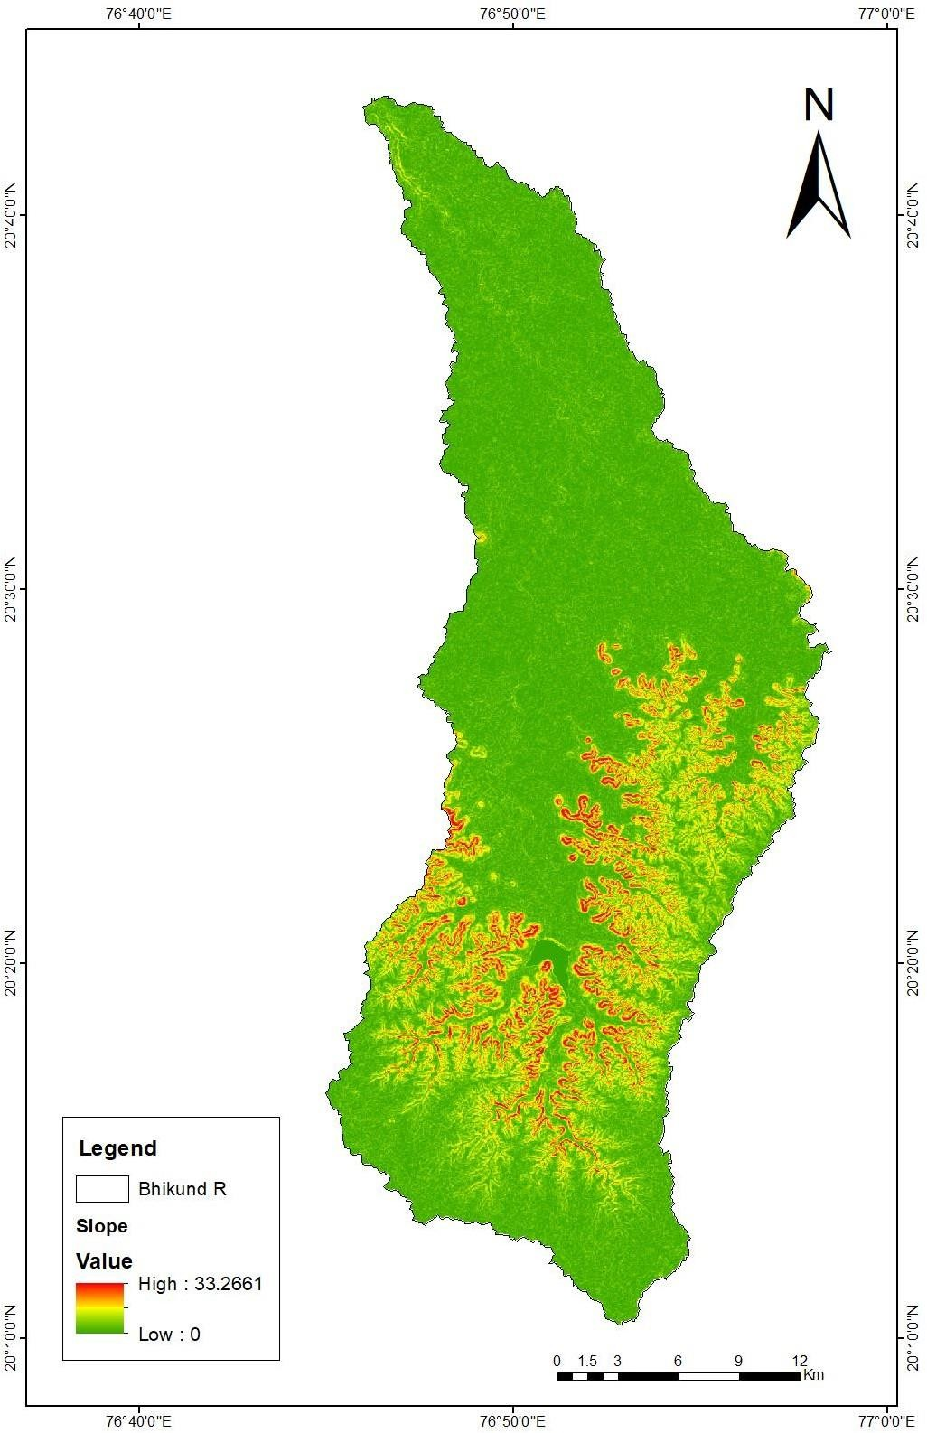ranges from 0 to 8. Extremely high (33.26) and extremely low.

**Fig. 4 Slope map of the Nirguna (Bhikund) river watershed.**

**3.3 Asymmetry:**

The amount of tectonic tilting at the scale of the drainage basin or in relation to a wide area is determined using the drainage asymmetric (AF). Hare and Gender (1985) define drainage asymmetry.

Af=Ar/At*100

Where,

Ar is the basin's area on the stream's right side.

At is the drainage basins area

The area of the basin's right side is greater than its left side. The region spanned 322 m on the left and 404 m on the right, respectively, indicating tectonic activity or the tilting of the river basin.   
The area's asymmetric value is 55.83.

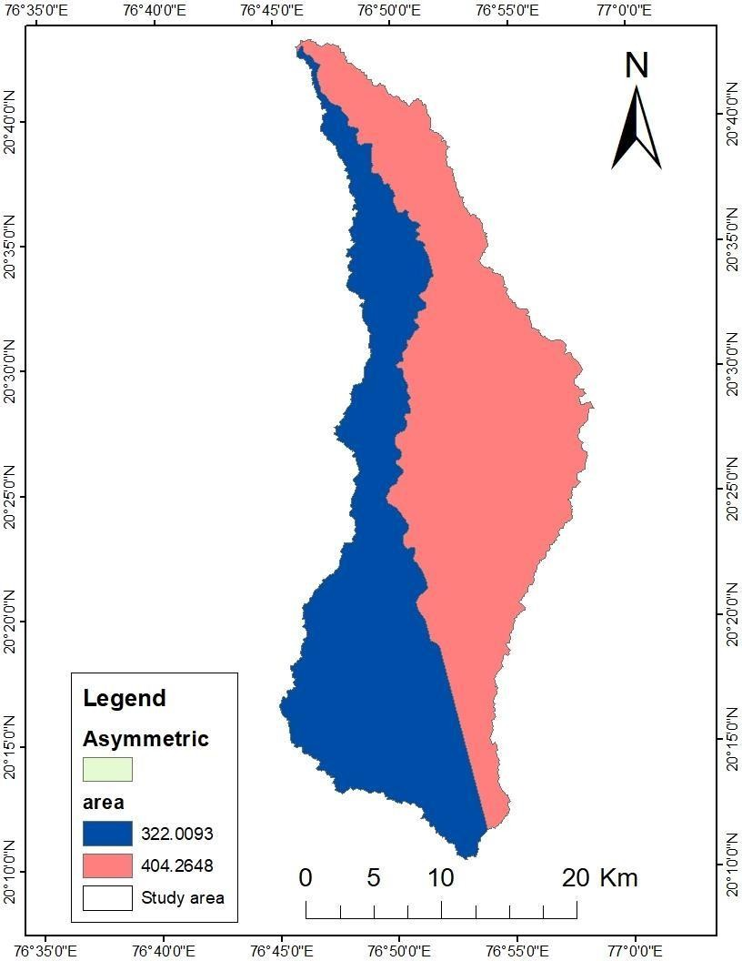

**Fig. 5 Asymmetry map of the Nirguna (Bhikund) river watershed.**

**3.4 Aspect:**

An aspect map is an easy idea to comprehend. The directions the physical slop face were specified by the aspect value. Based on the angle, we can categorise aspect direction. Typically, an output aspect raster would produce multiple slop directions. The "aspect map" of the region was created using the SRTM DEM. The aspect and slope angle of a terrain are displayed simultaneously on an aspect-slope map. Hues are used to represent aspect categories, and saturation mapping is used to map slope classes so that steeper slopes are represented by brighter colours. The map that is produced as a consequence will have the colour indicated to the right. Modelling and Kimberling's MKS-ASPECT Scheme (GIS world 1991) are the sources of the colouring.

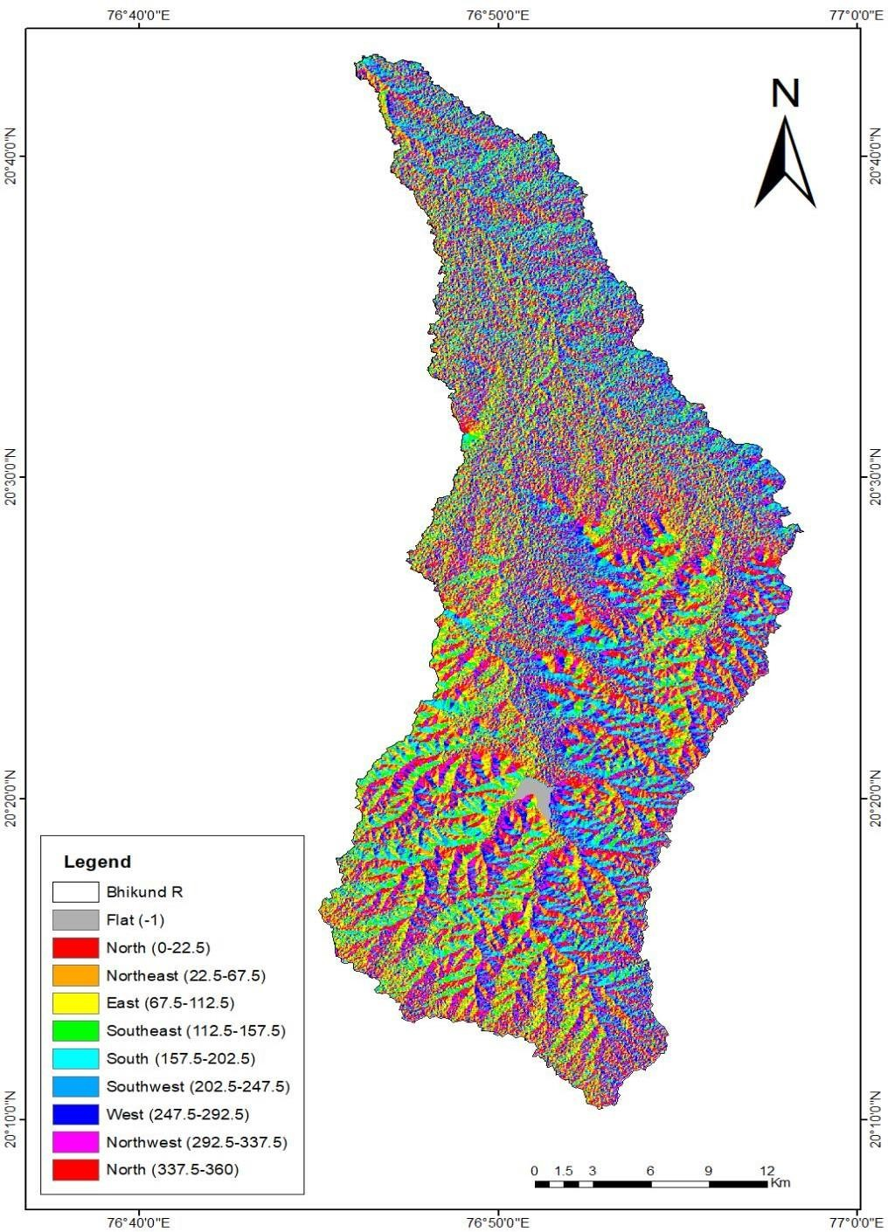

**Fig. 6 Aspect map of the Nirguna (Bhikund) river watershed.**

**.**

**3.5 Lineament:**

A lineament is a linear feature that is believed to represent fault lines and straight stream courses in the crust. The Nirguna (Bhikund) River Watershed area contains many lineaments that contain both major and small faults. Mostly horizontal, vertical NE-SW and NW-SE patterns were seen, frequently intersecting one another.

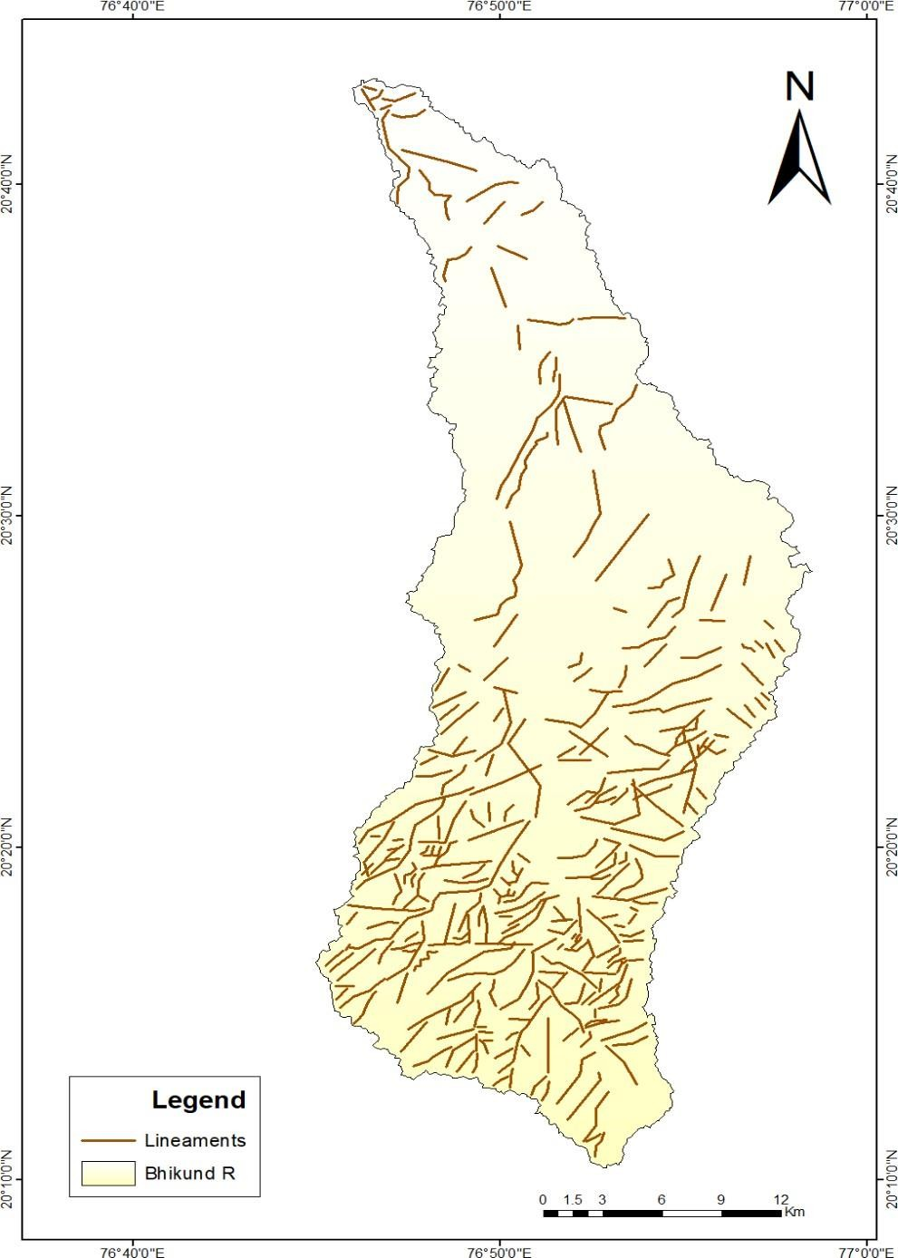

**Fig. 7 Lineament map of the Nirguna (Bhikund) river watershed.**

**.**

**3.6 Hillshed:**

A hill shadow is a three-dimensional, greyscale which in turn is the depiction of the surface that is shaded by the sun's position in relation to the observer. It is often useful to use a hill shading raster to depict the topography on a map when supporting additional data, such as population density or a thematic overlay like soils. It can significantly improve how a surface is visualised for graphical or analytical purposes. Particularly when employing transparency. A mosaic dataset can be utilised with the hill shade function. To create the illusion of three dimensions, use the Arc Map hill shade command.

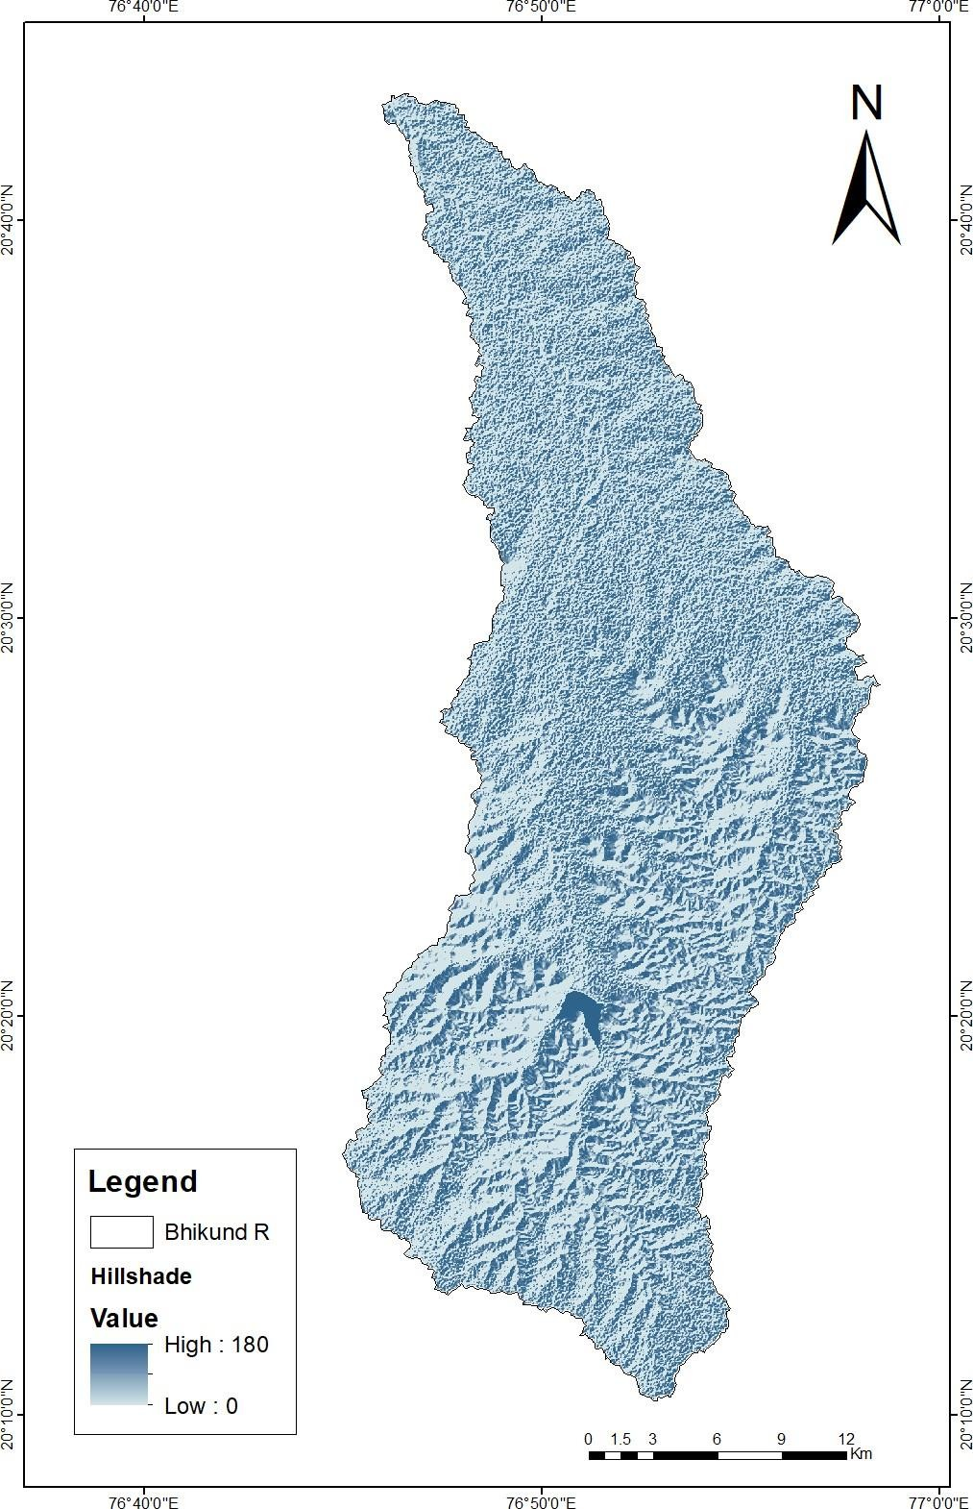

**Fig. 8 Hillshed map of the Nirguna (Bhikund) river watershed.**

**3.7 Geomorphology:**

The systematic study of landforms with respect to their climatology, geology, and structural aspects is known as geomorphology (Schumm and Hadley, 1961). The two main factors in determining an area's geomorphology are drainage and landforms. According to Schumm and Hadley (1961) and Thomas et al. (2012), the landforms, plains, and plateau are best described by the geomorphological records. In general, regions can be divided into several plains and plateaus (fig. ) This region is dominated by fractured, depressed plateaus and flood pains.

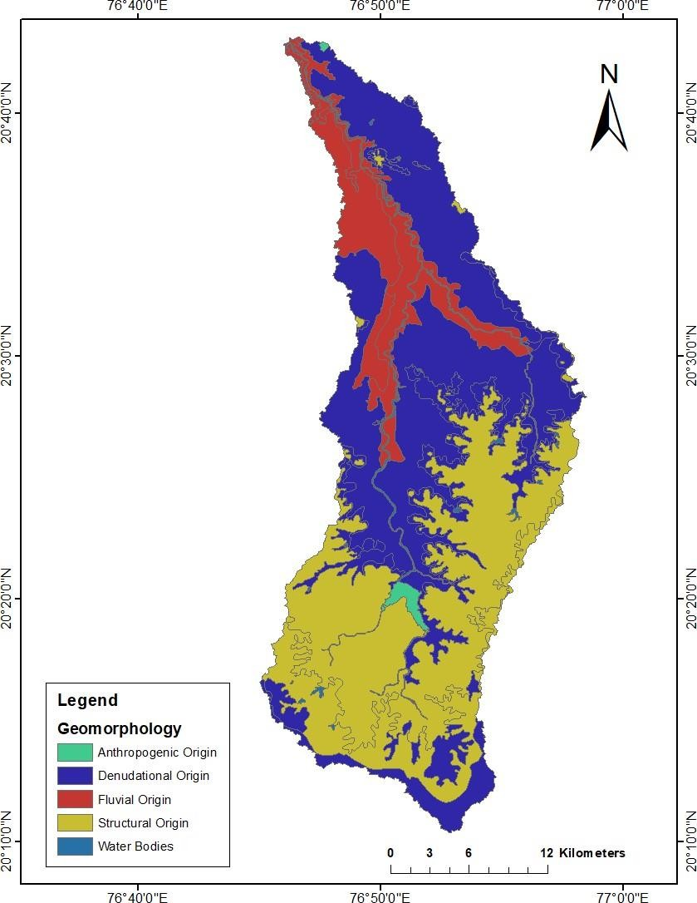

**Fig. 9 Geomorphological map of the Nirguna (Bhikund) river watershed.**

**3.8 Drainage Density:**

Most of DD's value ranges are expressed in Km2. It is a significant component for the basin's peak runoff potential and indication of landscape fragmentation. The Nirguna (Bhikund) river watershed is 2.3 sq. km. This suggests a low density of drainage. The proximity or distance between channels is expressed by the drainage density (Horton, 1932). According to Nag and Chakraborty (2003), this value suggests that a basin with heavy vegetative cover and highly permeable subsoil is one with low drainage density.

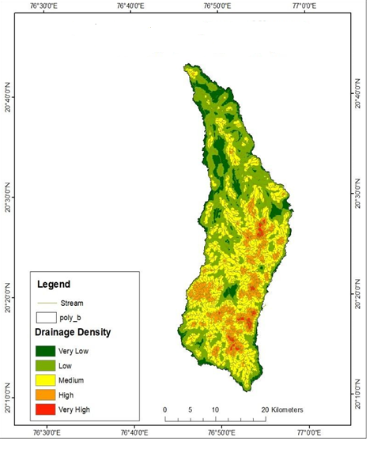

**Fig. 10 Drainage Density map of the Nirguna (Bhikund) river watershed.**

1. **MORPHOMETRIC ANALYSIS:**

Morphometric study can be defined as the quantitative study analysis of different landforms such as size and shape. It is mainly used to define the shape of drainage. Morphometric analysis can play a major role in order to know the different hydrological characteristics of watershed in relation with the type of flow. Testing theories concerning the factors influencing shape quantitatively is one of the main goals of morphometric analyses.

### Linear parameter of Nirguna (Bhikund) river watershed

### 4.1.1 Stream order (Su):

Finding the drainage's stream orders is the initial stage in the current investigation. The Strahler stream ordering approach has been used to rank the drainage basin's channel segment. A drainage basin of sixth order makes up the study area. The studied area's stream network drainage pattern is primarily of the dendritic type, which suggests a lack of textural homogeneity and structural control. A tree-like structure with branches meeting mostly at acute angles is what defines a dendritic pattern. Horton states that the number of stream segments in a basin that are of progressively lower orders and greatest order rising in accordance with the constant ratio at the beginning. As table 1 below.

|  |  |  |  |  |  |  |
| --- | --- | --- | --- | --- | --- | --- |
| Sr.  No. | Stream order  (u) | Number of Stream (Nu) | Total Length of Stream in km (Lu) | Mean Stream Length (Km) | Bifurcation ratio (Rb) | Mean Bifurcation ratio(Rbm) |
| 1 | I | 1552 | 946 | 0.61 | 4 |  |
| 2 | II | 388 | 363 | 0.94 | 3.6 |  |
| 3 | III | 108 | 168 | 0.64 | 3.6 |  |
| 4 | IV | 30 | 71 | 2.37 | 10 |  |
| 5 | V | 3 | 26 | 8.67 | 3 |  |
| 6 | VI | 1 | 65 | 65 | -- |  |
| Total |  | 2082 | 1639 |  |  | 4.9 |

**Table. 1:****The findings of drainage network properties of Nirguna (Bhikund) river watershed**

**4.1.2 Stream Number (Nu):**

Nu is the number of streams in a particular area ordered by count. According to Straher (1953), the number of streams with multiple orders is known as the stream number. Within the Bhikund river basin, there are a total of 2082 streams ranging in order from I to VI.

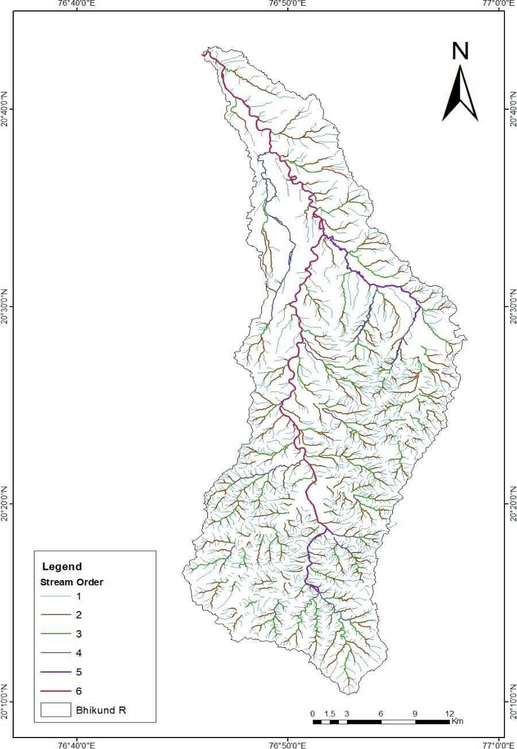**Fig. 11 Drainage map of the Nirguna (Bhikund) river watershed.**

**4.1.3 Stream Length (Lu):**

Greater slopes and finer textures are found in places with streams that are relatively shorter in length. Generally speaking, longer streams indicate flatter gradients. GIS software is used to measure the length of each stream segment. The Nirguna (Bhikund) River's streams span a total of 1639 kilometres. Stream length is a key component of the drainage basin system since it reveals how the surface runoff behaves in the basin.

**4.1.4 Stream Length Ratio (RL):**

According to Horton (1945), the length ratio of the order's mean (Lu) to the next lower order's mean length (Lu-1) tends to remain constant across a basin's successive order. The table displays the RL in the research area. Every sub basin in the research region exhibits variations. The observed variations in the stream length ratio between orders may be attributed to variations in topography and slope (Singh and Singh, 1997). The table 1 provides the stream length ratio's comparison values.

### 4.1.5 Bifurcation ratio (Rb):

A quantitative metric used to characterise the branching pattern of river networks is the bifurcation ratio, especially in the study of river systems and drainage patterns. It facilitates comprehension of the structure and development of drainage basins. For the research area, the Rb value is 4.9.

### 4.2.1 Aerial Aspects:

The term "basin area" refers to the entire area projected onto a horizontal plane that adds up to the total area of all basin orders. Drainage density is one of the various morphological characteristics that make up the aerial aspect.

**4.2.2 Basin Area (A)**:

A basin area is a sizable, frequently low-lying area where sediments build up over time. Numerous geological processes, including tectonic activity, erosion, and sediment deposition, can result in the formation of basins. The Nirguna (Bhikund) River Watershed spans approximately 726 sq. km.

**4.2.4 Stream Frequency (Rt):**

In geology, "stream frequency" refers to the quantity of streams or rivers in a given geographic area. It's a crucial variable that's utilised to analyse drainage patterns and river systems. It also sheds light on the geology, hydrology, and geomorphology of the area. The Nirguna (Bhikund) River Watershed has a stream frequency value of 2.87 sq. km.

**.4.5 Texture ratio (Rt):**

The phrase "texture ratio" in morphometric analysis frequently refers to the distribution of land surface features and the evaluation of landforms. Landforms' size, shape, and other properties are quantified as part of morphometric analysis in order to comprehend their evolution and traits. The Nirguna (Bhikund) River Watershed has a texture ratio (Rt) value 2.87.

**4.2.6 Elongation Ratio (Re):**

In geomorphology and hydrology, the elongation ratio (Re) is a metric used to express how much a landform, like a drainage basin or watershed, has stretched over time. Understanding the landform's shape and how erosion and hydrological processes are affected by it is helpful. In the research area, the elongation ratio value is 0.38.

**4.2.7 Circulatory ratio (Rc):**

This ratio expresses how much a landform's shape resembles a circle. Its definition is the ratio of the landform's area to the area of a circle with the same circumference. The basin's circulatory ratio value of 0.26 confirms the Miller's range of an elongated shape, modest runoff, and high subsurface permeability.

**4.2.8 Form Factor (Ff):**

The ratio of a drainage basin's size to the square of its maximum length is known as the form factor (Ff). It sheds light on the basin's form and how hydrological behaviour is affected by it. The Nirguna (Bhikund) River Watershed form factor ratio value is 0.1. It is extended in shape and suggests a lower value of from factor. A flatter flow peak for a longer period of time is predicted by the elongated basin with low from factor.

**4.3 Relief aspects:**

The drainage network's relief components, such as the ruggedness number (Rn), relief ratio (Rh), and basin relief (H).

**4.3.1 Basin relief (Bh):**

In geomorphology, the word "basin relief" (Bh) refers to the elevation difference between the highest and lowest locations within a certain basin or drainage area. It is a measurement of the vertical elevation variation within a basin that can provide information on the topography and general geomorphological features of the basin. The relief (R) of study area 563 m indicates a moderate to steep slope with substantial run-off.

**4.3.2 Relief Ratio (Rh):**

This ratio has no dimensions. Elevated Rh readings suggest a steep gradient, and vice versa. Higher erosive power and higher peaked basin discharges are produced by faster runoff in steeper basins. The Nirguna (Bhikund) River watershed having the relief ratio value of 6.63.

**4.3.3 Ruggedness Number (Rn):**

It provides an indication of how irregular or complex the surface is in terms of elevation changes. It is a gauge of the unevenness of the surface. When the slope is steep and both factors are large, the roughness number is exceptionally high (Strahler, 1956). The value of Rn for the study area is 0.34 which intern indicates the less susceptibility for the erosion.

**Table 2: Relief parameters of the study area.**

|  |  |
| --- | --- |
| **Morphometric Parameters** | **Calculated Value** |
| Maximum Elevation in the area (mts) | 563 |
| Minimum Elevation in the area (mts) | 256 |
| Basin Relief (mts) | 563 |
| Relief Ratio (Rh) | 6.63 |
| Ruggedness Number (Rn) | 0.34 |

**Table 3: Morphometric parameters of the Nirguna (Bhikund) River**

|  |  |  |  |  |  |  |
| --- | --- | --- | --- | --- | --- | --- |
| **Sr. No.** | **Morphometric Parameter** | | | **Formula** | | **Reference** |
| **Linear Aspects** | | | | | | |
| 1 | Stream order | | | Hierarchical Rank | | Strahler (1964) |
| 2 | Stream Number | | | Nu= S1+S2+S3+S4+S5+S6 | | Horton (1945) |
| 3 | Stream Length | | | Length of stream | | Horton (1945) |
| 4 | Stream Length Ratio | | | RL = Lu/Lu-1 Where,  RL = Stream Length Ratio  Lu = The Total Stream length of the  Order ‘u’  Lu-1 = The Total Stream Length of its next lower order. | | Horton (1945) |
| 5 | Bifurcation ratio | | | Rb = Nu/Nu+1 Where,  Rb = Bifurcation ratio Nu = Total No. of stream segments of the order ‘u’ Nu+1= Number of segments of the next higher order. | | Schumm (1956) |
| **Areal Aspect** | | | | | | |
| 1 | Basin area | | | A= outer boundary of  drainage basin | | Schumm,  (1956) |
| 2 | Drainage density | | | D = Lu/A Where,  D = Drainage density Lu = Total stream Length of all orders. A – Area of the basin (km)2 | | Horton (1932) |
| 3 | Stream frequency (Fs) | | | Fs = Nu/A Where,  Fs = Stream frequency Nu -Total no. of stream of all orders.  A = Area of the basin (Km)2 | | Horton (1932) |
| **Relief Aspects** | | | | | | |
| 1 | | Maximum Height of the Basin (Z) m | GIS Analysis / DEM | |  | |
| 2 | | Total Basin Relief (H) m | H = Z – z | | Strahler (1952) | |
| 3 | | Relief Ratio (Rhl) | Rhl = H / Lb | | Schumm(1956) | |
| 4 | | Ruggedness number | Rn = Bh*Dd Where, Bh  = Basin relief , Dd = Drainage density | | Schumm, (1956) | |

1. **Conclusion:**

The physical and meteorological properties of a certain basin area can be identified with great use by measuring its linear, areal, and relief aspects using a digital elevation model (DEM) created using contour and spot height. The value suggested by the bifurcation ratio (4.84), elongation ratio (0.38), drainage density (2.3), stream frequency (2.87), and relief ratio is 6.63 observed in this study which indicates that the watershed is less elongate and is in the late mature stage of erosional development stage. With the aid of GIS and RS technologies, the morphotectonic analysis of the Nirguna (Bhikund) River watershed established a significant contribution to understanding the relationship between the tectonics of the region and drainage morphometry. The research area's existing geology and other linear features, as well as the drainage pattern and morphometry derived from the available DEM data, were detected using digitally processed remote sensing data. The ground in the basin with the sixth order stream slopes fairly to moderately steep. In the research area, the drainage pattern is dendritic to sub-dendritic in nature. The major river's tributaries are the result of numerous tributary streams coming together. The form factor in the research region is 0.1, indicating that the basin has an elongated shape, modest runoff flow, and extremely permeable subsoil. The relief values of the watershed area higher in nature which itself indicates that the watershed lie in a hilly region. These relief values may also suggest that the watershed is in the early stage of erosional development. Based on the geomorphological studies the study area suggest for the development of agriculture or forestry or human habitat.

**DISCLAIMER (ARTIFICIAL INTELLIGENCE)**

Author(s) hereby declare that NO generative AI technologies such as Large Language Models (ChatGPT, COPILOT, etc) and text-to-image generators have been used during writing or editing of this manuscript.

### REFERANCES:

Gurav Chandrakant, Md.Barber (2019):Morphotectonic Analysis of Tiru River Sub-Basin of

Lendi River, Maharashtra, India Based on GIS.

Chougale S. Jagdish B. Sapkale (2017): Morphometric Analysis of Kadvi River basin,

Maharashtra Using Geospatial Techniques. Current World Environment, Vol. 12, No. (3)

2017.

B.S.Manjare (2020): Morphotectonic Analysis of Upper Tapi River Sub-basin, Madhya

Pradesh, using Remote sensing and GIS.

Horton, R.E.(1945):" Erosional development of streams and their drainage basins:

Hydrophysical approach to Quantitative morphology". Bull. Geol. Soc. Am. Vol. 56 pp.

275-370. In Olav Slaymaker (2004) (ed.) Fluvial geomorphology, Routledge, USAand Canada.

V. S., Nair A. S. K., Baiju K. V.(2013): "Drainage Basin Delineation and Quantitative 6.

Analysis of Panamaram Watershed of Kabani River Basin, Kerala Using Remote

Sensing And GIS". Journal Geological Society of India, Oct. 2013.

Kale, V.S. and Gupta, A. (2001): Introduction to Geomorphology. New Delhi, Orient

Longman. Random channel networks. J Geol 77:397–414.

Mishra A., Dubey D.P. and Tiwari R. N. (2011): Morphometric Analysis of Tons basin, Rewa

district, Madhya Pradesh, based on watershed approach. Earth Science India, Vol 3(III)

July, 2011pp 171-180.

M. Rudraiah, S. Govindaiah, S. Srinivas Vittaia (2008): Morphometry using Remote Sensing

and GIS Techniques in the Sub-Basins of Kagna River Basin, Gulburga District,

Karnataka, India. J. Indian Soc. Remote Sens. (December 2008) 36:351–360.

Nag S. K. and Lahiri A. (2011): Morphometric analysis of Dwarakeswar watershed, Bankura

District, West Bengal, India, using spatial information technology. International Journal

of Water Resources and Environmental Engineering Oct 2011, Vol. 3 (10) 2011.

Nageswara Rao.K, Swarna Latha.P, Arun Kumar.P, Hari Krishna.M (2010): Morphometric

Analysis of Gostani River Basin in Andhra Pradesh State, India Using Spatial

Information Technology, International Journal of Geomatics and Geosciences,Volume

1, No 2, 2010.

Nimkar A.M., Despande S. B., Babrekar P. G.,(1992): Evaluation of Salinity Problem in Swell-

Shrink Soils of a Part of the Purna Valley,Maharashtra.

Nisha Sahu, G. P. Obi Reddy, Nirmal Kumar, M. S. S. Nagaraju, Rajeev Srivastava, S.

K. Singh (2017) 'Morphometric analysis in basaltic Terrain of Central India using GIS

techniques: a case study'.Appl Water Sci (2017) 7:2493–2499.

Babar, Md. and Kaplay, R.D. and Panaskar, D.B. (2000). Structural control on drainage pattern

in the Tirna River Catchment, Central west India. Indian J- of Geomarphology, Vol-5

No.112 and pp 126-133.

Kapley, R.D., Md. Babar, D.B. Panaskar and A.M. Rakhe (2004). Geomorphometric

characteristics of 30th September 1993 Killari Earthquake Area, Maharashtra (India).

Journal of Geophysics, Vol. XXV No.2 & 3 pp.55-61.

Babar Md., R.V. Chunchekar, B.B. Ghute and R.D. Kaplay (2009). Tectonic Geomorphology

of Terna-Manjra River Basin, West Central India. Journal Indian Geological Congress,

Vol.1 (2), pp. 69-78.

Babar Md., B.B. Ghute and R.V. Chunchekar (2011). Geomorphic indicators of Neotectonics

from the Deccan Basaltic Province: A study from the Upper Godavari River Basin,

Maharashtra, India. International Journal of Earth Science and Engineering, Vol. 4 (2),

pp. 297-308