Original Research Article
PREVALENCE, TYPES AND FREQUENCY OF LIVER CHANGES IN BROILER BIRDS

Abstract
The present study was undertaken to know the prevalence, types and frequency of liver changes in broiler birds at Jabalpur city. During the 18 months of study period, post-mortem examinations were performed on a total of 608 broiler birds. From birds having gross liver lesions, representative tissue samples were collected for gross and microscopic examination of liver. Amongst the 608 birds examined, 273 birds showed gross liver lesions with a prevalence rate of 44.90%. The major gross lesions comprised haemorrhage and congestion (38.46%), fibrinous hepatitis/perihepatitis (18.68%), hepatomegaly, necrotic foci, fatty and pale liver. During the study period highest month wise prevalence of liver lesions was noticed in the month of September. Microscopic examination of liver showed congested /dilated sinusoids, haemorrhages, liver haemosiderosis, hepatocellular vacuolation, parenchymatous degeneration, Kupffer cell hyperplasia/hypertrophy, proliferation of bile ductules, infiltration/hepatitis, cholangiohepatitis, inflamed bile ductules/pericholangitis, fibrino-necrotic hepatitis, sinusoidal microthrombi, intracellular inclusion bodies and liver amyloidosis when stained with Haematoxylin and Eosin stain. Special staining of liver in Masson’s trichome revealed mild to extensive fibrosis.
Keywords: Liver, gross lesions, necropsy, histopathological, H&E, broiler birds, prevalence
1. INTRODUCTION
The liver is the most vital organ in the body's metabolic activities and is regarded as one of the most telling indicators of any illness because it is subject of different types of etiologic attacks like infectious, toxic, metabolic, nutritional, traumatic causes (Doneley, 2004). Additionally, liver disease serves as a significant diagnostic tool for the on-site identification of various ailments. Dolka et al. (2012) highlighted the critical role of histopathological examination in linking the identified etiology with the corresponding lesions (cause and effect), which aids in establishing a definitive diagnosis for many avian diseases. Lopes et al. (2022) in their study observed that the macroscopic and histopathological findings enabled the definitive etiological diagnosis in 59% of the chickens. Keeping the above facts in mind this study is conducted to determine the prevalence, types and frequency of liver changes in broiler birds.
2. MATERIALS AND METHODS
The study was conducted on dead broiler birds for the period of 18 months from November 2023 to April 2025 in the Department of Veterinary Pathology C.O.V.Sc and A.H, Jabalpur. Jabalpur is situated at 23.17° N latitude and 79.57° E longitude at 410.87 MSL (Mean Sea level) in the southern part of third agro-climatic zone of India.
Tissue samples (liver) were collected from birds showing gross lesions like haemorrhage, congestion, enlarged liver, fibrinous hepatitis/perihepatitis and necrotic foci. Simultaneously, the samples were collected in 10% buffered formalin for histopathological studies. During the study period 608 dead birds received for post mortem examination were examined, in which 273 broilers showed gross liver lesions.
Liver tissue having gross lesions were further processed for histopathological studies. Formalin fixed tissues were processed by standard paraffin embedding technique and stained with Haematoxylin and Eosin (H&E) stain. Additionally, the sections were processed with Masson’s trichome stain to examine the intensity of fibrosis (Gridley, 1960).
3. RESULTS AND DISCUSSION

3.1. Prevalence of lesions
The examination of deceased animals and birds is essential for accurately diagnosing diseases, managing outbreaks, and implementing treatment and prevention measures (Mishra et al., 2020). In this particular research, a thorough post-mortem examination was carried out of 608 dead birds from fifteen broiler farms. The table 06 illustrates the distribution of visible abnormalities in broiler chickens.
As shown in table 01, total 608 post-mortem of broilers were performed during the study period. Maximal lesions were recorded in respiratory system (70.55%) followed by gastrointestinal (62.99%), hepatobiliary (44.90%); urogenital (49.63%); cardiac (22.69%) and cutaneous and musculoskeletal system (17.43%).
S.  No. | Month | No. of P.M. | Organ system affected
 |  |  | Respiratory | Hepatobiliary | Cardiac | Gastro  intestinal | Urogenital | Cutaneous / musculoskeletal
1 | Jan | 84 | 47 | 30 | 15 | 69 | 37 | -
2 | Feb | 32 | 20 | 9 | - | 26 | - | -
3 | Mar | 62 | 36 | 27 | 20 | 29 | 3 | 34
4 | Apr | 15 | 11 | 4 | 2 | 7 | 2 | 12
5 | May | 96 | 68 | 40 | 25 | 33 | 39 | 44
6 | Jun | 12 | 6 | 9 | 6 | 2 | 10 | -
7 | Jul | 60 | 56 | 33 | - | 54 | 36 | 10
8 | Aug | 22 | 18 | 8 | - | 10 | 10 | -
9 | Sep | 8 | 8 | 6 | - | 3 | - | -
10 | Oct | 64 | 47 | 37 | 30 | 32 | 29 | -
11 | Nov | 112 | 87 | 57 | 32 | 89 | 66 | 1
12 | Dec | 41 | 25 | 13 | 8 | 29 | 9 | 5
 | Total | 608 | 429  70.55% | 273  44.90% | 138  22.69% | 383  62.99% | 241  49.63% | 106  17.43%
Table 01: Prevalence of lesions in broiler birds

Similar to our findings Hooda et al. (2009) reported that 30.88% dead birds had gastrointestinal lesions and 10.97% birds had lesions in respiratory system whereas 33.93% of cases showed combined lesions. Singh et al. (2018) reported highest prevalence of fibrinous pericarditis (50%) and 47.75 % prevalence of perihepatitis in postmortem studies of broiler chickens. Since the studies were carried out in different geographical locations the etio-pathomorphology is bound to differ between them. This emphasizes the fact that the studies on prevalent etio-pathomorphology in cases of spontaneous mortality should be conducted in different locations to prepare the poultry farmer for expected mortality.
3.2. Prevalence of gross liver lesion in broiler birds
In this particular research, out of 608 dead birds examined, 273 showed gross liver lesions, giving an overall occurrence of 44.90 percent. Randal et al. (1986) recorded that the carcasses condemnation in broiler farms varied from 3% to 12% due to liver lesions. Goyal et al. (2009) reported the prevalence of hepatobiliary lesions in poultry to be 46.03 %. Kittelsen et al. (2015) in their studies found that 9 out of 371 broilers birds with spontaneous mortality revealed hepatitis with enlarged liver having yellow to grey foci. Ninad (2022) reported the prevalence of 55.55 % hepatobiliary lesions in broilers. Lopes et al. (2022) in their investigations found that of the 272 chickens diagnosed with liver changes, 147 (54%) were broiler chickens.
Nevertheless, we endorse the view of Sarker et al. (2019) that considerable numbers of liver lesions are observed in chicken on necropsy examination and a systematic study of liver lesions will be helpful in making a diagnosis of various poultry diseases. Thus, the incidence and occurrence of liver lesions in birds reported by various workers from different areas vary widely. The reasons could be attributed to different climatic conditions and managemental practices being followed.
3.3. Distribution of liver lesions in broiler birds
In the study 273 birds from broiler farms showed lesions in liver. Major liver lesions as observed in the study comprised haemorrhage, congestion, perihepatitis, hepatomegaly, discoloration, necrotic foci, cysts, and rupture (Table 02, Plates 01-04). In birds most prominent liver lesion was haemorrhages/congestion (38.46%) followed by perihepatitis (18.68%).
Table 02: Prevalence of various types of gross liver lesions
S. No. | Liver lesions | Total birds with liver lesions (n=273)
 |  | Number of birds | Per cent
1. | Haemorrhagic, Congested | 105 | 38.46%
2. | Perihepatitis | 51 | 18.68%
3. | Hepatomegaly | 42 | 15.38%
4. | Necrosis/Necrotic foci | 38 | 13.91%
5. | Fatty Liver | 37 | 13.55%
6. | Pale liver | 35 | 12.82%
7. | Liver with cysts | 05 | 01.83%
8. | Liver Rupture | 04 | 01.46%

Gambo et al. (2016) and Bhat et al. (2019) have also reported similar liver lesions of congestion, hemorrhage, necrosis, fatty liver and hematoma in their surveys. Amini et al. (2015) examined 264 livers with gross lesions, 83% had multifocal to coalescing necrotizing hepatitis, 16% had perihepatitis, and 1% had haemorrhages. An overgrowth of gut organisms can induce an increased reticuloendothelial response and also induce liver alterations and liver injury (Ito et al., 2004).

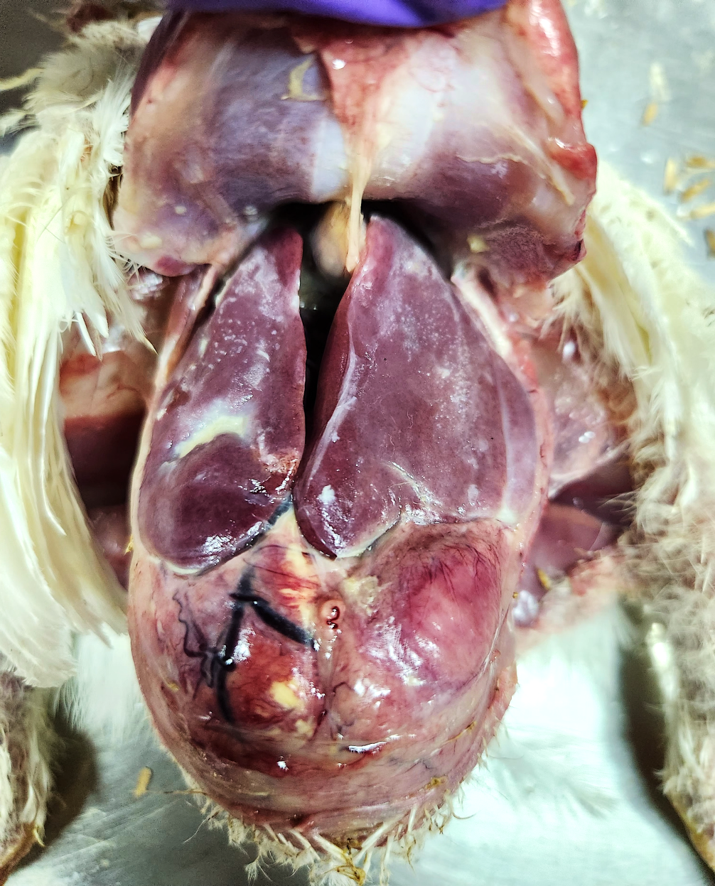
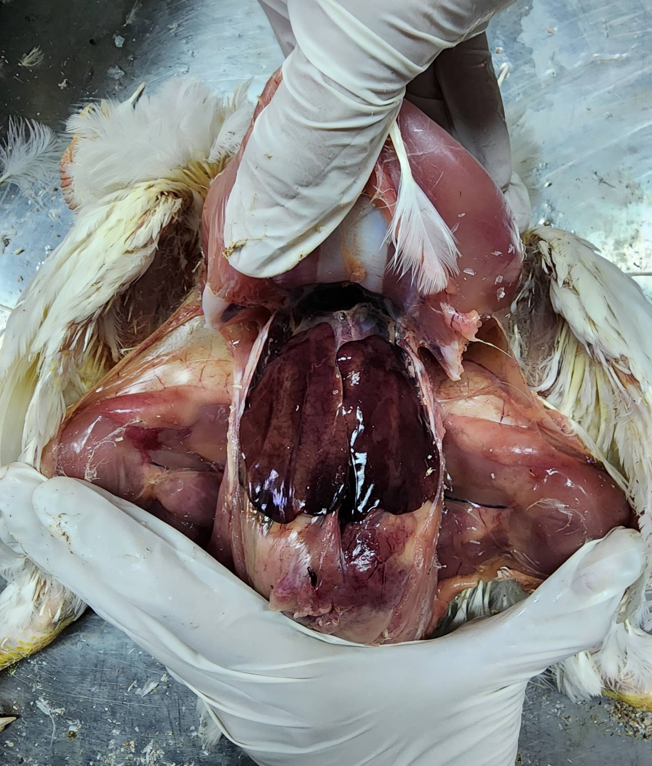

Plate 02: Enlarged liver from broiler with prominent perihepatitis
Plate 01: Liver of broiler showing congestion and haemorrhages.

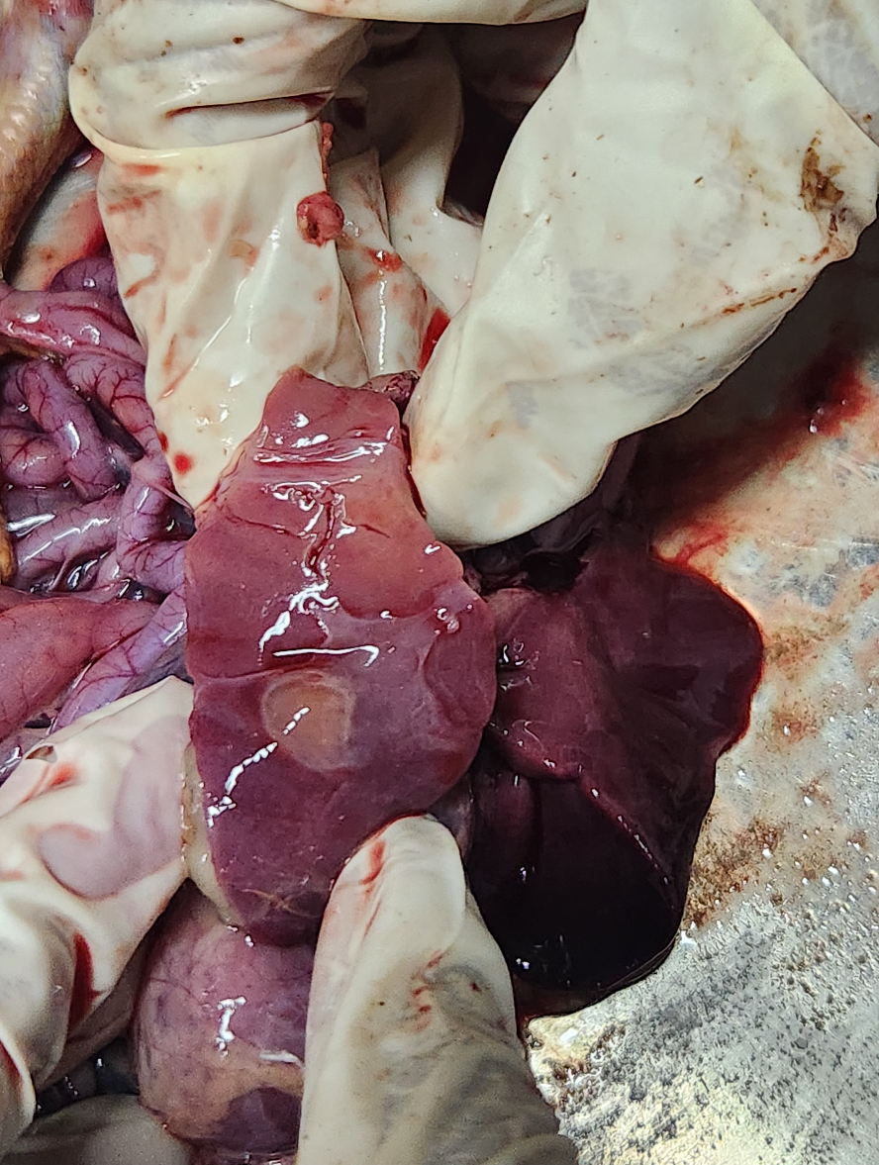
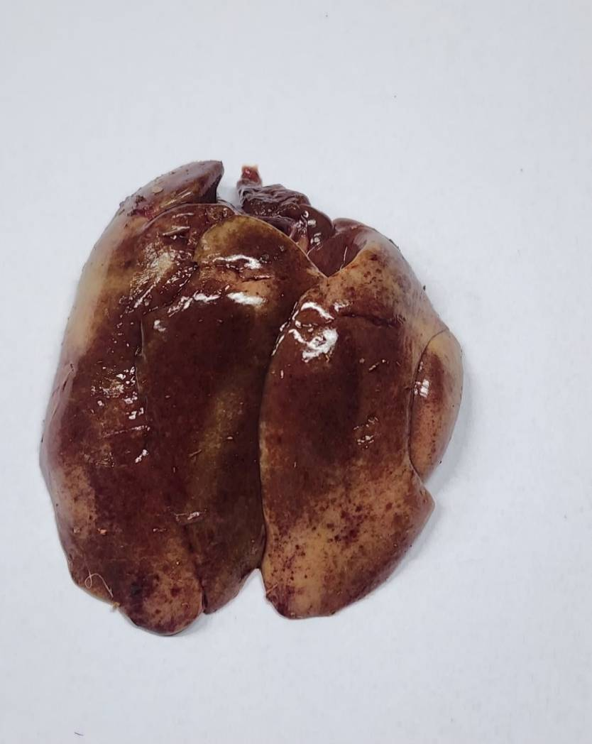

Plate 04: Liver from broiler birds having cysts on surface

Plate 03: Liver from broiler with multi focal grey white to yellow necrotic foci

3.4. Prevalence of liver lesions in different age groups
In the present study it was observed that the increased gross liver lesions were observed in birds below 3 weeks of age as shown in table 03.
Table 03: Liver lesions in different age groups of birds
Age of Birds | Number of broilers examined | Number showing gross liver lesions | Percent Prevalence | χ² =3.66, P=0.055. Non-Significant at P = 0.05
1 day – 3 weeks | 181 | 92 | 50.82%
3 weeks and above | 427 | 181 | 42.38%

Goyal et al. (2009) observed that broilers of 3-6 weeks of age group, were more susceptible to liver affections. Semenenko et al. (2020) while studying the causes of broiler birds’ mortality from the 8th to the 15th day, determined an increase in mortality from hepatopathies and by the 25th day of life hepatosis was recorded in the bulk of the dead poultry. Long-term exposure to infectious non-infectious, pollutants lead to poor health and the target for the damaging effect is ultimately liver, the organ with which most of the body’s metabolic processes are directly or indirectly associated.
However, the presence of gross liver lesions in both age groups highlights that factor beyond age, such as management practices, feed hygiene, and concurrent infections, also play significant roles in disease occurrence and progression (Cooper et al., 2013).
3.5. Microscopic lesions observed in broiler livers
The tissue pieces from liver with gross abnormalities were subjected to further histological examination. The microscopic lesions observed in the grossly affected liver were congested /dilated sinusoids, haemorrhages, liver haemosiderosis, hepatocellular vacuolation, parenchymatous degeneration, Kupffer cell hyperplasia/hypertrophy, proliferation of bile ductules, infiltration/hepatitis, cholangiohepatitis, inflamed bile ductules/pericholangitis, fibrino-necrotic hepatitis, sinusoidal microthrombi, intracellular inclusion bodies and liver amyloidosis (Plate 05-07). Masson’s trichome revealed severe fibrosis in portal area of liver (Plate 08).
The histopathology of broiler liver has been described by previous workers in relation to specific aetiologies (Jagmeet et al., 2020). Lopes et al. (2022) on the basis of their investigations stated that the macroscopic and histopathological findings enabled the definitive etiological diagnosis in 59% of the chickens with spontaneous mortality. Our findings endorse the opinion of earlier workers regarding the importance of the histopathological examination, for the association of the detected etiology with the corresponding lesions (cause and effect), providing a conclusive diagnosis in many avian diseases (Dolka et al., 2012).
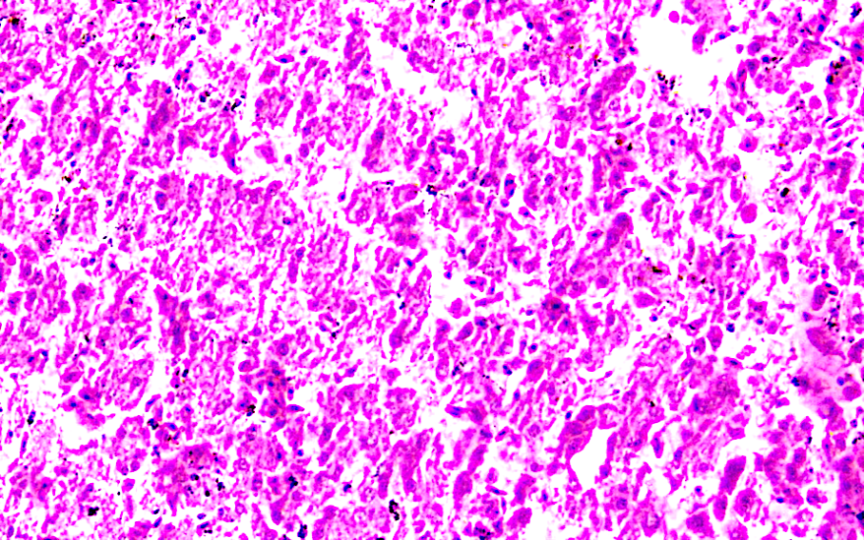
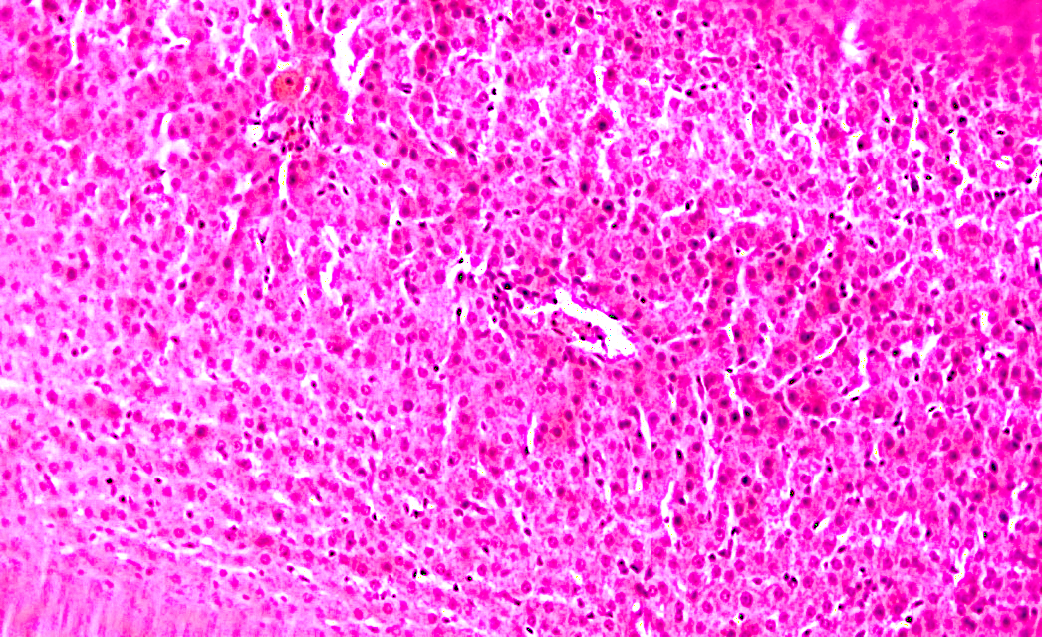

Plate 06: Microscopic section of liver having hepatocytic necrosis and large rounded cytoplasmic eosinophilic bodies. H&E X200
Plate 05: Microscopic section of liver showing Kupffer cell hyperplasia and perivascular mononuclear cell infiltration. H&E X200

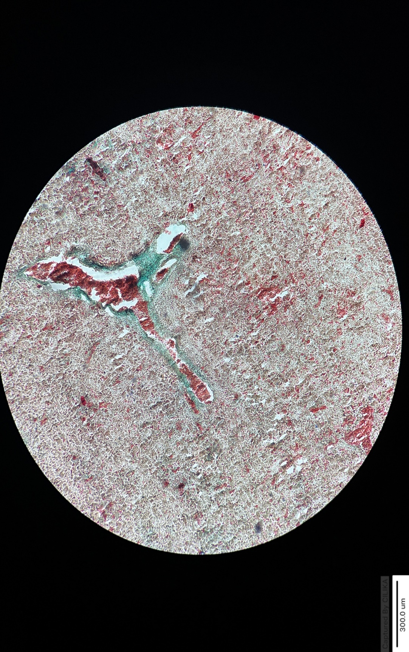
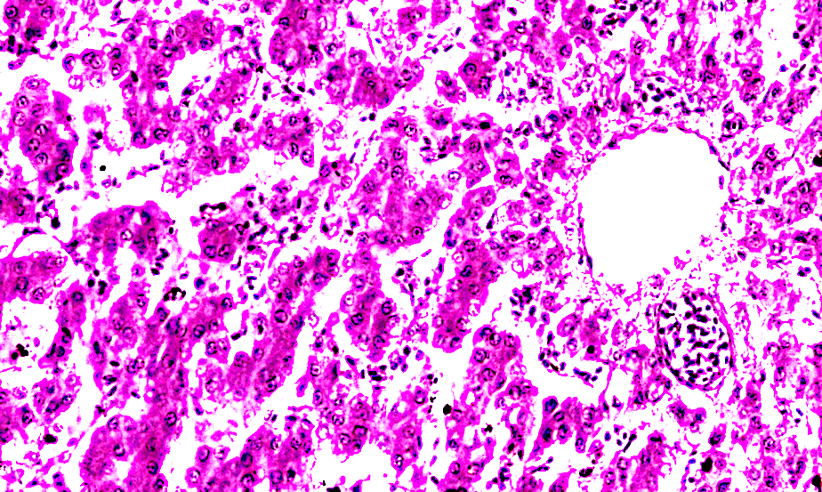

Plate 07: Microscopic section of poultry liver with cholangiohepatitis. An inflamed bile ductule contains clumps of granulocytes. H&E X400

Plate 08: Microscopic section of poultry liver showing fibrosis in portal area. Masson’s trichome stain X400

4. CONCLUSION
This study signifies the importance of necropsy as a tool in the suggestive diagnosis of underlying diseases. High prevalence (44.90%) of hepatic lesions was recorded in broilers with spontaneous mortality. Gross hepatic lesions observed in broilers with spontaneous mortality were haemorrhages, congestion, perihepatitis fatty/pale liver, necrotic foci, hepatomegaly, liver with cysts and liver rupture. Irrespective of the age, liver is affected by many agents and showed gross lesions. Microscopic lesions observed in the grossly affected liver were congested /dilated sinusoids, haemorrhages, liver haemosiderosis, hepatocellular vacuolation, parenchymatous degeneration, Kupffer cell hyperplasia/hypertrophy, proliferation of bile ductules, infiltration/hepatitis, cholangiohepatitis, inflamed bile ductules/pericholangitis, fibrino-necrotic hepatitis.
REFERENCES
Doneley, B. (2004). Treating liver disease in the avian patient. In Seminars in avian and exotic pet medicine, 13(1), 8-15.
Dolka, I., Sapierzynski, R., Bielecki, W., Malicka, E., Zbikowski, A., and Szeleszczuk, P. (2012). Histopathology in diagnosis of broiler chicken and layer diseases–review of cases 1999-2010. Polish Journal of Veterinary Sciences, 15(4), 773-779.
Lopes, M. C., Freitas Neto, O. C., Amaral, C. I., Lacerda, M. S., Fonseca, C. S., Martins, N. R. et al. (2022). Hepatic changes in Gallus gallus domesticus in Brazil. Pesquisa Veterinaria Brasileira, 42, 7078.
Gridley, M. F. (1960). Manual of Histological and Special Staining Technique, hill Book Company., Inc. New York, Toronto, London.
Mishra, A., Niyogi, D., Gupta, R. K., Tripathi, K. K., and Singh, S. V. (2020). Incidence of colibacillosis in poultry in Gonda district in north eastern plain zone of Uttar Pradesh. Journal of Animal Research, 10(5), 837-841.
Abalaka, S. E., Sani, N. A., Idoko, I. S., Tenuche, O. Z., Oyelowo, F. O., Ejeh, S. A. et al. (2017). Pathological changes associated with an outbreak of colibacillosis in a commercial broiler flock. Sokoto Journal of Veterinary Sciences, 15(1), 95-102.
Hooda, A. K., Mishra, S. K., Pruthi, A. K., and Gupta, R.P. (2009). Studies on poultry mortality with special reference to gastro-intestinal tract disorders. Haryana Veterinarian, 48, 103-104.
Singh, G. K., Niyogi, D., Tripathi, K. K., Joshi, N., Vaish, A., and Mishra, A. (2018). Pathomorphological changes in broiler chickens due to spontaneous E. coli infection. Journal of Pharmacognosy and Phytochemistry, 7(5), 798-801.
Randal, C. J., Krikpatrick, K. S., and Pearson, D. B. (1986) Liver abnormality in broilers. Veterinary Record, 119, 576.
Goyal, D., Singh, A., Sood, N., Gupta, K., and Sood, N. K. (2009). Pathological changes in naturally occurring inclusion body hepatitis and hydropericardium syndrome in poultry. Indian Journal of Veterinary. Pathology, 33, 105-106.
Kittelsen, K. E., Granquist, E. G., Kolbjornsen, O., Nafstad, O., and Moe, R.O. (2015). A comparison of post-mortem findings in broilers dead-on-farm and broilers dead-on-arrival at the abattoir. Poultry Science, 94(11), 2622-2629.
Ninad, S (2022) Pathological Studies on Spontaneous Mortality in Poultry, MVSc thesis, Nanaji Deshmukh Veterinary Science University, Jabalpur.
Sarker, M. M., Rahman, S., Hossain, M. S., Rashid Sarkar, M. and Hamid, S. A. (2019). Pathological study of bacterial infection that causes liver lesions in chickens. Asian Journal of Biology, 8, 1-6.
Gambo, H. I., Bitrus, A. A., Adam, B. M., Goni, D. M., Kwoji, I. D., Thliza, S. J. et al. (2016). Survey of hepatic lesions and incriminating pathogens in rural scavenger chickens in Maiduguri, North-Eastern Nigeria. Advances in Animal and Veterinary Sciences, 4, 174-177.
Bhat, T. A., Kamil, S. A., Mir, M. S., and Altaf, R. (2019). Occurrence and pathological profiling of hepatic affections in commercial broiler and layer chicken reared in the temperate northern Himalayan regions. SKUAST Journal of Research, 21(1), 15-26.
Amini, K., Zachar, T., Popowich, S., Knezacek, T., Goodhope, B., Willson, P. et al. (2015). Association of increased rate of condemnation of broiler carcasses due to hepatic abnormalities with immunosuppressive diseases in the broiler chicken industry in Saskatchewan. Canadian Journal of Veterinary Research, 79(4), 261-267.
Ito, N. M. K., Miyaji, C. I., Lima, E. A., Okabayashi, S., Claure, R. A., and Graca, E. O. (2004). Entero-hepatic pathobiology, histopathology and semi-quantitative bacteriology of the duodenum. Brazilian Journal of Poultry Science, 6, 31-40.
Semenenko, M. P., Kuzminova, E. V., Osepchuk, D. V., Grin, V. A., Semenenko, K. A. et al. (2020). Age-related features of the manifestation of non-contagious pathology and metabolic disorders of liver in broiler chickens. In BIO Web of Conferences 17, 00139.
Cooper, K. K., Songer, J. G., and Uzal, F. A. (2013). Diagnosing clostridial enteric disease in poultry. Journal of Veterinary Diagnostic Investigation, 25(3), 314–327.
Jagmeet, K., Rajinder, S. B., Harmanjit, S. B., and Nitin, S. D. (2020). Histopathological study of ascites syndrome in poultry in Punjab. Indian Journal of Veterinary Pathology, 44(4), 242-244.

