Species of Nepenthes (Pitcher Plant) in
Selected Barangays of San Isidro, Northern Samar

ABSTRACT
Nepenthes is a genus in the Nepenthaceae family of the order Nepenthales that is widely known as a carnivorous pitcher plant. Thus, study was conducted to identify the Nepenthes species in nine (9) barangays of San Isidro, Northern Samar. The descriptive method of research was utilized in this study. A total of nine (9) species were identified in the sampling sites. These species mostly grow in forest and woodland areas. In terms of economic importance, residents used Nepenthes species as ornamental plant, for barter with any goods, and an albolaryo used Nepenthes pitchers to treat snake and dog bites, “kulam”, and “usog”. Furthermore, habitat destruction, cultivation, and overexploitation of Nepenthes species were the identified anthropogenic activities. Results implied that the gathered environmental conditions data were normal and optimal for the growth and development of Nepenthes species in the sampling sites. Further study on the plant will be helpful for future conservation, more economic value, and possible pharmaceutical applications. Moreover, DENR may coordinate with LGU and strictly implement ordinances against habitat destruction, cultivation, collection, and trading of Nepenthes species to aid in their conservation.
Keywords:
Keywords: anthropogenic activities, conservation, species composition, Northern Samar, Nepenthes

INTRODUCTION
The Philippines is one of the world's 18 mega-biodiverse countries, accounting for two-thirds of the earth's biodiversity and between 70% to 80% of the world’s plant and animal species. Together with the Indonesian islands of Sumatra and Borneo, the Philippines is considered as the center of diversity for carnivorous pitcher plants of the genus Nepenthes. The country's current total of Nepenthes species is fifty-nine (59), greatly exceeding the totals for neighboring phytogeographic regions such as Sumatra and Borneo (Pelser, et al., 2011).
Nepenthes is a genus in the Nepenthaceae family that is widely known as a carnivorous pitcher plant. It is the only genus in the Nepenthaceae family of the order Nepenthales that produces specialized pitchers for catching and digesting insect prey to obtain nutrients in nitrogen-deficient habitats (Wan-Nor-AdibahWan, et al., 2016). Since the first encounter of Nepenthes in the mid-17th century, interest in the genus has profoundly altered knowledge on its taxonomy, diversity, and distribution, particularly with respect to understanding the Nepenthes of Indochina and the Philippines (McPherson, 2009; 2012).
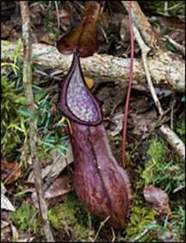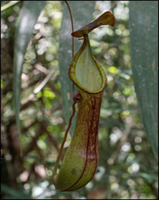
Figure 1. Photos of lower (left) and upper pitcher (right) of Nepenthes talaandig (Source: Gronemeyer, et al., 2014).
According to the International Union for Conservation of Nature (IUCN) Red List, the global status of Nepenthes sp. is currently critical. Around the world, 8.1% of Nepenthes sp. are critically endangered, 11.4% are threatened with extinction, and 17.2% are vulnerable. Forest fires, logging, conversion of forest land or bushes to residential areas, cultivation, plantations, and forest degradation are all common causes (Azwar, et al., 2006).
Natural habitat destruction is widespread in the Philippines, resulting in the extinction of many plant and animal species. There are already conducted studies about the Nepenthes species in Luzon and Mindanao but not in Northern Samar. Exploring the possible presence of Nepenthes in San Isidro and identifying them will be crucial to aid in their future conservation, hence, this study.
Thus, this study was conducted to ascertain the presence of Nepenthes species in selected barangays of San Isidro, Northern Samar.
Locale of the Study
The Nepenthes species was photo-documented in the selected barangays of San Isidro, Northern Samar. Northern Samar lies in the northernmost portion of the island of Samar. It is one of the six (6) provinces comprising the region of Eastern Visayas (Region VIII). The province consists of twenty-four (24) municipalities, five (5) of which are island municipalities, fifteen (15) are coastal towns, and four (4) are found in interior.
The Municipality of San Isidro is one of the twenty-four (24) municipalities of Northern Samar. It is a coastal town located in the southwestern part of the province facing the Samar Sea. It is about sixty-four (64) kilometers from Catarman and approximately fifty-four (54) kilometers northwest of Calbayog City. It is comprised of fourteen (14) barangays, which are San Roque, Poblacion Norte, Poblacion Sur, Buenavista, Balite, Seven Hills, Happy Valley, Alegria, Salvacion, San Juan, Palanit, Mabuhay, Veriato, and Caglanipao. The total population of the Municipality of San Isidro is 27,867 broken down into 5,545 households (www.philatlas.com).
Research Design
Descriptive type of research was utilized in this study. It is a method of research which is a fact-finding study with adequate and accurate interpretation of findings. The data was gathered by using an interview guide, through actual interview with the respondents, and by means of determining the environmental conditions in the sampling sites with the help of specific instruments. Also, photo documentation of the species was done in order to identify the samples.
Research Instrument
This study used an interview guide to obtain relevant data about the economic importance and anthropogenic activities that influence the condition of Nepenthes species found in the sampling sites. The interview guide was prepared in English and translated into the Ninorte Samarnon dialect so that the respondents will have a clear idea about the questions.
The Respondents
The respondents were purposively chosen by the researcher. In each barangay, fifteen (15) respondents were purposively identified, specifically the elderly villagers, who are aged 60 years old or older, have resided in the area for most of their lives, and regardless of their sex. Also, the “albolaryos” was included as respondents regardless of their age and sex.
The Interview Guide
In order to gather data for the economic importance and anthropogenic activities that may influence the condition of the Nepenthes, an interview guide that was composed of two parts was prepared. The first part was about the economic importance of Nepenthes that was known by the respondents. The second part was about the anthropogenic activities that might influence the condition of Nepenthes. In order to record the data, the responses of the respondents were written in a field notebook.
Identification and Authentication of the Plants
Photos of the plants was sorted for the ease of classification and identification. For the preliminary identification, references about Nepenthes in the internet was used. Verification of the preliminary identification was done by an expert botanist from the College of Science, University of Eastern Philippines, University Town, Northern Samar
Result and Discussions
Species Composition of Nepenthes species in San Isidro, Northern Samar
Table 1 shows that there were nine (9) species of Nepenthes present in the sampling areas which are Nepenthes alata Blanco, N. graciliflora Elmer, N. gracilis Korth, N. mirabilis (Lour.) Rafarin, N. reinwardtiana Miq., N. sanguinea Lindl., N. tentaculata Hook.f., N. truncata Macfarl, and N. ventricosa Blanco. Both N. alata Blanco and N. gracilis Korth had upper and lower pitcher, N. mirabilis (Lour.) Rafarin and N. reinwardtiana Miq. with upper pitcher only, and lower pitchers only of N. graciliflora Elmer, N. sanguinea Lindl., N. tentaculata Hook.f., N. truncata Macfarl, and N. ventricosa Blanco. All of these species were locally known as “pitchel-pitchel” or “pitchel-pitchelay”.
Table 1 also revealed that N. gracilis Korth lower pitcher was the most found species as it was present in all sampling areas, followed by N. mirabilis (Lour.) Rafarin upper pitcher that was found in seven (7) sampling areas which are Poblacion Sur, Seven Hills, Happy Valley, San Juan, Palanit, Veriato, and Caglanipao. Moreover, N. gracilis Korth upper pitcher was present in six (6) sampling sites which are Seven Hills, Happy Valley, Alegria, San Juan, Palanit, and Veriato while lower pitcher of N. alata Blanco was also present in six (6) sampling areas which are Balite, Seven Hills, Happy Valley, Alegria, San Juan, and Caglanipao. Upper pitcher of N. alata Blanco was found in five (5) sampling sites which are Seven Hills, Happy Valley, Palanit, Veriato, and Caglanipao. N. graciliflora Elmer lower pitcher was present only in four (4) sampling areas which are Balite, Seven Hills, Happy Valley, and Palanit while N. ventricosa Blanco lower pitcher was also present in four (4) sampling areas which are Poblacion Sur, Seven Hills, Happy Valley, and Palanit. Furthermore, three (3) species were present in three (3) sampling sites which are N. reinwardtiana Miq.– found in Happy Valley, San Juan, and Palanit, N. sanguinea Lindl.– found in Poblacion Sur, Seven Hills, and Caglanipao, and N. truncata Macfarl. – found in Balite, Happy Valley, and Veriato. Lastly, N. tentaculata Hook.f. lower pitcher was present only in two (2) sampling sites which are Happy Valley and Palanit.
Results in Table 1 indicated that Barangay Happy Valley appears to have the largest number of Nepenthes species with a total of eight (8) species. It was observed that Barangay Happy Valley was the most undisturbed forest area compared to others. Moreover, Barangay Palanit has a total of seven (7) species, Barangay Seven Hills has a total of six (6) species, and Barangays Poblacion Sur, Balite, San Juan, Veriato, and Caglanipao were all have a total of four (4) species. On the other hand, Barangay Alegria has the least number of Nepenthes species with a total of two (2) species only. It was observed that forest area of Barangay Alegria was frequently visited by the residents compared to other sampling areas.
Economic Uses of Nepenthes species in San Isidro, Northern Samar
Based on the interviews conducted by the researcher through an interview guide, it was revealed that the local residents used Nepenthes species as ornamental plant. In addition, sometimes Nepenthes species was used as a source of income or for barter for any goods like rice and instant coffees. According to Rizqiani, et al., (2018) the uniqueness and variation of the pitchers attract people to collect Nepenthes for ornamental plants.
On the other hand, the result of conducted interviews with albolaryos showed that they were all familiar with the plant, however, they do not know if it can be used as medicine since they have not tried it before except from one albolaryo from Barangay Caglanipao who used Nepenthes species as a treatment for snake and dog bites, “kulam”, and “usog”. It was prepared during Lenten seasons only, specifically, during Good Friday by finely chopping the Nepenthes pitchers, by adding the chopped roots of different woods, and then by adding some coconut oil. The mixture will be contained in a bottle and ready to be used. For snake and dog bites, the mixture will be applied directly in the bitten area. For “kulam” and “usog” the mixture will be applied by the albolaryo in the form of the cross in the head, stomach, and navel of the patient. However, this result was not anchored with other studies since there is no similar finding that was found and it was based only in the practice and belief of the said albolaryo.
Anthropogenic Activities that Influence the Conditions of Nepenthes species in the Sampling Sites
Through the interview guide, the interviews conducted with the local residents of the sampling sites revealed that habitat destruction, cultivation, and overexploitation of Nepenthes species were the human activities that influence the growth and condition of the plants. According to the respondents, during the surge of COVID-19 and the emergence of “Plantitas” and “Plantitos”, Nepenthes species was harvested by the farmers from its natural habitats and they will trade it or use it for an exchange of any goods. Considering its unique characteristics, many residents from the sampling sites and even from the other towns were attracted to buy, collect, and cultivate Nepenthes, resulting to the great deduction in the population of the plants. Moreover, since Nepenthes usually grow in the areas with high humidity, plants brought in the barrios sometimes died due to too much exposure to sun.

Table 1. Distribution of Nepenthes Species in San Isidro, Northern Samar
Species | Type | SS
Species | Type | 1 | 2 | 3 | 4 | 5 | 6 | 7 | 8 | 9
Nepenthes  alata Blanco | Upper pitcher | * | * | √ | √ | * | * | √ | √ | √
Nepenthes  alata Blanco | Lower pitcher | * | √ | √ | √ | √ | √ | * | * | √
Nepenthes graciliflora Elmer | Lower pitcher | * | √ | √ | √ | * | * | √ | * | *
Nepenthes gracilis Korth | Upper pitcher | * | * | √ | √ | √ | √ | √ | √ | *
Nepenthes gracilis Korth | Lower pitcher | √ | √ | √ | √ | √ | √ | √ | √ | √
Nepenthes mirabilis (Lour.) Rafarin | Upper pitcher | √ | * | √ | √ | * | √ | √ | √ | √
Nepenthes reinwardtiana Miq. | Upper pitcher | * | * | * | √ | * | √ | √ | * | *
Nepenthes sanguinea Lindl. | Lower pitcher | √ | * | √ | * | * | * | * | * | √
Nepenthes tentaculata Hook.f. | Lower pitcher | * | * | * | √ | * | * | √ | * | *
Nepenthes truncata Macfarl. | Lower pitcher | * | √ | * | √ | * | * | * | √ | *
Nepenthes ventricosa Blanco | Lower pitcher | √ | * | √ | √ | * | * | √ | * | *
TOTAL NO. OF SPECIES |  | 4 | 4 | 6 | 8 | 2 | 4 | 7 | 4 | 4

Legend:

(√) Present (*) Absent
SS- Sampling Sites

SS 1: Barangay Poblacion Sur SS 6: Barangay San Juan
SS 2: Barangay Balite SS 7: Barangay Palanit
SS 3: Barangay Seven Hills SS 8: Barangay Veriato
SS 4: Barangay Happy Valley SS 9: Barangay Caglanipao
SS 5: Barangay Alegria

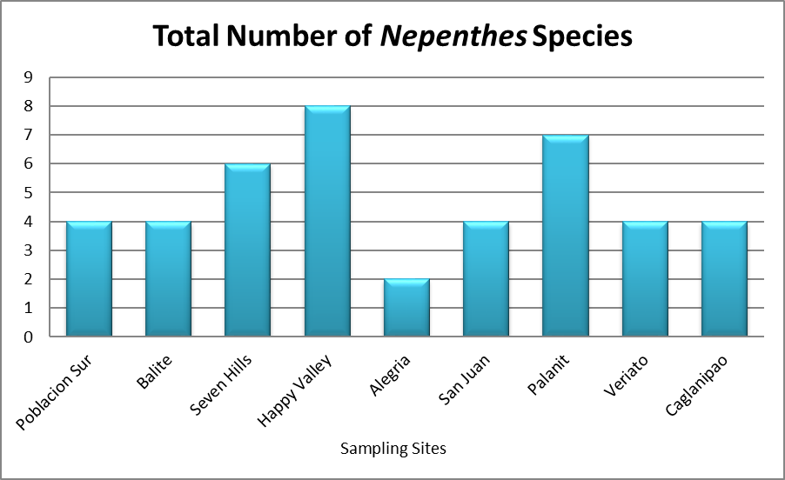
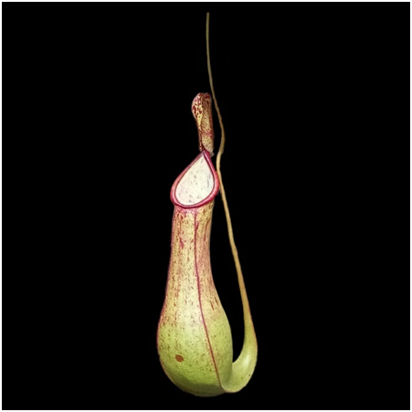
Figure 2. Distribution of Nepenthes species in each Sampling Site
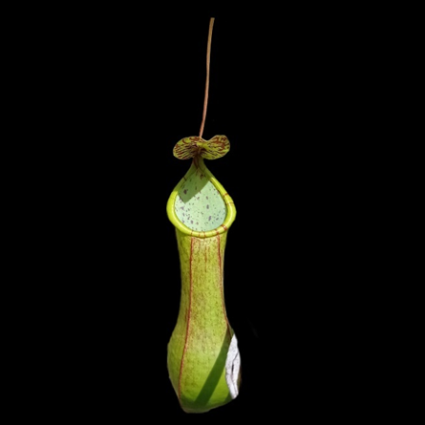


Fig3.Nepenthes alata Blanco, (A) upper pitcher and (B) lower pitcher
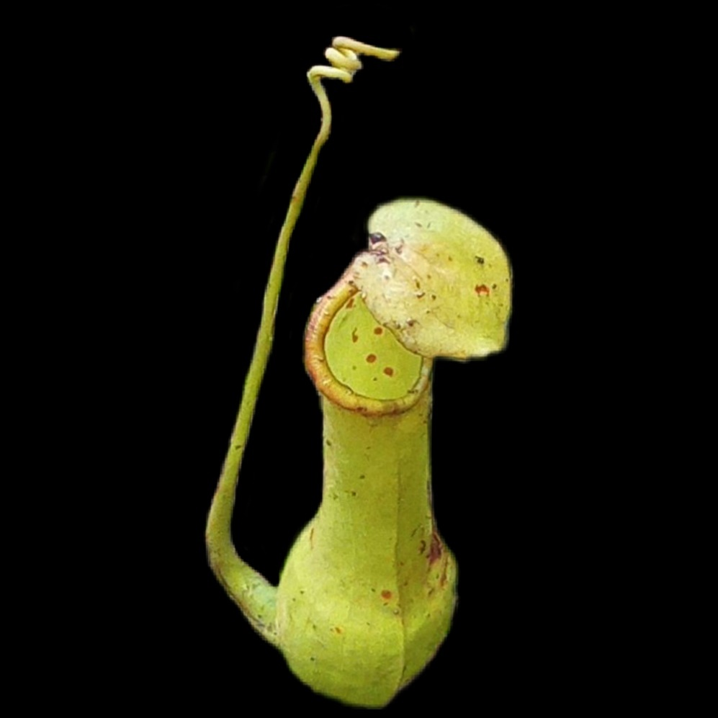
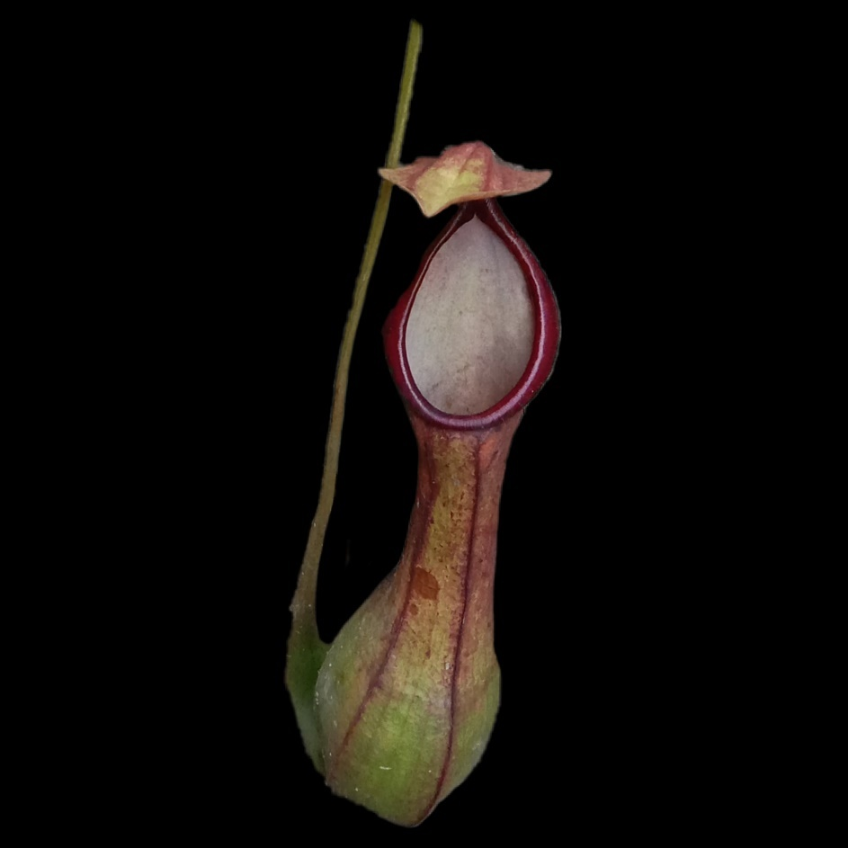

Fig4.Nepenthes graciliflora Elmer (lower pitcher) Fig5.Nepenthes mirabilis (Lour.) Rafarin (upper pitcher)
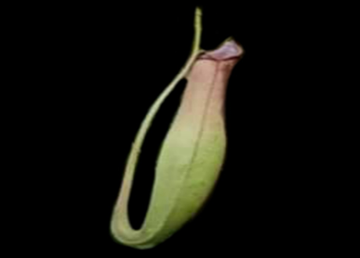
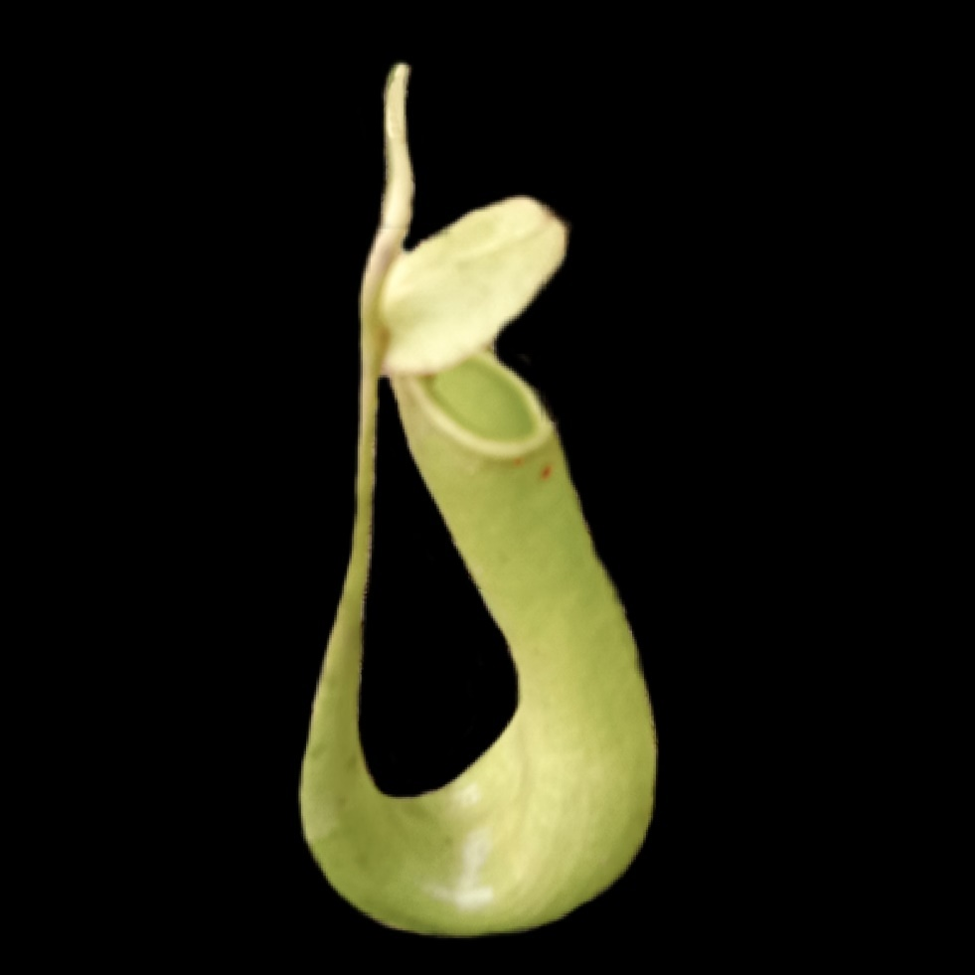
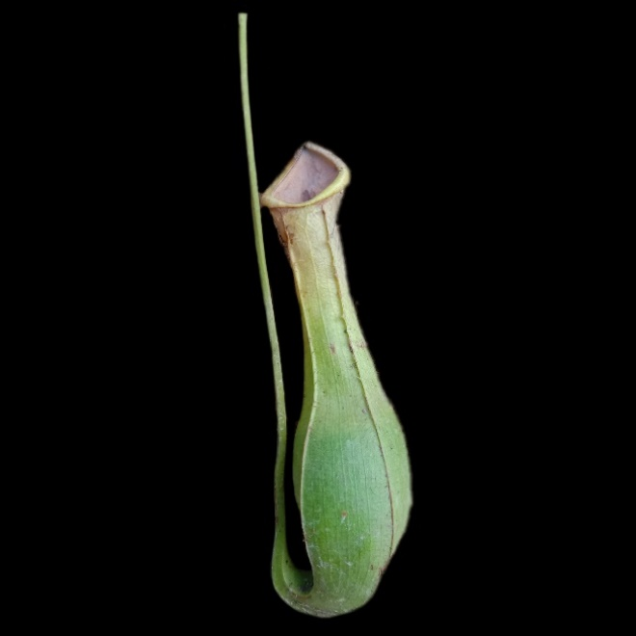
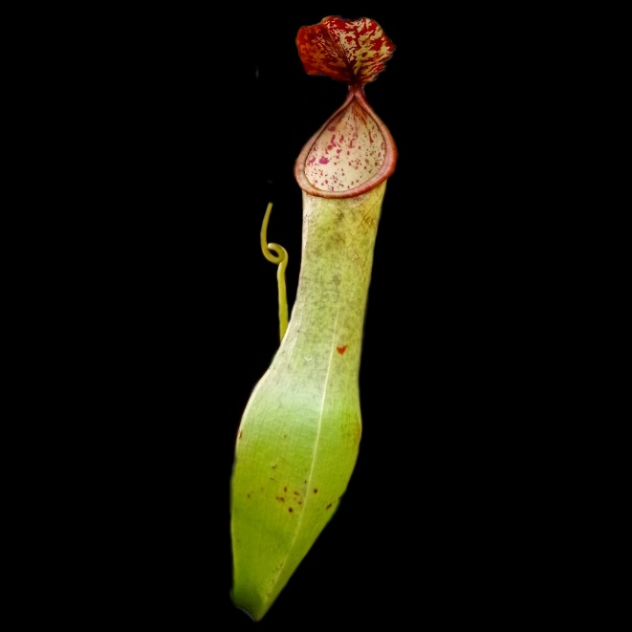
Fig6.Nepenthes graciliflora Elmer (lower pitcher) Nepenthes gracilis Korth, (A) actual photo (upper right)and emphasized photo of upper pitcher (center), (B) actual photo (upper right) and emphasized photo of lower pitcher (center).
B
A
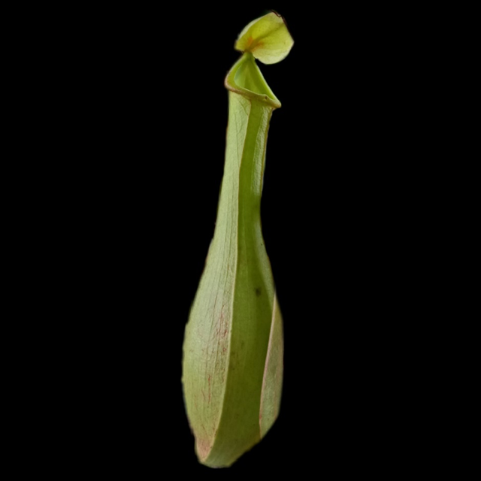
Fig7.Nepenthes reinwardtiana Miq. (upper pitcher) Fig8.Nepenthes sanguinea Lindl. (lower pitcher)
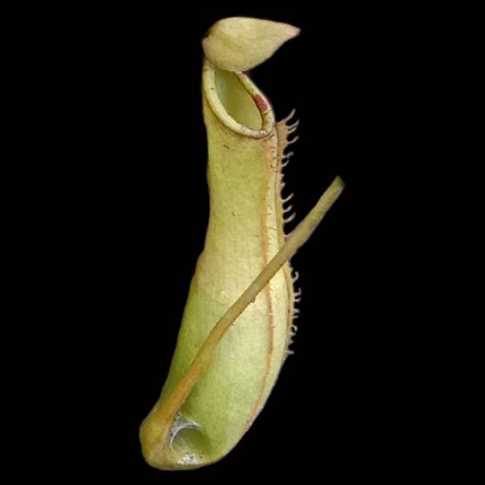
Fig9.Nepenthes tentaculata Hook.f. (lower pitcher) Fig10.Nepenthes truncata Macfarl. (lower pitcher)
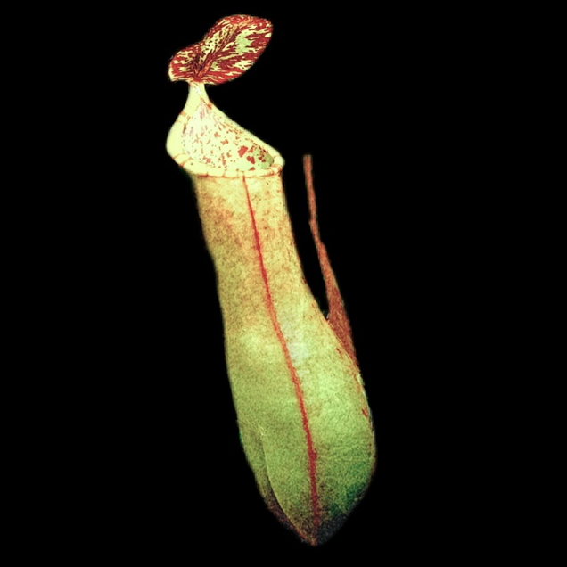

Fig11.Nepenthes ventricosa Blanco (lower pitcher)

Test for Tannins. The test tube method was used to determine the presence of tannins (Guevara 2005). Ten grams of the plant samples was centrifuge about 20 minutes to allow the solid particles of the extract to settle down at the bottom of the test tube, then the clear supernatant liquid was decanted and tested for the presence of tannin. About 3ml of supernated extract was added to a few drops of 1٪ lead acetate, the yellowish precipitate indicated the presence of tannins.
Preparation of culture media and sensitivity discs
Culture media for bacteria was prepared following by dissolving 19g Nutrient Agar (NA) in 500mL distilled water. Potato dextrose agar (PDA) (9.5g) was also dissolved in 250mL distilled water as culture medium for fungi. The mixtures were agitated vigorously to completely dissolve the media and were pressure sterilized at 121⁰C at 15psi pressure. Then allowed to cool down to about 50⁰C, and aseptically dispensed into individual petri dishes and allowed to solidify at room temperature.
Sensitivity discs were prepared using filter paper (Whatman No.41) formed into round discs using a puncher. Each disc was placed in petri dish, pressure sterilized at 121⁰C at 15psi pressure, and soaked in the P. foetida crude extracts.
Antimicrobial Screening
The antimicrobial activity of P. foetida extract was determined through the modified Kirby Bauer antibacterial sensitivity test (Bauer et al. 1996) against the test microorganisms S. aureus (gram-positive bacteria and E. coli (gram-negative bacteria, which were provided by the Centro Escolar University (CEU) Microbiological Laboratory. Chlorampenicol was used as positive control for S. aureus and Tetracycline for E. coli. The culture media plates were aseptically inoculated with bacteria, and the filter paper discs soaked in P. foetida extracts were carefully and aseptically placed at the center of each agar plate to maximize the space for bacterial growth and to facilitate measurement of the zone of inhibition. The plates were incubated at 37⁰C for 24h for bacteria. The zones of inhibition around the discs, which were measured using a vernier caliper, indicated that growth of the microorganism had been inhibited by the that diffused into the agar from discs. Absence of zone of inhibition indicated the resistance of the microorganisms to P. foetida extract.
Phytochemical screening

Tannins, alkaloids and saponins were detected in extracts from leaves of P. foetida as shown in Table 2. Flavonoids were not detected from extracts regardless of solvent used. Saponin and alkaloid was only present in extracts obtained using ethyl alcohol as solvent.

Table 2. Chemical Presence of the Extract from the Leaf of Paederia foetida
Chemical properties | Leaf Extract
Chemical properties | Ethyl alcohol | Ethyl acetate
Alkaloids | + | -
Flavonoids | - | -
Saponins | + | -
Tannins | + | +
Legend: (+) = present; (-) = not detected

Antimicrobial Property
Zones of inhibitions in plates inoculated with S. aureus and E. coli were numerically higher in extracts produced using ethyl alcohol as solvent as shown in Table 2. Inhibitory activity was observed only against bacteria. There is no significant difference of the leaf extracts as to their antimicrobial activity on E. coli and S. aureus.
There is no significant difference between the solvents used in the study as to their antimicrobial resistance and activity. Both of them showed great antimicrobial activity. Either of the two can be used as a source of substances capable to inhibit the growth of or kill microorganisms.

Table 3. Zone of inhibition (mm) formed in Nutrient Agar with crude extracts from leaves of P. foederia.
*chlorampenicol / **tetracyline
Leaf Extract | Test microorganism
Leaf Extract | S. aureus | E. coli
Ethyl alcohol | 22.70 mm | 21.00 mm
Ethyl acetate | 13.95 mm | 14.20 mm
Control | 21.00* mm | 19.70**mm

The ethyl alcohol leaves extracts of Paederia foetida showed a positive result for the presence of alkaloid, tannin, and saponin. These vast structural diversity of natural compounds found in P. foetida will provide potential opportunities for discovering new drugs. In terms of the antibactrial activity of the extract, no significant relationship was established between the effect of the extract and the microorganisms used in the study. However, the leaves extracts of P. foetida showed great antimicrobial resistance and activity, thus, it can be used as a source of substance capable of inhibiting the growth of, or even kill microorganisms.

The fact that the growth of E. coli and S. aureus can be inhibited by the leaves extracts of P. foetida, it is confirmed that the plant is an excellence source of organic antibactrials effective against both gram-positive and gram-negative bacteria. It can be recommended that the extracts be tested against other bacterial and fungal organisms that may be susceptible to the extract.

Conclusions

There were nine (9) Nepenthes species that have been photo-documented in the sampling sites which are upper and lower pitcher of Nepenthes alata Blanco and N. gracilis Korth, upper pitchers of N. mirabilis (Lour.) Rafarin and N. reinwardtiana Miq., and lower pitchers of N. graciliflora Elmer, N. sanguinea Lindl., N. tentaculata Hook.f., N. truncata Macfarl., and N. ventricosa Blanco.

Residents usually used Nepenthes species as ornamental plants or for barter for any goods like rice and instant coffees. On the other hand, an albolaryo from Barangay Caglanipao used the finely chopped Nepenthes pitchers together with chopped roots of different woods and some coconut oil as a treatment for snake and dog bites, “kulam”, and “usog”.

Anthropogenic activities such as habitat destruction, cultivation, and overexploitation of Nepenthes species were the anthropogenic activities that influence the condition of the plant that were identified by the residents of the sampling sites.

Recommendations

Same study maybe conducted but in other Barangays of San Isidro or in other Municipalities of Northern Samar for possible additional species and for future conservation.
In addition, the Local Government Unit (LGU) may implement ordinances that will strictly prohibit the habitat destruction, collection, cultivation, and trading of Nepenthes species to aid the conservation of the plant in San Isidro,

Lastly, the Department of Environment and Natural Resources (DENR) may conduct an assessment in San Isidro, Northern Samar to ascertain the status of Nepenthes species and they may coordinate with the LGU to take an immediate action on how to conserve the pitcher plants.

REFERENCES

Afroz S, Alamgir M, Khan MTH, Jabbar S, Nahar N and MSK Choudhuri. 2006. Antidiarrhoel activity of the ethanol extract of Paederia foetida Linn. (Rubiaceae). Journal of Ethnopharmacol, 105:125–30.

Barua U, Hore DK and R. Sarma. 2007. Wild edible plants of Ajuli Island and Darrang districts of Assam. Indian Journal of Traditional Knowledge, 6:191–194.

Bauer AW, Kirby MM, Sherris JC and M Turck. 1996. Antibiotic susceptibility testing by a standardized single disk method. The American Journal of Clinical Pathology 45(4).

Borah PK, Gogoi P, Phukan AC, Mahanta J. 2006. Traditional medicine in the treatment of gastrointestinal diseases in upper Assam. Indian Journal of Traditional Knowledge, 5: 510−512.

Chanda S, Sarethy IP, De B and K Singh. 2013. Paederia foetida- a promishing ethnomedicinal tribal plant of Northeast India. Journal of Forestry Research, 24:801–8.

Chanda S, De B, Tiwari RK. 2011. Traditional and ethnobotanical investiga-
tion of some edible plants among the tribes of Tripura, India. In: M.D. Choudhury, G.D Sharma, S. Choudhury, A.D. Talukdar (eds), Status and
conservation of bio-diversity in North East India. Delhi: Swastik publication, pp. 118−124.

Chopra, R.N., Nayar, L.C., Chopra, L.C. 1956. Glossary of Indian Medicinal Plants. Council of Scientific and Industrial Research. New Delhi India.

Chopra, R.N., Chopra, I.C. Verma, B.S., Supplement to Glossary of Indian Medicinal Plants. Council of Scientific and Industrial Research. New Delhi India.

Das P. 1997. Wild tribal plants of Tripura tribes. Agartala: Tripura Tribal Cultural Research Institute & Museum Government of Tripura, p. 57−58

Das S, Kanodia L, Mukherjee A, Hakim A., 2013. Effect of ethanolic extract of leaves of Paederia foetida Linn. on acetic acid induced colitis in albino rats. Indian J Pharmacol.

Dasgupta N, De B. 2007. Antioxidant activity of some leafy vegetables of India: A comparative study. Food Chemistry, 101: 471-474.

De S, Shukla VJ, Ravishankar B, Bhavsar GC. 1996. A preliminary study on the hepatoprotective activity of methanol extract of Paederia foetida leaf. Fitoterapia, 67: 106−109.

De S, Ravishankar B and GC Bhavsar. 1994. Investigation of the anti‒inflammatory effects of Paederia foetida. Journal of Ethnopharmacology, 43(1):31‒38.

De S, Ravishankar B and GC Bhavsar. 1993. Evaluation of Paederia foetida for hepatoprotective and anti–inflammatory activities. Indian Journal of Natural Product, 9:7–11.

Dey YN and MK Pal. 2011. Evaluation of anti‒helmintic activity of leaves of Paederia foetida. International Journal of Pharma Bio Sci, 2(1):227‒231.

Duke, J. A. 2002. Handbook of medicinal herbs. CRC Press: Boca Raton, Florida; 2nd edition, pp 896.

Ghani A. 2003. Medicinal plants of Bangladesh with chemical constituents and uses. 2nd edition. Asiatic Society of Bangladesh; 331‒33.

Guevara BQ. 2005. A Guidebook to Plant Screening: Phytochemical and Biological. Research Center for the Natural Sciences and University of Santo Tomas Publishing House, Beato Angelico Bldg. Espana, Manila.

Haider R, Khan AK and KM Aziz. 1991. Evaluation of indigenous plants in the treatment of acute shigellosis. Trop Geogr Med. 43(3):266‒270.

Hossain M, Mohammad SA, Saha A, Alimuzzaman M. 2006. Antinociceptive activity of whole plant extracts of Paederia foetida. Journal of Pharmaceutical Sciences, 5: 67−69.

Kalita D and B Phukan. 2010. Some Ethnomedicine used by the Tai Ahom of Dibrugarh district, Assam, India. Indian Journal of Natural Product, 1:507–11.

Kar A, Borthakur SK. 2008a. Wild vegetables of Karbi-Analog district, Assam. Natural Product Radiance, 7: 448−460.

Kar A, Borthakur SK. 2008b. Medicinal plants used against dysentery, diarrhea and cholera by the tribes of erstwhile Kameng district of Arunachal Pradesh. Natural Product Radiance, 7: 176−181.

Langeland, K. A. and K. Craddock Burks (eds.) 1998. Identification and Biology of Non-native Plants in Florida’s Native Areas. University of Florida, Gainesville, Florida, USA

Nandkoni KM (Ed) 2002. Indian Materia Medica. Mumbai: Bombay Popular
Prakashan: 892.

Osman H, Rahim AA and NM Isa. 2009. Antioxidant activity and phenolic content of Paederia foetida and Syzygium aqueum. Molecules, 14(3):970‒978. 17.

Prakash V, Mishra PK, Mishra M. 2009. Screening of medicinal plant extracts for antioxidant activity. Journal of Medicinal Plants Research, 3: 608−612.

Raghunathan K and R Mitra. 1982. Pharmacognosy of indigenous drugs vol 2. Central Council for Research in Ayurveda and Siddha: New Delhi, India.

Rajashekhara N, Sharma PP and P Vasanth. 2009. Comparative study of Prasarni [Merremia tridentate Hallier.f. (Convulvulaceae) and Paederia foetida (Rubiaceae)] in Amavata (Rheumatoid arthritis). 30:503-507
Ravi V, Saleem TSM, Patel SS, Raamamurthy J, Gauthaman K. 2009. Anti-inflammatory effect of methanolic extract of Solanum nigrum Linn berries. International Journal of Applied Research in Natural Products, 2: 33−36.

Srivastava RC, Singh RK. 2010. Apatani community, Mukherjee TK. Indigenous biodiversity of Apatani plateau: Learning on biocultural knowledge of Apatani tribe of
Arunachal Pradesh for sustainable live hoods. Indian Journal of Traditional Knowledge, 9: 432−442

de Tavera, T.H. Pardo, 2000. “(Plantas Medicinales de Filipinas) Medicinal Plants of the Philippines”. (Makati City: Ayala Foundation Inc., Filipinas Heritage Library, Makati Avenue, ayala Triangle, 59

The Ayurvedic Pharmacopeia of India (1999). Ministry of Health and Family Welfare Department and Indian System of medicine and Homeopathy, New Delhi. Part I, Vol – II: 137 –140.

The Wealth of India. 2001. A dictionary of Indian raw materials and industrial product, raw materials, vol. 7. New Delhi: Council for Scientific and Industrial Research (CSIR).

Thompson KD, Ather A., 2005. Antiviral activity of three Bangladeshi medicine plant extracts against herpes simplex viruses. Antiviral Res, 67:107–115

Wong, K. C.; Tan, G. L. 1994. Steam volatile constituents ofthe aerial parts of Paederia foetida L. Flavour Fragr. J; 9 (1): 25–28.

Yang LL, Yen KY, Kiso Y, Kikino H. 1987. Antihepatotoxic actions of Formosan plant drugs. Journal of Ethnopharmcology, 19: 103−110.

Barthlott, W., S. Porembski, R. Seine, and I. Theisen. 2007. The Curious World of Carnivorous Plants. Portland, Oregon: Timber Press.
Gronemeyer T., F. Coritico, A. Wistuba, D. Marwinski, T. Gieray, M. Micheler, F. Sockhom Mey, and V. Amoroso. 2014. Four New Species of Nepenthes L. (Nepenthaceae) from the Central Mountains of Mindanao, Philippines. Plants. 3, 284-303, ISSN 2223-7747, doi:10.3390/plants3020284.www.mdpi.com/journal/plants
McPherson, S. 2009. Pitcher Plants of the Old World. Redfern Natural History Productions, Poole, U.K.
McPherson, S. 2012. The New Nepenthes. Redfern Natural History Productions, Poole, U.K.
Pelser PB, JF Barcelona, and DL. Nickrent (eds.). 2011. onwards. Co's Digital Flora of the Philippines. Available at www.philippineplants.org
Wan-Nor-Adibah-Wan, Z., Loke, K.K., Zulkapli, M.M., Salleh, I.M., Goh, H.H. and Noor, N.M. (2016). RNA-seq analysis of Nepenthes ampullaria. International Journal of Plant Science, 164(1), 635- 639.

Northern Samar.

