Original Research Article

Surveillance of surgical site infection & burnt skin infection in high-risk area and documenting its spread to give prevention guidelines for resource constrained institute

**2. Abstract:**

**2.1 PURPOSE**: Our study aims at analyzing multiple factors such as; finding the prevalence of SSI and BSI infections including incidence rates and hospital wide rates, to find to antibiotic profile including multidrug resistant organism like CRE(carbapenem resistant Enterobacteriaceae) and ESBL ( extended spectrum beta-lactamases ) which would help us to come to appropriate guidelines, to perform antibiotic strain typing of isolated organism to identify exact sources, to find out risk factors associated with infection.

**2.2 METHOD:** Our study is a hospital based cross-sectional study. The study included all the patients from High risk containing ICUs, surgical ward and burn ward within the study period and show clinical symptoms and positive culture result. The antibiotic susceptibility testing was done by Kirby-Bauer disk diffusion method and interpretation was done following CLSI guidelines.

**2.3 RESULT**: The incidence rates (per 1000 hospital days) for SSI was 90.90 and for BSI was 41.66. Hospital wide rates were 29.94 for SSI and for BSI the same was 25. The occurrence was found to be twice more among males than females. The organism isolated in our study was Acinetobacter baumannii (31.39%), Pseudomonas aeruginosa (20.93%), E. coli(17.44%), Klebseilla pneumonia(13.95%), CONS (10.46%), Enterobacter species(4.65%) and the least being Klebseila oxytoca (1.16%).ESBL production rates were highest in E.coli (40%), P. aeruginosa (27.77%) and K. pneumonia (33.33%).

**2.4 CONCLUSION**: Our study shows that if infection control practices are executed and followed appropriately then it may decrease the incidence rates of infections occurring during the hospital stays of the patients. Proper monitoring should be ensured to control the infections in patients post-operatively and infections in the patients with burn wounds. Anti-microbial stewardship program should be taken into consideration to prevent antibiotic resistance in the organism to make sure the proper treatment of the patients admitted in health-care facilities and to reduce the economic burden of patients.

**3. Keywords:**

Infection spread prevention, Surgical site Infection, Burnt skin infection, Antibiotic susceptibility pattern, Antibiogram typing

**4. Introduction:**

Nosocomial infections represent one of the most significant adverse events for hospitalized patients, with Surgical Site Infections (SSIs) being the most prevalent among them. It is estimated that approximately 1.6 million individuals worldwide are affected by infections acquired in healthcare settings at any given time. SSIs continue to be a critical complication following surgery, impacting 2% to 5% of all surgical patients. Efforts at both local and national levels have led to substantial improvements in the incidence of SSIs. [1][2][3]

This leads to prolonged hospital stays, resulting in economic costs for patients and inefficient use of resources by hospitals.[4] Also, with time, the pathogenic flora of hospitals becomes more resistant to antibiotics causing failure of therapy during the critical time(s) leading to additional avoidable mortality.[5]

Burns are responsible for more than 300,000 deaths annually; infection is a major cause of morbidity and mortality in these patients. Early identification and treatment of infection improves outcome. Toward this end it's necessary to identify the institutions flora and organisms that most frequently produce infection.[6]

Interventions to prevent SSI are based on knowledge of the various risk factors that predispose a patient to develop such an infection and an understanding of the microbiology of SSI [7]. Many studies showed that such adverse events can be prevented by following basic guidelines of hygiene but some parallel studies also suggest that such regime is only effectible in a separate isolation ward where there is less chance of acquiring pathogens other than healthcare workers[8]

Frequent hand washing and aseptic precautions can reduce surgical site infections, especially in resource-limited settings. Washing hands and forearms before procedures lowers skin bacteria exposed to patients. Sterilizing contact devices is crucial, but solutions are needed for non-medical articles and electric equipment that can introduce pathogens, particularly harmful to those with pre-existing conditions. Open surgical and burn wounds are highly susceptible to contamination from environmental commensals.

**5. Material and Methods:**

This was hospital based cross sectional study which was done at medical college associated hospital for total of 16 weeks of length. It was done at high-risk areas including icus, surgical ward and burn ward. Patients suffering from surgical site infection and burnt skin infection.

were chosen as primary subjects.

Consent was obtained prior to enrolling them in the study. Case definition for surgical site infections as well as burnt skin infections were decided. [9][10]Personals coming in contact/ may be suspected to bring pathogens to the patient and article/ items coming in contact/ may be suspected to bring pathogens to patient were also included as study materials.

Samples were collected using techniques described under CLSI (Clinical and Laboratory Standards Institute) guidelines. Personnel sampling involved collecting specimens with sterile swabs moistened with nutrient broth from the palms, noses, and axillae of healthcare workers (including doctors, nursing staff, interns, medical students, janitors, and ward boys) as well as patient attendants. Surface sampling was conducted on high-touch surfaces in the vicinity of patients admitted to the ICU and wards. High-touch surfaces included, but were not limited to, bed rails, tray tables, and bedside tables. Air sampling was performed using the Settle Plate Method, employing the 1x1x1 method. Blood agar plates were placed in high-risk areas at different locations: 1 meter away from side walls and 1 meter above the floor. They were exposed to air for one hour and incubated at 37°C for 24 hours. Interpretation was done by counting CFU/m²/hr. Patient sampling was performed consistently, while the collection of other samples was carried out as required, ensuring an adequate interval between consecutive samples.

Laboratory testing was conducted in a microbiology lab. Gram staining, aerobic culture, and biochemical tests identified isolated species using standard techniques. Isolated species were categorized into pathogens and non-pathogenic flora. Antibiotic susceptibility was determined by the Kirby-Bauer disk diffusion method following CLSI 2018 guidelines. Isolates were tested for MRSA and ESBL per CLSI recommendations.

Antibiogram Strain Typing: Performed via Kirby-Bauer disc diffusion method, interpreted using CLSI criteria. Isolates with matching susceptibility profiles (within the same species) were labeled as Laboratory Isolates (LI-1, LI-2, etc.). Sources and routes were identified based on these profiles. Isolates were also screened for multidrug resistance patterns. SSI and BSI rates were calculated per 1000 hospital days using the following formula: Total number of infections * 1000 / Total number of patients in surgery ward or burn ward and their stay. Hospital-wide rates were calculated per 100 admissions for the given period using the following formula: Total number of infections * 100 / Total number of patients in which surgery was performed or burn cases.

**6. Result**

The total number of SSI cases was 50, and the total number of hospital days for patients with recent surgery was 550 days, resulting in an SSI rate of 90.90 per 1000 HD. The total number of patients admitted (who underwent surgery and met the inclusion criteria) was 167, leading to a hospital-wide SSI rate of 29.94 per 100 surgeries.The total number of BSI cases was 10, and the number of hospital days for patients with recent infections was 240 days, resulting in a BSI rate of 41.66 per 1000 HD. The total number of patients admitted was 40, leading to a hospital-wide BSI rate of 25 per 100 burn infection cases.

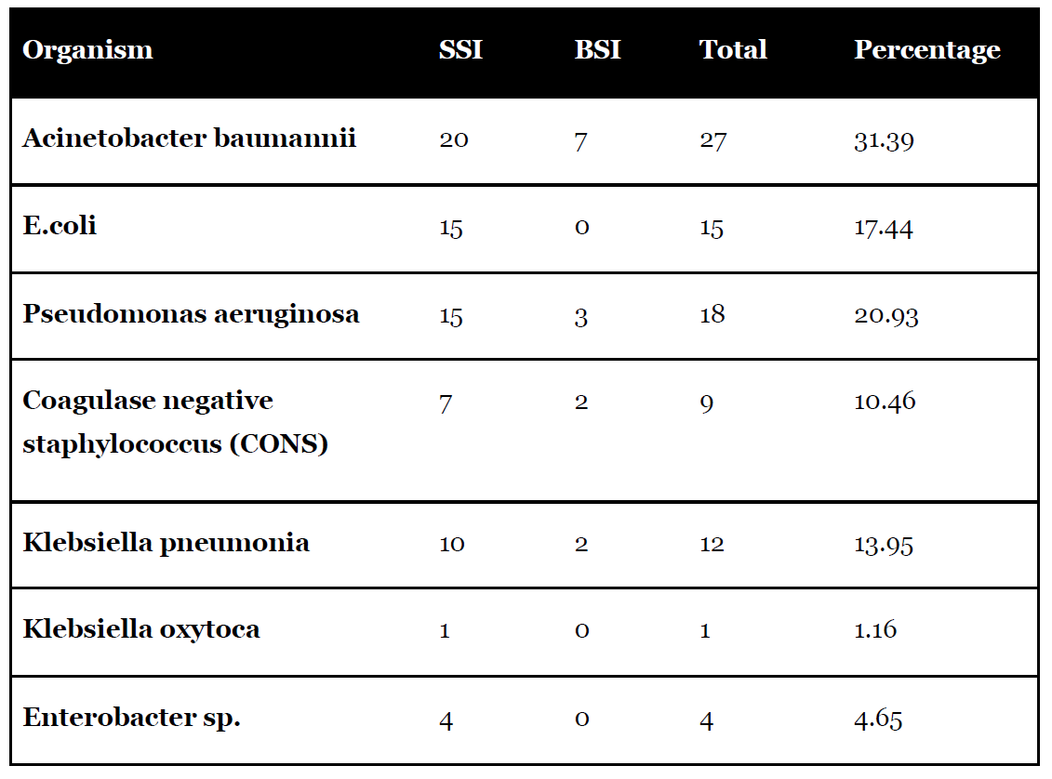

*Table 1: Distribution of isolated organis*

*Figure 1: Isolated organisms from various samples.*

*Figure 2: Comparative analysis of isolated organisms*

All isolated Acinetobacter baumannii are fully resistant to amikacin and over 90% are resistant to ceftazidime, ciprofloxacin, cefazolin, and cefoperazone-sulbactam. They show the highest sensitivity to tigecycline and colistin. Isolated Klebsiella pneumoniae is completely resistant to gentamicin and amoxicillin-clavulanic acid. Around 80-90% are resistant to ceftazidime, tetracycline, and cefoperazone-sulbactam. It’s mostly sensitive to clindamycin, colistin, and tigecycline.Escherichia coli isolates are fully resistant to cefazolin, with 70-90% resistant to ceftriaxone, piperacillin-tazobactam, and ciprofloxacin. They show maximum sensitivity to tigecycline and clindamycin.Enterobacter species isolates are entirely resistant to ceftazidime, piperacillin-tazobactam, and amikacin. Over 50% are resistant to cefoperazone-sulbactam and imipenem. They are most sensitive to aztreonam and tobramycin.Pseudomonas aeruginosa isolates are completely resistant to cefoxitin and amoxicillin-clavulanic acid. More than 70% resist ceftazidime, ceftriaxone, and piperacillin-tazobactam. They show 100% sensitivity to tigecycline and clindamycin. Klebsiella oxytoca shows resistance to all tested antibiotics. Coagulase-negative Staphylococcus (CONS) isolates are fully resistant to ceftriaxone and amikacin. Over 80% are resistant to ceftazidime, ciprofloxacin, and imipenem. CONS is most sensitive to gentamicin, aztreonam, and ceftaroline.

Out of a total of 18 isolates of P. aeruginosa, 5 (27.77%) were found to be ESBL-producing, and 6 (33.33%) were found to be CRE-producing bacteria. Out of a total of 12 isolates of K. pneumoniae, 4 (33.33Five (27.77%) of the 18 P. aeruginosa isolates were identified to produce ESBL, while six (33.33%) were found to produce CRE. Four (33.33%) of the twelve isolates of K. pneumoniae were identified to produce ESBL, and five (41.66%) were found to produce CRE. One isolated K. oxytoca (100%) was discovered to produce CRE.

Two (50%) of the four Enterobacter species isolates were discovered to produce CRE.%) were found to be ESBL-producing, and 5 (41.66%) were found to be CRE-producing bacteria. Out of a single isolated K. oxytoca 1 (100%) was found to be CRE-producing.

Out of a total of 4 isolates of Enterobacter species, 2 (50%) were found to be CRE-producing.

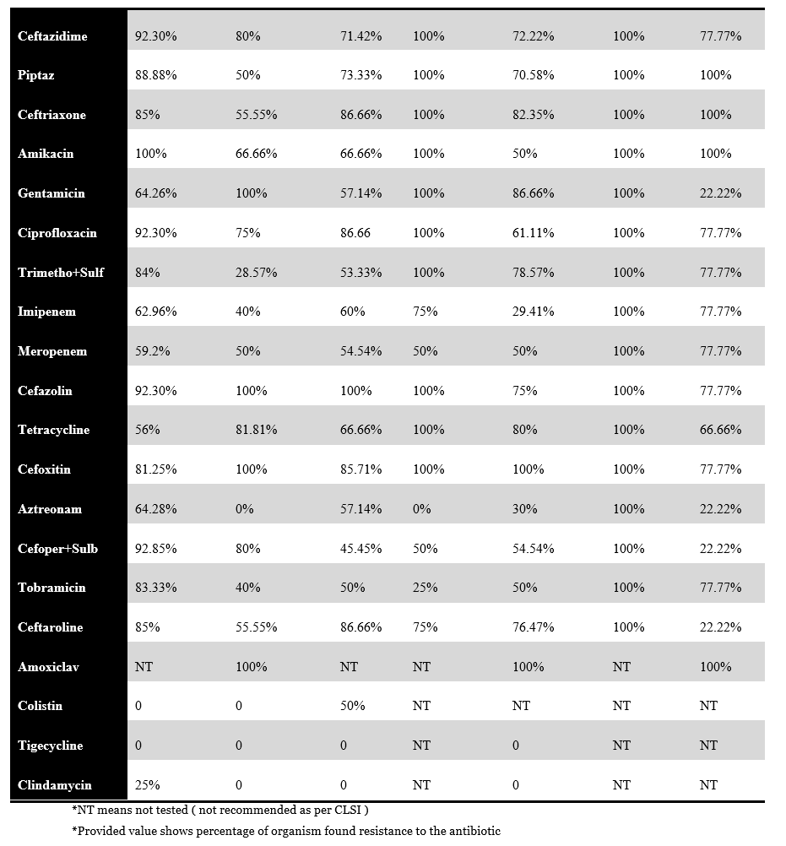

*Table 2: Antibiotic resistance pattern of isolated organisms*

*Table 3: ESBL and CRE Production rate*

**7. Discussion**

Healthcare associated infections (HAIs) are among the most frequent adverse events in patient care, leading to significant morbidity and mortality. They increase both the duration of hospital stays and the associated costs.

Our study included a total of 60 patients with surgical site infections (SSI) and bloodstream infections (BSI). Not all patients were contaminated via environmental surfaces or through contact transmission by healthcare workers. We observed that patients admitted for 11 days, or more were more susceptible to acquiring infections compared to those admitted for less than 11 days. Tess et al.[11] found that patients were more prone to infection between their 14th and 19th day of ICU/ward stay, while Hassan et al.[12] noted a significant period of 9.32 days, slightly lower than our findings. Singh et al.[13] suggested that staying longer than 5 days are also significant.

Patients with pre-existing conditions such as chronic bronchitis, emphysema, diabetes mellitus, or hypothyroidism had higher chances of acquiring HAIs. The common isolated organisms in SSI included A. baumannii, K. pneumonia, E. coli, P. aeruginosa, and CONS, which aligns with the findings of Ramasubramanian et al.[14] Similarly, the microbial profile for burnt skin infections consisted of K. pneumonia, A. baumannii, CONS, and E. coli, consistent with Neelam Taneja et al.[15]

More than half of the isolates exhibited multidrug resistance, complicating treatment options for clinicians. To mitigate the impact of SSIs caused by resistant pathogens, periodic surveillance of bacterial and antibiotic susceptibility, along with strict protocols for antibiotic administration and operative room regulations, is essential. Epidemiological studies showed that nurses and physicians had hand colonization rates ranging from 3% to 23%, with temporary colonization except in cases of injured skin. Pathogens demonstrated varying resistance levels to antibiotics, with high resistance to amoxicillin-clavulanic acid, ceftriaxone, gentamicin, and ciprofloxacin, like Mukagendaneza et al.'s findings.

.[16]

Our study identified several colonized objects or materials likely to carry microorganisms, including tray tables, bedrails, and bedside tables, contaminated by organisms like A. baumannii, CONS, P. aeruginosa, Klebsiella pneumoniae, and E. coli. Similar contamination patterns were observed in studies, also, samples collected from the hands and noses of healthcare workers revealed isolates of A. baumannii, CONS, E. coli, and P. aeruginosa, in line with Suleyman's research.[17]

The most common isolates from burnt skin infections were A. baumannii, E. coli, and K. pneumonia.Patients admitted to hospitals shed microorganisms that can survive for prolonged periods in healthcare environments. Cross-contamination via healthcare workers who touch contaminated surfaces or patients directly contributes to the spread.

Nosocomial infections in burn patients pose significant challenges for clinicians, with an estimated 75% of deaths in these patients associated with infections. Prolonged antibiotic use leads to development and selection of multidrug-resistant bacteria, resulting in treatment failure and complications. Therefore, knowledge of microbial flora and current antibiotic susceptibility patterns is crucial for treating sepsis.

Similar findings of P. aeruginosa being predominant isolates were reported in other tertiary care hospitals in India by M. Dash et al.[18] and C.S. Vinodkumar et al.[19] P. aeruginosa is a major pathogen causing ventilator-associated pneumonia, burn wound infections, and nosocomial bacteremia, spread via healthcare workers and environmental surfaces, with an associated mortality rate exceeding 30%.

Approximately 40% of E. coli isolates, 27.77% of P. aeruginosa, 33.33% of K. pneumoniae, and 50% of Enterobacter species were ESBL producers, similar to the rates shown in Mita D et al.'s study[20]. Additionally, 33% of E. coli isolates, 27.7% of P. aeruginosa, 41.66% of K. pneumoniae, 100% of K. oxytoca, and 50% of Enterobacter species were CRE producers, slightly similar to Qun Lin et al.'sresearch. [21]

**8. Conclusion & Suggestions**

* According to our study, not all patients were contaminated by healthcare workers or environmental surfaces. This is evidenced by the fact that not all patients who tested positive for bacterial isolates also showed positive results in the subsequent samples from healthcare workers and environmental surfaces (cited as articles in the study).
* The antibiotic profiles of patients, healthcare workers, and articles demonstrated similar resistance patterns, indicating that some patients acquired infections during their hospital stay through either healthcare workers, articles, or both.
* Fluoroquinolones, such as ciprofloxacin, were resistant in more than half of the cases. Most organisms exhibited resistance to aminoglycosides, including gentamicin, tobramycin, and amikacin.
* A majority of cephalosporins, such as ceftazidime, cefoxitin, cefoperazone-sulbactam, cefazolin, ceftaroline, and ceftriaxone, were sensitive to over 90% of organisms, which is a concerning situation.
* Amoxicillin-clavulanic acid and piperacillin-tazobactam were found to be resistant in over 90% of all bacterial isolates.
* Antibiotics like tigecycline and colistin showed the highest susceptibility in bacterial isolates.
* The risk factors identified in our study included gender, age, pre-existing medical conditions, and duration of hospital stays.
* Among the total 86 organisms, Acinetobacter baumannii was the most prevalent in both surgical site infections (SSI) and bloodstream infections (BSI), followed in decreasing order by Pseudomonas aeruginosa, E. coli, Klebsiella pneumoniae, Staphylococcus species, Enterobacter species, and Klebsiella oxytoca being the least prevalent.
* The rates of extended-spectrum beta-lactamase (ESBL) and carbapenem-resistant Enterobacteriaceae (CRE) production were high. Therefore, regular monitoring for SSIs should be mandatory in healthcare settings.
* Coagulase-negative staphylococci (CONS) were identified as non-pathogenic skin commensals that did not cause serious life-threatening illnesses. The antibiotic resistance patterns indicate the emergence of extensively drug-resistant and pandrug-resistant strains, with isolates exhibiting resistance to commonly used antibiotics.
* Every hospital should have an infection and control committee under the medical superintendent. Training healthcare workers can reduce infection rates. Regular surveillance of hospital environments, sanitizing ICUs and wards, and maintaining hand hygiene are crucial. Infection control measures must be followed. Antimicrobial stewardship should be included in medical curriculums. Medical and nursing students must learn about hospital infection control to lower infection rates.

**12. Ethical approval details:** Institutional ethical committee approval was obtained letter no S.No/ Med./ Ethics Commi./ 2023/233 dated 03/01/2023

prior to start of study.

**13. References**

1. Evans RP. Surgical Site Infection Prevention and Control. J Bone Joint Surg Am. 2009:91(6);2-9. doi: 10.2106/JBJS.I.00549
2. Aravind M, Navaneeth BV. A Study on Device Associated Infections in the Adult Intensive Care Unit at a Tertiary Care Hospital. Int J of Sci Re. 2014;3(9):2125–9.
3. Fuglestad MA, Tracey EL, Leinicke JA. Evidence-based Prevention of Surgical Site Infection. Surgical Clinics of North America. Surg Clin North Am. 2021;101(6):951-66. doi: 10.1016/j.suc.2021.05.027
4. Review of scientific data related to hand hygiene; Part I. Chapter 7, World Health Organization, WHO Guidelines on Hand Hygiene in Health Care 2009:p12-21. Available at: https://iris.who.int/bitstream/handle/10665/44102/9789241597906_eng.pdf
5. Dzidic S, Bedeković V. Horizontal gene transfer-emerging multidrug resistance in hospital bacteria. Acta Pharmacol Sin. 2003;24(6):519-26.
6. Ramirez-Blanco CE, Ramirez-Rivero CE, Diaz-Martinez LA, Sosa-Avila LM. Infection in burn patients in a referral center in Colombia. Burns. 2017;43(3):642–53. doi: 10.1016/j.burns.2016.07.008
7. Kirby JP, Mazuski JE. Prevention of Surgical Site Infection. Surg Clin North Am.  2009;89(2):365-89. doi: 10.1016/j.suc.2009.01.001
8. Richards MJ, Edwards JR, Culver DH, Gaynes RP. Nosocomial Infections in Combined Medical-Surgical Intensive Care Units in the United States. Infe Cont Hos Epi. 2000;21(8):510-5. doi:10.1086/50179
9. Posluszny JA Jr, Conrad P, Halerz M, Shankar R, Gamelli RL. Surgical burn wound infections and their clinical implications. J Burn Care Res. 2011;32(2):324-33. doi:10.1097/BCR.0b013e31820aaffe
10. Cisneros JM, Rodríguez-Baño J, Nosocomial bacteremia due to Acinetobacter baumannii: epidemiology, clinical features and treatment. Clin Microbiol Infect. 2002 ;8(11):687–93
11. Tess BH, Glenister HM, Rodrigues LC, Wagner MB. Incidence of hospital-acquired infection and length of hospital stay. Eur J of Clin Microbiol Infec Dis. 1993;12(2):81–6.
12. Hassan M, Tuckman HP, Patrick RH, Kountz DS, Kohn JL. Hospital length of stay and probability of acquiring infection. Int J Phar Health Mark. 2010 23;4(4):324–38. Doi: [10.1108/17506121011095182](https://doi.org/10.1108/17506121011095182)
13. Singh S, Chaturvedi R, Garg SM, Datta R, Kumar A. Incidence of healthcare associated infection in the surgical ICU of a tertiary care hospital. Med J Armed Forces India. 2013;69(2):124-9. doi: 10.1016/j.mjafi.2012.08.028
14. Ramasubramanian V, Vivek I, Sandeep S, Anish D. Epidemiology of healthcare acquired infection – An Indian perspective on surgical site infection and catheter related blood stream infection. In J Basi Appl Medi Re. 2014; 3(4): 46-63
15. Taneja N, Emmanuel R, Chari PS, Sharma M. A prospective study of hospital-acquired infections in burn patients at a tertiary care referral centre in North India. Burn. 2004;30(7):665–9
16. Mukagendaneza MJ, Munyaneza E, Muhawenayo E, Nyirasebura D, Abahuje E, Nyirigira J, et al. Incidence, root causes, and outcomes of surgical site infections in a tertiary care hospital in Rwanda: a prospective observational cohort study. Patient Saf Surg. 2019 18; 13:10. doi: 10.1186/s13037-019-0190-8
17. Suleyman G, Alangaden G, Bardossy AC. The Role of Environmental Contamination in the Transmission of Nosocomial Pathogens and Healthcare-Associated Infections. Curr Infect Dis Rep. 2018 27;20(6):12. doi: 10.1007/s11908-018-0620-2
18. Srinivasan S, Vartak A, Patil A, Saldanha J. Bacteriology of the burn wound at the bai jerbai wadia Hospital for children, Mumbai, India-A 13-year study, Part I-Bacteriological profile. Indian J Plast Surg. 2009;42(2):213-8. doi: 10.4103/0970-0358.59284.
19. Muktikesh D, Pooja M, Siddhartha R. Bacteriological profile and antibiogram of aerobic burn wound isolates in a tertiary care hospital, Odisha, India. Int J Medi Sci. 2013; 3(5):460-3
20. Kamalraj M, Kaviarasan.K, Padmapriya G, Phenotypic detection of ESBL and MBL in clinical isolates of Nonfermenters. Ind J Bas Ap Medic Re; 2015:4(4),470-5
21. Lin Q, Wang Y, Yu J, Li S, [Zhang](https://bmcinfectdis.biomedcentral.com/articles/10.1186/s12879-021-06315-0#auth-Yicheng-Zhang-Aff4) Y, [Wang](https://bmcinfectdis.biomedcentral.com/articles/10.1186/s12879-021-06315-0#auth-Hui-Wang-Aff5) H, et al. Bacterial characteristics of carbapenem-resistant Enterobacteriaceae (CRE) colonized strains and their correlation with subsequent infection. BMC Infect Dis; 2021:21(1): 638. doi: 10.1186/s12879-021-06315-0