**Advances in Brain-Computer Interfaces for Neurological and Mental Health Applications**

# **Abstract**

The medical diagnosis and treatment of neurological and psychiatric disorders have been revolutionized by using brain-computer interfaces (BCIs). Brain-computer interfaces (BCIs) can translate neural signals into control commands, providing new opportunities for therapeutic, rehabilitation, and communication technologies. In this article, we reviewed the most recent advances in BCI technology and discussed their applications in neurology and mental health, such as in the restoration of motor function, diagnosing seizures, and treatment of neurodegenerative diseases. BCIs offer potential promise, but also face major challenges such as technological and usability limitations, cost and accessibility challenges, ethical as well as legal, and social issues. These challenges could benefit from interdisciplinary collaboration to bridge the gap between technical understanding and the socio-political situation where it is being applied. To achieve this, there is a need to improve different components associated with the use of BCIs such as reliability and functionality, accessibility, and enactment of strict privacy regulations. Ongoing development approaches are also needed, which involves integration of newer technologies, creating personalized BCI systems, and researching into potential BCI-based mechanisms for neuroplasticity and cognitive enhancement.

**Keywords:** Brain-Computer Interfaces (BCIs), Brain–Machine Interface (BMI), Neurological disorders, Mental health, Neurorehabilitation, Assistive technologies, Neuroplasticity

# **Introduction**

Brain-computer interface (BCI) (otherwise known as brain-machine interface (BMI)) has been recognized as a multidisciplinary field involving cognitive neuroscience, biomedical engineering, material science, computer information technology, and applied mathematics [1]. The term BCI was introduced by Jacques Vidal in the 1970s, who published the first peer-reviewed papers on this subject matter [2], [3]. Since then, there has been great progress in brain-computer interface (BCI) technology, including more sophisticated neuro-images, signal processing, and machine learning algorithms to make them more effective. In the past few years, the rapid development of BCI has benefited from two technological improvements: one is the enhancement of input signal quality by high-density minimally invasive electrode implantation, and the other is the application of an unsupervised deep learning algorithm in brain intention recognition. Such a progressive usage of BCI in disease diagnosis, recovery process, and treatment of brain disorders [1], have currently been conceptualized as revolutionary technology in the realm of both neurological and mental health care, offering a new potential for therapeutic interventions in those affected by these conditions thereby improving their quality of life.

The brain-computer interface (BCI), depending on the method used in the measurement of the brain activity, can be invasive, semi-invasive, or noninvasive (Figure 2-4) [1], [4]. These methods will be discussed further in the following sections.  BCI transforms electrical, magnetic, or metabolic brain activity (the control signal) into control signals which can operate external devices, replacing, restoring, enhancing, supplementing, or improving the use of the brain's natural neural output [1], [5]. The billions of neurons in the brain utilize oxygen in carrying out a multitude of cognitive and motor tasks, leading to different electromagnetic imprints from brain activity. One can use sensors of different technologies, notably the BCI, to track brain activities. For instance, electroencephalography (EEG) involves the detection of electrical potentials at the scalp and is able to transform readings represented by random traces collected from multiple sensors. It is not possible to conclude about this data by just visual inspection it must be processed through various examination tools. This is where the fields of neurology and computer science come together to give rise to the BCI [6].

When the complex functions of the central nervous system and their impact on behavior, cognition, and general well-being is considered it gives clear view of how neurology and mental health are interrelated sciences. The focus of neurology is the diagnosis and management of diseases of the nervous system such as Alzheimer's disease, Parkinson's disease, epilepsy, stroke, and multiple sclerosis [7], [8], [9]. These disorders often arise due to anatomical or functional impairments of the brain, comprising a range of cognitive, motor, and sensory deficits [7]. On the other hand, mental health relates to people’s emotional, psychological, and social well-being, which affect how they think, feel, and act [10]. Common mental health illnesses are depression, anxiety, schizophrenia, and post-traumatic stress disorder (PTSD), in which there are brain network/neurochemical dysfunctions [11]. The brain's complex intertwining of neurological and psychological processes often results in a bi-directional relationship where neurological dysfunction can exacerbate mental health difficulties and vice versa resulting in a treatment scenario that is often difficult, if not impossible to treat [11], [12], [13].

BCI-based neurofeedback systems have great potential in the management and treatment of neurological and psychological disorders. They enable direct interaction between the brain and external devices without passing through physiological sensory or motor channels to restore lost functions or modulate brain activity. In the field of neurology, BCIs has demonstrated promise in restoring communication and movement through means of rehabilitative (e.g. robotic limbs or exoskeletons [2], [14], [15]) and assistive technologies (aimed at restoring movements in paralysis to aid in performing functions such as eating and drinking in real life scenarios of quadriplegic (using robotic actuators and/or functional electrical stimulation) [16]. On the other hand, in the area of mental health, brain-computer interfaces (BCIs) have become a powerful tool for monitoring brain activity, diagnosing psychological conditions, and delivering real-time interventions like neurofeedback or transcranial direct current stimulation (tDCS) to modulate neural networks responsible for mood and cognitive functioning [17]. The potential application of BCIs in these fields is due to BCIs' ability to target specific brain areas precisely and to reach key brain areas, which could offer patients a new way to treat diseases that are often not responsive to traditional therapies by directly interfacing with brain processes.

The aim of this article is to provide an overview of innovative developments in Brain-Computer Interface (BCI) technologies, specifically in the context of neurological disorders and mental health disorders, and explore how these technologies can underlie new therapeutic avenues in this field. In addition to highlighting the ethical, regulatory, and technical challenges involved, it also highlights areas for future research and development in these domains.

# **Foundational Technology in Brain-Computer Interface**

Brain-computer interfaces (BCIs) have the potential to change the way humans interact with computers. In contemporary BCI model there is direct connection of the brain of a human and a computer (modern BCI architecture) [18]. Based on the direction of action, BCIs are generally grouped into two classes, unidirectional and bidirectional BCIs. In unidirectional BCIs, signals are sent to or received from the brain and in bidirectional BCIs, there is the flow of information in both directions, enabling the brain to control external devices [19].

Usually, the BCI system operates by measuring brain impulses using electrodes, followed by processing the input data using a microcontroller, then removing noise and artifacts caused by the environment or the device itself. The received signal is then evaluated to determine the corresponding command; artificial neural networks are commonly used for this task due to their strong data processing and adaptation capabilities. The detected signal is normally routed to an external device for additional processing using a pre-programmed algorithm, though highly specialized systems may do this work themselves. Finally, the received command is interpreted by the controlled equipment by its unique characteristics. Therefore, the mechanism of BCI may be defined in three major steps, as depicted in Figure 1: collecting brain signals, processing and interpreting signals, and lastly sending commands to a linked computer via an application interface [6], [19], [20].

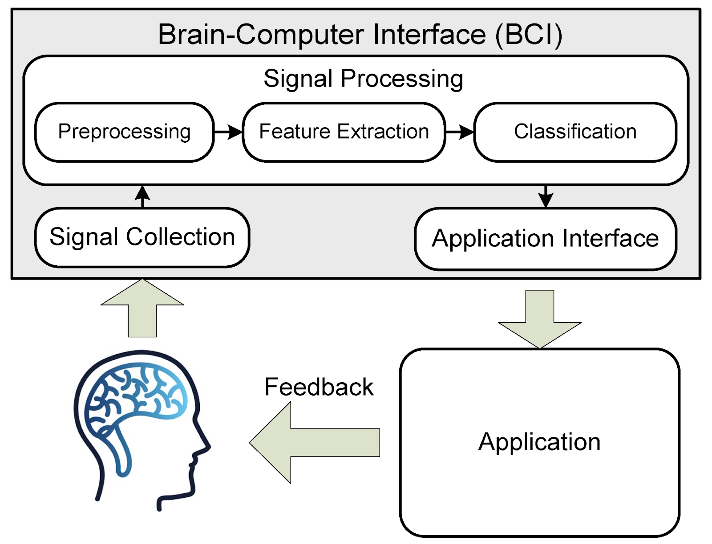

**Figure 1: Basis of Brain-Computer Interface (BCI) operation**

However, Brain-Computer Interface (BCI) models are classified into three categories based on their level of invasiveness and technique of signal collection. They are invasive, semi-invasive, and non-invasive. Each method has various benefits and drawbacks, depending on the extent of interaction with the human body and the type of the brain signals being recorded [20].

Non-invasive approaches involve measuring brain impulses without requiring any surgical intervention. This method commonly employs sensors (electrodes) positioned on the scalp, the brain's topmost layer as shown in Figure 2. Among the non-invasive technologies, Electroencephalography (EEG) is the most widely used technology due to its low cost and ease of use features. Other non-invasive methods include Magnetoencephalography (MEG), Positron Emission Tomography (PET), Functional Magnetic Resonance Imaging (fMRI), and Functional Near-Infrared Spectroscopy (fNIRS). These strategies are paramount to tracking brain activity and understanding valuable information about neural activity without the risks involved in experimental procedures [21].

On the other hand, in Semi-invasive methods electrodes are inserted into the skull but not into the brain as depicted in Figure 3. To be precise, electrodes are put on the exposed surface of the brain: outside the dura mater (epidural) or beneath the dura (subdural). This method allows for a higher number of electrodes, often arranged in strips or grids, covering larger areas of the brain. The primary technique used in this category is Electrocorticography (ECoG), which offers significant advantages over non-invasive methods, specially in terms of spatial resolution, which can reach tenths of a millimeter in contrast to the centimeter-level resolution of EEG [21]. However, ECoG electrodes are primarily used in medical settings, like neurosurgery, to monitor or treat neurological problems. Direct placement of electrodes on the brain's surface enhances signal quality by reducing the distance that electrical activity must travel [22].

Invasive methods provide the most direct contact with the brain, as illustrated with the "brain-surface electrode" in Figure 4, with electrodes being implanted directly into the brain's grey matter during neurosurgery. These microelectrodes are placed into the brain and can detect the activity of individual neurons. Invasive BCIs are divided into two types: single-unit BCIs, which monitor signals from a specific region of brain cells, and multi-unit BCIs, which record activity from several areas. The electrodes employed in these methods vary in length, with examples including the Utah array (up to 1.5 mm) and the FMA array (up to 10 mm), both of which are components of micro-electrode arrays (MEAs) [21].

While invasive BCIs provide the maximum signal quality, they present significant issues. One of the drawbacks of its usage is that the immune response to the foreign electrodes often creates scar tissue around the implants, which can diminish signal quality as time passes. Moreover, due to the high cost, risk, and complexity of surgery, invasive BCIs are mainly used for clinical purposes, typically as a treatment for critical patients, such as people who are paralyzed or suffer from blindness.

Ultimately, the choice of BCI method is dependent on application needs, signal resolution requirements, and safety, invasiveness, and cost considerations. Although readily available, non-invasive methods have lower spatial resolution compared to semi-invasive and invasive methods. Semi-invasive methods such as ECoG offer better spatial resolution, but bear greater risk and expense than non-invasive methods.

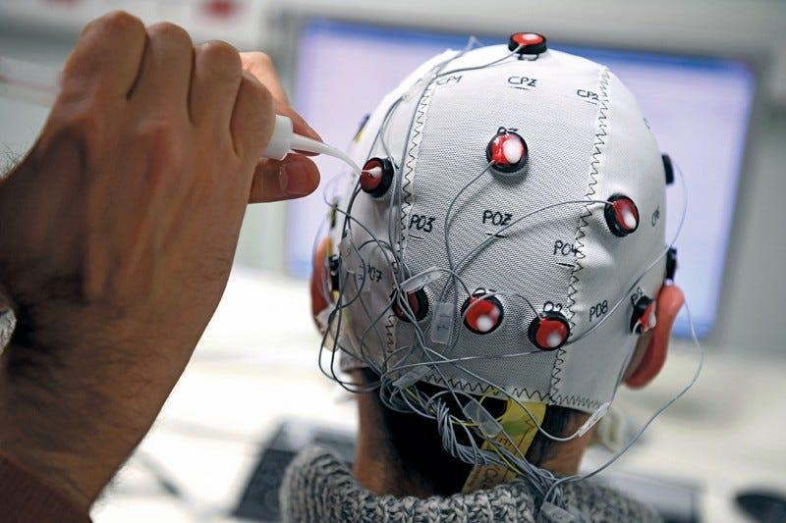

**Figure 2: Non-invasive method**

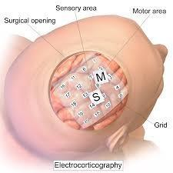

**Figure3: Semi-invasive method**

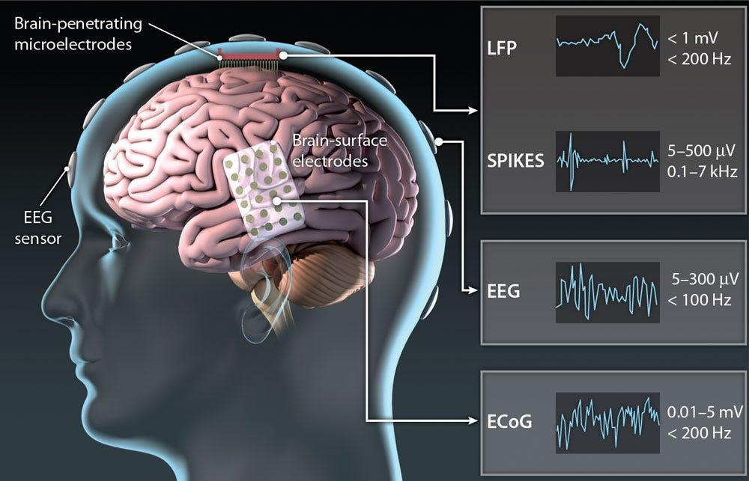

**Figure 4: Brain-Computer Interface (BCI) Technologies Showing the Non-invasive, Semi-invasive and Invasive Technologies**

# **Brain-Computer Interface (BCI) Applications in Neurological Disorders**

BCIs have demonstrated significant promise in the treatment of various neurological disorders, particularly by aiding in restoring motor functions, rehabilitation, and providing new means of communication. Here are some of the most common uses of BCIs in those with neurological disorders

**1. Motor Function Restoration in Spinal Cord Injury**

Motor rehabilitation in individuals with spinal cord injuries has been revolutionized through the use of BCIs. This technology can circumvent damaged spinal networks and translate signals from brain cortex through external devices such as robotic limbs and exoskeletons [23]. Such technologies enable users in the restoration of voluntary movements and practically imparting neuroplasticity.

One impressive breakthrough in this field is a Brain-Spine Interface (BSI), which directly bridges the gap between brain signals and spinal cord stimulation. BSI is for home use and it includes a wearable controller that is incorporated into a walker, which enables subjects to configure the settings of stimulation and start moving the involved limb independently. The device gradually provides persistent neuromodulation, allowing for walking, standing, and complex movements while also fostering neurological recuperation. The BSI's impact goes beyond mobility; it also boosts psychosocial well-being and allows for partial recovery of voluntary control even in the absence of stimulation [24]. Figure 5 is an illustration of this model.

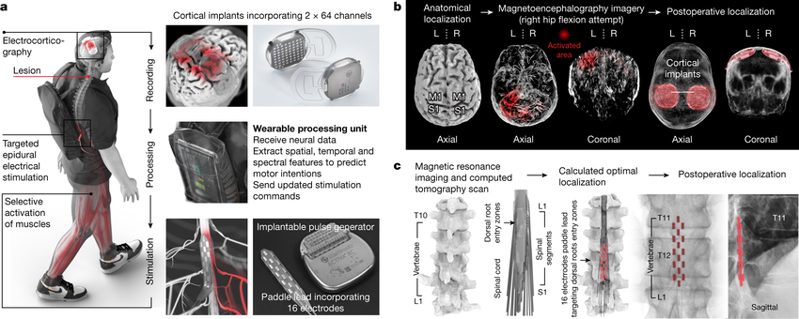

**Figure 5: Design, technology, and implantation of the BSI.** [**I,** Two cortical implants containing 64 electrodes are placed epidurally over the sensorimotor cortex to gather ECoG signals. A processing unit predicts motor intents and modulates epidural electrical stimulation programs that target the dorsal root entrance zones of the lumbosacral spinal cord. An implantable pulse generator is used to administer stimulations via a 16-electrode paddle lead. **II,** Images showing pre-operative planning of cortical implant placements and post-operative confirmation. L means left, and R means right. **III,** Personalized computational model predicting the appropriate placement of the paddle lead to target the dorsal root entry zones associated with lower limb muscles, with postoperative confirmation.]

**2. Stroke Recovery and Neuroplasticity Enhancement**

Stroke is a primary cause of long-term disability worldwide, causing considerable motor impairments, especially in the upper limbs, which can severely limit everyday activities. Traditional rehabilitation approaches, such as physical therapy and constraint-induced movement therapy (CIMT), have proven beneficial, but they may not be appropriate for all patients, particularly those with severe impairments. In recent years, Brain-Computer Interfaces (BCIs) have emerged as promising techniques for improving neuroplasticity and stroke recovery [25].

Noninvasive BCI models, typically based on EEG, detect motor intentions and deliver real-time feedback, promoting cortical reconfiguration. A recent study found that BCI-based motor imagery training dramatically improved upper limb function in chronic stroke patients while also increasing activation in motor-related regions [25]. The integration of BCIs with FES leads to better results by enabling the coordination of brain-generated commands with muscle movements, thus strengthening the principles of Hebbian learning.

The effectiveness of BCI-assisted rehabilitation programs has been validated by recent studies, which found chronic stroke patients receiving motor imagery-based BCI therapy to have excellent improvement in upper extremity motor function and greater activation of motor-related areas of the brain [26], [25]. Khan et al.'s systematic review (2023) of various FES-based rehabilitation systems established that closed-loop BCI-FES systems that decoded the intended motor action were able to yield improvement in motor recovery of stroke subjects by electrically stimulating compromised muscles. These devices utilize the Hebbian model to couple cortical activity with peripheral muscle activation that leads to neuroplastic changes [26]. Moreover, BCI training has been associated with functional and structural neuroplasticity, including enhanced event-related desynchronization in the ipsilesional hemisphere and increased functional connectivity, both of which correlate to improved motor skills [2]. These data suggest that BCI therapies may promote functional neuroplasticity, contributing to enhanced motor recovery [5].

**3. Communication Aid for Amyotrophic Lateral Sclerosis (ALS) and Locked-In Syndrome**

People living with Amyotrophic Lateral Sclerosis (ALS) and locked-in syndrome face troubling challenges because they have no voluntary muscle activity, including the ability to speak or move. Amyotrophic lateral sclerosis (ALS) is a neurodegenerative condition that leads to progressive motor weakness, significantly affecting physical functioning and the ability to communicate. Since ALS (Amyotrophic Lateral Sclerosis) is a rapidly progressive disorder with no curative treatment options available, decisions focus on preserving or improving the quality of life (QoL) of those living with the disease [27].

The cessation of verbal communication — a cardinal symptom of ALS, especially as the disease course progresses — is compounded by progressive paralysis. This loss is most often linked to locked-in syndrome (LIS), a condition in which individuals retain cognitive function but lose all voluntary movement, aside from some movements of the eye or blinking. One or more of these individuals may be using no-tech, low-tech, or high-tech AAC (augmentative and alternative communication) strategies. BCI technology could be a potential solution for people with severe motor disabilities. Instead of muscle movements used to control communication devices, BCIs use neuroelectric signals produced by the brain. In situations where standard technologies fail, non-invasive, scalp-based BCIs, and increasingly more advanced implanted BCIs hold great promise to help people with ALS initiate communication. These systems operate on the principle of sensing brain activity through electrodes worn on the head and translating activity into directional commands to control outside devices, such as speech-generating systems. Previous studies have indicated that using BCIs to communicate is feasible for patients who have ALS and gradually lose motor control [28], [29].

**4. Seizure Prediction and Management in Epilepsy**

By continuously monitoring brain activity, BCIs could potentially predict and prevent seizure events in individuals with epilepsy. BCIs can detect distinct brain patterns that often precede seizures in real time. In cases where a seizure is imminent, BCIs can cause electrical stimulation to the brain to prevent it, or signal caretakers and medical personnel so that quick intervention can be provided. BCIs are also capable of tracking how the brain is responding during treatment, and whether physicians will need to adjust medication dosages or stimulate certain regions to mitigate symptoms. It is expected that this predictive ability will greatly enhance epilepsy management, both by decreasing the incidence and severity of seizures and also improving the quality of life of patients as a whole [30].

**5. Treatment of Neurodegenerative Disorders**

BCIs are already being studied for applications against neurodegenerative diseases like Parkinson's, Multiple Sclerosis (MS), and Alzheimer's. These are conditions characterized by the progressive degeneration of brain structures, often leading to cognitive decline, motor dysfunction, and other functional impairments. BCIs may assist in managing such disorders by mitigating symptoms, cognitive training, and monitoring disease evolution [31].

In Parkinson’s disease, BCIs have been used for rehabilitation to alleviate tremors or stiffness. BCIs allow non-invasive assessment of cognitive functions that may decline over time, making them useful for tracking the progression of MS. The potential of BCIs for Alzheimer's disease treatment can be seen in their application in stimulating brain areas related to memory and cognition to slow cognitive decline and enhance memory capacity [31].

**Brain-Computer Interface (BCI) Applications in Mental Health**

Brain-Computer Interfaces (BCIs) have gained much attention and promise in the treatment of various mental health issues in recent years. BCI-based interventions have shown potential for mental health conditions, such as mood-related disorders and attention deficit disorders. BCIs have novel applications in mental health in the following ways:

**1. Neurofeedback for Anxiety and Depression**

Neurofeedback is an interesting example of a BCI-based technique designed to understand and manage emotional pathology, enabling patients to learn how to modify their emotional neural circuits through live neuronal feedback systems, which have been useful in managing anxiety and depression. Neurofeedback offers patients insight into their brainwave patterns and practically trains them to consciously regulate their neural activity. Such self-regulation may help reduce symptoms associated with anxiety, stress, and mood disorders [32]. Research has shown that neurofeedback can restore the brainwaves to their normal state, especially in the prefrontal cortex, which is often dysfunctional in people with mood disorders [33].

**2. Attention Enhancement in Attention Deficit Hyperactivity Disorder (ADHD)**

BCI application in rAttention Deficit Hyperactivity Disorder (ADHD) has been studied, with a focus on the improvement of concentration and attention abilities [32]. By utilizing neurofeedback modalities, BCIs actively train users — in this case, individuals with ADHD — to be in control of their attention thereby extending attention and dampening hyperactive responses. Neurofeedback application in ADHD typically involves training patients to reinforce brainwave patterns associated with sustained attention [34], through increasing theta waves and decreasing beta waves. Studies showed that attention and behavior control improve for children and adults with a BCI-based neurofeedback [35].

**3. Post-Traumatic Stress Disorder (PTSD) Treatment**

BCIs is of advantage in patients with Post-Traumatic Stress Disorder (PTSD), who may use BCIs to track and regulate real-time activity in brain regions associated with trauma. PTSD is often linked to abnormal brain activity, especially in the amygdala and prefrontal cortex, regions important for emotional processing and stress regulation. It is possible to monitor these areas via BCIs, and to provide biofeedback to help people reduce hyper-arousal, emotional numbing, and intrusive memories [32]. Moreover, using BCIs to modulate brain activity can help patients learn how to better regulate their physiological and emotional responses to trauma, which may reduce PTSD symptoms over time.

**4. Addiction Recovery and Craving Management**

BCIs are also being employed in addiction recovery programs, allowing patients to manage their cravings and control brain activity associated with addictive behaviors. Addiction is often associated with abnormal regulations of areas in the brain like the prefrontal cortex (which are related to decision-making and impulse control) and the nucleus accumbens (which is related with reward processing). BCIs can provide individuals with instantaneous feedback about the pattern of their brain activity and support them in modulating the neural circuitry that underlies cravings and addiction. By teaching individuals to activate brain areas associated with self-control while suppressing areas related to craving, BCIs may facilitate long-term recovery and reduce the risk of relapse [36].

**5. Sleep Disorders and Brain Activity Monitoring**

Brain–computer interfaces (BCIs) are also used in the therapy of sleep disorders such as insomnia and sleep apnea by monitoring the brain's activity during sleep. To monitor sleep, BCIs continuously record brainwave patterns in order to measure the neurological mechanisms behind sleep disruption. By identifying and analyzing patterns of brain activity that disrupts sleep, BCIs can aid in customizing treatments to reinstate normal sleep cycles. For instance, BCIs can assist in guiding therapeutic modalities such as cognitive behavioral therapy for insomnia (CBT-I), wherein patients are trained to improve their sleep quality by addressing dysfunctional thoughts and behaviors [20]. In addition, BCIs may assist in optimizing sleep patterns and controlling disease symptoms such as sleep apnea that causes sleep interruption due to cessation of breathing [37], [38].

**Emerging Trends in Therapeutic Applications of BCI as it Relates to Neurology and Mental Health**

BCIs and other similar technologies could have a major impact as clinicians rapidly integrate this novel technology into their routine therapeutic procedures, especially among patients with neurological and mental health illness. One promising development is the rise of closed-loop neuromodulation systems, where BCIs not only track brain activity but provide real-time stimulation to modulate neural activity, showing promise for treating neurological disorders such as Parkinson's disease. Deep brain stimulation (DBS) systems, for example, can optimize therapy outcomes by modifying stimulation parameters based on real-time neural feedback [31].

Virtual reality (VR) is another relatively new method of BCI-based therapy — it has already shown effectiveness as a promising tool for rehabilitation and mental health treatment. Program integration allows for patients within regulated virtual environments for treatment that supports motor rehabilitation, as well as anxiety and post-traumatic stress disorder (PTSD). BCIs help monitor neural response during VR sessions, providing for adaptive, individualized therapies. VR-BCI systems are also ideally suited for enhancing cognitive and motor therapy in stroke victims, generating environments that foster emotional management and physical restitution[39].

BCIs are also being implemented in biofeedback-assisted cognitive behavioral therapy (CBT, a type of psychotherapy), which would provide patients with real-time information about their mental and emotional states. This may aid the efficacy of CBT as it can help a person have greater control over initial reactions to stress, anxiety or sadness. [31], [40].

In remote monitoring as seen in telehealth, BCIs can provide continuous, real-time tracking of brain activity in remote monitoring and telehealth applications, enabling healthcare personnel to monitor patient progress even from a distance. Some BCIs are non-invasive, making it easier for patients to relax in remote evaluations. This can significantly improve patient outcomes with timely therapies in an underserved or rural areas [31].

P300-based BCIs have been effectively used to assist patients with severe neurological diseases (e.g., amyotrophic lateral sclerosis (ALS) or locked-in syndrome). P300-based BCIs enable users to select letters or words on a screen based on brain impulses, making it easier for individuals with little or no voluntary muscle control to communicate. Several such technologies have reported initial success in improving the quality of life of patients with ALS and locked-in syndrome, and in relieving feelings of loneliness [41].

Since the discovery of Artificial Intelligence (AI), it has been found to be applicable in different aspects of health (including Brain-Computer Interface (BCIs)). AI may emerge as a promising approach to enhance decoding performance, user experience and expand the usage of BCIs [42]. For instance, BCIs can successfully classify motor imagery using deep-learning algorithms [43], [42] and thus achieving compelling performance for the diagnosis of neurological diseases [44]. In particular, AI-BCI systems have proved to be successful in the diagnosis and treatment of neurological diseases, including epilepsy, Parkinson's disease and stroke. For instance, systems that combine artificial intelligence (AI) and brain-computer interfaces (BCI) have been developed with the goal of detecting epileptic seizures and thereby enabling a timely intervention to help prevent or lessen the severity of seizures [44],[45].

# **Ethical and Regulatory Considerations**

Some ethical and regulatory implications have arisen from the fast growth of BCIs, especially in healthcare, with the key considerations being user safety. Invasive BCIs and Non-Invasive BCIs pose numerous health hazards. Invasive devices in which electrodes are embedded in the brain can result in immediate complications like infections or electrode malfunction, and long-term dangers like changing the neuroplasticity of the brain. While non-invasive BCIs are less dangerous than the invasive methods, they may still impact brain functioning, raising questions about their use in young people [46], [47].

Based on the sensitive nature of the BCIs' neural data collection, there are great concerns about the privacy and data security in deploying BCIs, as they collect highly sensitive neural data. Protecting these data from unauthorized access is imperative, owing to the increasing fears over hypothetical 'neurocrime' and malign hack [48, 49].

The ethical issue of informed consent is significantly of consideration, particularly for vulnerable people such as those suffering from severe neurological disabilities. To preserve ethical standards, clear communication about the dangers and benefits of BCI technology is needed [49, 50, 51]. Additionally, there is a growing concern regarding autonomy, where some BCI-mediated actions may not be fully autonomous but are externally mediated by equipment and caregivers [51].

BCIs raise additional questions about identity and human nature. As BCIs start integrating with human bodies, they will be the ones who obscure the line between human and machine, resulting in philosophical issues surrounding the nature of self [49], [51]. The ability of BCIs to change cognitive states may affect how we see ourselves, re-making identity with implications for social identity and public understandings of disability and normality [18, 49, 51].

Access and equity is yet another challenge that must be addressed. Like many new medical technologies, BCIs are highly expensive, and this may worsen health inequities, especially in low-resource environments. It is critical that equitable access to these technologies is ensured so that new disparities are not created [52]. BCIs can also potentially be used in a process called neuroenhancement to improve human capacities above their normal range, which brings additional moral concerns in terms of justice and potential military use of such technologies [53].

Lastly, the legality of using BCI needs to be clarified. Legislation should also clarify who is liable for actions taken by users utilizing BCIs, especially in cases where a BCI malfunctions or is misused [54].

# **Challenges and Recommendations**

# BCIs have had a positive effect on the healthcare system, however, but they are not without challenges. The challenges associated with the use of BCIs are detailed below:

**Technical and Usability Challenges:**

BCIs face several challenges in terms of technology, the signals used are partially nonstationary and are susceptible to mood, fatigue and cognition [13, 14]. Additionally, noise – interference from electrical signals that are not coming from the brain – can make BCIs less accurate and reliable. The heterogeneity of patterns of brain signals across participants, sessions, and tasks has made it difficult to develop accurate models of pattern recognition [31], [55]. Machine learning algorithms, especially, suffer challenges from data scarcity and from variability among the individual cosmetics of the nervous system [31]. Brain dynamics are greatly influenced by cognitive processes, memory load, and attention — all of which may lead to variability in performance. BCIs are also plagued with low information transfer rates (ITRs) and user dissatisfaction due to the need for repetitive tasks. Enhancements of Signal-to-Noise Ratios (SNRs), which is crucial for bona fide target detection, remain a primary goal. Moreover, increasing usability requires the design of user-friendly interfaces making it comfortable for both physicians and patients to use [31].

**Cost, Accessibility, and Safety Concerns:**

Another significant barrier to the widespread adoption of BCIs in healthcare is their high cost. While advancements in consumer-grade technology are making BCIs more affordable, sophisticated systems with extensive electrode setups remain costly, limiting their access. Nonetheless, the trend is towards more affordable, consumer-grade BCIs, which will likely result in more accessible solutions for a broader population. The safety of BCI technology remains a major concern, especially for invasive treatments. Risks such as bleeding, infection, and other surgical consequences must be reduced to assure users' long-term safety. Furthermore, BCIs raise questions concerning the security and privacy of data, as unauthorized access to brain activity data could have serious consequences. Developing cryptographic security methods will be critical for protecting user privacy [31], [56].

**Ethical, Legal, and Social Challenges:**

BCIs raise a number of ethical, legal, and societal concerns, including those of consent, autonomy, privacy, and the interpretation of brain data. Users with limited cognitive capacity confront significant issues in providing informed permission, especially if the technology is used to stimulate the brain. The interpretation of brain data raises concerns about personal privacy and control over one's mental state. Addressing these ethical concerns needs interdisciplinary collaboration among neuroscientists, engineers, and doctors to ensure responsible and ethical BCI implementation in healthcare. Regulatory frameworks must be devised to adequately address these concerns as BCI technology becomes more widely used in clinical contexts [31], [55], [56].

# **Future Directions**

**Interdisciplinary Collaboration**

The advances witnessed by BCIs in medicine demonstrates the exciting potential of interdisciplinary collaboration, which combines neuroscience, engineering, and clinical expertise to assist in the restoration of functions for people with disabilities. Effective collaboration requires strong leadership, stakeholder support, and interprofessional education to create trust and understanding. Organizational measures such as co-location, shared electronic health data, and condition-specific referral policies can all help to speed up the integration process [56, 57].

**Improving Reliability and Functionality**

To meet therapeutic goals, BCIs must be as reliable as natural muscle-based activities. Future developments are likely to incorporate the integration of data from many brain regions, imitating the body's normal muscular outputs. Furthermore, integrating quicker sensory inputs, such as proprioceptive and cutaneous impulses, may considerably increase BCI performance, allowing for more seamless interactions [56], [58].

**Expanding Accessibility in Low-Resource Settings**

As a result of their high cost and maintenance requirements, BCIs are currently only available for people with severe disabilities. The objective is to decrease the complexity of maintenance to enhance the functionalities of BCIs to make them accessible in underdeveloped regions, given that technology continues to update. Financial mechanisms such as insurance that reimburse for BCIs can encourage use of these technologies by doctors, and this could help them gain traction [31], [59].

**Data and Algorithms, and Social Systems**

However, as BCIs become more widespread, there is an urgent need for strong privacy legislation to protect users' autonomy and personal information. Legal frameworks, alongside the potential use of (and innovations in) cryptographic contracts/BCIs, may also help protect sensitive brain data, keeping it private and secure. [31], [60].

# **Conclusion**

The emergence of Brain-Computer Interface (BCI) models has been found useful in health care, especially in neurology and mental health. By using the feature of brain and rehabilitation through the elucidation of neural patterns, BCIs offer novel strategies for diagnosis and treatment, thus enhancing the quality of life of people with neurological and mental health disorders. The key takeaway from this article is that BCIs hold great promise for restoring motor functions, communication, and modulating brain activity to ease symptoms of various neurological and mental health diseases.

Notwithstanding, BCIs have been faced with some challenges which are yet to be fully addressed with respect to various aspects of BCI adoption in healthcare such technical and usability challenges, cost and accessibility problems, as well as ethical and regulatory problems. Future directions must focus on interdisciplinary collaboration to foster better reliability, improve access, efficiency and privacy.

# **References**

1. Chai, X., Cao, T., He, Q., Wang, N., Zhang, X., Shan, X., Lv, Z., Tu, W., Yang, Y., & Zhao, J. (2024). Brain-computer interface digital prescription for neurological disorders. *CNS neuroscience & therapeutics*, *30*(2), e14615. <https://doi.org/10.1111/cns.14615>
2. Cervera, M. A., Soekadar, S. R., Ushiba, J., Millán, J. D. R., Liu, M., Birbaumer, N., & Garipelli, G. (2018). Brain-computer interfaces for post-stroke motor rehabilitation: a meta-analysis. *Annals of clinical and translational neurology*, *5*(5), 651–663. <https://doi.org/10.1002/acn3.544>
3. Vidal J. J. (1973). Toward direct brain-computer communication. *Annual review of biophysics and bioengineering*, *2*, 157–180. <https://doi.org/10.1146/annurev.bb.02.060173.001105>
4. Colucci, A., Vermehren, M., Cavallo, A., Angerhöfer, C., Peekhaus, N., Zollo, L., Kim, W. S., Paik, N. J., & Soekadar, S. R. (2022). Brain-Computer Interface-Controlled Exoskeletons in Clinical Neurorehabilitation: Ready or Not?. *Neurorehabilitation and neural repair*, *36*(12), 747–756. <https://doi.org/10.1177/15459683221138751>
5. Wolpaw J. R. (2013). Brain-computer interfaces. *Handbook of clinical neurology*, *110*, 67–74. <https://doi.org/10.1016/B978-0-444-52901-5.00006-X>
6. Singh SP, Mishra S, Gupta S, Padmanabhan P, Jia L, Colin TKA, Tsai YT, Kejia T, Sankarapillai P, Mohan A, et al. Functional Mapping of the Brain for Brain–Computer Interfacing: A Review. *Electronics*. 2023; 12(3):604. https://doi.org/10.3390/electronics12030604
7. National Academies of Sciences, Engineering, and Medicine; Health and Medicine Division; Board on Health Care Services; Committee on Identifying New or Improved Diagnostic or Evaluative Techniques. Advances in the Diagnosis and Evaluation of Disabling Physical Health Conditions. Washington (DC): National Academies Press (US); 2023 May 1. 5, Techniques for Neurological Disorders. Available from: <https://www.ncbi.nlm.nih.gov/books/NBK593674/>
8. Nicoldi, F., 2023. Exploring Neurological Disorders: Brief Introduction. *Primary Health Care: Open Access*, 13(7). Available at:<https://www.iomcworld.org/open-access/exploring-neurological-disorders-brief-introduction-102579.html> [Accessed 5 April 2025].
9. Siuly, S., & Zhang, Y. (2016). Medical big data: Neurological disease diagnosis through medical data analysis. *Data Science and Engineering, 1*(1), 54–64.<https://doi.org/10.1007/s41019-016-0011-3>
10. World Health Organization. (2022). *Mental health*.Fact Sheet. Available from: <https://www.who.int/news-room/fact-sheets/detail/mental-health> [Accessed 5 April 2025].
11. Murphy F, Nasa A, Cullinane D, Raajakesary K, Gazzaz A, Sooknarine V, Haines M, Roman E, Kelly L, O'Neill A, Cannon M and Roddy DW (2022) Childhood Trauma, the HPA Axis and Psychiatric Illnesses: A Targeted Literature Synthesis. *Front. Psychiatry* 13:748372. doi: 10.3389/fpsyt.2022.748372
12. National Institutes of Health (US); Biological Sciences Curriculum Study. NIH Curriculum Supplement Series [Internet]. Bethesda (MD): National Institutes of Health (US); 2007. Information about Mental Illness and the Brain. Available from: <https://www.ncbi.nlm.nih.gov/books/NBK20369/>
13. Mikulska J, Juszczyk G, Gawrońska-Grzywacz M, Herbet M. HPA Axis in the Pathomechanism of Depression and Schizophrenia: New Therapeutic Strategies Based on Its Participation. *Brain Sciences*. 2021; 11(10):1298. <https://doi.org/10.3390/brainsci11101298>
14. Dobkin B. H. (2007). Brain-computer interface technology as a tool to augment plasticity and outcomes for neurological rehabilitation. *The Journal of physiology*, *579*(Pt 3), 637–642. <https://doi.org/10.1113/jphysiol.2006.123067>
15. Yang, S., Li, R., Li, H., Xu, K., Shi, Y., Wang, Q., Yang, T., & Sun, X. (2021). Exploring the Use of Brain-Computer Interfaces in Stroke Neurorehabilitation. *BioMed research international*, *2021*, 9967348. <https://doi.org/10.1155/2021/9967348>
16. Soekadar, S. R., Witkowski, M., Gómez, C., Opisso, E., Medina, J., Cortese, M., Cempini, M., Carrozza, M. C., Cohen, L. G., Birbaumer, N., & Vitiello, N. (2016). Hybrid EEG/EOG-based brain/neural hand exoskeleton restores fully independent daily living activities after quadriplegia. *Science robotics*, *1*(1), eaag3296. https://doi.org/10.1126/scirobotics.aag3296
17. Carvalho S, Gonçalves ÓF, Brunoni AR, Fernandes-Gonçalves A, Fregni F and Leite J (2020) Transcranial Direct Current Stimulation as an Add-on Treatment to Cognitive-Behavior Therapy in First Episode Drug-Naïve Major Depression Patients: The ESAP Study Protocol. *Front. Psychiatry* 11:563058. doi: 10.3389/fpsyt.2020.563058
18. Wolpaw, J. R., McFarland, D. J., & Vaughan, T. M. (2000). Brain-computer interface research at the Wadsworth Center. *IEEE transactions on rehabilitation engineering : a publication of the IEEE Engineering in Medicine and Biology Society*, *8*(2), 222–226. <https://doi.org/10.1109/86.847823>
19. Peksa, J., & Mamchur, D. (2023). State-of-the-Art on Brain-Computer Interface Technology. *Sensors*, *23*(13), 6001. <https://doi.org/10.3390/s23136001>
20. He, Z., Li, Z., Yang, F., Wang, L., Li, J., Zhou, C., & Pan, J. (2020). Advances in Multimodal Emotion Recognition Based on Brain-Computer Interfaces. *Brain sciences*, *10*(10), 687. <https://doi.org/10.3390/brainsci10100687>
21. Waldert S (2016) Invasive vs. Non-Invasive Neuronal Signals for Brain-Machine Interfaces: Will One Prevail? *Front. Neurosci*. 10:295. doi: 10.3389/fnins.2016.00295
22. Leuthardt, E. C. et al. 2004. *A brain–computer interface using electrocorticographic signals in humans*. Journal of Neural Engineering, Volume 1, Number 2. Available from: <http://iopscience.iop.org/article/10.1088/1741-2560/1/2/001/meta;jsessionid=E687A7B4A1215A8655C2DF6429F87A05.c2.iopscience.cld.iop.org>
23. Wireko, A. A., Ahluwalia, A., Darko, K., Sanker, V., Tan, J. K., Tenkorang, P. O., Ben-Jaafar, A., Ranganathan, S., Aderinto, N., Mehta, A., Shah, M. H., Lee, K. B. C., Abdul-Rahman, T., & Atallah, O. (2024). Bridging minds and machines: The recent advances of brain-computer interfaces in neurological and neurosurgical applications. *World Neurosurgery, 189*, 138–153.<https://doi.org/10.1016/j.wneu.2024.05.104>
24. Lorach, H., Galvez, A., Spagnolo, V., Wenger, N., Benabid, A. L., Courtine, G., & Bloch, J. (2023). Walking naturally after spinal cord injury using a brain–spine interface. *Nature, 618*(7965), 126–133.<https://doi.org/10.1038/s41586-023-06094-5>
25. Ma, Z.Z., Wu, J.J., Cao, Z., et al. (2024). Motor imagery-based brain–computer interface rehabilitation programs enhance upper extremity performance and cortical activation in stroke patients. *Journal of NeuroEngineering and Rehabilitation*, 21, 91.<https://doi.org/10.1186/s12984-024-01387-w>
26. Khan MA, Fares H, Ghayvat H, Brunner IC, Puthusserypady S, Razavi B, Lansberg M, Poon A and Meador KJ (2023) A systematic review on functional electrical stimulation based rehabilitation systems for upper limb post-stroke recovery. *Front. Neurol.* 14:1272992. doi: 10.3389/fneur.2023.1272992
27. Brotman RG, Moreno-Escobar MC, Joseph J, et al. Amyotrophic Lateral Sclerosis. [Updated 2024 Feb 12]. In: StatPearls [Internet]. Treasure Island (FL): StatPearls Publishing; 2025 Jan-. Available from: <https://www.ncbi.nlm.nih.gov/books/NBK556151/>
28. National Institute of Neurological Disorders and Stroke. (n.d.). *Amyotrophic lateral sclerosis (ALS)*. National Institutes of Health. Retrieved April 6, 2025, from<https://www.ninds.nih.gov/health-information/disorders/amyotrophic-lateral-sclerosis-als>
29. Vansteensel, M. J., Klein, E., van Thiel, G., & et al. (2023). Towards clinical application of implantable brain–computer interfaces for people with late-stage ALS: Medical and ethical considerations. *Journal of Neurology, 270*(6), 1323–1336.<https://doi.org/10.1007/s00415-022-11464-6>
30. Huang, L., & van, G. (2013). Brain Computer Interface for Epilepsy Treatment. InTech. doi: 10.5772/55800
31. Awuah, W. A., Ahluwalia, A., Darko, K., Sanker, V., Tan, J. K., Tenkorang, P. O., Ben-Jaafar, A., Ranganathan, S., Aderinto, N., Mehta, A., Shah, M. H., Chun, K. L. B., Abdul-Rahman, T., & Atallah, O. (2024). Bridging minds and machines: The recent advances of brain-computer interfaces in neurological and neurosurgical applications. *World Neurosurgery*, 189, 138-153.<https://doi.org/10.1016/j.wneu.2024.05.104>
32. Banerjee S, Argáez C. Neurofeedback and Biofeedback for Mood and Anxiety Disorders: A Review of Clinical Effectiveness and Guidelines [Internet]. Ottawa (ON): Canadian Agency for Drugs and Technologies in Health; 2017 Nov 13. Available from: <https://www.ncbi.nlm.nih.gov/books/NBK531603/>
33. Oprea, D. C., Mawas, I., Moroșan, C. A., Iacob, V. T., Cămănaru, E. M., Cristofor, A. C., Dobrin, R. P., Gireadă, B., Petrariu, F. D., & Chiriță, R. (2024). A systematic review of the effects of EEG. *Journal of Personalized Medicine*, 14(7), 763.<https://doi.org/10.3390/jpm14070763>
34. Saif, M. G. M., & Sushkova, L. (2023). Clinical efficacy of neurofeedback protocols in treatment of Attention Deficit/Hyperactivity Disorder (ADHD): A systematic review. *Psychiatry Research: Neuroimaging*, 335, 111723.<https://doi.org/10.1016/j.pscychresns.2023.111723>
35. Enriquez-Geppert, S., Smit, D., Pimenta, M. G., & Arns, M. (2019). Neurofeedback as a Treatment Intervention in ADHD: Current Evidence and Practice. *Current psychiatry reports*, *21*(6), 46. <https://doi.org/10.1007/s11920-019-1021-4>
36. National Institute on Drug Abuse. (n.d.). *Deep brain stimulation for severe opioid addiction: Can resetting brain circuits help people find recovery?* U.S. Department of Health and Human Services. Retrieved April 6, 2025, from<https://heal.nih.gov/news/stories/deep-brain-stimulation>
37. Young, M. J., Lin, D. J., & Hochberg, L. R. (2021). Brain-Computer Interfaces in Neurorecovery and Neurorehabilitation. *Seminars in neurology*, *41*(2), 206–216. <https://doi.org/10.1055/s-0041-1725137>
38. Pratt, A. K., Chang, J. J., & Sederstrom, N. O. (2019). A Fate Worse Than Death: Prognostication of Devastating Brain Injury. *Critical care medicine*, *47*(4), 591–598. <https://doi.org/10.1097/CCM.0000000000003647>
39. Rizzo, A. S., Koenig, S. T., & Talbot, T. B. (2018). Clinical Virtual Reality: Emerging Opportunities for Psychiatry. *Focus (American Psychiatric Publishing)*, *16*(3), 266–278. <https://doi.org/10.1176/appi.focus.20180011>
40. Chand SP, Kuckel DP, Huecker MR. Cognitive Behavior Therapy. [Updated 2023 May 23]. In: StatPearls [Internet]. Treasure Island (FL): StatPearls Publishing; 2025 Jan-. Available from: <https://www.ncbi.nlm.nih.gov/books/NBK470241/>
41. Nijboer, F., Sellers, E. W., Mellinger, J., Jordan, M. A., Matuz, T., Furdea, A., Halder, S., Mochty, U., Krusienski, D. J., Vaughan, T. M., Wolpaw, J. R., Birbaumer, N., & Kübler, A. (2008). A P300-based brain–computer interface for people with amyotrophic lateral sclerosis. *Clinical Neurophysiology, 119*(8), 1909–1916.<https://doi.org/10.1016/j.clinph.2008.03.034>
42. Karikari, E., & Koshechkin, K. A. (2023). Review on brain-computer interface technologies in healthcare. *Biophysical reviews*, *15*(5), 1351–1358. <https://doi.org/10.1007/s12551-023-01138-6>
43. Sharma, R., Kim, M., & Gupta, A. (2022). Motor imagery classification in brain-machine interface with machine learning algorithms: Classical approach to multi-layer perceptron model. *Biomedical Signal Processing and Control, 71*(Part A), 103101.<https://doi.org/10.1016/j.bspc.2021.103101>
44. Akkus, Z., Galimzianova, A., Hoogi, A., Rubin, D. L., & Erickson, B. J. (2017). Deep Learning for Brain MRI Segmentation: State of the Art and Future Directions. *Journal of digital imaging*, *30*(4), 449–459. <https://doi.org/10.1007/s10278-017-9983-4>
45. Zhao, C., Liu, B., Piao, S., Wang, X., Lobell, D. B., Huang, Y., Huang, M., Yao, Y., Bassu, S., Ciais, P., Durand, J. L., Elliott, J., Ewert, F., Janssens, I. A., Li, T., Lin, E., Liu, Q., Martre, P., Müller, C., Peng, S., … Asseng, S. (2017). Temperature increase reduces global yields of major crops in four independent estimates. *Proceedings of the National Academy of Sciences of the United States of America*, *114*(35), 9326–9331. https://doi.org/10.1073/pnas.1701762114
46. Clausen, J. (2013). Bonding brains to machines: Ethical implications of electroceuticals for the human brain. *Neuroethics, 6*(4), 429–434.<https://doi.org/10.1007/s12152-013-9186-8>
47. Williams, S. C., Horsfall, H. L., Funnell, J. P., Hanrahan, J. G., Schaefer, A. T., Muirhead, W., & Marcus, H. J. (2022). Neurosurgical Team Acceptability of Brain-Computer Interfaces: A Two-Stage International Cross-Sectional Survey. *World neurosurgery*, *164*, e884–e898. <https://doi.org/10.1016/j.wneu.2022.05.062>
48. Sergio López Bernal, Alberto Huertas Celdrán, Gregorio Martínez Pérez, Michael Taynnan Barros, and Sasitharan Balasubramaniam. 2021. Security in Brain-Computer Interfaces: State-of-the-Art, Opportunities, and Future Challenges. ACM Comput. Surv. 54, 1, Article 11 (January 2022), 35 pages. <https://doi.org/10.1145/3427376>
49. Livanis, E., Voultsos, P., Vadikolias, K., Pantazakos, P., & Tsaroucha, A. (2024). Understanding the Ethical Issues of Brain-Computer Interfaces (BCIs): A Blessing or the Beginning of a Dystopian Future?. *Cureus*, *16*(4), e58243. <https://doi.org/10.7759/cureus.58243>
50. King, B. J., Read, G. J. M., & Salmon, P. M. (2024). The risks associated with the use of brain-computer interfaces: A systematic review. *International Journal of Human-Computer Studies, 40*, 131–148. <https://doi.org/10.1080/10447318.2022.2111041>
51. Burwell, S., Sample, M., & Racine, E. (2017). Ethical aspects of brain-computer interfaces: A scoping review. *BMC Medical Ethics, 18*, 60.<https://doi.org/10.1186/s12910-017-0220-y>
52. Coin, A., Mulder, M., & Dubljević, V. (2020). Ethical Aspects of BCI Technology: What Is the State of the Art? *Philosophies*, *5*(4), 31. <https://doi.org/10.3390/philosophies5040031>
53. Gordon, E. C., & Seth, A. K. (2024). Ethical considerations for the use of brain-computer interfaces for cognitive enhancement. *PLoS biology*, *22*(10), e3002899. <https://doi.org/10.1371/journal.pbio.3002899>
54. Thompson, K. (2021). Committing crimes with BCIs: How brain-computer interface users can satisfy actus reus and be criminally responsible. *Neuroethics, 14*(Suppl 3), 311–322.<https://doi.org/10.1007/s12152-019-09416-5>
55. Padfield, N., Zabalza, J., Zhao, H., Masero, V., & Ren, J. (2019). EEG-Based Brain-Computer Interfaces Using Motor-Imagery: Techniques and Challenges. *Sensors (Basel, Switzerland)*, *19*(6), 1423. <https://doi.org/10.3390/s19061423>
56. Ng, J. Y. (2025). Exploring the intersection of brain-computer interfaces and traditional, complementary, and integrative medicine. *Integrative Medicine Research, 2025*, 101142.<https://doi.org/10.1016/j.imr.2025.101142>
57. Shih, J. J., Krusienski, D. J., & Wolpaw, J. R. (2012). Brain-computer interfaces in medicine. *Mayo Clinic Proceedings, 87*(3), 268-279.<https://doi.org/10.1016/j.mayocp.2011.12.008>
58. Müller-Putz, G., del R. Millán, J., Schalk, G., & Müller, K.-R. (2015). The plurality of human brain–computer interfacing [Scanning the issue]. *Proceedings of the IEEE, 103*(6), 868–870. <https://doi.org/10.1109/JPROC.2015.2425835>.
59. du Bois, N., Bigirimana, A. D., Korik, A., et al. (2021). Neurofeedback with low-cost, wearable electroencephalography (EEG) reduces symptoms in chronic post-traumatic stress disorder. *Journal of Affective Disorders, 295*, 1319–1334.<https://doi.org/10.1016/j.jad.2021.08.071>.
60. Agarwal, A., et al. (2019). Protecting privacy of users in brain-computer interface applications. *IEEE Transactions on Neural Systems and Rehabilitation Engineering, 27*(8), 1546–1555.<https://doi.org/10.1109/TNSRE.2019.2926965>.