Case report

Type 2A Pontocerebellar Hypoplasia, A Rare Cause of Psychomotor Delay: A Case Report

.

ABSTRACT

|  |
| --- |
| **Aims: This case report aims to describe a child with type 2A pontocerebellar hypoplasia (PCH2), whose clinical features were suggestive but non-specific, emphasizing the diagnostic value of neuroimaging and genetic testing.**  **Presentation of Case: A 4-year-old girl, born at term from a consanguineous marriage, presented with feeding difficulties, neonatal hypotonia, psychomotor delay, epilepsy, and dyskinesia from 5 months of age. Examination revealed microcephaly, failure to thrive, spasticity, and clonus. Brain MRI showed hypoplasia of the cerebellar vermis. EEG indicated background slowing; visual evoked potentials were normal. Genetic testing revealed a homozygous mutation in the TSEN54 gene (17q25.1), confirming PCH2. She was treated with Levetiracetam, Clobazam, and Trihexyphenidyl.**  **Discussion: PCH2 is a rare autosomal recessive neurogenetic disorder linked to TSEN54 mutations. It typically presents neonatally with motor, feeding, and respiratory dysfunction, later progressing to severe neurological impairment. Diagnosis is based on clinical, radiological, and genetic findings. Due to its hereditary nature, genetic counseling is critical.**  **Conclusion: This case highlights the need to consider PCH2 in infants with early-onset neurological symptoms. Neuroimaging and genetic studies are essential for diagnosis. Multidisciplinary care and genetic counseling are key in managing such patients.** |

*Keywords: Pontocerebellar hypoplasia, TSEN54, Neonatalhypotonia, Pediatric neurology*

1. INTRODUCTION

Pontocerebellar hypoplasia type 2 (PCH2) is a rare neurodegenerative and genetic disorder with autosomal recessive inheritance. It is characterized by pontocerebellar hypoplasia associated with progressive neocortical atrophy. It is the most common form of pontocerebellar hypoplasia. The clinical presentation in the neonatal period is typically marked by dysphagia, respiratory distress, and feeding difficulties. The diagnosis is based on a combination of clinical and neuroradiological findings, with genetic confirmation.

1. CASE PRESENTATION

This is a 4-year-old female child, born at term, with a history of feeding difficulties, neonatal hypotonia, pneumonia at the age of 3, and second-degree consanguinity. She presents with psychomotor delay, epilepsy, and dyskinesia since the age of 5 months. Clinical examination revealed microcephaly, failure to thrive, spasticity, and generalized clonus. Brain MRI suggested hypoplasia of the vermis. The EEG showed a slowing of background activity compared to age-appropriate norms. The visual evoked potentials (VEP) were normal. Genetic testing identified a homozygous autosomal mutation in the TSEN54 gene on the short arm of chromosome 17 at 17q25.1, confirming the diagnosis of Pontocerebellar Hypoplasia Type 2A. In terms of treatment, the child is on levetiracetam, clobazam, and trihexyphenidyl.

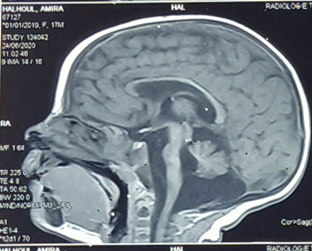

Figure 1: Sagittal section of a brain MRI showing cerebellar hypoplasia

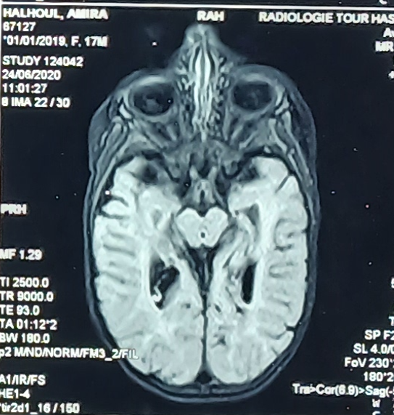

Figure 2: Transversal section of a brain MRI showing vermian hypoplasia

1. discussion

Pontocerebellar Hypoplasia Type 2 is a rare and severe neurodegenerative disorder, primarily affecting psychomotor development.This autosomal recessive condition is characterized by the underdevelopment and degeneration of key structures in the brainstem and cerebellum, leading to profound neurological impairment.

PCH2 typically presents with severe psychomotor delay, microcephaly, and early-onset extrapyramidal movement disorders such as chorea, dystonia, or dyskinesia. Neonatal symptoms often include feeding difficulties, respiratory issues, and clonus, which progress to more severe symptoms such as spasticity, epilepsy, and motor impairments. The clinical presentation can vary significantly, which has led to the identification of two distinct groups: one with dyskinesia/dystonia and severe infratentorial hypoplasia, and another with neonatal onset and polyhydramnios, hyperekplexia, and a more rigid, akinetic presentation. These differences highlight the complexity of the disease and underscore the importance of recognizing its varied manifestations (1) (2) (3) (4).

Imaging plays a crucial role in the diagnosis of PCH2, with MRI scans typically showing severe hypoplasia or flattening of the pons, cerebellar vermis, and hemispheres. The cerebellar structures often appear "wing-like," which can serve as a distinctive imaging feature. However, it is important to note that the severity of the neuroimaging findings does not always correlate with the clinical outcomes. This discrepancy emphasizes the importance of a comprehensive diagnostic approach that includes clinical, genetic, and radiological data(1) (5) (6).

Pontocerebellar hypoplasia type 2 is caused by mutations in the **TSEN54** gene, located on chromosome 17, which is involved in the maturation of transfer RNAs (tRNAs). Mutations in this gene disrupt normal cellular processes, leading to cerebellar and pontine hypoplasia. The autosomal recessive inheritance pattern of PCH2 is commonly seen in consanguineous families, which further underscores the importance of genetic counseling and early diagnosis in affected populations (7).

In addition to the primary neurological manifestations, patients with PCH2 may experience other complications, such as episodes of rhabdomyolysis and, rarely, Reye-like syndrome (8). These complications highlight the need for comprehensive management strategies that address not only the central nervous system involvement but also other organ systems potentially affected by the disorder.

Treatment is symptomatic and focuses on managing dystonia, dyskinesia, and seizures, as well as feeding the patient through a percutaneous endoscopic gastrostomy tube.

1. Conclusion

Pontocerebellar hypoplasia type 2A is often fatal in early childhood. Potentially life-threatening complications include sleep apnea, rhabdomyolysis, and malignant hyperthermia. In the parents of an affected child, the risk of having another affected child is 25%, highlighting the importance of genetic counseling with targeted genetic testing in the parents.

Consent

As per international standards or university standards, patient written consent has been collected and preserved by the author(s).

Ethical approval

ETHICAL APPROVALAs per international standards or university standards written ethical approval has been collected and preserved by the author(s)

References

1. Barth, P., Blennow, G., Lenard, H., Begeer, J., Van Der Kley, J., Hanefeld, F., Peters, A., &Valk, J. (1995). The syndrome of autosornal recessive pontocerebellar hypoplasia, microcephaly, and extrapyramidal dyskinesia (pontocerebellar hypoplasia type 2). *Neurology*, 45, 311 - 317.
2. Steinlin, M., Klein, A., Haas-Lude, K., Zafeiriou, D., Strozzi, S., Müller, T., Gubser-Mercati, D., Mechelke, T., Krägeloh-Mann, I., &Boltshauser, E. (2007). Pontocerebellar hypoplasia type 2: variability in clinical and imaging findings.. *European journal of paediatricneurology : EJPN : official journal of the European Paediatric Neurology Society*, 11 3, 146-52 .
3. Sans-Fitó, A., Campistol-Plana, J., Mas-Salguero, M., Póo-Argüelles, P., & Fernández‐Álvarez, E. (2002). Pontocerebellar Hypoplasia Type 2 and Reye-Like Syndrome. *Journal of Child Neurology*, 17, 132 - 134.
4. Coppola, G., Muras, I., &Pascotto, A. (2000). Pontocerebellar hypoplasia type 2 (PCH2): report of two siblings. *Brain and Development*, 22, 188-192.
5. Barth, P., Aronica, E., De Vries, L., Nikkels, P., Scheper, W., Hoozemans, J., Poll‐The, B., &Troost, D. (2007). Pontocerebellar hypoplasia type 2: a neuropathological update. *ActaNeuropathologica*, 114, 373 - 386.
6. Grellner, W., Rohde, K., &Wilske, J. (2000). Fatal outcome in a case of pontocerebellar hypoplasia type 2.. *Forensic science international*, 113 1-3, 165-72 .
7. Battini, R., D'Arrigo, S., Cassandrini, D., Guzzetta, A., Fiorillo, C., Pantaleoni, C., Romano, A., Alfei, E., Cioni, G., &Santorelli, F. (2014). Novel Mutations in TSEN54 in Pontocerebellar Hypoplasia Type 2. *Journal of Child Neurology*, 29, 520 - 525..
8. Zafeiriou, D., Ververi, A., Tsitlakidou, A., Anastasiou, A., &Vargìami, E. (2013). Recurrent episodes of rhabdomyolysis in pontocerebellar hypoplasia type 2. *Neuromuscular Disorders*, 23, 116-119.