**Colorectal Anal Cancers in a 10-Year Registry Review (2016–2024)**

**Abstract:**

Colorectal and anal cancers (CRACs) are increasingly reported in sub-Saharan Africa due to rising life expectancy, dietary shifts, and improved diagnostics. This study presents a 10-year review of CRACs in Makurdi, North Central Nigeria, analysing demographic, anatomical, and histological patterns.

A retrospective review was conducted of histologically confirmed CRAC cases from January 1, 2016, to December 31, 2024. Data on age, sex, anatomical site, and histological subtype were analysed using descriptive statistics.

Of 2341 total cancers, 129 (5.5%) were CRACs. Males constituted 56.6% (M:F ratio 1.3:1), with a peak age incidence between 51–60 years (27%). Rectum (27%) and anus (17%) were the most common sites. Adenocarcinoma (64%) was the predominant histologic type, followed by mucinous adenocarcinoma (16%). Notably, 19.4% of cases occurred in patients under 40 years.

CRACs are an emerging oncologic concern in Makurdi, with increasing cases among younger patients and predominance of aggressive histologic subtypes. Strengthening diagnostic infrastructure and establishing population-based screening programs are essential to address the growing burden in Nigeria and sub-Saharan Africa.

**Keywords:** Colorectal Anal Cancer, Colorectal Anal Cancers Patterns, Cancer Epidemiology, Retrospective Study, Cancer Burden in Sub-Saharan Africa

**Introduction:**

Colorectal and anal cancers (CRACs) represent a significant and evolving global health burden, with increasing incidence and mortality rates, particularly in low- and middle-income countries (LMICs)1. Globally, colorectal cancer (CRC) ranks as the third most common cancer and the second leading cause of cancer-related deaths, with projections indicating a continued rise in new cases and deaths by 20302. While developed nations have observed a stabilization or even decline in CRC incidence, a clear "cancer transition" is evident in transitioning countries, where the adoption of Westernized lifestyles is driving an escalating CRC burden2,3.

Sub-Saharan Africa (SSA) is experiencing a notable surge in CRAC incidence, with patients often presenting at a younger age and with more advanced disease stages compared to their counterparts in high-income countries4. This rising trend is partly attributed to improved cancer registration efforts, but more significantly to the increasing Westernization of diets and lifestyles across the continent4. Studies from various SSA countries have documented this upward trajectory 4.

In Nigeria, the changing epidemiology of CRACs is particularly striking. Once considered rare, colorectal cancer is now the second most common cancer in Nigerian men and the third most common in Nigerian women, ranking as the fourth most common overall5. This shift reflects a critical public health challenge, with numerous local studies in the past decade highlighting a concerning rise in incidence, early-onset presentation, and advanced disease at diagnosis5,6. Despite this escalating burden, Nigeria, like many SSA nations, faces significant challenges in cancer care, including inadequate infrastructure for early diagnosis, limited screening programs, and delays in presentation and treatment, which contribute to the high morbidity and mortality associated with CRACs in the region6. Therefore, a comprehensive 10-year registry review (2016–2024) is crucial to accurately assess the local burden, identify specific trends, and inform targeted interventions for improved outcomes in Nigeria.

**Materials and Methods**

This is a retrospective, descriptive study aimed at analysing the histopathological characteristics of patients diagnosed with colorectal malignancies.The study was conducted at Benue State University Teaching Hospital (BSUTH) and Federal Medical Centre all in Makurdi Benue State North Central Nigerian which are all tertiary health facility. It is a 10-year period from January 1, 2016, to December 31st, 2024. These centres have histopathology laboratories in Makurdi where histopathology services are rendered and have specialist histopathologists for analysing and reporting tissue specimens in Makurdi, Benue state and other surrounding states in North Central Region of Nigeria

The specimens receive included endoscopic biopsies, and incision biopsies and colectomy tissues. These tissues were preserved in 10% buffered formalin and auto-processed and paraffin-embedded sections (at 2–3 μm) were routinely stained with heamatoxyln and eosin stains.

Data were extracted from the patient request forms, histopathology departmental registers, duplicate copies of histology reports of all cases, and case notes and files of patients. Information extracted included age, sex, site location along the colorectal and anal region, and histological diagnosis. All data were computed and Continuous variables and were summarized using age range, while categorical variables presented as percentage frequencies were determined using descriptive statistics. Data were displayed using tables and charts.

Patients with histologically confirmed CRACs with complete clinical records available, including demographic, clinical, and histopathological data were included in the study while those with incomplete clinical or histopathological data were excluded.

**Results:**

CRACs constituted a significant 83.2% (129/155) of all gastrointestinal (GI) cancers in this population-based registry of 2,341 total cancers over a decade. This reflects a rising burden of lower GI tract malignancies relative to upper GI tract (e.g., gastric cancer: 12.3%, n=19), highlighting a shift in cancer epidemiology likely linked to urbanization, dietary transition, and increasing longevity.

The peak incidence occurred in the 51–60-year age group (27%), followed by 41–50 years (22%) and 61–70 years (16%). Collectively, over 65% of cases occurred between ages 41 and 70, consistent with global data identifying colorectal anal cancer (CRAC) as a middle-to-older age disease. Males were slightly more affected (73 vs. 56; M: F = 1.3:1), in line with known global male predominance. The presence of cases in younger age groups (8% in 21–30 years; 4% in 11–20 years) was also noted. (Table 1 and figure 1)

Rectal cancer was the most common anatomical site (27%), followed by anal canal (17%), ascending colon (16%), and sigmoid colon (12%). (Table 2 and figure 2)

Adenocarcinoma accounted for the majority (64%) of histologic subtypes, Mucinous adenocarcinoma was notably seen at 16%, rare histologies such as signet-ring cell adenocarcinoma (SRCA) (2.3%), small round blue cell tumours (SRBCT) (1.6%), and lymphomas (0.8%) highlight the histologic heterogeneity of CRACs. (Table 3 and figure 3)

**Table 1: Colorectal Anal Cancers: Age and Sex Distribution**

|  |  |  |  |  |
| --- | --- | --- | --- | --- |
| Age group (years) | Sex | | Total | Percentage |
|  | Male | Female |  | **%** |
|  |
| 1-10 | 00 | 00 | 00 | **0%** |
| 11-20 | 02 | 03 | 05 | **4%** |
| 21-30 | 06 | 04 | 10 | **8 %** |
| 31-40 | 10 | 08 | 18 | **14%** |
| 41-50 | 15 | 14 | 29 | **22%** |
| 51-60 | 23 | 12 | 35 | **27%** |
| 61-70 | 11 | 10 | 21 | **16%** |
| 71+ | 06 | 05 | 11 | **9%** |
| Total | **73** | **56** | **129** | **100%** |

**Table 2: Colorectal Anal Cancers - Anatomical Sites.**

|  |  |  |
| --- | --- | --- |
| Anatomical Site | Frequencies | Percentage  % |
| Anal | 22 | 17% |
| Rectum | 35 | 27% |
| Sigmoid colon | 15 | 12% |
| Descending colon | 11 | 9% |
| Transverse | 5 | 4% |
| Ascending | 21 | 16% |
| Caecum | 13 | 10% |
| Metastatic to the colorectal region | 04 | 3% |
| Appendix | 3 | 2% |
| Total | **129** | **100%** |

**Table 3: Colorectal Anal Cancers – Histological Types.**

|  |  |  |
| --- | --- | --- |
| Histological types | Frequencies | Percentage  % |
| Adenocarcinoma | 83 | 64% |
| Mucinoid adenocarcinoma | 20 | 16% |
| Lymphoma | 01 | 0.8% |
| Poorly Differentiated | 08 | 6.2% |
| Adeno Squamous | 01 | 0.8% |
| Small Round Blue Cell Tumour (SRBCT) | 02 | 1.55% |
| Metastatic To Colorectal Anal Region | 04 | 3% |
| Signet Ring Adenocarcinoma | 03 | 2.3% |
| Squamous Cell Carcinoma | 02 | 1.55% |
| GIT Stroma Tumours | 01 | 0.8% |
| Papillary Adenocarcinoma | 04 | 3% |
| Total | **129** | **100%** |

**10 Years Cancer Registry January 1st 2016 to December 31st 2024**

Total Cancer cases: 2341

Gastrointestinal cancers: 155 cases

Colorectal Anal Cancers cases: 129 cases

Gastric Cancers: 19 cases

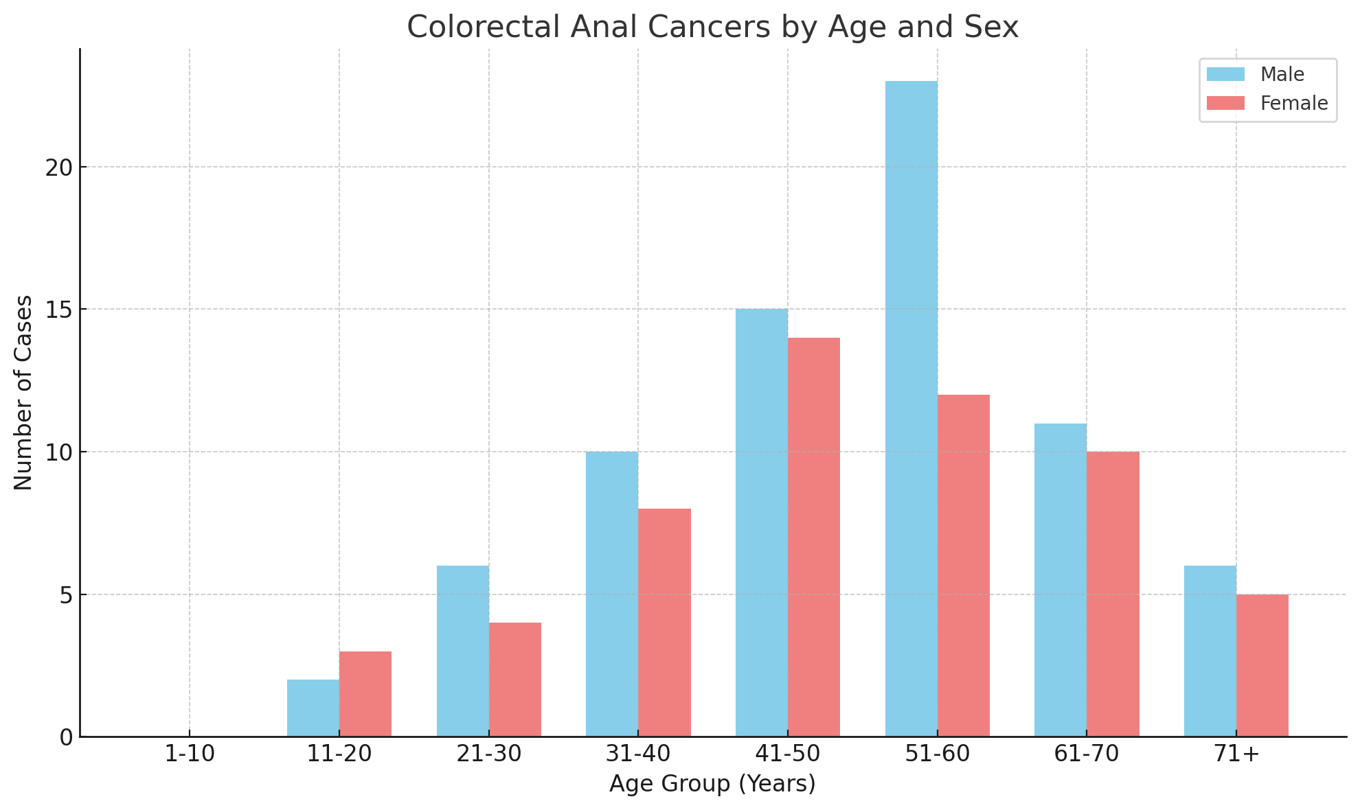

**Figure 1: CRAC Lesions: Sex and Age Group Distribution**

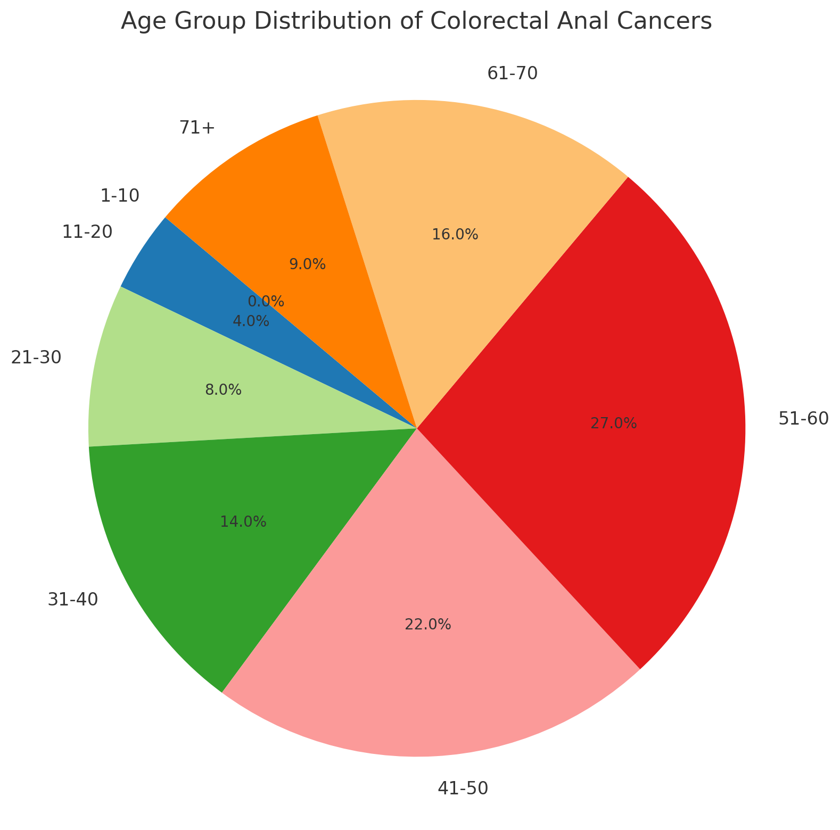

**Figure 2: Frequency of the Lesions by Age Group Distribution**

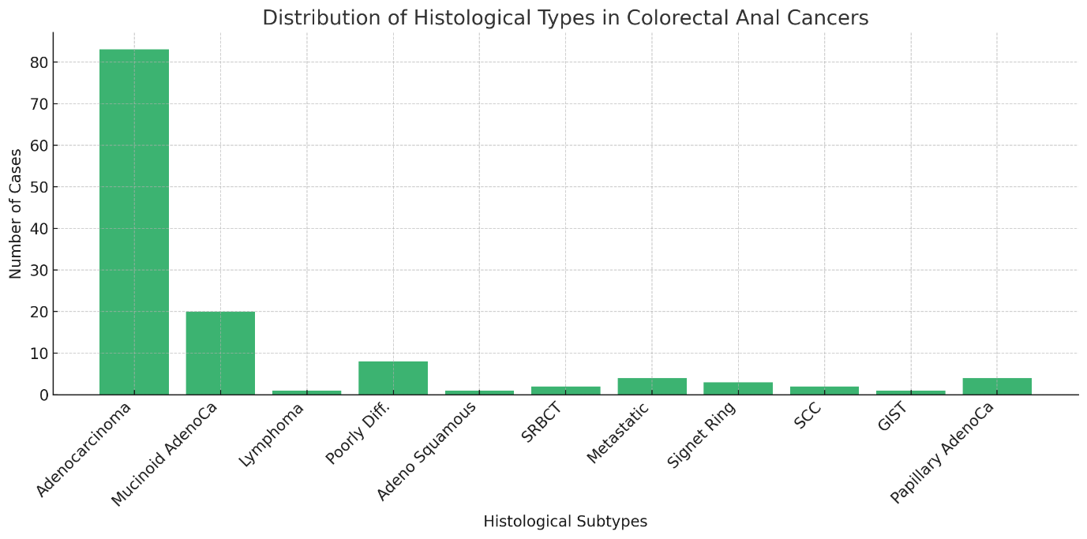

**Figure 3: Frequency of the Histological Types**

**Discussion**

This 10-year retrospective review of CRACs in Makurdi, North Central Nigeria, adds to the growing body of evidence that CRAC is an emerging oncologic challenge in sub-Saharan Africa. Once considered rare in Africa, the incidence is now rising rapidly due to epidemiological transition, urbanization, lifestyle changes, and improved diagnostic capabilities7.

The age distribution in our study, with a peak incidence between 51 and 60 years, mirrors findings from other Nigerian centres such as Lagos10, Ilorin11, and Enugu12 Notably, nearly one-fifth (19.4%) of cases occurred in individuals under 40, an alarming trend also reported in global similar studies, including the U.S., where early-onset CRAC is increasing13. These younger cases often present with mucinous or poorly differentiated histologic subtypes, as reflected in our findings (mucinous adenocarcinoma: 15.5%; poorly differentiated: 6.2%), consistent with aggressive tumour biology in younger populations13,15. Our finding of 26% early-onset CRC (<40 years) aligns with global trends but raises questions about hereditary susceptibility in an understudied population.

Globally, CRAC is the third most commonly diagnosed cancer and the second leading cause of cancer death, accounting for over 1.9 million new cases and 930,000 deaths in 202016. The WHO estimates a 77% increase in CRAC cases by 2040, with the most significant rise expected in low- and middle-income countries17. Risk factors such as physical inactivity, obesity, processed food consumption, and low dietary fibre — increasingly common in Nigeria — are known contributors to this burden18.

Our male-to-female ratio of 1.3:1 aligns with patterns reported both locally10-12 and globally19. Men are often exposed to more dietary and environmental carcinogens, and sociocultural differences in healthcare access may delay diagnosis in women10-20.

Anatomically, the rectum (27%) and anal canal (17%) were the most affected sites, paralleling findings from Ghana¹⁵ and other West African countries. Rectal cancers are often more symptomatic and thus more likely to present for care, while the relatively high proportion of anal cancers in this study may reflect regional HIV prevalence, given its known association with anal squamous cell carcinoma22. Screening for HPV-associated lesions and improved surveillance in high-risk groups such as HIV-positive individuals remain limited in Nigeria23.

Adenocarcinoma remains the dominant histologic subtype (64%), consistent with reports from Nigeria, Kenya, South Africa, and global studies10-15,24. Mucinous adenocarcinoma, known for chemoresistance and poor prognosis, was notably higher in our population (15.5%) than the 6–10% typically reported in Western cohorts25, suggesting potential regional or genetic differences in tumour biology. The high proportion of mucinous adenocarcinoma (16%) in our cohort invites exploration of region-specific environmental triggers. This necessitates scrutiny of dietary carcinogens: aflatoxin contamination in stored grains, nitrosamines in smoked fish (a dietary staple), and cyanogenic glycosides from poorly processed cassava. These compounds, known to induce mucinous differentiation in murine models, may synergize with genetic polymorphisms (e.g., CYP2E1) common with the north central communities, creating a unique oncogenic terrain warranting toxicogenomic investigation.

Rare histologies such as signet-ring cell carcinoma (2.3%), small round blue cell tumours (1.6%), and gastrointestinal stromal tumours (0.8%) were observed. These tumours are typically aggressive and present late, underscoring the need for advanced diagnostics, including immunohistochemistry and molecular profiling-capabilities still scarce in many Nigerian centers27.

Comparative studies across sub-Saharan Africa echo similar challenges: a Tanzanian review noted late presentation in over 70% of patients²³; Kenyan data highlight low screening rates and high-stage diagnoses28; Ethiopian studies also describe high mucinous histology prevalence and lack of awareness30. Unlike high-income nations, where early detection via colonoscopy and feacal immunochemical tests has reduced incidence and mortality²⁵, most African countries, including Nigeria, lack national screening policies, limiting prevention and early diagnosis27.

Our study adds to a growing literature calling for urgent investment in public education, screening programs, and diagnostic infrastructure to tackle the rising burden of CRAC in Nigeria and the broader region.

**Conclusion**

This study highlights an evolving epidemiological pattern of colorectal and anal malignancies in North Central Nigeria, marked by a substantial proportion of younger patients and predominance of advanced histological subtypes such as mucinous adenocarcinoma. The findings align with regional and global trends indicating a shift in CRAC incidence toward lower age groups and more aggressive tumour behaviour. These findings underscore the urgency of incorporating CRAC into Nigeria’s Revised National Cancer Control Plan (2024–2028). Immediate policy and healthcare interventions — including public awareness, early detection, and resource-appropriate screening — are critical to reducing morbidity and mortality in this vulnerable population.

**Limitations:**

This study is limited by its retrospective nature, potential documentation bias, and the absence of clinical-radiologic correlation. Additionally, histologic subclassification of CRACs and lack of follow-up data hinder risk assessment for subsequent malignant transformation.

**Recommendations:**

Public health campaigns should emphasize early evaluation of breast lumps in young women to alleviate anxiety and facilitate early diagnosis. Incorporate routine histologic subtyping of fibrocystic lesions to stratify cancer risk. Further prospective studies incorporating radiologic, hormonal, and molecular profiling are recommended. Establish regional breast pathology registries to enable comprehensive tracking of disease patterns.

**Ethical Approval:**

Institutional ethical clearance was obtained for the use of anonymised registry data.

**Ethical Approval:**  
Institutional ethical clearance was obtained.

**References**

1. Sung, H., et al. (2021). Global Cancer Statistics 2020: GLOBOCAN Estimates of Incidence and Mortality Worldwide for 36 Cancers in 185 Countries. *CA: A Cancer Journal for Clinicians*, *71*(3), 209-249.
2. Arnold, M., et al. (2017). Global Burden of Colorectal Cancer in Young Adults: a Worldwide Trend. *The Lancet Gastroenterology & Hepatology*, *2*(10), 717-726.
3. Irabor, D. O. (2017). Colorectal Cancer in Nigeria: Changing Trends and Clinical Phenotype. *Annals of Clinical and Laboratory Research*, *5*(2).
4. Katsidzira, L., et al. (2017). Colorectal cancer in sub-Saharan Africa: a review of the epidemiology, clinical features, and management. *Journal of Surgical Oncology*, *116*(3), 329-338.
5. Yusuf, M., et al. (2024). Clinical and Epidemiological Profiles of Patients with Colorectal Cancer Diagnosed on Colonoscopy in Nigeria, a Retrospective Study. *Iranian Journal of Colorectal Research*, *12*(3), 70-76.
6. Balogun, A. O., et al. (2024). Delays in Presentation, Diagnosis, and Treatment Among Patients with GI Cancer in Southwest Nigeria. *JCO Global Oncology*, *10*, e2400060
7. Adeloye D, Sowunmi OY, Jacobs W, David RA, Adeosun AA, Amuta AO, et al. Estimating the incidence of colorectal cancer in sub-Saharan Africa: A systematic analysis. *BMJ Open*. 2019;9(5): e028378.
8. Arnold M, Sierra MS, Laversanne M, Soerjomataram I, Jemal A, Bray F. Global patterns and trends in colorectal cancer incidence and mortality. *Gut*. 2017;66(4):683–91.
9. Alatise OI, Olasehinde O, Aliyu S, Adewale AT, Oketade I, Fatiregun OA, et al. Colorectal cancer in sub-Saharan Africa: An overview of clinical and pathological features. *JCO Glob Oncol*. 2019; 5:1–13.
10. Anya SE, Adebayo OT, Oguntola AS, Olagunju AE, Ojo BA. Pattern of colorectal cancers in Lagos, Nigeria: A 10-year histopathologic review. *Niger J Surg*. 2022;28(3):142–6.
11. Afolayan EO, Abiodun O, Amu EO. Colorectal carcinoma in Ilorin, Nigeria: An institutional experience. *Sub-Saharan Afr J Med*. 2022;9(1):23–7.
12. Ekenze SO, Ibeziako SN, Nzegwu MA. Colorectal carcinoma in Eastern Nigeria: A review of clinicopathological features and outcome. *J Gastrointest Cancer*. 2019;50(1):192–8.
13. Siegel RL, Miller KD, Goding Sauer A, Fedewa SA, Butterly LF, Anderson JC, et al. Colorectal cancer statistics, 2020. *CA Cancer J Clin*. 2020;70(3):145–64.
14. Wabinga HR, Parkin DM, Wabwire-Mangen F, Nambooze S. Trends in cancer incidence in Kyadondo County, Uganda, 1991–2010. *Afr Health Sci*. 2021;21(2):1012–21.
15. Brand M, Gaylard P, Ramos J. Colorectal cancer in South Africa: Epidemiology and screening. *S Afr Med J*. 2020;110(5):428–34.
16. Sung H, Ferlay J, Siegel RL, Laversanne M, Soerjomataram I, Jemal A, et al. Global cancer statistics 2020: GLOBOCAN estimates. *CA Cancer J Clin*. 2021;71(3):209–49.
17. Bray F, Soerjomataram I. The changing global burden of cancer: Transitions in human development and implications for cancer prevention and control. *Lancet Oncol*. 2018;19(11): e537–46.
18. Ngwogu AC, Anyanwu SN. Colorectal cancer in Nigeria: A public health perspective. *J Public Health Afr*. 2021;12(2):1537.
19. Murphy G, Devesa SS, Cross AJ, Inskip PD, McGlynn KA, Cook MB. Sex disparities in colorectal cancer incidence by anatomic subsite. *Cancer Epidemiol Biomarkers Prev*. 2018;27(11):1229–34.
20. Graham A, Adeloye D, Grant L, Theodoratou E, Campbell H. Estimating the incidence of colorectal cancer in Africa: A systematic analysis. *Int J Cancer*. 2017;141(5):926–34.
21. Nkrumah KN, Nimo PK, Agyei-Nkansah A, et al. Patterns of colorectal cancer in a tertiary hospital in Ghana. *Pan Afr Med J*. 2018; 30:240.
22. Darragh TM, Winkler B, Wentzensen N, et al. Anal cancer: Pathogenesis, classification, and clinical implications. *Nat Rev Dis Primers*. 2020;6(1):48.
23. Chukwudi OE, Ezeofor SN, Okorie DC, Umeh ON. Prevalence and histopathology of HIV-related malignancies in Enugu, Nigeria. *Afr Health Sci*. 2022;22(3):98–105.
24. Ogun GO, Akinbami FO, Akinola RA. Histopathological patterns of colorectal carcinoma in Ibadan, Nigeria. *World J Gastrointest Oncol*. 2017;9(6):256–62.
25. Khan SA, Morris M, Idrees K, Gimbel MI, Rosenberg SA, Minsky BD, et al. Clinicopathologic features of mucinous and non-mucinous colorectal cancer. *J Surg Oncol*. 2018;117(3):370–6.
26. Hamilton SR. Pathologic and molecular features of colorectal cancer. *Mod Pathol*. 2018;31(S1):S1–17.
27. Ojemakinde KO, Adisa AO, Omisore AD, Omonisi AE. Challenges in histopathologic diagnosis of colorectal cancer in Nigeria. *Afr Health Sci*. 2020;20(3):1433–41.
28. Mwakyusa S, Mrema JG, Ngoma T, Mpolya EA. Colorectal cancer in Tanzania: Trends and patterns. *East Cent Afr J Surg*. 2016;21(3):33–8.
29. Chalya PL, Mabula JB, Rambau PF, Masalu N. Clinicopathologic profile and surgical treatment of colorectal cancer in a resource-limited setting: Experience from Tanzania. *BMC Res Notes*. 2015; 8:533.
30. Dagne B, Atnafu A, Tsegaye A, et al. Histopathological patterns of colorectal cancer in Ethiopia. *Ethiop J Health Sci*. 2020;30(3):413–20.