***Original Research Article***

**Geospatial Assessment of Soil Loss in the Dibrugarh District, Assam using Revised Universal Soil Loss Equation (RUSLE)**

**Abstract**

Soil erosion is a critical global challenge, leading to the loss of fertile topsoil and contributing to decreased agricultural productivity, increased sedimentation in waterways, and ecosystem disruption. This environmental problem is more vulnerable in developing countries because of farmers' failure to restore degraded soil and nutrients. The depletion of soil is driven by extensive farming practices, land degradation, and various human activities that impact the environment. It is an emerging threat to sustainable land management in Dibrugarh District, Assam. This study uses the Revised Universal Soil Loss Equation (RUSLE) model, integrated with remote sensing and GIS, to quantify soil erosion that incorporates annual average rainfall, soil properties, topographic characteristics, and LULC as inputs to detect the soil erosion-prone areas. This study divides the whole Dibrugarh district into five soil erosion severity classes, i.e., very slight, slight, moderate, severe, and very severe. The results demonstrate that 91.147% of the area experiences very slight erosion (<2 t ha−1 yr−1), while severe erosion affects 0.148% and very severe erosion impacts 0.044% of the area, requiring urgent conservation efforts. Effective soil management and targeted conservation strategies are essential to mitigate erosion and ensure the region's long-term land productivity and environmental health.

***Keywords:*** Soil erosion, Remote sensing and GIS, RUSLE, soil management

**Introduction**

Among various environmental problems, soil erosion is a critical challenge for the environment that includes detachment, transport, and deposition of soil particles, resulting in the deterioration of the topsoil layer (Jazouli et al., 2017). This process is regarded as the second dominant environmental problem the world is facing after population growth (Jahun et al., 2015), which not only strips away the upper soil and plant cover but also depletes the entire productive soil layer. Additionally, it also removes the humus, plant nutrients, organic carbon, beneficial microorganisms, and other components required for supporting soil health and fertility (Behera et al., 2023). Deforestation, agriculture, overgrazing, construction, urban expansion, and mining are some of the anthropogenic activities that worsen this natural process (Jayasekara et al., 2018). Approximately 84% of land degradation worldwide is caused by soil erosion (Opeyemi et al. 2019), while the average rate of soil erosion fluctuates between 12 and 15 tons ha-1yr-1 (Ashiagbor et al., 2013; Behera et al., 2023), causing loss of productive land. Agriculture and its associated activities caused the removal of about 5334 million tons (1653 tons/sq km) of soil annually in India (Prasannakumar et al., 2011). The importance of soil erosion goes beyond the loss of fertile soil, as it affects the quality of water, agricultural productivity, and ecosystem stability (Ayalew et al., 2020).

Currently, the research community has concentrated on implementing remote sensing and GIS techniques to measure soil erosion and sediment yield in river basins (Benavidez et al. 2018; Sarma et al., 2021; Negese et al., 2021; Handique et al., 2023). The use of traditional methods for evaluating soil erosion is frequently time-consuming and expensive (Ganasri & Ramesh, 2016), particularly for large study areas such as district blocks. However, precise and cost-effective assessment of soil erosion and its spatial distribution across large areas is made possible by the use of remote sensing and GIS technologies (Milward & Mersey, 1999; Wang et al., 2002; Koirala et al., 2019). By combining remote sensing, GIS, and the Revised Universal Soil Loss Equation (RUSLE), soil erosion losses can be estimated on a detailed, cell-by-cell basis, enhancing precision in analysis (Milward & Mersey, 1999). In this regard, modeling supported by remote sensing and GIS provides important insights into current erosion processes and enables future predictions.

In 1968, Wischmeier and Smith developed the Universal Soil Loss Equation (USLE), revolutionizing the soil erosion prediction from cropland. This model’s simplicity and efficiency led to its worldwide popularity. The USLE model was updated and computerized in the early 1990s, resulting in the Revised Universal Soil Loss Equation (RUSLE). The Revised Universal Soil Loss Equation (RUSLE) is widely regarded as one of the most prominent empirically-based models for estimating and forecasting worldwide soil loss due to its simplicity and broader accessibility of input parameters (Perovic et al., 2013; Chalise et al., 2018; Behera et al., 2023). This updated model provides a reliable tool for forecasting average annual soil erosion rates incorporating remote sensing and GIS based on rainfall, soil, topography, cropping systems, and soil management (Wijesundara et al., 2018).

The RUSLE model is used to predict the average annual loss of soil using various factors i.e., rainfall erosivity (R), soil erodibility (K), topography (LS), cover and management (C), and support practices (P). These factors together contribute to a comprehensive understanding of the dynamics of soil erosion in a given area.

Hence, this study attempts to estimate soil erosion in the Dibrugarh district of Assam using the RUSLE model integrated with remote sensing and GIS techniques. This research seeks to provide critical insights for effective soil conservation and sustainable land management practices by evaluating the spatial distribution of soil erosion severity in the region.

**Study Area**

Dibrugarh district lies between latitudes 27°5'38" N to 27°42'03" N and longitudes 94°33'46" E to 95°29'08" E, covering an area of approximately 3381 sq. km in Assam (Fig. 1). The district is situated in the northeastern part of the upper Brahmaputra valley. It is bordered by Dhemaji and Lakhimpur districts on the north, while to the south it bordered by the Tirap district of Arunachal Pradesh. The Tinsukia and Sivasagar districts border it to the east and west respectively. Geographically, the region exhibits varied features, including extensive floodplains, swamps, wetlands, and occasional hills. The Brahmaputra River runs along its northern edge, while the Burhi Dihing River, an important tributary of the Brahmaputra, traverses the district with its widespread network of tributaries and wetlands (beels). The district has a humid subtropical climate, characterized by heavy rainfall during the summer and comparatively dry winter conditions (Bora et al., 2023).

**Materials and Methods**

**Data Collection**

The study utilized multiple geospatial datasets sourced from several repositories (Table 1). The datasets comprised of rainfall data, soil information, a digital elevation model (DEM), and satellite imagery, all essential for the RUSLE model implementation. A cloud-free Landsat 8 OLI satellite image, was retrieved from the United States Geological Survey (USGS) on 20th December 2023 to derive land cover and management details. To assess the topographical impacts on soil erosion, a 30-meter resolution SRTM 1 Arc-Second DEM, acquired on 21 December 2023. The DEM dataset was retrieved from Earth Explorer, managed by the United States Geological Survey (USGS).

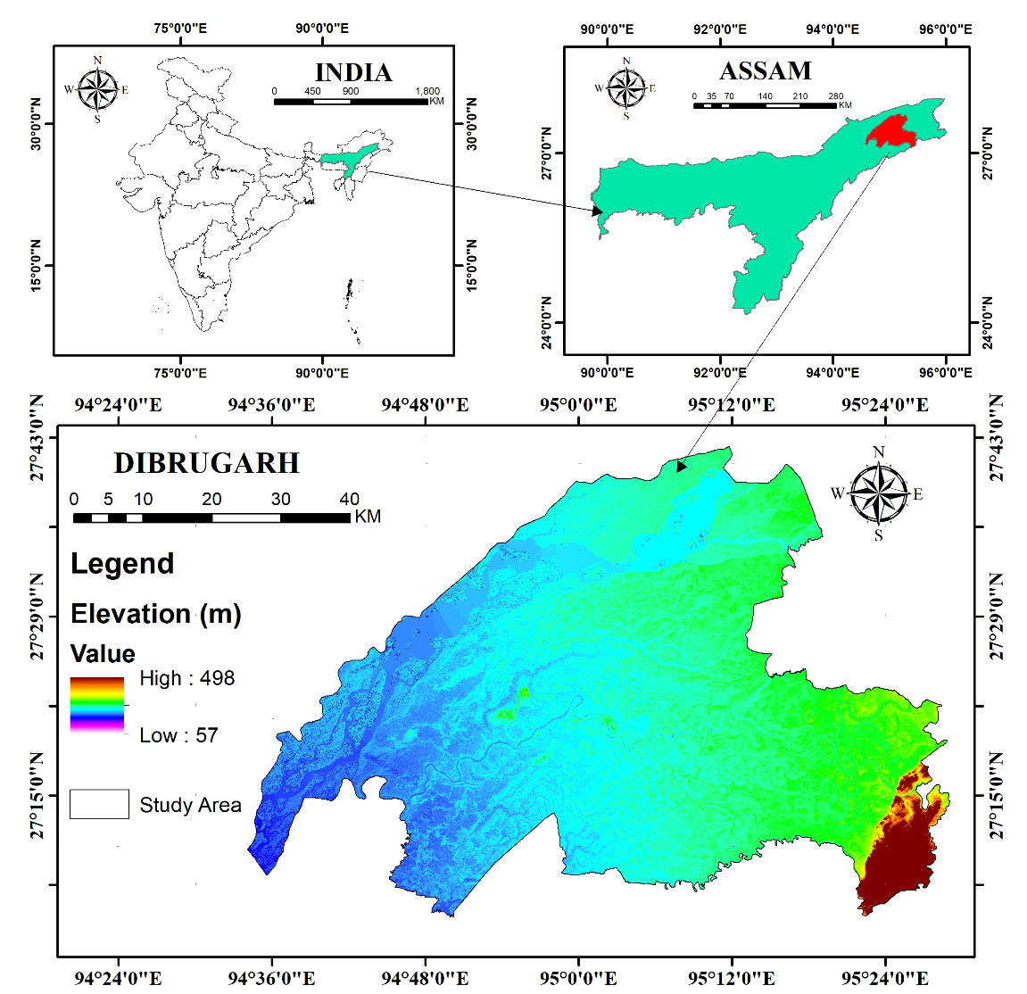

Fig. 1 Location of the study area

The study used high-resolution gridded average annual rainfall data (2021-22) obtained from the Climatic Research Unit (CRU) on 21 December 2023 for rainfall analysis. Additionally, the analysis of soil erodibility required the standardized soil profile data, which provides detailed information on soil properties such as sand, silt, clay content, and organic carbon. This data was attained from the United States Food and Agriculture Organization (FAO) soil data portal. Fig. 2 shows the methodological flow chart of the entire research.

Table 1: Sources of data used for the RUSLE model

|  |  |  |
| --- | --- | --- |
| **Datasets** | **Source** | **Date of acquisition** |
| Satellite data (Landsat 8 OLI) | <http://earthexplorer.usgs.gov/> | 20-12-2023 |
| DEM | SRTM DEM (30 m resolution) <http://earthexplorer.usgs.gov/> | 21-12-2023 |
| Rainfall data | Climate Research Unit (CRU), <https://crudata.uea.ac.uk/cru/data/hrg/> | 21-12-2023 |
| Soil data | FAO, UN <https://www.fao.org/soils-portal/data-hub/soil-maps-and-databases/en/> | 20-12-2023 |

**Application of the RUSLE Model**

The average annual soil loss (A) can be estimated through RUSLE model using five factors: rainfall erosivity (R), soil erodibility (K), slope length and steepness (LS), cover management (C), and conservation practices (P) (Renard et al., 1997), expressed as:

$A=R×K×L×S×C×P$ (1)

where, A = average annual soil loss (t ha−1 yr−1), R = rainfall erosivity factor (MJ mm ha−1 h −1, yr−1), K = soil erodibility factor (t h MJ−1 mm−1), LS = slope-length and slope steepness factor (dimensionless), C = land management factor (dimensionless), and P = conservation practice factor (dimensionless).

**Computation of causative factors**

***Rainfall Erosivity Factor (R)***

The R factor quantifies the erosive power of rainfall, measured in MJ mm ha¹ h¹ yr¹. Due to data limitations, the empirical equation by Singh (1981), favorable for the Indian context, was used:

R = 79 + 0.363 AAP (2)

where 'AAP' is the average annual precipitation in mm. A rainfall map was generated using gridded rainfall data (1921-2022) and IDW interpolation techniques in ArcGIS 10.8.

***Soil Erodibility Factor (K)***

The K factor measures loss of soil per rainfall erosion index unit, influenced by soil texture, structure, organic matter, and porosity. Using soil data from the FAO, and extracting it with the area of interest (AOI), K values were calculated with the formula from Sharpley & Williams, 1990:

$K = Fcsand×Fsi-cl×Forgc×Fhisand×0.1317$ (3)

$Fcsand=\left[0.2+0.3.exp\left(-0.256.SAN\left(1-\frac{SIL}{100}\right)\right)\right]$ (4)

$Fsi-cl = {\left[\frac{SIL}{CLA+SIL}\right]}^{0.3}$ (5)

$Forgc=\left[1.0-\frac{0.25 C}{C+exp\left(3.72-2.95C\right)} \right]$ (6)

$Fhisand=\left[1.0-\frac{0.70 SN_{1}}{{\text{ SN}}_{1}+exp\left(-5.51+2.95{\text{ SN}}_{1}\right)}\right]$ (7)

Where SAN, SIL, and CLA represent the percentages of sand, silt, and clay, respectively; C is the organic carbon content. SN1 is derived from the sand content by subtracting it from 1 and dividing by 100. Fcs and indicates a low soil erodibility factor for soils with coarse sand and a high factor for soils with low sand content. Fsi-cl reflects a low soil erodibility factor with a high clay-to-silt ratio. Forgc reduces soil erodibility for soils with high organic content, while Fhisand reduces soil erodibility for soils with extremely high sand content.

***Slope Length and Steepness Factor (LS)***

The LS factor reflects terrain influence on soil erosion, calculated using SRTM DEM data and the Wischmeier & Smith (1957) equation:

$LS={\left(\frac{λ}{Ψ}\right)}^{2}. \left(0.065+0.046s+0.0065s^{2}\right)$ (8)

where λ is flow path length, Ψ is 22.13 for SI units, and S is the average slope.

***Cover and Management Factor (C) and Conservation Support Practice Factor (P)***

The C factor accounts for vegetation's impact on soil erosion. A LULC map was created in ArcGIS 10.8, and C values were assigned based on land cover types (USDA-SCS, 1972; Wischmeier & Smith, 1978; Pandey et al., 2007). The P factor reflects conservation practices' effects on runoff and soil erosion, with values ranging from 0 (high conservation) to 1 (no conservation) 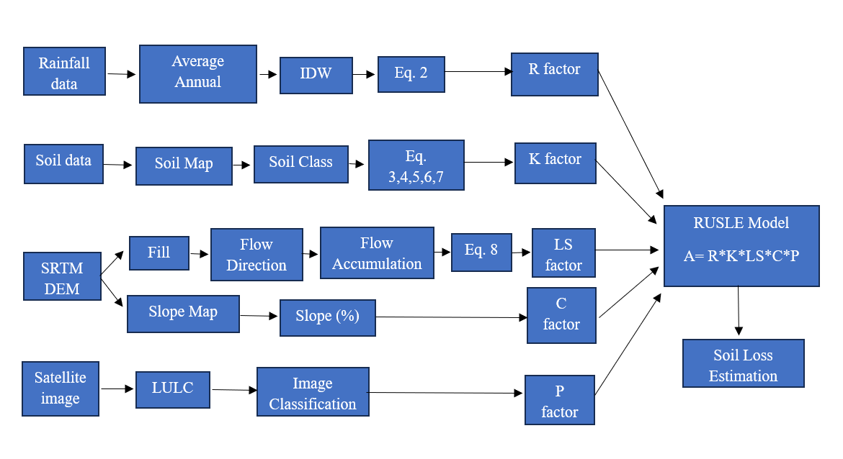(Wischmeier & Smith, 1957; Renard et al., 1997).

Fig. 2 Flow chart of the methodological framework

**Results and Discussions**

The soil erosion severity classes in the study for Dibrugarh district, Assam, were determined using the Revised Universal Soil Loss Equation (RUSLE) model. The RUSLE model used several factors to assess soil erosion. The Rainfall erosivity factor (R) value was derived from the annual average rainfall of Dibrugarh district, which ranges between 3971 and 4305 mm (Fig. 2 a). The R factor derived using Eq. 2 ranges between 1520.54 to 1641.9 MJ mm ha−1 h−1 yr−1 (Fig. 2 b). The higher rainfall and K factor value were witnessed in the southeast and south-eastern portions of the region. Soil Erodibility Factor (K) is an important determinant of soil erosion derived from the study area's soil type map. The main soil categories found in the region are clay loam (Ao) covering 46.1 sq. km area (1.3%), sandy clay loam (Af) covering 2075.03 sq. km area (61.6%), and sandy clay loam (Ao) covering 1257.9 sq. km (37.3%) (Fig. 3 a). The K factor derived from Eq. 3 (Table. 2) ranges between 0.018 to 0.020 h MJ− 1 mm− 1 (Fig. 3 b).

Table 2. Soil properties and the values of ƒcsand, ƒcl-si, ƒorgC and ƒhisand and K factor

|  |  |  |  |  |  |  |  |  |  |  |
| --- | --- | --- | --- | --- | --- | --- | --- | --- | --- | --- |
| **Soil Type** | **Area (Sq. k m)** | **Sand (%)** | **Silt (%)** | **Clay (%)** | **Organic Carbon (%)** | **fcsand** | **fcl-si** | **forgc** | **fhisand** | **K Factor** |
| Sandy Clay Loam (Af) | 2075.03 | 61.7 | 14.4 | 23.9 | 0.91 | 0.2000004 | 0.993749 | 0.989864 | 0.745675 | 0.0193205 |
| Sandy Clay Loam (Ao) | 1257.9 | 53.6 | 15.8 | 30.6 | 2.25 | 0.2000029 | 0.975001 | 0.998056 | 0.723839 | 0.0185534 |
| Clay Loam (Ao) | 46.1 | 46.1 | 21.6 | 27.4 | 1.73 | 0.20001018 | 0.977640 | 0.998867 | 0.782127 | 0.0201188 |

The influence of terrain on soil erosion is represented by slope length (L) and slope steepness (S). The slope categories in the study area ranges between 0⁰ and 18.6⁰ which has been reclassed into five classes including, 0–2° covering 1833 sq. km (54.4%), 2 - 4° covering 875 sq. km (26%), 4 - 6° covering 343 sq. km (10.5%), 6 - 8° covering 152 sq. km (4.5%) and more than 8° covering 165 sq. km (4.8%) (Fig. 4. a). The LS factor generated using Eq. 8 generated an LS factor map with value ranges between 0 to 18.64 (Fig. 4. b). It was observed that with increasing slope and flow accumulation; the LS factor also increases. The type of LULC significantly affects a region's hydrologic components, including surface runoff, infiltration, and evapotranspiration. The LULC of the study area comprises river bodies covering 239.51 sq. km (7.1%), sand deposits covering 657.01 sq. km (19.5%), Forest area covering 238.74 sq. km (7.08%), agricultural land covering 967.31 sq. km (28.7%), plantation covering 731.8 sq. km (21.7%), and settlement and built-up area covering 545.54 sq. km (Fig. 5 a). The C and P factor values assigned to each LULC class are displayed in Table 3 (Pandey et al., 2007; Dabral et al., 2008; Zonunsanga, 2016). The final C and P factor maps used in the estimation of soil erosion are shown in Fig. 5 b and 5 c.

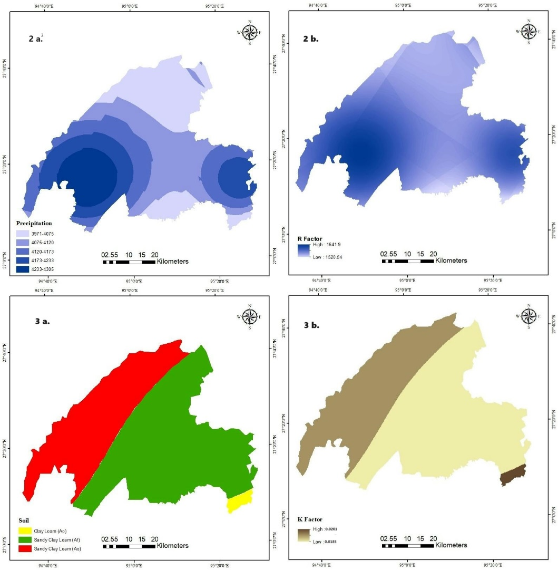

Fig. 2 a. Precipitation map; 2 b. R factor map;

Fig 3 a. Soil map; 3 b. K factor map

Table 3. LULC types, their areal coverage, and C and P factor value

|  |  |  |  |  |
| --- | --- | --- | --- | --- |
| **LULC types** | **Area (Sq. Km)** | **Area (%)** | **C Factor** | **P Factor** |
| River Bodies | 239.513 | 7.111 | 1.000 | 1.000 |
| Sand Deposits | 657.014 | 19.507 | 1.000 | 1.000 |
| Forest | 238.741 | 7.088 | 0.004 | 0.000 |
| Agriculture | 967.310 | 28.720 | 0.280 | 0.000 |
| Plantation | 731.886 | 21.730 | 0.080 | 0.000 |
| Settlement/ Built-up areas | 545.542 | 16.197 | 1.000 | 1.000 |

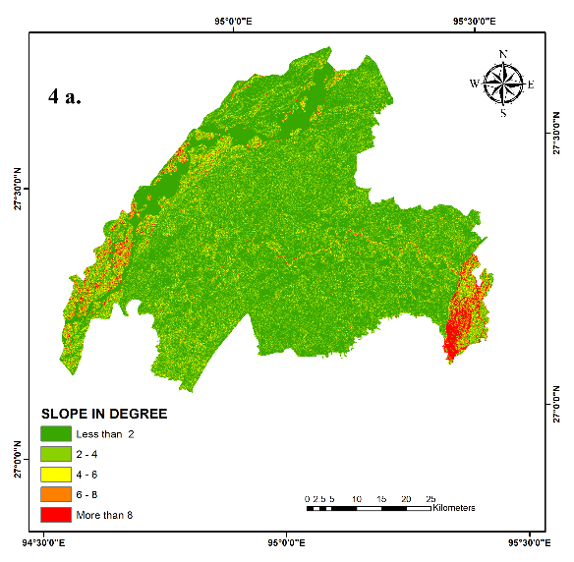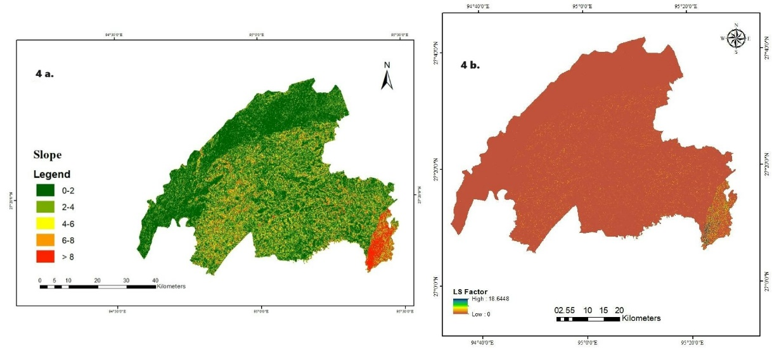

Fig. 4 a. Slope map; 4 b. LS factor map

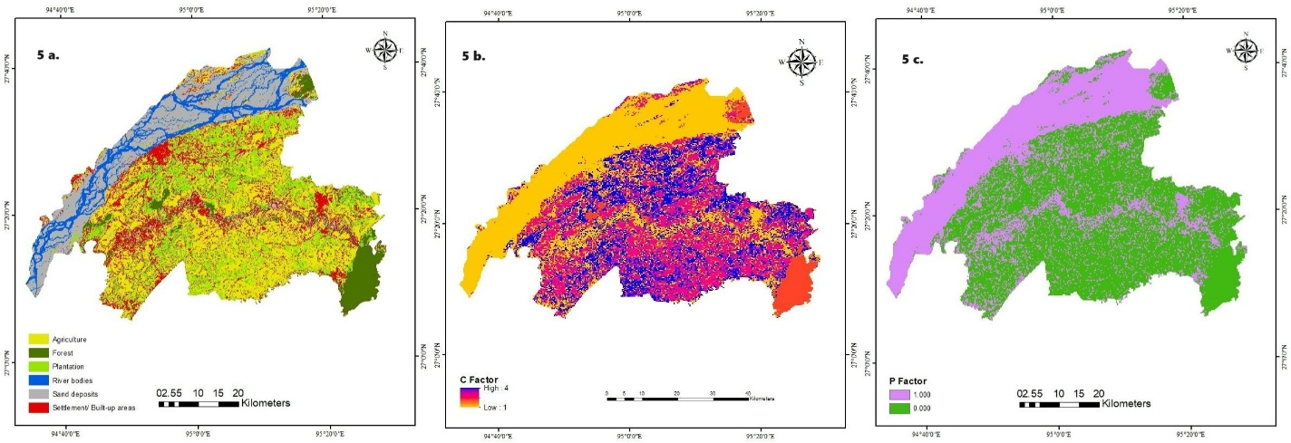

Fig. 5 a. LULC map; 5 b. C factor map; 5 c. P factor map

**Potential Soil Loss in Dibrugarh District**

The map of soil erosion (Fig. 6), prepared using Eq. 1 in ArcGIS 10.8, indicated that a vast majority of the area, approximately 91.147%, experiences very slight erosion with a soil loss rate of less than 2 t ha−1 yr−1, encompassing 3006.860 sq. km. This suggests that these areas are relatively stable, with minimal soil degradation. Slight erosion, characterized by soil loss rates between 2 and 10 t ha−1 yr−1, affects 7.638% of the district, covering 251.982 sq. km. Although not critical, these areas may benefit from basic soil conservation practices to prevent further degradation. Moderate erosion, with soil loss rates between 10 and 29 t ha−1 yr−1, was observed in 1.023% of the district (33.738 sq. km). These regions require attention and implementation of soil conservation measures to mitigate erosion. Severe erosion, identified by soil loss rates ranging from 29 to 71 t ha−1 yr−1, affects a smaller portion of the area, making up 0.148% or 4.866 sq. km. These areas are at high risk and require immediate intervention to prevent significant land degradation. Lastly, very severe erosion, with rates exceeding 71 t ha−1 yr−1, was found in only 0.044% of the district, equivalent to 1.466 sq. km (Table 4). These regions face extreme soil erosion and demand urgent and intensive soil conservation efforts to avoid irreversible damage to the land. The study highlights the importance of targeted soil conservation strategies to manage and mitigate soil erosion effectively across the district**.**

Table 4. Soil erosion severity classes and their areal coverage

|  |  |  |
| --- | --- | --- |
| **Severity classes** | **Area (sq. km)** | **Percentage Area** |
| < 2 (Very slight) | 3006.860 | 91.147 |
| 2 - 10 (Slight) | 251.982 | 7.638 |
| 10 - 29 (Moderate) | 33.738 | 1.023 |
| 29 - 71(Severe) | 4.866 | 0.148 |
| > 71 (Very Severe) | 1.466 | 0.044 |

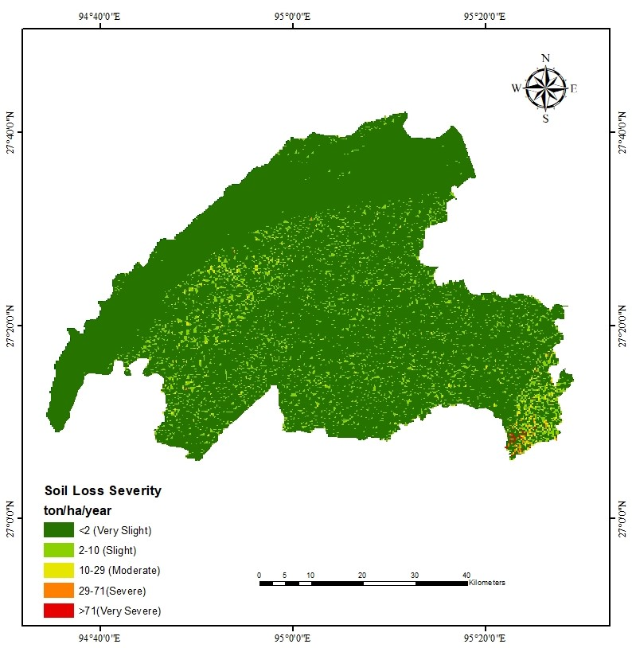

Fig. 6 Soil loss severity classes of the study area

**Implications of this study for policy and soil loss management**

The long-term average annual rate of soil erosion can be predicted using RUSLE, an empirically based modeling method that uses five factors, i.e., rainfall erosivity (R), soil erodibility (K), slope length and steepness (LS), cover and management factor (C), and support practice factor (P) (Thapa, 2020). Fayas et al., 2019 conducted a study using the RUSLE model in the Kelani River basin in Sri Lanka and reported that the higher rate of soil erosion is attributed to steeper slopes and high annual rainfall (R and LS factor). Similarly, Ghosh et al., 2022 also observed in their study on the Mayurakshi River basin that the areas with steeper slopes are most vulnerable to soil erosion. The RUSLE model can be used to estimate the average annual rate of soil loss for a site of interest for a variety of scenarios related to cropping systems, management strategies, and erosion control measures (Lee & Lee, 2006). Thus, the soil erosion model is an essential tool for forecasting excessive soil loss and supporting the implementation of erosion control strategies (Ismail & Ravichandran, 2008; Kamaludin et al., 2013). The present study used the RUSLE model to evaluate the soil erosion and its spatial distribution in the entire Dibrugarh district of Assam using remotely sensed data. It divides the entire Dibrugarh district into five soil erosion severity classes, such as very slight, slight, moderate, severe, and very severe. The results obtained from the study demonstrate that 91.147% of the area experiences very slight erosion (<2 t ha−1 yr−1), while severe erosion affects 0.148% and very severe erosion impacts 0.044% of the area. The severe and very severe erosion were identified in the areas of high altitude with steep slopes, whereas the low altitudinal areas have low rates of soil erosion. The southeastern part of the study area, where the elevation is high contributes to high potential loss of soil, while in the northern part the elevation is low, which contributes to very slight soil erosion. The rainfall and K factor value were also higher in the southeastern part of the study area, which also significantly contributes to the loss of soil. Hence, the outcome of this study would be helpful to take suitable erosion control measures in the severely affected areas as well as assist in evolving management scenarios and provide opportunities to policymakers for managing soil erosion hazards in the most effective technique.

**Conclusion**

In the present study, the RUSLE model was applied in the GIS environment to evaluate soil loss status in the Dibrugarh district of Assam. The RUSLE model used several factors such as rainfall erosivity (R), soil erodibility (K), topography (LS), cover and management (C), and support practices (P) to identify the areas prone to soil erosion. The soil erosion severity map was prepared and categorized into five different soil loss severity classes. The results indicate that a majority of the study area (over 91%) experiences a very slight rate of soil erosion, with most areas having erosion rates of less than 2 t ha−1 yr−1. However, small pockets, particularly near riverbanks, exhibited moderate to severe erosion, with rates ranging from 10 to 71 t ha−1 yr−1. The study highlights the importance of utilizing models like RUSLE, integrated with remote sensing and GIS techniques, for effective management of soil erosion. These models help identify critical areas requiring intervention and promote sustainable land use and land cover practices.

**References**

Ashiagbor G, Forkuo EK, Laari P, Aabeyir, R. Modeling soil erosion using RUSLE and GIS tools. Int J Remote Sens Geosci. 2013; 2(4); 1-17.

Ayalew DA, Deumlich D, Sarapatka B, Doktor D. Quantifying the sensitivity of NDVI-based C factor estimation and potential soil erosion prediction using Spaceborne earth observation data. Remote Sens. 2020; 12; 1136. <http://dx.doi.org/10.3390/rs12071136>

Behera DK, Jamal S, Ahmad WS, Taqi M, Kumar, R. Estimation of soil erosion using RUSLE Model and GIS tools: A study of Chilika Lake, Odisha. Journal of the Geological Society of India. 2023; 99(3); 406-414. <http://dx.doi.org/10.1007/s12594-023-2324-y>

Benavidez R, Jackson B, Maxwell D, Norton, K. A review of the (Revised) Universal Soil Loss Equation (R) USLE): With a view to increasing its global applicability and improving soil loss estimates. Hydrol. Earth Syst. Sci. 2018; 22; 6059–6086. <https://doi.org/10.5194/hess-22-6059-2018>

Bora SL, Das J, Bhuyan K, Hazarika PJ. Flood Susceptibility Mapping Using GIS and Multi-criteria Decision Analysis in Dibrugarh District of Assam, North-East India. In: Das, J., Bhattacharya, S.K. (eds) Monitoring and Managing Multi-hazards. GIScience and Geo-environmental Modelling. Springer, Cham; 2023. <http://dx.doi.org/10.1007/978-3-031-15377-8_4>

Chalise D, Kumar L, Shriwastav CP, Lamichhane S. Spatial assessment of soil erosion in a hilly watershed of Western Nepal. Environmental Earth Sciences. 2018; 77; 1-11. <https://doi.org/10.1007/s12665-018-7842-3>

Dabral PP, Baithuri N, Pandey A. Soil erosion assessment in a hilly catchment of North Eastern India using USLE, GIS and remote sensing. Water Resour Manage. 2008; 22; 1783–1798. <https://doi.org/10.1007/s11269-008-9253-9>

El Jazouli, A., Barakat, A., Ghafiri, A. et al. Soil erosion modeled with USLE, GIS, and remote sensing: a case study of Ikkour watershed in Middle Atlas (Morocco). Geosci. Lett. 2017; 4; 25. <https://doi.org/10.1186/s40562-017-0091-6>

Fayas CM, Abeysingha NS, Nirmanee KGS, Samaratunga D, Mallawatantri A. Soil loss estimation using RUSLE model to prioritize erosion control in KELANI river basin in Sri Lanka. International Soil and Water Conservation Research. 2019; 7(2); 130-137. <https://doi.org/10.1016/j.iswcr.2019.01.003>

Ganasri BP, Ramesh H. Assessment of soil erosion by RUSLE model using remote sensing and GIS-A case study of Nethravathi Basin. Geoscience Frontiers. 2016; 7(6); 953-961. <https://doi.org/10.1016/j.gsf.2015.10.007>

Ghosh A, Rakshit S, Tikle S, Das S, Chatterjee U, Pande CB, Alataway A, et al. Integration of GIS and Remote Sensing with RUSLE Model for Estimation of Soil Erosion. Land. 2022; 12(1); 116. <https://doi.org/10.3390/land12010116>

Handique A, Dey P, Patnaik SK. Application of Revised Universal Soil Loss Equation (RUSLE) model for the estimation of soil erosion and prioritization of erosion-prone areas in Majuli Island, Assam, India. Journal of Applied and Natural Science. 2023; 15(4); 1667-1678. <http://dx.doi.org/10.31018/jans.v15i4.5176>

Ismail J, Ravichandran S. RUSLE2 model application for soil erosion assessment using remote sensing and GIS. Water resources management. 2008; 22; 83-102. <https://doi.org/10.1007/s11269-006-9145-9>

Jahun BG, Ibrahim R, Dlamini NS, Musa SM. Review of soil erosion assessment using RUSLE model and GIS. Journal of Biology, Agriculture and Healthcare. 2015; 5(9); 36-47.

Jayasekara MJPTM, Kadupitiya HK, Vitharana UWA. Mapping of soil erosion hazard zones of Sri Lanka. Tropical Agricultural Research. 2018; 29 (2); 135–146. <https://doi.org/10.4038/tar.v29i2.8284>

Kamaludin H, Lihan T, Ali Rahman Z, Mustapha MA, Idris WMR, Rahim SA. Integration of remote sensing, RUSLE and GIS to model potential soil loss and sediment yield (SY). Hydrology and Earth System Sciences Discussions. 2013; 10(4); 4567-4596. <https://doi.org/10.5194/hessd-10-4567-2013>

Koirala P, Thakuri S, Joshi S, Chauhan R. Estimation of soil erosion in Nepal using a RUSLE modeling and geospatial tool. Geosciences. 2019; 9(4); 147. <https://doi.org/10.3390/geosciences9040147>

Lee GS, Lee KH. Scaling effect for estimating soil loss in the RUSLE model using remotely sensed geospatial data in Korea. Hydrology and Earth System Sciences Discussions. 2006; 3(1); 135-157. <https://doi.org/10.5194/hessd-3-135-2006>

Millward AA, Mersey JE. Adapting the RUSLE to model soil erosion potential in a mountainous tropical watershed. Catena. 1999; 38(2), 109-129. <https://doi.org/10.1016/S0341-8162(99)00067-3>

Negese A, Fekadu E, Getnet H. Potential Soil Loss Estimation and Erosion-Prone Area Prioritization Using RUSLE, GIS, and Remote Sensing in Chereti Watershed, Northeastern Ethiopia. Air Soil Water Res. 2021; 14; 1178622120985814. <https://doi.org/10.1177/1178622120985814>

Opeyemi OA, Abidemi FH, Victor OK. Assessing the impact of soil erosion on residential areas of Efon-Alaaye Ekiti, Ekiti-State, Nigeria. Int J Environ Plan Manag. 2019; 5(9); 23-31.

Pandey A, Chowdary VM, Mal BC. Identification of critical erosion prone areas in the small agricultural watershed using USLE, GIS and remote sensing. Water resources management. 2007; 21; 729-746. <https://doi.org/10.1007/s11269-006-9061-z>

Perovic V, Zivotic L, Kadovic R, Dorđevic A, Jaramaz D, Mrvic V, Todorovic M. Spatial modelling of soil erosion potential in a mountainous watershed of South-eastern Serbia. Environmental Earth Sciences. 2013; 68; 115-128. <https://doi.org/10.1007/s12665-012-1720-1>

Prasannakumar V, Shiny R, Geetha N, Vijith HJEES. Spatial prediction of soil erosion risk by remote sensing, GIS and RUSLE approach: a case study of Siruvani river watershed in Attapady valley, Kerala, India. Environmental Earth Sciences. 2011; 64; 965-972. <https://doi.org/10.1007/s12665-011-0913-3>

Renard, K.G., Foster, G., Weesies, G., McCool, D.K., & Yoder, D. (1997). Predicting Soil Erosion by Water: A Guide to Conservation Planning with the Revised Universal Soil Loss Equation (RUSLE); United States Department of Agriculture: Washington, DC, USA, 703.

Sarma K, Dutta PJ. Soil erosion estimation of Palasbari in northeast India by the RUSLE Model. Bulletin of Pure and Applied Sciences. 2021; 40 (2). <http://dx.doi.org/10.5958/2320-3234.2021.00012.3>

Sharpley A, Williams J. EPIC-erosion/productivity impact calculator: 1. model documentation (p. 1768). Washing ton: US Department of Agriculture. 1990. <https://lib.ugent.be/catalog/rug01:000223279>

Thapa P. Spatial estimation of soil erosion using RUSLE modeling: a case study of Dolakha district, Nepal. Environmental Systems Research. 2020; 9(1); 15. <https://doi.org/10.1186/s40068-020-00177-2>

USDA-SCS. ‘Hydrology’ in SCS National Engineering Handbook, section 4. Washington, DC: US Department of Agriculture. 1972.

Wang G, Gertner G, Singh V, Shinkareva S, Parysow P, Anderson A. Spatial and temporal prediction and uncertainty of soil loss using the revised universal soil loss equation: a case study of the rainfall–runoff erosivity R factor. Ecological Modelling. 2002; 153 (1-2); 143-155. <https://doi.org/10.1016/S0304-3800(01)00507-5>

Wijesundara NC, Abeysingha NS, Dissanayake DMSLB. GIS-based soil loss estimation using RUSLE model: a case of Kirindi Oya river basin, Sri Lanka. Model. Earth Syst. Environ. 2018; 4, 251–262. <https://doi.org/10.1007/s40808-018-0419-z>

Wischmeier W, Smith D, (1978). Predicting rainfall erosion losses—A guide to conservation planning. USDA Agricultural Handbook. 1978; 537.

Wischmeier W, Smith D. Factors affecting sheet and rill erosion. Transactions. American Geophysical Union. 1957; 38(6); 889–896. <https://doi.org/10.1029/TR038i006p00889>

Zonunsanga R. Estimation of Soil loss in Teirei watershed of Mizoram by using the USLE Model. Sci Technol J. 2016; 4; 43–47. <https://doi.org/10.22232/stj.2016.04.01.06>