**Urban spatial characteristics analysis of Siliguri, a class one city of West Bengal**

**Abstract**

To track and evaluate the urbanization process and provide a theoretical foundation for rural restructuring and landscape dynamics, it is imperative to quantify spatiotemporal patterns of urban expansion. In order to examine the relationship between the central city and its suburbs and to assess the overall spatiotemporal features of urban expansion in Siliguri and the surrounding area, this study combines remotely sensed data,  and GIS-based buffer gradient analysis. Based on the landscape expansion index, intensity index and differentiation index of urban growth, this paper presented the multifaceted features of urban expansion patterns. The findings demonstrate that while there are noticeable geographical variances, the distance from the urban center has a significant impact on the overall spatiotemporal changes of the area. According to the study, the western and southwestern regions, particularly those near highways, have had fast expansion whereas the eastern part is being held back from further expansion by natural obstacles such as forests. Edge expansion is the most prominent growth type, with outlying being the second most important growth type. Within the Municipal Corporation, there is compact expansion, but dispersed growth is more common outside the city center.

**Key wards: Land use land cover change, Urbanization, urban growth, urban sprawl, GIS**

**Introduction:**

India's economy has been growing quickly in recent years, which has led to a substantial increase in the pace of urbanization and the progressive expansion of urban land. Regional landscape and urban economic growth have an impact on the scope and process of urban space expansion, exhibiting clear regional features (Zhang et al., 2022; Tang et.al. 2017). As the urban economy grows and the number of non-agricultural residents rises, there will undoubtedly be a need for more land for building, which will reduce the amount of land under cultivation in the immediate area (Meng,et.al. 2022). However, haphazard or improperly planned urban growth typically results in ecological deterioration, pollution of the environment, loss of agricultural land, and ineffective use of land (Maimaiti et.al.2017; Tan et al., 2005).

Urban spatial expansion studies primarily concentrated on two areas: the delineation of urban spatial expansion and the qualitative and quantitative measurement of urban spatial patterns(Maimaiti et.al.2017).A popular method for examining how urbanization is altering ecological patterns and processes throughout the landscape is to combine landscape metrics with urban–rural gradient analysis based on remotely sensed data (Li et. al, 2010; McDonnell and Pickett, 1990; Medley et al., 1995; Luck and Wu, 2002; Zhang et al., 2004). The advancement of remote sensing has allowed researchers to more precisely measure urban growth in empirical research (Xian et.al,2019; Chen et.al.,2014). Remote sensing can also reveal the geographical distribution of recently added built-up regions, the patterns that result, and the changes over time using indicators such annual growth rate and gradient analysis (Xian et.al,2019. Ma and Xu, 2010; Xu and Min, 2013; Chen et al., 2014;). The transecting gradient paradigm, however, is also limited in its ability to capture the complexity of urban morphology and the variety of driving forces, particularly in a metropolitan area where the regional urbanization process is influenced by both the central city and rural urbanization of a satellite town. Furthermore, the outcomes of the transect selection of the various research area divisions may differ( Li et. al, 2010).It is consequently vital to investigate urbanization in surrounding villages and the related contribution to regional urbanization in order to comprehend the overall process driving regional urbanization; yet, such study has not been well documented to date( Li et. al, 2010). In this geographical setting, LEI identifies three types of urban expansion: infilling, edge expansion, and outlying. However, which type is more prevalent, and how does it alter the existing environment? Several topics have been prevalent in the current investigation.

Urbanization in Siliguri has brought economic opportunities and improved living standards for many but the rapid and uncontrolled expansion has led to significant challenges. Rather than being planned, Siliguri's infrastructure development has frequently been reactive. Urban sprawl has happened without proper planning as a result of the quick influx of people seeking better living and work conditions. Frequently, waste management facilities, drainage systems, and transportation are unable to keep up with the population growth. This leads to inefficient waste disposal systems, heavy traffic, and inadequate drainage during the rainy season. Illegal building has proliferated in Siliguri due to a lack of appropriate zoning regulations and enforcement. Unauthorized construction, encroachment on public property, and the creation of shoddy, illicit constructions are all examples of this. The city needs a thorough urban planning strategy that prioritizes sustainable expansion in order to address these problems. For sustainable growth in Siliguri, monitoring and quantifying urban sprawl is crucial. It is a complex process that calls for the fusion of data-driven insights, technology tools, and community involvement. Siliguri may accomplish regulated urban expansion and lessen environmental consequences by using advanced monitoring technologies like GIS, remote sensing, as well as by coordinating policies with sustainability objectives. The primary objective of the study is to analyze the urban spatial pattern, quantify it and to understand the future tendency of growth of Siliguri. This research is an initial attempt in examining the urban-suburban dynamics of West Bengal's fastest-growing city, Siliguri. The study can assist decision-makers and municipal development authorities in enhancing urban governance and managing urban expansion in a sustainable manner.

**Study area:**

Siliguri, located at the foothills of the eastern Himalayas, in the Darjeeling district of West Bengal, has emerged as one of the fastest-growing cities in the state. It is located at 26.72**° N latitude** and **88.39° E longitude**. The city lies at an elevation of around 300 meters (about 1,000 feet) above sea level. Siliguri is often referred to as the "Gateway to the Northeast" of India, as it connects the rest of West Bengal with the northeastern states like Assam, Sikkim, Meghalaya, and Arunachal Pradesh. Additionally, it serves as a key transit point to neighboring countries such as Nepal, Bhutan, and Bangladesh. Siliguri's proximity to international borders has made it an important commercial and trade center. This strategic location boosts trade activities, driving both economic growth and urban expansion. The four 'T's—**Tea, Timber, Tourism, and Transportation**—are fundamental to Siliguri's identity and growth. These sectors not only define its economy but also contribute to its cultural vibrancy and importance as a regional hub in North Bengal and the northeastern part of India.

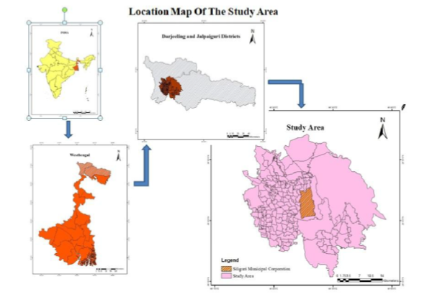

**Fig 1: Location map of the study area**

**Data base and Methodology:**

For the purpose of present study, LULC maps were produced using four sets of Landsat images (1990, 2000, 2010, & 2020). The built-up and non-built-up classifications have been applied to the LULC maps. The growth dynamics of Siliguri city and the surrounding area have been analyzed using these built-up maps. The Arc GIS buffer analysis tool was used to create multiple buffer zones outside of the city center as part of a GIS-based buffer gradient research for this purpose.

Table 1: Data sources

|  |  |  |  |  |
| --- | --- | --- | --- | --- |
| **Source** | **Data** | **Date of Acquisition** | **Resolution** | **No. Of Bands** |
| **Landsat 8** | OLI TIRS | 9/02/2020 | 30 | 11 |
| **Landsat 5** | TM | 28/01/2010 | 30 | 7 |
| **Landsat 5** | TM | 21/03/2000 | 30 | 7 |
| **Landsat 5** | TM | 6/02/1990 | 30 | 7 |

The average yearly pace of land development over two time periods is measured by the annual Built-up Rate (ABER). It is independent of the size of the spatial unit and is a modified variant of the compound growth rate formula (Alam et.al, 2023).

**ABER = [( ULAi,t+n -ULAi,t) / ULAi,t] *100**

ULA=Urban Land Area, ULAt+n = urban land-use for present years,ULAit= urban land-use for pastyears

Urban Expansion Intensity Index (UEII) is used to quantify the pace and nature of urban growth as well as to understand how quickly it has been happening over time( Liu,2000),. Urban expansion throughout the study period is expressed as a proportion of the total land area (Xu, 2013).

**UEIIi,t~t+n = [( ULAi,t+n - ULAi,t) /n] *100/ TLAi**(Liu, 2000 &Shimod,2021)

Where, t~t+n UIIi,t~t+n = intensity of urbanization within a spatial unit i during a time period t~t+n, ULAi, t+n = urban land-use for present years t+n ULAi,t = urban land-use for years t, TLAi = total area of the spatial unit i. There are five categories for UEII values: slow development (0.58), low development (0.28), medium speed development (0.59), fast development (1.05), and high speed development (more than 1.92) (Jaeger.et.al. 2010; Al-Sharif et. Al. 2014).

The third index that calculates the difference in land expansion across all spatial units is the Urban Expansion Differentiation Index (UEDI). The index may be used to determine urban expansion hotspots and evaluate regional urban land expansion. It contrasts the urban growth of the entire research region with the urban growth of the constituency of a geographical unit (Alam et.al, 2023).

**UEDI = (((ULAi,t+n -ULAi,t)/ ULAi,t) / ( (ULA,t+n -ULAt)/ ULAt)))**

Landscape Expansion Index (LEI)has been applied to quantify the three growth types – infilling, edge expansion and spontaneous growth. The LEI has been determined by shared boundary between newly grown patches and previous urban foot print using the following formula (Liu et. al., 2010):

**LEI = LC/ p**

Where, LEI = Landscape Expansion Index, Lc = length of common boundary and p = perimeter of the newly developed built-up area. The value of LEI in the above study ranges from 0 to 1 and the urban growth types identified as follows: LEI> 0.5 represents infill growth, LEI< 0.5 represent edge expansion and LEI equals to zero is termed as spontaneous growth.

**Results and discussions:**

**Land use land cover change**

The LULC analysis makes it clearly evident that the majority of the study area was covered by vegetation and agricultural land in the initial year (1990). Open areas and wetlands have been converted to urban building as a result of the extensive clearing of light vegetation and agricultural land within the study region throughout time. The plantation sector is still showing an increase trend, though. The conversion of agricultural land into a tea garden has resulted in an increase in the area covered by tea gardens, since the farmers benefit more from the crop. The primary causes are human activity-induced drying out and splintering of the river bank and illegal land encroachment by builders to construct hotels and resorts along the riverside.

Table 2: LULC of the study area (1990, 2000, 2010, 2020)

|  |  |  |  |  |
| --- | --- | --- | --- | --- |
| LULC classes | **Area in sq.km** | | | |
| **1990** | **2000** | **2010** | **2020** |
| **Build up** | 40.32 | 58.07 | 105.77 | 130.72 |
| **Agricultural land** | 425.00 | 359.17 | 300.25 | 288.86 |
| **Plantation** | 108.41 | 205.72 | 224.41 | 256.94 |
| **Vegetation** | 284.37 | 253.74 | 240.90 | 230.89 |
| **Water body** | 15.83 | 20.88 | 17.59 | 8.61 |
| **others** | 95.83 | 72.18 | 80.85 | 53.75 |
| **Total** | 969.77 | 969.77 | 969.77 | 969.77 |
| Source: Calculated by the author from LULC maps | | | | |

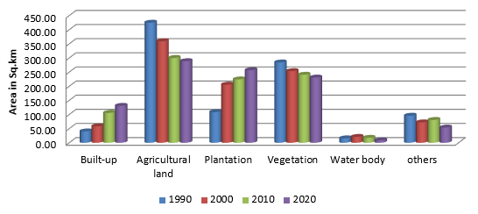

Fig 2: Land use Land cover of the study area in different time period

From 1990 to 2020, the metropolitan region developed significantly, particularly along the transportation corridor on the western and southern eastern sides, at the expense of vegetation cover and cultivated land. In 2020, the built-up area intensified profoundly, absorbing a larger proportion of agriculture, dense vegetation, and water body land uses in both the urban core and periphery. The degree of urban growth is restricted by the natural barrier produced by the Baikunthapur forest on the eastern side. Since 2001, the study area's natural landscape has undergone significant alteration due to the rapid growth of the built areas. Consequently, this LULC has suffered in the peri-urban area of this metropolis. A new set of commercial and industrial hubs was constructed in the suburbs as the city's trade and commerce activities increased in activity, attracting additional migrants. Consequently, between 2000 and 2010, the built-up area increased significantly. The Siliguri metropolitan agglomeration has experienced tremendous built-up growth due to a number of factors, including increased population, new layouts created by the public and private sectors, real estate expansion, the development of the IT sector and related infrastructure, the growth of industrial regions, etc. The primary kind of city expansion from 1990 to 2020 is edge expansion, during which the outermost areas that are far from the metropolis undergo some leap frog development.

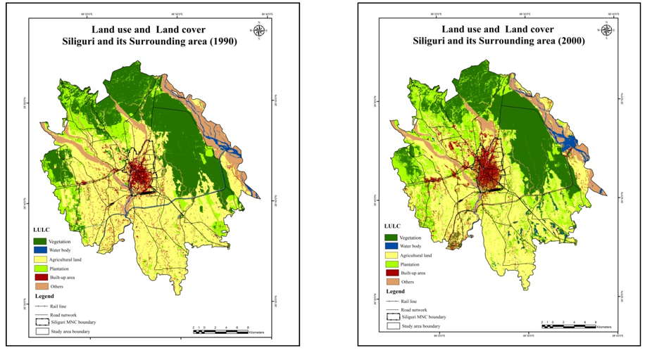

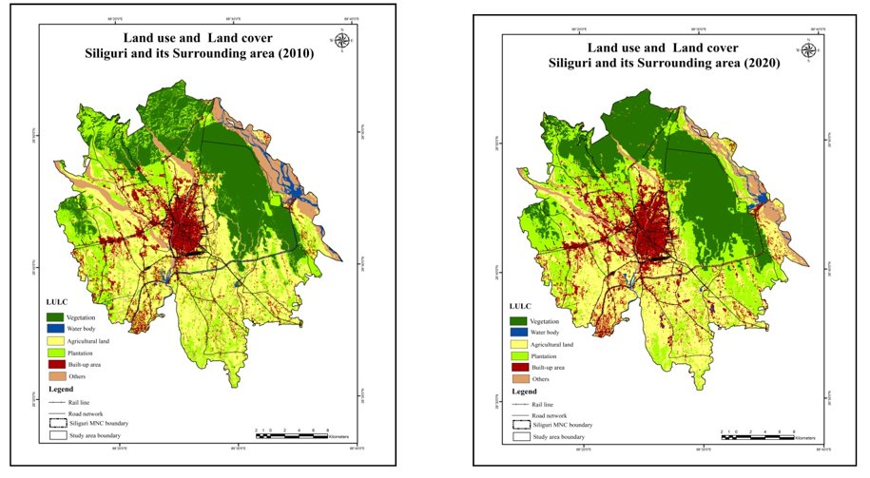

**Fig 3: Land use and land cover map of the study area (1990, 2000, 2010, and 2020)**

**Annual Built-up Expansion Rate (ABER):**

There are notable disparities in the built-up growth rates in Siliguri city and its surrounding region, particularly in the periphery. Over the past 30 years, the rate of urban expansion has fluctuated. The entire research area is 969.77 square kilometers. Of the entire area in 1990, 40.32 square kilometers were built up, while the rest 927.45 square kilometers were designated as non-built-up areas. The impervious surface grew steadily between 1990 and 2000, covering an additional 17.75 square kilometers of land throughout this decade. Between 2000 and 2010, the built-up area grew dramatically, from 58.07 square kilometers in 2000 to 105.77 square kilometers in 2010, and 47.7 square kilometers of land were transformed from non-built-up to built-up categories. From 1990 to 2000, the built-up expansion rate of the study area was a modest 4.40% annually. However, the pace of urban expansion accelerated after 2000, and between 2000 and 2010, the percentage nearly doubled to 8.21%.In the villages of Gouri, Lachka, Bhushibhita, Gadheaganj, and Sanyasikata, the built-up growth rate grew eight to ten times after 2000, despite the villages experiencing a negative growth rate from 1990 to 2000.

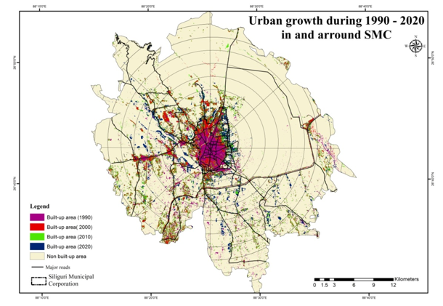

**Fig 4: Built-up expansion from 1990-2020**

The Siliguri Municipal Corporation's rate of urban expansion generally decreased between 1990 and 2020. Until 2000, the old core area's built-up area increased significantly. However, following that year, the old core region's pace of urban expansion decreased because it had reached a certain degree of development. However, the rate has accelerated in the recently added wads inside the city. The urban growth rate was quite high (9.56%) during the first phase (1990–2000) within the city limit, but it dropped to 3.23% after 2000 and then further reduced to 1.19% between 2010 and 2020.According to the research, the core city grew more quickly than the periphery over the first ten years, but after 2000, the core's built-up development rate slowed and the peripheral region's growth outpaced the core's.

Table 3: ABER, UEII of Siliguri Municipal Corporation and its peripheral area

|  |  |  |  |  |  |  |
| --- | --- | --- | --- | --- | --- | --- |
| **Year** | **Study area** | | | **Siliguri Municipal Corporation** | | |
| **Built-up area (sq.km)** | **ABER (%)** | **UEII** | **Built-up area (sq.km)** | **ABER (%)** | **UEII** |
| 1990 | 40.32 | _ | _ | 9.59 | _ | _ |
| 2000 | 58.07 | 4.40 | 0.18 | 18.76 | 9.56 | 2.19 |
| 2010 | 105.77 | 8.21 | 0.49 | 24.82 | 3.23 | 1.45 |
| 2020 | 130.72 | 2.36 | 0.26 | 29.55 | 1.91 | 1.13 |
| Source: Calculated by the author | | | | | | |

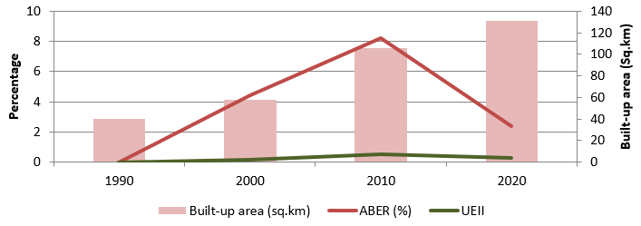

Fig 5: Annual built-up Expansion rate (ABER) and Urban Expansion Intensity Index (UEII) of the study area

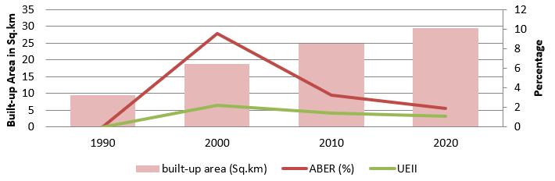

Fig 6: Annual built-up Expansion rate (ABER) and Urban Expansion Intensity Index (UEII) of Siliguri Municipal Corporation

**Spatio-temporal trends of Urban Expansion Intensity Index (UEII) based on buffer gradient analysis during 1990-2020:**

From 1990 to 2020, the UEII showed an upward-down and upward pattern, with equivalent starting and reach their highest values. The result appears to indicate that the urbanization intensity was most intense in the buffer zone surrounding the urban core. The curve exhibits a clear breaking point in 7 km from the urban core, implying a sharp decline in UEII for the region beyond the distance, demonstrating a distance decay relationship with the urban the center. Expansion intensity peaked between 2000 and 2010 (0.46), while it was comparatively lower between 1990 and 2000(0.18) and between 2010 and 2020 (0.26), indicating the region's varying spatial rate of expansion over these 30 years. The table shows that between 1990 and 2000, the UEII value inside 1 km buffer zones was 0.06; it then increased in the following decade (2000–

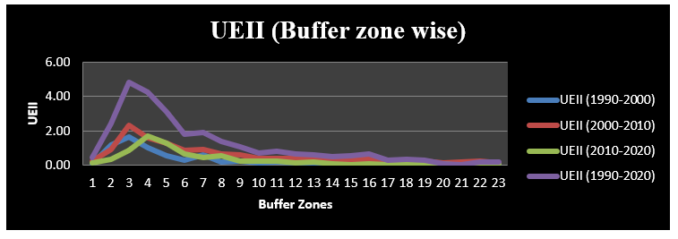

Fig 7: UEII according distance from city center

Table 4: UEII according to distance from city center

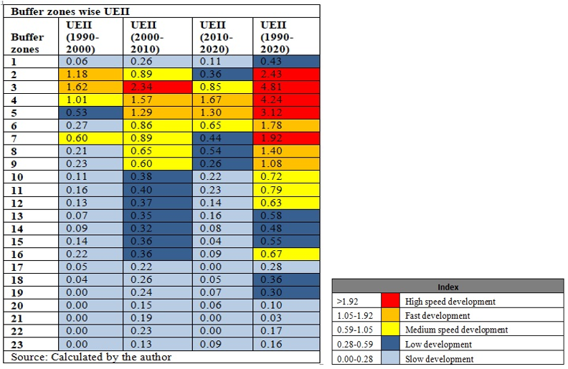

2010) and will reach 0.26, indicating infill growth within the inner city. However, the drop to 0.11 for the following ten years, 2010–2020, indicates that there is insufficient open space for more built-up growth. Due to a shortage of adequate land for development, the UEII value inside the 3 km buffer zone has generally been declining over the past 30 years. While zone 3 exhibit a very high speed development within the period of 2000-2010. Zones 4 and 5 show low to moderate expansion intensity between 1990 and 2000, however between 2000 and 2020, they show rapid development, with respective values of 1.57, 1.67 for zone 4 and 1.29 and 1.30 for zone 5. The UEII value from zone 6 to zone 23 rose significantly between 1990 and 2010, but then began to slow down between 2010 and 2020. Zones 4 and 5 show low to moderate expansion intensity between 1990 and 2000, however between 2000 and 2020, they show rapid development, with respective values of 1.57, 1.67 for zone 4 and 1.29 and 1.30 for zone 5. The UEII value from zone 6 to zone 23 rose significantly between 1990 and 2010 indicating an increased rural urbanization, but then began to slow down between 2010 and 2020. In general, there is extremely high speed development is seen between 2 and 5 km from the city center, fast development between 6 and 9 km, and medium speed development between 10 and 12 km from the city center. The intensity of the expansion, however, decreased after 12 km from the city, and the urban growth rate is extremely slow beyond 19 km. The area has a low UEII score and a progressive downturn in urbanization, indicating an absolute absence of influence relative to the Siliguri metropolitan region. Changes in UEII beyond a certain distance may be attributed to rural or local townships.

Figure displays the results of the spatial aeolotropies analysis of the UEII for Siliguri. In terms of geographic position, Siliguri City's capacity for physical growth is constrained by several factors, which prevent it from expanding uniformly in all directions. The international boundary with Bangladesh to the south and the Baikunthapur Forest to the east both confine the city's expansion. The city therefore grows primarily in two directions: north and west. Most of the development may be seen in the north and northeast on both sides of the Sevoke road, which leads to the Manpong forest. Along the westward-running NH-31 (Siliguri-Bagdogra road), the most significant urban expansion outside the city limit is seen. But the growth of this west is also constrained in certain respects by the existence of tea gardens.

Table 5: UEII according to different directions

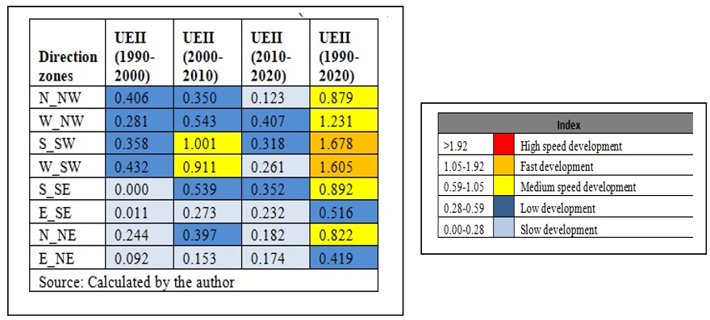

Fig 8: UEII according to different directions

During the period of 1990-2000 , the UEII curve had no sharp peak, and had low to very low trend of UEII.This intensity get picked during 2000-2010almost all directions and during this time highest pick is seen S-SW direction with a UEII value of 1.001 followed by W-SW (0.911) and W-NW(0.543). Along the Siliguri–Bagdogra national highway, the city expanded in the western part, giving rise to a number of large settlements, such as Champasari, Matigara, and Shivmandir, which later became part of the Siliguri Urban Agglomeration.On the other hand the eastern secion have experienced a slow development during this this 30 years. S-SE and N-NE section exhibits a moderate UEII. It is because, by serving as a natural barrier, the eastern forest stops additional expansion in that area. However, Dabgram, Binnaguri, and Chakiavita, which are situated immediately east of the city, had a remarkable increase during the decade due to their closeness to Siliguri as well as the creation of the Eastern bypass and Siliguri-Jalpaiguri corridor.

Siliguri city has an immense effect on the rural regions that surround it, causing them to rapidly change from non-urban to urban forms. In order to help urban planners create new planning and development strategies for the region, it is crucial to examine the UEII according to the administrative unit.The table below clearly shows that the majority of villages experienced slow to extremely slow development between 1990 and 2000, indicating that the level of urbanization was quite low during this time period.32.685 and 20.49% of villages are urbanizing at a sluggish to very slow pace, respectively.Many villages (Laldas, Lachka, Ruhinir chat, Rangapani, Bharatsing, etc.) had a negative UEII value or a decreasing trend of urbanization during this time, indicating rural-urban migration on the one hand and intensification in the city core region on the other. Only 13 administrative units (Uttar Bagdogra, Kalkut, Panchanai, Rajpairi, Kalabari, Sukna pratham Kanda, etc.) have experienced very high development (> 1.92) during this time period, while 17 villages experienced fast development (1.05-1.92). These villages are primarily located in the north and north-west directions, primarily along the major transportation axis.Between 2000 and 2010, the pace of urbanization increased significantly.Almost every area has favorable growth. During this time, villages with a negative intensity experience positive.

Table 6: UEII according to administrative unit

|  |  |  |  |  |  |  |  |
| --- | --- | --- | --- | --- | --- | --- | --- |
| **UEII** | **Intensity of Expansion** | **Number of villages/CTs** | | | **Percentage of villages or CTs** | | |
| **1990-2000** | **2000-2010** | **2010-2020** | **1990-2000** | **2000-2010** | **2010-2020** |
| >1.92 | High speed development | 13 | 19 | 18 | 6.34 | 9.27 | 8.78 |
| 1.05-1.92 | Fast development | 17 | 47 | 14 | 8.29 | 22.93 | 6.83 |
| 0.59-1.05 | Moderate speed development | 18 | 42 | 20 | 8.78 | 20.49 | 9.76 |
| 0.28-0.59 | Slow development | 42 | 31 | 29 | 20.49 | 15.12 | 14.15 |
| 0-0.28 | very slow development | 67 | 50 | 57 | 32.68 | 24.39 | 27.80 |
| <0.00 | Decreasing intensity | 48 | 16 | 67 | 23.41 | 7.80 | 32.68 |
| Source: Calculated by the author | | | | | | | |

urbanization. During this time span, around 32.2% of villages saw rapid or very rapid development.Harising has the highest UEII value (26.13), followed by Foutsingher chhat (18.25), Dumriguri chhat (16.45), and Malahar (15.11).Census towns like as Dabgram, Baramahansing, Dakhshin Bagdogra, Uttar Bagdigra, and Tari had substantial levels of urbanization during this time period.During the last decade (2010-2020) the urbanization intensity of the whole study area shows a decreasing trend. 67 villages (32.68%) have negative growth intensity. This is because the pulling capacity of the Siliguri city. Siliguri is a very alluring city for both residents and visitors due to its geographic position, economic prospects, infrastructure, natural beauty, and cultural variety. Its expansion is sustained by its function as a hub for trade and tourism, as well as by its affordability and expanding urban amenities. These factors draw more migrants from nearby villages, so it is clear from the study that more distant villages with fewer amenities have a lower level of urbanization than nearby Siliguri villages, which can access all the city's amenities and grow quickly. Thus people from distant villages migrate to the city for better quality of life.

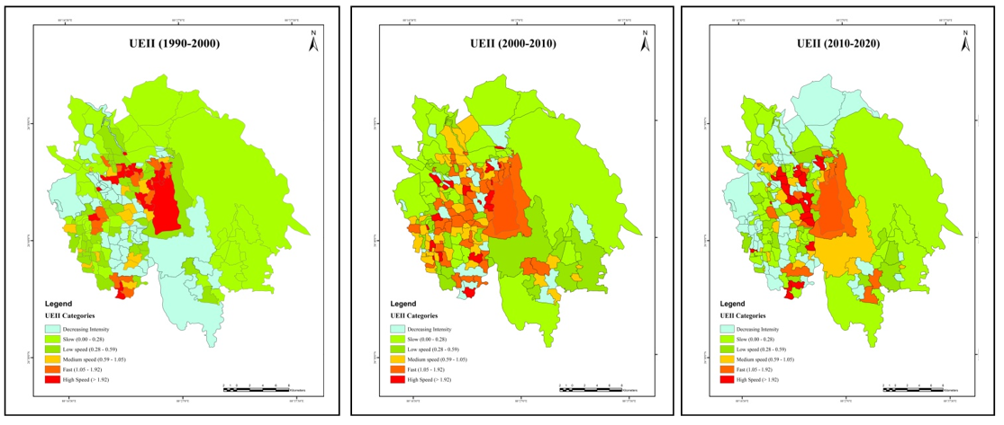

Fig 9: Urban Expansion Intensity Index (UEII) of the study area, 1990, 2000, 2010, & 2020

**Urban Expansion Differentiation Index (UEDI):**

UEDI makes a comparison between the urban growth of the entire research area and the urban growth of a spatial unit's constituent (Alam, 2023).Here for the present study the urban development state is divided into four categories: slow development, medium speed development, high speed development and decreasing trend. From the overall point of view, the speed of urban development is high in the western and north western part. Over the study period the center of rapid development moved from the city core and adjoining north western part to the western part along NH 31.The eastern(Mainly Dabgram) and south eastern part (Mainly Binnaguri, Chakiavita) of Siliguri city developed after 2000 when the city upgraded to Municipal Corporation and added some area from Dabgram. Siliguri, on the other hand, witnessed medium speed development (2.17) in the first ten years, followed by a spillover effect, and the speed decreased after 2000.

Table 7: UEDI of the study area (1990,2000,2010& 2020)

|  |  |  |  |  |  |  |  |
| --- | --- | --- | --- | --- | --- | --- | --- |
| **UEDI** | **Speed of development** | **Number of villages/CTs** | | | **Percentage of villages or CTs** | | |
| **1990-2000** | **2000-2010** | **2010-2020** | **1990-2000** | **2000-2010** | **2010-2020** |
| > 3.00 | High speed development | 77 | 46 | 41 | 37.56 | 22.44 | 20.00 |
| 1.5-3.00 | Moderate speed development | 27 | 60 | 23 | 13.17 | 29.27 | 11.22 |
| 0-1.5 | Slow development | 24 | 55 | 60 | 11.71 | 26.83 | 29.27 |
| <0.00 | Decreasing intensity | 77 | 44 | 81 | 37.56 | 21.46 | 39.51 |
| Source: Calculated by the author | | | | | | | |

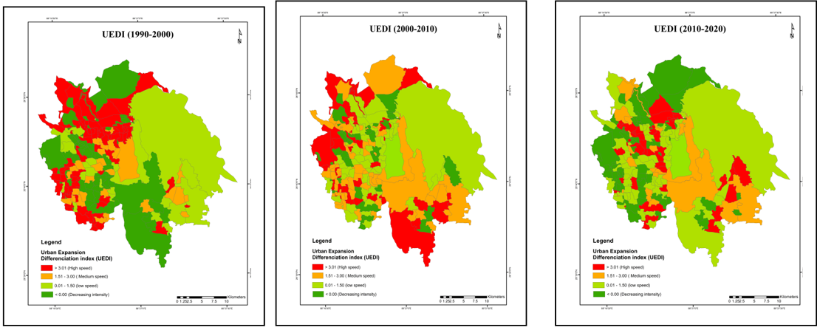

Fig 10: UEDI of the study area (1990,2000,2010, & 2020)

**Characterizing the growth types of built-up areas:**

Gradient analysis (buffer analysis) assists in understanding the urbanization pattern; however the Landscape Expansion Index (LEI) may be utilized to define the urban expansion type: infilling type, edge expansion and outlying pattern. It has been observed that Siliguri's dominant urban growth pattern spanning three consecutive periods is edge-expansion 45.5% of edge growth occurred between 1990 and 2000, and the percentage of edge expansion grew with time. It increased to 69.52% between 2000 and 2010, with the highest spike of 76.73% occurring between 2010 and 2020. The majority of the growth in edge expansion happened next to major roads, rivers, and the region that surrounds the central business district. The outlying growth appeared scattered and mostly developed beyond the city center. The most notable aspect is the significant outlier increase of around 40.1% between 1990 and 2000. It implies that at this time, tiny communities focused on markets, small enterprises, service hubs, or modest institutions developed in the suburbs. As these tiny patches grow geographically as a sort of edge expansion, the pattern of outlying diminishes with time, dropping to 28.37% in 2000-2010 and 26.13% in 2010-2020. Most infilling development occurred within the city, primarily in the open spaces. Infilling has been declining over time, going from 14.41% in 1990–2000 to 2.11% in 2000–2010 and 1.24% in 2010–2020.

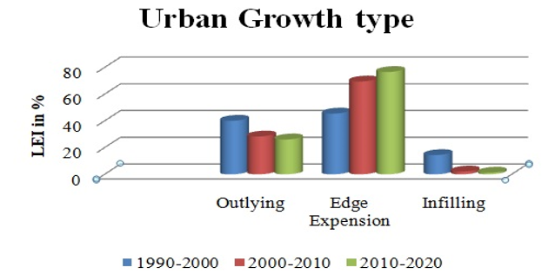

Fig 11: Urban growth type of the study area

**Conclusion:**

Significant findings from the study show that throughout these three decades, there has been a shift in the spatial pattern of land use. Over these 30 years of research, the built-up area has been rapidly growing. By 2020, 13.68% of the study area is covered by impermeable surface, up from 4.16% in 1990. The area along the major highway in the west has the most built-up change. The yearly rate of growth in the built-up area is 7.47%.A growing tendency has been seen in plantations over this time, with an annual growth rate of 4.57%. In 1990, plantations accounted up 11.18% of the study area; by 2020, that percentage had risen to 26.49%. Fast development is observed in the western and southwestern regions, whereas the eastern region is prevented from expanding further by natural barriers like forests. Dispersed type of growth is seen throughout the study area while compact growth is seen within the Municipal Corporation. Edge expansion is the predominant type of growth throughout the region, while the second significant growth type is the outlying. The counter-urbanization process is highly evident in case of Siliguri. As the city's old core wards are witnessing a low level of urbanization and persistent population decrease. Here, with people moving from the core to the periphery owing to high land value, congestion, and pollution, while the old city wards are predominantly associated with commercial activity. Siliguri is at a pivotal moment. Its future expansion has to be directed by careful planning, environmentally friendly infrastructure, and active public participation. The only way to create a sustainable Siliguri is through cooperative governance that strikes a balance between social and environmental responsibility and growth.

**References:**

1. Alam, I., Nahar, K., & Morshed, M. M. (2023). Measuring urban expansion pattern using spatial matrices in Khulna City, Bangladesh. *Heliyon*, *9*(2).
2. Al-Sharif, A. A., Pradhan, B., Shafri, H. Z. M., & Mansor, S. (2014, June). Quantitative analysis of urban sprawl in Tripoli using Pearson's Chi-Square statistics and urban expansion intensity index. In *IOP Conference Series: Earth and Environmental Science* (Vol. 20, No. 1, p. 012006). IOP Publishing
3. Chen, J., Chang, K.T., Karacsonyi, D., Zhang, X., 2014. Comparing urban land expansion and its driving factors in Shenzhen and Dongguan, China. Habitat Int.43 (3), 61e71
4. Jaeger, J.A., et al., Suitability criteria for measures of urban sprawl. Ecological Indicators, 2010. 10(2): p. 397-406
5. Li, X., Zhang, L., & Liang, C. (2010). A GIS-based buffer gradient analysis on spatiotemporal dynamics of urban expansion in Shanghai and its major satellite cities. *Procedia Environmental Sciences*, *2*, 1139-1156.
6. Liu, S., Wu, C., & Shen, H. (2000). A GIS-based model of urban land use growth in Beijing. Acta Geographica Sinica, 55, 407–416
7. Luck, M., & Wu, J., 2002. A gradient analysis of urban landscape pattern: a case study from the Phoenix metropolitan region of USA.Landscape Ecol. 17, 327–339.
8. Ma, Y., Xu, R., 2010. Remote sensing monitoring and driving force analysis of urban expansion in Guangzhou City, China. Habitat Int. 34 (2), 228e235
9. Maimaiti, B., Ding, J., Simayi, Z., & Kasimu, A. (2017). Characterizing urban expansion of Korla City and its spatial-temporal patterns using remote sensing and GIS methods. *Journal of Arid Land*, *9*, 458-470.
10. McDonnell, M.J., Pickett, S.T.A., Groffman, P., Bohlen, P., Pouyat, R.V., et al., (1997).Ecosystem processed along an urban-to rural gradient. Urban Ecosyst. 1, 21–36.
11. Medley, K.E., McDonnell, M.J., & Pickett, S.T.A., 1995. Human influences on forest-landscape structure along an urban-to-rural gradient. Prof. Geographer 47, 159–168.
12. Meng, H., Zhang, K., Ba, M., & Wen, D. (2022). Spatial Characteristics Analysis of Urban Expansion in Luoyang, China. *Journal of Geographic Information System*, *14*(2), 153-174.
13. Shimod, K. P.,(2021) Dynamics of urban growth in Kannur district a spatio temporal analysis using geographical information system and remote sensing.Doctoral thesis
14. Tang, X., Jiang, J., et al. (2017) Urban Spatial Expansion and Its Influence Factors Based on RS/GIS: A Case Study in Changsha. Economic Geography , 3, 81-85.
15. Xian, S., Li, L., & Qi, Z. (2019). Toward a sustainable urban expansion: A case study of Zhuhai, China. *Journal of Cleaner Production*, *230*, 276-285.
16. Xu, X., Min, X., 2013. Quantifying spatiotemporal patterns of urban expansion in China using remote sensing data. Cities 35 (4), 104e113
17. Zhang, K.G., Meng, H.L., Ba, M.T. and Sun, Y.M. (2022) Characteristics Analysis of Urban Space Expansion in Luoyang, China. Journal of Geoscience and Environment Protection, 10, 123-139.
18. Zhang, L.Q., Wu, J.P., Zhen, Y., & Shu, J., (2004). A GIS-based gradient analysis of urban landscape pattern of Shanghai metropolitan area, China. Landscape Urban Plan. 69, 1–16.