Original Research Article

Biological evaluation of proso millet and sweet lupine seeds in hypercholesterolemia rats

Abstract
Given the rising global prevalence of atherosclerosis and cardiovascular diseases, a study was conducted to evaluate the effects of incorporating proso millet seed powder (PMSP) and sweet lupine seed powder (SLSP) into the diet of hypercholesterolemic (Hyper-C) rats. These powders were included at varying levels (10% or 15%) as replacements for starch. The findings revealed that substituting a hypercholesterolemic diet with PMSP, SLSP, or a combination of both at 10% resulted in significant reductions in serum total cholesterol (T.C.), total triglycerides (T.G.), low-density lipoproteins (LDL), and very low-density lipoproteins (v.LDL), while simultaneously increasing high-density lipoproteins (HDL).Additionally, this dietary substitution led to a marked reduction in serum liver enzyme levels, indicating improved liver function, alongside enhanced activity of antioxidant enzymes. Histopathological evaluations further corroborated these findings, revealing that Hyper-C rats fed PMSP and SLSP displayed significant improvements in the structural integrity of the liver, heart and kidneys, with reduced lesion severity. These findings emphasize the potential of PMSP and SLSP as functional dietary components that not only lower serum cholesterol but also provide protective benefits for individuals at risk of liver and cholesterol-related diseases.

Keywords: rats; lipid profile; PMSP; SLSP; and hypercholesterolemia.

Abbreviations: (PMSP): proso millet seed powder; (SLSP): sweet lupine seed powder and Hyper-C: hypercholesterolemic
Introduction
Hypercholesterolemia and cardiovascular diseases, particularly atherosclerosis, are pressing challenges to global public health. Effective management and prevention require increased awareness of the role of dietary interventions, as highlighted by de Leon et al. (2007). Park et al. (2022) demonstrated that imbalanced diets significantly contribute to the risk of chronic diseases, including a 30% rise in cardiovascular disease, a 35% increase in cancer risk, and a 50% higher likelihood of obesity. To mitigate these risks, incorporating nutrient-dense foods such as proso millet into the diet offers considerable promise. Proso millet is rich in bioactive compounds, including nutraceuticals, dietary fiber, omega-3 fatty acids, phenolics, and flavonoids. These components support cholesterol metabolism, protect tissues and DNA from oxidative damage, and regulate blood sugar levels, making proso millet a valuable candidate for managing metabolic disorders and degenerative diseases, as outlined by Mishra et al. (2022).
Lupin, a legume with a high protein content (35-40%) and abundant in non-starch polysaccharides (NSP), has also demonstrated its potential to modulate cholesterol levels. Studies by Garmidolova et al. (2022) and Kefala et al. (2022) have shown that lupin can influence sterol and cholesterol absorption in the intestine. Research by Sirtori et al. (2004) found that lupin protein significantly reduced plasma total cholesterol, LDL cholesterol, and very low-density lipoprotein levels in rats, an effect attributed to the activation of LDL receptors by specific lupin seed proteins, as confirmed in vitro. Furthermore, Viveros et al. (2007) observed that lupin carbohydrates increased intestinal viscosity and reduced cecal pH, mechanisms linked to lower serum and liver cholesterol and decreased cholesterol absorption. Proso millet, recognized for its antioxidant, antibacterial, and anti-carcinogenic phytochemicals, continues to gain attention for its health-promoting properties, as noted by Taylor et al. (2014). Additionally, the proteins in proso millet have been found to enhance cholesterol metabolism. In recent years, its popularity as a whole-grain alternative has grown, particularly in Europe and North America, due to its gluten-free nature, mild flavor, and light color, making it an attractive ingredient in the food industry, as emphasized by Bora et al. (2018).
The primary objective of this study was to evaluate the nutritional properties of proso millet seed powder (PMSP) and sweet lupin seed powder (SLSP) and investigate their effects on hypercholesterolemic (Hyper-C) rats.

MATERIALS AND METHODS
Materials
Proso millet seeds (Panicum miliaceum) and sweet lupine seeds (Lupinus albus) were sourced from the Field Crops Department, Agricultural Research Center, Giza, Egypt, during the 2023 harvest season. These seeds were stored at -20°C to preserve their quality until use. A total of 49 male Sprague Dawley albino rats, weighing between 150-200 g, were procured from the Faculty of Medicine, Al-Mansoura University, Egypt. Chemicals and diagnostic kits used in the study were supplied by El-Gomhoriya Trading Company.

Methods:

Sample Preparation:
The preparation of proso millet seed powder (PMSP) and sweet lupine seed powder (SLSP) involved grinding the seeds using a laboratory hammer mill (Retsh, Germany). The resulting powders were sieved through a 60-mesh screen and stored at -20°C in polyethylene bags for subsequent analysis (Ahmed, 2014).

Gross Chemical Composition of PMSP and SLSP:
The chemical composition of PMSP and SLSP was assessed using AOAC (2005) methods, including moisture, crude protein, crude fat, and ash content. The carbohydrate content was determined by subtracting the total and available carbohydrates, providing a comprehensive nutritional profile. The energy value (kcal/100g) was calculated as per James’s (1995) equation:
Energy value (kcal/100g) = 4 × (g protein + g carbohydrates) + 9 × (g fat).

Phenolic and Flavonoid Content:
Total phenolic compounds were extracted following Salah et al. (2024). The Folin-Ciocalteu reagent was used for spectrophotometric determination of total phenolic compounds, with tannic acid serving as the standard (Salem et al., 2018). Similarly, the total flavonoid content was evaluated using Quercetin as the standard.

Antioxidant Activity:
The antioxidant activity of PMSP and SLSP was measured using the DPPH method as outlined by Peanparkdee et al. (2020)

Biological Assay:

Animal Model and Experimental Design:
Forty-nine male Sprague Dawley rats (153-155 g) were housed in cages with screen bottoms and acclimated to a basal diet for one week. During the 12-week study, the rats had ad libitum access to food and water.
The animals were divided into two main groups:
1-Negative control group (C-ve): Fed a standard basal diet (7 rats).
2-Hypercholesterolemic group (42 rats): Fed a diet enriched with 1% cholesterol and 10% beef tallow for four weeks to induce hypercholesterolemia. Subsequently, the hypercholesterolemic group was divided into six experimental groups and fed modified diets containing PMSP, SLSP, or their mixtures for eight weeks, as shown in Table 1. (Salem et al., 2018).

Sample Collection and Measurements:
At the end of the experiment, blood samples were collected, and the animals were sacrificed. The kidney, liver, and heart were dissected, cleaned, and weighed. Feed intake (F.I.), body weight gain (B. WG), and feed efficiency ratio (F.ER) were calculated weekly using the formula by Salem et al. (2019):
B. WG% = [(Final Weight - Initial Weight) / Initial Weight] × 100.
Relative organ weight (R.O.W.) was calculated as:
R.O.W. = (Organ weight / Animal weight) × 100.
𝐅. 𝐄𝐑 % = 𝑮𝒂𝒊𝒏 𝒘𝒆𝒊𝒈𝒉 / fee𝒅 𝒄𝒐𝒏𝒔𝒖𝒎

Table (1): Formulation of various experimental hyper-c diets
G7 | G6 | G5 | G4 | G3 | G2 | G1 | Groups
100 | 100 | 100 | 100 | 100 | 100 | 0 | Beef tallow
2.5 | 2.5 | 2.5 | 2.5 | 2.5 | 2.5 | 0 | Bile salt
140 | 140 | 140 | 140 | 140 | 140 | 140 | Casein
50 | 50 | 50 | 50 | 50 | 50 | 50 | Cellulose
10 | 10 | 10 | 10 | 10 | 10 | 0 | Cholesterol
2.5 | 2.5 | 2.5 | 2.5 | 2.5 | 2.5 | 2.5 | Choline chloride
100 | 100 | 100 | 100 | 100 | 100 | 100 | Corn oil
348 | 398 | 448 | 398 | 448 | 548 | 660.5 | Corn starch
2 | 2 | 2 | 2 | 2 | 2 | 2 | L-cystine
35 | 35 | 35 | 35 | 35 | 35 | 35 | Mineral mixture
100 | - | - | 150 | 100 | - | - | PMSP
100 | 150 | 100 | - | - | - | - | SLSP
10 | 10 | 10 | 10 | 10 | 10 | 10 | Vitamin mixture
PMSP: Proso millet seeds powder; SLSP: sweet lupine seeds powder.
G1: Feed on the basal diet (control -ve).
G2: Feed on Hypercholesterolemia diet (control +ve).
G3: Feed on Hypercholesterolemia diet replaced 10% (PMSP) for starch.
G4: Feed on Hypercholesterolemia diet replaced 15% (PMSP) for starch.
G5: Feed on Hypercholesterolemia diet replaced 10% (SLSP) for starch.
G6: Feed on Hypercholesterolemia diet replaced 15% (SLSP) for starch.
G7: Feed on Hypercholesterolemia diet replaced 10% (a mixture of PMSP and SLSP) for starch.

Biochemical Analysis and Enzyme Assays:
High-density lipoprotein cholesterol (HDL-C), total cholesterol (TC), and triglyceride (TG), levels were measured by enzymic colorimetric procedures using commercially available kits. HDL-C and (TC) were carried out according to the methods of Richmond (1973). (TG) were carried out according to the method of Fossati and Principe (1982).
Low-density lipoprotein cholesterol (LDL-c) and very low-density lipoprotein (VLDL-c) were calculated mathematically according to Friedwald's equations (Friedewald et al., 1972). VLDL-c = triglycerides/5 while LDL-c = TC – [HDL-c + (TG/5)].
Kidney function tests, including the determination of serum uric acid, urea, and creatinine levels, were performed following the methodologies described by Trinder (1969), Chaney and Marbach (1962), and Fabiny and Ertingshausen (1971), respectively.
Liver function tests involved measuring the activities of alanine aminotransferase (ALT) and aspartate aminotransferase (AST) enzymes as outlined by Varley et al. (1980), while the activity of alkaline phosphatase (ALP) was assessed according to King (1965). Additionally, antioxidant enzyme activities, including serum superoxide dismutase (SOD), glutathione peroxidase (GPx), and catalase (CAT), were evaluated using the methods detailed by Oyanatui (1984).

Histopathological Examination:
At the conclusion of the experiment, tissue samples from the heart, liver, and kidney, of the sacrificed rats were collected and analyzed to assess structural and histological changes. The examination followed the procedures outlined by Yoon et al. (2001).

Statistical Analysis
The collected data was subjected to statistical analysis using analysis of variance (ANOVA). Significant differences between group means were determined using Duncan’s Multiple Range Test (DMRT), as described by Steel and Torrie (1980).

RESULTS AND DISCUSSION
Nutritional composition of PMSP and SLSP samples:
According to the results presented in Table 2, the moisture contents of PMSP and SLSP were found to be 8.97% and 8.00%, respectively. This level of moisture is beneficial for the storage of seeds under appropriate conditions as it helps inhibit the growth of microorganisms and biochemical reactions.
Additionally, the data reveals that SLSP has higher protein, either extract, and crude fiber contents (35.08%, 11.37%, and 12.70%, respectively) than PMSP. On the other hand, PMSP exhibits higher ash content, total carbohydrates, total phenolic compounds, total flavonoid content, and antioxidant activity (4.00%, 79.14%, 130.00 mg TAE/100g, 33.00 mg QE/100g, and 78.00%, respectively) as compared to SLSP. These findings are consistent with the results reported by
El-Hadidi (2017), Reddy et al. (2019), Abdel-Gawad et al. (2020), Hassan et al. (2020), and Mansour et al. (2021) Salem et al. (2023).

Table (2): Nutritional evaluation of PMSP or SLSP (on a dry weight basis).
 | SLSP | PMSP | Samples  Compounds
8.00±0.15^{b} |  | 8.97±0.11ª | Moisture%
92.00±0.19ª |  | 91.03±0.13^{b} | Dry matter
35.08±0.39ª |  | 12.67±0.25^{b} | Crude Protein%
11.37±0.17ª |  | 4.19±0.24^{b} | Ether extract%
3.22±0.11^{b} |  | 4.00±0.10ª | Ash%
12.70±0.19ª |  | 8.70±0.17^{b} | Crude fiber%
50.33±0.32^{b} |  | 79.14±0.41ª | Total carbohydrates%
37.63±0.37^{b} |  | 70.44±0.48ª | Available carbohydrates%
443.97±3.11ª |  | 404.95±1.07^{b} | Caloric value (K. cal./100g)
18.00±0.08^{b} |  | 130.00 ±0.09ª | TPC (mg TAE/100g)
21.00±0.009^{b} |  | 33.00±0.04ª | TF (mg of QE/100g)
70.00 ± 0.17^{b} |  | 78.00±0.22ª | Antioxidant activity (%)

The values represent the average of seven measurements ± standard deviation (SD).
Within a column, means sharing the same letters indicate no statistically significant differences at a significance level of <0.05. TPC: Total phenolic compounds, and TF: total flavonoids.

Impact of feeding with varying levels of PMSP and SLSP in Hypercholesterolemic rats:
- growth parameters:
Table (3) displays the effects of PMSP and SLSP on (F.I.), (B. WG%), and (F.ER) of hyper-c rates over a 12-week period. The initial weights of the rat groups were similar with a range of 153.10 to 155.00 g. and the final weights of the Hypercholesterolemia rat Gr.2 (control +ve) were higher than the Gr.1 (control -ve) at the end of the experiment. However, all groups displayed a significant decrease in B. WG, which could be attributed to the rich amounts of dietary fiber present in both PMSP and SLSP. Anderson et al. (2009) have previously demonstrated that dietary fiber mechanisms, such as delayed gastric emptying, decreased glucose diffusion, and prevention of fat absorption, contribute to weight loss. It was also observed that there was a significant decrease in F.I. and F.ER in comparison to hypercholesterolemia rates in Gr.2 (control+ve), aligning with the findings reported by Salem et al. (2019).

B. Relative organs weight:
Table (4) provides an overview of the liver, kidney, and heart weights of rats subjected to a basal diet or other dietary treatments after 12 weeks. The relative organ weights were expressed as a percentage of the rats’ final body weight. The findings revealed that Group 2 (positive control) exhibited the highest liver weight and relative liver weight, recorded at 2.84 g and 7.10%, respectively. This increase is likely due to hepatic fat accumulation, consistent with the observations of Nagib (2021) and El-Bana et al., 2015 In contrast, Group 1 (negative control) displayed the lowest liver weight and relative liver weight across all groups. Moreover, rats consuming a diet where starch was substituted with SLSP and PMSP post-hypercholesterolemia induction demonstrated significantly reduced liver weights compared to Group 2. Regarding kidney and heart weights, Group 2 recorded the highest values at 1.71 g and 0.93 g, respectively, while Group 1 exhibited the lowest weights for these organs. The reduction in liver weight observed in the groups supplemented with SLSP and PMSP aligns with earlier findings by Bailey et al. (2004), Teradal et al. (2017), and Mohamed et al. (2021), reinforcing the potential benefits of these dietary modifications in mitigating organ weight abnormalities associated with hypercholesterolemia.

Table (3): Impact of feeding hyper-C rats with varying levels of PMSP and SLSP on growth parameters.
Parameters  Animal groups | Initial  weight (g) | Final weight  (g) | B. WG |  | F.I. (g) | F.ER
Parameters  Animal groups | Initial  weight (g) | Final weight  (g) | G | % | F.I. (g) | F.ER
Gr.1 | 154.80±1.29 ª | 181.20±0.65 ^{g} | 26.40±0.17^{g} | 17.05 | 1100.00±0.47 ^{c} | 2.40±0.015 ^{f}
Gr. 2 | 153.70±1.43 ª | 250.30±0.80 ª | 96.60±0.49 ª | 62.84 | 1250.20±2.44 ª | 7.72±0.045 ª
Gr. 3 | 154.63±1.45 ª | 210.40±1.1 ^{b} | 55.77±1.48 ^{b} | 36.06 | 1005.70±2.92 e | 5.54±0.125^{b}
Gr.4 | 153.40±1.30 ª | 205.40±0.70 ^{c} | 52.00±0.28 ^{c} | 33.89 | 1097.20±4.10 ^{c} | 4.73±0.04^{c}
Gr. 5 | 155.00±1.31 ª | 202.50±0.95 ^{d} | 47.50±1.16 ^{d} | 30.64 | 1070.9±40.23 ^{d} | 4.43±0.10^{cd}
Gr. 6 | 154.46±1.19 ª | 200.10±1.4 e | 45.64±1.51e | 29.54 | 1094.51±2.11 ^{c} | 4.16±0.16^{d}
Gr.7 | 153.10±1.17 ª | 195.80±1.45 ^{f} | 42.70±1.43^{f} | 27.89 | 1120.0±3.29 ^{b} | 3.81±0.10 e
Gr.1, Gr.2 … etc. were as in Table (1).
The values represent the average of seven measurements ± standard deviation (SD).
Within a column, means sharing the same letters indicate no statistically significant differences at a significance level of <0.05.

Table (4): Impact of feeding hyper-C rats with varying levels of PMSP and SLSP on the relative organ’s weight.

Final body  Weight | Heart |  | Kidneys |  | Liver |  | Animal groups
Final body  Weight | R. W. O. | G | R. W.O. | g | R. W. O. | g | Animal groups
181.20±0.65 ^{f} | 0.38 | 0.70±0.035 ^{c} | 0.78 | 1.42±0.02 ^{b} | 2.75 | 5.00±0.05 e | Gr.₁
250.30±0.80 ª | 0.37 | 0.93 ±0.045 ª | 0.68 | 1.71±0.05 ª | 2.84 | 7.10±0.045 ª | Gr. ₂
210.40±1.1 ^{b} | 0.37 | 0.78±0.035 ^{b} | 0.69 | 1.47±0.04 ^{b} | 2.48 | 5.22±0.035 ^{b} | Gr. ₃
205.40±0.72 ^{d} | 0.36 | 0.75±0.045^{bc} | 0.70 | 1.45±0.03^{b} | 2.51 | 5.16±0.04^{bc} | Gr. ₄
202.50±0.95 ^{c} | 0.37 | 0.76±0.04^{abc} | 0.72 | 1.46±0.035 ^{b} | 2.56 | 5.19±0.055 ^{b} | Gr. ₅
200.10±1.4 ^{b} | 0.35 | 0.72±0. 05^{bc} | 0.71 | 1.44±0.05 ^{b} | 2.54 | 5.10±0.05 ^{cd} | Gr. ₆
195.80±1.45 e | 0.36 | 0.71±0.02^{bc} | 0.72 | 1.42±0.025 ^{b} | 2.58 | 5.07±0.02 de | Gr. ₇
Gr.1, Gr.2 … etc. were as in Table (1).
The values represent the average of seven measurements ± standard deviation (SD).
Within a column, means sharing the same letters indicate no statistically significant differences at a significance level of <0.05.
R. O. W.: Relative organ weight.

C. Serum lipids parameter:
Table (5) presents the serum lipid profiles of hypercholesterolemic (hyper-C) rats after 12 weeks. The total cholesterol levels in Gr.1 (control -ve) were recorded at 145.00 mg/dL, significantly lower than the 241.00 mg/dL observed in Gr.2 (control +ve). Rats fed diets containing PMSP and SLSP (Gr.3–Gr.7) showed notable reductions in T.C. compared to Gr.2, consistent with previous research by Lee et al. (2010), Fontanari et al. (2012), and Bora et al. (2018), which attributed such effects to dietary fiber and phytochemicals with antioxidant properties present in PMSP and SLSP.
Similarly, the total triglyceride (T.G.) levels for Gr.1 were 118.00 mg/dL, rising to 208.00 mg/dL in hyper-C rats fed the control diet (Gr.2). Rats fed a hyper-C diet supplemented with PMSP at 10% and 15% (Gr.3 and Gr.4) had T.G. levels of 149.00 mg/dL and 142.00 mg/dL, respectively, while those fed SLSP at the same substitution levels (Gr.5 and Gr.6) showed T.G. levels of 146.00 mg/dL and 137.22 mg/dL. Additionally,, rats fed a mixture of PMSP and SLSP at 10% substitution levels (Gr.7) achieved the lowest T.G. level among the treated groups, at 131.36 mg/dL.
The data also highlighted an enhancement in HDL-C levels among rats fed diets containing PMSP and SLSP, with Gr.7 showing the closest values to Gr.1 and significantly higher levels than Gr.2. These results align with studies by Osman et al. (2011) and Anusha et al. (2018). LDL-C levels in Gr.1 were recorded at 65.70 mg/dL, increasing to 166.18 mg/dL in Gr.2. Substituting starch with PMSP at 10% and 15% in Gr.3 and Gr.4 resulted in LDL-C levels of 99.20 mg/dL and 82.70 mg/dL, respectively. Similar reductions were observed in Gr.5 and Gr.6, which were fed SLSP at 10% and 15%, achieving LDL-C levels of 92.65 mg/dL and 75.22 mg/dL, respectively. The group fed a mixture of PMSP and SLSP at 10% levels (Gr.7) demonstrated an LDL-C level of 70.18 mg/dL, aligning with findings from Bettzieche et al. (2008) and Tiwari and Srivasi (2017). Sirtori et al. (2004) similarly noted that lupin protein isolates can lower LDL-C by activating LDL receptors, driven by specific protein components in lupin seeds.
The very low-density lipoprotein cholesterol (v.LDL-C) levels followed a comparable trend. Gr.1 had a mean value of 23.80 mg/dL, which rose to 41.60 mg/dL in Gr.2. Substitution with PMSP (Gr.3 and Gr.4) resulted in values of 29.80 mg/dL and 28.40 mg/dL, respectively, while substitution with SLSP (Gr.5 and Gr.6) yielded values of 29.20 mg/dL and 27.44 mg/dL. Gr.7, fed a mixture of PMSP and SLSP at 10% each, showed the lowest v.LDL-C level among the treated groups, at 26.27 mg/dL. Overall, the data indicate that replacing a hyper-C diet with PMSP and SLSP significantly reduced T.G., T.C., LDL-C, and v.LDL-C levels while improving HDL-C levels, consistent with findings by Tiwari and Srivasi (2017) and Bora et al. (2018).

D- Liver function activities:

Table (6) highlights the effects of replacing starch with PMSP and SLSP in the diets of hypercholesterolemic (hyper-C) rats on the activity of key liver enzymes: alanine aminotransferase (AL.T.), aspartate aminotransferase (AS.T.), and alkaline phosphatase (AL.P.) over a 12-week period.
At the conclusion of the experiment, the AL.T. activity in the hyper-C control group (Gr.2) was significantly elevated at 70.60 U/L compared to 30.20 U/L in the negative control group (Gr.1). However, substituting starch with PMSP at 10% and 15% in the diet (Gr.3 and Gr.4) reduced AL.T. activity to 47.00 U/L and 42.00 U/L, respectively. A similar reduction was observed in groups feed SLSP at the same substitution levels (Gr.5 and Gr.6). Notably, rats fed a diet containing a combination of PMSP and SLSP (Gr.7) exhibited AL.T. levels closer to those of the negative control group, with a significant improvement compared to the hyper-C control (Gr.2). These results align with the findings of Shobana et al. (2010) and Harisa and Elanazi (2015).
A similar pattern was observed for AS.T. activity. The hyper-C control group (Gr.2) displayed a markedly higher AS.T. level of 95.40 U/L compared to 44.00 U/L in the negative control (Gr.1). Substitution of starch with PMSP at 10% and 15% (Gr.3 and Gr.4) reduced AS.T. activity to 61.00 U/L and 56.55 U/L, respectively. Comparable reductions were observed with SLSP substitutions at 10% and 15% (Gr.5 and Gr.6). The group feed a combination of PMSP and SLSP at 10% each (Gr.7) also exhibited AS.T. levels approaching those of the negative control group. These results are consistent with the studies by Osman et al. (2011) and El-Dakak et al. (2013).

Table (5): Impact of feeding hyper-C rats with varying levels of PMSP and SLSP on serum lipid parameters.
vLDL – C  (mg/dl) | LDL – C (mg/dl) | HDL -C (mg/dl) | Total triglyceride (mg/dl) | T.C  (mg/dl) | lipid profile  Animal groups
23.80±0.20 ^{g} | 65.70±0.66 ^{g} | 65.50 ±0.40 ª | 118.56±0.94 ^{g} | 145.00±0.65 ^{g} | Gr.₁
41.60±0.16 ª | 166.18±1.20 ª | 33. 22±0.38 ^{f} | 208.00±0.95 ª | 241.00±1.1 ª | Gr. ₂
29.80±0.10 ^{b} | 99.20±0.79 ^{b} | 49.00±0.20 e | 149.00±0.75 ^{b} | 178.21±0.85 ^{b} | Gr. ₃
28.40±0.07 ^{d} | 82.70±0.75 ^{d} | 51.87±0.33 ^{c} | 142.00±0.66 ^{d} | 163.00±0.95 ^{d} | Gr. ₄
29.20±0.13 ^{c} | 92.65±0.85 ^{c} | 50.15±0.42 ^{d} | 146.00±0.60 ^{c} | 172.00±1.15 ^{c} | Gr. ₅
27.44±0.14 e | 75.22±0.90 e | 52.34±0.37 ^{c} | 137.22±0.72 e | 155.00±0.75 e | Gr. ₆
26.27±0.15 ^{f} | 70.18±0.85 ^{f} | 53.55±0.32 ^{b} | 131.36±0.88 ^{f} | 150.03±1.00 ^{f} | Gr. ₇
Gr.1, Gr.2 … etc. were as in Table (1).
The values represent the average of seven measurements ± standard deviation (SD).
Within a column, means sharing the same letters indicate no statistically significant differences at a significance level of <0.05.

Regarding AL.P. activity, the negative control group (Gr.1) exhibited a value of 100.00 U/L, while the hyper-C control group (Gr.2) had a significantly higher AL.P. activity of 174.00 U/L. Groups fed PMSP, SLSP, or a combination of both at 10% substitution levels (Gr.3–Gr.7) demonstrated a marked reduction in AL.P. activity compared to Gr.2. Among these, the combination diet (Gr.7) showed the greatest improvement, with AL.P. levels closer to those of the negative control group. These findings align with the work of Bouchoucha et al. (2016).
The observed decreases in liver enzyme activities can be attributed to the antioxidant properties of polyphenols present in PMSP and SLSP. The polyphenol content, similar to that found in the seed coat of finger millet as reported by Shobana et al. (2010), likely contributed to the liver-protective effects observed in this study.

Table (6): Impact of feeding hyper-C rats with varying levels of PMSP and SLSP on liver function activities.
AL. P IU/L)) | AS. T IU/L)) | AL. T IU/L)) | Animal groups
100.00±0.65 ^{g} | 44.00±0.56 ^{g} | 30.20±0.60 ^{g} | Gr.₁
174.00±0.80 ª | 95.40±0.60 ª | 70.60±0.67 ª | Gr. ₂
120.00±0.58 ^{b} | 61.00±0.55 ^{b} | 47.00±0.50 ^{b} | Gr. ₃
116.50±1.00 ^{d} | 56.55±0.60 ^{d} | 42.00±0.51^{d} | Gr. ₄
118.00±0.65 ^{c} | 59.30±0.57 ^{c} | 44.70±0.21 ^{c} | Gr. ₅
110.80±0.68 e | 50.00±0.50 e | 40.50±0.58 e | Gr. ₆
105.70±0.75 ^{f} | 47.80±0.60 ^{f} | 35.30±0.57 ^{f} | Gr. ₇
Gr.1, Gr.2 … etc. were as in Table (1).
The values represent the average of seven measurements ± standard deviation (SD).
Within a column, means sharing the same letters indicate no statistically significant differences at a significance level of <0.05.

E- Kidney functions:
The data in Table (7) show that the urea concentration in the hypercholesterolemic positive control group (Gr2) was 48.90 mg/dl. In contrast, groups fed hypercholesterolemic diets substituted with 10% and 15% PMSP (Gr.3 and Gr.4) had reduced urea levels of 42.50 mg/dl and 38.40 mg/dl, respectively. Similarly, groups fed diets substituted with 10% and 15% SLSP (Gr5 and Gr6) exhibited urea levels of 40.80 mg/dl and 37.00 mg/dl, respectively. While the group supplemented with a mixture of 10% PMSP and 10% SLSP (Gr.7) displayed the lowest urea level at 35.20 mg/dl. These findings indicate that substituting PMSP or SLSP at various levels, as well as using the PMSP-SLSP mixture, significantly reduced urea levels compared to the hypercholesterolemic control group (Gr.2). Regarding uric acid, similar trends were observed. Groups substituted with 10% or 15% PMSP or SLSP (Gr.3–Gr.6) and the group receiving the PMSP-SLSP mixture (Gr7) showed significantly lower uric acid levels compared to Gr.2, the hypercholesterolemic control group. Creatinine levels were also significantly affected by dietary interventions. After 12 weeks, the negative control group (Gr.1) had a creatinine level of 0.79 mg/dl. The hypercholesterolemic control group (Gr.2) exhibited a higher creatinine level of 1.30 mg/dl. Groups substituted with 10% and 15% PMSP (Gr3 and Gr4) had reduced creatinine levels of 0.99 mg/dl and 0.85 mg/dl, respectively. Similarly, groups substituted with 10% and 15% SLSP (Gr5 and Gr6) had creatinine levels of 0.92 mg/dl and 0.82 mg/dl, respectively. The group receiving a combination of 10% PMSP and 10% SLSP (Gr.7) showed a further reduction in creatinine levels, emphasizing the effectiveness of the mixed supplementation.
Overall, groups fed hypercholesterolemic diets substituted with PMSP, SLSP, or their mixture demonstrated significantly lower levels of uric acid, urea, and creatinine compared to the hyper-c control group (Gr.2). The negative control group (Gr.1), fed a basal diet, consistently showed the lowest levels of these markers. These findings align with previous research by Karthika and Devi (2016) and Nie et al. (2017). Additionally, Shobana et al. (2010) reported a reduction in urea and creatinine levels following treatment with various concentrations of seed coat finger millet. This effect was attributed to the presence of polyphenols in the seed coat.

Table (7): Impact of feeding hyper-C rats with varying levels of PMSP and SLSP on kidney function.
Creatinine  mg/dl | Uric acid  mg/dl | Urea  mg/dl | Animal  Groups
0.25±0.079 e | 1.55±0.045 ^{g} | 34.40±0.60 ^{g} | Gr.₁
1.30±0.015 ª | 4.70±0.035 ª | 48.90±0.46 ª | Gr. ₂
0.99±0.005 ^{b} | 2.90±0.055 ^{b} | 42.50±0.26 ^{b} | Gr. ₃
0.85±0.045 ^{d} | 2.53±0.10 ^{d} | 38.12±0.27 d | Gr. ₄
0.92±0.045 ^{c} | 2.76±0.038 ^{c} | 40.80±0.51 ^{c} | Gr. ₅
0.82±0.02 de | 2.35±0.045 e | 37.00±0.53 e | Gr. ₆
0.80±0.015 de | 2.00±0.035 ^{f} | 35.20±0.40 ^{f} | Gr. ₇
Gr.1, Gr.2 … etc. were as in Table (1).
The values represent the average of seven measurements ± standard deviation (SD).
Within a column, means sharing the same letters indicate no statistically significant differences at a significance level of <0.05.
.

F- Antioxidant enzymes:
Table (8) highlights that hypercholesterolemic (hyper-C) rats exhibited markedly reduced activity levels of the antioxidant enzymes glutathione peroxidase (GPX), superoxide dismutase (SOD), and catalase (CAT) compared to the negative control group (Group 1). However, incorporating either PMSP or SLSP at 10% and 15% levels, or a combined supplementation of 10% PMSP and 10% SLSP into the hyper-C diet, significantly enhanced the enzymatic activities of GPX, SOD, and CAT when compared to the positive control group (Group 2). This suggests a promising role of PMSP and SLSP in mitigating oxidative stress associated with hypercholesterolemia. These findings align with the observations of Asai and Miyazawa (2001), who reported that high-fat diet (HFD) treatments supplemented with chickpea, lupin, or their combination enhanced liver enzyme parameters (AST, ALT, and ALP) compared to the group receiving HFD alone. Furthermore, studies by Osman et al. (2011) and Nagib (2021) emphasized that dietary fiber plays a crucial role in decreasing the absorption of dietary fat and cholesterol while simultaneously boosting the activity of antioxidant enzymes.
Table (8): Impact of feeding hyper-C rats with varying levels of PMSP and SLSP on antioxidant enzymes.
SOD (u/ml) | Catalase(u/ml) | GPX (u/ml) | Animal groups
71.00±0.46 ª | 35.22±0.30 ª | 43.00±0.25 ª | Gr.1
50.00±0.24 ^{g} | 22.24±0.185 ^{g} | 18.62±0.095 ^{g} | Gr. 2
61.57±0.25 ^{f} | 28.00±0.07 ^{f} | 35.00±0.09 ^{b} | Gr. 3
65.00±0.40 ^{d} | 31.53±0.45 ^{d} | 26.38±0.14 ^{d} | Gr. 4
63.06±0.15 e | 30.70±0.225 e | 28.00±0.135 ^{c} | Gr. 5
67.65±0.40 ^{c} | 32.86±0.175 ^{c} | 24.70±0.17 e | Gr. 6
69.40±0.25 ^{b} | 34.00±0.135 ^{b} | 20.50±0.09 ^{f} | Gr. 7
Gr.1, Gr.2 … etc. were as in Table (1).
The values represent the average of seven measurements ± standard deviation (SD).
Within a column, means sharing the same letters indicate no statistically significant differences at a significance level of <0.05.

Tissue Histopathology:
Histopathological alterations were examined to evaluate the impact of PMSP and SLSP at inclusion levels of 10% and 15%, as well as a combined supplementation of 10% PMSP and 10% SLSP, on the liver, heart, and kidney tissues of rats. The findings are detailed in Table (9) and visually represented through slides numbered 1 to 30, showcasing the histological changes observed in the respective organs across different treatment groups.

Table (9): Histopathological alterations in the liver, kidney, or heart tissues of hyper-c rats fed diets substituted with PMSP and SLSP for basal diets.

Animal groups | Liver | Kidney | Heart
Gr.1 | No abnormalities or pathological changes were detected. | No abnormalities or pathological changes were detected. | No abnormalities or pathological changes were detected.
Gr.2 | Congestion of the central vein and hepatic sinusoids, accompanied by cytoplasmic vacuolization of hepatocytes, and localized hepatocellular necrosis with infiltration of mononuclear inflammatory cells. | The renal blood vessels exhibited congestion, with the presence of proteinaceous material within the lumens of certain renal tubules. Additionally, focal necrosis of cardiac myocytes was observed, accompanied by infiltration of inflammatory cells. | Focal necrosis of cardiac myocytes was detected, characterized by the presence of inflammatory cell infiltration in the affected areas.
Gr.3 | Hepatocytes exhibited cytoplasmic vacuolization alongside noticeable dilation of the hepatic sinusoids. | No abnormalities or pathological changes were detected. | Focal necrosis of cardiac myocytes was observed, coupled with the presence of intermuscular edema in the surrounding tissue.
Gr.4 | The activation of Kupffer cells was evident. | No abnormalities or pathological changes were detected. | No abnormalities or pathological changes were detected.
Gr.5 | Activation of Kupffer cells was observed, accompanied by mild portal infiltration with a limited presence of inflammatory cells. | No abnormalities or pathological changes were detected. | No abnormalities or pathological changes were detected.
Gr.6 | The activation of Kupffer cells was noted, along with portal infiltration characterized by a sparse presence of inflammatory cells. | No abnormalities or pathological changes were detected. | Focal necrosis of cardiac myocytes was identified, accompanied by the infiltration of inflammatory cells in the affected regions.
Gr.7 | The activation of Kupffer cells was evident. | No abnormalities or pathological changes were detected. | No abnormalities or pathological changes were detected.

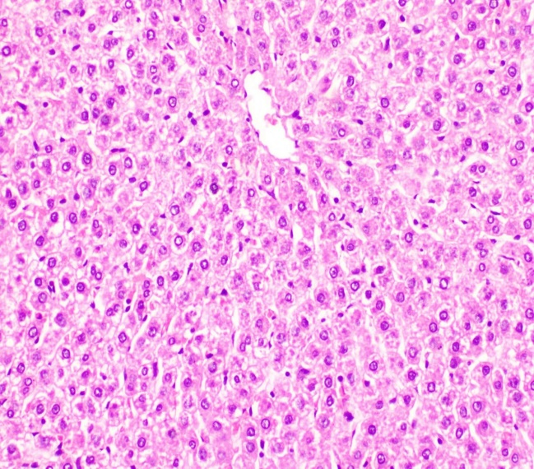Fig. (1): Photomicrograph of liver of rat from group 1 showing the normal histological architecture of hepatic lobule (H & E X 400) | 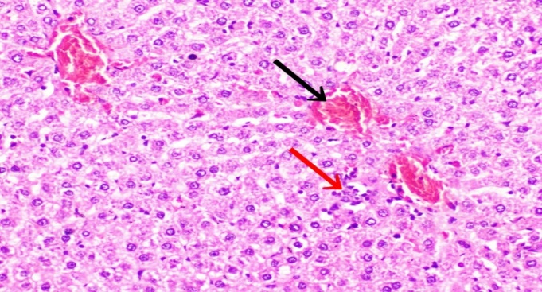  Fig. (2): Photomicrograph of liver of rat from group 2 showing congestion of central veins (black arrow) and focal hepatocellular necrosis associated with inflammatory cells infiltration (red arrow) (H & E X 400).
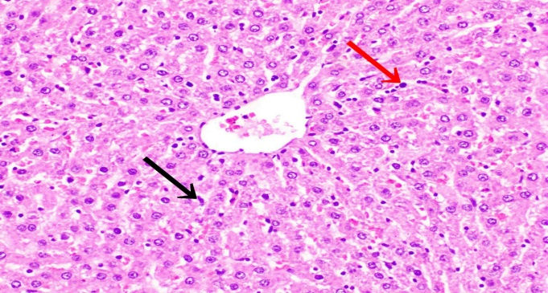 | 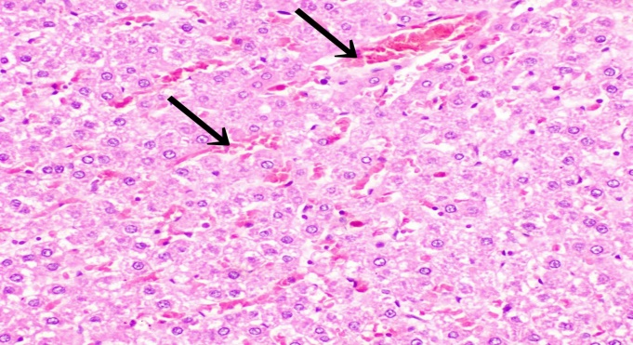
Fig. (3): Photomicrograph of rat from group 3 showing Kupffer cells activation (black arrow) and few leukocytes in the hepatic sinusoids (red arrow) (H & E X 400). | Fig. (4): Photomicrograph of liver of rat from group 4 showing congestion of central veins and hepatic sinusoids (black arrow) (H & E X 400).
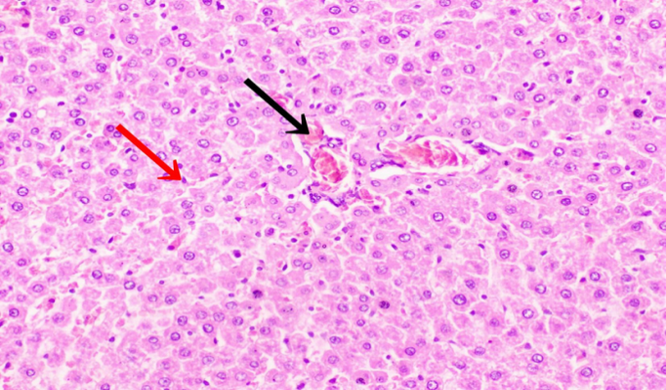 | 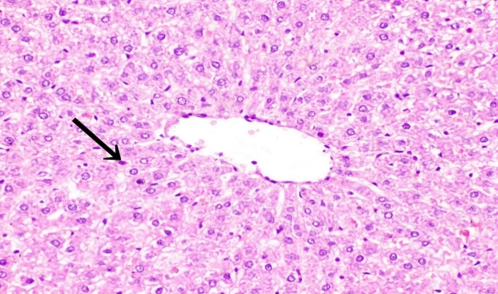
Fig. (5): Photomicrograph of liver of rat from group 5 showing Kupffer cells activation (red arrow) and congestion of hepatoportal blood vessel (black arrow) (H & E X 400). | Fig. (6): Photomicrograph of liver of rat from group 6 showing Kupffer cells activation (black arrow) (H & E X 400)
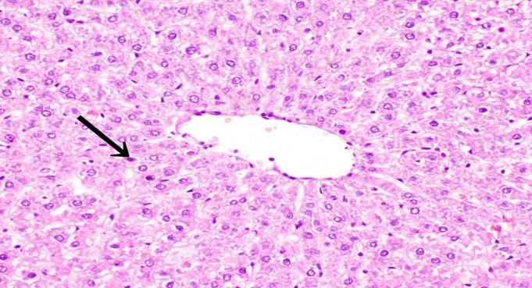 | .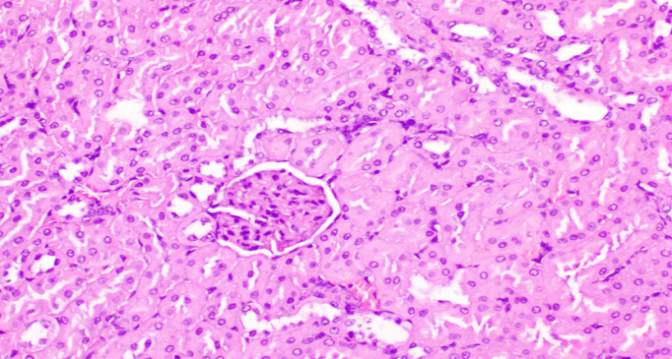
Fig. (7): Photomicrograph of liver of rat from group 7 showing Kupffer cells activation (black arrow) (H & E X 400). | Fig. (8): Photomicrograph of kidney of rat from group 1 showing the normal histological structure of renal parenchyma (H & E X 400).
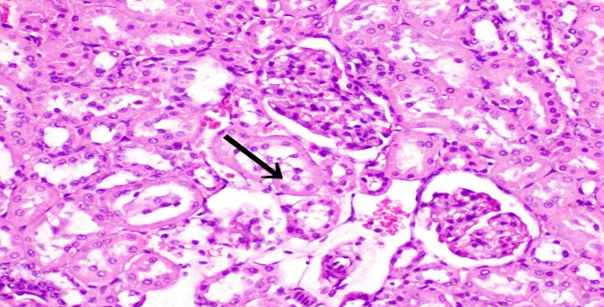  Fig. (9): Photomicrograph of kidney of rat from group 2 showing vacuolar degeneration of epithelial lining renal tubules (black arrow) (H & E X 400). | 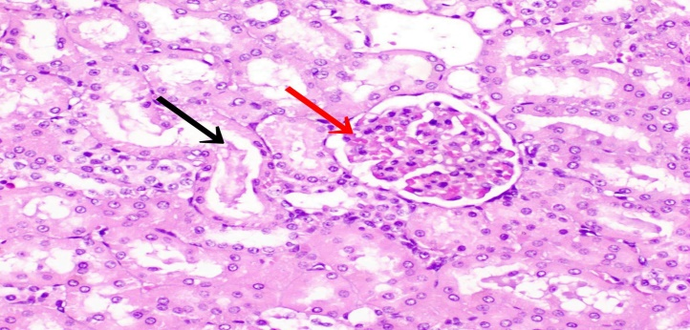Fig. (10): Photomicrograph of kidney of rat from group 2 showing proteinaceous material in the lumen of some renal tubules (black arrow) and slight congestion of glomerular tuft (red arrow) (H & E X 400).
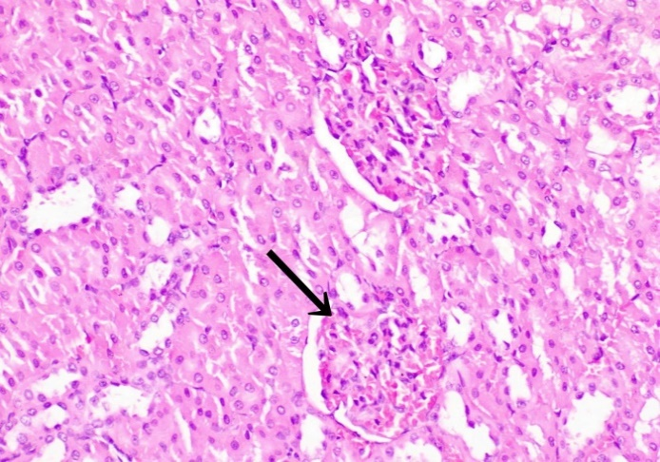 | 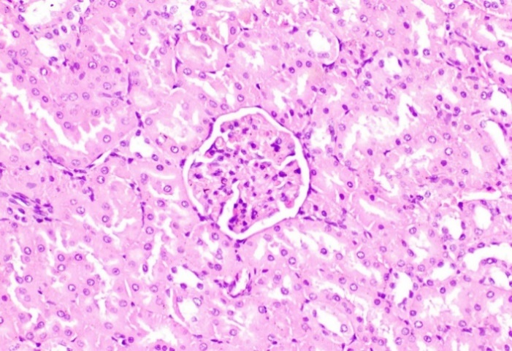
Fig. (11): Photomicrograph of kidney of rat from group 3 showing slight congestion of glomerular tuft (arrow) (H & E X 400). | Fig. (12): Photomicrograph of kidney of rat from group4 showing the normal histological structure of renal parenchyma (H & E X 400).
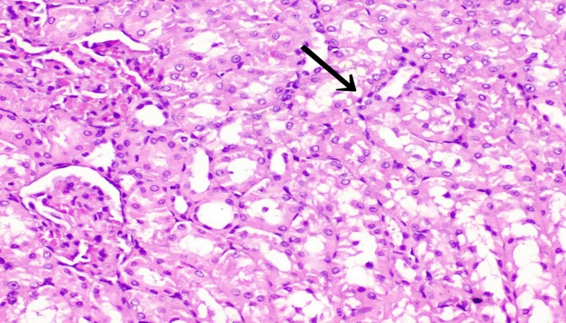 | 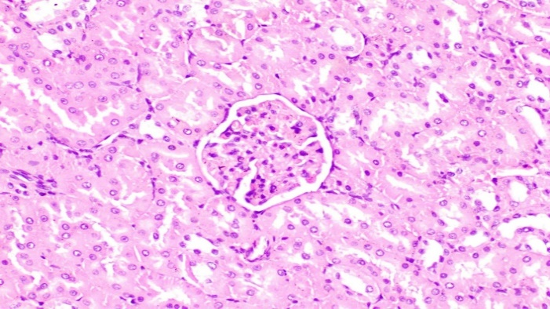
Fig. (13): Photomicrograph of kidney of rat from group 5 showing vacuolar degeneration of epithelial lining renal tubules (black arrow) (H & E X 400). | Fig. (14): Photomicrograph of kidney of rat from group 6 showing the normal histological structure of renal parenchyma (H & E X 400).
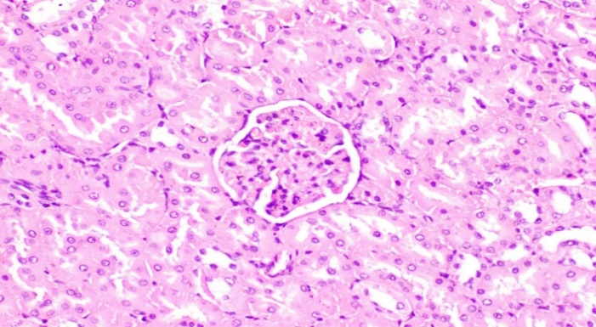 | 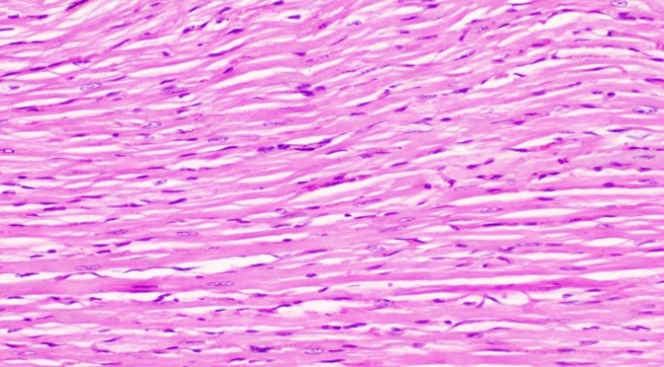
Fig. (15): Photomicrograph of kidney of rat from group 7 showing the normal histological structure of renal parenchyma (H & E X 400). | Fig. (16): Photomicrograph of heart of rat from group 1 showing the normal histological structure of cardiac myocytes (H & E, X 400).
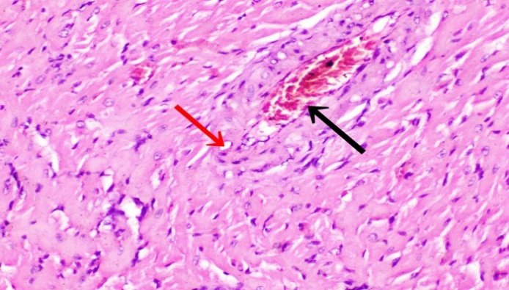 | 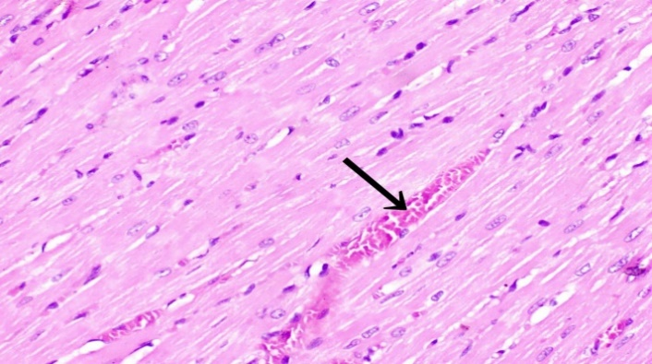
Fig. (17): Photomicrograph of heart of rat from group 2 showing congestion of myocardial blood vessel (black arrow) and vacuolation  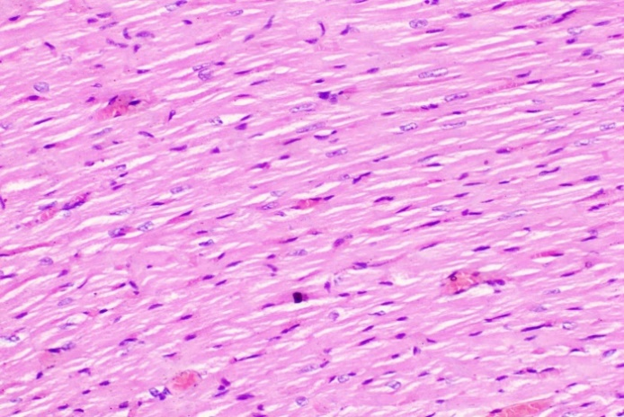 | Fig. (18): Photomicrograph of heart of rat from group 3 showing congestion of myocardial blood vessel (black arrow) (H & E, X 400).  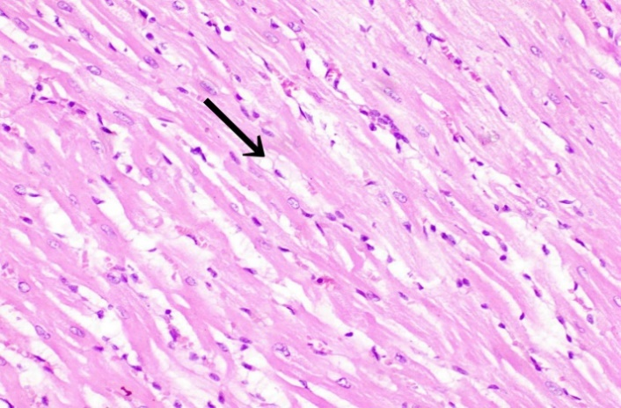
Fig. (19): Photomicrograph of heart of rat from group 4 showing no histopathological alterations (H & E, X 400). | Fig. (20): Photomicrograph of heart of rat from group 5 showing slight intermyocardial edema (black arrow) (H & E, X 400).
Fig. (21): Photomicrograph of heart of rat from group 4 showing no histopathological alterations (H & E, X 400). | Fig. (22): Photomicrograph of heart of rat from group 4 showing no histopathological alterations (H & E, X 400).

References :

A.O.A.C., Association of Official Analytical Chemists (2005).Official Methods of Analysis of the Association of Official Analytical Chemists. 18th Ed. Washington, DC, USA.
Abd El-Gawad, A., Rashwan, A., Mohamed, R. and Hefny, M. A. (2020).Wheat-Legumes Composite Flours. 2. Nutritional Value of Bread. Assiut J. of Agric. Sci., 51(1), 66-78.
Ahmad, S. and Ahmed, M. (2014). A Review on Biscuit, a Largest Consumed Processed Product in India, Its Fortification and Nutritional Important. International Journal of Science Inventions Today, 3: 169-186.
Anderson, J.W.; Baird, P.; Davis, R.H.; Ferreri, S.; Knudtson, M.; Koraym, A.; Waters, V.; Williams, C.L.( 2009). Health benefits of dietary fiber.Nutr. Rev., 67, 188–205.
Anusha, B., Hymavathi, T. V., Vijayalakshmi, V., Reddy, P., and Robert, T. P. (2018). Lipid-lowering effects of foxtail millet (Setariaitalica) and quinoa (Chenopodium quinoawild) in pre-diabetics. J. Pharm Res Int, 24, 1-7.
Asai, A. and Miyazawa, T. (2001): Dietary curcuminoids prevent high-fat diet-induced lipid accumulation in rat liver and epididymal adipose tissue. J Nutr., 131: 2932-2935
Bailey, S. A., Zidell, R. H., & Perry, R. W. (2004). Relationships between organ weight and body/brain weight in the rat: what is the best analytical endpoint?. Toxicologic pathology, 32(4), 448-466.‏
Bettzieche, A., Brandsch, C., Weiße, K., Hirche, F., Eder, K., and Stangl, G. I. (2008). Lupin protein influences the expression of hepatic genes involved in fatty acid synthesis and triacylglycerol hydrolysis of adult rats. British journal of nutrition, 99(5), 952-962.
Bora, P., Das, P., Mohan, P., and Barthakur, A. (2018). Evaluation of hypolipidemic property of proso millet (Panicum miliaceum L.) in high fat diet induced hyperlipidemia in rats. J.EntomolZool Stud, 6(3), 691-5.
Bouchoucha, R., Fradj, M. K. B., Bouchoucha, M., Akrout, M., Feki, M., Kaabachi, N., and Slimane, H. (2016). Effect of Lupinus albus on glycaemic control, plasma insulin levels, lipid profile and liver enzymes in type 2 diabetics. J. of Food and Nutrition Research, 4(9), 615-620.‏
Chaney, A. L., and Marbach, E. P. (1962). Modified reagents for determination of urea and ammonia. Clinical chemistry, 8(2), 130-132.
de Leon, J., Susce, M. T., Johnson, M., Hardin, M., Pointer, L., Ruaño, G., ... and Diaz, F. J. (2007). A clinical study of the association of antipsychotics with hyperlipidemia. Schizophrenia research, 92(1-3), 95-102.‏
El-Bana, M.A., M.E.A. El - Sayed, and Sahar R. Abd El-Hady, 2015. Biological evaluation of microwave defatted black rice bran (MDBRB) in CCL4 intoxicated rats. J. Food and Dairy Sci., Mansoura Univ., 6 (6): 419- 433.
El-Dakak H N ; Abd El-Rahman M S and El-Nahal M M (2013). Comparison studies between aqueous lepidium sativum L., lupinus albus and trigonellafoenum- gracum seeds, and their mixture extracts on streptozotocin-induced diabetic rats. J. of Applied Sci., Research, 9(4): 2965-2982.
El-Hadidi, S. T. (2017). Processing and quality of Lupin Tofu.‏ Curr. Sci. Int., 6(4): 930-939
Fabiny, D. L., and Ertingshausen, G. (1971). Automated reaction-rate method for determination of serum creatinine with the CentrifiChem. Clinical Chemistry, 17(8), 696-700.
Fontanari, G. G., Batistuti, J. P., da Cruz, R. J., Saldiva, P. H. N., and Arêas, J. A. G. (2012). Cholesterol-lowering effect of whole lupin (Lupinus albus) seed and its protein isolate. Food Chemistry, 132(3), 1521-1526.
Fossati, P. and Principe, L. (1982). Enzymatic colorimetric method to determination triglycerides. Clin. Chem, 28(2077), 1330.‏
Friedwald, W.T., R.I. Levy, and D.S. Fredrickson, 1972. Estimation of the concentration of low-density lipoprotein separate by three different methods. Clin. Chem., 18: 499-502.
Friedwald, W.T.; Levy, R.I. and Fredrickson, D.S. (1972). Estimation of the concentration of low-density lipoprotein separate by three different methods. Clin. Chem., 18: 499-502.
Garmidolova, A., Desseva, I., Mihaylova, D., & Lante, A. (2022). Bioactive Peptides from Lupinus spp. Seed Proteins-State-of-the-Art and Perspectives. Applied Sciences, 12(8), 3766.‏
Harisa, G.I., and Alanazi, F.K., (2015).The beneficial roles of Lupineus luteus and lifestyle changes in management of metabolic syndrome: A case study. Saudi Pharmaceutical J. In Press, Corrected Proof, Nov;23(6):712-5.
Hassan, E. M., Fahmy, H. A., Magdy, S. and Hassan, M. I. (2020). Chemical composition, rheological, organoleptical and quality attributes of gluten-free fino bread. Egyptian J. of Chemistry, 63(11), 4547-4563.
James, C.S., (1995). Analytical Chemistry of Foods. Blakie Academic and Professional, London, pp: 108-113.
Karthika, D. and P.N. Devi, 2016. Hypolipidemic effect of rice bran and rice bran oil Incorporated cookies. International J. of Scientific Res., 5 (4): 2277 - 8179.
King, J. (1965). The phosphohydrolases acid and alkaline phosphatases. In: Practical and Clinical Enzymology, Eds., King, J. Van Nostrand Co. Ltd., London, pp: 191- 208.
Lee, S. H., Chung, I. M., Cha, Y. S., and Park, Y. (2010). Millet consumption decreased serum concentration of triglyceride and C-reactive protein but not oxidative status in hyperlipidemic rats. Nutrition Research, 30 (4), 290-296.
Mansour, S., Siliha, H., El-Shourbagy, G. and Abou-zaid, F. (2021). Evaluation of dough characteristics and quality of Egyptian balady bread containing millet flour. Plant Archives, 21(1), 538-546.‏
Mishra, A., Dutta, T., & Baitharu, I. (2022). Nutritional values and potential health benefits of millets-a. Journal of Nutrients, 8(1), 9-26.‏
Mohamed, S. H., Shahat, A. A., Mohamed, M. R., Khalil, W. K., Salem, A. M., Farrag, A. R. H., and Ahmed, H. H. (2021). Camellia sinesis leaves extract ameliorates high fat diet-induced nonalcoholic steatohepatitis in rats: analysis of potential mechanisms. J. of Pharmaceutical Investigation, 51, 183-197.
Nagib, E.W. (2021).The Protective Effect of Chickpea and Lupine variety on rats with fatty liver. Scientific J. Faculty of Specific Education ,7(1): 39-64.
Nagib, E.W. (2021).The Protective Effect of Chickpea and Lupine variety on rats with fatty liver. Scientific J. Faculty of Specific Education ,7(1): 39-64.
Nie, Y., Luo, F., Wang, L., Yang, T., Shi, L., Li, X., and Lin, Q. (2017). Anti-hyperlipidemic effect of rice bran polysaccharide and its potential mechanism in high-fat diet mice. Food & function, 8(11), 4028-4041.
Osman, M., Mahmoud, G. I., Romeilah, R. M., and Fayed, S. A. (2011).Lupin seeds lower plasma lipid concentrations and normalize antioxidant parameters in rats. grasas y aceites, 62(2), 162-170.‏
Oyanatui, Y.(1984). Reevaluation of essay methods and establishment of kit for superoxide dismutase activity.Anal. Bio.,142,290-296.
Park, S. J., Kim, J. L., Park, M. R., Lee, J. W., Kim, O. K., & Lee, J. (2022). Indian gooseberry and barley sprout mixture prevents obesity by regulating adipogenesis, lipogenesis, and lipolysis in C57BL/6J mice with high-fat diet-induced obesity. Journal of Functional Foods, 90, 104951.‏
Peanparkdee, M., Patrawart, J. and Iwamoto, S. (2020). Physicochemical stability and in vitro bioaccessibility of phenolic compounds and anthocyanins from Thai rice bran extracts. Food Chemistry, 329, 127157.
Reddy, M, Shivakumara, CS, Aneesha. (2019). Flour and dough quality of millets and their suitability for preparation of traditional South Indian roti. Journal of Clinical and Biomedical Sciences, 9(1): 13-18
Richmond, W. (1973). Preparation and properties of cholesterol oxidase from Nocrdia spp. and its application to the enzymatic assay of total cholesterol in serum.Clin. Chem., 19: 1350-1356.
Saleh, M. N., El-Bana, M. A., Khalifa, T. H., and Mospah, W. M. (2024). Enhancing Protein Digestibility, Bioaccessibility, and Nutrient Retention in Faba Beans Using Nano-Zinc Oxide and Thermal Treatments. Journal of Food and Dairy Sciences, 15(10), 133-142.‏

Salem, M. A., Selem, S. B., & Sorour, A. M. (2023). Nutritional Evaluation of Cookies Supplemented with Sweet Lupine Seeds and Proso Millet Seed Powders. Journal of Sustainable Agricultural and Environmental Sciences, 2(3), 59-68.‏
Salem, M. A., Sorour, A. M. and El-Bana, M. A. (2018). Potential antioxidative activity of rice milling by-Products. Menoufia J. of Food and Dairy Sci., 3(1), 1-13.‏
Salem, M. A.; Sorour A. M. and El-Bana, M.A. Elsayed, M. E (2019). Biological Evaluation of Hemicellulose and carboxymethyl cellulose in Hypercholesterolemic Rats. J. Food and Dairy Sci., Mansoura Univ., 10 (11): 427- 436.
Shobana, S., Harsha, M. R., Platel, K., Srinivasan, K., and Malleshi, N. G. (2010). Amelioration of hyperglycaemia and its associated complications by finger millet (Eleusine coracana L.) seed coat matter in streptozotocin-induced diabetic rats. British journal of nutrition, 104(12), 1787-1795.‏
Sirtori, C. R., Lovati, M. R., Manzoni, C., Castiglioni, S., Duranti, M., Magni, C., and Arnoldi, A. (2004). Proteins of white lupin seed, a naturally isoflavone-poor legume, reduce cholesterolemia in rats and increase LDL receptor activity in HepG2 cells. The Journal of nutrition, 134(1), 18-23.‏
Steel, R. G. and Torrie, J. H. (1980). Principles and Procedures of statistics. 2nd Ed. Mc-Graw-Hill,New York, USA, pp. 120-150.
Taylor, J. R., Belton, P. S., Beta, T., and Duodu, K. G. (2014). Increasing the utilisation of sorghum, millets and pseudocereals: Developments in the science of their phenolic phytochemicals, biofortification and protein functionality. J. of Cereal Sci., 59(3), 257-275.‏
Teradal, D., Joshi, N., & Aladakatti, R. H. (2017). Therapeutic evaluation of grain based functional food formulation in a geriatric animal model. Journal of food science and technology, 54(9), 2789-2796.‏
Tiwari, N., and Srivasi, S. (2017). Effect of finger millet (Eleusine coracana) buns supplementation on serum glucose and serum lipids level in type 2 diabetics. Asian J. of Dairy and Food Research, 36(4), 337-340.
Trinder, P. (1969). Determination of glucose in blood using glucose oxidase with an alternative oxygen acceptor. Annals of clinical Biochemistry, 6(1), 24-27.
Varley, J. M., Macgregor, H. C., and Erba, H. P. (1980). Satellite DNA is transcribed on lampbrush chromosomes. Nature, 283(5748), 686-688.
Viveros, A., Centeno, C., Arija, I., and Brenes, A. (2007).Cholesterol-lowering effects of dietary lupin (Lupinus albus var Multolupa) in chicken diets. Poultry science, 86(12), 2631-2638.
Yoon, B.I.; Choi, Y.K. ; Kim, D.Y. ; Hyun, B.H. ; Joo, K.H. ;Rim, H.J. and Lee, J.H. ( 2001). Infectivity and pathological changes in murine clonorsweet lupine seed powdersis: Comparison in immunocompetent and immunodeficient mice. J. Vet. Med. Sci., 63(4): 421-425.

