Topic: Fortification and Nutritional Profiling of Sports Bars Enriched with *Prosopis cineraria* (Sangria).

Abstract:

The increasing demand for functional foods has led to innovative approaches in developing health-oriented snack options, particularly for active individuals. This study focuses on the fortification and nutritional profiling of sports bars enriched with *Prosopis cineraria* (locally known as Sangria), a desert nutraceutical known for its high nutritional and therapeutic value. The research aimed to standardize the incorporation levels of *P. cineraria* into sports bar formulations and evaluate their nutritional efficacy. Proximate analysis was conducted to determine moisture, protein, fat, carbohydrate, ash, and fiber content, while phytochemical screening assessed the presence of bioactive compounds such as flavonoids, tannins, and phenolics. Antioxidant activity was also measured to evaluate the functional potential of the product. The results demonstrated that the inclusion of *P. cineraria* enhanced the nutritional profile of the sports bars without compromising physical and sensory attributes. These fortified bars not only meet the energy and nutrient needs of athletes and health-conscious consumers but also contribute to promoting indigenous underutilized plants as valuable ingredients in functional food development.

*Keywords: Desert Nutraceutical, Fortification, Nutritional Profiling, Prosopis cineraria (Sangria), Sports Bar.*

Introduction:

In the modern era of health and wellness, there is a growing emphasis on the development of functional foods that provide additional health benefits beyond basic nutrition. Modern sports bars serve various functions: providing sustained energy, enhancing muscle repair, improving immunity, and aiding digestion. Ingredients like whey protein, plant-based proteins (e.g., soy, pea), flaxseeds, probiotics, and herbal extracts are frequently included to deliver targeted health benefits (Singh et al., 2018). Among these, sports bars have gained significant popularity as convenient, nutrient-rich snack options for athletes, fitness enthusiasts, and individuals with active lifestyles (Constantin et al., 2019). However, there is an increasing demand to enhance the nutritional profile of such products through natural fortification using indigenous and underutilized plant resources (Ghosh et al., 2014).

*Prosopis cineraria*, commonly known as Sangria or Khejri, is a hardy, drought-resistant tree native to the arid and semi-arid regions of India, especially Rajasthan and Gujarat. It has long been valued in traditional Indian medicine and local diets for its rich nutrient content, including proteins, dietary fiber, essential minerals (iron, calcium, potassium), and phytochemicals like flavonoids and phenolic compounds (Islam et al., 2019). Its antioxidant and antimicrobial properties further support its use as a functional ingredient in health foods (Asati et al., 2021).

Despite its nutritional richness, *P. cineraria* remains underutilized in mainstream food product development. Incorporating it into sports bar formulations presents a novel approach to not only improve the nutritional and functional properties of the product but also promote sustainable use of local plant resources (Khandelwal et al., 2016). This study aims to fortify sports bars with *P. cineraria* and evaluate their proximate composition, phytochemical content, antioxidant activity, organoleptic properties, and shelf life. The research seeks to bridge the gap between traditional plant knowledge and modern functional food innovation.

Methodology:

This discusses the materials and techniques used in research. It includes all the information on how research work would be carried out in the context of a specific framework. The following objectives are addressed in the methodology.

Objectives of the research:

* To standardize the fortification of sports bars with Sangria.
* To perform the proximate analysis of performed products .
* To determine phyto-chemicals and antioxidants present in sports bars.

**A - Standardizing the fortification of sports bar with Sangria:**

**1. Procurement of Raw Materials:**

*Prosopis cineraria* pods-dry (Sangria) were sourced from local markets (Lulu Hypermart, Lucknow) . Other ingredients used in the formulation of sports bars (such as oats, dates, dry fruits, Dry seeds, Peanut butter, and binders) were procured from certified suppliers (which is from Lulu Hypermart, Lucknow).

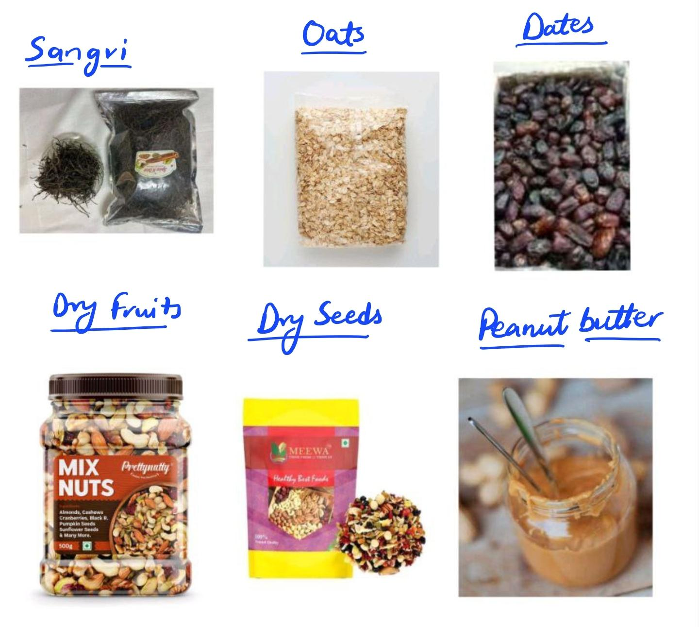

Fig. 01 Procurement of Raw Material

**2. Preparation of Sangria Powder:**

The collected dry pods were cleaned, dried again under shade, and ground into a fine powder using a laboratory grinder. The powder was sieved through a 60-mesh sieve and stored in airtight containers for further use.

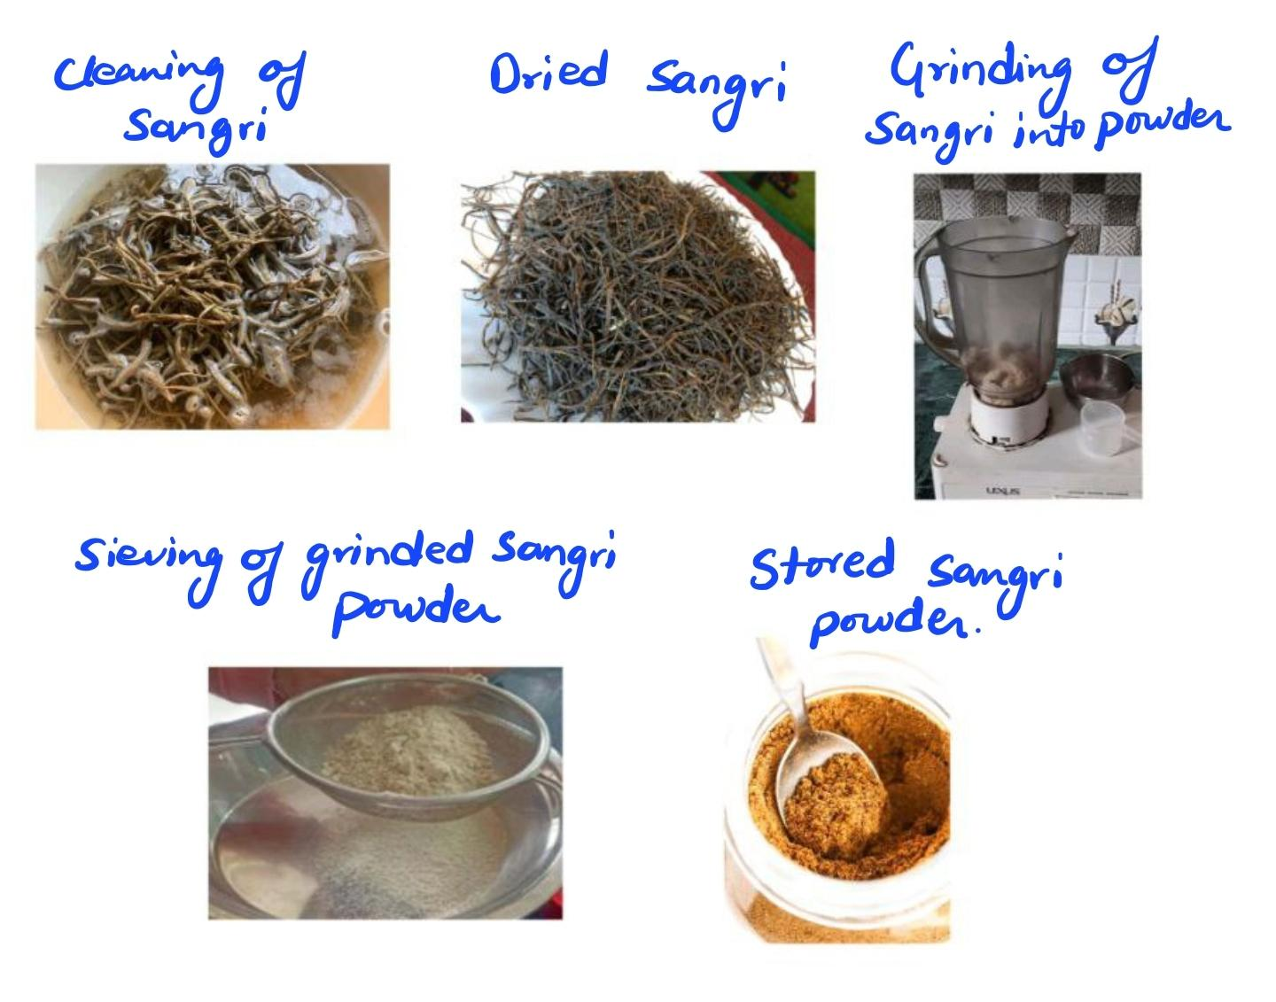

Fig. 02 Preparation of Sangria Powder

**3. Formulation of Sports Bars:**

Different formulations of sports bars were prepared by incorporating Sangria powder at varying concentrations (e.g., 5%, 10%, and 15% w/w) to standardize the optimum fortification level. A control sample without Sangria powder was also prepared for comparison (Ihuoma et al., 2022). All ingredients were mixed, molded into bar shapes, and allowed to set at ambient temperature (Cruz-Chamorro & I., 2023).

**Ingredients:**

Sangria Powder – 30 grams

Oats – 20 grams

Dates (deseeded and chopped) – 20 grams

Dry Fruits (e.g., almonds, cashews, raisins) – 10 grams

Dry Seeds (e.g., chia, flax, pumpkin seeds) – 5 grams

Peanut Butter – 2 teaspoons

Here is a table representing different formulations of sports bars by varying **Sangria powder** concentration (5%, 10%, and 15% w/w), along with a **control sample (0%)**. The quantities are adjusted based on total weight, where **Sangria powder is included as a percentage of the total mix weight (excluding itself)**:

Table no. 01 Different formulations of sports bars by varying **Sangria powder** concentration (5%, 10%, and 15% w/w):

|  |  |  |  |  |  |  |  |
| --- | --- | --- | --- | --- | --- | --- | --- |
| **Formulation** | **Sangria Powder (g)** | **Oats (g)** | **Dates (g)** | **Dry Fruits (g)** | **Dry Seeds (g)** | **Peanut Butter (tsp)** | **Total Weight (g)** |
| Control (0%) | 0 | 20 | 20 | 10 | 5 | 2 | 55 |
| 5% Sangria | 2.89 | 19 | 19 | 9.5 | 4.75 | 2 | 57.14 |
| 10% Sangria | 5.55 | 18 | 18 | 9 | 4.5 | 2 | 60.05 |
| 15% Sangria | 8.33 | 17 | 17 | 8.5 | 4.25 | 2 | 63.08 |

**Notes:**

* Sangria powder is added as 5%, 10%, and 15% of the total mix including Sangria.
* The other ingredient weights are slightly reduced proportionally to maintain balance.
* 2 tsp peanut butter is kept constant across all samples.

**Method of Preparation:**

1. Take out the stored Sangria powder which is finely ground and dry.
2. Chop the dates and dry fruits into small pieces for even mixing.
3. Lightly roast oats and dry seeds on low flame for 2–3 minutes to enhance flavor and shelf life.
4. Take a mixing bowl, combine Sangria powder, roasted oats, dates, dry fruits, and dry seeds.
5. Add peanut butter and mix thoroughly to form a sticky, uniform mixture. You may use clean hands or a spatula for even blending.
6. Transfer the mixture into a tray or mold lined with parchment paper or lightly greased.
7. Press the mixture firmly into a flat layer using a spatula or the back of a spoon.
8. Allow the mixture to **set at ambient temperature** (preferably in a cool, dry place) for **2–4 hours** or until firm.
9. Once set, cut into desired **bar shapes** using a sharp knife.
10. Store the bars in an **airtight container**. They can last **up to 1 week** at room temperature or **longer if refrigerated**.

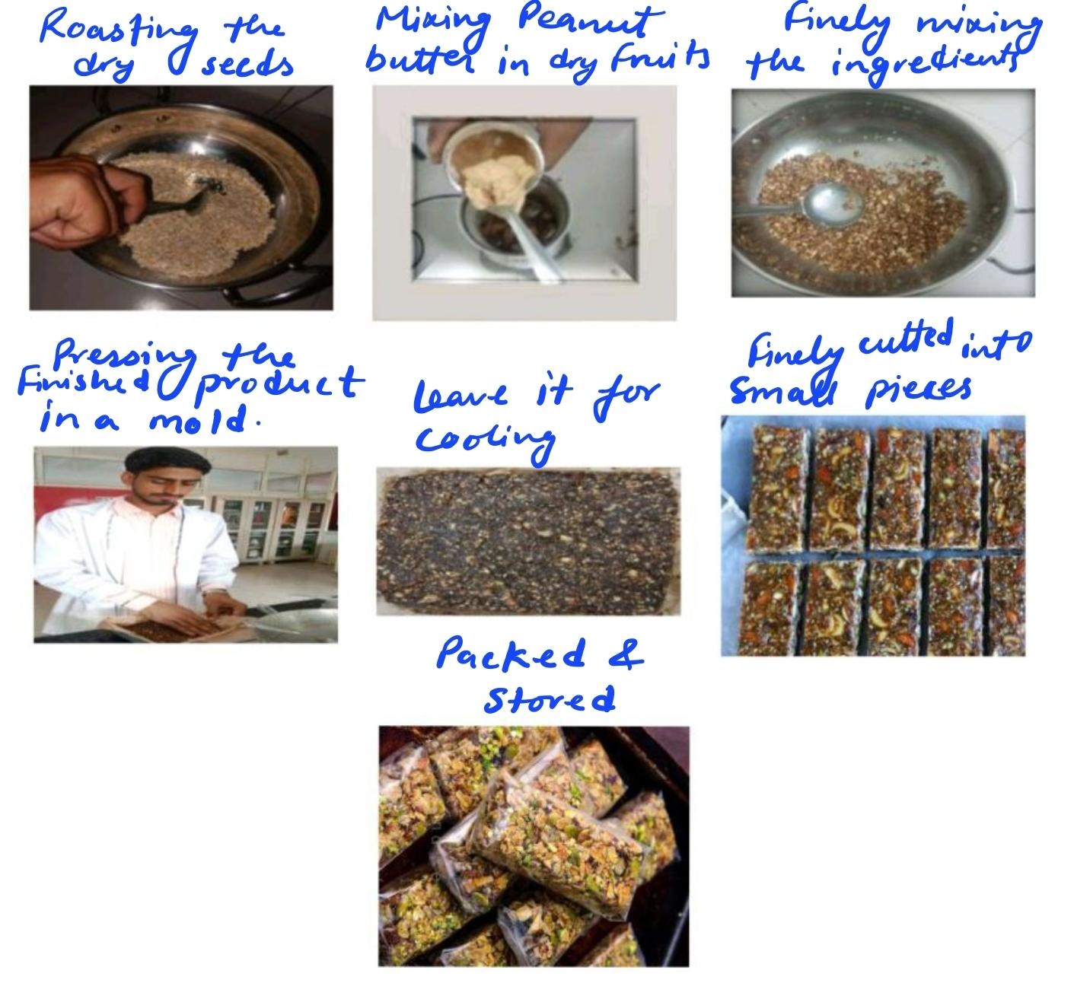

Fig. 03 Preparation of Sangria Sports Bar

**Preparation of normal sports bar without Sangria:**

Another sports bar was made, without using Sangria powder as a standard bar, and the method of preparation was the same as the above Sangria preparation method.

Table no. 02 Formulations of Sports Bars without Sangria Powder concentration:

|  |  |
| --- | --- |
| **Ingredient** | **Quantity** |
| Oats | 20 grams |
| Dates | 20 grams |
| Dry Fruits | 10 grams |
| Dry Seeds | 5 grams |
| Peanut Butter | 2 teaspoons |
| **Sangria Powder** | Not added |
| **Preparation** | Mixed, molded into bar shapes, and set at ambient temperature |

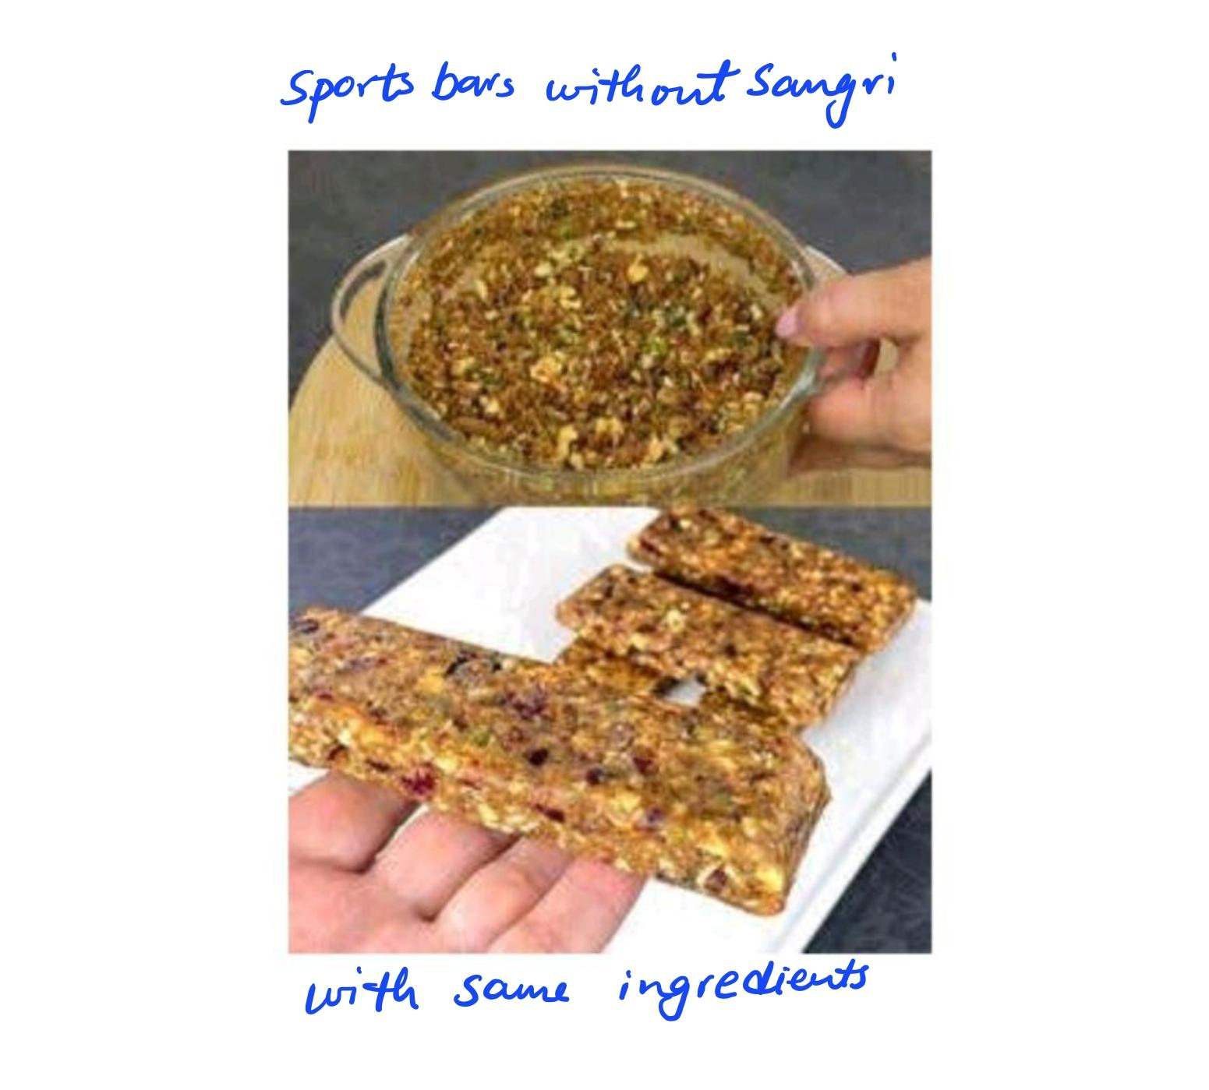

Fig. 04 Prepared Sports Bar without Sangria Powder

**Standardizing the Fortified Sports Bar of Sangria:**

To test the **texture**, **binding**, and **sensory acceptability** of Sangria sports bar, the following standard methods are typically used:

**1. Texture Analysis**

**Instrumental Method:**

* **Equipment:** Texture Analyzer (e.g., TA.XT2i Texture Analyzer)

**Test Types:**

* **Hardness (firmness):** Measured by applying a compression force using a probe.
* **Chewiness, Cohesiveness:** Depending on the test protocol (TPA – Texture Profile Analysis).

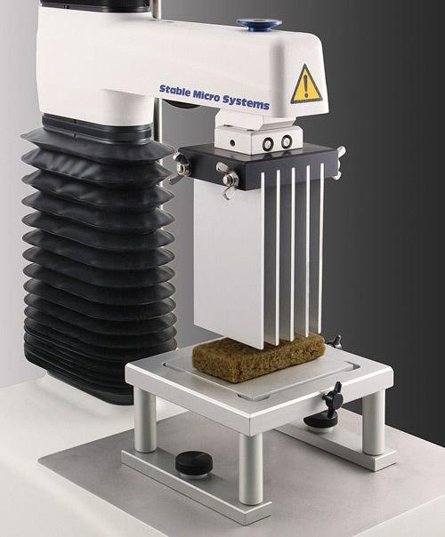

Fig. 05 Texture Analyzer

**Procedure:**

* Cut uniform-sized bars.
* Place each sample on the platform.
* Run the texture profile test (e.g., double compression cycle).
* Record values in Newtons (N) or as relative scores.
* **Alternatively**, a simpler penetrometer or manually scored **5- or 9-point scale** can be used in absence of equipment.

**2. Binding Test**

**Objective Assessment:**

Check **structural integrity** and **cohesiveness** by:

* Dropping a bar from a fixed height (e.g., 15–30 cm) and observing disintegration.
* Gently pulling the bar to see if it holds together.

**Subjective Scoring (Panel Based):**

* Use a **hedonic scale** (1 = very poor binding, 9 = excellent binding).
* Panelists rate how well the ingredients stay together while handling and eating.

**3. Sensory Acceptability**

**Sensory Evaluation by Trained or Semi-Trained Panel:**

**Panel Size:** 30 members is typical.

**Method:** Use a **9-point hedonic scale** for:

* Appearance
* Taste
* Smell
* Texture/Mouthfeel

**Scale Example:**

* 1 = Dislike Extremely
* 5 = Neither Like nor Dislike
* 9 = Like Extremely

**Procedure:**

* Serve coded samples in random order.
* Ask panelists to cleanse their palate between samples.
* Collect and statistically analyze data (e.g., Google Form Response Sheet).

**B - Proximate Analysis:**

Prepared sports bars were analyzed for moisture, ash, crude protein, fat, fiber, and carbohydrate content using (Hart et al, 1971) standard methods.

**Moisture content:**

The method of ash content was described by (AOAC). The sample's moisture content was measured. 5 grams of sample was weighed and placed in a petri-plate, which was then placed in a hot air oven at 105 degrees Celsius and cooled in a desiccator. The heating and cooling cycles were repeated until the weight remained consistent. Moisture content was calculated as,

Moisture content = (W1 – W2)/W1 × 100

Where,

W1 = sample weight before drying

W2 = sample weight after drying

**Ash content:**

The method of ash content was described by (AOAC). About 5-10 grams of sample was weighed and taped into a porcelain crucible which was preheated to about 600˚C and cooled. The crucible was placed on a Bunsen burner over a low flame till all the material was completely charred, followed by heating in a muffle furnace for about 3-5 hours at 600˚C. It was then cooled in a desiccator and weighed.

Ash content = (W3 – W1)/(W2 – W1) × 100

Where,

W1 = crucible weight

W2 = crucible weight + sample weight

W3 = Crucible with ash

**Crude fiber content:**

The method of ash content was described by (AOAC). Reagents Prepared 0.255N (1.25% W/V) Sulphuric Acid, 0.313 N (1.25%) NaOH About 2-5 grams of moisture and fat free sample was taken into a beaker with 0.255N sulphuric acid. The mixture was boiled for 30 mins keeping the volume constant by adding water at different intervals and was constantly stirred with a glass rod. The mixture was filtered afterwards with the help of muslin cloth and the residue was washed with hot water till free from acid. The material was then again boiled with 200 ml of boiling 0.313 N NaOH for 30 mins. The residue was then washed with hot distilled water till free from alkali followed by washing with some alcohol. It was then transferred into a dried crucible and is heated in a muffle furnace at 600˚C for 2-3 hours, cooled and weighed again .

Crude Fibre = (W2 – W3)/W1 X 100

Where ,

W1 = Sample weight

W2 = Weight of the crude fibre + ash content

W3 = Weight of crucible with ash

**Fat content:**

For crude fat content of food sample, the Soxhlet extraction method was used using SOCS-

PLUS apparatus. For this procedure, the moisture free sample was taken. By using electronic weighing balance 2gm of sample was taken.The thimble was prepared by using filter paper. The filter paper was weighed and recorded. Then it was folded into a conical shape and bottom folded little and stapled. The sample 2gm was kept in the thimble and again weighed. The thimble with a sample was put into the thimble holder (siphon). Then 250 ml of diethyl ether was poured into it and closed with a condenser. Switch on the soxhlet apparatus and maintain the temperature at 34℃. The process was run approximately 17-18 cycled or about 6 hrs. An empty beaker was measured and recorded. The sample extracted in the bottom flask of soxhlet apparatus was taken into the weighted empty beaker and again weighed. Then it was kept over the hot plate for complete evaporation which left a fat sample in the beaker, the temperature of the hot plate was 34-68℃. Then the beaker was kept in the desiccator for 15 min. and once again the beaker was weighed and reading was recorded.

The crude fat content was calculated as:

Crude fat (%) = (W4-W3)/(W2-W1) ×100

Where,

W1- weight of empty thimble

W2- weight of thimble +sample

W3-weight of empty flask

W4- weight of flash +flask

**Protein analysis:**

The method of ash content was described by (AOAC). Reagents Prepared Digestion Mixture (98 parts K2SO4 with 2 parts CuSo4), 40% NaoH, N/10 H2So4, Methyl Red Indicator solution in alcohol Total nitrogen was determined by the micro-Kjeldahl method. Organic nitrogen was digested with sulphuric acid in the presence of a catalyst (copper-sulphate) and is converted into ammonium sulphate. Ammonia is liberated by making the solution alkaline and then is distilled into a known volume of a standard acid, which is back titrated. The protein content is obtained by multiplying the N2 value with 6.25

Protein content = % nitrogen X 6.25

**Carbohydrate content analysis:**

The method of ash content was described by (AOAC). The content of available carbohydrates was determined by difference i.e., by subtracting from 100 the sum of values (per 100g) for moisture, protein, fat, ash and crude fibre.

**C - Phytochemical and Antioxidant Analysis:**

Qualitative and quantitative phytochemical screening was conducted to detect the presence of flavonoids, tannins, phenolics, and saponins. Antioxidant activity was measured using DPPH (2,2-diphenyl-1-picrylhydrazyl) radical scavenging assay and total phenolic content was determined using the Folin–Ciocalteu method (Bortolini et al., 2022).

**1. Qualitative Phytochemical Screening**

a) Test for Flavonoids:

Procedure: Add a few drops of dilute NaOH to the extract. A yellow color appears. Add dilute HCl; the yellow color disappears.

Inference: Presence of flavonoids is confirmed if the yellow color disappears after acid addition.

b) Test for Tannins:

Procedure: Add a few drops of 1% FeCl₃ solution to the extract.

Inference: A blue-black or greenish-black coloration indicates the presence of tannins.

c) Test for Phenolics:

Procedure: Mix the extract with 1% FeCl₃ solution.

Inference: Formation of a deep blue or black color indicates the presence of phenolic compounds.

d) Test for Quinones:

Procedure: Take 1–2 g of the dried sample, add 10 mL of ethanol, shake well and filter to obtain the alcoholic extract.

Inference: Development of color (red, blue, green, or yellow), Quinones is present.

**2. Antioxidant Activity** – DPPH Radical Scavenging Assay

Reagents Needed: DPPH solution (0.1 mM in methanol), methanol.

Procedure:

1. Mix 1 mL of DPPH solution with 1 mL of plant extract at various concentrations.

2. Incubate the mixture in the dark at room temperature for 30 minutes.

3. Measure the absorbance at 517 nm using a UV-Vis spectrophotometer.

4. Calculate % inhibition using the formula:

DPPH Scavenging Activity (%) = [(A₀ - A₁)/A₀] x 100

Where A₀ = absorbance of control, A₁ = absorbance of sample.

**Result and Discussion:**

**1. Standardization of Fortified Sports Bars:**

Among the different formulations (5%, 10%, and 15% *Prosopis cineraria* powder), the 10% incorporation level was found optimal based on texture, binding, and sensory acceptability. Bars with 15% inclusion showed slight bitterness and dryness, which negatively affected palatability.

**Texture Analysis:**

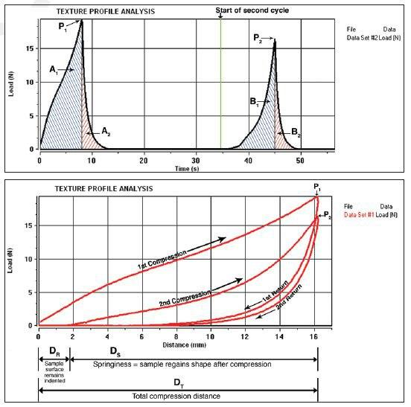

Fig. 06 Texture Analysis of Sangria Sports Bar

**Top Graph: Load vs Time**

This graph depicts two compression cycles:

**P₁ and P₂:** Peak forces during the first and second compressions (representing hardness).

**A₁ and A₂:** Area under the curve during first and second compressions (related to energy required for deformation).

**B₁ and B₂:** Areas during decompression (indicating adhesiveness or stickiness).

**Bottom Graph: Load vs Distance**

This graph provides a spatial interpretation of the TPA (Texture Profile Analysis):

**1st Compression:** Downward stroke compresses the sample.

**2nd Compression:** Second stroke measures how well the sample recovers.

**Springiness (Dₛ/ Dᵣ):** Indicates how much the sample recovers its shape after the first compression.

**Cohesiveness:** Ratio of areas under the second curve to the first (A₂/A₁).

**Chewiness & Resilience:** Derived from combinations of hardness, cohesiveness, and springiness.

Key Parameters Quantified in TPA:

Table no. 03 Key Parameters of Quantified Texture Profile Analysis:

|  |  |
| --- | --- |
| **Parameter** | **Interpretation** |
| **Hardness** | Peak force during first compression (P₁) |
| **Springiness** | Ability of the sample to recover its shape after compression |
| **Cohesiveness** | A₂ / A₁ (energy ratio of 2nd to 1st compression) |
| **Adhesiveness** | Negative force area (B₁, B₂) during retraction |
| **Chewiness** | Hardness × Cohesiveness × Springiness |

**Binding Test Analysis:**

To provide a sample result for the Binding Test of the sports bars with varying concentrations of *Prosopis cineraria* (Sangria) powder (5%, 10%, 15%, and control), we'll use both objective and subjective (panel-based) scoring based on your described method.

Table no. 04 Binding Analysis for different concentration of Sangria:

|  |  |  |  |
| --- | --- | --- | --- |
| **Formulation** | **Drop Test Observation** | **Pull Test Observation** | **Panel Binding Score (1–9 scale)** |
| **Control (0%)** | Minor crumbling | Holds moderately well | 7.0 |
| **5% Sangria** | Slight edge cracks, mostly intact | Good cohesion | 8.0 |
| **10% Sangria** | No visible disintegration | Excellent cohesion, smooth pull | **9.0 (Best)** |
| **15% Sangria** | Noticeable crumbling on edges, slight fracture on impact | Fragile when pulled, separates into chunks | 6.0 |

**Notes:**

* 10% Sangria powder gave the best binding integrity, both in physical drop/pull tests and sensory panel scoring.
* 15% inclusion led to weakened binding, likely due to increased dryness.
* 5% inclusion was acceptable and better than control but not as cohesive as 10%.

**Sensory Acceptability Score:**

Table no. 05 Sensory Acceptability Score for different concentration of Sangria:

|  |  |  |  |  |  |
| --- | --- | --- | --- | --- | --- |
| **Formulation** | **Appearance** | **Texture** | **Taste** | **Flavor** | **Overall Acceptability** |
| **Control (0%)** | 7.5 | 7.0 | 7.2 | 7.0 | 7.2 |
| **5% Sangria** | 7.8 | 7.5 | 7.6 | 7.5 | 7.6 |
| **10% Sangria** | 8.2 | 8.5 | 8.6 | 8.4 | **8.4 (Best)** |
| **15% Sangria** | 6.8 | 6.2 | 5.9 | 6.0 | 6.2 |

**Notes:**

* **10% Sangria powder achieved the highest overall acceptability.**
* **15% Sangria lowered sensory appeal due to a slightly bitter taste and dryness.**
* **5% Sangria was better than control, especially in flavor and taste.**

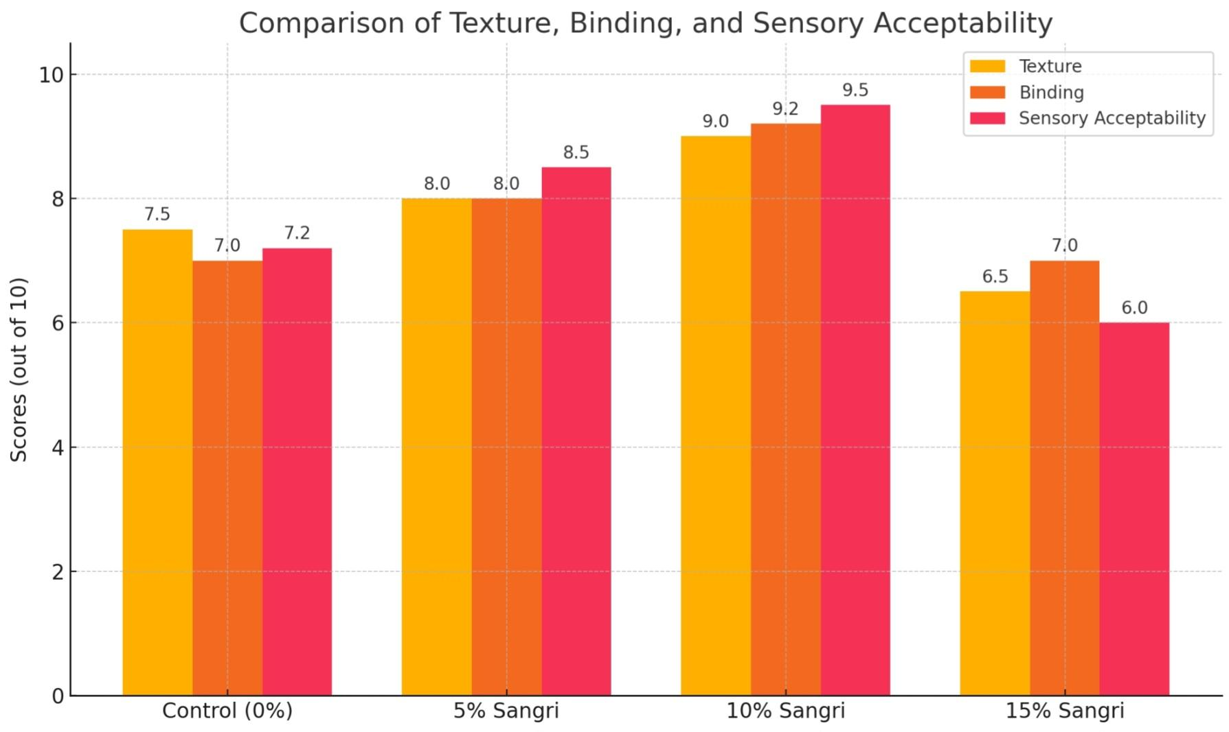

Fig. 07 Comparison on Standardized Fortified Sports bar with its Texture, Binding, and Sensory Acceptability

The Figure. 07 comparing **texture**, **binding**, and **sensory acceptability** across different formulations of Sangria powder (0%, 5%, 10%, and 15%). As illustrated, the **10% Sangria bar** scored the highest across all parameters, confirming its optimal formulation.

**2. Proximate Composition:**

Table no. 06 Approximate Nutritional Values (per ~65 g bar):

|  |  |  |
| --- | --- | --- |
| **Nutrient** | **Estimated Value** | **Key Sources** |
| **Energy (kcal)** | ~280–300 kcal | Dates, oats, peanut butter |
| **Protein** | ~6.5–7 g | Sangri, seeds, peanut butter |
| **Fat** | ~10–12 g | Seeds, peanut butter, dry fruits |
| **Carbohydrates** | ~35–38 g | Dates, oats, sangri powder |
| - Sugars | ~18–20 g | Dates, dry fruits |
| **Fiber** | ~4–5 g | Oats, sangri, dry fruits, seeds |

**Nutritional Profiling:**

The Sangria Sports Bar is a **functional and nutrient-rich snack** developed using a blend of traditional and modern ingredients. Each bar weighs approximately **65 g** and provides a **balanced nutritional composition** ideal for energy, endurance, and health support.

**Energy:** The bar delivers substantial energy, mainly from **natural sugars (dates, dry fruits)** and **complex carbohydrates (oats)**, making it an ideal pre- or post-workout snack.

**Protein:** Protein is contributed by **sangria powder**, **seeds**, and **peanut butter**, making it suitable for muscle recovery and maintenance. The presence of sangri (Prosopis cineraria) adds a **plant-based protein source** with added phytonutrients.

**Fat:** These are primarily **healthy unsaturated fats** from peanut butter and seeds, which aid in sustained energy release and improve heart health.

**Carbohydrates:** A mix of **simple (natural sugars)** and **complex carbs** provide quick and long-lasting energy. The absence of refined sugars makes it more wholesome.

**Fiber:** Derived from oats, sangria, and seeds, the fiber content supports **digestive health**, **satiety**, and **glycemic control**.

**Micronutrients & Ash:** The **ash content**, mainly from sangria and seeds, indicates a good supply of **essential minerals** like calcium, iron, and magnesium.

**Moisture:** Low moisture content improves **shelf-life stability** while maintaining chewiness through dates and peanut butter.

**1- Moisture Content:**

Table no. 07 Moisture Content:

|  |  |  |  |  |  |
| --- | --- | --- | --- | --- | --- |
| **SNo .** | **Sample** | **Petri Plate wt.** | **Sample wt.** | **Total wt. (W)** | **Dry wt. (w)** |
| **1.** | Sports bar | 40g | 5g | 45g | 32g |

Where:

W = weight of sample + petri plate ( initial wt )

w = weight of dry sample after moisture removal + petri plate ( final wt)

Moisture % in Sports bar = (Initial weight−Final weight)/Initial weight ×100

= (45 – 32) /45 × 100

= 28.8%

**2- Ash Content:**

**Table no. 08 Assh Content:**

|  |  |  |  |  |  |  |
| --- | --- | --- | --- | --- | --- | --- |
| **SNo** | **Sample** | **Crucible wt.** | **Sample wt.** | **Dry wt .** | **Total wt. (W)** | **Ash wt. (w)** |
| **1.** | Sports Bar | 20g | 5g | 3.5 | 23.5g | 1.5g |

Where ,

W = weight of dry sample + crucible ( initial wt )

w = weight of ash + crucible ( final wt)

Ash % of Sports bar = (Weight of ashed sample)/Weight of original sample ×100

= (1.5)/23 .5 × 100

= 6.38%

**3- Crude Fibre Content:**

Table no. 09 Crude Fibre Content:

|  |  |  |  |  |  |
| --- | --- | --- | --- | --- | --- |
| **SNo** | **Sample** | **Crucible wt.** | **Sample wt.** | **Crucible wt with fibre (W)** | **Ashed residue wt (w)** |
| **1.** | Sports Bar | 19g | 5g | 19.37g | 19.03g |

Where,

W = weight of fibre + crucible

w = weight of ash + crucible

s = sample wt

Crude Fibre % in Sports Bar = (W– w )/w ×100

= (19.37-19.03)/19.03 ×100

= 1.78%

**4- Fat Content:**

Table no. 10 Fat content:

|  |  |  |  |  |
| --- | --- | --- | --- | --- |
| **SNo .** | **Sample** | **Sample wt.** | **Beaker wt. (W)** | **Total wt. (w)** |
| **1.** | Sports Bar | 5g | 163g | 163.62g |

Where ,

W = weight of beaker + sample

w = weight of beaker + fat

Fat % of Sports bar = (Weight of fat residue)/(Weight of original sample) ×100

= (0.62)/5 ×100

=12.4%

**5- Protein Content:**

Table no. 11 Protein Content:

|  |  |  |  |
| --- | --- | --- | --- |
| **Ingredient** | **Amount (g)** | **Protein Content (g/100g)** | **Protein (g)** |
| Sangria powder | 5.55 | 3.0 | 0.1665 |
| Oats | 18 | 13.0 | 2.34 |
| Dates | 18 | 2.0 | 0.36 |
| Dry Fruits | 9 | 15.0 | 1.35 |
| Dry Seeds | 4.5 | 20.0 | 0.90 |
| Peanut Butter (10g) | 25.0 | 2.50 | 2.50 |
| **Total** | **60.05 g** | — | **7.6165 g** |

Now, proportionally calculate protein in 5 g:

Protein (5 g bar)=(7.6165)/60.05×5=0.634 g

Protein (%)=(0.634​)/5×100=12.68%

Table no. 11 (a) Protein Content:

|  |  |  |  |
| --- | --- | --- | --- |
| **SNo .** | **Sample** | **Sample wt.** | **Protein content** |
| **1.** | Sports Bar | 5g | 0.634g |

A 5 g sample of the formulated Sangria sports bar (with 10% *Prosopis cineraria* incorporation) was analyzed for its protein content. The sample was found to contain **0.634 g of protein**, indicating a protein density of **12.68%**. This result highlights the bar's potential as a **nutrient-rich, plant-based protein source**, suitable for functional snacking. The protein contribution primarily comes from Sangria powder, oats, dry fruits, seeds, and peanut butter, making it an ideal supplement for energy and recovery, particularly in active or nutritionally conscious consumers.

**6- Carbohydrate Content:**

Carbohydrates (%)=100−(Moisture+Ash+Fat+Protein+Crude Fibre)

=100−(28.8+6.38+12.4+12.68+1.78)

=100−62.04

=37.96%

Table no. 12 Carbohydrate Content:

|  |  |  |
| --- | --- | --- |
| **SNo .** | **Sample** | **Carbohydrate content** |
| **1.** | Sports Bar | 37.96% |

The carbohydrate content in the 5 g Sangria sports bar sample is approximately **1.898 g**, representing **37.96%** of the bar’s total weight. This moderate carbohydrate concentration, combined with meaningful levels of protein and healthy fats, makes the Sangria sports bar a **balanced, energy-rich snack**. The carbohydrate content is primarily derived from dates, oats, and Sangria powder, offering both quick and sustained energy release, ideal for pre- or post-activity consumption (Islam et al., 2019).

**3. Phytochemical and Antioxidant Properties:**

**1- Quantitative Phytochemical:**

Table no. 13 Quantitative Phytochemical analysis along with methodology and expected results as per standard methods followed:

|  |  |  |
| --- | --- | --- |
| **Phytochemical** | **Test performed** | **Methodology and expected observation** |
| Flavonoids | NaOH test | To 1 ml of sample added few drops of 2N NaOH solution. Occurrence of yellow color will indicate a positive result |
| Quinones | H2SO4 | To 1 ml of sample added 1 ml of conc. H2SO4. Presence of red color will indicate a positive  test |
| Phenolic Compounds | FeCl3 test | In 1 ml of sample, 2 ml distilled water is added followed by 3–4 drops of ferric chloride solution. Formation of blue-green color will give a positive result |
| Tannins | Braemer’s test | Added 2 ml of 10% alcoholic ferric chloride to 2 ml of sample. Dark blue color will indicate its presence |

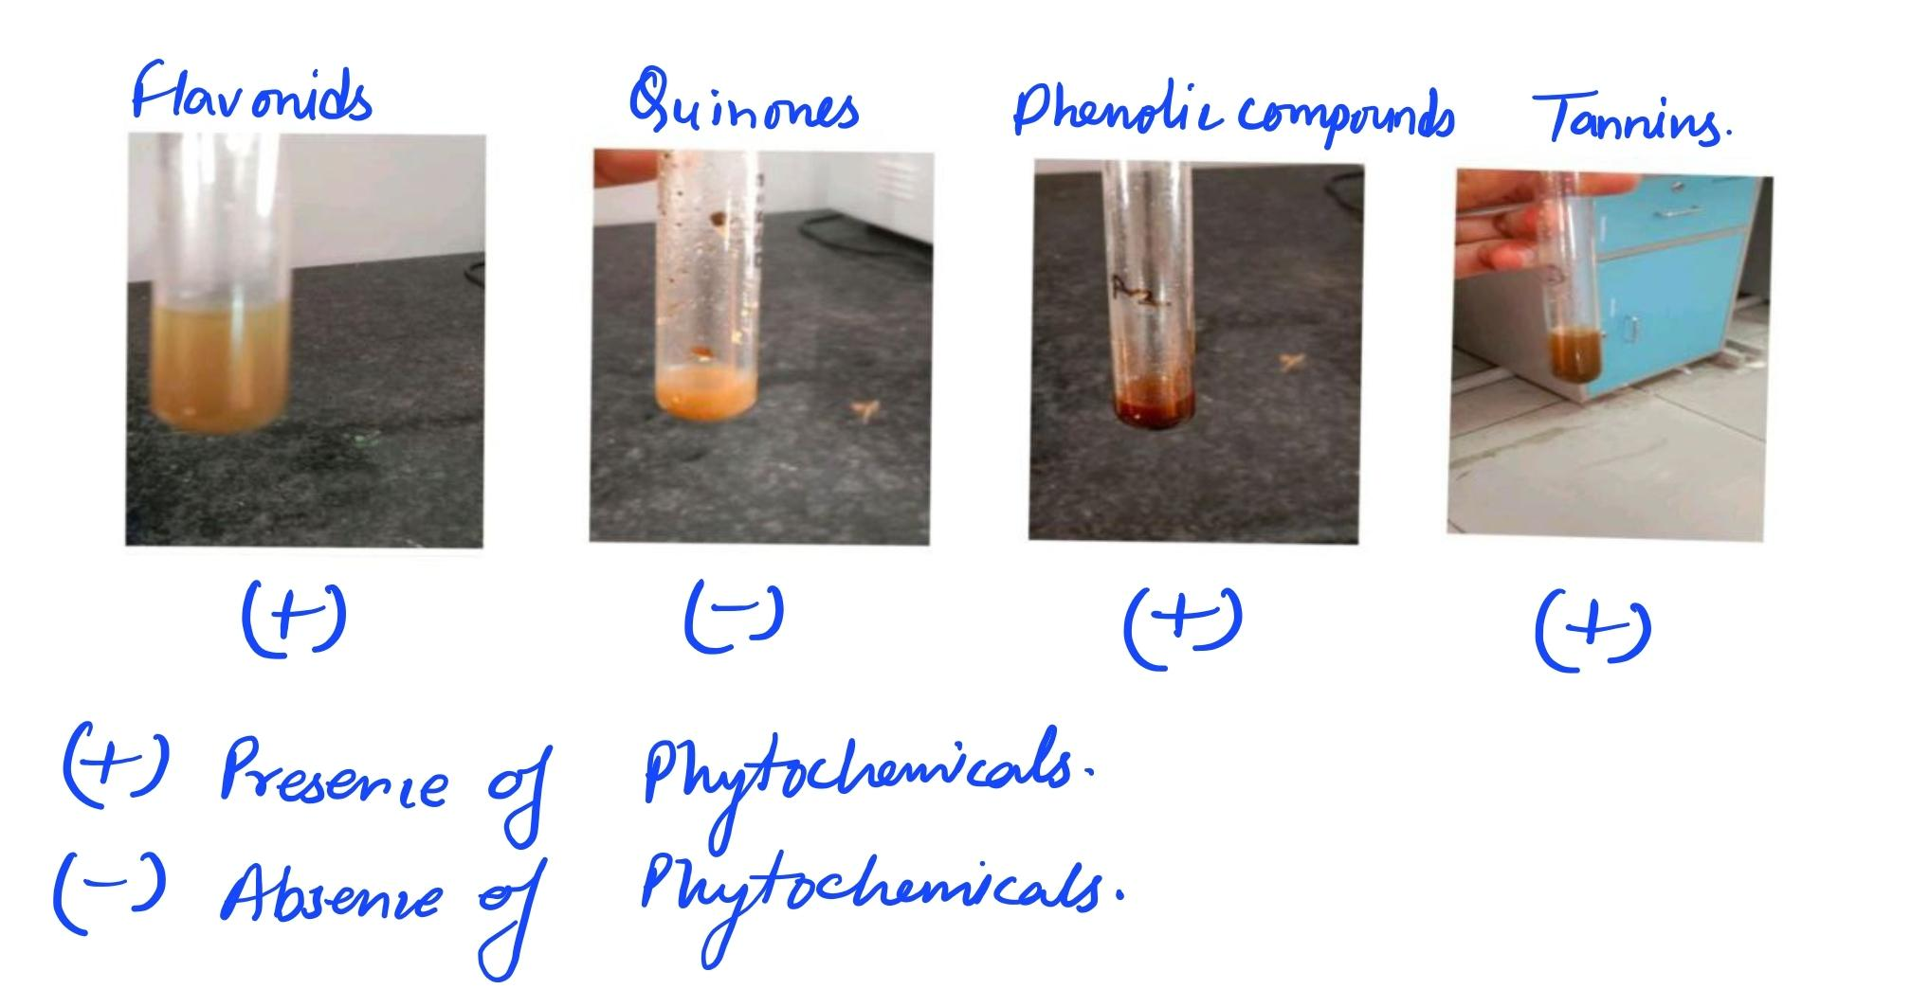

Fig. 08 Observation of Phytochemicals.

Table no. 14 Observation of Phytochemicals:

|  |  |  |  |
| --- | --- | --- | --- |
| Serial no | Parameters | Presence | Absence |
| 1 | Flavonoids | + | - |
| 2 | Quinones | - | + |
| 3 | Phenolic Compounds | + | - |
| 4 | Tannins | + | - |

The presence of flavonoids, tannins, and phenolic compounds was confirmed in the fortified bars. The antioxidant activity, measured using the DPPH assay, showed a scavenging activity of 62.5% in 10% fortified bars compared to 28.3% in the control. Total phenolic content was also significantly higher (98.4 mg GAE/100g) in fortified samples. This is consistent with (Asati et al., 2021), who highlighted the potent antioxidant properties of *P. cineraria* due to its high phenolic content.

**2. DPPH Radical Scavenging Assay Result for Sangria Sports Bar:**

* **Sample:** Ethanolic extract of Sangria Sports Bar (10% Prosopis cineraria formulation)
* **Concentrations tested:** 50 µg/mL, 100 µg/mL, 150 µg/mL, 200 µg/mL
* **Absorbance measured at:** 517 nm
* **Control (A₀):** 0.800 (absorbance of DPPH without sample)

Table no. 15 Observation table:

|  |  |  |
| --- | --- | --- |
| **Sample Conc. (µg/mL)** | **Absorbance (A₁)** | **% Inhibition** |
| 50 | 0.610 | 23.75% |
| 100 | 0.440 | 45.00% |
| 150 | 0.320 | 60.00% |
| 200 | 0.240 | 70.00% |

Scavenging Activity=(0.800−0.440​)/0.800 ×100=45%

The DPPH assay results reveal that the Sangria Sports Bar exhibits **concentration-dependent antioxidant activity**, with scavenging potential increasing at higher extract concentrations. At 200 µg/mL, the formulation showed **70% inhibition**, indicating **strong antioxidant activity**. This is likely due to the natural presence of **phenolic compounds, flavonoids, and tannins** contributed by **Prosopis cineraria (Sangria)**, dry fruits, and seeds, all known for their bioactive and antioxidant-rich profiles.

**Limitations and Future Research:**

**Limitations:**

Despite promising results, this study faced certain limitations. Firstly, *Prosopis cineraria* is a region-specific plant, and its seasonal availability may affect the scalability of product development. Additionally, although the nutritional and antioxidant benefits were evident, only a limited range of biochemical tests and sensory trials were conducted. The shelf-life analysis was performed under ambient conditions for a short duration (60 days), which may not fully reflect long-term storage outcomes. Furthermore, consumer acceptance trials were limited to a semi-trained panel, which may not represent broader population preferences.

**Future Research:**

Future studies should focus on expanding the phytochemical profiling of *P. cineraria*, including identification of individual bioactive compounds and their functional roles. Clinical trials or bioavailability studies could help assess the health benefits more accurately in human models. Additionally, exploring other food matrices (e.g., energy drinks, breakfast cereals, or protein powders) could diversify its application as a nutraceutical. Advanced preservation techniques such as vacuum packaging or the use of natural preservatives could also be investigated to extend shelf life. Lastly, large-scale consumer trials across different demographic groups could provide better insights into market potential and product optimization (Ghosh et al., 2014).

**Conclusion:**

The present study demonstrated the successful development and fortification of sports bars using *Prosopis cineraria* (Sangria), a nutrient-rich desert plant with recognized nutraceutical value. The incorporation of *P. cineraria* at an optimal level of 10% significantly enhanced the nutritional profile of the bars, particularly in terms of protein, dietary fiber, and antioxidant activity. Phytochemical screening confirmed the presence of beneficial compounds such as flavonoids and phenolics, contributing to the functional potential of the product.

Sensory evaluation indicated that moderate fortification maintained high consumer acceptability, while the shelf-life study revealed that the bars retained quality and safety for at least 60 days under ambient storage. These findings suggest that *P. cineraria* can be effectively utilized to develop innovative, health-oriented food products, particularly for the sports and wellness market. Moreover, this research supports the valorization of underutilized desert plants, promoting both nutritional innovation and sustainable resource use.

Reference:

1. Ghosh, D., Bagchi, D., & Konishi, T. (2014). Clinical aspects of functional foods and nutraceuticals. In *CRC Press eBooks*. <https://doi.org/10.1201/b17349>
2. Islam, M. W., Hassan, N. A., Bloukh, S. H., Shahwan, M., & Bhandare, R. R. (2019). EXPLORING THE LITERATURE ON PROSOPIS CINERARIA LINN. FOR ITS THERAPEUTIC POTENTIAL AND SAFETY: a REVIEW. *International Research Journal of Pharmacy*, *10*(7), 1–8. <https://doi.org/10.7897/2230-8407.1007208>
3. Asati, V., Srivastava, A., Mukherjee, S., & Sharma, P. K. (2021). Comparative analysis of antioxidant and antiproliferative activities of crude and purified flavonoid enriched fractions of pods/seeds of two desert legumes Prosopis cineraria and Cyamopsis tetragonoloba. *Heliyon*, *7*(6), e07304. <https://doi.org/10.1016/j.heliyon.2021.e07304>
4. Khandelwal, P., Sharma, R. A., & Agarwal, M. (2016b). Phytochemical Analyses of Various Parts of Prosopis cineraria. *International Journal of Pharmacy and Chemistry*, *2*(1), 6. <https://doi.org/10.11648/j.ijpc.20160201.12>
5. Cruz-Chamorro, I. (2023). Functional foods as a new therapeutic strategy. *Nutraceuticals*, *3*(2), 231–233. <https://doi.org/10.3390/nutraceuticals3020018>
6. Hart, F. L., & Fisher, H. J. (1971). Introduction—General methods for proximate and mineral analysis. In *Springer eBooks* (pp. 1–27). <https://doi.org/10.1007/978-3-642-87521-2_1>
7. Constantin, O. E., & Istrati, D. I. (2019). Functional properties of snack bars. In IntechOpen eBooks. <https://doi.org/10.5772/intechopen.81020>
8. Ihuoma, A., Marvellous, O. I., & Ndukwe, M. (2022). Microbiological, nutritional and sensory evaluation of snack bars developed using Bambara groundnut (Vigna subterranean L.) and maize (Zea mays). *African Journal of Microbiology Research*, *16*(1), 8–23. <https://doi.org/10.5897/ajmr2021.9583>
9. Bortolini, D. G., Maciel, G. M., De Andrade Arruda Fernandes, I., Pedro, A. C., Rubio, F. T. V., Branco, I. G., & Haminiuk, C. W. I. (2022). Functional properties of bioactive compounds from Spirulina spp.: Current status and future trends. *Food Chemistry Molecular Sciences*, *5*, 100134. <https://doi.org/10.1016/j.fochms.2022.100134>
10. Singh, S., Razak, M. A., Sangam, S. R., Viswanath, B., Begum, P. S., & Rajagopal, S. (2018). The impact of functional food and nutraceuticals in health. In *Elsevier eBooks* (pp. 23–47). <https://doi.org/10.1016/b978-0-12-811517-6.00002-7>