Original Research Article

Comparative Analysis of Aquatic Plants Biodiversity in Two Agroecological Zones of Bangladesh

Abstract
Aquatic plants are important for keeping ecological balance since they aid in the production of oxygen, purification of water, provision of habitat, and control of erosion. This paper presents a comparative study on aquatic plant diversity in the two agroecologically different districts of Bangladesh, Tangail and Chapai Nawabganj. Through covering fields all year round, Participatory Rural Appraisal, and sight identification, a total of 74 species from 32 families and 19 orders were recorded—53 species from Tangail and 34 from Chapai Nawabganj. The study divided aquatic plants into five categories according to their habitat: free floating, rooted floating, submerged, emergent and marginal. Tangail had greater diversity of emergent plants, whereas marginal species were higher in Chapai Nawabganj. As for seasonal distribution patterns, in both regions the highest presence of aquatic plants was observed during the monsoon season. Native species in Tangail were relatively higher along with low percentages of vulnerable plants, while in Chapai Nawabganj exotic species were dominant with no vulnerable species present. The results demonstrate the ecological differences captured in the study, which are influenced by geography, climate, and hydrology, and indicate further studies of biodiversity need to be conducted along with regional conservation plans focused on assessing the particular region’s needs.
Key words: Aquatic plant; Conservation status; Species diversity; Tangail and Chapai Nawabganj district.
Introduction
Aquatic plants are organisms specifically evolved to survive in water or moisture. Their ecological importance includes the generation of oxygen, water purification by absorbing impurities, providing food and shelter for aquatic animals, nutrient cycling and soil erosion control (Cook, 1990; Cronk & Fennessy, 2001, Chambers et al., 2008, O’Hare et al., 2017 and Uddin & Pal, 2020). Emerging, floating, and submerged macrophytes are examples of aquatic plants that form a group of macrophytes. They are part and parcel of freshwater ecosystems. Apart from contributing to biodiversity, aquatic plants also play an important role in water purification, sediment retention, and in providing habitats to a variety of aquatic life (Mitsch & Gosselink, 2015). The wetlands and water bodies in Bangladesh are of immense value in farming, fisheries, and the subsistence economy, which warrants the attention of studying their ecological interrelationships (Islam et al., 2017; Khan et al., 2014).
Bangladesh possesses numerous aqua-ecological zones which examined the diversity and distribution of species of aquatic plants. The central region includes Tangail together with Chapai Nawabganj in the north western part of the country. In the central part of Northwest Bangladesh, Chapai Nawabganj is an area of the Ganges floodplain known as low flat land with seasonal flooding. Tangail on the top of the Madhupur Plateau is marked by elevated relief and well-drained soil (Islam et al., 2017; Khan et al., 2014). Tangail forms a part of the Madhupur Plateau which has an elevated landform and well-drained soil, and Chapai Nawabganj is located at the Ganges floodplain which has lower altitude as well as areas that get seasonal flooding water. Both these contrasting places are likely to bring about changes in the regions of aquatic flora.
Recent researches have focused on documenting the rich diversity of aquatic flora across different parts of Bangladesh. For example, an investigation within the limits of Sadar Upazila of Chapai Nawabganj documented 35 species of aquatic flora though a good number of them were classified as vulnerable or endangered due to overexploitation and habitat destruction (Ahmed et al., 2020). Likewise, works carried out in the Botanic Garden of the Agricultural University of Bangladesh listed the number of documented species of aquatic flora at 70 which highlighted the importance of taking action to protect them (Islam et al., 2017). Still, there is a gap of comparative studies between different agroecological zones.
This investigation attempts to address the gap by exploring the aquatic plant biodiversity in Tangail and Chapai Nawabganj. More specifically, the study attempts to estimate the species richness, abundance, and distribution patterns of species in these areas. Understanding these patterns is important for the development of management and conservation plans, especially with regard to the impacts of climate change, land-use changes, and pollution (MEA, 2005; Dudgeon et al., 2006).
This research aims to add important information about the ecological condition of these areas by analyzing the relationship between agroecological factors and aquatic plant diversity to help design practices that sustainably manage agricultural activities aimed at conserving biological diversity (Hossain et al., 2024).
Materials and Methods
Study Area
The study was conducted in two agroecological zone of Bangladesh: Tangail and Chapai nawabganj (Fig.1). The Tangail district is located in the central part of Bangladesh, within the Dhaka division. Numerous agroecological zones, such as AEZ 7 (Active Brahmaputra-Jamuna Floodplain), AEZ 8 (Young Brahmaputra and Jamuna Floodplain), AEZ 9 (Old Brahmaputra Floodplain), and AEZ 28 (Madhupur Tract), define Tangail’s landscape (Kumar, Mukta, & Mia, 2019). The distribution and variety of aquatic plant species are affected by the differences in soil types, hydrology, and landforms found in these zones. The district has a tropical climate, which is characterised by high temperatures, high humidity, and moderate precipitation. The monsoon season provides the majority of the precipitation, with an average annual rainfall of about 1817 mm. Numerous rivers and bodies of water, like the Bangshi and Jamuna, offer a diversity of aquatic ecosystems that are home to a wide range of aquatic plant species. Chapai Nawabganj District, which is a part of the Rajshahi Division, is situated in northwest Bangladesh. The topography of Chapai Nawabganj consists of the Old Mahananda and Young Ganges floodplains in the southwest and the Barind Tract in the northeast. Alluvial deposits from the Ganges and Mahananda rivers winding channels define these regions, producing rich soils that support a variety of aquatic and agricultural habitats. With high temperatures, high humidity, and moderate rainfall, the district has a tropical wet and dry climate. The average annual rainfall is 1,448 mm. Numerous aquatic plant species are supported by the Padma River and its tributaries, which offer an abundance of water habitats. The seasons selected for the convenience of the study are Premonsoon (March-May), Monsoon (June-October) and Post monsoon (November- February).
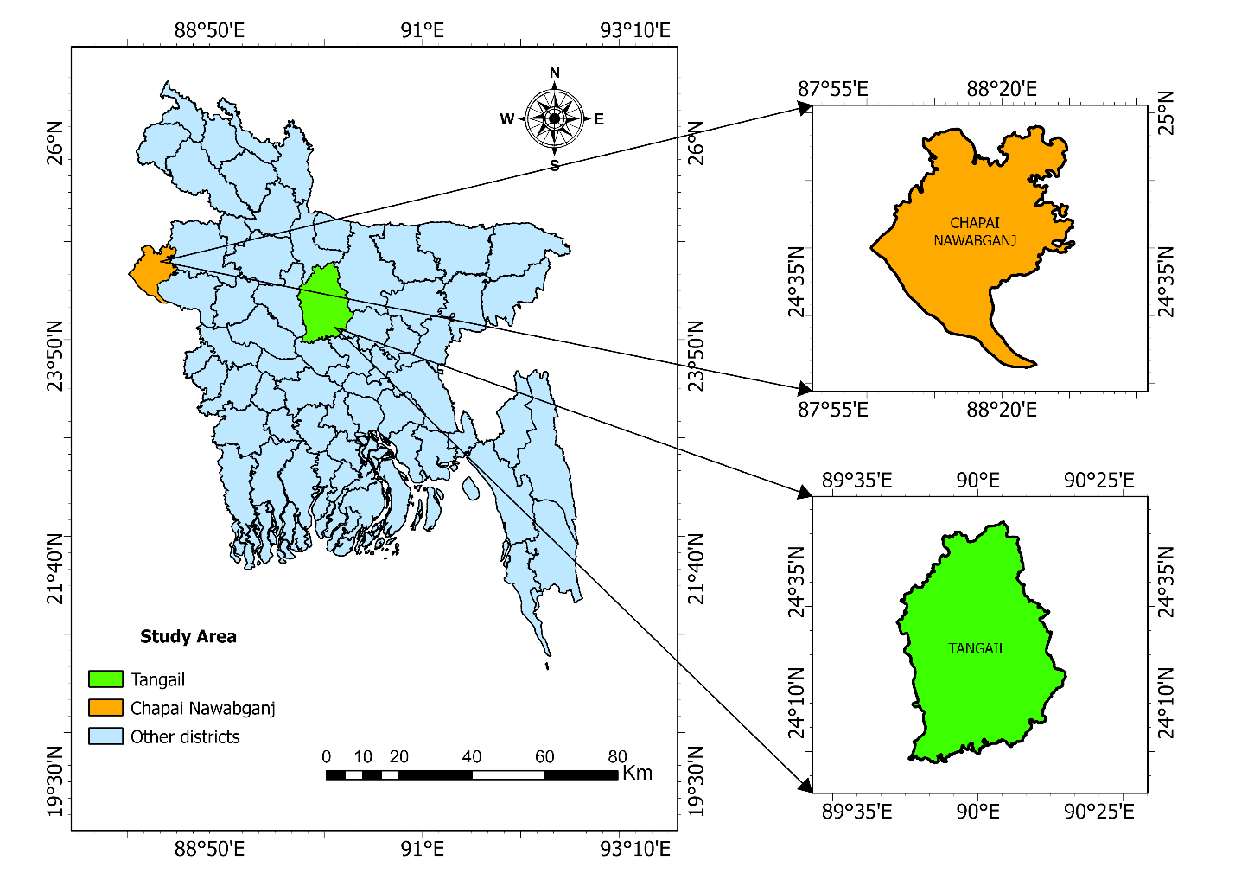

Fig. 1: Map showing the location of the study area in Two Agroecological Zones (Chapai Nawabganj and Talgail district).

Collection of Sample and data
The survey was conducted for a period of one year from March 2023 to February 2024. Visual observation was selected, and sampling was done using subjective estimating techniques (Madsen & Wersal, 2017). The samples were collected from the 26 sites of the study area, 13 sites in each district. The aquatic weeds were collected from the different water bodies, floodplain, wetlands and surroundind river (Bangshi and Jamuna for Tangail district, Padma and it’s tributaries for Chapai Nawabganj). Samples were gathered to cover around 150 ha (1.5 Square Kilometers) from Tangail and Chapai Nawabganj district.
Direct field surveys and interviews with locals were used to gather data on the aquatic plant types, diversity status and seasonal availability. A standardised survey procedure that followed a preset timetable and questionnaire design was used to collect the data. Key informant interviews, focus groups, and individual interviews were used as participatory rural appraisal (PRA) tools.
Aquatic plants data were collected via questionnaires and interviews with 25 informants (15 males, 10 females) in both district including villagers, fish farmers, healers, and others. Information on local plant names, frequency, and seasonal availability was gathered in Bengali. Two focus groups (8 people each) and 10 key informants were also consulted.
Identification of Species
The sole strategy used for sample identification was visual inspection. Collected aquatic weeds was identified in accordance with Journey (1993), Pasha (1996), Lewis and Miller (1980), Lancar and Krake, (2002). An investigation of published journals and reference materials, such as the Encyclopaedia of Flora and Fauna of Bangladesh (Siddiqui et al., 2007, Ahmed et al., 2009, Haque & Haque, 2009) was also conducted in order to identify the plant specimens.

Statistical Analysis
All data both qualitative and quantitative were collected and organized using MS word and MS Excel 2019 with careful consideration. The organized data were analysed using R and RStudio software to obtain the precise results. Finaly, the main findings of this study were presented in tables and figures for scientific disclosure. The map of the study area was made using ArcGIS Pro 3.2.

Results
- Types of aquatic plant
Aquatic plants are classified as five types according to visual inspections:
Free floating aquatic plants that may or may not have stems, leaves, or blooms that show above the surface of water. The roots of these aquatic plants are not attached to the water body's bottom, lakebed, or substrate (Fig. 2).
Rooted floating aquatic plants are usually anchored to the substrate, lakebed, or water body bottom. They have underground stems, called rhizomes, from which new plants can sprout. Usually, they can be seen in the shallower water near the edges. It is possible for their branches, leaves, or blossoms to stick above the surface of water (Fig. 2).
Submerged aquatic plants grow below the surface of water, the roots of these plants are anchored to the substrate or soil. Certain submerged aquatic plants may spend some time above the surface of water during their life cycle (Fig. 2).
Emergent aquatic plants whose stems and leaves are visible above the surface of the water. The roots of these aquatic plants are anchored to the lake bed or the bottom of water (Fig. 2).
Marginal aquatic plants that are found along the margin of the water bodies. These types of plants provide cover for the fish enemies and also harmful insects (Fig. 2).
https://aquatictechnologies.com.au/weed-identification
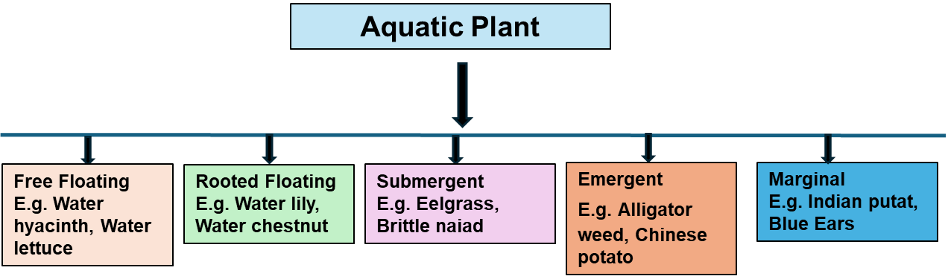

Fig. 2: Types of aquatic plants according to the visual inspection.

Table 1: List of aquatic plants of Chapai Nawabganj and Talgail district in Bangladesh with orders, families, local names, common names, scientific names, type, availability, origin and conservation status.

Aquatic plants recorded both in Chapai-Nawabganj and Tangail districts :
Order | Family | Local name | Common name | Scientific name | Type | Availability | Origin |  | Con. Stat.
Alismatales | Araceae | Khudipana | Duckweed | Lemna minor | FF | MS | N |  | LC
Alismatales | Araceae | Kachu | Chinese Potato | Colocasia esculenta | EM | AS | N |  | LC
Alismatales | Hydrocharitaceae | Kanjal | Water thyme | Hydrila verticillata | SU | MS | N |  | LC
Caryophyllales | Amaranthaceae | Malancha | Alligator weed | Alternanthera philoxeroides | EM | PreMS | E₍₁₎ |  | NE
Ceratophyllales | Ceratophyllaceae | Kata jhanji/ Sheola | Con's tail | Ceratophyllum demersum | SU | MS | N |  | LC
Commelinales | Pontederiaceae | Kachuripana | Water hyacinth | Pontederia crassipes | FF | AS | E₍₂₎ |  | NE
Myrtales | Onagraceae | Molsishak | Seedbox | Ludwigia hyssopifolia | MA | PMs | N |  | LC
Nymphaeales | Nymphaeaceae | Nil shapla | Blue water lily | Nymphaea nouchali | RF | MS | N |  | LC
Nymphaeales | Nymphaeaceae | Lalshapla | Red water lily | Nymphaea rubra | RF | MS | N |  | LC
Proteales | Nelumbonaceae | Poddo | Pink lotus | Nelumbo nucifera | FF | MS | E₍₃₎ |  | NE
Salviniales | Salviniaceae | Kutipana | Mosquito fern | Azolla pinnata | FF | AS | N |  | LC
Solanales | Convolvulaceae | Kolmi | Water spinach | Ipomoea aquatica | SU | AS | N |  | LC
Solanales |  | Dhol kolmi | Bush morning glory | Ipomoea fistulosa | EM | MS | E₍₄₎ |  | NE
Aquatic plants recorded only in Tangail districts:
Alismatales | Araceae | Topapana | Water lettuce | Pistia statiotes | FF | AS | N |  | LC
Alismatales | Araceae | Sonapana | Common duckweed | Spirodela polyrrhiza | FF | MS | N |  | LC
Alismatales | Araceae | Sujipana | Rootless duckweed | Wolffia arrhiza | FF | PMs | N |  | LC
Alismatales | Araceae | Mankochu | Elephant’s Ear | Alocasia macroorrhizos | EM | PreMS | E |  | NE
Alismatales | Alismataceae | Panikocu | Arrowhead | Sagittaria sagittifolia | EM | MS | E₍₅₎ |  | NE
Alismatales | Aponogetonaceae | Gechu | Ruffled sword plant | Aponogeton nutans | EM | MS | N |  | LC
Alismatales | Hydrocharitaceae | Pata jhanji | Eel-grass | Vallisneria spiralis | SU | PreMS | N |  | LC
Alismatales | Hydrocharitaceae | Najas | Brittle naiad | Najas minor | SU | MS | N |  | LC
Alismatales | Hydrocharitaceae | Goromi | Guppy grass | Najas guadalupensis | SU | AS | E |  | NE
Asterales | Asteraceae | Helencha | Water cress | Enhydra fluctuans | EM | MS | N₍₆₎ |  | NE
Asterales | Asteraceae | Gagra | Rough cocklebur | Xanthium indicum | EM | AS | N₍₇₎ |  | NE
Asterales | Menyanthaceae | Panichuli | Floating heart/ Water snowflake | Nymphoides indicum | RF | MS | N₍₈₎ |  | NE
Apiales | Apiaceae | Thankuni | Gotu kola | Centella asiatica | EM | AS | N |  | LC
Commelinales | Commelinaceae | Kanaidoga | Asiatic dayflower | Commelina appendiculata | EM | PreMS | N₍₉₎ |  | NE
Commelinales | Commelinaceae | Kanai nala | Blue Ears | Commelina axillaris | MA | PreMS | N |  | LC
Commelinales | Pontederiaceae | Boro-nauka | Leaf pond weed | Monochoria hastata | FF | MS | N |  | LC
Caryophyllales | Amaranthaceae | Notae shak | Green amaranth | Amaranthus viridis | RF | PreMS | N₍₁₀₎ |  | NE
Ericales | Lecythidaceae | Hizal | Indian putat | Barringotonia acutangula | MA | MS | N₍₁₁₎ |  | NE
Lamiales | Linderniaceae | Chhoto helencha | Spamow false pimpernel | Lindernia antipoda | EM | AS | N |  | LC
Myrtales | Onagraceae | Keshordham | Water primrose | Ludwigia octovalvis | EM | AS | N |  | LC
Myrtales | Lythraceae | Shingra | Water chestnut | Trapa bispinosa | RF | PMs | E₍₁₂₎ |  | NE
Myrtales | Lythraceae | Panifall | Water caltrop | Trapa natans | EM | MS | E₍₁₃₎ |  | NE
Myrtales | Lythraceae | Haincha | Yellow ammannia | Ammannia pedicellata | EM | PMs | E |  | VU
Nympheales | Menyanthaceae | Kara | Banana lily | Nymphoides aquatica | RF | MS | E₍₁₄₎ |  | NE
Oxalidales | Oxalidaceae | Amrool shak | Indian sord | Oxalis corniculata | EM | AS | U₍₁₅₎ |  | NE
Polypodiales | Pteridaceae | Pani dhekia | Floating antler fern | Ceratopteris pteridoides | FF | MS | N₍₁₆₎ |  | NE
Polypodiales | Polygonaceae | Bishkatali | Polygonum | Polygonum glabrum | EM | WS | N |  | LC
Polypodiales | Polygonaceae | Chemti sag | Small knotweed | Polygonum plebeium | MA | PMs | N |  | LC
Poales | Asteraceae | Nak ful | Indian lilac | Acmella paniculata | EM | MS | N |  | LC
Poales | Cyperaceae | Chechra | Bog bulrush | Schoenoplectiella mucronata | EM | MS | N |  | LC
Poales |  | Kesur | Giant bulrush | Scripus grossus | EM | PMs | U |  | NE
Poales |  | Mutha | Nut grass/ Coco-grass | Cyperus rotundus | EM | PMs | N |  | LC
Poales |  | Motmotigash | Greater club rush | Actinoscirpus grossus | MA | AS | N |  | LC
Poales | Typhaceae. | Dol | Common cattail/Bulrush | Typha latifolia | EM | MS | N |  | LC
Poales | Poaceae | Hugla | Asian waterweed | Hygroryza aristata | EM | MS | N |  | NE
Poales | Poaceae | Arail | Southern cut grass | Leersia hexandra | EM | MS | N |  | LC
Poales | Poaceae | Khude shama | Buffalograss | Panicum subalbidum | EM | MS | E |  | NE
Poales | Poaceae | Nolkhagra | Tall reed | Phragmites karka | EM | AS | N |  | LC
Salviniales | Salviniaceae | Pani dhekia | Floating fern | Salvinia natans | FF | PreMS | N |  | LC
Salviniales | Marsileaceae | Shusnishak | Pepperwort | Marsilea quadrifolia | EM | PMs | N |  | LC
Aquatic plants recorded only in Chapai Nawabganj districts:
Alismatales | Alismataceae | Pani kola | Yellow velvetleaf | Limnocharis flava | MA | AS |  | E₍₁₇₎ | NE
Alismatales | Hydrocharitaceae | Rasna jhanjhi | Indian oxygen weed | Nechamandra alternifolia | SU | MS |  | N | LC
Asterales | Menyanthaceae | Pan chuli | Floatingheart | Nymphoides hydrophylla | RF | MS |  | N | LC
Caryophyllales | Amaranthaceae | Hainsa shak | Sessile Joyweed | Alternanthera sessilis | EM | PreMS |  | N | LC
Commelinales | Pontederiaceae | Shar kachu | Ovalleafted pond | Monochoria vaginalis | FF | AS |  | N | LC
Commelinales | Commelinaceae | Dhol pata | Benghal dayflower | Commelina bangalensis | EM | MS |  | N₍₁₈₎ | NE
Fabales | Fabaceae | Shola | Indian jointvetch | Aeschynomene  indica | EM | MS |  | N | LC
Lamiales | Acanthaceae | - | Sage Swampweed | Hygrophila phlomoides | MA | MS |  | N₍₁₉₎ | NE
Lamiales | Acanthaceae | - | Swampweed | Hygrophylla erecta | MA | PMs |  | N₍₂₀₎ | NE
Lamiales | Plantaginaceae | - | Masshweeds | Limnophila heterophylla | EM | AS |  | N | NE
Myrtales | Lythraceae | Red ammania |  | Ammannia alternifolia | SU | MS |  | E₍₂₁₎ | NE
Myrtales | Onagraceae | Kesardum | Primrose | Ludwigia adscendens | EM | MS |  | N | LC
Myrtales | Onagraceae | - | Creeping water primerose | Ludwigia prostrate | EM | MS |  | E | NE
Myrtales | Onagraceae | - | Perennial Water Primrose. | Ludwigia perennis | MA | AS |  | N | LC
Poales | Poaceae | - | Summer grass | Alloteropsis cimicina | EM | AS |  | E₍₂₂₎ | NE
Poales | Poaceae | Nardul | Para grass | Brachiaria mutica | MA | PreMS |  | N | LC
Poales | Cyperraceae | - | - | Cyperu  s laxus | EM | MS |  | E₍₂₃₎ | NE
Poales | Poaleceae | Corighas | Armgrass millet | Brachiaria distachya | MA | AS |  | N₍₂₄₎ | NE
Salviniales | Salviniaceae | Lal khudipana | Red water fern | Azolla filiculoides | FF | AS |  | E₍₂₅₎ | NE
Sexifragales | Haloragaceae | - | Green foxtail | Myriophyllum tetrandrum | SU | MS |  | E | NE
Zingiberales | Zingiberaceae | Tara | Black galangal | Alpinia nigra | MA | MS |  | N | LC

NB.: FF-Free floating, RF-Rooted floating, EM-Emergent, MA-Marginal, SU-Submerged; PreM-Premonsoon; MS-Monsoon; PM- Post Monsoon; AS- All season; E-Exotic, N-Native, U-Unknown; NE-Not evaluated, LC-Least Concern, VU-Vulnerable.

- Aquatic plant diversity in Chapai Nawabganj and Tangail district
A total of 74 species from 19 orders and 32 families of aquatic plants were collected from the different water bodies of Chapai Nawabganj and Tangail district (Table 1). Among these, 34 aquatic plants were observed in Chapai Nawabganj, and 53 were observed in Tangail district (Table 1). Thirteen aquatic plants were predominant in these two district. In addition, all five types of aquatic plants according to visual inspections were observed in both district of Bangladesh. In Chapai Nawabganj, 32.35% of the emergent apuatic plants were observed (Fig. 3). In contrast in Tangail, emergent aquatic plants represent the highest proportion, comprising 49% of the recorded species. The distribution of free-floating species is comparatively similar in the two areas, making up roughly 17.65% in Chapai Nawabganj and 18.87% in Tangail (Fig. 3). However, Chapai Nawabganj has a significantly higher percentage of marginal plants 23.53% than Tangail 9.43%. Rooted floating plants were slightly more prevalent in Tangail (11.32%) compare to Chapai nawabganj (8.82%). Conversely, submerged plants were more dominant in Chapai Nawabganj 17.65% than in Tangail 11.32%.
Both district-specific and overlapping trends can be noticed in the comparative distribution of aquatic plant species by plant order. In Chapainawabganj, Poales and Alismatales represented approximately 17% of the aquatic plants population, with Myrtales and Commelinales followed at 11% individually. Only in Chapainawabganj were a number of orders, including Zingiberales, Fabales and Sexifragales (Fig. 4). In Tangail, the order Alismatales accounted for over 22% of total aquatic plants, with Poales (18%) and Myrtales (11%), following closely after. Orders such as Polypodials, Oxalidales, Ericales, Ceratophyllales, and Apiales were the only ones found in Tangail (Fig. 4).
Between Tangail and Chapainawabganj, the two study locations, a total of 32 aquatic plant families were identified. There were significant variations between the two districts in the relative abundance of each household, represented as a percentage. The groups Onagraceae (13.64%), Poaceae (9.09%), and Hydrocharitaceae (7.27%) were the
most prevalent in Chapai Nawabganj (Fig. 5). Acanthaceae, Amaranthaceae, Pontederiaceae, and Salviniaceae were among the other somewhatnumerous groups (all at 5.45%). Araceae (9.09%), Cyperaceae (7.27%), and Hydrocharitaceae, Poaceae, and Onagraceae (each 6.06%) were the most prevalent families in Tangail (Fig. 5). Tangail was the only or more often home of families such as Polygonaceae, Commelinaceae, Fabaceae, and Typhaceae. With the presence of multiple families (such as Typhaceae, Pteridaceae, Oxalidaceae, Marsileaceae, Lecythidaceae, and Apiaceae) that were not present in Chapainawabganj, Tangail notably showed a more diverse distribution. On the other hand, only in Chapainawabganj were families that included Zingiberaceae, Plantaginaceae, and Haloragaceae found (Fig. 5).
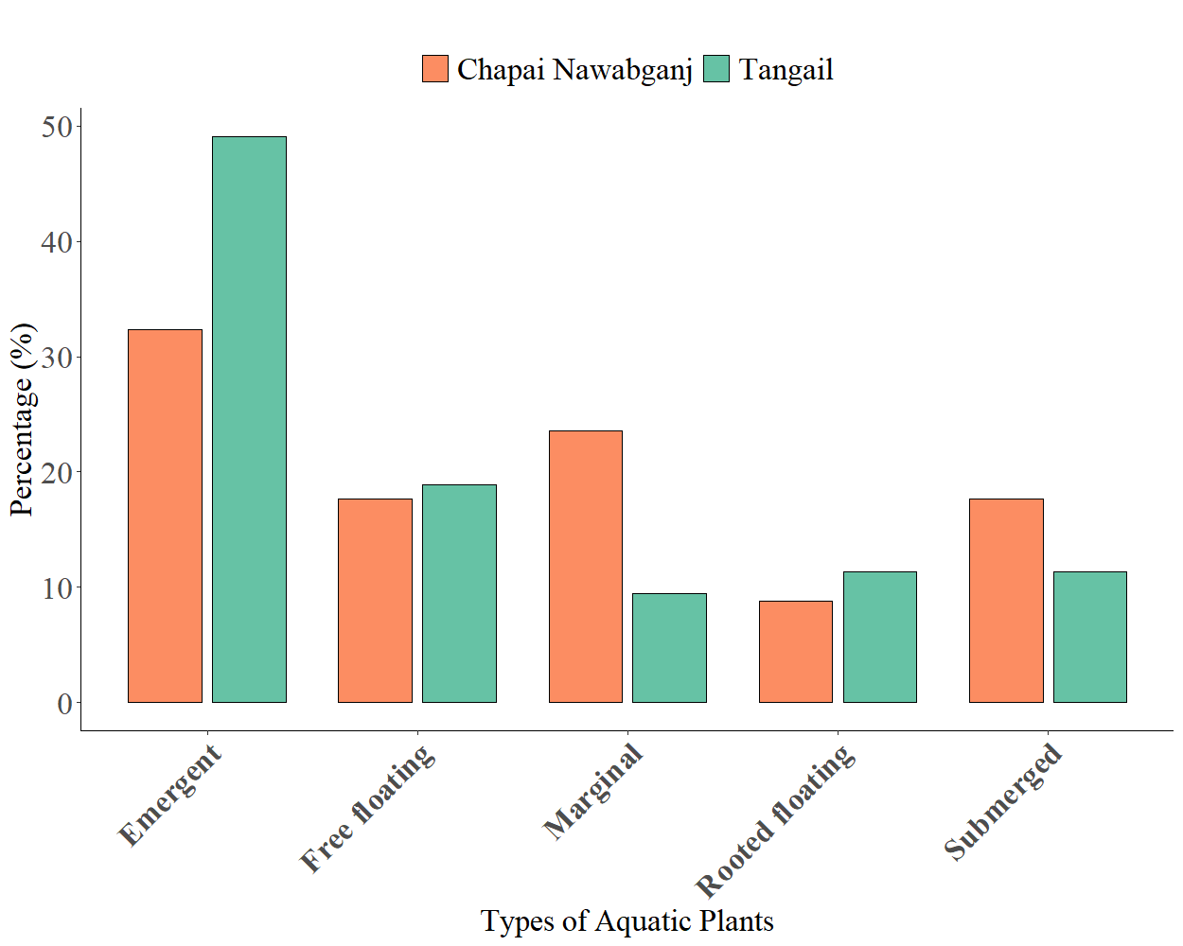
Fig. 3: Diversity and relative abundance of types of aquatic plants in Chapai Nawabganj and Talgail district.

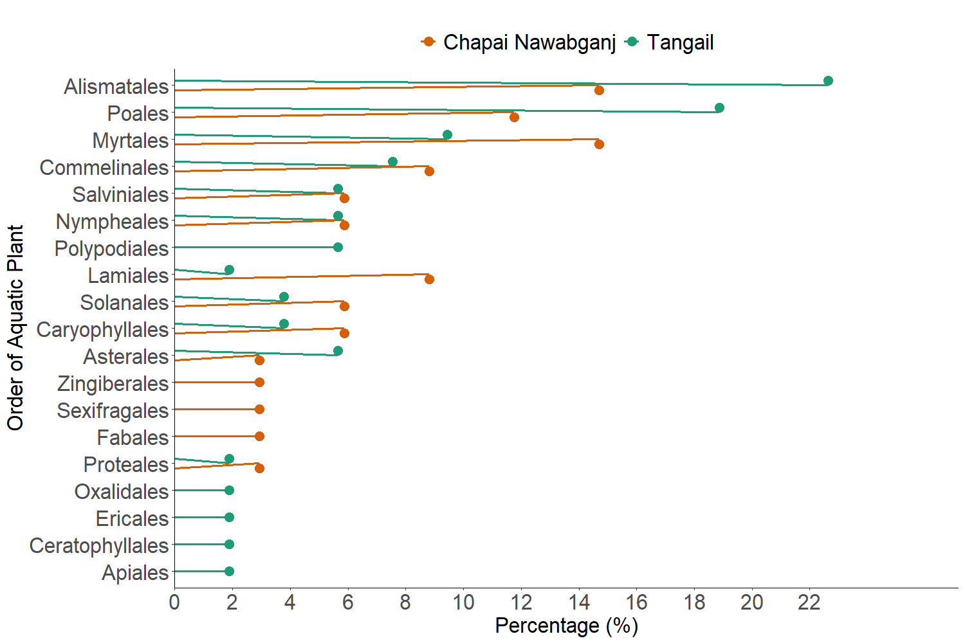

Fig. 4: Percentage of orders of aquatic plants in Chapai Nawabganj and Talgail district.

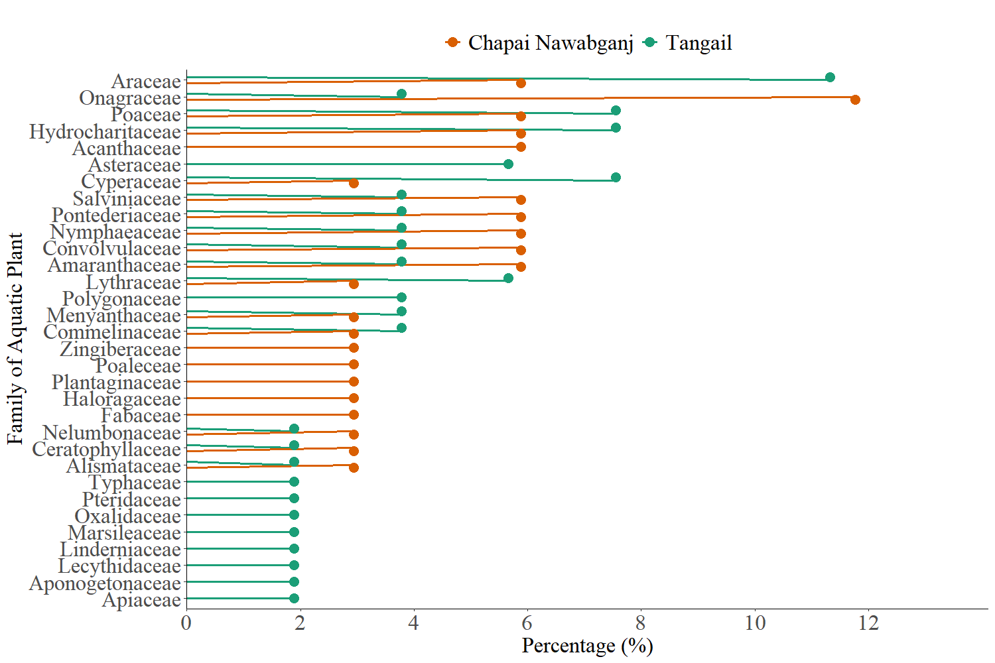

Fig. 5: Percentage of families of aquatic plants in Chapai Nawabganj and Talgail district.

- Availability of Aquatic plants
Four different seasonal categories: all season, monsoon, post-monsoon, and pre-monsoon, show significant variance in the seasonal occurrence of aquatic plants in Tangail and Chapai Nawabganj. (Fig. 6). In Chapai Nawabganj, the highest percentage of aquatic plants presence occurs during the monsoon season over 50%, followed by the all-season category approximately 32%. The pre-monsoon and post-monsoon seasons exhibit the lowest aquatic plants occurrence, accounting for around 10% and 8%, respectively. Similarly in Tangail, monsoon also exhibits the highest aquatic weed presence about 45%, followed by a moderate proportion recorded during the all-season roughly 25%. Interestingly, post-monsoon (17%) and pre-monsoon (13%) aquatic plants occurrences are notably higher in Tangail compared to Chapai Nawabganj.

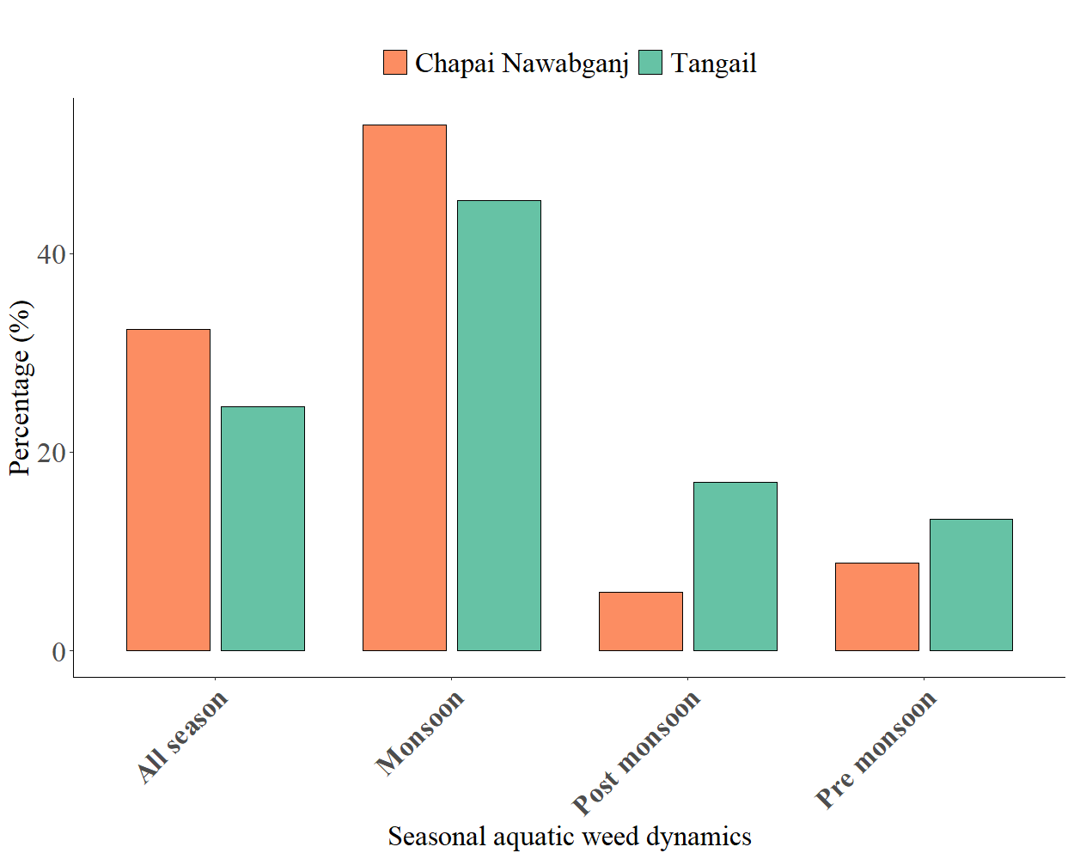

Fig. 6: Percentage of Seasonal availability of aquatic plants in Chapai Nawabganj and Talgail district.

- Origin and conservative status of Aqiatic plants
The proportion of native, exotic, and unknown aquatic plants varies significantly through the districts of Tangail and Chapai Nawabganj, according to the origin status of aquatic plant. At 67.6%, native species comprised the majority of Chapainawabganj, and exotic species comprised 32.4% (Fig. 7) In this district, no species of unknown provenance were found. In Tangail, the percentage of native species was even higher at 73.6%, with exotic species coming in second at 22.6%. Only 3.8% of aquatic plants were classified as having an unknown origin (Fig. 7)
In conservation status reveals the notable differences of the distribution of aquatic plants in Chapainawabganj and Tangail district (Fig. 8) In Chapai Nawabganj, 52.9% of the recorded aquatic plant species were classified as ‘Not Evaluated’ suggests a serious lack of conservation assessments. ‘Least Concern’ indicates that the remaining 47.1% of species are not currently in danger of going extinct. Interestingly, no ‘Vulnerable’ species were have been identified in Chapai Nawabganj (Fig. 8) Tangail, on the other hand, displayed a wider variety of conservation statuses. Of aquatic species, 39.6% were classified as ‘Least Concern’ and the remainder 58.5% as ‘Not Evaluated.’ It is interesting to note that 1.9% of aquatic plant species were classified as ‘Vulnerable,’ in Tangail indicating an insignificant but noticeable presence of possibly endangered species (Fig. 8)
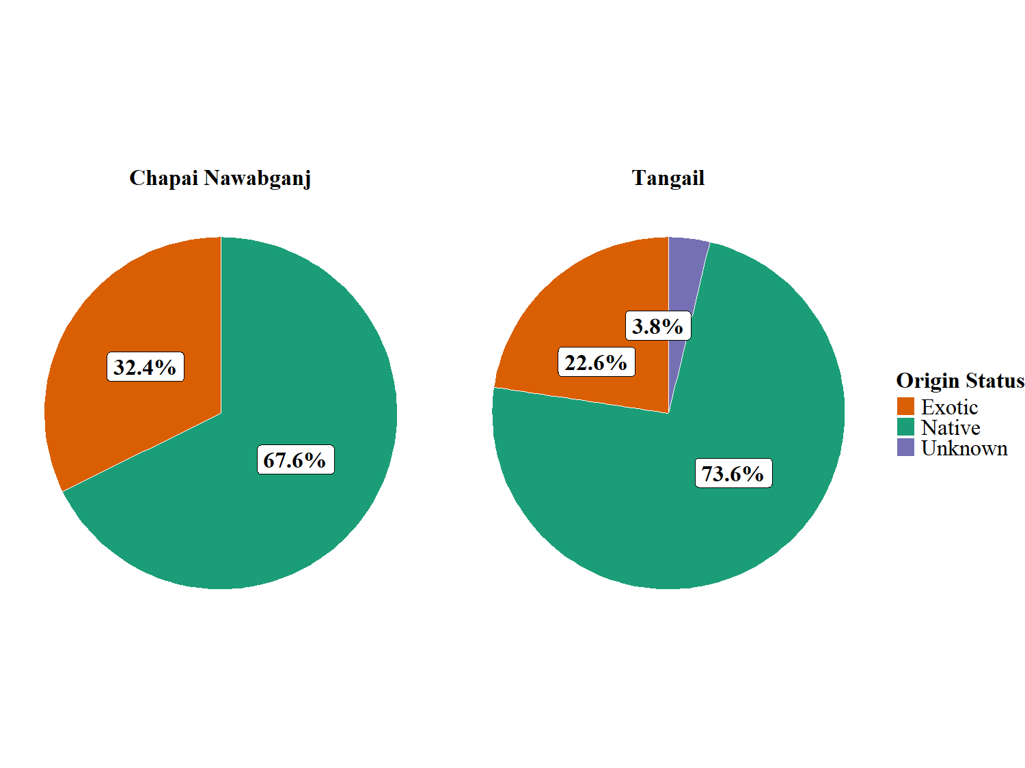
Fig. 7: Origin of aquatic plants in Chapai Nawabganj and Talgail district.

Fig.. 8 Percentage of Conservation status of aquatic plants in Chapai Nawabganj and Talgail district. Fig.. 8 Percentage of Conservation status of aquatic plants in Chapai Nawabganj and Talgail district.
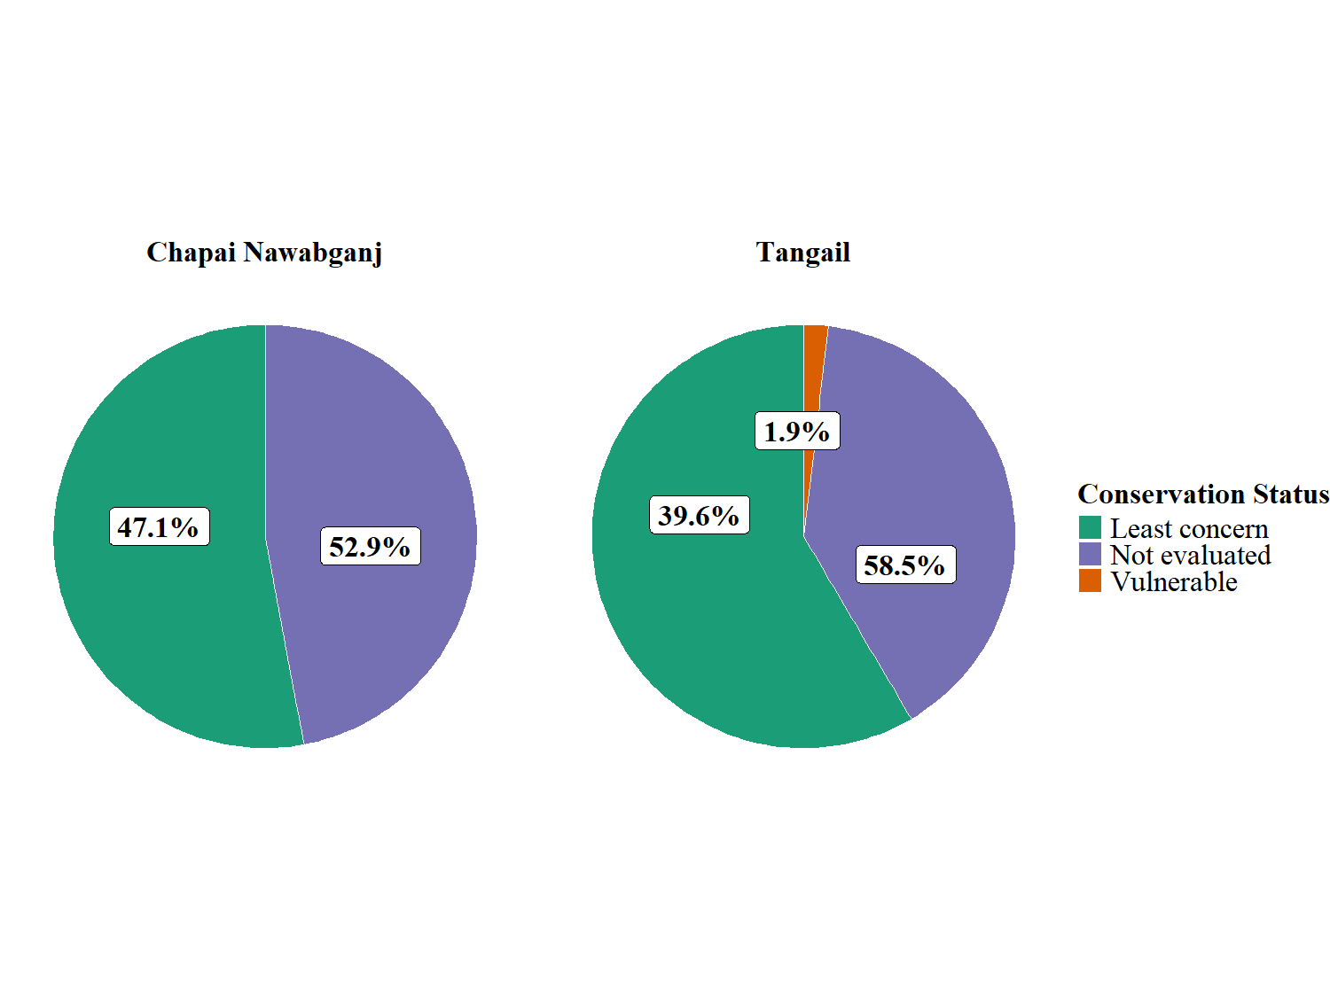
Fig. 8: Conservation status of aquatic plants in Chapai Nawabganj and Talgail district.
Discussion
Bangladesh is a riverine country and rich in aquatic vegetation but studies on the district-wise aquatic plant diversity are very rare. This gap is the background of the present study to assess the diversity, species size and stand population in two different agroecological regions such as Tangail and Chapai Nawabganj. The study demonstrated a diverse community of aquatic plants and substantial ecological differences between these two districts.
Aquatic plants observed in the present study were classified into one of the following five types according to visual inspection: free-floating, rooted floating, submerged, emergent, or marginal. This classification is comparable to previous classifications, such as those by Joshi (2012) and Islam (2017), but our work elicits more of a localized and field-based approach.
In total, 74 aquatic plant species, belonging to 32 families and 19 orders were documented from both districts. Tangail was more species rich with 53 species compared to 34 species for Chapai Nawabganj. Based on species richness it can be hypothesized that Tangail is more ecologically diverse, which could be likely related to the highly diverse aquatic habitat available there, such as seasonal wetlands and floodplains. Similarly, other studies reports lower species richness in other regions of Bangladesh to date, report 22 species in Noakhali (Kaiser et al., 2016), 19 species in Khulna (Rahama et al., 2008), 39 species in Mymensingh (Islam et al., 2017), 35 species in Chapai Nawabganj (Basar and Rahman, 2023) and 47 species in Noakhali, Cumilla and Chadpur district (Hossain et al., 2024) further augmenting the biodiversity significance of the areas we studied.
The differences in categories of vegetation is tied to the underlying plant ecology of both sites. In Tangail, more emergent species were noted, likely due to the shallow waterbodies, seasonal floodplains, and zones receiving agricultural runoff. These areas have slow moving, nutrient-laden waters, and change in depth, thus are the best circumstances for emergent vegetation (Van Geest et al., 2005; Finlayson, 2005). Conversely, Chapai Nawabganj contained more marginal vegetation and submerged vegetation, hinting at more stable riparian zones and clearer waterbodies that are permanent and could support these plants (Calvani et al., 2022). Basar and Rahman, (2023) reported that 34.78% aquatic plants grow to the edge of the waterbodies which align closely with our finding in chapai Nawabganj in the present study.
From a taxonomical view at the order level, Alismatales and Poales were important in both districts, however, the relative abundance of Alismatales and Poales was greater in Tangail. This is congruent with observations from southeastern Bangladesh (Hossain et al., 2024; Kaiser et al., 2016), in that shallow and marsh habitats are favorable to vegetation of the orders Alismatales and Poales.
Seasonal representation of aquatic flora had distinct variation across the two districts. Additionally, there frequently occur seasonal fluctuations in the abundance of aquatic plants ((Alhadari et al, 2020). Both districts had the maximum diversity and abundance during the monsoon season with increased availability of water, flooding, and nutrient-load contributing factors. The seasonal representation in both districts, Chapai Nawabganj particularly for the seasonal representation of the subcategories of monsoon and all seasons is higher and more concentrated than Tangail. We suggest the wider seasonal availability observed in Tangail supports aquatic plants in a more turnover fashion that likely reflects the nature of the dynamic floodplain, where the ephemeral wetlands and seasonal canals extend the time of potential growth for aquatic plants (Hossain et al., 2024, Rahman et al., 2020) offered by unique characteristics of the floodplain ecosystems.
Our preliminary analysis of plant origin indicated that both districts have a much higher proportion of native species of 73.6% for Tangail and 67.6% for Chapai Nawabganj. This indicates that these ecological environments have an ecological stability. However, with 32.4% of the aquatic vegetation representing exotic species in Chapai Nawabganj, it suggests that anthropogenic processes like agricultural runoff, habitat alteration or human-designed plant reminants have shown an increased potential for exotic plant growth (Davis et al., 2011).
Tangail had only 3.8% of aquatic plants representing species of unknown origin. This could suggest, whether plant was recently introduced, or as indicated by unknown origin, due to lack of taxonomic studies. Chapai Nawabganj did not have any plant species with unknown origin, which suggest that monitored growth was more familiar or recorded at compared to Tangail with unknown spatial distribution of origins.
With respect to conservation status, the majority of taxa in both districts are ‘Not Evaluated,’ highlighting a need for conservation assessments. Out of 47.1% of Chapai Nawabganj species that were ‘Least Concern’, none was ‘Vulnerable’. In comparison, Tangail had a lower percentage (1.9%) of ‘Vulnerable’ species, which may be as a consequence of habitat deterioration or localized anthropogenic pressure (Khan et al., 2020). This discrepancy could also correspond to differing degrees of environmental pressure, or only insufficient data from Chapai Nawabganj. These results highlight the critical need for more broader and current assessments to facilitate conservation of aquatic biodiversity in different AEZs (Islam et al., 2017; Rahaman et al., 2008, Butchart et al., 2010).
Conclusion
This study reveals remarkable spatial and ecological variability in the aquatic plant diversity in two distinct agroecological zones of Bangladesh. Tangail, being higher with well-drained soil allows more numbers and diversities of aquatic plants, especially emergent, to grow. On the other hand, the lowland floodplain of Chapai Nawabganj has low species richness, but high proportion of marginal plants. The monsoon was the determinative factor for aquatic plants in both districts, but was more so for Tangail. High proportions of native species in both regions were indicative of relatively unaltered aquatic communities, but the occurrence of exotic and threatened species in particular in Tangail, indicates that conservation issues are emerging. Large numbers of species are still unassessed for their conservation status and there is an urgent need for systematic biodiversity appraisals. These findings enhance the knowledge on aquatic plants ecology in Bangladesh and can be used as a starting point for further studies and conservation work. It is recommended that more research be done in order to monitor alterations in the species composition and create efficient management plans for long-term ecosystem health.

Disclaimer (Artificial Intelligent)
Authors hereby declare that no generative AI technologies such as Large Language Models (ChatGPT, COPILOT etc) and text -to-image generators have been used during writing and editing of manuscript.
Consent
As per international standards or university standards, Participants’ written consent has been collected and preserved by the authors.

Ethical Approved
Prior to the survey, participants were informed of the purpose of the research and their consent was taken into consideration. Confidentiality of their interviews and their willingness to participate were guaranteed. The Department of Aquatic Environment and Resource Management's ethical committee at Sher-e-Bangla Agricultural University in Dhaka, Bangladesh, formally approved the study.

References
- Ahmed, A. T., Kabir, S. M., Ahmad, M., Ahmed, Z. U., Begum, Z. N., Hassan, M. A., et al. (2009). Encyclopedia of flora and fauna of Bangladesh: Mammals (Vol. 27). Dhaka, Bangladesh: Asiatic Society of Bangladesh.
- Ahmed, F., Hossain, M. A., & Rahman, M. M. (2020). Biodiversity and conservation status of aquatic flora in Chapai Nawabganj. Journal of Environmental Biology, 41(3), 501–508.
- Alhadari, S. O., Dafaallah, A. B., & Zaroug, M. S. (2020). Distribution and mapping of aquatic weeds in some minor canals, Gezira Scheme, Sudan (2018). International Journal of Advanced Multidisciplinary Research (IJAMR), 4(1), 9–17.
- Aquatic Technologies. (n.d.). Aquatic weed identification. Aquatic Technologies. Retrieved June 6, 2025, from https://aquatictechnologies.com.au/weed-identification
- Bangladesh Bureau of Statistics (BBS). (2022). Statistical yearbook of Bangladesh 2022. Government of the People’s Republic of Bangladesh. https://bbs.gov.bd
- Basar, M. H., & Rahman, A. H. M. M. (2023). Aquatic vascular flora at Sadar Upazila of Chapai Nawabganj district, Bangladesh. Discovery, 59(326), e17d1019. https://doi.org/10.15190/d.2023.1
- Butchart, S. H. M., Walpole, M., Collen, B., van Strien, A., Scharlemann, J. P. W., Almond, R. E. A., ... & Watson, R. (2010). Global biodiversity: indicators of recent declines. Science, 328(5982), 1164–1168. https://doi.org/10.1126/science.1187512
- Calvani, G., Carbonari, C., & Solari, L. (2022). Stability analysis of submerged vegetation patterns in rivers. Water Resources Research, 58(8), e2021WR031901.
- Chambers, P. A., Lacoul, P., Murphy, K. J., & Thomaz, S. M. (2008). Global diversity of aquatic macrophytes in freshwater. In E. V. Balian, C. Lévêque, H. Segers, & K. Martens (Eds.), Freshwater animal diversity assessment (pp. 9–26). Hydrobiologia, 595. https://doi.org/10.1007/s10750-007-9154-6
- Cook, C. D. K. (1990). Aquatic plant book. SPB Academic Publishing.
- Cronk, J. K., & Fennessy, M. S. (2001). Wetland plants: Biology and ecology. CRC Press.
- Davis, M. A., Chew, M. K., Hobbs, R. J., Lugo, A. E., Ewel, J. J., Vermeij, G. J., ... & Briggs, J. C. (2011). Don't judge species on their origins. Nature, 474(7350), 153–154. https://doi.org/10.1038/474153a
- Dudgeon, D., Arthington, A. H., Gessner, M. O., Kawabata, Z.-I., Knowler, D. J., Lévêque, C., Naiman, R.J., Prieur-Richard, A.H., Soto, D., Stiassny, M.L., & Sullivan, C. A. (2006). Freshwater biodiversity: Importance, threats, status and conservation challenges. Biological Reviews, 81(2), 163–182. https://doi.org/10.1017/S1464793105006950
- Finlayson, C. M. (2005). Plant ecology of Australia's wetlands: A review. Aquatic Botany, 81(2), 133–143. https://doi.org/10.1016/j.aquabot.2004.10.009
- Haque, A. K., & Haque, E. U. (2009). Encyclopedia of flora and fauna of Bangladesh: Angiosperms: Dicotyledons Fabaceae–Lythraceae (Vol. 8). Dhaka, Bangladesh: Asiatic Society of Bangladesh.
- Hossain, I., Alam, M. M., Chamhuri, S., & Dey, M. M. (2014). Water productivity for living aquatic resources in floodplains of Northwestern Bangladesh. Journal of Coastal Life Medicine, 2(4), 324–331. https://doi.org/10.12980/JCLM.2.2014J50
- Hossain, M. F., Chowdhury, G., Nabil, T. A., Hossain, A., Bhuyain, S., Mithi, M. F., Begum, N., & Hossen, A. (2024). Diversity, abundance, and seasonal variation of aquatic macrophytes in southeastern Bangladesh. Asian Journal of Fisheries and Aquatic Research, 26(7), 55–66. https://doi.org/10.9734/ajfar/2024/v26i7783
- Hossain, M. I., Rahman, M. A., & Khatun, F. (2024). Floristic diversity of aquatic macrophytes in southeast Bangladesh. Wetlands Ecology Journal, 28(1), 15–26.
- Islam, M. A., Rahman, M. M., & Ahmed, K. U. (2017). Aquatic weeds diversity in BAU Botanic Garden. Bangladesh Journal of Plant Taxonomy, 24(2), 215–222. https://doi.org/10.3329/bjpt.v24i2.35184
- Islam, M. S. (2017). Diversity and distribution of aquatic macrophytes in Mymensingh district, Bangladesh. Bangladesh Journal of Botany, 46(3), 1211–1218.
- Joshi, A. (2012). Aquatic plant diversity and classification: A review. International Journal of Aquatic Biology, 1(1), 15–21.
- Journey, W. K., Skillicorn, P., & Spira, W. (1991). Duckweed aquaculture: A new aquatic farming system for developing countries (Vol. 30). Washington, DC: The World Bank.
- Kaiser, M. S., Rahman, M. M., & Kabir, M. H. (2016). Aquatic plant diversity in Noakhali, Bangladesh: A floristic analysis. Journal of Biodiversity and Environmental Sciences, 9(1), 35–42.
- Khan, M. A. R., Hassan, N., & Hoque, M. A. (2014). Wetland ecosystem services in Bangladesh: A review. Journal of Water Resources and Ocean Science, 3(1), 1–8. https://doi.org/10.11648/j.wros.20140301.11
- Khan, M. H., Rahman, M. M., & Islam, M. T. (2020). Impact of anthropogenic activities on aquatic biodiversity in wetland ecosystems of Bangladesh. Environmental Challenges, 1, 100005. https://doi.org/10.1016/j.envc.2020.100005
- Kumar, U., Mukta, M., & Mia, M. (2019). Changes in soil properties of four agro-ecological zones of Tangail district in Bangladesh. Progressive Agriculture, 29(4), 284–294. https://doi.org/10.3329/pa.v29i4.41342
- Lancar, L., & Krake, K. (2002). Aquatic weeds and their management (ICID Bulletin No. 1, pp. 22–57). New Delhi, India: International Commission on Irrigation and Drainage (ICID).
- Lewis, G. W., & Miller, J. F. (1980). Identification and control of weeds in southern ponds (Bulletin No. 839). Athens, GA: Cooperative Extension Service, University of Georgia.
- Madsen, J. D., & Wersal, R. M. (2017). A review of aquatic plant monitoring and assessment methods. Journal of Aquatic Plant Management, 55(1), 1–2.
- Millennium Ecosystem Assessment (MEA). (2005). Ecosystems and human well-being: Biodiversity synthesis. World Resources Institute. https://www.millenniumassessment.org
- Mitsch, W. J., & Gosselink, J. G. (2015). Wetlands (5th ed.). John Wiley & Sons.
- O’Hare, M. T., Aguiar, F. C., Asaeda, T., Bakker, E. S., Chambers, P. A., et al. (2017). Plants in aquatic ecosystems: Current trends and future directions. Hydrobiologia, 784, 1–11. https://doi.org/10.1007/s10750-017-3190-7
- Pasha, M. K. (1966). Aquatic plants of Illinois (Illinois State Museum Science Series, No. 1, p. 142). Springfield, IL: Illinois State Museum.
- Rahaman, M. M., Ali, M. Y., & Hossain, M. I. (2008). Floristic composition of aquatic plants in Khulna region. Bangladesh Journal of Plant Taxonomy, 15(2), 105–112.
- Rahman, M. A., Uddin, M. N., & Sultana, R. (2020). Seasonal variation of aquatic macrophytes in the floodplain wetlands of central Bangladesh. Wetlands Ecology and Management, 28(4), 611–624. https://doi.org/10.1007/s11273-020-09726-3
- Rashid, H. E. (2011). Geography of Bangladesh (4th ed.). The University Press Limited.
- Siddiqui, K. U., Islam, M. A., Ahmed, Z. U., Kabir, S. M. H., Hassan, M. A., Begum, Z. N. T., et al. (2007). Encyclopedia of flora and fauna of Bangladesh (Vols. 1–28). Dhaka, Bangladesh: Asiatic Society of Bangladesh.
- Uddin, M. Z., & Pal, J. C. (2020). Preliminary taxonomic survey of aquatic plants of Feni district, Bangladesh. Bangladesh Journal of Plant Taxonomy, 27(1), 103–111. https://doi.org/10.3329/bjpt.v27i1.47572
- Van Geest, G. J., Coops, H., Roijackers, R. M. M., Buijse, A. D., & Scheffer, M. (2005). Aquatic vegetation succession driven by reduced water-level fluctuations in floodplain lakes. Journal of Applied Ecology, 42(2), 251–260. https://doi.org/10.1111/j.1365-2664.2005.00998.x

