***Original Research Article***

**Dimensional analysis of cantrang fishing gear and its implications for the ecology and biology of fish in the Ancam River estuary, North Kalimantan, Indonesia**

**ABSTRACT**

The cantrang fishing gear is a type of fishing gear that is operated on the bottom of the waters by pulling it so that it is feared to have implications for damage to the ecosystem and biology of aquatic resources. This study aims to analyze the dimensions of the cantrang fishing gear based on Indonesian national standards (SNI) 01-7236-2006 and its implications for the ecology and biology of aquatic resources. This research is classified as a qualitative research type and was conducted using survey and interview methods. The research was conducted from March to May 2025 on the fishing gear used by fishermen in the Ancam River estuary, North Kalimantan. Observations and measurements of dimensions were carried out on the parts of the cantrang fishing gear, comparison of longitudinal and transverse sizes, comparison of the number of grids on the fishing gear parts, the material and size of the mesh. The results of the study showed that the longitudinal comparison of the parts of the cantrang fishing gear was in accordance, smaller and larger than SNI, in the transverse section all were smaller than SNI, the comparison of the number of grids on the cantrang section only the bag section was in suitable while the other parts were smaller, the material was all in suitable, while the mesh size was only the bag section that was in accordance while the others were all smaller. The dimensions of the cantrang fishing gear that did not comply with SNI had implications for damage to the basic aquatic ecosystem, disruption of the food chain and web, decreased catches, catching aquatic resources that had not reached a suitable size for catching. The dimensions of the cantrang fishing gear had differences in several parts so that they had an impact on the ecosystem and biology of aquatic resources.

Keywords: Cantrang; biological ecological implications; Ancam River; North Kalimantan

1. **INTRODUCTION**

The cantrang fishing gear is a type of bottom cantrang that is commonly used in small to medium-scale fisheries activities. Although it is known to have high effectiveness in catching demersal fish compared to other cantrangs (Yulieny *et al* 2019; Salsabila *et al* 2021, Indriadewi *et al* 2023). The use of cantrang fishing gear often causes controversy because it has a negative impact on the sustainability of aquatic resources and ecosystems, is not environmentally friendly (Ministerial Regulation of the Ministry of Marine Affairs and Fisheries Number 18 of 2021) and economically reduces people's income (Nurfitriana *et al* 2022).

Corresponding author: aryakantun@gmail.com

The operation of cantrang fishing gear in river estuary areas raises greater ecological concerns. River estuaries are transitional ecosystems between freshwater and marine waters that have high productivity and are important habitats for various fish species including as spawning, rearing and migration sites (Day *et al* 2013). Fishing activities using fishing gear that sweep the bottom of the waters such as cantrang can damage fine substrates, destroy aquatic vegetation and increase turbidity which can disrupt the process of photosynthesis and water quality (Budiarti *et al* 2024).

Several important factors that determine the level of selectivity and ecological impact of fishing gear are its physical dimensions such as the length of the rope, the width of the net mouth, and the size of the mesh. Cantrang dimensions that do not meet standards can increase bycatch and fishing below the catchable size. This can ultimately have a negative impact on the structure of fish populations and stock regeneration (Satria & Matsuda 2004).

In the context of sustainable fisheries management, it is very important to understand how the dimensions of cantrang contribute to ecological and biological pressures on fisheries resources. This study aims to analyze the relationship between the dimensions of cantrang fishing gear and its implications for the ecology of river estuaries and the structure of fish populations living in them as a basis for technical recommendations in more environmentally friendly fisheries practices.

1. **MATERIALS AND METHODS**

**2.1 Time and place of research**

This research was conducted from March to May 2025 on fishermen operating cantrang fishing gear at the Ancam River estuary, North Kalimantan, Indonesia.

**2.2 Research Procedures**

Observation and measurement of the dimensions of the cantrang fishing gear used by fishermen on the parts of the fishing gear related to the size of each part of the cantrang fishing gear construction, comparison of the length and cross sections of the cantrang, comparison of the number of grids on the cantrang section, material and size of the mesh. In addition, interviews were also conducted with the owners of the cantrang fishing gear and ship owners regarding the impact of the operation of the cantrang fishing gear on the ecosystem and biological aspects of resources.

**2.3 Data Analysis**

The data were analyzed descriptively and presented in a table by comparing the SNI 01-7236-2006 standard with actual conditions in the field. Meanwhile, the implications for the ecosystem and biological resources were narrated in an academic descriptive manner between the parts of the cantrang that did not comply with SNI.

1. **RESULT AND DISCUSSION**

**3.1 Dimensions of the cantrang fishing gear**

The cantrang fishing gear consists of wing parts, net body, and pocket. In other parts there are parts such as a sembar rope, upper ris rope, lower ris rope, weights, floats. Based on the measurement results of the cantrang operated at the Ancam river estuary, the length of each part is obtained as shown in Table 1. Based on the results of the comparison of the parts of the cantrang net referring to the SNI 01-7236-2006 criteria lengthwise and transversely, the results are obtained as shown in Table 2 and Table 3. Based on the results of the comparison of the cantrang parts lengthwise, it can be seen that the a/b value (mouth length to total net length) has a smaller value than the SNI value. Likewise, the c/b and d/b values ​​(wing length to total net length) have smaller values ​​(Table 3). Table 1 Size of each part of the cantrang

fishing gear construction

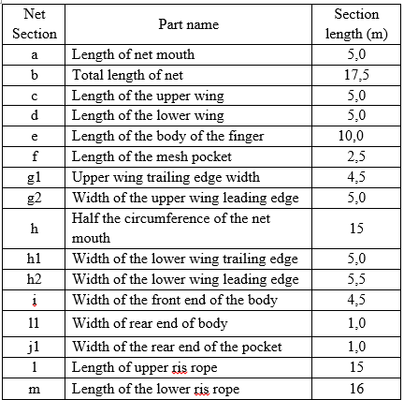

The data in Table 1 provides information that the cantrang net operated at the Ancam River estuary has a slightly shorter construction on the wings than the SNI standard. The e/b value (net body to total net length) has a larger value. This shows that the cantrang net construction operated has a longer net body than the SNI standard. The making of a longer net body is likely to take into account that fish that have been caught will have difficulty escaping from the net.

Table 2 Longitudinal comparison of

cantrang parts

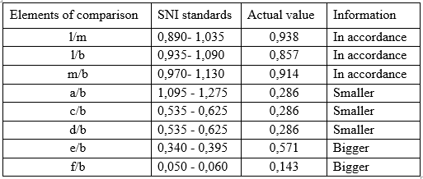

The transverse construction of the cantrang net operated in the Ancam River estuary has a smaller size than the SNI construction standard. This smaller size difference is adjusted to the operating area of ​​the fishing gear.

Table 3 Transverse comparison of cantrang

net parts

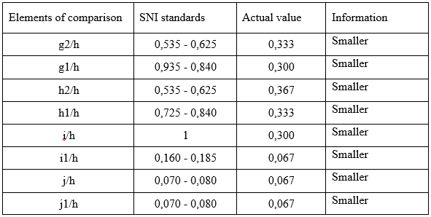

Comparison of cantrang construction based on the number of net grids shows that in general the cantrang operated at the Ancam River estuary is smaller than the SNI standard, but the net pocket section has a number of grids according to the SNI standard (Table 4). The dimensions of the cantrang based on the number of net grids show that in general the cantrang operated at the Ancam River estuary does not comply with the SNI standard, but there is a difference in the body of the net which has a number of grids below the standard, namely 3, so that the net body becomes shorter.

Table 4 Comparison of the number of grids

on the cantrang section

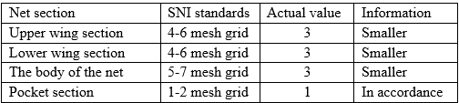

Based on the material used in the cantrang, the dominant type of material used is PE (Polyethylene). However, some parts of the net grid use PA (Polyamide) with the consideration that it is easy to sink in water. Based on the mesh size, the cantrang operated in the Ancam River estuary only has a bag size that meets SNI standards, while the upper, lower wings and body of the net do not meet or are smaller than SNI (Table 5).

Table 5 Materials and mesh sizes

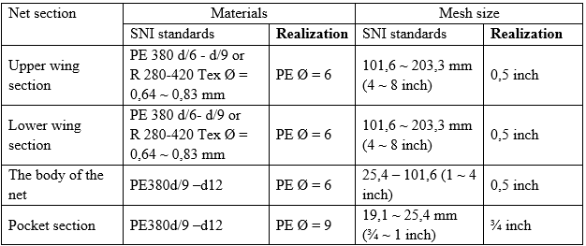

Based on the comparative values ​​of l/m, l/b and m/b, the cantrang operated in the Ancam River estuary complies with the standards set by SNI 01-7236-2006 longitudinally. This conformity is thought to be related to the standardization of the design and construction of the cantrang fishing gear which shows the ideal proportions of each part. This is intended so that the cantrang operated is efficient and safe to use, maintains the effectiveness of fishing in directing fish to the cantrang pocket, minimizes loss of catch and reduces operating time. Another possibility to maintain safety and operational feasibility is by considering the stability of the cantrang fishing gear when pulled, the workload of the gear on the ship and the fishermen. The existence of standardization helps in keeping the gear from being too heavy and reduces the risk of damage. The suitability of the cantrang fishing gear also makes it easier to carry out supervision and law enforcement related to supervision of compliance with fishing gear and to avoid sanctions given by fishermen due to the use of inappropriate fishing gear.

Smaller dimensions than SNI also cause decreased efficiency which can have an impact on the water flow becoming irregular, increasing pressure on the net section so that it is more easily damaged and difficult to pull. This can increase the workload of fishermen and operational costs. If many cantrang fishing gears are modified and do not comply with SNI standards, it can cause difficulties and assess the legality of fishing gear and law enforcement becomes weak (Handayani & Lituhayu 2020). This can encourage illegal fishing practices that can harm other fishermen and damage the environment.

The cross section comparison of the cantrang is all smaller than SNI 01-7236-2006 (Table 3). This can have an impact on the function of fishing gear, the sustainability of resources and ecosystems (Hardian *et al* 2020). In detail, the impact caused by the small cross section comparison of the cantrang is a decrease in the hydrodynamic efficiency of the tool related to the disruption of water flow and the direction of fish swimming and fish can escape on the sides of the net.

SNI 01-7236-2006 is established to ensure legality, sustainability and safety, so the cantrang fishing gear with a smaller cross section means it is not in accordance with regulations, has the potential to be considered as an environmentally unfriendly tool, is technically inefficient, is not selective to fish size, has the potential to reduce the quality of the catch, increases pressure on young fish stocks and is at high risk to the ecosystem, conflicts between fishermen (Afandi & Zainuri 2020) and fisheries regulations. However, the extended wings also have a negative impact, namely increasing bycatch because the cantrang catches more non-target species. The pressure of the cantrang fishing gear on the seabed is higher so that it can damage the habitat and also increase the drag resistance, causing increased fuel consumption.

* 1. **Implications for ecology**

The elongated part of the cantrang fishing gear that is smaller than the SNI 01-7236-2006 standard can cause several impacts on aquatic resources (Atmaja and Nugroho 2012) and ecosystems related to the decreased selectivity of the fishing gear, causing immature fish to have no chance of escaping and reducing the reproductive stock in nature. Dimensions that are smaller than the SNI can also increase bycatch and habitat damage due to catching more non-target species, damaging the bottom substrate which has an impact on damage to the bottom ecosystem of the waters and disrupting the food chain and web.

.The extension of the cantrang section outside the SNI has an ecological impact, namely causing overfishing because the tool becomes too efficient, causing damage to the bottom of the waters, can cause disorientation in fisheries management because the fishing gear does not meet the established standards. Although enlarging the cantrang fishing gear section may be able to increase catches in the short term, it risks damaging the balance of the ecosystem, can disrupt the sustainability of fish supplies and complicate law enforcement.

Modification of the cantrang fishing gear with smaller dimensions of the upper, lower and net body wings and with a mesh size that is also smaller than the SNI standard can have ecological and biological impacts on the estuary ecosystem and fish resources. The real impact is increasing negative selectivity, namely the ability of the tool to catch smaller aquatic resources that have not reached a suitable catch size, causing growth overfishing which in the long term can cause a decrease in the potential for fish stock regeneration (Pauly *et al* 2002).

In addition, it can also cause disruption to the food chain and trophic structure and disrupt the function of the ecosystem as a life support (Dayton *et al*., 1995; Jennings & Kaiser., 1998). Cumulatively, it has an impact on decreasing diversity and long-term productivity and increasing the risk of population imbalance between species. Modification of the dimensions of the cantrang should still refer to the principle of sustainable ecosystems, not only to economic efficiency.

**3.3 Implications for biological resources**

The comparison of the length of the larger cantrang section (Table 2) has various impacts. If the wing section is extended, it has a positive impact such as a wider sweep area so that the potential catch increases and is able to catch fish that are spread more widely. If the extended bag has a positive impact with a larger catch capacity volume. However, high fish density in the bag section can cause injury or death due to friction and pressure. If the size of the bag is not enlarged, more small fish will be caught, thus damaging the fish stock that is still in the juvenile phase.

The comparison of the cross section of the cantrang which is smaller than SNI 01-7236-2006 can cause a decrease in catch, longer fishing time, and an increase in the risk of fish density in the net. This can cause the catch to be physically injured, fish to die before being pulled onto the ship and a decrease in the quality of fish as a food commodity. The selectivity of the net is also low due to the width of the net mouth and other narrow cross sections so that they trap all sizes of fish which can reduce the chances of small fish to escape even though the mesh size is appropriate (Afandi et al 2020) so that in the long term this has an impact on over-catching. The operation of cantrang that does not comply with the permitted standard size causes damage to the ecosystem and habitat of fish biota (Ramadhan *et al* 2022).

**CONCLUSIONS**

The cantrang operated in the Ancam River estuary of North Kalimantan has differences in certain parts. The differences in these parts have implications for the ecological and biological factors of aquatic resources. Ecological implications include increased bycatch and habitat damage due to catching more non-target species, damaging the basic substrate which has an impact on the damage to the basic aquatic ecosystem and disrupting the food chain and web. Biological implications of resources include decreased catches, catching smaller aquatic resources that have not reached a suitable catch size, causing growth overfishing which in the long term can cause a decrease in the potential for fish stock regeneration.

**REFERENCES**

Afandi, J.T. & Zainuri, M. (2020). Cantrang Fishery and its Problems in Lamongan. Juveni. 1 (4): 525-532. <http://doi.org/10.21107/juvenil.v1i4.8950>

Atmaja SB, Nugroho D. 2012. Spatial Distribution of Cantrang Fishing Efforts and Its Problems in the Java Sea. Indonesian Fisheries Research Journal. 18(4): 233-241. <https://ejournal-balitbang.kkp.go.id/index.php/jppi/article/view/945>

[BSN] National Standardization Agency. 2006. ndonesian National Standard Standard Form of Cantrang Cantrang Construction. SNI 01-7236-2006. Jakarta. BSN. 5 p. <https://www.scribd.com/document/543450260/SNI-01-7236-2006-Bentuk-Baku-Konstruksi-Pukat-Tarik-Cantrang>

Budiarti, T.W., Tri, W.N., Eko, S.W., Zulkarnain, Wudianto. (2024). The Fishing Capacity of Cantrang Fisheries in Tegalsari Coastal Fishing Port in Tegal City, Province Central Java in Demersal Fisheries Management. Marine Fisheries: Journal of Marine Fisheries Technology and Management. 15 (1): 83-94. <https://journal.ipb.ac.id/index.php/jpsp/article/view/47619/28097>

Dayton, P. K., Thrush, S. F., Agardy, M. T., and Hofman, R. j., 1995. Environmental effects of marine fishing. Aquatie conservation: marine and freshwater ecosystems, 5: 205-232. https://www.google.com/url?sa=t&source=web&rct=j&opi=89978449&url=https://www.vliz.be/imisdocs/publications/ocrd/73980.pdf&ved=2ahUKEwjo9ZSiuMCNAxUB9zgGHd6kBX4QFnoECBcQAQ&usg=AOvVaw3qsk4Ie66ryT-sb_a4qy7c

Day, J.W., Crump, B.C., Kemp, W.M. & Yáñez-Arancibia, A. (2013). Estuarine Ecology (2nd ed.). Wiley-Blackwell. <https://www.wiley.com/en-us/Estuarine+Ecology%2C+2nd+Edition-p-9780471755678>

Handayani, Z.S. & Lituhayu, D. (2020). The Implementation of Cantrang Fishing Gear Prohibition Policy in Pati Regency. Journal of Public Policy and Management Review. 9(1): 67-79. <https://ejournal3.undip.ac.id/index.php/jppmr/article/view/26145>

Hardian D, Febryano IG, Supono, Damai AA, Winarno GD. 2020. Ban on Cantrangs: Strategy for Sustainable Development of Fish Resources in Lampung Bay. Journal of Tropical Marine Science. 3(1): 21-27. <https://doi.org/10.33019/jour.trop.mar.sci.v3i1.1734>

Indriadewi EM, Firdausy AG, Achmad. 2023. The Effectiveness of the Cantrang Prohibition Regulation in Rembang Regency. Journal of History Education and Social Humanities Research.3(3): 223-229. <https://ejournal.penerbitjurnal.com/index.php/humaniora/article/view/307>

Jennings, S., & Kaiser, M. J. (1998). The effects of fishing on marine ecosystems. Advances in Marine Biology, 34, 201–352. https://fish.gov.au/Archived-Reports/2014/Documents/2014_refs/Jennings%20et%20al%201998.pdf

[KKP] Ministry of Marine Affairs and Fisheries. Regulation of the Minister of Marine Affairs and Fisheries Number 18 of 2021: <https://jdih.kkp.go.id/Homedev/DetailPeraturan/3434>

Nurfitriana N, Saputra A, Mukani. (2022). Cantrang Fisheries in Indramayu Regency, West Java Province. Journal of Fisheries and Marine Extension. 16(1): 79-94. <https://jppik.id/index.php/jppik/article/view/253>

Pauly, D., Christensen, V., Guénette, S., Pitcher, T. J., Sumaila, U. R., Walters, C. J., Watson, R., & Zeller, D. (2002). Towards sustainability in world fisheries. Nature, 418, 689–695. https://www.researchgate.net/publication/11218797_Towards_sustainability_in_world_fisheries

Ramadhan, M.Y., Mario, L.,& Riena, F.T. (2020). Catch Composition of Cantrang at Kronjo Fish Landing Base. Jurnal Ilmiah Satya Minabahari, 08 (01): 36-49. <file:///C:/Users/ACER/Downloads/171-Article%20Text-522-1-10-20221030-1.pdf>

Salsabila K, Diamantina A, Putrijanti A. 2021. Temporary Revocation of the Ban on the Use of Cantrangs for Fishermen in Brebes Regency Based on Ministerial Regulation Number 2-Permen-KP-2015 concerning the Prohibition on the Use of Cantrang Fishing Gear and Seine Nets in the State Fisheries Management Area Republic of Indonesia

.Diponegoro Law Journal. 10(2): 367-374. <https://ejournal3.undip.ac.id/index.php/dlr/article/view/30614>

Satria, A., & Matsuda, Y. (2004). Decentralization of fisheries management in Indonesia. Marine Policy, 28(5), 437–450. <https://doi.org/10.1016/j.marpol.2003.10.001>

Yulieny NE, Fahrudin A , Zulbainarni N. 2019. Study on the Effectiveness of Replacing Cantrang Fishing Gear with Millenium Gillnet in Banyutowo, Pati, Central Java. Journal of Natural Resources and Environmental Management.10(1): 34-42. <file:///C:/Users/ACER/Downloads/26371-Article%20Text-98169-1-10-20200320.pdf>