Original Research Article

IMPACT OF POLICY INNOVATION ON HUMAN RESOURCE MANAGEMENT AND GOVERNANCE IN NIGERIA’S TEACHER EDUCATION SYSTEM

ABSTRACT
Human resources in teacher education across the globe constitute the core in the task of delivering quality learning objectives and outcomes because the humans are the primary driver of every policy framework put in place for the day-to-day activities of knowledge reproduction which is built on the engaging intersection of teaching and learning activities across different levels of human existence. Expanding the context and realities of the forgoing position, the governance system and policy instituted for the actualisation of and knowledge production for now and the next generation has become a subject of debate which is evident in the teaching functions, responsibilities and outcomes as evident within the Nigerian educational space. Given the forgoing, the paper examines the place of innovation in the current policy structure and the question of human resource management in Nigeria’s of teacher’s education from the standpoint of Triple Helix Model. This theoretical model was adopted as a framework of explaining and interrogating the complex yet symbiotic interconnectedness and relationships that exist amongst the three critical actors of the Research Institution, Industry and government in driving and actualisation of innovations in the delivery of knowledge reproduction sector in Nigeria. The study employed a mix method of research which is based on use of both primary and secondary methods of data collection. The study discovered disconnects between the major actors in the web of teacher education as the factor that has led to a significant dwindling fortune of educator and tutoring sectors in Nigeria i.e. the research institution (colleges of education-industry and government). It recommends a pragmatic approach between these actors.

Keywords: Human resources, Innovation, Policy, Triple Helix Model, Teacher Education,

INTRODUCTION
The place and importance of teacher education within the education sector has been established across literature (Eduwen, 1992; Okemakinde Adewuyi & Alabi, 2013; Eduwen and Osagie-Obazee). Within the framework of teacher education is the unquantifiable role and functions played by the teacher in either individual or collective capacity for imparting knowledge across different times and ages. This process of knowledge regeneration should be structured to address society’s developmental strides and advancement. Teacher education has been considered as the foundation upon which the task of knowledge production and reproduction for the now and future generation rest. Its importance as a primary sub-sector of the whole educational system and structure includes but not limited to the pivotal role it has played and will continue to play across human existence. By implication, developing a formidable educational system which is posed to address the generality of human needs and national development is premised on the standard of knowledge reproduction strategies in place. Importantly the process and procedure of human resources management and institutional governance are essential elements that enhances the operations of quality teaching and learning functions.
In recent times, the need for policy reforms in the teacher education sub-sector has been appreciated by major stakeholders given the dwindling fortune of the sub-sector within the generality of education in Nigeria. The evolving dynamics of the sub-sector therefore raises the fundamental questions associated with the essence and imperatives of policy innovation to meet the developmental aspirations of the Nigerian state and also in the same context deliver on the individual aspiration of reproducing knowledge-based society and economy. Within these realities are the many unresolved issues affecting the task of attracting and preparing competent teachers with requisite skills needed to deliver on the fortune of the generality of all sectors in the country and in the same vein meet the challenge of the 21th century economy built on knowledge.
Within the structure of educational practice and delivery is the question of policy content and framework. The role of policy as determining factor in every sphere of human endeavour and organisational functioning and existence cannot be overemphasized. Specifically, policy according to Rumki (2015) is broadly defined as a proposed course of action of an individual, group institution or government to realise a specific objective within a given environment or sphere of interest. The formulation of policy is seen as fundamental for the existence of any organisation. It is policy which lays down the framework within which an organisation’s goal is set to be accomplished. Within the same light, Ambali (2015) notes that, policy is a deliberate plan of action taken to guide decisions and achieve rational outcomes. The term may apply to individuals, government private sector or group’s line of action that is defined within a specific framework that sets the administrative rules and procedures in motion.
Closely tied to the above is the place of human resource management. It is noted that human resources are the management procedure involved in ensuring the efficient deployment of the totality of human element that exist within an organisation. Therefore, the ability of an organisation to achieve its stated objective is tied to the management framework deployed for hiring, training and effective use of the humans within the organisation.
Griffin (1997), described human resource management as the set of organizational activities aimed at attracting, developing and maintaining an effective workforce towards the actualisation of stated organisational objective. Human resource management involves the process of recruitment, staffing, welfare, maintenance, training and retraining, placement, promotion, motivation relationship, compensation or rewards, transfer and discipline of staff. It lies at the care of the efficiency of the organization. The quality of human resource management determines the extent and speed to which efforts will be directed towards actualising the objectives outlined by the organisation (Butcher, 2007).
In the education sector and most especially in teacher education, human resources are the primary drivers that aid the actualisation of existing educational policies and programmes. This simple implies that when staff in the education systems are adequately recruited, selected and supervised, inducted and adequately rewarded, and provided for, properly developed, appraised and promoted on the job, they will be committed to the job, remain dedicated and productive in the education systems (Omebe, 2014). By implication, the procedures involved in attracting the most qualified human resources into teacher education sub-sector and ensuring the domestication of all the core elements of recruiting, training, and motivation will significantly ensure the actualisation of teacher education objectives.
The core of human resource management is the function of motivation. Motivation is often seen as the totality of welfare packages available for the workforce within an organisation. Therefore, to drive the objectives of an organisation, the human resource function of motivation must be adequately addressed and this by implication will attract the best hands into the organisation.
Every educational system, especially teacher education sub-sector depends solely on the quality of its human resources for execution of its policies and programme. Nwaka and Ofojebe (2010) noted that teachers are the critical resources for effective implementation and realization of the educational policies and objectives at the practical level of classroom. A manager, whether in private or public sector, who underrates the critical role and underplays the importance of people in goal achievement, can neither be effective nor efficient (Oduma, 2012). It is the teacher who ultimately interprets and implements policy as represented in the school curriculum, which is designed to actualize educational goals (Omojunwa, 2007).
Maintaining and improving educational standards is only possible through teachers and the quality of teachers that can be attracted to the profession is tied to the human resource function deployed in recruiting, training and motivating them from the level of teacher-education trainees and trainers. Teachers therefore are the most indispensable entity in the school. They are the greatest aid to learning. The shortage and poor management of teachers especially in terms of poor remuneration has significant effect on admission to teacher training institutions and faculties of education and by implication reduces the extent to which the curriculum can be delivered effectively. It should be noted that the major premise of human resources management in education is that the end results of the educative process will be determined by the effectiveness of the teachers who facilitate learning for self-actualization and national development.
Given the forgoing position, this research interrogates the impact of urgent teacher education policy innovation within the light of the core functions of human resources management of recruitment, training, and motivation of both teacher-trainers and the trainees by all stakeholders on the one hand and on the other hand, the intersection of the existing governance system within the framework of policy innovations towards ensuring an effective teacher education sub-sector that will attract, retain and motivate the best brains towards delivering the good of individual and national development.
STATEMENT OF THE PROBLEM
Many researches have focused and revealed a number of challenges confronting the education sector, which include but not limited to financing which is always below the prescribed UNESCO benchmark of 26%, lack of infrastructure, over stretched facilities and decay, poor remuneration leading to poor attitude in the teaching profession. Despite all these, the urgent need to address prevailing issues through pragmatic policies cannot be overemphasised. Addressing these problems holistically would not just fix the development gap permeating all aspect of the Nigeria educational system but would in the quickest possible way help bridge the obvious manpower and motivation gap in the country’s primary and post-primary education systems.
Teacher education in Nigeria has come under extensive conversation in recent times given the various issues affecting the core aspect of the sector ranging from dwindling enrolment, inadequate funding, poor remuneration of the primary drivers of teaching responsibility and outcome, inconsistency of government policy, lackadaisical approach to human resource management, obsolete pedagogical approach to teaching functions and most importantly, the approach of the actors to graduates from teacher education institution in Nigeria.
These problems and many more issues though have had different approach inform of policy formulation and implementation from stakeholders in the sector with different contestable outcome which have defined the current status of teacher education in Nigeria. Given the forgoing, the study examined the problematic and contested issues of policy and human resources and the need for innovations within the policy circles of teacher education and most importantly, the need for effective collaborative functions between research institution (Teacher education institution), Government and the industry (Triple Helix Model) as the most veritable tool for reinvigorating teacher education and knowledge reproduction in Nigeria
OBJECTIVE OF THE STUDY
The primary objective of the study is to examine the imperatives of policy innovation, resource management and governance in Nigeria’s teacher education sector. The specific objective includes;
i) Examine the continued relevance of existing policy and the need for policy innovations on teacher education in Nigeria
ii) Investigate the nature and process of resource management and governance in Nigeria’s teacher education sector
iii) Determine the implications of collaboration between major actors as defined in the Triple Helix Model as major approach to resolving the issues affecting teacher education in Nigeria

RESEARCH HYPOTHESIS
H₀₁: Existing policies on teacher education in Nigeria remain fully relevant and effective, with no significant need for policy innovations.
H₀₂: The nature and process of human resource management and governance in Nigeria’s teacher education sector do not significantly impact the effectiveness and efficiency of the system
H₀₃: Collaboration between major actors in the Triple Helix Model has no significant implications for resolving issues affecting teacher education in Nigeria.
THEORETICAL FRAMEWORK
The study is built on the Triple Helix model as developed by Henry Etzkowitz and Loet Leydesdorff, is widely recognized as a framework for understanding innovation in knowledge-based societies and other aspects of policy innovation (Cai, 2020). This model emphasizes the interactions between research institutions, industry, and government to foster entrepreneurship, innovation, and economic growth (Cai, 2021). It posits that these three entities, traditionally seen as separate, can work collaboratively to create, transfer, and apply knowledge more effectively. According to Leydesdorff, & Zawdie, (2010) the Triple Helix model has been successful as a heuristic for analysis and as a normative guide for policies formulation, analysis and innovation.
The model as a framework for policy analysis emerged from early explorations of the role of academia and organized knowledge production in regional innovation (Cai, 2021). Henry Etzkowitz and Loet Leydesdorff consolidated the model through collaborative works and individual publications (Cai, 2021). Their work explains the dynamic interactions between academia, industry, and government, as major actor in policy circle which in turn drive policy innovation as a critical process in policy formulation, assessment, implementation and innovation (Cai, 2021).
The Triple Helix model is used to understand the roles of research institution, industries, and governments in regional innovation systems (RIS) (Coenen, 2007). It underscores the value of increased interaction and interdependence between these actors in modern, knowledge-based economies (Coenen, 2007). However, comparative analyses of RIS have questioned the one-size-fits-all approach, suggesting that various constellations are possible depending on the specific characteristics of the RIS (Coenen, 2007).
One criticism of the Triple Helix model is that it tends to place the state at the center, which may be more appealing to non-democratic regimes seeking to catch up with OECD nations (Balzer, 2016). This situation has the capacity to birth an oversimplistic perspective of the whole process of innovation and leave the good component of This can lead to an oversimplified view of the innovation process and neglect the importance of hierarchical ideas and promotion of activities that are entrepreneurial in nature and outlook thereby undermining the whole processes that can sustain development initiatives that are all-encompassing.
Cai (2014) noted that to adequately execute the core advantage of the Triple Helix Model, it is imperative to recondition the core characters and actions of actors in the environment which drive the interactions and engagement of the actors. Developing approaches that are innovative that will address the unique situations in each country with specific reference to their environmental peculiarities is of utmost importance especially for the development of teacher education through constructive utilization of the available human resources (Cai, 2014).
The model as promulgated by Etzkowitz & Leydesdorff (1994) presents an important context for internalising and promoting innovative actions in societies that are driven by the fundamental of knowledge driven societies and systems that are primarily focused on the development of the teacher education sectors. Within this frame is the important action of human resource management that places priorities on incentives that will enable the adequate utilisation of the workforce within the school environment.
POLICY INNOVATIONS IN NIGERIA’S TEACHER EDUCATION SYSTEM
Education is the cornerstone of national development, and the role of teachers in shaping the future workforce cannot be overstated. In Nigeria, the teacher education system has undergone several policy reforms aimed at improving the quality, accessibility, and effectiveness of teacher training and professional development. These policy innovations have been driven by government initiatives, the role of critical stakeholders such as Unions, Alumni association, international influences, and technological advancements. The role played by these actors mainly drive the current status of the sector aimed at revamping the sector and improving the fortunes of teachers and teachers-in-training.
Teacher education is a critical component of a nation's educational infrastructure, and its effectiveness hinges on the quality of its teachers and leaders (Schleicher, 2011). As such, policy innovations aimed at optimizing the teacher workforce, recruitment strategies, initial teacher education, ongoing support, compensation structures, and performance management are essential for ensuring effective teaching in the 21st century (Schleicher, 2011).
In the light of dwindling enrolment across teacher-training institution and reduction in students seeking admission to study education courses, the Colleges of Education Academic Staff Union (COEASU) has been instrumental in advocating for policies that strengthen Nigeria's teacher education sector, particularly through its push for the Dual Mandate Act which was signed into Law in 2023. This legislation seeks to upgrade Colleges of Education to degree-awarding institutions while maintaining their core role in training NCE-level teachers. COEASU's efforts have included:
- Policy Advocacy: Engaging with the government to implement structural reforms that allow Colleges of Education to award both NCE and Bachelor of Education (B.Ed.) degrees.
- Institutional Autonomy: Pushing for policies that grant more independence to Colleges of Education, enabling them to operate at par with universities in training teachers.
- Professional Development Initiatives: Ensuring that academic staff members receive adequate training and research support to align with global teaching standards.
- Improved Funding and Welfare: Negotiating with the government for better funding, improved facilities, and enhanced welfare for lecturers and trainee teachers.
- Curriculum Standardization: Working with regulatory agencies to design curricula that meet the needs of both NCE and degree programs in teacher education.
It is important to note that labs responsible for policy innovation are emerging as major players in the administration and governance of teacher education with the provision of technical expert ideas and methods that are significantly innovative in the field of education and learning. It was noted that these policy labs make use of design, public service system based on digital structures and science driven data generation methods (Williamson, 2015).
This process is built on an enabled system that thrives on digital analysis, evaluation that is based on verifiable evidence which is designed with strong policy framework that covers the core of policy circles with innovation at the core of all actions (Williamson, 2015). Specifically, emphasis is laid on computational reasoning and skills based on computer programmes which is becoming paramount in a society that is built and operated on the strength digital technology and architecture. This movement shows a drift to assigning functions to persons with the requisite digital skills and competence with the incorporation of capabilities structured to meet societal social and complex knowledge gaps, especially within the frame of well-motivated, adequately trained and informed human actors that plays crucial roles in the education sector (Williamson, 2015).
The implementation of educational policy of occurs within a complex multilayer process which is aimed at ensuring that specific policy statement is are put into operation across different stages of every society educational system (Viennet, 2017). For example, policy innovation in vocational, technical and teacher education in Nigeria. It also follows the conscious stakeholders’ action of identifying and making sure that this specific and contending contextual factors are addressed which can either ensure the successful operationalisations of these policies for the successful operation of the educational system. Within this framework, the process of policy implementation process is determined to a large extent by its outcome weather in terms of measuring success or failure of the whole policy content particular in policy conception, formulation, implementation and innovation (Viennet, 2017). That includes the statement of questions and principle that are complementary and help policy maker in analysing and ensuring smooth and result-conscious implementation of stated educational policies.
Contemporary description of career choices emphasizes the relationship that is this between knowledge generated based on professionalism studies data scientific and higher educational attainments (Beach, 2013). Despite these, new reforms in teacher education countries such as Finland, England and Sweden are directed towards merging critical training models that are digital based. This new move includes a shift towards organised and consistent training and retraining methods with the potentials to impact basic and core of knowledge acquisition to become professional teachers and also discharge teaching functions within the sphere of digital realities (Beach, 2013). The adequate understanding of the transforming realities and interactions between attending and acquiring practical training programs and deploying professional knowledge are major requirement for determining the next step in teacher education policy conception, formulation, implementation, reassessment and innovations (Beach, 2013).
Responding to the emerging global events and transformation, especially the outbreak of the global pandemic of Covid-19, the world educational system has been significantly affected with countries and the international systems drawing on these realities for existing policy reassessments and consequently innovations in order to maintain a continuous, safe leaning environment and within the same premise deliver quality learning outcomes. Specifically, the response of China and countries across the world to the new realities includes constructing or formulating education policies that is focused on governance of all levels of education, management of schools and learning environment, practices of teaching functions that aligns with these changing realities and most importantly, providing specific training and supports to teachers (Xue, 2020). The fundamental aim of these policies is to ensure safety of both the physical and mental of all actors (school managers, teachers and students), make sure need materials for knowledge delivery are provided, preserve and improve the quality of learning and its environment, and providing learning environment that will allow teachers access new technological skills for improved delivery of contents (Xue, 2020). Within the new global realities, countries of the world especially developing countries of Africa, adopts new educational policies which transformed the teaching and learning process through pragmatic formulation and implementation of policies that depends more on technological devices and digital tools such as computer-based learning systems for improved learning outcomes.
IMPACT OF GOVERNANCE IN TEACHER EDUCATION
The role of governance in determining the quality, structure and effectiveness of teacher education cannot be overemphasized. As a major aspect and force in actualising the core of national development, teacher education is to a large extent determined by the quality of policies, open, transparent process of taking decisions, providing effective administration which primarily focuses on providing quality training for teachers and educators that will sufficiently address the educational needs of the country and ensure the preservation of the education sector in the country. The development of Nigeria is basically tied to the quality of education especially the quality of its teaching via recruitment process, training, retraining, motivation and retention, teaching and learning environment, and importantly, the consistency and response to the changing global environment of knowledge.
The structure of governance in the education sector is built on the role of actors such the federal government who because of the division of power plays prominent role in the existence and operation of the section, the state and local government, educational institutions, educational regulatory agencies, international development partners, and supranational agencies. The role and functions played by these actors have for a long time determined the status and performance of education sector in general and teacher education in particular. Importantly, the responses and reaction of the citizens to the important sub-sector of teacher education is determined by the quality of government policies and approach to the sub-sector.
Studies have investigated the impact and relationships between actors in the processes involved in policy formulation, implementation, reassessment and innovation (Leydesdorff, 2017). These policy circles should address in details the delivery of teaching functions with the teacher education sub-sector which is a fundamental requirement for national development especially in developing country like Nigeria. Specifically, it has been stated that the systems that enable innovation within a society are often divided into different levels of operation which include the metropolitan and regional systems. Within this division, the metropolitan areas are often seen as playing more roles especially as regards providing the groundwork for innovative policy in teacher education (Leydesorff, 2017).
In Nigeria, the teacher education sub-sector is governed by some institutions and government agencies. The primary executive arm of government saddled with the governance responsibility of teacher education in Nigeria is the Federal Ministry of Education (FME), the National Universities Commission (NUC) for universities offering education courses, the National Commission for Colleges of Education (NCCE) and the Teachers’ Registration Council of Nigeria (TRCN). These agencies of government are charged with the primary function of regulating the establishment, conducting accreditation exercises, chatting policy direction and administration of teacher education across the country’s teaching training institutions in Nigeria. The framework establishing the governance functions and task undertaken by these organisations is to ensure that teachers, tutors and educators possess the requisite pedagogical skills and expertise to improve the process of teaching and learning function and outcomes in primary, secondary and other institutions of learning.
To sustain teacher education and attract the most committed and development-conscious workforce in Nigeria, emphasis must be placed on the quality of policies via formulation, implementation, reassessment and innovation governing the operation of the sub-sector. The existing policies must address contending global realities in terms of knowledge generation and dissemination and importantly, the human resources component of teacher education must be positioned to addresses global best practices and changing pattern of the world of work. For example, the government has introduced different policies that is aimed at repositioning and standardizing the sub-sector with the objective of improving learning outcomes (Adelabu, 2019). These policies including the revised National Teacher Education policy, signing the new dual mandate act, and the improved National Policy on Education (NPE).
CHALLENGES AND OPPORTUNITIES IN TEACHER EDUCATION
In Nigeria, the teacher education sub-sector is currently facing numerous challenges which including attracting and retaining quality and effective workforce, providing training opportunities for the workforce to meet global realities and environmental needs occasioned by advancement in technological and digital tools, providing a learning environment that cater for students’ difference and learning needs, (Nwuke & Yellowe, 2025; Ihua, 2024; Mata, 2024). However, policy innovations offer opportunities to address these challenges and improve the quality of teacher education (Schleicher, 2011), (Xue, 2020), (Viennet, 2017). By optimizing recruitment strategies, enhancing initial teacher education, providing ongoing support, and fostering a culture of continuous improvement, teacher education systems can better prepare teachers to meet the demands of the 21st century classroom (Schleicher, 2011).
Fundamentally, previous studies such as Salahu, (2020); Ezegwu, Okoye, & Wantchekon, (2023) have interrogated the challenges undermining teacher education sub-sector in Nigeria with emphasis laid on the place of educational policy and most importantly, teacher education policy formulation and implementation. In specific terms issues such as poor remuneration, government and stakeholders’ perception and reaction to the sub-sector, infiltration of the sub-sector by unprofessional teachers and other raging challenges have effect of the development and optimal use of the human resources in the sub-sector.
Some studies have revealed that, the present status and dwindling fortune of teacher education is largely tied to lack of interest occasioned by a number of issues that are both tied to policy frameworks, institutional and systemic issues (Adedeji, & Olaniyan, 2011; Nwokeocha, 2013; Esheya, & Ani, 2024)). Significant emphasis has been placed on the role of adequately remunerated teachers (the critical human resources) as drivers of the sub-sector and by implication building quality and motivated teachers on the basis of institutionalised policy framework.
The education sector faces numerous challenges, including equipping students with the competencies needed for active citizenship and the modern workforce (Schleicher, 2011). Teachers are tasked with personalizing learning experiences, addressing increasing cultural diversity, and adapting to innovations in curricula and digital resources (Schleicher, 2011). Meeting these challenges requires a re-evaluation of various aspects of the teacher education system (Schleicher, 2011). This includes optimizing the pool of potential teacher candidates, refining recruitment systems, and enhancing initial teacher education (Schleicher, 2011). Furthermore, providing continuous support, structuring compensation effectively, improving performance, and offering opportunities for professional growth are critical components of an effective teacher education system (Schleicher, 2011).
METHODOLOGY
The paper adopts the descriptive research design for data collection and analysis. It is important to note that the objectives identified in the study necessitated the chosen design of the study. The population for this study comprised purposively drawn respondents and actors from the core component of the model as identified within the structures of research institution (Colleges of Education), government and industry players. Specifically, the population of study comprises, State Colleges of Education such (Oyo State College of Education, Lanlate (2385 students and 98 academic staff); Osun State College of Education, Ila-Orogun and College of Education, Omu, Ijebu (1006 students and 200 academic staff) and Federal Colleges of Education in South West which include Federal College of Education (Technical, Akoka (3221 students and 264 academic staff); Federal College of Education, Abeokuta (2843 students and 342 academic staff); Federal College of Education (Special) (3789 students and 564 academic staff), Oyo and Federal College of Education, Iwo (1455 students and 128 academic staff) formed the colleges of education identified in the study. To determine the sample size for the study, the Miller and Dillman (2011) formular was adopted this is based on its accuracy, objectivity and currency when placed side-by-side other formular. The calculated sample size for the study is 386.7 which was approximated to 400 respondents to accommodate other issues that occurred in the course of collating the research instruments. Importantly, the stratified simple random sampling technique was used in the selection of respondents given the obvious stratification of the population.
Furthermore, the study used a self-developed questionnaire which was divided into two sections (Sections A and B) with Section A containing the demographic data of the selected respondents and Section B contained the items which were carefully drafted from the objectives raised in the study to obtained the necessary data. To ascertain the internal consistency and reliability of the instrument, a pilot study was conducted. Cronbach Alpha formular was adopted in the analysis of the research instrument which produced a reliability coefficient of 0.85. This validates the reliability of the instrument for data gathering in the study. Data was analysed with the use of descriptive statistics, one-sample t-tests, and Wilcoxon tests and Ordinal Logistic regression models
DATA ANALYSIS AND RESULTS
This section of the study contains the results of three hypotheses used in this study. For hypothesis one (H₀₁), presents the results of descriptive statistics, one-sample t-tests, and Wilcoxon tests. For hypotheses two and three (H₀₂ and H₀₃), we also present the results of Ordinal Logistic regression models to achieve the respective objectives.
Table 1: Descriptive statistics for the Demographic Character of Respondents in the study
Variable | Category | Frequency | Percentage
Age Range | 1(18 - 22 years) | 126 | 31.5
 | 2(23 - 25 years) | 84 | 21
 | 3(26 - 28 years) | 90 | 22.5
 | 4(29 years and above) | 100 | 25
Gender | 1(Male) | 195 | 48.75
 | 2(Female) | 205 | 51.25
Profession | 1(Lecturer) | 190 | 47.5
 | 2(Student) | 210 | 52.5

The demographic profile of respondents in the study, as displayed in Table 1 and Figures 1, 2, and 3, reflects a diverse representation across age, gender, and professional background.
In terms of age distribution, the largest group falls within the 18–22 years category, comprising 31.5% of the respondents. This is followed by those aged 29 years and above, who make up 25% of the sample. The 26–28 years and 23–25 years age brackets account for 22.5% and 21%, respectively. This distribution indicates a youthful population, with a notable portion of more mature participants, which could suggest a blend of undergraduates, postgraduates, and early-career professionals contributing to the dataset.
For gender, the sample is almost evenly split, with a slight majority of female respondents at 51.25%, compared to 48.75% male. This balanced representation allows for relatively unbiased gender-based inferences and suggests inclusive participation across both sexes.
Regarding profession, 52.5% of the respondents are students, while 47.5% are lecturers. The near-equal representation from both professional categories enhances the credibility of the findings by capturing perspectives from both learners and educators. This balance is particularly useful in educational research contexts, where insights from both groups are essential to understanding systemic challenges and opportunities.
Overall, the demographic composition of the study sample is well distributed, suggesting that the findings are likely to reflect the views and experiences of a broad and diverse participant base in the teacher education context.
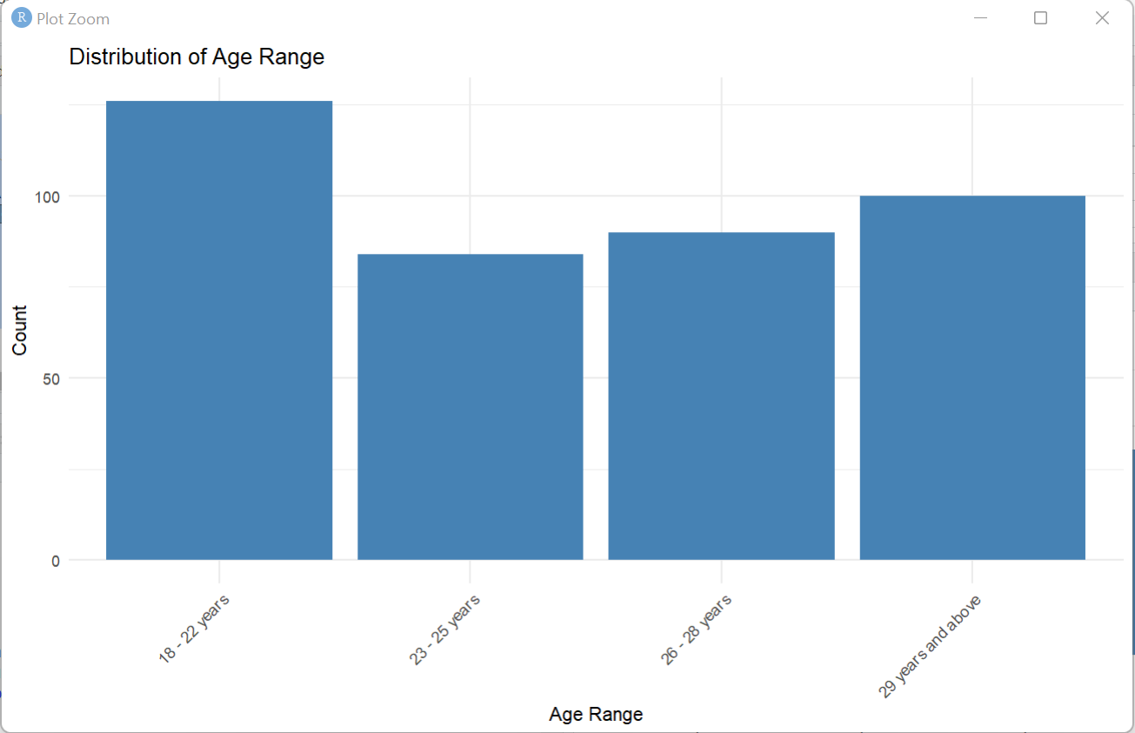
Figure 1: Bar chart for Distribution of Age Range
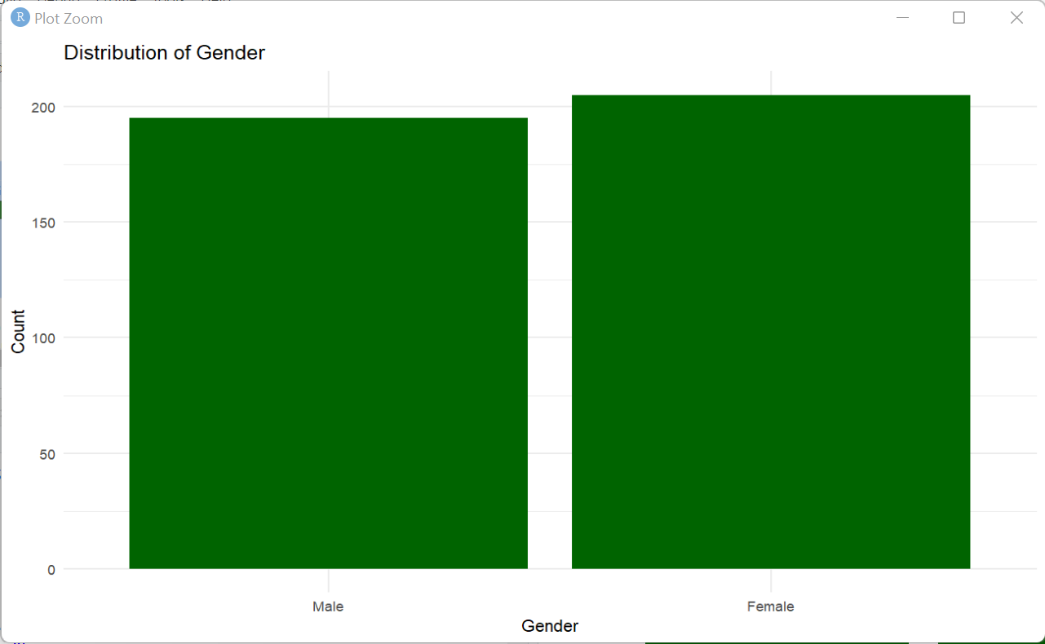
Figure 2: Bar chart for Gender
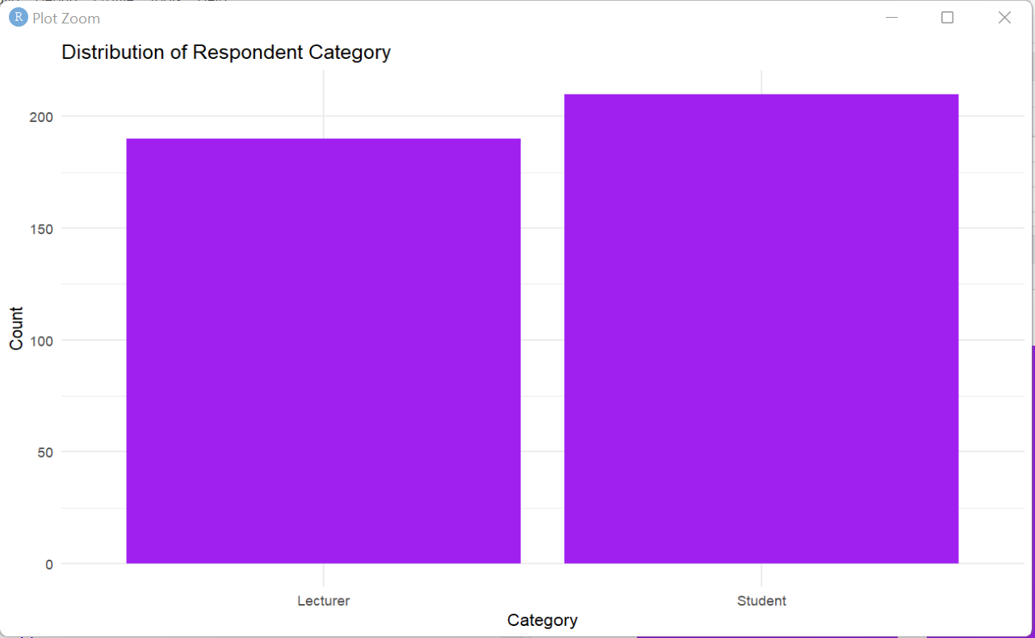
Figure 3: Bar chart for Category
Table 2: Descriptive statistics, one-sample t-tests, and Wilcoxon tests for hypothesis 1
Variable | Category | Frequency | Percentage | t-tests | Wilcoxon tests
PolicyAdequacy_TeacherEdu_ModernNeeds | 1(Strongly Agree) | 122 | 30.5 | -10.742 | 10098
 | 2(Agree) | 104 | 26
 | 3(Disagree) | 75 | 18.75
 | 4(Strongly Disagree) | 99 | 24.75
Need_InnovPolicyReform_TeacherEduQuality | 1(Strongly Agree) | 101 | 25.25 | -8.8707 | 9900
 | 2(Agree) | 97 | 24.25
 | 3(Disagree) | 102 | 25.5
 | 4(Strongly Disagree) | 100 | 25
PolicySupport_ProfDev_ContLearning | 1(Strongly Agree) | 89 | 22.25 | -7.3334 | 13275
 | 2(Agree) | 106 | 26.5
 | 3(Disagree) | 87 | 21.75
 | 4(Strongly Disagree) | 118 | 29.5
OutdatedPolicy_Challenge_TeacherEdu | 1(Strongly Agree) | 89 | 22.25 | -7.9906 | 10100
 | 2(Agree) | 98 | 24.5
 | 3(Disagree) | 112 | 28
 | 4(Strongly Disagree) | 101 | 25.25
PolicyMakers_Response_GlobalTrends | 1(Strongly Agree) | 87 | 21.75 | -7.885 | 10816
 | 2(Agree) | 103 | 25.75
 | 3(Disagree) | 106 | 26.5
 | 4(Strongly Disagree) | 104 | 26
Note: The bold values indicate ***p<0.01
The results presented in Table 2 provide robust statistical evidence against the null hypothesis (H₀₁), which posits that existing policies on teacher education in Nigeria remain fully relevant and effective, with no significant need for policy innovations. The analysis, through both one-sample t-tests and Wilcoxon signed-rank tests, shows significant deviations from this assumption across all measured variables.
For each policy-related variable, the negative and statistically significant t-values (all p < 0.01) indicate that respondents significantly disagreed with the notion that current teacher education policies are adequate and relevant. First, variable PolicyAdequacy_TeacherEdu_ModernNeeds shows a t-value of -10.742 and a Wilcoxon test value of 10098, reflecting strong disagreement with the adequacy of existing policies to meet modern educational needs (all p < 0.01). Similarly, the variable Need_InnovPolicyReform_TeacherEduQuality also shows significant disagreement (t = -8.8707, p < 0.01), emphasizing the perceived necessity for innovative policy reforms that has the capacity to improve the quality of education and its delivery system.
The consistent pattern across all variables, including Policy Support_ProfDev_ContLearning, OutdatedPolicy_Challenge_TeacherEdu, and PolicyMakers_Response_GlobalTrends demonstrates a strong and statistically significant perception among respondents that the current policy framework is inadequate (p-values < 0.01). The Wilcoxon test values, all in bold, further confirm these findings using a non-parametric approach, strengthening the reliability of the conclusions.
Overall, the results clearly reject the null hypothesis and underscore a widespread perception that there is a pressing need for innovation, reform, and modernization in Nigeria’s teacher education policy landscape.
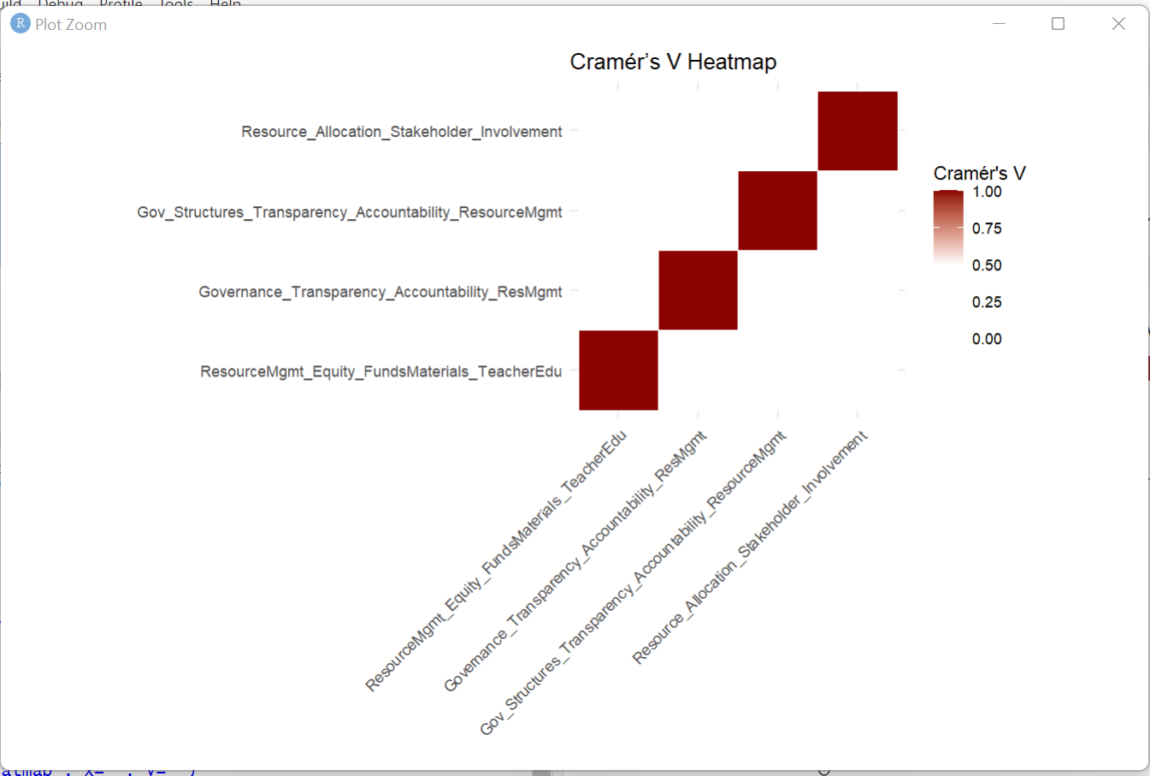
Figure 4: Crammer’s V Heatmap for variables under hypothesis 2
The Cramér’s V heatmap in Figure 4 illustrates the strength of association between several categorical variables related to governance, resource management, transparency, accountability, and stakeholder involvement, as evaluated under hypothesis 2.
The heatmap is described with the use of colour rise starting with light to dark red, where colour with darker shades indicate stronger associations (higher Cramér’s V values) between variable pairs. The diagonal elements, which are the darkest and have a value of 1.00, represent the association of each variable with itself, as expected.
It should be noted that elements that are in the heat map are considered not visible the suggest that the relationship between the different variable and relatively weak and negligible and sedated by the colors that are lighter such as (colors of white or closer related colours) and or those with lower creamer’s V value.
The implication is that apart from those with a perfect association in terms of variable with self, there is no association between them that can be considered different in terms of governance and resource management within the contextual analysis of teacher education and policy innovation in Nigeria. The role and actions of the actors within the model should be considered as major drivers of the required development leading to improved teacher education delivery.
In the final analysis the heat map presented above states that the variables in hypothesis 2 are independent of each other with low level of intersection or shared variance especially between human resource management and the enabling systems of teacher education. This finding is important for explaining the results of the hypothesis 2 as it shows that each variable covers a specific component of governance and resource management without any form of idleness in any of the variable components. Significant intersections of these variable such as development conscious teacher education systems and structure is built on a productive resource management endavour.
Table 3: Regression of Resource_Allocation_Stakeholder_Involvement on the independent variables under H₀₂
 | Value | Std. Error | t value | p value
ResourceMgmt_Equity_FundsMaterials_TeacherEdu | -0.0484 | 0.08408 | -0.5759 | 0.56467
Governance_Transparency_Accountability_ResMgmt | -0.0026 | 0.08019 | -0.0326 | 0.97396
Gov_Structures_Transparency_Accountability_ResourceMgmt | -0.0841 | 0.08019 | -1.0737 | 0.28294
SA|A | -1.3827 | 0.39502 | -3.5003 | 0.00046***
A|D | -0.318 | 0.39015 | -0.8151 | 0.41502
D|SD | 0.90571 | 0.39227 | 2.30892 | 0.02095***
The results in Table 3 test the hypothesis that the nature and process of human resource management and governance in Nigeria’s teacher education sector do not significantly impact system effectiveness and efficiency. This hypothesis is addressed by examining how various governance-related variables affect Resource Allocation and Stakeholder Involvement—two critical indicators of systemic effectiveness.
The regression coefficients for the independent variables ResourceMgmt_Equity_FundsMaterials_TeacherEdu, Governance Transparency Accountability Resource Managment, and Gov_Structures_Transparency_Accountability_ResourceMgmt are all negative and statistically insignificant (p-values > 0.05). This suggests that these specific governance and resource management factors, when taken individually, do not show a statistically significant direct effect on resource allocation and stakeholder involvement. In other words, there is no strong evidence that these institutional factors alone are driving the effectiveness of resource use and stakeholder engagement in the sector. However, the contrast effects among stakeholder perception categories (SA|A, A|D, and D|SD), where SA = Strongly Agree, A = Agree, D = Disagree, and SD = Strongly Disagree, reveal a more nuanced reality. The contrast between Strongly Agree and Agree (SA|A) is highly significant (p = 0.00046), and the contrast between Disagree and Strongly Disagree (D|SD) is also significant (p = 0.02095). These significant results indicate that the perception of differences in governance practices does have a meaningful impact on views about resource allocation and stakeholder involvement.
The negative coefficient for SA|A (-1.3827) implies that individuals who strongly agree with governance and resource issues report significantly less satisfaction or perceived effectiveness in resource allocation than those who only agree, potentially reflecting disillusionment among those with higher expectations. Conversely, the positive coefficient for D|SD (0.90571) suggests that those who strongly disagree may perceive a relatively higher concern or demand for reform than those who disagree, indicating polarization in stakeholder sentiment.
Taken together, these findings provide partial support for rejecting the null hypothesis. While direct governance and resource management indicators are not statistically significant on their own, the significant contrasts among perception categories suggest that stakeholder views about the governance process meaningfully shape the perceived effectiveness of the teacher education system. Therefore, the hypothesis that governance and HRM processes do not significantly impact system efficiency is not entirely supported. In fact, the variation in stakeholder responses implies that these governance dynamics exert an indirect but meaningful influence.
Table 4: Regression of Triple_Helix_Sustainable_Solution_Teacher_Education on the indpendent variables under H₀₃
 | Value | Std. Error | t value | p value
Collaboration_Research_Industry_Gov_Teacher_Education | -0.0086 | 0.08255 | -0.1038 | 0.91736
Joint_Efforts_Actors_Effective_Policies_Teacher_Education | -0.0009 | 0.08073 | -0.0113 | 0.99099
Coordinated_Partnerships_Resource_Allocation_Teacher_Training | -0.1372 | 0.07942 | -1.7272 | 0.08412
Industry_Involvement_Teacher_Ed_Curriculum_Relevance | 0.07483 | 0.08311 | 0.90036 | 0.36793
SA|A | -1.1583 | 0.41499 | -2.791 | 0.00525***
A|D | -0.1166 | 0.41072 | -0.284 | 0.77641
D|SD | 1.01876 | 0.41639 | 2.44664 | 0.01442***

The regression results in Table 4 revealed that most of the important component interacting within the framework of the model, such as Collab_Research_Industry_Gov_Teacher_Edu, Joint_Efforts_Actors_Effective_Policies_Teacher_Edu, and Industry_Involvement_Teacher_Ed_Curriculum_Relevance, do not significantly impact teacher education outcomes in Nigeria (p-values > 0.05). In other words, their respective p-values (0.91736, 0.99099, and 0.36793) are far above the conventional thresholds for statistical significance, indicating weak or negligible effects.
However, Coordinated_Partnerships_Resource_Allocation_Teacher_Training shows marginal significance at the 10% level (p = 0.08412), suggesting that poor coordination and funding could potentially hinder teacher training effectiveness.
More importantly, the interaction term SA|A, which likely reflects stakeholder alignment or agreement issues, is highly significant (p = 0.00525) with a strong negative effect. This suggests that misalignment or conflicts among stakeholders can significantly and adversely affect teacher education outcomes. In contrast, the variable D|SD, representing decision-making for sustainable development, has a significant positive effect (p = 0.01442), implying that well-structured and sustainable decisions among actors contribute meaningfully to resolving issues in teacher education.
In summary, although general collaboration alone does not yield statistically significant improvements, the manner and quality of collaboration, particularly in stakeholder harmony and sustainable decision-making, are crucial. This partially rejects the null hypothesis (H₀₃) and supports the view that effective collaboration among Triple Helix actors has significant implications for addressing challenges in teacher education in Nigeria.
CONCLUSION AND RECOMMENDATIONS
Consistent policy innovation plays an important function in the determination and organisation of the most needed human resource management and governance within teacher education systems. Effective policy implementation requires a multidimensional approach that considers smart design, stakeholder engagement, context, and coherent strategies that will address the evolving needs of educational development. As the education landscape continues to evolve, ongoing research and evaluation are essential for identifying and implementing policies that promote teacher quality, satisfaction with the working environment, equity, and student success. The integration of new realities within the teacher-education environment and enhanced teaching functions, presents both challenges and opportunities for innovation in teacher education. By embracing evidence-based practices and fostering collaboration among stakeholders, teacher education systems can effectively navigate these changes and ensure a high-quality education for all students.

REFERENCES
Adedeji, S. O., & Olaniyan, O. (2011). Improving the conditions of teachers and teaching in rural schools across African countries (pp. 1-89). Addis Ababa: UNESCO-IICBA.
Ambali, A. (2015). Public Policy, Universiti Teknologi Mara, 4000 Shah Alam, Selangor Darul Ehsan.
Ambussaidi, I. & Yang, Y. (2019). The impact of mathematics teacher quality on student achievement in Oman and Taiwan. None. https://doi.org/10.31763/ijele.v1i2.39
Antaya, J. (2005). Employee retention: 15 cost-effective steps to keep your best talent from leaving. Detroiter, 96(5), 42
Balzer, H. & Askonas, J. (2016). The triple helix after communism: Russia and China compared. Springer Science+Business Media. https://doi.org/10.1186/s40604-015-0031-4
Beach, D. & Bagley, C. (2013). Changing professional discourses in teacher education policy back towards a training paradigm: a comparative study. Taylor & Francis. https://doi.org/10.1080/02619768.2013.815162
Butcher, J. & Kritsonis, W. A. (2007). Human Resource Management: Managerial Efficacy in Recruiting and Retaining Teachers – National Implications, The Lamar University Electronic Journal of Student Research Summer, https://files.eric.ed.gov/fulltext/ED497357.pdf
Cai, Y. & Amaral, M. (2021). The triple helix model and the future of innovation: a reflection on the triple helix research agenda. Triple Helix. https://doi.org/10.1163/21971927-12340004
Cai, Y. & Etzkowitz, H. (2020). Theorizing the triple helix model: past, present, and future. None. https://doi.org/10.1163/21971927-bja10003
Cai, Y. (2014). Implementing the triple helix model in a non-western context: an institutional logics perspective. Springer Science+Business Media. https://doi.org/10.1186/s40604-014-0001-2
Cai, Y. (2022). Neo-triple helix model of innovation ecosystems: integrating triple, quadruple and quintuple helix models. Springer Science+Business Media. https://doi.org/10.1163/21971927-bja10029
Carayannis, E. G. & Campbell, D. F. J. (2014). Developed democracies versus emerging autocracies: arts, democracy, and innovation in quadruple helix innovation systems. Springer Nature. https://doi.org/10.1186/s13731-014-0012-2
Chan, C. K. Y. & Colloton, T. (2024). Generative ai in higher education. None. https://doi.org/10.4324/9781003459026
Coenen, L. (2007). The role of universities in the regional innovation systems of the north east of England and Scania, Sweden: providing missing links?. None. https://doi.org/10.1068/c0579
Diepenmaat, H., Kemp, R., & Velter, M. (2020). Why sustainable development requires societal innovation and cannot be achieved without this. Multidisciplinary Digital Publishing Institute. https://doi.org/10.3390/su12031270
Eduwen, F. O. (1992). In-service education as a tool for enhancing professionalization of teaching in Nigeria. In Afe, J. O. et al (eds.) In-service education of teachers: The Nigerian experience. Asaba, JID Printers (Nig) Ltd.
Esheya, G., & Ani, P. I. (2024). Poor Conditions of Service of Teachers in Nigeria and Its Impact on Teacher Education: A Case Study of Ebonyi State. Ebonyi State College of Education, Ikwo Journal of Educational Research, 10(2), 1-16.
Etzkowitz, H. (2015). Making a humanities town: knowledge-infused clusters, civic entrepreneurship and civil society in local innovation systems. None. https://doi.org/10.1186/S40604-014-0012-Z
Ezegwu, C., Okoye, D., & Wantchekon, L. (2023). Impacts of Political Breaks on Education Policies, Access and Quality in Nigeria (1970–2003). Research on improving systems of Education.
Godin, B. (2010). The knowledge economy: fritz machlups construction of a synthetic concept. Edward Elgar Publishing. https://doi.org/10.4337/9781849807180.00019
Griffin, R.W. (1997). Management. New Delhi AITBS Publishers
Hartong, S. (2016). Between assessments, digital technologies and big data: the growing influence of hidden data mediators in education. SAGE Publishing. https://doi.org/10.1177/1474904116648966
Hladchenko, M. & Pinheiro, R. (2018). Implementing the triple helix model: means-ends decoupling at the state level?. Springer Science+Business Media. https://doi.org/10.1007/s11024-018-9355-3
Ko, J., Cheng, Y., & Lee, T. (2016). The development of school autonomy and accountability in Hong Kong: multiple changes in governance, work, curriculum, and learning. None. https://doi.org/10.1108/IJEM-10-2015-0145
Kolleck, N., Jrgens, H., & Well, M. (2017). Levels of governance in policy innovation cycles in community education: the cases of education for sustainable development and climate change education. None. https://doi.org/10.3390/SU9111966
Lengyel, B. & Leydesdorff, L. (2010). Regional innovation systems in Hungary: the failing synergy at the national level. Routledge. https://doi.org/10.1080/00343401003614274
Leydesdorff, L. & Deakin, M. (2011). The triple-helix model of smart cities: a neo-evolutionary perspective. None. https://doi.org/10.1080/10630732.2011.601111
Leydesdorff, L. & Porto-Gmez, I. (2017). Measuring the expected synergy in Spanish regional and national systems of innovation. None. https://doi.org/10.2139/ssrn.2952675
Leydesdorff, L., & Zawdie, G. (2010). The triple helix perspective of innovation systems. Technology analysis & strategic management, 22(7), 789-804.
Liu, A. M., Liang, O. X., Tuuli, M. M., & Chan, I. Y. S. (2017). Role of government funding in fostering collaboration between knowledge-based organizations: evidence from the solar PV industry in China. SAGE Publishing. https://doi.org/10.1177/0144598717742968
Mata, Z. S. K. (2024). Innovation and Integration for Future Development of Teacher Education in Secondary Schools in Nigeria. Kashere Journal of Education, 7(2), 298-310.
Miller, M., & Dillman, D. A. (2011). Improving response to web and mixed-mode surveys. Public Opinion Quarterly, 75, 249-269.
Mullinix, B.B. (2002). Selecting and retaining teacher mentors. Washington, DC. (Eric Document Reproduction Service No. ED477728).
Nordberg, K., Mariussen, G., & Virkkala, S. (2020). Community-driven social innovation and quadruple helix coordination in rural development. case study on leader group aktion sterbotten. Elsevier BV. https://doi.org/10.1016/j.jrurstud.2020.08.001
Nusche, D., Radinger, T., Busemeyer, M. R., & Theisens, H. (2016). OECD reviews of school resources: Austria 2016. Organization for Economic Cooperation and Development. https://doi.org/10.1787/9789264256729-en
Nwaka, N. G. & Ofojebe, W. N (2010). Strategies for coping with Shortage of Resources in Primary School Administration in Anambra State. Journal of Education Leadership, 1 (1) 29-36
Nwokeocha, S. (2013). Issues of Education in Nigeria: A discourse. In Proceedings of African forum of teaching Regulatory Authorities (AFTRA).
Nwuke, T. J., & Yellowe, A. N. (2025). Managing the education sector in Nigeria and emerging technologies in the 21th century learning environment. World Journal of Innovation and Modern Technology, 9(10, Pg. 1-14.
Okemakinde, T., Adewuji, J. O. & Alabi, C. O. (2013). The place of teacher in national development in Nigeria. European Journal of Humanities and Social Science. 19 (1).
Omebe, C. A. (2014). Human Resource Management in Education: Issues and Challenges, British Journal of Education Vol.2, No.7, pp. 26-31,
Omojunnwa, J. (2007). Teacher Education in the 21st Century: making a different through a commitment to effective teacher preparation programme. A lead paper presented at the Festchrift in honour of Professor Mbong Akpan Udofot at the University of Uyo. July 18-21 2007.
Onah, F.O. (2008). Human Resource Management. John Jacob’s Classic Publisher Ltd Plot 7 Fmr ESUT Road, Nkpokiti Junction Enugu
Piqu, J. M., BerbegalMirabent, J., & Etzkowitz, H. (2020). The role of universities in shaping the evolution of silicon valleys ecosystem of innovation. Springer Science+Business Media. https://doi.org/10.1163/21971927-bja10009
Razak, A. A. & Saad, M. (2007). The role of universities in the evolution of the triple helix culture of innovation network: the case of malaysia. Intellect. https://doi.org/10.1386/ijtm.6.3.211_1
Razak, A. A. & White, G. (2014). The triple helix model for innovation: a holistic exploration of barriers and enablers. Inderscience Publishers. https://doi.org/10.1504/ijbpscm.2015.071600
Rumki, B. (2014), Public Administration Concept and Theories. New Delhi: Sterling Publishers Private Limited.
Salahu, M. O. (2020). Assessment of Educational Policy in Nigeria: A Study of State and Non-state Provision of Basic Education in Kwara State (2009-2019) (Doctoral dissertation, Kwara State University (Nigeria)).
Santiago, P., Levitas, A., Rad, P., & Shewbridge, C. (2016). OECD reviews of school resources: Estonia 2016. Organization for Economic Cooperation and Development. https://doi.org/10.1787/9789264251731-en
Santiago, P., Valos, B., Burns, T., Morduchowicz, A., & Radinger, T. (2016). OECD reviews of school resources: Uruguay 2016. Organization for Economic Cooperation and Development. https://doi.org/10.1787/9789264265530-en
Schleicher, A. (2011). Building a high-quality teaching profession. Organization for Economic Cooperation and Development. https://doi.org/10.1787/9789264113046-en
Sellar, S. & Lingard, B. (2013). The OECD and global governance in education. None. https://doi.org/10.1080/02680939.2013.779791
Taylor, N. (2021). The dream of Sisyphus: mathematics education in south Africa. None. https://doi.org/10.4102/SAJCE.V11I1.911
Todeva, E. (2013). Governance of innovation and intermediation in triple helix interactions. SAGE Publishing. https://doi.org/10.5367/ihe.2013.0
Verlinde, S. & Macharis, C. (2015). Innovation in urban freight transport: the triple helix model. Elsevier BV. https://doi.org/10.1016/j.trpro.2016.05.196
Viennet, R., Pont, B., Bell, A. L., Caddy, J., Cairney, P., ern, L., Datnow, A., Donaldson, G., Hargreaves, A., Mackay, A., Schwartz, R., Shewbridge, C., Figueroa, D., Zanten, A. V., Boekens, L., Goudard, P., Kools, M., MacIntyre, A., Rodriguez, T., & Rilling, M. (2017). Education policy implementation. None. https://doi.org/10.1787/fc467a64-en
Williamson, B. (2015). Governing methods: policy innovation labs, design and data science in the digital governance of education. Taylor & Francis. https://doi.org/10.1080/00220620.2015.1038693
Xue, E., Li, J., Li, T., & Shang, W. (2020). Chinas education response to covid-19: a perspective of policy analysis. Educational Philosophy and Theory. https://doi.org/10.1080/00131857.2020.179365

