**The Sustainable Development of Cultural dissemination within Non-government Organizations in the Context of the New Media Era**

**ABSTRACT**

This study explores how non-governmental organizations (NGOs) balance tradition and innovation to preserve intangible cultural heritage (ICH) in a rapidly digitalizing world, where cultural practices risk being forgotten, by using Anshun Mask & Nuo sculpture culture company’s ICH dissemination activities on Douyin and Xiaohongshu platform, both of them are Chinese popular new media platform, as a case. However, this study begins with the introduction of the history and recent challenge of local intangible culture heritage, Nuo culture, and the above non-profit organization. Thus, by analyzing the previous literature and conducting field-work approach, interviewees' insights of new media platforms and awareness of ICH were deeply understood. Nonetheless, a qualitative paradigm through the interview approach was employed in this study for collecting participant’s standpoints on these phenomena, including in-depth interviews with the general manager of this NGO, performers, artisans, audiences and learners, guided by case study methodology and thematic analysis. Subsequently, in order to explore the visual data obtained in innovation process, some of interview manuscripts will be presented in this paper and the methodology through thematic analysis will be applied, which will identify and organize the theme discussing in detail. Ultimately, the results indicate that the dissemination and promotion of ICH via the use of a combination of context and images on the Xiaohongshu platform, it is possible to better capture the awareness of younger generation, enhance public recognition and understanding of traditional culture, and provide new opportunities and challenges for the preservation and inheritance of ICH and the advocacy of NGOs at the same time.

Keywords: Non-Governmental Organization; Intangible cultural heritage; Nuo culture; Digital platform; Cultural dissemination

**INTRODUCTION**

With the accelerated progress of globalization, intangible cultural heritage (ICH) plays a crucial role in the development of cultural identity and diversity. The preservation of the ICH has become a big challenge for any country in the world that has the will to safeguard this wealth and to win the battle of cultural safeguarding (Chan, 2012 as cited in Hammou, Aboudou & Makloul 2020). Meanwhile, China has the most items in the Representative List of the Intangible Cultural Heritage of the Humanity, making it the first country in the world (Wang, 2024). Thousands of years of civilization, a vast area, and the joint efforts of people of all ethnic groups have created these cultural heritages, which represent the important cultural wealth of human civilization (Joy & Charlotte, 2017). However, in an rapid digitalisation, tradition and culture are at risk of being overshadowed or forgotten. Besides, both intangible and tangible cultural heritage is a response to the characteristics of a society and deserves to be protected and passed on to future generations, but there is still a lack of knowledge and skills related to it in the methodology of digital preservation of intangible cultural heritage (Wang, 2024). Also, the appearance of new media has provided both challenges and opportunities for the digital preservation and promotion of ICH. Additionally, while new media provides broader platforms for dissemination, it can also lead to the dilution or misinterpretation of cultural content, potentially affecting its original significance (Hammou & Aboudou, 2020).

Anshun Nuo Carving Art and Nuo Drama is a significant representative of traditional art facing the pressures of contemporary change. Nuo culture, as a unique and long-time tradition culture in Southwest China, has existed for nearly several hundred years, can be traced back to Ming Dynasty (1368-1644). It not only reflects rich folk traditions but also embodies deep religious beliefs and local characteristics (Zhang, 2021). In this region, where multiple ethnic groups coexist, Nuo culture is transmitted through forms such as dance, music, and drama, preserving unique local stories and beliefs, and becoming an important cultural identifier for the community (Li & Chen, 2022). As the most mysterious in Southwest China, it is perhaps one of the most difficult intangible cultural heritages to be disseminated due to its unique dialect and father-son inheritance.

Based on the above-mentioned background and information, the general idea of this paper is to understand the role of social media and non-profit organizations in the promotion of the intangible cultural heritage of Nuo culture. Therefore, this study takes the Anshun Mask & Nuo Carving Art Culture Company’s Non-legacy dissemination activities on Douyin and Xiaohongshu platform as an example, proposes optimum recommendations to provide reference for the propaganda strategy of Non-legacy dissemination.

**STATEMENT OF THE PROBLEM**

In the context of the rapid evolution of New Media Platforms, Non-Profit Organizations are faced with the challenges in transforming their dissemination strategies, particularly in the terms of intangible cultural heritage. Anshun Mask & Nuo Carving Art Culture Company, an local Non-Profit Organization, has encountered the limitations of traditional communication methods, while also facing changes in audience expectations and methods of participating in cultural activities. However, there is relatively few studies in the current literature on how NPOs can effectively disseminate ICH in the new media environment. Therefore, this study aims to explore and recommend the communication strategies of Anshun Mask & Nuo Carving Art Culture Company in the new media era, with the goal of identifying effective methods and practices that can provide possible references for other non-profit organizations.

**RESEARCH OBJECTIVES**

This research has identified three(3) research objectives stated as follows:

1. To explore the interactions and evolving relationships among NPOs, ICH and New Media in 21st century.
2. To examine current views of ICH participants on the use of New Media in their practice.
3. To investigate the development and strategies of cultural dissemination method used by NPOs in the context of New Media.

**LITERATURE REVIEW**

**THE INTERACTION AND EVOLVING RELATIONSHIP AMONG NPOs, ICH AND NEW MEDIA**

As the world progressed into the ages, newspapers (later mass media) and graphical representations, possibly accompanied by audio, became the norm(Goud & Lombardo, 2020), which means the mass media, including new media, has played a crucial role in the propaganda process under this digitalized world. Thus, it is essential to properly clarify the relationship between the three, non-profit organizations (NPOs), intangible cultural heritage (ICH), and new media. The combination and development of digital technologies has provided the ability to record, share cultural practices in more innovative methods. For instance, online narration context or live stream, documentary films, and virtual workshops and conference can bring traditional and indigenous culture to wider audiences in this world, currently overcoming geographical barriers.

In recent years, the notion of intangible heritage has grown considerably with a proliferation of its uses ranging from economy to computing (Bortolotto,2008). Hence, the more and more awareness from scholarly and practice were pointed, currently. If the «national and material heritage» is identified with restricted territory, the intangible heritage of the communities goes beyond the strictly territorial boundaries to open up to the culture in movement (Bortolotto, 2008). While, according to analyse, the intangible cultural heritage is associated with a descriptive definition, referring to the concept of «intangible or immaterial cultural heritage» (Hammou et al.,2020). The latter is still limited to a more or less «expert» use and has got a normative value since the adoption of the Convention on Intangible Cultural Heritage at UNESCO (Hammou et al., 2020). Accordingly, even though the definition of intangible cultural heritage has become more standardized and clear in this area recently, there are still ambiguous areas, such as how to identify whether a culture or tradition belongs to the intangible or tangible cultural heritage.

Social media is a collection of digital applications, media, and platforms grouped around common goal: facilitating collaborations, interactions, and content sharing (Kim and Ko, 2012, Richter and Koch, 2007). The dominance of Web 2.0 technologies and social media has made the use of this communication channel very widespread (Hammou et al.,2020) Indeed, even businesses and government institutions make use of it and use it as a means of communication (Kim and Ko,2012) and a marketing tool to promote assets directly(Timothy,2018). By employing social media, NPOs can directly establish virtual and in-person communities based on mutual cultural preferences, cultivating public engagement and encouraging participation from diverse populations, in particular younger generations, Generation Z, who are more skillful and comfortable at browsing virtual spaces.Consequently, based on the current literature and article, scholars have already indicated that the social media plays a pivotal role in the modern campaigns to promote intangible cultural heritage. Nevertheless, the relationship between NPOs and social media is becomingly noticeable and eye-catching. Interestingly, social media platforms, websites and new media allow NPOs to share various stories from local culture on Internet, record cultural activities and improve public engagement.

Overall, through the use of new media, non-profit organizations can increase the visibility of these cultural activity, bringing them to reach a wider Generation Z audience.However, the current literature does not fully verify the interactive and evolving relationship between the three, merely pointing out that the active use of new media allows for more public exposure of cultural activities.

**CURRENT VIEWS OF ICH PARTICIPANTS ON THE USE OF NEW MEDIA IN THEIR PRACTICE**

Many ICH participants recognize the advantages of new media platforms in increasing visibility and participation. Social media, websites, and streaming platforms enable practitioners to reach wider audiences, fostering greater awareness of their cultural practices (Gonzalez, 2021). For instance, practitioners report that platforms like Instagram and TikTok allow them to showcase traditional arts and crafts through visually engaging content, effectively attracting younger audiences who might not engage with traditional forms of cultural dissemination (Santos, 2020).In addition, new media facilitates community development and collaboration among ICH practitioners. Online platforms allow for networking, sharing of resources, and exchange of knowledge and technology, thus strengthening community ties and supporting the continuation of culture (Zhou, 2022).

Although they recognized the advantages of new media, they are also concerned about the negatively influence about their practice and performance. One of the most important issues is the threat of cultural commodification, where traditional behavior and culture may be oversimplified or misunderstood for audience on social media. This commodification may lead to a reduction in cultural meanings, since practitioners fear that the depth and context of their heritage may be lost in pursuit of the fast-food culture.In addition, the fast pace that is one of the characteristics of new media demands that users engage in frequent online activities, which can be confusing for elder practitioners who lack the time to actively stay online (Waters et al., 2020). Besides, the pressure to produce high-quality content within a regular schedule in new media platform would undermine and destroy the reality of culture, leading to a collision between authentic form and digital performance.

In sum, based on the review of present articles, which indicated that ICH practitioners have inconsistent views of new media. Though some individuals welcome the opportunities for publicity and participation provided by new media platform, others are still doubtful or resistant. In particular, older practitioners prefer choosing traditional methods of transmission. This generation gap highlights the need for individualized approaches that respect the varied perspectives of ICH practitioners.

**NON-LEGACY DISSEMINATION OF NPOs IN NEW MEDIA AGE**

Prior studies(e.g., Kent,Taylor,&White,2003; Saxton, Guo, & Brown,2007) have shown that nonprofit organizations have not been able to use websites as strategic, interactive stakeholder engagement tools (Lovejoy&Saxton,2012). Meanwhile, the newer mobile social media applications provide a more powerful energy to communicate. To allow real-time interaction and share content immediately, which are crucial for NPOs in order to extent their reputation.The analysis reveals there are three key functions of microblogging updates---information, community and action (Lovejoy&Saxton,2012). As a boundary point between new media and Web 2.0, this above cite also provided a clear insight that the informational and community-building use of new media is extensive. Based on the above-mentioned context , these digitalization environments actively encourage interactive communication, where audiences not only browse content but also offer the different information as comment or secondary sender at the same time. Trough strategically targeted content, firms mobilize stakeholders, build meaningful relationships, and ultimately foster increased accountability and public trust (Saxton&Guo, 2011). Therefore, online nonprofit/stakeholder interactions have effectively become more and more ubiquitous, multifaceted, and critical to organizational performance (Lovejoy&Saxton,2012).

According to collection of present paper, tourism become the popular and eye-catching topic on new media. As Qiu and Zhang’s survey in 2021, from 2011 to 2020, there are 9074 blogs posted on Sina Weibo, one of the most famous social media platforms in China. Hence, nowadays, professionals are integrating intangible cultural heritage with tourism on the slightly traditional media platform, due to the economic income. While, by contrast, in the new media platform Douyin, it’s clear see that most short videos are containing more function of dissemination and conservation. Besides, although ICH tourism development is outstanding in China, the language structure and restricted use of social media render ICH difficult for non-Chinese speakers to understand (Qiu & Zhang, 2021). Nevertheless, how to overcome language barrier is also become a focused topics in the future.

Despite the advantages of new media, NGOs face several challenges in adopting non-legacy dissemination strategies.Limited resources, lack of technological expertise, and difficulties in measuring impact can hinder effective implementation (Waters et al., 2009). Definitely, Most organizations operate with constrained budgets, restricting their ability to invest in the promotion of their new media accounts or hire a professional media team. Moreover, the rapid evolution of new media necessitates agility and adaptability, which may be difficult for NGOs with rigid structures or traditional practices (Waters et al., 2020).In terms of Non-legacy dissemination, it is about innovative communication approaches that emphasize audience interaction and involvement above traditional radio and TV methods. Studies have indicated that NGOs that employ narrative, user-center content. This transformation to an involvement and interactive activity is a new change in the dissemination of ICH in this decade.

As Yang & Zhang’s recent survey on the dissemination of Dunhuang’s ICH results show the growing demand for entertaining content among users, especially on platforms like Douyin (TikTok). After a literature survey, interviewees would like to watch short videos as a routine on Douyin. The survey results form Yang and Zhou indicate that 79% of the respondents prefer watching funny videos, while 19% samples like a special interest in videos related to intangible cultural heritage.

Fig 1. Preferences of users for different types of Douyin videos

Source from Yang & Zhang (2023)

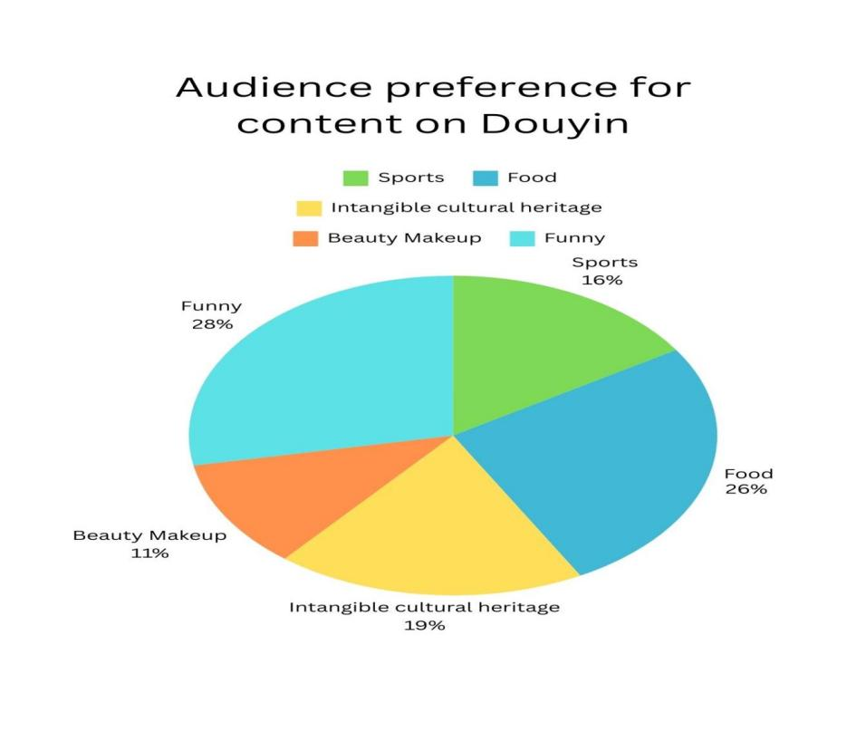

Users not only seek entertainment but also express a keen interest in preserving and inheriting traditional culture (Santos, 2020). This dual expectation creates challenges and opportunities for NGOs. By creatively integrating elements of traditional culture into engaging formats, non-profits organizations can capture audience attention and encourage participation in cultural preservation activities. For instance, successful campaigns that incorporate storytelling and interactive content not only inform but also resonate emotionally with audiences, enhancing their connection to the cultural narratives being presented (Zhou, 2022). This alignment with user interests can significantly enhance community involvement and support for ICH initiatives.

**METHODOLOGY**

This research employed a qualitative interview approach for gathering the data based on the participants’ perspectives on the phenomenon investigated in the study. The investigative study was employed because it was deemed the most appropriate for soliciting subjective views on a particular issue or event (Neuman, 2014 as cited in Tracy, 2020).The semi-structured interview was employed because it offered the opportunity of exploring issues that were not previously covered in the initial guided research questions (Flick, 2018 as cited in Smith & Osborn, 2020).

For the design of the study participants, 13 participants were selected were sampled through the fieldwork process using the purposive non-probability sampling method. The participants were interviewed until the saturation of the issue being surveyed was reached. Furthermore, the number of interviewees met the selection criteria and was not below the minimum of seven as required by Padgett (2016). However, the 13 participants were selected from Liu Guan town, Anshun city, Guizhou Province, China. They are 2 mask crafts, 3 theatre actors, 1 NGO manager and 1 employee, 4 audience and 2 students who are interested in ICH as shown in figure 1.

Finally, Thematic Analysis (TA) was adopted in analyzing the interview data. The purpose of employing thematic analysis is to identify and organize themes, which facilitates the development of more precise explanations for the themes that arise (Braun & Clarke, 2021 as cited in Tuckett et al., 2020). The six thematic stages of analysis as outlined by Gerald Holton (1975) were employed in this study. These included familiarized with data, assigning initial codes to the data, searching for themes in the codes, reviewing the themes, defining and naming the themes,and the final stage of report writing. To analyse the interview data from the study, the interview data from these six periods of the study used accordingly.

Table 1. List of Participants in the Research Interview

Number of Position in the Whether working

Participants dissemination of ICH for a NGO

2 Participants 1 Manager and 1 Staff from local Yes, both of

Non-Governmental Organization them

3 Participants 2 drama performers from Yes, they’re

local community partnership

2 Participants 2 Mask Craftsman from Yes, both of

Non-Governmental Organization them

4 Participants 3 Audiences in the 16-60 age ranges No, they are

from the local community villagers

2 Participants 1 Master’s student from Spain No, they are

who is interested in Nuo culture students

1 Bachelor’s student from China

who did fieldwork in that village

Total 13

Table 2. Interview Schedule and Affiliation Structures 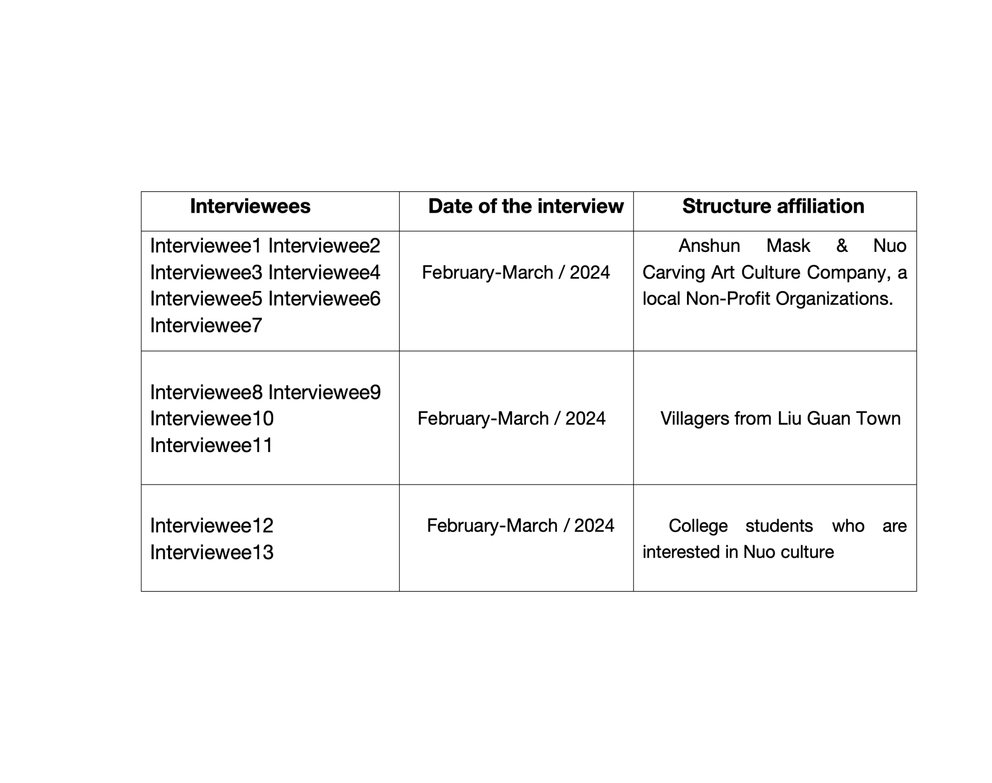

Anshun Mask & Nuo Carving Art Culture Company, a local NGO

**RESULTS AND DISCUSSION**

**THE RELATIONSHIP BETWEEN NGOs, ICH AND NEW MEDIA IN 21st CENTURY**

The first objective of the study investigated the relationship between NPOs, ICH and new media. This section surfaced with two themes. The two themes were: (1) The relationship between No-profit Organization and Intangible heritage. (2) What role did the new media play. For this specific objective, the relationship between NPOs and ICH is well-defined: (1) Non-profit organizations, as a carrier for the dissemination of intangible cultural heritage, should be oriented towards the dissemination of intangible cultural heritage as a goal in the process of their management. in order to spread intangible cultural heritage to the farther world. (2) In contrast, ICH is the central component of a non-profit organization, on which all the organization's planning, development, and corporate culture are constructed.

However, to define the role of new media is the key focus of this article. Based on in-depth interviews, almost all interviewees agreed that new media played a moderating role in enhancing the visibility of intangible cultural heritage. They noted that platforms like social media and online forums allowed No-profit organizations to share stories, show cultural activities and contact a wider audience, thus fostering greater participation. Furthermore,they emphasized that the openness of digital elements helps to bridge the generation gap, making it easier for younger audiences to connect with and appreciate their cultural heritage.

Thus, some extracts given by the interviewees in response to the relationships among those were quoted below:

*“Yes, there is a very close relationship between Qin’s company and Nuo culture. Because every day I can see him in the office to edit video, to participate in the live stream, from morning to night. Most time, I heard he said things related to Nuo culture.”---*Mr.Gong, Nuo mask making craftsman, employee from Qin’s NPO.

The above extract implied that the constant involvement in activities such as video clips and live streaming shows that the company is using new media to raise awareness and expand its audience.

Another participant responded to this:

*“Sure, I often visit Mr.Qin’s charity museum, which stores a full range of Nuo sculpture and masks, as well as historical artefact, sometimes, he invites theatre groups to perform at his organization, all of these are no charge.--*Mr.Liu, Nuo culture enthusiasts, audience.

From the above excerpts, interviewee noted that organization often invite theatre troupes to perform for free at local museum, demonstrating the strong community orientation and social responsibility of non-profit organizations. This practice not only enhances the cultural experience of attendees, but also promotes enjoyment and understanding of Nuo culture.The enthusiasm of this interviewee reflects the positive impact of this type of approach in promoting community cultural awareness and participation.

Another interviewee added this:

*“Right, I think Mr.Qin’s organization is like a platform for us, giving us traditional drama performers a chance to show off our skills. During the Covid-19, he opened a Douyin account, where he filmed our performances and uploaded them. That’s attracted the attention of netizen outside our province.--*Mr.Lei, Anshun Nuo drama third-generation inheritor.

The above excerpts illustrate the views of the interviewee regarding the leadership of the organization's advocacy as an important platform for traditional theatre performers.The interviewees acknowledged that the organization provides them with valuable opportunities to show their skills.

As a result, non-profit organizations are primarily important carriers for the transmission of ICH and they are managed in a way that aims to preserve and promote culture. Conversely, ICH is central to the identity and functioning of these organizations, influencing their planning, development and corporate culture. However, the role of new media became a focus of the study. Based on in-depth interviews, participants overwhelmingly agreed that new media significantly enhances the visibility of ICH. Overall, these insights highlight the important interplay between NPOs, ICH and new media, illustrating how digital platforms can contribute to cultural preservation, promote participation of communities and enhance appreciation of ICH.

**CURRENT PERSPECTIVES OF ICH PRACTITIONERS ON DIFFERENT TYPES OF NEW MEDIA IN PRACTICE**

The second objective of the study explored the current perspectives of ICH practitioners on different types of new media in practice.

For this particular objective, the vast majority of the interviewees believed that new media can help ICH to get out of dilemma. Additionally, they frequently post videos on Douyin (Tiktok). However, few of the interviewees disclosed that they prefer using Xiaohongshu (similar to Insgram) due to graphic articles could be more attracting to young people.Thus, some excerpts given by the interviewees in response to the use of new media in practice were quoted below:

*“Well, I often record the live performance activities of our local theatre and post them on Douyin platform because it brings more people’s attention and comments to our local tradition and gives my team more motivation to perform.”--* Mr.Sun, Head of the theatre team in Luguan Town.

Based on this participant, it can be seen that those involved in ICH at the grassroots have made a conscious effort to use new media platforms as the main route for dissemination. In addition, as he mentioned, most of the teammates focused on Douyin, China’s largest new media platform. Meanwhile, some comments from netizen positively lead to their motivation.

While another interviewee said this:

*“So, I prefer using Xiaohongshu because it resonates more with young people. This platform is visually appealing and is attracting an increasing number of young students to my organization.” --* Mr.Qin Fazhong, General Manager of Anshun Mask and Nuo sculpture culture company, a local No-profit Organization.

The above participant selected the more youthful new media platform Xiaohongshu to promote Nuo culture, an ICH in need of urgent preservation and promotion.

The subsequent interviewee also stated this:

*“I was through his Xiaohongshu account to learn about Nuo culture, as well as the Mr.Qin’s non-profit organization, which means that Mr.Qin these years in the new media platform to do the effort is recognized. Otherwise, I would not have come to Liu Guan Town to do field research, the production of the Mr.Qin as the subject of the documentary film, how to protect the Nuo culture as well as these intangible cultural heritage of Nuo opera.”* Miss.Li, student from Yibin College.

According to the above interviewees, Mr.Qin's efforts have been highly commended, especially in the current wave of new media, as he has not only been active in spearheading the establishment of non-profit organizations, but also, in spreading local traditional culture on the Internet.

As a result, a number of the interviewees demonstrated an emphasis on two types of new media, Douyin and Xiaohongshu. They unconsciously combining intangible cultural heritage and new media, in which Mr.Qin’s Non-profit organization played a mediating role, pushing Nuo culture, which was originally hidden in the mountainous regions of Southwest China, to the Chinese Internet, and actively promoting the local traditional culture via the power of new media platform. Moreover, it is also remarkable that Xiaohongshu, a popular new online platform in recent years,is gradually trending to overtake Douyin for its popularity in China.

**SUSTAINABLE DEVELOPMENT OF NON-LEGACY DISSEMINATION OF NGOs ON NEW MEDIA AGE**

The third objective of the study explored the sustainable development of Non-legacy dissemination of NGOs on new media.

For the particular objective, the most participants considered that NGOs have to find a path to advertise themselves. This section surfaced with two themes. The two themes were: (1)This part of the findings were mainly through the manuscript of an interview with Mr.Qin, after five years from the founding of his organization to the present. (2) The interview with Miss.Li will be a supplementary part.

Thus, some excerpts given by the interviewees in response to the external dissemination of NGOs on new media age were quoted below:

*“Indeed, I think he's done a great job in externally promoting his organization. Firstly, he actively participates in academic conferences and forums, and reaches school-enterprise co-operation with universities as the head of the organization and the protector of non-heritage, and regularly has Guizhou colleges and universities, such as Anshun College and Guizhou Minzu University , to visit the organization and conduct research.”*

This interview highlighted the effective promotional strategies employed by the organization’s leader. The leader actively participated in academic conferences and forums to increase awareness and promote collaboration between universities and corporation. Having to admit, it’s a great way of external publicity way.

The subsequent interviewee also stated this:

*“Definitely, as a postgraduate student of anthropology studying in Spain, I was unintentionally in the Douyin platform, saw his interview in the Pengpai News, China’s top self-media account. So I learned about his organization and Nuo culture, and then found his Xiaohongshu account. During the 2023 Spring Festival, I visited his No-profit organization, followed by him to participate in the study of Nuo culture.”--Miss He, [student from Universidad Complutense de Madrid.](https://www.ucm.es/)*

Based on the view of the above participant, that interviewee is often interviewed by the domestic media, which undoubtedly also increases the visibility of the organization and the traditional culture the interviewee is promoting.

In summary, effective external promotion strategies for NGOs includes several key approaches: (1) Collaborating with higher education institutions. (2)Participation in local academic conferences and forums.(3)Utilizing online live streaming. (4)Actively accepting media interviews.

**CONCLUSION AND RECOMMENDATION**

This article has discussed the current situation, advantages, challenges, and strategies of Non-profit organizations in disseminating intangible cultural heritage (ICH) in the context of the new media era. Taking the example of the Anshun Mask and Nuo sculpture culture company’s Non-legacy dissemination activities on Douyin and Xiaohongshu platform. That organization effectively spreads ICH by displaying the production process, cultural significance, and stories behind Nuo sculpture and drama in a humorous, vivid and interesting manner, gaining wider attention and positive feedback.However, it is still needed for sustainable development of cultural dissemination. Meanwhile, based on practical situations and interview manuscripts, this article presents a series of practical solutions and recommendations, aiming to provide reference and guidance for the theory and practice of intangible cultural heritage. These solutions and recommendations are derived from the research and analysis of the above NGOs. They have practical value, which can provide inspiration and enlightenment for the intangible cultural heritage in other related fields, and promote the inheritance and development of traditional culture. The research findings of this article will provide valuable references for the academic and practical communities and contribute to the protection and inheritance of intangible cultural heritage.

In terms of recommendation, based on the manuscript from interviewees, we can clear see that the combination and integration between literature and visual element is extremely crucial in disseminate intangible cultural heritage and Non-profit Organizations. However, due to the limitation of professional labor shortage and finical problem in new media field, a portion of NPOs have already recognized that communication strategy, yet they can not implement ultimately. Therefore, we’ll provide a few recommendations as following. Firstly, the constantly financial support from local government is important, which is the most significant issue at present. Secondly, we could not ignore that the regular workshop and sharing conference is still significant in order to improve professional skills about new media production. Finally, it’s pivotal to guidance from a professional short video team, due to the shortage of skillful employee from Non-profit organizations. Besides, the dissemination and protection of the intangible cultural heritagec is a topic that can not delay.

**LIMITATION**

In this study, in-depth interviews and focus group discussion are used to collect data and this may include bias results. Some participants may incorrectly understand questions or answer these questions in a certain way due to the individual perception that still live in remote area for a long time. However, to address this limitation, the interview questions have been simple in such clear and unbiased way in order to reduce the level of complexity in the given answers. Additionally, interviewees will be guaranteed confidentiality, hence their responses will be as honest as possible. Besides, the use of multiple sources of information can also reduce the issue of subjective bias in research questions.

Meanwhile, although, the impact of limitations has been minimized in this study, the findings may not be extended to other regions or cultural contexts, due to the fact that the research sample was only from one specific region, a city in Southwestern China. In addition, because of the limitations of the research cycle, this study was not able to investigate a long-term survey, and only spent 3-month fieldwork investigation during Chinese New Year in 2024, which resulted in a potentially partial comprehension of the phenomenon. Furthermore, due to financial , equipment and technical problems, a 30-minute documentary film on ICH and NGO was made after the interviews and study, which may not provide a comprehensive understanding of the social phenomenon.

**REFERENCE**

**UNESCO.** (2003). Convention for the safeguarding of the intangible cultural heritage. In Proceedings of the 32nd Session of the General Conference of the United Nations Educational, Scientific and Cultural Organization, Paris, France, 29 September–17 October 2003.

**UNWTO.** (2012). Tourism and intangible cultural heritage. UNWTO.

Kim, S., Whitfold, M., & Arcodia, C. (2019). Development of intangible cultural heritage as a sustainable tourism resource: The intangible cultural heritage practitioners' perspectives. Journal of Heritage Tourism, 14(4), 422–435. https://doi.org/10.1080/1743873X.2018.1531931

Bekele, M. K., & Champion, E. (2019). A comparison of immersive realities and interaction methods: Cultural learning in virtual heritage. Frontiers in Robotics and AI, 6, 91. <https://doi.org/10.3389/frobt.2019.00091>

Bekele, M. K., Pierdicca, R., Frontoni, E., Malinverni, E. S., & Gain, J. (2018). A survey of augmented, virtual, and mixed reality for cultural heritage. Journal of Computer Applications in Cultural Heritage, 11(2), Article 7. <https://doi.org/10.1145/3145534>

Chang, Y.-L., Hou, H.-T., Pan, C.-Y., Sung, Y.-T., & Chang, K.-E. (2015). Applying augmented reality in a mobile guidance system to increase the sense of place for heritage sites. Journal of Educational Technology & Society, 18(2), 166–178.

Zahidi, Z., Peng, Y., & Charles, P. (2014). User satisfaction determinants for digital culture heritage online collections. International Journal of Advanced Computer Science and Applications, 4(3), 18–27. https://doi.org/10.14569/specialissue.2014.040303

Abraham, S., & Abraham, J. (2015). The role of curiosity in making up digital content promoting cultural heritage. Procedia - Social and Behavioral Sciences, 184, 259–265. <https://doi.org/10.1016/j.sbspro.2015.05.089>

Taiqi, L., & Ming, S. (n.d.). An analysis of the dissemination patterns of intangible cultural heritage on the Douyin platform. West Broadcasting & Television. <https://doi.org/10.54097/ajmss.v4i2.11795>

Bennett, W. L., & Segerberg, A. (2020). The logic of connective action: Digital media and the personalization of contentious politics. Information, Communication & Society, 23(2), 264–278. https://doi.org/10.1017/CBO9781139198752

Yogesh, P. (2024). Cultural heritage management and sustainable development: Major themes and research trajectories. Journal of Electrical Systems, 15(2), 123–137. https://doi.org/10.52783/jes.3224

Vosinakis, S., & Ekonomou, T. (2018). Mobile augmented reality games as an engaging tool for cultural heritage dissemination: A case study. Zenodo. <https://doi.org/10.5281/zenodo.1214569>

Eyrich, N., Padman, M. L., & Sweetser, K. D. (2021). The role of social media in enhancing public relations in nonprofit organizations: A systematic review. Public Relations Review, 47(1), 101992. https://doi.org/10.1016/j.pubrev.2020.101992

Flick, U. (2018). An introduction to qualitative research (6th ed.). SAGE Publications.

Zhou, W. (2022). Engaging audiences through storytelling in digital media: A study of nonprofit organizations. Journal of Digital & Social Media Marketing, 10(1), 35–48.

Joy, & Charlotte. (2017). UNESCO on the ground: Local perspectives on intangible cultural heritage. Journal of Anthropological Research, 73(4), 507–523.

Kyriakou, P., & Hermon, S. (2019). Can I touch this? Using natural interaction in a museum augmented reality system. Digital Applications in Archaeology and Cultural Heritage, 12, 1–9. https://doi.org/10.1016/j.daach.2018.e00088

Limerick, H., Coyle, D., & Moore, J. W. (2014). The experience of agency in human-computer interactions: A review. Frontiers in Human Neuroscience, 8, 643. <https://doi.org/10.3389/fnhum.2014.00643>

Manghisi, V. M., Uva, A. E., Fiorentino, M., Gattullo, M., Boccaccio, A., & Monno, G. (2018). Enhancing user engagement through the user-centric design of a mid-air gesture-based interface for the navigation of virtual tours in cultural heritage expositions. Journal of Cultural Heritage, 32, 186–197. <https://doi.org/10.1016/j.culher.2018.02.014>

Dominick, J. R. (2012). Dynamics of mass communication: Media in transition (10th ed.). McGraw-Hill Higher Education.

Gao, Q., & Feng, C. (2016). Branding with social media: User gratifications, usage patterns, and brand message content strategies. Computers in Human Behavior, 63, 868–890. <https://doi.org/10.1016/j.chb.2016.06.022>

**Appendix A**

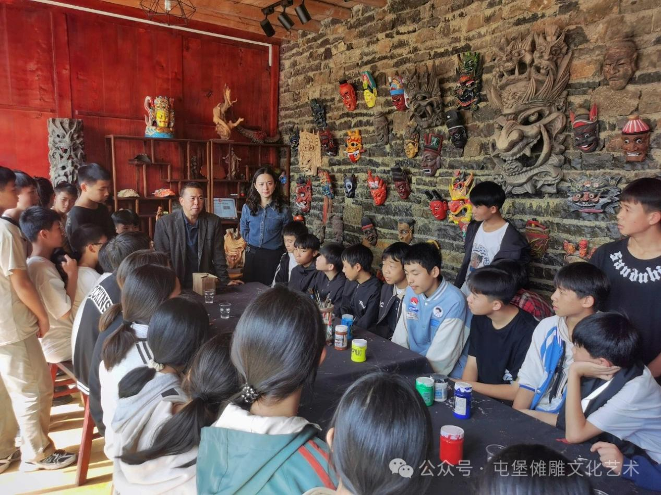

Figure A1. Mr.Qin is explaining Nuo Culture to Junior High school student

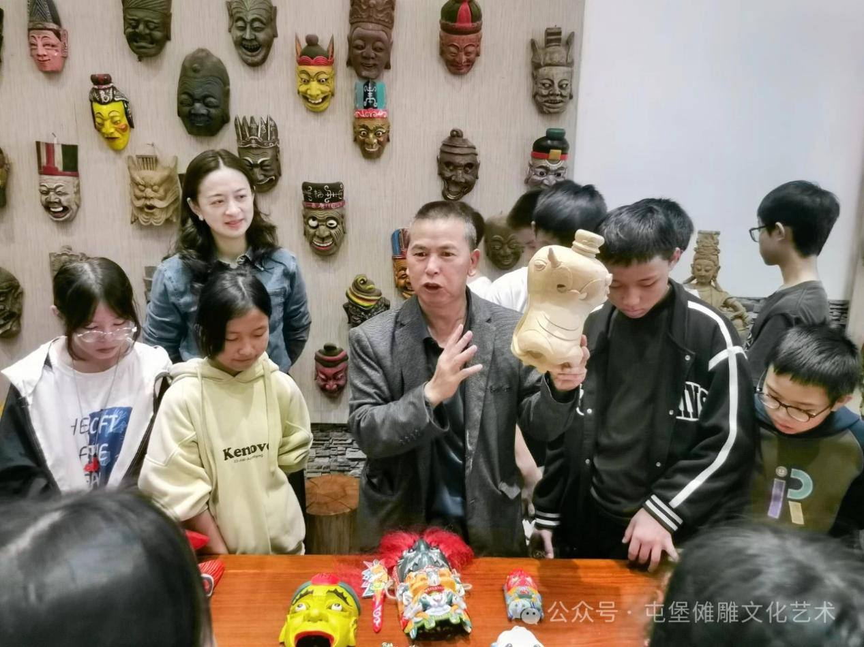

Figure A2: Mr.Qin is explaining Nuo Carving and mask at his charity museum

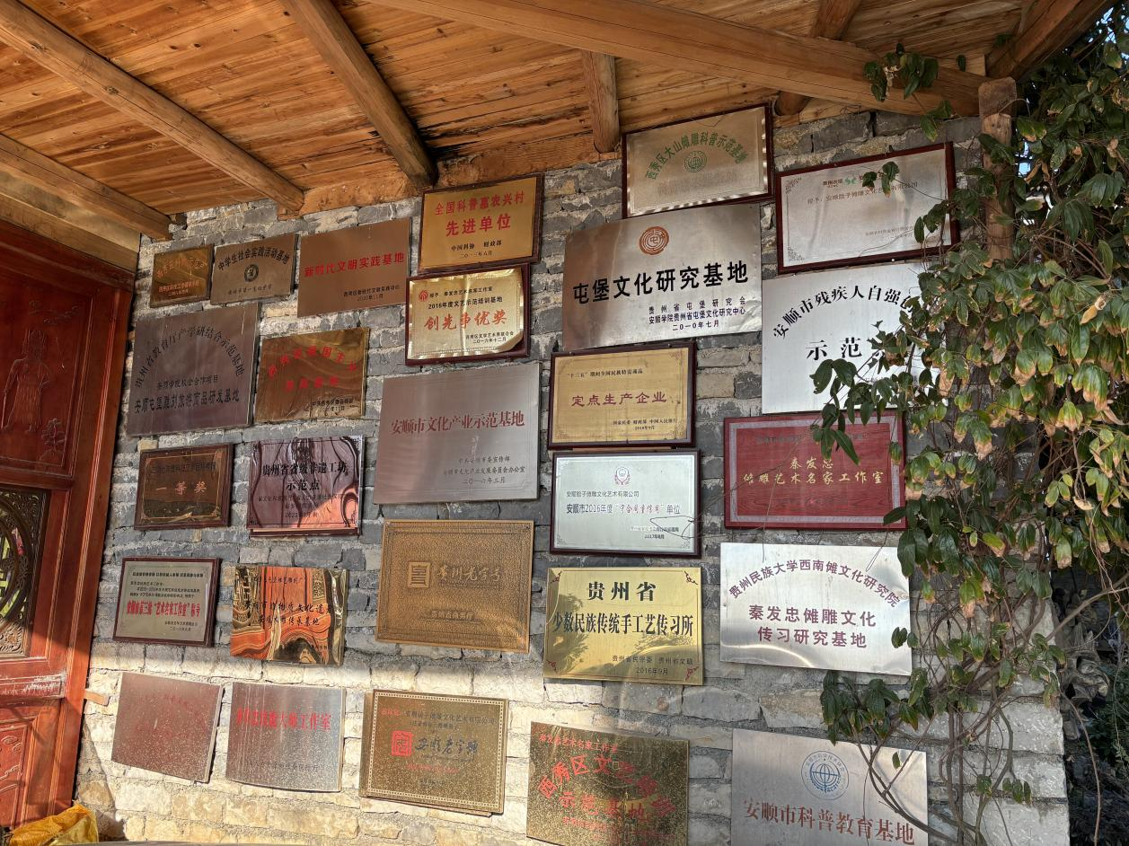

Figure A3. The wall of awards for this Non-profit Organizations

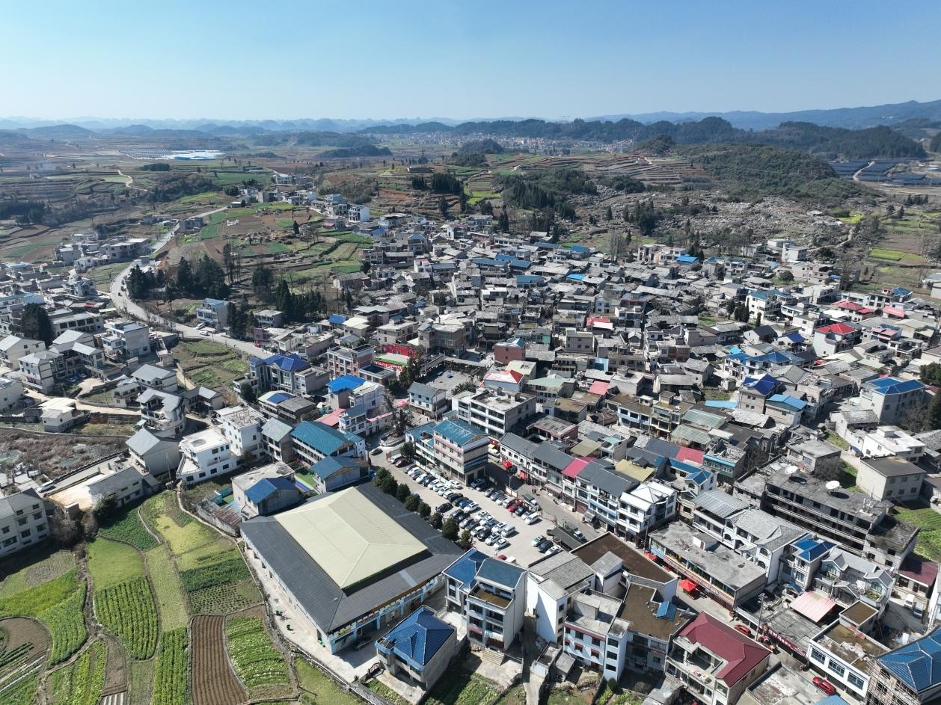

Figure A4. The overlook picture of Liu Guan town, home of Nuo carving and masks.