Development Of Teaching Modules Based On Problem-Based Learning To Improve Critical Thinking Skills And Learning Achievement Of Students In The Subject IPS Class 8 At SMP Negeri 1 Telaga Kab. Gorontalo

.

ABSTRACT

|  |
| --- |
| This study aims to describe the validity of learning tools, describe the practicality of learning tools, and determine the effectiveness of Problem Based Learning-based learning tools to improve students' critical thinking skills and learning achievement. This research was conducted in class VIII of SMP Negeri 1 Telaga, Gorontalo Regency. This development research uses the ADDIE development research model. The resulting products are Teaching Modules, Learner Worksheets, and Learning Outcomes Tests. Data collection was carried out using validation sheets, learning implementation sheets, student activity sheets, critical thinking tests and student response questionnaires. The data obtained was analyzed by calculating the percentage of each acquisition score. The results showed that linguist validation received an average score of 94, IT and design expert validation received an average score of 93. The average score for the teaching module is 90 very valid, for the Learner Worksheet the average score is 95, and for the learning outcomes test the average score is 95. The overall validation results are in the very valid category. The implementation of learning shows very good results with an average of 92.8%, student activity in learning shows very good results with an average of 94.7%, and the percentage of student responses is a very good category. The results of the critical thinking test showed that the indicators of simple explanation, and basic abilities experienced the highest increase, and the lowest was the conclusion indicator. Learning achievement of students measured through learning outcomes also increased with N-Gain values in the medium and high categories. The results of this study indicate that Problem Based Learning-based learning tools can improve students' critical thinking skills and learning achievement. |

*Keywords: [Teaching Module Development, Critical Thinking Ability, Learning Achievement ]*

1. INTRODUCTION

[The development of education is always changing for the better. Curriculum, learning media, learning approaches, and learning models are constantly changing. Currently, students are required to be able to master 21st century skills which include creative thinking, critical thinking, communication and collaboration (Partono et al., 2021). Learners should not only absorb information from the teacher, but they should also be involved in activities during the learning process. The teacher must be a motivator and facilitator during the learning process. Therefore, in designing the learning process, teachers must be able to create a teaching module that accommodates these expected skills.

Teachers in developing teaching modules that create learner competency development, must be able to encourage learners to acquire critical thinking skills, which are part of 21st century skills. The absence of tools that can accommodate these abilities can cause students to find it difficult to achieve their learning goals. So that students do not acquire the necessary critical thinking skills. Because the learning system used is generally teacher-centered, learners only become recipient objects. As a result, learners do not have the opportunity to develop knowledge in solving problems and thinking critically about problems or phenomena.

Students' critical thinking skills can be developed if the teaching module prepared by the teacher accommodates these abilities. The task of a teacher to develop teaching modules according to the applicable curriculum and the teacher's duties are carried out effectively and efficiently, this can improve the quality and quality of education (Ariawan et al., 2020).The use of teaching modules is one of the determining factors for the success of a learning process. Teaching modules that meet good criteria will create an effective learning process. On the other hand, if the teaching module used is not in accordance with the criteria and demands of basic competencies, it will cause various problems in learning (Alfiyanti & Erita, 2022).

Students who have critical thinking skills can be seen in their learning achievements. According to Syaodih (Muslim, 2019) learning achievement is all the behavior that students have as a result of the learning process they have taken, including all the results of the learning process that takes place at school or outside of school which are cognitive, affective, and psychomotor in nature, whether intentional or unintentional. reflects the goals at a certain level that are successfully achieved by students expressed by numbers or letters. The success of students, in learning activities can be seen by numbers or letters given by the teacher after the learning process is complete.

Social studies learning is a subject that reviews events both local and international, factual, perceptual and leveling events related to society. Learning will have more meaning if students discover for themselves what they are learning (Permana & Sujana, 2021). However, the reality of learning in schools is different from what is expected. The learning process is just listening, doing assignments, and only focusing on books, so learning in the classroom is very passive (Winoto & Prasetyo, 2020). This causes a lack of interaction between teachers and students, between students and other students, so that learning becomes ineffective, and has an impact on low student learning outcomes.

Based on observations in the field, experience with learning and analysis of social studies learning outcomes that have been carried out at SMP Negeri 1 Telaga, it shows that the teaching modules developed by teachers have not included 21st century skills, especially critical thinking skills, and their learning outcomes are still low. Although a person's learning outcomes can be influenced by various factors, the most prominent is the dominant role of the teacher in the learning process at school. The pattern of learning that is almost always done is the lecture method which is ultimately less than optimal. To achieve optimal learning outcomes, many things must be considered, including the selection of learning models that are appropriate to the subject matter so that they can stimulate student learning outcomes (Firman et al., 2024). Teachers also still tend to use conventional learning methods and models, thus providing comprehensive information without providing opportunities for students to find their own concepts. During the learning process, teachers rarely use learning methods and remain teacher-centered, which makes students understand the material less and makes them bored, passive, and do not take initiative.

The developed module uses PBL learning model. This PBL module directs students to analyze and think critically about the problems faced. In this module, students are directed to real problems, where students can dig deeper information or find a solution to solve a problem. The development of teaching modules using this learning model is expected to be able to improve students' critical thinking skills, and give them the opportunity to develop their knowledge contextually.]

2. methodology

[This research is a development research or RnD using the ADDIE model. The research was conducted from March to May 2025. The research development process according to the ADDIE procedure is described as follows:

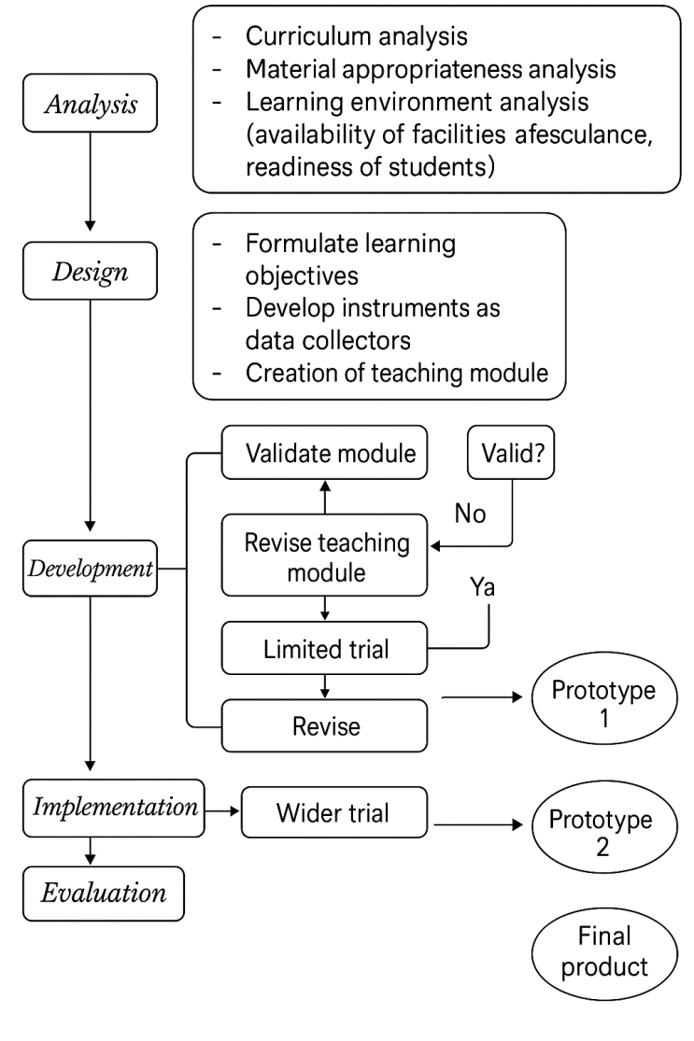

**Figure 1. ADDIE Development Design**

Validation is carried out by validators by giving scores on each aspect of the assessment. To determine the practicality, observers made observations on teacher and learner activities including initial, core, and closing activities. This study used a validation sheet to see the validity of the device. Validators validated the teaching modules, student worksheets, and learning outcomes tests. To see the practicality of the teaching module is done through observation of the implementation of the learning process, observation of student activity, and student response questionnaire.

The observer gives a score on each aspect assessed using the existing rubric. The results were then analyzed and reviewed to determine the level of practicality of the learning tools developed. The effectiveness of the teaching module is obtained from the analysis of learning outcomes tests. Students are given pretest questions then undergo the learning process and fill in the posttest at the end of the learning.

Data from the validation of learning devices given by the three validators were analyzed descriptively quantitatively. The validity criteria were developed based on (Akbar, 2013), namely:

**Table 1. Validity Criteria**

|  |  |
| --- | --- |
| **Validity Criteria** | **Level of Validity** |
| 85,01% - 100,00% | Highly valid, or can be used without revision |
| 70,01% - 85,00% | Moderately valid, or can be used but needs  minor revision |
| 50,01% - 70,00% | Less valid, recommended not to be used  because it needs major revision |
| 01,00% - 50,00% | Invalid, or should not be used |

(Source : Akbar, 2013)

The analysis of the learning implementation sheet and students' activities was carried out by calculating the score on the learning implementation observation sheet that had been filled in by the observer. Observation of learning implementation was carried out for 3 meetings. This analysis technique is used to measure the teacher assessment sheet given to students by calculating the average score for each aspect of the assessment using the following reference.

**% Implementation = $\frac{∑scores of implemented learning steps}{∑scores of total learning steps} x 100\%$**

The percentage of learning implementation is then converted into qualitative data using the criteria in table 2.

**Table 2. Practicality Criteria**

|  |  |
| --- | --- |
| **Validity Criteria** | **Level of Validity** |
| 85,01% - 100,00% | Highly valid, or can be used without revision |
| 70,01% - 85,00% | Moderately valid, or can be used but needs  minor revision |
| 50,01% - 70,00% | Less valid, recommended not to be used  because it needs major revision |
| 01,00% - 50,00% | Invalid, or should not be used |

(Source : Akbar, 2013)

Meanwhile, to determine the learning achievement of students through pre-test and post-test data learning outcomes are calculated by the normalized gain formula. Students' learning outcomes were analyzed by calculating the gain score <g>. In data analysis using gain score involves data on the initial ability of students (pre-test value) and the final ability of students (post-test value). The formula used is the N-Gain formula (Normalized Gain)

$$N-Gain = \frac{Score Posstest - Score Pretest}{Score ideal -Score Pretest }$$

Criteria for improving student learning outcomes based on the provisions presented in Table 3.

**Table 3. Normalized Gain Categorization Criteria**

|  |  |  |
| --- | --- | --- |
| *Number* | *Gain* | *Category* |
| 1. | (g) ≥ 0,7 | High |
| 2. | 0,3 ≤ (g) < 0,7 | Medium |
| 3. | < g > < 0,3 | Low |

]

3. results and discussion

[**3.1 RESULTS**

**3.1.1 TEACHING MODULE VALIDATION RESULTS**

*3.1.1.1 Language Expert Validation*

Language validity is carried out by one person who has the ability in the field of language. The validated aspects are related to the clarity of the use of terms and language, the suitability of the content with Problem Based Learning-based learning, the completeness, breadth and depth of the material, and the strengthening of students' literacy. The results of the language validity test can be seen in Figure 2.

**Figure 2 : Results of linguist validity test**

Based on Figure 2, only aspects 3 and 7 received a score of 80 while the other aspects received a score of 100. The average score given by language validators is 94, based on the validity criteria table, the validity level is very valid.

*3.1.1.2 IT and Design Expert Validation*

IT and teaching module design expert validators validated the aspects of module size according to ISO standards, completeness and layout of module elements, and the attractiveness of module content. The results of the IT and device design validity test can be seen in Figure 3.

**Figure 3 : IT and design expert validity test results**

Based on Figure 3, it can be seen that of the 9 aspects of the assessment, 6 aspects received a score of 100 and 3 aspects received a score of 80. The average score given by the validator is 93, which means that the validity level is very valid based on the validity criteria table.

*3.1.1.3 Validation of Teaching Modules, Learner Worksheets and Learning Outcome Tests*

The validators were two people, from lecturers and practitioners (teachers). The aspects assessed from the teaching module include general information, formulation of learning objectives, selection of learning models, learning activities, selection of learning resources, learning materials and assessment of learning outcomes. The results of the learning module validation can be seen in Figure 4.

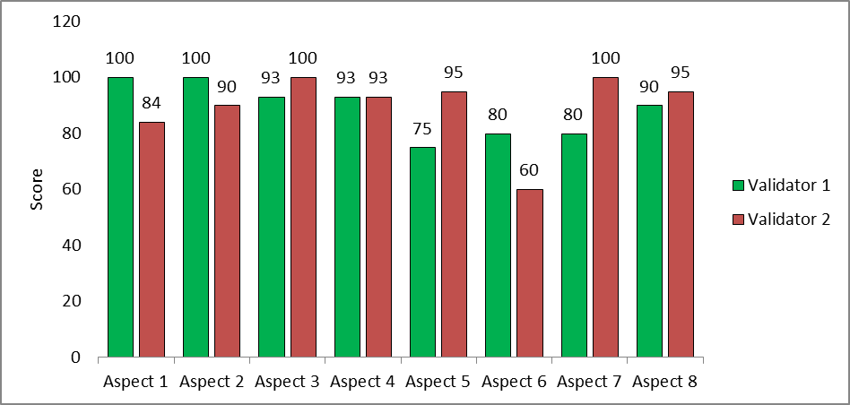

**Figure 4: Teaching module validation results**

The validation results of the two validators found that each aspect of the teaching module component has a different value. Validator 2 gave an average score for all aspects of 90.4; and validator 1 gave an average score of 89.6. The scores of these two validators are included in the very valid validity level based on the validity criteria table.

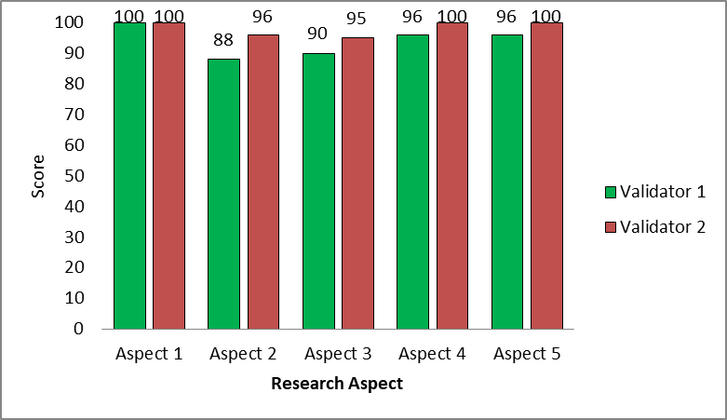

**Figure 5: Results of validation of the Learner Worksheet**

Based on Figure 5, validator 1 gave a score of 100 in aspect 1, a score of 88 in aspect 2, a score of 90 in aspect 3, and a score of 96 in aspects 4 and 5. Meanwhile, validator 2 gave a score of 100 in 1, 4 and 5, a score of 96 in aspect 2, and the lowest 95 in aspect 3. The average of validator 1 is 94 and validator 2 is 97.8. In accordance with the validity criteria table, the value given by these two validators is very valid.

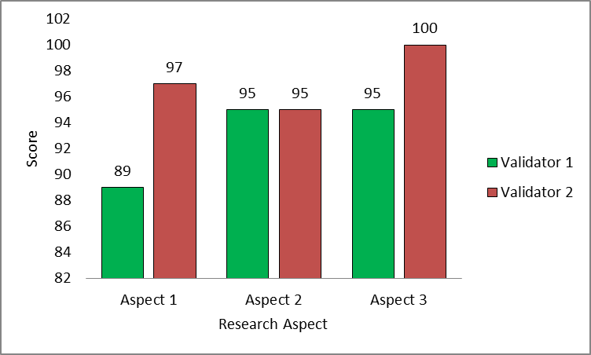

**Figure 6: Results of validation of learning outcomes test**

Based on Figure 6, it is known that the validation results of the two validators in all three aspects are at a very high validation level. Validator 1 gave consecutive scores from aspects 1-3 namely 89, 95, and 95 with an average of 93, and validator 2 gave consecutive scores from aspects 1-3 namely 97, 95, and 100 with an average of 97.3.

**3.1.2 Practicality Test Results**

*3.1.2.1 Teacher Activity Implementation Analysis Results*

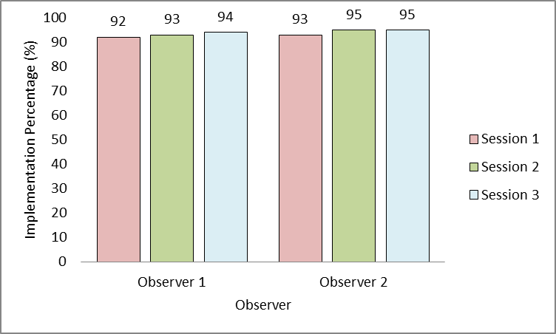

**Figure 7: Results of teacher activity implementation assessment**

Based on Figure 7, it is known that the results of the assessment of the implementation of teacher activities are in the very good category with the highest score at meeting 3. There is an increase from the observer's assessment at each meeting, except at meetings 2 and 3 from observer 2 giving the same score of 95. Based on the practicality table, this value is included in the very practical category.

*3.1.2.2 Results of Learner Activity Analysis*

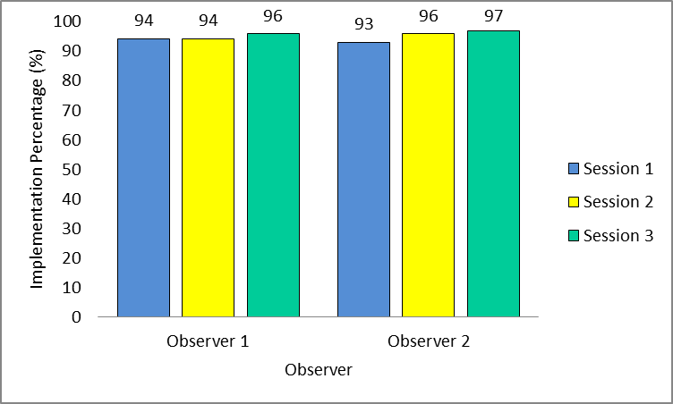

**Figure 8. Results of the assessment of the implementation of student activities**

Based on Figure 4.10, it shows that the value of students' activities at meetings 1 to 3 is in very good criteria. Observer 1 gave a score indicating that all learner activities were carried out. Observer 1 gave the same score at meetings 1 and 2, namely 94, and the highest score at meeting 4, namely 96. Observer 2 gave a score that showed an increase, namely 93, 96 and 97. Based on the practicality table, this value is included in the very practical category.

*3.1.2.3 Learner Response*

Learner response is done by giving a questionnaire after the learning process is complete from meeting 1 to meeting 3. This learner response is also to see the practicality of the Problem Based Learning based teaching module.

**Table 4. Percentage of Students' Response to Learning**

|  |  |
| --- | --- |
| Learner Response | Trial (%) |
| Strongly Agree | 75 |
| Agree | 25 |
| Don’t entirely agree | **-** |
| Disagree | **-** |
| Strongly Disagree | **-** |

Table 4 shows the results of students' responses after learning using teaching modules based on Problem Based Learning, from all indicators or 100% are in a positive response, with categories strongly agreeing 75% and agreeing 25%. Based on the results obtained, it shows that students are interested in the learning that is done.

**3.1.3 EFFECTIVENESS TEST RESULTS**

*3.1.3.1 N-Gain Data Analysis*

Assessment of learning outcomes tests was carried out in limited trials and broad trials. The results obtained in the limited trial can be seen in Table 5.

**Table 5. Pre-test and post-test results for each meeting**

|  |  |  |  |  |
| --- | --- | --- | --- | --- |
| *Description* | *Nilai rata-rata* | | *N-Gain* | *Category* |
| *Pre-test* | *Pos-test* |
| Meeting 1 | 47 | 83 | 0,63 | Medium |
| Meeting 2 | 49 | 85 | 0,67 | Medium |
| Meeting 3 | 50 | 87 | 0,72 | High |

Based on Table 5, the N-Gain values generated from the student learning outcomes test are mostly in the medium and high categories. The results of the N-Gain analysis show that at meetings 1 and 2 are still in the medium category, then at meetings already in the high category. These results prove that the teaching module is effective and can be used for the Problem Based Learning-based learning process in Class VIII.

*3.1.3.2 Analysis of Critical Thinking Ability of Each Indicator*

The critical thinking test indicators used in this study are critical thinking indicators according to Ennis. Each question represents each of Ennis' critical thinking indicators. Critical thinking test assessment analysis was conducted on a limited trial and a broad trial. The results of the critical thinking assessment of each indicator on the limited trial can be seen in Figure 9.

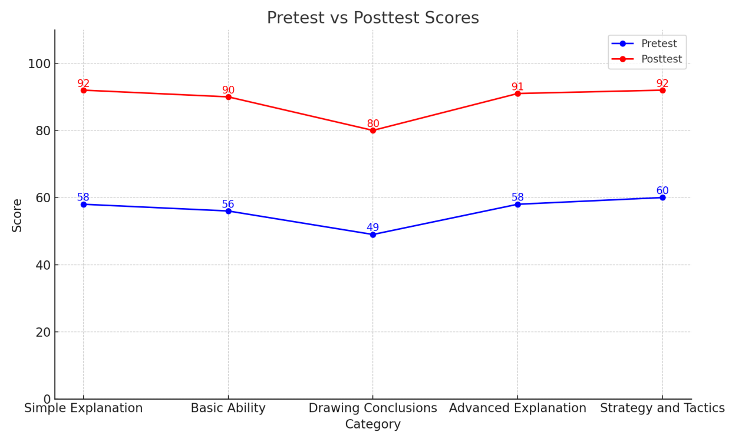

**Figure 9: Analysis of Critical Thinking Test Results for Each Indicator**

Based on Figure 9, it can be seen that there is an increase from pretest to posttest for all critical thinking indicators. The lowest score on the pretest was on the conclusion indicator and the highest on the strategy and tactics indicator. While on the posttest, the highest scores were on simple explanations and strategies and tactics. The highest increase from prestest to postest was in the simple explanation and basic skills indicators, while the concluding indicator was the indicator with the lowest increase.

**3.2 DISCUSSION**

This research aims to develop learning tools. The learning tools developed should meet the requirements of valid, practical, and effective. Therefore, this part of the discussion centers on three research problems, namely the validity, practicality and effectiveness of the products developed. Validation conducted by experts becomes the basis for the validity of the teaching module whether it can be used or not. Learning implementation, learner activities, and learner response questionnaires are tools used to measure the practicality of teaching modules. While measuring the learning achievement of students by looking at their learning outcomes using pre-test and post-test questions to determine the effectiveness of teaching modules (Windari et al., 2022).

Validation is done to assess whether the design of a product is valid or not. Terms are valid if they are in accordance with the subject of science and all components in the device are interrelated. A valid instrument will have an impact on students in obtaining knowledge that will be directed and appropriately develop the creative thinking skills of students to be mastered (MZ et al., 2021). The results of the first validation on linguists who concluded that the teaching module was very valid for use in research. From the assessment of the aspects of material completeness, breadth of material, depth of material, clarity of use of terms and language, and suitability of content, the validator gave a very valid score. Furthermore, the validation is related to the IT and design of the learning module. The results of product validation by experts show that the teaching modules developed are very valid.

The teaching module validation results obtained were that all validators concluded that the teaching module was valid and could be used. Aspects of content and objectives of all components such as learning outcomes and learning objectives must be appropriate. This is in line with the reference from (Suniasih, 2019) that the teaching module developed is said to be valid if what is developed is based on a strong theoretical foundation (content validity) and internal consistency between media components (construct validity).

The Learner Worksheet used in Problem Based Learning contains several problems and students are given the opportunity to analyze problems, determine sources to solve these problems, and summarize the concepts that have been found. The validation results from the validator show that the Learner Worksheet is very valid with a score of 97.8. There are suggestions for improvement from the validator that the Learner Worksheet is interesting and needs-based, but needs to be added with teaching materials and colored pictures. The use of Learner Worksheets in the learning process is to strengthen and support learning in order to achieve indicators and competencies in accordance with the curriculum. The proper use of Learner Worksheets can make students more active in carrying out learning activities, develop process skills, train independent attitudes in students in learning, elaborate scientific attitudes, arouse motivation and interest in learning students.

The practicality of the teaching module can be seen from the implementation of learning, student activities, and student responses. The implementation of learning in each syntax shows that the teacher is able to carry out the learning process, which is indicated by the implementation value being in a very high category. The results of this implementation indicate that the teacher is able to carry out the steps of teaching and learning activities very well (Khaerani et al., 2020). The role of the teacher in the study was maximized in this Problem Based Learning-based learning. By using PBL, the teacher's role is only to provide direction to students to be able to play an active role and find problem solving in the learning process. This learning model exposes students to problems as a reference in learning or in other words, students learn through problems (Nusi et al., 2024).

The results obtained from learner activities in the limited trial were 93.51 and the broad trial was 95.71. The results of this observation indicate that the activities of students in Problem Based Learning-based learning are very practical, so this teaching module can be used to be implemented in classroom learning. This shows that the activity of students during learning is very good.

Hapiz (2020) explains that the increase in student activity in learning includes: (1) students are more active in listening or listening to the teacher's explanation (2) students are quite active in asking questions to the teacher, (3) students are more active in answering questions and working on the Learner Worksheet from the teacher; (4) students are more active and enthusiastic in learning (5) students are more enthusiastic in receiving lessons; (6) students' desire to succeed increases; (7) students are more creative and initiative in learning; (8) students' creativity to learn increases.

Practicality analysis is not only seen from the implementation of the learning process and students' activities, but also from the students' responses. The response of students after using this Problem Based Learning-based teaching module is very good. The findings in the limited trial research results, 98% were in a positive response with details of 71% strongly agreeing and 27% agreeing. While the remaining 2% are in the negative response. The positive response given by the students was in the third statement, namely the ease of accessing the material presented.

The results of the critical thinking analysis show an increase in critical thinking skills. The increase can be seen in the pre-test and post-test results of students. The simple explanation and basic ability indicators are the indicators with the highest improvement. This happens because giving simple explanations is the indicator that is most often done by students in every lesson, so they are used to answering questions in that form. The results of research by (Agnafia, 2019) found that the explanation indicator or giving an explanation obtained good critical thinking ability results, because this indicator was commonly implemented by students so that the score was in the good category.

The indicator that showed the least improvement compared to other indicators was providing further explanation and drawing conclusions. While providing a simple explanation is common for students, providing further explanation is still difficult to achieve. This occurs because students do not fully understand the questions and are unable to connect one understanding with another. (Suriati et al., 2021) explain that students cannot answer questions well because they have not fully understood the questions, so they are reluctant to complete the answers to the questions given. Therefore, to improve critical thinking skills in this indicator, it is necessary to get students accustomed to answering questions in the form of further explanations.

(Hasanah et al., 2021) in their research showed that using the Problem-Based Learning model had a significant effect on students' learning achievement in the subject of human activities in meeting needs. Thus, the Problem-Based Learning model can be used as an alternative in social studies learning. Critical thinking, which is able to foster and improve students' understanding and skills in solving problems, will be very helpful for the students themselves. Therefore, teachers need to continuously explore students' thinking abilities, as critical thinking skills are essential for students in the learning process (Adam et al., 2024).

According to (Masrinah et al., 2019), critical thinking skills can be improved through PBL because of its approach to authentic problems, and students are not only asked to understand a problem but also must be able to work together to solve it, thereby stimulating students' abilities and skills, especially critical thinking skills.]

4. Conclusion

[The results of this research on the development of a Problem-Based Learning-based teaching module have met the requirements for validation, effectiveness, and practicality. This Problem-Based Learning-based teaching module meets the criteria for validity and is suitable for use in the learning process. Based on the validation results, the teaching module falls into the highly valid category for the teaching module, student worksheets, and learning outcome tests. This Problem-Based Learning-based teaching module meets the criteria for practicality and is practical for use in the learning process. Based on the assessment of learning implementation (teacher and student activities) in three meetings, it falls into the highly practical category. The responses given by the students were also in the positive category. This Problem-Based Learning-based Teaching Module meets the criteria for effectiveness. Based on the N-Gain values obtained in both the limited and extensive trials, it is in the moderate and high categories, meaning that the teaching module is effective for use in learning.]

References

Adam, N., Panigoro, M., Ardiansyah, A., Hafid, R., & Maruwae, A. (2024). Analysis of Students' Critical Thinking Skills Using the Problem-Based Learning (PBL) Model in Integrated Social Studies for Grade VIII. Journal of Economic and Business Education, 2(3). https://doi.org/https://doi.org/10.37479/jebe.v2i3.26167

Agnafia, D. N. (2019). Analysis of Students' Critical Thinking Skills in Biology Learning. Florea, 6(1), 1–8. https://doi.org/https://doi.org/10.25273/florea.v6i1.4369

Alfiyanti, D. G., & Erita, Y. (2022). The Validity of Teaching Materials Using the Problem-Based Learning Model for Social Studies Curriculum in Independent Elementary Schools. Didaktik: Scientific Journal of PGSD FKIP Universitas Mandiri, 8(2), 2353–2371. https://doi.org/https://doi.org/10.36989/didaktik.v8i2.558

Ariawan, R., Kinanti, D., & Putri, J. (2020). Development of Mathematics Learning Tools Using the Problem-Based Learning Model with a Visual Thinking Approach on the Topic of Cubes and Blocks in Grade VIII. In Journal for Research in Mathematics Learning) p (Vol. 3, Issue 3).

Firman, Meyko Panigoro, Zainal Abidin Umar, Heldy Vanni Alam, & Frahmawati Bumulo. (2024). The effect of the RADEC Learning Model (Read, Answer, Discuss, Explain, and Create), School Environment, and Motivation on Learning Outcomes of Students in Grade VII in Social Studies Subjects at MTS Negeri 2 Kotamobagu. World Journal of Advanced Research and Reviews, 22(3), 1448–1459. https://doi.org/10.30574/wjarr.2024.22.3.1854

Khaerani, S. H., Dwi Utami, S., & Mursali, S. (2020). Development of Science Learning Tools Based on Local Wisdom to Improve Students' Cognitive Learning Outcomes. Journal of Banua Science Education E, 1(1), 2745–7222. https://doi.org/https://doi.org/10.20527/jbse.v1i1.2

Hasanah, U., Sarjono, S., & Hariyadi, A. (2021). The Effect of the Problem-Based Learning Model on Social Studies Learning Achievement at Taruna Kedung Adem Junior High School. Aksara: Journal of Non-Formal Education, 7(1), 43. https://doi.org/10.37905/aksara.7.1.43-52.2021

Masrinah, E. N., Aripin, I., & Gaffar, A. A. (2019). Problem-Based Learning (PBL) to Enhance Critical Thinking Skills. Proceedings of the National Education Seminar, 1, 924-932, 1. https://doi.org/https://prosiding.unma.ac.id/index.php/semnasfkip/article/view/129

Muslim, I. F. (2019). Survey of eighth-grade students at private Islamic junior high schools in East Jakarta. Research and Development Journal of Education, 5(2).

MZ, A. F. S. A., Rusijono, R., & Suryanti, S. (2021). Development and Validation of Problem-Based Learning-Based Instructional Materials to Enhance Creative Thinking Skills in Elementary School Students. Basicedu Journal, 5(4), 2685–2690. https://jbasic.org/index.php/basicedu/article/view/1260

Nusi, C. A., Panigoro, M., Ardiansyah, A., Mahmud, M., & Sudirman, S. (2024). The Effect of the Problem-Based Learning (PBL) Model on Students' Learning Outcomes in Integrated Social Studies. Damhil Education Journal, 4(1), 57. https://doi.org/10.37905/dej.v4i1.2494

Partono, P., Wardhani, H. N., Setyowati, N. I., Tsalitsa, A., & Putri, S. N. (2021). Strategies for Enhancing 4C Competencies (Critical Thinking, Creativity, Communication, & Collaboration). Journal of Educational Research, 14(1), 41–52. https://doi.org/10.21831/jpipfip.v14i1.35810

Permana, I. M. J., & Sujana, I. W. (2021). Application of Social Studies Learning Based on the Contextual Approach. Journal of Educational Research and Development, Volume 5(1), 1–9. https://doi.org/https://doi.org/10.23887/jppp.v5i1.32445

Suniasih, W. N. (2019). Development of Neuroscience Teaching Materials with Character Education Using the Inquiry Model. Journal of Mimbar Ilmu, 24(3). https://doi.org/https://doi.org/10.23887/mi.v24i3.22542

Suriati, A., Sundaygara, C., & Kurniawati, M. (2021). Analysis of Critical Thinking Skills in Grade X Students at Kepanjen Islamic High School. Journal of Applied Science & Technology, 3(3), 176–185.

Windari, W., Latjompoh, M., & Hamidun, M. S. (2022). Development of POE (Predict-Observe-Explain) Oriented Learning Device to Improve Students' Problem-Solving Ability on Environmental Change Material. Journal of Learning and Biology Nucleus, 8(3), 721–732. https://doi.org/10.36987/jpbn.v8i3.3150

Winoto, Y. C., & Prasetyo, T. (2020). The Effectiveness of Problem-Based Learning and Discovery Learning Models on Elementary School Students' Critical Thinking Skills. Basicaedu Journal, 4(2), 228–238. <https://doi.org/https://doi.org/10.31004/basicedu.v4i2.348>