Development and Usability of a Smart Ripple Tank for Enhancing Understanding of Wave Concepts

.

ABSTRACT

|  |
| --- |
| This study aims to develop a Smart Ripple Tank to support the teaching and learning of wave concepts and to evaluate its usability among Form Four physics students. The study employed a development research design based on the ADDIE model and utilized a quantitative approach. The study was conducted in a secondary school physics classroom in Malaysia over the course of the 2024 academic year. The sample comprised 30 randomly selected Form Four students enrolled in physics. Instruments used included an expert validation form to assess the validity of the product and a usability questionnaire to evaluate its practicality. Expert validation was analyzed using percentage agreement, while student usability responses were analyzed using descriptive statistics (mean and standard deviation) via SPSS software. Expert agreement on the usability questionnaire reached 94.27%, while agreement on the Smart Ripple Tank development was 92.71%. Student responses indicated positive perceptions: usefulness (mean = 3.59, SD = 0.497), ease of use (mean = 3.52, SD = 0.504), ease of learning (mean = 3.62, SD = 0.489), and satisfaction (mean = 3.63, SD = 0.488). The findings suggest that the Smart Ripple Tank is a valid and usable educational tool that enhances students’ understanding of abstract wave concepts through practical experience and promotes the development of scientific skills. |

*Keywords: Smart Ripple Tank, teaching aid, wave concept*

1. INTRODUCTION

Twenty-first-century education emphasizes student-centered learning that nurtures critical thinking, creativity, communication, and collaboration (Silva, 2009). Traditional instructional methods such as "chalk and talk" are increasingly viewed as inadequate in preparing students for the demands of a rapidly evolving world. As such, teaching and learning strategies that incorporate interactive and technology-enhanced approaches are gaining prominence, particularly in complex subjects like physics (Nemejs et al., 2019; Watson et al., 2012). The integration of technology in education has proven to be an effective means of enhancing teaching and learning experiences. Tools such as smartphones and computers have enabled educators to adopt innovative pedagogical methods that not only support content delivery but also foster student engagement and motivation (Malik, 2023; Mokalu et al., 2022). Furthermore, the development of teaching aids (TAs) incorporating technological elements can significantly improve classroom interaction and provide a more immersive and enjoyable learning environment.

Despite these advances, the teaching of physics remains challenging, particularly when addressing abstract topics such as waves. Physics, as a field of science that investigates natural phenomena and interactions between objects, includes the study of mechanical waves such as water waves, which propagate energy through a medium (Susanto, 2022). Many students find it difficult to understand core wave concepts due to their abstract nature, and often perceive wave topics as complex and difficult to grasp. This challenge is heightened when lessons are delivered ineffectively, making it harder for students to relate prior knowledge to new content (Chu et al., 2023).

In response to these challenges, this study aims to develop a technology-based teaching aid known as the Smart Ripple Tank, specifically designed to support the teaching of wave concepts in Form Four physics. The objective of this research is to evaluate the usability and effectiveness of the Smart Ripple Tank in enhancing students' understanding and engagement in physics lessons. This study aspires to contribute to the advancement of innovative educational tools that can improve the quality of physics education at the secondary school level.

2. methodology

**2.1 Research Design**

This study employed a design and development research approach as outlined by Richei and Klein, 2007. The development of the Smart Ripple Tank was guided by the ADDIE instructional design model, which includes five phases: Analysis, Design, Development, Implementation, and Evaluation. The study adopted a quantitative methodology to measure the usability of the Smart Ripple Tank in the context of the wave topic in physics.

**2.2 Respondents**

The target population for this study comprised Form Four secondary school students enrolled in physics courses. A total of 30 students from two different secondary schools were selected as the sample. Simple random sampling was employed to ensure the reliability and generalizability of the collected data within the target population.

**2.3 ADDIE Model Phase**

The research followed the five phases of the ADDIE model. In the Analysis Phase, the researcher identified the learning challenges faced by students in understanding the wave topic and proposed appropriate solutions. During the Design Phase, the Smart Ripple Tank was conceptualized, and the research objectives along with the target user group—Form Four physics students—were clearly defined. In the Development Phase, the Smart Ripple Tank was built based on the proposed design, and a validation form was created to assess its usability. The Implementation Phase involved expert validation, a pilot study, and the actual implementation with selected students. Finally, in the Evaluation Phase, data obtained from expert assessments and usability questionnaires were analyzed using percentage agreement and descriptive statistical methods to determine the effectiveness and usability of the developed tool.

**2.4 Research Instrument**

The Expert Validity Form and the Usability Questionnaire were employed in this investigation. The expert validation form is divided into two sections: face validity and content validity. Three experts were involved in giving validity for this study before it was evaluated in a pilot study and an actual study. Expert validity is required to assess the item and measure the construct depending on the model utilized. A four-likert scale usability questionnaire was used to assess the degree of usability of this Specific Heat Capacity Application Kit. This form is used to collect quantitative information from responders. The USE questionnaire (Lund, 2001) was used to administer this survey, which comprises four primary constructs: usefulness, ease of learning, ease of use, and satisfaction. This usability questionnaire is divided into two parts: Part A and Part B. Part A comprises information about the assessor, whereas Part B has 20 questionnaire items based on the four primary components.

**2.5 Data Analysis**

The data collected were analyzed using the Statistical Package for the Social Sciences (SPSS). Face and content validity of the usability questionnaire and Smart Ripple Tank were assessed through expert percentage agreement. Reliability analysis was conducted using Cronbach’s Alpha to determine the internal consistency of the questionnaire. Table 1 shows the data analysis method use in this research.

**Table 1. Data analysis methods**

|  |  |  |
| --- | --- | --- |
| **Research Questions** |  | **Data Analysis Methods** |
| Does the Smart Ripple Tank have good validity? | Validity  Reliability | Expert agreement percentage  Cronbach Alpha |
| Does the Smart Ripple Tank have good usability among Form Four students? | Usability of the Smart Ripple Tank | Descriptive statistical analysis |

3. results and discussion

The findings of this study are presented based on the analysis of data collected through expert validation and student usability questionnaires. The data were analyzed using percentage agreement for expert validation and descriptive statistics (mean and standard deviation) for student responses.

**3.1 Smart Ripple Tank**

The development of the Smart Ripple Tank was guided by the ADDIE instructional design model. The entire system, including the Smart Ripple Tank and the integrated frequency measurement device, was developed by the researcher. The Smart Ripple Tank was built using materials such as wood, acrylic sheet, springs, silicone, battery, adjustable resistor, and a vibration motor. Meanwhile, the frequency measurement device was developed using an Arduino Uno microcontroller, a light sensor, and a Liquid Crystal Display (LCD).

The Smart Ripple Tank enables students to visualize wavefronts formed on the surface of the tank screen. With the help of the frequency measurement device, the values of frequency and wavelength can be detected automatically, enhancing the precision and efficiency of wave-related experiments. To support its use in educational settings, a user manual was also developed alongside the physical device. The manual includes an introduction to the Smart Ripple Tank, step-by-step usage instructions, guided learning activities (such as wave speed, reflection, diffraction, and interference), and reinforcement worksheets for students to complete after the experiments. This manual serves as a comprehensive guide to facilitate student exploration and understanding of wave phenomena. Figure 1 shows the Smart Ripple Tank with the integrated frequency measurement device, while Figure 2 shows the cover page of the user manual and an example of the guided learning activities

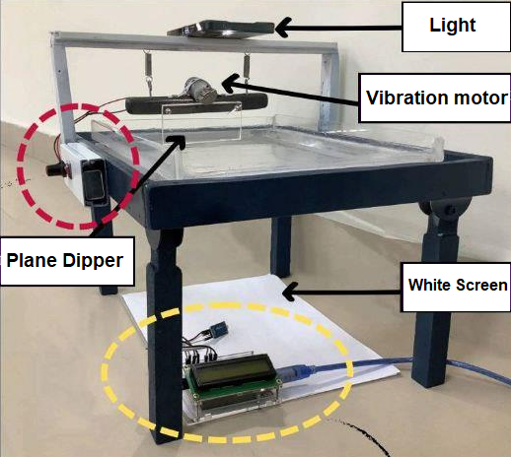

(a)

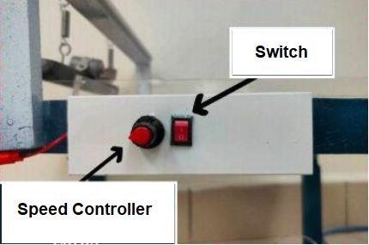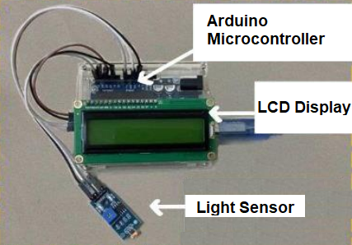

(b) (c)

**Fig. 1. (a) Smart Ripple Tank with the integrated frequency measurement device; (b) speed controller; (c) Frequency measurement device**

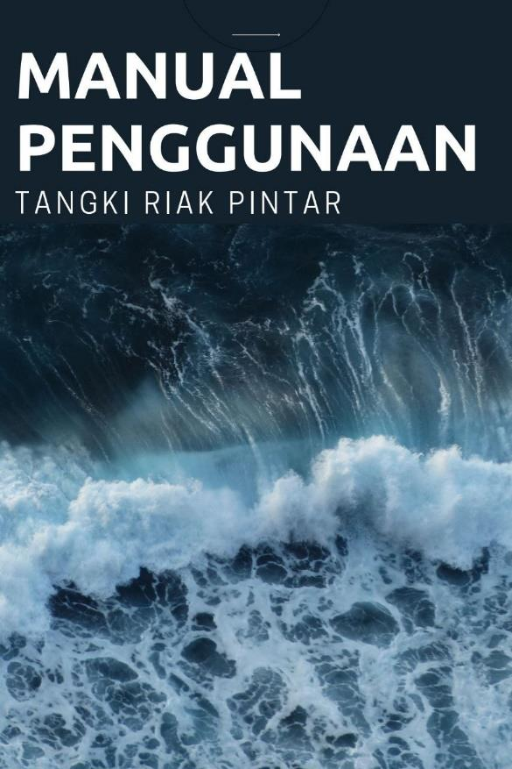 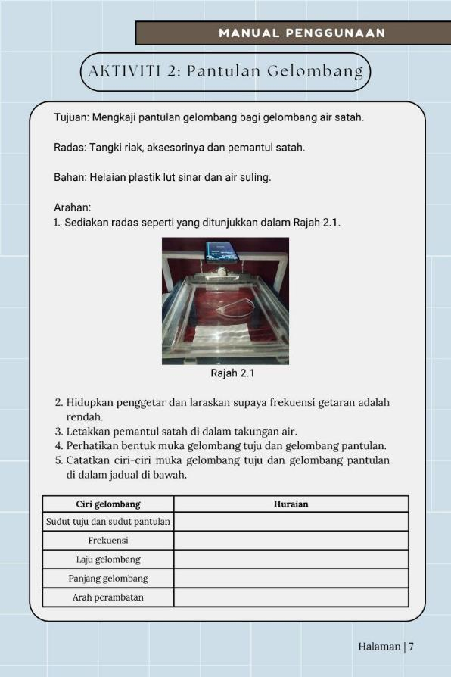 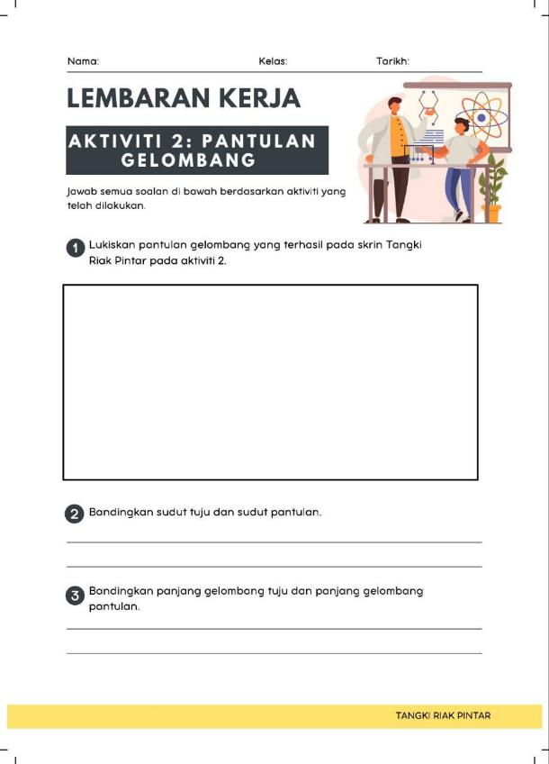

(a) (b) (c)

**Fig. 2. (a) The cover page of the user manual; (b-c) example of guided learning activities**

**3.2 Expert Validation Results**

The percentage of expert agreement for both the face and content validity of the Smart Ripple Tank is presented in Table 2. The analysis shows that the average expert agreement for face validity is 91.67%, while content validity achieved an average of 93.75%. According to Sidek and Ahmad (2005), a validity score exceeding 70% is considered to reflect high validity. These findings demonstrate that the Smart Ripple Tank has a sound and appropriate design that is capable of displaying wave patterns clearly, aligning well with the learning objectives of the Form Four physics curriculum. The teaching aid also meets the needs of its target users and includes clear and practical usage instructions. However, several improvements were suggested by the experts, particularly concerning the user manual. The feedback highlighted a lack of appeal and the presence of minor spelling errors. In response, the researcher revised the manual by incorporating more engaging 21st-century elements and correcting all identified errors to ensure better usability and effectiveness.

**Table 2. Expert agreement percentages for face and content validity of the Smart Ripple Tank development.**

|  |  |  |
| --- | --- | --- |
| **Expert** | **Face Validity (%)** | **Content Validity** |
| 1 | 100 | 100 |
| 2 | 91.67 | 100 |
| 3 | 83.33 | 81.25 |
| Average | 91.67 | 93.75 |

**3.3 Instrument Reliability**

In this study, a pilot test was conducted prior to the actual data collection in schools. According to Srinivasan and Lothi (2017), the purpose of conducting a pilot test is to identify any weaknesses in the questionnaire instrument by examining its accuracy and reliability. For the pilot test, 15 randomly selected Form Four physics students were involved. The researcher introduced the Smart Ripple Tank and guided the students to carry out the prescribed activities using the provided user manual. Upon completion, a usability questionnaire was distributed to the students for feedback.

The collected data were analyzed using Cronbach’s Alpha coefficient to determine the reliability of the questionnaire. The analysis yielded an average Cronbach’s Alpha value of 0.853, which indicates a good level of internal consistency. According to Bond and Fox (2014), a Cronbach’s Alpha value above 0.70 suggests that the questionnaire items are sufficiently reliable. Therefore, the researcher proceeded with the main data collection, as the instrument demonstrated an acceptable level of reliability.

**3.4 Usability Evaluation**

A questionnaire was used to evaluate the usability level of the Smart Ripple Tank. It was distributed to 30 respondents, consisting of Form 4 Physics students from two schools: SMK Proton City and SMK Abdul Jalil. The usability of the Smart Ripple Tank was assessed based on four main constructs: usefulness, ease of use, ease of learning, and satisfaction. Each construct was measured using a four-point Likert scale.

For the first construct, usefulness, Table 3 shows the frequency and percentage of agreement among respondents. The majority of respondents agreed or strongly agreed that the Smart Ripple Tank helped them become more effective and productive in learning the topic of waves. They also agreed that it improved their understanding, saved time, and fulfilled their learning needs. The highest mean score was 3.80 for the item related to functionality, indicating that students found the tool highly effective in terms of operation. The second construct, ease of use, is shown in Table 4. Respondents generally found the Smart Ripple Tank easy and straightforward to use. They agreed that it was user-friendly, flexible, and could be operated without referring to a manual. Most of them reported being able to use the tool successfully during each attempt, which demonstrates the product’s intuitive design and accessibility.

For the third construct, ease of learning, detailed in Table 5, most respondents agreed or strongly agreed that they could learn how to use the Smart Ripple Tank quickly. They also indicated that they were able to remember how to operate it easily and found it simple to learn. Notably, an equal number of respondents agreed and strongly agreed that they became proficient with the tool in a short amount of time. The final construct, satisfaction, is presented in Table 6. The results showed that all respondents agreed or strongly agreed that they were satisfied with the Smart Ripple Tank. They expressed enjoyment in using the product and felt that it functioned as expected. A large majority also stated that they found the Smart Ripple Tank impressive and believed it was something they needed for learning the topic of waves. The overall mean score for the satisfaction construct was 3.63, indicating a high level of positive user experience. Table 7 summarizes the overall mean and standard deviation scores for each construct, reflecting the general usability level of the Smart Ripple Tank.

**Table 3. Usability analysis of usefulness constructs**

|  |  |  |  |
| --- | --- | --- | --- |
| **No.** | **Item** | **Mean** | **Standard Deviation** |
| 1 | The Smart Ripple Tank helps me become more effective in learning wave topics. | 3.63 | 0.49 |
| 2 | The Smart Ripple Tank helps me become more productive in learning wave topics. | 3.57 | 0.50 |
| 3 | The Smart Ripple Tank helps me understand the wave topic more easily. | 3.57 | 0.50 |
| 4 | The Smart Ripple Tank helps me save time in learning wave topics. | 3.53 | 0.51 |
| 5 | The Smart Ripple Tank meets my learning needs for the wave topic. | 3.67 | 0.48 |

**Table 4. Usability analysis of ease-of-use constructs**

|  |  |  |  |
| --- | --- | --- | --- |
| **No.** | **Item** | **Mean** | **Standard Deviation** |
| 1 | The Smart Ripple Tank is easy to use. | 3.63 | 0.49 |
| 2 | The Smart Ripple Tank is simple to operate. | 3.57 | 0.50 |
| 3 | The Smart Ripple Tank is user-friendly. | 3.47 | 0.51 |
| 4 | The Smart Ripple Tank is flexible to use. | 3.50 | 0.51 |
| 5 | The Smart Ripple Tank can be used without referring to the manual. | 3.50 | 0.51 |
| 6 | The Smart Ripple Tank works successfully on every attempt. | 3.43 | 0.50 |

**Table 5. Usability analysis of ease to learn constructs**

|  |  |  |  |
| --- | --- | --- | --- |
| **No.** | **Item** | **Mean** | **Standard Deviation** |
| 1 | I can learn to use the Smart Ripple Tank quickly. | 3.67 | 0.48 |
| 2 | I can easily remember how to use the Smart Ripple Tank. | 3.63 | 0.49 |
| 3 | The Smart Ripple Tank is easy to learn. | 3.67 | 0.48 |
| 4 | I quickly become proficient in using the Smart Ripple Tank. | 3.50 | 0.51 |

**Table 6. Usability analysis of satisfaction constructs**

|  |  |  |  |
| --- | --- | --- | --- |
| **No.** | **Item** | **Mean** | **Standard Deviation** |
| 1 | I am satisfied with the Smart Ripple Tank. | 3.60 | 0.50 |
| 2 | I enjoy using the Smart Ripple Tank. | 3.53 | 0.51 |
| 3 | The Smart Ripple Tank functions as I expected. | 3.67 | 0.48 |
| 4 | The Smart Ripple Tank is impressive. | 3.70 | 0.47 |
| 5 | I feel that the Smart Ripple Tank is something I need for learning the topic of waves. | 3.63 | 0.49 |

**Table 7. Summary of usability constructs for the Smart Ripple Tank**

|  |  |  |  |
| --- | --- | --- | --- |
| **Construct** | **Mean** | **Standard Deviation** | **Usability Level** |
| Usefulness | 3.59 | 0.50 | High |
| Ease of Use | 3.52 | 0.50 | High |
| Ease of Learning | 3.62 | 0.49 | High |
| Satisfaction | 3.63 | 0.49 | High |
| **Overall Average** | **3.59** | **0.495** | **High** |

**3.5 Discussion**

This section discusses the findings in relation to the first and second research questions, which focus on the validity and usability of the developed Smart Ripple Tank among Form 4 Physics students. The development of the Smart Ripple Tank obtained strong validity support from three subject matter experts, as measured through the expert agreement percentage. The face validity score was 91.67%, while the content validity score reached 93.75%. Both values are considered high, indicating that the Smart Ripple Tank has a suitable measurement design aligned with the purpose of this study (Mokhtar and Aman, 2017). These results effectively answer the first research question, confirming that the developed Smart Ripple Tank possesses strong validity.

To address the second research question—whether the Smart Ripple Tank demonstrates good usability among Form 4 students—a field study was conducted involving 30 Form 4 Physics students from SMK Abdul Jalil and SMK Proton City. The usability questionnaire used in this study contained four key constructs: usefulness, ease of use, ease of learning, and user satisfaction. The usefulness construct achieved a mean score of 3.59 with a standard deviation of 0.497, indicating a high level of student perception. For instance, the item “The Smart Ripple Tank helps students understand the topic of waves more easily” scored a mean of 3.57, reinforcing the idea that the tool enhances students’ ability to grasp abstract wave concepts. This aligns with the findings of Rosyidah, Prima, and Riandi (2023), who state that ripple tanks help students visualize wave phenomena directly on water surfaces.

This construct recorded a mean score of 3.52 and a standard deviation of 0.504. Students found the tool easy to operate, particularly due to its vibration control system and frequency measurement device. The item “The Smart Ripple Tank is easy to use” had a high mean of 3.63, suggesting that the tool is well-designed for practical classroom use. This supports Sugiyono’s (2012) assertion that a good educational tool is one that is simple for students to use in hands-on settings. The ease of learning construct yielded a mean score of 3.62 and a standard deviation of 0.489, while the specific item “The Smart Ripple Tank is easy to learn” scored a mean of 3.67. This indicates that students can quickly understand how to operate the tool. According to Aziz, Esche, and Chassapis (2010), when a teaching aid is easy to learn, it helps both students and teachers better understand physics concepts, leading to more effective and engaging learning experiences. In terms of user satisfaction, the tool received a mean score of 3.63 and a standard deviation of 0.488. The item “I feel that the Smart Ripple Tank is something I need for learning the topic of waves” also scored a mean of 3.63. These results reflect the students’ appreciation of the tool’s relevance and usefulness in learning. This is consistent with the constructivist theory, which suggests that students learn more effectively through hands-on experiences that allow them to construct knowledge independently (Sudarsana, 2018).

4. Conclusion

In conclusion, this study has successfully achieved all of its objectives, namely the development of the Smart Ripple Tank for the Form 4 Waves topic and the evaluation of its usability among Form 4 students. The Smart Ripple Tank was developed based on the ADDIE model, which includes the phases of analysis, design, development, implementation, and evaluation. Through this structured approach, the product was not only successfully built but also validated for both face and content validity by experts, with agreement percentages exceeding 90%. Furthermore, the usability level of the Smart Ripple Tank was found to be high, based on four main constructs: usefulness, ease of use, ease of learning, and user satisfaction. The overall mean score was 3.59 with a standard deviation of 0.495, indicating that the product is effective and suitable to be used as a teaching aid for the topic of waves.

References

Aziz, E. S., Esche, S. K., & Chassapis, C. (2010). Design and implementation of a virtual laboratory for machine dynamics. International Journal of Online Engineering, 6(2).

Bond, T. G., & Fox, C. M. (2013). Applying the Rasch model: Fundamental measurement in the human sciences. Psychology Press.

Chu, W. W., Ong, E. T., Ayop, S. K., Mohd Azmi, M. S., Abdullah, A. S., Abd Karim, N. S., & Tho, S. W. (2023). The innovative use of smartphone for sound STEM practical kit: A pilot implementation for secondary classroom. Research in Science & Technological Education, 41(3), 1008–1030.

Lund, A. M. (2001). Measuring usability with the USE questionnaire. Usability Interface, 8(2), 3–6.

Malik, R. (2023, March). Impact of technology-based education on student learning outcomes and engagement. In 2023 10th International Conference on Computing for Sustainable Global Development (INDIACom) (pp. 784–788). IEEE.

Mokalu, V. R., Panjaitan, J. K., Boiliu, N. I., & Rantung, D. A. (2022). The relationship between learning theory and educational technology. Edukatif: Jurnal Ilmu Pendidikan, 4(1), 1475–1486.

Mokhtar, S., & Aman, R. C. (2017). Validity and reliability of the Malay version of the psychological well-being instrument. In Regional Seminar 2017 (pp. 2656–2661).

Nemejc, K., Smekalova, L., & Kriz, E. (2019, July). A Reflection of the Quality of Education in the Use of Teaching Aids and the Importance of Lifelong Learning. In The Proceedings of the International Scientific Conference Rural Environment. Education. Personality (REEP) (Vol. 12, pp. 94-103).

Richie, R. C., & Klein, J. D. (2007). Design and development research: Methods, strategies, and issues. New York: Routledge.

Rosyidah, T., Prima, E. C., & Riandi, R. (2023). Utilizing ripple tanks to measure the speed of surface water waves. Silampari: Journal of Physics Education, 5(1), 76–87.

Silva, E. (2009). Measuring skills for 21st-century learning. Phi Delta Kappan, 90(9), 630–634.

Srinivasan, R., & Lohith, C. P. (2017). Pilot study—Assessment of validity and reliability. In Strategic Marketing and Innovation for Indian MSMEs (pp. 43–49). Springer.

Sudarsana, I. K. (2018). Optimizing the use of technology in curriculum implementation at schools: A constructivist perspective. Cetta: Journal of Educational Science, 1(1), 8–15.

Susanto, A. (2022). Application of the CORE (Connecting, Organizing, Reflecting, Extending) model assisted with mind mapping method to improve science learning outcomes on vibration and waves for Grade VIII-A, Semester 2 students at SMP Negeri 1 Kauman Tulungagung. Journal of Learning and Educational Science, 2(2), 186–193.

Watson, W. R., Watson, S. L., & Reigeluth, C. M. (2012). A systemic integration of technology for new-paradigm education. Educational Technology, 52(1), 25–29.