**Challenges of Rural Youth to Pursue Higher Education: A Study in Kuchimpudi Village of Eluru District, Andhra Pradesh**

**ABSTRACT**

This article presents the major challenges faced by rural youth in accessing higher education in Kuchimpudi Village of Eluru District. Education is an important tool for the growth and development of both the nation and the society. More Specifically higher education plays a crucial role in the development and transformation of society and as well as the nation as a whole. Rural students are facing many challenges for getting higher education which may include lack of transportation, lack of awareness, non-availability of higher education institutions in the rural areas and poverty. Sometimes they may not get proper guidance and mentorship. The study was conducted with 147 rural youth who pursuing higher education and also looking to join in for their higher education from Kuchimpudi Village of Eluru District of Andhra Pradesh. The study found that 18.5 of the respondents dropped their studies due to a lack of awareness, backlogs in the previous classes, poverty and due to marriage. The major challenges faced by the rural youth to access higher education are financial challenges (72.8%), difficulty in getting loans or scholarships (65.3%), lack of good higher education institutes in the nearby area (66.7%), difficulty or expensive transportation to college (57.8%), accommodation problems in cities (61.2%), difficulty adapting to a new educational environment (47.6%), lack of resources (53.7%) and lack of quality education (47.6%), difficulty in balancing studies with family responsibilities (55.1%), lack of social support networks (44.9%), family expectations and pressures (51.7%), facing language barriers (99.3%) (learning English and Hindi is a challenge), caste/gender discriminations (51.7%), and lack of awareness about higher education opportunities (39.5%). The needs of rural youth are educational resources (94.6%), guidance and mentorship (81%), financial support (50.3%), and Transportation and Accommodation by 17.7%. The study suggested that more focused interventions to improve higher education in rural areas are required. The government and NGOs should educate the rural youth to complete their higher education. The rural youth also should be committed towards their higher education.

**Keywords:** Challenges, educational development,higher education, and rural youth.

**1. Introduction**

Education is a process of learning and acquiring knowledge and skills. It can take place in formal settings like schools, colleges, institutions and universities. We learn education informally through life experiences. The goal of education is to help individuals grow intellectually and personally, secure better jobs, stand up against injustice, boost their confidence, improve their quality of life and develop an equitable and just society and promote national development (UNESCO, 2015). The process of awakening to life, its mysteries, its solvable difficulties and their solutions, and the wonders of life itself has been characterized as education (Dewey, 1938). The harmonious development of the four facets of existence physical, mental, moral (spiritual), and social for a life of selfless service is what is meant by true education (Bhaskararaj, 2025). Youth is the embodiment of strength and courage of every Nation. Youth is an age between the childhood and adulthood (Mutluri, 2020). The majority of the people lives in rural areas. Nearly 64% of the youth population lives in Rural areas of India (Rajesh, 2024). The rural literacy rate in India in 2023-24 survey is to 77.5 (Chaudhary, 2024). The literacy rate in India is Increasing if compare with the previous years. The Gross Enrolment Ratio (GER) in higher education in India is currently around 27%, according to the AISHE (All India Survey on Higher Education) 2019-20 report. This indicates that 27% of the eligible population (aged 18-23) are enrolled in higher education. The government aims to increase this to 50% by 2035, as outlined in the New Education Policy (NEP) 2020

**1.1 Definition of Education**

Mahatma Gandhi said ‘By education I mean an all-round drawing out of the best in man’s body, mind and spirit.’ Rabindranath Tagore said ‘Education enables the mind to find out the ultimate truth, which gives us the wealth of inner light and love and gives significance to life.’ Swami Vivekananda said that ‘Education is the manifestation of divine perfection already existing in man’ (Bhaskararaj, 2025). According to Dewey (1938), education is not just preparation for life but is life itself, involving continuous growth and experiential learning. It helps individuals become responsible citizens, enhances critical thinking, and enables them to face the challenges of life effectively (Aggarwal, 2009). Education refers to transaction of its activities through a systematic institution and regulation. Educational aims are correlated to ideals of life (Farswan, 2023). The main types of education in India are formal, informal, and non-formal education. Formal education is the traditional education system in India, which takes place in schools, colleges, and universities. Informal education is an education that takes place outside of the formal system, without a predefined curriculum, including training programs, workshops, and internships. Non-formal education is an education that includes adult basic education, literacy education, and skill development (Elice et al. 2023; Cambridge Assessment, 2022; Ministry of Human Resource Development, 2020).

**1.2 Educational stages**

There are four stages of education as per the new education policy 2020 which are following in India. Those are Pre-Primary / Elementary Education, this stage is optional and includes pre-school and kindergarten education for children aged 3 to 6 years. It focuses on early childhood development and prepares children for formal schooling like Nursery/Anganwadi /Kindergarten. Primary education typically starts at the age of 6 and continues for 5 years, from Classes I to V. High School Educationcovers Secondary / Lower Secondary / Matriculation Education. Senior Secondary / Higher Secondary / Intermediate Education startsafter completing secondary education, students move on to higher secondary education, which includes classes XI and XII or Intermediate. This is known as Senior Secondary, Higher Secondary, or Intermediate Education. Usually, they focus on one of three areas: the arts, sciences, or commerce. Vocational Education: To offer specialized skills and training in industries like engineering, computer technology, hospitality, healthcare, and more, vocational education is taught at different stages in addition to the standard academic curriculum. Higher education is the last step of education. Students can attend colleges and universities to continue their education after finishing intermediate or higher secondary school. Higher education options include undergraduate programmes (bachelor's degrees), postgraduate programmes (master's degrees), and doctoral programmes (Ph.D. degrees) (Ministry of Human Resource Development, 2020).

**2. Review of Literature**

**Naveen Kumar M.S. and Dr. Ashwini S. (2018)** studyrevealed several barriers, including poor quality of faculty and infrastructure, lack of awareness among students and parents about educational opportunities, financial constraints, inadequate learning resources, and severe transportation issues. The study also highlighted persistent gender biases that discourage girls from pursuing higher education. Suggestions included improving institutional infrastructure, hiring competent faculty, increasing awareness about scholarships and educational loans, and enhancing public transport safety and availability. A key limitation of the study was its narrow geographical focus and limited sample size, restricting the generalizability of the findings to other rural contexts.

**Dr. Rajni Bala (2019)** study indicated that while most parents were supportive of their children’s education especially, during exams financial constraints, lack of separate study spaces, and expectations for domestic or agricultural labour were significant barriers. Despite these challenges, a majority of students reported receiving moral and financial support, with fathers and mothers often cited as key enablers. Suggestions included increasing financial aid, raising awareness about education's value among rural families, and improving infrastructural support for rural students. However, the study was limited by students’ reluctance to share factual home details, indicating a possible bias in self-reporting due to social stigma or fear of judgment.

**Jansi Rani and R. Aruna (2021)** study highlighted several challenges such as financial constraints, lack of transport facilities, societal pressure, gender discrimination, inadequate parental support, and insufficient infrastructure in rural educational institutions. The study emphasized that traditional norms and early marriage also restrict women’s educational advancement. Suggestions included increasing awareness among parents, improving transport and hostel facilities, offering financial assistance, and organizing motivational programs for rural women. One key limitation of the study was its limited geographical scope, which restricts the generalizability of the findings to a broader population.

**Priya Kumari and Kumari Jyoti (2021)**, in their study, indicated that rural women encountered numerous challenges including financial limitations, gender-based societal norms, early marriage, lack of proper transport and infrastructure, and limited awareness among parents regarding the importance of higher education. The researchers recommended government interventions such as increasing financial assistance, improving rural education infrastructure, and promoting awareness programs for families to support girls’ education. A limitation noted was that the study was restricted to a specific geographical region and a relatively small sample, which may affect the broader applicability of the findings.

**Research gap:** The studies by Naveen Kumar M.S. & Dr. Ashwini S. (2018), Dr. Rajni Bala (2019), Jansi Rani & R. Aruna (2021), and Priya Kumari & Kumari Jyoti (2021) collectively provide a comprehensive overview of the challenges faced by rural youth particularly girls and women in accessing and completing higher education in India. These studies, conducted across different regions (Mysuru, Punjab, and some other rural areas), consistently highlight several common barriers: financial constraints, lack of transportation and infrastructure, societal and gender-based discrimination, limited parental awareness or support, and inadequate educational facilities. While these studies provide valuable regional and gender-specific insights, none of them deeply explore the psychological and motivational dimensions (e.g., self-efficacy, aspirations, mental health) of rural students, especially girls, in the context of higher education. There is no comparative analysis of rural boys' and girls' experiences using psychological, social, and academic metrics. Hence the proposed study will be conducted with both male and female rural students and present their challenges.

**3. Research Methodology**

**Scope of the Study**

Education is an important tool for the growth and development of both the nation and the society. More Specifically higher education plays a crucial role in the development and transformation of society and as well as the nation as a whole. Rural students are facing many challenges for getting higher education which may include lack of transportation, lack of awareness, non-availability of higher education institutions in the rural areas and poverty. Sometimes they may not get proper guidance and mentorship. In view of the above, this study focuses on the issues and challenges of higher education in rural areas with reference to Kuchimpudi village, Pedavegi Mandal, Eluru District of Andhra Pradesh.

**3.1 Objectives of the study**

This study mainly focuses on the following objectives in the field of higher education;

1. To find the issues and challenges face by rural students for getting higher education in Kuchimpudi village, Andhra Pradesh.
2. To analyse the cause and effects of challenges facing rural youth in Kuchimpudi village.
3. To find out and analyse the higher education status in rural areas, especially in Kuchimpudi village, Andhra Pradesh.
4. To provide the appropriate suggestions and recommendations for better higher education opportunities for rural youth in Kuchimpudi village, Andhra Pradesh.

**3.2 Research Design**

Research design is the framework of research methods and techniques chosen by a researcher to conduct a study. The design allows researchers to sharpen the research methods suitable for the subject matter and set up their studies for success. The present study adopted a descriptive research design. Descriptive research design is a type of research design that aims to systematically obtain information to describe a phenomenon, situation, or population. Sampling is a technique of selecting individual members or a subset of the population to make statistical inferences from them and estimate the characteristics of the whole population. The study adopted the simple random sampling method and selected 147 youth who have completed their 10th class.

Data has been generated by the researcher himself/herself, surveys, interviews, experiments etc., specially designed for understanding and solving the research problem at hand. Data was collected from primary sources. Primary data was collected from all the students who are pursuing and dropouts of studies. The study adopted an interview schedule to collect the data from the respondents. An interview schedule is a plan for the interviewer that contains a set of questions with already researched answers to interview a candidate. It works as a guideline for an interviewer. The data was tabulated and statistically analysed using SPSS software. Qualitative data was interpreted based on the information collected from the field. A set of valid, reliable and specific indicators are considered to study the challenges in higher education in many aspects under study which are both quantitative and qualitative indicators. The study used SPSS extensively for making the analysis and advanced statistical techniques such as Discriminant Analysis. With the help of this software, the following mentioned hypotheses are tested.

**4. Results and Discussion**

***Age:*** The majority (61.9%) of the respondents in this study belong to the 19-22 years age group.

***Gender:*** The majority (61.9%) of the respondents in this study are male category, followed by 35.4% of the respondents belong to the female category.

***Caste Category:*** The majority (60.5%) of the respondents in this study belong to Other Castes category, followed by 25.2% belonging to the Other Backward Class category and the remaining respondents belonging to the Scheduled Caste category.

***Head of the Family (HOF):*** The majority (96.6%) of the respondents in this study have their father as HOF, followed by 3.4% of the respondents having their mothers as HOF.

***Annual Income Range of family:*** The majority (68.7%) of the respondents in this study are falling under below Rs.2 lakhs income, followed by 31.3% of the respondents falling under Rs.2 lakh to 5 lakhs range of annual income of the family.

***Educational Status of the HOF*:** The majority (57.8%) of the respondents in this study stated their family heads are illiterates, followed by 42.2% of the respondents who stated that their family heads are literates.

***College-going Students:*** The majority (81.6%) of the respondents in this study are going to college and the remaining 18.4% of the respondents are not going to college.

***Courses studying by respondents:*** The majority (50%) of the respondents in this study are pursuing a course of intermediate, followed by 37.3% of the respondents who are studying a course of graduation.

***Mode of Study:*** 100% of the respondents in this study are pursuing their studies through conventional full-time mode of study.

***Discontinuation of studies:*** The majority (59.3%) of the respondents in this study dropped their studies at the intermediate level, followed by 18.5% of the respondents dropped their studies at the Degree. The study is in contrast with the study of Shantinath (2021) who reported that there is a high dropout rate in rural areas. But in this study, we found only 18.5 percent. It may be a reason that the study was conducted in the year 2021.

***Reason for the drop out of the course*:** Dropping out of college refers to the act of quitting college education by students and there are 11 main reasons students do so.  Some of these reasons include rising tuition fees, limited financial aid, and family reasons, among others.

**Table No: 1 Distribution of the respondents by their reasons**

|  |  |  |
| --- | --- | --- |
| Reason for dropout | Frequency | Percentage |
| Lack of awareness | 10 | 34.5% |
| Due to backlogs | 9 | 31% |
| Poverty | 5 | 17.2% |
| Due to marriage | 4 | 13.8% |
| others | 1 | 3.5% |

The above table indicated that 34.5% of the respondents dropped their studies due to lack of awareness 31% of the respondents dropped out due to backlogs the remaining 17.2% due to Poverty, 13.8% due to marriage and 3.5% due to other reasons. The study is inline with the study of Irvin (2012) who reported that marriage, lack of awareness, and backlogs are the reasons for accessing higher education. The study is inline with the study of Naveen Kumar and Ashwini (2018) who reported that a lack of awareness of the various types of higher educational opportunities is also a challenge to rural youth.

**Availability of the college nearby area:** 100% of the respondents in this study confirmed that there is no college or higher education institution in the nearby area. They have to travel at least 15 kilometres to access college education.

**Financial Challenges Faced by Rural Youth While Studying:**  per the Right to Education Act children are provided free education till the age of 14, after this age, children do not come under the Right to Education Act. Families from rural areas are always in financial burden due to various reasons. For them education for their children becomes the second priority, and that's why they are forced for income generation activity for their survival. This is one of the reasons for low enrolment in secondary and higher education.

**Figure No: 1 Distribution of the respondents by their financial burden**

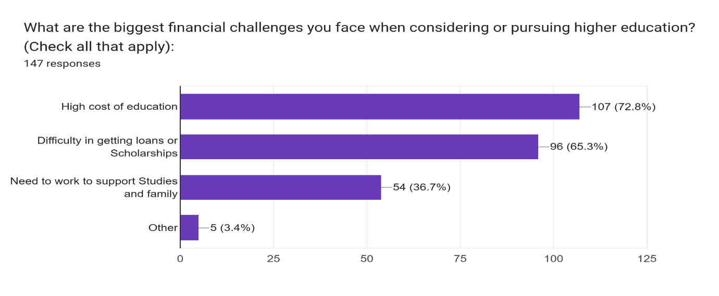

The above bar chart indicates that the majority of the respondents face financial challenges in different ways like the higher cost of education (72.8%), Difficulty in getting loans or scholarships (65.3%) and the need to work to support studies and family needs (36.7%) and other challenges (3.4%). The study inline with the study of Jhansi Rani (2021) and Priya Kumari (2021) who reported that financial problems are one of the major problems for the rural youth to access higher education in India.

**Geographical Challenges faced by Rural Youth in Education:** Students in rural areas may reside at significant distances from schools, creating transportation barriers and logistical difficulties.

**Figure No: 2 Distribution of the respondents by their Geographical Challenges**

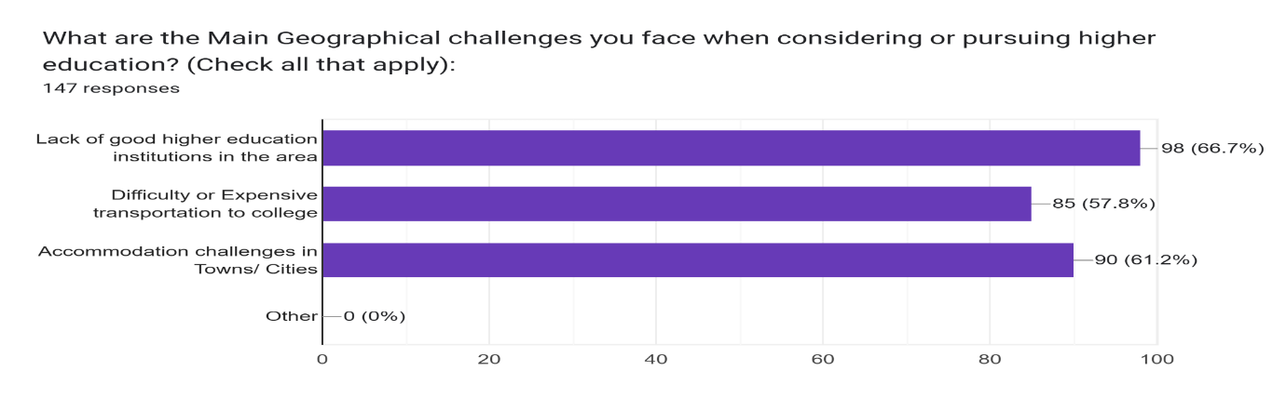

The above figure shows that most of the respondents are facing geographical challenges as follows 1. Lack of good higher education institutes in the area (66.7%) 2. Difficulty or expensive transportation to college (57.8%) 3. Accommodation problems in cities (61.2%).

**Educational Challenges Facing by Rural Youth:** Educational is only the way to come out from poverty and social inequality, all students should be provided with good resources and a better environment for education by ensuring equitable access to educational opportunities and empowering rural youth to reach their full potential and contribute to a thriving society.

**Figure No: 3 Distribution of the respondents by their challenges to accessing higher education**

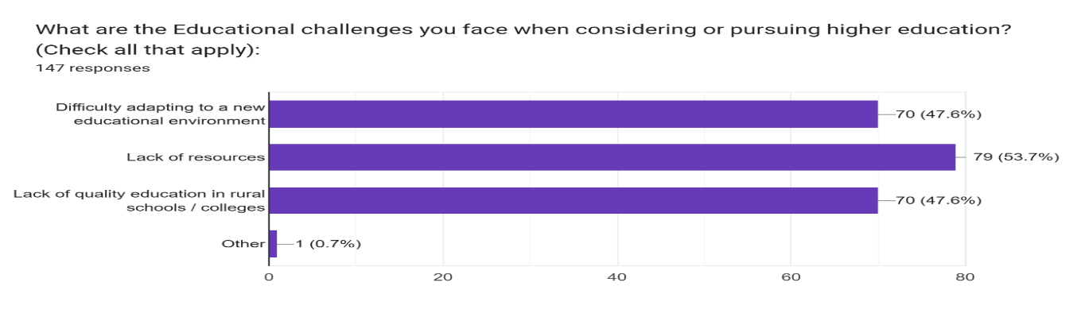

The above chart indicates that the respondents are facing challenges while studying: difficulty adapting to a new educational environment (47.6%), lack of resources (53.7%) and lack of quality education (47.6%).

***Social Challenges facing by Youth in rural area*:** Rural communities can limit access to educational resources beyond the classroom, such as educational enrichment programs, tutoring services, and technology at home due to their cultural issues and financial problems. Family structures may also play a role, with single-parent households or families with limited educational attainment facing challenges in providing adequate academic support.

**Figure No: 4 Distribution of the respondents by their social challenges**

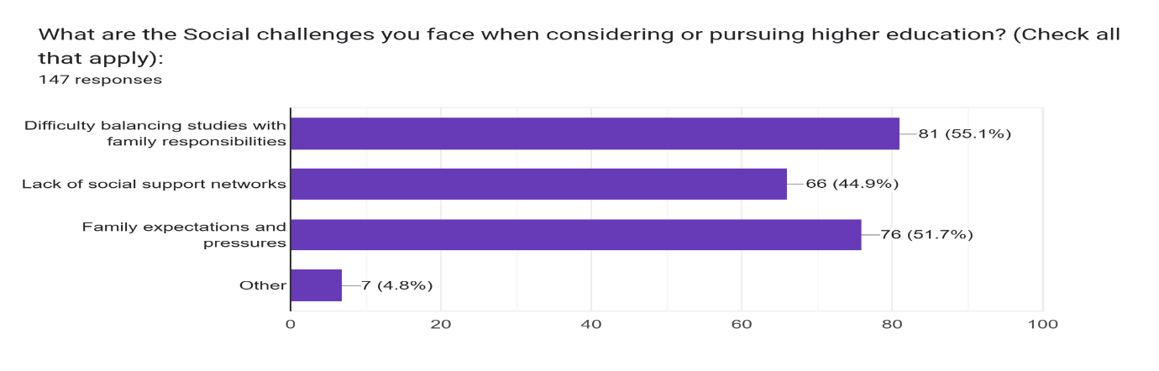

This bar chart indicates that the majority of rural students are facing social problems such as difficulty in balancing studies with family responsibilities (55.1%) & lack of social support networks (44.9%) and family expectations and pressures (51.7%). A study by Mutluri & Haranath (2023) reported that addiction to smartphones is also a challenge to continue their higher education. The study is inline with the study of Abraham (2015) who reported that a lack of technological skills i.e. working on computers, google is also a challenge to access the new educational programmes among rural youth. A study reported that the home environment and parents play the most significant factor in shaping educational aspiration by providing opportunities, encouragement and support for their adolescents learning (Safiya & Vishnu, 2017).

**Other Challenges Faced by Rural Youth While Studying:** Respondents in this study faced language barriers of 99.3% (learning English and Hindi is a challenge), followed by caste/gender discrimination (51.7%/23.1%) and 39.5% are of lack of awareness about higher education opportunities.

**Support needed to overcome the challenges:** Challenges are a natural part of life that can lead to personal growth and resilience when approached positively. Practical strategies, such as creating a plan, staying connected with a support system, and practising self-compassion, are essential for overcoming challenges.

**Table No: 2 Needed supports to overcome challenges**

|  |  |  |
| --- | --- | --- |
| Support needed | Frequency | Percentage |
| Financial support | 74 | 50.3% |
| Guidance and Mentorship | 119 | 81% |
| Resources like library, college, books, internet | 139 | 94.6% |
| Transportation and accommodation assistance | 26 | 17.7% |
| Other Support | 2 | 1.4% |

The above table showing a result that most of the respondents are in need of support through various forms like Resources (94.6%), Guidance and Mentorship (81%), Financial support (50.3%) & Transportation and Accommodation 17.7% and other support (1.4%).

**Career Aspirations of the Rural Youth:** The majority (39.5%) of the respondents in this study have career aspirations to become civil servants, followed by 24.5% wanting to become engineers and 22.4% doctors if they overcome the challenges faced by them.

**Awareness of government initiatives/schemes**: The Government of Andhra Pradesh initiated several welfare programs to promote higher education in rural areas, focusing on financial assistance, institutional development, and access to quality education. Some of them are Talliki Vandanam (Amma Vodi), Fee Reimbursement Scheme, Vidya Devena, Vasathi Devena, Rajiv Gandhi National Fellowship, Prime Minister's Special Scholarship Scheme (PMSSS), Post-Matric Scholarship Scheme and Mid-Day Meal to Intermediate Students. Almost all respondents (97.3%) in this study are not aware of government initiatives or schemes and very few of the respondents are aware of schemes which are provided to support the students for getting higher education. The study is in line with the study of Bala Murugan & Dhanasekaran (2015) who reported that 73% of the youth have knowledge of the government schemes. The study is inline with the study of Pralap Kumar Sethy (2023) who reported that the Government of India is spending a lot for the improvement of education in India.

**Higher education plays a crucial role in driving social change:** all respondents in this study believed that higher education is the only tool to drive social change and foster a more equitable and progressive society. The study is inline with the study of Khaja Nazimuddin (2017) who reported that the majority of the youth in India believe that higher education plays a crucial role in driving social change.

**Availability of NGO working in the rural education field:** all the respondents in this study confirmed that there is no NGO working in that area to improve rural education opportunities.

**If you could change one thing to improve the chances of rural students pursuing higher education, what would it be?:** Most of the respondents have an opinion that they could change things to improve the chances of pursuing higher education in rural areas as follows, mainly they need government colleges with free education in nearby villages, guidance and mentorship.

**5. Suggestions and Recommendations:**

***5.1 Suggestions to the Rural Youth*:** The following suggestions can be given to youth based on findings through the research survey and those are:

1. Rural youth should utilise available resources to complete their higher education.
2. Students can fulfil their career aspirations if they do hard work with positivity and zeal to complete their studies at any cost.
3. Students should not neglect their studies for other bad habits and be attracted to temporary money-earning methods.
4. Every student should get the awareness of the government initiatives and schemes which will be helpful in supporting their studies.
5. Students and their parents to be aware that the education is only way to change their lives and come out of poverty and discrimination and prosperity in their lives as well as in society.
6. Students should be aware that many organisations are providing support in the way of scholarships and mentorships for higher education students to pursue their studies.
7. Youth should fix their goal/ambitions in their childhood and then the goal will drive them in the correct direction.
8. Youth should always be in the search of best possible ways to fulfil their higher education goals.
9. Rural students should improve their communication skills to compete with their counterparts in their studies and to get jobs.
10. Students should be confident and they should adapt to the new educational environment with new technology and changes in the syllabus.

***5.2 Suggestions to the Government*:** The following suggestions can be given to the government to help rural youth pursue higher education, considering the focus on various aspects.

1. Improve access and infrastructure facilities like colleges, and libraries in the rural areas.
2. Ensure free transportation facilities for rural students from isolated areas to the college.
3. Promote digital education and access to technology like the internet to access online resources and learning platforms.
4. Provide financial aid, scholarships and loans to rural students to overcome the financial burdens of higher education.
5. Empower girls and women through awareness campaigns and support programs to ensure equal access to education.
6. Provide free accommodation facilities for rural students in the cities for their higher education.
7. Provide free coaching for rural students to improve their communication skills.
8. Provide skill development centres in rural areas to impart skills to get better job opportunities.
9. Ensure to provide quality education to the rural youth by recruiting qualified teaching staff in the colleges and universities.

***5.3 Suggestions to the NGO working in the education field*:** The following suggestions can be given to NGOs working in the education field to help rural youth pursue higher education.

1. Provide career counselling to rural youth through experienced career counsellors.
2. Conduct programs to Create awareness on government schemes and initiative towards higher education.
3. Provide guidance and mentorship to rural youth for their studies.
4. Organise workshops and camps to foster understanding and tolerance between rural and urban youth.
5. Provide financial support to rural students to pursue their higher education.
6. Foster a supportive network of peers, teachers and community members who can encourage and assist rural students in their educational journey.
7. Provide motivation by highlighting success stories to the rural youth which will help to inspire them.
8. Provide awareness sessions to overcome caste and gender discrimination in the villages in rural India.
9. NGOs should take part in connecting rural students to industries to get better job opportunities for rural youth.

**6. Conclusion**

Education is an important aspect for every individual in the society. Rural youth are a little backward in accessing higher education if compared with urban areas. Rural youth face many challenges in accessing higher education. The higher education institutes are far away from the rural areas. Speaking in other languages like English and Hindi is a challenge to the rural youth. Financial problems and agricultural responsibilities are also challenges to the rural youth. The government and NGOs should focus on rural youth, target their needs and develop their potential in their higher studies. Higher education is a powerful tool to provide societal benefits, impacting individuals, communities, and economic growth. It empowers individuals to reach their full potential, fostering critical thinking, innovation, and adaptability. Higher education in rural areas will be supported by the development of India.

**7. Limitations of the study**

This study is conducted in one village of West Godavari District, Andhra Pradesh. The data was collected from 147 students who completed their 10th class and facing challenges in accessing higher education. The sample size is small and the data was collected in the month of April 2025. The findings of the present study belong to this village only. There is a lot of scope to conduct research on this issue with a large sample size in rural, urban and tribal areas.

COMPETING INTERESTS DISCLAIMER:

Authors have declared that they have no known competing financial interests OR non-financial interests OR personal relationships that could have appeared to influence the work reported in this paper.

**8. References**

Abraham, M. (2015). Assessment of Basic Computer and Internet Skills among Students in Rural Areas of Prakasam District: A Study. *TechnoLearn: An International Journal of Educational Technology*, *5*(1and2), 1-7.

Aggarwal, J. C. (2009). *Philosophy and history of education*. Vikas Publishing House.

Bala, R. (2019). Rural youth in higher education in Punjab: A survey of parental attitude and facilities available within home. *Research Review International Journal of Multidisciplinary, 4*(5), 3189–3193. http://www.rrjournals.com/UploadArticle/3189-3193_RRIJM190405694.pdf

Balamurugan, P., & Dhanasekaran, G. (2015). Awareness and Utilisation of Govt. Welfare Schemes by Elderly in Selected Rural Areas of Tamilnadu. *PARIPEX - Indian Journal of Research*, 4 (9), 211-212.

Bhaskararaj, E. (2025). Nursing Education Made Easy, retrieved on 15-05-2025 from [Jaypee Digital | eBook Reader](https://www.jaypeedigital.com/eReader/chapter/9789386261571/ch1)

Cambridge Assessment. (2022). *Formal, non-formal, and informal learning: What are they and how can we research them?* <https://www.cambridgeassessment.org.uk/Images/665425-formal-non-formal-and-informal-learning-what-are-they-and-how-can-we-research-them-.pdf>[cambridgeassessment.org.uk+1ERIC+1](https://www.cambridgeassessment.org.uk/Images/665425-formal-non-formal-and-informal-learning-what-are-they-and-how-can-we-research-them-.pdf?utm_source=chatgpt.com)

Chaudhary, S. (2024, December 9). Rural literacy rate up by 10 percentage points in last 10 yrs. [Business Standard](https://www.business-standard.com/india-news/rural-literacy-rate-up-by-10-percentage-points-in-last-10-yrs-govt-in-ls-124120901182_1.html). [Business Standard](https://www.business-standard.com/india-news/rural-literacy-rate-up-by-10-percentage-points-in-last-10-yrs-govt-in-ls-124120901182_1.html)

Dewey, J. (1938). *Experience and education*. Macmillan.

Elice, D., Maseleno, A., & Pahrudin, A. (2023). Formal, informal and non-formal education systems. *Journal of Learning and Educational Policy*, 4(1), 30–35. <https://doi.org/10.55529/jlep.41.30.35>[ResearchGate+2HM Journals+2Grafiati+2](https://journal.hmjournals.com/index.php/JLEP/article/view/3180?utm_source=chatgpt.com)

Farswan, D. S. (2023). Role of education and culture in social development. *Journal of Social Review and Development*, 2(1), 13–16.

Irvin, M.J., Byun, S.Y., Meece, J.L., Farmer, T.W. (2012). Educational Barriers of Rural Youth: Relation of Individual and Contextual Difference Variables. *J Career Assess,* 20(1):71-87. doi: 10.1177/1069072711420105.

Jansi Rani, & Aruna, R. (2021). Challenges of rural women in pursuing higher education. *International Journal of Research and Analytical Reviews, 8*(1), 451–455. https://doi.org/10.6084/m9.figshare.13638449.v1

Khaja, N. (2017). Changing Educational Aspirations of Youth Among Muslim Community in Karimnagar District of Telangana State. *Desh Vikas,* 4 (2), 195-198.

Kumar, N. M. S., & Ashwini, S. (2018). Challenges for rural girl students in higher education: A study in Mysuru district. *Journal of Emerging Technologies and Innovative Research (JETIR), 5*(5), 1038–1050. http://www.jetir.org/papers/JETIR1805912.pdf

Kumari, P., & Jyoti, K. (2021). Challenges of rural women in pursuing higher education. *International Journal of Creative Research Thoughts, 9*(12), 34–39. https://doi.org/10.6084/m9.figshare.147174619546.v1

Ministry of Human Resource Development. (2020). *National Education Policy 2020*. Government of India. https://www.education.gov.in/sites/upload_files/mhrd/files/NEP_Final_English_0.pdf

Mutluri, A. (2020). The Youth of Particularly Vulnerable Tribal Groups (PVTGs) and their Livelihood Practices in India. *Antrocom: Online Journal of Anthropology*, *16*(2).

Mutluri, A., & Haranath, S. (2023). Understanding the smartphone addiction among the student youth: an empirical study. *International Journal of Recent Scientific Research*, 14 (7), 3610-3615

Pralapkumar, S. (2023). Reachability of Right to Education Act in Odisha: A Study, *Social Vision,* 10 (3), pp: 1-11

Rajesh, S. (2024). India’s young harbour big plans, People Research on India’s Consumer Economy, retrieved on 25-05-2025 from <https://www.price360.in/articles-details.php?url=indias-young-harbour-big-plans>

Safiya, M., & Vishnu, m. S. (2017). Educational Aspiration among Adolescent Girls: First Step in Pipeline, *Mahila Pratishtha*, 3 (1), 157-161

Shantinath, A.B. (2021). Status of Higher Education in Rural Areas of India. *International Journal of Creative Research Thoughts*, 9 (8), 497-504.

UNESCO. (2015). *Rethinking education: Towards a global common good?* United Nations Educational, Scientific and Cultural Organization. <https://unesdoc.unesco.org/ark:/48223/pf0000232555>