Original Research Article

School Environment and Students’ Academic Performance: A Comparative Study of Public and Private Primary Schools in North 24 Paraganas District

**ABSTRACT**

Primary education is the foundation of a child’s educational journey and plays a crucial role in their overall development. The purpose of this study is to compare the school environment and academic performance of students between public and private primary schools in the North 24 Parganas district of West Bengal. Descriptive survey design was employed for the present study. Through random sampling, a sample of 200 Class III students was selected from two government schools and two private schools. Data were collected using researcher made Academic Performance Test (APT) with reliability coefficient of 0.92 and by administering a checklist for collecting information regarding school environment covering three dimensions i.e, infrastructure, teaching-learning process and extracurricular activities. For analyzing the data, independent samples t-test and Pearson product moment correlation were employed. The findings of the study revealed that the academic performance of private school students was found to be superior to that of public school students, whereas female students outperformed male students. Moreover, a significant positive correlation was found between students’ academic performance and the school environment. The findings of the present study signify the impact of a supportive school environment on students’ academic achievement. The study highlights the importance of an enabling school environment for improving students’ academic performance, advocating for infrastructural developments, engaging teaching-learning and enriching academic climate. Future research may be carried out to a broader geographical area, larger sample size and at different levels of school education.

*Keywords:**Academic performance, School environment, Public school, Private school.*

**1. INTRODUCTION**

Education plays a crucial role for societal development, fostering individual growth and contributing to national progress (Cheek et al., 2015 & Turkkahraman, 2012). It serves as a medium for the transmission of knowledge, cultivation of skills and formation of attitudes essential for navigating the complexities of the modern world (UNESCO, 2018). Countries worldwide have prioritized initiatives aimed at enhancing access, equity and quality of education to empower citizen and to augment socio-economic advancement. Primary education is the foundation of child’s educational journey and provides a strong base for individual’s future progress in the field of education.

The Indian Education Commission of 1964, chaired by D.S.Kothari, famously asserted that “the destiny of India is being shaped in her classrooms” led to numerous legislative reforms aimed at ensuring educational access and improving standards. The Right to Education (RTE) Act of 2009, mentioned under Article 21A of the Indian constitution, led to a significant turning point in the history of Indian education.

In India’s primary education system, formal education is delivered within controlled and structured educational settings with prescribed curriculum and instructional methodologies. These educational settings serve for nurturing students' cognitive, socio-emotional and behavioral developments, laying the foundation for future academic pursuits and societal engagement. The school environment comprising of factors such as physical infrastructure, teaching practices, learning inputs and extracurricular activities, profoundly influences student’s academic experiences and outcomes.

Despite extensive research and studies on various aspects of primary education in India, there is a significant gap in comparative studies that examine the relationship between students’ academic performance and the school environment in the both public and private primary schools. This study seeks to fill this gap by comparing these variables in West Bengal’s public and private primary school, focusing on academic performance, classroom dynamics, teacher-student interactions, and infrastructural facilities.

**1.1 Emergence of the problem**

The Unified District Information System for Education (U-DISE) shows a significant shift in enrollment trends among government, private unaided and private aided primary schools. In 1978, government schools accounted for 74.1% of student enrollment, while private unaided and private aided school held minor shares of 3.4% and 22.5% respectively. By 1993, government school enrollment decreased to 70.8%, while private unaided and private aided school enrollment increased to 9.2% and 20%, respectively. By 2017, government school enrollment declined to 52.5% with private unaided schools increasing to 34.8% and private aided schools to 11.5% (UDISE+ Report, 2021-22).

The emergence of this problem raised critical questions regarding the underlying factors driving the observed shift in enrollment patterns. Factors such as perceived quality of education, availability of infrastructural facilities and other educational services likely influence parent’s decision in choosing private schools over public schools.

**1.2 SIGNIFICANCE OF THE STUDY**

This research aims to explore how different educational environments impact students’ academic performance in public and private primary schools within North 24 parganas district of West Bengal. Findings of the study can help administrators and legislators design intervention that cater to the unique requirements of each student, enhancing educational quality and equity. Teachers, parents and other stakeholders can use the findings to take their decisions on school selection, resource distribution and educational support.

**2. LITERATURE REVIEW**

Many studies have examined different aspects of school education and compared public and private schools in India and abroad. Rather (2023) compared the differences in study habit and academic achievement between private and government secondary school students and found a considerable disparity in the study habits and academic achievement between private and government secondary school students. Baruah et al. (2022) compared government and private elementary schools in Dibrugarh, Assam and explored that private schools excelled in areas like specialized teachers, infrastructural facilities and evaluations, whereas government schools were able to provide only the most essential facilities. Singh et al. (2022) explored the influence of school environments on high school students' academic performance, identifying a significant impact of academic climate and safety on student outcomes. Sharma et al. (2022) emphasized the importance of effective teaching methods in enhancing student learning in India.

Agbofa (2022) in his study compares academic performance indicators between public and private junior high schools in the Effutu Municipality, Ghana. Using a survey of 385 teachers, factors such as teacher practice, supervision, time usage, resource endowment, motivation and parental support were examined and found that students of private schools showed higher performance across most indicators. Kisigot et al. (2022) investigated how learning environments affect students' academic achievement and revealed that physical, social and teaching environments impact academic success of students. They recommended funding for school improvement and teacher training for better outcomes. Baafi (2021) employed a descriptive survey design, gathering data from 370 senior high school students in Ghana to assess the impact of the school physical environment on students’ academic performance. The study unveiled a positive and significant influence of the school environment on students’ academic performance. Key factors identified include the availability of infrastructural facilities, water, toilets, fire equipment, teaching methods and engagement in co-curricular activities as crucial elements, affecting students’ academic achievement. Kalasa et al. (2023) compared learner performance in private and public secondary schools in Lusaka district. They looked at different school activities, classroom management, teacher-pupil engagement and curriculum implementation. Using interviews, questionnaires, and observation, they found that factors like qualified teachers, proper management and adequate resources influenced students’ academic performance.

The literature on the impact of school environments on students' academic outcomes is extensive, but there is a gap in research in the context of West Bengal. This study aims to address this gap by comparing the school environment and students’ academic performance of public and private primary schools.

**3. OBJECTIVES**

1. To compare the mean scores of academic performance between students of public and private primary schools.
2. To compare the mean scores of academic performance between students of public and private primary schools in terms of gender.
3. To find out the relationship between school environment and academic performance of students of public and private primary schools.

**4. HYPOTHESES**

**H01:** There is no significant difference in the mean scores of academic performance between students of public and private primary schools.

**H02:** There is no significant difference in the mean scores of academic performance between students of public and private primary schools in terms of gender.

**H03:** There is no significant correlation between school environment and academic performance of students of public and private primary schools.

**5. METHODS**

**5.1 Research Design**

The present study employed a descriptive survey research design to compare students’ academic performance in public and private primary schools. To study the relationship between school environment and students’ academic performance, correlational method was also applied.

**5.2 Population**

The population of the study comprised all primary school students in the North 24 parganas district of West Bengal.

**5.3 Sampling Techniques and Sample**

Random sampling technique was employed to select the schools and then all the students of class III were taken as sample from four selected schools, among which two were private and two were public school. A total of 200 students were taken as sample for the study. A detail description of sample is shown below in figure 1.

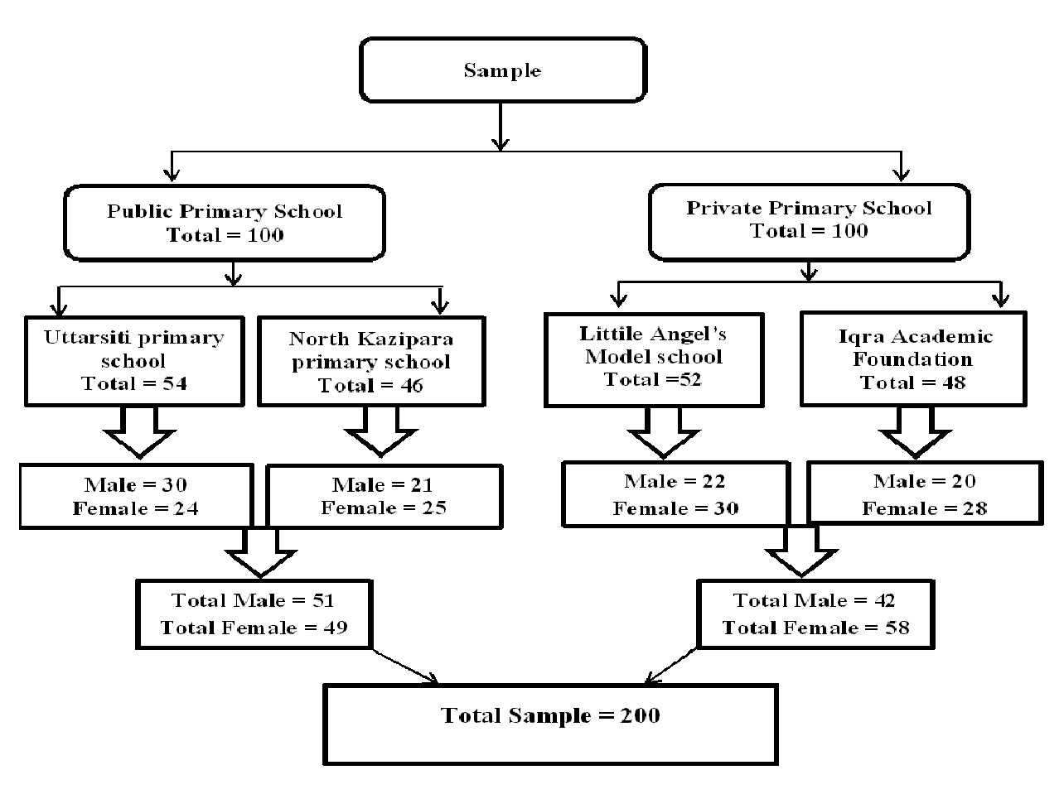

**Fig. 1. Description of Sample**

**5.4 Tool Used for Data Collection**

The Academic Performance Test (APT), based on three subjects namely Environmental Science, English and Mathematics, developed and standardized by the researcher was administered to assess students' academic performance. Reliability coefficient of the test was computed using Cronbach’s Alpha method and found to be 0.92 and the test was validated by incorporating suggestions from three subject experts. Additionally, a researcher-made checklist was utilized to gather data on school environment covering three dimensions namely, infrastructural facilities, teaching-learning processes and co-curricular activities of the school to get an overview of the total school environment.

**5.5 Data Collection**

At first, the researcher visited various public and private schools seeking permission to obtain data. After obtaining permission from the headmasters of two public and two private schools, the Academic Performance Test (APT) was employed to collect data regarding academic performance of Class III students. In addition to that, the researcher collected overall information of the school environment using the checklist. These systematic procedures ensured the comprehensive collection of data while maintaining adherence to ethical standards and protocols.

**5.6 Statistical Techniques Used for Data Analysis**

The statistical techniques applied for data analysis included mean, independent samples t-test, and Pearson product moment correlation. Data analysis was done with the help of SPSS.

**6. RESULTS**

**6.1 Normality of Data**

Normality of the test scores has been checked by calculating skewness, kurtosis and by Kolmogorov-Smirnov test of normality with the help of SPSS and the results are given below in Table 1 and Table 2 respectively. Normality of the data also shown with the help of Histogram, Q-Q Plot and it was also checked that if there is any outlier in the data by using Box Plot as shown in figure 2. It is found that the data is normal and no outlier exists in the data.

**Table 1. Summary of descriptive statistics of academic performance test score**

|  |  |  |  |  |  |  |  |
| --- | --- | --- | --- | --- | --- | --- | --- |
| **Mean** | **Std. Deviation** | **Skewness** | | **Kurtosis** | | **Z Value of Skewness** | **Z Value of Kurtosis** |
| **Statistic** | **Statistic** | **Statistic**  **(A)** | **Std. Error**  **(B)** | **Statistic**  **(C )** | **Std. Error**  **(D)** | **A ÷ B** | **C ÷ D** |
| 38.47 | 13.18 | -0.308 | 0.254 | -0.140 | 0.503 | -1.21 | -0.28 |

**Table 2. Test of normality**

|  |  |  |
| --- | --- | --- |
| **Kolmogorov- Smirnov** | | |
| **Statistic** | **df** | **Sig.** |
| 0.074 | 90 | 0.200* |

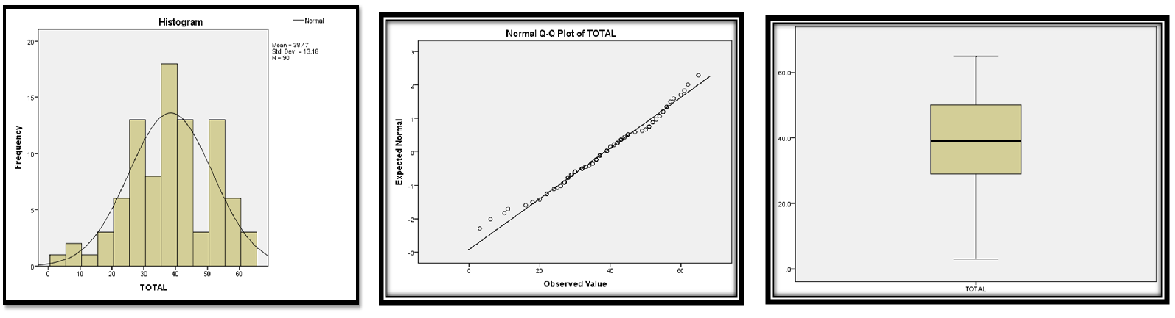**Fig. 2. Histogram, Q-Q Plot and Box Plot showing normality of data**

**Testing of H01**: For comparing the mean scores of academic performance between students of public and private primary schools, data analysis was done using an independent samples t-test and the results are shown below in Table 3.

**Table 3. Comparison of the mean scores of academic performance between students of public and private primary schools**

|  |  |  |  |  |  |
| --- | --- | --- | --- | --- | --- |
| **Type of School** | **N** | **Mean Score** | **SD** | **t- value** | **Significance**  **Level** |
| **Public School** | 100 | 28.14 | 5.56 | 11.84 | Significant at 0.01 level |
| **Private School** | 100 | 36.28 | 4.05 |

Table 3 shows that the calculated 't' value is 11.84 which is significant at 0.01 level with df 198. Therefore, the first null hypothesis which states that there is no significant difference in the mean scores of academic performance between students of public and private primary schools is rejected. Hence, it can be said that as compared to students in public primary schools, students in private primary schools achieved significantly higher scores on the Academic Performance Test.

Table 3 also shows that the mean score of academic performance of students of public primary schools was 28.14, while it was 36.28 for private primary schools. It means that the students of private primary schools performed better as compared to the students of public primary schools.

**Testing of H02**: For comparing the mean scores of academic performance between students of public and private primary schools in term of gender, data were analysed using an independent samples t-test and the results are shown below in Table 4.

**Table 4. Comparison of the mean scores of academic performance between students of private and public primary schools in terms of gender**

|  |  |  |  |  |  |
| --- | --- | --- | --- | --- | --- |
| **Name of the group** | **N** | **Mean Score** | **SD** | **t- value** | **Significance**  **level** |
| **Male** | 94 | 30.38 | 5.78 | 3.98 | Significant at 0.01 level |
| **Female** | 106 | 33.83 | 6.39 |

Table 4 shows that the calculated 't' value is 3.98, which is significant at the 0.01 level with df 198. Therefore, the second null hypothesis, that there is no significant difference in the mean scores of academic performance between students in public and private primary schools in terms of gender, is rejected. Hence, it indicates that male and female students perform very differently in the classroom. Female students achieved significantly higher scores on the academic performance test as compared to their counterparts. Table 4 also shows that, the mean score of academic performance was 30.38 for male students, while for female students, the mean of academic performance was 33.83. It means that female students perform better in academic performance test as compared to male students in both public and private primary schools.

**Testing of H03**: For studying the correlation between school environment and students’ academic performance, data were analyzed using Pearson product moment correlation and the outcomes are given below in Table 5.

**Table 5. Pearson correlation coefficient between school environment and students’ academic performance**

|  |  |  |
| --- | --- | --- |
| **Variables** | **Correlation Coefficient**  **( r )** | **Remark** |
| School Environment | 0.94 | Significant at 0.01 level |
| Academic Performance |

From Table 5, it can be noticed that correlation coefficient between school environment and students' academic performance is 0.94 which is significant at 0.01 level. It reveals that there is a significant positive correlation between school environment and academic performance of students. Thus the hypothesis in null form that there is no significant correlation between school environment and academic performance of students of public and private primary schools is rejected. Therefore, the school environment and academic performance of students are positively correlated with each other.

**7. DISCUSSION**

The present study revealed that the students in private primary schools outperform their counterparts in public schools, which is consistent with the findings of previous researches conducted by Rather et al. (2023), Agbofa (2022), Kalasa et al. (2023) and Gupta et al. (2019) who found superior academic performance of students in private schools than public schools. This superiority in academic performance is attributed to factors such as better infrastructural facilities, more engaging teaching learning and co-curricular activities prevalent in private institutions (Baruah et al., 2022; Kalasa et al., 2023). Private schools in our country provides better infrastructural facilities, an engaging learning environment created by active and disciplined teachers and noteworthy extra-curricular activities which in total create a conducive academic environment that leads to improved academic performance of its students.

The study also found that female students consistently outperformed male students in both public and private schools, reflecting previous findings by Sheergugri (2021) and Singh (2021). This highlights the importance to address gender gaps in education and investigate the elements influencing gender based differences in academic performance in different type of schools.

Findings of the third objective revealed that there is a significant positive correlation between school environment and academic performance of students, as highlighted by Shanoji et al. (2018) and Singh et al. (2022). This finding highlights the important component of factors such as school environment and academic climate in shaping students' academic outcomes. A positive school atmosphere, characterized by supportive teachers and well-maintained infrastructural facilities, fosters student motivation and engagement, ultimately enhancing academic performance (Baafi, 2022). Conversely, inadequate resources and unsupportive environments can hinder students’ learning, which is very common in most of the public schools. To address this, investments in improving infrastructure, professional development for teachers and fostering a culture of engagement, activity and safety are essential.

Moreover, improving the academic climate through curriculum enrichment, adopting engaging teaching-learning process and access to extracurricular activities can further promote student success across both public and private schools. Policymakers need to enact reforms targeting the disparities in the school environment between public and private primary schools, focusing on improving infrastructural facilities, enhancing teacher engagement and fostering a supportive academic climate in public schools to promote educational equity. Equitable resource allocation is paramount to ensuring quality education for all students, necessitating adequate funding and allocation to public schools to bridge infrastructural gaps.

**8. CONCLUSION**

The present study made a comparative analysis of students’ academic performance and school environment between public and private primary schools in the district of North 24 Parganas of West Bengal and also aimed to find out the relationship between school environment and academic performance of students. Findings of the study revealed significant differences in academic performance between public and private primary school students, where private school students outperforming their counterparts. Gender-based comparison also showed significant difference in academic performance, indicating that female students performed better academically as compared to male students in both type of schools. Further, this study indicated positive correlation between school environment and academic performance of students, highlighting the importance of infrastructural facilities, teaching-learning process and co-curricular activities. Government and stakeholders must bring some reforms to reduce the prevailing disparities in the school environment between public and private schools. Further research may be carried out on broader geographical area, larger sample sizes and at different level of school education.

**REFERENCES**

1. Agbofa, F. J. K. (2022). Exploring the Difference in Academic Performance Determinants between Public and Private Junior High Schools. Creative Education, 14(1), 182-196.
2. Baafi, R. K. A. (2021). The Impact of School Learning Environment on Students’ Academic Performance in Senior High Schools in the Greater Accra Region, Ghana. Doctoral Dissertation, Eotvos Lorand University, Budapest, Hungary.
3. Baruah, D., Konwar, B., Das, C., & Chakhap, C. (2022). Comparative Analysis of Government and Private Schools at Elementary Level: A Study of Dibrugarh District of Assam. Journal of Positive School Psychology, 6(12), 2398-2405.
4. Cheek, D. W., Buss, T. F., & Onwuegbuzie, A. J. (2015). The Role of Education in Development: An Empirical Assessment of the Human Capital, Human Rights, and Human Development Perspectives. International Journal of Educational Development, 41, 153–162.
5. Gupta, R., Sharma, A., & Verma, S. (2019). Impact of Teacher Professional Development on Students’ Performance in India. Journal of Educational Research and Policy Studies, 9(2).
6. Kalasa, S., Phiri, A., & Chitondo, L. (2023). A comparative Analysis of Learner Performance in Public and Private Schools: A Case of Twenty Secondary Schools in Lusaka District. International Journal of Novel Research in Education and Learning, 10(5), 76-85.
7. Kisigot, C. K., Ogula, P., & Munyua, J. (2022). Relationships of Learning Environment, School Type, and Secondary School Students’ Academic Achievement in Marakwet East Sub-County, Kenya. International Journal of Humanities, Social Sciences and Education, 9(6), 77-88.
8. Rather, T. (2023). A Comparative Study of Study Habits and Academic Achievement Among Government and Private Secondary School Students. Annals of the Bhandarkar Oriental Research Institute, 44(1), 123-138.
9. Shanoji, S., Gupta, R., & Verma, A. (2018). Home Climate and Academic Achievement: A Comparative Study of Private and Government Secondary School Students. Journal of Educational Psychology and Social Sciences, 8(2), 123-136.
10. Sharma, D., Sood, A. K., Darius, P. S. H., Gundabattini, E., Gnanaraj, S. D., & Jeyapaul, A. (2022). A Study on the Online-Offline and Blended Learning Methods. Journal of the Institution of Engineers (India): Series B, 103, 1373–1382.
11. Sheergugri, S. A. (2021). A Comparative Study of Academic Achievement of Government and Private Secondary School Students in Gwalior City of Madhya Pradesh. International Journal of Advance Research and Innovative Ideas in Education, 7(4), 347-354.
12. Singh, A., Sharma, R., & Gupta, S. (2022). Influence of School Environment on Academic Performance of High School Students. Journal of Educational Research and Practice, 12(3), 123-136.
13. Singh, N. (2021). Study of the Academic Achievement of the Students at Elementary Level in the Government Schools of Delhi. International Journal of Advance Research and Innovative Ideas in Education, 7(4), 347-354.
14. **Turkkahraman, Y. (2012). Education in Nigeria: The impact on individual and national development. International Journal of Educational Development, 32(4), 612–618.**
15. Unified District Information System for Education Plus (UDISE+) Report, 2021–22.