Threatened freshwater faunal species of India and their conservation strategies

ABSTRACT
Freshwater ecosystems in India, encompassing rivers, lakes, ponds, and wetlands, are home to a rich variety of aquatic life, including mammals, fish, amphibians, crustaceans and mollusk. These ecosystems rely on a delicate balance of food chains and food web, with aquatic plants serving as the primary producers. India's freshwater ecosystems support a rich diversity of aquatic life, including threatened species like the Ganges River Dolphin, Ganges Shark, Mugger Crocodile, and Hump-backed Mahseer. Human activities such as pollution, overfishing, habitat destruction, and fragmentation have significantly impacted these species, leading to population declines and local extinctions. This study documents 19 threatened freshwater fauna in India. The present study reviews that aquatic fauna relies on vegetation for food, shelter, breeding, and nesting, and that changes in water quality and vegetation composition can have cascading effects on faunal populations. Effective conservation approaches include awareness programs, anti-poaching efforts, pollution control, habitat restoration, and restoring native vegetation. This study emphasizes the need for urgent conservation action to protect India's freshwater ecosystems and the threatened species that depend on them.
Keywords: Freshwater ecosystems, threatened aquatic fauna, associated vegetation, habitat restoration, conservation
INTRODUCTION
India's freshwater ecosystems are home to a diverse array of faunal species. The country's rivers, lakes and wetlands support a wide range of aquatic life, including fish, amphibians, waterbirds and mammals like otters and dolphins. Freshwater ecosystems provide essential services such as water filtration, flood control, and habitat for biodiversity, while also supporting the livelihoods of communities dependent on them. Gangetic dolphin, India's national aquatic animal, inhabits the Ganges-Brahmaputra River system but is categorized as Endangered due to a significant decline in population, with fewer individuals remaining (Braulik and Smith 2017). Another species such as the Smooth-Coated Otter, found in the known to be distributed in major rivers of Southeast Asia and in India from Himalayas to the Southern part of India is experiencing a decline in population and distribution range due to anthropogenic pressures, including pollution (Arivoli and Narasimmarajan 2021). In freshwater ecosystems, many fish species often coexist in communities, making the entire fish population vulnerable to changes in water's physio-chemical characteristics, such as pollution, disease, or overfishing. As key faunal communities, fish play a vital role in aquatic food webs. Some fish populations are confined to specific, isolated areas, rendering them susceptible to localized changes in water quality. Diadromous fish species, which migrate between freshwater and saltwater habitats, face additional threats from predators, pollution, and overfishing during their migrations. Human activities like overfishing, pollution, and land-use changes have significantly impacted aquatic faunas, particularly fish. Due to the challenges in monitoring fish populations, many species become threatened or extinct without detection. This has led to fishless lakes or degraded fish communities in regions like Eurasia and North America (Maitland 1995; Maitland and Crivelli 1996). Species like the Humpbacked Mahseer, Peninsular hill trout and Tambraparini barb are some threatened fishes of India that face threats from habitat degradation, fragmentation and overfishing. The changes in the fresh water ecological system and habitat loss are evident from the existing floral diversity (Miranda and Miqueleiz 2021). This is because the aquatic faunal species are directly or indirectly dependent on the associated flora. Freshwater ecosystems are facing significant threats due to pollution, which degrades water quality, harms aquatic life and disrupts the delicate balance of these systems. Pollutants like nutrients, pesticides, metals and persistent organic pollutants contaminate water bodies, altering their chemical composition and affecting biodiversity (Knight and Boyer 2007). This can lead to a decline in species diversity, disrupt food webs, and increase vulnerability to climate change. Such pollution can have implications on the existence of many freshwater faunal species. This documentation aims to compile information on selected threatened aquatic fauna, their roles in food webs, and the significance of their relationships with associated vegetation. It also explores ways to restore and conserve the habitats of these vulnerable species, highlighting the importance of preserving ecological balance and biodiversity in aquatic ecosystems.
METHODOLOGY
Present study conducts a comprehensive literature review to gather information on threatened aquatic fauna in India, focusing on species listed in the IUCN Red List. The review examines their current status, feeding habits, relationships with associated vegetation, and identified threats. Additionally, the study highlights the importance of vegetation in conserving these species. Field surveys were conducted in various aquatic habitats, including marshes, lakes, and rivers, to observe the behavior and feeding habits of aquatic fauna, providing valuable insights into their ecological roles and conservation needs (Kumar, 2025).
RESULTS AND DISCUSSION
The present study documents 19 threatened freshwater fauna including 5 fishes, 5 turtles, 3 crabs, 2 mammals, 1 crocodile, 1 gharial and 2 mollusks that comes under different category of IUCN threatened list as Endangered (EN), Critically Endangered (CR), Vulnerable (VU) and Near Threatened (NT) listed in Table 1.
Table 1: Some important threatened freshwater aquatic fauna of India
Common name | Scientific name | Family | IUCN Status
Black pond turtle | Geoclemys hamiltonii | Geoemydidae | EN
Black softshell turtle | Nilssonia nigricans | Trionychidae | CR
Crab | Liotelphusa quadrata | Gecarcinucidae | VU
Crab | Oziothelphusa biloba | Gecarcinucidae | VU
Crab | Phricotelphusa elegans | Gecarcinucidae | VU
Deccan labeo | Labeo potail | Cyprinidae | EN
Fingernail clam | Sphaerium austeni | Sphaeriidae | NT
Ganges river dolphin  (Figure 3) | Platanista gangetica | Platanistidae | EN
Ganges shark | Glyphis gangeticus | Carcharhinidae | CR
Gharial (Figure 2) | Gavialis gangeticus | Gavialidae | CR
Hump-backed mahseer | Tor remadevii | Cyprinidae | CR
Indian softshell turtle  (Figure 1) | Nilssonia gangetica | Trionychidae | EN
Leith’s softshell turtle | Nilssonia leithii | Trionychidae | CR
Mugger (Figure 4) | Crocodylus palustris | Crocodylidae | VU
Peninsular hill trout | Lepidopygopsis typus | Cyprinidae | EN
Pond snail | Lymnaea ovalior | Lymnaeidae | VU
Red-crowned roofed turtle | Batagur kachuga | Geoemydidae | CR
Smooth-coated otter | Lutrogale perspicillata | Mustelidae | VU
Tambraparini barb | Dawkinsia tambraparniei | Cyprinidae | EN
(EN: Endangered; CR: Critically endangered; VU: Vulnerable; NT: Near threatened)
Glyphis gangeticus or the Ganges shark is a species that inhabits tropical rivers in freshwater as juveniles and subadults, while adults are found in coastal and marine environments. However, its population has declined drastically, by over 80%, in the last three generations due to intensive fisheries for meat and its fin. Historically, the species had a patchy distribution across the Indo-West Pacific region, with reported occurrences in Bangladesh, India, Malaysia, Myanmar, Pakistan, and Indonesia. Unfortunately, it is possibly extinct in Malaysia, Myanmar, and Pakistan. The Ganges shark's habitat is under severe threat from human activities such as intensive fishing, pollution, sand mining, power plant construction, dam development, and increased river usage. In India, the species is protected under Schedule I, Part II A of the Wildlife (Protection) Act, 1972 (Rigby et al., 2021). Crocodylus palustris or the Mugger crocodile is a medium-sized species native to the Indian subcontinent, historically found in freshwater habitats like lakes, rivers, and marshes in India, Iran, Nepal, Pakistan, and Sri Lanka. However, it is possibly extinct in Bangladesh, Bhutan, and Myanmar. Listed as Vulnerable on the IUCN Red List, the population has declined by about 20% over the last three generations. The main threats include habitat fragmentation and destruction, entanglement in fishing nets, egg predation, and the use of crocodile parts for medicinal purposes. As a top predator in aquatic ecosystems, Muggers play a crucial role in maintaining ecological balance. Conservation efforts, such as habitat protection, controlling human activities, and reducing pollution and illegal trade, are essential to restore the population and ensure the long-term health of freshwater ecosystems (Silva and Lenin 2010). Tor remadevii or The Hump-backed Mahseer is a critically endangered freshwater fish endemic to the Cauvery River and its tributaries in the Western Ghats. With a population decline of over 90% in three generations, it faces severe threats from overexploitation and the introduction of non-native species that disrupt its habitat. Found only in Karnataka, Kerala, and Tamil Nadu in India, the species has largely disappeared from most of its known habitats (Pinder et al., 2018).
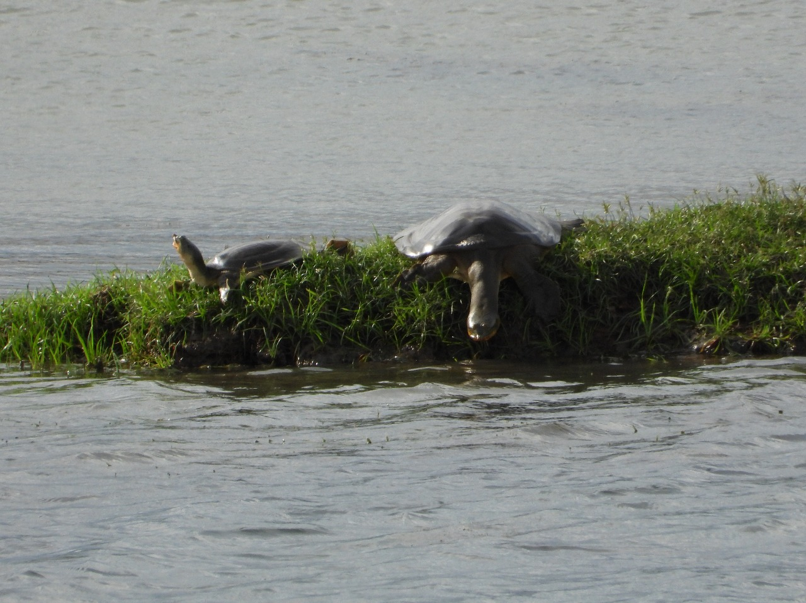
Figure 1: Indian softshell turtle in Mahanadi River
Turtles feed on small aquatic insects and mollusc and aquatic plants. The freshwater clam feed on phytoplankton, diatoms and macroalgae. The Ganges River Dolphin feed mainly on fishes that directly or indirectly consume aquatic plants and phytoplankton. The fresh water snails feed on the detritus macrophytes and phytoplankton. There are direct or indirect relationship with the surrounding vegetation and any changes in the physiochemical nature of the water affecting the vegetation affects the nature of the faunal existence. Vegetation like Vallisneria spiralis, Hydrilla verticillata, Ipomoea aquatica, Neptunia oleoracea, Nelumbo nucifera, Trapa natans, Wolffia globosa, Azolla pinnata (Devi et al., 2022) and algae like Blue green algae, macroalgae are commonly feed on by small fishes, aquatic birds, turtle and other herbivores of the aquatic ecosystem.
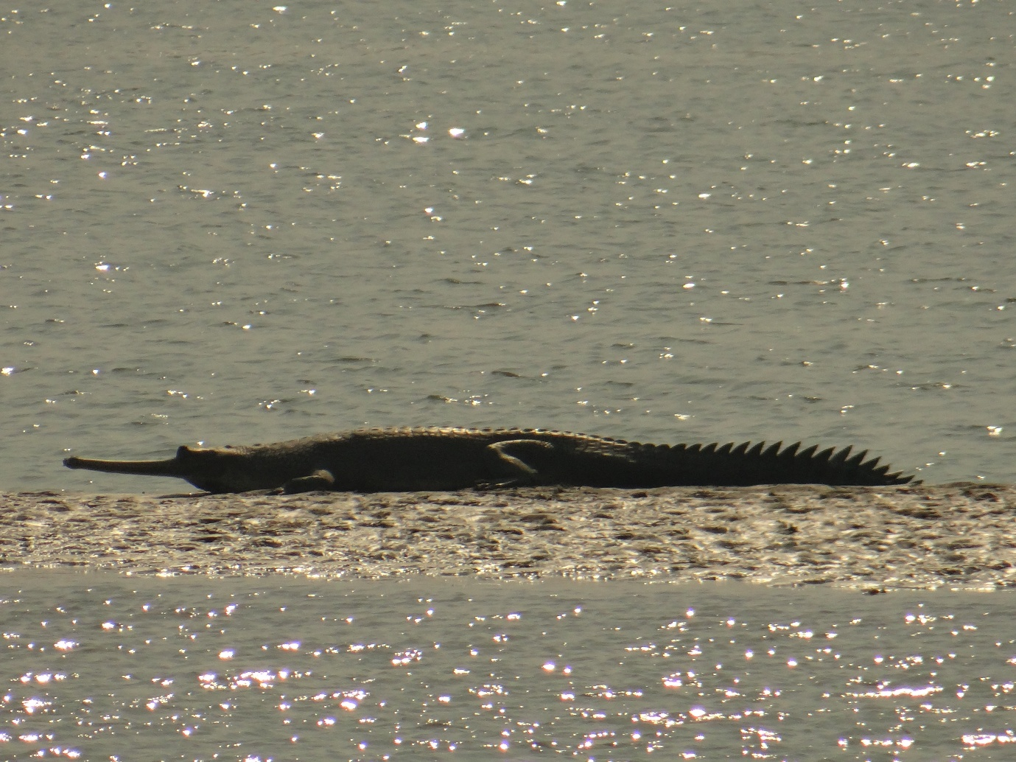
Figure 2: Gavialis gangeticus basking in Gandak River
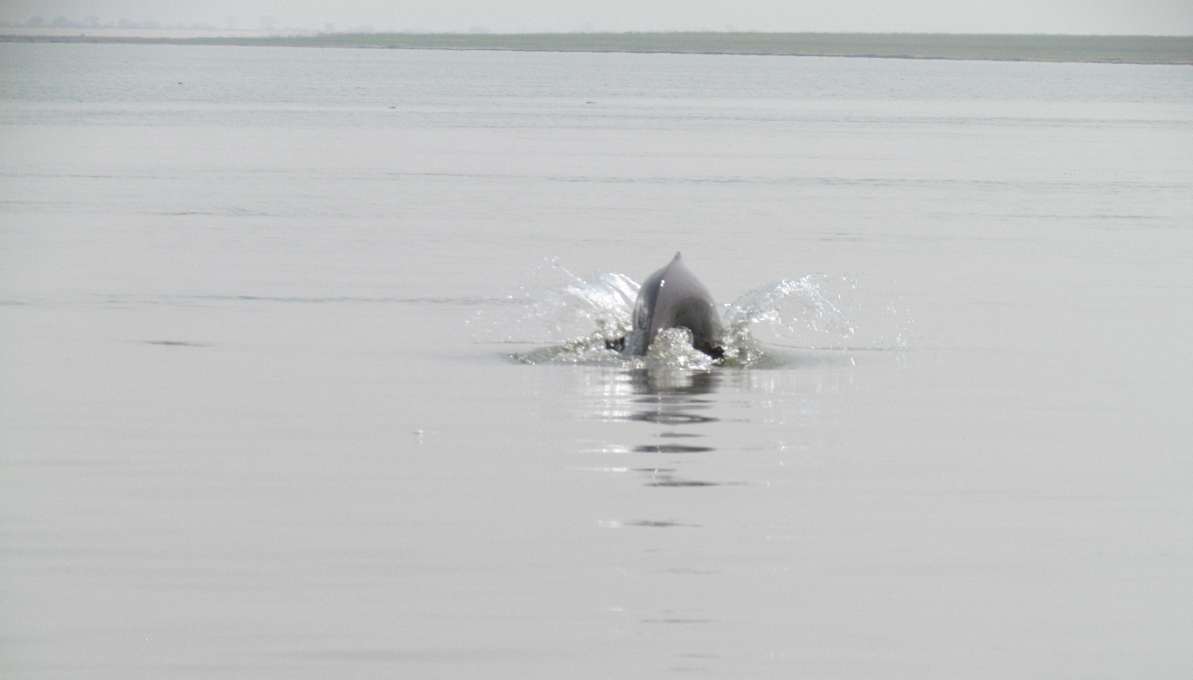
Figure 3: Ganges river dolphin surfacing in Gandak River

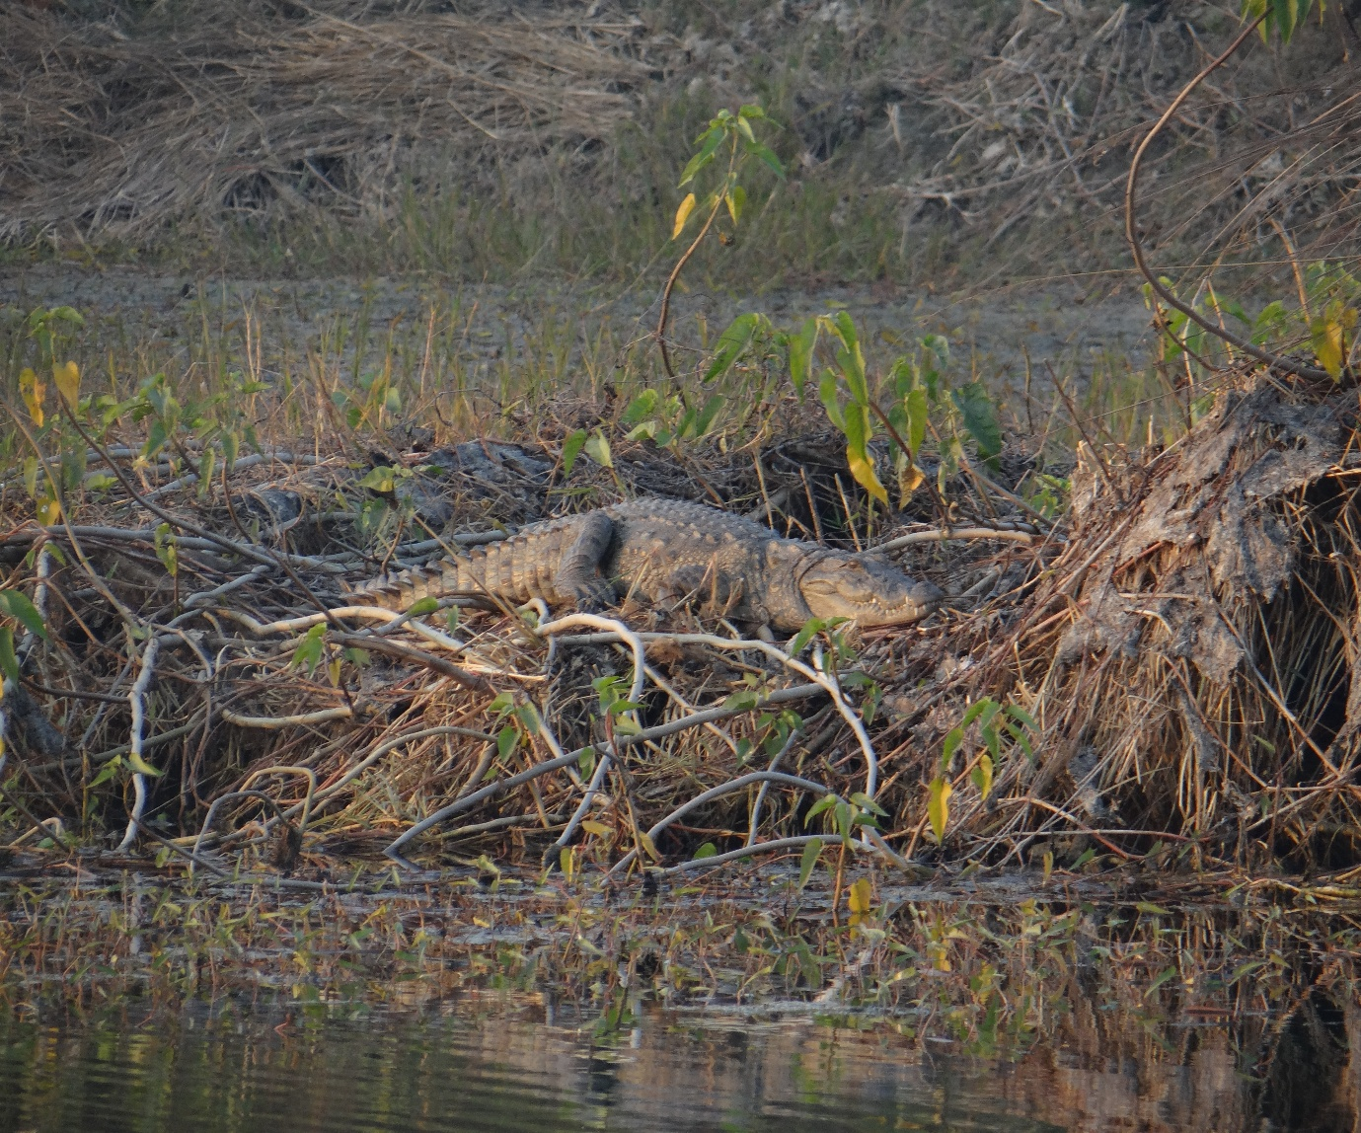
Figure 4: Crocodylus palustris basking near a pond at Airport area of Valmiki Tiger Reserve
The submerged vegetation including Hydrilla verticillata, Potamogeton natans, Typha angustifolia, Pontederia hastata, Ottelia alismoides, Blyxa echinosperma, Ceratophyllum demersum are some common flora (RPD 2025; Devi et al., 2024) where small aquatic faunal species like fishes, prawns, snails, hide from predators while some lay eggs. Some direct or indirect relationship with smaller fauna and associated flora is listed in Table 2.
Threatened freshwater predators like the Ganges shark, mugger crocodile, Hump-backed Mahseer, and gharial occupy higher trophic levels in aquatic ecosystems, indirectly interacting with associated flora. Herbivorous species rely on associated vegetation for food, while many species use aquatic plants for shelter, breeding, and nesting. Otters, for example, use plant material for holts. Anthropogenic activities like pollution, overexploitation, habitat destruction, and fragmentation have significantly declined populations of these species. The list of associated flora is listed in Table 2. Effective conservation approaches include awareness programs for local communities, anti-poaching efforts, pollution control, habitat restoration, preventing invasive species introductions, and restoring native vegetation.
Table 2: Threatened freshwater fauna and interaction with probable associated flora and other smaller faunal species
Scientific name | Relationship with smaller fauna & associated flora | Associated plant species
Glyphis gangeticus | Consumed fishes predominantly and fishes consume plants and others smaller aquatic faunal species. | Vallisnaria spiralis, Hydrilla verticillata, Ipomoea aquatica, Nymphoides indica, Nymphoides hydrophylla, etc.
Crocodylus palustris | Consumed fishes predominantly and fishes consume plants and others smaller aquatic fauna | Nelumbo nucifera, Nymphea nouchali, Limnophyton obtusifolium, Potamogeton nodosus, Aponogeton natans, Ampelopteris prolifera
Tor remadevii | Consume algae, crustaceans, fishes, insects, frogs and fruits | Nelumbo nucifera, Nymphea nouchali, Limnophyton obtusifolium, Potamogeton nodosus, Aponogeton natans,
Lepidopygopsis typus | Consume phytoplankton zooplankton | Phytoplankton, zooplankton
Dawkinsia tambraparniei | Consume insects, worms, detritus, algae and small plants | Ceratophyllum demersum, Pistia stratiotes, Wolffia globosa, Spirodela polyrhiza
Labeo potail | Consume algae, plant matter, and detritus | Ceratophyllum demersum, Blyxa echinosperma, Nechamandra alternifolia, Ottelia alismoides, Pontederia hastata
Gavialis gangeticus | Primarily consume fishes and fishes directly or indirectly consume or hide using plant parts | Azolla pinnata, Salvinia cucullata,
Liotelphusa quadrata | Consume decaying plant matter, plants, algae and small invertebrates | Blue green algae, Phytoplankton, Leaf litter, Macroalgae
Oziothelphusa biloba | Consume decaying plant matter, plants, algae and small invertebrates | Blue green algae, Phytoplankton, Leaf litter, Macroalgae
Phricotelphusa elegans | Consume decaying vegetation, phytoplankton, small plants, bacteria and small invertebrates | Blue green algae, Phytoplankton, Seeds and fruits, Leaf litter, Macroalgae
Batagur kachuga | Consume aquatic plants, seeds, nuts and fruits | Vallisnaria spiralis, Hydrilla verticillata, Nelumbo nucifera, Ipomoea aquatica,
Geoclemys hamiltonii | Consume snails, dragonfly larvae, insects, crustaceans, and plants | Vallisnaria spiralis, Hydrilla verticillata, Nelumbo nucifera, Ipomoea aquatica, Typha angustifolia,
Lymnaea ovalior | Consume algae, detritus, tissues of living macrophytes, phytoplankton | Phytoplankton, Seeds and fruits, Macroalgae, Neptunia oleracea, Dopatrium junceum
Lutrogale perspicillata | Consume fish and prawns. Fishes then consume small plant material, crustaceans, phytoplankton. They collect small branches from nearby trees for making holts | Acacia auriculiformis, Diospyros malabarica, Barringtonia acutangula, Sygygium cumini, Garcinia cowa, Rotula aquatica,
Platanista gangetica | Crustaceans such as prawns and fish including carp. These indirectly feed on plants and other smaller fauna | Vallisnaria spiralis, Hydrilla verticillata, Nelumbo nucifera, Ipomoea aquatica,
Sphaerium austeni | Consume on diatoms and other phytoplankton | Blue green algae, Phytoplankton, Macroalgae
Nilssonia leithii | Consume mosquito larvae, crabs, freshwater molluscs, fish and plant matter | Vallisnaria spiralis, Hydrilla verticillata, Nelumbo nucifera, Ipomoea aquatica, Alisma plantago-aquatica,
Nilssonia nigricans | Consume snails and aquatic insects and aquatic plants | Vallisnaria spiralis, Hydrilla verticillata, Nelumbo nucifera, Ipomoea aquatica,
Nilssonia gangetica | Consume animal and plant matter, including aquatic plants. | Vallisnaria spiralis, Hydrilla verticillata, Ipomoea aquatica, Limnophila hydrophylla

CONCLUSION
The conservation of threatened aquatic fauna in India's freshwater ecosystems requires a comprehensive approach that addresses the complex relationships between species, habitats, and human activities. This study highlights the importance of associated vegetation in supporting the diverse array of aquatic life, from fish and turtles to mammals. The decline in the population of the threatened aquatic faunal species calls for urgent need for conservation efforts that prioritize habitat restoration, pollution control, and protection of native vegetation. By adopting a holistic approach that balances human needs with ecological sustainability, we can work towards preserving the rich biodiversity of India's freshwater ecosystems and ensuring the long-term survival of its threatened aquatic fauna.

COMPETING INTERESTS DISCLAIMER:
Authors have declared that they have no known competing financial interests OR non-financial interests OR personal relationships that could have appeared to influence the work reported in this paper.

REFERENCES

Arivoli K and Narasimmarajan K. (2021). First record of an elusive predator: the Smooth-coated Otter (Lutrogale perspicillata) from Vaduvoor Bird Sanctuary, Thiruvarur district, Tamil Nadu, Southern India. IUCN Otter Specialist Group Bulletin. 38(2): 79-84.

Braulik GT and Smith BD. (2017). Platanista gangetica. The IUCN Red List of Threatened Species 2017: e.T41758A5038361. DOI: 10.2305/IUCN.UK.2017-3.RLTS.T41758A50383612.en

Devi RS, Satapathy KB and Kumar S. (2022). Ethnobotanical Plants of Phumdi, Loktak Lake, Manipur, India. Asian Pacific Journal of Health Sciences. 9(4): 77-80.

Devi RS, Satapathy KB and Kumar S. (2024). Loktak Lake of the state Manipur: A review to educate theintellectuals and awareness on its biowealth. Educational Administration: Theory and Practice. 30(5): 6936 – 6947.

Knight SS and Boyer KL. (2007). Effects of Conservation Practices on Aquatic Habitats and Fauna. Fish and Wildlife Response to Farm Bill Conservation Practices.

Kumar S. (2025). Data collection from literature for biological sciences, medicinal plants research, ethnobotany, and pharmacology: a methodological overview. Journal of Biodiversity and Conservation. 9(2): 167-169.

Maitland PS (1995). The conservation of freshwater fish: past and present experience. Biological Conservation. 72: 259-270.

Maitland PS and Crivelli AJ. (1996). Conservation of Mediterranean Wetlands Conservation of Freshwater fish. The MetWet Publication European Community.

Miranda R and Miqueleiz, I. (2021). Ecology and Conservation of Freshwater Fishes Biodiversity: We Need More Knowledge to Develop Conservation Strategies. Water. 13:1929. DOI: 10.3390/w13141929

Pinder A, Katwate U, Dahanukar N and Harrison A. (2018). Tor remadevii. The IUCN Red List of Threatened Species. 2018: e.T56096394A56717605. DOI: 10.2305/IUCN.UK.2018-2.RLTS.T56096394A56717605.en

Rigby CL, Derrick D, Dulvy NK, Grant I and Jabado RW. (2021). Glyphis gangeticus. The IUCN Red List of Threatened Species 2021: e.T169473392A124398647. DOI: 10.2305/IUCN.UK.2021-2.RLTS.T169473392A124398647.en

RPD (Report on Floral Diversity 2024 – 2025 Study on floral diversity of Mahanadi River areas in Cuttack, Angul and Nayagarh districts, Odisha. (2025). Ambika Prasad Research Foundation, Odisha, India.

Silva DA and Lenin J. (2010). Mugger Crocodile Crocodylus palustris. Status Survey and Conservation Action Plan. Third Edition, ed. by S.C. Manolis and C. Stevenson. Crocodile Specialist Group: Darwin. 94-98.

