TREND ANALYSIS AND FORECAST OF GHANA’S PALM OIL EXPORTS AND IMPORTS

.

ABSTRACT

|  |
| --- |
| **Aims:** To analyze the trends in Ghana's palm oil exports and imports, and also forecast imports and exports of oil palm in Ghana.  **Study design:** Quantitative Study.  **Place and Duration of Study:** The Department of Mathematical Sciences at University of Mines and Technology, Ghana, between June 2024 and July 2024.  **Methodology:** Secondary data on the annual imports and exports of oil palm in Ghana was sourced from IndexMundi from 1964 to 2023, a data portal that collects information and statistics from numerous sources and converts them into various graphical formats. The data was then reorganized and refined to enhance simplicity and clarity. Data gathering, regression analysis, and Vector autoregressive (VAR) are the techniques employed.  **Results:** Key findings reveal a strong positive correlation between imports and exports, suggesting that fluctuations in one are closely linked to the other. The study identifies that both imports and exports exhibit volatility, with forecasts indicating increased variability in the future.  **Conclusion:** The project concludes with recommendations for policymakers to develop flexible strategies to manage trade fluctuations and enhance domestic production capabilities, ultimately positioning Ghana as a competitive player in the global palm oil market. |

*Keywords: Analyze; Imports; Exports; Vector Autoregressive; Fluctuating; Variance; patterns*

1. INTRODUCTION

1.1 Background of Study

Palm oil, derived from the fruit of the oil palm tree (Elaeis guineensis), is one of the most versatile and widely consumed vegetable oils globally (Sehgal and Sharma, 2021). It is used in a vast array of products, from food items like margarine and ice cream to non-food items such as soaps, cosmetics, and biofuels. Ghana, with its favorable climate and growing conditions for oil palm cultivation, has a long history of palm oil production, dating back to the 19th century. Today, palm oil remains a significant agricultural commodity for Ghana, contributing to both domestic food security and economic development (Dompreh et al., 2021b).

The country imports substantial quantities of palm oil to meet domestic demand, while also exporting significant volumes. This dual nature of Ghana’s palm oil trade raises important questions about the factors driving these trends and their implications for the national economy. Understanding the trends in Ghana’s palm oil exports and imports is essential for formulating effective trade policies and strategies that can enhance the sector’s contribution to economic growth and development (Asante, 2023). Analyzing the trends in Ghana’s palm oil exports and imports provides insights into the country’s trade performance and its potential for growth and development.

1.2 Problem Statement

The primary problem this study seeks to address is the complex dynamics of Ghana’s palm oil exports and imports. Despite being a significant producer of palm oil, Ghana continues to import large quantities to satisfy domestic demand (Sarpong et al., 2022). This paradox raises several critical questions about the underlying factors influencing these trade patterns and their broader economic implications.

One major issue is the inconsistency and volatility in Ghana’s palm oil export and import volumes (Omosehin et al., 2022). For instance, while the country has experienced periods of increased export activity, these gains are often offset by substantial imports, suggesting a potential inefficiency in domestic production and processing capabilities.

Another significant concern is the impact of international trade policies and agreements on Ghana’s palm oil sector. Trade barriers, tariffs, and non-tariff measures imposed by importing countries can influence Ghana’s export performance. On the other hand, the absence of protective measures in Ghana can lead to an influx of imported palm oil, undermining local producers’ competitiveness (Asante, 2021). Understanding these external factors is crucial for creating a conducive environment for the growth of Ghana’s palm oil industry.

Furthermore, socio-economic factors such as land tenure systems, access to finance, and infrastructure development significantly impact the productivity and competitiveness of Ghana’s palm oil sector. Smallholder farmers, who form the backbone of the industry, often face challenges in securing land rights, obtaining credit, and accessing markets, which hinder their ability to scale up production and improve quality (Oteng, 2020).

1.3 Objectives of the Study

The objectives of this project are to;

i. analyze the trends in Ghana’s palm oil exports and imports.

ii. forecast imports and exports of oil palm in Ghana.

1.4 Literature Survey

The past few decades have seen a considerable evolution of Ghana’s palm oil industry due to a variety of economic, social, and environmental issues. This review of the literature looks at some important studies that assess trends in Ghana’s imports and exports of palm oil, with an emphasis on future outlooks, trade dynamics, production patterns, and policy consequences.

(Etuah et al., 2020) gave a thorough analysis of Ghana’s oil palm sector with an emphasis on the socioeconomic and environmental effects of the sector. They drew attention to the fact that fluctuating production levels, driven by both market dynamics and environmental considerations, have caused fluctuations in Ghana’s palm oil exports. The study underlines how important it is to use sustainable methods to increase output without jeopardizing natural harmony. The writers also stress the interaction between local supply and global demand by talking about how importation bridges the gap when home production is insufficient. Some key findings are sustainability of the environment is essential for long-term production, each time there are shortages in production, imports are required to meet domestic demand and sustainable practices require the backing of policy actions.

The relationship between Ghana’s expanding oil palm cultivation and land tenure regimes is examined in this study by (Yaro et al., 2018). They contend that unstable land tenure impedes the expansion of the oil palm industry, impacting export and production capabilities. The impact of land tenure difficulties on the investment climate which impacts both domestic and foreign investments in the oil palm sector is also covered in this article. They discovered that stable land tenure is essential for drawing capital to oil palm plantations, that land tenure reforms can boost output and export potential, and that resolving land tenure issues can result in more stable and higher production.

(Huddleston and Tonts, 2007) provides an in-depth analysis of the growth trajectory and challenges facing Ghana’s oil palm industry. The study identifies key factors influencing export trends, such as global market prices, domestic production capacities, 10 and governmental policies. Huddleston points out that while exports have potential for growth, they are often hampered by logistical challenges, quality control issues, and competition from major global producers like Indonesia and Malaysia. Global competition and quality control are major challenges and governmental policies play a significant role in shaping export trends. Logistical improvements are needed to enhance export capabilities.

(Boansi, 2014) compared the export performance of seven agricultural commodities in Ghana before, during, and after the initiation of the agricultural diversification project (1991-1999). The aim was to identify the project’s impact on Ghana’s agricultural exports and to determine the country’s ability to sustain or improve the observed performances. The study covered the years 1987 to 2011, utilizing secondary data on commodity and aggregate agricultural export values for Ghana and the world, with the latter serving as the reference group. In evaluating export performance, the CEP, SCEP, and lnCEP indices were used, and based on newly developed thresholds, commodities were classified as “highly competitive,” “competitive,” “weakly competitive,” and “uncompetitive.” These thresholds effectively reflected the fragility of agricultural export trade. The findings revealed that, besides cocoa and pineapples, which were “Highly Competitive” before the project’s initiation, only rubber exports saw significant improvement among the other five commodities during the project phase. However, in recent years, the export performance of rubber has declined below its previous levels, whereas oil palm exports have shown improvement. The improvement in oil palm exports was attributed to recent efforts by various stakeholders to promote the commodity’s export development, while the decline in rubber exports was attributed to decreased attention to the subsector and other potential inefficiencies.

1.5 Scope and Justification of Work Done

2. material and methods

The methodologies used to examine and interpret the data are covered in this chapter. Data gathering, regression analysis, and vector autoregressive (VAR) are the techniques employed.

**2.1 Data Source and Type**

Secondary data on the annual imports and exports of oil palm in Ghana was sourced from IndexMundi from 1964 to 2023, a data portal that collects information and statistics from numerous sources and converts them into various graphical formats. The data was then reorganized and refined to enhance simplicity and clarity.

**2.2 Research Design and Instruments**

This project seeks to find the relationship between exports and imports using regression analysis and also forecast the annual imports and exports in Ghana. The data was analyzed using R Software, and Microsoft Excel.

**2.3 Regression Analysis**

**2.3.1 Overview**

According to (Montgomery et al., 2021), regression analysis is a statistical technique used to model and analyze the relationship between a dependent variable and one or more independent variables. The main goal of regression analysis is to predict the value of the dependent variable based on the values of the independent variables, and to understand the relationship between these variables.

**2.3.2 Nonlinear Regression**

Nonlinear regression is a form of regression analysis where observational data is modeled by a function that is a nonlinear combination of the model parameters. Nonlinear models are more flexible than linear models, as they can capture more complex relationships between variables. A general nonlinear regression model can be represented as:





Where  is the dependent variable,  is the independent variable, is a nonlinear function of  with a parameter vector ,  is the error term.

Unlike linear regression, where the relationship between the independent and dependent variables is linear, in nonlinear regression, could take many forms, such as exponential, logarithmic, or polynomial.

**2.3.3 Residual Analysis**

Residual analysis is an essential step in regression analysis, used to assess the goodness of fit of a model. The residuals are the differences between the observed values and the values predicted by the model:



Where,  is the predicted value of .

***2.3.3.1 Residual Plot***

A residual plot is a graphical representation of residuals on the y-axis and the predicted values or another variable on the x-axis. In a well-fitting model, residuals should be randomly scattered around zero, indicating that the model’s assumptions are met.

**2.3.4 Hypothesis Testing**

Hypothesis Testing is a fundamental concept in statistics, used to make inferences about a population based on a sample of data. The main goal of hypothesis testing is to assess whether the observed data provide enough evidence to reject a null hypothesis in favor of an alternative hypothesis.

Null Hypothesis (H0) represents the default or status quo assumption. It is typically a statement of no effect or no difference. For example, H0 might state that there is no difference in the means of two populations.

Alternative Hypothesis (H1 or Ha) is what you want to prove. It is the opposite of the null hypothesis, representing a new theory or effect. For example, H1 might state that there is a difference in the means of two populations.

A test statistic is a standardized value calculated from sample data, used to determine whether to reject the null hypothesis. Common test statistics include the t-statistic, z-statistic, and chi-square statistic.

The p-value is the probability of observing a test statistic as extreme as the one calculated from the sample data, assuming the null hypothesis is true. A low p-value (typically less than 0.05) indicates that the null hypothesis is unlikely to be true, leading to its rejection. Significance Level (α) is a threshold set by the researcher (commonly 0.05), below which the null hypothesis will be rejected. It represents the probability of making a Type I error, which is rejecting the null hypothesis when it is actually true.

**2.4 Time Series Analysis**

**2.4.1 Overview**

Time series analysis is a critical area in statistics and data science, focusing on analyzing data points collected or recorded at specific time intervals. Unlike other forms of data, time series data is ordered, and the chronological sequence of data points is crucial in understanding the underlying patterns and making accurate predictions. A time series is a collection of observations recorded sequentially over time. These observations are dependent on time and are often spaced at uniform intervals, such as hourly, daily, monthly, or annually. (Box et al., 2015).

Time series data can be univariate, where only one variable is tracked over time, or multivariate, where multiple variables are recorded. The primary goal of time series analysis is to model the data to uncover patterns, trends, and relationships over time. Time series analysis is integral in various fields, such as economics, finance, environmental science, engineering, and social sciences. For instance, in economics, it helps forecast economic indicators like GDP, inflation, or unemployment rates. In finance, time series models predict stock prices, interest rates, and other financial metrics. In environmental science, time series data are used to monitor climate change and predict weather patterns. (Shumway and Stoffer, 2017).

One of the unique characteristics of time series data is the correlation between data points that are close in time. This temporal correlation distinguishes time series analysis from other types of statistical analysis, where data points are often assumed to be independent of each other. Understanding and modeling this temporal structure is crucial for accurate analysis and forecasting. (Hyndman and Athanasopoulos, 2018).

**2.4.1 Component of Time Series**

Capturing the kind of data displayed in the time series graph is an essential step in the correct modeling and forecasting procedure. These patterns fall under one of several components. Any combination of these components can be used to represent a time series model. The four components are, trend (T), seasonality (S), cyclic (C), and irregular (I).

***2.4.1.1 Trend (T)***

The trend component represents the long-term movement in the time series data. It indicates the general direction in which the data is moving over time, either upwards, downwards, or staying relatively constant. Trends can be linear or nonlinear and are influenced by underlying factors such as economic growth, technological advancements, or changes in population demographics.

***2.4.1.2 Seasonality (S)***

Seasonality refers to periodic fluctuations that occur at regular intervals within a time series. These patterns are typically tied to the calendar and can be observed daily, monthly, quarterly, or annually. Seasonality arises due to factors that recur predictably over time, such as weather changes, holidays, or cultural events. Identifying and understanding seasonality is crucial because it helps in adjusting for predictable fluctuations, leading to more accurate forecasting. Seasonal adjustments are commonly made using techniques like seasonal decomposition, where the time series is separated into its trend, seasonal, and irregular components. This allows analysts to remove the seasonal effect to focus on the underlying trend and other aspects of the data.

***2.4.1.3 Cyclic (C)***

Cyclic in a time series refers to patterns that occur over longer, irregular intervals, usually linked to broader economic or business cycles. Unlike seasonality, which occurs at fixed, predictable periods, cyclic patterns can vary in length and are often driven by factors such as economic conditions, technological changes, or societal shifts. For example, economic indicators such as unemployment rates or GDP might exhibit cyclic, rising and falling in response to economic expansions and contractions. These cycles are typically associated with periods of boom and bust in the economy, often influenced by external factors like monetary policy, global trade dynamics, or technological advancements. Understanding cyclic is essential for long-term strategic planning and decision making. Businesses, for instance, might adjust their investment strategies or workforce planning based on the phase of the economic cycle. Economists and analysts often use techniques such as spectral analysis or filtering methods to identify and model cyclic patterns in time series data. Cyclic differs from seasonality in that cycles do not have a fixed duration and can be influenced by a wide range of factors, making them harder to predict.

***2.4.1.4 Irregular (I)***

The irregular component, also known as noise or residual, captures the random, unpredictable variations in the time series data. This component is assumed to be uncorrelated and does not follow a specific pattern or cycle. Irregularity can be due to unforeseen events such as natural disasters, strikes, or sudden market shifts. For instance, in financial markets, the Irregular component might be caused by sudden geopolitical events, unexpected news, or random market fluctuations that do not follow any predictable pattern. In other contexts, noise can be due to measurement errors, missing data, or other irregularities that introduce random variability. Managing noise is crucial for effective time series analysis. While it is impossible to eliminate noise completely, analysts often use smoothing techniques, such as moving averages or filtering methods, to reduce its impact and reveal the underlying patterns in the data. By doing so, they can focus on the more meaningful components, such as the trend or seasonal patterns.

**2.4.1 Seasonality**

A time series is considered stationary if its statistical properties such as mean, variance, and autocorrelation remain constant over time. Formally, a time seriesis stationary if it has a:

i. Constant Mean: The expected value of the series is constant for all time periods.



Where is the constant mean

ii. Constant Variance: The variance of the series is constant for all time periods.



Where is the constant variance

iii. Constant Autocovariance: The autocovariance between  and  (where h is the lag) depends only on the lag h, not on the actual time t.



Where,  is the autocovariance function, depending only on the lag h

These properties imply that the behavior of the series does not change over time, making it easier to model and predict future values using historical data. Stationary time series are commonly analyzed using models like Autoregressive (AR), Moving Average (MA), Autoregressive Integrated Moving Average (ARIMA) or Vector Autoregressive (VAR).

**2.4.1 Non-seasonality**

A time series is non-stationary if its statistical properties change over time. Non-stationary series often exhibit trends, seasonality, or varying variance. Mathematically, a non-stationary series may have:

i. Changing Mean: The expected value of the series is not constant over time.



ii. Changing Variance: The variance of the series changes over time.



This can happen in time series where the variability increases or decreases over time.

iii. Non-Constant Autocovariance: The autocovariance depends on both the time t and the lag h.



**2.4.1 Transforming Non-Seasonality to Seasonality**

To analyze non-stationary time series, it is common to apply transformations to make the series stationary. One of the most widely used methods is differencing, where the differences between consecutive observations are taken:



If the original series  has a linear trend, differencing once (i.e. ) might remove the trend and result in a stationary series. For seasonal data, seasonal differencing might be applied:



where, (*s)* is the length of the seasonal cycle.

After differencing or applying other transformations, the time series can often be modeled using standard techniques that assume stationarity. For example, the ARIMA model (Autoregressive Integrated Moving Average) incorporates differencing as part of its process to handle non-stationarity.

**2.5 Time Series Models**

**2.5.1 Overview**

Time series analysis involves various models to capture patterns in data, including trend, seasonality, and autocorrelation. Key models include Additive, Multiplicative, Autoregressive (AR), Moving Average (MA), Autoregressive Moving Average (ARMA), Autoregressive Integrated Moving Average (ARIMA) and Vector Autoregressive (VAR). Each model has specific use cases depending on the nature of the time series data.

**2.5.2 Vector Autoregressive (VAR) Model**

The Vector Autoregressive (VAR) model is a multivariate time series model that captures the linear interdependencies among multiple variables over time. It is an extension of the univariate autoregressive (AR) model to multiple time series, allowing each variable to depend not only on its own past values but also on the past values of other variables.

Suppose you have k time series variables  The VAR model with lag order “p” is denoted as VAR(p) and is written as:



Where



is a  vector of the variables at time,  is a vector of constants (intercepts).

are matrices of coefficients representing the relationships between the variables across different time lags.



is a  vector of error terms (white noise) at time t, assumed to be normally distributed with zero mean and covariance matrix 

The VAR model provides a flexible framework for understanding and predicting the interactions between time series data without assuming any a priori structure.

3. results and discussion

**3.1 Overview of Analysis**

The research consists of several steps to reach its objectives. This chapter consists of data exploration and description, residual analysis, data spliting, stationarity test, and model deployed.

**3.2 Data Presentation**

This research used secondary data from IndexMundi over a period of 59 years. It spans from 1964 to 2023, and the dataset contains annual palm oil imports and exports. The dataset consists of two (2) independent variables (imports, and exports). Table 1 shows a brief description of the datasets.

The descriptive statistics about the data show that all the data variables (imports, and exports) are right-skewed. The maximum imports and exports occurred in the years 2018 and the minimum import of palm oil occurred in the year 1968. A way of ensuring a good model is estimated is when the data variables are all normally distributed. When testing for normality, we use ShapiroWilk Test test. If the probability value of Shapiro-Wilk Test is greater 0.05, it means that the data are normally distributed else not.

Decision rule: Since all Probability values of Shapiro-Wilk Test probability is less than 0.05 significance level, we accept the null hypothesis and hence the datasets are normally distributed for all variables.

**Table 1. Descriptive Statistics Ghana’s Oil Palm Exports, and Imports**

|  |  |  |
| --- | --- | --- |
| **Statistics** | **Imports** | **Exports** |
| Count | 60.0000 | 60.00000 |
| Mean | 57.56667 | 22.45000 |
| Maximum Value | 422.00000 | 133.00000 |
| Minimum Value | 0.00000 | 0.00000 |
| Skewness | 2.13312 | 1.75035 |
| Kurtosis | 6.89024 | 4.42148 |
| Standard Deviation | 94.75989 | 40.11358 |
| Shapiro- Wilk Test | 0.64293 | 0.6429 |
| *P*- value | 8.157e-11 | 1.707e-11 |

**3.3 Residual Analysis**

Fig.1. and Fig. 2. are noticeable pattern in the residuals over time, particularly in the later years (post-2000s). This pattern suggests that a quadratic model may not fully capture the underlying dynamics of Imports, Exports, and Production, especially in the more recent data. The residuals exhibit increasing variance over time in all three plots, which indicates heteroscedasticity (non-constant variance). This could mean that the data’s variability increases over time.

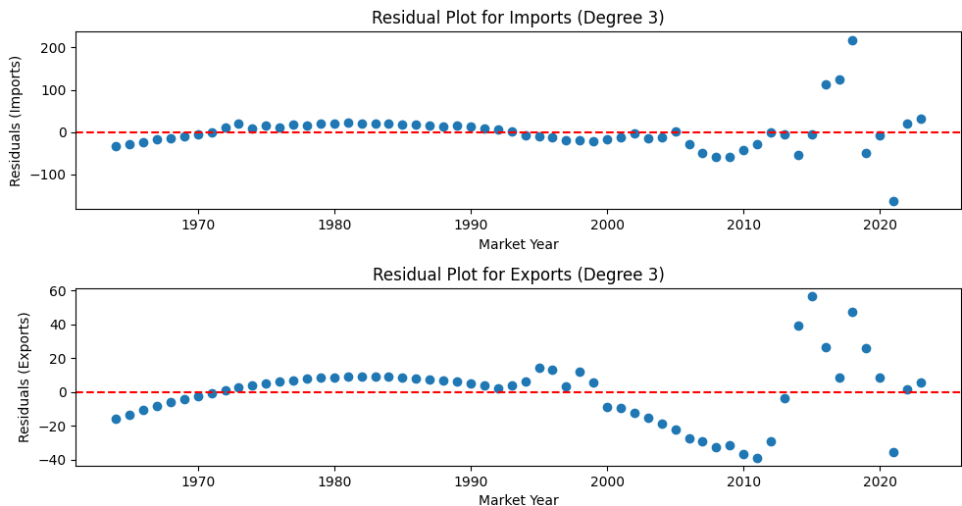

**Fig. 1. Residual Plot for Ghana’s Palm Oil Imports**



**Fig. 2. Residual Plot for Ghana’s Palm Oil Exports**

**3.4 Correlation Analysis**

The green line of best fit (linear regression line) across the graph in Fig. 3. indicates a positive linear relationship between Imports and Exports. The steady upward slope, reinforce the idea that higher Imports generally might correspond to higher Exports of palm oil in the country. Though the scatter of points shows some variation, but the majority of data points cluster around the trend line, which suggest the strong positive correlation.

The Correlation Coefficient is 0.89354, this value is close to 1, indicating a strong positive correlation, and a significant linear relationship between Imports and Exports of Ghana’s Palm Oil. This could indicate that the economic activities driving Imports and Exports are closely linked.

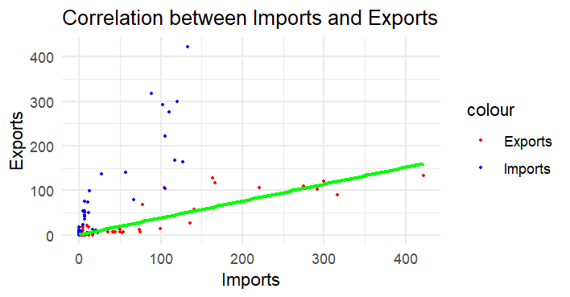

**Fig. 3. A Scatter plot of Ghana’s Palm Oil Imports and Exports**

**3.5 Data Splitting**

The dataset was spitted into two halves, a training data and a testing data to assess how well the VAR model generalizes to new, unseen data, it is important because, it has to evaluate its performance on a data that the model has not been trained on. Eighty two percent (82%) of the dataset was trained to be tested on eighteen percent (18%) of the dataset. Fig. 4. shows a graph of how the data set was separated in training and testing.

1964 to 2012 imports and exports were used to train the model, using 2013 to 2023 to test or validate the model.

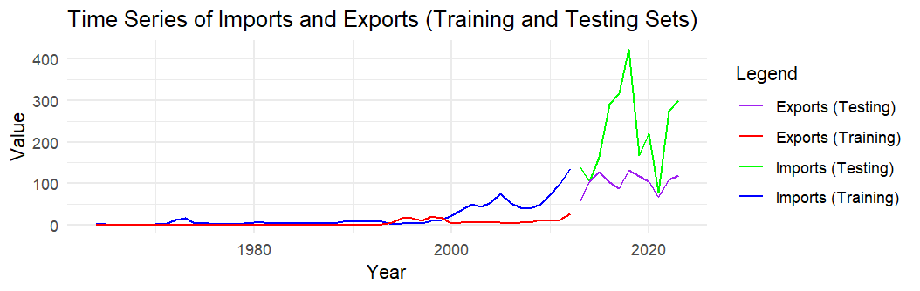

**Fig. 4. A Training and Testing Split Graph of Ghana’s Palm oil Imports, and Exports**

**3.6 Stationarity Test**

**3.6.1 Overview**

We test for the stationarity of each variable to see if they are stationary at level, first order, or second order. We use the Augmented Dickey-Fuller (ADF) test, Phillips-Perron (PP) test and Kwiatkowski-Phillips-Schmidt-Shin (KPSS) test for stationarity.

**3.6.2 Stationarity at Level**

Since the P-values of both the ADF and PP test is greater than 0.05 in Table 2 and Table 3, the training imports and exports data are not stationary. The KPSS test confirms this with a P-value of 0.01 in both tables which is less than 0.05. Hence, we difference the data.

**Table 2. Stationarity Test at Level for Imports**

|  |  |  |
| --- | --- | --- |
| **Test** | **Level** | ***P*- value** |
| ADF | 0.33 | 0.99 |
| PP | 3.83 | 0.99 |
| KPSS | 0.91 | 0.01 |

**Table 3. Stationarity Test at Level for Exports**

|  |  |  |
| --- | --- | --- |
| **Test** | **Level** | ***P*- value** |
| ADF | -2.60 | 0.34 |
| PP | -13.9 | 0.27 |
| KPSS | 0.89 | 0.01 |

**3.6.2 Stationarity at Third Level**

We test for the stationarity of both imports and exports at the Third difference. Both Table 4 and Table 5 records the P-values of the ADF test and the PP test to be less than 0.05, suggesting the training imports and exports are stationary. The P- value, 0.1, of the KPSS test in both tables are greater than 0.05, also confirming that the training data is stationary.

**Table 4. Stationarity Test at Third Level for Imports**

|  |  |  |
| --- | --- | --- |
| **Test** | **Level** | ***P*- value** |
| ADF | -6.78 | 0.01 |
| PP | -59.45 | 0.01 |
| KPSS | 0.05 | 0.1 |

**Table 5. Stationarity Test at Third Level for Exports**

|  |  |  |
| --- | --- | --- |
| **Test** | **Level** | ***P*- value** |
| ADF | -7.91 | 0.01 |
| PP | -55.20 | 0.01 |
| KPSS | 0.09 | 0.1 |

**3.7 Lag Order**

We select the maximum number of lags that can be included in the model by using a vector autoregressive model. This model takes each of the variables as a dependent variable and regresses it with the others and their lags. This brings out the best lag included with the best information criteria.

In Table 6, each of the basic information criteria used by most economists chose lag 10 to be the best maximum. Lag 10 can be included in the model to make it best. It can also be noted that AIC gave the least value of 6.489374 and hence AIC is the best information criterion for this VAR model selection.

**Table 6. Model Selection Criteria for Lag Order**

|  |  |  |
| --- | --- | --- |
| **N** | **AIC(n)** | **HQ(n)** |
| 1 | 9.750607 | 9.8427 |
| 2 | 8.7736 | 8.927223 |
| 3 | 8.624 | 8.83896 |
| 4 | 7.7876 | 8.064004 |
| 5 | 7.725 | 8.163720 |
| 6 | 7.3280 | 7.727183 |
| 7 | 6.5500 | 7.010651 |
| 8 | 6.635916 | 7.15702 |
| 9 | 6.676763 | 7.260159 |
| 10 | 6.489374 | 7.134180 |

**3.7 VAR Model**

The equations below show the estimation results for imports and exports using the VAR model of lag order 10.



(3.1)



(3.2)

The model suggests that both imports and exports of palm oil in Ghana are significantly influenced by their own past values and, to a lesser extent, by the past values of the other variable. The significant coefficients for the lagged values imply that there is a strong autoregressive component in both imports and exports. The correlation of 0.464 between the residuals indicates that there is some degree of common influence or interaction between the imports and exports that is not fully captured by the lagged variables in the model.

In summary, the VAR model provides evidence that both palm oil imports and exports in Ghana are influenced by their historical values, with imports showing a slightly more complex dynamic interaction compared to exports. The model fits the data reasonably well, although the potential instability indicated by the roots and the moderate correlation of residuals suggests that further refinement or checks might be needed.

**Table 7. VAR Model Analysis for Ghana’s Palm Oil Imports**

|  |  |
| --- | --- |
| **Statistic** | **Value** |
| Residual Standard Error | 5.045 on 15 Degree of Freedom |
| Multiple R-squared | 0.9593 |
| Adjusted R-squared | 0.9023 |
| F- statistic | 16.83 on 21 and 15 Degree of Freedom |
| P- value | 5.927e-07 |

**Table 8. VAR Model Analysis for Ghana’s Palm Oil Exports**

|  |  |
| --- | --- |
| **Statistic** | **Value** |
| Residual Standard Error | 4.267 on 15 Degree of Freedom |
| Multiple R-squared | 0.9198 |
| Adjusted R-squared | 0.8075 |
| F- statistic | 8.19 on 21 and 15 Degree of Freedom |
| P- value | 6.763e-05 |

**3.8 Forecasting Ghana’s Palm Oil Imports and Exports**

The VAR of lag 10 model was used to forecast the imports and exports of Ghana’s Oil Palm Oil. The time series plot is shown below. The imports graph shows some fluctuation in the historical data, with the values oscillating around a central mean. This indicates that the quantity of palm oil imports has not been stable, with periodic increases and decreases. In the forecasted period (beyond the vertical dotted line), the graph shows even more pronounced fluctuations, with the range between the upper and lower confidence intervals (dotted lines) widening. This indicates a higher level of volatility, meaning that future imports are expected to be more variable and less predictable.

Unlike imports, the historical data for exports shows much less volatility, with the values remaining relatively stable over time. This suggests that exports have been more consistent in the past, however, similar to the imports forecast, the forecasted period shows an increase in volatility. The forecast suggests that exports, which were once stable, may experience greater fluctuations in the future, as evidenced by the widening gap between the confidence intervals.

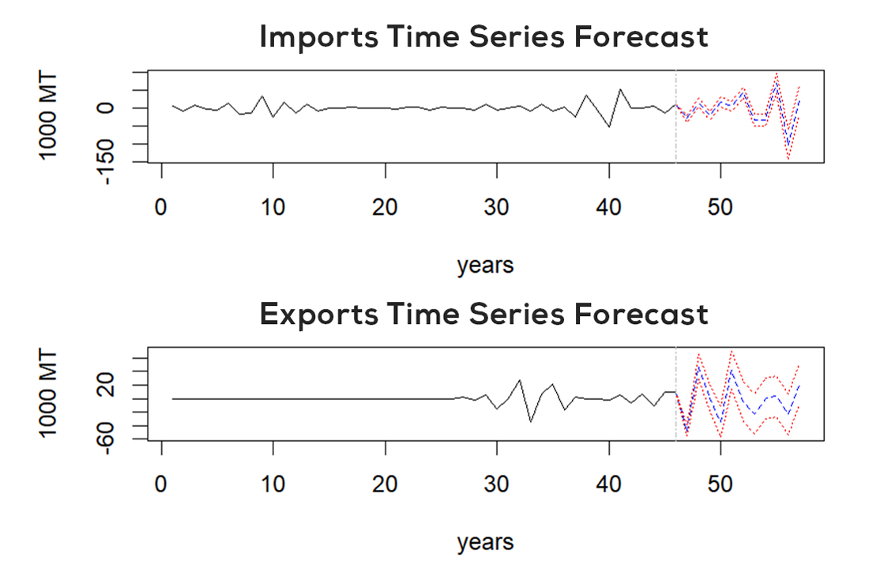

**Fig. 5. A Graph of Ghana’s Palm oil Imports Forecast**



**Fig. 6. A Graph of Ghana’s Palm oil Exports Forecast**

**3.8.1 Diagnostic Test**

The Shapiro-Wilk normality test was used to check for normality for the residuals of the VAR model. Table 9 shows the results.

W Statistic =0.99075 value is close to 1, which indicates that the sample’s distribution is similar to a normal distribution. *P*- Value= 0.8803 indicates the probability of observing the data if the null hypothesis (that the data is normally distributed) is true. In this case, the *P*-value is 0.8803, which is quite high. Since the p-value is much higher than the common significance level thresholds (e.g., 0.05 or 0.01), we fail to reject the null hypothesis. This means there is no significant evidence to suggest that the residuals from your VAR model deviate from normality.

**Table 9. Shapiro-Wilk Normality Test Results for Residuals of VAR model**

|  |  |
| --- | --- |
| **Statistic** | **Value** |
| W | 0.99075 |
| *P*- value | 0.8803 |

4. Conclusion

Conclusions drawn from the research are that:

**a.** trends in Ghana’s palm oil imports and exports were analyzed in subsections 3.2 and 3.4, indicating that the data is normally distributed and also there is a positive correlation between Ghana’s palm oil imports and exports respectively.

**b.** imports and exports of Ghana’s palm oil was forecasted in section 3.8 suggesting increasing volatility in both imports and exports in the future.

References

Adjei, B. E. (2014). *The Making of Quality: A Technography of Small-scale Women’s Groups and a Medium-scale Firm Processing Oil Palm in Ghana*. Wageningen University and Research.

Adjei-Nsiah, S., Sakyi-Dawson, O., & Kuyper, T. W. (2012). Exploring Opportunities for Enhancing Innovation in Agriculture: The Case of Oil Palm Production in Ghana. *Journal of Agricultural Science*, *4*(10), 212.

Asante, K. T. (2021). Political economy of the oil palm value chain in Ghana. *APRA Working Paper, 54*.

Asante, K. T. (2023). The Politics of Policy Failure in Ghana: The Case of Oil Palm. *World Development Perspectives*, *31*, 100509.

Awere, E., Bonoli, A., Obeng, P. A., Pennellini, S., Bottausci, S., Amanor, W. K., et al. (2022). Small-Scale Palm Oil Production in Ghana: Practices, Environmental Problems and Potential Mitigating Measures. In *Palm Oil-Current Status and Updates*. IntechOpen.

Boansi, D. (2014). Comparative Performance of Agricultural Export Trade: During and Post- Agricultural Diversification Project in Ghana. *British Journal of Economics, Management & Trade*, *4*(10), 1501–1511.

Box, G. E., Jenkins, G. M., Reinsel, G. C., & Ljung, G. M. (2015). *Time Series Analysis: Forecasting and Control*. John Wiley & Sons.

Byerlee, D. (2014). The Fall and Rise again of Plantations in Tropical Asia: History Repeated? *Land*, *3*(3), 574–597.

Darfour, B., & Rosentrater, K. A. (2016). Agriculture and Food Security in Ghana. *ASABE Annual International Meeting*, 1. American Society of Agricultural and Biological Engineers.

Dompreh, E. B., Asare, R., & Gasparatos, A. (2021a). Stakeholder Perceptions about the Drivers, Impacts and Barriers of Certification in the Ghanaian Cocoa and Oil Palm Sectors. *Sustainability Science*, *16*(6), 2101–2122.

Dompreh, E. B., Asare, R., & Gasparatos, A. (2021b). Sustainable but Hungry? Food Security Outcomes of Certification for Cocoa and Oil Palm Smallholders in Ghana. *Environmental Research Letters*, *16*(5), 055001.

Etuah, S., Ohene-Yankyera, K., Aidoo, R., Haleegoah, J., Wiggins, S., & Henley, G. (2020). Impact of Oil Palm-related Activities on Women’s Empowerment in Ghana. *World Development Perspectives*, *19*, 100225.

Fold, N., & Whitfield, L. (2012). Developing a palm oil sector: The experiences of Malaysia and Ghana compared. *DIIS Working Paper, No. 8*.

Havinden, M. (1970). The History of Crop Cultivation in West Africa: a Bibliographical Guide. *The Economic History Review*, *23*(3), 532–555. *(The original "Vol. 3.3" for The Economic History Review has been interpreted as New Series, Vol. 23, Issue 3, a common format for this journal, as "Vol 3.3" is atypical; if it refers to an older series, the volume might differ but the format X(Y) is applied as per style guide examples like "49(3)".)*

Huddleston, P., & Tonts, M. (2007). Agricultural Development, Contract Farming and Ghana’s Oil Palm Industry. *Geography*, *92*(3), 266–278.

Hyndman, R. J., & Athanasopoulos, G. (2018). *Forecasting: Principles and Practice*. OTexts.

Jama, B., & Pizarro, G. (2008). Agriculture in Africa: Strategies to Improve and Sustain Smallholder Production Systems. *Annals of the New York Academy of Sciences*, *1136*(1), 218–232.

MacArthur, R., Teye, E., & Darkwa, S. (2021). Quality and Safety Evaluation of Important Parameters in Palm Oil From Major Cities in Ghana. *Scientific African*, *13*, e00860.

Montgomery, D. C., Peck, E. A., & Vining, G. G. (2021). *Introduction to Linear Regression Analysis*. John Wiley & Sons.

Newman, O. B. (2021). Export Promotion as a Development Strategy: Evidence from Selected Southeast Asian Countries and Lessons for Ghana. *[Journal/Book Title Missing]*, *1*, 667–678.

Okoth, A. (2006). *A History of Africa: African Societies and the Establishment of Colonial Rule, 1800-1915* (Vol. 1). East African Publishers.

Omosehin, O., Oseni, J., Olutumise, A., & Osabuohien, E. (2022). Palm Oil Price Fluctuations and Welfare in Nigeria. In *COVID-19 in the African Continent: Sustainable Development and Socioeconomic Shocks* (pp. 169–182). Emerald Publishing Limited.

Osei-Amponsah, C., Agbotse, P., Swanzy, F., & Stomph, T. (2018). Role of Small-scale Enterprises in Agricultural Development Agendas: Insights from Oil Palm Processing Enterprises in the Kwaebibirem District of Ghana. *Ghana Journal of Agricultural Science*, *52*, 131–144.

Oteng, A. (2020). *Livelihood Vulnerability and Adaptive Capacity of Smallholder Oil Palm Farmers in Kwaebibirem Municipality of Ghana*. University of Cape Coast.

Pretty, J. (2008). Agricultural Sustainability: Concepts, Principles and Evidence. *Philosophical Transactions of the Royal Society B: Biological Sciences*, *363*(1491), 447–465.

Rhebergen, T., Fairhurst, T., Zingore, S., Fisher, M., Oberthür, T., & Whitbread, A. (2016). Climate, Soil and Land-use Based Land Suitability Evaluation for Oil Palm Production in Ghana. *European Journal of Agronomy*, *81*, 1–14.

Rival, A., & Levang, P. (2014). *Palms of Controversies: Oil Palm and Development Challenges*. Cifor.

Samar, G. K. (2021). *The Implications of Large-Scale Land Acquisitions on Agrarian Societies, a Gender Perspective: The Case of Oil Palm Development in Ghana*. [Publication Details Missing].

Santeramo, F. G., Di Gioia, L., & Lamonaca, E. (2021). Price Responsiveness of Supply and Acreage in the EU Vegetable Oil Markets: Policy Implications. *Land Use Policy*, *101*, 105102.

Sarpong, F., Dery, E. K., Danso, I., & Oduro-Yeboah, C. (2022). The Socio-economic Impact of Mitigating the Challenges at the Artisanal Palm Oil Mills in Ghana. *World Food Policy*, *8*(2), 225–236.

Sayer, J., Ghazoul, J., Nelson, P., & Boedhihartono, A. K. (2012). Oil Palm Expansion Transforms Tropical Landscapes and Livelihoods. *Global Food Security*, *1*(2), 114–119.

Sehgal, S., & Sharma, V. (2021). Palm Kernel (Elaeis guineensis). In *Oilseeds: Health Attributes and Food Applications* (pp. 145–161). [Publisher Missing, Editors Missing].

Shiferaw, B., Smale, M., Braun, H.-J., Duveiller, E., Reynolds, M., & Muricho, G. (2013). Crops That Feed the World 10. Past Successes and Future Challenges to the Role Played by Wheat in Global Food Security. *Food Security*, *5*, 291–317.

Shumway, R. H., & Stoffer, D. S. (2017). *Time Series Analysis and its Applications: With R Examples*. Springer.

Yamoah, F. A., Kaba, J. S., Botchie, D., & Amankwah-Amoah, J. (2021). Working Towards Sustainable Innovation for Green Waste Benefits: the Role of Awareness of Consequences in the Adoption of Shaded Cocoa Agroforestry in Ghana. *Sustainability*, *13*(3), 453.

Yaro, J. A., Teye, J. K., & Torvikey, G. D. (2018). Historical Context of Agricultural Commercialisation in Ghana: Changes in Land and Labour Relations. *Journal of Asian and African Studies*, *53*(1), 49–63.