An Essay on Public Expenditure in India since Independence

Abstract
This working paper examines the progression of public spending in India since its independence in 1947, analysing its development within the framework of economic policies, political dynamics, and social concerns. In the post-independence period, India's public spending was primarily influenced by the need to create a self-sustaining economy, including substantial expenditures in infrastructure, public services, and critical industries such as agriculture and industry. Gradually, the emphasis of spending transitioned towards attaining welfare goals, including poverty reduction, healthcare, education, and rural development. The article examines the influence of several Five-Year Plans on government expenditure, emphasising the gradual transition from a centrally planned economy to a more market-oriented one, particularly after the economic changes of 1991. This analysis explores the function of fiscal federalism and the increasing influence of state governments on public spending, highlighting the problems and intricacies of managing public finances in a varied and populous nation. In conclusion, the article contends that while India has achieved notable progress in its public spending strategy, issues pertaining to efficiency, accountability, and sustainability persist in influencing the conversation on fiscal policy. It necessitates a more open and results-oriented methodology to guarantee that public expenditure adequately meets the country's changing requirements.
Key Words: Public finances, Public Expenditure, political dynamics, economic growth, economic development, India
JEL Code: H50, H61, O10, O53

- Introduction and Context
Public Expenditure refers to the expenditure incurred by the government entities at various levels- central, state and local- to maintain its administration, social welfare as well as the growth& development of the country. It serves as a vital instrument of fiscal policy, reflecting the government's priorities and its role in influencing economic stability, growth, and social welfare. Upon gaining independence in 1947, India chose a path of planned economic development, deeply influenced by socialist principles (Dash & Raja, 2013). Leaders like Jawaharlal Nehru were committed to the ideals of democratic socialism, aiming to achieve social justice and reduce the deep-seated inequalities prevalent in Indian society (Bhat, 1996). The Soviet Union's model of rapid industrialization through centralized planning significantly shaped India's economic policies. Given the nascent stage of the private sector and skepticism towards unfettered markets, substantial government intervention was considered essential. Indian policymakers firmly believed that meticulous economic planning was indispensable for fostering economic growth and ensuring a more equitable distribution of resources in the newly independent nation. The establishment of the Planning Commission in 1950 formalized India's commitment to a state-led development strategy, primarily implemented through a series of comprehensive Five-Year Plans (Seshaiah et al., 2018). These plans played a crucial role in allocating resources across various economic sectors, with a strong emphasis on developing core industries considered vital for the nation's progress (Wadhwa, 2013). While the initial plan prioritized agricultural development to address immediate food security challenges, subsequent plans, notably the Second Five-Year Plan, shifted the focus towards rapid industrialization, with the expansion of the public sector as a key driver (Tilak, 2003). These Five-Year Plans provided a structured framework for India's economic development, although their success varied due to a combination of internal policy challenges and external economic factors.
- Public Expenditure sine 1947 to 1990
A defining characteristic of India's economic policy during this era was the large-scale public investment in Public Sector Undertakings (PSUs). Investments were concentrated in key strategic sectors, including steel (with major plants established at Bhilai, Durgapur, and Rourkela), coal, and power generation. This focus on state-led industrialization was driven by the belief that public ownership was essential for achieving redistributive goals and ensuring national security. The Industrial Policy Resolutions of 1948 and 1956 explicitly granted the state a dominant role, even a monopoly in some cases, over these key industries. Consequently, the number of PSUs increased substantially. While this large-scale investment aimed to build a robust industrial base and reduce reliance on imports, the selection and management of these enterprises were not always driven by strict considerations of economic efficiency, which would later contribute to issues of inefficiency.
Public expenditure also played a pivotal role in modernizing India's agricultural sector, most notably through the Green Revolution. The government made significant investments in expanding irrigation infrastructure, including major, medium, and minor irrigation projects, which were essential for the success of high-yielding variety (HYV) seeds. Furthermore, substantial public funds were allocated to agricultural research and development, leading to the creation and dissemination of these HYV seeds. To encourage the adoption of modern farming practices, the government provided subsidies on crucial inputs such as fertilizers. Recognizing the importance of price stability for farmers, the Minimum Support Price (MSP) system was implemented through the Food Corporation of India (FCI), guaranteeing a minimum price for key crops and incentivizing increased production. Public investment thus served as the primary catalyst for the Green Revolution, leading to a significant increase in food grain production.
India also experienced increased public expenditure in defence and an expansion of the bureaucracy, particularly in response to regional conflicts such as the Sino-Indian War of 1962 and the Indo-Pakistani Wars of 1965 and 1971. The average defence expenditure as a percentage of GDP rose from around 1.8% in the initial years after independence to approximately 3% in the subsequent decades. The state's expanding role in managing the economy and implementing the Five-Year Plans also necessitated a larger bureaucratic apparatus, contributing to the overall growth of public expenditure. The need to safeguard national sovereignty and territorial integrity in a complex geopolitical environment was a significant driver for increased defence spending.
In contrast to the substantial investments in industrial development and agricultural modernization, public expenditure on the social sector, particularly in critical areas like health and education, remained relatively limited throughout the 1950s-1980s. While the importance of social development was acknowledged, budgetary allocations to these sectors were comparatively lower. Public spending on health, for instance, increased from a very low base of 0.22% of GDP in 1950-51 to about 1% of GDP by the mid-1980s, where it largely stagnated. Similarly, despite the recognition of education's crucial role in national progress, public expenditure consistently fell short of the 6% of GNP recommended by the Kothari Commission, generally hovering around 3% of GDP in later years. The initial Five-Year Plans placed a greater emphasis on building the foundations for industrial and agricultural development. This relatively lower priority for social sector spending had long-term implications for India's human capital development.
The substantial public expenditure during the 1950s-1980s had significant socio-economic ramifications for India. The focus on state-led industrialization and heavy investment in PSUs resulted in the growth of core industries like steel, coal, and power. This contributed to a notable expansion of India's industrial base and a reduction in the country's dependence on imports in several key sectors. India's share of global industrial output, which had declined considerably under British rule, began to show signs of recovery. However, this state-led industrial growth often came at the expense of efficiency and global competitiveness, as the protected domestic market provided limited incentives for innovation and technological advancement.
Public investment also played a transformative role in the agricultural sector through the Green Revolution. This period witnessed a remarkable surge in food grain production, particularly wheat and rice, enabling India to achieve self-sufficiency and end its reliance on food imports by the 1970s. Farmers in regions with favourable conditions, such as Punjab, Haryana, and western Uttar Pradesh, experienced substantial increases in their incomes. However, the benefits of the Green Revolution were not evenly distributed across the nation, leading to the emergence of regional disparities in agricultural development and income. The initial success was largely concentrated in wheat production within well-irrigated areas. This uneven impact contributed to existing regional inequalities.
In contrast to the advancements in industrial and agricultural output, the limited public investment in health and education during this period resulted in a slower pace of improvement in key human development indicators. While literacy rates did show progress, increasing from 18.33% in 1951 to 43.56% in 1981, this rate remained relatively low compared to many other developing countries. Similarly, despite an increase in life expectancy from 32.1 years in 1951 to 54.4 years in 1981, infant mortality rates remained stubbornly high at 110 per thousand live births. This insufficient focus on the social sector hindered the development of India's human capital, a crucial element for sustained long-term economic and social progress, and contributed to persistent levels of poverty and inequality.
The public expenditure regime of the 1950s-1980s faced several significant challenges and criticisms. One of the most prominent was the inefficiency prevalent in Public Sector Undertakings (PSUs), which led to substantial fiscal burdens for the government. Many PSUs suffered from issues such as overstaffing, underutilization of production capacity, the use of outdated technology, poor management practices, and misjudgments in product selection. Often, these enterprises were run based on political considerations rather than sound economic principles, resulting in significant financial losses that the government had to absorb. The initial expectation that PSUs would generate surpluses for further development largely remained unfulfilled; instead, they became a drain on the public exchequer, diverting resources from potentially more productive investments.
Another major criticism centred on the extensive regulatory framework known as the "License Raj". The requirement for government licenses for almost all aspects of business activity created significant bureaucratic bottlenecks and stifled entrepreneurship. Obtaining these licenses often involved lengthy delays, bureaucratic hurdles, and even corruption, discouraging private investment and hindering innovation. This system also shielded domestic industries from international competition, contributing to the production of low-quality and often obsolete goods. The "License Raj" fostered an environment where bureaucratic processes and political connections often held greater sway than market forces, thereby impeding economic efficiency and slowing down overall growth.
Furthermore, the government's substantial expenditure, particularly on PSUs and various subsidies, led to increasing fiscal deficits. To finance these growing deficits, the government resorted to both domestic and external borrowing. The practice of creating new money to fund expenditures also contributed to significant inflationary pressures within the economy. By the late 1980s, this pattern of unsustainable fiscal management contributed to a severe balance of payments crisis. The average annual growth rate of the Indian economy during this period was around 4%, with per-capita income growing at a modest 1.3%. The expansionary fiscal policies, while intended to promote development and social welfare, ultimately resulted in mounting fiscal imbalances and an increasing national debt, making the economy more vulnerable to external economic shocks. The Green Revolution in India during the 1960s and 1970s stands as a significant example of how public expenditure can drive transformative change in a crucial sector like agriculture. The government played a pivotal role through various policy interventions and substantial financial investments. A key aspect was the funding of agricultural research, which led to the development of high-yielding varieties (HYVs) of staple crops like wheat and rice. Recognizing the necessity of adequate water supply for these HYVs, the government made significant public investments in expanding irrigation infrastructure across the country, including the construction of major dams and canal networks. To encourage the widespread adoption of modern farming practices, the government provided subsidies on essential inputs such as fertilizers, making them more affordable and accessible to farmers. Furthermore, the establishment of the Food Corporation of India (FCI) in 1965, coupled with the implementation of the Minimum Support Price (MSP) mechanism, provided farmers with a guaranteed market and price for their produce, reducing risk and incentivizing increased production.
The outcomes of these concerted public investments were remarkable. India achieved self-sufficiency in food grains by the end of the 1970s, marking a significant turning point in its post-independence history and ending its reliance on food aid from other nations. Agricultural GDP growth rates witnessed a notable increase during the Green Revolution period. However, this success was accompanied by certain unintended consequences. The benefits of the Green Revolution were not evenly distributed geographically. Regions with better existing irrigation infrastructure and more favorable landholding patterns, primarily Punjab, Haryana, and western Uttar Pradesh, were the first and largest beneficiaries, leading to increased regional disparities in agricultural development and income. The focus on wheat and rice production also led to a relative neglect of other important crops like pulses and coarse grains in some areas, impacting dietary diversity and nutritional security. Additionally, the increased use of chemical fertilizers and pesticides, while boosting yields, also raised concerns about their long-term environmental impact, issues that would gain greater attention in later decades.
The nationalization of the 14 largest private commercial banks in India in 1969, followed by a second round of nationalization in 1980, represents another significant instance of public expenditure and policy intervention aimed at achieving specific socio-economic objectives. The primary motivations behind this move were to align the banking sector with the government's socialist ideals and to promote more inclusive economic growth. Key objectives included directing credit towards priority sectors such as agriculture and small-scale industries, which were often underserved by private banks, encouraging the growth of new entrepreneurs, and fostering development in backward regions of the country. There was also a desire to curb the concentration of economic power in the hands of a few private entities and to reduce income inequality. Ultimately, the government sought greater control over the allocation of financial resources to ensure they were channelled in line with national development priorities.
One of the most notable impacts of bank nationalization was the significant expansion of the banking network, particularly into rural and previously unbanked areas. This led to a substantial increase in access to formal financial services for a larger proportion of the population, contributing to greater financial inclusion. Gross domestic savings as a percentage of national income almost doubled in the decade following the initial nationalization. Furthermore, the introduction of priority sector lending mandates ensured that sectors like agriculture and small-scale industries received a larger share of bank credit. The ratio of bank branches in rural areas to the total number of branches across the country rose considerably after 1969, demonstrating a clear shift in focus towards reaching underserved populations. While nationalization aimed to foster economic stability and ensure wider access to credit, in the long run, the nationalized banks faced several challenges. These included issues of inefficiency, instances of political interference in lending decisions, and a gradual increase in non-performing assets (NPAs). Some critics have argued that despite its initial positive impact on financial inclusion, bank nationalization ultimately hindered India's economic growth by creating a less competitive and efficient banking sector.
- Public Expenditure in Post Liberalisation Period (1991-2000s)
In this section of the paper, we would like to discuss the public expenditure of India during the liberalisation phase i.e. from 1991-2000s (early 2000s). Liberalisation policies, or to be more descriptive, the LPG - Liberalisation, Globalisation, Privatisation policies were introduced in 1991, by the then Finance Minister, Dr. Manmohan Singh under the ministry of Shri. P.V. Narasimha Rao. These policies were introduced as a remedy to counter the financial crisis India was experiencing during the 80s and 90s. Liberalisation policies basically meant to open up the economy to the global market forces, reduce government intervention in economic activities and enhance the investment and role of the private sector to the economy.
Even though policies of liberalization aimed to reduce government intervention to the activities of the economy, there was a hike in the influence and intervention of the government. This can be easily identified from analysing the expenditure changes of the government before the liberalisation phase and in the post liberalisation phase. The total government spending during the period 1990-91 was 100,879 crore Rupees with an expenditure rate of 5.03%. After the policy introduction, by the end of 1990s (1999-2000), expenditure rose to 289,400 crore Rupees with expenditure rate of 9.26%. The development expenditure of the government rose from 64,360 crore Rupees (1990-91) to 277,760 crore Rupees by the end of the decade (2000-01). (Source : https://html.scirp.org/file/_6-1501391_1.htm)
Below is a graph showing the growth in India’s GDP between the time period 1970-2000s.
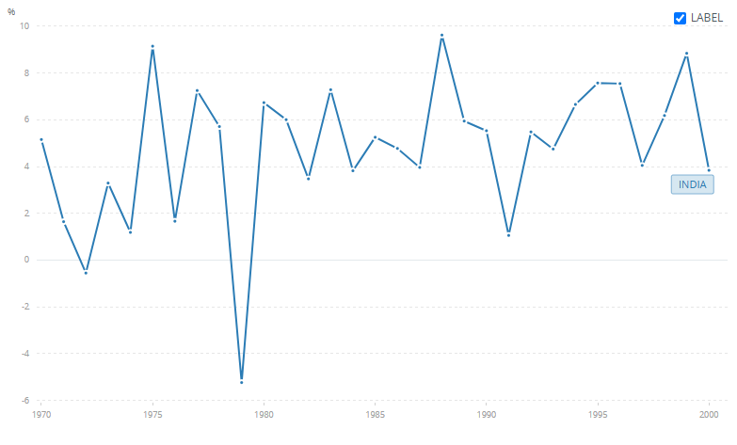
Source : https://data.worldbank.org
FIG 1. Public Expenditure in Post Liberalisation Period (1991-2000s)
Accumulated fiscal deficits, interest payments, downfall of standard of living of the public, rise in the emphasis on the notion of social welfare and democracy, political scenario paved the way for the rise in government intervention (via expenditure) in India. Government financed these expenditures through various revenue sources - mainly direct and indirect taxes (customs, excise duty). It also included sources like government grants, fees, fines and remittances (non-tax revenue), borrowings and revenue from initial disinvestments. (Source:https://www.scirp.org/journal/paperinformation?paperid=82933#:~:text=Over%20the%20years%20it%20rose,2000%2D01%20and%20to%20Rs). The later sections of the paper would analyse the changes brought by government spending during the post liberalisation period.
3.1 Economic reforms and policy shift
The Indian economy during the period after independence till 1990s were characterised by extensive government control and licensing policies. These were implemented to protect indigenous industries and also to attain self- reliance. The IPR - Industrial Policy Resolution 1956 characterized by import substitute industrialization (ISI), helped in doubling the manufacturing sector share to GDP and also in reducing the import share from foreign countries. However, faults like low quality, high prices technological obsolescence prevailed which was a major drawback. (source : https://www.promarket.org ) GDP growth during the ISI period was only around 3.4% along with factors like over protectionism of the state contributing as a reason to it. A combination of factors, such as the threat of currency devaluation, fiscal extravagance, accelerating inflation rates, and a fall in net international receipts, painted a dismal picture of an economy on the verge of collapse. In addition to these issues, a problem of Twin Deficit aroused - a condition where government faces fiscal and balance of payment deficit. The disintegration of the Soviet Union and collapse of Billion Dollar trade relation, Gulf war and consequent oil shock made the economy worse. By June 1991, India's foreign exchange reserves stood at a point of crisis of just $1.2 billion, barely sufficient to cover approximately three weeks of essential imports. This critical situation made the policy makers come up with a drastic change in India's economic policies to prevent a serious crisis and guide the country towards sustainable and sound growth.
Intervention of IMF and World Bank were the key driving force of reforms. The IMF supported a structural adjustment programme with 4 important elements for stabilizing and promoting growth of the economy. They are mentioned as follows:
- Devaluation of Indian Rupee: Indian Rupee was devalued by around 18-20% with the agenda to enhance exports by making them cheap. This devaluation was done in two stages (By June 1 1991- 9% and July 3 1991- 11%). The monetary value of Indian Rupee to US Dollar was ₹17.50 to ₹18.00 per USD. After devaluation, it rose to ₹22.70 to ₹23.00. (source: https://byjus.com , https://www.elibrary.imf.org )
- Fiscal Consolidation: In order to counter the huge fiscal deficit of the government, fiscal consolidation strategies were proposed and were aimed to reduce the fiscal deficit from 9% of GDP to 6.5% of GDP. This also aimed to control government expenditure and to induce more revenue for the government.
- Mobilization of finance from financial institutions and bilateral donors: This included securing a crucial SDR 1.7 billion stand-by facility from the IMF and commitments of gigantic quick-disbursing aid from the World Bank and a number of bilateral donors.
- Liberalization and Deregulation of economy: The most important element of the structural adjustment programme was to open up the economy for global integration and to make the economy more market oriented. This led to the creation of a more market oriented, competitive and opened up economic environment.
Following the IMF guidelines, Indian foreign reserves which were only left for less than a week’s imports rose to more than 3Billion Dollars.
Along with these large-scale structural reforms like opening up of the economy, the government initiated the processes of deregulation and privatisation of industries. As a result of industrial deregulation, government licensing of industries was eliminated. This was marked as the end of the license raj system. Along with industrial deregulation, the financial sector was also deregulated, including the conferring of more autonomy on the Reserve Bank of India (RBI) and commercial banks, opening the sector to new private sector banks, and lessening the extent of government control over financial institutions. Large scale privatization of Indian trade and industries were made during this period. Trade was liberalized through reducing tariff rates and industries were liberalized through selling. The privatised industries were PSU’s - Public Sector Undertakings. The 2 aims of privatisation were to generate more revenue to the government and to increase efficiency of PSU’s. Privatisation produced mixed results. In the realm of raising revenue, the government has succeeded in raising huge amounts of money through disinvestment, to the tune of ₹3,47,439 Crore during 1991-92 to 2017-18. Efficiency and profits of the PSU’s increased sufficiently. The drop in employment and biased beneficiaries to large scale business only were the highlighting drawbacks of privatisation.When we analyse the policy shifts of the government, we can identify the changes brought in the subsidies practice of the government. Subsidies were majorly provided for the production of fertilisers, food and fuel. Subsidies created a large burden on government finances. In order to manage the finances of the government, subsidies were rationalized. Rationalization of subsidies were also aimed to counter the problem of ineffective targeting of subsidies, as they did not reach the targeted group (poor and marginalized producers and farmers). As a result of the rationalisation, agricultural production and soil fertility were affected (price hike in fertilizers). There was an acute rise in food and fuel prices. Food security of the citizens was eroding.
The hike in fuel prices resulted in the severe rise of transportation costs. One of the key impacts of the 1991 economic reforms was the opening up of the Indian economy to foreign investment, which attracted more FDI inflows. FDI - Foreign Direct Investment can be defined as an investment made by an individual or a company in one country into business interests located in another country. Opening up of the economy boosted capital inflow and also the confidence in foreign investors in India. There was a rise from 15 Billion Dollar FDI inflow in 1990 to 161 Billion Dollar inflow by the 2000s. Rise in FDI inflows created large scale job creation, technology transfer and a rise in productivity of workers.
3.2 Changes in government expenditure priorities
The key intention behind the introduction of LPG reforms was to loosen the government control over the economy. But, the then situation of the economy, dire need and emphasis on social welfare and political dilemmas in the economy pressurized the government to extend its influence throughout the economy via extending their expenditure in various sectors.
In infrastructure, major changes were seen in the field of roads and power sector. This was made because roads and power generation (including distribution) have its own importance in trade, improvising standard of living, societal development and also in technological advancement. The government focused on developing the infrastructure in rural areas to improve the HDI level of India which was 0.429 (source: https://www.undp.org). Rural population constitutes 74% of India’s total population. Therefore, it was necessary to expand the activities of the government towards the rural population.
The NHAI - National Highways Authority of India, established as per the NHAI Act, 1988, under the Ministry of Road, Transport and highways, initiated NHDP- National Highway Development Programme; a 7phase flagship programme that dealt with the networking of highways, connecting various points of the country which has economic and trade importance. The Golden Quadrilateral project, a large-scale highway development programme connecting Mumbai, Delhi, Chennai and Kolkata, was the first phase of NHDP which will be discussed in the later parts of the paper.
The next infrastructure government extended its concern was the power sector. Power sector basically deals with generation, transmission and distribution of electricity to various parts across the country. IPP - Independent Power Producers was introduced during the 1990s to encourage private investment in the power sector due to the inefficiency or loopholes in the demand and availability of electricity, financial and technical aids and also the inefficiency of state and central governments in mobilizing resources for generational capacity and expansion projects. (source: Harbans L. Bajaj and Deepak Sharma https://www.osti.gov/etdeweb/servlets/purl/21115880) This period majorly enhanced private and foreign investment in electricity generation and distribution but not completely privatising the power sector.
The contributions to capital investment and infrastructure were initially low. It was because of the financial constraints and deficits that were to be cleared.
Later, the government made improvements in the social sector through educational and health incentives. The Education Act, 2002 (86th amendment) was passed making primary education compulsory for children in the age group 6-14. This was supported by the programme SSA - Sarva Shiksha Abhiyan, which deals with universalizing elementary education. It was also responsible for the reconstruction of schools, provision of better infrastructure for quality education and also in providing adequate training to teachers. Meanwhile, the midday meal programme which was introduced by Kerala and Madras governments in 1961, was implemented at national level by the central government in 1991 as a part of NP-NSPE - National Programme of Nutritional Support to Primary Education.
Other programmes that were introduced as a part of social security assurances are as follows:
- Food for Work programmes
- Targeted Public Distribution Scheme - 1997
- Annapurna Scheme - 1991-2000
- Indira Gandhi National Old Age Pension Scheme (IGNOAPS)
- National Family Benefit Scheme (NFBS)
- National Maternity Benefit Scheme (NMBS)
(IGNOAPS, NFBS, NMBS were a part of National Social Assistance Programme launched in 1995)
In the health sector, the government refurbished the National Health Policy 1991. It emphasized the need of strengthening infrastructure and also the extension of primary health care. As an extension of this, NRHM - National Rural Health Mission was launched in 2005, addressing and countering health issues in rural areas. This would be discussed in the later sections. Other related programme launches were:
- National AIDS Control Programme (NACP) - 1992
- Pulse Polio Immunization Programme
- Reproductive and Child Health (RCH) Programme (Phase 1) - 1997
- Revised National Tuberculosis Control Programme (RNTCP) - 1993
- National Vector Borne Disease Control Programme (NVBDCP)
India, in this period, also introduced a variety of poverty alleviation programmes. Rural employment generation programmes were notable among them. As a part of this programme, the government made investments in wage employment for the rural population and also in the creation of productive assets. Swarnajayanti Gram Swarozgar Yojana, Jawahar Rozgar Yojana, MGNREGA are examples for government investments in poverty eradication programmes during 1991-2000s. MGNREGA laid its foundation in early 2000s through the Employment Assurance Scheme (EAS 1993) later implemented as MGNREGP in 2005-06. Other schemes and programmes for poverty alleviation and employment generation are as follows:
- Jawahar Rozgar Yojana (JRY) 1989 later Jawahar Gram Swarozgar Yojana (JGSY) 1999
- Prime Minister’s Rozgar Yojana (PMRY) 1993
- Indira Awas Yojana
- Rural Employment Generation Programme (REGP) 1995
- Swarnajayanti Shahari Rozgar Yojana (SJSRY) 1997 consisting of Urban Self Employment Programme (USEP) and Urban Wage Employment Programme (UWEP)
(Sources: en.wikipedia.org. testbook.com. dcmsme.gov.innfsa.gov. brainly.in) Here is a graph showing the growth in India’s Public Expenditure. For the sake of comparison, graph includes timeline from 1980s-2000s
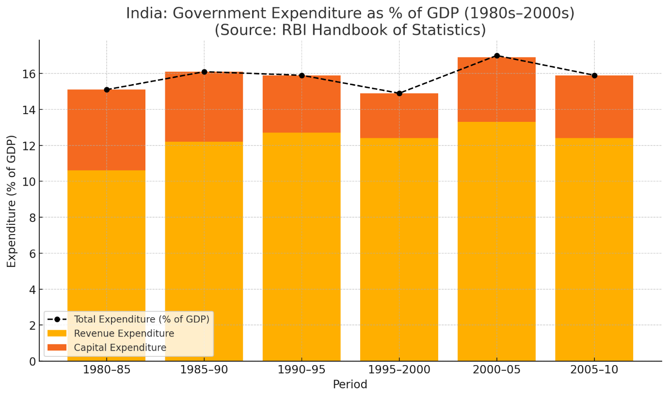
Source : https://www.rbi.org.in
FIG 2. Gouvernement expenditure as percentage of GDP (1980s-2000s)
3.3 Economic Impact
While assessing the public expenditure during the post liberalisation era, we should assess the economic impact of these policies. In this section we would be assessing the impact on indicators like GDP and poverty. In addition, we will also analyse the impact of taxation on the general public.
The impact of LPG policies are obvious when we compare the growth rate of GDP before and after the 1990s. There was a sudden and favourable increase in the GDP growth rate. During the 1950s - 1980s there was an average growth rate of 4%; also termed the “Hindu Rate of Growth” as the growth rate was lagging when compared to other East Asian Countries. The pace of economic expansion was comparatively slower than them. By the 1980s there was an increase in growth rate by 5.6% due to the New Computer Policy introduced by Shri Rajiv Gandhi, which can be considered as the initial stage of liberalization. However, the growth was unsustainable because there were faults in the government deficit and emerging BoP crisis. After the introduction of LPG policies, the real GDP growth rate was accelerated to 7.3% per annum by the 2000s. Peak growth rates ranging to 9% was also experienced by 2005-2008. Induction of more foreign investment, dismantling of licensing policy, reduction of trade barriers contribute to the growth. When we assess the sectoral wise contribution, we can find that the contribution of agriculture has been steadily declining. In addition, we can find how steadily the service sector is emerging and also being the most contributing to GDP of the economy.
India, being one of the richest countries in the world, after being colonised and British rule, was left into utter poverty. India had a poverty rate of 54.9% (rural area - 56.4%, urban areas - 49.0%) during 1973-74. Apart from poverty, inequalities in income also grew parallely. We can see that the inefficiencies in economic policies are a key factor in the increasing poverty and income inequality rates. By the introduction of 1991 reforms, several changes were seen in the poverty rates. Poverty rate fell to 36% by 1993-94. A series of poverty alleviation programmes was implemented during this period to address this issue. The programmes and additional details are defined in the previous sections. Still the reduction in poverty rates was not uniform. Southern states had better performance in addressing poverty and income inequality compared to northern states. When our focus shifts to income inequality, the changes are minute. It is shown that the income gap widened after the introduction of 1991 reforms. Income inequality is measured through the Gini coefficient, a statistical tool. During the early 1990s the coefficient measure was 31.6. By the 2000s it rose to 34, showing us the rise in inequalities in income. In addition, inter-state inequality coefficient rose to 0.19 in the 1990s (source: https://360analytika.com ). The inequalities had a significant rise due to various factors like regional disparities in development, increased investment in private sectors and shift in wages of labour based on skills, and also due to rise in investment for capital which resulted in an acute decline in labour wages.
Another economic impact that should be focused is the economic impact of taxation policies.Tax is considered as the major revenue source of the government. Certain alterations were made in the public taxation policies in such a way that it would induce more revenue to the government without creating any harm to the society. Direct taxes like corporate tax and personal income taxes were reduced as per the recommendations of TRC 1991- Tax Reforms Committee with the intention of rationalizing tax structure and also to broaden the tax base. (source: https://lawfullegal.in) Changes in indirect taxation created regressive impacts on society as they are not based on the income of the taxpayer. There were major reductions in import and excise duties. In order to reduce the cascading effect of taxes, domestic production taxes were recommended to merge it with VAT - Value Added Taxes and extend it to wholesale level. (source: https://www.elibrary.imf.org). However, these tax reforms brought certain regressive impacts on society. There was an increase in the price of goods due to the rationalization of excise duties, making essential goods more expensive. Shortage of subsidies provision due to its rationalization also contributed to the regressive impacts. Further analysis of the tax system reforms would be discussed in the upcoming section.
3.4 Fiscal Sustainability and Challenges
Initially, by the start of the 1990s, India faced severe fiscal deficit problems. To be more precise, India was facing a twin deficit crisis; a situation where an economy faces both current account and trade deficits together. India had a current account deficit of approx 3.1% of GDP (source : indiabefore91.in) and a fiscal deficit of 8.4% of the GDP (source : https://en.wikipedia.org). The deficits were accumulated mainly due to 2 geopolitical causes :
- Fall/ Disintegration of the USSR (Soviet Union): USSR was India’s largest trade partner with bilateral trade of over 5Billion $ per year. Fall of the USSR was a major trade shock to India.
- Gulf War of 90s: The Gulf War between Iraq and Kuwait caused a massive price hike in crude oil causing a trade deficit. India only had foreign reserves that were able to finance 3 weeks of imports.
Along with these deficits India had approx 61.7% of GDP as public debt as result of international borrowing to finance the infrastructure projects and industrialisation as part of the ongoing five year plans. To meet these deficits, India decided to pledge its gold reserves as collateral in the Bank of England and in the Union Bank of Switzerland. This move of India received various criticisms. Finally India went under the structural changes prescribed by the World Bank and IMF; also known as the Liberalization policies.
This section of the paper would analyse the Fiscal Sustainability and Challenges that India faced during the early 2000s liberalization era.
After the introduction of liberalization policies, the Indian economy was still facing problems like the low sustainability of fiscal policies and also the immediate need of stabilization measures. In order to counter these issues, the government decided to make necessary adjustments in the fiscal structure. To meet the upcoming expenditures and debts, the government introduced various reforms in the tax structure as tax revenue is the key revenue source of the government. (source : https://www.elibrary.imf.org). The highlighted changes brought in direct and indirect taxes are:
In direct taxes: ( sources : https://economictimes.indiatimes.com , https://www.internationaltaxreview.com )
- Deductions in income and corporate marginal tax rates, tax slabs and tax brackets.
- Broadening of tax base through rationalizing exemptions and deductions.
- Excluding financial assets from wealth tax.
- Introducing Minimum Alternative Tax (MAT) for profit making companies so that they pay very less or no tax after all exemptions.
- Introduction of DDT - Dividend Distribution Tax; where taxes for dividends were paid by the companies instead of shareholders.
In Indirect taxes : ( source : https://www.elibrary.imf.org , https://cleartax.in )
- Reduction and rationalization in tariff rates and structure
- Introduction of Modified Value Added Tax (MODVAT)
- Valorem system in excise duties
- Introduction of service tax
4. Public Expenditure since 2000’s
Low Social Sector Expenditure despite Promises
Even in the early 2000s, real expenditure on core social sectors like education and health were below par. Public expenditure on education was consistently at 3% of GDP, well below the 6% target of the Kothari Commission and later reaffirmed in policy documents. Similarly, government health spending was at around 1.1% of GDP, much below the average of the other emerging economies. While flagship schemes like Sarva Shiksha Abhiyan and the National Rural Health Mission were launched for improving access and quality in the sectors, implementation funds granted tended to be inadequate, resulting in patchy delivery, particularly in poorer states, and aggravating regional imbalances, making the vision of inclusive growth only partially successful.
Insufficient Budgetary Allocation to Healthcare
Throughout the 2000s and early 2010s, public health was at the bottom of India's budgetary concerns, with government expenditure on health consistently at 1% of GDP—well short of the 3–4% that many middle-income nations spent. The persistent underinvestment had a huge cost to people, driving many to access the services of private health care providers and generating high out-of-pocket spending. As a result, millions were driven into poverty by health expenditures. Even the limited public health expenditure was undermined by failures in governance, such as delay, misallocation, and inefficiency. Though inclusive health reforms were initiated, they were hampered by weak financing and institutional capacity, which excluded full implementation of public health programs and highlighted the call for more investment and accountability.
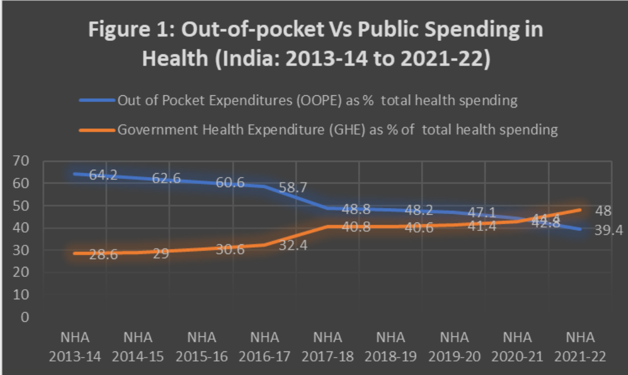
(Source- https://www.orfonline.org/)
FIG 3. Out of pocket Vs. Public spending in health
Over the past 10 years, India’s total health spending as a share of GDP has gone down. This shift happened mainly because both state and central governments started spending more on health, which helped reduce the money people had to pay from their own pockets. Still, in 2021–22, families were covering 39.4% of health costs themselves—a big issue that needs attention. India is also still working toward its goal of spending 2.5% of GDP on health by 2025, as set in the 2017 National Health Policy.
Increased Public Spending Raises Health Access
Strategic targeted public expenditure has been shown to have a marked effect in the provision of basic services, most notably in maternal and reproductive health. States given targeted investment have reaped great dividends in the form of institutional delivery, child immunization rates, and antenatal care coverage, indicating the positive effect well-targeted expenditure can have on health. Yet, it is not a question of health budgets being merely increased. Without effective governance, transparency, and accountability, even huge injections of funds could be futile. Inefficiencies in implementation and delivery of services can negate the effectiveness of public health programs. In order to win investment equating to real health gains, most notably in the underserved communities, then, in addition to extra budgets, effective program design, strong monitoring systems, and institutional reforms are required.
Infrastructural Shortages in the Health Sector
Despite various national health missions and policy efforts, India's rural health infrastructure remains saddled with major challenges. Vast areas, particularly high-burden states, still lack an adequate number of sub-centers, PHCs, and CHCs. Apart from these facility shortages, there is also a critical shortage of trained health workers, which constrains the ability of public healthcare systems to provide quality services. These infrastructure and staffing gaps are the reasons for the underutilization of government health facilities, driving people to private healthcare providers. This relocation incurs a heavy economic burden on families, as out-of-pocket spending continues to be the dominant source of healthcare finance in India. The ongoing dependence on private care based on poor public infrastructure makes health care unaffordable for the majority, particularly in rural and economically backward districts. Generally, India's health infrastructure development has not been keeping up with its increasing population and health needs, sabotaging efforts towards universal health coverage.
Public Expenditure Efficiency Instead of Quantity
India has shown relatively good social sector spending efficiency compared to other countries of the region like Pakistan and Bangladesh. With moderate average public expenditure, India has done better in health access and education. Targeted schemes, institution reform, and improved governance mechanisms provided maximum utilization of resources available, with considerable improvement in the rise in school enrollment and greater primary healthcare coverage. Progress, however, is patchy in nature, with most regions still suffering from bureaucratic delays, corruption, and infrastructure shortages. Leakages of funds and absence of accountability also further reduce the efficiency of public spending. These problems indicate the requirement of structural reforms that will introduce transparency, reduce inefficiencies, and provide equal distribution of the resources, which will improve social spending and lead to inclusive and sustainable growth.
Emerging trends In Public Expenditure
- Climate goals are now being included in budget planning.
- Public money can attract private climate-friendly investments.
- India has the chance to lead with new green budgeting ideas.
India is slowly moving towards climate-friendly budgeting, where environmental goals are considered while making financial decisions. By using public funds smartly, the government can encourage private players to invest in green projects. India also has an opportunity to become a leader in developing new and innovative ways to include climate needs in its budgeting system.
Union Budget 2025: Green Growth and Reform of Investment
- Major funds have been set aside for green hydrogen, solar power, and electric vehicles.
- The focus is on local manufacturing under the Atmanirbhar Bharat initiative.
- Environmental goals are now tied with industrial growth policies.
The 2025 Union Budget strongly supports green industries by investing in clean energy and electric mobility. These investments aim to reduce pollution and promote home-grown technology. Through this approach, India links its industrial growth with sustainability goals, making progress in both economy and environment.
Redefining Public Expenditure for Climate Resilience
Current climate spending leans more towards emissions reduction than climate preparedness.
- Adaptation areas like flood control and drought response need more funding.
- Climate planning should be built into all development strategies.
Much of India’s climate funding has focused on reducing emissions, but there is a growing call to shift more focus to climate adaptation. This means preparing better for extreme weather and protecting vulnerable people. Making climate concerns a regular part of national development plans is key to building long-term resilience.

A Green Tomorrow: A Budget Roadmap for Climate Resilience
- Budgets should include tools to measure climate-related spending.
- There is a push for more open and clear reporting on climate funding.
- Big public projects should be checked for their environmental impact.
India’s recent budget promotes tracking and measuring how much government money supports climate goals. It also stresses the need for openness about how these funds are used. Setting clear standards to assess the climate impact of large projects will help improve accountability and effective use of resources.
Union Budget 2024–25 and the Quest for Sustainability
- More money is being spent on eco-tourism, renewable energy, and protecting nature.
- Local communities are involved in conservation efforts.
- Programs are supporting green job creation and eco-skills training.
Public Expenditure in the COVID-19 Era
India's COVID-19 Public Expenditure (FY 2020–21 to FY 2022–23)
Component | 2020-21 (Actual) | 2021-22 (Revised Estimate) | 2022-23 (Budget Estimate)
COVID19 Emergency Response & Health System Preparedness | ₹13,857 crore | _ | _
Vaccination (Healthcare & Frontline Workers) | ₹360 crore | _ | _
Total COVID19 Expenditure (including above components) | ₹11,941 crore | ₹16,545 crore | ₹226 crore
Pradhan Mantri Garib Kalyan Anna Yojana (PMGKAY) | _ | _ | ₹2,00,000 crore
Pradhan Mantri Atma Nirbhar Swasth Bharat Yojana (PM ABHIM | _ | ₹1,040 crore | ₹5,846 crore
Indian Council of Medical Research (ICMR) | ₹1,275 crore | _ | _
Emergency Response & Health System Preparedness Package (including testing kits procurement) | ₹10,529 crore | _ | _

Note: "–" indicates data not specified for that fiscal year.
Source: PRS Legislative Research. "Demand for Grants 2022–23 Analysis: Health and Family Welfare." PRSIndia.org
TABLE 1. Public Expenditure in the COVID-19 Era

Summary and Conclusion
India's trajectory of public spending since independence illustrates the development of its economic policies and goals. The nation has seen substantial transformations in the distribution and use of public finances, from the first phase of state-directed industrialisation to the market-oriented reforms of the 1990s and beyond. Public spending has been crucial in influencing the nation's growth, especially in infrastructure, social welfare, and poverty reduction. Nonetheless, the efficacy of public spending has often been compromised by inefficiency, corruption, and the increasing fiscal load. The government's emphasis on extensive infrastructure and social welfare initiatives has not consistently yielded the anticipated results owing to inadequate execution and governance challenges. Furthermore, the growing fiscal deficit and debt load provide substantial obstacles to the sustainability of future public spending. India must prioritise enhancing the efficiency and accountability of its public spending. Improved targeting of social assistance programmes, rationalisation of subsidies, and a greater focus on results rather than simple allocations are essential. Moreover, enhanced fiscal discipline and improved coordination between national and state governments will be essential for ensuring that public spending yields concrete developmental results. Ultimately, public spending in India will remain an essential instrument for attaining inclusive growth and development. Nonetheless, its success hinges on a more efficient, transparent, and accountable governance structure that prioritises the needs of the most vulnerable while maintaining budgetary sustainability. Through appropriate reforms, India may use public spending to foster a more affluent and equitable future for its populace.

COMPETING INTERESTS DISCLAIMER:
Authors have declared that they have no known competing financial interests OR non-financial interests OR personal relationships that could have appeared to influence the work reported in this paper.

References
ADB. (2021). Asian Development Outlook: Financing Human Capital Development.
Arora, G. (2023). Climate budgeting: Unlocking the potential of India's fiscal policies for climate action. ORF Expert Speak
Berman, P., Ahuja, R., & Bhandari, L. (2010). The Impoverishing Effect of Healthcare Payments in India. Economic & Political Weekly.
E-International Relations (2024). Redefining India’s Public Expenditure for Climate Resilience. E-IR
ETGovernment (2025). Union Budget 2025: Investments & reforms to drive India towards a green, sustainable future. ETGovernment
FICCI (2024). The Impact of India’s Union Budget 2024–2025 on Sustainability. FICCI Blog
Narayanan, P. (2024). A green tomorrow: A roadmap for India's public expenditure. ORF
National Health Profile. (2019). Central Bureau of Health Intelligence.
UNDP. (2020). Human Development Report: India.
Vijaya Lakshmi Devi, G. Public Expenditure on Health Sector in India. JournalCRA.
World Health Organization (2017). Public Financing for Health in India: Prospects and Challenges.
BMC Public Health. (2022). Exploring the Possible Sources of Fiscal Space for Health in India.
Das, J., & Hammer, J. (2014). Quality of Primary Care in Low-Income Countries. Health Affairs.
Chattopadhyay, S. (2018). Social Sector Expenditure in India in the 2000s: Trends and Implications. SAGE Journals.
Bhat, K. S. (1996). Political Economy of Public Expenditure and Tax Revenue in India. The Indian Economic Journal, 44(1), 108-119.
Seshaiah, S. V., Reddy, T. K., & Sarma, I. R. S. (2018). General government expenditure and economic growth in India: 1980-81 to 2015-16. Theoretical Economics Letters, 8(4), 728-740.
Tilak, J. B. (2003). Public expenditure on education In India: A review of trends and emerging issues. Financing in India: Current Issues and Changing Perspectives. New Delhi: Ravi Books, 3-54.
Wadhwa, J. K. (2013). Growth of the Public Expenditures in India and its impact on the Deficits. IOSR Journal of Humanities and Social Science (IOSR-JHSS) Volume, 14, 01-13.
Dash, B. B., & Raja, A. V. (2013). Do political determinants affect the size and composition of public expenditure? A study of the Indian states. International Review of Economics, 60, 293-317.

