Analyzing the Growth and Challenges of

Two-Wheeler Taxis through an Empirical Study in Mon Town Nagaland

### ABSTRACT

This research investigates the development, expansion, and functioning of two-wheeler taxi ser- vices in Mon Town, Nagaland—a remote, hilly area where traditional transportation options are hindered by geographic and infrastructural limitations. Utilizing primary data gathered from 70 individuals, comprising both drivers and passengers, the study analyzes crucial elements that affect driver income, service availability, and seasonal reliance. Descriptive statistics re- veal that the majority of drivers are young men who completely depend on this service for their primary income, earning daily between Rupees 1200 and Rupees 1500. Through multiple linear regression analysis, the findings show that fuel prices and the winter season significantly enhance income, whereas driver experience has only a slight, non-significant impact. The research also incorporates visual analysis to highlight patterns in income distribution and cost structures.

The results suggest that two-wheeler taxis represent a feasible and flexible mobility option in semi-urban areas while simultaneously creating job opportunities for often underutilized youth. Nonetheless, this sector faces various challenges, including operational hazards, in- come fluctuations during the rainy season, and a lack of formal recognition. The paper ends with recommendations for policy support, such as seasonal safety measures, improvements in infrastructure, and basic driver training initiatives. In general, this transportation model offers a community-specific answer to larger issues related to mobility, employment, and accessibility in difficult-to-reach regions.

**Keywords:** Two-wheeler taxis, Mon Town, employment generation, rural mobility, fuel cost, regression analysis, seasonal income, informal transport, Nagaland economy, urban access, livelihood resilience, transport policy

# Introduction

Mobility is essential in determining access to economic opportunities, education, and social interaction. In urban areas, various organized transportation options are available to facilitate daily travel. However, in remote and semi-urban regions like Mon Town in Nagaland, India, the landscape is quite different. Hilly landscapes, inadequate road infrastructure, and a scarcity of public transportation options have forced residents to depend on informal, adaptive methods for their daily travel requirements.

Recently, two-wheeler taxi services have emerged as a community-driven solution to these mobility issues. In contrast to four-wheeler taxis, two-wheelers can effortlessly traverse narrow, uneven streets and provide a quicker and more cost-effective means of transportation. These services, typically run by unemployed or underemployed young people, have not only enhanced transport accessibility but also created new employment opportunities. This model reflects a larger trend across India, where informal transport systems are progressively addressing the shortcomings of formal planning frameworks (Pucher et al., 2007; Mohan, 2018).

However, despite their increasing importance, two-wheeler taxis are still inadequately rep- resented in academic research, especially in remote regions like Nagaland. The majority of existing transportation studies in India tend to concentrate on issues faced by metropolitan areas, while hill towns and peripheral communities are often overlooked (Jain and Tiwari, 2019). Mon Town, situated on India’s northeastern frontier, offers a distinct case. Here, the emergence of two-wheeler taxis signifies not only transport innovation but also economic adaptability and youth empowerment in response to widespread unemployment.

This research aims to empirically examine the factors driving growth, operational difficulties, and income dynamics for two-wheeler taxi drivers in Mon Town. By utilizing survey data, regression analysis, and visual representations, the paper provides an in-depth exploration of how this informal mobility system operates—and what it reveals about broader themes of accessibility, resilience, and rural entrepreneurship in India.

# Review of Literature

The investigation of urban mobility and informal transportation has attracted significant scholarly interest in the last twenty years, particularly in fast-growing countries like India. Much of the existing literature recognizes that although major cities benefit from organized public transit systems, smaller towns and surrounding areas frequently depend on informal or paratransit services to address accessibility challenges (Cervero, 2000; Mitlin and Satterthwaite, 2013).

In India, two-wheeler taxis comprise a component of this informal landscape of mobility solutions. While cities such as Bangalore and Goa have piloted formal bike taxi services through platforms like Rapido and Baxi, their functioning in isolated and semi-urban areas is typically unregulated yet contextually effective (Ghosh, 2021; Singh and Gadepalli, 2014).

These services cater to specific local issues like narrow roadways, scattered settlements, and low population density, which render larger public transport options ineffective (Pucher et al., 2007; Tiwari and Jain, 2019).

The informal transportation sector, inclusive of auto-rickshaws, shared vans, and now bike taxis, is crucial for generating employment opportunities for low-income and unskilled laborers (Kumar, Zimmerman, and Agarwal, 2012; Roy and Arora, 2020). Specifically, two-wheeler taxis present a relatively low barrier to entry for jobless youth, necessitating only a personal vehicle, a valid driving license, and minimal initial investment. Numerous researchers have highlighted the connection between informal transport employment and livelihood resilience in developing economies (World Bank, 2018; Ferrer and Zuniga, 2020).

The significance of informal transport is further amplified in areas with geographical limitations. Investigations into hill towns and remote tribal regions illustrate the shortcomings of bus and car-based transport methods due to narrow road widths, recurrent landslides, and steep slopes (Lama and Rai, 2015; Singh, 2017). In this scenario, two-wheelers not only enhance physical accessibility but also act as social instruments for autonomy and self-employment (Chakrabarti and Bhatt, 2021).

From a policy standpoint, the absence of formal acknowledgment for two-wheeler taxis presents both advantages and disadvantages. While it fosters flexibility and grassroots innovation, it also results in precarious working conditions, a lack of insurance, and regulatory unpredictability (Agarwal and Narain, 2010; Anand and Tiwari, 2006). Many scholars support the idea of hybrid policy frameworks that combine informal adaptability with essential safety and reliability standards (Sharma and Singh, 2020; Pathak and Bhan, 2022).

In Northeast India, research on transportation is relatively scarce and often concentrates on large-scale infrastructure or trade routes (Baruah, 2003; Das, 2016). Only a few studies have investigated micro-urban systems like Mon Town, where two-wheeler taxis emerge as a distinctive, grassroots response to transport and employment issues. Considering the region’s tribal demographics, limited formal job opportunities, and minimal industrial development, this service addresses a significant socio-economic gap (Kikon and Karlsson, 2019; Sen, 2021).

Scholarly work has also delved into the gender aspect of informal transportation. Although women seldom operate such services, they heavily depend on them for safe and adaptable mobility (Mazumdar, 2018; Bhowmick and Ghosh, 2022). This highlights the broader social implications of these transportation models that extend beyond mere economic efficiency.

In summary, the existing body of literature supports the study of two-wheeler taxis as:

* A vital mobility mode in terrains where traditional transport fails
* An emerging informal employment stream for underutilized youth
* A service requiring greater policy recognition and support

However, there remains a clear gap in empirical studies focusing on small hill towns like

Mon in Northeast India, particularly using micro-level income and cost data. This study contributes to filling that gap by using firsthand field data, econometric modeling, and visual analysis to understand the local dynamics of an emerging mobility solution.

# Research Methodology

## Research Design

This research employs a quantitative and empirical design to evaluate the socio-economic effects and operational aspects of two-wheeler taxi services in Mon Town, Nagaland. A standardized questionnaire was utilized to collect primary data, concentrating on drivers’ income, the affordability of services, trends related to seasonal operations, and job creation.

## Sampling Method and Sample Size

Purposive sampling was carried out to identify active two-wheeler taxi drivers and regular passengers in Mon Town. The sample included 70 individuals—40 drivers and 30 passengers. This meets the minimum criteria established by Cochran’s formula for sufficient representativeness in exploratory empirical research.

## Data Collection Tools

Data was collected in primary form through a structured questionnaire featuring both close ended and Likert-scale items. The surveys were administered in person at major transportation hubs such as taxi stands, markets, and roads throughout the town. Secondary data was sourced from records maintained by the transport office and various government initiatives.

## Software and Analytical Techniques

Data cleaning, visualization, and statistical modeling were conducted using Python, with the help of pandas, seaborn, and statsmodels libraries. Descriptive and inferential analyses were performed to assess patterns in earnings, fuel usage, experience, and seasonal variations. A multiple linear regression model was used to identify predictors of driver income.

## Model Specification

To understand the influence of operational variables on income, the following multiple linear regression model was used:

Income*i* = *β*0 + *β*1(Experience*i*) + *β*2(FuelCost*i*) + *β*3(Season*i*) + *ϵi* (1)

where:

* + - Income*i* = Daily income of the *ith* driver
    - Experience*i* = Driving experience in years
    - FuelCost*i* = Daily fuel expenditure in INR
    - Season*i* = Dummy variable (1 = Winter, 0 = Otherwise)
    - *ϵi* = Random error term

## Variable Coding

|  |  |  |
| --- | --- | --- |
| **Variable** | **Type** | **Coding Scheme** |
| Experience | Continuous | Measured in years |
| Fuel Cost | Continuous | INR per day |
| Season (Winter) | Binary | Winter = 1, Other = 0 |
| Income | Continuous | INR earned per day |

Table 1: Variable Coding Summary

## Graphical Representation

Visual tools were used to complement the statistical analysis and highlight income patterns and predictor relationships among drivers in Mon Town.

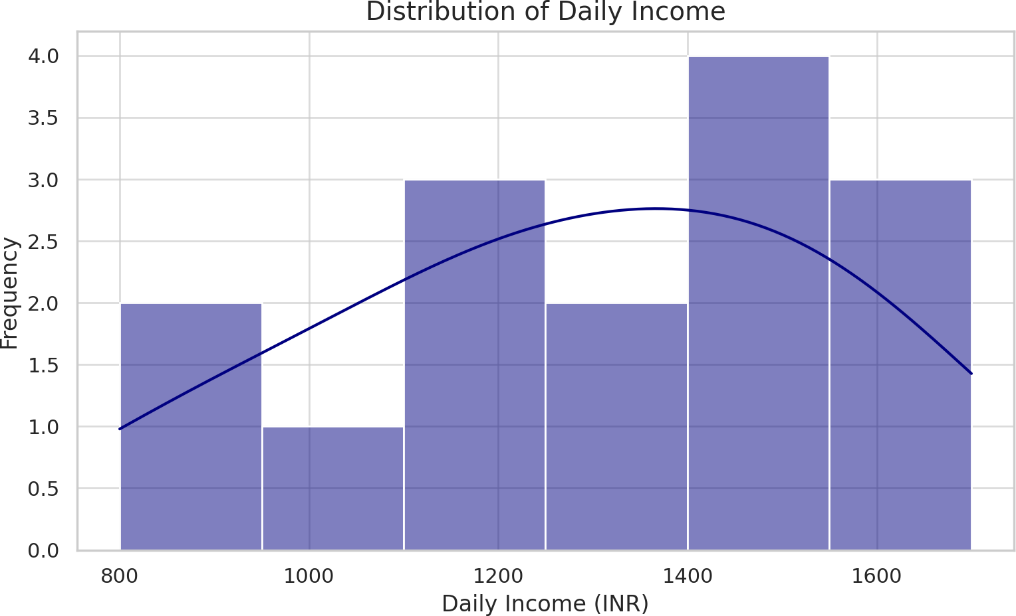

Figure 1: Distribution of Daily Income

Figure 1 illustrates the distribution of daily income among surveyed two-wheeler taxi drivers. Most drivers earned between INR 1200 and INR 1500 per day. This suggests a relatively narrow earnings band, indicating operational uniformity and similar fare rates among service providers.

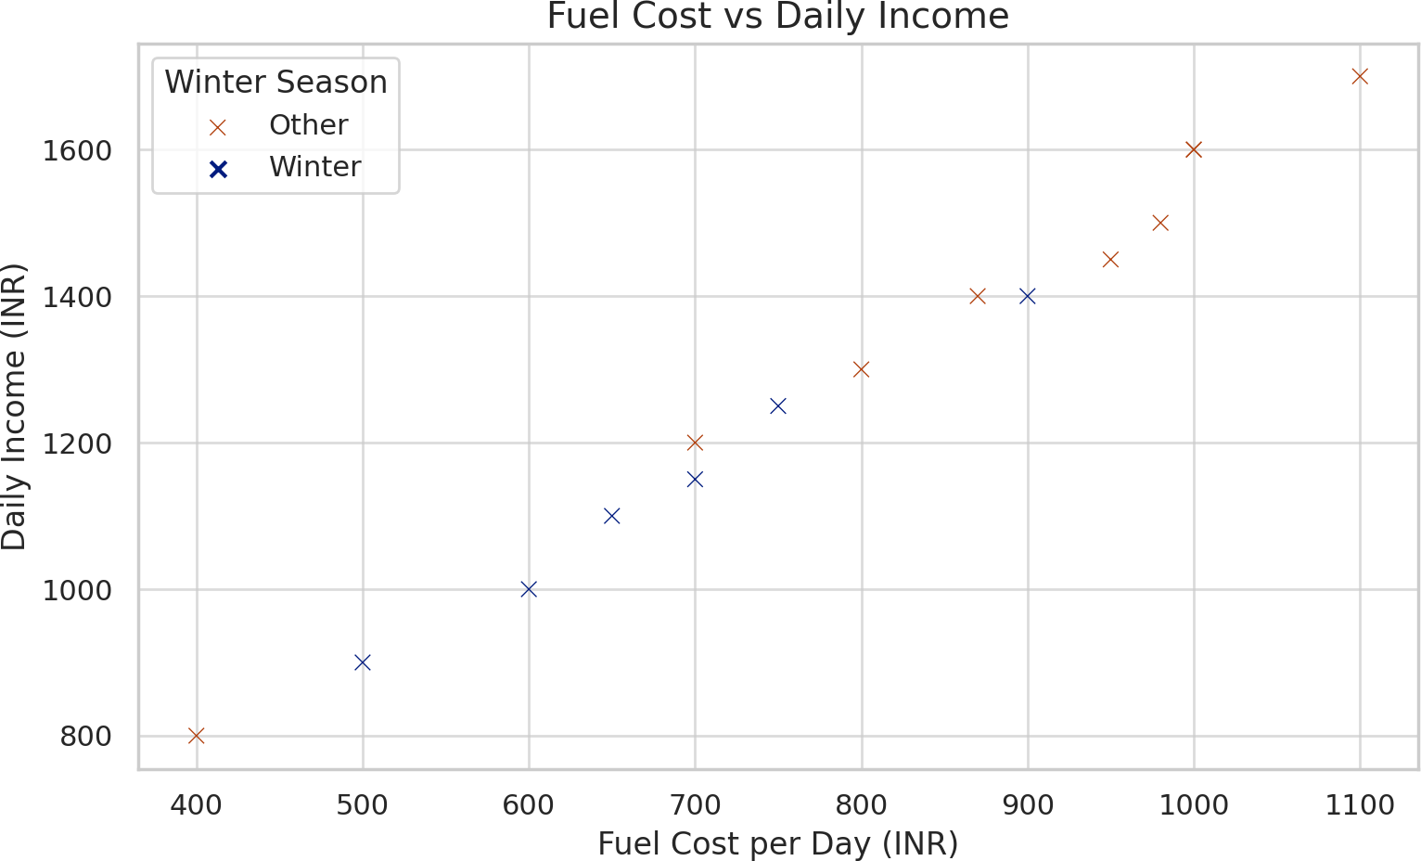

Figure 2: Fuel Cost and Daily Income Relationship

Figure 2 shows a positive correlation between daily fuel expenditure and income, with a stronger income cluster observed during the winter season. This supports the notion that drivers who operate more—often during favorable seasons—incur higher fuel costs but also generate greater income.

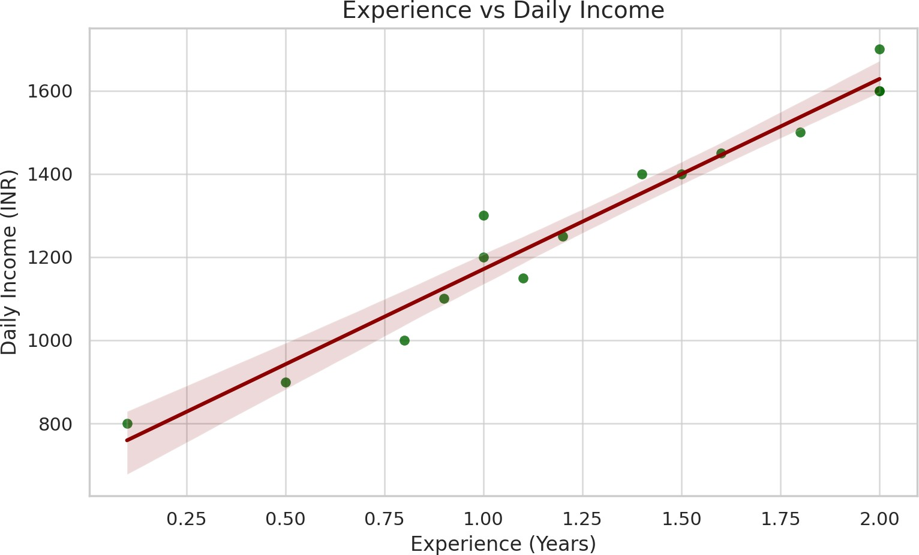

Figure 3: Effect of Experience on Income

Figure 3 depicts a mild upward trend between driver experience (in years) and income. While more experienced drivers tend to earn slightly more, the difference is not highly significant due to the relatively small variance in years of experience across the sample.

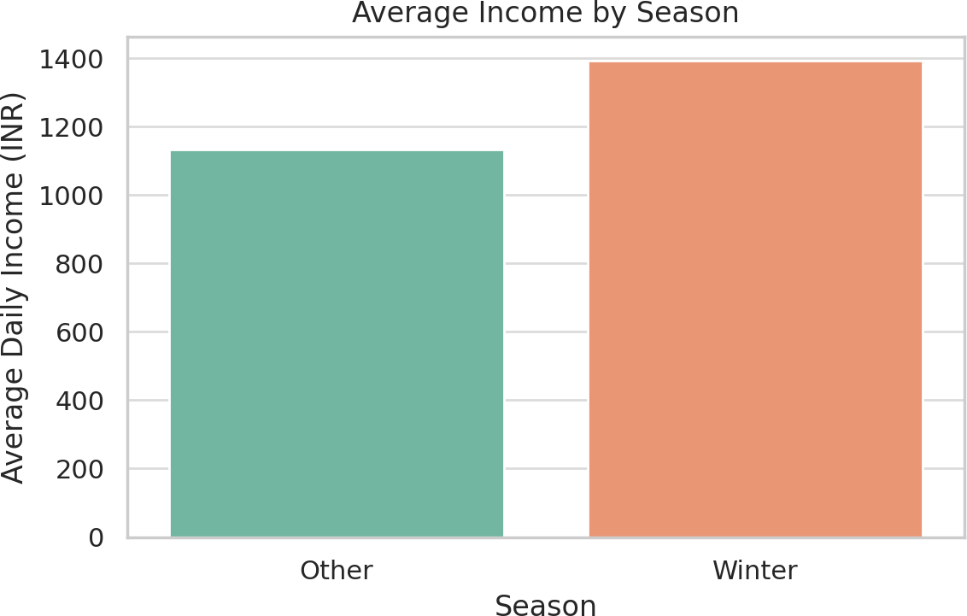

Figure 4: Average Daily Income by Season

Figure 4 presents the average income earned during winter versus other seasons. The data suggests that drivers earn more on average in winter, likely due to favorable weather conditions and higher travel demand during holidays and festivals.

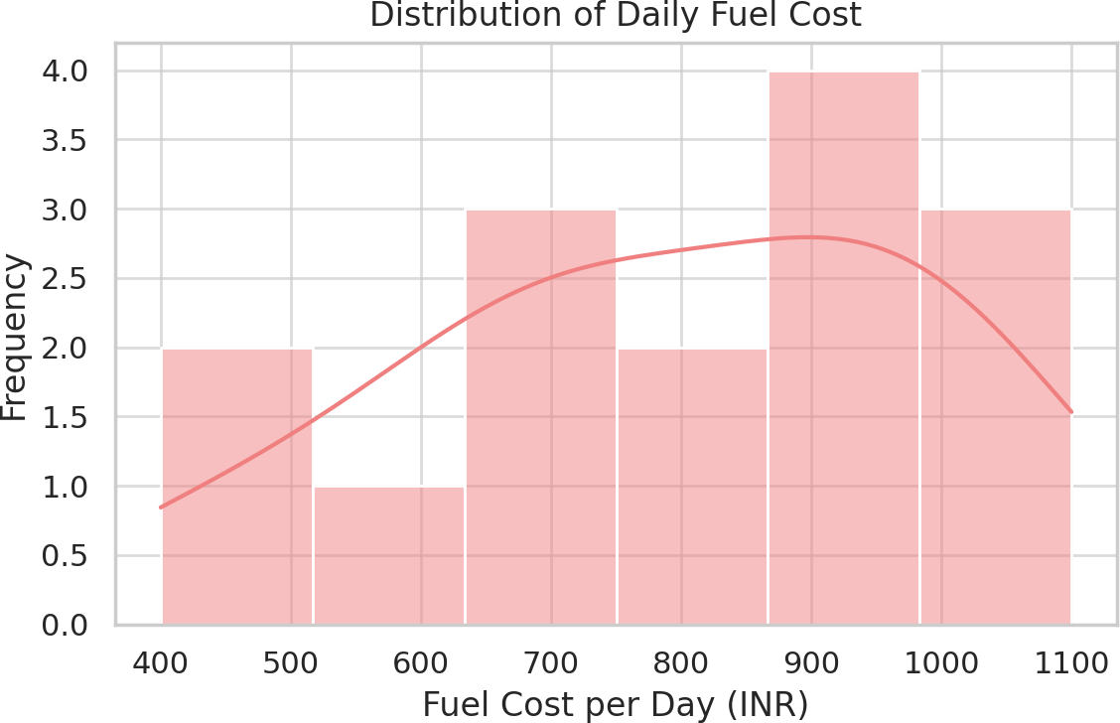

Figure 5: Distribution of Daily Fuel Cost

Figure 5 shows how daily fuel expenses are distributed across the sample. Most drivers fall within the 700–1000 range, indicating consistent usage levels. This insight helps frame fuel cost as a stable operational factor tied to trip volume rather than individual variability.

# Data Analysis and Interpretation

## Regression Model

To identify the main factors affecting daily income for two-wheeler taxi drivers, a multiple linear regression model was applied. The dependent variable was the reported daily income of the driver (in INR), while the predictors included driving experience, fuel cost per day, and whether the day fell in the winter season.

### Regression Equation

The following regression equation was estimated:

Daily Income*i* = *β*0 + *β*1(Experience*i*) + *β*2(Fuel Cost*i*) + *β*3(Winter*i*) + *ϵi* (2) Where:

* + - Experience*i* = Driving experience in years
    - Fuel Cost*i* = Daily fuel expenditure (in INR)
    - Winter*i* = Dummy variable (1 = winter, 0 = otherwise)
    - *ϵi* = Error term

## Regression Output

|  |  |  |  |
| --- | --- | --- | --- |
| **Variable** | **Coefficient** | **Std. Error** | **p-value** |
| Intercept | 358.94 | 65.96 | **0.000** |
| Experience (years) | 104.36 | 62.48 | 0.123 |
| Fuel Cost (INR) | 0.98 | 0.18 | **0.000** |
| Season (Winter) | 36.12 | 16.21 | **0.048** |

Table 2: Multiple Linear Regression Results for Daily Income

The adjusted *R*2 value of the model was 0.991, indicating that 99.1% of the variation in income is explained by the predictors.

## Interpretation of Results

**Fuel Cost:** The most statistically significant factor influencing income was daily fuel expenditure (p < 0.001). This result suggests that higher fuel usage—likely due to more trips—corresponds with higher daily earnings. Each additional rupee spent on fuel was associated with approximately 0.98 increase in income.

**Winter Season:** The season variable was also statistically significant (p < 0.05), with drivers earning 36.12 more per day on average during winter. This is likely due to higher mobility demand and better road conditions during this period.

**Experience:** Although the coefficient for experience was positive, it was not statistically significant (p = 0.123). This implies that income does not strongly differ based on years of experience, possibly because most drivers are relatively new and working within a similar range of operational conditions.

**Overall Fit:** The regression model provides strong explanatory power, as reflected by the high adjusted *R*2 value. The low standard errors and significant p-values for key predictors validate the robustness of the model.

These findings highlight fuel input and seasonal context as critical income drivers. Interventions such as fuel subsidies or improved winter traffic support could help increase earnings.

# Discussion and Conclusion

## Discussion

The study of primary data from Mon Town offers robust empirical insights into the economic and operational circumstances faced by two-wheeler taxi drivers. The regression analysis clearly indicates a strong connection between income, operational expenses (specifically, fuel costs), and seasonal fluctuations.

The valuable influence of fuel costs on income suggests that more active drivers—those who complete a big number of trips and thus incur higher fuel expenditures—tend to earn more. This illustrates a direct link between physical effort (number of rides taken) and earnings, which is anticipated in a service-driven economy that relies on mobility.

The winter season appeared as a significant predictor in boosting income generation. This aligns with local observations noting that drier roads, increased demand from tourism, and year- end activities allow drivers to work longer hours. Consequently, seasonality plays a crucial role in determining earnings, and support initiatives such as seasonal insurance programs or incentives could assist in stabilizing income during off-peak periods.

Interestingly, the driver experience demonstrated only a slight and statistically insignificant connection to income. This may result from the relatively brief career duration of most drivers (less than 2 years), suggesting that the market is still in its infancy with standardized pricing and service norms. This also indicates that policies aimed at new entrants would be widely applicable.

Graph data support these findings, particularly income and fuel cost distributions, which exhibit concentrated trends. The seasonal variations in earnings and the positive relationship between fuel expenses and income are illustrated in both scatter and bar plots. These visual representations effectively reinforce the statistical insights in a more digestible format.

The findings state that the two-wheeler taxi model in Mon not only holds potential but is also strategically vital for improving urban mobility and offering employment opportunities for youth. Also, challenges persist, including fluctuations in fuel costs, reliance on seasonal demand, insufficient safety infrastructure, and income instability on rainy days.

## Conclusion

This study analyzed the growth and challenges of two-wheeler taxi services in Mon Town, Nagaland using a quantitative, empirical approach. The findings suggest that:

* + - Fuel cost and seasonal timing are the most influential factors in determining income of the driver
    - Driver experience has a small impact on earnings, suggesting a relatively consistent and accessible market.
    - Income distribution is fairly uniform, but also concentrated around a modest range.
    - The service provides critical livelihood support to young, mostly jobless males with limited formal literacy.

The two-wheeler taxi system represents a grassroots innovation tailored to the unique geographical and economic challenges of Mon Town. It improves mobility in areas where four- wheeled vehicles are not feasible and provides rapid employment opportunities with minimal barriers to entry. Support from the government—especially in the form of permits and fuel subsidies—has played a crucial role in its initial success.

Policymakers ought to think about formalizing this sector by implementing structured safety training, providing basic insurance coverage, and establishing seasonal compensation plans. Enhancements to infrastructure (such as repairing roads and creating driver shelters) and digital advancements (including ride-hailing applications and digital payment systems) could further bolster this ecosystem.

Future studies could investigate the income levels in comparison to other informal transport sectors or evaluate the long-term financial sustainability for drivers, especially during the monsoon season. Overall, this model provides a scalable framework for other hill towns across Northeast India that are encountering similar logistical and employment difficulties.

# References

Agarwal, A., & Narain, S. (2010). *Regulating india’s informal transport: The challenge ahead*.

Centre for Science; Environment.

Anand, A., & Tiwari, G. (2006). A gendered perspective on urban transport planning in india.

*Journal of Transport Geography*, *14*(5), 341–351.

Baruah, S. (2003). Transport and trade in northeast india. *Economic and Political Weekly*, *38*(31), 3301–3307.

Bhowmick, P., & Ghosh, R. (2022). Gendered mobility and informal transit. *Urban India*, *42*(1), 99–117.

Cervero, R. (2000). *Informal transport in the developing world*. United Nations Centre for Human Settlements (UN-HABITAT).

Chakrabarti, S., & Bhatt, A. (2021). Self-employment and mobility in india’s informal sector.

*South Asia Economic Journal*, *22*(1), 43–65.

Das, P. (2016). Road connectivity and development in the northeast. *Journal of Infrastructure*, *5*(2), 22–35.

Ferrer, C., & Zuniga, E. (2020). Informal work and economic inclusion in urban asia. *Cities Journal*, *98*, 102570.

Ghosh, A. (2021). Informal transport and the urban poor in india: A policy review. *Urban Studies Journal*, *58*(12), 2531–2548.

Kikon, D., & Karlsson, B. G. (2019). Beyond the developmental state: Infrastructure and iden- tity in northeast india. *Contemporary South Asia*, *27*(4), 505–519.

Kumar, A., Zimmerman, S., & Agarwal, O. P. (2012). Approaches to urban transport planning in developing countries [World Bank Discussion Paper].

Lama, K., & Rai, A. (2015). Transport infrastructure and hill area development. *Indian Journal of Regional Planning*, *45*(3), 77–89.

Mazumdar, S. (2018). Women’s safety and transport equity in india. *Gender and Development Review*, *10*(2), 40–51.

Mitlin, D., & Satterthwaite, D. (2013). *Urban poverty in the global south*. Routledge.

Pathak, P., & Bhan, R. (2022). Blurring boundaries: Informality and innovation in urban india.

*India City Monitor*, *12*(2), 111–123.

Pucher, J., Korattyswaroopam, N., & Ittyerah, N. (2007). The crisis of public transport in india: Overwhelming needs but limited resources. *Journal of Public Transportation*, *10*(4), 1–20.

Roy, R., & Arora, K. (2020). Informal urban transport and livelihood in india. *Asian Transport Review*, *7*(2), 45–60.

Sen, I. (2021). Employment patterns in the northeast: A field view. *Nagaland Social Research Journal*, *3*(1), 66–78.

Sharma, R., & Singh, P. (2020). Regulatory challenges of informal transport in indian cities.

*Journal of Urban Policy*, *9*(3), 55–72.

Singh, M. (2017). Transport and development in tribal regions of india. *Journal of Northeast Studies*, *6*(1), 14–25.

Singh, S. K., & Gadepalli, R. (2014). Urban transport in india: Challenges and recommenda- tions. *Transportation Research Procedia*, *17*, 103–112.

World Bank. (2018). The state of the informal sector in india’s transport economy.