***Case report***

**FOCAL CEMENTO-OSSEOUS DYSPLASIA- A CASE REPORT**

**ABSTRACT:**

Focal cemento-osseous dysplasia (FCOD) is a subgroup of benign fibro osseous lesions, which occur in a single site of tooth-bearing areas of the jaws. It is usually asymptomatic and noticed accidentally through routine radiological examinations. This article is a case report of a 37-years-old female patient with a complaint of swelling of mandibular anterior region for the past 3 months. Extraoral examination revealed a diffuse swelling in the right lower anterior segment. On radiographic examination, a mixed radiolucent/radio-opaque lesion with ginger root-like opacities and a radiolucent rim, but with extension into the basal bone was noticed in the symphysis region. Based on radiographic appearance, a provisional diagnosis of Cementoblastoma / Calcifying Epithelial Odontogenic Tumour was given. An incisional biopsy was submitted to the department of Oral Pathology for histopathological reporting and the case was finally reported as FCOD. This case report is being presented with interest to focus on FCOD Expansive type. Cemento-Osseous Dysplasia (COD) can be divided into focal and florid types, familial and non-familial types, and an expansive type. The expansive COD is a rare entity presenting as a single expanding lesion in a non-familial capacity.

**INTRODUCTION:**

Fibro-osseous lesions represent an uncommon and distinct category of disorders that involve the jaws and craniofacial skeleton. The word "benign fibro-osseous lesion" describes a collection of non-neoplastic conditions where normal bone is substituted by a fibrous connective tissue stroma that includes irregular bone or cementum-like material(1). Fibro-osseous lesions affecting the jaws encompass conditions such as fibrous dysplasia, ossifying fibroma, and cemento-osseous dysplasia (COD). Among these, COD is the most commonly encountered and typically appears as a painless lesion with a mixed radiolucent and radiopaque appearance, located in the tooth-bearing regions of the jaw(2). The World Health Organization (WHO) has classified cemento-osseous dysplasia into three categories—focal, periapical, and florid—based on its clinical presentation and radiographic characteristics(3).

Periapical cemento-osseous dysplasia typically appears as single or numerous lesions located at the root end of vital mandibular anterior teeth. Focal COD is usually asymptomatic, seen most often in middle-aged women, and primarily affects the mandibular posterior molar region. Florid COD represents a more widespread and multifocal variant, often involving both the maxilla and mandible, or appearing on both sides of the mandible(4). Focal cemento-osseous dysplasia (FCOD) typically affects a solitary location, chiefly in the posterior region of the mandible. Prior to its clearer classification in the middle of the 1990s, many reports were mistakenly identified as a form of ossifying fibroma(5). Cemento-osseous dysplasia is generally asymptomatic, with surrounding teeth remaining vital. As a result, it is most commonly identified during routine radiographic evaluations(6). In its early osteolytic phase, the lesion appears radiolucent and may be mistaken for periapical dental pathology, leading to unwarranted procedures such as extractions or root canal treatments. As the condition advances, the radiographic appearance shifts to a mixed radiolucent-radiopaque pattern due to bone regeneration at the lesion site. In the mature phase, it becomes predominantly radiopaque with a surrounding radiolucent border. The margins are typically well-defined but may appear slightly irregular(7).

In numerous instances, diagnosing cemento-osseous dysplasia (COD) can be challenging, as early-stage radiographic findings often resemble those of periapical cysts or granulomas. In these cases, histopathological examination serves as a crucial part in guiding accurate identification and appropriate patient management. Microscopically, COD is characterized by a fibrous connective tissue stroma containing scattered areas of woven or lamellar bone along with cementum-like calcified structures(2). This report presents a case of focal cemento-osseous dysplasia (FCOD) located in the anterior mandible of a 37-year-old female patient.

**CASE PRESENTATION:**

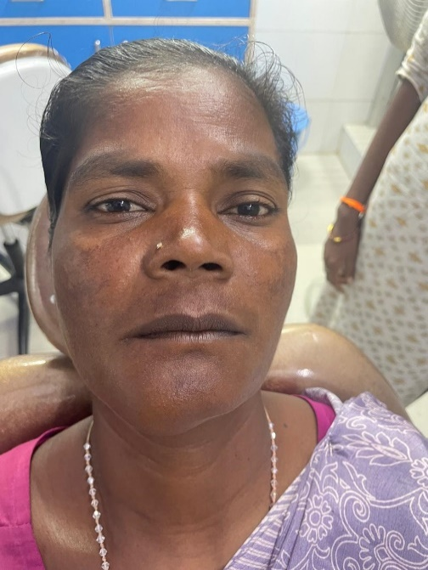A female patient of age 37 years reported to the outpatient department complaining of a swelling in the lower front tooth region for the past three months. During extra-oral assessment,a diffuse swelling in the right anterior segment of mandible was noted which was firm, non-fluctuant measuring of approximately 1.5 cm in size. The patient was generally healthy, with no prior history of trauma or relevant medical conditions.

**Figure-1:** Extraoral picture illustrating a diffuse swelling in the lower right front tooth region.

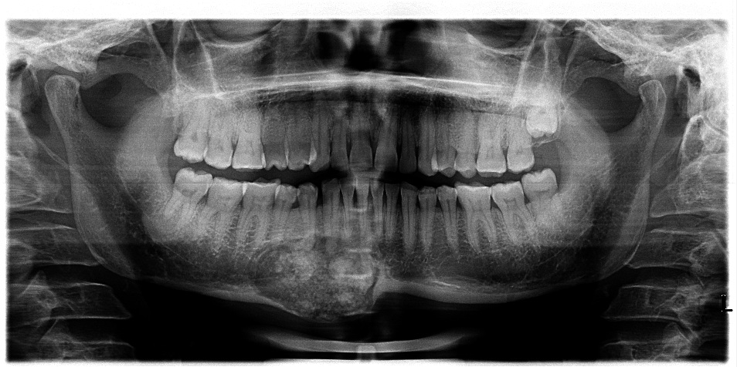On radiographic examination, orthopantamogram (OPG) revealed a lesion exhibiting both radiolucent and radiopaque areas, characterized by opacities resembling ginger roots and surrounded by a radiolucent border extending from mesial side of 32 to mesial root of 46. However, extention into the underlying basal bone was also noticed in the symphysis region. Provisional diagnosis was given as cementoblastoma? or CEOT?

**Figure-2:** OPG shows a mixed radiolucent-radioopaque lesion with ginger root-like opacities and a radiolucent rim, extending from 32 mesial to 46 mesial root.

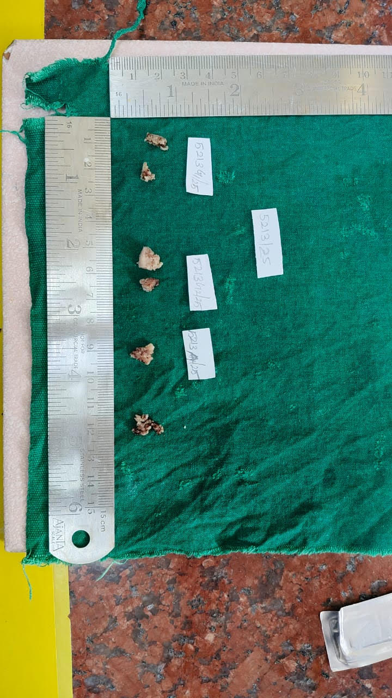An incisional biopsy was done and the specimen was submitted to the department of oral and maxillofacial pathology for final diagnosis. Received multiple bits of mixed tissue specimen, which were yellowish white in colour & mixed in consistency with an irregular surface. The specimen was routinely decalcified, processed, sectioned and stained for histopathological examination.

**Figure-3:** Image displaying the gross appearance of the surgically removed specimen.

On microscopic examination, the H&E stained sections of the given mixed tissue specimen reveals a delicate fibrocellular connective tissue stroma with numerous plump fibroblast like cells. Within the connective tissue stroma are seen numerous interspersed curvilinear hard tissue structures with many osteocytes resembling woven bone with osteoblastic rimming in some areas. Also seen calcified structures with lamellations resembling lamellar bones. Large and small globules of acellular, homogenous, eosinophilic to basophilic structures resembling cementum are also seen dispersed within the stroma. Scattered capillaries are noticed throughout the stroma and the periphery of the sections reveals haemorrhagic areas. Final diagnosis of “FOCAL CEMENTO OSSEOUS DYSPLASIA- EXPANSIVE” was given based on histopathological features.

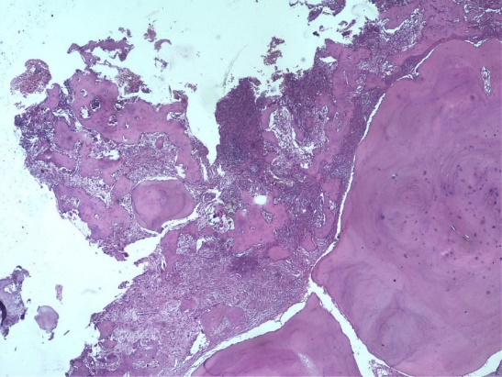

**Figure-4:** Low-power view of H&E-stained decalcified section illustrating globular cementum-like calcifications.

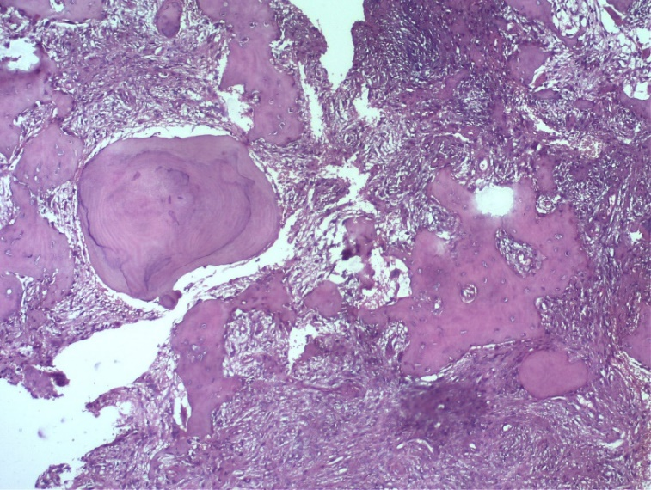

**Figure- 5:** Low-power H&E-stained decalcified section illustrating woven bone lined by osteoblasts.

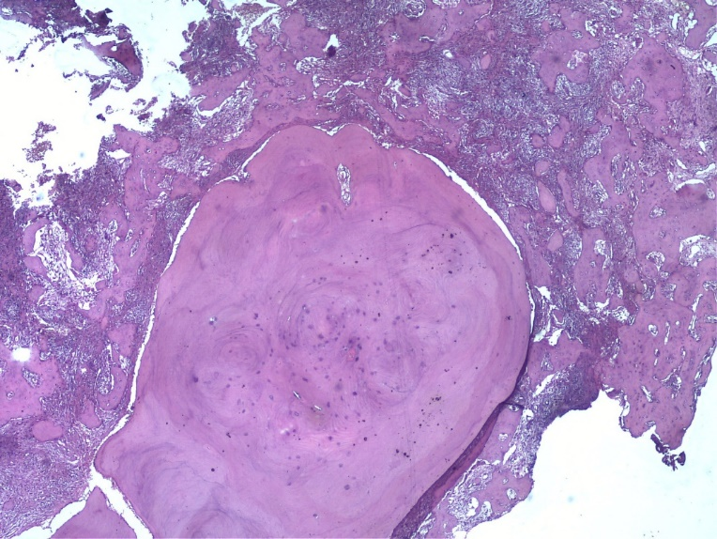

**Figure- 6:** Low-power H&E-stained decalcified section revealing fibrocellular connective tissue stroma.

**DISCUSSION:**

Cemento-osseous dysplasia is a group of fibro-osseous lesions typically found in the alveolar regions of the jaws, characterized by the formation of abundant cementum-like mineralized tissue (8). The cause and development of FCOD are still not well understood and it is thought to be either a reactive or a dysplastic lesion. It is believed to originate from the periodontal ligament or result from a defect in extraligamentary bone remodeling affected by both local and systemic factors (9).

WHO recognizes three distinct forms of cemento-osseous dysplasia based on clinicoradiographic features namely Focal and Florid types, Familial and Non-Familial types and Expansive type(10). Focal-type dysplasia affects a solitary location in either tooth-bearing or previously tooth-bearing (edentulous) areas of the jaw (11). These lesions grow slowly and typically do not exceed 2 cm in diameter. Expansive COD is an uncommon condition characterized by a solitary, enlarging lesion that occurs sporadically without a familial link. The development of FCOD takes place in 3 stages(12). The first stage consists of Proliferation of a cellular connective tissue followed by the second stage in which Bone / cementum is formed within the fibrous tissue giving a radiolucent / radiopaque appearance and the in third stage continuous progressive formation of bone / cementum is evident. A narrow rim of connective tissue surrounds the mass(13).

Molecular pathogenesis of FCOD lies in mesenchymal stem cell differentiation, extracellular matrix (ECM) remodelling, osteoclast regulation and genetic and epigenetic modifications(14). FCOD originates from stem cells derived from the periodontal ligament (PDLSCs) or other multipotent stromal stem cells (MSCs) that undergo abnormal differentiation(15). Overexpression of RUNX2 (Runt-related transcription factor 2) may contribute to excessive cementoblastic and osteoblastic activity in FCOD. Dysregulation of β-catenin/Wnt signaling pathway may enhance osteoblastic differentiation in FCOD. Overexpression of collagen type I and III and MMP-9 and altered expression of osteoprotegerin (OPG) in FCOD may contribute to its characteristic sclerotic and mineralized appearance. Altered microRNA (miRNA) expression may also regulate differentiation of MSCs into cementoblasts and osteoblasts(10).

This case underscores the diagnostic challenges posed by focal cemento-osseous dysplasia (FCOD), particularly when its clinical and radiographic features mimic those of cementoblastoma or calcifying epithelial odontogenic tumor (CEOT). The lesion's presentation—radiopaque with a radiolucent halo and apparent attachment to the tooth root—initially suggested cementoblastoma. However, histopathological examination revealed fragmented, hemorrhagic tissue with a fibrous stroma interspersed with irregular bone trabeculae and cementum-like deposits, consistent with FCOD. The present case highlights the critical significance of integrating clinical, radiographic, and histopathological findings to achieve an accurate diagnosis. Recognizing FCOD is essential to prevent unnecessary surgical interventions, as it is a benign, self-limiting condition that typically requires no treatment beyond regular monitoring.

**CONCLUSION:**

FCOD is possibly the most frequent bone lesion in the jaw, typically asymptomatic and presenting as a focal mixed radiolucent-radiopaque area with either well-defined or poorly defined borders in tooth-bearing regions. Once diagnosed, complete surgical removal is unnecessary; however, there is a potential for progression to florid cemento-osseous dysplasia, so regular monitoring is advised.

**REFERENCES:**

1. Oral-Radiology.pdf [Internet]. [cited 2025 May 13].
2. Shafer’s Textbook of Oral Pathology. 2016 [2025 May 13].
3. World Health Organization 4th edition of head and neck tumor classification: insight into the consequential modifications | Virchows Archiv. [2025 May 13].
4. Osseous (Cemento-osseous) Dysplasia of the Jaws: Clinical and Radiographic Analysis | JCD. [2025 May 13].
5. Oral and Maxillofacial Pathology Neville 4ed | PDF | Diseases And Disorders | Clinical Medicine. [2025 May 13].
6. Cavalcanti PHP, Nascimento EHL, Pontual ML dos A, Pontual A dos A, Marcelos PGCL de, Perez DE da C, et al. Cemento-Osseous Dysplasias: Imaging Features Based on Cone Beam Computed Tomography Scans. Braz Dent J. 2018 Feb [2025 May 13];29:99–104.
7. Min CK, Koh KJ, Kim KA. Recurrent symptomatic cemento-osseous dysplasia: A case report. Imaging Sci Dent. 2018 Jun [2025 May 13];48(2):131–7.
8. Bulut EU, Acikgoz A, Ozan B, Zengin AZ, Gunhan O. Expansive Focal Cemento-Osseous Dysplasia. The Journal of Contemporary Dental Practice. 2012 Feb [2025 May 13];13(1):115–8.
9. Ravikumar SS, Vasupradha G, Menaka TR, Sankar SP. Focal cemento-osseous dysplasia. J Oral Maxillofac Pathol. 2020 Feb [2025 May 13];24(Suppl 1):S19–22.
10. Ver Berne J, Jacobs R, Hauben E, Politis C. An expansile presentation of focal cemento-osseous dysplasia of the mandible in a young girl. BJR|case reports. 2023 May [2025 May 13];9(3):20230013.
11. Focal cemento-osseous dysplasia, Review and a case report. ResearchGate. [2025 May 21];
12. Salvi AS, Patankar S, Desai K, Wankhedkar D. Focal cemento-osseous dysplasia: A case report with a review of literature. J Oral Maxillofac Pathol. 2020 Feb [2025 May 21];24(Suppl 1):S15–8.
13. Peter A. Reichart / Hans P. Philipsen | Odontogenic Tumors and Allied Lesions | Quintessence Publishing Company, Ltd. [2025 May 13].
14. Günhan Ö, Kahraman D, Yalçın ÜK. The possible pathogenesis of cemento-osseous dysplasia: A case series and discussion. Advances in Oral and Maxillofacial Surgery. 2021 Jul 1 [2025 May 21];3:100105.
15. Novello S, Tricot-Doleux S, Novella A, Pellen-Mussi P, Jeanne S. Influence of Periodontal Ligament Stem Cell-Derived Conditioned Medium on Osteoblasts. Pharmaceutics. 2022 Apr [2025 May 21];14(4):729.