*Case report*

A Case of Cerebellar Stroke: Unmasking the Intricate Role of Arteria Lusoria

Abstract:

**Background**: The aberrant right subclavian artery (ARSA), also known as Arteria Lusoria, is a rare congenital anomaly of the aortic arch. Although typically asymptomatic and isolated, it can sometimes coexist with other congenital anomalies and present complications.

**Case Presentation**: We present a 64-year-old male with a history of hypertension, hyperlipidemia, and cholelithiasis who presented with acute cerebellar stroke. Investigations revealed ARSA and a patent foramen oval (PFO) with atrial septal aneurysm (ASA).

**Discussion:** This case highlights the potential interplay between ARSA and other stroke risk factors, particularly in atypical presentations. While the definitive role of ARSA in stroke pathogenesis remains under investigation, this case adds to the growing body of literature exploring this association.

**Conclusions:** This case underscores the importance of considering uncommon anatomical variations during stroke workup, especially when dealing with atypical presentations or increased risk factors. This approach can improve diagnostic accuracy and contribute to optimal patient care.

*Keywords: Arteria Lusoria, Cerebellar stroke, Atrial septal aneurysm, Persistent foramen oval*

1. **Introduction:**

Arteria lusoria, also known as aberrant right subclavian artery, is a rare congenital anomaly affecting approximately 0.5% to 2% of the population [1]. This anomaly involves the abnormal origin of the right subclavian artery, arising from the descending aorta instead of the usual brachiocephalic trunk.[2] While typically asymptomatic, ARSA can occasionally present with complications like dysphagia (swallowing difficulty) due to esophageal compression[3], [4]. However, its potential association with stroke remains an evolving area of research.

This case report delves into the intriguing presentation of a 64-year-old male with a history of hypertension, hyperlipidemia, and cholelithiasis who experienced an acute cerebellar stroke. Interestingly, investigations revealed the presence of both ARSA and a patent foramen ovale (PFO) with atrial septal aneurysm (ASA).

1. **Case presentation:**

A 64-year-old male with a history of hypertension, hyperlipidemia, and cholelithiasis presented to the emergency department with a sudden onset of severe vertigo, frontal headaches, and vomiting. On examination, he was conscious, alert, and oriented but exhibited rotatory vertigo, left upper limb dysmetria, multidirectional nystagmus, and an inability to stand without assistance. No cranial nerve abnormalities were found, and deep tendon reflexes were normal. While an initial head CT scan was unremarkable, subsequent MRI confirmed a left cerebellar stroke (Figure 1).

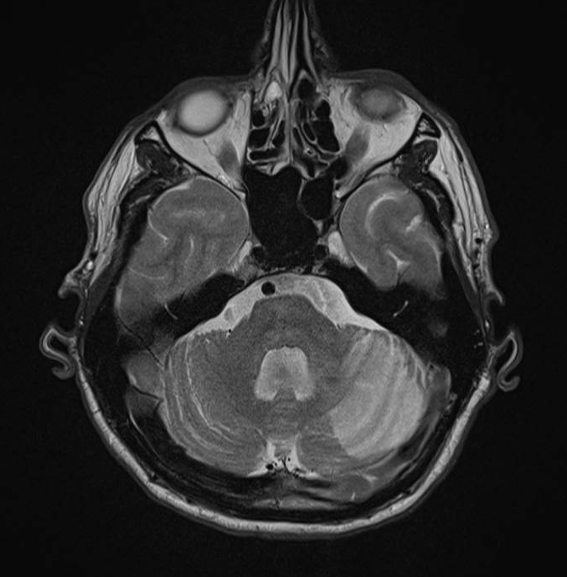

**Figure 1: MRI showing a left cerebellar stroke.**

Transthoracic echocardiography revealed a normal left ventricle and atrium, no significant valvular abnormality, and a normal ascending aorta. EKG indicated normal sinus rhythm, and laboratory tests, including a hypercoagulability panel, were unremarkable.

A 72-hour Holter ECG showed no rhythm disturbances, and a negative neoplastic workup ruled out malignancy.

Transesophageal echocardiography identified a PFO with ASA and a positive bubble test, demonstrating the potential for paradoxical embolism. Additionally, it revealed a normal left ventricular ejection fraction, a discrete mitral and aortic regurgitation, a free auricle, and a non-atheromatous appearance of the ascending aorta and aortic arch.

Finally, the supra-aortic trunks CT showed the presence of an aberrant right subclavian artery (ARSA), or arteria lusoria with a plaque formation (Figures 2,3).

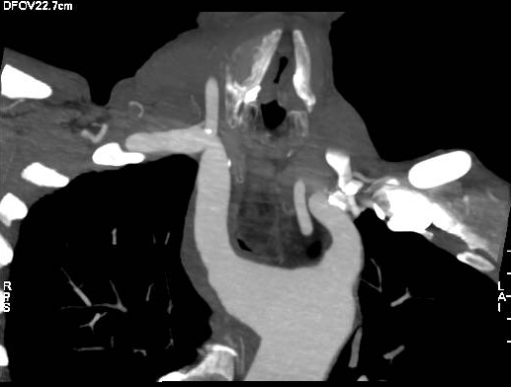

**Figure 2: CT showing an arteria Lusoria with a plaque formation**

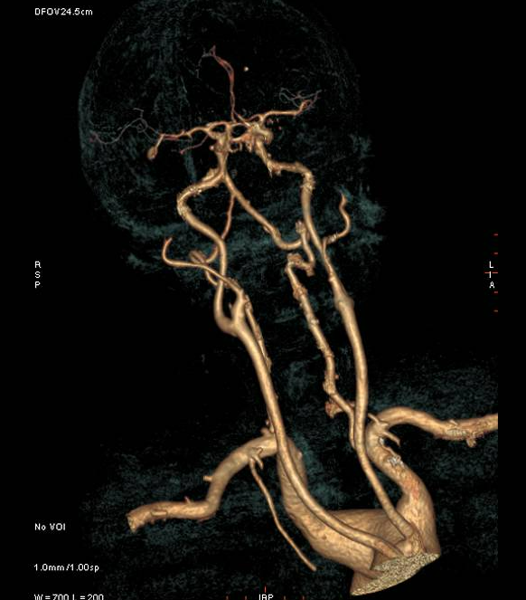

**Figure 3: Reconstruction of the aortic arch with the arteria Lusoria**

Based on these findings, the patient received a diagnosis of cerebellar stroke, PFO with ASA, and arteria Lusoria with plaque. He was initiated on antiplatelet therapy with aspirin 160mg daily to prevent future thromboembolic events and underwent physical therapy to regain mobility. This comprehensive approach resulted in significant improvement, with symptom resolution and regained ability to walk with assistance, highlighting the potential for recovery with proper management.

1. Discussion:

Left aortic arch with aberrant right subclavian artery (ARSA), also known as arteria lusoria, is a congenital anomaly occurring in approximately 0.5% to 2% of the population [1], with a higher prevalence among females [2]. This anomaly arises due to regression of the right arch, including the right ductus arteriosus, leading to the proximal right subclavian artery originating from the distal right dorsal aorta instead of the usual fourth arch. Consequently, the aberrant right subclavian artery typically courses obliquely behind the esophagus, from the left caudal to the right cranial direction [1]. In such cases, the brachiocephalic trunk is absent, and the aortic arch gives rise directly to four arteries: the right common carotid, left common carotid, left subclavian, and the ARSA (Figure 4).

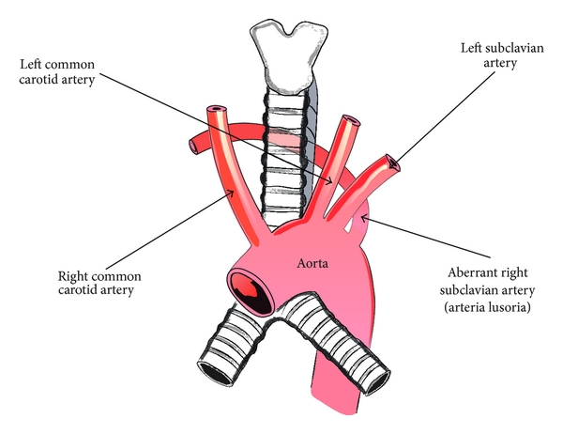

**Figure 4: Schematic arrangements of the presence of an aberrant right subclavian artery.**

While typically isolated, ARSA can coexist with other congenital anomalies such as aortic coarctation, patent ductus arteriosus (PDA), ventricular septal defect (VSD), or carotid and vertebral artery anomalies [1], [5]. In a study analyzing over 11,000 pathologic specimens, Hugo Zapata reported septal defects in 28% of arteria lusoria cases, including a small proportion with atrial origin[6] .

Most individuals with ARSA remain asymptomatic [3]. However, esophageal or tracheal compression may lead to dysphagia or dyspnea, respectively—though tracheal compression is rare in adults [4]. A classical presentation is dysphagia lusoria, caused by esophageal compression from the retroesophageal artery [5], [7], [8]. Another rare but important manifestation is Ortner syndrome, where recurrent laryngeal nerve palsy results from vascular compression [9]. Kommerell's diverticulum—dilatation at the ARSA origin—also poses clinical and surgical challenges due to its association with aneurysmal transformation and risk of rupture [10]. ARSA’s aberrant course may also increase the risk of vascular injury during head and neck surgeries such as thyroidectomy, tracheotomy, and mediastinal lymph node dissection.

Although ARSA is often regarded as a benign anatomical variant, recent literature has underscored its clinical relevance, particularly when it coexists with anomalies like atrial septal defects (ASD), patent foramen ovale (PFO), or atherosclerotic plaques[3]. In our case, the patient presented with a cerebellar stroke and was found to have a rare triad: PFO with atrial septal aneurysm (ASA), and ARSA containing atherosclerotic plaque. This combination creates a prothrombotic environment and increases the potential for paradoxical embolism.

This association is significant, facilitating embolic transit through transient right-to-left shunting [3]. In their case, the combination of ARSA and ASD led to paradoxical embolism and cerebral infarction. These findings support the use of vascular imaging in young patients with cryptogenic stroke.

Our case also supports this diagnostic strategy. CT angiography revealed the ARSA and its plaque burden, while transesophageal echocardiography (TEE) confirmed the PFO and ASA. These tools were essential for diagnosis, and align with the growing body of evidence recommending multimodal imaging for comprehensive stroke evaluation, especially in younger patients without traditional vascular risk factors [3].

Furthermore, the patient's history of hypertension, hyperlipidemia, and cholelithiasis increased his baseline cardiovascular risk. However, the coexisting PFO and ASA offered a likely anatomical conduit for paradoxical embolism. Simultaneously, the ARSA may have contributed via local turbulence and plaque formation—factors recognized for embolic potential.

Management strategies for symptomatic ARSA are evolving. Historically, left thoracotomy was the standard surgical approach, but it presented technical difficulties, especially for anterior repositioning of the subclavian artery [11]. Similarly, right posterolateral thoracotomy carries the risk of incomplete relief if the ARSA is not adequately divided near its origin [3]. More recent literature supports the use of median sternotomy or hybrid/endovascular approaches as safer, more adaptable options with favorable outcomes [4]. Dueppers et al. demonstrated high technical success using individualized multimodal techniques, including subclavian-carotid transpositions and stent grafting [12].

In our case, the absence of recurrent embolic events and compressive symptoms supported a conservative, medical approach. Nevertheless, the possibility of future events necessitates careful follow-up. This case emphasizes the importance of considering less common anatomical variants in stroke etiology and highlights how early diagnosis using appropriate imaging can guide optimal treatment.

Ultimately, ARSA—particularly when atherosclerotic or coexisting with PFO—should not be dismissed as an incidental finding. It warrants thorough evaluation and long-term monitoring. In select cases, early antithrombotic management or surgical referral may be indicated to prevent further embolic complications.

1. **Conclusion:**

This case presentation highlights the possible connection between uncommon anatomical variations, like ARSA, and other established stroke risk factors in atypical presentations. While the definitive role of ARSA in stroke pathogenesis is still under investigation, this case adds to the growing body of literature exploring this potential association.

It emphasizes the necessity for clinicians to consider less common anatomical variations and associated anomalies in stroke evaluation, ensuring early diagnosis and appropriate treatment to optimize patient outcomes.

Consent:

All authors declare that ‘written informed consent was obtained from the patient (or other approved parties) for publication of this case report and accompanying images. A copy of the written consent is available for review by the Editorial office/Chief Editor/Editorial Board members of this journal.

References

[1] K. Hanneman, B. Newman, and F. Chan, “Congenital Variants and Anomalies of the Aortic Arch,” *RadioGraphics*, vol. 37, no. 1, pp. 32–51, Jan. 2017, doi: 10.1148/rg.2017160033.

[2] M. Polguj, Ł. Chrzanowski, J. D. Kasprzak, L. Stefańczyk, M. Topol, and A. Majos, “The Aberrant Right Subclavian Artery (Arteria Lusoria): The Morphological and Clinical Aspects of One of the Most Important Variations—A Systematic Study of 141 Reports,” *Sci. World J.*, vol. 2014, pp. 1–6, 2014, doi: 10.1155/2014/292734.

[3] T. Gupta, N. Jamaleddine, and S. I. McFarlane, “Arteria Lusoria With Right-Sided Aortic Arch and Atrial Septal Defect Associated With Extensive Thrombosis and Paradoxical Embolism: A Case Report,” *Cureus*, Jun. 2022, doi: 10.7759/cureus.26173.

[4] E. Kieffer, A. Bahnini, and F. Koskas, “Aberrant subclavian artery: Surgical treatment in thirty-three adult patients,” *J. Vasc. Surg.*, vol. 19, no. 1, pp. 100–111, Jan. 1994, doi: 10.1016/S0741-5214(94)70125-3.

[5] C. R. Norris, C. A. Wilson, and M. C. Lin, “Truncus Bicaroticus With Arteria Lusoria: A Rare Combination of Aortic Root Anatomy Complicating Cardiac Catheterization,” *Fed. Pract.*, vol. 38, no. 2, pp. 84–88, Feb. 2021, doi: 10.12788/fp.0089.

[6] H. Zapata, J. E. Edwards, and J. L. Titus, “Aberrant right subclavian artery with left aortic arch: Associated cardiac anomalies,” *Pediatr. Cardiol.*, vol. 14, no. 3, pp. 159–161, Jul. 1993, doi: 10.1007/BF00795645.

[7] “ABERRANT RIGHT SUBCLAVIAN ARTERY.” Accessed: Jun. 11, 2025. [Online]. Available: https://www.ajronline.org/doi/epdf/10.2214/ajr.97.2.438

[8] I.-C. Tsai *et al.*, “Vertebral and carotid artery anomalies in patients with aberrant right subclavian arteries,” *Pediatr. Radiol.*, vol. 37, no. 10, pp. 1007–1012, Oct. 2007, doi: 10.1007/s00247-007-0574-2.

[9] A. Rafiq, S. Chutani, and N. R. Krim, “Incidental finding of arteria lusoria during transradial coronary catheterization: Significance in interventional cardiology,” *Catheter. Cardiovasc. Interv.*, vol. 91, no. 7, pp. 1283–1286, 2018, doi: 10.1002/ccd.27439.

[10] S. Priya, R. Thomas, P. Nagpal, A. Sharma, and M. Steigner, “Congenital anomalies of the aortic arch,” *Cardiovasc. Diagn. Ther.*, vol. 8, no. Suppl 1, Art. no. Suppl 1, Apr. 2018, doi: 10.21037/cdt.2017.10.15.

[11] J. M. Smith and D. C. Wukasch, “RETROESOPHAGEAL SUBCLAVIAN ARTERIES: SURGICAL MANAGEMENT OF SYMPTOMATIC CHILDREN”.

[12] P. Dueppers, N. Floros, H. Schelzig, M. Wagenhäuser, and M. Duran, “Contemporary Surgical Management of Aberrant Right Subclavian Arteries (Arteria Lusoria),” *Ann. Vasc. Surg.*, vol. 72, pp. 356–364, Apr. 2021, doi: 10.1016/j.avsg.2020.08.151.