***Case report***

**Ischemic Stroke Revealing a Left Atrial Myxoma and Paroxysmal Atrial Fibrillation in a 56-Year-Old Woman**

**Abstract:**

Left atrial myxomas are rare but potentially serious tumors capable of causing systemic embolism and obstructive cardiac symptoms. We report the case of a 56-year-old woman with cardiovascular risk factors who was admitted for an acute ischemic stroke. Investigations revealed a large mass attached to the interatrial septum, highly suggestive of a myxoma, associated with biatrial dilation. Surgical excision was successfully performed. Subsequent Holter monitoring uncovered silent paroxysmal atrial fibrillation, requiring long-term anticoagulation therapy. This case highlights that even when an obvious embolic source such as a myxoma is identified, it remains essential to search for underlying pathologies, particularly atrial fibrillation, to optimize management and secondary prevention.

**Introduction:**

A 56-year-old woman with a history of hypertension and dyslipidemia presented to the emergency department with sudden-onset right-sided hemiparesis and dysarthria. Neurological evaluation and imaging confirmed an acute ischemic stroke (AIS) in the territory of the left middle cerebral artery. In the absence of significant carotid stenosis or previously known arrhythmias, a cardioembolic source was suspected [1,3].

**Clinical Presentation:**

The patient had a medical history notable for hypertension and dyslipidemia but no previously documented cardiac disease.

On physical examination, she was conscious and hemodynamically stable, without respiratory distress. Her heart rate was 88 beats per minute, regular and in sinus rhythm. Blood pressure was elevated at 155/95 mmHg, consistent with her hypertensive background. Respiratory rate was 18 breaths per minute and body temperature 36.6°C. Cardiac auscultation revealed normal heart sounds without murmurs, pericardial friction rubs, or gallops. Jugular venous pressure was normal, and no signs of right heart failure were observed. Pulmonary examination was unremarkable, with clear lung fields. Peripheral pulses were palpable and symmetrical. Neurological examination confirmed right-sided hemiparesis without altered consciousness.

Given the embolic nature of the stroke and absence of vascular anomalies on cervico-cerebral Doppler studies, a transthoracic echocardiogram (TTE) was promptly performed. It revealed a mobile, pedunculated mass in the left atrium measuring approximately 35 mm × 28 mm, attached to the interatrial septum. Biatrial dilation was also evident (Figures 1, 2, 3). A diagnosis of left atrial myxoma was strongly suspected [1,3,4]

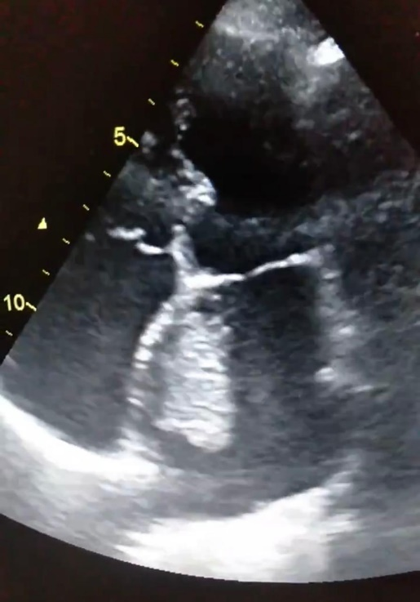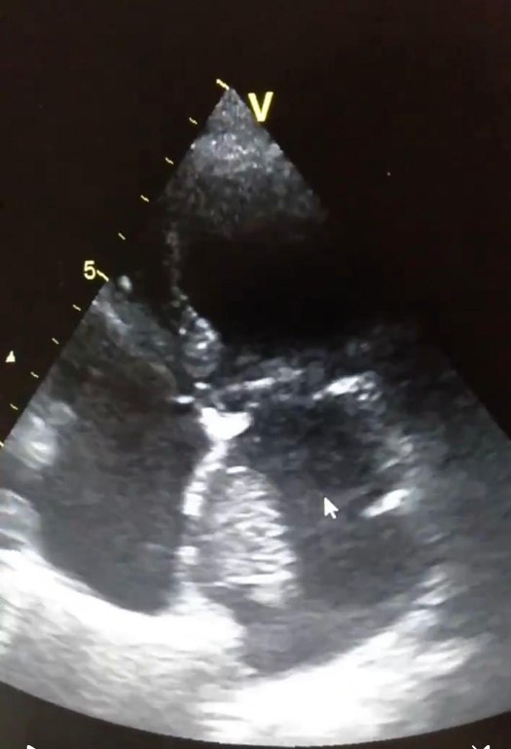

**Figure 1 Figure 2**

**Apical 4-chamber view showing a mobile mass in the left atrium attached to the interatrial septum, measuring approximately 35 mm × 28 mm.**

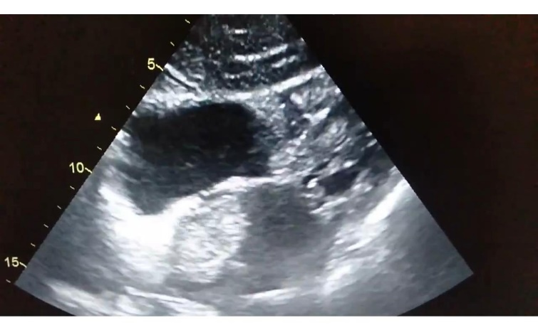

**Figure 3 : Subcostal view showing the same mass.**

**Management and Outcome:**

The patient was urgently referred for surgical intervention. Through a median sternotomy under cardiopulmonary bypass, complete excision of the tumor (tumorectomy) was performed. Intraoperative findings revealed a gelatinous, pedunculated mass originating from the interatrial septum, consistent with a myxoma. Histopathological examination confirmed the benign nature of the cardiac myxoma [2,8].

The postoperative course was uneventful. A 72-hour Holter ECG performed postoperatively revealed asymptomatic episodes of paroxysmal atrial fibrillation (PAF). Despite the clear embolic source represented by the myxoma, the detection of atrial fibrillation warranted the initiation of long-term oral anticoagulation therapy using a direct oral anticoagulant (DOAC) [6,10].

Following a tailored rehabilitation program, the patient achieved complete neurological recovery without residual deficits. At six-month follow-up, she remained asymptomatic with no recurrence of neurological or arrhythmic events. Repeat echocardiographic assessments confirmed the absence of residual tumor [9,12].

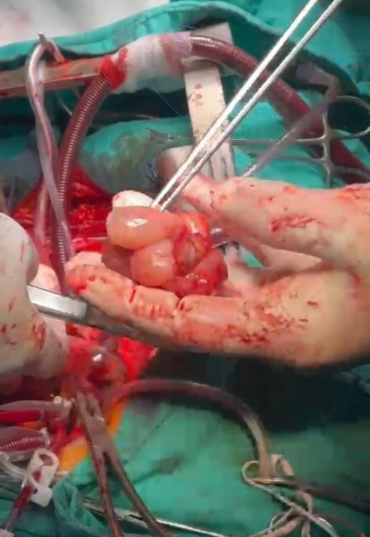

**Figure 4 : Intraoperative image illustrating the surgical resection of the cardiac myxoma.**

**Discussion:**

Left atrial myxomas represent the most common primary cardiac tumors, predominantly affecting adult women [1,3,8]. Their clinical manifestations are highly variable, ranging from systemic embolism and intracardiac obstruction to nonspecific constitutional symptoms such as fatigue, fever, and weight loss. These systemic effects are thought to be mediated by the tumor’s secretion of inflammatory cytokines, notably interleukin-6 [1,4]. In the present case, ischemic stroke was the initial clinical manifestation, resulting from embolization of tumor fragments. This presentation is frequently encountered, with embolic events occurring in approximately 30 to 40% of patients with atrial myxomas [3,7,9].

The concomitant detection of biatrial dilation and paroxysmal atrial fibrillation highlights an important pathophysiological interaction: atrial enlargement fosters an arrhythmogenic substrate, which significantly elevates the risk of additional embolic complications. This relationship underscores the imperative to systematically screen for atrial fibrillation, even when an apparent embolic source such as a myxoma is identified [5,6,10]. Indeed, atrial fibrillation independently increases stroke risk, necessitating appropriate anticoagulation to prevent recurrent embolic events [6,10].

Diagnostic imaging remains crucial for confirming cardiac myxomas and guiding therapeutic decisions. Transthoracic echocardiography is the first-line imaging modality, often demonstrating the typical pedunculated, mobile mass attached to the interatrial septum. However, its sensitivity can be limited in certain patients due to poor acoustic windows or obesity, where transesophageal echocardiography (TEE) provides superior spatial resolution and near 100% sensitivity. Additionally, cardiac MRI and CT imaging can further delineate tumor morphology, size, and anatomical relationships, enhancing preoperative planning [1,3,4,11].

Surgical excision is the definitive treatment for left atrial myxoma, generally yielding excellent prognosis upon complete resection. Histopathological confirmation excludes malignancy, and tumor recurrence remains rare, especially with meticulous surgical technique. Postoperative surveillance must include prolonged cardiac rhythm monitoring to detect paroxysmal atrial fibrillation, as its identification is critical for instituting long-term anticoagulation and reducing the risk of recurrent embolism [2,8,10,12].

This case thus exemplifies the paramount importance of comprehensive cardiological evaluation in patients presenting with embolic stroke, not only to identify the primary source but also to uncover coexisting conditions that profoundly influence prognosis and management

**Conclusion:**

This case underscores the importance of comprehensive cardiological evaluation in embolic stroke patients. Even when the cause appears clear, such as a cardiac myxoma, the search for underlying conditions like paroxysmal atrial fibrillation remains crucial. Rapid management, appropriate surgical excision, and careful rhythm monitoring are essential to optimize prognosis and prevent recurrence [5,6,10].

**References:**

1. Reynen K. Cardiac myxomas. N Engl J Med. 1995 Dec 14;333(24):1610-7. doi:10.1056/NEJM199512143332407.
2. McAllister HA Jr, Fenoglio JJ Jr. Tumors of the cardiovascular system. In: Atlas of Tumor Pathology. 2nd series, Fascicle 15. Armed Forces Institute of Pathology; 1978.
3. Pinede L, Duhaut P, Loire R. Clinical presentation of left atrial cardiac myxoma: a series of 112 consecutive cases. Medicine (Baltimore). 2001 May;80(3):159-72. doi:10.1097/00005792-200105000-00002.
4. Aggarwal SK, Barik R, Sarma TC, et al. Clinical presentation and investigation findings in cardiac myxomas: new insights from the developing world. Am Heart J. 2007 Dec;154(6):1102-7. doi:10.1016/j.ahj.2007.07.036.
5. Hart RG, Diener HC, Coutts SB, et al. Embolic strokes of undetermined source: the case for a new clinical construct. Lancet Neurol. 2014 Apr;13(4):429-38. doi:10.1016/S1474-4422(13)70310-7.
6. January CT, Wann LS, Calkins H, et al. 2019 AHA/ACC/HRS focused update of the 2014 atrial fibrillation guideline. Circulation. 2019 Jul 9;140(2):e125-e151. doi:10.1161/CIR.0000000000000665.
7. Lee VH, Connolly HM, Brown RD Jr. Central nervous system manifestations of cardiac myxoma. Arch Neurol. 2007 Aug;64(8):1115-20. doi:10.1001/archneur.64.8.1115.
8. Yuan SM. Cardiac myxomas: a review. Braz J Cardiovasc Surg. 2015 Mar-Apr;30(2):225-32. doi:10.5935/1678-9741.20150039.
9. Kuroczyński W, Kiliszek M, et al. Embolic stroke as a first manifestation of cardiac myxoma. Cardiol J. 2013;20(2):187-90. doi:10.5603/CJ.2013.0027.
10. Rajendran S, Rajendran R, et al. Cardiac myxoma presenting with embolic stroke and atrial fibrillation: a case report and review of literature. J Stroke Cerebrovasc Dis. 2017 Mar;26(3):e58-e61. doi:10.1016/j.jstrokecerebrovasdis.2016.11.022.
11. Knirsch W, Walpoth BH, et al. Cardiac myxoma and stroke: surgical treatment and outcome in 12 patients. J Card Surg. 2018 Oct;33(10):610-6. doi:10.1111/jocs.13732.
12. Wang H, Chen Y, et al. Clinical features and surgical outcomes of cardiac myxoma in patients with embolic stroke: a single-center experience. Medicine (Baltimore). 2019 Nov;98(44):e17782. doi:10.1097/MD.0000000000017782.