Case report

Mucoepidermoid Carcinoma of Esophagus with No Mass Lesion

.
ABSTRACT

Introduction: Mucoepidermoid Carcinoma (MEC) is a rare variety of primary cancers found in the esophagus with a global incidence of merely 1%. The clinical presentation of this cancer is indistinguishable from the common varieties leading to a diagnostic dilemma with final confirmation only on histopathological examination. Being aggressive and unresponsive to chemotherapy or radiotherapy, surgical resection is the primary treatment modality and possibly curative.
Case: We present the case of a 58-year-old lady who presented with pain in epigastrium, on and off loose stools, and dysphagia for one year. With no comorbidity and no significant family history, patient’s only risk factor was beedi smoking since past 10 years. While the patient had unremarkable examination findings and normal routine blood investigations, upper gastrointestinal endoscopy (UGIE) reported a growth in distal esophagus.
Diagnosis & Management: Endoscopic biopsy revealed moderately differentiated squamous cell carcinoma (SCC), however, no growth or mass lesion was seen in computed tomography (CT) scan of the patient. She underwent Trans-hiatal Esophagectomy with cervical esophagogastrostomy and was subsequently discharged. Final histopathological report confirmed MEC Esophagus.
Conclusion: Even though a rare variety, MEC should be considered as a differential diagnosis in patients presenting with dysphagia, with or without esophageal growth.

Keywords: Mucoepidermoid carcinoma, Esophageal cancer, Trans-hiatal esophagectomy

1. INTRODUCTION

Oesophageal cancer is the eighth most common cancer in the world, with its incidence rising in India since past few years. There are two most common histological variants seen, namely, squamous cell carcinoma and adenocarcinoma, accounting for approximately >90% of oesophageal carcinomas. Other varieties include squamous cell carcinoma with sarcomatoid features, adenoid cystic, small cell carcinomas, leiomyosarcoma and mucoepidermoid carcinomas.¹ Herein we describe the case of a 58-year-old lady who presented with pain in epigastrium and dysphagia and was ultimately diagnosed with mucoepidermoid carcinoma of oesophagus following transmittal esophagectomy.

2. PRESENTATION OF CASE

A 58-year-old lady presented with chief complaints of upper central abdominal pain and dysphagia since past 1 year. Pain was insidious in onset, gradually progressive, not shifting or radiating to any other part, aggravating on food intake and completely relieved with only intravenous analgesia. Loose stools occurred approximately once a month, 2 to 3 episodes a day, lasting for about 3 to 4 days, not containing any blood or mucous and not associated with any pain while defecating. Dysphagia began with the sensation of something getting stuck in throat initially, which gradually progressed to patient only taking soft pureed or liquid diet. Neither patient nor the relatives noticed any significant loss of weight as the patient had always been a thin built lady. Patient was a chronic smoker, smoking three to four beedi every day. Physical examination findings were unremarkable, no abdominal lump or lymphadenopathy. Routine blood investigations were within normal limits.

2.1 Diagnostic Assessment

Patient had presented to us with an UGIE report which was almost confirmatory of malignancy of oesophagus. The endoscopy, dated 07/05/2023, done in a private lab, reported a nodular infiltrative growth in posterolateral wall at 35 cm distance from central incisor. The gastroesophageal junction, situated at 40 cm distance, was reported normal. A biopsy sample was taken from the growth, which reported tumour cells having moderate to abundant eosinophilic cytoplasm with vesicular nuclei. The biopsy was reported on 23rd May 2023, and stated mitotic figures and keratin pearls also being seen. Final impression was given as moderately differentiated Squamous Cell Carcinoma. Following this, a Contrast Enhanced Computed Tomography (CECT) scan of Neck, Chest and Abdomen with oral and intravenous contrast was done on 28th June 2023, in our institute for staging the disease. In the scan, thoracic oesophagus appeared to not be well distended in its entire course, however, no obvious thickening or mass lesion was noted. There was presence of a well-defined ovoid sub-centimetric necrotic lymph node (SAD 8mm) noted in para-oesophageal location (adjacent to aortic arch). Presence of few tiny sub-centimetric discrete mediastinal lymph nodes were noted in bilateral lower paratracheal region. No other evidence of any distant metastasis was noted.
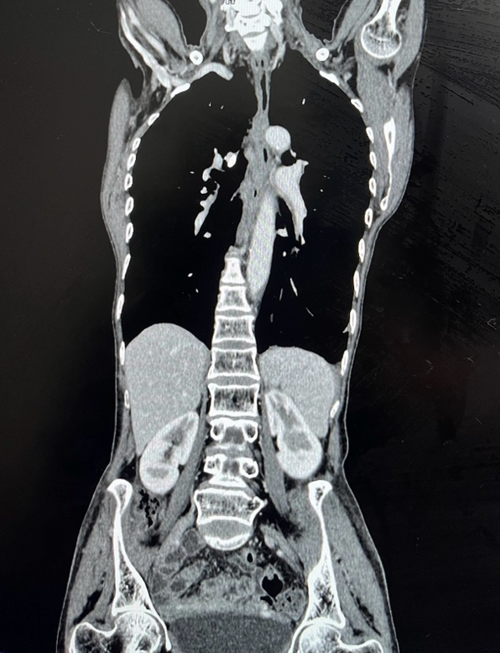
Fig. 1. CECT Coronal section showing filling of oral contrast in lower esophagus without mass lesion

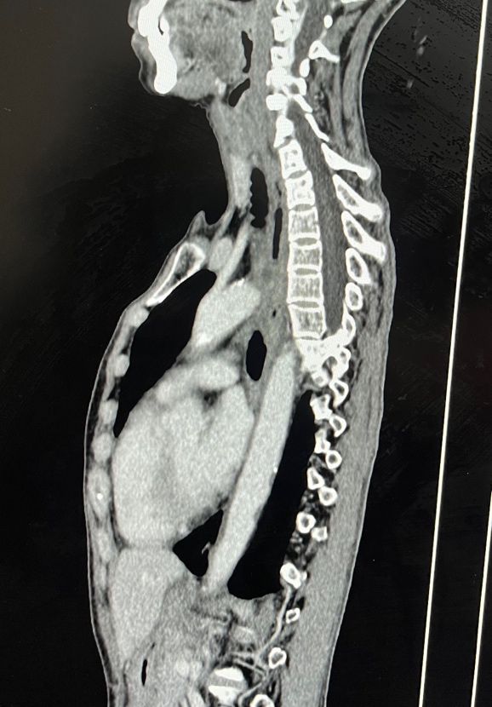
Fig. 2. CECT Sagittal section showing filling of oral contrast in lower esophagus without any mass lesion

Based on clinical, radiological and pathological investigations, a diagnosis of Oesophageal Carcinoma was made with stage I (cT1N0M0). A decision to perform curative resection in the form of Trans-hiatal Esophagectomy with Cervical Esophagogastrostomy was made.

2.2 Surgical Intervention

Patient underwent Exploratory Laparotomy with Trans-hiatal Esophagectomy with Cervical Esophagogastrostomy (end to side hand-sewn anastomosis) with bilateral intercostal drain insertion with feeding jejunostomy with intraabdominal sub-hepatic drain with cervical subcutaneous drain insertion.
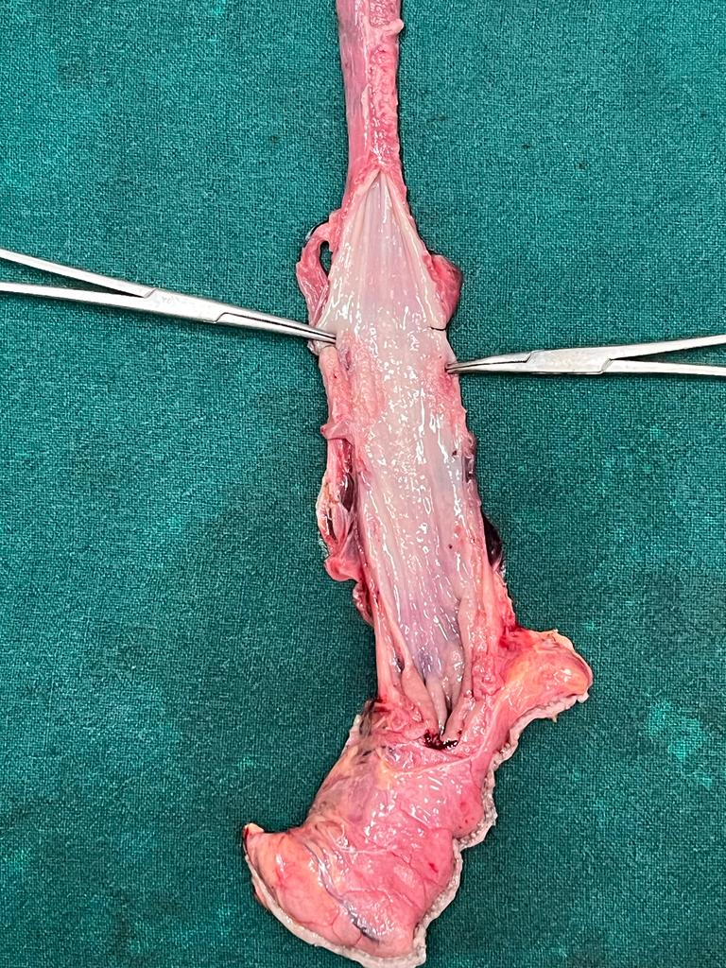
Fig. 3. Surgical specimen of Esophagectomy (opened transversely) with both forcep tips pointing to endoscopic level of growth (35 cms)

2.3 Postoperative Management and Outcome

Following the surgery, the patient underwent close postoperative surveillance. FJ test feeds started on POD4 with FJ feeds started on POD5. Right ICD with Foley’s catheter and abdominal drain removed on POD6. Patient allowed sips orally with mashed bananas on POD8, along with removal of left ICD and nasogastric tube. Cervical drain removed on POD9, and patient allowed semisolid and mashed food diet. Sutures removed on POD14, and patient discharged with FJ in situ and uneventful postoperative period on POD20.
Histopathological report post-trans-hiatal esophagectomy came out to be Mucoepidermoid carcinoma of lower oesophagus with present lympho-vascular invasion and all margins negative for invasive carcinoma or dysplasia. Tumour present in regional cervical lymph node (1/1).
IHC - Her2neu Negative
pT1bN1Mx, stage IIB
The patient’s postoperative course was uneventful, however after discharge, patient was lost to follow-up.

3. discussion

Oesophageal cancers are the eighth most common cancers in the world, and sixth most common cause of death. They are predominantly of two types, Squamous Cell Carcinomas (SCC) and Adenocarcinomas, each with their own risk factors and management principles. Mucoepidermoid Carcinomas (MEC) of the oesophagus as a primary tumour are, however, rare. These account for less than 1% of all oesophageal cancers, mainly occurring in men aged 58 years or more.²

MEC are predominantly carcinomas of the salivary glands, which are believed to arise from the reserve cells of excretory ducts of these glands that are considered to be pluripotent in nature. In oesophagus, the origin of these cancers is hypothesised using two theories. One theory suggests that these tumours arise from oesophageal gland cells or ductal cells, supported by the submucosal location of these tumours as well as the similar embryological origin of the oesophagus and salivary glands.^{4,5} The other theory hints at an origin from squamous epithelial cells. This theory is reinforced by the behaviour of this tumour in oesophagus as compared to salivary glands while having similar histological features. Carcinoma in situ changes in the mucosa adjacent to this tumour also favours this theory.^{6,7}

The clinical features of oesophageal MEC mimic those of the predominant varieties, i.e. SCC and Adenocarcinoma, with the major symptom being dysphagia, along with weight loss, and sometimes retrosternal pain. Esophagoscopic picture may show stenotic lesions or growths, with diagnosis confirmed only on histopathological examination.^{5,8}

With the current data available, surgical resection is the primary treatment that can provide a cure, as these tumours have been reported to have little to no sensitivity to chemotherapy or radiotherapy. Recently, neoadjuvant chemoradiation has shown survival benefit when used in the treatment of oesophageal cancer patients. Nevertheless, further research is required to establish the value of this approach for MEC oesophagus patients.^{9,10}

Most reports suggest that MEC is more aggressive than its counterpart SCC or Adenocarcinoma, leading to early metastasis, higher recurrence, poorer prognosis and death. Hagiwara et al. had reported eight cases of oesophageal MEC, half of which had died due to widespread metastasis, while two of them died within two years of surgery because of local recurrence leading to an overall median survival of 10.8 months.¹¹ Koide et al. reviewed 22 cases retrospectively that had undergone surgical resection before 1998 in Japan, and found the survival rate of only 27.7%.¹² Chen et al reported a median survival of 29 months and a post resection 5-year survival of 25% in the study that was conducted in their institution over a 20-year period with 36 patients of MEC oesophagus.³

This case was rather unique both clinically and pathologically. While the patient complained of dysphagia and endoscopic findings revealed a growth in lower oesophagus, even so, the CT scan did not show any obvious thickening or mass lesion which was confirmed intra-operatively on examining the resected specimen. Another peculiarity noted was that even though the endoscopic biopsy revealed a moderately differentiated SCC, the final histopathological examination confirmed MEC. Although a surgical resection with curative intent was carried out at the earliest from when the patient presented to us, unfortunately the tumour had metastasised. At the time of discharge, the patient was explained about possible recurrence, and the importance of regular follow-up emphasised. Regrettably, the patient was lost to follow-up.

4. Conclusion

Given the rarity and aggressive nature of this cancer, one should keep an open mind while assessing a patient for dysphagia and suspected oesophageal cancer for a faster evaluation and surgical intervention. This case highlights that this diagnosis should be considered even though endoscopic biopsy states otherwise and prompt appropriate action taken. Additionally, further research is needed for therapeutic options for this variety of oesophageal carcinoma to prevent loss of life.

References

- DeVita VT, Lawrence TS, Rosenberg SA. DeVita, Hellman and Rosenberg’s Cancer: principles and practice of oncology. 11th ed. [e-book]. Wolters Kluwer; 2019. Chapter 52, Cancer of the Esophagus; p1307-85.
- Zhang Y. Epidemiology of esophageal cancer. World journal of gastroenterology: WJG. 2013 Sep 14;19(34):5598.
- Chen S, Chen Y, Yang J, Yang W, Weng H, Li H, Liu D. Primary mucoepidermoid carcinoma of the esophagus. Journal of Thoracic Oncology. 2011 Aug 1;6(8):1426-31.
- Matsufuji H, Kuwano H, Ueo H, Sugimachi K, Inokuchi K. Mucoepidermoid carcinoma of the esophagus—a case report. The Japanese journal of surgery. 1985 Jan;15:55-9.
- Ozawa S, Ando N, Shinozawa Y, Ohmori T, Kase K, Sato T, Abe O. Two cases of resected esophageal mucoepidermoid carcinoma. The Japanese journal of surgery. 1989 Jan;19:86-92.
- Mafune KI, Tanaka Y, Fujita K, Takubo K. Sclerosing mucoepidermoid carcinoma of the esophagus with intraepithelial carcinoma or dysplastic epithelium. Journal of surgical oncology. 1995 Mar;58(3):184-90.
- Pascal RR, Clearfield HR. Mucoepidermoid (adenosquamous) carcinoma arising in Barrett's esophagus. Digestive diseases and sciences. 1987 Apr;32:428-32.
- Turkyilmaz AT, Eroglu A, Gursan N. Muco-epidermoid carcinoma of the oesophagus: a case report. Acta Chirurgica Belgica. 2009 Jan 1;109(3):416-8.
- Schreiber D, Rineer J, Vongtama D, Wortham A, Han P, Schwartz D, Choi K, Rotman M. Impact of postoperative radiation after esophagectomy for esophageal cancer. Journal of thoracic oncology. 2010 Feb 1;5(2):244-50.
- Gebski V, Burmeister B, Smithers BM, Foo K, Zalcberg J, Simes J. Survival benefits from neoadjuvant chemoradiotherapy or chemotherapy in oesophageal carcinoma: a meta-analysis. The lancet oncology. 2007 Mar 1;8(3):226-34.
- Hagiwara N, Tajiri T, Miyashita M, Sasajima K, Makino H, Matsutani T, Tsuchiya Y, Takubo K, Yamashita K. Biological behavior of mucoepidermoid carcinoma of the esophagus. Journal of Nippon Medical School. 2003;70(5):401-7.
- Koide N, Hamanaka K, Igarashi J, Hanazaki K, Adachi W, Hosaka S, Uehara T, Amano J. Co-occurrence of mucoepidermoid carcinoma and squamous cell carcinoma of the esophagus: report of a case. Surgery Today. 2000 Jul;30:636-42.

Definitions, Acronyms, Abbreviations
CECT – Contrast Enhanced Computed Tomography
FJ – Feeding Jejunostomy
ICD – Intercostal Drain
MEC – Mucoepidermoid Carcinoma
POD – Postoperative Day
SAD – Short Axis Diameter
SCC – Squamous Cell Carcinoma
UGIE – Upper Gastrointestinal Endoscopy

