***Case report***

**A young female with anterior mediastinal mature teratoma: a rare etiology of chest pain in young adults managed successfully**

**Abstract:**

Mediastinal teratoma is rare congenital neoplasm which is usually discovered in the late second or third decade of life. A 24 year old young female with no past significant history came to a private hospital with complaints of central chest pain for 6 months. On examination her vitals were normal with no significant findings including cardiovascular and respiratory system. Her Computed tomography (CT) of chest revealed a large mass of 10×8 cm size, non-contrast mixed density lesion which was partly cystic and partly solid occupying in her anterior mediastinum and right hemithorax with calcification in the outside wall. She was planned for surgical excision. A standard median sternotomy was done. Then wall of the lesion was excised and whitish fluid was sucked out. (Fig-4) A lot of semisolid whitish material came out of the lesion containing hair and bony fragments.The wall was separated from pericardium and pleura along with great vessels. After removal of the remaining tissue, the cavity was washed with normal saline. Sternotomy was closed keeping two chest drains. Her post-operative period was uneventful. Her Histopathology report revealed the lesion was a mature cystic teratoma with no malignant potential. She came for follow up after 3 months and she was in good health.

**Key words:** *anterior mediastinum, mature teratoma, sternotomy*

**Introduction:**

Mediastinal teratoma is rare congenital neoplasm which is usually discovered in the late second or third decade of life.1 Multiple embryonic germ cell layers give rise to these tumors, which are further divided into subtypes such as immature teratomas, teratomas with malignant transformation, and mature teratomas, which are composed of fully differentiated adult tissues.2 Mature teratomas make up 8–13% of all mediastinal tumors, which is a rather rare occurrence.3 The sacrococcygeal region, ovaries, testes, brain, neck, and mediastinum are among the usual locations for these tumors, which affect both sexes equally.4

Mature teratomas are benign and develop slowly. Over 60% of individuals with mediastinal masses do not exhibit any symptoms, and they are only accidentally found during routine chest imaging procedures.5 But when the tumor grows and puts strain on nearby structures, symptoms including coughing, dysphagia, chest pain, and respiratory failure might happen.5

Chest CT scan is the preferred diagnostic modality to evaluate teratomas. . It offers important details on the tumor's location and relationship to nearby structures. These tumors usually manifest as distinct, heterogeneous masses with a range of diameters that exhibit a mix of solid, fatty, and cystic elements.7 Mediastinal benign teratomas usually manifest as an anterior mediastinal mass that is well-defined, heterogeneous, and resembles multilocular cysts with calcifications and solid and fatty components on radiographic imaging.8 The differential diagnosis of benign teratoma in the anterior mediastinum involve a wide variety of illnesses. Important differentials include mediastinal lipoma,pericardial cysts, lymphomas, and thymomas are examples of mediastinal diseases that may resemble mature teratomas in certain ways.9

Surgical removal is the mainstay of treatment for teratomas because they are often well-encapsulated and infrequently invade nearby structures. A median sternotomy is usually the recommended surgical procedure for the best exposure.10 However, anterolateral thoracotomy is frequently preferred when the tumor is limited to a particular hemithorax.10 Although total tumor removal is usually possible, adhesions to nearby structures such the pericardium, pleura, and thymus might make it difficult. For tiny tumors, endoscopic removal might be a good alternative in some cases.10

Although total surgical resection is usually curative, additional therapies like chemotherapy or radiation therapy can be required if the teratoma shows signs of malignant potential or complex interspersing among surrounding structures.11 In order to monitor for postoperative complications and evaluate any recurrence or residual disease, follow-up imaging is essential.

Here we present a case of young female presented with anterior mediastinal teratoma which was managed successfully by surgical excision.

**Case Presentation :**

A 24 year old young female with no past significant history came to a private hospital with complaints of central chest pain for 6 months. The pain was compressive, non-radiating, and mild to moderate in intensity with no specific aggravating or relieving factors. On examination her vitals were normal with no significant findings including cardiovascular and respiratory system. She underwent routine investigation and her chest X-ray chest revealed a dense homogenous shadow in mediastinum extending towards right lung field. (Fig-1)

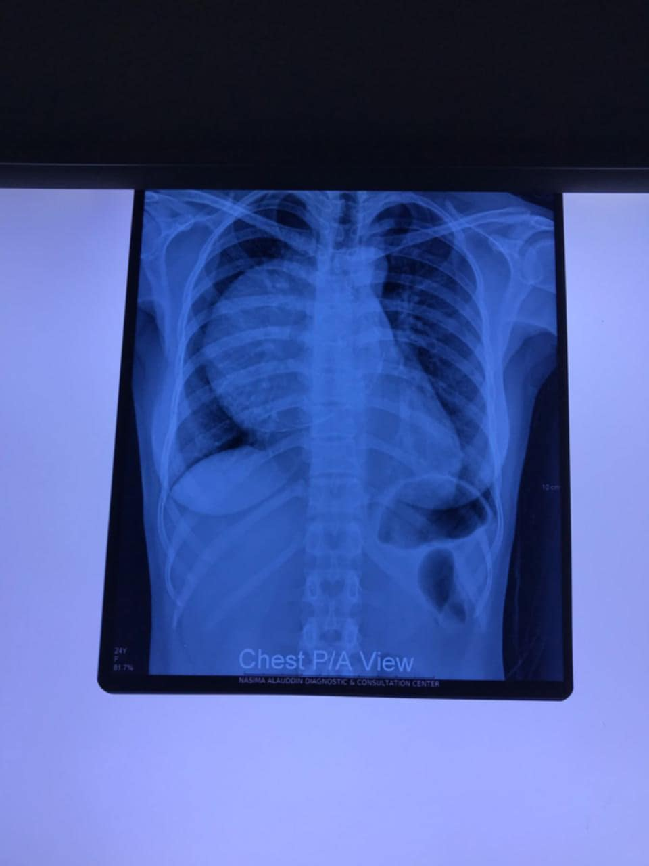

Fig-1 Chest Radiograph of the Patient

Her Computed tomography (CT) of chest revealed a large mass of 10×8 cm size , non-contrast mixed density lesion which was partly cystic and partly solid occupying in her anterior mediastinum and right hemithorax with calcification in the outside wall.(Fig-2) The mass was attached with pericardium, great vessels and right pleura. A CT guided FNAC showed presence of inflammatory cells with was non-conclusive.

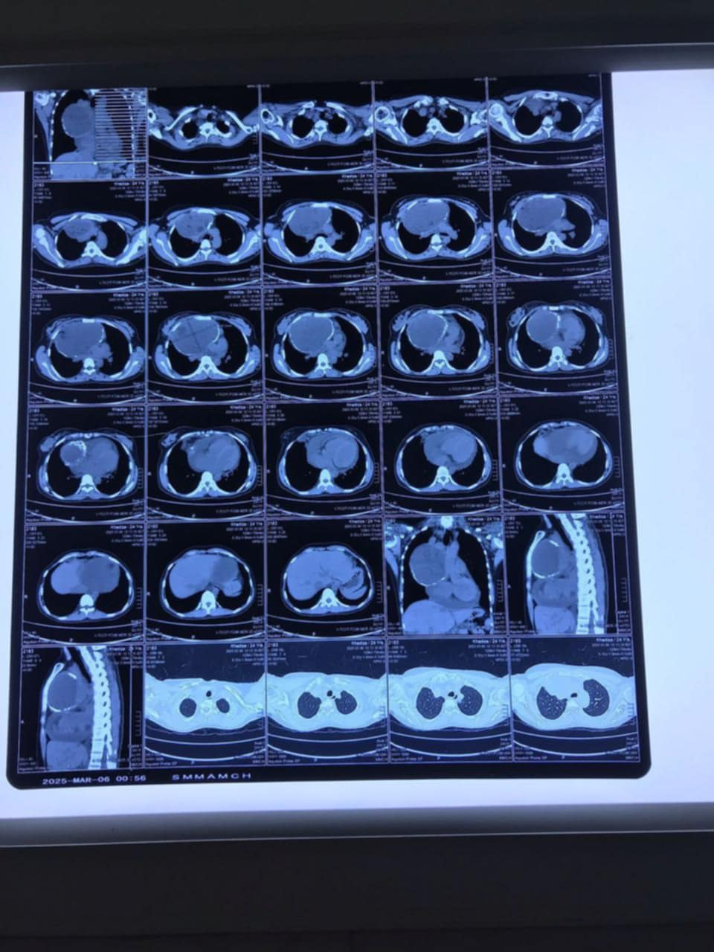

Fig-2 CT scan of the Patient

So she was planned for surgical excision. A standard median sternotomy was done. (Fig-3)Then wall of the lesion was excised and whitish fluid was sucked out.(Fig-4) A lot of semisolid whitish material came out of the lesion containing hair and bony fragments.(Fig-5) The wall was separated from pericardium and pleura along with great vessels.

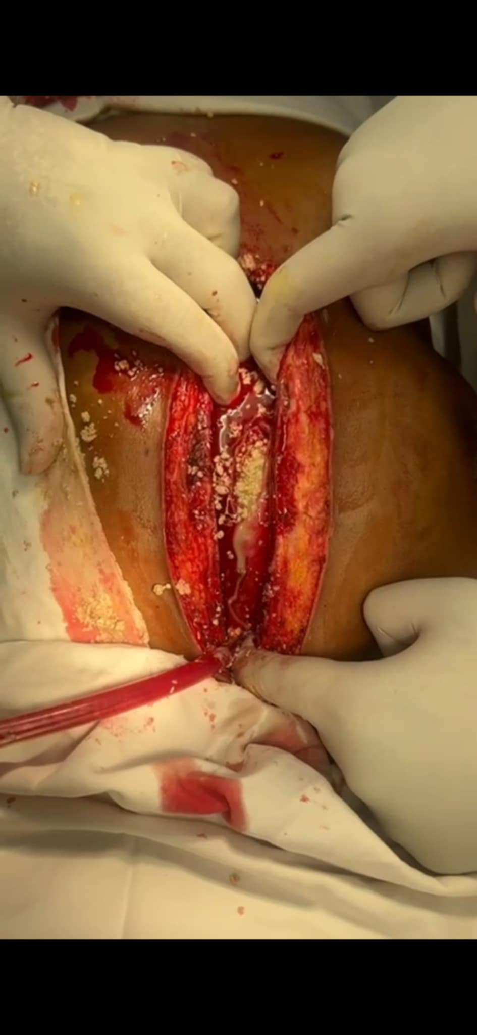

Fig-3: Per-operative view after median sternotomy of the Patient

After removal of the remaining tissue, the cavity was washed with normal saline. Sternotomy was closed keeping two chest drains. Her post-operative period was uneventful. Her Histopathology report revealed the lesion was a mature cystic teratoma with no malignant potential. She came for follow up after 3 months and she was in good health.

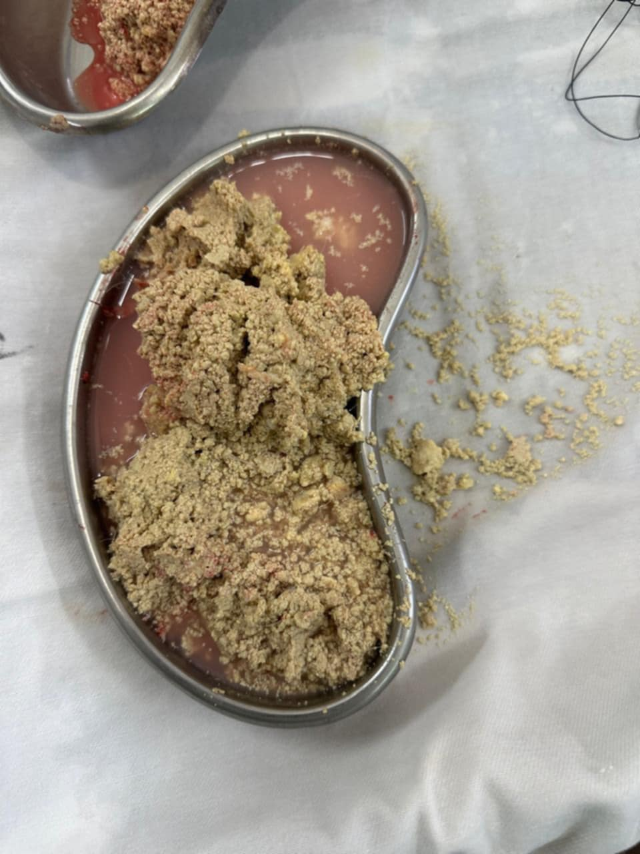

Fig-4 Contents of Cystic mass of the patient

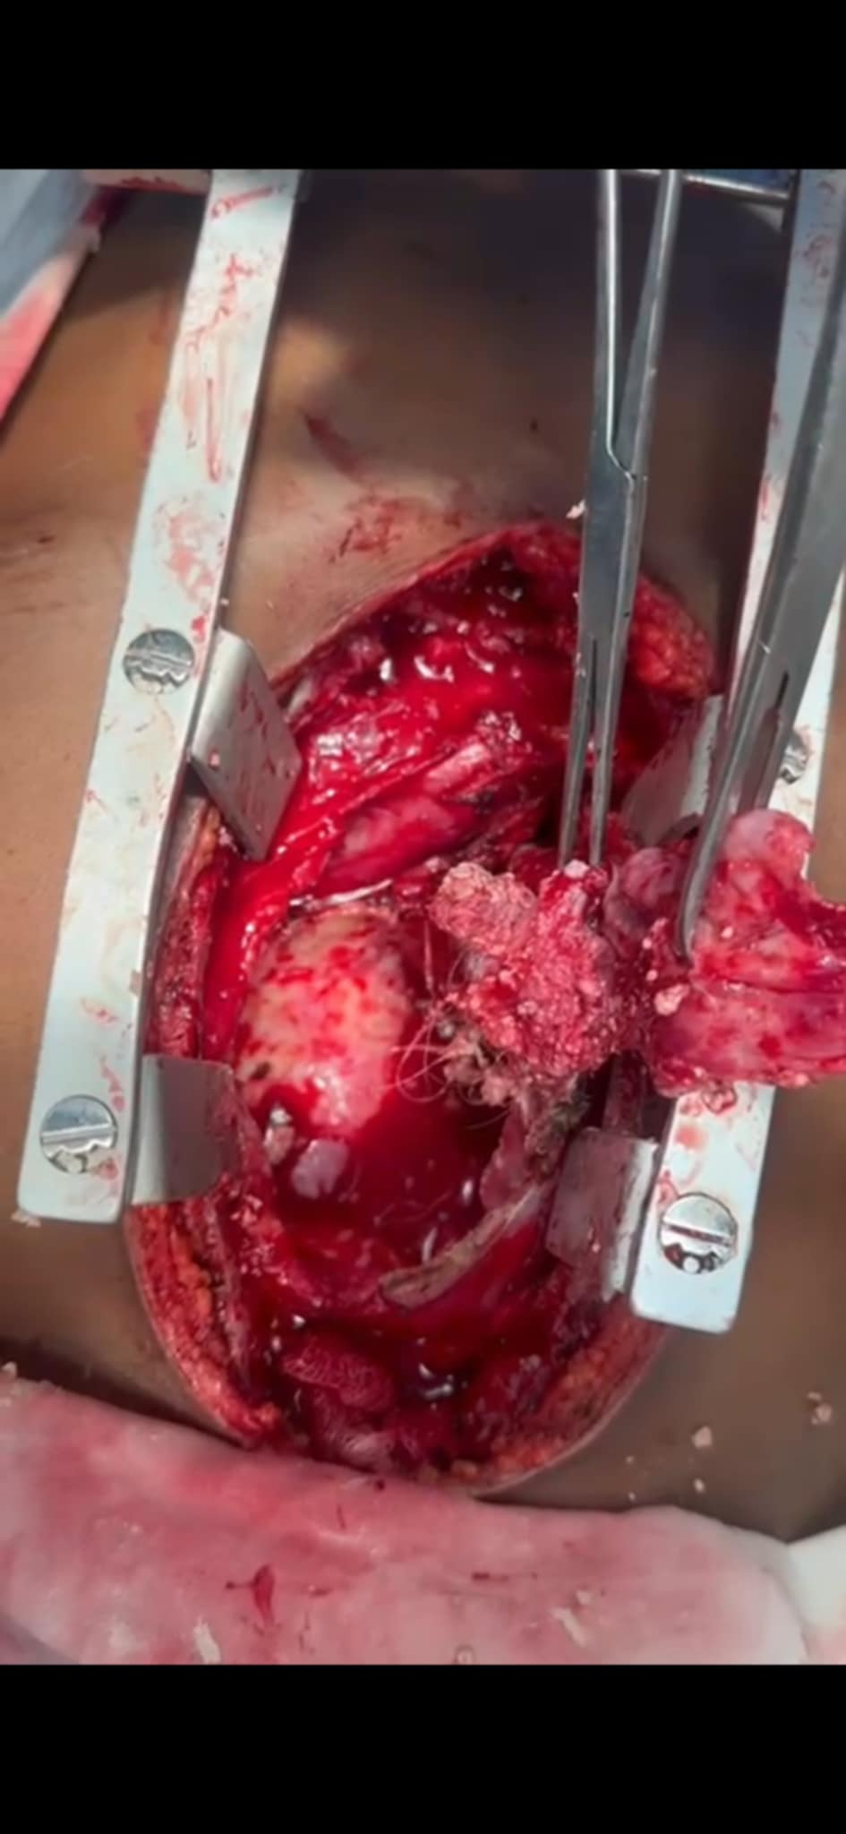

Fig-5 Per-operative View of the Mediastinal mass

**Discussion:**

Germ cell tumors are rare neoplasm that typically develop in the gonads. Anterior mediastinum is the most common location for extragondal site of germ cell tumor.12 Mediastinal mature teratoma is a slow-growing benign tumor having an incidence of 1 in every 4000 live births.12 The typical age of presentation is between 20 and 40 years where females are more affected by mature teratoma.12 Our patient was also a 24 year old female who presented with anterior mediastinal mature teratoma.

Compression-related symptoms include coughing, respiratory difficulty, chest pain, and dyspnea, are major presentation of mediastinal teratoma as the majority of patients are asymptomatic.13 Horner syndrome and the superior venacava are may also be seen if rare instances.13 Occasionally these tumors may damage or erode nearby structures, leading to issues like pericardial and pleural effusion.13 In our case, the patient was asymptomatic for a long period. Later on, she was diagnosed incidentally with mediastinal mass while evaluating her chest pain.

CT scan of chest is the investigation of choice for mediastinal teratoma.14 Benign teratomas usually have distinct margins with calcifications containing fat, sebaceous material, hair or bone.14 The diagnosis was made by CT scan in case of our patient while investigating her chest pain. Besides. imaging findings had also similarities with previous studies.

Our patient underwent surgical excision through sternotomy which is the mainstay of treatment of mature anterior mediastinal teratoma. Compared to immature teratomas, which exhibit aggressive high mitotic activity, the prognosis is excellent, with a 5-year survival rate of almost 100%.15

Studies have described multiple approaches of mediastinal tumor removal depending on the location and the size.15 Lateral thoracotomy has a better immediate post-operative outcome as it leads to less pain and early recovery.15 But Median Sternotomy provides good exposure and aids for complete removal of lesion.15 In the present case, median sternotomy was performed as it created enhanced visibility to excise the tumor.

**Conclusion:**

Mature teratoma is an uncommon neoplasm of anterior mediastinum. It should be considered as an important differential of chest pain especially in young adults. Surgical excision should be done in all cases as it provides a better outcome to the patients.

**Consent:**

An informed written consent was taken from the patient to publish her case for academic purposes.

**References:**

1. Al Smady M, Zahari NNB, Mohd Sahid NSB, et al. Anterior mediastinal teratoma with pericardial effusion. Rare presentation. J Surg Case Rep. 2019;7: 136.

2. Anand S, Longia S, Agarwal N, et al. Mature mediastinal teratoma: a rare cause of recurrent respiratory distress. Peoples J Sci Res. 2010;3:33-35.

3. De Hoyos A, Sundaresan RS. Resection of mediastinal teratoma. Oper Tech Thorac Cardiovasc Surg. 2021;6:209-220.

4. Jothianandan K, Tibb AS, McLemore M, Keller S, Appel DW. An adult man presenting with hemoptysis caused by mature teratoma with rupture into the bronchus and pericardium and complicated by Haemophilus influenzae infection. J Thorac Cardiovasc Surg. 2010;139(5):e104-e107.

5. Nusjirwan R, Hermawan K, Dewi M, Nugraha HG, Dewayani BM, Nataprawira HM. Mediastinal teratoma in children: a case series of misdiagnoses in a high-endemic tuberculosis setting. Int J Surg Case Rep. 2024;116:109307.

6. AlHarbi KM, Sairafi MH, Almuzaini SA. Mature cystic teratoma of mediastinum compressing the right atrium in a child: a rare case report. J Taibah Univ Med Sci. 2017;12(6):555-560.

7. Ghareeb A, Al Sharif F, Alyousbashi A, Dawarah M, Ghareeb A, Dalati H. Mediastinal mature cystic teratoma in a child: a case report study. Int J Surg Case Rep. 2023;103:107904.

8. Sato D, Izu A, Sakakibara M. A neuroendocrine tumor within an anterior mediastinal mature teratoma: a case report. J Cardiothorac Surg. 2022;17:333.

9. Anushree CN, Shanti V. Mature mediastinal teratoma. J Clin Diagn Res. 2015;9:34-37

10. Yasa KP, Permana AACT, Dewi SM. Mediastinal benign mature teratoma in young girl, catastrophic delayed and complications of surgery: a case report. Open Access Maced J Med Sci. 2020;8:201-204

11. Mardani P, Kamran H, Ghaderpanah R. A massive immature mediastinal teratoma treated with chemotherapy and surgical resection: a case report. J Cardiothorac Surg. 2023;18:294.

12. Omachi N, Kawaguchi T, Shimizu S. Life-threatening and rapidly growing teratoma in the anterior mediastinum. Intern Med. 2015;54(19):2487-2489.

13. Kebalo SP, Lamboni D, Guedenon KM. Mature teratoma of the mediastinum in children: a case revealed by persistent chest pain. J Pediatr Surg Case Rep. 2022;78:1022

14. Ouadnouni Y, Serraj M, Fatemi H. Tératomes matures du médiastin mediastinum’s mature teratoma. J Afr Cancer. 2014;6:224-227.

15. Abid H, Neji H, Haddar S. Mediastinal mature teratoma with spontaneous malignant transformation]. Rev Mal Respir. 2013;30(5):424-428.