***Case report***

**Post revascularization graft thrombosis due to CYP2C19 genotype polymorphism and clopidogrel resistance: A rare case managed successfully.**

**Abstract:**

Peripheral arterial disease (PAD) is the third most common atherosclerotic disease. Patients who suffer from critical lower extremities ischemia should also be revascularized as soon as possible In order to lower the risk of ischemia events following surgery, patients with PAD usually receive short-term (3–6 months) dual antiplatelet medication including clopidogrel and aspirin following revascularization. Few studies have examined the impact of CYP2C19 polymorphisms on clopidogrel resistance (CR) in PAD patients following revascularization. In the present case, an elderly diabetic hypertensive male was admitted to Cardiovascular Surgery department of Dhaka Medical College and Hospital with the diagnosis of chronic right lower limb Ischemia due to distal Superficial femoral artery occlusive disease. He subsequently underwent revascularization by dacron vascular graft and received 6 months of aspirin and clopidogrel with rivaroxaban to prevent post-operative graft thrombosis. But after stopping rivaroxaban, he developed graft thrombosis due to genetic polymorphism of CYP2C19 gene resulting clopidogrel resistance. He then received 3 cycles of prostaglandin therapy with aspirin and rivaroxaban and his symptoms were reduced gradually.

Key words: *graft thrombosis, CYP2C19 polymorphism, clopidogrel resistance*

**Introduction:**

Peripheral arterial disease (PAD) is the third most common atherosclerotic disease.1 It is also the leading cause of morbidity and death from cardiovascular and cerebrovascular disorders.1 With a global frequency of 5.6%, PAD affects over 236 million individuals worldwide.2 Revascularization, risk factor management, medication, and lifestyle modification are the mainstay of the treatment for this illness. According to guidelines, revascularization is advised for patients with early-stage PAD if conservative drug treatment proves unsuccessful.3 Patients who suffer from critical lower extremities ischemia should also be revascularized as soon as possible. 3

In order to lower the risk of ischemia events following surgery, patients with PAD usually receive short-term (3–6 months) dual antiplatelet medication following revascularization.4 This is followed by a switch to long-term antiplatelet therapy with aspirin or clopidogrel alone. However, because of platelet resistance, some patients even while receiving antiplatelet medication have recurrent ischemic episodes following revascularization.5 High platelet reactivity in patients despite the administration of antiplatelet agents is referred to as platelet resistance.5 Besides, the chance of acquiring clopidogrel resistance is increased by variables like age, diabetes mellitus, smoking, and the use of proton pump inhibitors (PPIs).6

Clopidogrel is a thienopyridine class medication is frequently employed as an antiplatelet agent due to its distinct pharmacokinetics.7 Following oral administration, it is absorbed into the gastrointestinal tract and bioactivated by cytochrome P450 (CYP450) enzymes in the liver through a two-step oxidation process, resulting in the intermediate metabolite 2-oxo-clopidogrel.7 Four isomers (H1–H4) are subsequently produced from this intermediate metabolite. Clopi-H4 binds permanently to platelets' adenosine diphosphate (ADP) receptor P2Y12, making it the only active metabolite in vivo.7 In the end, this prevents thrombosis and platelet activation. CYP2C19 is the primary catalyzer of both oxidative processes.7 CYP2C19 mutations, however, diminish or completely stop this gene's activity.8 This consequently stops this prodrug from inhibiting platelet function and has an impact on clopidogrel metabolism and activation in vivo8 .Mutations at the CYP2C19 have therefore attracted a lot of attentions. Few studies have examined the impact of CYP2C19 polymorphisms on clopidogrel resistance (CR) in PAD patients following revascularization.9 The majority of the information on CR and CYP2C19 polymorphisms comes from clinical research on heart conditions.10 Additionally, the limited number of studies that have been conducted on CYP2C19 polymorphisms and their association with the prognosis of CR and PAD.

Here we present a case of graft thrombosis due to CR following revascularization resulting from CYP2C19 polymorphism.

**Case Presentation:**

A 65 year old male was admitted to Cardiovascular Surgery Department of Dhaka Medical College and Hospital with the complaints of intermittent claudication and rest pain in his right lower limb for 5 months. He was diabetic and hypertensive. Besides he was a smoker for 15 years. His below knee pulses of left lower limb was absent. There were features of ischemia including cold calmly skin, brittle nails, hair loss and dry skin in his right lower limb below the knee joint. Ankle brachial pressure was 0.65 of the affected side. His sensory modalities were intact. Left lower limb was apparently normal. He was diagnosed a case of chronic lower limb ischemia (Rutherford stage-4 or Fontan grade –III). His duplex study revealed monophasic blood flow on the left side from popliteal artery (POPA) and onwards. CT angiogram showed distal superficial femoral artery (SFA) occlusive disease. (Fig-1)

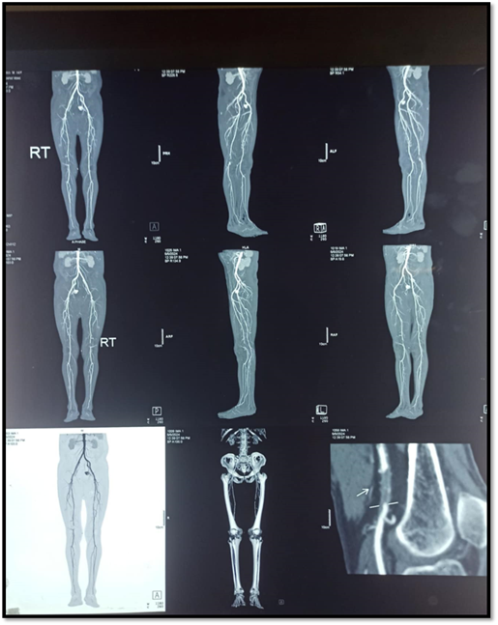

Fig-1 Pre-operative CT angiogram of the patient

He was planned for revascularization as highest medical therapy was failed to alleviate his symptoms. As endovascular facilities was not available in our center, he underwent mid SFA to infrageniculate POPA bypass by Dacron graft. His post-operative period was uneventful and symptoms were reduced. He was advised with dual antiplatelet medications including aspirin and clopidogrel along with rivaroxaban for 6 months. After 6 months, rivaroxaban was stopped and only aspirin and clopidogrel were continued. Unfortunately only after one week, his symptoms came back and features of ischemia re-appeared. His duplex Ultrasound demonstrated no flow within the graft (Fig-2) indicating graft thrombosis which was confirmed by CT angiogram.(Fig-3)

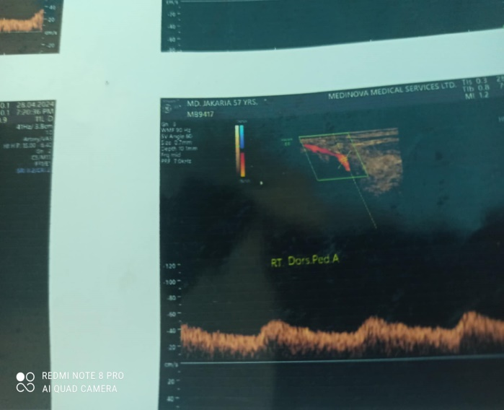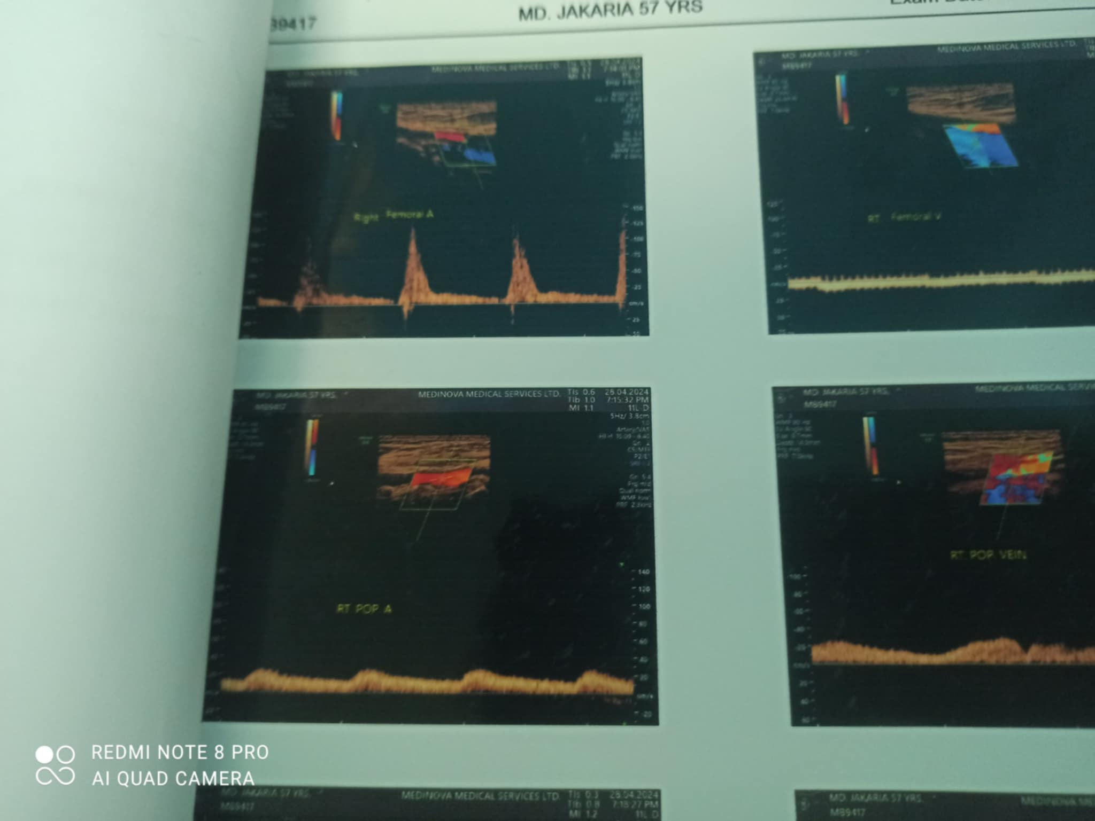

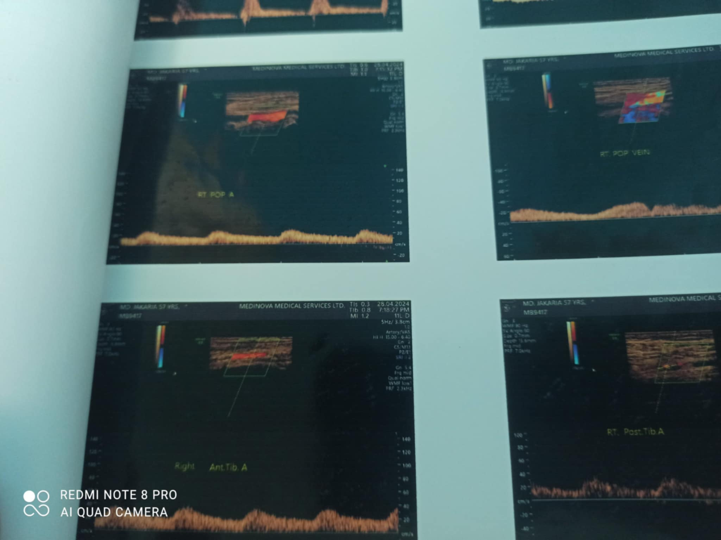

Fig-2 Duplex ultrasound showing monophasic flow from Right POPA to Arteria dorsalis Pedis(ADP)

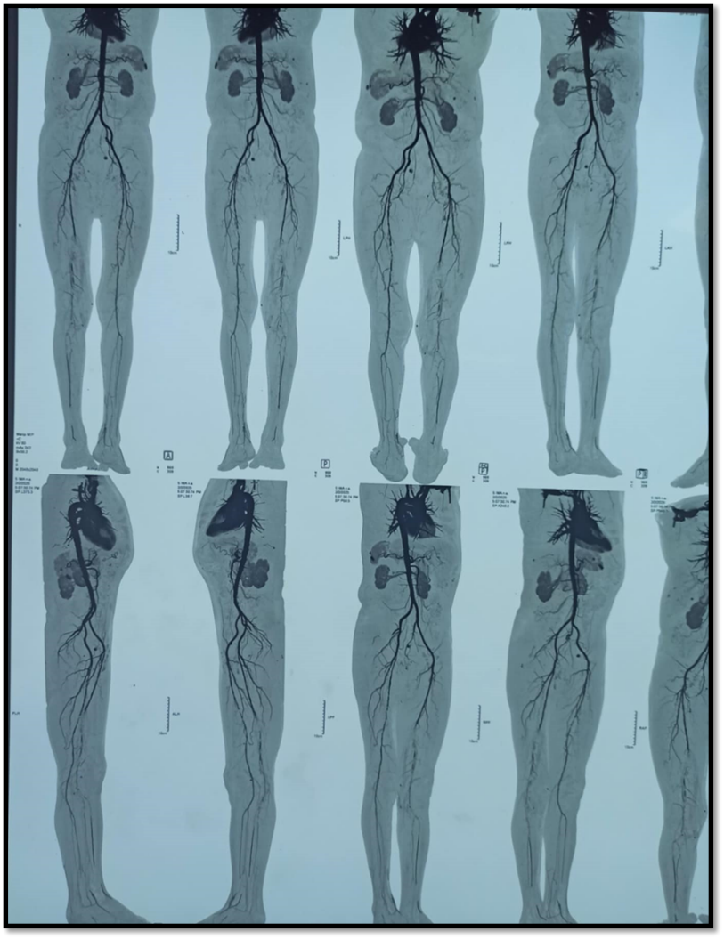

Fig-3 Showing graft thrombosis of the patient after 6 months

Then he was advised for aspirin and clopidogrel resistance testing by Polymerase chain reaction (PCR). Results of pharmacogenomics study by PCR revealed one gene mutation of CYP2C19 (intermediate metabolizer) indicating presence of CR. But there was no aspirin resistance in this patient. Then he was the switched to rivaroxaban 10 mg and aspirin 75 mg instead of clopidogrel. Prostaglandin E1 (PG) therapy was initiated in order to reduce his symptoms. Currently the patient is doing well after 3 cycles of PG therapy.

**Discussion:**

Ischemic events following revascularization is a grave complication for the patients suffering from PAD. There are several factors responsible post-revascularization ischemic events like graft thrombosis. Among them CYP2C19 genetic polymorphism is an emerging factors. Several researches are ongoing regarding CYP2C19 genetic polymorphism which is a leading cause of CR which may give rise to post-operative graft thrombosis.11,12

Clopidogrel is metabolized by an enzyme that is encoded by the CYP2C19 gene.12 A person's ability to metabolize clopidogrel can be impacted by genetic differences in CYP2C19. The effectiveness of clopidogrel in a person can be predicted with the use of genotype testing. If an individual has a genotype for clopidogrel resistance, alternative antiplatelet drugs might be taken into consideration. Variations in CYP2C19, a crucial gene that influences clopidogrel metabolism and activation in vivo, as well as the effectiveness of antiplatelet medication. 13Additionally, there aren't many studies on CYP2C19 genotype polymorphisms and the frequency of ischemia events during PAD revascularization. In a study conducted by Pastromus et al,100 patients who received endovascular therapy for superficial femoral artery blockage revealed that individuals with moderate and poor metabolisms taking clopidogrel may have a poor prognosis following the surgery.12 The occurrence of cardiovascular events following revascularization for PAD has also been linked to CYP2C19 polymorphisms.12 In another retrospective cohort study found that patients with intermediate and poor metabolism treated with clopidogrel had a lower amputation-free survival and a higher risk of death.13 In our instance, the CYP2C19 gene polymorphism was also the source of the graft thrombosis following revascularization.

Many other factors have been linked to the response to clopidogrel, in addition to the genetic variation of the drug-metabolizing enzyme CYP2C19. Diabetes mellitus (DM) has been linked in multiple studies to both a decrease in clopidogrel responsiveness and an increase in platelet reactivity in patients with PAD receiving dual antiplatelet treatment. In our case the patient suffered from DM which may be a contributing factor for CR.

The absence of clinical guidelines for PAD patients highlights the need for a post-revascularization antithrombotic management plan, particularly in situations with CR. There is no additional data to advise medication use in PAD patients with decreased clopidogrel metabolism because there are no exploratory trials on this population. In order to treat CR, prior research has recommended either increasing the dosage of clopidogrel or altering existing drugs.14 In our case we shifted to ecospirin and rivaroxaban for management of graft thrombosis. Besides PG therapy was also initiated to increase collateral circulation and reduce platelet aggregation to minimize the ischemic symptoms.

Several researches have showed that even with consistent clopidogrel (75 mg/day) dosing, individuals who have revascularization for PAD paired with CR, are still at significant risk of ischemic events.15,16 The guidelines, however, don't give these patients precise instructions on how to take antiplatelet medication. After revascularization for PAD, individuals on clopidogrel may require routine testing of their CYP2C19 genotype and platelet function due to the elevated risk of ischemic events. Moreover, in patients with CR and intermediate and poor metabolism, the clopidogrel dosage should be raised or changed to aspirin, prasugrel, or ticagrelor to reduce the risk of ischemic events.16

**Conclusion:**

The present case showed a rare cause of post revascularization graft thrombosis due to mutation of CYP2C19 leading to CR. As there is no clear consensus regarding management of CR especially after revascularization, further large scale multicenter studies should be constructed to provide a better outcome to the patients of PAD.

**References:**

1. A.W. Aday, K. Matsushita, Epidemiology of peripheral artery disease and polyvascular disease, Circ. Res.2021;128:1818-1832.

https://doi.org/10.1161/CIRCRESAHA.121.318535.

1. M.H. Criqui, K. Matsushita, V. Aboyans, C.N. Hess, C.W. Hicks, T.W. Kwan, M. M. McDermott, S. Misra, F. Ujueta, American Heart Association Council on E, Prevention, Council on Arteriosclerosis T, Vascular B, Council on Cardiovascular R, Intervention, Council on L, Cardiometabolic H, Council on Peripheral Vascular D,Stroke C, Lower extremity peripheral artery disease: contemporary epidemiology,management gaps, and future directions: a scientific statement from the American Heart Association, Circulation .2021;17:171-91 [https://doi.org/10.1161/CIR.0000000000001005 e171-e91](https://doi.org/10.1161/CIR.0000000000001005%20e171-e91).
2. P. Song, Z. Fang, H. Wang, Y. Cai, K. Rahimi, Y. Zhu, F.G.R. Fowkes, F.J.I. Fowkes, I. Rudan, Global and regional prevalence, burden, and risk factors for carotid atherosclerosis: a systematic review, meta-analysis, and modelling study, Lancet Glob. Health.2020;12:721 https://doi.org/10.1016/S2214-109X(20)30117-0 e721-e9.
3. M.D. Gerhard-Herman, H.L. Gornik, C. Barrett, N.R. Barshes, M.A. Corriere, D. E. Drachman, L.A. Fleisher, F.G. Fowkes, N.M. Hamburg, S. Kinlay, R. Lookstein, S. Misra, L. Mureebe, J.W. Olin, R.A. Patel, J.G. Regensteiner, A. Schanzer, M. H. Shishehbor, K.J. Stewart, D. Treat-Jacobson, M.E. Walsh, 2016 AHA/ACC guideline on the management of patients with lower extremity peripheral arteryAssociation task force on clinical practice guidelines, Circulation . 2017;135:726.https://doi.org/10.1161/CIR.0000000000000471 e726-e79.
4. M.S. Conte, F.B. Pomposelli, Society for vascular surgery practice guidelines for atherosclerotic occlusive disease of the lower extremities management of asymptomatic disease and claudication, Introduction. J Vasc Surg.2015;61:223-227,https://doi.org/10.1016/j.jvs.2014.12.006.
5. Farber, M.T. Menard, M.S. Conte, J.A. Kaufman, R.J. Powell, N.K. Choudhry, T. H. Hamza, S.F. Assmann, M.A. Creager, M.J. Cziraky, M.D. Dake, M.R. Jaff, D. Reid, F.S. Siami, G. Sopko, C.J. White, M. van Over, M.B. Strong, M.F. Villarreal.Surgery or endovascular therapy for chronic limb-threatening ischemia, N. Engl. J. Med..2022;223:2305–2316. https://doi.org/10.1056/NEJMoa2207899.
6. M. Majumdar, D. Waller, J. Poyant, I. McElroy, S. Lella, Z.M. Feldman, E. Levine, Y. Kim, K. Nuzzolo, A. Kirshkaln, C. DeCarlo, A. Dua, Variability of antiplatelet response in patients with peripheral artery disease, J. Vasc. Surg. 2023;77 :208–15 <https://doi.org/10.1016/j.jvs.2022.08.015>.
7. H. Wu, L. Xu, X. Zhao, H. Zhang, K. Cheng, X. Wang, M. Chen, G. Li, J. Huang, J. Lan, G. Wei, C. Zhang, Y. Wang, J. Qian, J. Ge, O. Investigators, Indobufen or aspirin on top of Clopidogrel after coronary drug-eluting stent implantation(OPTION): a randomized, open-label, end point-blinded, Noninferiority Trial.Circulation. 2023;147:212–222, <https://doi.org/10.1161/> CIRCULATIONAHA.122.062762.
8. R.J. Desai, J. Spoendlin, H. Mogun, J.J. Gagne, Contemporary time trends in use of antiplatelet agents among patients with acute coronary syndrome and comorbid diabetes mellitus or chronic kidney disease, Pharmacotherapy .2017.23(10):1322–1327, <https://doi.org/10.1002/phar.2018>.
9. Nakagawa, H.S. Park, S. Yokoyama, T. Wada, Y. Hironaka, Y. Motoyama, K. Takayama, K. Kichikawa, H. Nakase, Influence of diabetes mellitus and cigarette smoking on variability of the clopidogrel-induced antiplatelet effect and efficacy of active management of the target P2Y12 reaction unit range in patients undergoing neurointerventional procedures, J. Stroke Cerebrovasc. Dis.2016;25:163–171.https://doi.org/10.1016/j.jstrokecerebrovasdis.2015.09.010.
10. T. Simon, D.L. Bhatt, L. Bergougnan, C. Farenc, K. Pearson, L. Perrin, E. Vicaut, F. Lacreta, F. Hurbin, M. Dubar, Genetic polymorphisms and the impact of a higher clopidogrel dose regimen on active metabolite exposure and antiplatelet response in healthy subjects, Clin. Pharmacol. Ther. 2021;23:287–295. https://doi.org/10.1038/clpt.2011.127.
11. J.Pasturamus, N. Cheng, H. Tai, J. Jimmy Juang, C. Wu, L. Lin, J. Hwang, J. Lin, F. Chiang, C. Tsai, CYP2C19 polymorphism is associated with amputation rates in patients taking clopidogrel after endovascular intervention for critical limb Ischaemia, Eur. J. Vasc. Endovasc. Surg. 2019;13:373–382.https://doi.org/10.1016/j.ejvs.2019.02.011.
12. N.L. Pereira, J.B. Geske, M. Mayr, S.H. Shah, C.S. Rihal, Pharmacogenetics of clopidogrel: an unresolved issue, Circ. Cardiovasc. Genet.2016;9:185188.

https;//doi.org/10.1161/CIRCGENETICS.115.001318.

1. S.G. Johnson, D. Gruntowicz, T. Chua, R.J. Morlock, Financial analysis of CYP2C19 genotyping in patients receiving dual antiplatelet therapy following acute coronary syndrome and percutaneous coronary intervention, J. Manag. Care Spec. Pharm. 2017;21:552–7. <https://doi.org/10.18553/jmcp.2015.21.7.552>.
2. J.P. Lewis, A.R. Shuldiner, Clopidogrel pharmacogenetics: beyond candidate genes and genome-wide association studies, Clin. Pharmacol. Ther. 2017;101: 323–325. https://doi.org/10.1002/cpt.519.
3. N.F. Ford, The metabolism of clopidogrel: CYP2C19 is a minor pathway, J. Clin.Pharmacol. 2016;56:1474–1483.https://doi.org/10.1002/jcph.769.