*Case report*

Billiary Stent Migration with Duodenal Perforation in an Elderly Man: A review of Management Strategies

.

ABSTRACT

|  |
| --- |
| **Introduction:** Biliary stenting during endoscopic retrograde cholangiography (ERCP) is essential for managing biliary obstructions and leaks. The complications rate is reported to be low that when feasible, this technique is preferred.  **Case Presentation:** This is a case of 83 years old gentleman who presented 2 weeks post ERCP with complaint of abdominal pain and fever. He underwent ERCP for biliary obstruction secondary to choledocholithiasis. He underwent laparotomy, stent removal, duodenal patch repair and gastrojejunostomy for duodenal perforation from biliary stent migration. The patient died day 3 post-operative due to acute coronary syndrome.  **Discussion:** ERCP is increasingly utilized in the management of biliary obstruction. Although ERCP related complications can occur, they remain relatively uncommon. One rare but serious complication is duodenal perforation secondary to stent migration. Nevertheless, in patient presenting with severe abdominal pain and clinical signs suggestive of acute abdomen, this diagnosis should be considered promptly to ensure timely intervention.  **Conclusion:** Duodenal perforation from stent migration can occur and when interventions is delayed, may lead to mortality and morbidity. Early recognition and high index of suspicion allows for early interventions and good outcomes. |

*Keywords: endoscopic retrograde cholangiopancreatography, biliary stent, stent migration, duodenal perforation, case report*

1. INTRODUCTION

Endoscopic retrograde cholangiopancreatography (ERCP) is a diagnostic and therapeutic endoscopic technique used primarily for the evaluation and management of biliary and pancreatic ductal systems. Initially developed as a diagnostic tool, ERCP has evolved into a predominantly therapeutic procedure with applications including biliary and pancreatic ductal stenting, stone extraction, sphincterotomy, and stricture dilatation[1]. Indications for ERCP include choledocholithiasis, malignant or benign biliary strictures, pancreatic ductal abnormalities, and biliary leaks[2].

Despite its clinical utility, ERCP is associated with a range of complications. These include pancreatitis (reported in up to 10% of cases), cholangitis, haemorrhage, perforation, and adverse reactions to sedation or contrast agents[3,4]. One of the less common but clinically significant complications is stent migration.

ERCP stents, typically placed for biliary drainage or stricture management, can migrate either proximally into the bile duct or distally into the duodenum or further along the gastrointestinal tract. Migrated stents may be asymptomatic or can cause serious sequelae such as bowel perforation, obstruction, or stent occlusion[5,6]. Less than 1% of migrated stent cause intestinal perforations with mortality rate below 1 % [7].

Early recognition and appropriate management of ERCP-related complications, particularly stent migration, are crucial to minimize morbidity and ensure optimal patient outcomes. Here, we presented a case of migrated stent causing duodenal perforation in elderly man.

2. presentation of case

An 83-year-old gentleman with ischaemic heart disease, hypertension and dyslipidaemia presented with ascending cholangitis secondary to choledocholithiasis.An endoscopic retrograde cholangiopancreatography (ERCP) was done and common bile duct stent was inserted. After 3 months he was electively admitted for a change of stent. A new straight plastic stent (10F, 10mm) was inserted, and the patient was discharged after 24 hours of observation.

He presented after 2 weeks with persistent epigastric pain. Clinically, he was haemodynamically stable; abdominal examination revealed distension and localized tenderness in the right hypochondrium. Chest X-ray showed no air under the diaphragm. Ultrasound and CT abdomen revealed stent malposition, with the distal tip penetrating the anterior D2 segment of the duodenum into the peritoneal cavity.

Decision was made for surgical intervention, as the patient later became haemodynamically unstable with peritonitis. An exploratory laparotomy, stent removal, duodenal patch repair, and gastrojejunostomy were performed. Unfortunately, the patient succumbed to acute coronary syndrome on postoperative day three.

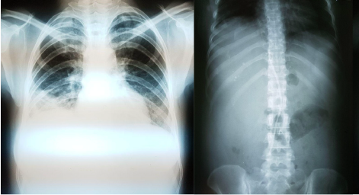

Figure 1: Chest X-Ray (left), Abdominal X-Ray supine (right) with no signs of pneumoperitoneum.

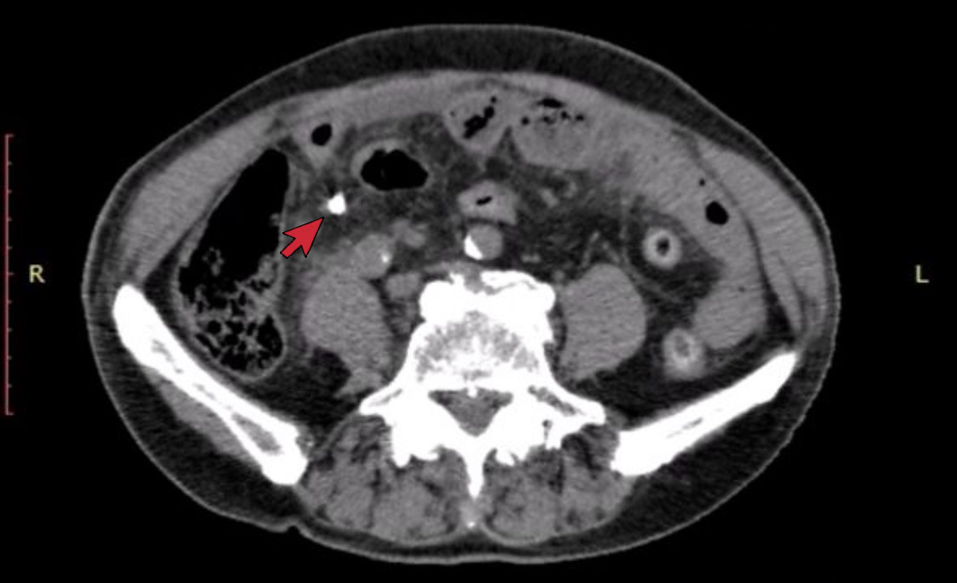

Figure 2: CECT abdomen showing the stent penetrating the 2nd part of duodenum into the peritoneal cavity

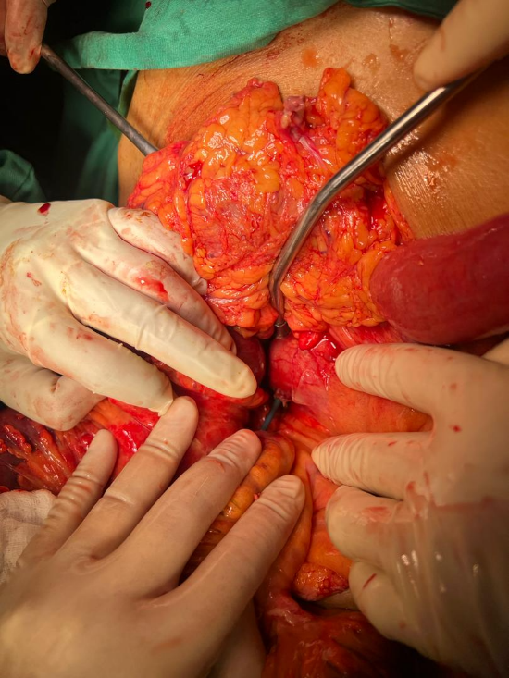

Figure 3: Stent protruding from the 2nd part of the duodenum

3. discussion

Stent migration, while uncommon, poses significant risks, including duodenal perforation. Review of literature reveals that the majority of complications associated with stent migration and perforation are seen with straight stents, as in our patient [8,9]. Management strategies depends on the perforation type and patient condition. Conservative management, including fasting, intravenous hydration, nasogastric suction, and antibiotics, is typically employed for small, contained perforations.

However, surgical intervention is often necessary for uncontained perforations, persistent symptoms, or major leaks. Endoscopic therapies, such as fully covered self-expandable metal stents (SEMS), over-the-scope clips, and endoscopic suturing, offer less invasive alternatives for specific perforations [10].

Risk factors for stent migration include anatomical variations, previous surgeries, and procedural complexities. Other potential risk factors for perforation include impaired mucosal healing and integrity. Our patient is 83 years old with multiple co-morbidities, which could impair his mucosal healing. Impaired mucosal healing in elderly patients can indeed increase the risk of perforation, particularly in the context of biliary stents. Age-related factors such as decreased tissue elasticity, reduced mucosal blood flow, and the prevalence of comorbidities that affect wound healing (like diabetes or vascular disease) contribute to this risk. Moreover, elderly patients are more susceptible to complications due to the diminished regenerative capacity of their tissues and the possible presence of chronic inflammation or fibrosis, which compromises the structural integrity of the gastrointestinal tract.

Studies highlight that the elderly population is at a higher risk for complications like perforation due to these factors, especially after procedures involving stents or other foreign objects within the biliary or gastrointestinal tract. For instance, one study emphasizes the importance of careful monitoring and timely intervention in elderly patients with biliary stents, considering their heightened vulnerability to complications such as migration and subsequent perforation [11].These insights underline the necessity of vigilant post-procedural care in elderly patients to minimise the risk of severe complications like perforation.

Preventive measures involve meticulous endoscopic technique, careful patient selection, and the use of pigtail biliary stent to prevent mucosal injury. Experienced endoscopists should handle high-risk cases to mitigate complications.

4. Conclusion

Biliary stent migration with duodenal perforation, though rare, is a critical complication requiring timely diagnosis and appropriate management. Elderly patients are particularly vulnerable due to comorbidities and reduced physiological reserves. A comprehensive understanding of risk factors, prompt therapeutic interventions, and preventive strategies are essential to improving outcomes in this population. It involves a combination of careful technique, appropriate stent selection, and patient-specific considerations.

Consent

All authors declare that written informed consent was obtained from the patient’s next of kin for publication of this case report and accompanying images. A copy of the written consent is available for review by the Editorial office/Chief Editor/Editorial Board members of this journal.

Ethical approval

As per international standards, patient written ethical approval has been collected and preserved by the authors.

References

1. Cotton PB, Lehman G, Vennes J, et al. Endoscopic sphincterotomy complications and their management: an attempt at consensus. Gastrointest Endosc. 1991;37(3):383-393.

2. Testoni PA, Mariani A, Aabakken L, et al. Papillary cannulation and sphincterotomy techniques at ERCP: European Society of Gastrointestinal Endoscopy (ESGE) Clinical Guideline. Endoscopy. 2016;48(7):657-683.

3. Freeman ML, DiSario JA, Nelson DB, et al. Risk factors for post-ERCP pancreatitis: a prospective, multicenter study. Gastrointest Endosc. 2001;54(4):425-434.

4. Andriulli A, Loperfido S, Napolitano G, et al. Incidence rates of post-ERCP complications: a systematic survey of prospective studies. Am J Gastroenterol. 2007;102(8):1781-1788.

5. Johanson JF, Schmalz MJ, Geenen JE. Incidence and risk factors for biliary and pancreatic stent migration. Gastrointest Endosc. 1992;38(3):341-346.

6. Arhan M, Odemiş B, Parlak E, et al. Migration of biliary plastic stents: experience of a tertiary center. Surg Endosc. 2009;23(4):769-775.

7. A. Bagul, C. Pollard, A. Dennison, A Review of problems following insertion of biliary stents illustrated by an unusual complication 92 (4) (2010) e27-e31.

9. Diller R, Senninger N, Kautz G, et al. Stent migration necessitating surgical interventions. Surg Endosc 2003; 17: 1803-1807

10. Saxena P, Khashab MA. Endoscopic Management of Esophageal Perforations: Who, When, and How? Curr Treat Options Gastroenterol. 2017 Mar;15(1):35-45. doi: 10.1007/s11938-017-0117-3. PMID: 28116696.

11. Pattonieri, V., Tarasconi, A., Perrone, G., Abongwa, H.K., Catena, F. (2021). Gastric and Duodenal Perforation in Elderly. In: Latifi, R., Catena, F., Coccolini, F. (eds) Emergency General Surgery in Geriatrics . Hot Topics in Acute Care Surgery and Trauma. Springer, Cham. https://doi.org/10.1007/978-3-030-62215-2_15