Case report

Intraoperative diagnosis of 3 exceptional cases of internal hernias during an acute intestinal obstruction pattern

Abstract :
Internal hernias are rare, representing 0.5-5% of acute intestinal obstructions. The diagnosis is suggested in a subject with no surgical history presenting with an occlusive syndrome. We report 3 cases of internal hernias through the triangular ligament, the falciform ligament and the mesosigmoid in subjects between 60 and 75 years old responsible for ileal strangulation with reversible ischemia, discovered incidentally during surgery and whose treatment was the release of the intestinal contents and the flattening of the newly formed cavity.
KEYWORDS :
Internal hernia, intestinal obstruction, triangular ligament of the liver, falciform ligament,intramesosigmoid internal hernia.
INTRODUCTION :
Internal abdominal hernias are rare pathologies, resulting from protrusion of hollow viscera, most often the intestine, through a natural or abnormal intra-abdominal orifice. Often discovered incidentally during surgery during an acute intestinal obstruction or by abdominal CT scan during the exploration of a painful episode. They represent 0.5% to 5.8% of acute intestinal obstructions. In light of medical observations and literature reviews, we report the diagnostic difficulty and the therapeutic modalities of this pathology..
CASE PRESENTATION:
Case number 1:INTERNAL HERNIA THROUGH THE LEFT TRIANGULAR LIGAMENT OF THE LIVER:
A patient, aged 69, a chronic smoker at 10 PA who quit 17 years ago, never operated on and without any pathological history or associated comorbidities. The history of his illness dates back to 8 days before his admission with the onset of an occlusive syndrome consisting of diffuse abdominal pain with cessation of waste and gas and bilious vomiting without externalized digestive hemorrhage, all evolving in a context of apyrexia and decline in general condition. On general examination: the patient is conscious 15/15, stable on a hemodynamic and respiratory level with: BP: 12/7, RR: 16 cycles/min, HR: 86 beats/min, T: 36.8°C. On abdominal examination: The abdomen is distended, tympanic and tender, no hepatosplenomegaly or palpable mass, the hernial orifices are free.
For the rectal examination: the anal margin is healthy with good sphincter tone, no palpable mass and the finger cot returns soiled with traces of normal-colored stool.
The remainder of the somatic examination was unremarkable.
The unprepared tree objectified the presence of hail-like hydro-aeric levels.
Abdominopelvic CT shows significant intestinal distension of 57mm, the site of fluid-air levels, without a visible transitional level with the last ileal loop and the colonic frame which are collapsed, presence of a low-abundance intraperitoneal effusion located in the peri-hepatic region.
Assessment: Hemoglobin: 15.5 g/dl, white blood cells: 18,220/mm3, platelets: 363,000/mm3, Na+: 140 mmol/L, K+: 3 mmol/L, Urea: 1.86 g/L, Creatinine: 16 mg/L, CRP: 37.3 mg/L.
The patient underwent an exploratory laparotomy with the following findings: Presence of a moderately abundant intraperitoneal effusion of painful fluid, presence of an internal hernia by incarceration of 30cm of small intestine distended to 5cm but viable at the level of an unnatural orifice at the level of the left triangular ligament. The procedure consisted of the extrication of the small intestine and the section of the left triangular ligament to prevent recurrence.
The patient is declared discharged on post-operative day 2 with food authorized on post-operative day 1, a clean dressing, a soft abdomen and transit resumed in the form of stools and gas.
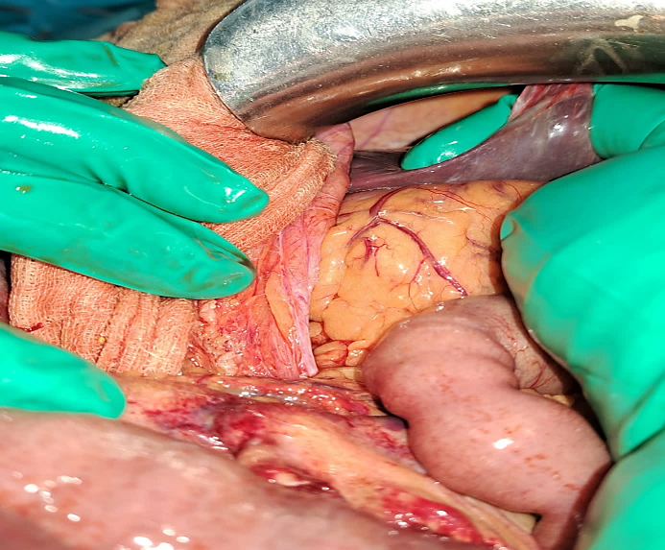
Figure 1:Intraoperative photo of the unnatural orifice at the level of the left triangular ligament responsible for the internal hernia.
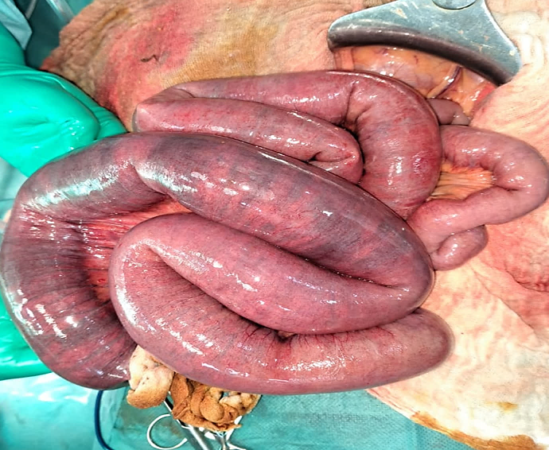
Figure 2:intraoperative photo of the small bowel loops which were incarcerated and distended to 5cm.
Case number 2:INTERNAL HERNIA THROUGH THE FALCIFORM LIGAMENT:
This is Mr. HO, aged 74, with no particular medical history and never operated on. The history of his illness: dates back to 9 days before his admission, with the onset of an occlusive syndrome, without externalized digestive hemorrhage, all evolving in a context of apyrexia and decline in general condition. On general examination: the patient is conscious 15/15, stable on a hemodynamic and respiratory level with: HR: 88 beats/min, BP: 10/05, RR: 22 cycles/min, T°: 36.6 °c
On abdominal examination: The abdomen is distended, tympanic and soft
The hernial orifices are free and the rectal examination is unremarkable.
The urinary tree without preparation objectified the presence of intestinal hydro-aeric levels
Abdominopelvic CT scan shows distension of a few small bowel loops measuring 36 mm, infrahepatic at D12-L1, causing small bowel occlusion due to a band? Or due to adhesions?
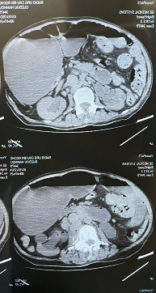
Figure 3:Sagittal sections of an abdominal CT scan showing distended small bowel loops in the subhepatic region, performing a chilaiditi
On balance: Hemoglobin: 12.9 g/dl, white blood cells: 14,900/mm3, platelets: 303,000/mm3, Na+: 136mg/L, K+: 4.5mmol/L, CRP: 128mg/L, urea: 0.13 g/L, creatinine: 6 mg/L.
The patient underwent an exploratory laparotomy with, upon exploration: absence of peritoneal effusion and presence of an internal hernia with incarceration of 50cm of small intestine distended to 3.5cm but viable at the level of the falciform ligament. The procedure consisted of the extrication of the small intestine with section of the falciform ligament and its diaphragmatic insertion..
The patient The patient is declared discharged on post-operative day 1 with food authorized on post-operative day 1, a clean dressing, a soft abdomen and transit resumed under
form of stools and gas.

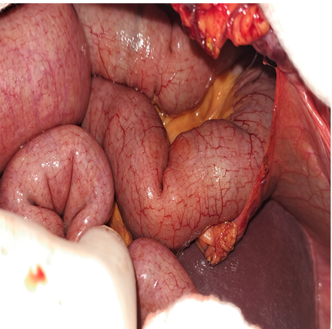
Figure 4: intraoperative photo of the shunt loops incarcerated at the level of the falciform ligament

Case number 3:INTRAMESO SIGMOID INTERNAL HERNIA:
This is Mr. BA, aged 66, whose only history is chronic smoking at 50PA. The history of his illness dates back to 7 days before his admission with the onset of an occlusive syndrome with diffuse abdominal pain., without externalized digestive hemorrhage, all evolving in a context of apyrexia and decline in general condition. On general examination: the patient is conscious 15/15, stable on a hemodynamic and respiratory level with: BP: 12/7, RR: 16 cycles/min, HR: 86 beats/min, T: 36.8°C. On abdominal examination: The abdomen is distended, tympanic and tender, the hernial orifices are free and the rectal examination is unremarkable.
The urinary tree without preparation revealed the presence of intestinal hydro-aeric levels.

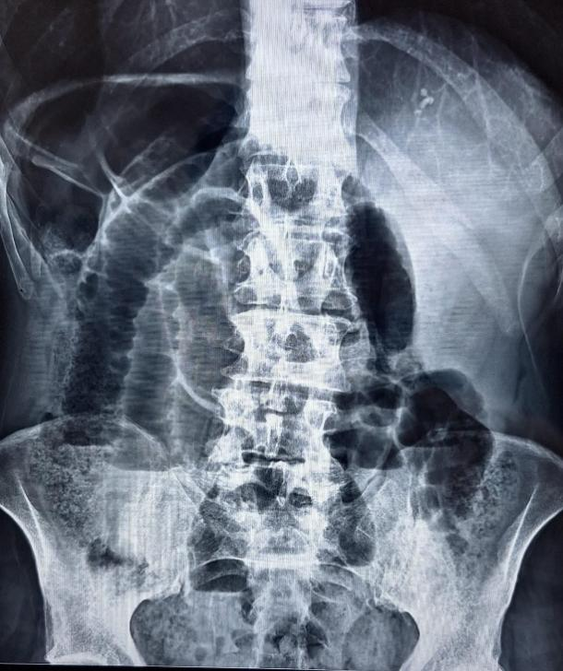

Fig .5 CT scan showing acute intestinal occlusion

Abdominopelvic CT scanis in favor of an acute intestinal occlusion, located in the small intestine on a sub-stenosing parietal thickening located at the level of the hypogastrium measuring 15 x 52 mm, with no sign of digestive distress

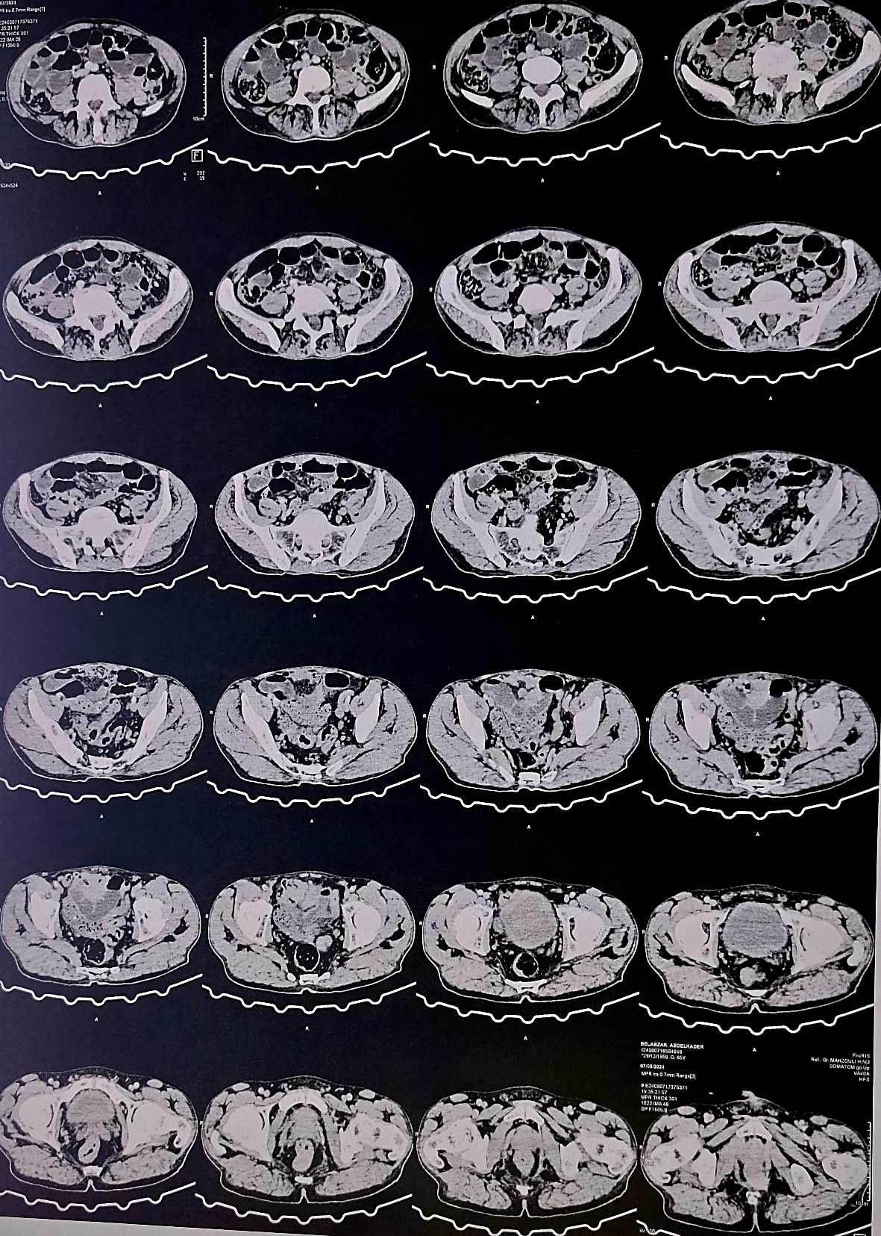
Figure 6:cross-sections of an abdomino-pelvic CT scan showing distended small bowel loops with transitional level (small bowel parietal thickening responsible for the occlusion = yellow arrow).

On balance: Hemoglobin: 13 g/dl, white blood cells: 11200/mm3, platelets: 214,000/mm3, Na+: 138mg/L, K+: 3.5mmol/L, CRP: 11mg/L, urea: 0.22 g/L, creatinine: 10 mg/L.
The patient underwent an exploratory laparotomy with, upon exploration: absence of peritoneal effusion and presence of an intramesosigmoid internal hernia with incarceration of 30cm of small bowel distended to 3cm, painful but viable at the level of an orifice with inextensible fibrous contours formed by the layers of the mesosigmoid. The procedure consisted of the extrication of the small bowel with flattening of the newly formed cavity.
The patient is declared discharged on post-operative day 1 with food authorized on post-operative day 1, a clean dressing, a soft abdomen and transit resumed under
form of stools and gas on day 1 post-operatively.

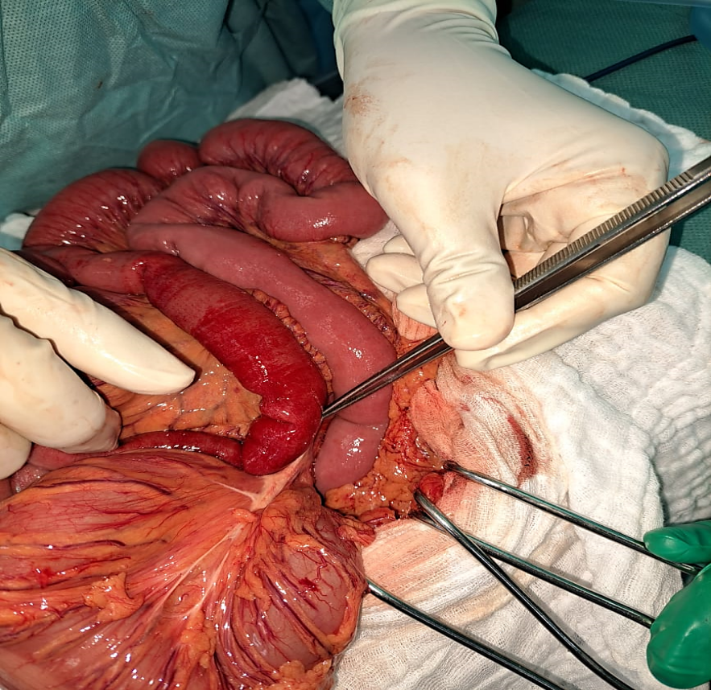 A 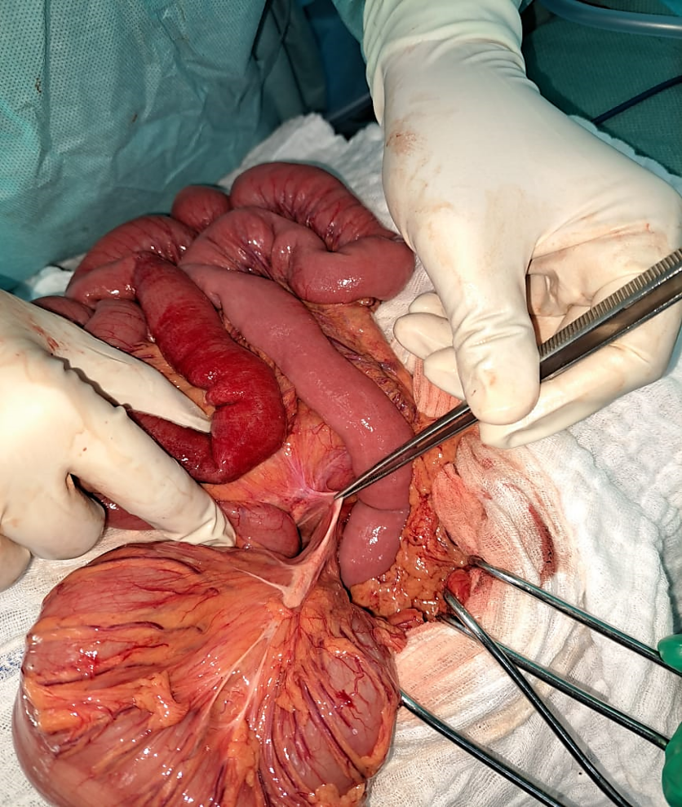 B
Figure 7:Intraoperative image of an intramesosigmoid internal hernia: A: small intestine loop incarcerated at the level of the newly formed orifice, B: after extrication.
DISCUSSION :
Internal hernia is a rare pathology, often secondary to a defect in the adhesion of the peritoneum and an anomaly in the rotation of the small intestine during embryological development. It is discovered incidentally with a percentage of 0.2 to 2% in large series of autopsies. They can be post-operative or congenital on a "virgin" abdomen and therefore occur through a normal or abnormal orifice. It is the second case that will be discussed in our article. Intestinal obstruction by internal hernia remains rather rare with a percentage of 5.8% of all causes of intestinal obstruction, often unrecognized by the clinician and the radiologist, the diagnosis is always made intraoperatively. Our article has highlighted 3 extremely rare types of internal hernias which are: internal hernia at the level of the falciform ligament which represents 0.1 to 0.3% of internal hernias and whose orifice on the falciform ligament can be of congenital origin as in our case, inflammatory (satellite of acute cholecystitis) or secondary tosurgical intervention (2/3 gastrectomy), intramesosigmoid internal herniadescribed by Benson et al in 1963 which represents 5% of hernias at the level of the sigmoid mesocolon due to congenital anomaly of adhesion of the peritoneal layer of the sigmoid mesocolon.
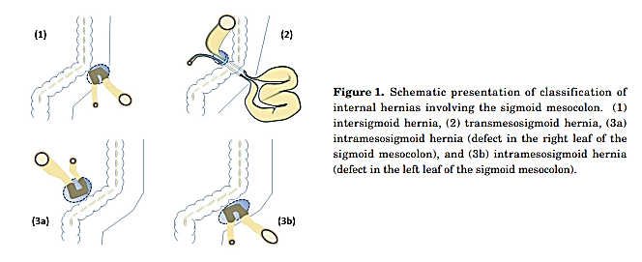
Figure 8: Schematic presentation of classification of internal hernias involving the sigmoid mesocolon: (1) intersigmoid hernia, (2) transmesosigmoid hernia, (3) intramesosigmoid hernia

For internal hernia at the level of the left triangular ligament of the liver, its incidence is particularly difficult to estimate; 2 previous cases in France and Brazil have been reported in the literature; the origin can also be congenital, post-traumatic or post-operative. Being asymptomatic, internal hernias go unnoticed, but as soon as they become painful following strangulation of the loops at the level of the hernial orifices, the clinical picture becomes that of occlusion as described in our cases. Abdominal CT scanis the examination of choice for diagnosing internal hernia in 77% of cases, with a sensitivity of 63% and a specificity of 76%, however the diagnostic difficulty will depend on the type of hernia, as observed in the 3 observations where the precise diagnosis could not be made. The surgical approachwhich consists of the extrication of the small intestine and the collapse of the hernial orifice to avoid recurrences, can be approached by laparotomy as well as by laparoscopy, thus providing the advantages of minimally invasive surgery. However, the classic approach was chosen for the 3 patients given the significant distension of the small intestine which could prevent exploration with the risk of iatrogenic perforation which could go unnoticed.
CONCLUSION :
Internal hernias are a rare cause of acute intestinal obstruction, often diagnosed intraoperatively. Abdominal CT scanning, performed urgently, can aid in preoperative diagnosis and guide therapeutic action. Treatment is always surgical.
Références :

Ouedraogo, Souleymane, and others, 'Congenital Transmesenteric Internal Hernia Occlusion: About Two Cases', The Pan African Medical Journal, 27 (2017), p. 131, doi:10.11604/pamj.2017.27.131.12203
Zida, M, and others, 'EPIDEMIOLOGICAL, DIAGNOSTIC ASPECTS AND THERAPEUTIC RESULTS OF STRANGLED INTERNAL HERNIA AT THE YALGADO OUEDRAOGO CHU (YO) IN OUAGADOUGOU.', 11 (2009)
Jean Lubrano, Eric Delabrousse, Brice Paquette, Ouajih Idelcadi, Georges Mantion, Image of the month. Internal hernia through the left hepatic triangular ligament, Arch Surg. 2011 Oct;146(10):1215-6. doi: 10.1001/archsurg.2011.261-a.
Armstrong, O., 'Internal Hernia through the Falciform Ligament', Hernia, 17.6 (2013), pp. 815–16, doi:10.1007/s10029-013-1154-z
Macina, Simona, Tommaso Testa, and Caterina Losacco, 'Congenital Internal Hernia through Defect in the Falciform Ligament in Adult: A Case Report and Review of the Literature', International Journal of Surgery Case Reports, 26 (2016), pp. 104–07, doi:10.1016/j.ijscr.2016.05.003
Benson, J. Robert, and Duncan A. Killen, 'Internal Hernias Involving the Sigmoid Mesocolon', Annals of Surgery, 159.3 (1964), pp. 382–84
Lukman, Kiki, and others, 'Sigmoid Mesocolon Internal Hernia: A Case Report', Annals of Medicine and Surgery, 85.5 (2023), pp. 2115–18, doi:10.1097/MS9.0000000000000566
Monica, Marina Lanzetta, and others, 'Internal Hernias: A Difficult Diagnostic Challenge. Review of CT Signs and Clinical Findings', Acta Bio Medica: Atenei Parmensis, 90.Suppl 5 (2019), pp. 20–37, doi:10.23750/abm.v90i5-S.8344
Takeshita, Tohru, and others, 'Small Bowel Obstruction Due to an Intramesosigmoid Hernia Diagnosed by Multidetector Row Computed Tomography: A Case Report', Osaka City Medical Journal, 56.2 (2010), pp. 37–45
Doishita, Satoshi, and others, 'Internal Hernias in the Era of Multidetector CT: Correlation of Imaging and Surgical Findings', RadioGraphics 2015, 2015, doi:10.1148/rg.2016150113
Murali Appavoo Reddy, Uma Devi, Bhawna Dev, and Roy Santosham, 'Internal Hernias: Surgeons Dilemma-Unravelled by Imaging', The Indian Journal of Surgery, 76.4 (2014), pp. 323–28, doi:10.1007/s12262-012-0620-7

