***Case report***

**FOURNIER’S GANGRENE: A CASE REPORT**

**ABSTRACT:**

Fournier's gangrene is an uncommon necrotizing fasciitis of the vaginal and perineal areas that progresses quickly and is frequently linked to significant morbidity and fatality rates. Survival depends on intensive care and early detection. In order to successfully treat Fournier's gangrene, it emphasizes the significance of early clinical suspicion, timely surgical intervention, and multidisciplinary management. The most important elements in lowering mortality and enhancing patient outcomes continue to be prompt diagnosis and vigorous therapy. We report the case of a 55 years old male patient with a history of hypertension and diabetes mellitus from past 10 years who presented with complaints of scrotal swelling from 1 week and raw area over scrotum followed by discharge from the raw area. Signs of a necrotizing soft tissue infection were found during the clinical examination. Based on the surgical findings and imaging diagnosis was confirmed and undergone emergency surgical debridement therapy and eventually recovered from the condition.

***Keywords:*** Fournier’s gangrene, necrotizing fasciitis, surgical debridement, perineal infection.

1. **INTRODUCTION:**

A rare and potentially fatal bacterial infection, Fournier's gangrene affects the anal area, perineum, and genitalia. It’s a type of necrotizing fasciitis also known as flesh-eating illness. Severe inflammation and infection that spreads along fascial planes are the hallmarks of Fournier gangrene, which frequently results in sepsis, fast tissue destruction, and a high fatality rate of 40% (Mishra SP, 2013) (Joury A, 2019). The main cause of this illness is a polymicrobial infection that involves both aerobic and anaerobic bacteria (Escherichia coli, Streptococcus spp., Staphylococcus aureus, Bacteroides spp., Clostridium spp.) and typically comes from the skin, intestines, or urine (Leslie SW, 2015). Less than 0.02% of hospital admissions result from the rare infection known as Fournier gangrene. The male-to-female ratio is 10:1, with higher rates of morbidity and mortality observed among women. Women experience more severe illness and have longer hospital stays compared to men, with the highest incidence of Fournier gangrene observed in the Southeast region of the United States. This condition often leads to debilitating or immunocompromised states, particularly affecting males aged 50 and older who have a history of alcohol abuse and diabetes (Leslie SW, 2015). Skin discoloration, vaginal swelling, moderate genital pain, malaise, fever, crepitus, and a crackling sound when the afflicted areas are massaged are some of the symptoms. Causes include genital trauma, anorectal or urogenital trauma, pelvic and perineal damage, and pelvic procedures, which allow bacteria from the gastrointestinal tract to reach the skin. Treatment options include intravenous fluids, vasoactive drugs, broad-spectrum antibiotics, reconstructive surgery, and emergency surgical debridement to remove necrotic and infected tissue. Complications include multiple organ failure, death, and septic shock, in which the body is unable to maintain blood pressure and organs shut down. Risk factors include HIV, alcohol abuse, and diabetes mellitus.

Here we describe a case of 55 years old male patient came with complaints of scrotal swelling for 1 week and raw area over scrotum followed by discharge from raw area in the past 5 days and based on the assessment and various diagnostic criteria he was diagnosed with Fournier’s gangrene. We further discussed the clinical findings and the management approach done for the patient.

1. **CASE PRESENTATION:**

A 55year old male patient came with complaints of scrotal swelling from 1 week and raw area over scrotum followed by discharge from raw area from the past 5 days.

**History of Present Illness:** Patient was apparently asymptomatic 1 week ago then he noticed scrotal swelling which was sudden onset and gradually progressive in nature, he also noticed raw area on the left side of scrotum which was associated with discharge and of foul smell from past 5 days. He has a history of fever.

**Past history:** He is a known case of Diabetes mellitus and hypertension from past 10 years and on medication metformin 500mg, glimepiride 2 mg and telmisartan 40 mg respectively.

**Social history:** He was a smoker from the last 30 years (1 pack/ day) and an alcoholic from the last 30 years (weekly once 180 ml).

Patient was moderately built and nourished. On examination patient was afebrile, his blood pressure was found to be 130/70 mmHg and pulse rate was 85 bpm.

Local examination:

Inspection: A raw area of 10*4 cms noted on the left side of the scrotum extending from 1cm to median graph horizontally surrounding skin edematous and erythematous. No engorged veins and sinus and no visible scars.

Palpation: All inspectory findings confirmed. Tenderness (+) and no local rise of temperature.

**Laboratory findings:**

***High -resolution ultrasound of the scrotum:***

Right and left testis are normal in size, echotexture and vascularity. Bilateral cord structures appear mildly bulky with increased vascularity therefore likely funiculitis.

Bilateral epididymis is normal.

Mild to moderate free fluid noted in bilateral hemiscrotum with thin moving internal echoes noted with thickened scrotal wall of maximum thickness m/s 20 mm to rule out pyocele.

Impression: B/L Funiculitis with pyocele with thickened scrotal wall

***Lipid profile test:***

Total cholesterol- 93 mg/dl

Triglycerides- 124 mg/dl

HDL cholesterol-17 mg/dl

LDL cholesterol-51.2 mg/dl

VLDL-25 mg/dl

TSH-5.50 μIU/mL

T4-9.5ug/dL

LDH-297 U/L

Widal test- Negative

RA Factor- Negative

Dengue -Negative

Malaria-Negative

Pus for culture and sensitivity: Contaminants grown on culture on day 5

Urine for culture colony count: Polymicrobial growth seen in culture on day 5

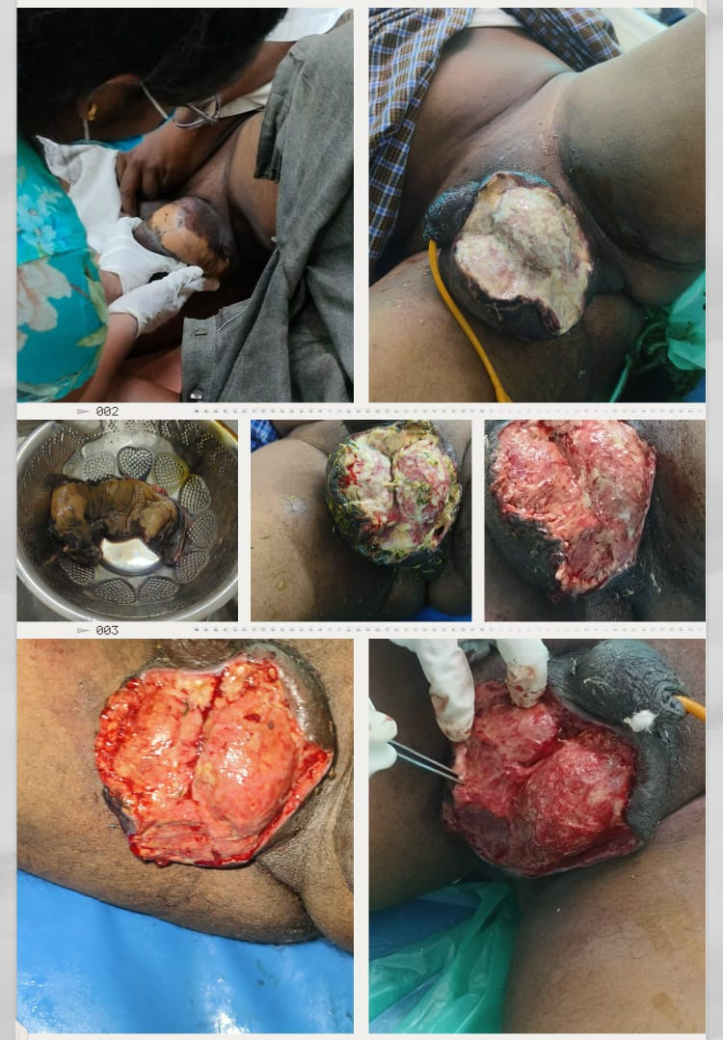

Figure 1: Image shows the removal of the gangrenous tissue and regular surgical dressing after the debridement therapy.

| **Laboratory parameters** | **Day 1** | **Day 3** | **Day 6** | **Day 7** | **Day 12** | **Day 18** |
| --- | --- | --- | --- | --- | --- | --- |
| Haemoglobin (g/dl) | 14.5 | **13.2** | **12.5** | **12.5** | **13.1** | **10.8** |
| Total RBC (mln/cumm) | **4.38** | **3.92** | **3.94** | **3.91** | **4.16** | **3.41** |
| HCT (vol%) | 40.3 | **36.3** | **35.8** | **35.4** | **37.2** | **30.3** |
| MCV (fl) | **92.0** | **92.6** | **90.9** | **90.5** | **89.4** | **88.9** |
| MCH (pg) | 33.1 | 33.7 | 31.7 | 32.0 | 31.5 | 31.7 |
| MCHC (g/dl) | 36.0 | **36.4** | 34.9 | 35.3 | 35.2 | 35.6 |
| RDW CV (%) | 12.4 | 12.3 | 12.3 | 12.3 | 12.2 | 12.2 |
| Total WBC (10^3cells/cumm) | **15.24** | 10.00 | 7.42 | 7.86 | **11.92** | 4.55 |
| Platelet (10^3/micro L) | **131** | 164 | 248 | 224 | 277 | **140** |
| Neutrophils (%) | 75.7 | 67.7 | 68.3 | 62.2 | 71.6 | 62.3 |
| Lymphocytes (%) | **16.5** | 20.8 | 24.4 | 30.0 | **17.6** | 27.0 |
| Eosinophils (%)  0.1  0.5  1.9  2.2  0.3  0.2  Monocytes (%)  7.5  10.9  5.3  5.6  10.4  10.3  Basophils (%)  0.2  0.1  0.1  0.0  0.1  0.2 | **0.1**  0.5  1.9  2.2  0.3  0.2 | **0.5** | 1.9 | 2.2 | **0.3** | **0.2** |
| Monocytes (%) | 7.5 | 10.9 | 5.3 | 5.6 | 10.4 | 10.3 |
| Basophils (%) | 0.2 | 0.1 | 0.1 | 0.0 | 0.1 | 0.2 |
| Blood urea (mg/dl) | 26 | 27 | 15 | **12** | 32 | 27.3 |
| Serum creatinine (mg/dl) | 0.78 | **0.59** | **0.59** | **0.53** | **0.68** | 0.75 |
| Serum sodium (m Eq/L) | **133** | **130** | 142 | **130** | **126** | **133** |
| Serum potassium(mEq/L) | **8.0** | **3.5** | **3.5** | 3.8 | 4.1 | 4 |
| Serum chloride (mEq/L) | **97** | **97** | 104 | **96** | **92** | 104 |
| Total serum bilirubin (mg%) | **1.47** | **1.33** | 0.84 | 0.52 | 0.90 | 0.56 |
| Direct bilirubin (mg/dl) | **0.53** | **0.41** | **0.21** | 0.10 | **0.24** | 0.15 |
| S.G.O.T(U/L) | 32 | 23 | **37** | 35 | 30 | 31 |
| S.G.P.T (U/L) | 29 | 20 | 24 | 23 | 21 | 28 |
| Alkaline Phosphatase (I.U/L) | **148** | **140** | **174** | **149** | **140** | 105 |
| Albumin (g/dL) | **3.4** | **2.8** | **2.64** | **2.51** | **2.86** | **2.8** |
| Protein (g/dL) | 6.26 | **5.52** | 6.45 | 6.31 | 6.71 | **5.92** |
| Globulin (g/dL) | 3 | **3** | **3.81** | **3.80** | **3.85** | 3 |
| Serum calcium (mg/dL) | **4.5** |  | **8.3** | **8.0** |  | **8.1** |
| Serum Phosphorus (mg/dL) | **2.38** |  | **2.35** | **2.17** |  | **2.3** |
| Uric acid (mg/dL) | **2.38** |  | **1.69** | **1.25** |  | **2.7** |
| Amylase (U/L) |  |  |  |  | 66 |  |
| Lipase (U/L) |  |  |  |  | 28 |  |

TABLE 1: This table shows the laboratory data of the patient during his admission period.

The above findings are suggestive for the Fournier’s Gangrene and at the time of admission, physician planned to perform surgery i.e., Debridement of the gangrenous tissue and Orchidectomy (if necessary). After the debridement therapy he was prescribed with IVF 2-pint Ringer’s Lactate solution, 3pint 5% dextrose @100cc/ hr. Inj. Piperacillin + Tazobactam -4.5g /IV/TID, Inj. Metronidazole- 500 mg/ IV/ TID, Inj. Pantoprazole - 40 mg/IV/OD, Inj. Paracetamol- 1g/IV/TID, Inj. Diclofenac 75 mg/ IV/BD, Inj. Multivitamin + Vitamin c in 1 pint 5% D /IV/OD, Inj. Tramadol 2cc+8cc NS/slow IV/BD were also included in the management of the patient. He was advised to continue his anti- hypertensive and anti- diabetic medication i.e., Tab. Telmasartan-40 mg/ PO/OD and Tab. Metformin- 500mg+ Glimepiride 2 mg/ PO/ OD respectively.

On day 13, Pus for culture and sensitivity, urine for culture colony count were performed and Contaminants grown on culture and polymicrobial growth seen in culture respectively. Additional care was taken while regular dressing of debrided region and the blood glucose levels were monitored frequently and antibiotics were changed to Inj. Ceftriaxone -1g/ IV/ BD, Inj. Ciprofloxacin- 500 mg/IV/ TID, Inj. Clindamycin- 300 mg/ IV/ BD thereby improvement in the patient’s condition and the culture sensitivity reports suggests no bacterial growth on Day 18.

While discharge he was counselled about the importance of wound care, adherence to the treatment plan and the follow up appointments. Discharge medications include Tab. Cefotaxime-200 mg/PO/BD, Tab. Pantoprazole- 40 mg/PO/OD, Tab. Multivitamin + vitamin C /PO/OD, Tab. Paracetamol- 500 mg/PO/SOS, Tab. Diclofenac -50 mg/PO/BD, Tab. Metformin-500 mg + Tab. Glimepiride 2 mg/PO/BD, Tab. Telmisartan- 40 mg/PO/OD.

1. **DISCUSSION:**

Fournier's gangrene (FG) is an uncommon necrotizing fasciitis of the perianal, genital, or perineal areas that progresses quickly and can be lethal. Since Jean-Alfred Fournier first reported the illness in 1883, it has changed from being thought to be an idiopathic process in young, healthy men to a polymicrobial infection that primarily affects elderly individuals with comorbidities. According to recent research, diabetes mellitus persists as the most prevalent risk factor, accounting for up to 60% of cases (Sorensen MD, 2009). The cornerstones of therapy are: Hemodynamic stabilization, broad-spectrum intravenous antibiotics, supportive intensive care, and prompt surgical debridement, which is frequently repeated. Hyperbaric oxygen therapy (HBOT) and vacuum-assisted wound closure (VAC) have demonstrated advantages in certain situations, but they are still used as adjuncts. Reduced mortality is associated with vigorous and early surgery (Yilmazlar T,2010). The major challenge is delayed diagnosis and antibiotic resistance and lack of standardized guidelines for the adjuvant therapy (HBOT). Here in this patient he was managed with early diagnosis and an immediate surgery (Debridement of the gangrenous tissue) and was managed with intravenous broad-spectrum antibiotics and supportive care was provided, regular monitoring of blood pressure and blood glucose levels accordingly which further helped the patient to improve his condition.

1. **CONCLUSION:**

Fournier's gangrene is still a potentially fatal surgical emergency that progresses quickly and has a high death rate, especially in patients who have underlying comorbidities like diabetes mellitus. The case highlights the vital significance of extensive supportive care, broad-spectrum antibiotic therapy, early detection, and swift and forceful surgical debridement. Even though results have improved due to developments in imaging, wound care, and adjuvant therapy like hyperbaric oxygen, prognosis is still greatly impacted by delays in diagnosis and treatment. Future studies should concentrate on creating uniform treatment plans, enhancing early detection diagnostic instruments, and investigating cutting-edge antimicrobial tactics to counteract growing resistance. For individuals with this debilitating illness, a multidisciplinary approach is still crucial to increasing survival and lowering morbidity.

1. **COMPETING INTEREST:** Nil
2. **ETHICAL APPROVAL:** Nil
3. **REFERENCES:**
4. Mishra, S. P., Singh, S., & Gupta, S. K. (2013). Necrotizing soft tissue infections: surgeon’s prospective. *International journal of inflammation*, *2013*(1), 609628.
5. Joury, A., Mahendra, A., Alshehri, M., & Downing, A. (2019). Extensive necrotizing fasciitis from Fournier's gangrene. *Urology Case Reports*, *26*, 100943.doi: 10.1016/j.eucr.2019.100943. PMID: 31236328; PMCID: PMC6582197.
6. Leslie SW, Foreman J. Fournier Gangrene. [Updated 2025 Feb 15]. In: StatPearls [Internet]. Treasure Island (FL): StatPearls Publishing; 2025 Jan-.
7. Sorensen, M. D., Krieger, J. N., Rivara, F. P., Broghammer, J. A., Klein, M. B., Mack, C. D., & Wessells, H. (2009). Fournier's Gangrene: population based epidemiology and outcomes. *The Journal of urology*, *181*(5), 2120-2126. doi: 10.1016/j.juro.2009.01.034. Epub 2009 Mar 14. PMID: 19286224; PMCID: PMC3042351.
8. Yılmazlar, T., Öztürk, E., Özgüç, H. B., Ercan, İ., Vuruşkan, H., & Oktay, B. (2010). Fournier's gangrene: An analysis of 80 patients and a novel scoring system.doi: 10.1007/s10151-010-0592-1. Epub 2010 Jun 18. PMID: 20559857.