Case report
A case report of an exceptionally huge Gastrointestinal stromal tumor (GIST) in a tertiary health facility in South West Nigeria.

ABSTRACT
Gastro-intestinal stromal tumors (GIST) represent mesenchymal tumors, located in the digestive tract wall, with the possibility of alternate locations such as the caul or the mesentery. This is an uncommon gastrointestinal tumor that most commonly arises in the stomach.
Gastrointestinal stromal tumors (GISTs) are rare, making up less than 1% of all gastrointestinal tumors. Each year, approximately 4,000 to 6,000 adults in the United States will be diagnosed with a GIST. GISTs can occur along any location in the GI tract, with most occurring in the stomach and fewer along the jejunum and ileum of the small intestine.
GISTs represent a problematic subset of gastrointestinal neoplasms that pose a diagnostic challenge due to the variability of immunohistochemistry and cytogenetics of the tumors across patients. GISTs should always be considered in the differential diagnosis of the presentation of a gastrointestinal mass.
The objective of this study is to create awareness about this rare tumor, GIST, which presents with non-specific symptoms, and also to review other existing literature. Therefore, clinicians must have a high index of suspicion, with prompt diagnosis and treatment initiated.
Keywords; GIST, tumor, stomach

INTRODUCTION
Gastrointestinal stromal tumors (GIST) account for 80% of gastrointestinal mesenchymal tumors and 1-3% of all gastrointestinal neoplasms.¹ GISTs can occur along any location in the GI tract, but most GISTs are found in the stomach (60%), as well as the jejunum and ileum of the small intestine (20-30%)² However, some GISTs have been reported in extra- gastrointestinal areas like in the pancreas and gallbladder though these are considered exceptional or metastasis from malignant GIST tumors located in the GI tract.³ GISTs are said to arise from interstitial cells of Cajal, which are derived from mesoderm and serve as the pacemaker cells for the gastrointestinal tract.⁴ In the past, GISTs, were classified as benign or malignant tumors, however, over time, the classification is been downplayed because the “benign” or “malignant” classification is not useful in patient management; rather classification is focused on the rate of recurrence and risk of metastasis^{5,6} The predominant age group for GISTs are the middle-aged or older individuals, with the mean age of diagnosis being at 63-64 years of age reported.⁷
Several factors have been linked to GISTs including hereditary defects and advanced age making preventive strategies a dilemma. To prevent recurrence, early detection with complete resection of the mass and the use of specific agents have been implicated in the current standard of care in patients with GIST.

CASE PRESENTATION
A 58-year-old woman presented with complaints of early satiety of 6 months, left hypochondriac swelling of 5 months, and easy fatigability of 1 month's duration. She developed early satiety about 6 months before presentation, with progression to anorexia and weight loss. Left hypochondria swelling was noticed about 5 months before presentation, diffused, constant in size, and painless, with some occasional abdominal discomfort. No history of fainting spells or fever, abdominal distension, hematemesis/vomiting, hematochezia/melena, chronic cough, night sweats, and no symptoms suggestive of abdominal TB or lymphoma, and no recurrent transfusions of blood and its products.
No palpitation, hemoptysis, headache, jaundice, leg swelling, limb weakness, back or joint pain, and neither smokes cigarettes nor drinks alcohol. She is a known hypertensive, well-controlled on medications. She had a subtotal thyroidectomy for a simple multinodular goiter about 12 years ago.
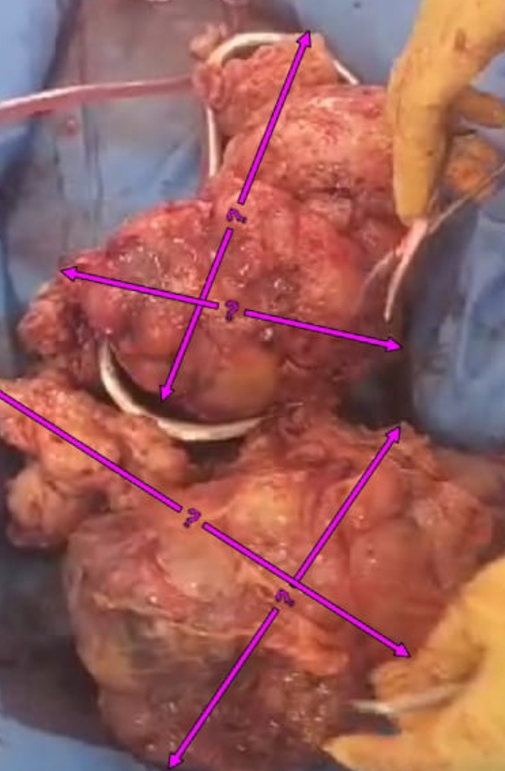

FIGURE 1; Intraoperative finding of a huge mass

General examination - middle-aged woman, not in any distress, pale, not febrile, anicteric, not cyanosed, mildly dehydrated, no Virchow's node, no peripheral edema, no digital clubbing.
On abdominal examination- full abdomen with a huge left hypochondriac oblique mass, measuring 30X20cm, firm to hard in consistency, could get above it and below it, nontender, no sister Mary Joseph's nodule, no ascites.
Other systemic examinations were normal. A diagnosis of a suspected Intragastric Gastrointestinal Tumor (Gastric GIST) was made. Investigations were done, and the results include;
Esophagogastroduodenoscopy report
Stomach- the anterior wall of the corpus and fundus bears a huge spherical submucosa whose dimensions were difficult to determine. Neither mucosal ulcerations nor umbilications were noted, and the surface was intensely erythematous. Duodenum- easily intubated up to D3, which was normal, and an assessment of submucosal gastric mass (? GIST) was made.
Histology findings following endoscopy revealed a chronic, severely active, HLO (Helicobacter organism)- associated gastritis. Abdominopelvic CT SCAN showed – an enlarged stomach, with a huge mass (174 x122) mm arising from the greater curvature of the body of the stomach and growing endophytically into the gastric lumen with heaped up shoulders and areas of necrosis seen within it, no evidence of perforation. The gastrohepatic, gastrosplenic, and gastro-pancreatic fat planes were not invaded. No evidence of gastric outlet obstruction. The liver was normal-sized with homogenous density and multiple small simple cysts within its parenchyma. The portal hepatis was normal. The gall bladder, pancreas, spleen, adrenals, kidneys, small bowels, and colon, as well as the uterus and ovaries, were normal. No ascites, adenopathy, or area of peritoneal fat standing was noted. The urinary bladder, uterus, and adnexa were normal. The lower lung fields were clear. No pleural effusion was noted. These features were suggestive of gastric carcinoma.
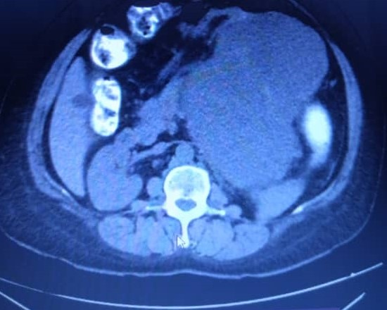 | 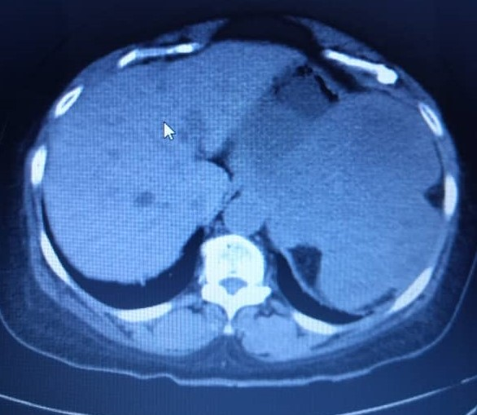
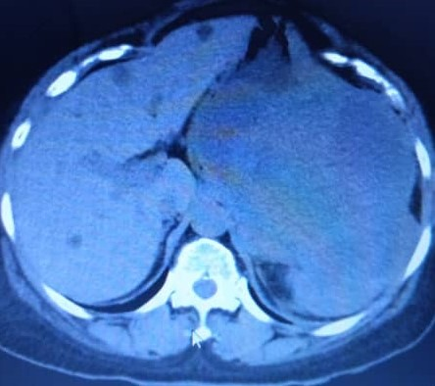 | 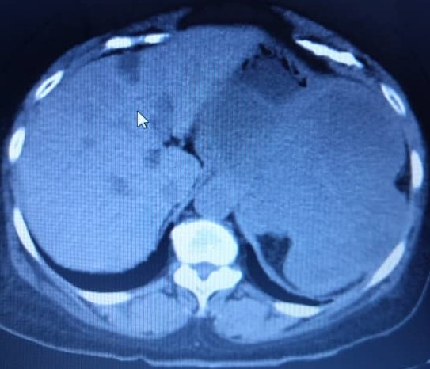
Fig . 2 Abdominal CT imaging

Chest X-ray- reported features of hypertensive heart disease.
Liver and kidney function tests were all normal
CA 19-9 <0.8 (0-35)
Carcinoembryonic antigen (CEA) 0.97 (0-5.0) ng/mL
H. Pylori IgG = 2.13 (0-0.75)- Positive
Four (4) units of blood were grouped and crossmatched. Hemoglobin (Hb) was 9g/dl. Her PCV was optimized to 30% with a unit of blood, and the remaining was kept for both intra- and postoperative care. Dehydration was also corrected before the surgery.
A laparotomy with gastric resection, splenectomy, and R2 Tumor resection was done. The findings intraoperatively; multiple adhesions of the omentum to the liver and anterior abdominal wall. Multiple heterogeneous tumors (cystic and solid), with the largest about 45 x 45cm, impinging on the fundus of the stomach (extra-gastric), extending to the retroperitoneal space, abutting on the medial surface of the spleen. There were multiple neovascularizations of the tumor, with hemorrhagic effluent from the cystic component aspirated. No peritoneal seeding, ascites, or liver metastasis. There was an intracystic hemorrhagic effluent of about 1 liter. The other solid organs and bowel were preserved, with a huge peritoneal capsule.
Histopathology reports - Macroscopic findings revealed a firm, huge grey-white tissue 35x28x10cm, weighing 4000g, with a hemorrhagic appearance.
Microscopic findings showed a malignant mesenchymal neoplasm with spindle-shaped cells in intersecting fascicles, storiform patterns, and sheets in a fibrocollagenous stroma. An admixture of hyperchromatic nuclei, mild to moderate amphophilic cytoplasm with oval hyperchromatic vesicular nuclei, occasional conspicuous nuclei, and moderate eosinophilic to clear cytoplasm, with some paranuclear vacuolation. Mitosis was about 10/50 HPF with abnormal mitotic forms. These features were in keeping with a high-grade sarcoma, most likely a high-grade gastrointestinal stromal tumor, with a differential diagnosis of peripheral nerve sheath tumor.
No atypical or malignant cells in the spleen, and there was moderate spleen congestion. A diagnosis of high-grade GIST with moderate spleen congestion was made.

IMMUNOHISTOCHEMISTRY

Antibodies Status

1.Desmin No staining of tumor cells Negative

2. Ki67 2% staining of tumor cells Low

3. CD117 3+ staining in 80% of tumor cells Positive

4. CD34 No staining of tumor cells Negative

5..$100 No staining of tumor cells Negative

DIAGNOSIS; Gastrointestinal stromal tumor with low proliferative index.

Following surgery, she had blood transfusions, antibiotics, analgesics, and fluids. She has commenced on oral imatinib 400mg daily and is scheduled for a 6 monthly Abdominal CT scan for 3 years and 1 yearly for 2 years as a follow-up. She was discharged home and she is been followed up in the clinic and has been clinically stable.

DISCUSSION
GIST is known to be the most common gastrointestinal mesenchymal tumor, however, its precise global incidence is still under consideration due to the absence of a complete definition and classification.⁸ However, it is estimated that 10-20 million people are afflicted by it.⁸
GISTs represent 80% of all gastrointestinal mesenchymal tumors, with about 60% of GISTs found in the stomach, and this was the same site found in the index case, with extra-gastrointestinal locations being predominantly documented as seen in the intra-operative findings in this patient. It is generally believed that the stomach (55.6%) and small intestine (31.8%) are the most prevalent sites for GIST, with the colon (6.0%) and esophagus (0.7%) being uncommon sites.⁹ The gender distribution is equal. Our patient is a middle-aged woman, which corresponds to the risk factor for the development of GISTs. Furthermore, GISTs have been associated with vague symptoms such as bloating, abdominal pain or discomfort, and early satiety (also noticed in this case); some may ulcerate, bleed, or grow large enough to cause gastrointestinal obstruction, and some of these symptoms were found in the index case. More specifically, gastric and small intestinal tumors cause ambiguous symptoms, with bleeding and blockage observed commonly with colorectal GIST.¹¹ GIST can also be completely asymptomatic and found only incidentally during scans or physical examination. Though rare, some paraneoplastic syndromes like hypothyroidism and islet cell hypoglycemia have been linked to GISTs and this may have accounted for the thyroidectomy undergone by our patient some years ago.¹² There was no metastasis to the liver in this patient, though this is contrary to reports of the liver and peritoneum being the commonest site for metastasis.
Most adult GISTs occur sporadically, unlike in the pediatric population, where it is associated with some syndromes known as familial GIST syndrome, like neurofibromatosis type 1, and Carney Stratakis syndrome.¹³
A small fraction of GIST can also be malignant. Tumors that exhibit a low mitotic rate of less than five mitoses per 50 high-power fields (HPF) are often benign, but a percentage of them eventually metastasize. However, a combination of small tumors that are less than 5 cm with a low mitotic rate is regarded as a low-risk tumor. The very large tumors of more than 5 cm in size and more than five mitoses per 50 HPF have been grouped as being at a higher risk, and this was the finding in the index patient. High-grade malignant GISTs, which are more than 50 mitoses per 50 HPF, can commonly metastasize intra-abdominally or to the liver.¹⁴ However, it is critical to emphasize that no lesion can be regarded as benign regardless of size and mitotic rate.
GIST often appears grossly as an exophytic growth, appearing as a mass. Moreover, it is well-defined with a pseudo capsule and a smooth, gray, and white tint, which was also reported in the index case. Rarely, necrosis, bleeding, and cystic degeneration may be present^{15,} as we found in this case. Microscopically, GIST can appear as either one of the following groups: spindle cell (70%), epithelioid (20%), or mixed type (10%), and in our patient, spindle cells, which is the most common, was reported.^{2,8,14}
In addition, most immunohistochemistry reported a strong positivity to antibodies CD-117, CD-34, DOG-1, and vimentin¹⁶, however, the index patient had strong positivity only to CD-117.

CONCLUSION
GIST is a rare gastrointestinal tumor that can occur anywhere in the gastrointestinal tract. It should not be neglected as it could be a malignant lesion; hence, a high index of suspicion is key. The symptoms of GIST are usually vague and nonspecific and could lead to a delay or a misdiagnosis. Long-term follow-up is necessary as a surveillance protocol. A successful outcome requires a multidisciplinary approach and postoperative targeted molecular therapy in intermediate and high-risk patients.

REFERENCES
1. Ashoor AA, Barefah G. Unusual presentation of a large GIST in an extraintestinal site: a challenging diagnosis dilemma. BMJ.2020;6;13(2).

2. Llenas-Garcia J, Guerra-Vales J. M, Moreno A, Ibarrola C, Castelbon FJ, Fernandez-Ruiz M.et al. Primary extra- gastrointestinal stromal tumors in the omentum and mesentery: a clinicopathological and immunohistochemical study. Hepato- gastroenterology, 2008, 55(84):1002–1005. 2008.

3. Miettinen M, Monihan JM, Sarlomo-Rikala M, Kovatich AJ, Carr NJ, Emory TS, et al. Gastrointestinal stromal tumors/smooth muscle tumors (GISTs) primary in the omentum and mesentery: clinicopathologic and immunohistochemical study of 26 cases. Am J Surg Pathol. 1999;23(9):1109-18.

4. Mantese G. Gastrointestinal stromal tumor: epidemiology, diagnosis, and treatment. Curr Opin Gastroenterol. 2019;35(6):555-559.

5. Menge F, Jakob J, Kasper B, Smakic A, Gaiser T, Hohenberger P. Clinical Presentation of Gastrointestinal Stromal Tumors. Visc Med. 2018 Oct;34(5):335-340.

6. Huang HY, Li CF, Huang WW, Hu TH, Lin CN, Uen YH, et al. A modification of NIH consensus criteria to better distinguish the highly lethal subset of primary localized gastrointestinal stromal tumors: a subdivision of the original high-risk group on the basis of outcome. Surgery. 2007;141(6):748-56.

7. Ma GL, Murphy JD, Martinez ME, Sicklick JK. Epidemiology of gastrointestinal stromal tumors in the era of histology codes: results of a population-based study. Cancer Epidemiol Biomarkers Prev. 2015;24(1):298-302.

8. Gupta P, Tewari M, Shukla HS: Gastrointestinal stromal tumor. Surg Oncol. 2008, 17:129-38.

9. Soreide K, Sandvik OM, Soreide JA, Giljaca V, Jureckova A, Bulusu VR: Global epidemiology of gastrointestinal tumors (GIST): a systematic review of population-based cohort studies. Cancer Epidemol.2016, 40:39-46.

10.Feng F, Tian Y, Liu Z, et al. Clinicopathological features and prognosis of colonic gastrointestinal tumors: evaluation of a pooled case series. Oncotarget. 2016, 7:40735-45.

11. Miettinen M, Makhlouf H, Sobin LH, Lasota J. Gastrointestinal stromal tumors of the jejunum and ileum: a clinicopathologic, immunohistochemical, and molecular genetic study of 906 cases before imatinib with long-term follow-up. Am J Surg Pathol. 2006;30(4):477-89.
12. Maynard MA, Marino-Enriquez A, Fletcher JA, Dorfman DM, Raut CP,
Yassa L. Thyroid hormone inactivation in gastrointestinal stromal tumors. N Engl J Med. 2014 3;370(14):1327-34.

13. Mussi C, Schildhaus HU, Gronchi A, Wardelmann E, Hohenberger P. Therapeutic consequences from molecular biology for gastrointestinal stromal tumor patients affected by neurofibromatosis type 1. Clin Cancer Res. 2008 15;14(14):4550-5.

14. Fletcher DM, Berman JJ, Corless C, Gorstein F, Lasota J, Longley j et al. Diagnosis of gastrointestinal stromal tumors: a consensus approach. Hum Pathol. 2002, 33:459-65.

15. Stamatakos M, Douzinas E, Stefanaki C, Safioleas P, Polyzou E, Levidou G, et al. Gastrointestinal stromal tumor. World J Surg Oncol. 2009; 7(1): 1.

16. Gupta P, Tewari M, Shukla HS: Gastrointestinal stromal tumor. Surg Oncol. 2008, 17:129-38. 10.016/j.suronc.2007.12.002.

