**Original Research Article**

**Optimizing Geneticin Lethal Dose for Effective NPT-II Selection in Transgenic Sugarcane (Genotype CoC671)**

**Abstarct**

Establishing a kill curve is an essential preliminary step in the genetic transformation of plants, including sugarcane. This process helps determine the optimal selection pressure required to differentiate between transformed and non-transformed tissues, ensuring that only genetically modified cells survive under antibiotic or herbicide treatment. In the context of sugarcane, the kill curve is particularly critical due to the plant's recalcitrant nature and genotype-specific responses to transformation protocols. In this study, the sugarcane genotype CoC671, which is extensively cultivated in India, especially in Maharashtra, was selected to develop a kill curve using geneticin (G418) as the selection agent. The sensitivity of different tissue types—callus and in vitro regenerated shoots—was tested across a gradient of geneticin concentrations: 0, 20, 30, 40, 50, and 60 mg/l. The impact of geneticin was evaluated based on parameters such as callus proliferation, regeneration potential, and shoot survival. The results revealed a concentration-dependent response to geneticin. At the highest concentration of 60 mg/l, complete inhibition of callus growth was observed, with 100% tissue mortality. A concentration of 50 mg/l also showed a strong inhibitory effect, severely affecting callus regeneration and resulting in the death of most tissues. At 40 mg/l, about 70% of the calli exhibited bleaching, and regeneration was limited. Among the few regenerated calli, approximately 53% of the shoots showed bleaching symptoms, indicating compromised viability. In shoot-based assays, similar trends were noted. At 50 mg/l, no shoot development occurred within a month, even with regular subculturing every 14 days. The concentration of 40 mg/l geneticin emerged as the most suitable for selection, as it resulted in 76% shoot mortality while still allowing the survival of a small fraction of shoots, critical for the identification and propagation of successfully transformed tissues. Based on these observations, 40 mg/l geneticin was established as the optimal selection pressure for conducting genetic transformation in sugarcane genotype CoC671. This optimized kill curve provides a reliable foundation for transformation protocols involving CoC671, whether via *Agrobacterium*-mediated methods or biolistic particle delivery. It ensures effective discrimination between transformed and non-transformed tissues, improving the efficiency and precision of sugarcane genetic engineering efforts.

**Key words**: Kill curve, Sugarcane, Genotype CoC671, Geneticin, Callus tissues

# Introduction:

Sugarcane (*Saccharum officinarum* L.) is a major industrial cash crop, extensively cultivated in tropical and subtropical regions worldwide to produce sugar and other industrial products, including bio-ethanol. It accounts for approximately 80% of global sugar production (Brant et al., 2025). India contributes significantly to global sugarcane cultivation, covering 19.07% of the world's sugarcane-growing area (approximately 6 million hectares) and producing about 398.90 million tons of cane. Although sugarcane cultivation occupies only around 2.57% of India's total agricultural land it contributes significantly to the national GDP, accounting for 1.1% (Solomon, 2016).

Maharashtra ranks second in both area under cultivation (1.359 million hectares) and production (123.97 million tons) (E&S, DAC, New Delhi, 3rd Adv. Est., 2022–23). The sugar industry and its associated processing units generate substantial employment opportunities for both skilled and unskilled labour in rural and urban areas (Sahu, 2018). Thus, sugarcane plays a vital role in India's socio-economic development.

However, sugarcane is frequently affected by various biotic and abiotic stresses, leading to significant economic losses (Khaliq et al., 2005). The crop is propagated vegetatively through stem cuttings, and its varieties are highly heterogeneous (Behera & Sahoo, 2009). Traditional crop improvement efforts are hindered by several challenges, including narrow genetic variability, large and complex genome size, high polyploidy, heterozygosity, photosensitivity, long breeding cycles (10–12 years), poor seed setting, and environmental influences (Grivet & Arruda, 2002; Gallo-Meagher & Irvine, 1996).

Given these limitations, genetic engineering has emerged as a promising approach to improve sugarcane varieties. Genetic transformation allows the introduction of desirable traits directly into the plant genome, bypassing the lengthy conventional breeding process. Techniques such as tissue culture (Yadav et al., 2012), Agrobacterium-mediated transformation, biolistic transformation (Lakshmanan et al., 2005), and gene editing tools like CRISPR/Cas9 (Oz et al., 2021) play a crucial role in achieving targeted and efficient crop improvement.

Genetic engineering involves inserting foreign genes into the plant genome using cells, tissues, or protoplasts, leading to the development of transgenic plants that maintain normal physiological and biological functions (Jenes et al., 1993). A critical step in this process is the establishment of an effective selection system. This typically involves negative selection using antibiotics or herbicides to eliminate non-transformed cells (Park et al., 1998; Mustafa et al., 2012). The success of transformation depends on the appropriate choice and concentration of the selective agent.

Selection markers are broadly classified into positive and negative types. Positive selection systems can be conditional, where a marker gene allows transformed cells to metabolize a selective substrate, or non-conditional, where growth occurs independently of external agents (Miki & McHugh, 2004). Among the available selectable markers, the *neomycin phosphotransferase II* (*NPT-II*) *gene*, derived from the Tn5 transposon of *E. coli*, is widely used. It confers resistance to aminoglycoside antibiotics like kanamycin and geneticin (G418) by encoding an enzyme that inactivates these compounds via phosphorylation, thus preventing ribosomal inhibition (Bower & Birch, 1992; Fitch et al., 1995). Geneticin, in particular, is a potent antibiotic derived from *Micromonospora rhodorangea*, that inhibits protein synthesis in both prokaryotic and eukaryotic cells by interfering with ribosomal elongation. It is more effective than kanamycin at lower concentrations, making it a preferred selection agent in many plant transformation systems (Yu et al., 2003; Parveez et al., 2007).

For the successful commercialization of genetically modified (GM) crops, the selection system must ensure high transformation efficiency while adhering to bio-safety standards and minimizing potential health risks (Sundar & Sakthivel, 2008). Before initiating transformation, it is crucial to determine the minimum inhibitory concentration of the selective agent to optimize the selection process.

Despite the importance of the CoC671 sugarcane cultivar, no comprehensive studies have focused on developing an efficient selection system for its transformation. Therefore, in this study, we evaluate the lethal concentration of geneticin across key stages of plant regeneration—namely, callus proliferation, regeneration, and shoot development—to enable the successful introduction of target genes and the precise selection of putative transgenic plants.

**Materials and Methods**

Plant materials: Stems of the sugarcane genotype CoC671, containing eye buds, were collected from the Central Sugarcane Research Institute, Padegaon, District Satara, Maharashtra. These stems were grown under controlled greenhouse conditions. After three months, the immature stem tissues were harvested, surface sterilized using 2% sodium hypochlorite, and cut into 2 mm diameter leaf discs for callus induction.

Callus induction was carried out using CI-3 medium, which consisted of MS media (Murashige and Skoog, 1962) containing 3% sucrose, and 0.3% phytagel supplemented with 2 mg/l 2,4-D, adjusted to pH 5.8. The cultures were incubated in the dark at 28°C for two months, with subculturing performed at 15-day intervals. Nodular calli were successfully obtained under these conditions.

1. **Standardization of the Kill Curve for Geneticin Sensitivity in Callus Proliferation**

An antibiotic sensitivity assay was conducted to determine the optimal geneticin concentration for selection in the sugarcane genotype CoC671. Calli were cultured on CI-3 medium supplemented with geneticin (Hi-media) at concentrations of 0 (control), 20, 30, 40, 50, and 60 mg/l. For each treatment, 40 callus stacks (each ~300 mg or 3–4 mm in diameter) were cultured (10 stacks per plate), with four replicates per treatment. Cultures were maintained at 28°C in complete darkness and subcultured onto fresh media every two weeks over 8 weeks. Callus response to geneticin was assessed by monitoring changes in morphology and size and mortality, with observations made at the end of the 8-week culture period. To evaluate growth inhibition or cell death, the diameter and fresh weight of 30 randomly selected callus stacks were measured, and the average values were calculated.

**Table. 1**

**Geneticin concentration used in the sensitivity assay for callus selection**

|  |  |  |  |  |  |
| --- | --- | --- | --- | --- | --- |
| **Sr. No** | **Treatment** | **Media Code** | **Geneticin Conc (mg/1)** | **Calli pieces placed (No)** | **Remark** |
| 1 | T1 | CI-3 G0 | 00 | 40 | 10 Stacks/plate |
| 2 | T2 | CI-3 G20 | 20 | 40 | 10 Stacks/plate |
| 3 | T3 | CI-3 G30 | 30 | 40 | 10 Stacks/plate |
| 4 | T4 | CI-3 G40 | 40 | 40 | 10 Stacks/plate |
| 5 | T5 | CI-3 G50 | 50 | 40 | 10 Stacks/plate |
| 6 | T6 | CI-3 G60 | 60 | 40 | 10 Stacks/plate |

The callus mortality percentage was calculated by using the following formula.

Callus mortality% = $\frac{Number of dead calli on selection media}{Total calli inoculated on selection media} ×100$

1. **Optimization of Geneticin Kill Curve for Callus Regeneration**

An antibiotic sensitivity assay was conducted to determine the optimal concentration of geneticin for shoot regeneration in sugarcane genotype CoC671. Calli were cultured on SR-2 (MS media enriched with BAP 0.5 mg/l) regeneration medium supplemented with geneticin at concentrations of 0 (control), 20, 30, 40, 50, and 60 mg/l. For each treatment, 30 callus stacks (~300 mg or 3–4 mm in diameter) were transferred to the selection medium (10 stacks per plate), with three replicates per concentration. Cultures were maintained at 26°C under light conditions for 4 weeks. Regeneration response was assessed by recording the number of callus stacks that developed shoots, while non-responding or necrotic calli were considered non-viable. Data from this experiment were used to evaluate the lethal dose threshold of geneticin for effective selection during regeneration (Table 2).

**Table. 2**

**Geneticin concentration used in the sensitivity assay for callus regeneration**

|  |  |  |  |  |  |
| --- | --- | --- | --- | --- | --- |
| **Sr. No** | **Treatment** | **Media Code** | **Geneticin Conc.**  **(mg/1)** | **Calli pieces placed** | **Remark** |
| 1 | T1 | SR-2G0 | 00 | 30 | 10 Stacks/plate |
| 2 | T2 | SR-2G20 | 20 | 30 | 10 Stacks/plate |
| 3 | T3 | SR-2G30 | 30 | 30 | 10 Stacks/plate |
| 4 | T4 | SR-2G40 | 40 | 30 | 10 Stacks/plate |
| 5 | T5 | SR-2G50 | 50 | 30 | 10 Stacks/plate |
| 6 | T6 | SR-2G60 | 60 | 30 | 10 Stacks/plate |

The callus regeneration percentage was calculated by using the following formula.

Callus regeneration % = $\frac{Number of calli regenerated on selection }{Total calli inoculated on selection media} ×100$

1. **Optimization of Geneticin Kill Curve for Shoot Development**

An antibiotic sensitivity assay was performed to determine the lethal concentration of geneticin for shoot selection in sugarcane genotype CoC671. Regenerated shoots (previously developed on geneticin-free medium) were transferred to E-1 medium (MS media enriched with 0.2 mg/l BAP) supplemented with geneticin at concentrations ranging from 0 to 50 mg/l. A total of six treatments were established, each consisting of 30 shoots.

Shoots were subcultured onto fresh medium every 10–12 days over six weeks. Shoot viability was assessed at the end of the experiment by recording the number of surviving and necrotic shoots, allowing evaluation of the optimal geneticin concentration for effective selection (Table 3).

**Table 3**

**Geneticin Concentration used in the sensitivity assay for shoots**

|  |  |  |  |  |  |
| --- | --- | --- | --- | --- | --- |
| **Sr. No** | **Treatment** | **Media code** | **Geneticin Conc (mg/1)** | **Shoots placed (No)** | **Remark** |
| 1 | T1 | E-1 G0 | 00 | 30 | 3 shots/bottle |
| 2 | T2 | E-1 G20 | 20 | 30 | 3 shots/bottle |
| 3 | T3 | E-1 G30 | 30 | 30 | 3 shots/bottle |
| 4 | T4 | E-1 G40 | 40 | 30 | 3 shoots/bottle |
| 5 | T5 | E-1 G50 | 50 | 30 | 3 shoots/bottle |
| 6 | T6 | E-1 G60 | 60 | 30 | 3 shoots/bottle |

The Shoot survival percentage was calculated by using the following formula

Shoot Survival % = $\frac{Number of shoots survived on selection media}{Number of shoots placed on selection media} ×100$

**Results**

Establishing a kill curve is a critical preliminary step in genetic transformation, whether through Agrobacterium-mediated methods or biolistic gene delivery. This process helps define the optimal selection pressure necessary to distinguish transformed from non-transformed tissues. In this study, a geneticin sensitivity assay was conducted using callus tissues and regenerated shoots of sugarcane genotype CoC671.

Explants were exposed to a range of geneticin concentrations to identify the minimum lethal dose that effectively inhibits the growth of non-transformed cells. The results provided a clear dose-response relationship, enabling the determination of the lowest concentration of geneticin that resulted in complete growth suppression of untransformed callus and shoots. These findings are essential for establishing a robust and genotype-specific selection regime for downstream transformation experiments in sugarcane.

1. **Standardization of the Kill Curve for Callus Proliferation in Genotype CoC671**

Callus tissues of sugarcane genotype CoC671 were exposed to varying concentrations of geneticin to determine the optimal lethal dose for selective callus proliferation. Cultures were subcultured at 14-day intervals, and observations were recorded after 8 weeks. (Table 4) In the control treatment without geneticin, all 40 callus pieces successfully proliferated into nodular or embryogenic secondary callus. These calli were yellowish and creamy in appearance, with each growing to an average of 1 gram in weight and reaching a diameter of 2.5 cm.

At 20 mg/l geneticin, slight inhibition was observed. Eight out of 40 callus stacks exhibited bleaching, while the remaining developed yellowish, creamy, nodular, or embryogenic callus. Growth was somewhat reduced, with calli reaching an average of 750 mg in weight and 1.7 cm in diameter. In the 30 mg/l treatment, 26 callus pieces formed healthy-looking nodular callus, though smaller in size (around 550 mg and 1.1 cm in diameter), while 14 pieces bleached. Five of these produced minimal, brownish calli, indicating early signs of stress.

A marked decline in viability was seen at 40 mg/l, where only 12 callus stacks generated secondary callus. These were predominantly watery and nodular, with a pale yellow to brownish color and moderate growth (approximately 300 mg and 9 mm in diameter). Twenty-eight callus pieces bleached, and nine additional ones produced only sparse, brownish callus, with some displaying bleached shoot primordia, suggesting high stress and reduced viability.

At 50 mg/l geneticin, a strong inhibitory effect was evident. Only 4 callus stacks produced secondary callus, which were pale, watery, and poorly developed, averaging about 100 mg in weight and 7.5 mm in diameter. A total of 36 callus stacks bleached, and around 15 others produced only minimal brownish tissue, often with visible bleaching symptoms. Complete inhibition was observed at 60 mg/l, where all 40 callus stacks bleached and no callus growth was recorded. These results confirm a concentration-dependent response to geneticin and help establish the lethal threshold required for effective selection of transformed callus tissue (**Figure 1 and 2**). The results indicate a concentration-dependent inhibitory effect of geneticin on callus proliferation. Complete suppression was achieved at 60 mg/l, while 30–40 mg/l marked a transition zone between partial survival and significant mortality. These findings are visually represented in **Figure 1 and 2**.

**Table.4**

**Effect of different concentrations of geneticin on callus growth in Genotype CoC671**

|  |  |  |  |  |  |  |  |
| --- | --- | --- | --- | --- | --- | --- | --- |
| **Sr. No** | **Treatment** | **Geneticin Conc. (mg/l)** | **Plate (No)** | **Calli**  **pieces (No)** | **Calli bleached (No)** | **Calli grown (No)** | **Callus mortality (%)** |
| 1 | T1 | 00 | 4 | 40 | 00 | 40 | 0 |
| 2 | T2 | 20 | 4 | 40 | 8 | 32 | 20 |
| 3 | T3 | 30 | 4 | 40 | 14 | 26 | 35 |
| 4 | T4 | 40 | 4 | 40 | 28 | 12 | 70 |
| 5 | T5 | 50 | 4 | 40 | 36 | 4 | 90 |
| 6 | T6 | 60 | 4 | 40 | 40 | 0 | 100 |

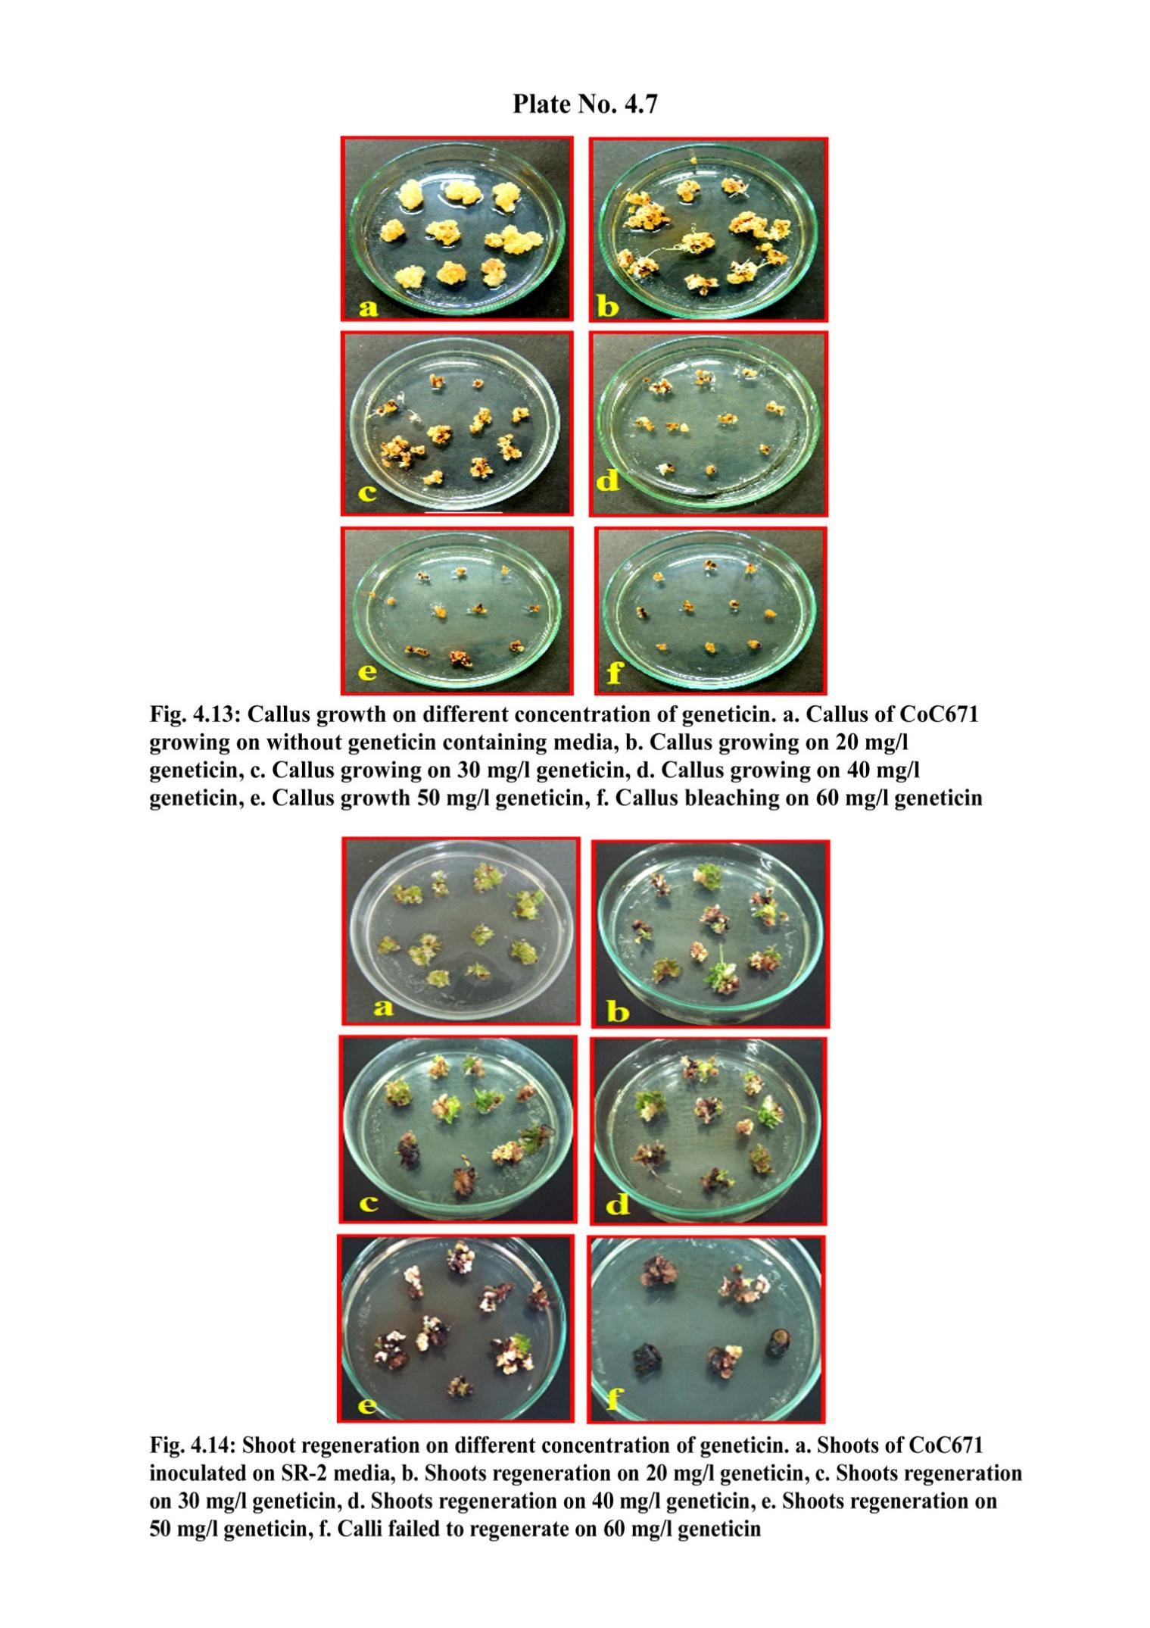

Fig. 1. Effect of different geneticin concentrations on callus growth in sugarcane genotype CoC671.a. Callus growth on medium without geneticin (control) b. Callus growth on 20 mg/l geneticin c. Callus growth on 30 mg/l geneticin d. Callus growth on 40 mg/l geneticin e. Callus growth on 50 mg/l geneticin f. Callus bleaching observed on 60 mg/l geneticin.

Fig.2. Graphical presentation showing callus mortality on different concentrations of geneticin of genotype CoC671.

1. **Standardization of the kill curve for callus regeneration in genotype CoC671**

To evaluate the optimal lethal dose of geneticin for effective selection during callus regeneration, callus stacks of sugarcane genotype CoC671 were cultured on SR-2 regeneration medium supplemented with five different concentrations of geneticin. (Table 5). In the control treatment (T1), which contained no geneticin, 28 out of 30 callus stacks successfully regenerated into healthy shoots, indicating full regeneration potential in the absence of selection pressure.

In treatment T2 (20 mg/l geneticin), shoot regeneration was observed in 22 callus stacks, although a few exhibited slight bleaching, suggesting the onset of sensitivity to the antibiotic. Treatment T3 (30 mg/l) further reduced regeneration, with only 18 callus stacks producing shoots, and bleaching symptoms became more apparent.

A significant drop in regeneration was observed in treatment T4 (40 mg/l), where 20 out of 30 callus stacks failed to regenerate, and those that did exhibited pronounced bleaching and weak shoot development. In treatment T5 (50 mg/l), shoot induction was minimal, with only 12 explants showing limited regeneration, often accompanied by pale or necrotic tissue. The highest concentration, T6 (60 mg/l), completely inhibited shoot formation, with all 30 explants showing bleaching and 100% mortality.

These results indicate a dose-dependent inhibitory effect of geneticin on shoot regeneration, with substantial suppression occurring at concentrations above 40 mg/L. The findings are visually supported by Figure 3 and 4.

**Table.5**

**Effect of different concentrations of geneticin on callus regeneration.**

|  |  |  |  |  |  |  |  |
| --- | --- | --- | --- | --- | --- | --- | --- |
| **Sr. No** | **Treatment** | **Geneticin Conc (mg/l)** | **Calli** | | | | **Morphological response** |
|  |  | **(SR-2**  **media)** | **Placed (No)** | **Regenerated (No)** | **Bleached (No)** | **callus regeneration (%)** |  |
| 1 | T1 | 00 | 30 | 28 | 02 | 93.3 | Multiple shoots induced. |
| 2 | T2 | 20 | 30 | 22 | 8 | 73.3 | Multiple shoots with bleaching signs. |
| 3 | T3 | 30 | 30 | 18 | 12 | 36.6 | Shoot regeneration is affected by bleaching. |
| 4 | T4 | 40 | 30 | 10 | 20 | 53.3 | Shoot regeneration affected by bleaching |
| 5 | T5 | 50 | 30 | 2 | 28 | 76.6 | Shoot regeneration was affected severely |
| 6 | T6 | 60 | 30 | 00 | 30 | 100 | No shoots regeneration, Bleaching of all calli. |



Fig.3. Effect of different concentrations of geneticin on shoot regeneration in sugarcane genotype CoC671. a. Callus inoculated on SR-2 medium (control) b. Shoot regeneration on 20 mg/l geneticin. c. Shoot regeneration on 30 mg/l geneticin.d. Shoot regeneration on 40 mg/l geneticin. e. Shoot regeneration on 50 mg/l geneticin. f. No regeneration observed; calli necrotic on 60 mg/l geneticin.

Fig.4. Graphical presentation showing callus regeneration on different concentrations of geneticin in genotype CoC671.

1. **Standardization of the kill curve for shoot development**

To determine the optimal lethal concentration of geneticin for shoot development in sugarcane genotype CoC671, an antibiotic sensitivity assay was performed using E-1 medium supplemented with varying concentrations of geneticin, ranging from 0 to 50 mg/L. Six treatments were prepared, each consisting of 30 regenerated shoots. Subculturing was carried out every 10 to 12 days over a total period of eight weeks, during which shoot survival and bleaching symptoms were closely monitored. (Table 6)

In the control group (T1), which lacked geneticin, all shoots demonstrated vigorous growth, reaching up to 5 cm in height. The shoots maintained healthy morphology and exhibited no signs of stress, indicating that the E-1 medium supported normal development in the absence of selection pressure. In treatment T2, although most shoots showed expected growth patterns, five exhibited early signs of bleaching, suggesting a mild inhibitory effect of the antibiotic at this concentration.

Treatment T3, which involved 20 mg/l of geneticin, resulted in 11 out of 30 shoots displaying bleaching symptoms. However, the remaining 19 shoots continued to grow, indicating partial tolerance. As the geneticin concentration increased to 30 mg/l in treatment T4, shoot viability further declined, with only 14 surviving, and the remaining 16 exhibiting significant bleaching. In treatment T5 (40 mg/l), shoot mortality became more severe, with only 7 shoots surviving while the rest were completely bleached, reflecting increased sensitivity to the antibiotic at this level.

Treatment T6, which contained the highest geneticin concentration (50 mg/l), led to complete shoot mortality, with all 30 shoots bleaching by the end of the experimental period. Based on the observed results, treatment T5 (40 mg/l) resulted in a 23.4% survival rate, marking it as the threshold concentration for further shoot selection studies. These findings are illustrated in Figure 5 and 6.

**Table.6**

**Effect of different concentrations of geneticin on shoot growth**

|  |  |  |  |  |  |  |  |
| --- | --- | --- | --- | --- | --- | --- | --- |
| **Sr. No** | **Treatment** | **Geneticin concentration (mg/l)** | **Shoots** | | | | **Morphological response** |
|  |  | **(E-1 media)** | **Placed** | **Survived** | **Bleached** | **Mortality**  **%** |  |
| 1 | T1 | 00 | 30 | 30 | 00 | 00 | All the shoots have grown averagely  6 cm. |
| 2 | T2 | 10 | 30 | 25 | 5 | 16.6 | Shoot growth was normal, but  slight bleaching symptoms. |
| 3 | T3 | 20 | 30 | 19 | 11 | 36.6 | Shoot growth was affected by bleaching. |
| 4 | T4 | 30 | 30 | 14 | 16 | 53.3 | Shoots growth affected with  more bleaching. |
| 5 | T5 | 40 | 30 | 7 | 23 | 76.6 | Shoots turned pale white. |
| 6 | T6 | 50 | 30 | 00 | 30 | 100 | No growth, all shoots bleaching. |

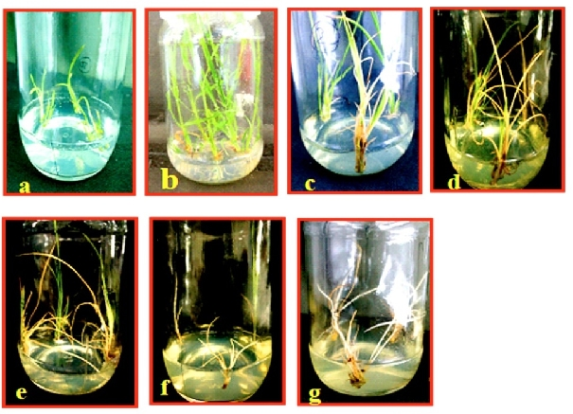

Fig. 5. Effect of different geneticin concentrations on shoot growth in sugarcane genotype CoC671. a. Shoots of CoC671 inoculated on E-1 medium b. Shoot growth on E-1 medium without geneticin (control) c. Normal Shoot growth on 10 mg/l geneticin d. Shoot start belching on 20 mg/l geneticin e. Shoot bleaching increased on 30 mg/l geneticin f. Shoots turned pale yellow on 40 mg/l geneticin g. Complete Shoot death on 50 mg/l geneticin.

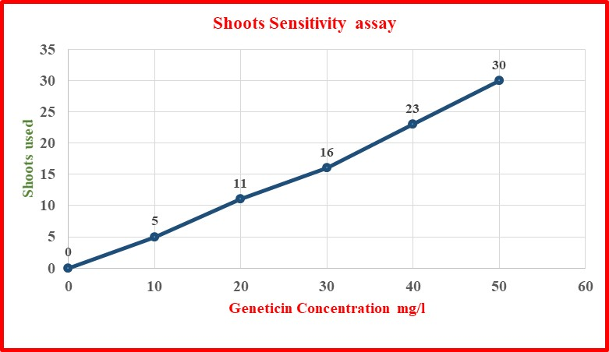

Fig.6. Graphical presentation showing shoot mortality on different concentrations of geneticin in genotype CoC671

**Discussion**

The success of genetic transformation depends on the integration of DNA into the plant genome, subsequent gene transcription, and the inheritance of the gene by the next generation. In this process, a gene is introduced into the target tissue, but only a small number of cells become transgenic or incorporate the transgene. Identifying these transformed cells from the non-transformed ones is essential and requires an effective selection system utilizing selectable marker genes. The *neomycin phosphotransferase II* (NPT-II) gene, which confers resistance to antibiotics such as geneticin or kanamycin, is commonly used for this purpose in genetic transformation experiments across various plant species.

Geneticin has been reported to be effective in selecting transformed sugarcane cells. Studies have shown that geneticin is efficient in killing non-transformed cells, thereby allowing for the selection of transgenic cells that have incorporated the NPT-II gene. Burner (1992) demonstrated the use of geneticin in sugarcane transformation, highlighting its effectiveness in this crop. In various other crops, geneticin has shown superior effectiveness over kanamycin. Geneticin provides a higher level of stringency with a low concentration compared to kanamycin with a high concentration. (Bett et al., 2019). In rice, Hiei et al. (1994) found geneticin to be more effective in selecting transformed cells. Similarly, in wheat, geneticin has been preferred due to its higher selection efficiency (Wu et al., 2003). Yu et al. (2003) in Papaya transformation demonstrated that callus development from non-transformed root segments was more sensitive to geneticin than to kanamycin. However, callus growth from NPT-II transformed papaya root tissue was not inhibited by either antibiotic.

This study presents the first detailed assessment of how different concentrations of geneticin affect sugarcane callus tissues and shoots. We identified 40 mg/l as the lethal dose, which eradicates 70% of the callus tissues and 76.6% of the shoots, indicating endogenous resistance to geneticin. Due to the stringent nature of geneticin selection, we allowed for 30% survival to facilitate the recovery of transformed cells at an early stage. CC DA et al. (2012) suggested that a concentration of 0.5 mg/l ammonium glufosinate is suitable for genetic transformation, as it resulted in 66% mortality in tomato explants. Nalavade et. al. (2016) also considered a 30 % to 40 % escape rate to recover putative transgenic sugarcane plants in genotype CO 86032. Raza et al. (2010) observed that 60 mg/l geneticin concentration was most effective for the varieties S-2003US633, CPF-245, and CSSG-668. However, for the variety S-2003US114, a lower geneticin concentration of 35 mg/l was sufficient, with a 10% survival rate. This discrepancy is likely due to differing levels of endogenous resistance among the sugarcane varieties, with S-2003US114 exhibiting higher natural resistance to geneticin. Van Boxtel et al. (1995) observed that the sensitivity of different sugarcane genotypes varies depending on the selective agents used. Parveez et al. (2007) stated that using very high concentrations of antibiotics for the selection of plant tissues is not only economically impractical but also biologically ineffective. Ali et al. (2015) found that a geneticin concentration of 40-60 mg/l could be optimal for selecting transformed calli, while a concentration of 40-50 mg/l is suitable for shoot regeneration and rooting in different sugarcane genotypes.

**Conclusion**

This study represents the first successful effort to determine and optimize the lethal dose of geneticin (G418) specifically for callus proliferation, callus regeneration, and shoot development in the sugarcane genotype **CoC671**. Through systematic experimentation, we established that a geneticin concentration of **40 mg/l** is optimal for effectively selecting transformed cells without compromising the regeneration potential of the tissue. The ability to use the ***neomycin phosphotransferase II (NPT-II)*** *gene* as a selectable marker at this concentration provides a reliable and efficient selection system for the development of transgenic sugarcane plants. Importantly, the optimized selection conditions described in this study would not only enhance the efficiency of transformation in CoC671 but also offer a standardized framework that can be applied to other sugarcane genotypes. This will aid in the development of genotype-specific protocols for **callus induction**, **callus proliferation**, **plant regeneration**, and **transgenic shoot development**, ultimately accelerating the genetic improvement of sugarcane through biotechnology.

**Data availability**

The data that support the findings of this study are available from the corresponding author upon reasonable request.

**References**

1. Ali, K., Raza, G., Mukhtar, Z., Mansoor, S., & Asad, S. (2015). Ideal in-vitro culture and selection conditions for sugarcane genetic transformation. *Pakistan Journal of Agricultural Sciences,* 52(1).
2. Behera, K. K., & Sahoo, S. (2009). Rapid in vitro micropropagation of sugarcane *(Saccharum officinarum* L. cv-Nayana) through callus culture. *Nature and science*, 7(4), 1-10.
3. Bett, B., Gollasch, S., Moore, A., Harding, R., & Higgins, T. J. (2019). An improved transformation system for cowpea (Vigna unguiculata L. Walp) via sonication and a kanamycin-geneticin selection regime. *Frontiers in plant science*, 10, 219.
4. Bower, R., & Birch, R. G. (1992). Transgenic sugarcane plants via microprojectile bombardment. *The Plant Journal*, *2*(3), 409-416..
5. Brant, E., Zuniga‐Soto, E., & Altpeter, F. (2025). RNAi and genome editing of sugarcane: Progress and prospects. *The Plant Journal*, *121*(5), e70048..
6. Burner, D. M. (1992). Regeneration and phenotypic variability of plants cultured in vitro from mature sugarcane caryopses..
7. CC, D. S., da Silva, E. M., & de Paula, S. O. (2012). Analysis of the inhibitory concentration of ammonium glufosinate in cotyledons explants of tomato plants (Solanum lycopersicon). *Biotechnology*, *11*(3), 184-188.
8. Fitch, M., De La Cruz, A., & Moore, P. (1995). Effectiveness of different selection markers for sugarcane transformation. *Plant Genome II*, 57.
9. Gallo-Meagher and Irvine 1996 Gallo‐Meagher, M., & Irvine, J. E. (1996). Herbicide resistant transgenic sugarcane plants containing the bar gene. Crop Science, 36(5), 1367-1374.
10. Grivet, L., & Arruda, P. (2002). Sugarcane genomics: depicting the complex genome of an important tropical crop. *Current opinion in plant biology*, *5*(2), 122-127..
11. Hiei, Y., Ohta, S., Komari, T., & Kumashiro, T. (1994). Efficient transformation of rice (Oryza sativa L.) mediated by Agrobacterium and sequence analysis of the boundaries of the T‐DNA. *The Plant Journal*, *6*(2), 271-282.
12. Jenes, B., Moore, H., Cao, J., Zhang, W., & Wu, R. (1993). Techniques for gene transfer. In *Transgenic plants* (pp. 125-146). Academic Press..
13. Khaliq, A., Ashfaq, M., Akram, W., CHOI, J. K., & LEE, J. J. (2005). Effect of plant factors, sugar contents, and control methods on the Top Borer (Scirpophaga nivella F.) Infestation in selected varieties of sugarcane. *Entomological Research*, *35*(3), 153-160.
14. Lakshmanan, P., Geijskes, R. J., Aitken, K. S., Grof, C. L., Bonnett, G. D., & Smith, G. R. (2005). Sugarcane biotechnology: the challenges and opportunities. *In Vitro Cellular & Developmental Biology-Plant*, *41*, 345-363.
15. Miki, B., & McHugh, S. (2004). Selectable marker genes in transgenic plants: applications, alternatives and biosafety. *Journal of biotechnology*, *107*(3), 193-232.
16. Murashige, T., & Skoog, F. (1962). A revised medium for rapid growth and bio assays with tobacco tissue cultures. *Physiologia plantarum*, *15*(3).
17. Mustafa, G., & Sarwar Khan, M. (2012). Prospecting the Utility of Antibiotics as Lethal Selection Agents for Chloroplast Transformation in Sugarcane. *International Journal of Agriculture & Biology*, *14*(2
18. Nalavade, V., Kale, R., Thorat, S., Babu, H. (2016) Standardization of protocol for callus induction, regeneration and genetic transformation of sugarcane (Saccharum officinarum l) genotype co 86032. *Progressive Research – An International Journal, Volume 11* (Special-VI) : 4196-4201.
19. Oz, M. T., Altpeter, A., Karan, R., Merotto, A., & Altpeter, F. (2021). CRISPR/Cas9-mediated multi-allelic gene targeting in sugarcane confers herbicide tolerance. *Frontiers in Genome Editing*, *3*, 673566.
20. Park, S. H., Rose, S. C., Zapata, C., Srivatanakul, M., & Smith, R. H. (1998). Cross-protection and selectable marker genes in plant transformation. *In Vitro Cellular & Developmental Biology-Plant*, *34*, 117-121..
21. Parveez, G. A., Majid, N. A., Zainal, A., & Rasid, O. A. (2007). Determination of minimal inhibitory concentration of selection agents for selecting transformed immature embryos of oil palm. *Asia-Pacific Journal of Molecular Biology and Biotechnology*, *15*(3), 133-146..
22. Raza, G., Ali, K., Mukhtar, Z., Mansoor, S., Arshad, M., & Asad, S. (2010). The response of sugarcane (Saccharum officinarum L) genotypes to callus induction, regeneration and different concentrations of the selective agent (geneticin-418). *African Journal of Biotechnology*, *9*(51), 8739-8747.
23. Sahu, O. (2018). Assessment of sugarcane industry: Suitability for production, consumption, and utilization. *Annals of Agrarian Science*, *16*(4), 389-395..
24. Solomon, S. (2016). Sugarcane production and development of sugar industry in India. *Sugar Tech*, *18*(6), 588-602..
25. Sundar, I. K., & Sakthivel, N. (2008). Advances in selectable marker genes for plant transformation. *Journal of Plant Physiology*, *165*(16), 1698-1716.
26. (Source - E&S, DAC, New Delhi, 3rd Adv. Est.-2022-23). Sugar industries and its allied reprocessing units generate new employment opportunity.
27. Van Boxtel, J., Eskes, A., & Berthouly, M. (1997). Glufosinate as an efficient inhibitor of callus proliferation in coffee tissue. *In Vitro Cellular & Developmental Biology-Plant*, *33*, 6-12.
28. Wu, H., Sparks, C., Amoah, B., & Jones, H. D. (2003). Factors influencing successful Agrobacterium-mediated genetic transformation of wheat. *Plant cell reports*, *21*(7), 659-668.
29. Yadav SW, Ahmad AQ, Rastogi JY, Lal MA. Tissue culture strategies in sugarcane (Saccharum officinarum L.). International Journal of Pharma and Bio Sciences. 2012;3(2): B427-41.
30. Yu, T. A., Yeh, S. D., & Yang, J. S. (2003). Comparison of the effects of kanamycin and geneticin on regeneration of papaya from root tissue. *Plant cell, tissue and organ culture*, *74*, 169-178.

--------------------------------------------------------------------------------------------------------------------