Original Research Article

Addition of Methionine to Commercial Feed for Growth Induction of Sangkuriang Catfish Fingerlings (*Clarias gariepinus*)

|  |
| --- |
|  |

ABSTRACT

|  |
| --- |
| This research was conducted at Hatchery Building 4, Faculty of Fisheries and Marine Sciences, Padjadjaran University. The implementation began in December 2024 until February 2025. The purpose of this experiment was to obtain the best dose of methionine mixture with commercial feed Hi Pro Vite 781-1 to support growth induction, feed efficiency ratio, feed protein efficiency ratio, and protein retention in sangkuriang catfish. The treatment design used the RAL method with 4 treatments: A (0 g/kg feed), B (4 g/kg feed), C (6 g/kg feed), and D (8 g/kg feed) with four replications. Significant differences between treatments were tested using the Duncan Multiple Range Test (DMRT) with a confidence level of 95%. Data on absolute weight growth (Wg), feed conversion ratio (FCR), protein efficiency ratio (PER), protein retention, and carbohydrate retention were analyzed using Sigmaplot 16.0. The results showed that treatment C, using 6 g methionine/1 kg feed, showed the highest body weight gain (157.90 g), lowest FCR (1.580), protein efficiency ratio (16.91%), and lowest protein retention (53.01%) compared to other treatments. The best results in treatment C were due to methionine can induce growth more significantly compared to commercial feed without methionine addition. The best dose of methionine addition to commercial feed suitable for supporting optimal fish growth induction was found to be 6 g/kg feed. |

***Keywords:*** *Sangkuriang catfish, methionine; absolute growth; protein efficiency ratio; protein retention.*

1. INTRODUCTION

Sangkuriang catfish (*Clarias gariepinus*) is a commercially important freshwater species with substantial economic value and considerable potential for expansion in the aquaculture industry. One of the primary challenges in its cultivation is the low efficiency of feed utilization, which contributes significantly to elevated production costs [20].

This inefficiency arises from the fact that only about 40–60% of the commercial feed is effectively utilized for growth [15]. Catfish require dietary protein levels ranging from 30% to 36% for growth. Protein levels below 30% are known to significantly inhibit growth performance [12].

To support optimal growth, fish feed must contain ten essential amino acids: leucine, lysine, isoleucine, tryptophan, valine, arginine, histidine, phenylalanine, threonine, and methionine. Methionine plays an essential role in protein biosynthesis, acts as a methyl group donor in various metabolic pathways, and contributes to the synthesis of key biomolecules, including enzymes, hormones, and antioxidants such as glutathione, which are vital for maintaining cellular integrity [23]. Supplementation of methionine at optimal levels has been shown to significantly enhance weight and length gain in Sangkuriang catfish by improving feed efficiency, digestive enzyme activity, protein retention, energy metabolism, and immune function [17]. Methionine is recognized as the first-limiting amino acid, meaning that its deficiency can hinder growth even when other amino acids are present in adequate amounts [18]. The methionine requirement for optimal growth in catfish has been estimated to be approximately 2.3% of the total dietary protein [5]. Improper dosing can lead to adverse effects, as excessive methionine may cause amino acid antagonism and toxicity, ultimately impairing growth performance [16]. Therefore, determining the optimal level of methionine supplementation in commercial feed formulations is essential to promote efficient and sustainable growth in Sangkuriang catfish aquaculture.

1. MATERIAL AND METHODS

This research was carried out from December 2024 to February 2025, at the Hatchery Building 4, Faculty of Fisheries and Marine Sciences, Padjadjaran University. Proximate analysis could be conducted for the test feed at the Laboratory Sentral Padjadjaran University at the beginning and end of the study. Materials used in the study: juvenile sangkuriang catfish measuring 7-9 cm, Hi Pro Vite 781-1 commercial feed with a protein content of 33%, Methionine powder, and Progol.

* 1. Research Design

The study was carried out experimentally with four treatments and four replicates, the treatment given was the ratio of commercial feed addition: methionine powder, namely A (0 g/kg feed), B (4 g/kg feed), C (6 g/kg feed) and D (8g/kg feed). Feed is given as much as 5% of the total biomass weight and is given twice a day. The research design used was a completely randomised design (CRD).

2.1.1 Preparation for implementation

Each aquarium is filled with ± 15 L of water, followed by the installation of aeration and heating installations. Then, 5 fish with a length of 7-9 cm are put into the aquarium and acclimatized first for 7 days in a fiber tub to adjust to the new environment, maintenance media, use of aeration and heater installations are set at a temperature of 28°C. During the acclimatization process and the fish are feed commercial feed (without treatment) at a frequency of twice a day. Then the fish are weighed to determine the initial weight and the dose of feed to be given to the fish.

2.1.2 Implementation of research

The research was carried out for 56 days, and fish growth sampling was conducted every week, including water quality measurements, weighing, and measuring body length, along with weighing the feed that would be given to adjust the amount of feed in the next maintenance period. Feed is given twice a day, namely at 08.00 a.m. and 04.00 p.m. The amount of feed given is 5% of the fish biomass. The observation parameters for protein growth and efficiency are as follows:

1. Average Weight Gain

Average absolute weight gain is measured by calculating the weight of fish every 7 days. The calculation of absolute weight gain is carried out using the formula for absolute weight gain.

AWG = Wt−Wo

Information:

AWG = average weight gain (g)

Wt = final fish weight after harvesting (g)

Wo = initial fish weight of the first stocking (g)

T = duration of fish reared (days)

1. Feed Conversion Ratio

The feed conversion ratio is measured by calculating the amount of feed consumption during culture divided by the total weight gain after the fish is harvested (if any dead weight is added to the final weight), using the formula feed conversion ratio, which is:

F

FCR = (Wt + D) − Wo

Information:

FCR = feed conversion rate

Wo = biomass weight of the test fish at the start of the study (g)

Wt = biomass weight of the test fish after the fish is harvested (g)

D = weight of dead fish (g)

F = weight of Feed given (g)

1. Protein Efficiency Ratio

The protein efficiency ratio can be determined by comparing weight gain with the amount of feed protein consumed during maintenance. The protein efficiency ratio formula is as follows:

REP = (Wt-Wo)/P

Information:

FCR = feed conversion rate

Wo = biomass weight of the test fish at the start of the study (g)

Wt = biomass weight of the test fish after the fish is harvested (g)

D = weight of dead fish (g)

F = weight of Feed given (g)

1. Protein Retention

Protein retention can be determined by analyzing the proximate protein of the fish's body at the beginning and end of maintenance and dividing by the amount of protein consumed during maintenance. The formula for protein retention is as follows:

RP = ((Fp - Lp))/P x 100%

**Information:**

PR = protein Retention

Fp = amount of fish body protein at the beginning of rearing (g)

Lp = amount of body proteins at the end of maintenance (g)

P = amount of protein consumed during maintenance

1. Water quality

Observation of water quality parameters is carried out every 7 days, and used as supporting data in determining the optimal conditions for the maintenance of test fish. Instruments used for measuring water quality parameters were water temperature with a thermometer, dissolved oxygen (DO) with a DO meter, and pH with a pH meter.

1. Proximate Analysis

At the beginning and end of the experiment, the final weight of the fish is measured, and the total amount of feed consumed is determined to calculate the feed conversion ratio (FCR). Finally, one catfish was taken from each replicate of each treatment for further analysis (used 50g fish for whole-body proximate analysis). Proximate analysis of water, ash, protein, lipid and carbohydrate content in fish follows the AOAC method (1990) [24].

* 1. Data Analysis

The data obtained was analyzed by Analysis of Variance (ANOVA) with a confidence level of 95%, and if there is a significant difference, it will be continued with Duncan Multiple Range Test (DMRT).

1. RESULT AND DISCUSSION
   1. Absolute weight gain

Absolute weight gain differed significantly between treatments, representing final biomass weight and early biomass due to different methionine administrations. The value of absolute weight gain (Fig. 1).

The results of the analysis showed that the absolute weight gain of test fish kept for 56 days increased at each treatment, as observed outcomes indicate that incorporating methionine into commercial feed significantly influences the weight gain of sangkuriang catfish. Specifically, treatment C with the addition of methionine at 6 g/kg feed showed the highest results, with weight growth reaching 157.90 ± 15.10 g, far exceeding other treatments. Treatment B with a dose of 4 g/kg feed produced a weight growth of 79.70 ± 11.40 g, while treatment D with a dose of 8 g/kg feed produced 73.40 ± 11.83 g. The lowest results were shown by treatment A (control) without adding methionine, with a weight growth of only 66.20 ± 9.84 g. The results showed that supplementing commercial feed with 6 g/kg methionine (treatment C) optimally enhanced the weight growth of Sangkuriang catfish fry. The methionine requirement for optimal catfish growth is consistently reported to range between 6.0 and 6.3 g/kg of feed. This consistency persists despite variations in fish strains, feed formulations, and rearing conditions, suggesting that methionine plays a fundamental role in supporting growth across different production settings [8].

Methionine plays a critical role in regulating the expression of growth-related genes and enhancing protein utilization, underscoring its importance in the physiological processes that support optimal fish development [7]. The optimal inclusion of synthetic methionine enhances proteolytic enzyme activity within the digestive tract, facilitating improved protein digestion and absorption, which in turn is positively associated with marked somatic growth in treatment C [17]. Methionine has been identified as the first limiting amino acid in plant-based diets, and its supplementation effectively overcomes this limitation to promote growth [18]. Optimal methionine supplementation enhances catfish health and immunity, improving energy use and growth performance [13].

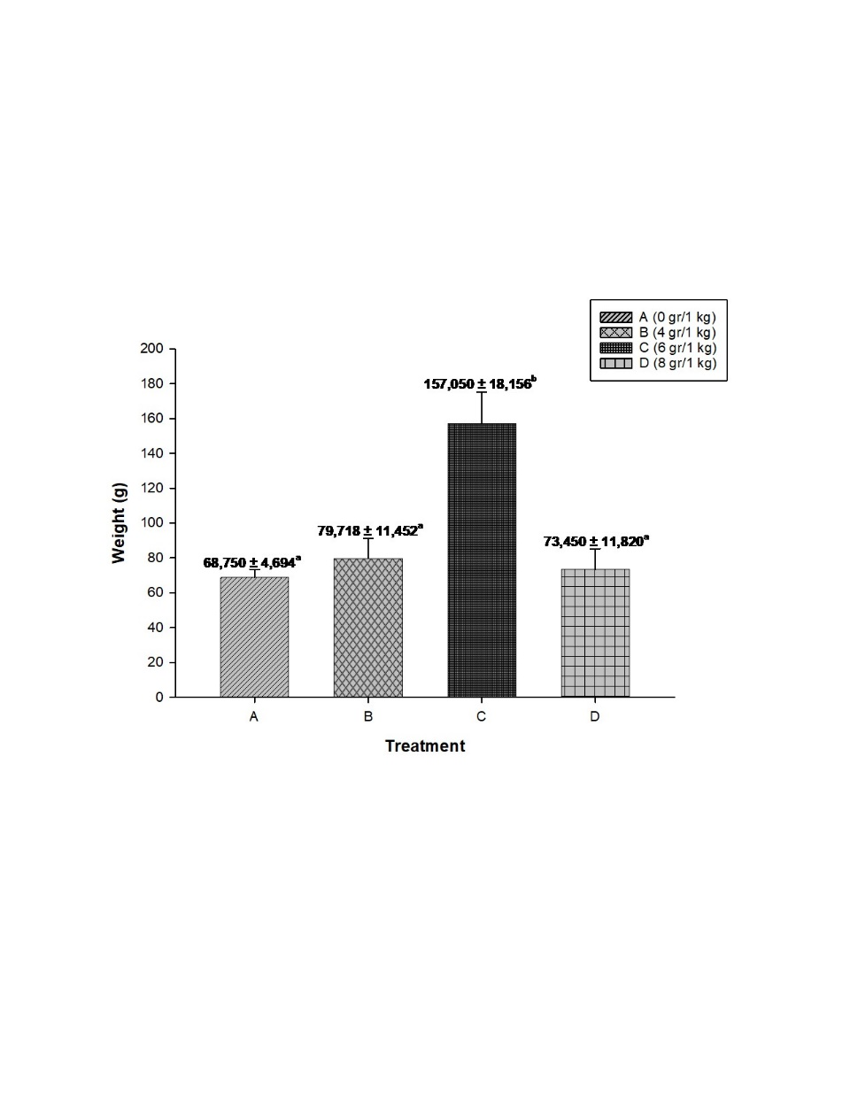

Fig. 1. Absolute weight growth of sangkuriang catfish with the addition of different doses of methionine during 56 days of research.

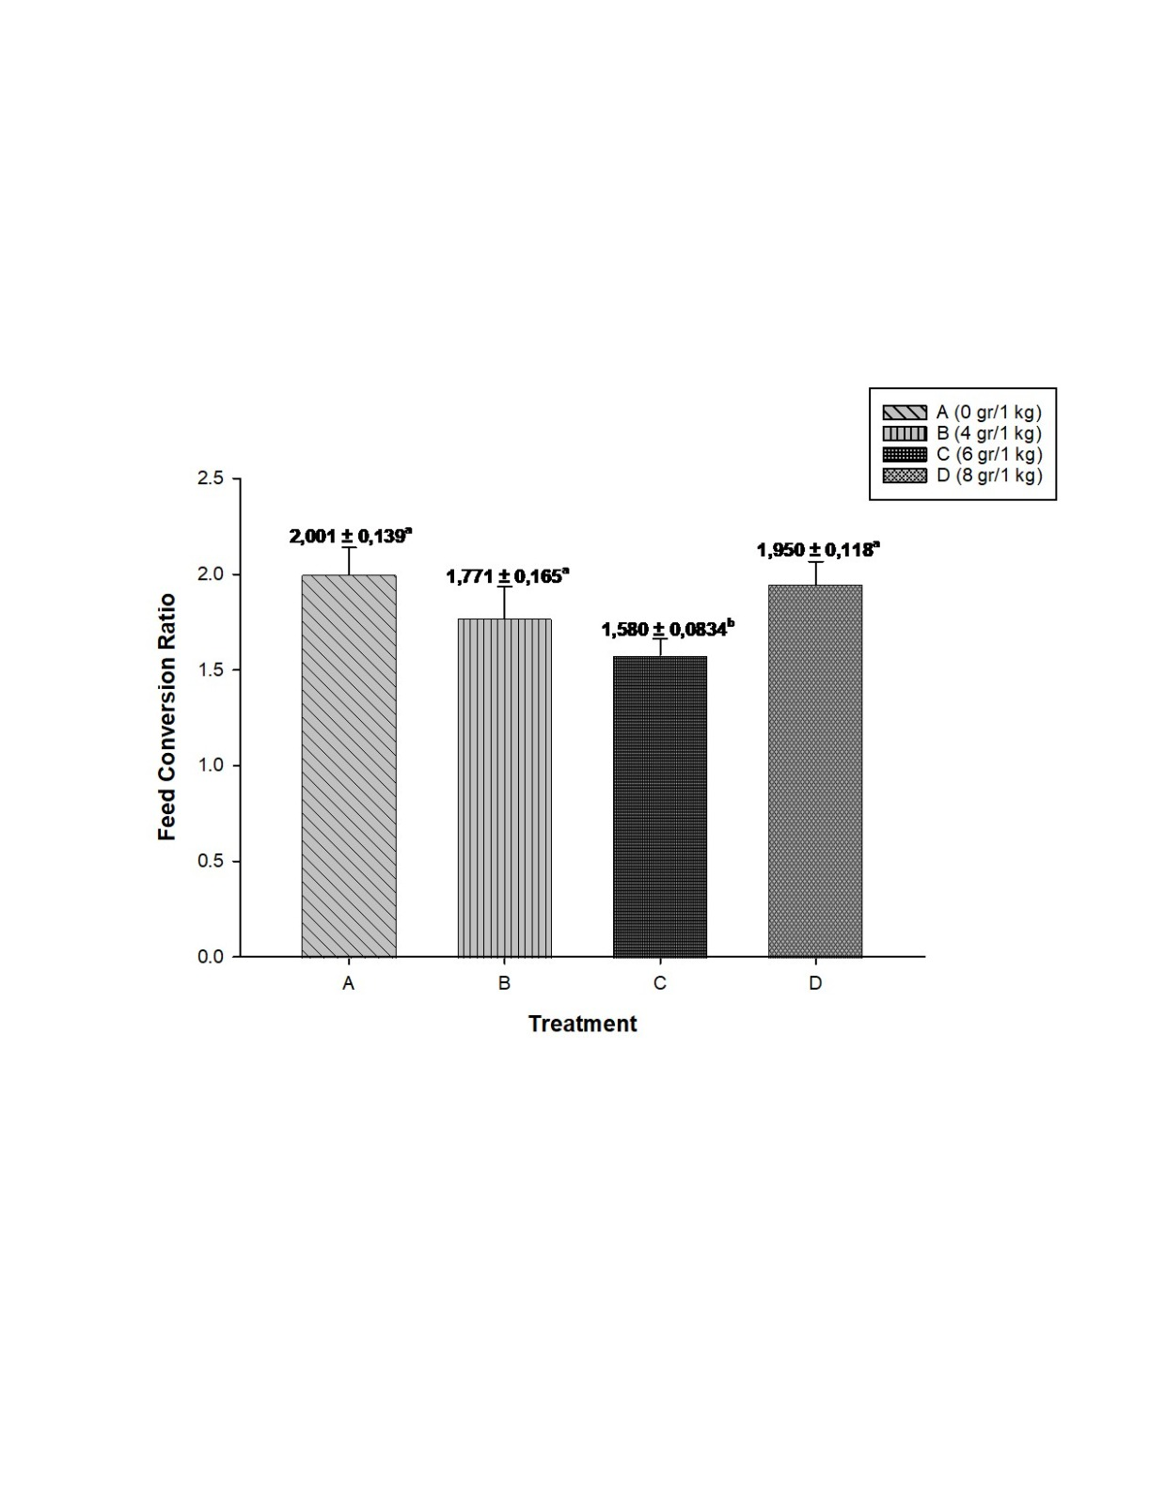

Fig. 2. Feed conversion ratio (FCR) value of sangkuriang catfish with the addition of different doses of methionine during 56 days of research.

* 1. Feed Coversion Ratio

Based on the data from the research results that have been carried out (Fig.2), the feed conversion value ranges from 1.580-2.001. Treatment C gave the lowest feed conversion value (1.580) compared to other treatments, followed by treatment B of 1.771, treatment D of 1.950, and treatment A (control) at 2.001. This indicates that the addition of methionine to commercial feed at an optimal dosage can improve feed conversion ratio (FCR) efficiency in Sangkuriang catfish.

Based on the research data presented in the graph, Treatment C (6 g/kg) exhibited the lowest FCR value of 1.503 ± 0.0934, followed by Treatment B (4 g/kg) with a value of 1.717 ± 0.106, Treatment D (8 g/kg) at 1.990 ± 0.118, and Treatment A (control) with the highest FCR value of 2.003 ± 0.130. A lower FCR value indicates more efficient feed utilization, as it reflects the fish's ability to convert feed into body biomass more effectively. Feed Conversion Ratio (FCR) values reflect the efficiency of energy utilization, in which methionine plays a critical role not only in protein synthesis but also in energy and lipid metabolism. At the optimal dosage (Treatment C), methionine enhances energy efficiency by allowing more energy to be directed toward somatic growth. Conversely, both deficient and excessive dosages impair this efficiency. Additionally, methionine contributes to methylation processes, phospholipid synthesis, and taurine production mechanisms that collectively facilitate lipid absorption. These multifaceted functions support the conclusion that the 6 g/kg dosage used in Treatment C is the most effective in reducing FCR values.

The importance of a balanced amino acid profile for achieving efficient feed conversion has been confirmed by previous studies. For example, research on the use of pumpkin leaf meal as a feed additive for African catfish demonstrated that feeds with imbalanced amino acid compositions resulted in elevated feed conversion ratio (FCR) values ranging from 2.46-3.10 [6]. In contrast, supplementation with ingredients rich in essential amino acids significantly reduced FCR values to a range of 1.89 to 2.31.

The role of methionine in improving energy utilization and supporting growth is further evidenced by the reduction of the feed conversion ratio (FCR) to 1.42 following supplementation with essential amino acids in G3 Pearl transgenic catfish [4]. This is consistent with the notion that a balanced amino acid profile enhances protein retention by minimizing its catabolic use for energy and promoting its anabolic utilization in protein synthesis and somatic tissue development [20]. In a similar context, high-quality commercial catfish feeds are typically characterized by a balanced amino acid composition, with a methionine-to-protein ratio of approximately 2-3%, highlighting the critical role of sufficient methionine inclusion in optimizing feed efficiency [23].

* 1. Protein Efficiency Ratio

Protein efficiency ratio is a measure used to assess how effectively the protein given to fish or livestock can be converted into body growth [22]. The results of the analysis of the methionine addition to commercial feed have a significant effect on the protein efficiency ratio in sangkuriang catfish, the val value in each treatment is between 0.781 to 2.042 (Fig. 3)

The results showed that the treatment of methionine addition to commercial feed had a very significant effect on the absolute length gain of sangkuriang catfish. Specifically, treatment C with the addition of methionine at 6 g/kg feed showed the best results with a protein efficiency ratio value reaching 2.042 ± 0,235, far exceeding other treatments. Treatment B with a dose of 4 g/kg feed produced a protein efficiency ratio of 1.016 ± 0.200, while treatment D with a dose of 8 g/kg feed produced 0.982 ± 0.158. The lowest results were shown by treatment A (control) without the addition of methionine, with a protein efficiency ratio value of only 0.781 ± 0.281.

The results of this study indicate that the addition of methionine to commercial feed can increase the efficiency of protein utilization in sangkuriang catfish fry. The optimal methionine dose of 6 g/kg feed is supported by findings indicating that the methionine requirement for promoting growth in catfish is approximately 6.3 g/kg feed. This alignment reflects the consistency of methionine needs across various catfish strains, there by reinforcing the validity of the present findings. In intensive aquaculture systems, improved feed efficiency not only enhances growth performance but also reduces nitrogenous waste resulting from inefficient protein metabolism, thus mitigating the environmental impact of aquaculture operations [8]. Protein efficiency ratio (PER) in catfish is strongly influenced by the amino acid profile of the diet, with methionine being a key contributing factor [1].

Amino acid supplementation in aquafeeds has been identified as an effective strategy to enhance feed utilization efficiency and growth performance in cultured fish. This aligns with the findings of the present study, in which methionine supplementation at an optimal dose was shown to improve the protein efficiency ratio and promote the growth of Sangkuriang catfish [2].

* 1. Protein Retention

The results showed that the treatment of methionine addition to commercial feed had a very significant effect on the absolute length gain of sangkuriang catfish in Fig. 4.

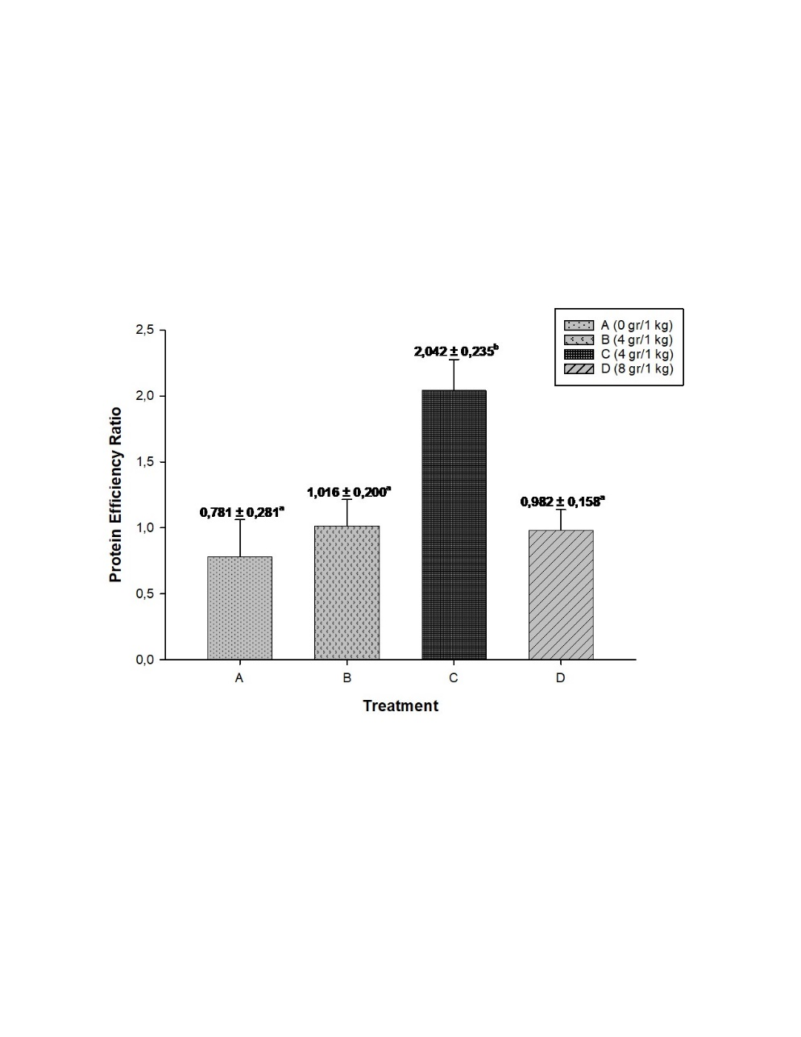

Fig. 3. Protein efficiency ratio values of sangkuriang catfish with the addition of different doses of methionine during 56 days of research

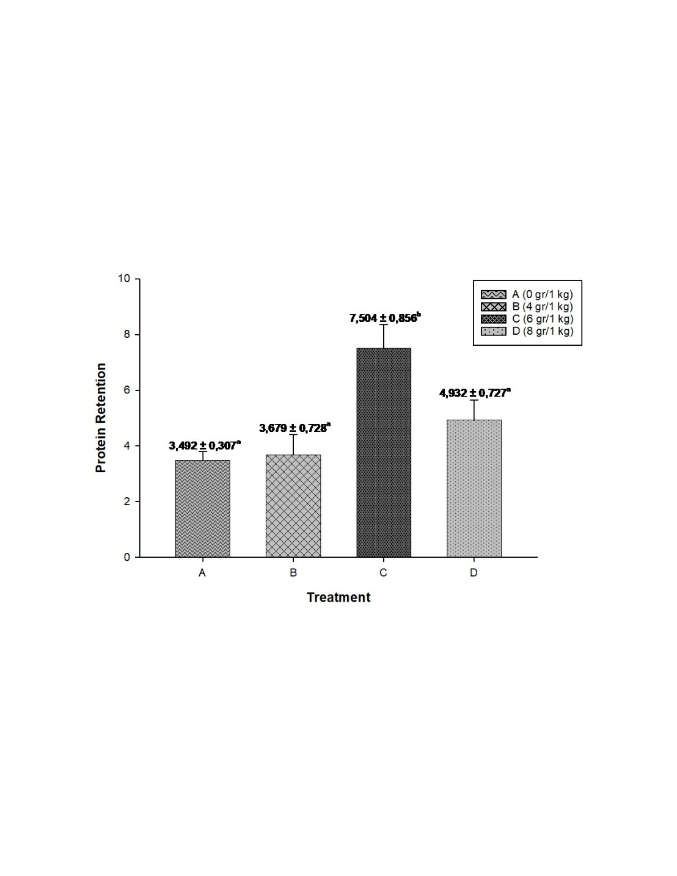

Fig. 4. Protein retention valueof sangkuriang catfish with the addition of different doses of methionine during 56 days of research

Specifically, treatment C with the addition of methionine at 6 g/kg feed showed the best results with protein retention values reaching 7.504 ± 0.856%, followed by treatment D with a dose of 8 g/kg at 4.932 ± 0.727%, treatment B with a dose of 4 g/kg at 3.679 ± 0.728%, and the lowest results in treatment A (control) at 3.492 ± 0.307% (Fig. 4). The results of this study are consistent with previous findings indicating that methionine supplementation in feed can enhance protein retention and promote fish growth. It has been reported that methionine addition to formulated diets improves specific growth rate, feed utilization efficiency, and protein efficiency ratio in Sangkuriang catfish fry, with an optimal dose ranging from 4 to 4.1 g/kg feed. In contrast, the present study identified 6 g/kg feed as the optimal methionine dose. This variation may be attributed to differences in experimental conditions, fish size, basal diet composition, or other environmental factors [16]. Increasing feed utilization efficiency and protein retention can reduce production costs and enhance profitability in fish farming. Furthermore, methionine supplementation may contribute to mitigating the environmental impact of aquaculture by improving feed utilization efficiency, which leads to reduced organic waste production [3]. By enhancing nutrient absorption and minimizing nitrogen and phosphorus excretion, methionine helps decrease the release of pollutants into aquatic environments, thereby supporting more sustainable aquaculture practices.

* 1. Water quality

Water quality plays an important role in supporting the survival of catfish. The water quality measured for 56 days in this study was temperature, pH, and dissolved oxygen (DO) levels. The average value of water quality can be seen in Table 1.

Table 1. Water Quality

|  |  |
| --- | --- |
| Water Quality | Observation Results |
| Temperature (°C) | 28°-30° |
| pH | 3,2-4,1 |
| DO (mg/l) | 6,7-7,4 |

Water quality plays a crucial role in the growth of fish. An increase in temperature generally enhances fish appetite; however, excessively high temperatures lead to elevated ammonia toxicity. Elevated ammonia concentrations result in decreased dissolved oxygen levels and impair the oxygen-binding capacity of hemoglobin in the blood. Consequently, these conditions reduce fish appetite and inhibit growth. Methionine supplementation in feed predominantly enhances growth performance and feed efficiency in African catfish, while growth rate is more strongly influenced by environmental factors such as water quality and effective management practices throughout the cultivation period [11].

1. CONCLUSIONS

The conclusion of this study is that the addition of methionine to commercial feed has a significant effect on improving growth performance, feed conversion ratio, protein efficiency ratio and protein retention in sangkuriang catfish. The use of 6 g methionine/kg feed showed the highest body weight gain (157.90 g) lowest FCR (1.580), protein efficiency ratio (2.042) and best protein retention (7.504 %) compared to other treatments.

DISCLAIMER (ARTIFICIAL INTELLIGENCE).

Author(s) hereby declare that NO generative AI technologies such as Large Language Models (ChatGPT, COPILOT, etc) and text-to-image generators have been used during writing or editing of manuscripts.

REFERENCES

1. Adebayo, O. and Quadri, K. (2005). Dietary protein level and feeding rate for hybrid clariid catfish, clarias gariepinus x heterobranchus bidorsalis, in homestead tanks. Journal of Applied Aquaculture, 17(1), 97-106.

2. Agustiana, A., Rachmawati, D., & Herawati, V. (2022). Effect of tryptophan in artificial feed on feed utilization efficiency and growth performance of sangkuriang catfish (Clarias gariepinus) fry. Tropical Aquaculture Science Indonesian Journal of Tropical Aquaculture, 6(2), 202-215.

3. Buwono, I. D., Grandiosa, R., Iskandar, I., & Rahmawati, V. (2024). Growth, Protein Efficiency Ratio and Protein Retention of G6 Transgenic Mutiara Catfish with Mixed Feeding at Different Ratio of Commercial Feed and Rebon Shrimp Flour. Unram Fisheries Journal. 14(2), 481-491.

4. Buwono, I., Iskandar, I., & Grandiosa, R. (2021). Growth hormone transgenesis and feed composition influence growth and protein and amino acid content in transgenic g3 pearl catfish (clarias gariepinus). Aquaculture International, 29(2), 431-451.

5. Buwono, I. I. D. (2000). The need for essential amino acids in fish diets. Canisius.

6. Dada, A. (2016). Use of fluted pumpkin (Telfairia occidentalis) leaf powder as feed additive in African catfish (Clarias gariepinus) fingerlings. Journal of Applied Animal Research, 45(1), 566-569.

7. Davies, D. (2001). Use of soybean flour (dehulled, solvent-extracted soybean) as a fish meal substitute in practical diets for African catfish, Clarias gariepinus (Burchell 1822): growth, feed utilization and digestibility. Journal of Applied Ichthyology, 17(2), 64-69.

8. Elesho, F. E., Sutter, D. A. H., Swinkels, M. A. C., Verreth, J. A. J., Kröckel, S., Schrama, J. W. (2021). Quantifying methionine requirements of juvenile African catfish (Clarias gariepinus). Aquaculture, 532, 736020.

9. Emu, S. (2022). Effect of Addition of Amino Acid Methionine with Different Doses in Feed on the Growth of Red Tilapia. Aqua Marine (Jurnal FPIK UNIDAYAN), 9(2), 8-12.

10. Emu, S. (2022). Effect of Addition of Amino Acid Methionine with Different Doses in Feed on the Growth of Red Tilapia. Aqua Marine (Jurnal FPIK UNIDAYAN), 9(2), 8-12.

11. Kaiser, F., Schlachter, M., Schulz, C., & Figueiredo-Silva, C. (2023). Dietary Supplementation With Chromium Dl-Methionine Enhances Growth Performance of African Catfish (Clarias gariepinus). Aquaculture Nutrition, 2023, 1-8.

12. Nugraha, E. H. (2020). Effect of artificial feed on the growth of Clarias gariepinus seeds in the Manunggal Jaya Fish Farming Group. Journal of Physics and Science Education (JPFS), 3(2), 59-67.

13. Oyedokun, J. O. (2019). Growth Performance and Protein Digestibility in Clarias gariepinus, Burchell, 1822 Fed Soyabean Meal Based Diets Supplemented with Amino Acid and Protease (Doctoral dissertation).

14. Prayor, H. 2021. Effect of Methionine Addition to Formulated Feed on Growth Rate of Tiger Grouper (Epinephelus fuscoguttatus) in the Rolling Phase.

15. Rachmawati, D., Hutabarat, J., Susilowati, T., Samidjan, I., & Pranggono, H. (2020). Addition of Saccharomyces cerevisiae to commercial artificial feed for sangkuriang catfish (Clarias gariepinus) fry on feed utilization efficiency, growth, and survival. Pena Akuatika: Scientific Journal of Fisheries and Marine Sciences, 19(2).

16. Rohchimawati, R., Rachmawati, D., & Amalia, R. (2022). Effect of different doses of methionine in artificial feed on growth and survival of sangkuriang catfish (Clarias gariepinus) fry. Tropical Aquaculture Science: Indonesian Journal of Tropical Aquaculture, 6(2), 193-201.

17. Ruben, N., Thierry, A., Raphaël, K., & Téguia, A. (2023). Growth performances of Clarias gariepinus fry fed hermetia illucens based diet supplemented with synthetic amino acids (methionine and lysine). Asian Journal of Fisheries and Aquatic Research, 25(6), 86-95.

18. Schutte, J.B., and Pack, M. 1995. Sulfur Amino Acid Requirement of Broiler Chicks from Fourteen to Thirty-Eight of Age. I Performance and Carcass Yield. Poultry Sci. 74: 480-487.

19. Silalahi, R. F. A., & Fatimah, N. (2024). Enlargement of Sangkuriang Catfish (Clarias gariepinus) with the Addition of Banana Peel Flour to Feed. Jurnal Marshela (Marine and Fisheries Tropical Applied Journal), 2(2), 78-89.

20. Sopha, S., Santoso, L., & Putri, B. (2015). Effect of Partial Substitution of Fish Meal with Bone Meal on the Growth of Sangkuriang Catfish (Clarias Gariepinus). e-Journal of Aquaculture Engineering and Technology, 3(2), 403-410.).

21. Thaiin, A. (2016). Effect of Lysine Supplementation in Commercial Feed on Energy Retention and Feed Conversion Ratio of Gourami Fish (Osphronemus gouramy) (Doctoral dissertation, AIRLANGGA UNIVERSITY).

22. Zeitoun, I. H., Ullrey, D. E and Mages, W. T. 1976. Quantifying nutrient requirement of fish. J. Fish Res. Board of Canada. Vol. 33: 167-172.

23. Zemanova, V., Paylik, M., Pavlikova, D., and Tlustos, P. 2014. The Significance of Methionine, Histidine and Tryptophan in Plant Re spones and Adaptation to Cadmium Stress. Plant Soil Environ. Volume 60. Number 9.

24. Zhao, J., Li, X., Leng, X., Song, P., Hu, J., & Zhao, X. (2016). Comparative study on the utilization of different methionine sources by channel catfish, ictalurus punctatus.

25. AOAC. The official methods of analyses 15th edn. Association of official analytical chemists international. Arlington, Virginia, USA; 1990.