Original Research Article
Whole genome sequence of Pandoraea pnomenusa GXDRC_01 isolated from a clinical sample, Gujarat, India

.
ABSTRACT
Aims: This research aims to report the genome sequence of Pandoraea pnomenusa GXDRC_01 isolated from a pregnant woman, from western India
Study design: Vaginal swab sample collection, enrichment, screening on Blood Agar medium, gDNA extraction, NGS, and data analysis.
Place and Duration of Study: Molecular Biology Department, Genexplore Diagnostics and Research Centre Pvt. Ltd., Ahmedabad, India, between October 2024 and March 2025
Methodology: High quality gDNA was isolated and quantified by Epoch. Phylogenetic analysis based on 16S rRNA sequence homology was carried out for identification of the bacterium by Sanger sequencing. For WGS the library was prepared using Ion Xpress™ Plus Fragment Library Kit, and sequencing was carried out by NGS using Ion Torrent S5 Plus (550 Chip) (Thermo scientific, USA). Sequence data was assembled using SPAdes v. 4.0.0 and annotation was done by NCBI Prokaryotic Genome Annotation Pipeline (PGAP).
Results: The genome sequence of P. pnomenusa GXDRC_01 included 118 contigs with a calculated genome size of 5.4 Mb. The completeness of genome using CheckM analysis (V1.2.3) was 94.74% with 0.07% contamination.
Conclusion: A beta-proteobacteria was isolated from a vaginal swab sample obtained from a tertiary hospital in Ahmedabad, India. It was identified as Pandoraea pnomenusa, and the genome assembly code is GCA_050017075.1, and genome assembly identified as ASM5001707v1. This is the first report on the isolation and genome analysis of this gram-negative bacterium from the vaginal swab sample of a pregnant woman in India. It is important to report this gram-negative bacterium in vaginal flora as it is known to cause sepsis, bacteremia and cystic fibrosis.
Keywords: Pandoraea pnomenusa, WGS, vaginal swab, pregnant woman, emerging pathogen, LIM broth, NCBI PGAP, ION Torrent S5

1. INTRODUCTION

The major microbial flora of the vagina of a healthy woman is dominated by members of the Lactobacillus family, which helps in maintaining vaginal pH by producing lactic acid and prevention of the development of pathological flora. Unusual changes in the composition of the vaginal microbiome in pregnancy leads to many pregnancy pathologies. One of the abnormalities is preterm premature rupture of membranes (PPROM), which may be caused by changes in the vaginal microbiota [1,2]. In a report the PPROM was associated with higher diversity predominately during the second trimester, which was associated with a relative increase in the abundance of potentially pathogenic species including Prevotella, Peptoniphilus, Streptococcus, and Dialister during second trimester of pregnancy [3]. Microbiome studies based on PCR-DGGE and 16SrRNA sequencing of vaginal swab samples from 64 healthy pregnant women (from all trimesters) of Mexico City showed the presence of twenty (21) diﬀerent bacteria: Lactobacillus genus (98%) was predominant to include the species L. acidophilus, L. iners, L. gasseri, and L. delbrueckii. The microbiota of pregnant women with disturbed or bacterial vaginosis conditions contained seventeen (17) diverse bacteria namely, Ureaplasma urealyticum, BVAB1 and Gemella bergeriae [4]. Group B streptococcus (GBS) is a leading cause of infections in newborn in the USA since 1970s and has been reported in other parts of the world. American College of Obstetricians and Gynaecologists’ (ACOG) Committee in collaboration with American College of Nurse-Midwives (ACNM) published an interim update in 2019 on GBS screening for the prevention of GBS Early Onset Disease (EOD) in newborns. According to this guideline it is recommended that during pregnancy all women should undergo screening for GBS at 36 0/7–37 6/7 weeks of gestation, exception: intrapartum antibiotic prophylaxis for GBS due to GBS bacteriuria during the pregnancy or history of a previous neonatal GBS-infection. This schedule would provide a 5-week window for GBS testing in case of births that occur up to a gestational age of at least 41 0/7 weeks. GBS testing involves collection of recto-vaginal swab sample from a pregnant woman, inoculation first into a selective enrichment broth such as LIM broth, after incubation a subculture is made onto blood agar plates. Further identification of beta-hemolytic colonies as GBS is done by using latex agglutination with group B antisera, chromogenic agars, DNA probes, or nucleic acid amplification tests [5,6]. LIM broth (Todd -Hewitt broth supplemented with selective antibiotics such as colistin and nalidixic acid is primarily used as a selective enrichment medium for GBS (S. agalactiae) [7,8,9], however other bacteria such as Streptococcus faecalis, Lactobacillus, Gardnerella vaginalis, Mycoplasma hominis, or other anaerobic bacteria resistant to the inhibitory agents can also grow in the LIM broth [10, 11,12]. The genus Pandoraea gen. nov. was first described by Coenye et al (2000), and it was earlier classified as Burkholderia cepacia and Ralstonia paucula or picketti. Four new species including P. pnomenusa were also described [13]. This gram-negative, obligate aerobic, rod-shaped bacterium that belongs to the Burkholderiaceae family, is an emerging pathogen, which causes infections primarily in patients with Cystic fibrosis (CF), bacteremia, endocarditis, osteomyelitis, pneumonia, etc. [14,15]. However, there are no reports about the presence of Pandoraea species in LIM broth enrichment obtained from vaginal swab of normal or pregnant woman or causing preterm birth. This is the first report on the isolation, identification and whole-genome sequence analysis of Pandoraea pnomensua species from a pregnant woman with preterm birth.

2. MATERIALS AND METHODS
2.1 SAMPLE
A vaginal swab sample from a pregnant woman with premature membrane rupture from a tertiary hospital in Ahmedabad was obtained with patient’s informed consent for detection of GBS (group B Streptococcus). It was transported to the laboratory within 4-5 hours and inoculated into LIM broth and incubated at 37⁰C for 24-48 hours for enrichment, The enriched broth was streaked onto Blood agar plate [15,16]. A pure culture of a dominant bacterium from Blood agar plate with opaque, mucoid colony characteristics was isolated and purity checked by streaking on LB agar plates. Primary identification was done by routine microbiological tests such as gram staining, catalase, oxidase test, and Vitek2 identification system (bioMerieux). Glycerol stocks of the pure culture were prepared and stored at -20ºC.

2.2 WHOLE GENOME SEQUENCING
The gDNA was extracted by routine manual procedure and checked for quality by Epoch. Library was prepared using Ion Xpress™ Plus Fragment Library Kit as per the instruction manual. WGS was carried out by NGS using Ion Torrent S5 Plus (550 Chip) (Thermo scientific, USA).

2.2 WGS ANALYSIS
Sequence data with 75X coverage was submitted to NCBI GenBank as BioProject PRJNA1225484 and the raw sequence data was assembled using SPAdes v. 4.0.0. The annotation was done by NCBI Prokaryotic Genome Automatic Annotation Pipeline (PGAP) and Rapid Annotation using Subsystems Technology (RAST) [17,18]. The completeness of the genome was checked with CheckM analysis (V1.2.3).
Whole-genome sequence data of the target organism was also submitted to Comprehensive genome analysis service at PATRIC (BV-BRC), which integrates multiple curated databases and tools for antimicrobial resistance (RGI: Resistance gene identifier) at CARD, virulence factors prediction by three virulence databases: PATRIC VF, VFDB (Virulence Factor Database) and VICToR, therapeutic implications by cross-referencing of predicted resistance proteins with: DrugBank and TTD (Therapeutic Target Database), determining Specialty genes, functional categorization (Subsystems), phylogenetic tree (Phylogenetic analysis) (22, 23).
3. RESULTS AND DISCUSSION
A non-hemolytic bacterium was isolated on Blood agar plate streaked from growth in LIM broth (enriched after inoculation with a vaginal swab sample from a pre-term pregnant woman). The colonies were convex, mucoid, opaque and white on Luria-Bertani agar plates (Figure 1 and 2). The gram-negative, oxidase positive isolate was designated as GXDRC_01 and identified as Pandoraea species by Vitek2 Compact system using GN card.

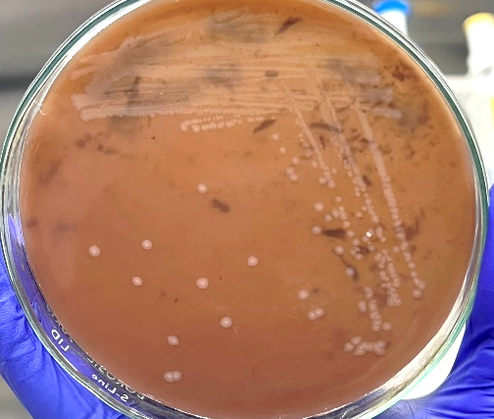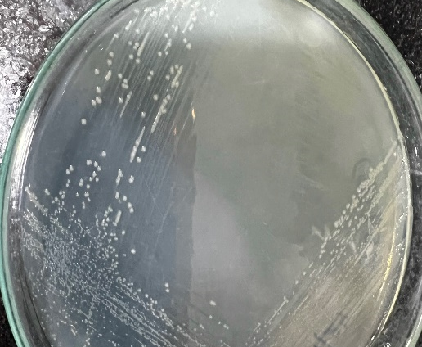

Fig. 1. Colony characteristics of Pandoraea GXDRC_01 on (A) Blood Agar plate and (B) LB agar plates.

The WGS raw data was submitted in GenBank: Genome submission portal as BioProject PRJNA1225484, WGS project JBLTIJ01, Genome Assembly ASM5001707v1 and NCBI RefSeq assembly GCF_050017075.1. The strain GXDRC_01 was identified as Pandoraea pnomenusa with ANI 99.33%, assembly coverage 93.33%. The whole genome assembly statistics is given in Table 1 and Annotation details in Table 2. The completeness of genome using CheckM analysis (V1.2.3) was 94.74% with 0.07% contamination [20,21]. The Pandoraea pnomenusa GXDRC_01 genome was annotated using RAST tool kit (RASTtk) and assigned a unique genome identifier of 93220.100. This genome is in the superkingdom Bacteria and was annotated using genetic code 11.

The taxonomy of this genome is: cellular organisms > Bacteria > Pseudomonadati > Pseudomonadota > Betaproteobacteria > Burkholderiales > Burkholderiaceae > Pandoraea > Pandoraea pnomenusa.

Table 1. Contig level assembly statistics
 | RefSeq/GenBank
Genome size | 5.4 Mb (5350994 bp)
Contig N50 | 89.3 kb (89267)
Contig L50 | 21
Number of contigs | 118
Contig N50 | 89.3 kb
GC percent | 64.87
Plasmids | 0
Genome coverage | 75x

Table 2. Annotation details
 | RefSeq
Provider | NCBI RefSeq
Name | GCF_050017075.1-RS_2025_04_30
Genes | 4,956
Protein-coding (CDS) | 5,241
tRNA | 60
rRNA | 2
Pseudogenes | 176
Software version | 6.10
Based on the annotation statistics and a comparison to other genomes in PATRIC within this same species, this genome appears to be of Good quality. Details of the analysis, including genes of interest (Specialty Genes), and a functional categorization (Subsystems). Strain GXDRC_01 was identified as P. based on Phylogenetic tree (Figure 2).

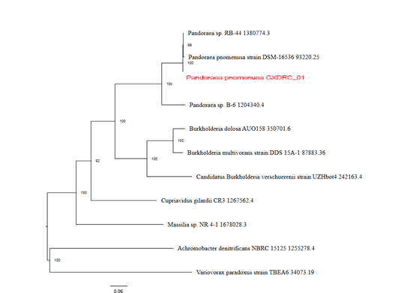

Figure 2. Phylogenetic Tree (Comprehensive genome analysis service at PATRIC, BV-BRC)
The identification of antimicrobial resistance (AMR) determinants is essential for understanding the resistance profile of pathogenic bacteria. In this study, the Resistance Gene Identifier (RGI) tool, based on the Comprehensive Antibiotic Resistance Database (CARD), was used to predict AMR employing the “protein homolog model” and the “strict” criteria to ensure high-confidence detection. A total of five AMR genes were identified as shown in Table 3. The detection of these genes highlights the multidrug resistance potential of the organism. The presence of efflux systems (adeF, qacJ), β-lactamases (OXA-62, PNC-2), and resistance to disinfectants poses serious concerns in clinical and hospital environments, as they may limit the effectiveness of both antibiotic therapy and hygiene control measures.
Table 3. AMR profile by protein homology model

ARO Term | AMR (Gene Family) | Drug Class | Resistance Mechanism | % Identity of Matching Region | % Length of Reference Sequence
OXA-62 | OXA beta-lactamase, (OXA-62-like beta-lactamase) | carbapenem, penicillin beta-lactam | antibiotic inactivation | 99.3 | 100
qacJ | small multidrug resistance (SMR) (antibiotic efflux pump) | disinfecting agents and antiseptics | antibiotic efflux | 42.45 | 101.87
PNC-2 | PNC beta-lactamase | cephalosporin | antibiotic inactivation | 79.35 | 98.53
adeF | resistance-nodulation-cell division (RND)  (antibiotic efflux pump) | fluoroquinolone antibiotic, tetracycline antibiotic | antibiotic efflux | 80.14 | 103.49
adeF | resistance-nodulation-cell division (RND) antibiotic efflux pump | fluoroquinolone antibiotic, tetracycline antibiotic | antibiotic efflux | 43.03 | 100

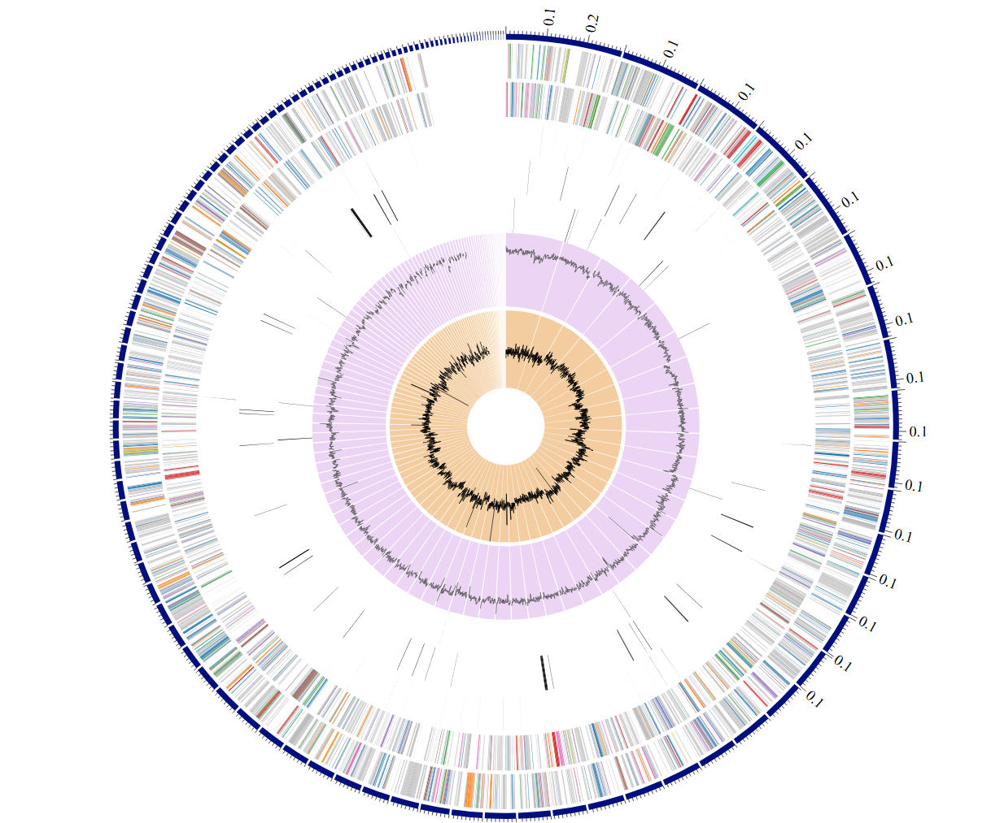
Figure 3. A circular graphical display of the distribution of the genome annotations
A circular graphical display of the distribution of the genome annotations is provided (Figure 3). This includes, from outer to inner rings, the contigs, CDS on the forward strand, CDS on the reverse strand, RNA genes, CDS with homology to known antimicrobial resistance genes, CDS with homology to know virulence factors, GC content and GC skew. The colors of the CDS on the forward and reverse strand indicate the subsystem that these genes belong to (Comprehensive genome analysis service at PATRIC, BV-BRC).
The specialty gene with source database is provided in Table 4. These virulence factors include genes involved in adherence, immune evasion, secretion systems, and toxin production.

Table 4. Specialty genes
 | Source | Genes
Antibiotic resistance | CARD | 5
Antibiotic resistance | NDARO | 1
Antibiotic resistance | PATRIC | 47
Drug Target | DrugBank | 11
Drug Target | TTD | 2
Transporters | TCDB | 7
Virulence factors | PATRIC_VF | 1
Virulence factors | VFDB | 2
Virulence factors | Victors | 16

The DrugBank and TTD hits provides a pharmacological context, potentially guiding alternative treatments or drug repurposing strategies. Virulence factors detected indicate the organism’s ability to cause disease and evade host defenses. The VICToR database, with 16 hits, showed the most comprehensive coverage.
PATRIC annotation also provides an analysis of the subsystems (a set of proteins that together implement a specific biological process or structural complex which is unique to each genome) as shown in Figure 4 below.
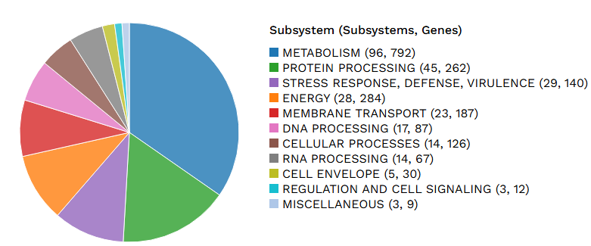

FIG 4: PATRIC annotation provides an analysis of the subsystems
Besides causing infection in cystic fibrosis patients, Pandoraea has also been isolated from blood, samples from patients with chronic obstructive pulmonary disease or chronic granulomatous disease (13, 24). There has been a report of sepsis and multiple organ failure and death in a non-cystic fibrosis patient who underwent lung transplantation for sarcoidosis (25). Six (6) species (i.e., Pandoraea apista, Pandoraea norimbergensis, Pandoraea pulmonicola, Pandoraea pnomenusa, Pandoraea sputorum, and Pandoraea fibrosis) have been isolated from human clinical specimens (13,26), while five (5) species (Pandoraea faecigallinarum, Pandoraea oxalativorans, Pandoraea terrae, Pandoraea thiooxydans, and Pandoraea vervacti have been isolated from environmental samples (27,28,29).
In 2019 Peeters C et al. carried out WGS by Illumina HiSeq4000 platform (PE150) at the Oxford Genomics Centre of 27 strains (selected from phylogenetic trees constructed based on gyrB, recA, and gltB gene sequences) for comparative genomics along with forty-one (41) publicly available Pandoraea genome sequences. Many of the isolates were obtained from environmental samples such as polluted soils, pond water from green house, river water, maize root rhizopshere, etc., and possessed metabolic pathways for xenobiotic degrdation. They proposed seventeen (17) novel Pandoraea species namely: P. anapnoica, P. anhela, P. aquatica, P. bronchicola, P. capi, P. captiosa, P. cepalis, P. commovens, P. communis, P. eparura, P. horticolens, P. iniqua, P. morbifera, P. nosoerga, P. pneumonica, P. soli, and P. terrigena. Members of Pandoraea tend to exhibit broad resistance to ampicillin, extended-spectrum cephalosporins, aztreonam, aminoglycosides, and meropenem, but they are sensitive to imipenem (24, 25, 30).
Lim YL et al (2016) reported the complete genome sequence analysis of P. pnomenusa [DSM 16536(T)] (isolated from a cystic fibrosis patient in United Kingdom) to gain a better understanding of this species and its virulence, role in pathogenesis and genetics. It consisted of a single circular chromosome of 5,389,285bp, average GC content of 64.87%, absence of plasmid. There were a total of 4811 genes (4586 genes were identified as CDS), 88 RNA genes consisting of 12 rRNA (4 5S rRNA, 4 16S rRNA, and 4 23S rRNA) and 65 tRNA genes (GenBank accession number: CP009553.2) (31).

Table 5. Pandoraea pnomenusa genomes available in GenBank databases.

Sr. No. | Assembly | Accession no. | Genome size (Mb) | Remarks (Strain no., Sample type, Submitter, Year)
1 | ASM50458v2 | GCA_000504585.2 | 5.4 | RB-44, Soil, Univ. of Malaya (2016)
2 | ASM76761v3 | GCA_000767615.3 | 5.4 | DSM 16536, CF, Univ. of Malaya (2015)
3 | ASM163627v1 | GCA_001636275.1 | 5.6 | MCB032, Bioreactor, UK (2016)
4 | ASM783312v1 | GCA_007833125.1 | 5.5 | TF-18, Rice rhizsphere, Colorado State Univ., USA (2019)
5 | ASM654700v1 | GCA_006547005.1 | 5.4 | M202, Waste water, Shandong First Medical University, 2017
6 | ASM60406v3 | GCA_000604065.3 | 5.4 | RB-38, Soil, Univ. of Malaya (2016)
7 | ASM59049v2 | GCA_000590495.2 | 5.4 | 3kgm, Soil, Univ. of Malaya (2014)
8 | 52184_F01 | GCA_900454355.1 | 5.5 | NCTC13160, human, Wellcome sanger Institute (2018)
9 | LMG 31119 | GCA_902459755.1 | 5.3 | LMG 31119, CF, LM-Ugent, USA (2019)
10 | De Novo Assembly | GCA_000523065.1 | 5.3 | RB-44, Soil, Univ. of Malaya (2014)
11* | ASM5001707v1 | GCA_050017075.1 | 5.4 | GXDRC_01, Vaginal swab, India (2014)
12 | ASM4039147v1 | GCA_040391475.1 | 5.6 | T2.bin.69, late-stage decomposing Cetonia aurata grub, Baden-Wuerttemberg, Tuebingen , Germany (2024)**
13 | ASM1784895v1 | GCA_017848955.1 | 5.1 | HJP_bin7, Sludge from phenol fed wastewater aerobic bioreactor, NEERI, Nagpur, India (2021)**
14 | ASM1730607v1 | GCA_017306075.1 | 5.5 | SCN18_26_2_15_R4_B_65_12, Bioreactor biome (Africa) University of California Berkeley , USA (2021)**
15 | ASM4039561v1 | GCA_040395615.1 | 4.2*** | T1.bin.40, late-stage decomposing Cetonia aurata grub, Baden-Wuerttemberg, Tuebingen , Germany (2024)**
*Current paper **metagenomics assembly (insect metageneome) ***genome length too small
As of date there are six (6) WGS genome projects and fifteen (15) genomes (including this genome and metagenome assembled) of P. pnomenusa in genome database, Table 5 [20]. One metagenome assembled genome from a sludge sample has been reported from India. This is the first report on the genome of P. pnomenusa isolated from a clinical sample (vaginal swab from pre-term rupture during pregnancy) from India.

2. Conclusion
The strain P. pnomenusa strain GXDRC_01 possesses numerous genes/proteins that are involved in infection and antibiotic resistance such as hemolysins (5 proteins), virulence factors (16), superinfection exclusion B family protein (1), OXA-62 family carapenem-hydrolyzing class D beta-lactamase, etc. Therefore, it is important to isolate and characterize this bacterium from clinical samples as well as environment from other parts of the country as it is one of the emerging pathogens.

3. AVAILABILITY OF DATA
The data described in this article can be free accessed on GenBank under the accession no.

BioProject PRJNA1225484, GenBank annotation: ASM5001707v1 (GCF_050017075.1). It is important to share this data with other scientists and clinicians as it represents the first characterization of genome sequence data of an emerging pathogen P. pnomenusa from a vaginal swab sample to study its epidemiology, diagnosis and treatment.

References
1. Bennett PR, Brown RG, MacIntyre DA. (2020) Vaginal Microbiome in Preterm Rupture of Membranes. Obstet Gynecol Clin North Am. 47(4):503-521. https://doi.org/ 10.1016/j.ogc.2020.08.001. PMID: 33121642.
2. Gorczyca K, Kozioł MM, Kimber-Trojnar Ż, Kępa J, Satora M, Rekowska AK, Leszczyńska-Gorzelak B. (2024) Premature rupture of membranes and changes in the vaginal microbiome - Probiotics. Reprod Biol. 24(3):100899. https://doi.org/10.1016/j.repbio.2024.100899. PMID: 38805904
3. Brown RG, Al-Memar M, Marchesi JR, Lee YS, Smith A, Chan D, Lewis H, Kindinger L, Terzidou V, Bourne T, Bennett PR, MacIntyre DA. (2019) Establishment of vaginal microbiota composition in early pregnancy and its association with subsequent preterm prelabor rupture of the fetal membranes. Transl Res. 207:30-43. https://doi.org/10.1016/j.trsl.2018.12.005. PMID: 30633889
4.Hernández-Rodríguez, C, Romero-González, R, Albani-Campanario, M, Figueroa-Damián, R, Meraz-Cruz, N, Hernández-Guerrero, C. (2011) Vaginal microbiota of healthy pregnant Mexican women is constituted by four Lactobacillus species and several Vaginosis-Associated Bacteria, Infectious Diseases in Obstetrics and Gynecology 851485, https://doi.org/10.1155/2011/851485
5. Schrag SJ, Verani JR. (2013) Intrapartum antibiotic prophylaxis for the prevention of perinatal group B streptococcal disease: experience in the United States and implications for a potential group B streptococcal vaccine. Vaccine13: 31(suppl 4): D20-6 https://doi.org/10.1016/j.vaccine.2012.11.056. PMID: 23219695
6. Prevention of group B streptococcal early-onset disease in newborns (2020) ACOG Committee Opinion 797 American College of Obstetricians and Gynecologists. Obstet Gynecology135:e51–72
7. Wilson DA, Hall GS, Procop GW. (2010) Detection of group B streptococcus bacteria in LIM enrichment broth by peptide nucleic acid fluorescent in situ hybridization (PNA FISH) and rapid cycle PCR. Journal of Clinical Microbiology 48(5):1947-8 https://doi.org/10.1128/JCM.01809-09. PMID: 20200295
8. El Aila NA, Tency I, Claeys G, Saerens B, Cools P, Verstraelen H, Temmerman M, Verhelst R, Vaneechoutte M. (2010) Comparison of different sampling techniques and of different culture methods for detection of group B streptococcus carriage in pregnant women. BMC Infectious Diseases 29(10):285 https://doi.org/10.1186/1471-2334-10-285. PMID: 20920213
9. Rosa-Fraile, M., Spellerberg, B. (2017). Reliable Detection of Group B Streptococcus in the Clinical Laboratory. J. Clin. Microbiol. 55, 2590–2598 https://doi.org/10.1128/JCM.00582-17
10. Wali IE, Sorour SE, Abdalla MAH (2007) Assessment of Different Methods for Detection of Group B Streptococci carriage among Pregnant Females. Egyptian Journal of Medical Microbiology 16(4):593-597
11. Baud, A., Hillion, KH., Plainvert, C. et al (2023) Microbial diversity in the vaginal microbiota and its link to pregnancy outcomes. Science Reporter 13:9061 https://doi.org/10.1038/s41598-023-36126-z
12. Bennett PR, Brown RG, MacIntyre DA. (2020) Vaginal microbiome in preterm rupture of membranes. Obstetric Gynecology Clinical North American 47(4):503-521 https://doi.org/ 10.1016/j.ogc.2020.08.001. PMID: 33121642
13. Coenye T, Falsen E, Hoste B, Ohlén M, Goris J, Govan JRW et al. Description of Pandoraea gen. nov. with Pandoraea apista sp. nov., Pandoraea pulmonicola sp. nov., Pandoraea pnomenusa sp. nov., Pandoraea sputorum sp. nov. and Pandoraea norimbergensis comb. nov. International Journal of Systematics and Evolutionary Microbiology 50(2):887-899 https://doi.org/10.1099/00207713-50-2-887. PMID: 10758901.
14. Ziogou, A, Giannakodimos A, Giannakodimos I, Tsantes AG, Ioannou P (2024) Pandoraea Infections in Humans—A Systematic Review. Journal of Clinical Medicine 13:6905. https:// doi.org/10.3390/jcm13226905
15. Cubides-Diaz DA, Muñoz Angulo N, Martin Arsanios DA, Ovalle Monroy AL, Perdomo-Rodriguez DR, Del-Portillo MP. (2022) Pandoraea pnomenusa superinfection in a patient with SARS-CoV-2 pneumonia: First Case in the Literature. Infectious Diseases Report 14:205–212. https://doi.org/10.3390/idr14020025
16. Montague, N. S., T. J. Cleary, O. V. Martinez, and G. W. Procop. 2008. Detection of group B streptococci in Lim broth by use of group B Streptococcus peptide nucleic acid fluorescent in situ hybridization and selective and nonselective agars. J. Clin. Microbiol. 46:3470–3472
17. Wilson DA, Hall GS, Procop GW. Detection of group B Streptococcus bacteria in LIM enrichment broth by peptide nucleic acid fluorescent in situ hybridization (PNA FISH) and rapid cycle PCR. J Clin Microbiol. 2010 May;48(5):1947-8. doi: 10.1128/JCM.01809-09. PMID: 20200295
18. Li W, O'Neill KR, Haft DH, DiCuccio M, Chetvernin V, Badretdin A, Coulouris G, et al. (2021) RefSeq: expanding the Prokaryotic Genome Annotation Pipeline reach with protein family model curation. Nucleic Acids Res. 8:49(D1):D1020-D1028. https://doi.org/10.1093/nar/gkaa1105. PMID: 33270901
19. Aziz, R.K., Bartels, D., Best, A.A. et al. (2008) The RAST Server: Rapid Annotations using Subsystems Technology. BMC Genomics 9:75. https://doi.org/10.1186/1471-2164-9-75
20.https://www.ncbi.nlm.nih.gov/bioproject?term=229918[top+bioproject]+NOT+1225484[uid
21. Parks DH, Imelfort M, Skennerton CT, Hugenholtz P, Tyson GW. (2015) CheckM: assessing the quality of microbial genomes recovered from isolates, single cells, and metagenomes. Genome Res. 2015 Jul;25(7):1043-55. https://doi.org/10.1101/gr.186072.114. PMID: 25977477
22. Alcock BP, Huynh W, Chalil R, Smith KW, Raphenya AR, Wlodarski MA, Edalatmand A, Petkau A, Syed SA, et al. (2023) CARD 2023: Expanded Curation, Support for Machine Learning, and Resistome Prediction at the Comprehensive Antibiotic Resistance Database. Nucleic Acids Research 51, D690-D699 https:doi.org/10.1093/nar/gkac920. PMID: 36263822; PMCID: PMC9825576.
23. https://card.mcmaster.ca/analyze/rgi
24. Daneshvar MI, Hollis DG, Steigerwalt AG, Whitney AM, Spangler L, Douglas MP, et al. (2001). Assignment of CDC weak oxidizer group 2 (WO-2) to the genus Pandoraea and characterization of three new Pandoraea genomo species. Journal of Clinical Microbiology 39 1819–1826 https://doi.org/10.1128/JCM.39.5.1819-1826.2001
25. Stryjewski ME, LiPuma JJ, Messier RH, Reller LB, Alexander BD (2003) Sepsis, multiple organ failure, and death due to Pandoraea pnomenusa infection after lung transplantation. Journal of Clinical Microbiology 41:2255–2257 https://doi.org/10.1128/JCM.41.5.2255-2257.2003
26. See-Too WS, Ambrose M, Malley R, Ee R, Mulcahy E, Manche E, et al. (2019) Pandoraea fibrosis sp. nov., a novel Pandoraea species isolated from clinical respiratory samples. International Journal of Systematics and Evolutionary Microbiology 69:645–651 https://doi.org/10.1099/ijsem.0.003147
27. Anandham R, Indiragandhi P, Kwon SW, Sa TM, Jeon CO, Kim YK, et al. (2010) Pandoraea thiooxydans sp. nov., a facultatively chemolithotrophic, thiosulfate-oxidizing bacterium isolated from rhizosphere soils of sesame (Sesamum indicum L.). Int. J. Syst. Evol. Microbiol. 60 21–26. 10.1099/ijs.0.012823-0
28. Sahin N., Tani A., Kotan R., Sedlacek I., Kimbara K., Tamer A. U. (2011). Pandoraea oxalativorans sp. nov., Pandoraea faecigallinarum sp. nov. and Pandoraea vervacti sp. nov., isolated from oxalate-enriched culture. International Journal of Systematics and Evolutionary Microbiology 61 2247–2253. 10.1099/ijs.0.026138-0 [DOI] [PubMed] [Google Scholar]
29. Jeong SE, Lee HJ, Jia B, Jeon CO (2016) Pandoraea terrae sp. nov., isolated from forest soil, and emended description of the genus Pandoraea International Journal of Systematics and Evolutionary Microbiology 66:3524–3530. https:doi.org/10.1099/ijsem.0.001229
30. Peeters C, De Canck E, Cnockaert M, De Brandt E, Snauwaert C, Verheyde B, Depoorter E, Spilker T, LiPuma JJ, Vandamme P. (2019) Comparative Genomics of Pandoraea, a genus enriched in xenobiotic biodegradation and metabolism. Frontiers in Microbiology 6(10):2556. https://doi.org/10.3389/fmicb.2019.02556. PMID: 31781066
31. Lim YL, Ee R, Yong D, Yu CY, Ang GY, Tee KK, Yin WF, Chan KG. (2016) Complete genome sequence analysis of Pandoraea pnomenusa Type Strain DSM 16536(T) isolated from a Cystic Fibrosis Patient. Frontiers in Microbiology 8(7):109. https://doi.org/ 10.3389/fmicb.2016.00109. PMID: 26903988

