**A Visual “STAGED” Nomogram to Predict the Risk of Full Stomach in Adult Outpatients Undergoing Elective Sedated Upper Endoscopy**

**ABSTRACT**

**Background:** A full stomach during elective sedated upper endoscopy (UE) is highly associated with aspiration. Aspiration is related to increased morbidity and mortality. We aimed to develop a nomogram model to predict the risk of having a full stomach in adult outpatients undergoing elective sedated UE.

**Methods:** Data of 1171 adult outpatients undergoing elective sedated UE were collected retrospectively between July 2021 and February 2022. Univariable analysis, multivariable logistic regression, and Boruta were used to identify independent risk factors associated with full stomach. Using the identified risk factors, a nomogram was developed. The area under the receiver operating characteristic (AUROC), decision curve analysis (DCA), and calibration curve (CC) were used to evaluate the model’s performance.

**Results:** After exclusion, 990 patients were enrolled in this study. In the training set, 305 patients (38.5%) had a full stomach, and 71 patients (35.9%) had a full stomach for the testing set. The AUROC (95% Cl) was 0.819 (0.788-0.85) and 0.823(0.759-0.887) for the training and testing set, respectively. The variables incorporated in the development of our STAGED model were **S**ex = female (OR: 2.147), fasting **T**ime (OR: 0.839), **A**ge (OR: 0.971), **G**ERD (OR: 15.61), diab**E**tes (OR: 8.614) and **D**iet (OR: 3.691). DCA and CIC analyses showed that our model had a significant net benefit compared to the "treat all or "treat none" strategies and had high predictive value, making it clinically useful.

**Conclusion:** The “STAGED” nomogram model was successfully developed and made easily accessible online via a visual web-based calculator.

**Keywords:** full stomach; nomogram model; prediction; upper endoscopy; aspiration

**Graphical abstract:** Summary of the patient’s inclusion along with the study design, the methodology used for model development, the implementation of the model, and model performance.

1. Introduction

The term “full stomach” refers to the presence of solid or liquid gastric content before anesthetic induction [1, 2]. The incidence of a full stomach is about 5% in elective patients [3]. During upper endoscopy (UE), having a full stomach can lead to pulmonary aspiration, which can cause various complications, with aspiration pneumonia being the most severe [4-6]. Aspiration occurs in about 0.16% to 0.18% of endoscopy procedures and is related to increased morbidity and prolonged mechanical ventilation [7]. Its mortality rate is as much as 5%, and up to 9% of all anesthesia-related deaths are associated with pulmonary aspiration [8, 9, 4]. Prevention is the best way to reduce the impact of intraoperative aspiration. Predicting a full stomach in adult outpatients undergoing UE could help prevent the risk of pulmonary aspiration and its related effects.

Recent studies have shown that advancement in gastric sonography has enabled anesthesiologists to determine the qualitative and quantitative nature of gastric content [10, 6, 11, 12]. However, performing gastric sonography requires costly specialized equipment and trained professionals to carry out the procedure, as less experienced personnel are more likely to misinterpret or misjudge sonographic images, potentially compromising patient safety [13, 12]. As overcrowding continues to strain healthcare facilities, the limited number of trained sonographers and ultrasound machines may result in extended wait times for patients needing gastric ultrasounds. This delay can significantly impact patient outcomes. An easy-to-use, affordable, fast, and accurate nomogram that can help predict the likelihood of a full stomach would greatly assist anesthesiologists in reducing their workload and improving patient care.

Currently, no study uses nomograms to predict full stomach in adult outpatients undergoing elective sedated UE. We aimed to investigate the nomogram’s ability to predict full stomachs in adult outpatients undergoing elective sedated UE while considering significant risk factors for the occurrence of full stomachs. We look to accomplish this by creating an easily accessible online visual nomogram (risk-based calculator) model, which will be helpful for clinicians in making informed decisions.

1. Materials and Methods

***2.1 Data Collection and Study Population***

This current study followed the Transparent Reporting of a multivariable prediction model for individual prognosis or diagnosis (TRIPOD) checklist guidelines (**Supplementary Table 1**)[14]. We conducted this research at *anonymized* in *anonymized* between July 2021 and February 2022. Clinical data were collected retrospectively by an experienced anesthesiologist from electronic medical records (EMR) of adult outpatients who underwent elective sedative UE procedures with a maintained modified observer's assessment of alert sedation (MOAA/S) score of ≤ 3 and with an American Society of Anesthesiologists physical status (ASA PS) I, II, III. Patients with severe cardiopulmonary disease, acute upper respiratory tract infections (nasopharyngitis, pharyngitis, and tonsillitis), and allergy to propofol, soybean or eggs were excluded based on the sedative UE procedure contraindications. After excluding the patients with contraindications, all remaining eligible adult outpatients who underwent elective sedative UE procedures were enrolled in this study. A study flow diagram of patient inclusion and exclusion criteria is provided in (**Fig. 1).**

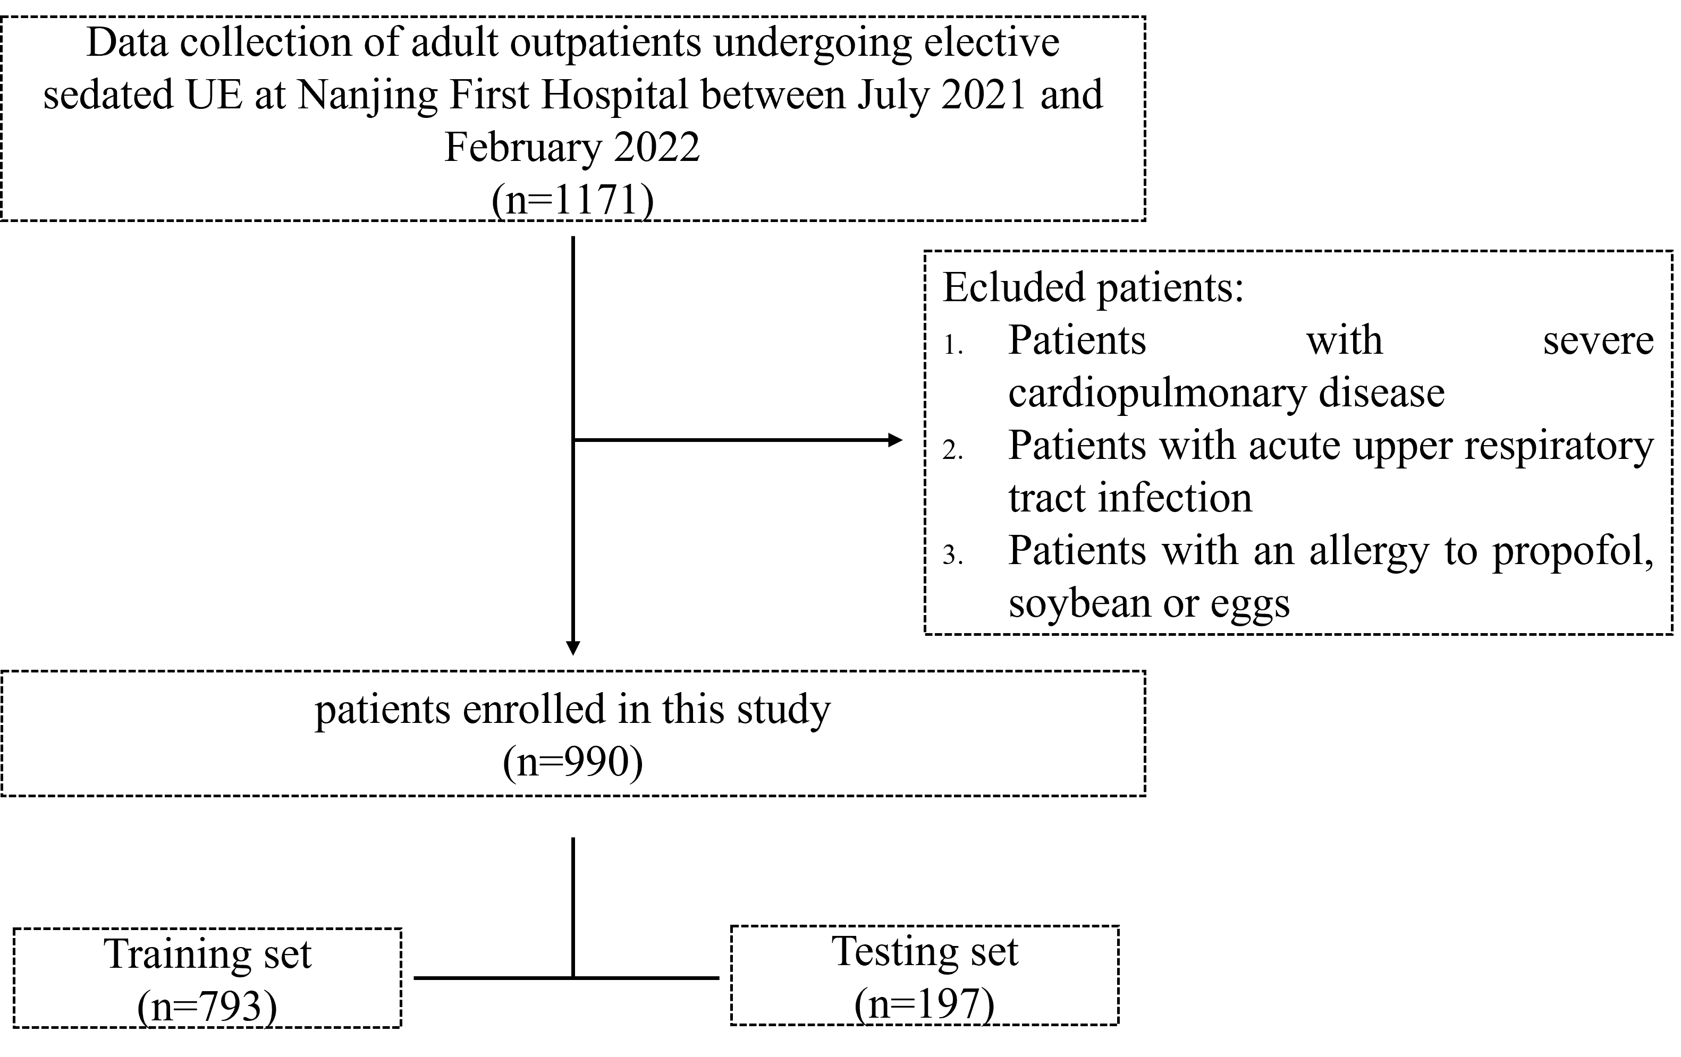

**Fig.1**: study flow diagram of patient inclusion and exclusion criteria

***2.2 Patient Preparation***

Elective patients undergoing UE admitted to the surgical department had to adhere to specific gastrointestinal preparation guidelines before receiving sedation for an UE procedure [15]. They also had to consume less than 50ml of mucosal cleanser (a mixture of Simethicone Emulsion and Pronase Granules in a glass of water) 30 minutes before the gastroscopy. All patients were fully informed of fasting requirements before the procedure to prevent aspiration pneumonia (avoid solid food for at least 8 hours and liquids for at least 4 hours). However, patients could drink clear liquids such as water, carbohydrate drinks, or pulp-free fruit juice (excluding alcohol) up to 2 hours before the procedure to encourage postoperative recovery.

***2.3 Feature Selection and Clinical Outcome***

All data were collected from EMR. EMRs contain numerous records based on patients’ medical history, laboratory results, prescriptions, and doctor’s notes. The significant predictors from this study were selected based on the patients’ demographic (such as age, sex, and BMI), patients’ clinical characteristics (such as mental illness, coronary heart disease, hypertension, CKD, cirrhosis, hypothyroidism, cerebral infarction, sequelae of cerebral infarction, neuromuscular disease, diabetes, GERD, peptic ulcer, and the use of PPI or H2RA, gastrointestinal motility drugs, antibiotics, and gastric mucosal protectants), laboratory data (such as hemoglobin levels), preoperative management (such as fasting and preoperative diet), and patient’s social life (smoking and drinking style).

The clinical outcome was determined by the presence of high-risk residual gastric content, defined as solid particles or gastric fluid volume ≥0.4 ml/kg. Patients who did not meet this specific definition were considered low risk.

***2.3 Statistical Analysis***

Shapiro-Wilk test was used to analyze the normality of continuous variables. The student t-test or Mann-Whitney U test was used for comparing continuous variables, and the chi-square test or Fisher’s exact test was used for comparing categorical variables. The continuous variables were presented as mean (standard deviation) or median (interquartile range) and categorical variables were presented as proportions. Finally, all missing or incomplete data were excluded. All statistical analysis was performed using the software package R version 4.1.3 (https://www.r-project.org/) and Python 3.9.12(https://www.anaconda.com/products/distribution) whereby statistical significance was defined by P < 0.05.

***2.4 Construction and Validation of the Nomogram***

Data of 1171 adult outpatients who underwent elective sedated UE were collected. Of these, 181 were excluded; 5 patients were due to unobtainable data and 176 were due to serious missing data. The remaining 990 were divided into two groups, a training set (792) and a testing set (198) for analysis at a ratio of 8:2. The training cohort was used to identify the significant predictors and create the prediction model. In contrast, the testing cohort data were used to evaluate and validate the model's performance. After univariable analysis, all variables with probability values less than 0.05 (p<0.05) were entered into the multivariable logistic regression. Variables found to be significant after multivariable logistic regression were used to develop our model. Further confirmation of the significance of these variables was achieved through the use of Boruta analysis.

When developing prediction models for binary outcomes, a well-known rule of thumb for the required sample size is to ensure at least 10 events for each predictor parameter[16]. To have less overfitting in our model, we selected the 20 events per variable (EPV) rule of thumb to estimate the sample size. We expected that about 10 variables would enter the model, requiring approximately 200 positive events. Assuming a 25% incidence in our data, we would need (10*20)/0.25=800 samples based on the EPV rule[17]. Considering a 10% dropout rate, about 880 samples may be required. In this study, we collected clinical data from 990 patients which demonstrated a good sample size.

Boruta analysis technique was used to identify the most relevant features that contribute significantly to predicting the nomogram model. It randomly permutes the values of each feature to destroy any potential relationship with the response variable, by creating shadow features that act as noise variables. The STAGED nomogram model was then trained on both datasets (original features and shadow features), to calculate the importance of each feature based on the number of times it is selected over its shadow counterpart. The importance of each feature was then compared to the importance of random features. If a feature's importance is greater than the highest importance among the random features, it is considered significant. The final selected features were those deemed significant in more than 50% of the iterations[18]

To evaluate the accuracy of a model, the area of the discrimination under the receiver operating characteristic curve (AUROC) was quantified. The threshold for the optimal cut-off was determined by the maximum Youden index (Youden index = Specificity + Sensitivity - 1) using the receiver operating characteristic curve (ROC). Furthermore, several accuracy metrics, including sensitivity, specificity, accuracy, true negative (TN), true positive (TP), false negative (FN), false positive (FP), positive and negative predictive values (PPV and NPV), were also calculated. Calibration was assessed by analyzing a calibration curve (CC) and the Hosmer-Lemeshow test, where a P-value greater than 0.05 indicates a good fit. The predictive accuracy of the proposed nomogram was evaluated by examining the degree of overlap between the calibration curve and the diagonal. Finally, the model's generalization performance was internally validated by evaluating its discrimination and calibration ability in the testing cohort data.

***2.5 Clinical Utility of the Nomogram***

We evaluated the clinical usefulness of our nomogram using two statistical methods: Decision curve analysis (DCA) and clinical impact curve (CIC). DCA graphically represents the net benefit of clinical strategies across different probabilities, while CIC visually represents the impact of the risk threshold on the classification of individuals as high-risk. The two methods helped evaluate the accuracy of the risk assessment, by identifying any variation between the estimated and true positive number of individuals who would be identified as high risk for each level of risk threshold. Finally, we developed an interactive application of a web-based nomogram calculator by using Shiny (<https://www.shinyapps.io/>).

1. Results

***3.1 Patient’s Demographic and Clinical Characteristics***

**Table 1(A and B)** shows the demographic and clinical characteristics of the patients from both the training set and the testing set. A total of 305 patients (38.5%) were presented with a full stomach in the training set, while for the testing set, 71 patients (35.9%) were presented with a full stomach. The interquartile range (IQR) for age was 57.00[47.75, 65.00] and 54.00[45.00, 64.00] in the training set and testing set respectively. Univariable analysis was carried out on a total of 27 variables. All variables with p<0.05 were considered statistically significant. 7 variables were identified to be associated with full stomach in adult outpatients undergoing elective sedated UE and these were age (p<0.001), fasting time (p<0.001), ASA score (p<0.001), sex = female (p<0.018), diabetes (p<0.001), GERD (p<0.001) and diet (p<0.001).

**Table 1A:** Patient characteristics in the training set baseline.

|  |  |  |  |  |
| --- | --- | --- | --- | --- |
| **Variables** | **Overall**  (792) | **Low Risk**  (487) | **High Risk**  (305) | **P-value** |
| Age  (median [IQR]) | 57.00 [47.75,65.00] | 57.00 [50.00, 65.00] | 55.00 [42.00, 65.00] | *0.001 |
| BMI  (median [IQR]) | 24.30 [22.60,25.60] | 24.30 [22.60, 25.50] | 24.30 [22.60, 25.80] | 0.444 |
| Hemoglobin  (median [IQR]) | 127.00[122.00,132.00] | 127.00[122.00,132.00] | 127.00[121.00,132.00] | 0.317 |
| Fasting time  (median [IQR]) | 18.00 [15.00, 19.00] | 18.00 [16.00, 19.00] | 16.00 [14.00, 19.00] | *<0.001 |
| No drinking time (median [IQR]) | 6.00 [5.00, 8.00] | 7.00 [6.00, 8.00] | 6.00 [5.00, 8.00] | 0.26 |
| Ultrasound to gastroscopy time (median [IQR]) | 6.00 [5.00, 6.00] | 6.00 [5.00, 6.00] | 6.00 [6.00, 6.00] | 0.265 |
| Sex = Female (%) | 424 (53.5) | 244 (50.1) | 180 (59.0) | *0.018 |
| ASA scores (%) |  |  |  | <0.001 |
| Ⅰ | 265 (33.5) | 147 (30.2) | 118 (38.7) |  |
| Ⅱ | 469 (59.2) | 314 (64.5) | 155 (50.8) |  |
| Ⅲ | 58 (7.3) | 26 (5.3) | 32 (10.5) |  |
| Drinking =Yes (%) | 150 (18.9) | 90 (18.5) | 60 (19.7) | 0.746 |
| Smoking = Yes (%) | 114 (14.4) | 76 (15.6) | 38 (12.5) | 0.261 |
| Asthma = Yes (%) | 30 (3.8) | 20 (4.1) | 10 (3.3) | 0.687 |
| Cranial nerve diseases = Yes (%) | 87 (11.0) | 55 (11.3) | 32 (10.5) | 0.815 |
| Coronary heart disease = Yes (%) | 71 (9.0) | 42 (8.6) | 29 (9.5) |  |
| Hypertension = Yes (%) | 294 (37.1) | 193 (39.6) | 101 (33.1) | 0.077 |
| Chronic kidney disease = Yes (%) | 41 (5.2) | 27 (5.5) | 14 (4.6) | 0.671 |
| Cirrhosis = Yes (%) | 17 (2.1) | 12 (2.5) | 5 (1.6) | 0.598 |
| Hypothyroidism  = Yes (%) | 37 (4.7) | 28 (5.7) | 9 (3.0) | 0.1 |
| Neuromuscular diseases = Yes (%) | 8 (1.0) | 2 (0.4) | 6 (2.0) | 0.077 |
| Diabetes = Yes (%) | 107 (13.5) | 33 (6.8) | 74 (24.3) | *<0.001 |
| GERD = Yes (%) | 97 (12.2) | 15 (3.1) | 82 (26.9) | *<0.001 |
| Peptic ulcer = Yes (%) | 26 (3.3) | 17 (3.5) | 9 (3.0) | 0.834 |
| PPIs or H2RA = Yes (%) | 26 (3.3) | 17 (3.5) | 9 (3.0) | 0.834 |
| Gastrointestinal motility  drugs = Yes (%) | 19 (2.4) | 14 (2.9) | 5 (1.6) | 0.386 |
| Gastric mucosal protectant = Yes (%) | 23 (2.9) | 15 (3.1) | 8 (2.6) | 0.877 |
| Antibiotic = Yes (%) | 65 (8.2) | 45 (9.2) | 20 (6.6) | 0.228 |
| Diet (%) |  |  |  | *<0.001 |
| Liquid | 38 (4.8) | 31 (6.4) | 7 (2.3) |  |
| Semi-liquid | 539 (68.1) | 372 (76.4) | 167 (54.8) |  |
| General food | 215 (27.1) | 84 (17.2) | 131 (43.0) |  |
| POCs = Yes (%) | 99 (12.5) | 69 (14.2) | 30 (9.8) | 0.092 |

Data are presented as median (IQR) or number (%). **Abbreviations:** IQR, interquartile range; GIE, gastrointestinal endoscopy; BMI, body mass index; ASA, American Society of Anesthesiologists physical status; HGB, hemoglobin; PPIs, proton pump inhibitors; H2-RA, H2-receptor antagonists; POCs, point of care. * Included in a multiple logistic regression model.

**Table 1 B:** Patient characteristics in the testing set baseline.

|  |  |  |  |  |  |
| --- | --- | --- | --- | --- | --- |
| **Variables** | **Overall**  (198) | | **Low Risk**  (127) | **High Risk**  (71) | |
| Age (median [IQR]) | 54.00 [45.00, 64.00] | | 55.00 [48.00, 63.00] | 51.00 [40.00, 65.00] | |
| BMI (median [IQR]) | 24.30 [22.33, 26.00] | | 24.20 [22.80, 25.65] | 24.40 [22.10, 26.65] | |
|  |  | |  |  | |
|  |  | |  |  | |
| Hemoglobin (median [IQR]) | 128.00 [122.00, 133.00] | | 129.00 [123.00, 133.00] | 127.00 [121.00, 133.00] | |
| Fasting time (median [IQR]) | 18.00 [16.00, 19.00] | | 18.00 [17.00, 19.00] | 17.00 [14.00, 19.00] | |
| No drinking time (median [IQR]) | 6.00 [6.00, 8.00] | | 7.00 [6.00, 8.50] | 6.00 [5.00, 7.00] | |
| Ultrasound to gastroscopy time (median [IQR]) | 6.00 [6.00, 6.00] | | 6.00 [5.00, 6.00] | 6.00 [6.00, 6.00] | |
| Sex = Female (%) | 106 (53.5) | | 68 (53.5) | 38 (53.5) | |
|  |  | |  |  | |
|  |  | |  |  | |
| ASA scores (%) |  | |  |  | |
| Ⅰ | 71 (35.9) | 43 (33.9) | | | 28 (39.4) | |
| Ⅱ | 113 (57.1) | | 76 (59.8) | 37 (52.1) | |
| Ⅲ | 14 (7.1) | | 8 (6.3) | 6 (8.5) | |
| Drinking = Yes (%) | 38 (19.2) | | 24 (18.9) | 14 (19.7) | |
| Smoking = Yes (%) | 30 (15.2) | | 17 (13.4) | 13 (18.3) | |
| Asthma = Yes (%) | 6 (3.0) | | 4 (3.1) | 2 (2.8) | |
| Cranial nerve diseases = Yes (%) | 23 (11.6) | | 14 (11.0) | 9 (12.7) | |
| Coronary heart disease = Yes (%) | 17 (8.6) | | 8 (6.3) | 9 (12.7) | |
| Hypertension = Yes (%) | 67 (33.8) | | 40 (31.5) | 27 (38.0) | |
| Chronic kidney disease = Yes (%) | 8 (4.0) | | 7 (5.5) | 1 (1.4) | |
| Cirrhosis = Yes (%) | 8 (4.0) | | 7 (5.5) | 1 (1.4) | |
| Hypothyroidism = Yes (%) | 11 (5.6) | | 7 (5.5) | 4 (5.6) | |
| Neuromuscular diseases = Yes (%) | 198 (100.0) | | 127 (100.0) | 71 (100.0) | |
| Diabetes = Yes (%) | 26 (13.1) | | 10 (7.9) | 16 (22.5) | |
| GERD = Yes (%) | 22 (11.1) | | 3 (2.4) | 19 (26.8) | |
| Peptic ulcer = Yes (%) | 5 (2.5) | | 3 (2.4) | 2 (2.8) | |
| PPIs or H2RA = Yes (%) | 5 (2.5) | | 3 (2.4) | 2 (2.8) | |
| Gastrointestinal motility drugs = Yes (%) | 1 (0.5) | | 0 (0.0) | 1 (1.4) | |
| Gastric mucosal protectant = Yes (%) | 5 (2.5) | | 3 (2.4) | 2 (2.8) | |
| Antibiotic = Yes (%) | 14 (7.1) | | 10 (7.9) | 4 (5.6) | |
| Diet (%) |  | |  |  | |
| Liquid | 11 (5.6) | | 7 (5.5) | 4 (5.6) | |
| Semi-liquid | 137 (69.2) | | 99 (78.0) | 38 (53.5) | |
| General food | 50 (25.3) | | 21 (16.5) | 29 (40.8) | |
| POCs = Yes (%) | 21 (10.6) | | 12 (9.4) | 9 (12.7) | |

Data are presented as median (IQR) or number (%). **Abbreviations:** IQR, interquartile range; GIE, gastrointestinal endoscopy; BMI, body mass index; ASA, American Society of Anesthesiologist physical status; HGB, hemoglobin; PPIs, proton pump inhibitors; H2-RA, H2-receptor antagonists; POCs, point of cares.

***3.2 Significant Predictors***

Multivariable logistic regression analysis was conducted on 7 potential variables. Out of these, 6 factors with p values <0.05 were found to be significant predictive variables associated with full stomach in outpatients undergoing sedated UE. Further confirmation of the significance of these variables was achieved through the use of Boruta analysis. The 6 factors found to be of utmost importance, listed in ascending order were sex = female (OR: 2.147, p< 0.001), age (OR: 0.971, p<0.001), diet (OR: 3.691, p< 0.007), fasting time (OR: 0.839, p<0.001), diabetes (OR: 8.614 p< 0.001) and GERD (OR: 15.61, p <0.001). (**Table 2**) (**Fig. 2**).

**Table 2:** Significant predictors of the full stomach after multivariate logistic regression and Boruta analysis.

|  |  |  |  |
| --- | --- | --- | --- |
| **Variables** | **OR** | **95% CI** | **P-value** |
| Age, years | 0.971 | (0.956-0.986) | < 0.001 |
| Fasting time, h | 0.839 | (0.777-0.905) | < 0.001 |
| Sex = Female | 2.147 | (1.502-3.095) | < 0.001 |
| Diabetes = Yes | 8.614 | (5.158-14.70) | < 0.001 |
| GERD = Yes | 15.61 | (8.424-30.63) | < 0.001 |
| Preoperative diet = General diet | 3.691 | (1.481-10.32) | 0.007 |

**Abbreviation:** OR, odd ratio; CI, confidence interval; GERD, gastroesophageal reflux disease.

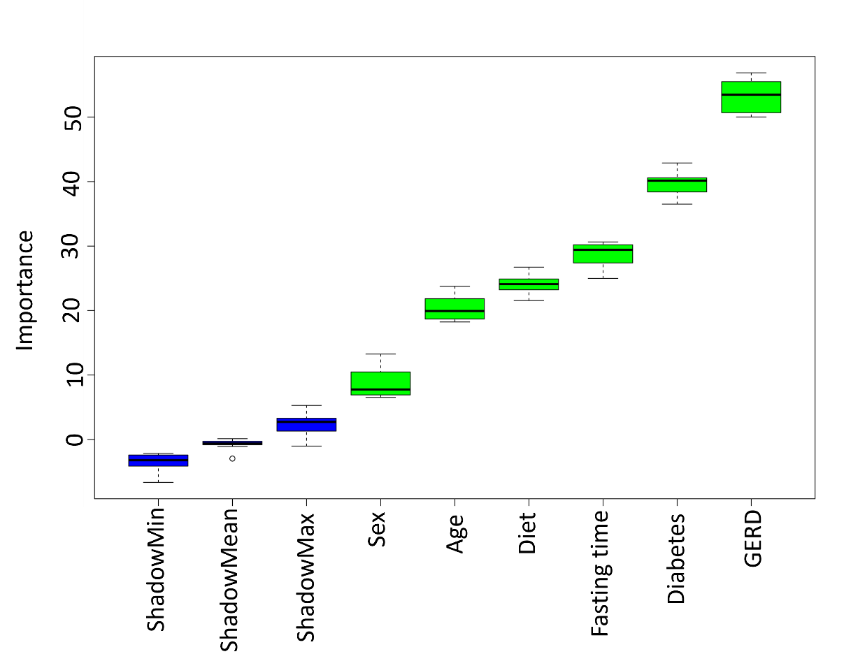

**Fig. 2:** Boruta Analysis curve of a full stomach. The x-axis represents the different variables considered, while the y-axis represents the importance or relevance of each feature in predicting a full stomach. Higher values on the y-axis indicate a stronger relationship with a full stomach, and lower values suggest a weaker association. The curve helps visualize the relative importance of each feature in determining the outcome. **Abbreviations:** GERD, Gastroesophageal Reflux Disease.

***3.3 Nomogram Model Development***

The nomogram model was developed based on the independent variables identified using multivariable logistic regression. It was developed by giving each element a starting score between 0 and 100 points. After evaluating the scores for each risk factor, we summed them up and the overall score was used to create the risk prediction model, which was expressed as a percentage. A higher score on the nomogram indicates a higher risk for a full stomach, while a lower score suggests a lower likelihood of the patient having a full stomach (**Fig. 3**).



**Fig. 3:** The Nomogram Model, which consists of a series of calibrated lines and scales that allow for easy estimation of the likelihood of a full stomach. **Abbreviations:** GERD, Gastroesophageal Reflux Disease.

* 1. Model performance

The ROC curve analysis revealed an AUC of 0.819, a sensitivity of 69.5%, a specificity of 84.0%, a PPV of 73.1%, and a Negative Predictive Value (NPV) of 81.5% for the training dataset. Upon examination of the calibration curve, it became evident that the observed outcomes were remarkably aligned with the anticipated results (**Figure 4A**). To further substantiate our model through internal validation, a testing dataset was employed, and the pertinent curves were illustrated (**Fig. 4B**). The ROC curve analysis for the testing dataset revealed an AUC of 0.823, a sensitivity of 66.2%, a specificity of 88.2%, a PPV of 75.8%, and an NPV of 82.4%.

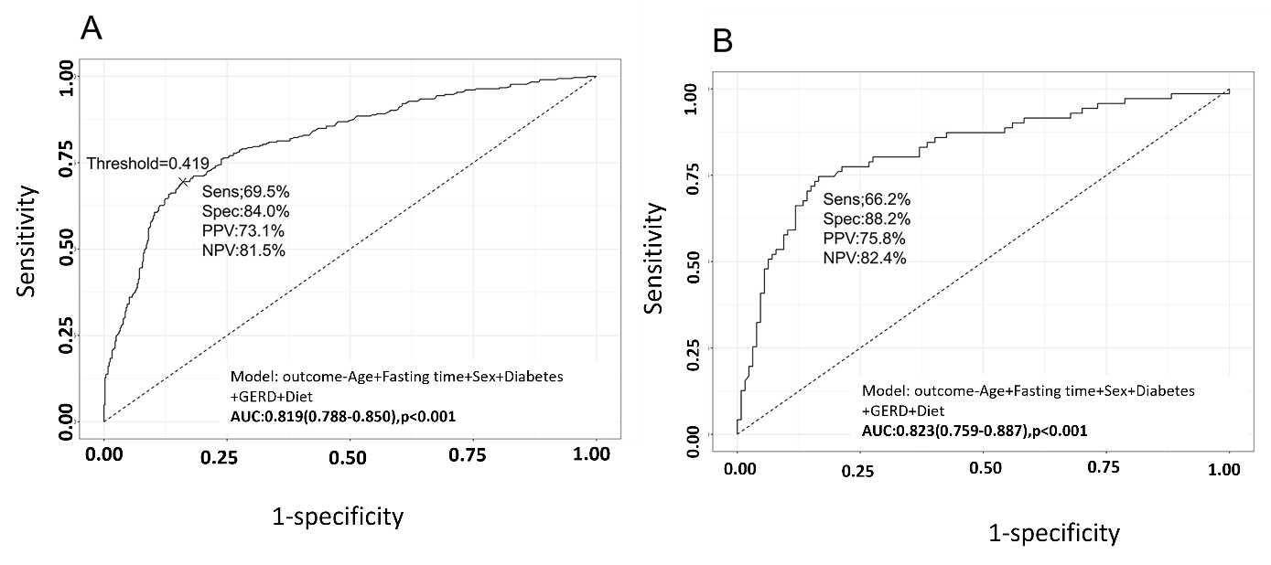

**Figure 4:** AUC values of the training and testing set **(A)** ROC shows an AUC of 0.819 in the training sets. (**B)** ROC showing an AUC of 0.823 in the testing sets. **Abbreviations:** ROC, Receiver Operating Characteristic; AUC, Area Under the Curve; Sens, Sensitivity; Spec, Specificity; PPV, Positive Predictive Values; NPV, Negative Predictive Values; GERD, Gastroesophageal Reflux Disease.

* 1. Model calibration

The calibration curves demonstrated good consistency between the nomogram prediction and the actual observations (**Fig. 5 A and B**).

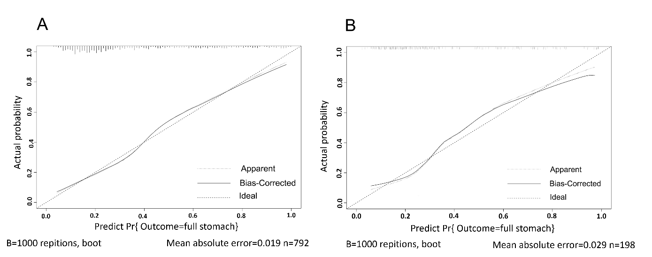

**Fig. 5:** CC of the nomogram **(A)** CC of the nomogram in the training sets with a mean absolute error of 0.019 with a 1000-repetition bootstrap. **(B)** CC of the nomogram in the testing sets with a mean absolute error of 0.029 with a 1000-repetition bootstrap. **Abbreviation:** CC, Calibration Curve.

***3.4 Clinical Utility of the Nomogram***

DCA and CIC were used to evaluate the clinical utility of the nomogram model. DCA demonstrated a significant net benefit when compared to all or none strategies (**Fig. 6**).



**Fig. 6:** DCA of the nomogram. The x-axis is the high-risk threshold probability at which the decision to intervene is made in between 0 and 0.8. The y-axis represents the difference between the proportion of TP cases and the proportion of FP cases, weighted by the relative harm of FP. The area between the blue curve and the horizontal line indicates the clinical usefulness of the nomogram. **Abbreviations:** DCA, Decision Curve Analysis; TP, True Positive; FP, False Positives.

The CIC, which serves as a visual representation of data, clearly illustrated that the nomogram exhibited a significantly greater overall net benefit when evaluated across a broad spectrum of threshold probabilities that are both extensive and applicable in clinical practice, thereby influencing the outcomes experienced by patients substantially (**Fig. 7 A and B**).

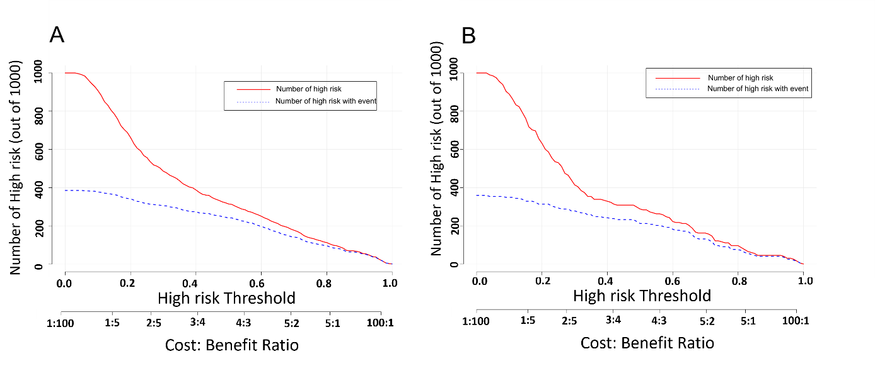

**Fig. 7:** CIC Analysis of the nomogram model. The solid red line indicates the number of patients who are classified as positive at each threshold probability. The figure demonstrates that the nomogram provides a positive clinical impact across a range of threshold probabilities, indicating its potential value in predicting full stomach. **(A)** CIC of the nomogram for the training sets. **(B)** CIC of the nomogram for testing sets. **Abbreviations:** CIC, Clinical Impact Curve.

This indicated that the nomogram model has a high predictive value. Our **STAGED** nomogram (**S**ex, fasting **T**ime, **A**ge, **G**ERD, diab**e**tes and **D**iet) demonstrated good clinical utility by providing an individualized risk predictor. This can help clinicians take preventive measures and provide reasonable care. The visual nomogram (web-based calculator) can be accessed at <https://medication.shinyapps.io/fxs1/>.

* 1. Discussion

During sedated UE the risk of aspiration increases in patients with full stomachs. Anesthesia is commonly considered safe, but anesthesia-related aspiration can pose fatal consequences [19, 20]. In this current study, we developed the first nomogram model that effectively predicts full stomach in adult outpatients (including those with GERD and diabetes) who are undergoing elective sedated UE by categorizing them into high-risk (full stomach) and low-risk (empty stomach).

Nomograms are user-friendly diagnosis estimators that are simple, quick, and noninvasive. They have improved precision and provide a straightforward understanding of the diagnosis, which allows clinicians to make better-informed decisions and predict patient outcomes accurately [21, 22]. Despite their widespread use in the medical field, no study has attempted to use them to predict full stomachs in outpatients. Our newly proposed nomogram showed good discriminative advantages and can successfully categorize low and high-risk patients with good accuracy and precision. After calibration, our model had a mean absolute error (MAE) of 0.029 for the training set (**Fig. 5A**) and 0.019 for the testing set (**Fig. 5B**). Despite good discrimination and calibration, a model’s statistical measures may still fall short when evaluating its impact on clinical decision-making [23]. As a result, we used DCA to evaluate our model’s clinical impact. First introduced in 2006 by Vickers and Elkin [24], DCA calculates the clinical net benefit of a prediction model in comparison to the treat all or none strategies. The net benefit which is a combination of the true positives and false positives shows just how clinically useful or harmful a model is. Given that our model’s net benefit is higher than the treat all or none strategies, this shows that our model is clinically useful.

While there is no definitive threshold for the increased risk of aspiration in humans[6], a previous study on rhesus monkeys reported that the critical level for severe aspiration in adult humans could range from 25 to 50 ml (corresponding to 0.4 - 0.8 ml/kg) [25, 26]. Therefore, in this study, we opted for a lower threshold of 0.4ml/kg to enhance the precision of our model and ensure patient safety. Patients with gastric volume ≥ 0.4ml/kg were classified as high risk and patients with gastric volume <0.4ml/kg were classified as low risk. The classification of patients into high and low-risk groups would help clinicians quickly identify patients in need of urgent attention, reducing workload and unnecessary procedures for gastric sonography while ensuring patient safety.

Our research has several noteworthy strengths. Firstly, our model is the first of its kind to accurately predict a full stomach in adult outpatients undergoing elective sedated UE. Our model is easily accessible through a web-based calculator that utilizes our identified risk factors, which can be accessed from patients' medical records or through questioning. Moreover, our model is notably quicker than the currently used bedside sonography and does not require trained experts to operate. This makes it an excellent resource not just for larger public healthcare facilities, but also for primary hospitals that may have limited resources, including a shortage of ultrasound devices or trained staff. Our model is easily accessible online through a smartphone or computer, making it both convenient and efficient for clinicians and patients alike. By directing appropriate resources to high-risk patients, healthcare facilities can improve patient outcomes and reduce the incidences of aspiration and its related risks, including fatal ones.

Secondly, to enhance our model's clinical usefulness, we designed it to be visual. Being visual, our model offers a concise and easily interpretable representation of the complex relationships between the variables, allowing clinicians to quickly make informed decisions and reducing the likelihood of misinterpretation, which can occur during bedside sonography where the accuracy of interpretation depends on the expertise of the person performing UE [13, 12]. The graphical nature of our developed nomogram also enables rapid estimation of probabilities and risk assessment of treatment outcomes without the need for lengthy calculations. Moreover, our model would help facilitate communication with patients by presenting information in a visually appealing and accessible manner. This would empower both patients and healthcare providers to engage in shared decision-making discussions while enhancing patient understanding and compliance.

The third highlight of our study was the inclusion of patients with diabetes and GERD. According to the IDF diabetes atlas 10th Edition, 1 in 10 patients is currently living with diabetes worldwide and this number is expected to increase in the coming years [27]. Furthermore, the prevalence of GERD worldwide ranges from 15% to 25% [28]. Multiple studies have shown that both diabetes and GERD cause gastroparesis [29-40]. We found that patients with both commodities had a 3-4 times higher risk of experiencing a full stomach. High blood sugar levels and nerve damage associated with diabetes can affect the muscles and nerves responsible for regulating stomach contractions, resulting in slower digestion and delayed gastric emptying. While GERD primarily affects the lower esophageal sphincter, it can also influence gastric emptying. In some cases, the reflux of stomach acid into the esophagus can cause irritation and inflammation, leading to changes in the function of the stomach, including impaired gastric emptying [32]. Both diabetes and GERD can independently impair gastric emptying, leading to various symptoms and complications. Despite the high number of people living with diabetes and GERD, the latest ASA fasting guidelines do not take both groups of patients into account [15]. We believe that our proposed model could be of utmost benefit to guide anesthesiologists in quickly and efficiently screening and identifying high-risk patients with these comorbidities

Our current study in agreement with many previous studies also showed that sex is associated with a risk of experiencing gastroparesis with females being at a higher risk compared to males [41-45]. Females are typically associated with an increased risk of gastroesophageal reflux and postoperative emesis due to the effects of estrogen [7]. The other possible reason is that women in their menstrual cycle later portion known as the luteal phase exhibit much slower gastric emptying than males [46]. For instance, a 37 year (41 points) old male (28 points), with no history of GERD (28 points) and diabetes (28 points), diet = semi-liquid (38 points), a fasting time of 17 hours (28 points), by using our developed nomogram the risk of a full stomach would be 0.220 (0.1557-0.3014) with a total of 191 points. In addition, using a second example, of a 37 year (41 points) old female (50 points), with no history of GERD (28 points) and diabetes (28 points), diet = semi-liquid (38 points), a fasting time of 17 hours (28 points), with a total of 213 points by using our developed nomogram the risk of a full stomach would be 0.377(0.293 - 0.469) which is significantly higher compared to the male patient in the first example.

The impact of age on gastric emptying is a topic of debate in literature. Some studies suggested that gastric emptying time increases with age due to several factors such as changes in the muscular function of the gastrointestinal tract, causing reduced motility and weaker contractions that hinder gastric emptying as well as alterations in hormonal levels such as ghrelin and cholecystokinin that affect appetite regulation and overall digestion [47, 48]. However, other studies reported that the odds of having high-risk residual gastric content were reduced by 23% for every ten-year increase in age [49, 7]. Our findings were in line with the latter and showed that gastric emptying time was reduced in older patients hence reducing the risk of having a full stomach.

Additionally, we considered the type of food consumed and the time elapsed from ingestion to the evaluation of the patient. The type of food ingested is crucial to how quickly gastric emptying occurs. Gastric emptying of different types of food (solid, semi-liquid and liquid) varies with solids taking the longest time and liquids requiring the shortest time to be emptied from the stomach [50]. In our training set, about 2.3% of the patients were presented with a liquid full stomach, 54.8% semi-liquid and 43.0% with general food. While for the testing set 5.6% of the patients presented with a liquid full stomach, 53.5% with semi-liquid and 40.8% general food. Moreover, participants in our study who observed a longer fasting time than the recommended ASA fasting guidelines showed a significant risk reduction of having a full stomach. To ensure patient safety, it is crucial to educate patients about the fasting requirements and provide clear instructions on the types of foods and drinks they should avoid before undergoing an elective sedated UE. Adhering to these guidelines helps minimize the risk of complications and ensures the procedure is conducted effectively.

***4.1 Limitations***

This retrospective research study has some limitations. Firstly, only adult patients who underwent sedated UE were considered. Therefore, further research studies are needed to expand the scope of the study by including other age populations such as children and elderly patients. This will ensure that the findings and conclusions drawn from the research are more representative and applicable to a wider range of patients. Secondly, previous studies have shown that the acidity level of the gastric content that enters the lung during aspiration has a greater impact than the content's quantity [51, 52]. Regrettably, our model cannot accurately predict the acidity level of these gastric contents.

* 1. Conclusion

In this study, we developed a STAGED nomogram model, a visual web-based calculator to predict the risk of a full stomach in adult outpatients undergoing elective sedated UE by considering multiple variables. The STAGED model categorizes patients into high and low-risk groups, this could help anesthesiologists make informed decisions to optimize patient safety and reduce resource utilization. Future studies can further validate and refine this model to enhance its accuracy and applicability in clinical practice.

**Statement of Ethics:** This study obtained ethical approval from the Nanjing First Hospital Ethics Committee (document number: KY20220621-05-KS-01) and complied with the principles of the Declaration of Helsinki and postoperative ethical requirements. Due to the study’s retrospective nature, no written informed consent was required. This study was not concerned with patients’ confidential information.

**Data Availability Statement****:** The data that support the findings of this study are available upon request from the corresponding author (Jianjun Zou)

**Abbreviations**

UE: Upper Endoscopy.

ASA: American Society of Anesthesiologists.

GERD: Gastroesophageal Reflux Disease.

EMR: Electronic Medical Records.

MOAA/S: Modified Observer's Assessment of Alert Sedation score.

BMI: Body Mass Index.

CKD: Chronic Kidney Disease.

PPI: Proton-Pump Inhibitors.

H2RA: Histamine-H2-Receptor Antagonists.

DCA: Decision Curve Analysis.

CIC: Clinical Impact Curve.

ROC: Receiver Operating Characteristic.

STAGED: **S**ex, fasting **T**ime, **A**ge, **G**ERD, diab**E**tes and **D**iet.

**References**

1. Kinsella SM. The 'full stomach': full time for sloppy terminology? Anaesthesia. 2018 Oct;73(10):1189-90.

2. Al Bassam S, Zaghw A, Jaffar Khan M, Arun N, Karmakar A. Airway Management in Full Stomach Conditions. IntechOpen; 2021.

3. Bouvet L, Desgranges FP, Aubergy C, Boselli E, Dupont G, Allaouchiche B, et al. Prevalence and factors predictive of full stomach in elective and emergency surgical patients: a prospective cohort study. Br J Anaesth. 2017 Mar 1;118(3):372-79.

4. Lienhart A, Auroy Y, Pequignot F, Benhamou D, Warszawski J, Bovet M, et al. Survey of anesthesia-related mortality in France. Anesthesiology. 2006 Dec;105(6):1087-97.

5. Cooper GS, Kou TD, Rex DK. Complications following colonoscopy with anesthesia assistance: a population-based analysis. JAMA Intern Med. 2013 Apr 8;173(7):551-6.

6. Perlas A, Mitsakakis N, Liu L, Cino M, Haldipur N, Davis L, et al. Validation of a mathematical model for ultrasound assessment of gastric volume by gastroscopic examination. Anesth Analg. 2013 Feb;116(2):357-63.

7. Phillips S, Liang SS, Formaz-Preston A, Stewart PA. High-risk residual gastric content in fasted patients undergoing gastrointestinal endoscopy: a prospective cohort study of prevalence and predictors. Anaesth Intensive Care. 2015 Nov;43(6):728-33.

8. Warner MA. Is pulmonary aspiration still an important problem in anesthesia? Curr Opin Anaesthesiol. 2000 Apr;13(2):215-8.

9. Shime N, Ono A, Chihara E, Tanaka Y. [Current status of pulmonary aspiration associated with general anesthesia: a nationwide survey in Japan]. Masui. 2005 Oct;54(10):1177-85.

10. Cubillos J, Tse C, Chan VW, Perlas A. Bedside ultrasound assessment of gastric content: an observational study. Can J Anaesth. 2012 Apr;59(4):416-23.

11. Nason KS. Acute Intraoperative Pulmonary Aspiration. Thorac Surg Clin. 2015 Aug;25(3):301-7.

12. Tankul R, Halilamien P, Tangwiwat S, Dejarkom S, Pangthipampai P. Qualitative and quantitative gastric ultrasound assessment in highly skilled regional anesthesiologists. BMC Anesthesiol. 2022 Jan 3;22(1):5.

13. Arzola C, Carvalho JC, Cubillos J, Ye XY, Perlas A. Anesthesiologists' learning curves for bedside qualitative ultrasound assessment of gastric content: a cohort study. Can J Anaesth. 2013 Aug;60(8):771-9.

14. Collins GS, Reitsma JB, Altman DG, Moons KG. Transparent reporting of a multivariable prediction model for individual prognosis or diagnosis (TRIPOD): the TRIPOD statement. Bmj. 2015 Jan 7;350:g7594.

15. Practice Guidelines for Preoperative Fasting and the Use of Pharmacologic Agents to Reduce the Risk of Pulmonary Aspiration: Application to Healthy Patients Undergoing Elective Procedures: An Updated Report by the American Society of Anesthesiologists Task Force on Preoperative Fasting and the Use of Pharmacologic Agents to Reduce the Risk of Pulmonary Aspiration. Anesthesiology. 2017 Mar;126(3):376-93.

16. Riley RD, Ensor J, Snell KIE, Harrell FE, Jr., Martin GP, Reitsma JB, et al. Calculating the sample size required for developing a clinical prediction model. BMJ. 2020 Mar 18;368:m441.

17. Peduzzi P, Concato J, Kemper E, Holford TR, Feinstein AR. A simulation study of the number of events per variable in logistic regression analysis. J Clin Epidemiol. 1996 Dec;49(12):1373-9.

18. Kursa M, Jankowski A, Rudnicki W. Boruta - A System for Feature Selection. Fundam Inform. 2010 01/01;101:271-85.

19. Jenkins K, Baker AB. Consent and anaesthetic risk. Anaesthesia. 2003 Oct;58(10):962-84.

20. Kluger MT, Visvanathan T, Myburgh JA, Westhorpe RN. Crisis management during anaesthesia: regurgitation, vomiting, and aspiration. Qual Saf Health Care. 2005 Jun;14(3):e4.

21. Jiang F, Wei K, Lyu W, Wu C. Predicting Risk of Insulin Resistance in a Chinese Population with Polycystic Ovary Syndrome: Designing and Testing a New Predictive Nomogram. Biomed Res Int. 2020;2020:8031497.

22. Wang Q, Zeng N, Tang H, Yang X, Yao Q, Zhang L, et al. Diabetic retinopathy risk prediction in patients with type 2 diabetes mellitus using a nomogram model. Front Endocrinol (Lausanne). 2022;13:993423.

23. Van Calster B, Wynants L, Verbeek JFM, Verbakel JY, Christodoulou E, Vickers AJ, et al. Reporting and Interpreting Decision Curve Analysis: A Guide for Investigators. Eur Urol. 2018 Dec;74(6):796-804.

24. Vickers AJ, Elkin EB. Decision curve analysis: a novel method for evaluating prediction models. Med Decis Making. 2006 Nov-Dec;26(6):565-74.

25. Raidoo DM, Rocke DA, Brock-Utne JG, Marszalek A, Engelbrecht HE. Critical volume for pulmonary acid aspiration: reappraisal in a primate model. Br J Anaesth. 1990 Aug;65(2):248-50.

26. Engelhardt T, Webster NR. Pulmonary aspiration of gastric contents in anaesthesia. Br J Anaesth. 1999 Sep;83(3):453-60.

27. Magliano DJ, Boyko EJ, committee IDFDAtes. IDF Diabetes Atlas. Idf diabetes atlas. Brussels: International Diabetes Federation © International Diabetes Federation, 2021.; 2021.

28. Zaterka S, Marion SB, Roveda F, Perrotti MA, Chinzon D. Historical Perspective of Gastroesophageal Reflux Disease Clinical Treatment. Arq Gastroenterol. 2019 Aug 13;56(2):202-08.

29. Reissell E, Taskinen MR, Orko R, Lindgren L. Increased volume of gastric contents in diabetic patients undergoing renal transplantation: lack of effect with cisapride. Acta Anaesthesiol Scand. 1992 Oct;36(7):736-40.

30. Soykan I, Sivri B, Sarosiek I, Kiernan B, McCallum RW. Demography, clinical characteristics, psychological and abuse profiles, treatment, and long-term follow-up of patients with gastroparesis. Dig Dis Sci. 1998 Nov;43(11):2398-404.

31. Vu MK, Straathof JW, v d Schaar PJ, Arndt JW, Ringers J, Lamers CB, et al. Motor and sensory function of the proximal stomach in reflux disease and after laparoscopic Nissen fundoplication. Am J Gastroenterol. 1999 Jun;94(6):1481-9.

32. Buckles DC, Sarosiek I, McMillin C, McCallum RW. Delayed gastric emptying in gastroesophageal reflux disease: reassessment with new methods and symptomatic correlations. Am J Med Sci. 2004 Jan;327(1):1-4.

33. Moldovan C, Dumitrascu DL, Demian L, Brisc C, Vatca L, Magheru S. Gastroparesis in diabetes mellitus: an ultrasonographic study. Rom J Gastroenterol. 2005 Mar;14(1):19-22.

34. Gourcerol G, Benanni Y, Boueyre E, Leroi AM, Ducrotte P. Influence of gastric emptying on gastro-esophageal reflux: a combined pH-impedance study. Neurogastroenterol Motil. 2013 Oct;25(10):800-e634.

35. Shen HL, Yang SP, Hong LW, Lin LQ, Wang KJ, Cai XH, et al. Evaluation of gastric emptying in diabetic gastropathy by an ultrasonic whole stomach cylinder method. Ultrasound Med Biol. 2014 Sep;40(9):1998-2003.

36. Sharma G, Jacob R, Mahankali S, Ravindra MN. Preoperative assessment of gastric contents and volume using bedside ultrasound in adult patients: A prospective, observational, correlation study. Indian J Anaesth. 2018 Oct;62(10):753-58.

37. Sabry R, Hasanin A, Refaat S, Abdel Raouf S, Abdallah AS, Helmy N. Evaluation of gastric residual volume in fasting diabetic patients using gastric ultrasound. Acta Anaesthesiol Scand. 2019 May;63(5):615-19.

38. Wang KY, Chen YW, Wang TN, Hsu WH, Wu IC, Yu FJ, et al. Predictor of slower gastric emptying in gastroesophageal reflux disease: Survey of an Asian-Pacific cohort. J Gastroenterol Hepatol. 2019 May;34(5):837-42.

39. Zhou L, Yang Y, Yang L, Cao W, Jing H, Xu Y, et al. Point-of-care ultrasound defines gastric content in elective surgical patients with type 2 diabetes mellitus: a prospective cohort study. BMC Anesthesiol. 2019 Oct 10;19(1):179.

40. Aswath GS, Foris LA, Ashwath AK, Patel K. Diabetic Gastroparesis. StatPearls. Treasure Island (FL): 2023.

41. Datz FL, Christian PE, Moore J. Gender-related differences in gastric emptying. J Nucl Med. 1987 Jul;28(7):1204-7.

42. Grybäck P, Hermansson G, Lyrenäs E, Beckman KW, Jacobsson H, Hellström PM. Nationwide standardisation and evaluation of scintigraphic gastric emptying: reference values and comparisons between subgroups in a multicentre trial. Eur J Nucl Med. 2000 Jun;27(6):647-55.

43. Tougas G, Eaker EY, Abell TL, Abrahamsson H, Boivin M, Chen J, et al. Assessment of gastric emptying using a low fat meal: establishment of international control values. Am J Gastroenterol. 2000 Jun;95(6):1456-62.

44. Sadik R, Abrahamsson H, Stotzer PO. Gender differences in gut transit shown with a newly developed radiological procedure. Scand J Gastroenterol. 2003 Jan;38(1):36-42.

45. Mori H, Suzuki H, Matsuzaki J, Taniguchi K, Shimizu T, Yamane T, et al. Gender Difference of Gastric Emptying in Healthy Volunteers and Patients with Functional Dyspepsia. Digestion. 2017;95(1):72-78.

46. Gill RC, Murphy PD, Hooper HR, Bowes KL, Kingma YJ. Effect of the menstrual cycle on gastric emptying. Digestion. 1987;36(3):168-74.

47. Jones KL, Doran SM, Hveem K, Bartholomeusz FD, Morley JE, Sun WM, et al. Relation between postprandial satiation and antral area in normal subjects. Am J Clin Nutr. 1997 Jul;66(1):127-32.

48. Soenen S, Rayner CK, Horowitz M, Jones KL. Gastric Emptying in the Elderly. Clin Geriatr Med. 2015 Aug;31(3):339-53.

49. Lambert R. Therapeutic upper gastrointestinal endoscopy. Past, present, and future. Scand J Gastroenterol Suppl. 1990;175:63-76.

50. Hellmig S, Von Schoning F, Gadow C, Katsoulis S, Hedderich J, Folsch UR, et al. Gastric emptying time of fluids and solids in healthy subjects determined by 13C breath tests: influence of age, sex and body mass index. J Gastroenterol Hepatol. 2006 Dec;21(12):1832-8.

51. Mendelson CL. The aspiration of stomach contents into the lungs during obstetric anesthesia. Am J Obstet Gynecol. 1946 Aug;52:191-205.

52. Song Y, Thiagarajah J, Verkman AS. Sodium and Chloride Concentrations, pH, and Depth of Airway Surface Liquid in Distal Airways. Journal of General Physiology. 2003;122(5):511-19.

.