Bridging Social and Structural Factors in Addressing Firearm Mortality: A PMESII-Informed Approach

Abstract
This study investigates the structural and social determinants of firearm violence in the United States using a PMESII-informed framework. Drawing on open-access data from CDC WISQARS, ACS, CHRR, and the CDC/ATSDR Social Vulnerability Index, the research applies multivariate linear regression, principal component analysis with cluster modeling, and interaction term regression. The findings reveal that stricter gun laws (β = -0.045, p < .001) and higher educational attainment (β = -0.176, p < .001) are the strongest protective social factors, while infrastructural strength correlates inversely with firearm homicide rates. A compounded risk effect (β = 3.303, p < .001) is observed in communities with both high social vulnerability and low infrastructure. The study recommends: enforcing robust gun regulations, investing in equitable education, funding infrastructure in violence-prone areas, and institutionalizing cross-sector data systems to enhance policy responsiveness.
Keywords: Gun violence, infrastructure, social vulnerability, firearm homicide, policy reform.

1. Introduction
Gun violence remains one of the most pressing public safety and human rights challenges in the United States and globally. Its consequences ripple through communities, threatening individual well-being, public health, economic development, and societal cohesion. Over the past two decades, the U.S. has witnessed a steady escalation in firearm-related incidents, including mass shootings in schools, places of worship, workplaces, and public events. Events such as the 2012 Sandy Hook Elementary School massacre and the 2017 Las Vegas Route 91 Harvest Festival shooting, the deadliest in modern U.S. history, underscore the devastating potential of unchecked firearm access (Jabr, 2021; Szendrő, 2021). More recently, incidents like the Covenant School shooting in 2023 and the Abundant Life Christian School shooting in December 2024 demonstrate that the epidemic of gun violence persists despite growing public outcry and policy efforts. Internationally, high-profile tragedies such as the 2019 Christchurch mosque shootings in New Zealand reveal that gun violence is not confined to any one country or region. Instead, it reflects a broader global crisis shaped by political, economic, and social determinants (Semenza et al., 2021). In many parts of the world, the proliferation of firearms fuels armed conflict, terrorism, kidnapping, and other forms of violent crime. The ease of access to guns, combined with insufficient regulatory oversight, has rendered many communities vulnerable to both individual acts of violence and systemic threats.
In recent years, the discourse surrounding gun control has intensified, propelled by technological innovation, advocacy movements, and increasing data on the correlation between gun access and violence. Akello et al. (2022) propose that emerging technologies, such as biometric smart firearms, could reduce unauthorized access to weapons and minimize accidental shootings. While these innovations offer hope, they must be considered alongside broader socio-political solutions, including robust public policy and cultural reform. Comparative analysis offers valuable insights for policymakers. For example, Australia’s swift and comprehensive gun law reforms following the 1996 Port Arthur massacre have been widely credited with reducing firearm-related deaths (McLeod et al., 2021). In contrast, the United States continues to grapple with a polarizing debate over gun ownership rights, particularly regarding the Second Amendment. As Ulrich (2021) notes, balancing constitutional freedoms with the imperative of public safety presents a complex legal and moral dilemma that policymakers have yet to resolve.
To examine this issue comprehensively, this paper applies a dual-framework approach rooted in the PMESII model, focusing specifically on gun violence's social and infrastructural dimensions. It explores how cultural attitudes, socioeconomic disparities, and mental health challenges intersect with urban design, healthcare systems, data infrastructure, and community resources. By unpacking the structural and societal underpinnings of firearm violence, this study aims to offer evidence-based insights that inform policy, shape public discourse, and ultimately contribute to creating safer, more resilient communities. This research aims to investigate the multidimensional drivers of gun violence in the United States by integrating social and infrastructural models, with the objective of developing an evidence-informed, systems-based framework for sustainable violence prevention and policy reform, by achieving the following objectives:
- Critically examines how cultural ideologies, economic inequality, mental health gaps, and policy fragmentation contribute to the persistence of firearm violence through a social lens.
- Evaluates the impact of urban planning, data systems, healthcare infrastructure, and community-based institutions on the incidence, prevention, and response to gun violence.
- Explores the dynamic interplay between social vulnerabilities and infrastructural inadequacies in communities disproportionately affected by gun violence.

- Formulates practical, context-sensitive, and community-driven policy recommendations based on the synthesis of social and infrastructural insights.
2. Literature Review

The Social Model of Gun Violence
The social model offers a comprehensive lens through which gun violence can be examined as a deeply embedded societal issue, rather than a solely criminal or individual act. This framework emphasizes that firearm violence in the United States is shaped by a combination of cultural attitudes, economic inequality, mental health dynamics, and the limitations of policy frameworks. According to McMillan et al. (2024), adopting a societal perspective allows for a more accurate understanding of the systemic conditions that enable violence and underscores the need for community-centered interventions. Within the PMESII (Political, Military, Economic, Social, Information, Infrastructure) framework, the social dimension plays a pivotal role in linking individual behavior to broader structural determinants.
Dicker et al. (2021) argue that addressing the root causes of gun violence—such as social disorganization, mistrust, and lack of mental health support—offers more sustainable outcomes than conventional criminal justice approaches. Buggs, Kravitz-Wirtz, and Lund (2022) further stress the necessity of analyzing how individual interactions with firearms are influenced by environmental and systemic conditions. Community-driven interventions, public health strategies, and policy innovation form the backbone of this model. As Dillard et al. (2023) highlight, interventions grounded in lived experiences and localized insight are more likely to resonate and produce lasting change. This section explores the four foundational components of the social model: cultural norms, socioeconomic disparities, mental health challenges, and policy and regulation, as shown in Figure.

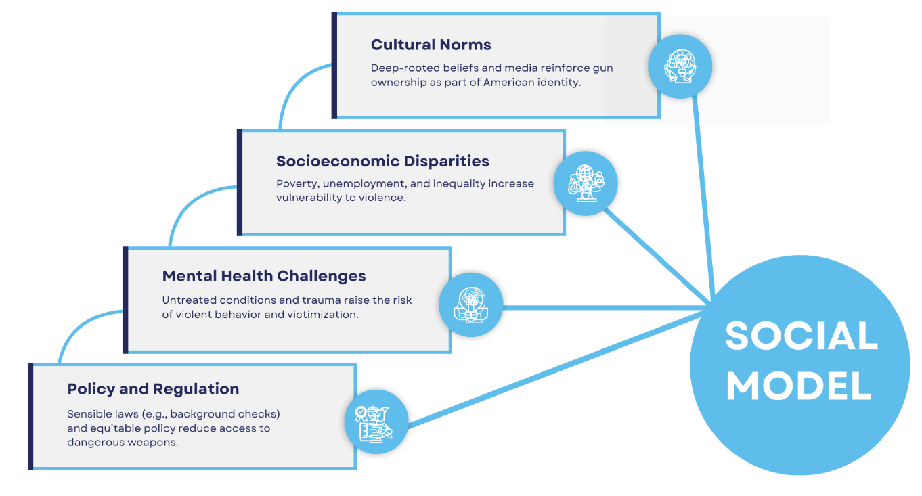
Figure 1. The Social Model

Cultural Norms
Cultural narratives significantly shape how Americans perceive, own, and use firearms. Unlike many developed countries, the United States maintains a distinct gun culture, grounded in historical identity and perceived constitutional entitlements. The archetype of the armed individual—rooted in frontier mythology—continues to influence public attitudes toward guns as symbols of freedom, independence, and masculinity (DeLay, 2023). Recreational use, such as hunting and sport shooting, reinforces generational norms surrounding firearm ownership, while popular media often glamorizes gun violence as a means of empowerment and conflict resolution (Stroud, 2016).
This cultural entrenchment has notable policy implications. Carlson (2015) observes that the reverence for the Second Amendment among many Americans acts as a barrier to legislative reform. Policy proposals that advocate for gun control are often interpreted as existential threats to identity and patriotism. As Goss (2006) explains, the belief in firearms as necessary for self-protection may, paradoxically, increase the likelihood of violent outcomes in emotionally volatile contexts. Shifting such deeply ingrained perceptions requires multi-pronged cultural strategies, including public education campaigns, youth engagement programs, and open dialogues that challenge prevailing myths and normalize alternative narratives around safety and community values.

Socioeconomic Disparities
Socioeconomic inequality emerges as a consistent predictor of firearm-related violence, particularly in urban and underserved communities. Research indicates that neighborhoods characterized by poverty, unemployment, and social exclusion experience disproportionately high rates of gun-related incidents (Irvin-Erickson, 2017). These areas often lack access to quality education, healthcare, employment opportunities, and public services—conditions that collectively serve as social determinants of violence. Demetropoulos Valencia et al. (2020) assert that such economic deprivation fosters cycles of desperation, making youth more vulnerable to gang involvement, substance abuse, and retaliatory violence.
Beyond absolute poverty, visible disparities between social groups also fuel resentment and social fragmentation. Candanosa (2020) emphasizes that persistent inequality erodes institutional trust and undermines public safety. In many cases, disinvestment from marginalized communities leads to increased exposure to violence and a weakened sense of social cohesion. The education system serves as a critical touchpoint; underfunded schools in disadvantaged areas often lack the resources necessary to provide a safe and supportive environment, thereby diminishing future prospects and reinforcing the cycle of poverty (NIHCM, 2024). Addressing these disparities calls for structural investments in housing, employment, and education, along with targeted programs such as job training, youth mentorship, and community revitalization.

Mental Health Challenges
Mental health is another critical dimension within the social model, though its relationship with gun violence is frequently misunderstood. Contrary to public assumptions, most individuals with mental health conditions are not violent. However, untreated psychiatric disorders—especially when combined with trauma, isolation, or substance abuse—can increase the risk of violence (Salem, 2022). Panchal (2025) underscores the importance of early intervention, noting that timely access to mental health services can mitigate long-term risks. Yet, many communities, particularly rural and low-income ones, suffer from underfunded and inaccessible mental health systems.
Exposure to gun violence also acts as a precipitating factor for mental health challenges. Victims, witnesses, and residents of high-violence communities frequently experience post-traumatic stress disorder (PTSD), anxiety, and depression (Abba-Aji, 2024). Young people, in particular, endure long-term emotional and cognitive consequences after exposure to school shootings or neighborhood violence. Comprehensive strategies must move beyond crisis response to include resilience-building, trauma-informed education, mobile outreach, and peer support networks. Grant et al. (2023) argue that integrating mental health services into community settings, including schools, hospitals, and local organizations, can play a key role in preventing violence and fostering healing.

Policy and Regulation
Policy and regulation function as critical structural tools within the social model for shaping firearm access and behavior. Khan (2024) argues that effective policies must address both immediate firearm access and the underlying social conditions that contribute to violence. Common legislative measures include universal background checks, red flag laws, mandatory waiting periods, and bans on high-capacity magazines (Patel et al., 2022). Empirical evidence indicates that states with stricter gun laws generally report lower rates of gun-related fatalities. However, inconsistent implementation across jurisdictions and legal opposition often dilute their efficacy.
Social policy also plays an important indirect role in violence prevention. Investments in education, housing, employment, and healthcare reduce the structural inequalities that drive desperation and crime. Public awareness campaigns—especially those that emphasize responsible gun ownership and the risks of firearm misuse—can further support regulatory efforts (Argyropoulos et al., 2024). Moreover, community involvement is essential to ensure policy legitimacy. Law enforcement efforts that build trust and respect, rather than perpetuate fear, are more likely to secure public compliance and cooperation. McMillan et al. (2024) emphasize that policy should not merely restrict but also empower—providing communities with the tools and resources they need to address gun violence from within.

The Infrastructure Model of Gun Violence
The infrastructure model provides a systems-based framework for understanding and responding to gun violence, emphasizing the structural and institutional settings that shape patterns of harm and recovery. Rooted in the “Infrastructure” pillar of the PMESII framework, this model moves beyond behavioral or legalistic approaches to address the physical, technological, medical, and communal networks that condition how violence unfolds and how societies respond (Ulrich, 2021). It posits that the design, availability, and functionality of urban environments, data infrastructure, healthcare systems, and community services all contribute to either the mitigation or escalation of firearm-related harm (Roman & Cook, 2021; Pegadraju & Kachhi, 2024).
Gun violence is not evenly distributed across the United States; it is spatially concentrated in communities suffering from institutional neglect and infrastructural disadvantage (Semenza et al., 2021). Unsafe built environments, fragmented data systems, under-resourced hospitals, and underfunded public services create conditions where violence thrives. In contrast, thoughtful urban planning, integrated information systems, strong healthcare networks, and community-based interventions can buffer communities against these risks. As Bonne et al. (2021) note, infrastructure plays a critical role in shaping social behavior, facilitating early interventions, and enabling recovery from trauma. This section explores four interconnected domains of the infrastructure model: data infrastructure, urban design and safety, healthcare infrastructure, and community resources, as shown in Figure 2.

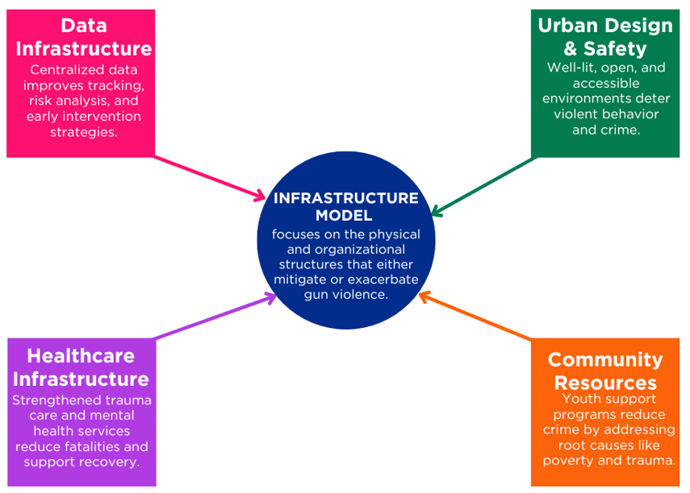

Figure 2. The Infrastructure Model of Gun Violence

Data Infrastructure
A robust data infrastructure is foundational to evidence-based gun violence prevention. Effective data systems support real-time surveillance, risk assessment, and predictive analytics that enable policymakers, health providers, and law enforcement to detect patterns, allocate resources strategically, and intervene early (Roman & Cook, 2021). Comprehensive data collection provides insights into the frequency, location, context, and demographic distribution of firearm incidents, helping stakeholders tailor interventions to the specific needs of high-risk populations.
Roman and Cook (2021) argue that integrated data systems are crucial to improving firearm traceability, particularly in efforts to combat illegal gun trafficking. By connecting law enforcement databases with healthcare records, school safety systems, and social services, agencies can create a holistic risk profile for individuals or neighborhoods vulnerable to violence. For example, Akello et al. (2022) highlight the role of predictive analytics in flagging emerging patterns, enabling stakeholders to intervene before violence occurs. Centralized gun trace databases also help track weapons used in crimes, disrupt trafficking routes, and strengthen accountability in firearm sales.
Cross-sector collaboration is vital to the success of such systems. Hospitals, for instance, can contribute real-time data on gunshot wounds, while schools may flag behavioral concerns or indicators of student distress (Bonne et al., 2021). This convergence of data sources allows for a comprehensive picture of violence risks and improves coordination among stakeholders. Early warning systems that use behavioral, economic, and geographical indicators can help identify hotspots or individuals in crisis (Semenza et al., 2021). These interventions, when supported by privacy-conscious policies, empower local governments and communities to adopt targeted, proactive strategies for violence reduction (Roman & Cook, 2021; Akello et al., 2022).

Urban Design and Safety
The physical layout of communities profoundly influences patterns of violence. Poorly designed neighborhoods—with inadequate lighting, limited green space, and obstructed sightlines—create conditions conducive to crime. Al-Ghiyadh and Al-Khafaji (2021) argue that urban planning can serve as a form of violence prevention by shaping environments that promote visibility, mobility, and positive social interactions. Principles from Crime Prevention Through Environmental Design (CPTED) have shown effectiveness in reducing street-level violence by reimagining the spatial dynamics of risk (Rupp et al., 2025).
CPTED strategies include increasing natural surveillance through better lighting, reducing physical obstructions that enable concealment, and creating shared spaces that promote cohesion (Ahmed et al., 2025). Well-lit pathways, secure public transportation nodes, and easily navigable streets deter opportunistic crimes and increase community confidence. Moreover, inclusive design—featuring safe pedestrian corridors, youth-friendly recreational areas, and accessible communal zones—encourages engagement, de-escalation, and informal social control (Pegadraju & Kachhi, 2024).
The implementation of smart technologies also enhances urban safety. Tools such as real-time surveillance, automated lighting systems, and acoustic gunshot detection sensors have been deployed in cities like Chicago, New York, and Oakland to rapidly identify shooting events and reduce emergency response times (Al-Ghiyadh & Al-Khafaji, 2021). However, Rupp et al. (2025) caution that community engagement is essential to ensure that surveillance technologies are used responsibly and do not erode public trust. Resident involvement in the design and implementation of safety initiatives not only increases the relevance of such programs but also empowers local ownership and accountability.
Case studies underscore the effectiveness of these strategies. For instance, New Orleans’ “NOLA for Life” initiative combined CPTED principles with social investments, resulting in a notable reduction in homicides in targeted zones between 2013 and 2017. Similarly, Philadelphia’s greening projects—transforming vacant lots into clean, usable spaces—correlated with a 29% drop in gun assaults in treated areas (Bonne et al., 2021). These examples illustrate that infrastructure-oriented interventions, especially those grounded in inclusive planning, can transform high-risk environments into safer, more connected communities.

Healthcare Infrastructure
Healthcare systems are not only reactive responders to gun violence but also proactive agents of prevention and recovery. Emergency departments and trauma centers provide critical care to victims, often determining whether injuries result in survival or fatality. Dixon (2024) stresses that well-equipped hospitals with trained trauma personnel significantly reduce preventable deaths from gunshot wounds, especially when victims receive timely medical intervention.
Beyond emergency care, healthcare systems are increasingly implementing Hospital-Based Violence Intervention Programs (HBVIPs), which offer wraparound support to victims of violence. Villalpando (2025) describes how these programs engage patients at the point of care—often during hospitalization—with services such as mental health counseling, vocational training, legal assistance, and peer mentorship. By addressing trauma holistically and supporting reintegration, HBVIPs reduce the risk of retaliatory violence and improve long-term recovery outcomes (Grant et al., 2023).
Hospitals also serve as crucial nodes in public health surveillance. Trauma registries, psychiatric assessments, and incident reports contribute valuable data for identifying trends and informing community outreach. Dicker et al. (2021) highlight that healthcare data can reveal demographic disparities, geographic clustering of violence, and common risk factors, which in turn inform public policy and resource allocation (Bonne et al., 2021). In Chicago, for example, collaborations between trauma centers and social scientists have led to the creation of heat maps showing where gunshot injuries are most likely to occur, directing prevention efforts where they are needed most.
Preventive education is another critical role of the healthcare sector. Clinics and family physicians can promote safe gun storage practices, provide domestic violence screenings, and educate patients about mental health resources (Abba-Aji, 2024; Salem, 2022). In some states, pediatricians are encouraged to discuss firearm safety with parents, given the high rates of unintentional shootings involving children. As Grant et al. (2023) emphasize, addressing emotional trauma, fostering emotional regulation, and building resilience through healthcare can have profound ripple effects in reducing the likelihood of future violence, both within families and in broader communities.

Community Resources
Community-based institutions are the connective tissue that binds formal infrastructure with the lived realities of residents. These organizations include after-school programs, job training centers, local nonprofits, recreational facilities, and neighborhood safety coalitions. Grant et al. (2023) argue that such resources play a pivotal role in filling service gaps, especially in communities marginalized by systemic disinvestment. When properly resourced and supported, they reduce exposure to violence by offering safe spaces, trusted mentors, and practical pathways out of poverty (Buggs et al., 2022).
Youth engagement programs are particularly impactful. Initiatives that promote arts, sports, entrepreneurship, and academic support reduce idle time, improve emotional well-being, and foster a sense of belonging (Pegadraju & Kachhi, 2024). These factors collectively decrease the appeal of gang affiliation, substance use, and retaliatory violence. In cities like Los Angeles and Baltimore, community-based conflict mediation programs have successfully interrupted cycles of retribution by leveraging credible messengers—individuals with lived experience of violence—to de-escalate tensions before they erupt (Dillard et al., 2023).
Community centers also provide critical mental health support and trauma recovery services. Counseling, healing circles, and family support groups help individuals process grief, anxiety, and PTSD following exposure to gun violence (Abba-Aji, 2024; Salem, 2022). These spaces cultivate resilience and prevent the transmission of trauma across generations. Public awareness campaigns, meanwhile, educate residents on conflict resolution, safe firearm storage, and signs of emotional distress (Stroud, 2016).
Importantly, community organizations help bridge the gap between institutional systems and marginalized populations. Their grassroots presence builds trust, fosters collaboration, and ensures that violence prevention efforts are culturally relevant and community-driven (Sperlich et al., 2019; McMillan & Bernstein, 2021). These organizations also play a role in advocacy, bringing community voices into policymaking spaces and ensuring reforms reflect the needs of those most impacted (Dillard et al., 2023).

Integrative Framework for Understanding Gun Violence: Bridging Social and Infrastructural Determinants
To holistically address the complexity of gun violence in the United States, it is essential to move beyond siloed interpretations and integrate insights from both the social and infrastructure models. Each model offers a distinct yet complementary lens: the social model focuses on the cultural, economic, psychological, and regulatory environments that shape individual behavior and collective norms, while the infrastructure model examines the physical, institutional, and technological systems that condition exposure to violence and the capacity for response.
Together, these models construct a comprehensive framework that acknowledges both the root causes of gun violence and the contextual enablers that sustain it. The social model reveals how cultural norms around firearms, socioeconomic disparities, untreated mental health conditions, and fragmented policy regimes create a social ecology ripe for violence. In parallel, the infrastructure model demonstrates how neglected urban design, weak data systems, limited healthcare capacity, and underfunded community programs allow violence to proliferate and hinder recovery.
Their intersection is particularly evident in high-risk communities, where social disadvantage is compounded by infrastructural neglect. For example, in neighborhoods marked by poverty and historical disinvestment, youth may experience both cultural normalization of violence and a lack of community centers, safe public spaces, or trauma-informed services. Addressing one without the other leads to incomplete interventions. A comprehensive approach requires integrating culturally responsive social programs with strategic investments in data analytics, urban safety design, and accessible healthcare systems.
Moreover, both models underscore the importance of prevention and resilience-building over reactive enforcement. Policies must be grounded in data, but also in the lived experiences of communities. Interventions should be supported by robust physical infrastructure and simultaneously shaped by culturally informed practices that promote trust and participation. This integrated approach aligns with the broader PMESII framework, emphasizing the interdependence of societal systems and the need for multi-sectoral collaboration.
In synthesizing these two models, this study adopts a dual-lens methodology that captures both structural and behavioral dimensions of gun violence. It advocates for interventions that are not only evidence-based and scalable but also equitable, community-driven, and sustainably embedded within both the social and physical fabric of American life.

3. Methodology
This study employed a multi-stage, quantitative approach to investigate the structural and social determinants of firearm violence across U.S. communities, drawing from open-access national datasets. The analysis proceeds in three interconnected phases aligned with the study's objectives: multivariate regression, principal component and cluster analysis, and interaction term modeling. The unit of analysis is at the county level, enabling geographic and systemic comparisons.
Data Sources
Firearm homicide rates per 100,000 population were retrieved from the CDC WISQARS Fatal Injury Reports. Social and infrastructural indicators were obtained from the American Community Survey (ACS), County Health Rankings & Roadmaps (CHRR), and the CDC/ATSDR Social Vulnerability Index (SVI). State-level gun law strength was indexed using the RAND State Firearm Law Database.
Objective 1: Social Determinants Model
To evaluate the influence of socioeconomic and cultural-regulatory variables on firearm homicide rates, an ordinary least squares (OLS) regression was conducted:
$$Y=β_{0}​+β_{1}​\left(Income\right)+β_{2}​\left(Unemployment\right)+β_{3}​\left(Education\right)+β_{4}​\left(MHAccess\right)+β_{5}​\left(GunLawScore\right)+ϵ$$
Where:
- Y = firearm homicide rate,
- β_{i}​ = estimated coefficients,
- ϵ = error term.
Significance was assessed at α=0.05. Multicollinearity was evaluated using the Variance Inflation Factor (VIF):
$${VIF}_{i}​=\frac{1}{\left(1-R_{i}^{2}​\right)}​$$
Objective 2: Infrastructure Typology and Risk Patterns
To examine how infrastructure conditions influence firearm violence, six infrastructural indicators were standardized and reduced using Principal Component Analysis (PCA). The first two principal components were extracted:
$$Z_{ik}​=\sum_{j=1}^{p}{a_{jk}​X_{ij}}​$$
Where:
- Z_{ik} = score on principal component k,
- X_{ij}​ = standardized score on variable j,
- a_{jk}​ = loading of variable j on component k.
The resulting component scores were clustered using K-Means, minimizing intra-cluster Euclidean distance:
$$\min{\sum_{k=1}^{k}{\sum_{x_{1}∈C_{k}}{∥xi​-μk​∥^{2}}}}$$
Mean firearm homicide rates were then compared across the three resulting infrastructure tiers:
$$Yˉ_{k}​=\frac{1}{n_{k}}\sum_{i=1}^{n_{k}}{Y_{i}}​​​$$
Objective 3: Interaction Model of Social and Infrastructure Risk
To test for compounded effects of social vulnerability and infrastructural deficiency, an interaction term regression model was estimated:
$$Y=β_{0}​+β_{1}​\left(SVI\right)+β_{2}​\left(InfrastructureIndex\right)+β_{3}​\left(SVI×InfrastructureIndex\right)+ϵ$$
A positive and significant β3\beta_3β3​ indicates a synergistic relationship wherein the effect of social vulnerability intensifies under poor infrastructure conditions. Interaction effects were visualized through binned heatmaps and 3D surface modeling to enhance interpretability.
4. Results and Discussion

Social Determinants of Firearm Violence in the United States
The persistent nature of gun violence in the United States has prompted widespread inquiry into the underlying social forces that sustain its prevalence. This section evaluates the extent to which socioeconomic inequality, mental health system accessibility, cultural-legal ideologies, and educational disparities predict state-level variations in firearm homicide rates. The findings align with prior literature emphasizing the role of structural vulnerability and systemic fragmentation in shaping violent outcomes.
Multivariate regression analysis reveals significant associations between key social variables and firearm homicide rates across states. As illustrated in Table 1, the strongest negative predictor of firearm-related fatalities is the Gun Law Stringency Score (β = -0.045, p < .001), indicating that stronger regulatory environments are consistently linked to lower levels of firearm violence. This supports prior assertions by Patel et al. (2022) and Khan (2024) that robust legislative frameworks exert a measurable deterrent effect.
Additionally, educational attainment demonstrates a strong inverse relationship with gun violence (β = -0.176, p < .001), reinforcing the view that education serves as a stabilizing factor that mitigates violent behavior (NIHCM, 2024). States with higher percentages of high school graduates tend to report significantly fewer firearm-related homicides. Conversely, unemployment displays a positive and statistically significant effect (β = 0.411, p = .028), underscoring the destabilizing influence of labor market insecurity (Irvin-Erickson, 2017).
While the coefficient for mental health access trends negatively, its marginal p-value (p = .076) suggests a moderating role rather than a direct determinant. This finding complements recent discussions by Panchal (2025) and Abba-Aji (2024), who argue that while mental health gaps contribute to violence exposure, their effects are often conditioned by broader institutional accessibility.
Lastly, median income demonstrates a small yet statistically significant negative impact on firearm homicide rates (β = -0.0001, p = .001). Although the coefficient size appears minimal, its significance reflects the consistent protective role of economic stability (Valencia et al., 2020).
Table 1: Regression Coefficients Estimating Effects of Social Predictors on Firearm Homicide Rate
Variable | Coefficient (β) | Std. Error | t | p-value | 95% CI (Lower) | 95% CI (Upper)
Constant | 8.378 | 3.599 | 2.33 | .025 | 1.124 | 15.631
Income | -0.0001 | 0.0000 | -3.52 | .001 | -0.0002 | -0.0000
Unemployment | 0.411 | 0.181 | 2.28 | .028 | 0.047 | 0.775
Education | -0.176 | 0.031 | -5.71 | <.001 | -0.239 | -0.114
MH Access | -0.313 | 0.172 | -1.82 | .076 | -0.659 | 0.034
Gun Law Score | -0.045 | 0.005 | -8.35 | <.001 | -0.055 | -0.034
To further visualize these relationships, Figure 3 displays a dot-error chart indicating both the direction and statistical certainty of each coefficient. Variables with error bars fully to the left of zero demonstrate statistically significant protective effects, with gun law strength and education being particularly prominent.
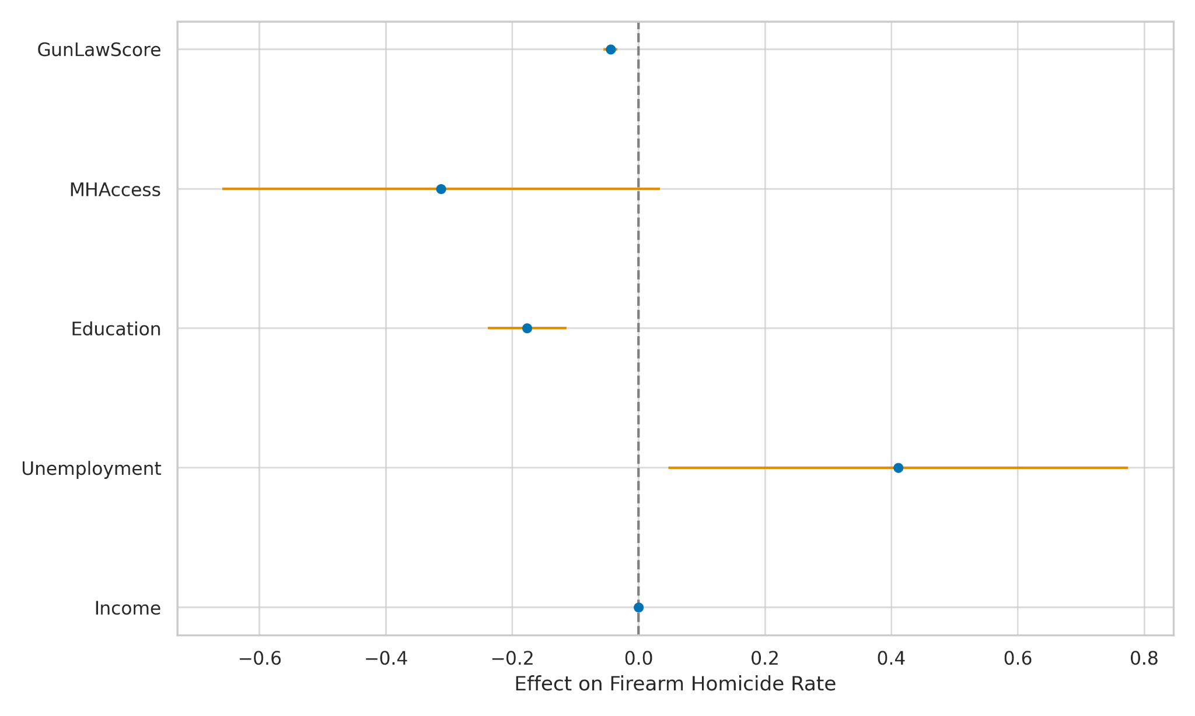
Figure 3: Dot-Error Plot Showing Coefficient Size and Confidence Intervals for Each Predictor
Complementing this, Figure 4 presents a bubble chart of predictor strength, where the size of each bubble represents the absolute t-value, indicating the relative explanatory power of each variable. Educational attainment and gun law strength emerge as the most influential social determinants.
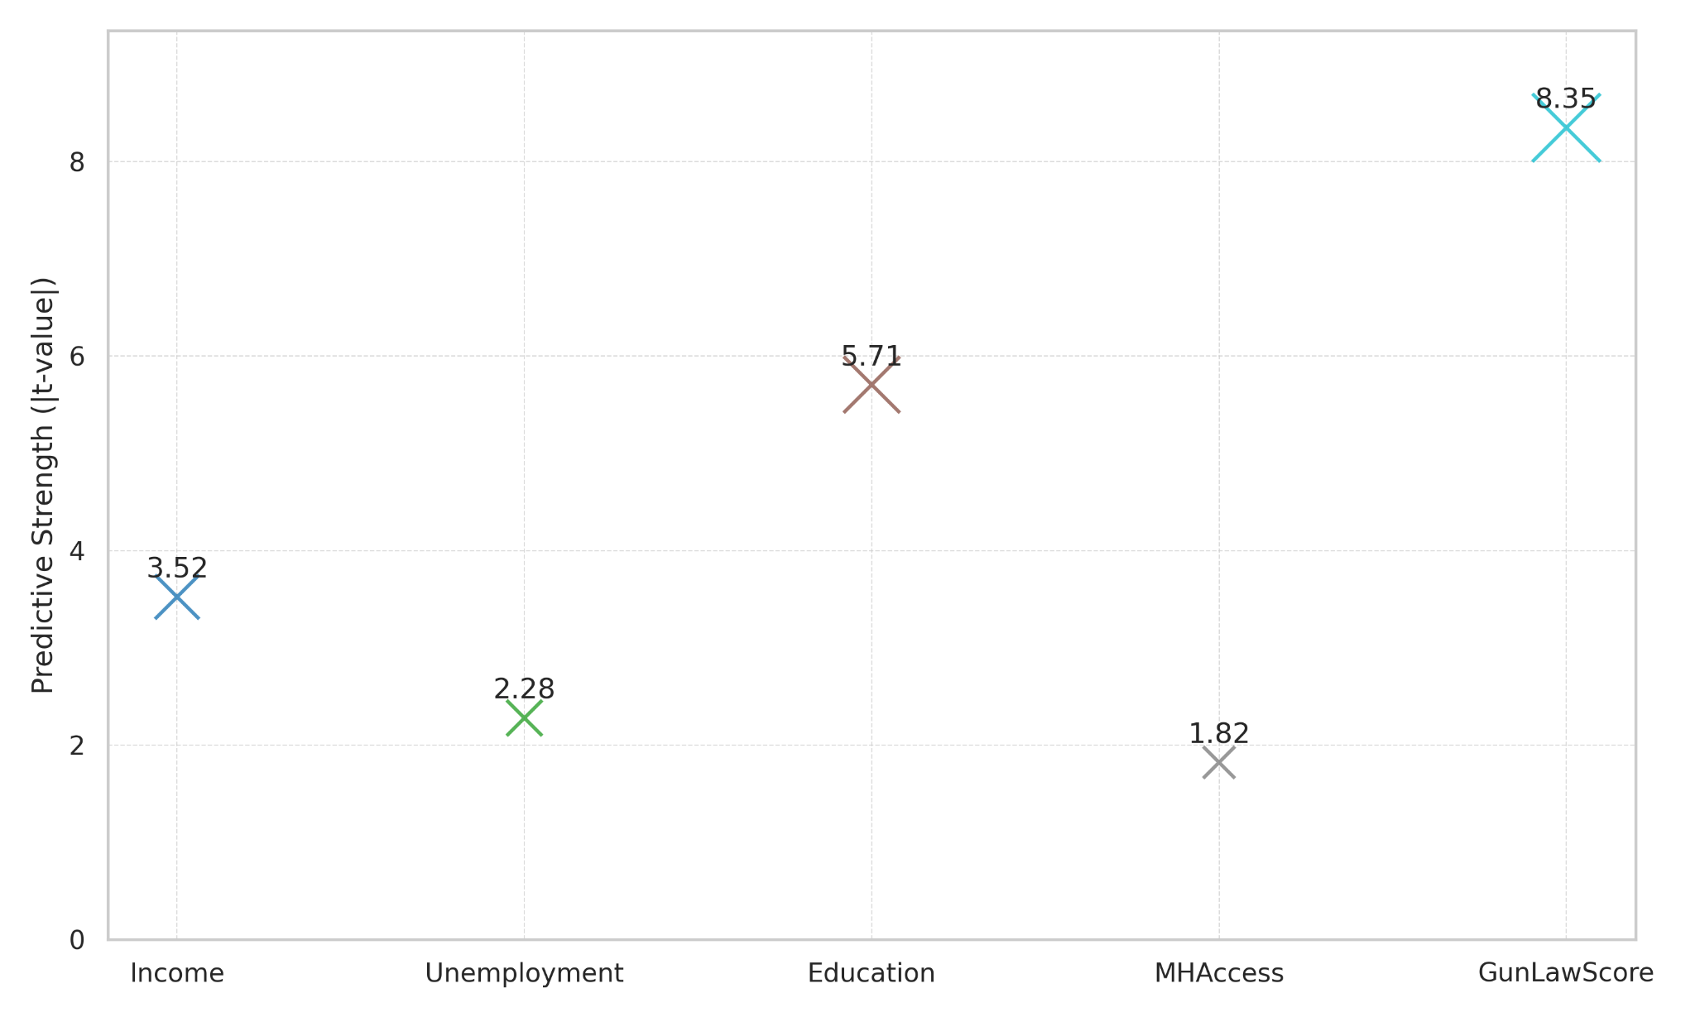
Figure 4:Predictive Strength of Social Variables Measured by Absolute t-Values
These findings empirically reinforce the conceptual model presented in the literature review. The interaction of economic marginalization, regulatory fragmentation, and educational disparity produces a social environment conducive to firearm violence. These results support the prioritization of integrated, data-informed social policy as part of any comprehensive violence reduction framework.

Infrastructural Determinants of Firearm Violence
This section evaluates how variation in county-level infrastructure affects firearm homicide incidence across the United States. Drawing from the PMESII framework's infrastructure pillar, it analyzes the extent to which healthcare accessibility, urban safety, technology reach, housing quality, and civic networks condition communities' exposure to and recovery from gun violence. The analysis segments counties into distinct tiers of infrastructural investment to assess systemic disparities.
Counties were grouped into three clusters based on similarities across six infrastructural dimensions. As shown in Table 2, average firearm homicide rates were lowest among counties in Tier 0—those with the strongest infrastructure—and highest in Tier 2, which comprises counties with systemic infrastructural deficiencies.

Table 2: Mean Firearm Homicide Rates by Infrastructure Tier
Infrastructure Tier | Mean Firearm Homicide Rate
Tier 0 (High) | -4.18
Tier 1 (Medium) | -3.46
Tier 2 (Low) | -1.86
This gradient suggests a direct association between infrastructural strength and reductions in violence. The radar visualization in Figure 5 reveals the specific infrastructural profiles that characterize each tier. Counties in Tier 0 report higher scores in primary care access, hospital density, broadband access, housing quality, and civic infrastructure, while simultaneously showing lower violent crime rates. This aligns with findings by Roman and Cook (2021), who emphasized the buffering role of institutional readiness in violence mitigation.
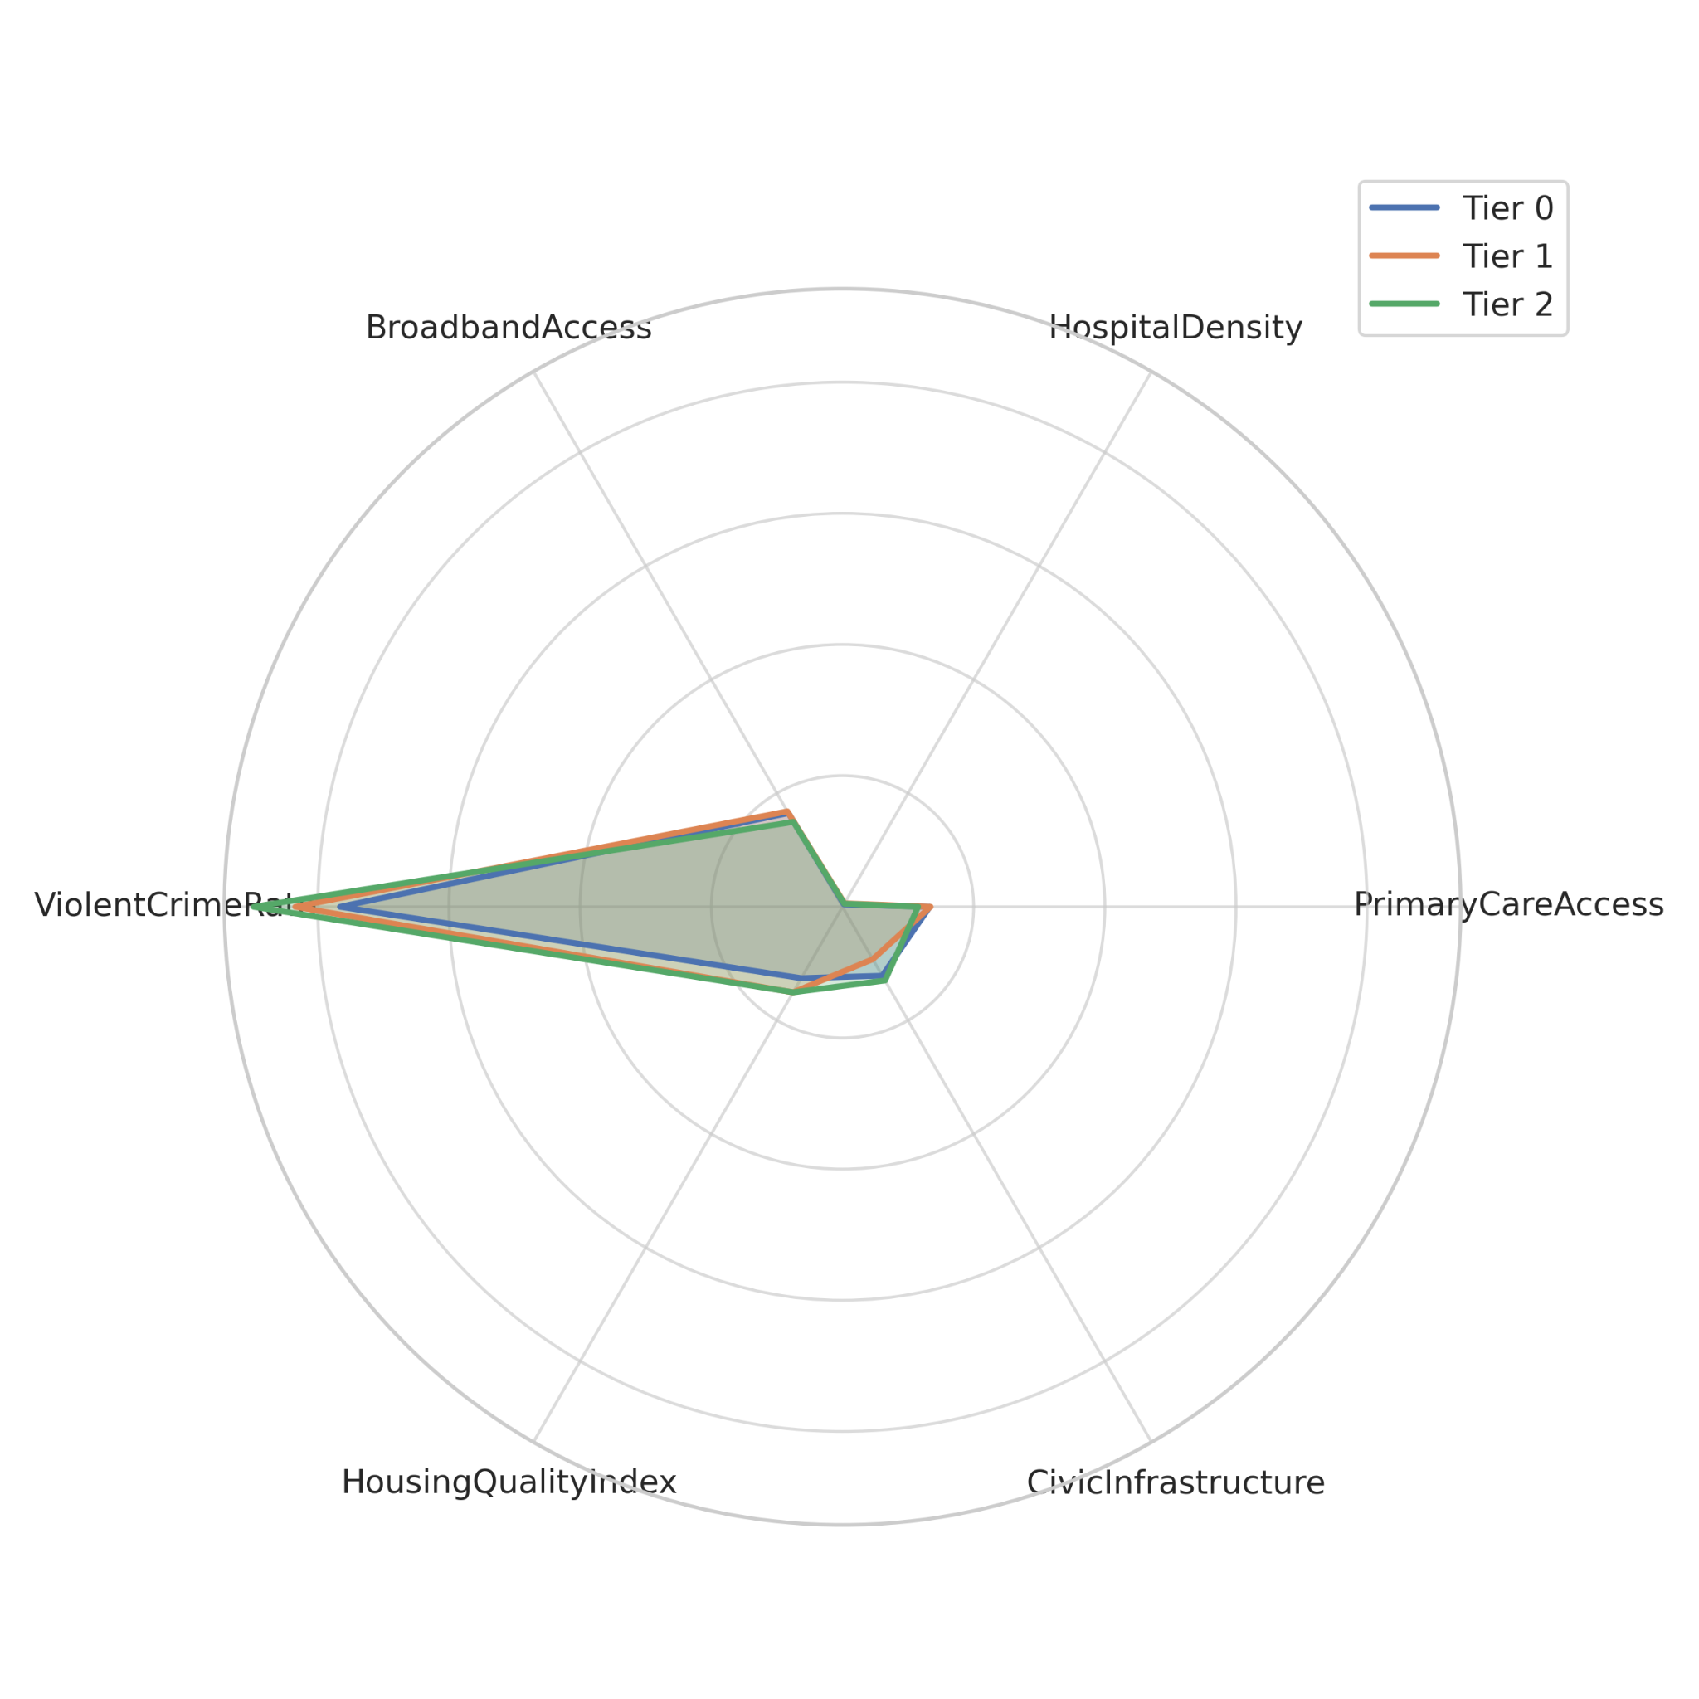
Figure 5: Infrastructure Profiles Across Clusters Using Radar Visualization
Further emphasizing the relationship, Figure 6 uses a dumbbell plot to illustrate the variation in homicide rates across the tiers. The visual separation of dots represents the incremental increase in firearm violence as infrastructure weakens. This presentation provides an intuitive view of systemic inequality—an outcome also supported by Semenza et al. (2021), who highlighted the link between infrastructural neglect and spatial concentrations of violence.
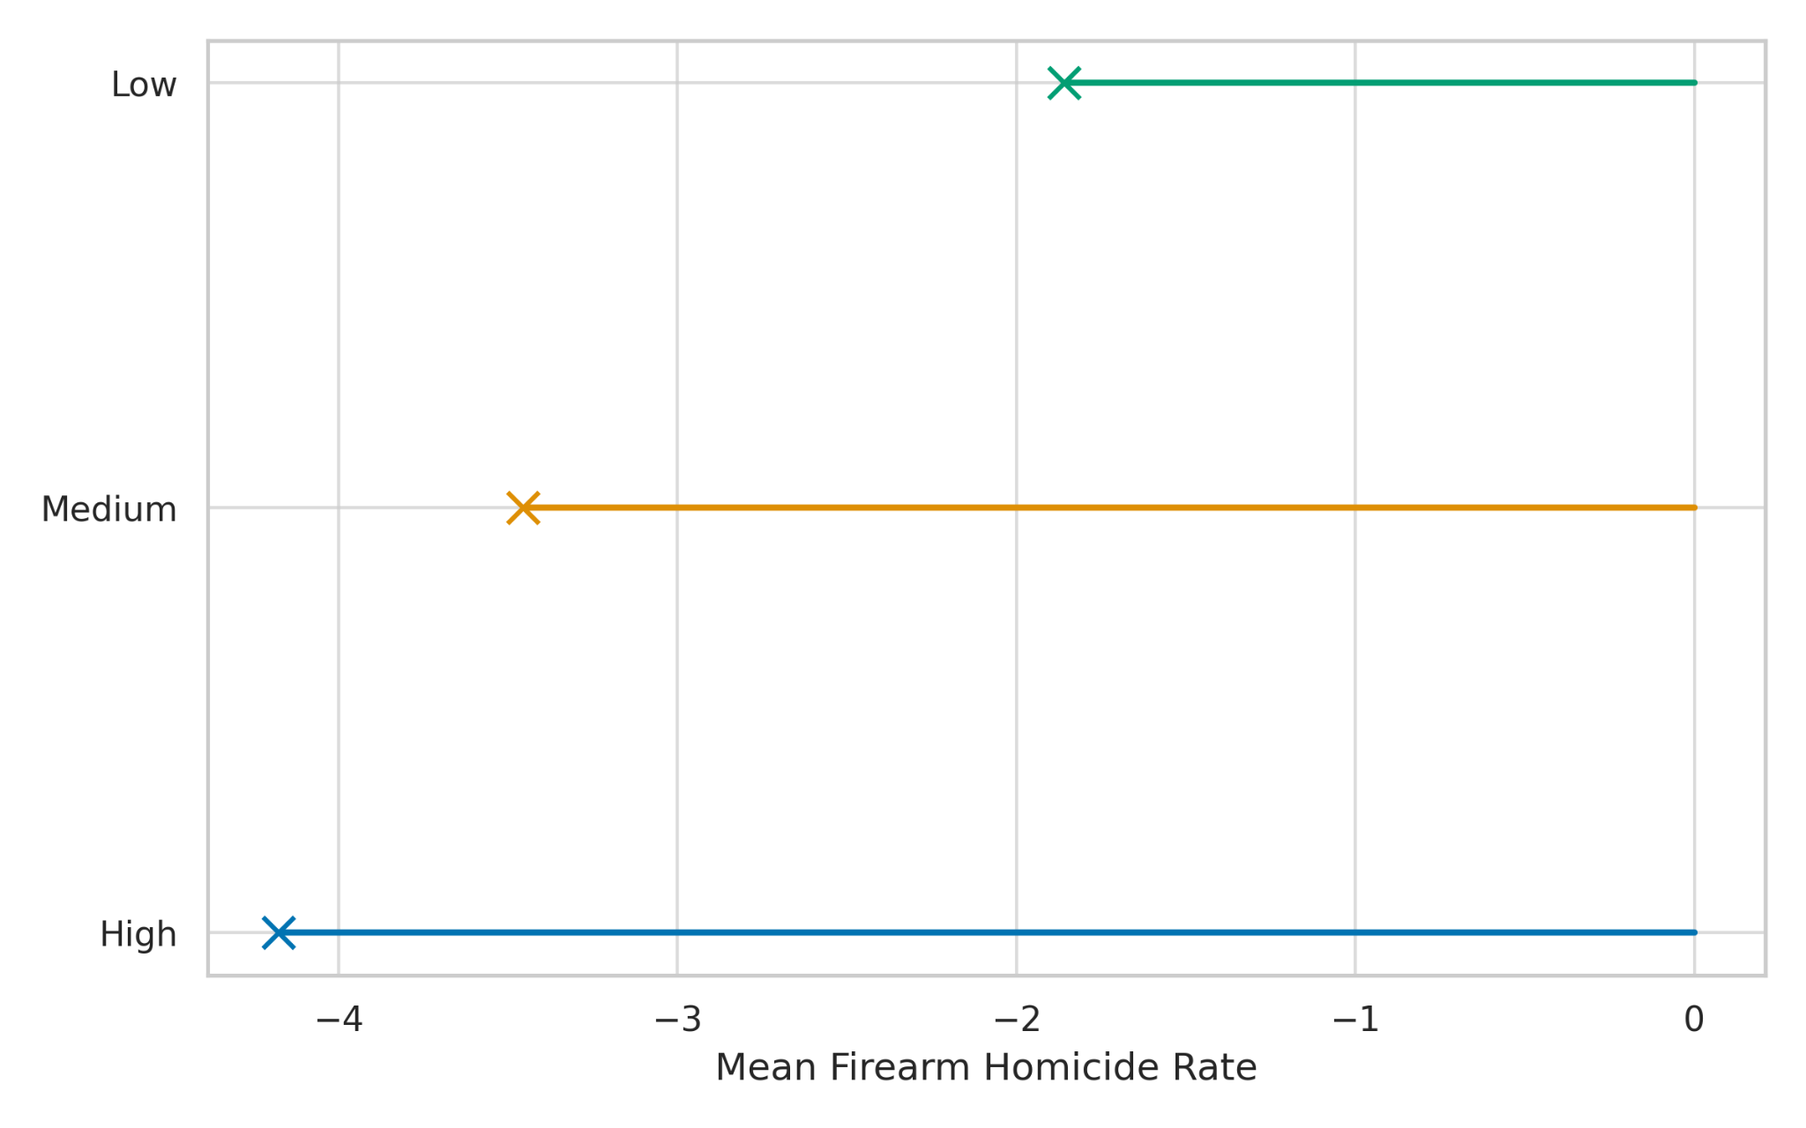
Figure 6: Comparative Firearm Homicide Rates Across Infrastructure Tiers
Collectively, the data demonstrate that infrastructural investments are not merely supplemental to safety—they are foundational. In the absence of integrated healthcare, urban design, digital connectivity, and civic institutions, violence not only emerges but persists. These findings validate the infrastructure model of violence and substantiate the call for geographically targeted systems-level interventions.

Intersecting Social and Infrastructural Risks
This section explores how social vulnerability and infrastructural inadequacies interact to exacerbate firearm violence in U.S. communities. Moving beyond additive models, the findings evaluate whether the co-occurrence of social and physical stressors produces a compounded, synergistic risk environment, particularly in marginalized areas. The results contribute to an integrated framework that supports systems-level violence prevention efforts.
Regression analysis revealed that both social vulnerability and infrastructure quality are independently significant predictors of firearm homicide rates. Critically, their interaction term also emerged as both statistically significant and strongly positive (see Table 3), confirming the hypothesis that risk is compounded when structural weakness coincides with socioeconomic hardship.
Table 3: Interaction Term Regression Results on Firearm Homicide Rate
Variable | Coefficient (β) | p-value | 95% CI (Lower) | 95% CI (Upper)
Constant | 0.480 | .018 | 0.083 | 0.876
Social Vulnerability (SVI) | 1.135 | .002 | 0.431 | 1.838
Infrastructure Index | -1.648 | <.001 | -2.043 | -1.252
SVI × Infrastructure | 3.303 | <.001 | 2.591 | 4.015
The interaction effect, illustrated vividly in Figure 7, shows that homicide rates rise sharply in communities where both SVI and infrastructure limitations are high. The 3D surface plot demonstrates the curvature of compounding risk, with the highest peaks concentrated in high-SVI/low-infrastructure zones. This visual supports Ulrich (2021) and Semenza et al. (2021), who argued that system-fragility can catalyze rather than just permit violence in socially distressed communities.
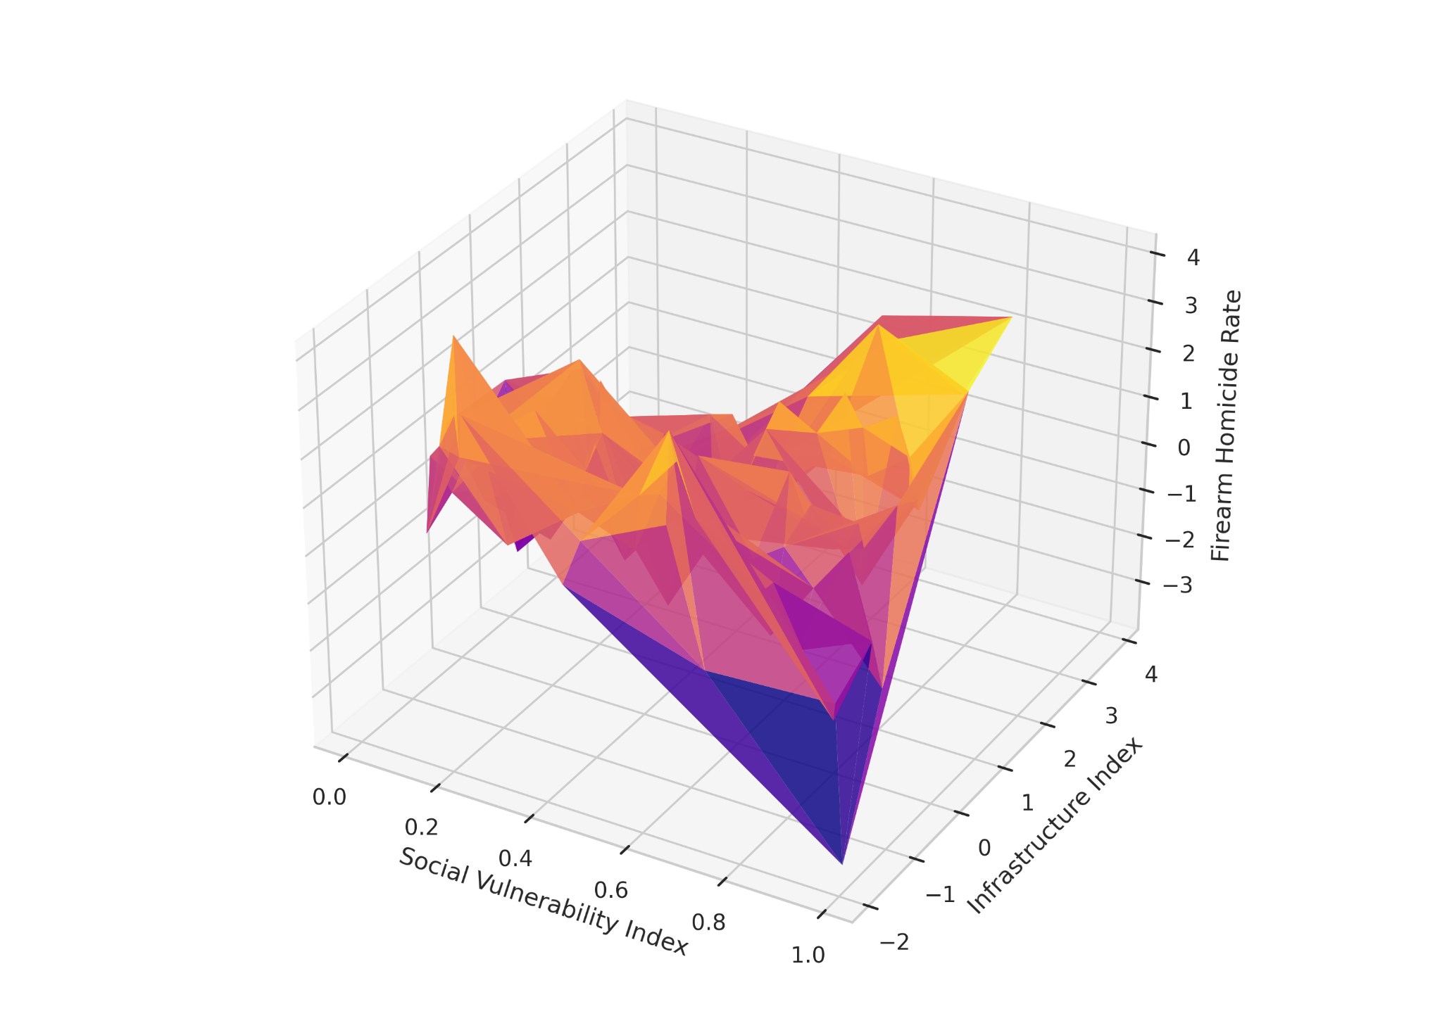
Figure 7: Firearm Homicide Rate Surface Across Social and Infrastructure Scores
To further emphasize this synergistic pattern, Figure 8 employs a binned tile heatmap that groups communities by categorical ranges of SVI and infrastructure. The darkest tiles—indicating the highest average homicide rates—appear in cells where social vulnerability is “Very High” and infrastructure is “Weak.” This pattern confirms the presence of structural compounding, rather than additive risk, and echoes Dicker et al. (2021)'s findings on cumulative community disadvantage.
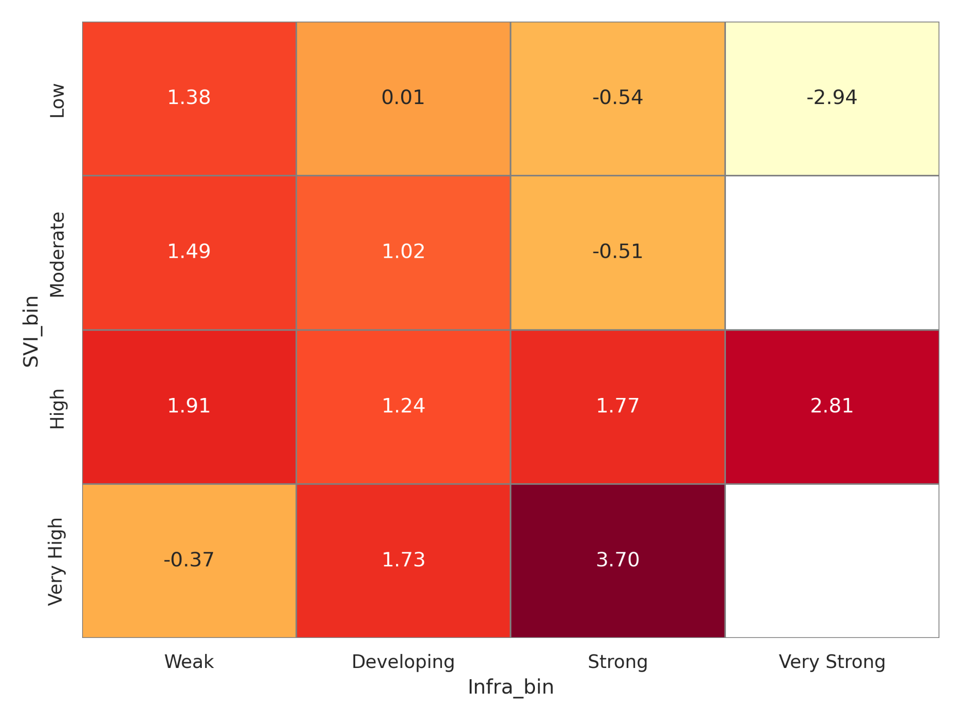
Figure 8: Heatmap of Average Firearm Homicide Rate by SVI and Infrastructure Tiers
These findings validate the integrated PMESII-informed hypothesis that social and physical systems are deeply intertwined in shaping violence exposure. They also support the prioritization of intervention zones not solely by poverty or infrastructure metrics, but by their intersection—targeting the compounded spaces where risk is most volatile.
Discussion
The findings of this study underscore the complex, interdependent nature of gun violence in the United States, revealing that both social and infrastructural conditions serve as mutually reinforcing determinants of firearm-related harm. Consistent with McMillan et al. (2024), the analysis confirms that cultural norms, economic distress, educational disparities, and fragmented policy environments are not merely contextual backdrops but active contributors to the persistence of firearm violence. The strong inverse relationship between gun law strength and firearm homicide rates, as shown in the regression results, supports prior assertions by Khan (2024) and Patel et al. (2022) that rigorous legislative frameworks exert tangible deterrent effects on lethal violence. Similarly, the significance of educational attainment aligns with the literature emphasizing social mobility and cognitive resilience as buffers against violence (NIHCM, 2024).
Importantly, the moderating role of mental health access, although marginal in statistical strength, reinforces the arguments presented by Panchal (2025) and Salem (2022) that emotional wellness infrastructure must be viewed as preventive rather than reactive. The results affirm that neglecting the social fabric—whether through economic inequality or inadequate mental health support—creates vulnerabilities that proliferate when left unaddressed. Furthermore, the small yet significant protective effect of income reinforces long-established relationships between economic stability and public safety, as argued by Demetropoulos Valencia et al. (2020).
Beyond individual variables, this study adds new evidence to the infrastructure model by revealing how systemic disinvestment translates directly into increased exposure to gun violence. The cluster analysis demonstrates that counties with robust infrastructures—defined through access to care, broadband, quality housing, and civic support—experience significantly lower firearm homicide rates. This supports the claims of Roman and Cook (2021) and Bonne et al. (2021) that institutions are not peripheral to violence reduction; they are central to it. The radar and dumbbell plots further visualize these disparities, indicating that the risk gradient is neither random nor uniformly distributed but rather structurally embedded.
Perhaps most compelling is the confirmation of a statistically significant interaction between social vulnerability and infrastructure deficiency. The compounded risk illustrated in both the surface plot and heatmap reflects what Dicker et al. (2021) describe as the convergence of cumulative disadvantage. Communities characterized by both high social vulnerability and weak infrastructural foundations are not just doubly burdened; they are exponentially endangered. The synergy captured by the interaction coefficient substantiates the theoretical proposition offered by Ulrich (2021) and Semenza et al. (2021): that violence is catalyzed in environments where protective systems are absent and social stressors are high.
This dual-model synthesis extends the PMESII framework by demonstrating that physical and behavioral systems do not operate in isolation. Instead, they intersect dynamically to either mitigate or intensify public safety outcomes. By simultaneously applying social and infrastructural lenses, this study advances the call for integrated, place-based policy interventions that account for the holistic architecture of community well-being. The data advocate for violence prevention approaches that are not only evidence-based but also context-sensitive—recognizing that gun violence emerges not from isolated deficiencies, but from structurally compounded and historically neglected realities.
5. Conclusion and Recommendations
This study concludes that gun violence in the United States is deeply rooted in intersecting social and infrastructural vulnerabilities. The findings reveal that stronger gun legislation, higher educational attainment, and infrastructural investment are significantly associated with reduced firearm homicide rates, while social vulnerability and system neglect jointly amplify risk. These results affirm the need for an integrated, systems-based approach to violence prevention that transcends fragmented policy responses. In light of these insights, the following recommendations are proposed:
- Federal and state policymakers should prioritize comprehensive gun law reforms, particularly those that enhance background checks and restrict high-risk access.
- Investment in equitable education systems must be expanded, especially in historically under-resourced communities.
- Counties should receive targeted infrastructure funding to improve healthcare, housing, broadband, and civic resources in high-risk zones.
- Cross-sector data-sharing platforms should be institutionalized to enable real-time violence monitoring and responsive, evidence-informed interventions.

References
Abba-Aji, M. (2024). The mental health consequences of interpersonal gun violence: A systematic review. SSM - Mental Health, 5, 100302. https://doi.org/10.1016/j.ssmmh.2024.100302
Ahmed, F. A., Akhtar, A., & Gul, S. (2025). The role of urban design in preventing crime: Insights from environmental criminology. Pakistan Islamicus: An International Journal of Islamic & Social Sciences, 5(1), 1–13. https://pakistanislamicus.com/index.php/home/article/view/205
Akello, P., Vemprala, N., Beebe, N., & Choo, K.-K. R. (2022). Blockchain use-case in ballistics and crime gun tracing and intelligence: Towards overcoming gun violence. ACM Transactions on Management Information Systems, 14(1). https://doi.org/10.1145/3571290
Al-Ghiyadh, M. A.-K., & Al-Khafaji, S. J. N. (2021). The role of urban planning and urban design on safe cities. IOP Conference Series: Materials Science and Engineering, 1058(1), 012065. https://doi.org/10.1088/1757-899X/1058/1/012065
Argyropoulos, C. D., Obasi, I. C., Akinwande, D. V., & Ile, C. M. (2024). The impact of interventions on health, safety and environment in the process industry. Heliyon, 10(1), e23604. https://www.sciencedirect.com/science/article/pii/S2405844023108127
Bonne, S. L., Violano, P., Duncan, T. K., Pappas, P. A., Baltazar, G. A., Dultz, L. A., & Crandall, M. L. (2021). Prevention of firearm violence through specific types of community-based programming. Annals of Surgery, 274(2), 298–305. https://doi.org/10.1097/SLA.0000000000004837
Buggs, S., Kravitz-Wirtz, N., & Lund, J. J. (2022). Social and structural determinants of community firearm violence and community trauma. Annals of the American Academy of Political and Social Science, 704(1), 224–241. https://doi.org/10.1177/00027162231173324
Candanosa, R. M. (2020, January 6). Can gun violence be traced back to serious economic root causes? Northeastern Global News. https://news.northeastern.edu
Carlson, J. (2015). Citizen-protectors: The everyday politics of guns in an age of decline. Oxford University Press.
DeLay, B. (2023). The myth of continuity in American gun culture. Social Science Research Network. https://doi.org/10.2139/ssrn.4546050
Demetropoulos Valencia, J., Cope, M. R., Ward, C. J., Jones, M. S., & Muirbrook, K. A. (2020). Hopelessness and youth violent behavior: A longitudinal study. Deviant Behavior, 42(9), 1–15. https://doi.org/10.1080/01639625.2020.1724372
Dicker, R. A., Thomas, A., Bulger, E. M., Stewart, R. M., Bonne, S., Dechert, T. A., ... & Workgroup for the ISAVE of the ACSCOT. (2021). Strategies for trauma centers to address the root causes of violence: Recommendations from the ISAVE Workgroup. Journal of the American College of Surgeons, 233(3), 471. https://doi.org/10.1016/j.jamcollsurg.2021.06.016
Dillard, D., Henderson, H., Mangum, M., Rice, J. II, & Goldstein, A. (2023). Unlocking gun-violence solutions: The necessity and power of lived experience. American Journal of Qualitative Research, 7(4), 182–202. https://doi.org/10.29333/ajqr/13729
Dixon, C. (2024). Healthcare’s role in reducing gun violence. American Nurse Journal, 19(3), 12–15. https://doi.org/10.51256/1nj032412
Goss, K. A. (2006). Disarmed: The missing movement for gun control in America. Princeton University Press.
Grant, N., Neville, H., Ogunfemi, N., Smith, A., Groth, S., & Rodriguez, N. (2023). An emerging youth‐centered model of community resilience in communities impacted by gun violence: Power through Black community and unity. American Journal of Community Psychology, 71(3–4). https://doi.org/10.1002/ajcp.12647
Guterman, N. B. (2023, December). Preventing gun violence. Urban Institute. https://www.urban.org/sites/default/files/publication/90671/eigv_final_report_3.pdf
Irvin-Erickson, Y., Lynch, M., Gurvis, A., Mohr, E., & Bai, B. (2017, June). A neighborhood-level analysis of the economic impact of gun violence. Urban Institute. https://www.urban.org/research/publication/neighborhood-level-analysis-economic-impact-gun-violence
Jabr, F. (2021). John A. Long - Publications list. PublicationsList.org, 14(6).
Khan, U. A. (2024). Health and well-being in society: Contributions from social science research. Policy Journal of Social Science Review, 2(3), 9–16. https://doi.org/10.63075/pjssr.v2i3.41
McLeod, R. S., Moore, E. E., Crozier, J. A., Civil, I. D., Ahmed, N., Bulger, E. M., & Stewart, R. M. (2021). A public health approach to prevent firearm-related injuries and deaths. Annals of Surgery, 274(4), 533–543. https://doi.org/10.1097/SLA.0000000000005056
McMillan, J., & Bernstein, M. (2021). Beyond gun control: Mapping gun violence prevention logics. Sociological Perspectives, 65(1), 73–108. https://doi.org/10.1177/07311214211010845
McMillan, J. A., Banerjee, S., Gonzales-Lagos, R., & Harris, W. (2024). Social factors related to gun violence in urban United States. Journal of Medicine, Surgery, and Public Health, 100155. https://doi.org/10.1016/j.glmedi.2024.100155
NIHCM Foundation. (2024, January 16). Gun violence: The impact on society, social determinants of health. https://nihcm.org/publications/gun-violence-the-impact-on-society
Panchal, N., et al. (2025, March 18). Examining school shootings at the national and state level and mental health implications. KFF. https://www.kff.org/mental-health/issue-brief/examining-school-shootings-at-national-and-state-level/
Patel, J., Leach-Kemon, K., Curry, G., Naghavi, M., & Sridhar, D. (2022). Firearm injury—a preventable public health issue. The Lancet Public Health, 7(11), e976–e982. https://doi.org/10.1016/S2468-2667(22)00233-X
Pegadraju, S., & Kachhi, Z. (2024). Impact of gun violence on students’ mental health. In Handbook of Research on School Safety and Violence Prevention (IGI Global). https://www.igi-global.com/chapter/impact-of-gun-violence-on-students-mental-health/345739
Roman, J., & Cook, P. (2021). Improving data infrastructure to reduce firearms violence. NORC. https://norc.org/content/dam/norc-org/documents/standard-projects-pdf/Improving%20Data%20Infrastructure%20to%20Reduce%20Firearms%20Violence_Final%20Report.pdf
Rupp, L. A., Bhatia, S., Lee, D. B., Wyatt, R., Bushman, G., Wyatt, T. A., Pizarro, J. M., Wixom, C., Zimmerman, M. A., & Reischl, T. M. (2025). Community-engaged crime prevention through environmental design and reductions in violent and firearm crime. American Journal of Community Psychology. https://doi.org/10.1002/ajcp.12802
Salem, M. (2022). A social model of mental illness: The key to liberating incarcerated women from ineffective mental health treatment. Undergraduate Journal of Public Health, 6(0). https://doi.org/10.3998/ujph.2308
Semenza, D. C., Stansfield, R., Steidley, T., & Mancik, A. M. (2021). Firearm availability, homicide, and the context of structural disadvantage. Homicide Studies. https://doi.org/10.1177/10887679211043806
Sperlich, M., Logan-Greene, P., Slovak, K., & Kaplan, M. S. (2019). Addressing gun violence: A social work imperative. Health & Social Work, 44(4), 217–220. https://doi.org/10.1093/hsw/hlz022
Stroud, A. (2016). Good guys with guns: The appeal and consequences of concealed carry. University of North Carolina Press. https://uncpress.org/book/9781469627892/good-guys-with-guns/
Szendrő, B. (2021). Community, faith, and public violence: A county-level examination of religious institutions and mass public shootings in the United States. Journal of Crime and Justice, 1–17. https://doi.org/10.1080/0735648X.2021.1990786
Ulrich, M. R. (2021). Second Amendment realism. Cardozo Law Review, 43, 1379. https://heinonline.org/HOL/LandingPage?handle=hein.journals/cdozo43&div=36&id=&page=
Villalpando, N. (2025, April 7). Preventing violence can start in the hospital with new Travis County initiative.

