Social, Economic, and Environmental Factors in Determining the Sustainability of Tourist Attractions: The Case of Strawberry Agro-tourism in Sembalun District, Indonesia

ABSTRACT

Strawberry agrotourism as the mainstay of the East Lombok Regency Tourism Office. Strawberry agrotourism is located in the Upland Tourism Area in Sembalun District. The Strawberry Harvest Attraction is worried about its sustainability as an impact of social, economic, and environmental changes. These concerns can be answered from the results of the study, namely a study that aims to determine the sustainability status of strawberry agrotourism in Sembalun District and analyze the attributes that influence its sustainability. To determine the sustainability status of strawberry agrotourism using the Multi-Dimensional Scaling (MDS) approach with Rapfish software modified into Rap-Agro. In the analysis using five dimensions of sustainability: ecology, economy, socio-culture, institutions, and technology. The research method used is quantitative descriptive, and the Rapfish MDS approach. The location sample was determined by purposive sampling based on the availability of strawberry harvest tourist attractions, namely Sembalun Bumbung Village, Sembalun Lawang Village, Sembalun Village, and Sembalun Timba Gading Village. Respondents consisted of 45 strawberry farmers. The number of sample units was determined using the Slovin formula with a 10% error rate. The results of the study indicate that strawberry agrotourism in Sembalun is in the “quite sustainable” category, with a multidimensional sustainability index of 50.51. The economic (53.51), ecological (52.29), and socio-cultural (50.93) dimensions are classified as “quite sustainable”, while institutional (46.35) and technological (49.48) are still in the “less sustainable” category. Leverage analysis identified that the main attributes that have the most influence in each dimension are the type of mulch use and waste utilization in the ecological dimension; product diversification and distribution channels in the economic dimension; and worker training and age in the socio-cultural dimension. The results of the study can be concluded that the economic dimension, ecological dimension, and socio-cultural dimension are determining factors for the sustainability of strawberry agrotourism in Sembalun District.

The research results recommend maintaining the conduciveness of economic, ecological, and socio-cultural factors to ensure the sustainability of strawberry agrotourism, and increasing institutional support and application of technology in agrotourism management, and strengthening infrastructure, marketing, and product diversification to ensure long-term sustainability.
Keywords: Strawberry Agrotourism, Sustainability, Multi-Dimensional Scaling (MDS), Sembalun, Sustainability Analysis
- INTRODUCTION
Indonesia as an archipelagic country has natural potential that can be developed as a potential attraction for tourism development. In 2023, Indonesia's tourism sector contributed 3.8% to national GDP and in the following year increased by 3.6%. One of the tourism potentials that can be developed in Indonesia is agriculture-based tourism or agrotourism. Agrotourism is a combination of the agribusiness and tourism sectors that can create new economic opportunities, improve the welfare of rural communities, and strengthen Indonesia's agricultural identity (Athallah et al., 2024).
The concept of developing agrotourism aims to increase or optimize income in the agricultural sector, which will directly or indirectly benefit the community, especially farmers (Saji et al., 2023). Palit et al. (2017), states that agrotourism is a series of tourism activities that utilize agricultural potential as a tourist attraction. The agricultural potential in question can be in the form of natural panoramas in agricultural areas, or in the form of uniqueness and diversity of agricultural production activities and technology, as well as the culture of the people living in the agricultural area. Aridiansari et al. (2015), also provides a similar definition. According to him, agrotourism is a series of activities that are identical to the rural atmosphere, including participating in farming activities, learning local culture, enjoying the scenery and biodiversity, practicing organic and conventional farming, and harvesting fruits and vegetables.
In Sembalun District, East Lombok Regency, there is a growing potential for agrotourism, one of which is strawberry agrotourism. This area is the main attraction in the agrotourism sector with activities such as picking strawberries directly from the garden. Strawberries, which are one of the typical commodities in this region, have great prospects because they can only be found in certain areas and are in demand by local people and tourists from outside the area (Putradi et al., 2019).
With an area of ​​245.89 km² covering six villages, Sembalun District has great potential as a strawberry production center in West Nusa Tenggara. The majority of farmers utilize land in the highlands with fertile soil conditions and a cool climate, which is ideal for growing strawberries. In addition, agrotourism activities, such as picking strawberries directly in the garden, provide a unique experience that supports the local tourism sector (Putradi et al., 2019). This shows the potential for strawberry farming that is growing rapidly in the Sembalun area, as well as its important role in the local economy. It is known that in Sembalun District there are 6 villages, the planting area and number of strawberry farmers in Sembalun District are presented in Table 1.
Table 1. Utilization of Cultivation Areas and Number of Strawberry Farmers Per Village in Sembalun District.
Village | Planted Area  (ha) | Number of Strawberry Farmers  (person)
Sembalun Bumbung | 10 | 26
Sembalun Lawang | 3 | 22
Sajang | 0 | 0
Sembalun | 2 | 20
Sembalun Timba Gading | 1 | 15
Bilok Pitung | 0 | 0
Amount | 16 | 83
*Source: BPP Sembalun District, 2025.
Based on data from the BPP of Sembalun District (table 1), the number of strawberry farmers per village in Sembalun District is 83 farmers with a land area of ​​16 ha. Strawberry farmers in Sembalun generally utilize land in the highlands that have fertile soil conditions and a cool climate, which is very suitable for growing strawberries. In addition to meeting local needs, the strawberry harvest also supports agrotourism activities, where tourists can pick strawberries directly from the garden. The growth in the number of strawberry farmers shows the great potential of the agricultural sector as well as agrotourism in Sembalun District.
The sustainability of strawberry agrotourism in Sembalun District is very important because it offers various benefits. These benefits include educational and recreational experiences for tourists, diversification of farmers' income, promotion of local products, and introduction of sustainable agricultural practices. According to Aini et al. (2023), agrotourism integrated with elements of education, recreation, and community participation can be a tool to drive the local economy as well as a means of preserving culture and the environment, supporting sustainable regional development.
However, the challenges faced by this strawberry agrotourism are quite significant, such as a decrease in production. The total strawberry production in Sembalun District in 2019 reached 6,592 quintals, decreased in 2,020 to 2,045 quintals, and continued to decrease in 2,021 to 418 quintals (Putradi et al., 2019). These conditions are caused by unfavorable weather conditions, pest attacks, and unskilled harvesting practices by tourists. These problems can hinder the sustainability of strawberry agrotourism and affect the quality of the tourist attractions offered. In addition, the characteristics of strawberries that are easily damaged and dependent on tourist visits make farmers' income unstable (Te'dang et al., 2024).
The aim of this research is toevaluate the sustainability status of strawberry agrotourism in Sembalun District and to analyze what attributes influence the sustainability of strawberry agrotourism in Sembalun District.
This research will also consider the role of government, non-governmental organizations (NGOs), and the private sector in supporting the sustainability of strawberry agrotourism through policies, training programs, and increasing access to markets and technology (Pradita et al., 2024). The benefits of this study are to be a reference for the government in formulating more targeted policies, especially in the strategy for developing the strawberry agrotourism sector in Sembalun District. This study is also expected to provide useful information and as a consideration in efforts to increase the attractiveness of strawberry agrotourism in East Lombok District, and the results of this study are also expected to broaden the insight and understanding for researchers, as well as become a source of reference for further research that discusses similar topics, in order to further explore the dynamics and sustainability status of strawberry agrotourism.
- MATERIALS AND METHODS
This study uses mixed data types, which combine quantitative and qualitative data. The selection of this type of data is based on the complementary strengths of these two approaches, which allow researchers to obtain objective, structured, measurable, as well as in-depth and accurate results (Pradita et al., 2024). Data obtained from the results of interviews with respondents in the form of numerical numbers is called quantitative data, while qualitative data is data in the form of information or descriptions such as natural physical conditions, geographical conditions, rainfall conditions, soil type, land cover, land use. Quantitative data and qualitative data are used to transform into qualitative numerical numbers as determinants of each sustainability indicator with Rapfish's Multi-Dimensional Scaling (MDS) approach. These conditions are based on field facts and respondent perceptions that are determined at what interval class of the conditions sought (Jasmawadi et al., 2022). The unit of analysis in this study was the farmer households that cultivate strawberries in Sembalun District, East Lombok Regency. The determination of the sample area was carried out by purposive sampling where four villages were selected as research locations, namely Sembalun Bumbung, Sembalun Lawang, Sembalun, and Sembalun Timba Gading, because they have the potential for strawberry agrotourism. The determination of the number of respondents in this study used the Slovin formula with a 10% error rate, so that 45 respondents were obtained from a population of 83 strawberry farmers. The determination of respondents in each village was carried out using Random Sampling. This study used two data sources, namely primary and secondary. Primary data sources were obtained through observation, surveys, and in-depth interviews. Observations were carried out by direct observation of the research object at the strawberry agrotourism business place. The survey was conducted through interviews between researchers and respondents based on a structured questionnaire. To obtain more complete information and to cross-check the data, in-depth interviews were conducted by researchers with Sembalun extension workers and the East Lombok Tourism Office (Tajidan et al., 2025). While secondary data sources were obtained from the Central Statistics Agency (BPS) of East Lombok and reports from the Agricultural Extension Agency (BPP) of Sembalun District.
The Sustainability Analysis of Strawberry Agrotourism in Sembalun District was carried out using the Multi-Dimensional Scaling (MDS) approach, namely an approach using Rapid Appraisal for strawberry agritourism which is a modification of the RAPFISH (Rapid Assessment Technique for Fisheries) program developed by (Pitcher and Preiksho, 2001) at the University of British Columbia (Yusuf et al., 2023).
The Rap-HG Agrotourism (Rapid Appraisal for Home Garden Agrotourism) anointing technique, which is a statistical technique that tries to convert multi-dimensionality into simpler dimensions (Dutton & Kaswadji, 1968). Rapfish is a sustainability analysis tool. Rapfish was developed by the University of British Columbia Canada. Rapfish was developed to evaluate and evaluate fisheries sustainability in a multidisciplinary manner. Through the process of modification, the use of Rapfish was extended to various disciplines such as agriculture using an ordination technique (placing things in the order of attributes measured) using MDS. Multi-Dimensional Scaling (MDS). MDS is a statistical technique that tries to convert multi-aspects into lesser aspects. The aspects in Rapfish involve sustainability aspects ranging from ecology, economy, technology, social, and ethics. Each aspect has attributes or indicators related to sustainability as required by the FAO Code of Ethics (Trisnanto et al., 2023).
Multi-Dimensional Scaling (MDS) analysis with the Rapfish (Rapid Appraisal for Fisheries) approach. According to (Ibrahim et al., 2013). In general, data analysis steps include the following stages:
- Determination of sustainability indicators based on interpretive qualitative analysis with stakeholders.
- Conduct sustainability assessments according to indicators based on discussions and field surveys with strawberry farmers.
- Sustainability analysis using MDS method and Monte Carlo analysis integrated in Rapfish software modification.
MDS is used to assess the index and sustainability status and is able to identify sensitive attributes of each dimension through leverage analysis. The MDS analysis conducted will produce a sustainability index visualized in a two-dimensional image where there is a range of assessment scales, namely 1% ─ 100%. The scale can then be classified into four indicators, namely:
Table 2. Categories of Sustainability Level of Strawberry Agrotourism.
Mark | Category | Sustainability Status
< 25 | Not Good (Bad) | Unsustainable
>25 – 50 | Not enough | Less Sustainable
>50 – 75 | Enough | Quite Sustainable
>75 – 100 | Good | Very Sustainable

*Source: (Dzikrillah et al., 2017).

The following are the stages of the MDS method for this research presented in Figure 1.
Start

Classification of attributes and scoring criteria

Scoring

Input data
MDS analysis

Run monte carlo
Run leverage
Run rapfish

Sustainability analysis

Finished

*Figure 1. Stages of using MDS Analysis of Sustainability Status of Strawberry Agrotourism in Sembalun District (Parmawati et al., 2020).
The evaluation of the sustainability of strawberry agrotourism in Sembalun District was conducted on 5 dimensions of study, namely: ecological, economic, socio-cultural, institutional, and technological dimensions. Each dimension is determined by 6 ─ 10 attributes or factors that are considered critical to the sustainability of commodity development. The criteria for determining attributes are based on considerations of ease in scoring so that the value can be interpreted in a spectrum from good to bad in relation to sustainability (Pitcher & Preikshot, 2001). The assessment of each attribute is carried out based on observations of the analysis unit (farmers) from each dimension. All scores are reviewed and documented. The score range for all attributes is 1-4, making it easier for respondents to assess.
- RESULTS AND DISCUSSION
The sustainability of an agricultural system, including strawberry agrotourism, is greatly influenced by the underlying attributes in each dimension of sustainability analysis. To achieve effective sustainability in the future, it is important to identify and improve sensitive attributes in each dimension, including ecological, economic, socio-cultural, institutional, and technological aspects. By intervening and improving these attributes, it is expected that the sustainability status of each dimension can be significantly improved. This effort will not only support agricultural sustainability but also contribute to community welfare and environmental preservation, thus creating a more balanced and sustainable ecosystem (Afrianto et al., 2024).
  - Ecological Dimension of Sustainability
The ecological dimension in the sustainability of strawberry agrotourism in Sembalun District refers to efforts to maintain and preserve the natural environment so that agrotourism activities can take place sustainably without damaging the local ecosystem. Based on the results of the analysis using the Multi-Dimensional Scaling (MDS) Rapfish method on the ecological dimension in the sustainability of strawberry agrotourism in Sembalun District, an index value of 52.29 was shown in (Figure 2) which is included in the “quite sustainable” category. This value reflects that the environmental management aspect in the area has shown a positive direction towards sustainability, although improvements are still needed in cultivation practices to be more environmentally friendly. When compared to research Elvira et al. (2022), entitled “Analysis of Sustainability Status of Sustainable Agriculture-Based Agrotourism: Case Study of Upang Strawberry Garden”, there is a significant difference. In the study, the ecological dimension obtained a sustainability index value of 48.38, which is categorized as “less sustainable”. This shows that although both studies examine strawberry agrotourism, differences in environmental conditions, land management methods, and implementation of sustainable agriculture principles in each location can produce different levels of sustainability. Thus, the results in Sembalun reflect relatively better ecological conditions compared to Upang Strawberry Garden, while also emphasizing the importance of improving the quality of environmental management in each agrotourism location to achieve higher sustainability.
Leverage analysis on 10 attributes that influence the ecological dimension is marked by the largest Root Mean Square (RMS) value. The three largest RMS values ​​mean that these three attributes have a large contribution in determining the level of sustainability of strawberry agrotourism in Sembalun District in the ecological dimension. The three attributes are: (1) type of mulch use, (2) utilization of damaged or rotten strawberry waste and (3) post-harvest land management (Figure 3).
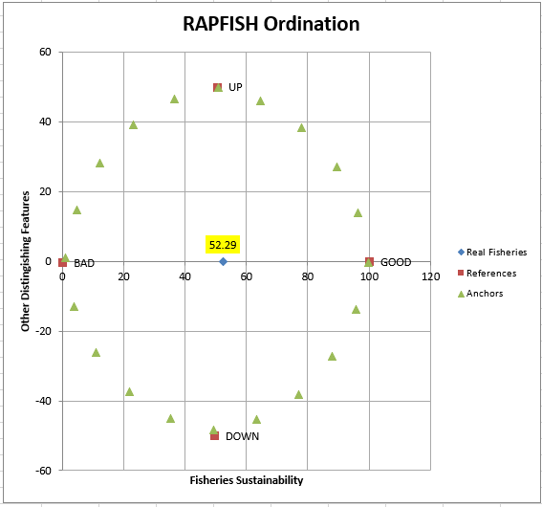  *Figure 2. Ecological Dimension Sustainability Ordination | 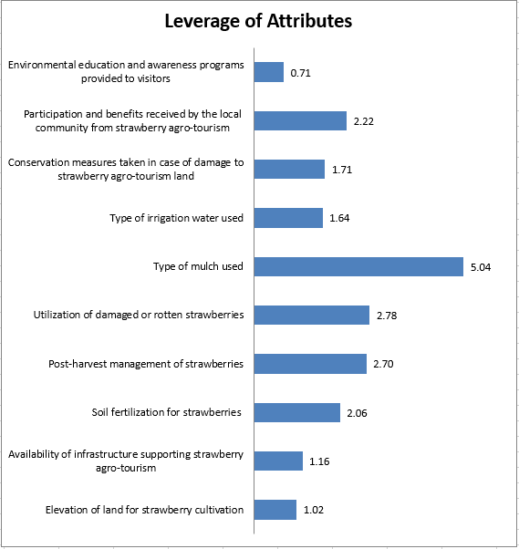  *Figure 3. Results of Ecological Dimension Leverage Analysis
The most influential attribute in the sustainability of strawberry agrotourism in Sembalun District is the type of mulch used, with an RMS value of 5.04. All business actors in this area use plastic mulch because it can control soil moisture, reduce evaporation, and maintain water availability for plants. However, the use of plastic mulch that is not managed properly can pollute the environment, so alternatives such as biodegradable mulch or recycling systems need to be considered. The second influential attribute is the utilization of damaged or rotten strawberry waste with an RMS value of 2.78. Generally, business actors resell the waste after being cleaned, and frozen, or dispose of it directly on the land as natural fertilizer without a composting process. Although it provides economic value and organic benefits, the potential for processing waste into compost has not been maximized. The application of more systematic waste processing technology is needed to support ecological efficiency and sustainability. The third attribute is post-harvest land management with an RMS value of 2.70. Post-harvest land management practices are still minimal, which can reduce soil fertility and increase the risk of environmental degradation. Therefore, education and encouragement for business actors to implement sustainable land management is very necessary to maintain ecosystem balance and long-term productivity.
  - Economic Dimension of Sustainability
The economic dimension in the sustainability of strawberry agrotourism in Sembalun District refers to the extent to which the activity is able to provide stable and sustainable financial benefits for business actors, especially farmers and the surrounding community. Based on the results of the Rapfish Multi-Dimensional Scaling (MDS) analysis of the economic dimension in the sustainability of strawberry agrotourism in Sembalun District, it shows an index value of 53.51 as shown in (Figure 4) which places it in the “quite sustainable” category. This shows that agrotourism activities in the Sembalun area have made a positive contribution to increasing community income and strengthening the local economy, although there is still room for improvement, especially in terms of farming efficiency, market access, and product value chain development. These results are in line with the findings Elvira et al. (2022), in the study “Analysis of Sustainability Status of Sustainable Agriculture-Based Agrotourism: Case Study of Upang Strawberry Farm”, where the economic dimension also scored 53.61 which is considered “quite sustainable”. The similarity of these values ​​reflects that strawberry agrotourism, both in Sembalun and Upang, has made a significant economic contribution to the surrounding community. However, both studies also indicate the need for a long-term sustainable strategy in strengthening the economic position of agrotourism, including through product diversification, entrepreneurship training, and increasing access to regional and national markets.
Leverage analysis on 10 attributes that influence the economic dimension is marked by the largest Root Mean Square (RMS) value. The three largest RMS values ​​mean that these three attributes have a large contribution in determining the level of sustainability of strawberry agrotourism in Sembalun District in the economic dimension. The three attributes are: (1) diversification of strawberry products, (2) strawberry distribution channels (3) financial management (Figure 5).
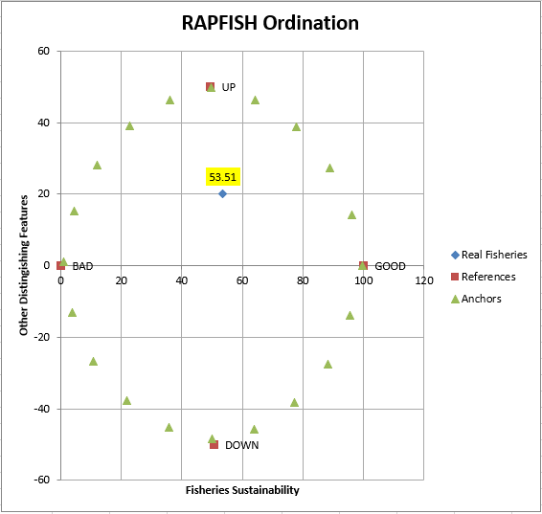  *Figure 4. Economic Dimension Sustainability Ordination | 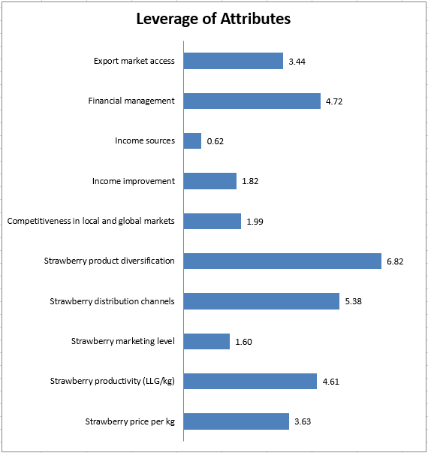  *Figure 5. Results of Economic Dimension Leverage Analysis
The most influential attribute on the sustainability of strawberry agrotourism in Sembalun District in the economic dimension is product diversification, with an RMS value of 6.82. Product diversification can increase added value and expand the market, but currently most business actors still rely on selling fresh fruit through pick-your-own tourism due to limited processing facilities. This dependence makes businesses vulnerable to price fluctuations and harvest results. Therefore, the development of processed products such as strawberry-based jams, juices, and snacks, accompanied by training and provision of processing facilities, is very necessary to strengthen the competitiveness and economic resilience of business actors. The second attribute is distribution channels, with an RMS value of 5.38. Currently, distribution is carried out directly to tourists and through collectors, which can reach a wider market but causes dependence and price instability. Improving the distribution system through digital marketing channels or cooperation with modern retailers can increase the efficiency and income of farmers. The third attribute is financial management, with an RMS value of 4.72. The majority of business actors have not implemented a good bookkeeping or financial management system, so they have difficulty in managing income, allocating funds, and planning long-term businesses. Education and implementation of a structured financial system are essential so that business actors can increase financial resilience and ensure the sustainability of the strawberry agrotourism economy in Sembalun District.
  - Socio-Cultural Dimension of Sustainability
The socio-cultural dimension in the sustainability of strawberry agrotourism in Sembalun District refers to the impact of agrotourism activities on the quality of life of the community, local values, and the preservation of local culture and wisdom. This dimension is important to ensure that the development of agrotourism does not only pursue economic benefits, but also strengthens the social and cultural identity of the local community. Based on the results of the Rapfish Multi-Dimensional Scaling (MDS) analysis, the socio-cultural dimension in the sustainability of strawberry agrotourism in Sembalun District obtained an index value of 50.93 as shown in (Figure 6) which is included in the “quite sustainable” category. This value reflects that the socio-cultural aspects in the Sembalun area have experienced positive developments, such as increased community participation in agrotourism activities, preservation of local cultural values, and contributions to social welfare. However, these results also indicate the need for strengthening in terms of wider local community involvement, protection of cultural heritage, and equal distribution of economic and social benefits from agro-tourism activities. When compared with the results of the study Elvira et al. (2022), In “Analysis of Sustainability Status of Sustainable Agriculture-Based Agrotourism: Case Study of Upang Strawberry Garden”, the socio-cultural index value was obtained at 51.21 which is also categorized as “quite sustainable”. The similarity of these scores indicates that both in Sembalun and Upang, the socio-cultural dimension has been relatively well-developed, but still faces similar challenges related to long-term sustainability, especially in terms of social justice and the preservation of inclusive and sustainable local culture.
Leverage analysis on 8 attributes that influence the socio-cultural dimension is marked by the largest Root Mean Square (RMS) value. The three largest RMS values ​​mean that these three attributes have a large contribution in determining the level of sustainability of strawberry agrotourism in Sembalun District in the socio-cultural dimension. The three attributes are: (1) age of workers working in strawberry agrotourism, (2) attending counseling/training on agrotourism (3) positive impact of agrotourism on social society (Figure 7).
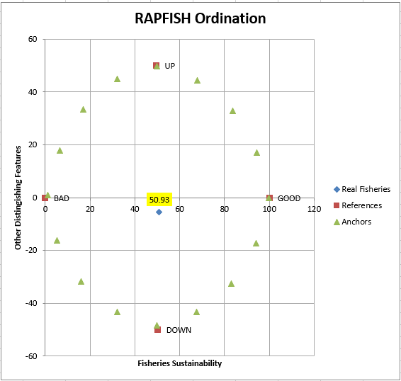  *Figure 6. Socio-Cultural Dimension Sustainability Ordination | 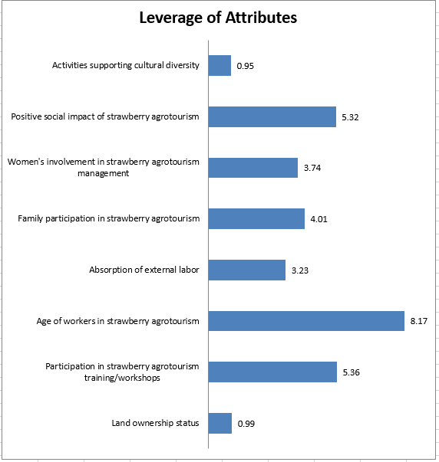  *Figure 7. Results of Socio-Cultural Dimension Leverage Analysis
The most influential attribute on the socio-cultural sustainability of strawberry agrotourism in Sembalun District is the age of workers, with an RMS value of 8.17. Currently, the majority of workers are over 40 years old, indicating a lack of involvement of the younger generation. This can threaten the sustainability of the production system and the stability of the workforce in the long term. Therefore, regeneration through the involvement of young workers is crucial, which can be realized through education, training, and attractive incentives. The second attribute is participation in counseling and training on agrotourism sustainability, with an RMS value of 5.36. Although this program is important for increasing the knowledge of business actors in agrotourism management, marketing, and business innovation, the current counseling is still limited to the technical aspects of agriculture. The lack of education on agricultural tourism and sustainability hinders the development of this sector to its full potential. The third attribute is the positive social impact of strawberry agrotourism, with an RMS value of 5.32. Agrotourism has contributed to creating jobs, improving welfare, and strengthening social relations in the community. However, the low availability of tour guides and the suboptimal integration of local culture have resulted in a lack of knowledge transfer to tourists and low exposure to local cultural values. Therefore, training for tour guides, development of educational programs, and the implementation of culture-based activities are needed to strengthen local identity and increase the attractiveness of strawberry agrotourism sustainably.
  - Institutional Dimension of Sustainability
The institutional dimension in the sustainability of strawberry agrotourism in Sembalun District is related to the extent to which institutions or organizations involved in the management of agrotourism are able to work effectively, participatively, and in a structured manner. This includes organizational structure, the role of farmer groups used to encourage participation and learning, both of which are key to the sustainable development process (Muktasam et al., 2024). and support from the government, partnerships between stakeholders, and the existence of clear rules and coordination mechanisms. Based on the results of the Rapfish Multi Dimensional Scaling (MDS) analysis of the sustainability status of strawberry agrotourism in Sembalun District, it shows that the institutional dimension obtained an index value of 46,85 as shown in (Figure 8) which is in the “less sustainable” category. This value indicates that the institutional system that supports the management of strawberry agrotourism in the Sembalun area still faces various challenges, especially related to coordination between institutions, policy implementation, and assistance and regulatory support for local business actors. Similar conditions were also found in the study Elvira et al. (2022), entitled “Analysis of Sustainability Status of Sustainable Agriculture-Based Agrotourism: Case Study of Upang Strawberry Garden”, where the institutional dimension recorded an index value of 49.19, which is also included in the “less sustainable” category. Both studies underline the weak role of local institutions in promoting the sustainability of agrotourism, although the regions and contexts are different. This shows that strengthening institutional capacity and increasing collaboration between stakeholders are urgent needs that must be prioritized in order to create more effective, adaptive, and sustainable agrotourism governance in various regions.
Leverage analysis on 10 attributes that influence the socio-cultural dimension is marked by the largest Root Mean Square (RMS) value. The two largest RMS values ​​mean that these two attributes have a large contribution in determining the level of sustainability of strawberry agrotourism in Sembalun District in the institutional dimension. The two attributes are: financial assistance and the function and benefits of the existence of farmer groups (Figure 9).
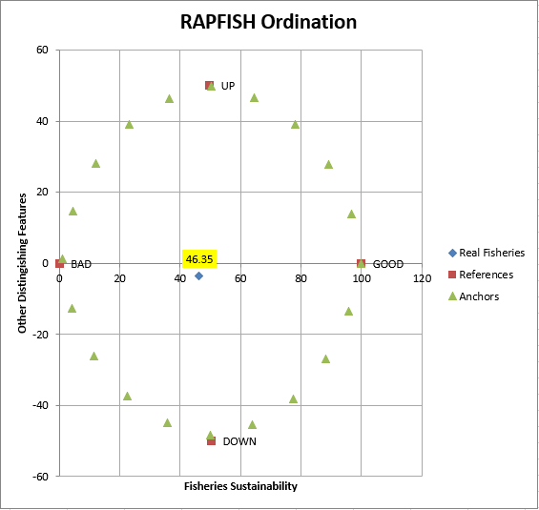  *Figure 8. Institutional Dimension Sustainability Ordination | 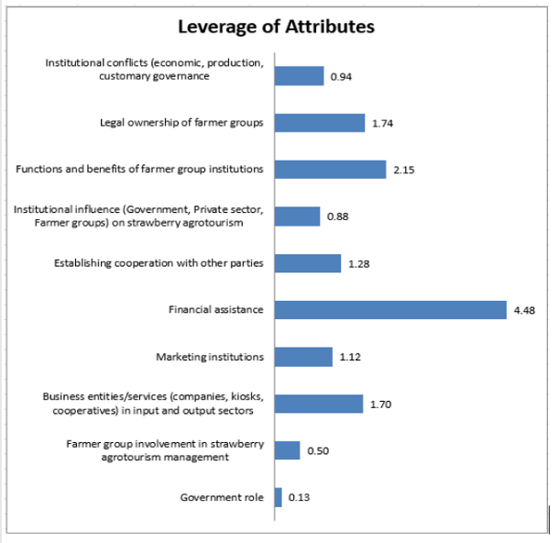  *Figure 9. Results of Institutional Dimension Leverage Analysis
The most influential attribute on the sustainability of strawberry agrotourism in Sembalun District in the institutional dimension is financial assistance, with an RMS value of 4.48. Financial assistance is very important to support infrastructure development, human resource training, and product diversification, all of which contribute to increasing competitiveness. However, the majority of business actors have never received assistance from the government, NGOs, or the private sector, the agro-tourism development is still limited and highly dependent on personal capital. This condition hinders business expansion, sustainable land management, and innovation in product marketing and processing. Therefore, access to funding is key to strengthening institutions and ensuring sustainable agrotourism growth. The second attribute is the institutional function of farmer groups, with an RMS value of 2.15. Currently, there is no special farmer group that oversees strawberry businesses in Sembalun; existing farmer groups focus more on general horticulture such as onions and chilies. The absence of special institutions makes it difficult for strawberry business actors to access assistance and training that is relevant to their needs. In fact, the existence of a special strawberry farmer group can be a means of coordination, sharing information, strengthening market networks, and increasing farmers' bargaining power in the supply chain. The formation of this special farmer group is very necessary to increase the effectiveness of institutional support and strengthen the sustainability of strawberry agrotourism both economically and socially in Sembalun District.
  - Technology Dimension of Sustainability
The technological dimension in the sustainability of strawberry agrotourism in Sembalun District refers to the extent to which technology is used effectively to improve productivity, efficiency, competitiveness, and quality of agrotourism services. Technology is not only limited to agricultural aspects, but also includes digital promotion, information systems, and product innovation. Based on the results of the Rapfish Multi-Dimensional Scaling (MDS) analysis, the technological dimension in the sustainability of strawberry agrotourism in Sembalun District shows an index value of 49.48 as shown in (Figure 10). This value places the dimension in the “less sustainable” category, indicating that the use of technology in the agrotourism system in the Sembalun area is still not optimal. The low adoption of modern agricultural technology, the lack of supporting information systems, and limitations in the use of innovation-based production facilities are the main obstacles to increasing efficiency and productivity. This finding is in line with the results of the study Elvira et al. (2022), in the study “Analysis of Sustainability Status of Sustainable Agriculture-Based Agrotourism: Case Study of Upang Strawberry Garden”, which recorded a technology sustainability index value of 46.42, is also in the “less sustainable” category. Both studies show that the technology aspect is one of the dimensions that is still weak in the development of strawberry agrotourism in both locations. Therefore, increasing access to appropriate technology, innovation-based training for farmers and agrotourism business actors, and developing a local technology system that is adaptive to regional needs are important strategies in supporting the sustainability of this sector more comprehensively.
Leverage analysis on 8 attributes that influence the socio-cultural dimension is marked by the largest Root Mean Square (RMS) value. The two largest RMS values ​​mean that these two attributes have a large contribution in determining the level of sustainability of strawberry agrotourism in Sembalun District in the technology dimension. The two attributes are: availability of strawberry processing and harvesting industry (Figure 11)
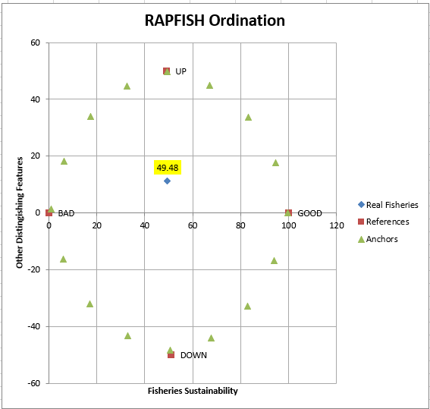  *Figure 10. Technology Dimension Sustainability Ordination | 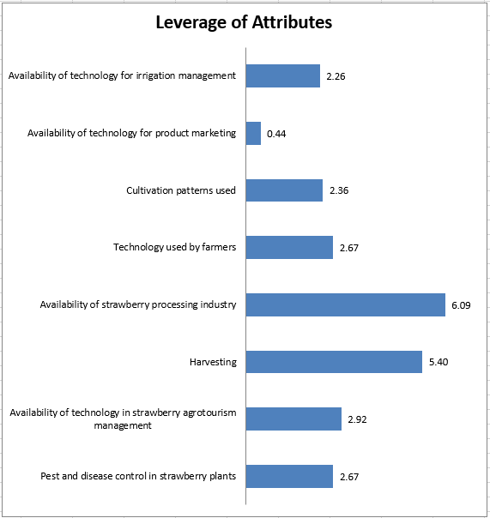  *Figure 11. Results of Technology Dimension Leverage Analysis
The most influential attribute on the sustainability of strawberry agrotourism in Sembalun District in the technological dimension is the availability of a strawberry processing industry, with an RMS value of 6.09. The existence of this industry is very important to increase production efficiency, expand the market, and reduce dependence on fresh fruit sales that are vulnerable to price and quality fluctuations. Currently, there are no processing facilities in Sembalun, and previous efforts by KWT Putri Rinjani were halted due to limited technical knowledge. By utilizing technology such as automatic washing machines, pasteurization systems, freeze drying, and vacuum packaging, business actors can produce value-added processed products such as jam, juice, frozen strawberries, or strawberry powder. The development of this processing technology is a strategic step to increase competitiveness and ensure the economic sustainability of strawberry agrotourism in Sembalun. The second influential attribute is harvesting, with an RMS value of 5.40. The harvesting process plays an important role in maintaining the quality of the harvest and production efficiency. Currently, harvesting is done manually, which although it maintains the quality of the fruit, requires a lot of energy and time. Delays in picking can also cause losses due to overripe fruit. The use of modern harvesting technologies such as automatic pickers or fruit ripeness sensors, as well as direct packaging systems in the field, can increase efficiency, reduce fruit damage, and strengthen the competitiveness of strawberry products. The application of these technologies will contribute to increasing the productivity and sustainability of strawberry agrotourism as a whole.
- CONCLUSIONS AND RECOMMENDATIONS

Based on the research results, it can be concluded that strawberry agrotourism in Sembalun District, East Lombok Regency, is in the “quite sustainable” category with a multidimensional sustainability index value of 50.51 on a scale of 50.01–75.00. The economic, ecological, and socio-cultural dimensions show a level of sustainability in the “quite sustainable” category with index values ​​of 53.51, 52.29, and 50.93, respectively. Meanwhile, the institutional and technological dimensions are still in the “less sustainable” category, with index values ​​of 46.35 and 49.8. The most influential attributes in each dimension include: type of mulch use, utilization of strawberry waste, and land management for the ecological dimension; product diversification, distribution channels, and financial management for the economic dimension; age of workers, participation in extension, and positive social impacts of agrotourism for the socio-cultural dimension; financial assistance and the function of farmer groups for the institutional dimension; and the availability of processing industries and harvesting systems for the technological dimension. Therefore, efforts to improve sustainability need to be focused on strengthening institutions and technology, as well as optimizing key attributes in each dimension so that strawberry agrotourism in Sembalun District can develop more sustainably and provide long-term benefits for local communities.
DISCLAIMER (ARTIFICIAL INTELLIGENCE)
The authors hereby declare that No generative AI technologies such as Large Language Models (ChatGPT, COPILOT, etc.) and text-to-image generators were used during the writing or editing of this manuscript.
REFERENCES
Afrianto, WF, Tanjungsari, RJ, Wati, SI, Hidayatullah, T., Zulkarnaini, Sari, HP, Izzudin, M., & Ilham, M. (2024). Sustainability index analysis of traditional organic coffee agroforestry in Pati Regency, Central Java, Indonesia. Ethnobotany Research and Applications , 27. https://doi.org/10.32859/era.27.38.1-22.
Aini, L., Sukoco, DH, & Andayani, RHR (2023). Journal of Social Work. Social Work, 22(1), 212–220. https://doi.org/10.31595/peksos.v22i1.630.
Aridiansari, R., Elih, E., & Puji, K. (2015). Development of agrotourism in Tulungrejo Tourism Village, Batu City, East Java. Development of Agrotourism in Tulungrejo Tourism Village, Batu City, East Java, 3(5), 383–390.
Athallah, AR, Suliswanto, MSW, & Sari, NP (2024). THE ROLE OF TOURISM SECTOR ON ECONOMIC GROWTH IN ASEAN 4 (THAILAND, SINGAPORE, MALAYSIA, AND INDONESIA). Journal of Tourism Industry, 7(1), 1–13. https://doi.org/10.36441/pariwisata.v7i1.2059.
Dutton, IM, & Kaswadji, RF (1968). Journal of COASTAL & OCEANIC RESEARCH Volume 4, No. 2. European Journal of Biochemistry, 5(4), 590–590. https://doi.org/10.1111/j.1432-1033.1968.tb00410.x.
Dzikrillah, GF, Anwar, S., & Sutjahjo, SH (2017). Analysis of Sustainability of Paddy Farming Business in Soreang District, Bandung Regency. Journal of Natural Resources and Environmental Management, 7(2), 107–113. https://doi.org/10.29244/jpsl.7.2.107-113.
Elvira, S., Putra, RE, & Rahman, H. (2022). Analysis of Sustainability Status of Sustainable Agriculture-Based Agrotourism: Case Study of Upang Strawberry Farm. JSEP (Journal of Social and Agricultural Economics), 15(2), 123. https://doi.org/10.19184/jsep.v15i2.30767.
Ibrahim, H., Amanah, S., Gani, SD, & Purnaningsih, N. (2013). ANALYSIS OF SUSTAINABILITY OF CRAFTSMEN OF CREATIVE ECONOMY SILK CRAFTS IN SOUTH SULAWESI PROVINCE. 23(3), 11–13.
Jasmawadi, LA, Budastra, IK, Tajidan, T., Zaini, A., & Siddik, M. (2022). Sustainability Analysis on Economic and Ecological Aspects of Dry Land Management in Jerowaru District Using Multi Dimensional Scaling (MDS). Prisma Sains: Journal of Science and Mathematics and Science Learning Studies IKIP Mataram, 10(3), 478. https://doi.org/10.33394/j-ps.v10i3.5242.
Muktasam, Rusdiani, & Hayati. (2024). Study of Household Food Security of Dry Land Farmers in West Sekotong Village, Sekotong District, West Lombok Regency. Journal of Socio-Economics and Humanities, 10(2), 280–288. https://doi.org/10.29303/jseh.v10i2.550.
Palit, IG, Talumingan, C., & AJRumangit, G. (2017). Strategy for Developing the Rurukan Agrotourism Area. Unsrat Agri-Socio-Economic Journal, 13(2), 21–34.
Parmawati, R., Pangestuti, E., Wike, W., & Hardyansah, R. (2020). Sustainable Tourism on Red Island Beach Banyuwangi: An Analysis of Rapfish-MDS (Multi-Dimensional Scaling). https://doi.org/10.4108/eai.23-10-2019.2293035.
Pradita, N., Sukardi, L., & Tajidan. (2024). Determining Factors for the Sustainability of Arabica Coffee-based Eco-farming in Sembalun, Indonesia. 11(4), 191–198.
Pitcher, T. J., and Preikshot, D. (2001). RAPFISH, A Rapid Appraisal Technique for Fisheries, and Its Application to the Code of Conduct for Responsible Fisheries. J. Fisheries Research 49: p255-270.
Putradi, L., Kusnendar, KL, & Widiantari, ANPN (2019). EAST LOMBOK DISTRICT IN FIGURES 2022. Sustainability (Switzerland), 11(1), 1–14. http://scioteca.caf.com/bitstream/handle/123456789/1091/RED2017-Eng-8ene.pdf?sequence=12&isAllowed=y%0Ahttp://dx.doi.org/10.1016/j.regsciurbeco.2008.06.005%0Ahttps://www.researchgate.net/publication/305320484_CENTRALIZED_SECTION_SYSTEM_AS_A_STRATEGY_TO_SUSTAIN_THE_STRATEGY.
Saji, L., Budiasa, WI, & Suardi, OPDI (2023). Sustainability Analysis of Community-Based Agrotourism. 11(2), 260–272.
Tajidan, Efendi, Nabilah, S., Mulyawati, S., Usman, A., & Novita, S. (2025). RAW MATERIAL VOLUME CONTRACTION TO INCREASE LABOR ABSORPTION IN THE TOFU AGRO-INDUSTRY. 2 (November 2024), 144–159.
Te'dang, D., Loho, EA, & Montolalu, HM (2024). Analysis of Organic Strawberry Farming in Strawberry Garden Tomohon Delvin Te'dang, Agnes Estephina Loho, Maya H. Montolalu Agribusiness Study Program, Faculty of Agriculture, Sam Ratula University. 6, 171–178.
Trisnanto, A., Soekmadi, R., Arifin, HS, & Pramudya, B. (2023). Sustainability Analysis of Yard Utilization as an Agrotourism Area in Banyuwangi Regency, East Java. Journal of Environmental Science, 21(3), 534–544. https://doi.org/10.14710/jil.21.3.534-544.
Yusuf, LOMI, Ismail, A., & Nuva, N. (2023). Evaluation of the Sustainability Status of Seaweed Cultivation in Pasikolaga District, Muna Regency (Rapfish-Multi Dimensional Scaling Approach). Journal of Environmental Science, 21(1), 150–158. https://doi.org/10.14710/jil.21.1.150-158.

