ANALYSIS OF THE SUSTAINABILITY STATUS OF WATER SPINACH FARMING BUSINESS ON LOMBOK ISLAND

.

ABSTRACT

|  |
| --- |
| The purpose of this study is to: (1) Analyze the sustainability status of water spinach farming on Lombok Island (2) Identify attributes that influence the sustainability of water spinach farming on Lombok Island. This study used a descriptive method, and the unit of analysis was farmers who farm water spinach on Lombok Island spread across Mataram City, West Lombok Regency and East Lombok Regency with the consideration that these three areas have the largest harvest area. Data collection was carried out through surveys and direct interviews with respondents. The analysis method used is Multiaspect Sustainability Analysis (MSA) with Exsimpro software, which is used to measure sustainability by forming dimensions and attributes as well as benchmark indicators for scoring to determine the sustainability index value.  This research resulted in: (1) The sustainability status of water spinach farming on Lombok Island using MSA analysis is included in the sustainable status with a sustainability index value of 50.26 on a scale of (50.01 – 75.00) (2) Sensitive attributes that influence the sustainability of water spinach on Lombok Island in each dimension, namely (a) Ecology: disease control (b) Economy: market access (c) Social: participation in extension or training (d) Technology: post-harvest processing (e) Institutions: existence of farmer groups and support institutions. |

*Keywords: Sustainability, water spinach, agriculture, Multiaspect Sustainable Analysis (MSA)*

1. INTRODUCTION

Lombok Island, located in West Nusa Tenggara (NTB), is known as one of the centers of horticultural agriculture in Indonesia. One of the commodities widely cultivated by local farmers on this island is water spinach (Ipomoea aquatica), which is a popular vegetable plant and has a fast harvest cycle. Water spinach is one of the people's livelihoods, where the results of water spinach that are ready to be harvested become a livelihood and are traded in markets or small stalls at relatively cheap and affordable prices, but this can provide benefits to the community if cultivated properly and intensively (Handriatni & Susilo, 2010). According to Wahyuni ​​(2020), the marketing of water spinach on Lombok Island can be optimized through the development of strategies that expand market reach. The demand for water spinach, both for local consumption and culinary tourism needs, continues to increase along with the popularity of Lombok's signature dishes that use water spinach as the main ingredient, such as "Pelecing Kangkung".

Water spinach farming on Lombok Island has great potential to be developed sustainably with the increasing interest in culinary tourism. The combination of culinary tourism promotion and adoption of environmentally friendly agricultural techniques can help create a mutually supportive system between agriculture and tourism on Lombok Island. However, Sulistiyani et al., (2020) in their research said that water spinach farming on Lombok Island faces complex problems that affect its productivity and sustainability. One of the main problems is the conversion of agricultural land to non-agricultural land such as housing, industry, and tourism, thus reducing the area of ​​agricultural land as indicated by the shrinking of agricultural land, such as the reduction in land for water spinach farming on Lombok Island, where in 2022 the water spinach harvest area was 379.55 Ha and decreased in 2023 with a harvest area of ​​330.24 Ha (NTB Provincial Agriculture and Plantation Service, 2024).

Lack of extension and technical training for farmers also hampers the adoption of technology and effective farm management. The sustainability of water spinach farming in Lombok Island can also be influenced by other factors such as climate change that affects water quality, temperature, and rainfall and excessive use of chemical fertilizers can reduce soil and water quality, which then impacts water spinach productivity and human and environmental health (Nugroho et al., 2020). In addition, farmers experience problems with the use of limited agricultural inputs because the government never allocates subsidized fertilizers, while the availability of non-subsidized fertilizers is limited because it is used for horticultural crops that have more economic value (Sudarmaji et al., 2018).

The problems faced by water spinach farmers will certainly affect the production of water spinach and its existence is threatened, this will certainly also have an impact on the tourism sector considering the need for culinary tourism on Lombok Island continues to increase. So that it can raise doubts about the continuation or not of water spinach farming on Lombok Island, so research on "Analysis of the Sustainability Status of Water Spinach Farming on Lombok Island" needs to be done, because it is related to various aspects, both environmental, economic, and social.

The objectives of this study are: (1) To analyze the sustainability status of water spinach farming on Lombok Island (2) To identify attributes that influence the sustainability of water spinach farming on Lombok Island.

2. methodology

This study uses a descriptive method, to provide a comprehensive understanding of the sustainability of water spinach farming on Lombok Island. The unit of analysis is farmers who do water spinach farming on Lombok Island, especially in West Lombok Regency, East Lombok Regency and Mataram City which were selected by purposive sampling with data collection for two months. This study involved 65 respondents who were selected using the Slovin formula, with an error rate of 12% considering the level because the population is more than 1000 people, Sugiyono (2019). Primary data were collected through surveys and interviews, while secondary data were obtained from literature reviews and official records.

Sustainability analysis was conducted using multiaspect sustainability analysis (msa) with eximpro software which was used to assess the sustainability status of water spinach farming in five dimensions: ecology, economy, social, technology and institutions.then, to determine the sensitive attributes that influence the sustainability of water spinach, leverage analysis is used.

**2.1 Data Analysis** **Methods**

**2.1.1 Multiaspect Sustainability Analysis (MSA)**

According to Ibrahim et al., (2024) Multiaspect Sustainability Analysis (MSA) is a method designed to evaluate and assess the sustainability conditions of a system or activity at a certain time, which is used to measure sustainability status and performance indexes, in order to plan future strategies. MSA can be applied in various fields such as social, economic, environmental, and development planning, including in abstract assessments in multi-aspect sustainability analysis. So that it can identify strengths and weaknesses in resource management and evaluate how current conditions can affect long-term sustainability (Firmansyah et al., 2022).

According to Ibrahim (2013), the general steps in data analysis are as follows:

1. Determining sustainability dimensions and indicators based on interpretive qualitative analysis with stakeholders.
2. Conduct sustainability assessments according to indicators based on discussions and field surveys with farmers.
3. Sustainability status analysis using the MSA method.

AnalysisThe MSA conducted will produce a sustainability index visualized in a two-dimensional image where there is a range of assessment scales, namely 0%–100%. The scale can then be classified into four indicators, namely:

**Table 1. Categories of Sustainability Level of Water Spinach Farming Business**

|  |  |
| --- | --- |
| ***Value*** | ***Sustainability Status*** |
| 0-25% | *Unsustainable* |
| >25-50% | *Low Sustainable* |
| >50-75% | *Sustainable* |
| >75-100% | *Very Sustainable* |

**2.1.2 Leverage Analysis**

Sutrisno and Kurniawan (2020) explain that leverage analysis is used to identify sensitive attributes or those that have the greatest influence on increasing the sustainability index value of each dimension with the aim of identifying critical points, which if improved will have a significant impact on the sustainability of the system as a whole.

3. results and discussion

**3.1 Respondent Characteristics**

The characteristics of respondents in this study include gender, age, education level, farming experience, and number of family members. The details are presented in the following Table 2.

**Table 2. Characteristics of Water Spinach Farm Respondents on Lombok Island**

|  |  |  |  |
| --- | --- | --- | --- |
| No | Description | Number of people) | Percentage (%) |
| 1 | Gender |  |  |
|  | Man | 22 | 33.85 |
|  | Woman | 43 | 66.15 |
|  | Amount | 65 | 100 |
| 2 | Age |  |  |
|  | 26-45 | 0 | 0 |
|  | 45-65 | 26 | 40.00 |
|  | >65 | 35 | 53.85 |
|  | 15-25 | 4 | 6.15 |
|  | Amount | 65 | 100 |
| 3 | Level of education |  |  |
|  | No school | 8 | 12.31 |
|  | SD | 20 | 30.77 |
|  | Junior High School | 24 | 36.92 |
|  | High School/Vocational School | 12 | 18.46 |
|  | Diploma/S1 | 1 | 1.54 |
|  | Amount | 65 | 100% |
| 4 | Farming experience (years) |  |  |
|  | <3 | 2 | 3.08 |
|  | 3-5 | 15 | 23.08 |
|  | 6-10 | 22 | 33.85 |
|  | >10 | 26 | 40 |
|  | Amount | 65 | 100% |
| 5 | Number of family members |  |  |
|  | 1-4 | 45 | 69.23 |
|  | 5-6 | 16 | 24.62 |
|  | ≥7 | 4 | 6.15 |
|  | Amount | 65 | 100 |

Source: Processed Primary Data, 2025

**3.1.1 Respondent Gender**

Based on Table 2. in this study, it is known that there are more male respondents, namely 43 people (66.15%) who are involved in water spinach farming on Lombok Island. This shows the dominance of the role of men in the local agricultural social structure, where they are more involved in the main activities such as land cultivation, sowing, fertilizing, and marketing the results.

**3.1.2. Respondent Age**

The results of the study showed that 61 respondents were in the productive age of 93.85%. The table above shows that the age of water spinach farmers is mostly in the age range of 45-65 years, which is 35 people, which is still classified as a productive age. According to Hasyim (2006) in Ryan et al. (2018), farmers of productive age will work better and more optimally than farmers of non-productive age.

**3.1.3. Level of Education**

In table 2 above, it shows that the education level of water spinach farmers is dominated by farmers with a junior high school education level of 24 people (36.92%). This shows that water spinach farmers on Lombok Island still have a low level of education, because farmers who take the compulsory education program are 12 people and 1 other is attending college.

**3.1.4. Farming Experience**

The respondents' farming experience is mostly in the range of >10 years, which is 26 people, where at this stage it is a transition from the adaptation stage to maturity in farming. So in this study it can be said that water spinach farmers on Lombok Island already have quite good farming experience in doing farming. Farmers with longer experience tend to have better abilities in their farming because it can affect the mastery of innovation (Manyamsari & Mujiburrahmad, 2014)

**3.1.5. Number of Family Members**

Based on the table above, it is known that the largest percentage is found in farmers who have 1-4 family members, namely 45 farmers (69.23%), so it can be seen that the number of family members of water spinach farmers on Lombok Island is classified as a small family according to BKKBN. Family members can help farmers in carrying out the farming business that will be carried out, so that they can reduce costs incurred during cultivation activities.

**3.2 Sustainability Status of Water Spinach Farming on Lombok Island**

**Table 3. Sustainability Status of Water Spinach Farming on Lombok Island**

|  |  |  |  |
| --- | --- | --- | --- |
| No | Dimensions | Sustainability index | Sustainability status |
| 1 | Ecology | 48.22 | Low sustainable |
| 2 | Economy | 58.33 | Sustainable |
| 3 | Social | 50 | Low sustainable |
| 4 | Technology | 71.88 | Sustainable |
| 5 | Institutional | 22.88 | Low sustainable |
| Total average | | 50.26 | Sustainable |

Source: Processed Primary Data (2025)

The sustainability index value of water spinach farming in Lombok Island is 50.26 which is included in the sustainable category, which indicates that water spinach farming has met some of the principles of sustainability, but is not yet fully stable in the long term and still has sustainability risks and challenges faced in various aspects. Based on the results of the analysis of each dimension that has been obtained, it can be illustrated in the following kite diagram:

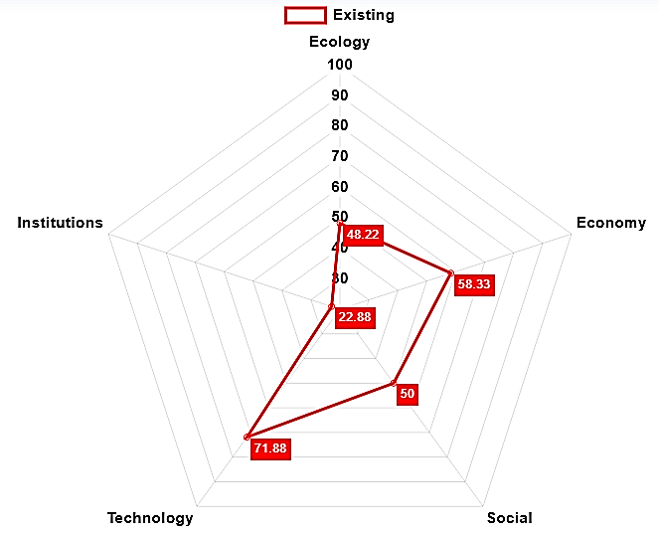

**Figure 1. Sustainability Fly Diagram of Water Spinach Farming in Lombok Island**

Figure 1. Kite diagram of the sustainability of water spinach farming on Lombok Island

Based on the image above, it is known that the institutional dimension in water spinach farming has the lowest ordination value, which is 22.88, which means it is not sustainable. While the highest ordination value is in the technology dimension of 71.88, which means its sustainability is better. This sustainable status confirms the gap between local potential and realization in the field. The agroecological potential of the Lombok region that supports horticultural crop cultivation has not been fully optimized with minimal institutional support, especially in water spinach farming. So that the agricultural system has not shown resilience to long-term sustainability challenges.

* 1. **Sustainability Status of Each Dimension**

**3.3.1 Ecological Dimension**

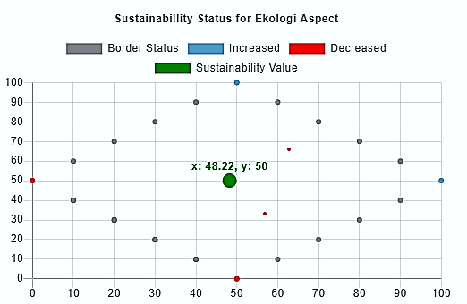

**Figure 2. Ordination of Sustainability Status of Ecological Dimension**

The ecological dimension ordination value is 48.22 which is included in the low sustainable status, which indicates that the sustainability of farming has not reached an adequate level in terms of ecology. The uncontrolled use of chemical fertilizers is a major challenge in building an environmentally friendly and sustainable water spinach farming system, because farmers in this area still rely on synthetic inputs such as chemical fertilizers and pesticides in carrying out farming.

3.3.2 **Economic Dimension**

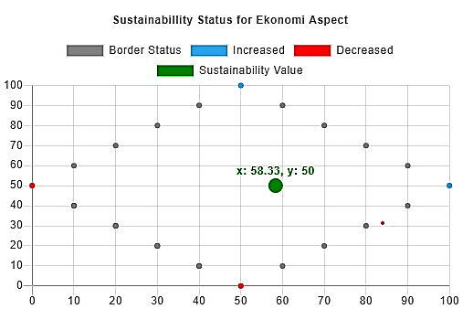

**Figure 3. Ordination of Sustainability Status of Economic Dimension**

In Figure 3, the economic dimension ordination is 58.33 which is included in the sustainable status. This value shows that in terms of economy, water spinach farming is quite sustainable. This indicates that this business provides a positive contribution to the farmer's economy, both in terms of income and economic stability. Although the sustainability value is not too high, this farming business generates enough profit to survive in the long term.

* + 1. **Social Dimension**

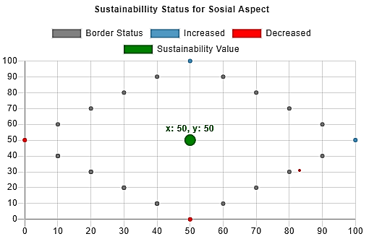

**Figure 4. Ordination of Social Dimension Sustainability Status**

The social dimension of water spinach farming in Lombok Island is in the low sustainable category with an index value of 50, which means that the social aspect still needs to be improved to be better. Water spinach farming in Lombok is generally small-scale and managed by families, which causes limitations in access to additional labor and efficient division of labor. Although there are some social benefits that can be felt, there are challenges related to uneven welfare, lack of training or education for farmers.

* + 1. **Technology Dimension**

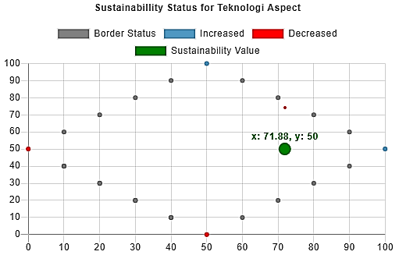

**Figure 5. Ordination of Sustainability Status of Technology Dimension**

In the technology dimension, the ordination value is 71.88 which is included in the sustainable status, this dimension is the most sustainable because it has the highest index value, which indicates that the use of technology in water spinach farming is good and contributes positively to sustainability. This indicates that although the technological aspect has begun to be applied in farming practices, it is not yet fully optimal and still requires improvement in several indicators in order to implement sustainable agriculture.

* + 1. **Institutional Dimension**

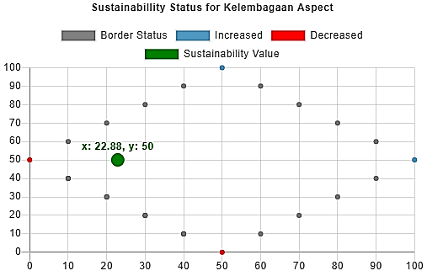

**Figure 6. Institutional Dimension Sustainability Ordination**

The results of the analysis show that the institutional structure of water spinach farming in Lombok Island is still weak because it is in an unsustainable status with a sustainability index value of 22.88 or 22.88% of the 100% range. This shows that the institutional dimension in water spinach farming is very weak. This could mean that the institutional system, such as support from the government or related institutions, is very limited, such as government policies that do not support the sustainable agricultural sector.

* 1. **Sensitive Attributes in Water Spinach Farming**

**3.4.1 Sensitive Attributes in Ecological Dimension**

The results of the leverage analysis of this study to determine the most sensitive attributes in influencing the sustainability of water spinach farming in the ecological dimension are as follows:

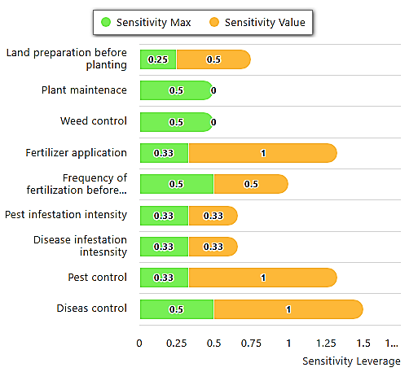

**Figure 7. Sensitive Attributes Affecting the Sustainability of Water Spinach**

**Farming in the Ecological Dimension**.

In the ecological dimension, disease control has a sensitivity value of 1 and the largest maximum sensitivity of 0.5, which means that this attribute is the most sensitive to influencing sustainability in the ecological dimension. Water spinach farmers on average still use chemical drugs to control diseases that attack plants, of course this will affect the farming environment. Excessive and uncontrolled use of chemical pesticides can pollute irrigation water and soil which are the main media for cultivating water spinach. So it is necessary to avoid dependence on chemical pesticides that can pollute the environment and endanger human health.

* + 1. **Sensitive Attributes on Economic Dimension**

The results of the leverage analysis on MSA to determine the most sensitive attributes on the economic dimension can be seen in the image below:

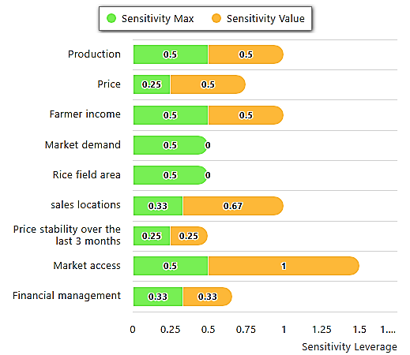

**Figure 8. Sensitive Attributes Affecting the Sustainability of Water Spinach**

**Farming in the Economic Dimension.**

In the economic dimension, market access is the most sensitive attribute to changes in the sustainability index value because it has a sensitivity value of 1 and a maximum sensitivity of 0.5. This shows that the economic sustainability of farming is highly dependent on how widely and easily water spinach farmers can market their harvests. Most farmers in Lombok sell their harvests in local markets and collectors, while local markets usually still have low absorption and tend to be saturated during the peak harvest season, which is when all farmers harvest at the same time, but only rely on the local market, then the price of water spinach will fall or decrease.

* + 1. **Sensitive Attributes in Social Dimension**

The results of the leverage analysis on MSA for the most sensitive attributes on the technology dimension can be seen in the figure below:

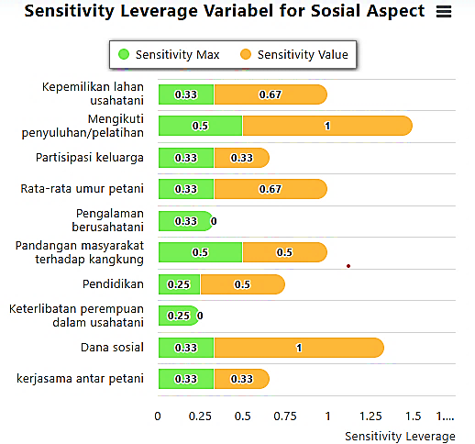

**Figure 9. Sensitive Attributes Affecting the Sustainability of Water Spinach**

**Farming in the Social Dimension**

In the social dimension, participation in extension/training is the most sensitive attribute influencing changes in the sustainability index value with a sensitivity value of 1 and a maximum sensitivity of 0.5. This means that small changes in participation in training/extension can have a major impact on increasing or decreasing social sustainability. One of the main challenges faced by water spinach farmers on Lombok Island is the limited availability of specific extension or training on water spinach cultivation. However, when there is a government program for horticultural farmers, many farmers find it difficult to attend training due to time constraints, considering that many farmers, especially water spinach farmers, depend on their other daily jobs.

* + 1. **Sensitive Attributes in Technology Dimension**

The results of the leverage analysis on MSA for the most sensitive attributes on the technology dimension can be seen in the figure below:

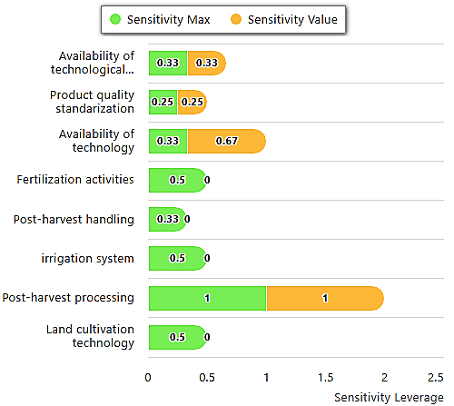

**Figure 10. Sensitive Attributes Affecting the Sustainability of Water Spinach**

**Farming in the Technology Dimension.**

In the technology dimension, post-harvest processing is the most sensitive attribute to changes in the sustainability index value because it has a sensitivity value of 1 and a maximum sensitivity of 1. This shows that water spinach farmers on Lombok Island have not carried out post-harvest processing of their production, where most water spinach products are sold fresh without any additional stages such as processing into derivative products such as fresh products in packaging or processed finished products. This shows that there are limitations in technology adoption at the farmer level so that it can have an impact on the low selling value of products, the quality of the harvest that decreases rapidly, and farmers' dependence on traditional markets.

* + 1. **Sensitive Attributes on Institutional Dimension**

The results of the leverage analysis on MSA for the most sensitive attributes on the technology dimension can be seen in the image below:

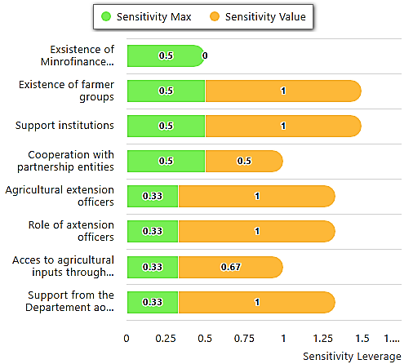

**Figure 11. Sensitive Attributes Affecting the Sustainability of Water Spinach**

**Farming in the Institutional Dimension**.

In the institutional dimension, there are 2 (two) attributes that are most sensitive in influencing, namely the existence of farmer groups and support institutions because they have the same sensitivity value and maximum sensitivity values, namely 1 and 0.5.

The first sensitive attribute is farmer groups, according to Widodo et al., (2023) is a social organization system based on agriculture that is expected to be the main actor in encouraging innovation, increasing productivity, and maintaining the sustainability of local community-based farming businesses. Water spinach farmers, the level of participation in farmer groups is still low, because many farmers operate individually and have not joined formal groups. Based on field results, the lack of farmer groups is due to the uneven formation of farmer groups based on specific commodities such as water spinach

The second sensitive attribute is the supporting institution, in Lombok supporting institutions such as the government, non-governmental organizations (NGOs), and other agricultural organizations provide important support for farmers, both in terms of market information, technology access, and capital. However, the conditions in the field for water spinach farmers in Lombok are the lack of technical assistance so that many farmers rely on hereditary experience without modern cultivation technology innovation.

4. Conclusion

Based on the results of data analysis and discussion, the following conclusions were obtained: (1) The sustainability status of water spinach farming on Lombok Island with MSA analysis is included in the sustainable status with a sustainability index value of 50.26 on a scale (50.01 - 75.00). (2) Determining factors or sensitive attributes that influence and need to be considered to improve the sustainability status index of water spinach farming on Lombok Island in each dimension are as follows: a. Ecological dimension: Disease control, b. Economic dimension: Market access, c. Social dimension: Participation in extension or training, d. Technological dimension: Post-harvest processing, e. Institutional dimension: Existence of farmer groups and supporting institutions.

DISCLAIMER (ARTIFICIAL INTELLIGENCE)

Author(s) hereby declare that nogenerative ai technologies such as large language models (chatgpt, copilot, etc) and text-to-image generators have been used during writing or editing of this manuscript.

CONSENT

All respondents voluntarily participated in this research. Written consent was obtained from all participants before interviews and observations. This research involved direct interviews and observations of water spinach farmers in Lombok Island.

References

NTB Agriculture and Plantation Service.2024. Condition of Water Spinach Farming on Lombok Island

Firmasyah A, Rizal, Muksin. 2022. Analysis of Sustainability Status and Strategy for Improving Mango Agribusiness Performance in Kapongan District, Sidobundo Regency. Journal of Scientific Innovation. 22(2): 1411-5549

Ibrahim H. Amanah S. Darwis S,G. Purnaningsih N. 2013. Analysis of Sustainability of Creative Economy Silk Craftsmen Business in South Sulawesi Province. Journal of Agricultural Industrial Technology. 3 (3):210-219.

Ibrahim S., Sapanli K., Tropical Marine Economics Study Group. 2024. Analysis of Sustainable Livelihoods of Bajo Fishermen in Wuring Village. Journal of Tropical Marine Economics, 8(3), 275–287.

Manyamsari I., Mujiburrahmad. 2014. Characteristics of Farmers and Their Relationship with the Competence of Small Land Farmers. Agrisep Journal, 15(2), 58–74.

Nugroho B., Kartika D., Sulistiyanti D. 2020. Climate Change and Its Impact on Water Spinach Farming. Journal of Agricultural Sciences, 20(2), 1-10.

Ryan E., Prihtanti TM, Nadapdap HJ 2018. Factors Influencing Farmers' Adoption of the Implementation of the Jajar Legowo Farming System in Barukan Village, Tengaran District, Semarang Regency. Proceedings of the National Seminar of the Faculty of Agriculture, UNS, 2(1), E.53-64.

Sudarmaji T., Wahyuni ​​S., Hendriyanto H. (2018). The Effect of Chemical Fertilizers on Soil and Water Quality. Journal of Agricultural Sciences, 13(1): 1-8.

Sugiyono. 2016. Quantitative, Qualitative, R&D Research Methods. Bandung: IKAPI J Lexy.

Sulistiyanti D., Wahyuni, Hendriyanto H. (2020). Conversion of Agricultural Land on Lombok Island. Journal of Agricultural Sciences, 20(1), 1-9.

Sutrisno J., Kurniawan H. 2020. Analysis of the sustainability of wetland agricultural agroecosystems using the Multi Aspect Sustainability Analysis (MSA) approach. National Resilience Journal, 26(2), 195–208.

Wahyuni ​​S. (2020). Increasing Farmer Productivity and Welfare through Environmentally Friendly Cultivation. NTB Agricultural Journal, 15(2), 35-47.

Widodo S., Susanto D., Maharani N. 2023. The Role of Farmer Institutions in Sustainable Agriculture. Journal of Agriculture and Agribusiness. 7(1), 23-34.