Review Article
Artificial Intelligence and Machine Learning Applications for Non-Destructive Prediction of Tomato Ripening and Shelf Life

Abstract
Tomato softening and quality degradation during postharvest storage present major challenges in minimizing food waste and maintaining market value. This review explores the integration of artificial intelligence (AI) and machine learning (ML) technologies with non-destructive methods such as computer vision, imaging, electrical signal analysis, to monitor and predict tomato ripening stages and shelf life. Recent studies demonstrate high prediction accuracies using advanced models, including artificial neural networks, ensemble learning, and fuzzy inference systems, which analyze features like firmness, color, lycopene content, and texture. These AI-driven approaches enable accurate classification of ripeness stages and optimization of storage conditions, offering significant advantages over traditional destructive techniques. The potential of mobile applications for end-user shelf life prediction is also discussed. Overall, the adoption of AI-based solutions in tomato postharvest management holds promise for improving quality monitoring, reducing spoilage, and enhancing sustainability in the agri-food sector.
Keywords: postharvest, predictive modelling, sustainability, tomato ripening

Introduction
Fruit softening is a complex physiological and biochemical process that involves hormonal regulation, cell wall breakdown, and the conversion of various nutrients (Shi et al., 2023). Softening is an irreversible, programmed phase of fleshy fruit ripening, during which the development of a soft and juicy texture enhances eating quality, an adaptation that attracts animals and promotes seed dispersal. However, excessive softening shortens shelf life, increases vulnerability to physical damage and microbial infection, and ultimately contributes to food waste and economic losses. Therefore, developing technologies to control fruit softening is essential for preserving fruit quality and ensuring safety. These technologies include modified atmosphere packaging (MAP) (Oliveira et al., 2015), cold-chain storage and transportation (Liu et al., 2019), ozone treatment (Horvitz and Cantalejo, 2014), and the application of 1-methylcyclopropene (1-MCP) (Watkins, 2006), among others.
Consumers regard the quality of fruits and vegetables as a key consideration. Attributes such as color, size, shape, and texture are critical quality indicators, and any changes in these characteristics during storage can significantly affect the overall quality and consumer appeal of the product (Shadedi et al., 2024). The ripening stage at the time of harvest plays a critical role in determining not only the initial quality of the product but also its sensitivity and shelf life during storage. In the post-harvest period, the primary goal is to preserve the quality of these perishable products for as long as possible to minimize food waste and reduce economic losses. Many producers seek fast, non-invasive methods to assess the quality of fruits and vegetables efficiently. Visual methods are capable of assessing key quality attributes such as color and shape. One such approach is the Computer Vision System (CVS), an artificial intelligence-based technology used to detect, sort, and classify fruits and vegetables (Singh et al., 2020). Numerous studies have reported on the successful application of CVS in evaluating the quality of fruits and vegetables. For example, quality changes in ‘Fard’ bananas were tracked over 20 days at 22 °C using physicochemical tests and image processing. Key traits like firmness, weight, and color were monitored. A decline in firmness and an 18.2% weight loss were observed, along with significant color shifts. Strong correlations were found between total soluble solids, acidity, sugar:acid ratio, and pH. Banana quality during storage was effectively assessed through color analysis (Al-Dairi et al., 2024). In another recent study, RGB image features and qualitative traits were used to monitor surface defects and predict the quality of sweet cherries during storage. ANN (Multilayer Perceptron) and ANFIS (with various membership functions) models were applied, incorporating color and texture features with physicochemical data such as weight loss, firmness, acidity, and anthocyanin content. Quality prediction and classification were achieved with over 90% accuracy across all four algorithms. Strong performance was demonstrated by both models (Shadedi et al., 2024).
Tomato ripening/softening and AI
Tomato (Solanum lycopersicum) is one of the most widely cultivated and economically significant crops globally, valued for both its nutritional benefits and commercial importance. In 2023, global tomato production reached approximately 192 million tons, generating an estimated market value of 100 billion USD (FAOSTAT, 2023). In addition to their economic relevance, tomatoes are nutritionally dense, containing essential compounds such as sugars, organic acids, lycopene, and vitamin C (ascorbic acid) (Frusciante et al., 2007), which contribute meaningfully to a balanced human diet. Numerous studies have linked tomato consumption to a reduced risk of various health conditions, including certain types of cancer, cardiovascular diseases, and age-related macular degeneration (Averello et al., 2022) underscoring their role as a functional food. Furthermore, tomatoes are widely used as a model system in plant science, particularly in studies focused on fruit development and ripening processes (Karlova et al., 2014), due to their well-characterized genetics and physiological traits.
It has been well-documented that various factors, particularly storage conditions and packaging materials, play a critical role in determining the postharvest quality of fruits and vegetables, including tomatoes. These factors can significantly influence key quality attributes such as texture, color, nutritional content, and shelf life, ultimately affecting consumer acceptability and market value (Sharma et al., 2023). As consumers become more health-conscious, the demand for tomatoes with high nutritional quality and extended shelf life is steadily rising. However, meeting these expectations presents several challenges, particularly in determining the optimal storage conditions and selecting appropriate packaging materials. These factors are crucial for maintaining the physicochemical characteristics, enzyme activities, phytochemical composition, and antioxidant properties of tomatoes during postharvest handling and storage. Ensuring the preservation of these quality attributes is essential not only for consumer satisfaction but also for minimizing postharvest losses and maintaining the marketability of the produce (Sharma et al., 2023). Interestingly, the advent of artificial intelligence (AI) technologies and machine learning (ML) predictive models has introduced transformative opportunities across various sectors, including agriculture. AI-assisted optimization employs advanced algorithms to identify optimal solutions for complex challenges, such as determining the most effective storage conditions and packaging materials to maintain the quality of agricultural products (El-Mesery et al., 2024). Similarly, machine learning models analyze large datasets to uncover patterns and correlations, facilitating accurate predictions and informed decision-making. In recent years, growing interest from the scientific community has highlighted the potential of these technologies to address critical issues related to postharvest quality management in fruits and vegetables, offering innovative approaches to enhance shelf life, reduce spoilage, and improve overall product quality. The application of machine learning and AI-driven optimization to large postharvest tomato datasets enables the development of predictive models capable of identifying the most effective storage conditions for maintaining tomato quality. By analyzing complex interactions among variables such as temperature, humidity, packaging type, and storage duration, these models can offer precise recommendations to minimize quality loss. This data-driven approach not only enhances postharvest management strategies but also ensures that consumers receive tomatoes with optimal freshness, nutritional value, and sensory attributes. Ultimately, integrating AI into postharvest systems supports more sustainable and efficient supply chains in the tomato industry.
Numerous studies have been conducted worldwide to identify the optimal storage conditions and packaging materials for preserving the quality of fresh tomatoes (Pathare et al., 2021; Sualeh et al., 2016). A recent study assessed how storage temperature and packaging affect Chinese tomato quality. Machine learning models showed that 4 °C with 85% humidity and NPHDP packaging best preserved colour, enzymes, phytochemicals, and antioxidants. Two-way ANOVA confirmed significant effects of both factors, except on lightness (L) and some color metrics. Optimized conditions are crucial for maintaining postharvest tomato quality (El-Mesery et al., 2024). Another recent study presented an ensemble machine learning approach for predicting tomato ripeness and shelf life based on image-derived features like defects and color intensity. Using a custom image acquisition system, 3450 tomato images were processed, and 63 features were used. A total of 13 features manually extracted and 50 automated (from PCA-reduced Inception V3 outputs). Regressors including SVM, DT, RF, and GBM were stacked to classify tomatoes into three shelf-life categories: Store, Sell, and Discount. The model achieved a high prediction accuracy of 90.35%, outperforming traditional methods by integrating diverse features and advanced preprocessing techniques (Goyal et al., 2024). A smartphone-based method was developed using contact imaging and focused light beams to assess tomato quality and ripening stages. RGB images from 220 tomatoes were analyzed after feature selection, and neural networks were used to build predictive models. Various light wavelengths were applied to enhance accuracy for different quality traits. An app called TomatoScan was created, showing strong performance (R = 0.664–0.964) and 75% accuracy in classifying ripening stages (Sherafati et al., 2022). A fuzzy logic-based system was used to assess beefsteak, Roma, and cherry tomato quality from images of 165 fruits. Features like shape, color, and texture were extracted using image processing. A Mamdani-type Fuzzy Inference System with 22 rules evaluated ripeness and defects. Trained on 80% of the data, the system accurately identified poor-quality areas, offering a non-destructive alternative to traditional methods (Cano-Lara et al., 2024). The physiological processes underlying fruit ripening can lead to different electrical signatures at each ripening stage, making it possible to classify tomato fruit through the analysis of electrical signals. In a study, electrical signals were analyzed to classify tomato ripening stages. Electrical activity was recorded in cherry tomatoes using inserted electrodes during ripening. The signals were processed using FFT, Wavelet Transform, PSD, and Approximate Entropy. Key features were extracted and applied in machine learning models to classify mature green, breaker, and light red stages. The breaker stage was found to be the most accurately classified. This method was shown to provide a novel, non-destructive approach for monitoring tomato ripening (Reissig et al., 2021).
To maintain both the marketability and nutritional value of fruits, it is essential to rapidly and accurately evaluate the optimal ripening stage and lycopene content during storage (Sharma et al., 2022) aimed to develop AI models to predict lycopene content in raw tomatoes using 14 physicochemical parameters, including salinity, firmness, pH, color values, and antioxidant properties. Data were collected from over 100 tomatoes stored for 15 days. Linear multivariate regression (LMVR), principal component regression (PCR), and partial least squares regression (PLSR) models were trained using 10-fold cross-validation. LMVR performed best with an R² of 0.70 and RMSE of 8.48 (CV) and 9.69 (Test). PCA revealed strong correlations between lycopene and parameters like color value ‘a’, TPC, TFC, and AOA. The findings support that fully ripened tomatoes offer higher lycopene content and greater health benefits. Similar to this study, a spectral-based, non-destructive method was developed using a handheld hyperspectral camera to assess tomato quality. A total of 567 fruits were analyzed for seven traits, and machine learning models (RF, XGBoost, ANN) were applied. Random Forest achieved the best accuracy (e.g., R² = 0.94 for weight, 0.89 for firmness). Only five spectral bands were needed for accurate predictions, offering a fast and cost-effective solution for tomato quality assessment. Recent studies demonstrate that, with the integration of artificial intelligence and machine learning technologies, it is now possible to accurately determine the optimal ripening stage of tomatoes based on current data inputs (Figure 1). In the near future, advancements in these technologies are expected to enable the non-invasive assessment of fruit maturity—such as tomatoes and other fruit species—using only an image captured by a smartphone or similar device, eliminating the need for manual data entry.

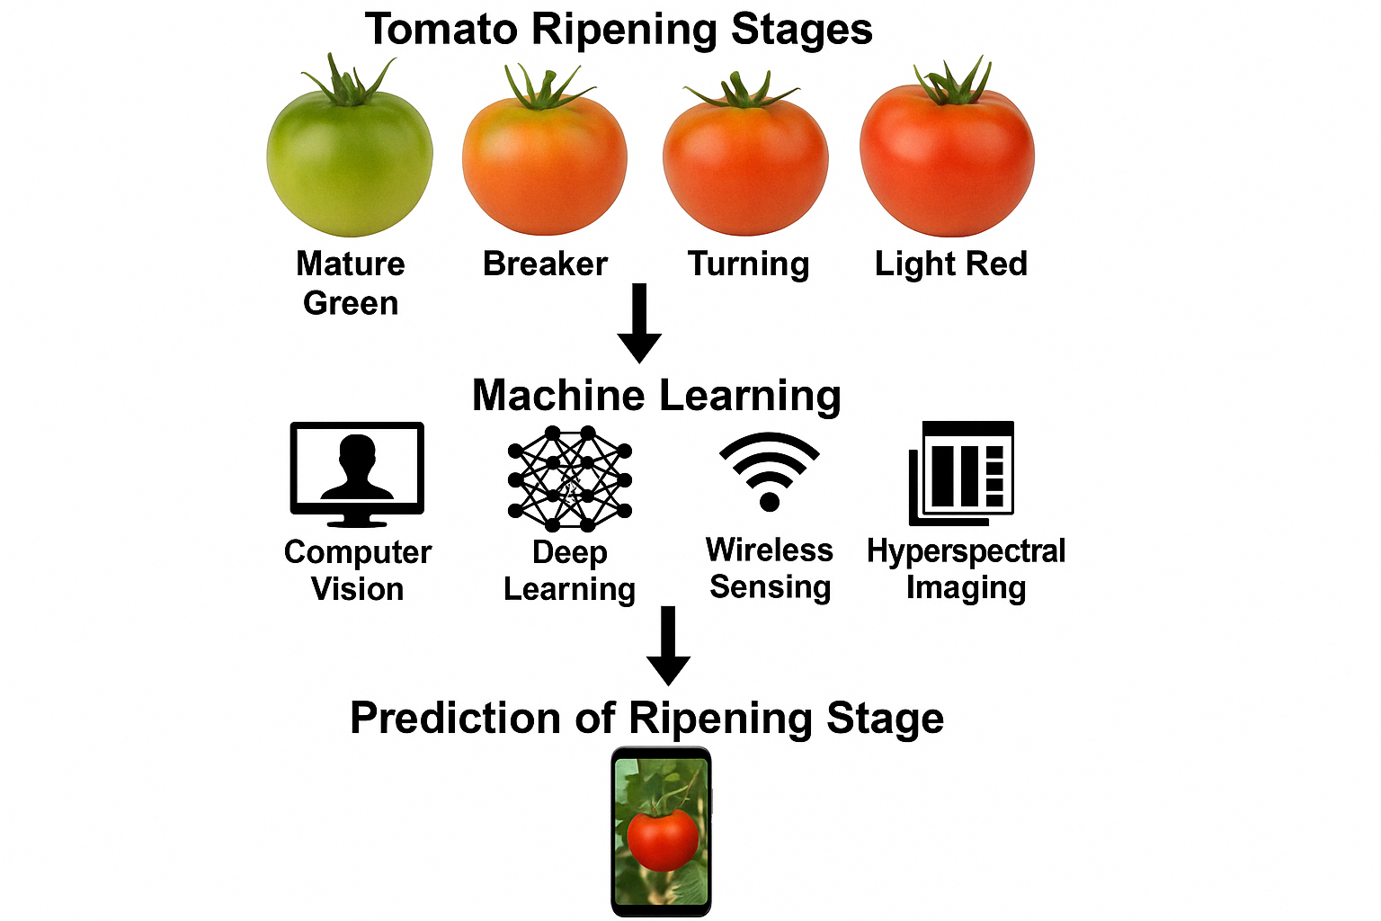
Figure 1. Schematic overview of a machine learning-based system for predicting tomato ripening stages. The process begins with visual and spectral data collection across key ripening stages—mature green, breaker, turning, and light red. Technologies such as computer vision, deep learning, wireless sensing, and hyperspectral imaging are integrated to enable accurate, non-destructive prediction of tomato ripeness, potentially via a mobile application interface.

Conclusion and future scope
In today’s era of global digitalization, humans rely heavily on cyberspace content due to its speed and efficiency compared to manual labor. As a result, computer vision has emerged as a powerful tool capable of replicating human visual perception. AI and ML algorithms can be utilized by researchers to analyze key factors influencing shelf life, develop predictive models, and accurately estimate food longevity. These models offer a valuable foundation for optimizing storage, transportation, and distribution strategies. As reported in the literature, ML and deep learning methods have been used to evaluate tomato ripeness. In this review, systems designed to predict the maturity and usability of tomato fruit, particularly based on color, firmness, and lycopene content were examined. By using various factors that influence tomato quality and shelf life as input parameters, the models are effectively trained through testing and learning processes, enabling it to achieve optimal predictive accuracy. Currently, researchers are also integrating ML with various non-destructive testing technologies to monitor tomato quality and accurately predict ripening level. This approach is especially important for maintaining tomato quality and extending shelf life without causing any damage to the product. Accurate shelf life predictions improve inventory management by ensuring tomatoes are harvested, transported, and consumed at peak quality. This benefits consumers with fresher produce, reduces food waste, and promotes sustainable agriculture. The results demonstrate that the proposed method effectively predicts tomato ripeness and usability on the validation dataset. With a larger dataset, the model's generalizability can be enhanced in future research. Additionally, a mobile application would be the friendliest approach for end users to estimate tomato ripening stage and shelf life.
References
Al-Dairi, M., Pathare, P. B. (2024). Evaluation of physio-chemical characteristics of ‘Fard’banana using computer vision system. Journal of Agriculture and Food Research, 15, 101057
Averello, V., Hegeman, A. D., Chen, C. (2024). Finding the balance: Modifying the cholesterol and steroidal glycoalkaloid synthesis pathway in tomato (Solanum lycopersicum L.) for human health, fruit flavor, and plant defense. Horticultural Plant Journal, 11, 42-56
Cano-Lara, M., Rostro-Gonzalez, H. (2024). Tomato quality assessment and enhancement through Fuzzy Logic: A ripe perspective on precision agriculture. Postharvest Biology and Technology, 212, 112875.
El-Mesery, H. S., Adelusi, O. A., Ghashi, S., Njobeh, P. B., Hu, Z., Kun. W. (2024). Effects of storage conditions and packaging materials on the postharvest quality of fresh Chinese tomatoes and the optimization of the tomatoes' physiochemical properties using machine learning techniques. LTW, 201,116280
FAOSTAT (2023) https://www.fao.org/faostat/en/#data/QV accessed May 1, 2025
Frusciante, L., P. Carli, M.R. Ercolano, R. Pernice, A. Di Matteo, V. Fogliano, N. Pellegrini. (2007). Antioxidant nutritional quality of tomato. Molecular Nutrition & Food Research, 51, 609-617
Goyal, K., Kumar, P., Verma, K. (2024). Tomato ripeness and shelf-life prediction system using machine learning. Food Measure, 18, 2715–2730
Horvitz, S., and M. J. Cantalejo. (2014). Application of ozone for the postharvest treatment of fruits and vegetables. Critical Reviews in Food Science and Nutrition, 54 (3), 312-39.
Karlova, R., N. Chapman, K. David, G.C. Angenent, G.B. Seymour, R.A. De Maagd. (2014). Transcriptional control of fleshy fruit development and ripening. Journal of Experimental Botany, 65, 4527-4541
Liu, B., H. Liu, R. Xu, W. Guan, and Z. Wu. (2019). Development and validation of a storage time prediction model for fruits and vegetables in cold chain systems. Journal of Food Processing and Preservation, 43, (3):e13887.
Oliveira, M., M. Abadias, J. Usall, R. Torres, N. Teixidó, and I. Viñas. (2015). Application of modified atmosphere packaging as a safety approach to fresh-cut fruits and vegetables-A review. Trends in Food Science & Technology, 46(1),13–26.
Pathare, P. B., M. Al Dairi, A. Al-Mahdouri. (2021). Effect of storage conditions on postharvest quality of tomatoes: A case study at market-level. Journal of Agricultural and Marine Sciences, 26 (1), 3-20
Reissig, G.N., Oliveira, T.F.C., Costa, Á.V.L., Parise, A.G., Pereira, D.R., Souza, G.M. (2021) Machine Learning for Automatic Classification of Tomato Ripening Stages Using Electrophysiological Recordings. Frontiers in Sustainable Food Systems, 5, 696829.
Shadedi, Y., Zandi, M., Bimakr, M. (2024). A computer vision system and machine learning algorithms for prediction of physicochemical changes and classification of coated sweet cherry. Heliyon, 10(20), e39484
Sharma, A., Tiwari, A. D., Kumari, M., Kumar, N., Saxena, V. (2022). Artificial intelligence-based prediction of lycopene content in raw tomatoes using physicochemical attributes. Pytochemical Analysis, 34, 729-744
Sherafati, A., K. Mollazade, M.K. Saba, et al. (2022). TomatoScan: an android-based application for quality evaluation and ripening determination of tomato fruit. Computers and Electronics in Agriculture, 107214
Shi, Y. N., Li, B. J., Grierson, K. S. (2023). Chen Insights into cell wall changes during fruit softening from transgenic and naturally occurring mutants. Plant Physiology, 192, 1671-1683
Singh, S.K., Vidyarthi, S.K., Tiwari, R. (2020). Machine learnt image processing to predict weight and size of rice kernels. Journal of Food Engineering, 274, 109828
Sualeh, A., A. Daba, S. Kiflu, A. (2016). Mohammed Effect of storage conditions and packing materials on shelf life of tomato. Food Science and Quality Management, 56 (0), 60-67
Watkins, C. B. (2006). The use of 1-methylcyclopropene (1-MCP) on fruits and vegetables. Biotechnology Advances, 24 (4), 389-409.

