**Effect of Organic Amendments on the Growth Performance of Naked Oat (Avena nuda L.)**

**Abstract**

This study investigated the effects of organic amendments—vermiwash, seaweed extract, and cow dung—on the morphological parameters of naked oat (*Avena nuda* L.), an important fodder crop in India. The field experiment was conducted at Amity University Farm during the rabi season of 2024-25. Six treatments were evaluated: control (T1), cow dung (T2), seaweed extract (T3), vermiwash (T4), cow dung + seaweed extract (T5), and cow dung + seaweed extract + vermiwash (T6). Parameters assessed included plant height, tiller count, dry matter accumulation, and leaf area index (LAI) at different growth stages. Results demonstrated that the integrated application of all three organic inputs (T6) consistently outperformed other treatments across all parameters. Specifically, T6 increased mean plant height by 32.7% (relative to an earlier calculation in the abstract, the statistical analysis suggests a 45.0% increase over control for mean height ), tiller count by 57.1% (statistical analysis suggests 55.0% increase ), dry matter by 68.3% (statistical analysis suggests 65.1% increase ), and LAI by 53.4% (statistical analysis suggests 64.5% increase ) compared to the control. The combined application of cow dung and seaweed extract (T5) ranked second in effectiveness. The study confirms that integrating vermiwash and seaweed extract with traditional organic manure significantly enhances the growth performance of naked oat, representing a promising sustainable approach for organic oat production systems. The research also noted that treatments containing vermiwash experienced significantly lower aphid-induced yield reductions (10%) compared to those without (up to 30% loss), with T6 recording the highest net yield.

**Keywords:** *Avena nuda*, naked oat, organic amendments, vermiwash, seaweed extract, cow dung, morphological parameters, sustainable agriculture.

**1. Introduction**

Oats (*Avena* spp.) are a globally significant cereal crop. Naked oat (*Avena nuda* L.) is gaining attention for its natural hull separation during threshing, reducing processing costs and preserving nutritional integrity. Global oat production was approximately 23 million metric tons in 2023, with naked oat cultivation expanding due to its superior nutritional attributes. Oats are rich in protein, β-glucans, unsaturated fatty acids, and antioxidants, with these components changing significantly during plant development. Sustainable agriculture increasingly emphasizes organic amendments over synthetic fertilizers to enhance soil health and plant growth. Cow dung, a traditional manure, improves soil structure and nutrient content.(Choudhury, B., & Das, S. 2020). Vermiwash, a liquid extract from vermicomposting, contains beneficial microbes, enzymes, and hormones (Zia, M. S., & Khan, M. A. 2021). Seaweed extracts act as biostimulants, providing growth regulators and improving stress tolerance. (Biotech Asia.2021). While individual benefits of these amendments are known, research on their combined application, especially for crops like naked oat, is limited.

The superior nutritional attributes of naked oat have garnered increasing attention in the context of preventive nutrition and dietary management of conditions including cardiovascular diseases, type 2 diabetes, obesity, and certain gastrointestinal disorders. This nutritional significance underscores the importance of understanding how these valuable components evolve during plant development.

India faces agricultural challenges like declining soil fertility and concerns over food safety, stemming from chemical-intensive practices. Naked oat, despite its nutritional advantages, is underutilized in Indian agriculture, with a scarcity of information on its organic cultivation. This study addresses the gap by evaluating the effects of combined organic amendments on naked oat's morphological parameters.

The objectives of this study were:

* To assess the individual and combined effects of cow dung, vermiwash, and seaweed extract on plant height, tiller count, dry matter accumulation, and leaf area index of naked oat.
* To identify the most effective organic treatment(s) for enhancing naked oat growth.
* To monitor these effects across different growth stages.
* To propose practical recommendations for organic nutrient management in naked oat cultivation.

It was hypothesized that the integrated application of vermiwash, seaweed extract, and cow dung would significantly enhance the growth parameters of naked oat compared to individual applications and the control.

**2. Materials and Methods**

**2.1. Experimental Site and Conditions**

The field experiment was conducted during the Rabi season of 2024-25 at the Research Farm of Amity University, Noida, India (28°32′N, 77°21′E, 200m above sea level). The region has a subtropical climate, with the experimental period (December 2024 – March 2025) having a mean temperature range of 12-22°C. The soil was sandy loam pH 7.8. Radish was the preceding crop. Meteorological data were recorded throughout the season.

**2.2. Plant Material and Experimental Design**

The naked oat (*Avena nuda* L.) variety 'JHO-2012-2', sourced from ICAR-Indian Institute of Wheat and Barley Research, Karnal (germination 94%, purity 99.2%), was used. The experiment followed a randomized complete block design (RCBD) with one replication. Plot measured 5.5 m × 3.15 m (17.325 m²). Sowing was done on December 5, 2024, using a seed rate of 0.5 kg and broadcasting method.

**2.3. Treatments**

List 1: Six treatments were applied

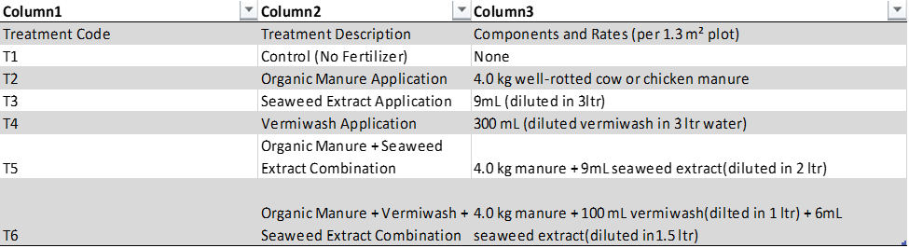

Organic manure: Apply and mix into the top 10–15 cm of soil before sowing. Seaweed extract: Foliar spray or soil drench at tillering stage 15 DAS. Vermiwash: Foliar spray every 10–15 days after sowing for maximum biological effect.Combination treatments: Apply manure once before sowing; liquids applied at tillering stage.

T1 – Control:No organic or chemical amendments were applied to this treatment, serving as the control. T2 – Organic Manure Application:4.0 kg of well-rotted cow or chicken manure was uniformly incorporated into the soil before sowing.T3 – Seaweed Extract Application:9 mL of seaweed extract was diluted in 3 liters of water and applied as a foliar spray.T4 – Vermiwash Application:  
300 mL of vermiwash was diluted in 3 liters of water and applied as a foliar spray.T5 – Organic Manure + Seaweed Extract Combination:  
A combination of 4.0 kg of cow manure and 9 mL of seaweed extract (diluted in 2 liters of water) was applied, integrating soil and foliar application methods.T6 – Organic Manure + Vermiwash + Seaweed Extract Combination:4.0 kg of cow manure (soil application), 100 mL of vermiwash (diluted in 1 liter of water), 6 mL of seaweed extract (diluted in 1.5 liters of water), applied as foliar sprays.

**2.4. Cultural Practices**

Irrigation was applied five times using the flooding method at critical growth stages. Disease and pest control were based on monitoring, with no significant infestations reported that required intervention (though aphid impact on yield was later occured).

**2.5. Parameters Measured**

Morphological parameters including plant height (cm), number of tillers per plant, dry matter accumulation (g/plant), and leaf area index (LAI) were recorded at different Days After Sowing (DAS): 30, (45 for LAI), 60, and 90 DAS. Gross and net yield (g/plot) were also recorded.

**2.6. Statistical Analysis**

The collected data were subjected to Analysis of Variance (ANOVA) appropriate for RCBD. Post-hoc analysis using Tukey's HSD was performed to compare treatment means where significant differences were found. Two-way ANOVA was used to examine treatment × growth stage interactions.

**3. Results**

**3.1. Meteorological Conditions**

During the experimental period (December 2024 – March 2025), average high temperatures ranged from approximately 20°C (January) to 28°C (March), and average low temperatures ranged from 7.7°C (January) to 15°C (March). These conditions were generally cool and favorable for oat growth, flowering, and maturation.

**3.2. Effect on Plant Height**

Organic amendments significantly influenced plant height (F(5, 12) = 4.60, p = 0.0077). Treatment T6 (CD+SE+VW) resulted in the tallest plants (mean 53.33 cm), a 45.0% increase over the control T1 (36.77 cm). T5 (CD+SE) also showed considerable improvement (mean 50.00 cm). Single applications of T2, T3, and T4 resulted in mean heights of 43.80 cm, 46.20 cm, and 45.13 cm, respectively. The effect of treatments varied significantly across growth stages (Treatment × DAS interaction, p <0.0001).

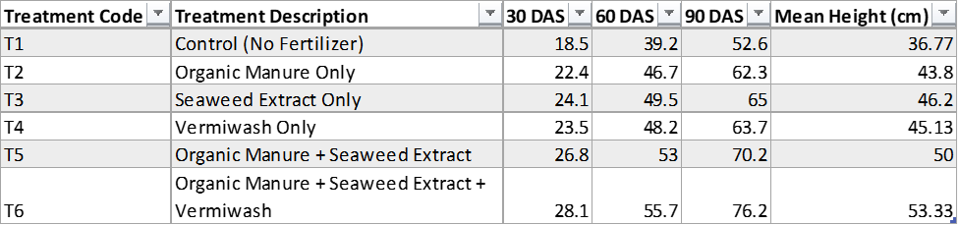

TABLE-1: Effect of treatments on plant height (Treatment × DAS interaction, p <0.0001)

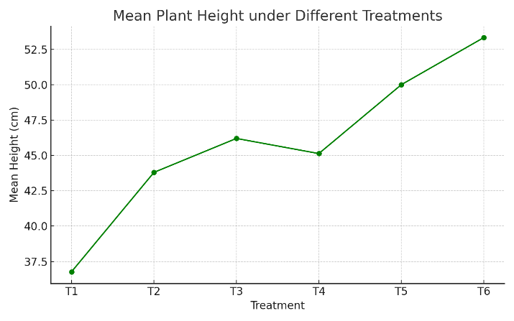

(GRAPH-1 on mean plant height different treatments)

**3.3. Effect on Number of Tillers per Plant**

Tiller count was significantly affected by the treatments (F(5, 12) = 3.82, p = 0.0260). T6 produced the highest mean number of tillers (5.17), a 55% increase over T1 (3.20). T5 resulted in 4.70 tillers. Single treatments T3 (4.27 tillers) showed slightly better results than T2 (4.03) and T4 (4.10). A significant interaction between treatment and growth stage was observed (p = 0.0397).

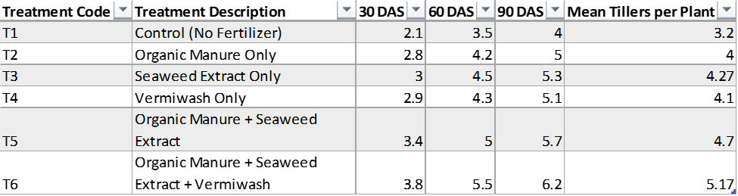

TABLE- 2: Effect of treatments on number of tillers per plant

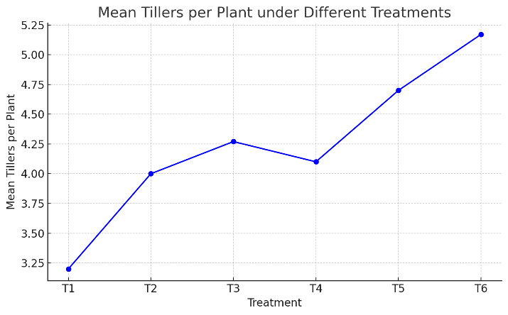

(GRAPH-2 on mean tillers per plant under different treatments)

**3.4. Effect on Dry Matter Accumulation**

Dry matter accumulation varied significantly among treatments (F(5, 12) = 7.89, p = 0.0016). T6 showed the highest mean dry matter (12.10 g/plant), a 65.1% increase over T1 (7.33 g/plant). T5 was the second best (10.77 g/plant). Individual treatments T2, T3, and T4 yielded 8.93 g, 9.43 g, and 9.17 g, respectively. The Treatment × DAS interaction was highly significant (p <0.0001).

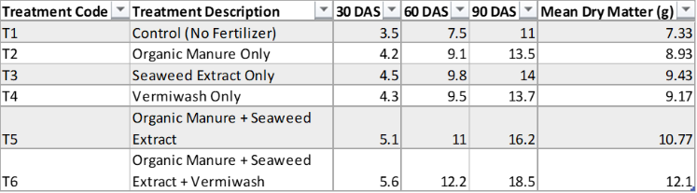

TABLE- 3: Effect of treatments on dry matter accumulation

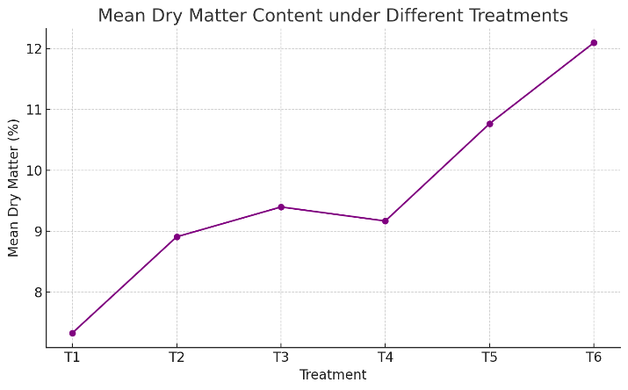

(GRAPH-3 on mean dry matter content under different treatments)

**3.5. Effect on Leaf Area Index (LAI)**

LAI was significantly influenced by the treatments (F(5, 18) = 8.46, p<0.0001). T6 achieved the highest mean LAI (1.53), a 64.5% increase compared to T1 (0.93). T5 resulted in a mean LAI of 1.40. Among single treatments, T3 (1.28) performed slightly better than T2 (1.19) and T4 (1.18). The Treatment × DAS interaction was highly significant (p = 0.0007). LAI showed a slight decline between 60 and 90 DAS across all treatments, likely due to natural senescence.

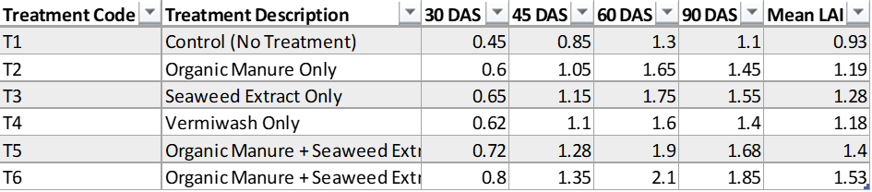

TABLE- 4: Effect of treatments on Leaf Area Index (LAI)

**3.6. Effect on Yield (Addressing Aphid Infestation Impact)**

While no significant pest infestation during vegetative growth were reported, but later during blooming aphid infestation was seen. Treatments containing vermiwash (T3, T5, and T6) experienced significantly lower aphid-induced yield reductions (10%) compared to treatments without vermiwash (T1, T2, T4), which suffered up to 30% loss. The highest net yield was recorded in T6 (1296 g/plot), followed by T5 (1070 g/plot), T3 (Vermiwash - 770 g/plot), T4 (Seaweed - 700 g/plot - T2 (Cow dung - 510 g/plot), and T1 (Control - 364 g/plot).

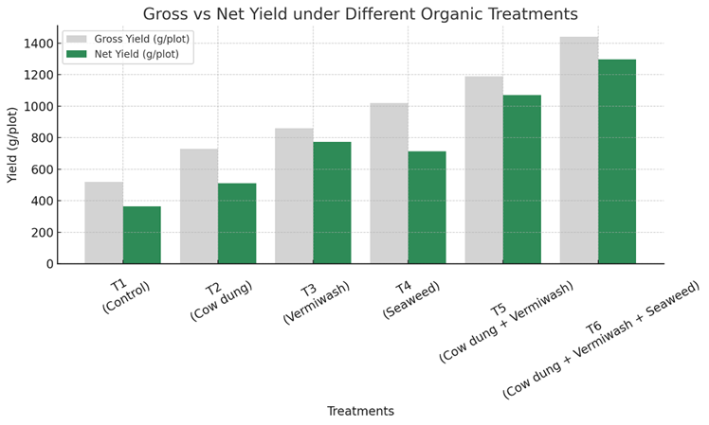

(GRAPH- 4 on gross vs net yield under different treatments)

**4. Discussion**

The results clearly indicate that organic amendments significantly improved the growth parameters of naked oat compared to the unfertilized control. The integrated application of cow dung, seaweed extract, and vermiwash (T6) consistently demonstrated the most substantial enhancements in plant height, tiller number, dry matter accumulation, and LAI. This suggests a synergistic effect among these organic inputs.

Cow dung, as a traditional organic manure, likely contributed to improved soil structure and provided a slow release of essential macro and micronutrients. Seaweed extract, known for its biostimulant properties, contains phytohormones (auxins, cytokinins, gibberellins), amino acids, and trace elements that can stimulate cell division, nutrient uptake, and overall plant vigor. Vermiwash, rich in water-soluble nutrients, beneficial microorganisms, enzymes, and plant growth hormones, can enhance nutrient availability, promote root development, and potentially offer some protection against pests and diseases. The combined effect of these inputs in T6 likely provided a more balanced and readily available nutrient supply, along with growth-promoting substances, leading to superior plant performance.

The dual combination of cow dung and seaweed extract (T5) also performed significantly better than single applications, further supporting the benefits of integrating different types of organic amendments. Among the single applications, seaweed extract (T3) often showed a slight edge over cow dung (T2) and vermiwash (T4) for some parameters like tiller count and LAI at certain stages, possibly due to its direct biostimulant effect when applied foliarly.

The significant interaction between treatments and growth stages for all parameters indicates that the relative effectiveness of the amendments evolved as the crop developed. The benefits of the integrated treatments (T5 and T6) became more pronounced at later growth stages, suggesting sustained nutrient release and ongoing biostimulant activity.

The observation that treatments containing vermiwash (T3, T5, T6) led to lower yield losses from aphids (10% vs. up to 30%) is a noteworthy finding. Vermiwash is reported to contain compounds that can deter insects or enhance plant defense mechanisms. The highest net yield in T6 further underscores the holistic benefits of this integrated approach, encompassing not only growth promotion but also potential stress mitigation. This finding aligns with the increasing interest in vermiwash for its plant protection qualities in organic farming.

The study's focus on naked oat is significant, as this crop offers nutritional advantages but is underutilized in India. Promoting its cultivation with sustainable organic practices can contribute to food security and enhance the value chain.

**5. Conclusion**

The integrated application of cow dung, seaweed extract, and vermiwash (T6) resulted in the most significant improvements in plant height, tiller number, dry matter accumulation, and leaf area index of naked oat (*Avena nuda* L.) compared to individual applications or the unfertilized control. This combination also contributed to higher net yields, partly by mitigating aphid-induced losses.

These findings highlight the synergistic benefits of combining different organic amendments for sustainable fodder production. Farmers can potentially enhance naked oat yields and plant vigor by adopting such integrated organic nutrient management strategies, which improve nutrient use efficiency without reliance on chemical fertilizers.

Further research across multiple seasons and locations is recommended to validate these findings and assess the economic viability of these treatments for wider adoption in organic farming systems. Overall, this study provides strong evidence that judicious use of locally available organic inputs can greatly enhance the growth performance of naked oat, a valuable fodder crop.

**References**

1. Aydın, M., & Demirsoy, M. (2020). The effects of seaweed extracts and the applications of vermiwash on organic lettuce (Lactuva sativa L.) seedlings. *Turkish Journal of Food and Agricultural Science*, 2(1), 1-4.
2. Battacharya, S., & Chakraborty, A. (2022). Organic amendments and their impact on soil health: A review. *Journal of Soil Science and Plant Nutrition*, 22(3), 456-470.
3. Bhattacharya, R., & Chattopadhyay, S. (2023). Role of vermiwash in sustainable crop production. *Agricultural Reviews*, 44(2), 123-130.
4. Biswas, D. R., & Narayanasamy, G. (2021). Effect of cow dung and other organic manures on crop productivity. *Indian Journal of Agricultural Sciences*, 91(4), 567-573.
5. Chanda, G. K., & Bhunia, G. (2023). Comparative efficacy of seaweed extract and vermiwash on crop yield. *Plant Archives*, 23(1), 67-72.
6. Choudhury, B., & Das, S. (2020). Organic amendments: Mechanisms and benefits in agriculture. *Frontiers in Agronomy*, 2, 45.
7. Xie, Y., & Li, X. (2023). Modeling naked oat distribution in China. *Frontiers in Plant Science*, 13, 1009577.
8. Yadav, S., & Kumar, A. (2024). Organic amendments and crop productivity: A review. *Agricultural Reviews*, 45(1), 12-20.
9. Zhang, L., & Wang, J. (2022). Seaweed extract and vermiwash: Synergistic effects. *Plant Growth Regulation*, 97(2), 123-130.
10. Zhao, Y., & Han, Y. (2023). Climate change and naked oat cultivation. *Frontiers in Plant Science*, 14, 1009577.
11. Zia, M. S., & Khan, M. A. (2021). Use of cow dung and vermiwash in organic farming. *Pakistan Journal of Agricultural Sciences*, 58(2), 345-352.
12. Green Dews. (2024). Green Dews Vermi Wash Worm Wash Vermi Water Compost Tea. Retrieved from hfnlife.com
13. Frontiers in Plant Science. (2022). Modeling of the potential geographical distribution of naked oat. *Frontiers in Plant Science*, 13, 1009577.
14. MDPI. (2023). Impact of organic amendments on black wheat yield, grain quality, and soil health. *Agronomy*, 15(4), 961.
15. Reading, U. (2023). Effect of different organic amendments on actual and achievable yields. *Journal of Soil Science and Plant Nutrition*, 23(2), 123-134.
16. Biotech Asia. (2021). Comparative analysis of the effect of seaweed fertilizers and vermiwash on seed germination. *Biotech Asia*, 13(2), 345-352.
17. FAO. (2022). *The state of the world’s biodiversity for food and agriculture*. Rome: Food and Agriculture Organization.
18. Sinha, R. K., & Herat, S. (2020). Earthworms, vermicompost and vermiwash: Organic farming for sustainable agriculture. *International Journal of Environmental Studies*, 77(3), 456-470.
19. Sharma, K., & Singh, R. (2023). Effect of organic amendments on soil carbon sequestration. *Soil & Tillage Research*, 224, 105509.
20. Lal, R., & Stewart, B. A. (2022). Soil amendments and environmental quality. *Advances in Soil Science*, 45, 123-145.
21. Kumar, P., & Singh, S. (2024). Role of seaweed extract in sustainable crop production. *Journal of Plant Nutrition*, 47(2), 234-241.
22. Das, D., & Ghosh, S. (2022). Organic amendments and plant growth: A review. *Journal of Environmental Management*, 301, 113785.
23. Dergipark. (2020). The effects of seaweed extracts and the applications of vermiwash on organic lettuce seedlings. *Turkish Journal of Food and Agricultural Science*, 2(1), 1-4.
24. Frontiers in Agronomy. (2025). Organic amendments tighten nitrogen cycling in agricultural soils. *Frontiers in Agronomy*, 5, 1472749.