Antibiotic sensitivity profiling of subclinical mastitis affected sheep and goat in an organized farms of Tamil Nadu

Abstract:
Mastitis is an inflammation of mammary gland or udder. Totally 267 numbers of milk samples were collected from 3-4 years old recently kidded female sheep and goats of an organized sheep and goat farms of Tamil Nadu for the period from 2021-2024. The suspected animals were clinically examined showed of sudden swelling of both quarter of udder and unable to feed kids and some of them are hyperthermia and anorectic. The clinical examination revealed that the mammary gland is hard, swollen, and reddish in color some of the goats doesn’t have any clinical symptoms. It may also be hot and sensitive to touch. Milk secretions are watery and yellowish in color. The body temperature remain elevated and the animal was very dull and depressed some of them showed diarrhoea and metritis. The BHI, Mac Conkey, SDA, Hichrome agar, EMP agar were used for isolation of different types of bacteria. The affected animal milk sample showed resistance against erythromycin, ampicillin, amoxycillin and sensitive towards ciprofloxacin, cefriazone chloramphenicol and cefataxime, gentamicin, enrofloxacin and gatrifloxacin in ABST in case of staphylococcus. The streptoccus showed sensitivity towards ciprofloxacin, gentamicin, enrofloxacin and chloramphenicol, resistance towards cefataxime, oxytetracycine, sulphadiazine, cefriazone
Key words: mastitis, goat, isolation, ABST, control of mastitis
Introduction
Mastitis is common in dairy breeds and meat breeds of goat raised in intensive system of rearing. Mastitis also associated with viral, bacterial, mycoplasma and fungi and their toxins. The stressful condition like high temperature, environmental changes, sudden changes of diet, malnutrition and unhygienic maintenance are predisposing factor for mastitis. Staphylococcus aureus, Streptococcus agalactiae, Streptoccous dysagalactiae, Escherichia coli, Pseudomonas are the common bacteria causing mastitis in goat and caprine arthritis encephalitis virus causing mastitis in goat and some of the yeast infection also causes mastitis due to the frequent use of penicillin along with the prolonged and repetitive use of systemic and intra-mammary infusions of antibiotics
The annual incidence of clinical mastitis in small ruminants is generally lower than 5%, but it can increase sporadically. The prevalence of subclinical mastitis has been estimated at 5–30% (Bergonier and Berthelot, 2003, Contreras et al., 2003), but there are only limited data available about incidence of intramammary infection (IMI) of goat and sheep in the literature. Giadinis et al., 2012 reported that the mammary infections are the primary causes of 85% milk-drop syndrome in ewes. The syndrome has been defined as a pathological entity at flock level and characterised by reduced milk yield of lactating ewes with no clinical signs specific to a disease (Giadinis et al., 2012).
In dairy-type sheep and goat flocks, mammary infections have important due to the reduction in milk yield, the downgrading of milk quality and the rejection of milk after antibiotic administration. The mammary infections are important also in meat production flocks, as reduced milk yield of ewes has been shown to lead to suboptimal growth of their lambs (Fthenakis and Jones, 1990a) and other costs associated with the disease include those for replacement ewes and the relevant veterinary expenses. In case of sheep, mammary infections are also of great welfare concern clinical mastitis is a disease that leads to anxiety, restlessness, changes in feeding behavior and pain in affected animals (Fthenakis and Jones, 1990b).
Materials and method:
The milk samples (N=267) were collected from suspected animals in sterile container from the period of 2021-2024 (fig 1). The BHI, Mac Conkey, SDA, Hichrome agar, EMP agar were used for isolation of different types of micro organism present in milk and both cultural isolation and identification, catalase oxidase test, biochemical test and antibiotic sensitivity test were performed by using the isolated organism ( fig 2,3,4,7,8) The isolated bacteria were biochemically characterized and confirmed by gram’s staining ( Fig. 5.6 )and PCR by using specific primers. The antibiotic sensitivity patterns were performed with 15 different types of antibiotics by disc diffusion method by disc diffusion method using Muller Hinton agar (Fig. 5,6)
Results and discussion:
The organism were identified based on colony morphology and biochemical character. Some of the milk sample showed metallic shine colony and gram staining showed gram negative rods, E.coli (N=67) and some sample showed Staphylococcus (N=24) ,few of the showed Streptoccus (N=12), Pseudomonas (N=8), Klebsiella (N=18), Candida species(N=22) and Aspergillus (N=4). ( table 1 and Fig 2,7,8).
The affected animal milk sample showed resistance against erythromycin, ampicillin, amoxycillin and sensitive towards ciprofloxacin, cefriazone chloramphenicol and cefotaxime, gentamicin, enrofloxacin, doxycycline and gatrifloxacin in ABST in case of staphylococcus. (Fig 2,3). The streptococcus showed sensitivity towards ciprofloxacin, gentamicin, enrofloxacin and chloramphenicol, resistance towards cefataxime, oxytetracycine, sulphadiazine, cefriazone. The isolated Pseudomonas showed sensitivity towards sulphadiazine, cefriazone, ciprofloxacin, gentamicin, enrofloxacin and Klebsiella showed sensitivity towards chloramphenicol,gentamicin,erythromycin, gatrifloxacin, endrofloxacin and resistance towards sulphadiazine, cefotaxime, cefriazone (table .2)
The clinically affected animals were treated with antibiotic and anti inflammatory. The treatment for mastitis based on the results of the microbiologic culture obtained from milk samples. Dry off the affected gland and application of intramammary infusion of 2 percent chlorhexidine solution into affected udder twice at 24-hour intervals. Drugs should be administered for a period of 5 to 10 days to allow efficacy of the product. The use of antibiotics or corticosteroids are recommended in some cases. Antibiotics always selected based on ABST results. Treatment during the dry-off period is an efficient method for the cure of subclinical mastitis and for control of somatic cell counting.
Mastitis is an inflammation of the mammary gland causes a chemical and physical reaction in milk produced by sheep and goats. Mastitis more common in dairy and meat goats raised under intensive and semi-intensive system of rearing and causes economic loss to the sheep and goat farmers. The mastitis in sheep and goat was generally associated with poor management practices and injuries of mammary tissue or teats due to traumas, nursing, fly bites or other wounds to the mammary gland that provide an important barrier to infection. Some of the stressful conditions such as extreme temperatures, muddy and wet living conditions or a sudden change in diet, poor nutrition and pregnancy stress leads to immune deficiency and has a difficult time fighting off the invasion of foreign bodies that cause diseases like mastitis. Another important predisposing factor is the abnormal anatomy of the udder or teat. Mostly the infection occurs when infectious agents reach the mammary gland. The infectious microbes enters through the milk canal and interacts with the mammary tissue cells and multiplies and produce infection and some of the microbial microorganisms release toxins leads to systemic infection. The mammary tissue reacts to these toxins leads to inflammation of udder. The Coagulase-negative staphylococci species like Staphylococcus aureus, Streptococcus agalactiae, S. uberi, S. dysgalactia, and S. caprae Mycoplasma capricolu, Enterobacteria such as Escherichia coli coliforms, Pseudomonas aeruginosa, and Clostridium spp. are the most common causes of mastitis in sheep and goat. The virus like caprine arthritis-encephalitis virus (CAEV) causes mastitis in goats. The mastitis can also caused by yeast and mold infection mainly associated with the frequent use of penicillin along with the prolonged and repetitive use of systemic and intra-mammary infusions which predispose the fungal mastitis. The acute systemic form of mastitis shows elevated body temperature above 105° F and an accelerated pulse and the affected animals were depressed and lose its appetite. The clinical examination of mammary gland shows hard, swollen, reddish in color and hot and sensitive to touch. Milk secretions are watery and yellowish in color and milk had flake and clot. In most severe form of mastitis causes death in some animals. The chronic form of mastitis occurs as a persistent and incurable infection. The udder may have hard lumps as a result of bacteria forming colonies and reactions occurring in the mammary tissues. In chronically affected animals shows agalactia and sometimes reduced milk production. The subclinical mastitis causes the most concern among producers and veterinarians because there are no visible signs of the disease. There is no swelling of the udder or detectable abnormalities in the milk to indicate the presence of mastitis. but sub-clinical form can eventually develop into the chronic clinical form of mastitis. The diagnosis based on signs and history of the herd, microbiologic milk culture, a somatic cell count (SCC) or an Enzyme-Linked Immuno Sorbent Assay (ELISA). However, the microbiological culture is the most reliable source of diagnosis of mastitis in sheep and goats. The SCC and the California Mastitis Test (CMT) are the most common tests used to diagnose mastitis in dairy goats. Some of the antibiotics like benzylpenicillin, cloxacillin, amoxicillin plus clavulanic acid, cephalonium and cefoperazone, erythromycin, thymosin, kanamycin, penicillin, ampicillin, erythromycin, or tetracycline have been recommended to treat mastitis but the cure rates may vary from animal to animal and according to the severity of the case. After treating goats with antibiotics, it is necessary to withdraw drug treatment to prevent antibiotics from building up in the milk and meat that can be hazardous to humans. Glucocorticoids can be administered early in the course of disease and administration of dexamethasone in the mammary gland has been reported to reduce swelling of udder. In addition, intramammary infusion with mastilip ointments used to treat mastitis among dairy cows is effective among sheep and goats as well. Strict hygienic practice in indoor sheep and goat farms will prevent subclinical mastitis. However, observe tissue irritation after administration intramammary antibiotics. In this study most of the small ruminant mastitis caused by E.coli and Staphylococcus, Klesiella and Candida and antibiotic sensitive pattern showed sensitivity towards gentamicin, erythromycin, gatrifloxacin, enrofloxacin and resistance towards oxytetracycline, cefotaxime, cefrizone, sulphadiazine but however indepth detailed study were needed for antibiotic pattern analysis.
Disclaimer (Artificial intelligence)
Hereby I declare that NO generative AI technologies such as Large Language Models
(ChatGPT, COPILOT, etc.) and text-to-image generators have been used during the writing or editing of this manuscript.

References
- Berri, M., Rousset, E., Champion, J. L., Russo, P., and Rodolakis, A. (2007, August). Goats may experience reproductive failures and shed coxiella burnetii at two successive parturitions after a Q fever infection. Research in Veterinary Science. 83(1), 47-52.
- Brouillette, E., Grondin, G., Lefebvre, C., Talbot, B. G., and Malouin, F. (2004, August). Mouse mastitis model of infection for antimicrobial compound efficacy studies against intracellular and extracellular forms of staphylococcus aureus. Veterinary Microbiology, 101(4), 253-262.
- Chávez González, Y. R., Ros Bascuñana. C., Bölske, G., Mattsson, J. G., Fernández Molina, C., and Johansson, K. E. (1995, November). In vitro amplification of the 16S rRNA genes Mycoplasma bovis and Mycoplasma agalactiae by PCR. Veterinary Microbiology. 47(1-2), 183-190
- Hötzel, I., and Cheevers, W. P. (2001, August). Host range of small-ruminant lentivirus cytopathic variants determined with a selectable caprine arthritis-encephalitis virus pseudotype system. Journal of Virology, 75(16), 7384-7391.
- Karzis, J., Donkin, E. F., and Petzer, I. M. (2007, June). The influence of intramammary antibiotic treatment, presence of bacteria, stage of lactation and parity in dairy goats as measured by the California Milk Cell Test and somatic cell counts. Onderstepoort Journal of Veterinary Research, 74(2), 161-167.
- Kyozaire, J. K., Veary, C. M., Petzer, I. M., and Donkin, E. F. (2005, June). Microbiological quality of goat's milk obtained under different production systems. Journal of the South African Veterinary Association, 76(2), 69-73.
- Merck & Company, Incorporated. (2008). The Merck veterinary manual. New Jersey: Merck & Company, Incorporated.
- Moroni, P., Pisoni, G., Antonini, M., Ruffo, G., Carli, S., Varisco, G., and Boettcher, P. (2005). Subclinical mastitis and antimicrobial susceptibility of staphylococcus caprae and staphylococcus epidermidis isolated from two Italian goat herds. Journal of the American Dairy Science Association, 88, 1694-1704.
- Moroni, P., Vellere, F., Antonini, M., Pisoni, G., Ruffo, G., and Carli, S. (2004, June). Antibiotic susceptibility of coagulase-negative staphylococci isolated from goats' milk. International Journal of Antimicrobiological Agents, 23(6), 637-640.
- National Mastitis Council. (1990). Procedures for collecting milk samples. In Microbiological Procedures for the Diagnosis of Bovine Udder Infection (3rd ed.). Retrieved November 7, 2008.
- Poutrel B, de Crémoux R., Ducelliez M., Verneau D. (1997). Control of intramammary infections in goats: impact on somatic cell counts. Journal of Animal Science, 75(2), 566-570.
- Schweiz, A. and Schweiz, T. (2006, December). Prevalence of subclinical udder infections and individual somatic cell counts in three dairy goat herds during a full lactation. Schweiz Arch Tierheilkd, 148(12), 641-648.
- Sela, S., Hammer-Muntz, O., Krifucks, O., Pinto, R., Weisblit, L., and Leitner, G. (2007, November). Phenotypic and genotypic characterization of Pseudomonas aeruginosa strains isolated from mastitis outbreaks in dairy herds. Journal of Dairy Research, 74(4), 425-459.
Table 1: Bacteria isolated from milk sample of suspected for mastitis
S.No | Organism isolated | Sheep | Goat
1 | Staphylococcus | 4 | 20
2 | E.coli | 7 | 60
3 | Streptococcus | 3 | 9
4 | Pseudomonas | - | 8
5 | Klebisella | 3 | 15
6 | Candida | 3 | 19
7 | Aspergillus | - | 4
8 | Total | 20 | 135

Table 2: Antibiotic sensitivity patterns for different bacterial isolates
S.No | Organism isolated | Sensitive | Resistance
1 | Staphylococcus | ciprofloxacin, cefriazone chloramphenicol and cefotaxime, gentamicin, enrofloxacin and gatrifloxacin The isolated Pseudomonas showed sensitivity towards sulphadiazine, cefriazone, ciprofloxacin, gentamici ,enrofloxacin | Erythromycin , ampicillin, amoxycillin
2 | E.coli | Ciprofloxacin , gentamicin , cefataxime | Oxytetracycine sulphadiazine, cefriazone, ampicillin,amoxyclav, chloramphenicol,
3 | Streptococcus | Ciprofloxacin , gentamicin enrofloxacin and chloramphenicol, | cefataxime,oxytetracycine, sulphadiazine, cefriazone, ampicillin,amoxyclav
4 | Pseudomonas | Sulphadiazine , cefriazone, ciprofloxacin, gentamicin ,enrofloxacin | cefataxime,oxytetracycine, sulphadiazine, cefriazone,chloramphenicol, ampicillin,amoxyclav
5 | Klebisella | Chloramphenicol,gentamicin,erythromycin, gatrifloxacin, endrofloxacin | Sulphadiazine , cefotaxime, cefriazone, ampicillin,amoxyclav
6 | Candida | Ciprofloxacin , gentamicin chloramphenicol, gatrifloxacin | cefataxime,oxytetracycine, sulphadiazine, cefriazone, ampicillin,amoxyclav
7 | Aspergillus | Gatrifloxacin, sulphadiazine catrimazole | cefataxime,oxytetracycine, sulphadiazine, cefriazone, ampicillin,amoxyclav

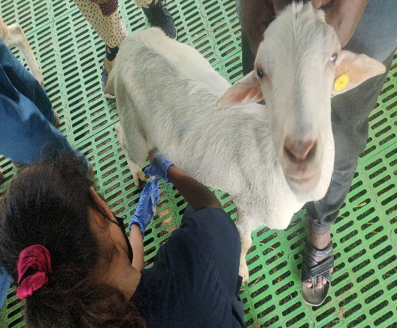  Fig 1: milk sample collection from suspected goat | 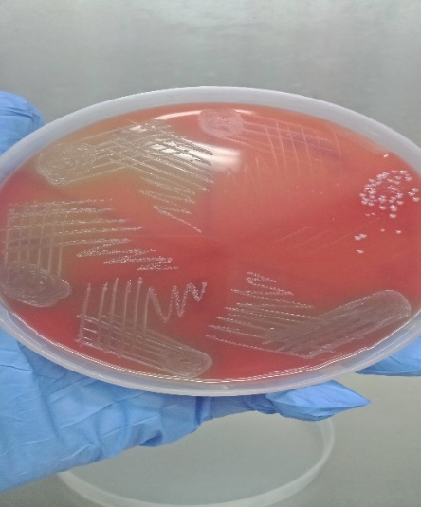  Fig 2: Isolation of Staphylococcus in blood agar
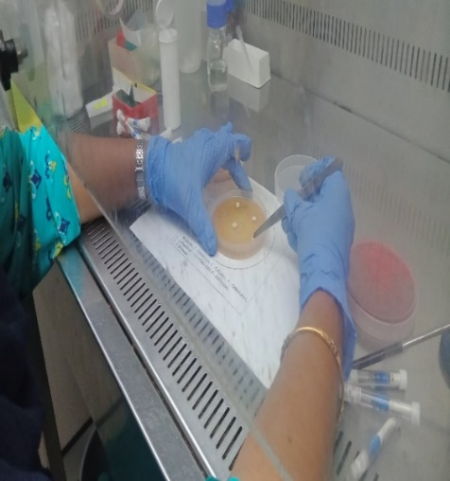  Fig 3: Antibiotic sensitivity test for isolated bacterial organism | 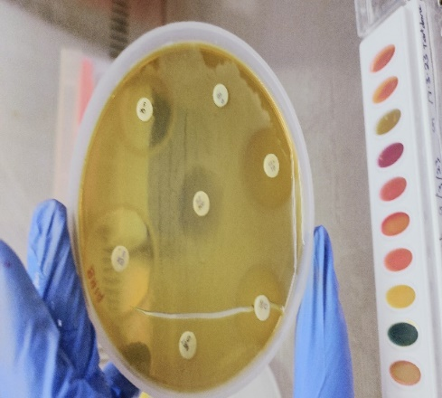  Fig 4: analysis of antibiotic sensitivity patterns of isolated micro organism
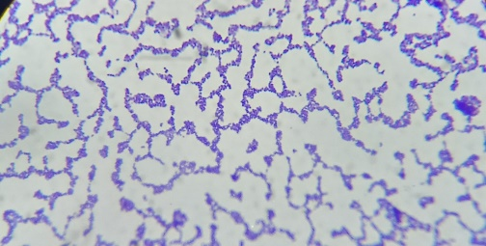  Fig 5: Gram staining of isolated organism showed Staphylocous  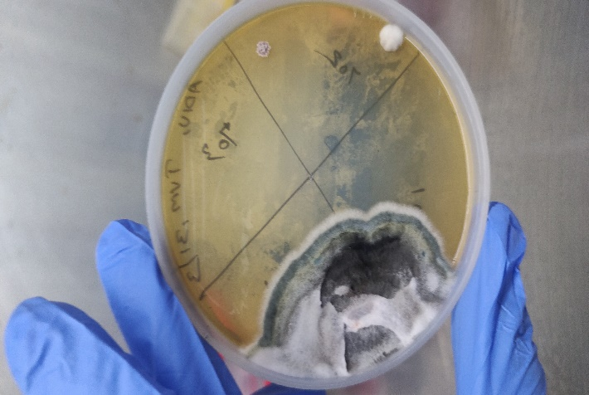  Fig 7: Isolation of Aspergillus from milk sample of mastitis affected goat | 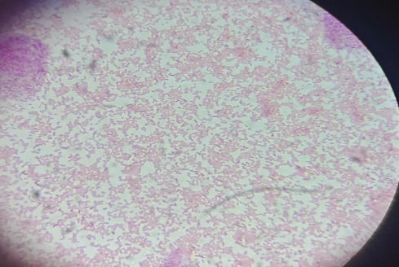  Fig 6 : Gram staining of isolated organusm shows gram negative rods  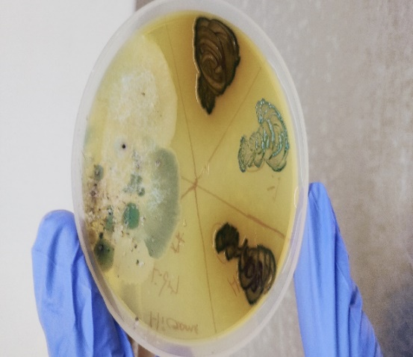  Fig 8: Isolation of Candida species from mastitis affected goat

