**Advanced Fibre Blending in Nonwoven Technology: Enhancing Performance and Sustainability**

**Abstract**

Nonwoven fabrics have become integral to numerous industries due to their lightweight, versatile and cost-effective nature. A critical aspect of nonwoven production is fibre mixing and blending, which enables the enhancement of material properties such as tensile strength, absorbency, flexibility and functionality. This review explores the strategic blending of synthetic, natural, regenerated and specialty fibres to meet diverse application needs in sectors like hygiene, medical, filtration, and geotextiles. Emphasis is placed on the objectives of fibre blending, including performance optimization, cost reduction and functionalization. This paper also highlights challenges such as achieving fibre compatibility and uniform distribution, as well as the growing importance of sustainable and biodegradable fibre options. Advances in digital control, nanofibres integration and bio-based material use are expanding the potential of nonwoven fabrics. Overall, fibre blending remains a cornerstone in engineering nonwovens for modern performance and sustainability requirements.

**Key words:** Nonwoven fabrics, fibre blending, web formation, performance enhancement, biodegradable materials, textile engineering

**1. Introduction**

Nonwoven fabrics, unlike traditional woven or knitted textiles, are manufactured by bonding or interlocking fibres through mechanical, thermal or chemical processes without converting them into yarns (Russell, 2007). This method results in versatile and cost-effective materials that can be tailored for specific applications in sectors such as healthcare, personal hygiene, automotive, filtration, agriculture and geotextiles. Among the numerous variables influencing the performance of nonwoven fabrics, fibre mixing and blending have emerged as crucial processes that determine the end-use properties, sustainability and economic feasibility of these materials (Albrecht *et al.,* 2003). Fibre blending involves the combination of two or more types of fibres to produce a composite with improved or multifunctional properties. This technique allows manufacturers to merge the strengths of different fibres while compensating for their individual limitations. For example, blending synthetic fibres like polypropylene (PP), known for its strength and water resistance, with natural or regenerated fibres like cotton or viscose can yield fabrics that are strong, breathable and absorbent qualities desirable in hygiene and medical applications (Gholamreza *et al.,* 2020).

The rising global demand for lightweight, high-performance and eco-friendly materials has driven innovation in nonwoven blending technologies. Advanced systems such as carding, airlay, wetlay and spunbond-meltblown-spunbond (SMS) allow for the precise control of fibre orientation, thickness and layering (Chinta and Gujar, 2018). Through these technologies, manufacturers can produce composite structures that integrate different fibre functionalities in a single sheet improving mechanical strength, fluid management and breathability simultaneously. For instance, the airlay process enables the incorporation of short fibres from various sources, including recycled and biodegradable fibres, into a uniform web, supporting circular economy goals in textile manufacturing. Also, carding systems have been optimized to mix and align fibres of varying lengths and diameters to ensure web uniformity and consistent quality. Such flexibility in processing allows the blending of specialty fibres such as carbon, aramid or chitosan-coated fibres, expanding the application scope of nonwovens to advanced sectors like defense, filtration and biomedical fields (Soin *et al.,* 2014).

However, despite these advancements, several technical and environmental challenges remain. Achieving a uniform distribution of fibres in blended webs continues to be difficult, especially when combining fibres of different geometries, densities or surface properties. For example, hydrophilic and hydrophobic fibres tend to separate during web formation, leading to product inconsistency (Zhang *et al.,* 2020). The compatibility of bonding agents and finishes with mixed fibres also affects the integrity and durability of the final product. Moreover, the chemical finishing required to improve performance (e.g., waterproofing, flame retardancy, antimicrobial treatment) may negatively impact the biodegradability and recyclability of the product (Shen *et al.,* 2020).

Environmental concerns further underscore the importance of sustainable fibre selection and blending practices. As nonwoven products are frequently designed for single use, especially in medical and hygiene sectors, the integration of biodegradable and recyclable fibres becomes vital. Blending polylactic acid (PLA), cellulose-based fibres or recycled polyester (rPET) with traditional synthetics can reduce the carbon footprint of nonwoven products (Mather and Wardman, 2005). However, this also introduces challenges in ensuring mechanical performance and processing compatibility, which has led to ongoing research in bio-based crosslinking agents, green solvent systems and fibre surface modifications (Liao *et al.,* 2018). Moreover, digital technologies and artificial intelligence are being increasingly integrated into the blending process to optimize fibre ratios, monitor web uniformity in real time and reduce waste. Smart control systems based on machine learning algorithms can predict fibre behavior and adjust process parameters automatically, significantly improving process efficiency and quality assurance (Xu *et a.l,* 2021).

**2. Nonwoven Fabric Technology**

Nonwoven fabrics are engineered sheet materials composed of staple fibres or continuous filaments that are bonded together through mechanical, thermal or chemical means, without being spun into yarn or woven into fabric (Russell, 2007). This distinguishes nonwovens from traditional woven and knitted textiles, which rely on the interlacing of yarns. Because of their simplified and highly adaptable manufacturing processes, nonwovens can be produced rapidly and often at lower cost compared to conventional textiles (Horrocks and Anand, 2016).The core manufacturing methods for nonwoven fabrics include spunbonding, meltblowing, carding, air laying, wet laying and hydroentangling. These technologies can be used individually or in combination, depending on the end-use requirements. For instance, spunbond-meltblown-spunbond (SMS) structures are widely used in medical masks and gowns for their high barrier properties and breathability (Albrecht *et al.,* 2003; Hutten, 2007).

Nonwovens have become indispensable across a variety of sectors due to their lightweight nature, customizability and functional adaptability. In the hygiene industry, they are used in diapers, sanitary napkins and adult incontinence products due to their softness, absorbency and liquid barrier performance. In the medical field, nonwovens are used for surgical drapes, masks, gowns and wound dressings because they provide sterile barriers and are often disposable, reducing the risk of cross-contamination (Baker and Sreenivasan, 2010). In geotextiles, nonwovens are used for soil stabilization, drainage and erosion control due to their mechanical strength and permeability (Koerner, 2016). The performance of nonwoven fabrics is significantly influenced by several factors, including fibre selection (synthetic, natural or regenerated), web formation (random or oriented), bonding technique (needle punching, thermal bonding, chemical bonding) and post-processing treatments (lamination, coating, embossing). Fibre properties such as length, fineness and surface characteristics affect web uniformity and bonding behavior, which in turn influence tensile strength, abrasion resistance, absorption and breathability (Adanur, 1995).

Moreover, with the global shift toward sustainability, there is growing interest in nonwovens made from recycled fibres, biodegradable polymers (e.g., PLA) and natural fibres like hemp, jute and bamboo. These materials are being integrated into both disposable and durable nonwoven applications to reduce environmental impact (Shen *et al.,* 2020; Mather and Wardman, 2005).

**3. Objectives of Mixing and Blending of fibres**

Mixing and blending of fibres in nonwoven production involve combining two or more types of fibres before web formation to enhance product functionality, process efficiency or cost-effectiveness. This practice allows manufacturers to tailor the properties of nonwoven fabrics to meet specific performance criteria across a wide range of applications. Key objectives of fibre blending include:

* **Enhancing performance characteristics**, such as tensile strength, absorbency, softness, flame resistance and thermal insulation (Soin *et al.,* 2014). For instance, blending hydrophilic viscose with hydrophobic polypropylene can create fabrics with controlled moisture-wicking and absorbency profiles.
* **Reducing production costs** by blending high-cost, functional fibres with low-cost carrier fibres (Gholamreza *et al*., 2020). For example, carbon or silver-coated fibres can be blended in small percentages with polyester to achieve conductivity or antimicrobial effects while keeping material costs down.
* **Achieving multifunctionality** through fibre combination. Selective blending allows the integration of antimicrobial, hydrophobic, fire-retardant or UV-resistant features into a single fabric layer (Liao *et al.,* 2018).
* **Improving processing behavior**, particularly when dealing with recycled, short-staple or specialty fibres. Blending these with well-aligned synthetic fibres improves fibre orientation and bonding during carding or airlay processes, resulting in better web uniformity and mechanical strength (Chinta and Gujar, 2018).

**4. Types of Fibres Used in Nonwovens**

A diverse range of fibre types—natural, synthetic, regenerated and specialty is used in nonwoven fabric production. The selection is based on intended end-use performance, processing compatibility, cost and environmental impact.

**4.1 Synthetic Fibres**

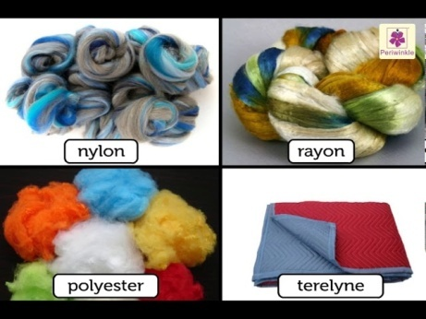Synthetic fibres dominate nonwoven applications due to their processability, consistency and high-performance characteristics. Common examples include:

* **Polypropylene (PP):** Widely used in spunbond and meltblown nonwovens for hygiene and medical applications. Offers excellent chemical resistance, low density, and good mechanical strength (Russell, 2007).
* **Polyester (PET):** Known for durability, dimensional stability, and resistance to stretching and shrinking. Frequently used in filtration, insulation, and automotive textiles (Horrocks & Anand, 2016).

https://www.youtube.com/watch?v=W-uNxR5Zua0

FIG 1. Synthetic Fibres

* **Polyamide (PA or nylon):** Provides high abrasion resistance, making it suitable for geotextiles and industrial wipes. It also enhances tensile strength when blended with other fibres (Albrecht et al., 2003).

**4.2 Natural Fibres**

Natural fibres are increasingly used in sustainable nonwovens for their biodegradability and skin-friendly properties:

* **Cotton:** Highly absorbent and breathable, used in hygiene and medical applications, though often blended with synthetics to improve strength and reduce cost (Mather and Wardman, 2005).
* **Flax and jute:** Offer good tensile strength and biodegradability, making them ideal for agricultural and packaging nonwovens (Shen *et al.,* 2020).
* **Hemp:** Known for antimicrobial and UV-resistant properties; used in composite nonwovens for eco-friendly consumer products (Liu *et al.,* 2017).

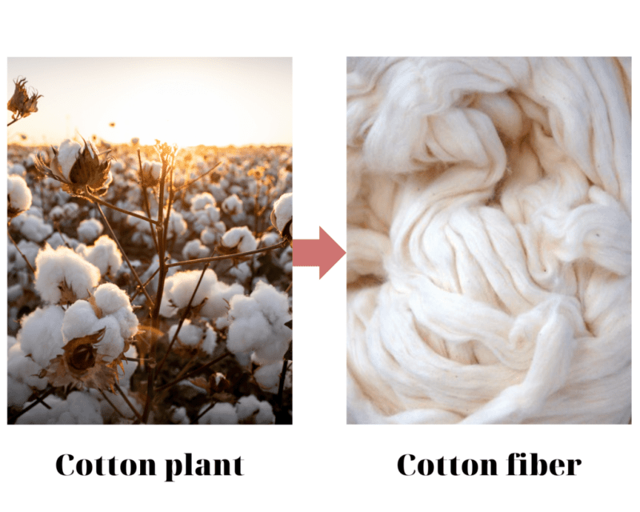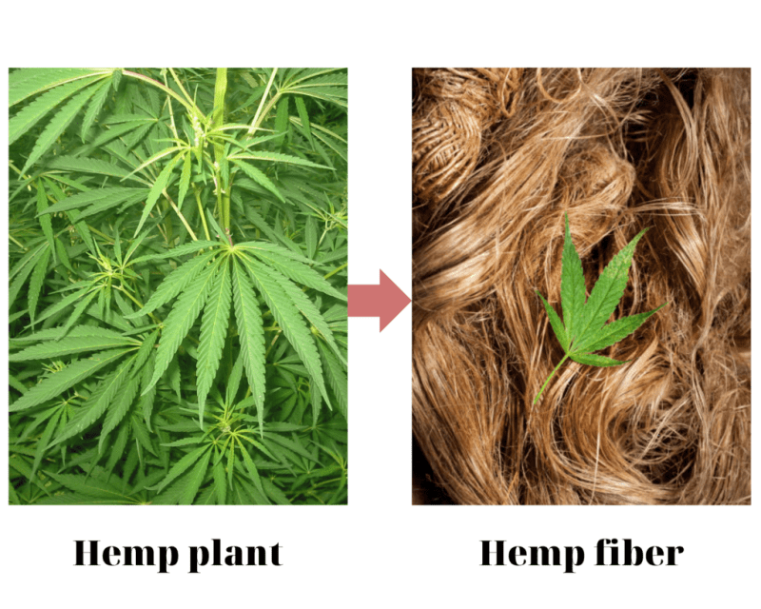

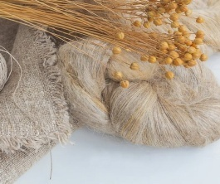

https://textilelearner.net/difference-between-flax-and-hemp-fiber/

https://www.ecosilky.com.vn/en/explore-natural-and-synthetic-fibers-images-with-names/

**FIG 2.** **Natural Fibres**

**4.3 Regenerated Fibres**

These fibres are derived from natural polymers but are chemically processed to achieve better control over fibre properties:

* **Viscose rayon:** Highly absorbent, soft and biodegradable. Common in wipes, sanitary products, and hospital textiles (Edana, 2020).
* **Lyocell (Tencel):** A solvent-spun cellulose fibre that is strong when wet, soft to the touch and environmentally friendly (Liao *et al.,* 2018).
* **Bamboo fibre:** Offers natural antibacterial properties and good absorbency. Often blended with PP or PET for biodegradable hygiene applications (Rhim and Wang, 2013).

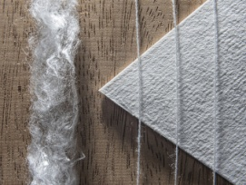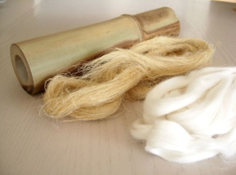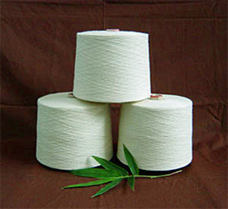

https://vnpolyfiber.com/viscose-rayon-modal-lyocell-tencel/

https://www.gaiadiscovery.com/design-building/lyocell-a-sustainable-fabric-solution.html

https://textilefocus.com/bamboo-fiber-a-sustainable-alternative-to-cotton/

**FIG 3.** **Regenerated Fibres**

**4.4 Specialty Fibres**

Specialty fibres are used in high-performance nonwovens requiring advanced functionality:

* **Glass fibres:** Used in filtration, insulation and composite reinforcement due to their high thermal and chemical resistance.
* **Carbon fibres:** Provide electrical conductivity and high tensile strength; used in EMI shielding and aerospace applications (Horrocks and Anand, 2016).
* **Aramid fibres (e.g., Kevlar®):** Extremely strong and heat-resistant, used in protective clothing, fire barriers and industrial filters.
* **Metallic fibres (e.g., stainless steel or copper):** Offer conductivity and are blended into nonwovens for antistatic or electromagnetic shielding materials (Gao *et al.,* 2021).

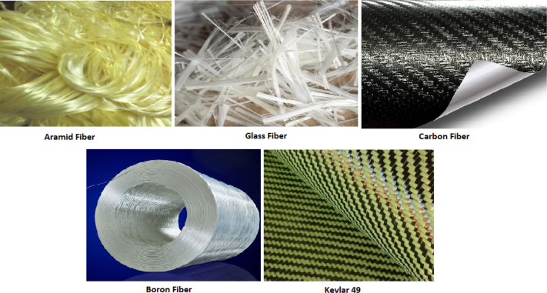

https://www.sciencedirect.com/topics/materials-science/synthetic-fiber

FIG 4. Specialty Fibres

Blending multiple fibre types allows manufacturers to tailor the nonwovens’ functionality, durability and feel while balancing cost and environmental impact.

**5. Blending for Functional Applications**

Blending in nonwoven manufacturing is increasingly being employed not just for cost or process benefits, but to enhance the functional properties of the end product. Strategic mixing of different fibre types allows the design of multi-functional nonwoven fabrics tailored to meet the demands of various industries (Russell, 2007).

**5.1 Medical Applications**

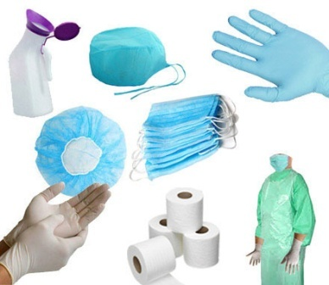In medical textiles, nonwoven fabrics are used in products such as surgical gowns, drapes, wound dressings and face masks. Blending synthetic fibres like polypropylene (PP) with absorbent fibres like viscose rayon results in composites that offer both fluid resistance and high moisture absorption (Gholamreza *et al.,* 2020). Incorporation of antimicrobial fibres or finishes (e.g., silver-coated fibres,

https://www.tradeindia.com/products/medical-disposable-product-c6499954.html

FIG 5. Medical Applications

chitosan-based fibres) enhances the bioactive functionality of these fabrics (Rhim and Wang, 2013). The uniform blending of such functional fibres is essential

to maintain consistent performance, especially in critical applications

like wound care and infection prevention.

**5.2 Filtration**

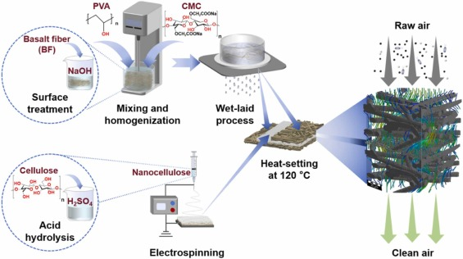Fibre blending plays a critical role in air and liquid filtration nonwovens. Fine-denier fibres such as melt blown polypropylene are blended with coarser support fibres to optimize particle capture efficiency while maintaining structural integrity and air permeability (Tang *et al.,* 2020). Electrostatic fibres (e.g., electret-treated PP) are often combined with structural fibres to increase particulate filtration without increasing pressure drop, a principle widely used in face masks and HVAC filters (Cheng *et al.,* 2018).

Atalie et al., 2024

**FIG 6. Filtration process**

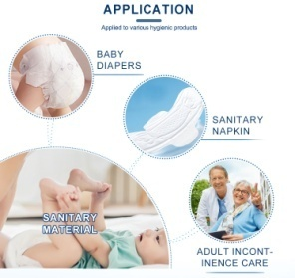**5.3 Hygiene Products**

In disposable hygiene products like diapers, sanitary napkins and adult incontinence pads, blending allows for the creation of multi-layered absorbentcores. Cellulose pulp is often blended with superabsorbent polymers (SAPs) and thermo bondable fibres to ensure liquid retention, fluid distribution and structural strength (Kimmerle and Horrocks, 2016). Blending also improves skin comfort and reduces bulk while optimizing liquid management performance.

https://www.alibaba.com/product-detail/Baby-Hygiene-Products-14GSM-SSS-Hydrophobic_1601438516578.html

**FIG 7.** **Hygiene Products**

**5.4 Geotextiles**

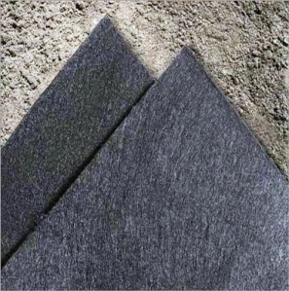Geotextiles require high mechanical strength, durability and chemical resistance, often achieved through blending synthetic fibres such as polyester (PET) and polypropylene. These blends provide reinforcement, drainage and separation functions in civil engineering projects. Use of recycled polyester and PP blends has also been explored to improve environmental performance (Koerner, 2016). Fibre blending ensures product performance across a range of environmental and mechanical stressors.

https://www.indiamart.com/proddetail/nonwoven-geotextile-black-fabrics-4863492188.html

**FIG 8.** **Geotextiles**

**6. Challenges in Mixing and Blending**

Despite its advantages, fibre blending presents several technical and process-related challenges in nonwoven manufacturing.

**6.1 Uniformity**

Achieving homogeneous distribution of fibres is critical to ensure consistent mechanical and functional properties across the fabric. Variations in fibre fineness, length or density can lead to clustering or segregation during blending, particularly in air lay or carding systems (Chinta and Gujar, 2018).

**6.2 Compatibility of Fibres**

Blending chemically or physically incompatible fibres (e.g., hydrophilic with hydrophobic, natural with synthetic) can compromise the structural integrity or performance of the end product. Thermal bonding incompatibility, differing shrinkage behavior and electrostatic issues are common obstacles (Soin *et al.,* 2014).

**6.3 Process Optimization**

Blending often requires precise control of machine settings, feed ratios and environmental conditions to maintain fibre orientation and avoid web defects. Manual mixing may be sufficient in lab-scale setups but is less reliable in industrial settings without automation and real-time monitoring (Russell, 2007).

**7. Sustainability and Recycling in Blending**

Blending contributes significantly to circular textile design when it includes recycled or biodegradable fibres. Blending virgin fibres with recycled PET (rPET) or natural fibres like hemp and jute enhances the sustainability profile of nonwovens (Mather and Wardman, 2005). Challenges arise in achieving mechanical performance parity with virgin fibre blends, but innovations in chemical recycling and fibre regeneration continue to expand opportunities (Shen *et al.,* 2020). Biodegradable fibre blends are also being investigated for single-use products in hygiene and agriculture, helping to reduce micro plastic pollution.

**8. Recent Innovations**

Modern research in fibre blending for nonwovens is increasingly focused on smart and functional textiles.

* **Nanofibre blending**: Incorporating electrospun nanofibres into nonwoven matrices to improve barrier, filtration and sensor functionality (Thenmozhi, et al., 2017).
* **Bio-based fibre innovation**: Use of polylactic acid (PLA) and chitosan fibres blended with PP or cellulose for eco-friendly and antimicrobial nonwovens (Liao *et al.,* 2018).
* **Digital process control**: AI and machine vision technologies are being used to optimize blending processes, ensuring consistency and reducing material waste (Xu *et al*., 2021).
* **3D-structured nonwovens**: Innovations in layering and fibre orientation are enabling the production of three-dimensional nonwovens with enhanced acoustic and thermal properties.

**Conclusion**

The advancement of nonwoven fabric technology has opened new frontiers in material science, particularly through the strategic use of fibre mixing and blending. These processes are critical in achieving desired functional properties, such as strength, absorbency, flexibility and biodegradability, tailored for diverse applications across medical, filtration, hygiene and geotextiles sectors. While blending enhances performance and cost-efficiency, it also presents challenges related to fibre compatibility, uniform distribution and process optimization.

Emerging innovations, including the integration of nanofibres, smart materials and AI-driven process control, are addressing many of these limitations, enabling more consistent and functional nonwoven products. Moreover, the growing emphasis on sustainability is driving research toward the use of biodegradable fibres, recycled materials and low-impact manufacturing practices. Despite ongoing challenges, the blending of fibres remains a cornerstone of nonwoven fabric engineering, offering versatile solutions for the future of technical and sustainable textiles. Continued interdisciplinary collaboration and technological investment will be unlocking the full potential of blended nonwoven materials in global industries.

**References**

Adanur, S. 1995. *Wellington Sears Handbook of Industrial Textiles*. Technomic Publishing.

Albrecht, W., Fuchs, H.and Kittelmann, W. 2003. *Nonwoven Fabrics: Raw Materials, Manufacture, Applications, Characteristics, Testing Processes*. Wiley-VCH.

Atalie, D., Chen, Z. X., Li, H., Liang, C. G., Gao, M. C., Cheng, X. X., & Ma, P. C. (2024). Eco-friendly and highly efficient PM0. 3 air filter made from nonwoven basalt fiber and electrospun nanocellulose fiber. *Journal of Hazardous Materials*, *478*, 135608.

Baker, R. and Sreenivasan, D. 2010. Applications of nonwoven materials in medical textiles. *Textile Asia*, 41(2), 43–48.

Cheng, Y., Ma, Z., He, X. and Liu, C. 2018. Filtration performance of nonwoven polypropylene filters with nano-enhanced structures. *Separation and Purification Technology*, 203, 74–81.

Chinta, S. K. and Gujar, P. 2018. Fibre blending and web uniformity in carded nonwovens. *Textile Research Journal*, 88(5), 539–550.

Edana. 2020. *Nonwovens: Material Definitions and Industry Standards*. Brussels: European Disposables and Nonwovens Association.

Gao, Y., Chen, S. and Zhu, W. 2021. Conductive nonwoven fabrics with metallic fibre blending for EMI shielding. *Journal of Industrial Textiles*, 51(1), 89–101.

Gholamreza, M., Komeily, A. and Alipoor, R. 2020. Multi-functional nonwoven fabrics through fibre blending: A review. *Journal of Industrial Textiles*, 50(6), 863–886.

Horrocks, A. R. and Anand, S. C. 2016. *Handbook of Technical Textiles*. Woodhead Publishing.

Hutten, I. M. 2007. *Handbook of Nonwoven Filter Media*. Elsevier.

https://www.youtube.com/watch?v=W-uNxR5Zua0

https://www.ecosilky.com.vn/en/explore-natural-and-synthetic-fibers-images-with-names/

https://textilelearner.net/difference-between-flax-and-hemp-fiber/

https://vnpolyfiber.com/viscose-rayon-modal-lyocell-tencel/

https://www.indiamart.com/proddetail/nonwoven-geotextile-black-fabrics-4863492188.html

https://www.alibaba.com/product-detail/Baby-Hygiene-Products-14GSM-SSS-Hydrophobic_1601438516578.html

https://www.tradeindia.com/products/medical-disposable-product-c6499954.html

https://www.sciencedirect.com/topics/materials-science/synthetic-fiber

https://textilefocus.com/bamboo-fiber-a-sustainable-alternative-to-cotton/

https://www.gaiadiscovery.com/design-building/lyocell-a-sustainable-fabric-solution.html

Kimmerle, R. and Horrocks, A. R. 2016. Nonwovens for hygiene products. In A. R.

Horrocks and S. C. Anand (Eds.), *Handbook of Technical Textiles* (pp. 89–112). Woodhead Publishing.

Koerner, R. M. 2016. *Designing with Geosynthetics* (6th ed.). Xlibris Corporation.

Liao, K., Wu, C. and Liu, W. 2018. Sustainable and biodegradable nonwovens: PLA and chitosan blends. *Carbohydrate Polymers*, 189, 204–212.

Liu, Y., Zhang, L. and He, Y. 2017. Hemp-based nonwovens: Properties and applications. *Textile Bioengineering and Informatics Symposium Proceedings*, 10(2), 145–150.

Mather, R. R. and Wardman, R. H. 2005. *The Chemistry of Textile Fibres*. Royal Society of Chemistry.

Rhim, J. W. and Wang, L. F. 2013. Antimicrobial activity of chitosan-based nonwoven textiles. *Carbohydrate Polymers*, 98(2), 1173–1181.

Russell, S. J. 2007. *Handbook of Nonwovens*. Woodhead Publishing.

Shen, L., Worrell, E. and Patel, M. 2020. Present and future sustainability of bio-based plastics. *Biofuels, Bioproducts and Biorefining*, 14(3), 537–554.

Soin, N., Shah, T. and Sharma, R. 2014. Optimization of fibre blending for enhanced mechanical properties in nonwoven composites. *Materials Science and Engineering: C*, 42, 101–108.

Tang, X., Zuo, Y., Wang, H. and Cao, Y. 2020. Advances in fibre blending for high-efficiency air filtration. *Journal of Applied Polymer Science*, 137(45), 49187.

Thenmozhi, S., Dharmaraj, N., Kadirvelu, K. and Kim, H. Y. 2017. Electrospun nanofibers: New generation materials for advanced applications. *Materials Science and Engineering: B*, *217*, 36-48.

Xu, Y., Li, X. and Hu, H. 2021. AI-assisted fibre blending and quality monitoring in nonwoven production. *Textile Research Journal*, 91(13–14), 1535–1547.

Zhang, S., Wang, X. and Li, Y. 2020. Electrospun nanofibre-nonwoven composites for smart textiles. *Advanced Functional Materials*, 30(14), 2000958.