**Original Research Article**

**Characterization of Prevalent Agroforestry Practices and Common Fruit Tree Management in Erer District, Sitti Zone, Somali Region, Ethiopia**

**Abstract**

This study was conducted to characterize the prevalent agroforestry practices and assess the common fruit tree management techniques in Erer District, Sitti Zone, Somali Region, Ethiopia. The research employed a multistage sampling technique, selecting 114 households (57 adopters and 57 non-adopters) from two purposively chosen kebeles (Hurso and Halsho). Data were collected through household surveys, key informant interviews (KIIs), and focus group discussions (FGDs), and analyzed using both qualitative and quantitative methods, including SPSS for statistical analysis. Results revealed that orange and mandarin trees are the most widely adopted fruit trees due to their drought tolerance and market value. Socioeconomic variables such as age, income, and education level significantly influenced the adoption of fruit-based agroforestry, while landholding size showed no significant difference between the adopter and non-adopter groups. Fruit tree management practices include irrigation, organic fertilization, pruning, and protection from animals. Marketing is dominated by informal traditional channels, with produce sold in local and regional markets. The study concludes that despite climatic challenges, agroforestry presents a viable livelihood strategy in dryland areas when supported with appropriate resources and training. Recommendations include improving access to quality seedlings, irrigation support, and market linkages to strengthen the agroforestry sector in Erer District.

**Keywords:** Agroforestry, Fruit tree management, Dryland farming, Adoption, Citrus fruits

1. **Introduction**

Dryland systems constitute approximately 41% of the global land surface and support the livelihoods of nearly 2.5 billion people (Millennium Ecosystem Assessment, 2005). In Africa, drylands cover over 30% of the continent, spanning 1.96 billion hectares across 25 countries, amounting to 65% of the continental landmass (Jama and Zeila, 2005). Ethiopia's drylands encompass diverse agro-ecologies, including arid, semi-arid, and dry sub-humid zones, which account for roughly 75% of the nation's total land area (Kindeya, 2004). These dryland areas are concentrated in the northern, eastern, central Rift Valley, and the southern and southeastern regions of the country (Kidane et al., 2010).

Despite their vastness, Ethiopia's drylands face significant environmental degradation, largely intensified by poverty and climate variability (Bezabih and Hadera, 2007). Low agricultural productivity, limited access to modern technologies, pest and disease outbreaks, and unpredictable weather conditions render rural households in drylands highly vulnerable to climatic shocks.

The Somali Region, where this study is focused, is particularly fragile, experiencing severe natural resource degradation and a shift in rainfall patterns coupled with rising temperatures (FAREH, 2011). Such climatic variability leads to increased risks of drought and chronic food insecurity due to unreliable and erratic rainfall patterns.

Agroforestry emerges as a vital strategy for addressing these challenges. It contributes to climate change mitigation and adaptation while enhancing food security, agricultural productivity, and ecosystem resilience (Garrity, 2004). As a socially acceptable and cost-effective practice, agroforestry helps intensify farming sustainably and provides substantial benefits to rural communities (Thangataa et al., 2012).

Among the various agroforestry practices, fruit-based agroforestry is particularly significant in dryland regions. It integrates fruit trees with annual crops on the same land, providing both economic products and environmental services. Fruit trees have a relatively short pre-production phase, offer high market value, and contribute significantly to household nutrition, making them especially attractive to resource-constrained farmers (Bellow, 2004).

Climate variability exacerbates existing environmental and socioeconomic challenges in the Erer District of Sitti Zone, Somali Region. Rising temperatures and decreasing rainfall make conventional farming practices unsustainable. However, agro-pastoralists are increasingly turning to fruit-based agroforestry as a resilience strategy. This practice enables households to manage climate-related risks while generating income through local trade and market sales, and improving food security through the consumption of fruits. This study aims to fill that knowledge gap by characterizing the dominant agroforestry systems and identifying common fruit tree management practices in the Erer District.

1. **MATERIALS AND METHODS** 
   1. **Description of the Study Area** 
      1. **Geographic Location**

This study was conducted in Erer. Erer is one of the districts in Sitti (Shinile) Zone of Somali Region, Ethiopia. Erer is geographically located between 9o41’24”and 10o 12’00” N and 40o52’12” and 41o28’49” E (Figure 1). The average altitude in this district is 1,107 meters above sea level. The district is located 64 km southeast from Dire Dawa and 455 km east from Addis Ababa the capital city of Ethiopia. It is bordered in south by Oromia region, in the southwest, by Afdem district in the west by Afar Region, in the north by Djibouti, in the northeast by Ayesha district, and in the east, by Shinile district. The track of the Addis Ababa - Djibouti Railway crosses the southern part of this district along the lower slopes of the Amhar Mountains.

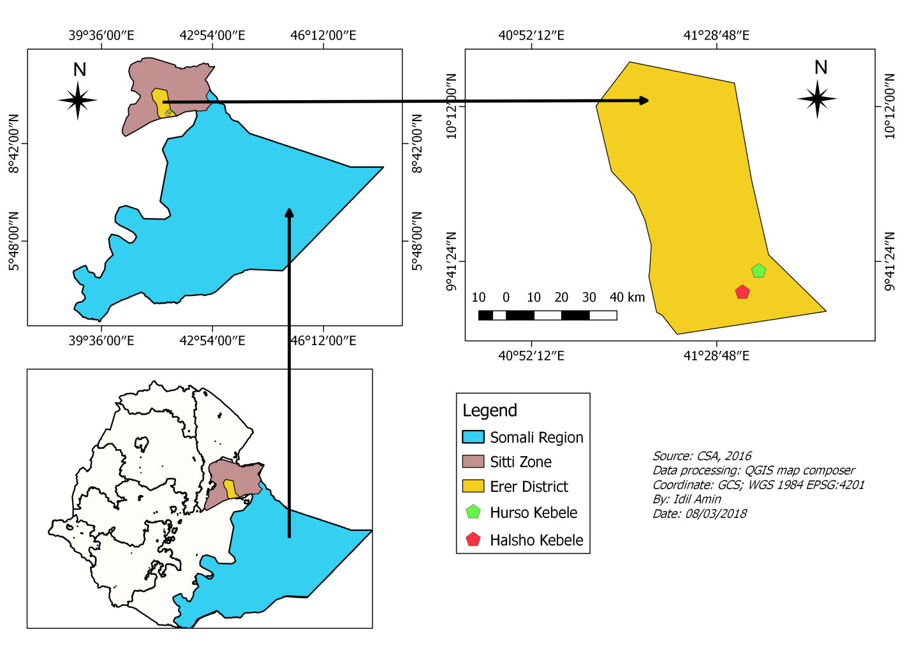

Figure 1: Map of the Study Area.

* + 1. **Climate**

According to the Shinile zonal Bureau of Agriculture (SZBA, 2002), the agro-ecology of the study area (Erer) includes arid (60%), semi-arid (30%) and semi-desert and rocky areas (10%). The area is known for its harsh climate, which is inadequate to support crop agriculture without supplementary irrigation (ADPO, 2004). The rainfall is bimodal, which include the short rainy season from October to December (3 months), which is locally known as ‘Gu’ and the main rainy season from late March to early June (3 months) known locally as the ‘Deyir’. the minimum and maximum rainfall in the district is between 350mm and 650mm, respectively, (Crop and Natural Resource Development Bureau of Erer, 2009). The mean annual temperature varies between 26°C to 40°C.

* + 1. **Population**

Based on the 2007 Census conducted by the Central Statistical Agency of Ethiopia (CSA), this woreda has a total population of 77,628, of whom 42,461 are men and 35,167 women. While 12,657 or 16.31% are urban inhabitants, a further 45,766 or 58.96% are pastoralists and the rest 19205 or 25% are agro-pastoralist. 98% of the population is Muslims, and 2% said they practice Orthodox Christian (Crop and Natural Resource Development Bureau of Erer, 2009). The **Issa** clans who are predominately pastoralists dominate the district. The **Gurgura**, **Gadabursi** and **Hawiya** who are mainly agro-pastoralists are also found in Erer district.

* 1. **Sampling Design and Data Collection** 
     1. **The selection of the specific study sites and households**

In this study, a multistage sampling technique was employed. In the first stage, Erer district was purposively selected among nine districts in Sitti Zone of the Ethiopian Somali Regional State (ESRS) because fruit based dryland agroforestry practice is highly practiced in that district. In the second stage, two kebeles were selected out of eighteen kebeles in the district where both adopters and non-adopters of fruit based dryland agroforestry practice were highly found, namely known as **Hurso** and **Halsho.** In the third stage, households were selected from the two Kebeles based on probability proportional to the size following Green, (1991);

$N ≥50 + 8m$------------------------------------------------------------------------------- (1)

N= Sample size required

M= Variables/predictors

Accordingly, 114 household heads (M = 8 variables) were used in this study. Simple random sampling was used to select the sampled HHs. Questionnaire survey was used to collect information from the household.

Table 1: Household Size and Sample Distribution by Kebele in Erer District, Somali Region

|  |  |  |  |  |  |
| --- | --- | --- | --- | --- | --- |
| Kebeles | Total number of households | |  | Sample size taken | |
| Adopters | Non-adopters |  | Adopters | Non-adopters |
| Hurso | 313 | 330 |  | 26 | 26 |
| Halsho | 335 | 395 |  | 31 | 31 |
| Total | 648 | 785 |  | 57 | 57 |

* 1. **Data collection**

Close and open-ended questionnaires were developed and face to face semi-structured interviews were under taken to assess the factors affecting wild edible fruit bearing species. The questions were prepared in to ‘Somali language’. Enumerators who were researchers, knowledgeable about the area were involved in data collection. In addition, 10 key informant interviews and 12 Focus group discussions were conducted to get general information on the vegetation status, production and the traditional uses and challenges faces; and factors affecting of the species production and conservation. The information generated here was used to validate the information collected from household respondents.

* 1. **Data Analysis**

Data collected were checked, corrected, coded and encoded in a computer, which were then  
analyzed to extract meaningful information. Different data analysis techniques were employed since both qualitative and quantitative data were collected. The qualitative data that were obtained through key informant interviews and group discussion were narrated and summarized. Descriptive statistics was employed to determine and assess the following aspects: respondents’ demographic and socioeconomic characteristics and assess perception of the local community on the impacts of the climate variability through Statistical Package for Social Sciences (SPSS) version 16 software. Independent sample t-test and chi-square were also employed to test the existence of a significant difference between adopters and non-adopters in their education level, age, income and total land owned.

1. **RESULT AND DISCUSSION** 
   1. **Demographic and Socioeconomic Characteristics**

A total of one hundred fourteen sample households had completed the questionnaire survey. 57 respondents were selected from each of adopter and non-adopter households respectively. Within the adoption categories 91% and 82 % were male 9% and 8% were female. Besides, 100% of the respondents from both adopter and non-adopter respondents were Muslim religion followers and majority of 84% and 72% of adopter and non-adopter respondents were married. Majority of the adopter and non-adopter respondents 97% and 50% were engaged in on-farm activities such as practicing of fruit-based agroforestry and cultivating annual crops. Only 24 % of non-adopter respondents engage in off-farm activities like, rope producing, charcoal making, daily laborer and shepherds (Table 2).

Table2: Demographic and Socioeconomic Characteristics of Households in Hurso and Halsho, Erer District

|  |  |  |  |  |  |
| --- | --- | --- | --- | --- | --- |
| Household characteristic | | adopter |  | Non-adopter | |
|  |  | frequency | percent | frequency | percent |
| Sex | Male | 52 | 91 | 47 | 82 |
|  | Female | 5 | 9 | 10 | 18 |
|  | Single | 2 | 4 | 4 | 7 |
|  | Widowed | 6 | 10 | 5 | 9 |
| Marital status | Married | 48 | 85 | 41 | 72 |
|  | Divorced | 1 | 1 | 7 | 12 |
| Religion | Muslim | 57 | 100 | 57 | 100 |
|  | On-farm | 55 | 97 | 30 | 50 |
| Occupation | Off-farm | - | - | 24 | 45 |
|  | Both | 2 | 3 | 3 | 5 |

**Age:** As depicted in Table 3 the average age of adopter and non-adopters sample households were 45.32±10.84 and 39.79±12.33 respectively. The independent sample t-test result shows (t-test; t= 2.542; df =112 and P<0.05) which implies that there is 5% level statistically significant variation in between the adopter and non-adopters in their age (Table 3). The older the household head the higher to adopt the fruit-based agroforestry, the age of the household head has a positive relationship with the adoption of the fruit-based agroforestry practice.

Livestock are sources of income. Using conversion factors (Appendix 1) determined by Storck et al. (1991) **Livestock holding (TLU)** has been converted as shown in (Table 4)., the average TLU is 6.70±5.52and 11.85±7.039 for adopters and non-adopters respectively. The result of the independent t-test indicates that there is significant variation between adopters and non-adopters in the TLU size (t-test; t = -4.347; df =112 and P<0.01). The farmers with large number of livestock were pastoralists and did not have willing to be adopters of fruit-based agroforestry.

According to FGD and KIs most of the residents in the district generate income from both on-farm and off-farm activities such as farm diversification, fruit and vegetation product marketing, selling annual income of Adopter and non-adopters of Fruit based agroforestry 20200±8837.39 and 11500±6571.23 congruently. The result of independent t-test (t-test; t=5.966; df =112 and p<0.01) indicated that there is statistically variation between the adopters and non-adopters in their annual income. The much money that the household generates an income the higher they adopt the practice so that there is a significant positive relationship between the adoption of fruit trees and household income.

The result from the discussion with key informants asserted that land size is one of the indicators of wealth status of the household (Table 3). The household survey result revealed that average

land size of adopters and non-adopters sample households were 1.77±0.708 and 1.75±0.83 correspondingly. The independent sample t-test result shows that there is no significant variation in between the two adoption categories in their land size (t-test; t= 0.121; df =112 and P>0.05). the land size of the household affects the adoption of fruit-based agroforestry practice.

|  |  |  |  |  |  |
| --- | --- | --- | --- | --- | --- |
|  | Adopter | Non-adopter |  |  |  |
| Variables | Mean Std.D | Mean Std.D | t | df | Sig |
| Age(Year) | 45.32±10.84 | 39.79±12.33 | 2.542 | 112 | 0.012** |
| HH size(number) | 6.58± 2.95 | 5.86 ±2.634 | 1.374 | 112 | 0.172 |
| HH income(Birr) | 20200 ± 8837.39 | 11500±6571.23 | 5.966 | 112 | 0.00*** |
| TLU( number) | 6.70 ±5.53 | 11.8568±7.04 | -4.347 | 112 | 0.00*** |
| HHL size(number) | 1.77 ±0.708 | 1.75± 0.83 | 0.121 | 112 | 0.904 |
| *** And **Shows significance difference 1% and 5% level of probability, HH= household | | | | | |

Table3**:** Socioeconomic characteristics of respondents

The household survey result exhibited that 46% and 77% of adopters and non-adopters were illiterate those can’t read and write. While 32% and 16% of adopters and non-adopters were in the primary education level between grades 1-4, nevertheless 19% and 5% of adopters were on education level between grades 5-8 (Table 4). The chi-square test in this study indicated that there is 5% level of probability significant difference between the education level of the adopters and non-adopters (χ2 = 13.2; df = 4; P <0.05). the educated household heads adopted the fruit based agroforestry practice much more than the illiterate households.

Table4. Education level of the respondents

|  |  |  |  |  |  |  |  |
| --- | --- | --- | --- | --- | --- | --- | --- |
|  | Adopter |  | Non-adopter | |  |  |  |
| Variables | Frequency | Percent | Frequency | percent | χ2 | df | p-value |
| Educ level | |  |  |  | 13.2 | 4 | 0.01** |
| Illiterate | 26 | 46 | 44 | 77 |  |  |  |
| Grade1-4 | 18 | 32 | 9 | 16 |  |  |  |
| Grade5-8 | 11 | 19 | 3 | 5 |  |  |  |
| Grade9-10 | 1 | 2 | 1 | 2 |  |  |  |
| Collage | 1 | 1 | - | - |  |  |  |
| Total | 57 | 100 | 57 | 100 |  |  |  |
| ** Shows significance difference 5% level of probability | | | | | | | |

* 1. **Orange –Mandarin-based agroforestry practice**

The KIIs, FGDs and household survey results displayed that Orange (Citrus sinensis) and Mandarin (Citrus reticulate) are the most common fruits integrated in the practice. The respondents

Table 5: The major fruits practiced in the Erer district.

have indicated that the embracing or planting of orange is the most awesome endeavor because a little management applied could provide high product. Orange and Mandarin are most preferred fruit trees because both frui;t trees are deficiency tolerant fruit species and could easily adapt with scarcity of water during the shortage of rain fall as well as the surface streams which is used as an irrigation water. But the growers of the fruit trees irrigate the fruit trees at early stage. Lemon (Citrus aurantifolia), Banana (musa spp), mango (magnifera indica), papaya (carica papaya) and Peach (Prunus persica) are the other commonly fruits produced in the study area.

Ranchers in **Hurso** and **Halsho** kebele indicated that they highly make use of the **Deyir** rain which starts March to April and try to irrigate their farm lands in good manner so as to reduce water stress in the long dry seasons. The major annual crops and vegetables practiced by the fruit adopters are, sorghum, maize, onion and chili through which maize and onion are largely integrated with fruit trees.

|  |  |  |
| --- | --- | --- |
| Type of fruit | Adopter | |
| Frequency | Percent |
| Orange and Mandarin | 26 | 46 |
| Papaya and Orange | 10 | 17 |  |
| Banana, Orange, Limon, Mango and Mandarin | 16 | 28 |  |
| Peach | 3 | 5 |  |
| Banana | 2 | 4 |  |
| Total | 57 | 100 |  |

* 1. **Access to seedling, Management Practices Applied to Fruit Trees**

The discussants of FGDs precisely signposted that getting seedlings is the most important issue in adoption of fruit-based agroforestry in the study area. The FG discussants also said that they get seedling in two ways; from own nursery site for seedling preparation near to their farm land (Figure 2); purchasing from Billa nursery site in the district and from Dire Dawa nursery site. The discussants explained that various challenges such as lack of plastic bags and watering have been encountered for preparing the seedlings in their own site.

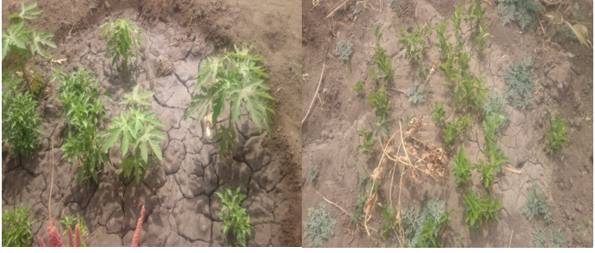

Figure 2: Seedling preparation of households at Erer district.

Figure 3: The Principal Management applied to Fruit Trees in Erer District.

Management is the most essential for fruit product, about 40% respondents mentioned watering, weeding, pests and disease control, and controlling competition for moisture and nutrients is one of the main reasons to control fruit trees, while 23% uses the fruit trees organic fertilizer application (manure) and uses crop residue. The 11% of the respondents uses common management like branch pruning, prescribed thinning, and 11% of the respondents practice protection from animal and human damage and 15% of the adopters’ respondents practice all the management mentioned above (Figure 3). This study is similar to the previous study of Jadhav, (2009) that indicated in his study more than have of the respondents 55% had a correct knowledge about the fruit irrigation at early stage and about 96.6% of the respondents had knowledge on protection measures from pests’ disease and number of years to possess fruit trees grafting and at what year to obtain fruits.

* 1. **Marketing of Fruit Products**

Marketing of fruit products is studied by considering the situation in the district. As per the findings of the field visit, marketing of various fruit products such as Orange, Mango, Mandarin, Papaya and Lemon was carried out.

According to FG discussants indicated to their discussion that traditional marketing system is used viaadopters of fruit-based agroforestry to sell fruit product. FGs in district asserted in to their discussion the local collectors usually interact with farmers on one to one basis, either buying from them at the farm gate or at roadsides near villages markets where many fruit adopters are located. Local collectors, Provincial wholesale markets and street market provide the most convenient way that adopters sell their produce.

Adopter respondents in the district generally use to distribute their main fruit crops were collectors 20%, local markets 33%, street markets 27% and whole sale market 20%. These buyers usually supply fruit to larger marketing systems, and trade to Djibouti, Dire Dawa, Malka Jebdu and Jigjiga towns. This study is consistent with previous study ofBhawat, (2017) that fruit farmers in Chanthaburi used traditional markets to sell the fruit crops.

1. **Conclusion**

This study highlighted that fruit-based agroforestry is an emerging and impactful land use practice in Erer District, offering multiple livelihood and environmental benefits. The majority of adopters integrated orange and mandarin trees due to their adaptability to dryland conditions and high market demand. Socioeconomic variables, particularly age, education level, and income, significantly influenced the adoption of these practices. However, limited access to quality seedlings, water, and marketing opportunities were reported as major constraints. Management practices such as early-stage irrigation, manure application, pruning, and pest control were widely applied, although not uniformly. Traditional market systems dominate the sale of fruits, with limited engagement in value addition or structured marketing.

1. **References**

ADPO) Agricultural Development Project Office of Erer woreda. 2004. Assessment report of the meteorology and crop production in Erer woreda. Annual report. Dire Dawa.

Bellow, J.G. 2004. *Fruit-tree-based agroforestry in the Western highlands of Guatemala: an evaluation of tree-crop interactions and socioeconomic characteristics*. PhD thesis, University of Florida, USA.

Bezabih Emana and Hadera Gebremedhin. 2007. Constraints and opportunities of horticulture production and marketing in eastern Ethiopia. *Dry land coordination group (DCG) report*, *46*.

FAREH, A.M. 2011. Opportunities and Challenges in Implementing Poverty Reduction Policies in Pastoral Communities: A Case Study from the Somali Regional State, Ethiopia.

Garrity, D.P. 2004. Agroforestry and the achievement of the Millennium Development Goals. In *New Vistas in Agroforestry.* 5-17. Springer Netherlands.

Green, S.B. 1991. How many subjects does it take to do a regression analysis? *Multivariate behavioral research* *26*: 499-510.

Jadhav, B. 2009.Technological gap in adoption of recommended practices of mango cultivation,department of Agricultural Extension Education College of agriculture, Dharwad University of agricultural sciences, Dharwad – 580 005.M.sc90p.

Jama. B and A. Zeila. 2005. Agroforestry in the drylands of eastern Africa: a call to action. ICRAF Working Paper no. 1. Nairobi: World Agroforestry Centre.

Millennium Ecosystem Assessment. 2005. Ecosystems and human well-being: desertification synthesis. Island Press, Tucson.

Thangata, P.H. and P.E. Hildebrand. 2012. Carbon stock and sequestration potential of agroforestry systems in smallholder agroecosystems of sub-Saharan Africa: Mechanisms for ‘reducing emissions from deforestation and forest degradation’ (REDD+). *Agriculture, ecosystems and environment*, *158*, pp.172-183.

Kidane Georgis, Alemneh Dejene, Meshack Malo. 2010. Agricultural based livelihood systems in drylands in the context of climate change: Inventory of adaptation practices and technologies of Ethiopia. *Environment and Natural Resources Management Working Paper*, *38*.

Kindeya Gebrehiwot. And N.K. Headquarters. 2004. Dryland agro-forestry strategy for Ethiopia. *Mekelle, Tigray, Ethiopia*, pp.1-20.