THE IMPACT OF CREATIVITY AND RISK APPETITE ON ENTREPRENEURIAL INTENTION OF ECONOMICS STUDENTS IN HANOI

ABSTRACT
This study examines the impact of creative competence and risk appetite on entrepreneurial intention among Economics students in Hanoi. Additionally, it investigates the mediating role of students' creative competence in the relationship between risk appetite and entrepreneurial intention. Primary data were collected from 346 valid survey questionnaires. The research employs the Structural Equation Modeling (SEM) framework, with data processed using SPSS 24 and AMOS 24. Results indicate that both creative competence and risk appetite positively influence the entrepreneurial intention of Economics students in Hanoi. Managerial implications and future research directions are also discussed.
Keywords: Risk appetite, creative competence, creative thinking, creative motivation, volition, entrepreneurial intention.

1. INTRODUCTION
In the context of the global economy shifting decisively toward a knowledge- and innovation-driven development model, entrepreneurship - particularly innovative entrepreneurship - has emerged as a critical catalyst for economic growth and sustainable job creation. In Vietnam, according to statistics from the Ministry of Education and Training (MOET), over 500,000 students annually enroll in or graduate from Economics, Business, and Management programs—a cohort expected to form the backbone of the national startup ecosystem. However, in practice, the proportion of graduates engaging in entrepreneurship remains low. MOET reports that only 8% of students launch startups within five years of graduation. Between 2020 and 2024, Vietnam recorded 33,808 student-led startup projects (averaging 5,635 projects annually), yet most struggled to sustain or scale due to lack of funding, managerial skills, and systemic support from the entrepreneurial ecosystem.
To foster student entrepreneurship, the Vietnamese government issued Decision No. 1665/QĐ-TTg (October 30, 2017), “Supporting Student Startups by 2025,” aiming for 100% of universities to implement startup support programs, promote innovation, and strengthen campus-based entrepreneurial networks. Concurrently, initiatives like Techfest Vietnam, the National Innovation Fund (NATIF), and the National Innovation Center (NIC) have provided financial, training, and networking platforms for student entrepreneurs.
Despite these efforts, MOET data reveals that only 12 student startups secured investment during 2020–2024, with the highest funding capped at 1 billion VND (~$40,000) per project. This underscores a critical gap: while the quantity of student ventures is substantial, their success rate in fundraising and scaling remains minimal. Key barriers include students’ lack of creative skills, risk tolerance, and confidence to operationalize ideas. A CafeF survey found that while 57% of students expressed entrepreneurial aspirations, 36.6% remained undecided, and 5% ruled out future entrepreneurship.
Prior research highlights the significance of creative competence and risk appetite in entrepreneurial intention. Zampetakis et al. (2006) posit that creativity enables individuals to identify and develop new business opportunities, while Zhao et al. (2011) argue that high-risk-tolerant individuals overcome fear of failure more readily, facilitating startup decisions. Nga & Autio’s (2016) cross-national study further confirms these traits as key predictors of entrepreneurial disparities among students.
While international studies have elucidated the relationship between these factors, similar research in Vietnam remains limited. Notably, few scientific works have focused on Economics students - a group with appropriate professional backgrounds for business model implementation but still exhibiting hesitancy in entrepreneurial behavior. Furthermore, the mediating role of creative competence in the relationship between risk appetite and entrepreneurial intention has not been clearly verified within Vietnam's unique cultural, educational, and market context.
Additionally, in-depth analysis of specific components constituting creative competence - such as flexible thinking, ideation capability, and creative problem-solving - would enhance the practical applicability of the research. Such analysis would enable universities to adjust curricula, supplement extracurricular activities, organize startup idea competitions, and implement creative training methods tailored to the characteristics of Economics students.
These reasons demonstrate both the theoretical and practical urgency of the research topic. The study's findings will provide a scientific basis for developing training strategies, support mechanisms, and young entrepreneur development programs, thereby contributing to the sustainable growth of Vietnam's startup ecosystem during the digital transformation and international integration period.
This study aims to address existing research gaps by answering the following questions:
1. How do creative competence and risk appetite affect entrepreneurial intention among Economics students in Hanoi?
2. To what extent does creative competence mediate the relationship between risk appetite and entrepreneurial intention?
3. Which specific components of creative competence (flexible thinking, ideation, problem-solving) most significantly influence entrepreneurial intention?
4. What are the practical implications for university training programs to enhance students' creative competence and risk tolerance?
To achieve these objectives, the paper is structured into five sections: following this introduction, the second section presents the theoretical framework and literature review, the third details the research methodology, the fourth reports findings, and the final section provides discussion and managerial implications.
2. THEORETICAL FRAMEWORK AND LITERATURE REVIEW
2.1. Students' Entrepreneurial Intention
Entrepreneurial intention (EI) is a central concept in entrepreneurship behavior research. According to Bird (1988), EI refers to a mental state directed toward creating new business activities or establishing new ventures, serving as a predictor of future entrepreneurial behavior rooted in personal cognition, attitudes, and motivations. Gupta and Bhawe (2007) posit that EI represents the drive for individuals to plan and build businesses—a continuous process from ideation to action. Similarly, Souitaris, Zerbinati, and Al-Laham (2007) define EI as an individual’s concrete intention to start a business in the future.
From another perspective, Dohse and Walter (2012) conceptualize EI as a psychological readiness to engage in self-employment, job creation, or new venture establishment. This pragmatic definition aligns well with Vietnam’s current educational and entrepreneurial context. Recent studies approach EI through psychological and social lenses. Shi et al. (2020) argue that EI reflects an individual’s structured perception of entrepreneurship, shaped by personal traits, social environment, attitudes toward autonomy, creativity, and risk-taking. Zain, Akram, and Ghani (2010) emphasize the emotional dimension of EI, viewing it as an expression of inner ambition and the desire for self-reliance.
Drawing on theoretical synthesis and practical conditions, this study adopts Dohse and Walter’s (2012) definition: EI is "a mental state of readiness to pursue self-employment, job creation, or new venture establishment." Within this scope, two key factors are analyzed:
Creative competence (skill-based capacity for innovation)
Risk appetite (tolerance for uncertainty in entrepreneurial decisions)
These individual-level factors exert direct and indirect effects on EI. Crucially, the study examines the mediating role of creative competence in the relationship between risk appetite and EI, thereby clarifying the interaction mechanisms among these variables.
2.2. Research Overview
The study by Zampetakis and Moustakis (2006) titled "Linking Creativity with Entrepreneurial Intention: A Structural Approach" presented a preliminary model connecting creativity with entrepreneurial intention. The research surveyed 532 university students in Greece to examine the relationship between creative competence and entrepreneurial intention. Results indicated that students' self-perceived creativity and family environments that foster creative thinking could predict increased levels of entrepreneurial intention. Furthermore, the study argued that contemporary university environments do not promote entrepreneurial intention through the development of creative thinking. Survey results from Greek universities demonstrated that creative competence has a positive and significant influence on entrepreneurial intention.
Tran Loi's (2021) study "Analysis of Factors Affecting Entrepreneurial Intention Among Youth in Tra Vinh Province" surveyed 800 young people in Tra Vinh Province to identify factors influencing entrepreneurial intention. The research found that risk appetite plays a crucial role in determining youths' entrepreneurial intention. Individuals willing to accept risks were better able to recognize entrepreneurial opportunities and had stronger motivation to realize business ideas.
Nguyen Thi My Hanh's (2019) study "Risk Appetite and Entrepreneurial Intention Among Students at Tien Giang University" was conducted at Tien Giang University, identifying risk appetite as a factor strongly correlated with students' entrepreneurial intention. The study showed that students with higher risk tolerance tended to exhibit stronger entrepreneurial intentions, especially when supported by family and a creative learning environment.
Truong Hoang Diep Huong, Pham Duc Hien, Tran Ngoc Lam, Nguyen Thanh Thai & Nguyen Thi Thu Huong (2022) investigated factors influencing students' entrepreneurial intention through a survey of 1,200 students at major Vietnamese universities. The study found that creative competence was the most influential factor affecting students' entrepreneurial intention, particularly in the context of the digital economy.
2.3. Research hypothesis and proposed research model
Based on the theoretical foundations examined through domestic and international research, the research team has identified the factors influencing the entrepreneurial intention of Economics students in Hanoi. These factors were derived from established models to ensure appropriate scale, alignment with the research scope, and accurate reflection of practical urgency. The findings aim to provide additional empirical support for policies assisting student entrepreneurship and fostering innovative thinking in the current university environment.
From this, the research team identified two influencing factors: creative capacity and risk appetite. According to Trần Việt Dũng (2013) in “Some Reflections on Creative Capacity and Directions to Foster Creativity Among Contemporary Vietnamese People”, creativity broadly comprises three core components: creative thinking, creative motivation, and volition (willpower).
The research team proposes the following study model: "Examining the Impact of Creative Capacity and Risk Appetite on Entrepreneurial Intention Among Economics Students in Hanoi" as illustrated in the following diagram:
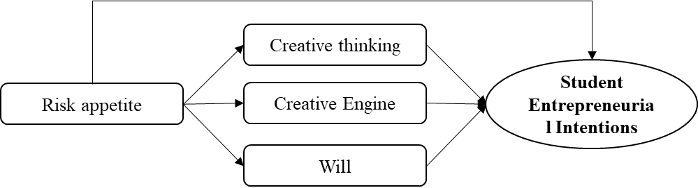
Figure 1: Proposed research model
Creative Thinking: The system of cognitive operations and methods by which the brain processes and transforms data and information to generate ideas or solutions for creative problem-solving.
Creative Motivation: The driving force behind an individual's engagement in creative activities, comprising: Intrinsic motivation (needs, emotions, personal feelings); Extrinsic motivation (social influences, external stimuli).
Volition (Willpower): The mental resilience that enables individuals to overcome challenges during the creative process and persistently pursue their goals.
Research Hypotheses Derived from the Proposed Model
H1: Risk appetite (RA) has a positive impact on entrepreneurial intention (EI) among Economics students in Hanoi.
H2: Risk appetite (RA) positively influences creative thinking (CT).
H3: Risk appetite (RA) positively affects creative motivation (CM).
H4: Risk appetite (RA) positively enhances volition (VL).
H5: Creative thinking (CT) has a positive impact on entrepreneurial intention (EI) among Economics students in Hanoi.
H6: Creative motivation (CM) positively influences entrepreneurial intention (EI) among Economics students in Hanoi.
H7: Volition (VL) has a positive effect on entrepreneurial intention (EI) among Economics students in Hanoi.
3. RESEARCH METHODOLOGY
3.1. Questionnaire Design
The questionnaire was developed using the back-translation technique to ensure semantic accuracy and consistency of measurement scales compared to their original sources. First, the author collected and selected measurement scales from prior studies related to the constructs in the proposed model. These scales were then translated into Vietnamese and adapted to suit the survey context in Vietnam, particularly for Economics students. During the adaptation process, the author consulted with experienced faculty members and research experts to ensure the questionnaire's clarity, accuracy, and relevance to the local context. After finalizing the Vietnamese version, the questionnaire was back-translated into English to cross-check with the original scales, ensuring that the observed variables retained their original meaning while accurately reflecting the research content.
Specifically:
- Risk Appetite (RA) was measured using 4 items (RA1–RA4), adapted from Zhao et al. (2010), Mueller & Thomas (2001), and Xu et al. (2019).
- Creative Thinking (CT) was assessed with 4 items (CT1–CT4), drawn from Torrance (1974) and Runco & Jaeger (2012).
- Creative Motivation (CM) included 5 items (CM1–CM5), based on Amabile (1983) and Tierney & Farmer (2002).
- Volition (VL) was measured with 4 items (VL1–VL4), adapted from Karwowski & Beghetto (2019).
- Entrepreneurial Intention (EI) was evaluated using 4 items (EI1–EI4), sourced from Liñán & Chen (2009), Ajzen (1991), and Krueger et al. (2000).
All constructs were measured on a 5-point Likert scale, ranging from Strongly Disagree (1) to Strongly Agree (5).
3.2 Data Collection
Using a combination of convenience sampling and snowball sampling techniques, the research team distributed 400 survey questionnaires to students at Hanoi University of Industry. A total of 366 completed surveys were returned. After data cleaning and removal of invalid responses, 346 valid responses were obtained for subsequent analysis stages.
Table 1: Descriptive statistics of the study sample
No. | Element | Ingredient | Quantity | Rate (%)
1 | Gender | Male | 188 | 54.3
1 | Gender | Female | 158 | 45.7
2 | Year Student | Year 1 | 37 | 10.7
2 | Year Student | Year 2 | 95 | 27.5
2 | Year Student | Year 3 | 101 | 29.2
2 | Year Student | Year 4 | 113 | 32.7
3 | Startup status | Ever | 264 | 76.3
3 | Startup status | Have | 82 | 23.7
4 | Entrepreneurial Intention | No | 118 | 34.1
4 | Entrepreneurial Intention | Not sure | 116 | 33.5
4 | Entrepreneurial Intention | No | 112 | 32.4
(Source: Author's synthesis)
The descriptive statistics reveal a balanced gender distribution in the sample, indicating that the survey was evenly distributed among Economics students across Hanoi. Regarding academic year, the majority of respondents were 2nd, 3rd, and 4th-year students.
As this study examines how risk appetite and creative capacity influence entrepreneurial intentions, we specifically targeted mid-to-late year undergraduates who have had sufficient time to develop career aspirations. The sample characteristics confirm this rationale: 76.3% of respondents reported prior entrepreneurial experience; 34.1% expressed intentions to start businesses in the future.
These findings demonstrate that our sample is representative and aligns with the research objectives of investigating established entrepreneurial intentions among university students.
4. RESEARCH RESULTS
4.1 Reliability, Unidimensionality, Discriminant Validity, and Convergent Validity Tests of Measurement Scales
Scale Reliability and Exploratory Factor Analysis
To evaluate the measurement scales, this study employed the following assessment criteria: Cronbach's Alpha coefficient (α) > 0.6; Item-total correlation > 0.3. The results demonstrated strong reliability, with Cronbach's Alpha values ranging from 0.857 to 0.924 (all exceeding the 0.6 threshold), as detailed in the following tables:
Table 2. Cronbach's alpha reliability statistics
Factors | Cronbach's Alpha (Ca)
Risk Appetite (KVRR) | 0,877
Creative Thinking (TDST) | 0,877
Creative Motivation (DCST) | 0,890
Willpower (YC) | 0,896
Entrepreneurial Intention (YD) | 0,823
(Source: Author's synthesis)
The analysis revealed that all constructs - Risk Appetite (RA), Creative Thinking (CT), Creative Motivation (CM), Volition (VL), and Entrepreneurial Intention (EI) - demonstrated good reliability with Cronbach's Alpha coefficients exceeding 0.6. Furthermore, all observed variables showed item-total correlations greater than 0.3. These results confirm that all five measurement scales meet the required reliability standards for Exploratory Factor Analysis (EFA).
The EFA results are presented in the following tables:
Table 3: KMO and Barlett test
Kaiser-Meyer-Olkin Measure of Sampling Adequacy. |  | 0,930
Bartlett's Test of Sphericity | Approx. Chi-Square | 21979,440
Bartlett's Test of Sphericity | df | 378
Bartlett's Test of Sphericity | Sig. | 0,000
(Source: Author's synthesis)
Results of the analysis indicate that the KMO value is 0.930 (0.5 ≤ KMO ≤ 1), and the Bartlett’s test of sphericity yielded a value of 21,979.440 with a statistical significance level of sig = 0.000 (<1%). These results imply that the variables are correlated in the population and that the application of factor analysis is appropriate. To identify the principal components, the study employed the factor extraction method based on Eigenvalue values. The results of the Exploratory Factor Analysis (EFA) indicate that five factors explain 60% (>50%) of the total variance in the dataset. The table above shows that all observed variables have factor loadings greater than 0.6, which confirms that the independent variables in the research model achieve both convergent validity and discriminant validity.
Unidimensionality Testing and Model Fit with Market Data
It is essential to determine whether the model fits the data to ensure the unidimensionality of the observed variable set [36]. To evaluate this fit, the study employed the following indicators: CMIN, CMIN/df, CFI, GFI, TLI, RMSEA, and PCLOSE.
After conducting Confirmatory Factor Analysis (CFA), the results are as follows: CMIN/df = 1.920 (CMIN/df ≤ 3); GFI = 0.917 (0.9 < GFI < 1); CFI = 0.968 (CFI ≥ 0.9); TLI = 0.961 (TLI ≥ 0.9); RMSEA = 0.052 (RMSEA ≤ 0.06); RMR = 0.034 (RMR < 0.08). These results indicate that the measurement scales used in this study are appropriate and meet the criterion of unidimensionality.
Table 4. Summary table of CFA analysis results
Index | Standard | Result | Evaluate
CMIN/df | ≤3 | 1,920 | Good
GFI | 0,9<GFI<1 | 0,917 | Good
CFI | ≥0,9 | 0,966 | Good
TLI | ≥0,9 | 0,961 | Good
RMSEA | ≤0,6 | 0,052 | Good
RMR | <0,08 | 0,034 | Good
(Source: Author's synthesis)
Thus, after conducting the CFA, the results indicate that the measurement model fits the actual collected data. Therefore, it can be concluded that the scale satisfies the evaluation criteria and achieves unidimensionality. The first-order measurement model is illustrated as follows:
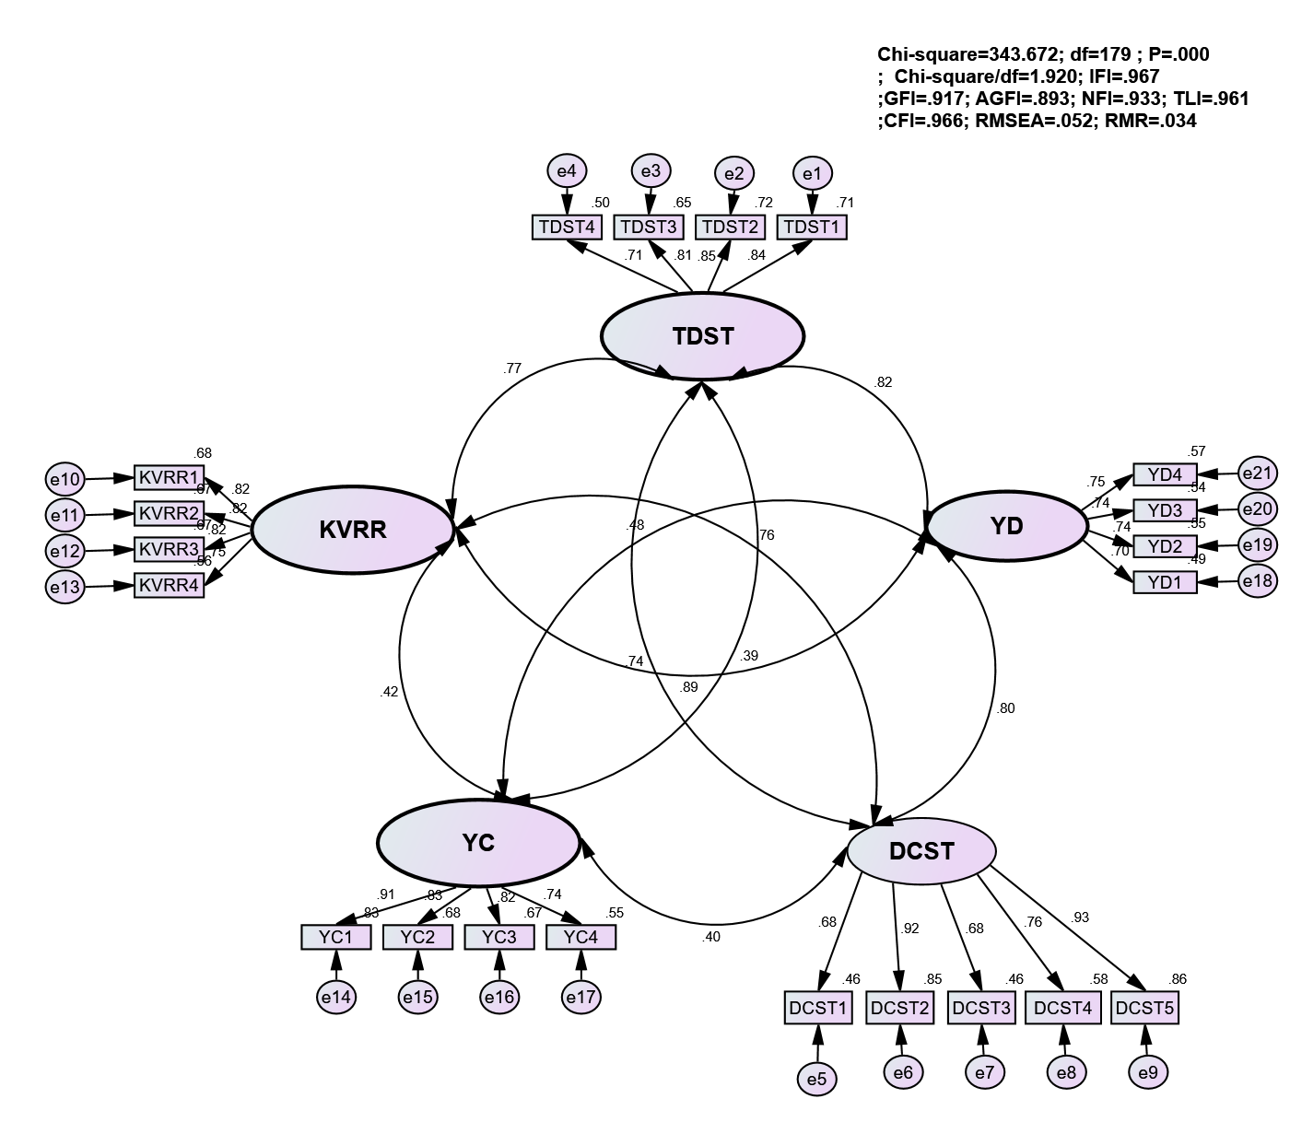
Figure 2: CFA Test
Thus, the results of the CFA analysis indicate that the measurement model fits the actual data well. To proceed with the study, we assess the reliability, convergent validity, and discriminant validity of the measurement scales.
- Assessment of Reliability, Convergent Validity, and Discriminant Validity of the Scales
First, to evaluate reliability, the study examines two indicators: standardized factor loadings (≥ 0.5) and Composite Reliability (CR ≥ 0.7).
Next, convergent validity is assessed using the Average Variance Extracted (AVE ≥ 0.5).
Finally, for discriminant validity to be achieved, the Maximum Shared Variance (MSV) must be less than the corresponding AVE values; additionally, the square root of the AVE (SQRTAVE) should be greater than the inter-construct correlations.
The table below presents these statistical indicators:
Table 5: Statistical indicators
 | CR | AVE | MSV | KVRR | TDST | DCST | YC | YD
KVRR | 0.879 | 0.645 | 0.783 | 0.803
TDST | 0.879 | 0.646 | 0.679 | 0.773 | 0.804
DCST | 0.898 | 0.642 | 0.645 | 0.757 | 0.745 | 0.801
YC | 0.894 | 0.681 | 0.231 | 0.417 | 0.391 | 0.397 | 0.825
YD | 0.823 | 0.538 | 0.783 | 0.885 | 0.824 | 0.803 | 0.481 | 0.733
(Source: Author's synthesis)
The table “Results of CR, AVE, MSV, and SQRTAVE Evaluation” shows that all MSV values are smaller than their corresponding AVE values. Additionally, the SQRTAVE values are greater than the inter-construct correlations. Therefore, it can be concluded that all criteria for assessing discriminant validity are satisfied. As a result, the CFA testing confirms that the constructs meet the required standards of validity and reliability. The number of factors and the measurement items associated with those factors align with theoretical expectations based on the established framework. Thus, the measurement scales are appropriate for use in the structural equation modeling (SEM) analysis.
4.2. Hypothesis Testing
Before testing the hypotheses, the model is re-evaluated to determine its fit with the market data:
Table 6: Model fit coefficients used to test data
Target | P | CMIN/df | GFI | CFI | TLI | RMSEA | RMR
Result | 0,000 | 2,052 | 0,910 | 0,961 | 0,955 | 0,055 | 0,039
Evaluation criteria | <0,05 | <3 | >0,9 | >0,9 | >0,9 | <0,6 | <0,08
(Source: Author's synthesis)
The key indicators for assessing the structural equation model (SEM) are presented above. These results demonstrate that the research model and the collected data are consistent with real-world conditions. All measurement indices meet the evaluation criteria and are appropriate for the context in which the study was conducted.
Specifically:
The P-value = 0.000, satisfying the criterion P < 0.05
CMIN/df = 2.052, meeting the standard of CMIN/df < 3
GFI = 0.910, CFI = 0.961, and TLI = 0.955, all exceeding 0.9
RMSEA = 0.055, which is less than 0.06, as required
RMR = 0.039, satisfying the condition RMR < 0.05
Based on these indicators, it can be concluded that the model employed by the research team is a good fit for the actual data and is appropriate for conducting subsequent statistical analyses.
From the results above, the model can be illustrated as follows:
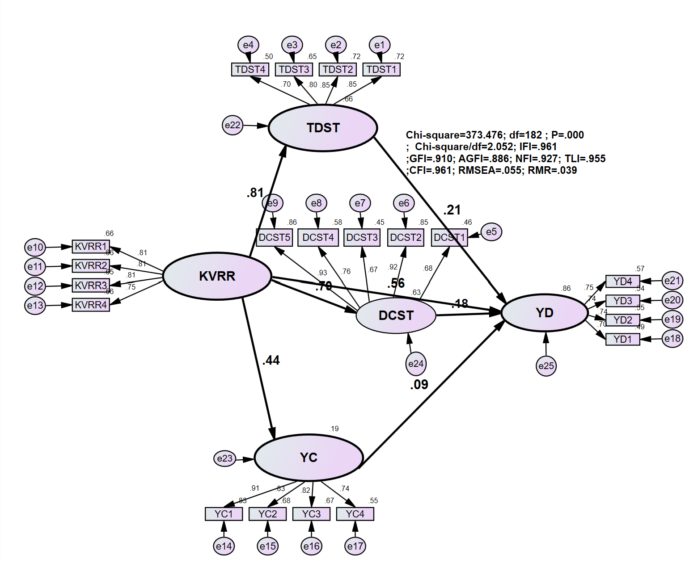
Figure 3: the Structural Equation Modeling
Hypothesis Testing:
The table below presents the unstandardized regression coefficients of the model in detail, along with the necessary statistical indicators for hypothesis testing:
Table 7: Unstandardized regression coefficients
 |  |  | Estimate | S.E. | C.R. | P | Label
DCST | <--- | KVRR | .661 | .057 | 11.619 | ***
TDST | <--- | KVRR | .850 | .060 | 14.147 | ***
YC | <--- | KVRR | .606 | .079 | 7.679 | ***
YD | <--- | DCST | .165 | .065 | 2.557 | .011
YD | <--- | TDST | .158 | .056 | 2.813 | .005
YD | <--- | YC | .048 | .023 | 2.073 | .038
YD | <--- | KVRR | .431 | .086 | 4.980 | ***
(Source: Author's synthesis)
Based on the indicators presented in the table above, the research team proceeded to test the hypotheses proposed in Chapter 1 of this study. Through the analysis of the Structural Equation Modeling (SEM) results, it is observed that the unstandardized P-values for the effects of Risk Appetite (KVRR) on both Creative Motivation (DCST) and Creative Thinking (TDST) are 0.000 < 0.05. This indicates that there is a statistically significant relationship between KVRR, DCST, and TDST. Furthermore, the results also show that the unstandardized P-values for the effects of KVRR, DCST, TDST, and Willpower (YC) on Entrepreneurial Intention (YD) are all less than 0.05. This again indicates statistically significant relationships among these variables. Moreover, the unstandardized regression coefficients between the above factors are all positive, suggesting a direct (positive) relationship between the independent variables and the dependent variable.
Therefore, the following hypotheses are supported:
H1: Risk Appetite (KVRR) has a positive effect on the Entrepreneurial Intention (YD) of economics students in Hanoi.
H2: Risk Appetite (KVRR) has a positive effect on Creative Thinking (TDST).
H3: Risk Appetite (KVRR) has a positive effect on Creative Motivation (DCST).
H4: Risk Appetite (KVRR) has a positive effect on Willpower (YC).
H5: Creative Thinking (TDST) has a positive effect on Entrepreneurial Intention (YD) of economics students in Hanoi.
H6: Creative Motivation (DCST) has a positive effect on Entrepreneurial Intention (YD) of economics students in Hanoi.
H7: Willpower (YC) has a positive effect on Entrepreneurial Intention (YD) of economics students in Hanoi.
Standardized Regression Coefficients
The table below presents the standardized regression coefficients among the research variables. These coefficients indicate the strength of the effect of each independent variable on the dependent variable:
Table 8: Standardized regression coefficients
 |  |  | Estimate
DCST | <--- | KVRR | .794
TDST | <--- | KVRR | .810
YC | <--- | KVRR | .441
YD | <--- | DCST | .177
YD | <--- | TDST | .215
YD | <--- | YC | .086
YD | <--- | KVRR | .556
(Source: Author's synthesis)
From the table above, it can be seen that the factors of risk appetite, creative thinking, creative motivation, and will all have a positive impact on students' entrepreneurial intentions. Specifically, risk appetite has the greatest impact on students' entrepreneurial intentions, followed by creative thinking, creative motivation, and finally will. The research results also show that creative motivation, creative thinking, and will are positively affected by the risk appetite factor in a decreasing direction.
Finally, the Squared Multiple Correlations table in Appendix 1shows that the variables used by the research team in this study explain 85.8% of the variation in the dependent variable of students' entrepreneurial intention, while the remaining 14.2% of the variation depends on errors and factors outside the model. The topic has certain contributions to theory and practice, these contents are presented by the research team in Chapter 4 within the framework of this study.
5. DISCUSSION AND MANAGERIAL IMPLICATIONS
5.1. Discussion of Research Findings
The results of the Structural Equation Modeling (SEM) analysis in this study confirm that factors such as Risk Appetite (KVRR), Creative Thinking (TDST), Creative Motivation (DCST), and Willpower (YC) all have significant influences on the Entrepreneurial Intention (YD) of economics students in Hanoi. The regression path coefficients indicate both direct and indirect effects among the variables in the model, thereby clarifying the theoretical relationships previously proposed.
First and foremost, Risk Appetite (KVRR) has the strongest direct effect on Entrepreneurial Intention, with an estimated coefficient of 0.556. This suggests that students who are more willing to accept risk in life and business are also more inclined to initiate entrepreneurial ventures. In the context where entrepreneurship is inherently associated with uncertainty and the possibility of failure, students’ willingness to face risks is a key prerequisite for forming and enhancing entrepreneurial intention. This finding aligns with previous studies such as Zhang et al. (2020) and Liang & Dunn (2021), which identify risk appetite as a crucial personal trait in predicting entrepreneurial behavior.
In addition to its direct impact, Risk Appetite also indirectly influences Entrepreneurial Intention through three mediating variables: Creative Thinking, Creative Motivation, and Willpower. Specifically, Risk Appetite has a very strong effect on Creative Thinking, with a coefficient of 0.810, indicating that students willing to take risks often demonstrate open-mindedness, a willingness to experiment, and a readiness to develop new ideas—an essential foundation for exploring innovative business solutions. Additionally, KVRR significantly affects Creative Motivation (coefficient = 0.794), showing that risk appetite not only reflects a willingness to take chances but also sparks a desire for innovation and contribution through creative ideas. Furthermore, Risk Appetite influences Willpower (YC) with a coefficient of 0.441, suggesting that it fosters persistence and determination—critical traits for entrepreneurial success.
Regarding the mediating factors, all have direct effects on Entrepreneurial Intention, although to a lesser extent than Risk Appetite. Specifically, Creative Thinking (TDST) affects YD with a coefficient of 0.215, Creative Motivation (DCST) with 0.177, and Willpower (YC) with 0.086. While these coefficients are smaller, they underscore the indispensable mediating roles of these factors. Creative Thinking enables students to conceptualize and plan unique entrepreneurial paths, while Creative Motivation and Willpower provide the intrinsic drive to pursue their ventures to completion.

Conclusion And Recommendation
In conclusion, Risk Appetite emerges as the central and foundational factor in activating and guiding other creative and personal elements toward the formation of Entrepreneurial Intention. The complex interplay among these factors reflects the proposed theoretical model and provides a solid empirical foundation for the policy recommendations and strategic solutions to be discussed in the following section of the study.
5.2. Recommendations for Enhancing Entrepreneurial Intention among Economics Students in Hanoi
The following are several practical solutions aimed at fostering creative capacity and enhancing risk appetite, thereby strongly promoting entrepreneurial intention among university students, particularly those majoring in Economics.
First and foremost, universities should design curricula that cultivate a mindset willing to face challenges and embrace calculated risks. Integrating subjects such as "Risk Management in Business," "Entrepreneurial Psychology," or "Analyzing Failures in Startups" into the academic program will help students recognize risk as an inherent part of the creative and business development process, rather than viewing it as a negative element to be avoided. Furthermore, lecturers should serve not only as educators but also as mentors who inspire, share real-world experiences, and guide students in developing strategic startup plans—emphasizing risk assessment and informed decision-making over impulsive behavior.
Beyond classroom instruction, universities should enhance the organization of experiential learning activities, such as Startup Weeks, roundtable discussions like “Failure Stories – A Different View on Risk”, or seminars with young entrepreneurs who started from scratch. Experiential platforms that simulate real business risks—such as crisis management contests, virtual investment competitions, or mock fundraising events—can offer students valuable exposure and help develop psychological resilience in volatile scenarios. Moreover, support from families, communities, and particularly startup incubators, provides a vital safety net, allowing students to take calculated risks with greater confidence. In essence, promoting risk appetite should be viewed not merely as an individual development effort but as a shared responsibility among educational institutions and society to build an entrepreneurial culture that is resilient yet proactive.
Creative capacity is equally crucial in driving entrepreneurial intention. Entrepreneurship, at its core, is a journey of discovering novel solutions, identifying niche markets, or applying innovative approaches to existing problems. The study reveals a positive correlation between creativity and entrepreneurial intention, suggesting that individuals with higher creative potential are more confident in generating ideas and implementing business plans. However, the current educational environment in many universities remains overly theoretical, lacks practical orientation, and offers limited space for experimentation—conditions that do not sufficiently encourage student creativity.
To foster creativity, teaching methods must shift toward student-centered approaches. Lecturers should incorporate interactive learning formats such as project-based learning, case studies, and real-world problem solving. Creative thinking techniques like the Six Thinking Hats, mind mapping, and design thinking should be integrated into coursework to develop students’ abilities to observe, connect ideas, and devise breakthrough solutions in business contexts. Dedicated courses on creativity, such as “Business Idea Development” or “Innovative Entrepreneurship”, should be developed, and students should be encouraged to undertake small-scale research projects from their first year.
Additionally, universities can establish innovation and entrepreneurship clubs guided by faculty members and business mentors to create a space for sharing, networking, and testing ideas. Organizing innovation competitions, hackathons, and pitching events will provide foundational experience in transforming ideas into viable business projects. More importantly, institutions should build open innovation spaces, equipped with resources like 3D printers, design software, and simulation tools, allowing students to prototype products or business models under near-real conditions. Collaborations with businesses, startup support centers, and international organizations can further expand students’ creative horizons and provide them with greater motivation and exposure.
In summary, fostering students’ creativity cannot be achieved in isolation—it requires a well-developed innovation ecosystem within the university. When students are empowered to create, trusted in their potential, and supported by an enabling environment, they are more likely to develop strong entrepreneurial intentions and aspirations.
5.3. Limitations and Directions for Future Research
Despite its contributions, this study has several limitations that should be acknowledged:
First, the research is limited in terms of sample size and scope. The survey subjects were confined to students from universities and colleges in the field of Economics within Hanoi. This restriction may reduce the generalizability of the findings to students from other disciplines (e.g., Engineering, Technology, Medicine–Pharmacy, Education) or from different geographical areas such as rural regions, mountainous areas, or provinces in Central and Southern Vietnam.
Second, the study focuses primarily on internal factors such as risk appetite and creative capacity in influencing students’ entrepreneurial intention. However, entrepreneurial intention is influenced by a multitude of factors. Future studies should consider incorporating external elements such as governmental policy, family support, societal attitudes, and institutional support. This would provide a more comprehensive understanding of the determinants that shape students' entrepreneurial intentions.
Lastly, the moderating roles of demographic variables such as age, gender, and academic background have not been explored in this study. Future research should include tests for these moderating effects to enrich both theoretical insights and practical implications related to entrepreneurial behavior among university students.

COMPETING INTERESTS DISCLAIMER:
Authors have declared that they have no known competing financial interests OR non-financial interests OR personal relationships that could have appeared to influence the work reported in this paper.

REFERENCES

- Ajzen, I., & Fishbein. (1975). Attitude-behaviour relations: A theoretical analysis and review of empirical research. Psychological Bulletin.
- Amabile, Teresa M. (1983). The social psychology of creativity. Springer-Verlag.
- Bae, Tae Jun, Qian, Shanshan, Miao, Chia-Yen, & Fiet, James O. (2014). The relationship between entrepreneurship education and entrepreneurial intentions: A meta‐analytic review. Entrepreneurship Theory and Practice, 38(2), 217–254.
- Daniel K. Hsu, Karin Burmeister-Lamp, Steven A. Simmons, Maw-Der Foo, Ming-Chu Hong, and James D. Pipes. (2019). “I know I can, but I don’t fit: Perceived fit, self-efficacy, and entrepreneurial intention,” Journal of Business Venturing, vol. 34, no. 2, pp. 311–326.
- Ferreira, João J., Fernandes, Cristina I., & Kraus, Sascha. (2019). Entrepreneurship research: Mapping intellectual structures and research trends. Review of Managerial Science, 13(1), 181–205.
- Karwowski, Maciej, & Beghetto, Ronald A. (2019). Creative behavior as agentic action. Psychology of Aesthetics, Creativity, and the Arts, 13(4), 402–415.
- Leonidas A. Zampetakis and Vassilis Moustakis. (2006). Creativity and entrepreneurial intention in young people: Empirical insights from business school students, Thinking Skills and Creativity, vol. 1, no. 3, pp. 158–168.
- Liñán, Francisco, & Chen, Yi-Wen. (2009). Development and cross–cultural application of a specific instrument to measure entrepreneurial intentions. Entrepreneurship Theory and Practice, 33(3), 593–617.
- Mueller, Stephen L., & Thomas, Anisya S. (2001). Culture and entrepreneurial potential: A nine country study of locus of control and innovativeness. Journal of Business Venturing, 16(1), 51–75.
- Ozaralli, Nuray, & Rivenburgh, Nancy K. (2016). Entrepreneurial intention: antecedents to entrepreneurial behavior in the U.S.A and Turkey. Journal of Global Entrepreneurship Research, 6(3), 1–32.
- Rauch, Andreas, & Frese, Michael. (2007). Let’s put the person back into entrepreneurship research. European Journal of Work and Organizational Psychology, 16(4), 353–385.
- Stewart, Wayne H., & Roth, Philip L. (2007). A meta-analysis of the achievement motivation–entrepreneurial performance relationship. Journal of Small Business Management, 45(4), 401–417.
- Torrance, Ellis Paul. (1974). Torrance Tests of Creative Thinking: Norms-technical manual. Scholastic Testing Service.
- Ward, Thomas B. (2004). Cognition, creativity, and entrepreneurship. Journal of Business Venturing, 19(2), 173–188.
- Xu, Yongqiang, Li, Yuying, & Ji, Qian. (2019). Risk-taking propensity and entrepreneurial intention: The roles of perceived opportunity and institutional environment. International Journal of Entrepreneurial Behavior & Research, 25(3), 531–553.
- Zhao, Hao, Seibert, Scott E., & Lumpkin, G. Thomas. (2010). The relationship of personality to entrepreneurial intentions and performance: A meta-analytic review. Journal of Management, 36, 381–404.
- Zampetakis, L. A., & Moustakis, V. (2006). Linking creativity with entrepreneurial intentions: A structural approach. The International Entrepreneurship and Management Journal, 2(3), 413–428.
- Baldan, C., Zen, M., & Bianchi, M. (2014). Risk appetite framework and its linkage with risk capacity and risk limits. Journal of Financial Regulation and Compliance.
- Baldan, C., Zen, M., & Bianchi, M. (2014). Risk appetite framework and its linkage with risk capacity and risk limits. Journal of Financial Regulation and Compliance.
- Bird, B. (1988). Implementing Entrepreneurial Ideas: The Case for Intention. Academy of Management Review, 13(3), 442–453.
- Gupta, V., & Bhawe, N. M. (2007). The Influence of Proactive Personality and Stereotypes on Entrepreneurial Intentions. Journal of Leadership & Organizational Studies, 13(4), 73–84.
- Souitaris, V., Zerbinati, S., & Al-Laham, A. (2007). Do entrepreneurship programs raise entrepreneurial intention of science and engineering students? Journal of Business Venturing, 22(4), 566–591.
- Shane, S. (2003). A General Theory of Entrepreneurship: The Individual-Opportunity Nexus. Edward Elgar Publishing.
- Zain, Z. M., Akram, A. M., & Ghani, E. K. (2010). Entrepreneurship intention among Malaysian business students. Canadian Social Science, 6(3), 34–44.
- Kuckertz, A., & Wagner, M. (2010). The influence of sustainability orientation on entrepreneurial intentions—Investigating the role of business experience. Journal of Business Venturing, 25(5), 524–539.
- Dohse, D., & Walter, S. G. (2012). Knowledge context and entrepreneurial intentions among students. Small Business Economics, 39(4), 877–895.
- Shi, H., Xing, Y., Liu, W., & Zhang, L. (2020). Entrepreneurship education and entrepreneurial intention: A meta-analytic study. International Journal of Management Education, 18(3), 100295.
- Yıldız, S., Çakır, O., & Aşkun, O. B. (2016). Ready to dare? A study on the role of creative personality and self-efficacy on entrepreneurial intentions. Procedia - Social and Behavioral Sciences, 229, 277–288.
- Baron, R. A. (2004). The cognitive perspective: A valuable tool for answering entrepreneurship’s basic "why" questions. Journal of Business Venturing, 19(2), 221–239.

