Case report

Monoclonal Immunoglobulin Deposition Disease (MIDD): A rare but not forgotten diagnosis- A Case Report

ABSTRACT
Aim: To report a rare case of biopsy-proven Monoclonal Immunoglobulin Deposition Disease (MIDD) in Malaysia and emphasize the importance of early diagnosis and multidisciplinary management in resource-limited settings.
Presentation: A 75-year-old Chinese woman with longstanding diabetes and hypertension was referred for progressive renal impairment, marked proteinuria, and elevated serum creatinine. Initial workup, including autoimmune and malignancy screening, was unremarkable. Serum free light chain assay revealed markedly elevated kappa and lambda levels. A first renal biopsy was inconclusive, showing only features of diabetic nephropathy. However, due to clinical suspicion, a repeat biopsy with electron microscopy was performed, which revealed linear kappa light chain deposition and characteristic “powdery” electron-dense deposits in the glomerular and tubular basement membranes, consistent with MIDD. The patient was started on a bortezomib-based chemotherapy regimen (Bortezomib, Thalidomide, Dexamethasone) but remained dialysis-dependent.
Discussion: MIDD is a rare manifestation of Monoclonal Gammopathy of Renal Significance (MGRS) that often mimics diabetic or hypertensive nephropathy, leading to delayed diagnosis. Definitive diagnosis requires immunofluorescence and electron microscopy, which may not be readily available in all settings. Early identification and clone-directed therapy are crucial for halting progression.
Conclusion: This case highlights the diagnostic complexity and aggressive nature of MIDD. A high index of suspicion and access to specialized diagnostics are essential. Early, multidisciplinary intervention remains key to improving outcomes, though renal recovery may be limited in advanced disease.

Keywords : Monoclonal Immunoglobulin Deposition Disease(MIDD), Monoclonal Gammopathy of Renal Significance(MGRS), renal biopsy, proteinuria

Introduction
Monoclonal Immunoglobulin Deposition Disease (MIDD) is a rare form of plasma cell dyscrasia that falls under the umbrella group of Monoclonal Gammopathy of Renal Significance (MGRS). MIDD is categorized based on the deposition of monoclonal immunoglobulins (MIg) as light chain deposition disease (LCDD), heavy chain deposition disease (HCDD), or both, in the mesangium and tubular basement membranes. MIDD is a systemic disorder that predominantly involves renal manifestations and often results in progressive renal impairment with glomerular proteinuria or hematuria. As MIDD is a rare disorder, the exact prevalence and incidence are unknown. The lack of widespread access to electron microscopy (EM) hinders the identification and diagnostic process, especially in developing nations such as Malaysia. Herein, this case report details the first documented instance of biopsy-proven MIDD in an elderly Chinese woman who developed progressively deteriorating renal function and eventually became dialysis-dependent.
Case presentation
The patient is a 75-year-old Chinese female with a long-standing history of diabetes mellitus and hypertension, under the care of a local general practitioner (GP). In early March 2024, her GP referred her to a tertiary center as her routine blood tests showed a rapid rise in creatinine with significant proteinuria. She was asymptomatic with no clear evidence of infection, autoimmune features, signs of malignancy, or significant family history of renal disease. Unfortunately, she admitted to taking several oral supplements purchased from local stores for health and wellness. There were no other nephrotoxic drugs involved. Physical examination yielded unremarkable results.
Her blood investigations showed a hemoglobin level of 7.8 g/dL, white cell count of 5.7 × 10⁹/L, and platelet count of 192 × 10⁹/L. Her renal profile showed a urea level of 22 mmol/L and a creatinine level of 376 µmol/L (baseline: 70 µmol/L). Her glycemic control was poor, with an HbA1c of 8.9%. Urine analysis showed Protein 1+, RBC 1+, and a urine protein-creatinine ratio of 340 mg/mmol. An ultrasound of the kidneys, ureters, and bladder (USG KUB) showed no signs of obstructive uropathy, with the right kidney measuring 10.6 cm and the left 10.4 cm, and a simple renal cyst noted on the right side. Further investigations, including autoimmune workup, ANCA, tumor markers (CEA), and serum and urine electrophoresis, were negative.
During her admission, the patient's kidney injury worsened, requiring multiple sessions of hemodialysis. Due to rising creatinine, a renal biopsy was performed in April 2024, which revealed acute tubular necrosis, attributed to diabetic nephropathy or drug-induced injury. Immunofluorescence stains showed linear IgG (1+) positivity along the glomerular basement membrane, while other markers (IgA, IgM, C1q, and C3) were negative. In view of the acute kidney injury and biopsy report indicating acute tubular injury, she was treated with intravenous glucocorticoids and discharged with oral prednisolone (tapering dose). Her renal function remained stable at the time of discharge, with a creatinine level of 357 µmol/L. She was scheduled for regular follow-up at the nephrology clinic to monitor renal profile.
Regrettably, her renal impairment worsened in August 2024, with creatinine increasing to 712 µmol/L. Further investigations, including serum free light chain testing, were conducted. The results showed a significantly elevated serum free kappa light chain level of 430 mg/L (normal range: 6.7–22.4 mg/L) and a lambda light chain level of 1380 mg/L (normal range: 8.3–27 mg/L). A bone marrow aspiration and trephine biopsy revealed plasma cells comprising less than 10% of total nucleated cells, with interstitial expression of CD138, kappa, and lambda. A second renal biopsy with electron microscopy was performed. This biopsy showed kappa linear positivity along the tubular and glomerular basement membranes, while IgG, IgA, IgM, C3, C1q, and lambda were negative. Congo red staining was negative for amyloid deposits.
Electron microscopy demonstrated a significantly expanded mesangium with increased mesangial matrix and cellularity, along with "powdery" electron-dense deposits. The glomerular basement membrane (GBM) was diffusely thickened, showing granular punctate regions of "powdery" electron-dense deposits near the subendothelial and intramembranous areas. Podocytes exhibited extensive foot process effacement (70%) with fusion, and many appeared abnormal, containing intracytoplasmic protein. These combined findings were consistent with monoclonal immunoglobulin deposition disease (MIDD) with monoclonal kappa light chain restriction, showing diffuse to nodular mesangial expansion and GBM thickening. There were 18 out of 33 globally sclerotic glomeruli and 1 showing segmental glomerulosclerosis, along with features of diabetic nephropathy.
Multidisciplinary discussions and counseling were conducted with the hematology team. The patient is currently under hematology care and has been receiving chemotherapy consisting of Bortezomib (a proteasome inhibitor), Thalidomide (an immunomodulatory drug), and Dexamethasone (a corticosteroid). She is attending weekly visits to the hospital daycare center for her VTD regimen and has tolerated the treatment well without complications. However, her renal function has shown no signs of recovery, and she remains dependent on regular hemodialysis six months into therapy.
Discussion
Monoclonal immunoglobulins have been identified to manifest as systemic disorders that can cause organ damage, predominantly to the kidneys, even in the absence of clear evidence of malignancy. As more research and evidence are published, this understanding has led to the identification of Monoclonal Gammopathy of Renal Significance (MGRS), a term describing clonal proliferative disorders of B cells or plasma cells that produce nephrotoxic monoclonal immunoglobulins and do not meet the hematologic criteria for treatment of a specific malignancy. The conceptualization of MGRS and associated entities not only emphasizes the harmful effects of monoclonal immunoglobulin deposits but also supports the use of clone-directed therapy to protect renal function and improve patient outcomes. These monoclonal proteins may be light chains, heavy chains, or intact immunoglobulins. Monoclonal Immunoglobulin Deposition Disease (MIDD), as part of MGRS, is defined by the linear deposition of monoclonal immunoglobulins (MIg) along renal basement membranes.
MIDD is a rare disorder that predominantly presents in middle-aged males. Renal involvement often includes chronic glomerular symptoms such as proteinuria, nephrotic syndrome, and renal insufficiency. Extra-renal involvement includes a spectrum of organs and tissues such as the liver (elevated liver enzymes), heart (dyspnea, arrhythmias, prolonged QT interval, or sinus bradycardia), cystic lung disease, and peripheral neuropathy. MIDD deposits have also been identified in the gastrointestinal tract, pancreas, adrenal glands, lungs, thyroid, eyes, and salivary glands. In this case report, the patient's renal function deteriorated with significant proteinuria, necessitating a renal biopsy for diagnostic purposes.
Due to its rarity, renal histology plays a crucial role in diagnosing MIDD. MIDD often involves glomerular capillaries and the tubular basement membrane. Glomerular lesions predominantly involve the mesangium, with increased extracellular matrix expansion and glomerulosclerosis observed in the majority of cases (Figure 1). In order to confirm the diagnosis of MIDD, immunofluorescence studies must show diffuse linear staining along the basement membranes of glomeruli, tubules, and vascular myocytes for a single light chain (LC) isotype (usually kappa) in LCDD, a single immunoglobulin (Ig) heavy chain and LC in LHCDD, or a single class of Ig with a CH1 domain deletion and no corresponding LC in HCDD. Electron microscopy typically exhibits punctate "powdery" electron-dense deposits along the inner aspect of glomerular basement membranes and the outer aspect of tubular basement membranes (Figure 2).
The treatment of MIDD involves several strategies, including clone-directed therapy followed by autologous stem cell transplantation (ASCT), or in some cases, kidney transplantation. Clone-directed therapy, particularly regimens containing bortezomib, has been shown to achieve good hematological and renal responses. The definitions of response are as follows:
- Complete hematologic response (CR): Normalization of free light chains (FLC) with negative serum immunofixation
- Very good partial response (VGPR): Difference in free light chains (dFLC) < 40 mg/L
- Partial response (PR): dFLC drop of ≥ 50%
Renal response is defined as a 50% decrease in proteinuria (>0.5 g/day) without a ≥25% decrease in baseline eGFR. However, these criteria still need further validation in MIDD. The role of ASCT in MIDD remains unclear and requires more studies. Kidney transplantation raises concerns about disease relapse in the allograft and the risk of progression to symptomatic malignant hematological disease.
This patient was treated with a proteasome inhibitor-based combination as a first-line strategy but has yet to show a favorable hematologic or renal response.

Conclusion
MIDD is an aggressive rare condition requiring prompt diagnosis and intervention to preserve organ function. A multidisciplinary approach involving hematology, nephrology, and pathology is essential for optimal management.

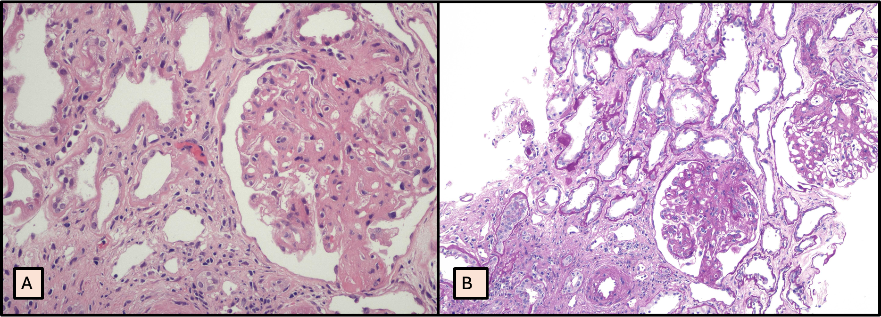
Figure 1 (A & B): Light microscopy and special stain studies. In both, (A & B), the glomeruli show moderate to marked diffuse mesangial matrix expansion with pale eosinophilic areas accompanied by patchy mesangial cells. There is thickening of the capillary walls of the glomerular tufts. One glomerulus show adhesion of the capillary tufts to Bowman capsule forming segmental glomerulosclerosis. Many of the tubules throughout the core show irregular dilatation with regenerative atypia. Many of the tubules show thickened basement membrane with homogenous pale appearance. (A) Haematoxylin-eosin stain (H&E; original magnification, x 200) & (B) Periodic Acid-Schiff stain; PAS; original magnification, x 100)
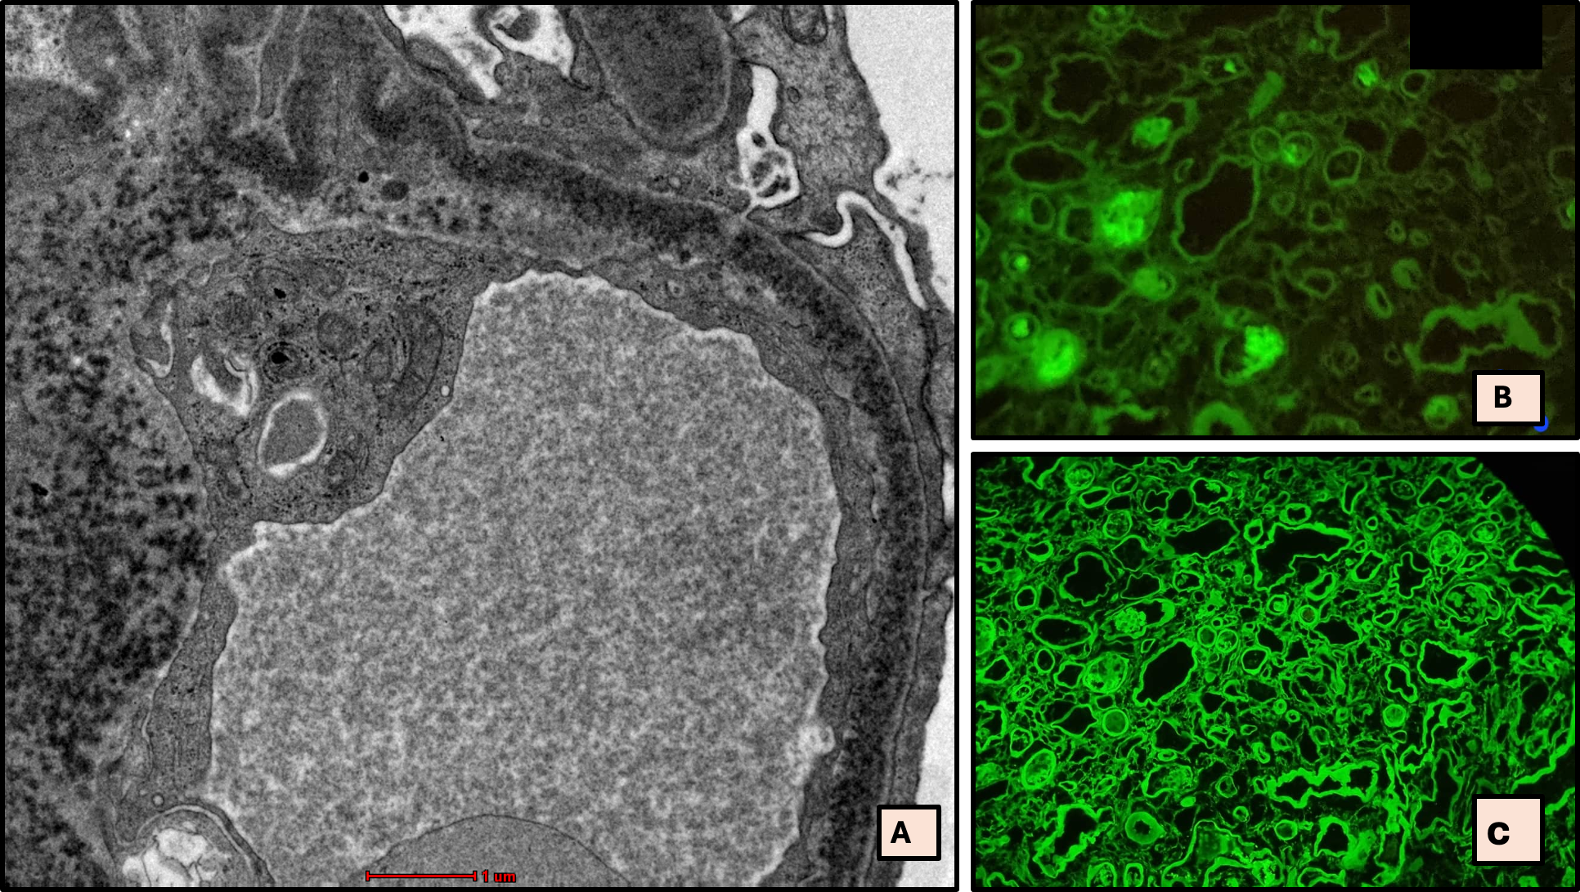
Figure 2: Electron microscopy(EM) images in (A) demonstrate diffusely thickened glomerular basement membrane with markedly expanded mesangium demonstrating fine granular punctate, ‘powder’ electron dense deposits. Immunofluorescence findings in (B) demonstrates negative staining for Lambda and in (C) demonstrates strong positive linear staining for Kappa along the tubular basement membranes. (A) Electron microscopy (EM); original magnification, x 2700nm, (B) Lambda immunofluorescence (Lambda; original magnification, x100 & (C) Kappa immunofluorescence (Kappa; original magnification, x100,)

References
- Bridoux, F.; Leung, N.; Hutchison, C.A.; Touchard, G.; Sethi, S.; Fermand, J.-P.; Picken, M.M.; Herrera, G.A.; Kastritis, E.; Merlini, G.; et al. Diagnosis of Monoclonal Gammopathy of Renal Significance. Kidney Int. 2015, 87, 698–711
- Cohen C, Joly F, Sibille A, Javaugue V, Desport E, Goujon JM, Touchard G, Fermand JP, Sirac C, Bridoux F. Randall-type monoclonal immunoglobulin deposition disease: new insights into the pathogenesis, diagnosis and management. Diagnostics. 2021 Mar 2;11(3):420.
- Alonso-Titos J, Martínez-Esteban MD, López V, León M, Martin-Reyes G, Ruiz-Esteban P, Hernández D. Monoclonal gammopathy of renal significance: Early diagnosis is key. nefrologia. 2021 Sep 1;41(5):502-13.
- Lin, J.; Markowitz, G.S.; Valeri, A.M.; Kambham, N.; Sherman, W.H.; Appel, G.B.; D’Agati, V.D. Renal Monoclonal Immunoglobulin Deposition Disease: The Disease Spectrum. J. Am. Soc. Nephrol. 2001, 12, 1482–1492.
- Joly, F.; Cohen, C.; Javaugue, V.; Bender, S.; Belmouaz, M.; Arnulf, B.; Knebelmann, B.; Nouvier, M.; Audard, V.; Provot, F.; et al. Randall-Type Monoclonal Immunoglobulin Deposition Disease: Novel Insights from a Nationwide Cohort Study. Blood 2019, 133, 576–587.

