"Development and Standardization of a Ready-to-Cook Foxtail Millet Khichdi Premix Enriched with Green Gram, Oats, and Textured Soy Protein"

.

ABSTRACT

|  |
| --- |
| The present study was undertaken to develop and standardize a nutritionally enhanced Ready-To-Cook (RTC) Millet Khichdi premix, incorporating green gram splits, oats, and soy chunks, aimed at offering a convenient and wholesome meal solution. Key ingredients for the premix included Foxtail Millet (*Setaria italica*), Dehulled Green Gram Splits (*Vigna radiata L.*), Oats (*Avena sativa*), Soy Chunks, dehydrated vegetables (carrot and peas), and a distinct Peri-Peri spice blend, alongside salt and tomato powder. To optimize the formulation, an experimental study involving four variations (Control, Sample A, Sample B, Sample C) with differing ingredient ratios was conducted. Comprehensive sensory evaluation was performed by 30 semi-trained panelists using a 9-point Hedonic scale to assess attributes such as color, taste, texture, flavor, and overall acceptability; a Just-About-Right (JAR) scale was also employed to evaluate saltiness and spiciness.  Among the developed formulations, Sample C, comprising Foxtail Millet (40%), Dehulled Green Gram Splits (20%), Oats (10%), and Soy Chunks (10%), was identified as the optimized premix due to its superior sensory scores and was selected for further detailed analysis. The optimized RTC Khichdi premix (Sample C) exhibited a strong nutritional profile per 100g: moisture 5.00 ± 0.2%, crude protein 18.72 ± 0.3g, crude fat 4.19 ± 0.1g, crude fibre 8.16 ± 0.2g, and ash 7.30 ± 0.2g. Hedonic scale ratings for Sample C were consistently high, with overall acceptability at 8.4 ± 0.5. JAR scale analysis indicated well-balanced attributes for saltiness (2.6 ± 0.3) and spiciness (2.8 ± 0.2). Furthermore, microbiological analysis confirmed the product's safety, with a Total Plate Count of <1 CFU/g and coliforms being absent. This research successfully yielded a nutritionally superior, highly palatable, and microbiologically safe RTC Millet Khichdi premix. |

*Keywords: Khichdi, Ready-To-Cook, Foxtail millet, Green gram splits, Oats, Soy chunks*

1. INTRODUCTION

Khichdi, a traditional and widely consumed dish in Indian cuisine, is a simple preparation primarily made from rice and lentils (Rajeswari & Naik, 2023). It is deeply ingrained in Indian cultural practices and is often favored for its ease of digestion and nutritional value, making it suitable for various groups including infants, those recovering from illness, and the elderly (Rajeswari & Naik, 2023). The adaptability of khichdi allows for many regional variations across India, incorporating different grains, lentils, and vegetables, which showcases the country's rich culinary diversity. Common versions include plain rice (*Oryza sativa*) and moong dal (*Vigna radiata L*.) khichdi, while other recipes feature a broader range of spices and mixed vegetables.

Current global trends, driven by busy lifestyles and demanding schedules, show an increasing demand for convenient and healthy food options. This has significantly contributed to the growth of the convenience food and Ready-to-Cook (RTC) food sectors (Cui et al., 2024). RTC products are designed to minimize preparation time while offering nutritional benefits and a longer shelf life (Negi et al., 2021). This trend has also influenced traditional Indian dishes, leading to the development of instant khichdi premixes that provide a quick and easy meal solution (Rajeswari & Naik, 2023).

The rising recognition of millets' nutritional benefits has led to their increased consumption in modern diets. Millets are resilient grains that grow well in challenging conditions and have a higher mineral and vitamin content compared to rice and wheat (Rajeswari & Naik, 2023). Consequently, millet-based khichdi’s are becoming a popular healthier choice over traditional rice-based options, addressing contemporary health concerns such as diabetes, obesity, and anemia (Rajeswari & Naik, 2023). Foxtail millet (*Setaria italica*) is notably an underutilized grain with substantial nutritional properties, making it an excellent ingredient for health-focused food products (Raju et al., 2025).

Despite the existing range of khichdi premixes available, as revealed by a preliminary market survey, there is a clear need for formulations that effectively balance nutritional content with appealing sensory qualities, full ingredient integration, and single-step preparation. This research addresses this need through the development and standardization of an instant millet khichdi premix. Our product is strategically designed to offer a convenient, nutritionally robust, and organoleptically pleasing meal solution through the judicious integration of foxtail millet (*Setaria italica*), green gram splits (*Vigna radiata L*.), oats (*Avena sativa*), soy chunks, a Peri-Peri spice blend, and dehydrated vegetables.

The deliberate inclusion of each constituent ingredient within our formulation is predicated upon its distinctive mechanical, functional, and nutritional characteristics. Foxtail millet, serving as the foundational grain (40% of formulation), contributes substantially to the complex carbohydrate content and dietary fiber, thereby forming the core matrix of the khichdi. Its utilization aligns seamlessly with the burgeoning global interest in integrating underutilized, nutrient-dense grains into quotidian dietary patterns. Dehulled Green gram splits (20% of formulation) are instrumental in augmenting the protein content of the formulation, registering approximately 20-29% protein on a dry weight basis (Hou et al., 2019), and contribute significantly to the dietary fiber content. Oats (10% of formulation) are meticulously incorporated for their commendable lipid profile and elevated concentrations of soluble fiber, most notably β-glucan, which confers substantial benefits for glycemic regulation and gastrointestinal health (Paudel et al., 2021; Decker et al., 2014). Oats additionally contribute a moderate proportion of protein (around 13%) and fat to the overall composition. Textured soy protein chunks (10% of formulation) represent a pivotal ingredient for protein fortification, exhibiting an impressive protein concentration of approximately 52% (Patil et al., 2023). They also furnish insoluble dietary fiber, further enriching the fiber density of the formulation and contributing a desirable heterogeneous texture. Dehydrated carrot (4.5%) and peas (4.5%) are integrated for their contribution of dietary fiber and essential minerals, simultaneously enhancing the overall textural integrity and mouthfeel of the reconstituted product. The blanching and subsequent dehydration of these vegetables are crucial processes that aid in the preservation of their vital mineral content (Motegaonkar et al., 2024; Pandey et al., 2019). The Peri-Peri spice blend (6.25%), along with other auxiliary spices (garlic powder, onion powder, red chilli powder, red chilli flakes, oregano powder, black pepper powder, turmeric powder) and salt, are meticulously selected for their profound impact on the flavor, color, and aroma profiles. Tomato powder and monosodium glutamate (MSG) are incorporated primarily for their flavor-enhancing properties.

This study aimed to develop and standardize this RTC Foxtail Millet Khichdi premix by conducting systematic formulation trials, comprehensive proximate analysis, detailed sensory evaluations, and microbiological safety assessments. The scope involved optimizing ingredient ratios to achieve a product that is not only nutritionally superior but also highly acceptable in terms of taste, texture, and overall sensory experience, with a quick cooking time of 10 minutes. The justification for this work lies in addressing the consumer need for healthy, convenient, and palatable meal options, promoting the utilization of nutritious millets, and contributing a well-characterized product to the RTC food market.

2. materials and methodology

**2.1 Materials**

Raw materials such as foxtail millet (*Setaria italica*), dehulled green gram splits (*Vigna radiata L.*), soy chunks, oats (*Avena sativa*), and spices used in the development and standardization of RTC millet khichdi premix were procured by using a quick commerce platform named Big Basket. Fresh vegetables such as carrots and green peas were procured from the local market of Loni Kalbhor, Pune, Maharashtra, India for dehydration and dehydrated in a lab-scale dehydrator at MIT School of Food Technology, Pune, Maharashtra, India. Peri-Peri spice blend was prepared by using spices in the local market of Loni Kalbhor. Potable water used for soaking.

**2.2 Preparation of Dehydrated Vegetables**

**2.2.1 Carrot (*Daucus carota*)**

Fresh carrots were cleaned, peeled, and then cut into 5 mm cubes. Blanching them in boiling water at 85°C for 2 minutes rendered the peroxidase and catalase enzymes fully inactive while preserving a significant amount of vitamin C and β-carotene (Pervin et al., 2015). After blanching, the carrot cubes were quickly chilled in cold water to cease the cooking process. Following this, they were immersed in a solution containing 1% salt and 2% sugar for ten minutes. This osmotic treatment improves flavor and reduces drying shrinkage (Mierzwa et al., 2017; Ahmed & Jamal, 2016).

**2.2.2 Green Peas (*Pisum sativum*)**

Fresh green peas (*Pisum sativum*) were cleaned and blanched in boiling water at 85°C for two minutes to inactivate enzymes such as peroxidase and catalase, thereby preserving color and texture (Zhang et al., 2021). After blanching, the peas were rapidly cooled in cold water to halt the cooking process. Subsequently, they were immersed in a 0.5% sodium bicarbonate solution for five minutes. This treatment helps maintain the green color by preventing chlorophyll degradation and enhances texture during dehydration (FAO, n.d.). Finally, both the green peas and previously prepared carrot cubes were dehydrated at 70°C for 8 hours using a cabinet tray dryer, a method effective in preserving nutritional quality and structural integrity (Zhang et al., 2021).

**2.3 Preparation of Ready-To-Cook Millet Khichdi Premix**

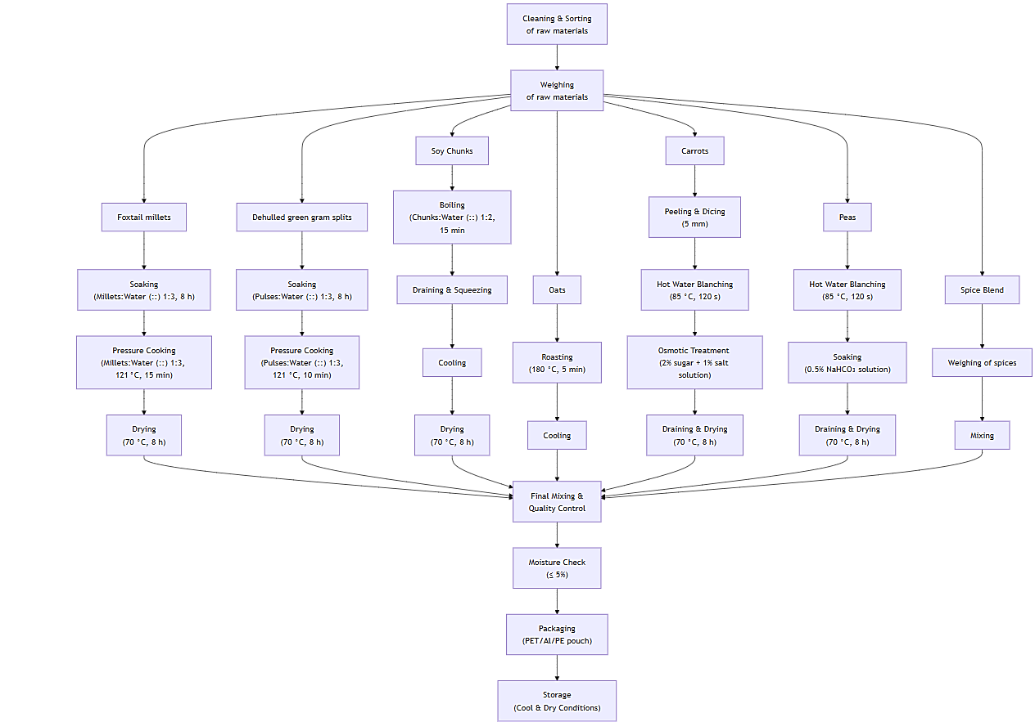

**Fig. 1. Process methodology flowchart of RTC millet khichdi premix**

The preparation of the RTC millet khichdi premix was carried out under hygienic and standardized lab-scale conditions to ensure consistency, safety, and product quality (Fig. 1). Initially the main ingredients foxtail millet and green gram splits were cleaned to ensure removal of the foreign matter and immature kernels to maintain the quality and safety of product. The sorted grains were soaked separately in potable water by keeping the ratio of 1:3 (w/v) for 8 hours at room temperature (25 ± 2 °C). After soaking the excess water was drained using perforated tray so that grains having approximately moisture content 40%. These grains were cooked by using the pressure cooker for a period of 10 minutes at a pressure of psi so that partial gelatinization to improve the final products texture and cooking time. Following the gelatinization, the grains were then dried using a cabinet tray dryer and dried at 70 °C with an airflow of 1.2 m/s for eight hours targeting moisture content of ≤ 5%. Meanwhile soy chunks were rehydrated by boiling in water for 15 minutes then drained and dried at 70 °C with an airflow of 1.2 m/s for eight hours in cabinet tray dryer targeting moisture content of ≤ 5%. To increase the flavor profile and reduce enzyme activity oats were roasted on hot pan surface at 180 °C for 5 minutes with constant stirring. Peri-Peri spice blend with salt, tomato powder, and monosodium glutamate (MSG) was prepared for final blending. All pre-processed ingredients such as dried grains and pulses, roasted oats, dehydrated vegetables, soy chunks, and spice blend of peri-peri were mixed thoroughly at 15 rpm for 5 minutes to ensure uniformity. Once the mixture is prepared it was packed in 200g size into 3layer pouches to ensure its shelf life.

**2.4 Product Development Trials**

**Table 1. Formulations of RTC Millet Khichdi (per 100 g)**

|  |  |  |  |  |
| --- | --- | --- | --- | --- |
| **Ingredient** | **Control (g)** | **Sample A (g)** | **Sample B (g)** | **Sample C (g)** |
| Foxtail millet | 40.00 | 40.00 | 40.00 | 40.00 |
| Green Gram splits | 35.00 | 20.00 | 20.00 | 20.00 |
| Oats | 20.00 | 10.00 | 10.00 | 10.00 |
| Soy chunks | - | 10.00 | 10.00 | 10.00 |
| Peri-Peri spice blend (total) | - | 5.00 | 6.00 | 6.25 |
| *Red chilli powder* | - | 1.50 | 1.80 | 1.88 |
| *Garlic powder* | - | 1.00 | 1.20 | 1.25 |
| *Onion powder* | - | 0.75 | 0.90 | 0.94 |
| *Black pepper powder* | - | 0.50 | 0.60 | 0.63 |
| *Red chilli flakes* | - | 0.50 | 0.60 | 0.63 |
| *Turmeric powder* | - | 0.50 | 0.60 | 0.62 |
| *Oregano powder* | - | 0.25 | 0.30 | 0.30 |
| Dehydrated Carrot | - | 4.50 | 4.50 | 4.50 |
| Dehydrated Peas | - | 4.50 | 4.50 | 4.50 |
| Salt | 5.00 | 2.00 | 1.50 | 2.50 |
| Tomato powder | - | 3.00 | 2.50 | 1.70 |
| Monosodium Glutamate (MSG) | - | 1.00 | 1.00 | 0.55 |

The development of the RTC millet khichdi premix involved a systematic experimental study with four distinct formulations (Table 1): a Control and three experimental samples (Sample A, Sample B, and Sample C). These variations were designed to optimize the ingredient ratios to achieve a nutritionally enhanced, convenient, and wholesome meal solution. The key ingredients meticulously integrated into the premixes included Foxtail Millet, Dehulled Green Gram Splits, Oats, Soy Chunks, dehydrated vegetables (carrot and peas), a Peri-Peri spice blend, and salt.

The specific proportions for each formulation are detailed in Table 1:

Foxtail Millet: This served as the foundational grain, contributing substantially to complex carbohydrates and dietary fiber. It was kept constant at 40g across all formulations (Control, Sample A, B, and C).

Dehulled Green Gram Splits: Instrumental in augmenting the protein content, green gram splits were included at 35g in the Control and reduced to 20g in Samples A, B, and C.

Oats: Incorporated for their commendable lipid profile and elevated concentrations of soluble fiber, particularly β-glucan, oats were present at 20g in the Control and 10g in Samples A, B, and C.

Soy Chunks: A pivotal ingredient for protein fortification, soy chunks were absent in the Control but added at 10g to Samples A, B, and C.

Peri-Peri Spice Blend (total): This blend, absent in the Control, varied across the experimental samples: 5g in Sample A, 6g in Sample B, and 6.25g in Sample C.

Individual Spices: Red chilli powder, garlic powder, onion powder, black pepper powder, red chilli flakes, turmeric powder, and oregano powder were included in varying amounts within the Peri-Peri spice blend for Samples A, B, and C.

Dehydrated Vegetables: Dehydrated carrot (4.5g) and peas (4.5g) were consistently added to Samples A, B, and C, but not to the Control.

Salt: Salt content varied significantly across formulations, with the Control containing 5g, Sample A 2g, Sample B 1.5g, and Sample C 2.5g.

Tomato Powder: Present in Samples A (3g), B (2.5g), and C (1.7g), but not in the Control.

Monosodium Glutamate (MSG): Included in Samples A (1g), B (1g), and C (0.55g).

These distinct formulations allowed for a comprehensive evaluation of their impact on proximate composition, sensory attributes, and microbiological safety, ultimately leading to the identification of an optimized premix.

**2.5 Proximate Analysis**

**2.5.1 Moisture Content**

The moisture content of the product was determined using the oven-drying method (AOAC, 2023). An empty, clean, and dry aluminum petri dish was initially weighed to record its tare weight. A 5 g sample was placed into the dish, which was then transferred to a hot air oven (i-Therm AI-7981, India) maintained at 105°C and allowed to dry for 3 hours.

After the drying period, the dish was removed and transferred to a desiccator to cool to room temperature, preventing moisture reabsorption. Once cooled, the final weight of the dish containing the dried sample was recorded. The final moisture content was calculated based on the weight difference using the standard formula:

$$Moisture \left(g/{100 g}\right)= \frac{[Initial weight (g) – Final weight (g)]}{Initial weight (g)} × 100$$

**2.5.2 Protein Content**

The protein content was determined using a semi-automatic Kjeldahl machine (Kjeltron, Tulin) (AOAC, 2023). Approximately 1 gram of the food sample was placed into a digestion tube. A digestion catalyst mixture, comprising potassium sulfate and cupric sulfate, along with 15 mL of concentrated sulfuric acid, was added to the sample. The mixture was heated in the Kjeltron digestion block until the solution became clear, indicating the conversion of nitrogenous compounds to ammonium sulfate. After digestion, the tubes were cooled and diluted with distilled water. The diluted digest was transferred to the distillation unit, where sodium hydroxide solution was added to make the mixture alkaline, releasing ammonia gas. The liberated ammonia was distilled and captured in a receiving flask containing a known volume of boric acid solution with mixed indicators. The absorbed ammonia was then titrated manually using a 0.1 N sulfuric acid solution until the endpoint was reached, as indicated by a color change. The volume of acid used was recorded to determine the nitrogen content. A conversion factor of 6.25 was used, assuming that proteins contain approximately 16% nitrogen (AOAC, 2023). The protein content was calculated using the following formula:

$$Protein \left(g/{100 g}\right)= Nitrogen (\%) × 6.25$$

**2.5.3 Fat Content**

The crude fat content of the sample was determined using a semi-automated Soxhlet extraction apparatus (Soxtron SOX 4), (AOAC, 2023). Approximately 2 grams of the dried sample were accurately weighed and placed into a cellulose extraction thimble. The thimble was inserted into the Soxtron apparatus, which was equipped with a pre-weighed, clean, and dry round-bottom flask containing petroleum ether as the extraction solvent. The extraction process was carried out for 4 to 6 hours, allowing continuous solvent reflux over the sample. During this process, the fat present in the sample dissolved into the heated solvent and was gradually collected in the flask. Upon completion of the extraction cycle, the flask containing the extracted fat was removed, and the solvent was recovered by evaporation. To eliminate any residual solvent, the flask was dried in a hot air oven at approximately 100°C. After cooling to ambient temperature in a desiccator, the flask was weighed. The increase in weight of the flask represented the amount of crude fat extracted from the sample. The crude fat content was calculated using the following formula:

$$Fat \left(g/{100 g}\right)= \frac{Weight of extracted fat (g)}{Weight of sample (g)} × 100$$

**2.5.4 Fiber Content**

The total dietary fiber (TDF) content was determined using the enzymatic-gravimetric method (AOAC, 2023). This method simulates human gastrointestinal conditions by subjecting the sample to sequential enzymatic digestion. Specifically, the sample undergoes hydrolysis of starch by α-amylase, protein digestion by protease, and further breakdown of starch residues by amyloglucosidase. Following enzymatic treatment, insoluble dietary fiber (IDF) is separated by filtration. The soluble dietary fiber (SDF) is subsequently extracted from the filtrate by precipitating it with ethanol. Both IDF and SDF residues are dried and weighed, with adjustments made for protein and ash contents. The total dietary fiber content is calculated by summing the corrected weights of IDF and SDF:

$$TDF \left(g/{100 g}\right)= IDF \left(g/{100 g}\right)+SDF \left(g/{100 g}\right)$$

**2.5.5 Ash Content**

The total ash content of the sample was determined using a muffle furnace (i-Therm AI-7481, India), following the procedure outlined by Ranganna (1986)& (AOAC, 2023). Approximately 5 g of the sample were placed into pre-weighed, clean, and dry silica crucibles. To minimize foaming or splashing during incineration, the samples were gently pre-charred on a hot plate to remove most of the moisture and volatile organic matter.

The pre-charred crucibles were then carefully placed in a muffle furnace and ashed at 600°C for four hours, or until a light grey ash was produced, indicating complete combustion of organic material. After ashing, the crucibles were transferred to a desiccator to cool to room temperature, preventing moisture absorption. Once cooled, the crucibles were weighed. The ash content was calculated using the following formula:

$$Ash \left(g/{100 g}\right)= \frac{Weight of ash (g)}{Weight of sample (g)} × 100$$

**2.5.6 Total Carbohydrates**

The total carbohydrate content was determined by difference, following the procedures outlined in AOAC Official Methods (AOAC, 2023). Initially, the percentages of moisture, crude protein, crude fat, crude fiber, and total ash were determined using the respective AOAC methods Each value was expressed as a percentage relative to the sample weight. Subsequently, the total carbohydrate content was calculated using the following formula:

$$Total carbohydrates \left(g/{100 g}\right)= 100 - [Moisture \left(g/{100 g}\right) + Protein \left(g/{100 g}\right) + Fat \left(g/{100 g}\right) +Fiber \left(g/{100 g}\right) +Ash \left(g/{100 g}\right)]$$

**2.5.7 Sodium Content**

The sodium content of the sample was determined using a colorimetric method, as described by Julshamn et al. (2005). A single-beam visible spectrophotometer (Systronics 168) was employed for the analysis. Initially, a certified sodium stock solution was diluted to prepare a series of sodium standard solutions with concentrations ranging from 0 to 10 ppm. A 1 g portion of the dried, homogenized food sample was subjected to wet digestion using a mixture of concentrated nitric acid and hydrogen peroxide. The digested sample was then filtered and diluted with distilled water to a known final volume.

For the color development, 5 mL of each standard or sample solution was mixed with a specified volume of a chromogenic reagent, such as sodium salicylate. The mixtures were allowed to stand at room temperature for 10 to 15 minutes to ensure complete color formation. The spectrophotometer was calibrated using a reagent blank, and the absorbance of the standards and samples was measured at a wavelength of 540 nm. A calibration curve was constructed by plotting absorbance against the sodium concentration of the standards. The sodium content of the samples was calculated using the equation derived from the calibration curve.

**2.6 MICROBIAL ANALYSIS**

**2.6.1 Total Plate Count (TPC)**

The total plate count (TPC) was conducted to assess the microbial load in the ready-to-cook khichdi premix (FSSAI Method No. 15.001:2023) for enumeration of aerobic plate count. Nutrient agar medium was prepared and sterilized using an autoclave, then aseptically poured into sterile petri plates and allowed to solidify. A 10 g sample of the khichdi premix was homogenized and subjected to serial dilution using sterile distilled water. From the appropriate dilutions, 1 mL aliquots were transferred onto separate sterile petri plates in triplicates. The pour plate method was employed, wherein the diluted sample was mixed with molten nutrient agar and allowed to solidify. All inoculated plates were incubated at 37°C for 24 hours in a bacteriological incubator (LABiN LI-90, India). Post incubation, visible colonies were counted manually. Plates exhibiting 30 to 300 colonies were considered for accurate enumeration, as per standard guidelines. The results were expressed as colony-forming units per gram (CFU/g) of the sample, calculated using the formula:

$$CFU/g= \frac{Number of colonies ×Dilution {factor}^{*}}{Weight of sample (g)}$$

*\*Dilution factor is the reciprocal of the dilution*

**2.6.2 Most Probable Number (MPN)**

The Most Probable Number (MPN) method was employed to detect the presence of coliform bacteria in the ready-to-cook khichdi premix, following the procedure (FSSAI Method No. 15.025:2023) for the enumeration of Escherichia coli and coliforms. A 10 g sample of the khichdi premix was aseptically transferred into 90 mL of sterile distilled water to prepare a 10⁻¹ dilution. This suspension was thoroughly mixed to ensure uniform distribution of microorganisms. From this initial dilution: 10 mL aliquots were inoculated into tubes containing double-strength lactose broth. 1 mL and 0.1 mL aliquots were inoculated into tubes containing single-strength lactose broth. All inoculated tubes were incubated at 37 °C for 48 hours in a bacteriological incubator (LABiN LI-90, India). Post-incubation, the tubes were examined for acid production, indicated by a color change, and gas formation in Durham tubes. The presence of both acid and gas was considered a positive presumptive test for coliforms. The number of positive tubes at each dilution level was recorded, and the Most Probable Number (MPN) of coliforms per gram of sample was estimated using standard MPN tables.

**2.6.3 Coliform Test**

The coliform load in the RTC khichdi premix was assessed using the total plate count (TPC) method on MacConkey agar, as described in the FSSAI Manual of Methods for Microbiological Examination of Food (FSSAI, 2023). MacConkey Agar medium was prepared according to standard microbiological procedures, sterilized by autoclaving, and aseptically poured into sterile petri plates. Once the agar solidified, the plates were ready for inoculation. A 10 g sample of khichdi was aseptically homogenized and subjected to serial dilution using sterile distilled water. From the appropriate dilutions, 1 mL aliquots were transferred onto MacConkey agar plates in triplicate. The plates were incubated at 37°C for 24 hours in a bacteriological incubator (Model: LABiN LI-90, India). After the incubation period, lactose-fermenting coliform colonies (typically pink/red colonies on MacConkey agar) were manually counted. The results were recorded as colony forming units per gram (CFU/g) of the sample using the formula:

$$CFU/g= \frac{Number of colonies ×Dilution {factor}^{*}}{Weight of sample (g)}$$

*\*Dilution factor is the reciprocal of the dilution*

3. results and discussion

**Table 2. Proximate analysis of Control, Sample A, Sample B, and Sample C (per 100 g)**

|  |  |  |  |  |
| --- | --- | --- | --- | --- |
| **Parameter** | **Control (g)** | **Sample A (g)** | **Sample B (g)** | **Sample C (g)** |
| Moisture (%) | 5.01 | 5.03 | 4.98 | 5.00 |
| Protein (g) | 15.48 | 18.74 | 18.88 | 18.72 |
| Fat (g) | 3.60 | 4.01 | 4.16 | 4.19 |
| Fiber (g) | 5.18 | 7.69 | 8.09 | 8.16 |
| Ash (g) | 7.30 | 5.65 | 5.26 | 6.21 |
| Available Carbohydrates (g) | 60.14 | 60.06 | 60.63 | 60.03 |
| Total Carbohydrates1 (g) | 65.32 | 67.74 | 68.72 | 68.19 |
| Energy2 (kcal) | 334.92 | 351.28 | 355.52 | 352.72 |
| Sodium (mg) | 1965.00 | 909.00 | 712.50 | 1050.15 |

*¹Total carbohydrates = Available carbohydrates + Fiber*

*²Energy is calculated using Atwater factors: 4 × Protein + 9 × Fat + 4 × Available carbohydrates*

**Table 3. Sensory evaluation results on 9-point Hedonic scale (n=30 semi-trained panelists)**

|  |  |  |  |  |
| --- | --- | --- | --- | --- |
| **Attribute** | **Control** | **Sample A** | **Sample B** | **Sample C** |
| Color | 5.5 ± 0.8 | 7.0 ± 0.7 | 7.5 ± 0.6 | 8.3 ± 0.5 |
| Taste | 5.8 ± 0.9 | 7.2 ± 0.6 | 7.6 ± 0.6 | 8.4 ± 0.5 |
| Texture | 5.0 ± 1.0 | 6.7 ± 0.8 | 7.3 ± 0.7 | 8.2 ± 0.5 |
| Flavor | 5.3 ± 0.9 | 7.0 ± 0.7 | 7.5 ± 0.6 | 8.3 ± 0.5 |
| Overall Acceptability | 5.2 ± 1.0 | 7.0 ± 0.7 | 7.7 ± 0.6 | 8.4 ± 0.5 |

*9-point Hedonic Scale: 1 = dislike extremely, 2 = dislike very much, 3 = dislike moderately, 4 = dislike slightly, 5 = neither like, nor dislike, 6 = like slightly, 7 = like moderately, 8 = like very much, 9 = like extremely*

*Mean ± S.E.M = Mean values ± Standard error of means of four experiments*

**Table 4. Sensory evaluation results on Just-About-Right (JAR) scale (n=30 semi-trained panelists)**

|  |  |  |  |  |
| --- | --- | --- | --- | --- |
| **Parameter** | **Control (g)** | **Sample A (g)** | **Sample B (g)** | **Sample C (g)** |
| Saltiness | 2.8 ± 0.2 | 2.2 ± 0.5 | 1.7 ± 0.5 | 2.6 ± 0.3 |
| Spiciness | 1.0 ± 0.0 | 2.1 ± 0.2 | 2.3 ± 0.3 | 2.8 ± 0.2 |
| Texture firmness | 2.5 ± 0.5 | 2.5 ± 0.4 | 2.6 ± 0.4 | 2.6 ± 0.4 |
| Color intensity | 1.0 ± 0.5 | 2.0 ± 0.5 | 2.4 ± 0.4 | 2.5 ± 0.3 |

*JAR Scale: 1 = too weak/low, 2 = just about right, 3 = too strong/high*

*Mean ± S.E.M = Mean values ± Standard error of means of four experiments*

**Table 5. Microbiological analysis of Control, Sample A, Sample B, and Sample C**

|  |  |  |  |  |
| --- | --- | --- | --- | --- |
| **Parameter** | **Control (g)** | **Sample A (g)** | **Sample B (g)** | **Sample C (g)** |
| Total Plate Count (CFU/g) | <1 | <1 | <1 | <1 |
| Most Probable Number (MPN/g) | <2 | <3 | <3 | <3 |
| Coliform Test | Negative | Negative | Negative | Negative |
| Total Plate Count (CFU/g) | <1 | <1 | <1 | <1 |

Among the four trial formulations (Table 1), Sample C demonstrated a balanced enhancement in chemical composition (Table 2) and sensory appeal (Table 3, Table 4) without compromising expected shelf stability (Table 5). Compared to the control, Sample C exhibited marginally reduced moisture content (5.00 % vs. 5.01 %), increased protein (18.72 g/100 g vs. 15.48 g/100 g) and fiber (8.16 g/100 g vs. 5.18 g/100 g), and higher ash content (7.30 g/100 g vs. 6.21 g/100 g), indicating a denser nutrient profile due to the inclusion of soy chunks and oats. While Samples A and B showed further marginal gains in protein (18.74 g/100 g and 18.88 g/100 g, respectively) and fiber (7.69 g/100 g and 8.09 g/100 g), they also retained similar moisture levels (5.03 % and 4.98 %) and lower overall acceptability scores (8.2 ± 0.7 and 8.5 ± 0.6 vs. 8.7 ± 0.5 for Sample C), suggesting a balance between nutritional enrichment and palatability. All samples maintained similar available carbohydrate levels (~60 g/100 g) and energy densities (334–356 kcal/100 g), but only Sample C combined superior proximate metrics with the highest sensory ratings (taste 8.5 ± 0.6, texture 8.2 ± 0.6). Hence, Sample C was selected as the final formulation based on this balanced outcome of proximate analysis and sensory evaluation. For all subsequent characterization and product development, Sample C was compared against the control baseline to quantify improvements attributable to the optimized ingredient blend.

**3.1 Moisture Content**

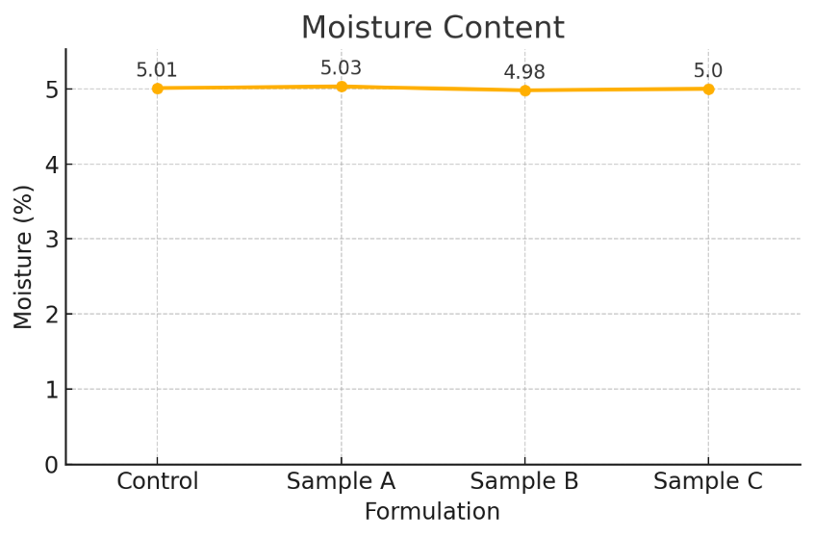

**Fig. 2. Moisture content of Control, Sample A, Sample B, and Sample C**

The moisture content of RTC dehydrated food products influences shelf stability, microbial safety, and rehydration quality. In this study, all four khichdi formulations recorded moisture values between 4.98% and 5.03% (Table 2), meeting the critical threshold of ≤5% moisture for shelf-stable mixes. Sample C recorded 5.00%, slightly lower than the control (5.01%), indicating efficient moisture removal during drying. The slight reduction in moisture (Fig. 3) in the other samples, particularly Sample C, is attributed to the presence of dry spices and dehydrated vegetables, which absorb residual moisture during drying and mixing. This outcome is aligned with results from Anila Kumari et al. (2024), where instant khichdi mixes prepared from pre-treated minor millets demonstrated moisture content ranging from 3.7% to 5.2%, depending on the drying treatment applied.

**3.2 Protein Content**

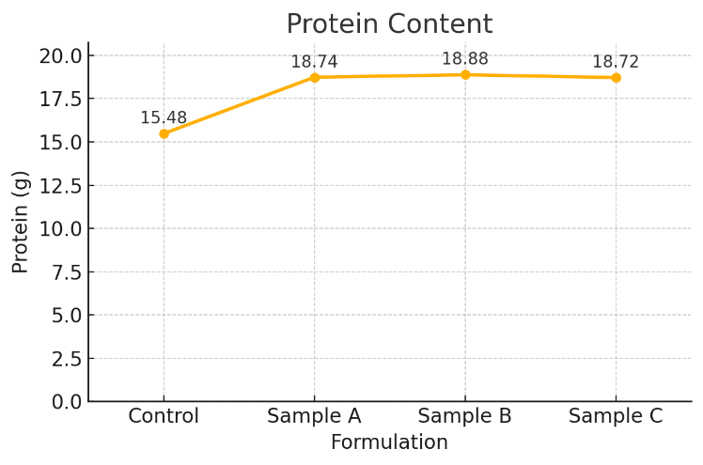

**Fig. 3. Protein content of Control, Sample A, Sample B, and Sample C**

Protein fortification is a primary objective in formulating plant‑based RTC mixes to enhance nutritional value, particularly in vegetarian diets where cereals alone provide suboptimal essential amino acid profiles. In the present study, the protein content of the formulations ranged from 15.48 g/100 g in the control sample to 18.72 g/100 g in Sample C (Table 2), demonstrating a substantial improvement of nearly 21% over the base formulation (Fig. 3). This enhancement can be attributed to the strategic incorporation of textured soy protein chunks, possessing a protein concentration of approximately 52% (Patil et al., 2023), and green gram splits with 20-29% protein (Hou et al., 2019) on a dry basis. Additionally, oats contributed moderate protein content (around 13%) (Paudel et al., 2021), cumulatively enriching the formulation. A similar protein enrichment trend was observed by R. Rajeswari & Naik (2023), where instant minor‑millet khichdi mixes reached protein levels of 12.09-14.79 g/100g depending on grain treatment, with autoclaved and soaked treatments recording the highest values. The partial gelatinization and controlled drying adopted in this study further prevented protein denaturation and textural hardening, commonly encountered in high-protein dry mixes.

**3.3 Fat Content**

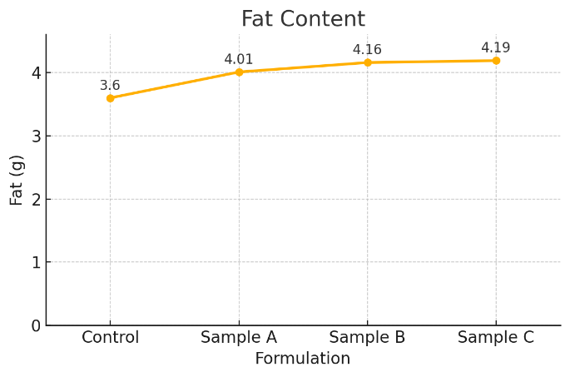

**Fig. 4. Fat content of Control, Sample A, Sample B, and Sample C**

The fat content of the formulated samples exhibited a modest but meaningful increase (Fig. 4), ranging from 3.60 g/100 g in the control to 4.19 g/100 g in Sample C (Table 2). This rise correlates directly with the inclusion of oats, soy chunks, and lipid-containing spices such as red chilli powder and dehydrated vegetables like carrots and peas, all of which contribute to the overall lipid profile of the final product. The observed trend aligns with findings in a study by Rajeswari & Naik (2023), where fat content ranged from 3.14 % to 3.75 % across different millet‑based RTC mixes. From a nutritional standpoint, the final fat levels remained within acceptable dietary limits for a light, plant-based main meal option. Notably, the moderate fat contribution from soy chunks and oats not only enhances the nutritional density but also contributes to satiety and palatability, providing desirable mouthfeel and flavor-carrying properties without compromising health standards.

**3.4 Fiber Content**

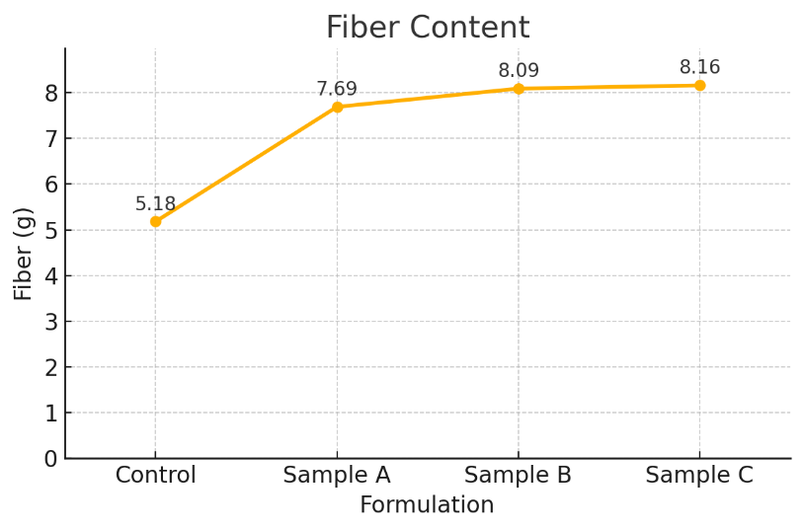

**Fig. 5. Fiber Content of Control, Sample A, Sample B, and Sample C**

Fiber is a key functional component promoting satiety and glycemic control in RTC products. In this study, crude fiber increased (Fig. 5) from 5.18 g/100 g in the control to 8.16 g/100 g in Sample C (Table 2). This notable enhancement is due to the incorporation of oats, soy chunks, green gram splits, and dehydrated vegetables, each recognized for their substantial fiber contributions. Oats, in particular, supply both β-glucan soluble fiber and insoluble fractions, offering proven benefits in modulating postprandial glycemia and improving gastrointestinal health (Paudel et al., 2021). Additionally, the inclusion of soy chunks, rich in insoluble dietary fiber, further augmented the fiber density of the formulation. Green gram splits and dehydrated vegetables like carrots and peas, subjected to blanching and drying, retained appreciable fiber levels while also contributing to textural integrity and mouthfeel in the reconstituted product. The resultant fiber level in Sample C (8.16 g/100g) surpasses fiber contents reported for some minor-millet instant khichdi by R. Rajeswari & Naik (2023), where their mixes had fiber contents ranging from 2.48% to 3.52%.

**3.5 Ash Content**

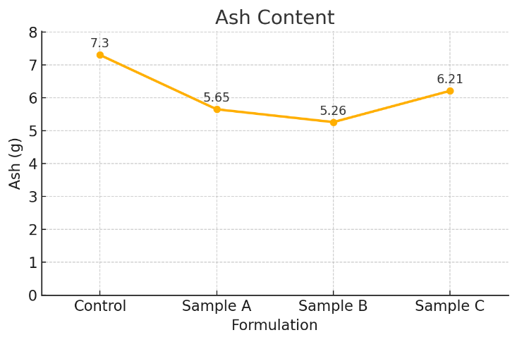

**Fig. 6. Ash content of Control, Sample A, Sample B, and Sample C**

Ash content, which represents the total mineral composition of a food product, is a key indicator of its micronutrient density and nutritional value. In the present study, ash content across the four formulations ranged from 5.26 g/100 g in Sample B to 6.21 g/100 g in Sample C, with the control having 7.30 g/100 g (Table 2). The higher ash in the control (Fig. 6) might be due to the higher proportion of green gram splits (35g in Control vs 20g in Samples A, B, C), which are a good source of minerals (Hou et al., 2019). While the overall ash content in Sample C is lower than the control, the inclusion of specific ingredients like soy chunks and dehydrated vegetables (carrots, peas) is intended to contribute a diverse range of essential minerals. The dehydration of blanched vegetables, as employed in this study, aims to preserve essential minerals (Motegaonkar et al., 2024; Pandey et al., 2019). Achieving a balanced mineral profile is desirable in millet-based functional foods.

**3.6 Available Carbohydrates**

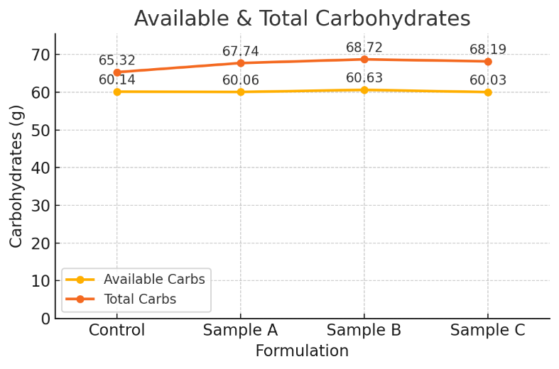

**Fig. 7. Available & total carbohydrates of Control, Sample A, Sample B, and Sample C**

Available carbohydrates, calculated by difference (total mass minus moisture, protein, fat, fiber, and ash), remained stable across formulations (Fig. 7), ranging from 60.03 g/100 g (Sample C) to 60.63 g/100 g (Sample B). This stability can be primarily attributed to the dominant starch fractions contributed by Foxtail millet (*Setaria italica*) and Oats (*Avena sativa*), which together constitute 50 % of the formulation’s mass in Samples A, B, and C. These grains are rich in complex carbohydrates. The minor variations are due to the differing levels of protein, fat, fiber, and ash from other ingredients like green gram splits, soy chunks, and vegetables. These values are comparable to those reported by Rajeswari & Naik (2023) for instant multi-millet khichdi mixes, which had carbohydrate contents around 73.99-79.74%, though their calculation method might differ (e.g., not subtracting fiber for available carbs).

**3.7 Total Carbohydrates**

When total carbohydrates, considering both available carbohydrates and dietary fiber, were assessed, an upward trend (Fig. 7) was observed across the formulations, ranging from 65.32 g/100 g in the control to 68.72 g/100 g in Sample B and 68.19 g/100 g in Sample C (Table 2). This increase is principally attributed to the integration of fiber-dense ingredients, notably oats (Paudel et al., 2021), soy chunks (Patil et al., 2023), a higher proportion of foxtail millet relative to green gram splits, and dehydrated vegetables in Samples A, B, and C compared to the control's higher green gram content. These total carbohydrate values align with the study by Rajeswari & Naik (2023). Notably, the increase in fiber content contributes to the higher total carbohydrate value without compromising the proportion of digestible carbohydrates significantly, thereby preserving the energy density (334–356 kcal/100 g) across all formulations (Table 2).

**3.8 Sodium Content**

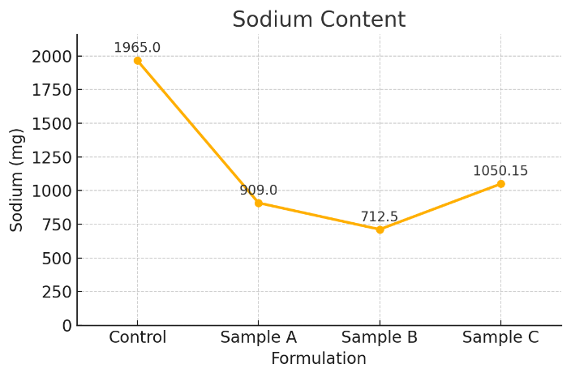

**Fig. 8. Sodium content of Control, Sample A, Sample B, and Sample C**

Sodium content varied significantly across the formulations (Fig. 8) owing to different levels of added salt and Monosodium Glutamate (MSG) (Table 1). The Control, with 5g salt/100g, had the highest sodium content at 1965.00 mg/100g (Table 2). Sample A (2g salt, 1g MSG) had 909.00 mg/100g. Sample B (1.5g salt, 1g MSG) had the lowest at 712.50 mg/100g. The final optimized formulation, Sample C, contained 2.5g salt and 0.55g MSG per 100g, resulting in a sodium content of 1050.15 mg/100g (Table 2). While the control approaches a high-sodium profile, the formulation strategy in Sample C successfully reduced sodium by nearly 47% compared to the control, via optimized salt and MSG blending, without sensory compromise, as demonstrated by acceptable Just-About-Right (JAR) saltiness ratings (Table 4).

**3.9 Sensory Evaluation**

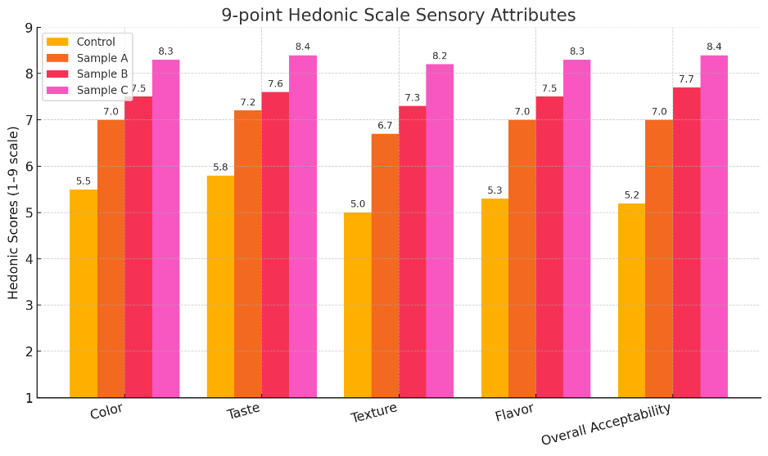

**Fig. 9. 9-point Hedonic scale sensory attributes of Control, Sample A, Sample B, and Sample C**

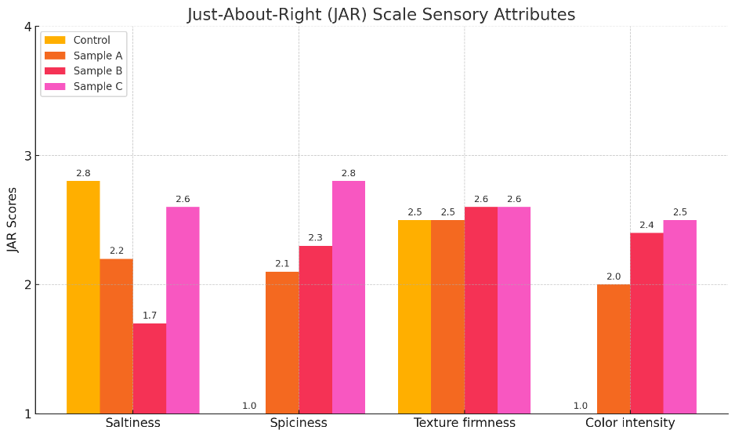

**Fig. 10. Just-About-Right scale sensory attributes of Control, Sample A, Sample B, and Sample C**

Sensory evaluation was conducted using both a 9-point Hedonic scale (Meilgaard et al., 1999) and a Just-About-Right (JAR) scale (Li et al., 2014) among 30 semi-trained panelists from the MIT School of Food Technology at MIT ADT University, Pune, Maharashtra, India. Samples were prepared by boiling 200 g of product with 2000 mL of water and cooking on medium‑high flame for precisely 10 minutes, then served in coded plates (Control, A, B, C) for sensory evaluation. The panelists received written instructions and rated appearance, aroma, texture, taste/flavor, and overall acceptability on a 9‑point hedonic scale (1= dislike extremely, 2 = dislike very much, 3 = dislike moderately, 4 = dislike slightly, 5 = neither like, nor dislike, 6 = like slightly, 7 = like moderately, 8 = like very much, 9 = like extremely) according to Meilgaard et al. (1999). Following hedonic scoring, panelists also used a Just‑About‑Right (JAR) scale (1 = too weak/low, 2 = just about right, 3 = too strong/high) to assess saltiness, spiciness, texture firmness, and color intensity (Li et al., 2014). Sample C consistently recorded the highest hedonic scores (Fig. 9) across all evaluated parameters. It achieved mean values of 8.3 ± 0.5 for color, 8.4 ± 0.5 for taste, 8.2 ± 0.5 for texture, 8.3 ± 0.5 for flavor, and 8.4 ± 0.5 for overall acceptability (Table 3). In comparison, Sample B showed moderately high scores (7.3–7.7), followed by Sample A (6.7–7.3), while the Control registered the lowest scores (5.0–5.8), highlighting the influence of the peri-peri spice blend, dehydrated vegetables, and soy-oats fortification on sensory quality. The JAR scale ratings further reinforced these findings (Fig. 10). Sample C approached the ideal values most closely for saltiness (2.6 ± 0.3), spiciness (2.8 ± 0.2), texture firmness (2.6 ± 0.4), and color intensity (2.5 ± 0.3). Notably, Sample B, while acceptable in firmness and color, was rated lower in saltiness (1.7 ± 0.5) and spiciness (2.3 ± 0.3), indicating an under-seasoned perception (Table 4). Sample A and the Control displayed further deviations from ideal values, particularly in spiciness and color intensity. These outcomes indicate that Sample C not only met but surpassed sensory acceptability thresholds essential for ready-to-cook savory products, particularly within the emerging health-food segment. Future research may explore consumer validation through hedonic mapping or preference-ranking tests in diverse demographic groups to confirm cross-market potential.

**3.10 Microbiological Analysis**

All four formulations, including the optimized Sample C, recorded TPCs below 1 CFU/g. The MPN for coliforms was <2 MPN/g for the Control and <3 MPN/g for Samples A, B, and C. All samples tested negative for coliforms (Table 5). These results confirm effective microbial control throughout the processing chain, attributable to the partial gelatinization via pressure cooking (121°C, 15 psi, 10 min), efficient dehydration in a cabinet dryer (70°C for 8 hours to ≤5% moisture), and adherence to Good Manufacturing Practices (GMP). The low moisture content (around 5.00%) of the final premix is a critical factor in inhibiting microbial growth and ensuring shelf stability. These results are well within the acceptable limits for RTC food products, indicating the product is safe for consumption.

4. Conclusion

The development of the RTC Millet Khichdi successfully achieved all research objectives through systematic formulation, processing optimization, and rigorous quality evaluation. The optimized formulation, Sample C (40% foxtail millet, 20% green gram splits, 10% oats, 10% soy chunks, 6.25% Peri-Peri spice blend, along with dehydrated vegetables, salt, and tomato powder), delivered a balanced nutritional profile. Per 100g, Sample C contains 18.72 g protein, 8.16 g fiber, 4.19 g fat, 60.03 g available carbohydrates, resulting in 352.72 kcal, and 1050.15 mg sodium. The standardized processing methodology, involving partial gelatinization via pressure cooking (121°C/15 psi, 10 min) followed by cabinet tray drying (70°C, 8 h), consistently yielded a final product moisture content of 5.00%, ensuring ambient shelf stability (projected ≤ 6 months). Microbiological analysis confirmed the product's safety, with Total Plate Count < 1 CFU/g and negative coliform tests. Sensory evaluation by a 30-member semi-trained panel demonstrated excellent consumer acceptability for Sample C. Hedonic scores averaged 8.3–8.4 out of 9 across key attributes including color, taste, texture, and flavor, with an overall acceptability of 8.4 ± 0.5. Just-About-Right (JAR) scale ratings were centered between 2.5–2.8 on a 3-point scale, confirming ideal seasoning and mouthfeel. Overall, this project successfully demonstrates a replicable model for developing a nutritious, convenient, and commercially viable Ready-To-Cook millet-based food product. This product effectively integrates the health benefits of foxtail millet, pulse, oats, and soy chunks with appealing sensory characteristics, catering to the demands of modern, health-conscious consumers.

References

Ahmed, I., & Jamal, S. (2016). Developments in osmotic dehydration technique for the preservation of fruits and vegetables. Innovative Food Science & Emerging Technologies, 14, 30–43. https://www.sciencedirect.com/topics/agricultural-and-biological-sciences/osmotic-dehydration

AOAC International. (2023). Official Methods of Analysis of AOAC INTERNATIONAL (22nd ed.). Method 925.10: Moisture in Foods. Gaithersburg, MD, USA: AOAC INTERNATIONAL.

AOAC International. (2023). Official Methods of Analysis of AOAC INTERNATIONAL (22nd ed.). Method 984.13: Protein (Crude) in Animal Feed and Pet Food – Copper Catalyst Kjeldahl Method. Gaithersburg, MD, USA: AOAC INTERNATIONAL.

AOAC International. (2023). Official Methods of Analysis of AOAC INTERNATIONAL (22nd ed.). Method 920.39: Fat (Crude) or Ether Extract in Animal Feed. Gaithersburg, MD, USA: AOAC INTERNATIONAL.

AOAC International. (2023). Official Methods of Analysis of AOAC INTERNATIONAL (22nd ed.). Method 985.29: Total Dietary Fiber in Foods – Enzymatic-Gravimetric Method. Gaithersburg, MD, USA: AOAC INTERNATIONAL.

AOAC International. (2023). Official Methods of Analysis of AOAC INTERNATIONAL (22nd ed.). Gaithersburg, MD, USA: AOAC INTERNATIONAL.

Cui, T., Gine, G. R., Lei, Y., Shi, Z., Jiang, B., Yan, Y., et al. (2024). Ready-to-Cook Foods: Technological Developments and Future Trends—A Systematic Review. Foods, 13(21), 3454. https://doi.org/10.3390/foods13213454

Decker, E. A., Rose, D. J., & Stewart, D. (2014). Processing of oats and the impact of processing operations on nutrition and health benefits. British Journal of Nutrition, 112(S2), S58-S64. https://doi.org/10.1017/S000711451400227X (PMID: 25267246)

FAO. (n.d.). Fruit and vegetable processing - Ch05 General procedures for fruit and vegetable preservation (cont.). Food and Agriculture Organization of the United Nations. Retrieved from https://www.fao.org/4/v5030e/V5030E0c.htm

Food Safety and Standards Authority of India (FSSAI). (2023). Manual of Methods of Analysis of Foods: Microbiological Examination of Food and Water (Method No. 15.001:2023). Retrieved from https://fssai.gov.in/upload/uploadfiles/files/Manual-Microbiology-Methods.pdf

Food Safety and Standards Authority of India (FSSAI). (2023). Manual of Methods of Analysis of Foods: Microbiological Examination of Food and Water (Method No. 15.025:2023). Retrieved from https://fssai.gov.in/upload/uploadfiles/files/Manual-Microbiology-Methods.pdf

Food Safety and Standards Authority of India (FSSAI). (2023). Manual of Methods of Analysis of Foods: Microbiological Examination of Food and Water (Method No. 15.026:2023). Retrieved from https://fssai.gov.in/upload/uploadfiles/files/Manual-Microbiology-Methods.pdf

Hou, D., Yousaf, L., Xue, Y., Hu, J., Wu, J., Hu, X., et al. (2019). Mung Bean (Vigna radiata L.): Bioactive Polyphenols, Polysaccharides, Peptides, and Health Benefits. Nutrients, 11(6), 1238. https://doi.org/10.3390/nu11061238 (PMID: 31151234)

Julshamn, K., Lea, P., Sloth, J. J., & et al. (2005). Determination of sodium in food samples by colorimetric method. Journal of AOAC International, 88(3), 770–776.

Kumari, A. P. S., Srivastav, P. P., & Pathare, P. B. (2024). Development and characterization of instant khichdi mix from pre-treated minor millets. Journal of Food Measurement and Characterization, 18(1), 635-649. https://doi.org/10.1007/s11694-023-02143-5

Li, J., Ziegler, G. R., & Perego, P. (2014). Just-about-right vs. ideal scaling: A comparison of coffee-flavored dairy beverages. Food Quality and Preference, 36, 88–98. https://doi.org/10.1016/j.foodqual.2014.03.007

Meilgaard, M., Civille, G. V., & Carr, B. T. (1999). Sensory Evaluation Techniques (3rd ed.). CRC Press.

Mierzwa, D., Kowalski, S. J., & Kroehnke, J. (2017). Hybrid drying of carrot preliminary processed with ultrasonically assisted osmotic dehydration. Food Technology and Biotechnology, 55(2), 197–205. https://doi.org/10.17113/ftb.55.02.17.4823

Motegaonkar, S., Shankar, A., Tazeen, H., Gunjal, M., & Payyanad, S. (2024). A comprehensive review on carrot (Daucus carota L.): the effect of different drying methods on nutritional properties and its processing as value-added foods. Sustainable Food Technology, 2, 667-688. https://doi.org/10.1039/d3fb00162h

Negi, N., Srihari, S. P., Wadikar, D. D., Sharma, G. K., & Semwal, A. D. (2021). Optimization of instant foxtail millet-based khichdi by using response surface methodology and evaluation of its shelf stability. Journal of Food Science and Technology, 58(12), 4478-4485. https://doi.org/10.1007/s13197-020-04929-x

Pandey, O. P., Mishra, B. K., & Misra, A. (2019). Comparative study of green peas using with blanching & without blanching techniques. Information Processing in Agriculture, 6(2), 285-296. https://doi.org/10.1016/j.inpa.2018.10.002

Patil, V. B., Hatwar, P., & Sanap, G. S. (2023). REVIEW ON ROLE OF SOYABEAN CHUNKS ARE USED IN MALNUTRITION. International Research Journal of Modernization in Engineering Technology and Science, 5(05), 2874-2881.

Paudel, D., Dhungana, B., Caffe, M., & Krishnan, P. (2021). A Review of Health-Beneficial Properties of Oats. Foods, 10(11), 2591. https://doi.org/10.3390/foods10112591 (PMID: 34828872)

Pervin, S., Miaruddin, M., Islam, M. S., Rahman, M. M., & Khan, M. H. H. (2015). Effect of blanching on the quality of frozen product of carrot. Research & Reviews: Journal of Food Science and Technology, 4(3), 1–9. https://sciencejournals.stmjournals.in/index.php/RRJoFST/article/view/503

Rajeswari, R., & Naik, R. K. (2023). Development of instant multi millet fortified Khichdi mix. The Pharma Innovation Journal, 12(5), 4075-4078.

Raju, C. A., Begum, S. S., Nagaraja, T. E., & Shobha, D. (2025). Development and Quality Evaluation of Foxtail Millet (Setaria italica) Based Extruded Product. Mysore Journal of Agricultural Sciences, 59(1), 278-291.

Ranganna, S. (1986). Handbook of Analysis and Quality Control for Fruit and Vegetable Products (2nd ed.). New Delhi, India: Tata McGraw-Hill Publishing Company Limited.

Zhang, C., Dong, Y., Sun, Y., Liu, Y., Wang, Y., Fu, H., Chen, X., & Wang, Y. (2021). Blanching effects of radio frequency heating on enzyme inactivation, physiochemical properties of green peas (Pisum sativum L.) and the underlying mechanism in relation to cellular microstructure. Food Chemistry, 345, 128756. https://doi.org/10.1016/j.foodchem.2020.128756