**Food Security Awareness among University Students: A Case Study on CCN University of Science and Technology**

**ABSTRACT**

This paper seeks to better understand food insecurity among public university students. The informants were CCN university students chosen on purpose. An online questionnaire survey followed to ensure accurate information collection. Understanding the causes, coping strategies, and consequences of food insecurity is crucial. The study identified several factors that contribute to food insecurity, including cafeteria closures, financial issues, limited transportation, poor food quality, and time constraints. To overcome these challenges, students used various coping strategies such as purchasing food outside campus grounds, storing food, reducing meal portions, choosing cheaper foods, choosing cleaner cafeterias, requesting outside food from friends, and skipping meals altogether. As a result, students experienced anxiety, fatigue, difficulty concentrating in class, and illness. The university authorities should be made aware of food insecurity issues among students.

**Keywords: Awareness, food security, University students, Bangladesh**

1. **Introduction:**

Universities play a vital role in producing a highly skilled workforce that contributes significantly to a country's development. In Bangladesh, there are currently 56 public and 120 private universities, offering opportunities for students from diverse backgrounds to pursue tertiary education. However, the university life experience can pose challenges for students, particularly in terms of meeting their basic needs. Food insecurity has emerged as a significant global public health concern, with developing nations being particularly affected. A substantial proportion of households in these countries, especially those with low incomes, experience food insecurity (Coleman-Jensen, Nord, & Singh, 2013; Dhokarh et al., 2011; Ihab et al., 2012). The Food and Agriculture Organization (1996) defines food security as a condition in which all people, at all times, have physical and economic access to sufficient, safe, and nutritious food that meets their dietary needs and preferences for an active and healthy life. The FAO (2008) further identifies several dimensions of food security, including food availability, food access, food utilization, and food stability.

Food insecurity occurs when individuals or households face limited access to nutritious and safe foods or lack the ability to acquire them through socially acceptable means (Anderson, 1990). Many students, particularly those experiencing food insecurity, often only manage to consume three basic meals—breakfast, lunch, and dinner—when circumstances allow. Consuming balanced meals is essential for maintaining good health, providing sufficient energy, and ensuring adequate intake of macronutrients and micronutrients for activities such as studying, engaging in group discussions, and exercising (Herrera et al., 2003). Research has shown that a significant proportion of students who face food insecurity tend to skip breakfast, which has received considerable attention in previous studies (Moy et al., 2009; Gan et al., 2011). Skipping meals, particularly breakfast, is detrimental to cognitive functions related to memory and concentration and may negatively impact academic performance, attendance, health, and overall well-being (Rampersaud, Pereira, Girard, Adams, &Metzl, 2005).

The limited availability of food on campus further restricts students' food choices, which leads many to seek alternatives off-campus (Shii, Baki, &Sulaiman, 2015). This behavior highlights the importance of adequate food options within the university environment. Additionally, residing far from food sources has been shown to exacerbate food insecurity, particularly in rural areas, where access to food can be limited (Zakari, Ying, & Song, 2014). While public transport may alleviate some of these challenges, the psychological impact, including feelings of worry and stress, remains significant.

Financial constraints are a universally recognized factor contributing to food insecurity, affecting not only university students but also other vulnerable groups (Olson, Rauschenbach, Frongillo, & Kendall, 1996; Zakari et al., 2014). When examining food security among university students, food hygiene must also be considered. The World Health Organization (WHO) has emphasized the importance of safe food and water practices during food preparation and handling. To raise awareness, the WHO recommends the "five keys to safer food," which include using safe raw materials and water, keeping food clean, separating raw and cooked food, ensuring that food is thoroughly cooked, and storing food at appropriate temperatures (WHO, n.d.).

Furthermore, Moy et al. (2009) observed that due to time constraints, students at a public university in Kuala Lumpur often skipped meals, including breakfast, lunch, and dinner. Such habits, stemming from poor time management, highlight the broader issue of time-related stress and its negative impact on students' dietary habits and health.

1. **Methods of the Study**

The study employed a qualitative study methodology to explore their perspectives on food insecurity. The selected participants were specifically surveyed to assess their understanding of food insecurity, the factors contributing to it, the coping strategies they employ, and the impact it has on their daily lives. Purposive sampling was used to select participants, rather than probability sampling, ensuring that the study focused on CCN university students. The final sample comprised 100 students, who were surveyed using an online questionnaire. The online survey, hosted on Google Forms, facilitated data collection. The study included students from various academic levels, including bachelor’s and master’s students (n = 100), ensuring a diverse representation within the student population. Data collection took place from February 2025 through the spring semester.

1. **Results And Discussion**

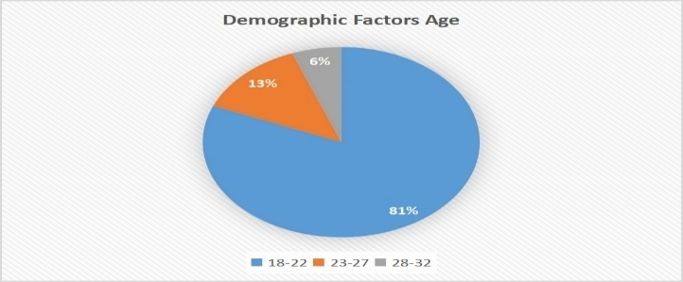

**Figure 1.** Age of the Respondents

The age distribution of university pupils taking part in the food security awareness campaign is shown in this chart. According to this data, 81% of respondents are between the ages of 18 and 22 years old. Additionally, it guarantees that a large number of students are most likely undergraduates. Additionally, only 6% of people are essentially in the 28–32 age range, while a smaller percentage, 13%, are between the ages of 23 and 27. This demographic distribution essentially implies that it raises university students' awareness of food security. Furthermore, knowing the age distribution is crucial to understanding the food security results, which must change with age and different academic standards.



**Figure 2.** Gender

Figure 2 shows the gender distribution of the university students who participated in the valuable study on food security awareness. The given data indicated that 59% of the respondents are female, actually, whereas only 41% are male. Basically, this distribution reflects a moderately higher female representation in this sample. Moreover, acknowledging these demographic factors increased the accuracy as well as the relevance of the study findings, especially in understanding how gender mobility might contribute to varying levels of food security consciousness within the university pupils.

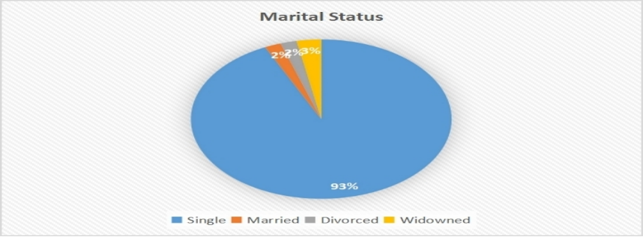

**Figure 3.** Current Marital Status

The given data reveals that the vast majority, 93%, of the participants are single; on the other hand, 2% are married, 2% are divorced, and 3% are widowed. This demographic pattern is absolutely vital to understanding food security consciousness, as single pupils may have different dietary habitual activities and budgets in their daily lives compared to married people. In addition to that, most of the students suggest that food security initiatives should be focused on their unique daily needs, for instance, low income or depending on the campus meals.

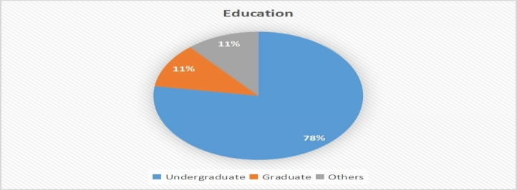

**Figure 4.** Current level of education

The chart depicts that 78% of the respondents are also undergraduate students; in contrast, only 11% are graduate pupils, and another 11% fall into the other categories. So, this distribution indicates that food security awareness programs initially target undergraduates, who may face various sorts of drawbacks; for instance, financial constraints, lack of nutritional knowledge, and limited cooking facilities. Besides, tailoring proper initiatives to this group could aid in building better food habits and better knowledge in their academic journey.



**Figure 5.**Faculty of Study

Figure 5 illustrates the distribution of participants by faculty in the study on food security consciousness among university pupils. A significant majority of respondents, 88%, are from the BBA (Business Administration) faculty, actually. Furthermore, 5% of student participants from CSE (Computer Science & Engineering) and EEE (Electrical & Electronic Engineering) are also the same percentage. But LAW faculties are the least responsive, with only 2%. So the findings mainly reflect the perspective of business students, offering focused insight into food security awareness within the BBA party. Whatever limited input from other disciplines suggests a requirement for broader participation in future research for large applicability

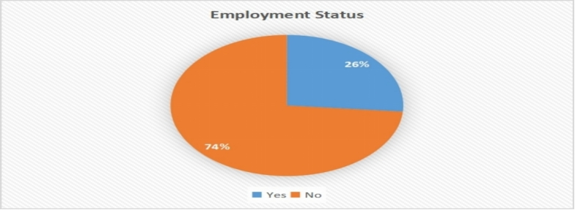

**Figure 6.**Employment Status

The given chart actually shows that 74% of university pupils are not employed, but on the contrary, 26% are employed. So it is definitely vital for the study on food security mindfulness among university pupils. Because of unemployment, students are not able to get substantial nutritious food for their daily needs, as well as they are so vulnerable. The given data highlighted that probable link between employment status and food insecurity.

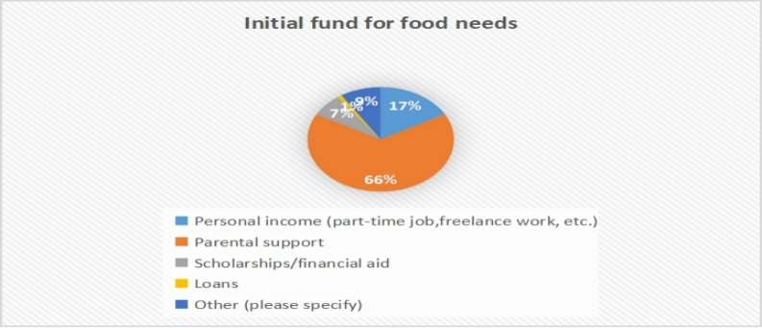

**Figure 7**.Initial fund for food needs

Figure 7 displays that 66% of pupils rely on their parents for their food demand, which highlights their strong dependence on family. On the other hand, only 17% depend on their individual income, for instance, freelancing work as well as other part-time jobs. [In](http://jobs.In) addition to that, only 7% rely on scholarship loans, 1% on other loans, and 9% on other sources. From that given chart, it is clear that many pupils attempt to support themselves, but some of the students would struggle if they lost their family support, actually. It highlights the importance of better financial help and food-related support programs at the university.

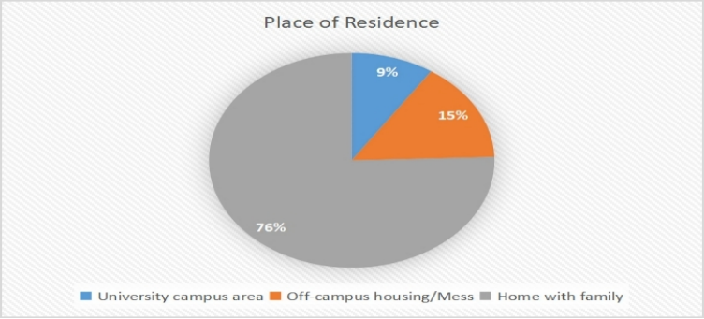

**Figure 8. Place of Residence**

The given chart reveals that most of the university pupils, 76%, live at home with their families; conversely, 15% only live in off-campus housing or mess. Moreover, the university campus area stays 9% also. So, based on this information, it is clear that those students who are living with their families consistently can get home-cooked meals as well as contribute to better food security. On the contrary, those living in off-campus housing or campus areas may face different kinds of challenges for maintaining a balanced diet due to resource obstacles. So, it is highlighted the need for proper support and consciousness programs to aid university pupils in staying food secure.

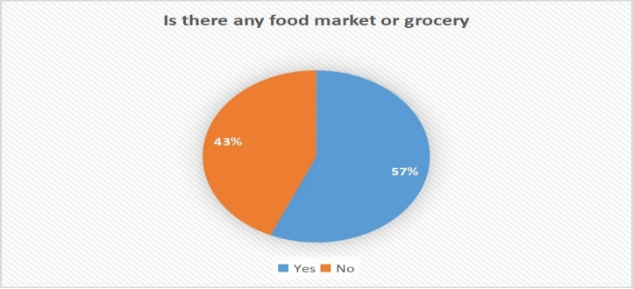

**Figure 9.** Is there a grocery store or food market available on or near your campus/ location?

Figure 9 illustrates that 57% of pupils said that there was a grocery store alongside a food market available near their university campus. While 43% said they do not get these facilities. So that easy and suitable grocery stores could aid students in maintaining a stable and healthier diet, which generally supports better food security. But those pupils who have not got this advantage face various sorts of difficulties, like not getting fresh food and increasing their food insecurity. For that reason, universities should evaluate food markets or food-related support programs that actually fight it.

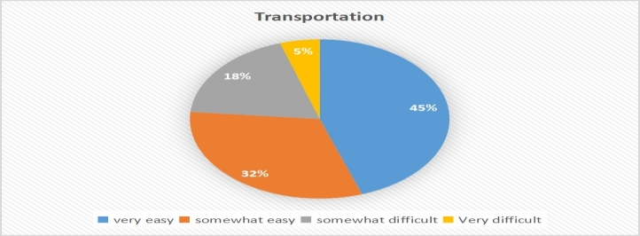

**Figure 10.** "Is it simple to get to food markets or grocery stores by transportation?

According to this given data, 45% of respondents reported that it is so much easier to reach the food market. Conversely, 32% found it to be somewhat easy. Whatever 18% said that it is somewhat difficult, as well as 5% indicated that it is very difficult. Basically, this finding suggests that most of the pupils do not encounter harmful barriers when they need to go to a food source, which is a positive side for food security. On the other hand, 5% of pupils said that it was extremely complicated for them to reach the food market. So that addressing these transportation barriers can play a vital role in developing overall food security consciousness and access among university students.

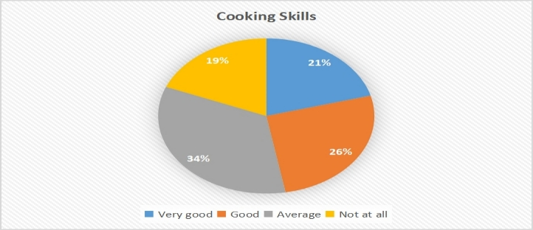

**Figure 11.** Cooking Skills

Figure 11 illustrates that 34% of pupils think their cooking ability is average; conversely, 26% evaluated them well, and 21% are very good. Remarkably, 19% of students said that they are not able to cook. So that, this given data reported that most of the respondents' cooking ability is average. On the other hand, a significant portion of students lack confidence in preparing any kind of meal. From that chart it is clear that cooking competency is crucial for pupils for making themselves affordable, nutritious meals, particularly when healthy food options are constrained. Therefore, enhancing cooking skills among university students can strengthen their food security status.

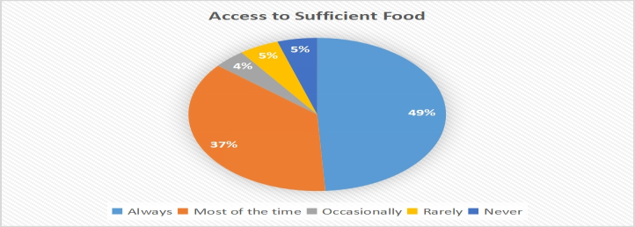

**Figure 12.** Access to Sufficient Food

According to this given chart, the level of access to sufficient food among university pupils. We identified that 49% of respondents said that they always had access to get substantial food for their daily life, and 37% said they could get enough food most of the time. However, a concerning portion of pupils reported 4% stating they had access to get substantial food occasionally, 5% rarely, as well as another 5% never getting any basically. So that this study suggests that a small portion of respondents face food insufficiency, which could usually create a harmful impact on their academic performance as well as overall well-being. But a significant number of pupils could appear food secure.

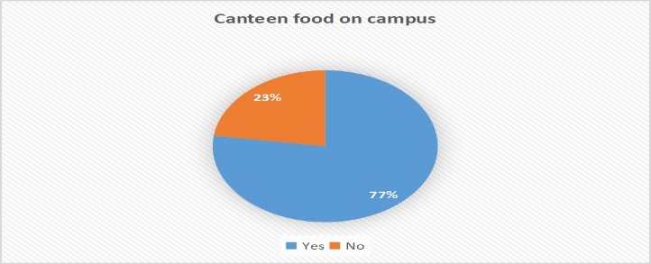

**Figure 13.** Canteen food on Campus

Figure 13 illustrates pupil’s responses regarding the availability of canteen food on campus. In the given chart, we found 77% of respondents said yes, which means that they could get better satisfaction from canteen food. On the contrary, 23% responded no, suggesting that a smaller number of pupils might find canteen food insufficient. This chart shows that the majority of the campus community is positively served by better service, which generally meets student’s needs.

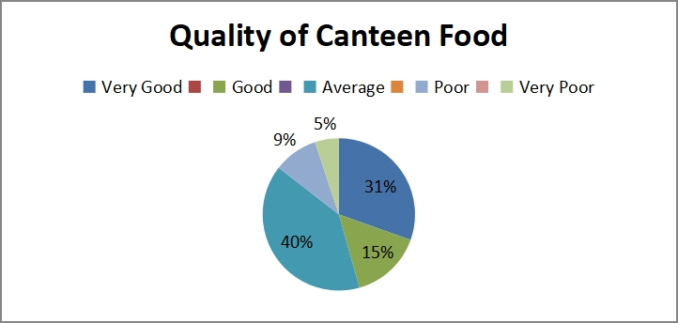

**Figure 14.** The Quality of Canteen Food

Figure 14 illustrates that 40% of students said that is very good. While 31% reported that it is average, 15% said that it is good, 9% said that it is poor, and 5% said that it is very poor. So it suggests that the majority of respondents said that although necessary, food quality is common in university canteens. But it is very crucial to ensure not just food quality but also its nutritiousness as well as safety, which is essential for university students.

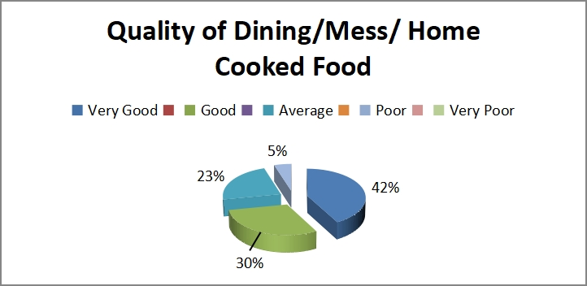

**Figure 15:** The Quality of Dining Food

The given chart displays that the quality of dining is less than home-cooked food. We found that 42% of respondents said that the food was very good, 30% said it was just good, and 23% said it was average. In contrast, only a small number, 5%, found it poor, actually. From that study it is clear that the majority of university students are satisfied with their food quality. On the other hand, a small portion of students reported that it is so poor. For that reason, it is very vital to arrange food security awareness programs to ensure that all pupils have access to nutritious, safe, and satisfactory food, which are absolutely essential elements for food security.

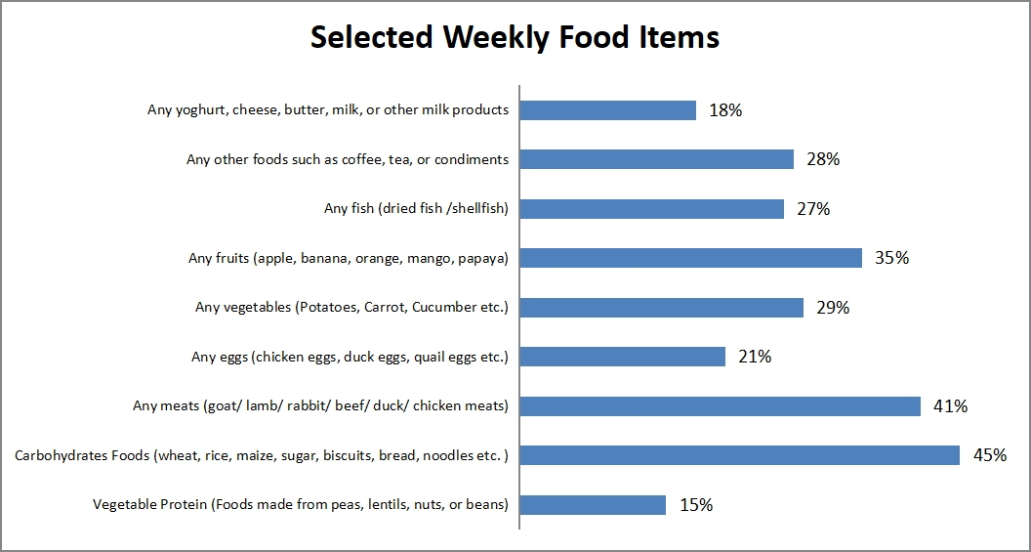

**Figure 16: Selection of Weekly Based Food Items**

This given information outlines that carbohydrate-rich nourishments, for instance, wheat, rice, and bread, are the most commonly devoured (45%). interest in meat items (41%) and different sorts of nourishment (35%) Vegetable admissions are eminent at 29%, dairy items at 18%, angle at 27%, and other nourishments like coffee, tea, and eggs at 21%. Besides, vegetable protein is at 15%, which is comparatively lower. From that study it is evident that when fundamental vitality necessities are largely met through.

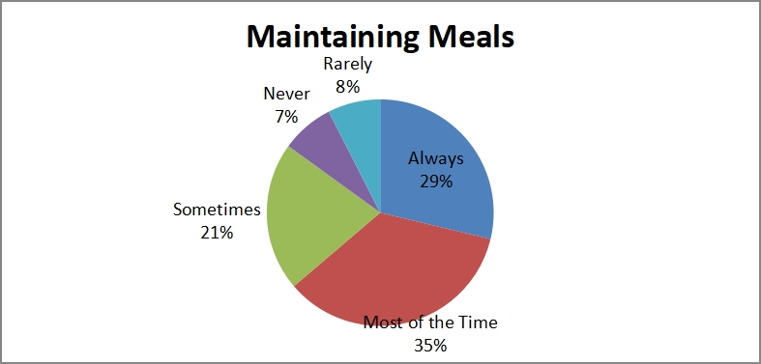

**Figure 17:Maintaining Meals**

Figure 17 shows how often students could maintain their meals generally. Which is an essential component related to security awareness. From that chart we found that 35% of students can maintain their meals properly; on the other hand, 21% sometimes, 8% never, 7% rarely, and 29% always. So that study suggests that a notable number of respondents may be facing challenges with food availability or financial constraints.

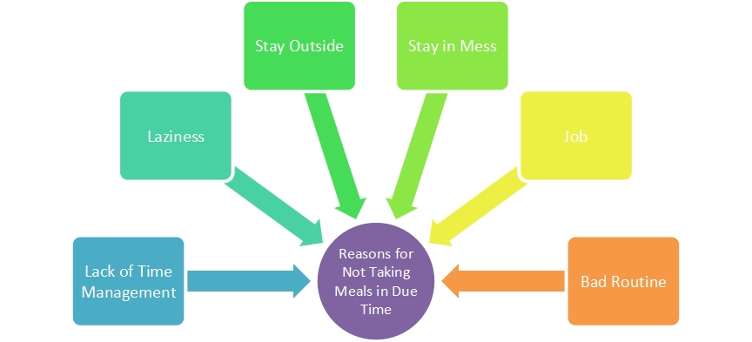

* **Figure 18:Reasons for Not Taking Meals in Due Time**

**Table 1: Facing Challenges by Accessing Nutritious Meals: Views of the Respondents**

|  |
| --- |
| **Issues** |
| Less time for preparing meals, buying groceries, and cooking due to academic demands, study pressure and extracurricular endeavors. |
| Less Access to reasonably priced buying nutritious food |
| The limited options in dining hall/ Canteen |
| University dining hall provides less food than demands |
| Lack of knowledge of cooking |
| Relying on fast food from outside |
| Take extra pressure to maintain job and academic study (especially those are job holder, cannot maintain healthy eating habits) |
| Can't afford to buy healthy food on a limited budget |
| Lack of access to good cooking women |
| Increase the cost of foods |
| Lack of awareness implies inadequate food choices. |
| Lack of Health Awareness Center in the Campus |

1. **Recommendation**

As key institutions for education and sustainability, universities must take proactive measures to address and promote solutions to food insecurity among their students. Food pantries and voucher programs are commonly implemented to support food-insecure students. Effective strategies to provide comprehensive support for students—such as access to adequate housing and healthcare—necessitate collaboration between universities and various other institutions, including governmental agencies. Based on Researchers observations and findings of the study, Researchers provide suggestions on how food security can be improved.

* The university provides low-cost on-campus access to wholesome food for underprivileged students.
* Set up nutritional food campaign initiatives to educate students about good eating practices and provide them the tools they need to make wise dietary decisions.
* Provide cooking classes to foster culinary abilities and educate students about healthy eating, which include expanding the variety and nutrient-dense options available in university cafeterias and canteens.
* Assistance for students who have trouble getting food.
* Incorporate nutritional education into the curriculum to help students make educated food choices and to increase awareness of healthy eating practices.
* Encourage students to ask for assistance when necessary and lessen the negative image attached to food insecurity.

1. **Conclusion**

The present study identified several factors likely contributing to food insecurity among university students, including the closure of campus cafeterias, financial constraints, lack of personal transportation, poor food quality, and time limitations. To cope with these challenges, students employed various strategies, such as sourcing food off-campus, consuming food available in cafeterias and mini-marts despite personal dissatisfaction, storing food, reducing portion sizes, opting for cheaper food items, requesting friends to purchase food off-campus, and skipping meals. Food insecurity negatively affects students, leading to anxiety, fatigue, reduced attention during lectures, and overall poor health. The findings suggest that the Ministry of Higher Education and universities should prioritize addressing food insecurity among students due to its detrimental impact on both academic performance and students' overall well-being.

To mitigate these issues, several measures could be considered, including negotiating with cafeteria operators to enhance the availability of fruits and vegetables, launching health campaigns to reduce excessive consumption of sugar, salt, and oil, and offering financial assistance to students in dire need. Furthermore, students should be encouraged to abandon unhealthy coping mechanisms, such as skipping meals, and instead adopt more sustainable and healthier strategies.

**References**

Anderson, S.A. (1990). Core indicators of nutritional state for difficult-to-sample populations. J. Nutr., 120, 1555–1600.

Coleman-Jensen, A., Nord, M., & Singh, A. (2013). Household food security in the United States in 2012. United States Department of Agriculture, Economic Research Service.

Food and Agriculture Organization (FAO). (1996). Declaration of World Food Security and World Food Summit Plan of Action. World Food Summit, 13-17 November 1996, Rome.

Food and Agriculture Organization (FAO). (2008). Food security information for action: Practical guides. European Commission and FAO Food Security Programme.

Herrera, H., Rebato, E., Arechabaleta, G., Lagrange, H., Salces, I., & Susanne, C. (2003). Body mass index and energy intake in Venezuelan university students. Nutrition Research, 23(3), 389-400.

Moy, F.M., Johari, S., Ismail, Y., Mahad, R., Tie, F., & Ismail, W.W. (2009). Breakfast skipping and its associated factors among undergraduates in a public university in Kuala Lumpur. Malaysian Journal of Nutrition, 15(2), 165-174.

Olson, C.M., Rauschenbach, B.S., Frongillo, E.A., & Kendall, A. (1996). Factors contributing to household food insecurity in a rural upstate New York county. Discussion Paper no. 1107-96. Institute for Research on Poverty.

Rampersaud, G.C., Pereira, M.A., Girard, B.L., Adams, J., &Metzl, J.D. (2005). Breakfast habits, nutritional status, body weight, and academic performance in children and adolescents. Journal of the American Dietetic Association, 105(5), 743-760.

SHII, L., BAKI, R., & SULAIMAN, N. (2015). Understanding food insecurity among public university students. Asia Pacific Journal of Youth Studies, 12, 1-28.

World Health Organization (WHO). (n.d.). Reducing foodborne diseases by educating consumers. Accessed May 2, 2014, from <http://www.who.int/foodsafety/about/flyer_5_keys.pdf?ua=1>

Zakari, S., Ying, L., & Song, B. (2014). Factors influencing household food security in West Africa: The case of southern Niger. Sustainability, 6(3), 1191-1202.